Matthew

Messiah with Authority over the Church

Preliminary Evidence that  Jesus is Messiah |  |  | Rejections and  Interadvent Age |  |  |  | Final Evidence that  Jesus is Messiah
Chapters 1–10 |  |  | Chapters 11–27 |  |  |  | Chapter 28
The King Offered |  |  | The King Rejected |  |  |  | The King Re-offered
Teaches Droves |  |  | Teaches Disciples
Topical |  |  | Chronological
Bethlehem & Nazareth  1:1–4:11 | Galilee  4:12–16:12 |  |  |  | Judea  16:13–28:15 |  |  |  |  | Galilee  28:16-20
Advent  &  Approvals  1:1–4:11 | Early Ministry &  Proclamation  4:12–7:29 | Miracles  &  Authority  8–10 |  | Rejection & Delay  11:1–16:12 | Prepares Disciples  16:13–20:34 | Official Presentation & Rejection  21–27 |  | Empty Tomb  28:1-10 | False Report  28:11-15 | Great Commission  28:16-20
Prelude | Preaching | Power |  | Postponed | Prepares | Presented |  | Proof | Perjury | Plan
Israel

Written in AD 40s
Covers 5 BC–AD 33

Key Word: Kingdom

Key Verses: “Say to the daughter of Zion, ‘See, your king comes to you, gentle and riding on a donkey, on a colt, the foal of a donkey’” (Matthew 21:5).

“Simon Peter answered, ‘You are the Christ, the Son of the living God.’ Jesus replied, ‘…you are Peter, and on this rock I will build my church, and the gates of Hades will not overcome it’” (Matthew 16:16-18).

Summary Statement: The reason to serve Jesus is because he is Messiah for unbelieving Jews with kingdom authority over the Church during Israel’s rejection.

Application:
Have you trusted Christ as your Saviour?
If not, what qualification does he need to meet before you will accept Him?
Matthew

Introduction

I. Title The earliest title (κατὰ Μαθθαῖον According to Matthew) is found at the end of the second century, perhaps even as early as AD 125, although probably not part of the original text (Hiebert, 1:47-49). Matthew's name means “gift of the LORD.”

II. Authorship

A. External Evidence: All of the earliest sources attribute authorship to Matthew:

1. The Didache (ca. AD 110) quotes Matthew more than any other Gospel.

2. The letters of Ignatius and Polycarp (ca. AD 110) show a familiarity with this book.

3. Roman Christians knew about the book by AD 120, especially the account of the magi.

4. The Epistle of Barnabas (ca. AD 130) quotes Matthew 20:16; 22:14 with “it is written.”

5. Papias (ca. AD 140) notes that, “Matthew composed the logia in the Hebrew tongue” (cited by Eusebius, Eccl. Hist. 3.39.16). Although the meaning of logia is disputed, it is reasonable to conclude that it refers to the Gospel since it agrees with the earliest title (above), it agrees with Papias' parallel uses of the word (Guthrie, 34-35), and both the NT and Church Fathers used the word as a synonym for the Scriptures (Harrison, 159).

6. Irenaeus wrote, “Matthew also published a book of the Gospel among the Hebrews in their own dialect” (Against Heresies 3.1.1).

7. Origen stated, “I have learned by tradition that the first [gospel] was written by Matthew… for the converts from Judaism” (quoted by Eusebius, Eccl. Hist. 6.25.4).

B. Internal Evidence: The text makes no mention of its author, but a few incidental details support the tradition that Matthew composed the account:

1. The tax collector is called “Matthew” (9:9), whereas he is called “Levi” in the other Synoptic Gospels (Mark 2:14; Luke 5:27).

2. The author gives more specific information regarding money than any other Gospel writer. Matthew uses three words for money not found elsewhere in Scripture (17:24, 27; 18:24), he notes the cost of certain items (25:15ff.; 26:6-9), and this Gospel alone records the payment of the temple tax (17:24-27) which is consistent with the author's background as a tax collector.

3. As already mentioned, the superscription to the Gospel is the oldest known witness to its authorship. Matthew's name appears in every known manuscript of this Gospel.

III. Circumstances

A. Date: The date for Matthew and all three Synoptic Gospels involves the “Synoptic Problem.” This theory tries to account for both the similarities and differences in Matthew, Mark, and Luke, which are termed “Synoptic Gospels” (Greek syn, “with,” plus opsesthai, “to see,” equals synoptic, “to see with or together”), as they have common content in contrast to John. Since Luke admitted to using other written sources (1:1-4) to compile his Gospel, the Synoptic debate has largely focused on whether Matthew wrote first (Matthean priority) or whether Mark wrote first (Marcan priority). So the issue is, “Who used whom?” to write his account. This issue has produced extensive debate.

In response, both written sources (Luke 1:1-4) and oral tradition (Acts 20:35; 1 Cor. 7:10) were used in composing the Gospels. Also, the writers had extensive first-hand experience either with the Lord (Matthew, John) or with one of his disciples (Mark, Luke) and wrote under the direction of the Holy Spirit (John 14:26). In short, all of the discussions of the Synoptic Problem have added little to understanding the individual messages of the various Gospels. Similarities may be attributed to a common source (such as M, L, or Q), but the superintending work of the Holy Spirit nevertheless guided the process and guaranteed the accuracy of the content. Similarly, differences between the accounts are minimal and merely reflect each author's individual purposes.

Aside from the Synoptic Problem, Matthew has some indications of early composition. The Olivet Discourse (Matt 24–25) anticipates the destruction of Jerusalem in AD 70, as does the book’s strong Jewish flavour. However, the phrases “to this day” (27:8) and “until this day” (28:15) argue that the crucifixion and resurrection had not occurred recently. Since the church tradition argued for the priority of Matthew over the other Synoptic Gospels, a date in the AD 40s satisfies all the available data. If Marcan priority is assumed, the date for Matthew's composition would be about AD 65-70. See pages 49-51a, 78a.

B. Origin/Recipients: The strong Jewish emphasis suggests that the first readers were Jewish, but no one knows where Matthew wrote his account, nor which specific group of Jews read it first. A significant issue concerns whether these Jews were believers or non-believers, but evidence can be marshalled to prove either point (see below). Irenaeus's comment that Matthew produced his gospel originally in Aramaic and among the Hebrews may argue for Israel, but Syria (Hiebert, 1:63) and Antioch (Harrison, 164) may also be possible.

C. Occasion: What influenced Matthew to write his account? What issue was he seeking to address? Answers vary, but his extensive OT quotations are designed to prove that Christ fulfilled the age-old prophecies, thereby identifying him as the Messiah. This apologetic purpose proves to unbelieving Jews that Jesus is the Messiah and provides material for Jewish Christians to prove the same.

The Gospel also answers a natural question from any first-century Jewish believer: ”Since Christ is Messiah and the Messiah is supposed to bring in a new earthly kingdom, where's that kingdom?” Matthew wrote to encourage born-again Jews that God has not forgotten his promise to restore Israel’s kingdom. Still, at present, this kingdom is delayed in its political realm because of the nation's unbelief. In the meantime, Gentiles are allowed into God's program, and all believers are responsible to bring this message to the entire world (28:18-20) until the nation of Israel repents and accepts its Messiah.

IV. Characteristics

A. Matthew presents Christ as Messiah in all three required aspects (Toussaint, 20-21):

1. Prophet: Discourses (Matt 5–7, 10, 13, 18, 23–25)

2. Priest: Atoning death (Matt 26–27)

3. King: Of the three offices, the stress is upon Christ as King, which is the clear theme:

a. The beginning of the account refers to him as the “son of David” (1:1), who was also a king (1:6), and the end recognizes his ultimate authority (28:18).

b. The magi search for one born “king of the Jews” (2:2) and the prophecy of Micah 5:2 regarding Israel's great ruler's birth is fulfilled (2:6).

c. Christ is referred to as the Son of David several times (9:27; 12:23; etc.).

d. Zechariah 9:9 (which prophesies the King riding a donkey) portrays Jesus “not only as the Christ, but as the royal Messiah” (21:5; Toussaint, Behold the King, 21).

e. The kingdom is frequently noted and always as a literal kingdom (see below).

B. Support for a literal view of the kingdom is extensive:

1. Jesus is qualified for the same literal kingdom as other kings in the genealogy (1:1-17).

2. The most natural interpretation of “repent, for the kingdom of heaven is at hand…” preached by John (3:2) and Jesus (4:17) is that the same type of earthly kingdom seen in the Old Testament is in view (see the study beginning on page 78b).

3. Jesus never rebuked the disciples for an incorrect view of the kingdom.

a. When the disciples argued who would be greatest in the kingdom, Jesus did not correct their concept of a literal kingdom. He only taught that humility was needed to enter it (18:1-3).

b. When James and John's mother asked that her sons sit with Jesus in the kingdom, he did not say she had the wrong idea of the kingdom. He only said that this decision was not his (20:20-28).

4. The kingdoms offered to him by Satan were literal (4:8).

5. The references to kingdoms involve literal thrones and rules (19:28).

6. The quote of David’s (Ps. 110:1) is a literal view of the kingdom (22:44).

C. The Jewish character of the book is evident (Toussaint, 15-18; Blomberg, 26):

1. Writing Style: Hebrew parallelisms are common and connectives such as “then, at that time” (tote) occur 90 times (cf. Mark 6 times, Luke 14 times, John 10 times)

2. Vocabulary: “kingdom of heaven” (3:2; 4:17) appears only in Matthew; Jerusalem is designated the “holy city” (4:5; 27:53)

3. Subject Matter: The law, ceremonial defilement, Sabbath, the kingdom, Jerusalem, temple, David, Messiah, Moses, etc.

4. Old Testament References: 129 (53 citations, 76 allusions)

5. Genealogy traces Christ's lineage back to Abraham (1:1)

6. Emphasis on Peter (apostle to the Jews) and Jewish evangelism (10:5-6, 23; 15:24)

7. Unexplained Customs: Jewish rulers (2:1, 22; 14:1), ceremonial cleansing (15:2)

8. Tradition: Irenaeus, Origen, Eusebius (cf. p. 78a)

* However, only Matthew has these Gentile emphases: the Magi (2:1-12), the church (16:18; 18:17), and the commission to evangelise all peoples (28:19). This does not detract from its Jewish emphasis but rather highlights how Israel’s rejection has opened the door of salvation to all nations until Israel finally receives her Messiah at his return (19:28; 23:39).

D. Matthew places a great emphasis on the teaching ministry of Christ (Barbieri, BKC, 16):

1. Sermon on the Mount (Matt 5–7)

2. Instructions to the twelve (Matt 10)

3. Parables of the kingdom (Matt 13)

4. Rebuke of the Jewish leaders (Matt 23)

5. Olivet Discourse (Matt 24–25)

E. The arrangement is logical rather than chronological.

1. The genealogy is arranged into three groups of 14 names (1:1-17).

2. Several miracles appear as a group (Matt 8–10).

3. The opposition to Christ is in one section (11:2–16:12).

4. Only the beginning (Matt 1–4) and the end (Matt 19–28) have a chronological order.

F. The book begins with a summary statement in reverse order (1:1) and concludes with the Great Commission (28:19-20), which is God’s will for the Church in the present church age until Christ returns. Christ promises his presence until the end of this time period.

Argument

Matthew's Gospel is designed both to convince unbelieving Jews that Jesus is the Messiah and to comfort Jewish Christians that God's kingdom program has not been abandoned in light of the nation's rejection of the Messiah. The key verse (21:5) depicts the official offer of the kingdom.

This first purpose, Christ's Messiahship, is demonstrated throughout each section of the book. his advent and approval by others provide Messianic evidence (1:1–4:11), his early ministry and proclamation befit the Messiah (4:12–7:29), he shows the power and authority of the Messiah (8–10), the opposition to him and his message are prophesied of the Messiah (11:1–16:12), he delegates his authority to his disciples as evidence of his Messianic authority (16:13–20:34), his official presentation and rejection in crucifixion confirm the postponement of the kingdom (Matt 21–27), and his victory over death confirms him as Messiah (Matt 28).

Matthew's second purpose, to explain the present kingdom program in light of Israel's rejection, cannot be traced as neatly into sections of the book but nevertheless is still present. Matthew reveals that the Jews rejected the promised earthly kingdom when they rejected Christ as Messiah (11:16-24; 21:28–22:10). This rejection has caused a postponement of the earthly kingdom (19:28; 20:20-23; 23:39; 24:29-31; 25:31-46) so that the present form of the kingdom embraces Gentiles in the Church, a new identity never foreseen in the Old Testament (16:18; 18:17). This “Interadvent Age” between Christ's first and second comings has the kingdom in “mystery form” and is declared in Christ's parables of the kingdom (Matt 13) immediately after his rejection by the Jewish leaders (Matt 12).

Synthesis

Messiah with kingdom authority over the Church

1:1–4:11 Advent/approvals
1–2 Right to throne
1:1-17 Davidic line
1:18–2:23 Messianic fulfilments
1:18-25 Virgin birth
2:1-12 Bethlehem birth/Gentile worship
2:13-18 Weeping caused by non-Davidic king
2:19-23 Humble origins
3:1–4:11 Opening events
3:1-12 John—escape his fire
3:13-17 Father–baptism
4:1-11 Spirit–temptations (personal, national, universal)

4:12–7:29 Early ministry/proclamation
4:12-25 Early ministry
4:12-17 Message
4:18-22 Messengers
4:23-25 Ministry
5–7 Sermon on the Mount (exhorts righteousness before the kingdom)
5:1-2 Hearers
5:3-16 Kingdom subjects
5:17–7:12 Internal, not external
5:17-48 Rejects Pharisee teachings
6:1–7:12 Rejects Pharisee practices
7:13-27 Invitation
7:28-29 Response

8–10 Authority
8:1–9:34 Miracles/discipleship
8:1-17 Healing
8:18-22 –Discipleship cost
8:23–9:8 Power
9:9-17 –Discipleship requirements
9:18-34 Restoration
9:35–10:42 Delegation
9:35-38 Prayer for workers
10:1-42 Instructing healers/exorcists

11:1–16:12 Rejection
11:1-30 Anticipated
12 Effected
13:1-52 Mysteries
13:53–16:12 Rejecting groups
13:53-58 Nazareth/few miracles
14 Herod/5000 fed
15 Scribes and Pharisees/4000 fed
16:1-12 Pharisees and Sadducees/withdrawal

16:13–20:34 Prepares disciples
16:13-17 Peter's declaration
16:18–17:13 Program
16:18-20 Church
16:21-28 Death/Resurrection
17:1-13 Transfiguration
17:14–20:34 Instruction on various issues
17:14-23 Faith Epileptic boy healed
17:24-27 Responsibility Temple tax
18:1-14 Humility Childlike faith
18:15-20 Holiness Church discipline
18:21-35 Forgiveness Unmerciful servant
19:1-12 Divorce Deut. 24 “trap”
19:13-15 Children Blesses them
19:16-30 Sacrifice Rich young ruler
20:1-16 Church rewards Vineyard workers
20:17-19 Death/Resurrection
20:20-28 Servanthood “Momma Zebedee” request
20:29-34 Israel's blindness Two blind men healed

21–27 Official presentation/rejection
21:1-11 Triumphal Entry
21:12-17 Temple Cleansing
21:18–22:46 Confrontation
21:18-22 Fig Tree–symbolic rejection
21:23-27 John’s Baptism–authority questioned
21:28-32 Parable of Two Sons
21:33-46 Parable of Tenants
22:1-14 Parable of Wedding Banquet
22:15-22 Taxes to Caesar
22:23-33 Marriage & Resurrection
22:34-40 Greatest Commandment
22:41-46 Whose Son is Messiah?
23 Condemnation
24–25 Olivet Discourse
24:1-3 Questions: When? What?
24:4–25:46 Answers: Israel's eschatological history
24:4-26 Tribulation
24:4-8 First half
24:9-14 Second half
24:15-26 Antichrist: climactic sign (repetition/explanation)
24:27-30 Second advent
24:31 Regathering of Israel
24:32-51 Parenthetical exhortations
24:32-44 Fig tree (watchfulness/preparedness)
24:45-51 Faithful servant (faithfulness)
25:1-30 Judgment on Israel
25:1-13 Ten virgins (kingdom entrance)
25:14-30 Talents (individual responsibility)
25:31-46 Judgment on Gentiles
26–27 Rejection
26:1-46 Preparations/Passover
26:47–27:66 Crucifixion

28 Resurrection
28:1-10 Empty tomb
28:11-15 False report
28:16-20 Commission

Outline

Summary Statement for the Book
The reason to serve Jesus is that he is the Messiah for unbelieving Jews with kingdom authority over the Church during Israel’s rejection.

The reason to serve Jesus is that he is the Messiah worthy of trust for unbelieving Jews (Matt 1–10).

Christ's advent and approvals reveal him as Messiah and rightful King of Israel (1:1–4:11).

Christ's advent fulfilled both the Davidic line requirement and prophetic Scripture, demonstrating his Messianic right as heir to the throne of Israel (Matt 1–2).

The genealogy of Christ shows him to be in the rightful kingly line of David and thus qualified in his lineage as Israel's King (1:1-17).

The circumstances surrounding Christ's birth verify his fulfilment of Messianic prophecies, presenting him as the Messiah (1:18–2:23).

He was born of a virgin in fulfilment of Isaiah 7:14 (1:18-25).

Gentiles worshipped him, but Jews rejected him (2:1-12). See pp. 78h-79.

He is of the right lineage in contrast to the Edomite Herod (2:13-18).

He is from humble origins, as is expected of the Messiah (2:19-23).

Christ is approved as Messiah by John, God the Father, and the Holy Spirit in his first public introduction, baptism, and temptation, respectively (3:1–4:11).

John the Baptist’s approval of Jesus as the Messiah is confirmed by prophetic Scripture, as John is the forerunner of the Messiah (3:1-12).

God the Father's approval of Jesus as Messiah is witnessed at Christ's baptism (3:13-17).

The Holy Spirit's approval of Jesus as Messiah is validated in Christ's resistance to Satan's temptations in the wilderness (4:1-11).

Christ's early ministry and Sermon on the Mount principles reveal him to have the prophetic ministry expected of the Messiah (4:12–7:29).

Christ's early ministry further reveals him as the Messiah and provides the setting for his teaching in the Sermon on the Mount (4:12-25).

Christ teaches repentance—not physical heritage—to enter the kingdom (4:12-17).

Christ's calling of disciples demonstrates his authority over men's lives as Messiah (4:18-22).

A summary of Christ's early Galilean ministry of teaching, preaching, and healing identifies him as doing the work of the Messiah (4:23-25).

Christ's Sermon on the Mount teaches how one who is in right relationship with God should live in anticipation of the kingdom (Matt 5–7).

People entering Messiah's kingdom should show holiness instead of mere Pharisaic observances (Matt 5:1-16; Luke 6:17-26).

The response a holy believer should have to the benefits and persecution related to trusting Christ as King is joy (Matt 5:1-12).

The sermon setting is Jesus as a rabbi, teaching the disciples how to embrace him as king (Matt 5:1-2; Luke 6:17-19).

Jesus saw the crowds and sat down on a mountainside (1a).

Jesus began teaching his disciples, who showed initiative to listen (1b-2).

The benefits of trusting Christ as King are many (Matt 5:3-11; Luke 6:20-26).

Depending on God leads to a rich experience of life (5:3)

Admitting our needs leads to receiving God’s comfort (5:4).

Humility now brings honour in the millennial kingdom (5:5).

Holiness gives a deep satisfaction in life (5:6).

Showing mercy to others leads to receiving God’s mercy (5:7).

A pure lifestyle results in seeing God in our lives today (5:8).

Making peace with others enables us to be God’s channel (5:9).

Persecution for Christ gives a rich experience of life (5:10-11).

The response a believer should have to persecution is joy in his heavenly reward and identification with the persecuted OT prophets (5:12).
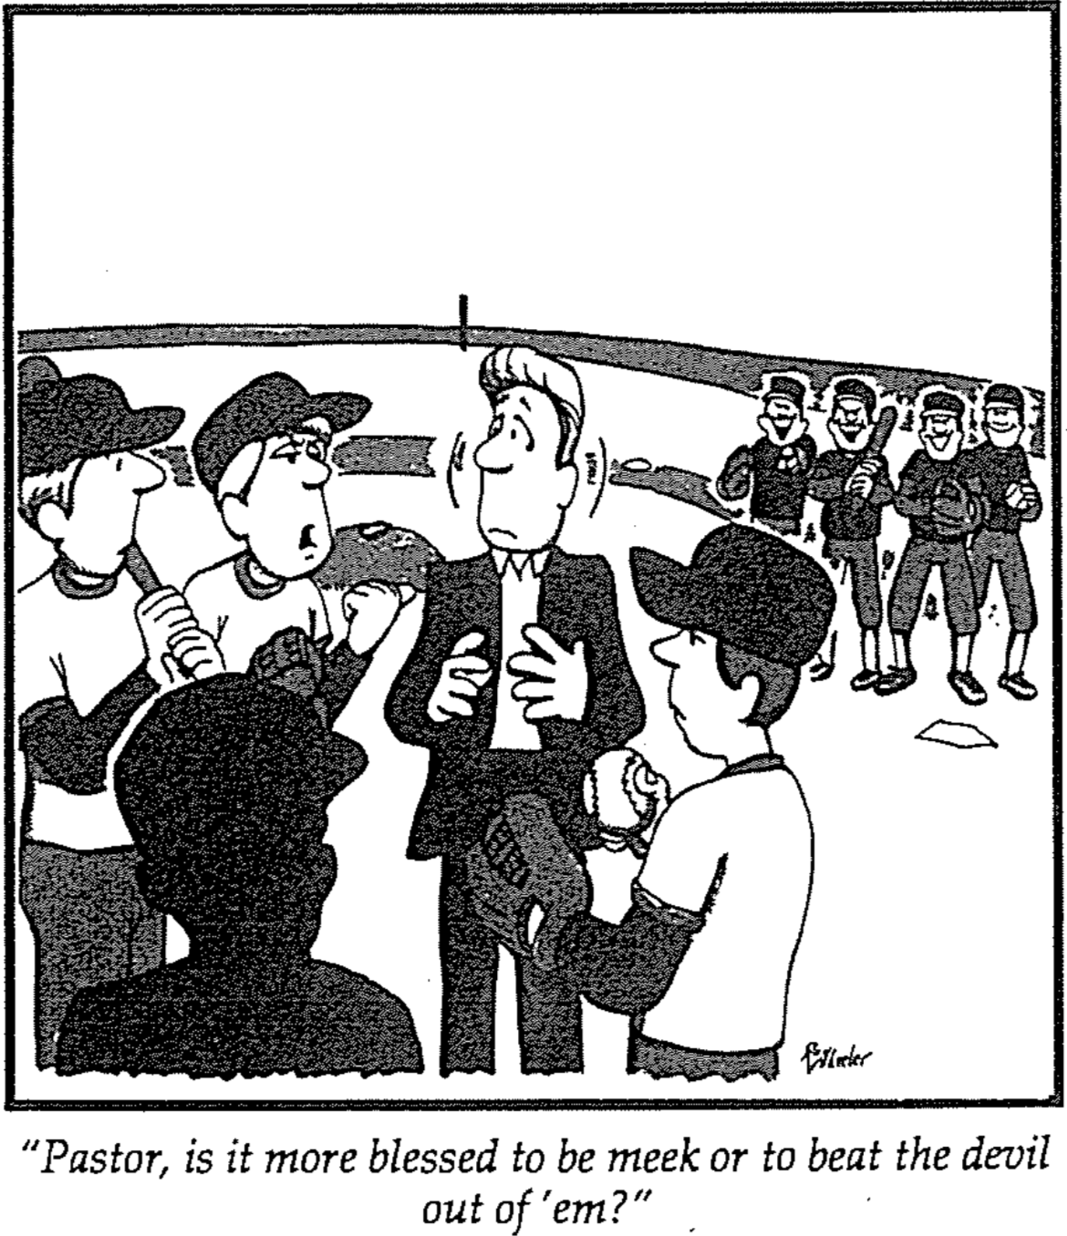

The way believers create a thirst for God in others is by revealing God's righteousness and attracting them to the Lord (Matt 5:13-16).

The way believers can bless others is to help them hunger for God (5:13).

Christians are like salt to create hunger for God in others (5:13a).

Christians who don’t help others hunger for God are useless (5:13b).

The way believers should bless others is by helping them praise God by the good works they do (5:14-16).

Christians are lights to show people to God (5:14a).

A city on a hill and a lamp help others see the way to go (5:14b-15).

Be “light” through good deeds to help others praise God (5:16).

Christ rejects the Pharisaic views of the law that the disciples might know the proper type of righteousness needed to enter the kingdom (5:17–7:6).

Christ fulfilled the OT and denied that Pharisaic morality saves from sin (5:17-20).

The time the OT will disappear is when all it prophesies about Jesus comes true (5:17-18). See pages 80a-e.

Jesus came to fulfil the OT rather than abolish it (5:17).

The OT won’t disappear until every prophecy about Christ is fulfilled in the eternal state (5:18).

Believers will be rewarded by obeying and teaching the true spirit of the Old Testament (5:19-20).

Our level of millennial rewards depends on practicing and teaching the true spirit of the Old Testament (5:19).

We won’t even enter the millennium apart from internal holiness in Christ rather than external piety of the Pharisees (5:20).

Pharisaic righteousness cannot bring one into the kingdom, so people should show proper conduct towards others (Matt 5:21-48).

Murder: To be better than Pharisees, you’ll not only preserve life but will avoid the anger, hatred, and poor relationships that lead to murder (Matt 5:21-26).

The way to sustain great relationships is to control the anger that leads to murder (5:21-22).

Murder is wrong (5:21).

Anger that causes murder hurts you the most (5:22).

God will judge you for anger (5:22a).

Others will judge you for slander (5:22b).

If you curse others, you deserve hell (5:22c).

The way to sustain great relationships is to refuse to worship God until you make a relationship right (5:23-24).

You can try to worship God until you see it hurt someone (5:23).

Reconciling with that person enables you to worship (5:24).

The way to keep good relationships is pay debts quickly (5:25-26).

Seek to resolve relationships quickly out of court (5:25a).

If you neglect people, you can lose your freedom (5:25b).

If you don’t prioritize people, you can lose your money (5:26).

Adultery: To be better than Pharisees, you will not only be faithful to your spouse but will shun the lust that causes adultery (5:27-30).

The nature of the seventh command of God is to avoid adultery (5:27).

Jesus’ hearers knew the seventh commandment (5:27a).

God prohibited adultery in this command (5:27b).

The way to avoid adultery is to guard yourself from lust (5:28-30).

Lust is adultery of the heart (5:28).

We must protect ourselves from lust (5:29-30).

Avoid seeing things that stimulate lust (5:29).

Avoid doing things that encourage lust (5:30).

Divorce: To be better than Pharisees, never divorce your wife to prevent her and her future husband from both committing adultery when she remarries (5:31-32).

The way Jewish leaders attacked marriage was to use marriage protection as an excuse for frivolous divorce (5:31).

Jesus’ listeners knew that the divorce certificate protected wives from frivolous divorce (5:31a).

Pharisees used this OT protection to justify their frivolous divorces (5:31b).

The way Jesus defended marriage was to prohibit divorce unless promiscuity had led to adultery (5:32).

Jesus honored marriage by declaring that divorce leads to adultery unless preceded by sexual unfaithfulness (5:32a).

Jesus honored marriage by declaring that divorce also leads to adultery for the person who marries the divorcee (5:32b).

Oaths: To be better than Pharisees, replace ambiguous oaths with trustworthy speech at all times so oath-taking becomes unnecessary (5:33-37).

The way we should treat our vows is to keep them (5:33).

Jesus’ listeners knew about Deut. 23:21 (5:33a).

The verse was God’s command to fulfil their vows (5:33b).

The best way to treat our vows is to make them unnecessary (5:34-37).

The way not to vow is by making them tricky (5:34-36).

The way we should speak is to give the simple truth (5:37a).

The reason to speak truthfully is that otherwise, we follow evil (5:37b).

Retaliation: One surpassing Pharisaic righteousness will not demand his right for retaliation but give up such rights as a characteristic of righteousness and godliness (5:38-42).

Give up personal honor (5:38-39)

Give up personal property (5:40)

Give up personal liberty (5:41)

Give to the one who begs from you, and do not refuse the one who would borrow from you (5:42).

Love: One surpassing Pharisaic righteousness will not only love his neighbor who will repay favors but will love his enemy as well, who will never repay favors (5:43-48).

The way to treat your enemy is to love and pray for him (5:43-44).

Human tradition says to love friends and hate enemies (5:43).

Jesus’ higher law says to love and pray for your enemy (5:44).

The reason to bless your enemy is because you live by Christ’s higher law (5:45-48).

Blessing your enemy shows that you are God’s child (5:45a).

Blessing your enemy shows that you also don’t deserve God’s grace (5:45b).

Blessing your enemy shows that you live on a higher plane (5:46-47).

Loving only the lovable isn’t rewarded (5:46).

Kindness only to the kind isn’t unique (5:47).

Blessing your enemy shows that you strive for perfection (5:48).
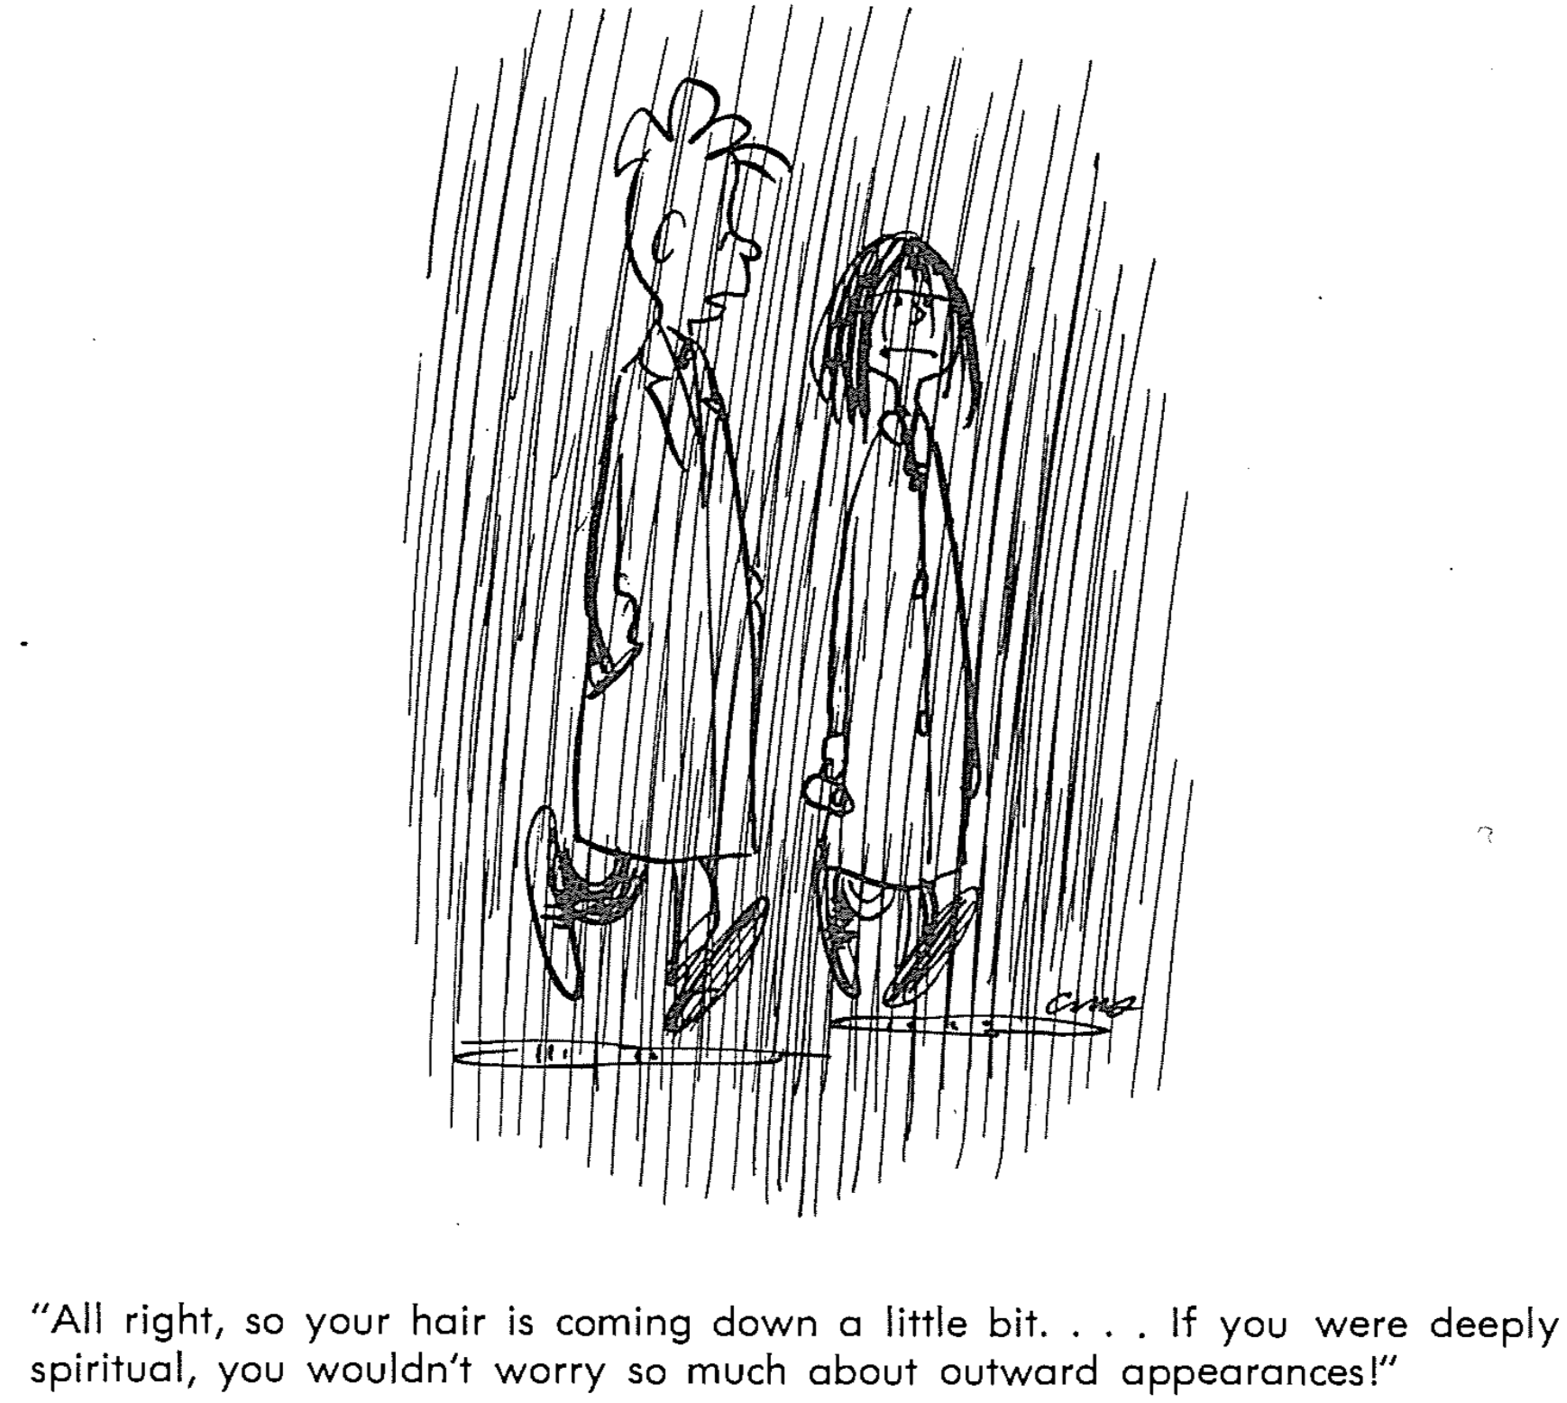

Jesus rejects six Pharisaic practices that emphasize external observance over heart attitude, teaching that an inwardly repentant life anticipates the kingdom (6:1–7:6).

Giving: The rewards for giving depend on its public nature (6:1-4).

The rewards of public giving is blessing only from people (6:1-2).

The reward for public good deeds is not from God (6:1).

The warning for believers is not to do good deeds publicly (6:1a)

The reward for public good deeds is not from God (6:1b).

The reward for publicly giving to the needy is only from people (6:2).

The way not to give to the needy is by showing off (6:2a).

The reward for public giving to needs is only from people (6:2b).

The rewards of private giving is blessing from the God who sees all (6:3-4).

The way to give in honour of God is privately (6:3-4a).

The result of private giving is a reward from the God who sees all (6:4b).

Prayer: The way to pray is for God’s glory, not selfish needs (6:5-15). See pages 78.1-4.

The way not to pray is with self-focus like the Pharisees (6:5-8).

The way not to pray is for public show like the Pharisees (6:5-6).

People admired the Pharisees for their public prayers (6:5).

God rewards us for our private prayers (6:6).

How not to pray is in meaningless repetition like pagans (6:7-8).

Pagans think their babbling will be answered (6:7).

God forbids repetition, as he already knows our needs (6:8).

The way to pray is for God’s glory and our real needs (6:9-15).

Pray for God to be honored (6:9-10). PRAYERS acronym:

Praise Him: First, relate to God as Father (6:9a).

Reverence Him: Honour God’s name as holy (6:9b).

Anticipate his Kingdom (6:10a).

Yield your will to his (6:10b).

Pray for God to meet your real needs (6:11-13).

Entreat God for personal needs (6:11).

Release sins against God and man (6:12).

Succeed over temptation (6:13).

Forgive others for fellowship with God (6:14-15).

Forgiving people leads to experiencing God’s forgiveness (6:14).

Not forgiving others puts barriers between God and us (6:15).

Fasting: The way to get God’s praise instead of man’s praise is to fast so that only God knows (6:16-18).

The way to fast for man’s praise is to look gloomy like Pharisees (6:16).

Jesus assumed that people would sometimes fast (6:16a).

Those fasting should not imitate Pharisees who look gloomy (6:16b).

The Pharisee’s motivation for fasting was to look spiritual (6:16c).

The way to fast for God’s praise is to fast secretly (6:17-18).

Those fasting should make their hair and face look good (6:17).

The Father rewards fasting in a way that people do not notice (6:18).

Investments: The reason to invest in heaven is because eternal reward is better than greed (Matt 6:19-24).

The reason to invest in heaven is because pursuing eternal reward makes sense (6:19-21).

Collect heavenly—not earthly—rewards since they’re eternal (6:19-20).

What we value takes our time and energy (6:21).

The reason to invest in heaven is that wisdom avoids greed (6:22-23).

Lamps reveal good priorities, and wisdom prevents greed (6:22-23a).

One who thinks that greed is good is in real trouble (6:23b).

The reason to invest in heaven is that either God or money controls us (6:24).

We all commit to only one authority (6:24a).

We can’t serve both God and money (6:24b).

Worry: The way to defeat worry about food and clothes is to trust God that you’ll rule with Jesus (6:25-34).

The way to defeat worry about food is to see that God feeds us while worry starves us (6:25-27).

Don’t worry about food, drink, or clothes (6:25).

God will feed you more than diligent birds as he values you more (6:26).

Worry doesn't help us live even one hour longer (6:27).

The way to defeat worry about clothes is to see that God clothes nature without any worry (6:28-30).

Don’t worry about clothes (6:28a).

God clothes lilies even better than he clothed Solomon (6:28b-29).

God cares for passing grass, so he’ll care for precious people like us (6:30).

The way to defeat worry about food and clothes is to trust God that you’ll rule with Jesus (6:31-34).

Therefore, replace worry with seeking Christ’s rule on earth (6:31-33).

Therefore, replace care for tomorrow with trust in God today (6:34).

Judging: The way to judge others is with fear, humility, and wisdom (Matt 7:1-6; cf. Luke 6:37-42). See page 80i.

Fear: The way to judge others is to realize that God will judge you (7:1-2).

Don’t pick on weak areas in others when you are even weaker (7:1).

Know that God will hold you to the standard you impose on others (7:2).

Humility: The way to judge others is first to judge your own life (7:3-5).

Don’t pick on weak areas in others when you are even weaker (7:3-4a).

Solve your issue before helping another who struggles even less in this area (7:4b-5).

Wisdom: The way to judge others is to discern in whom to invest your life (7:6).

Don’t waste valuable resources on those who couldn’t care less (7:6a).

People who scorn you for investing in them can really harm you (7:6b).

Despite the Pharisees' rejection, Christ taught the way of salvation and other key truths to those who wanted to enter the kingdom (7:7-29).

God answers persistent prayer because he is a caring Father, not because of the endless repetitions of the Pharisees (7:7-12).

Jesus invites unbelievers into the kingdom by trusting his narrow way rather than the destructive, broad way of the Pharisees (7:13-14).

Ungodly heretics like the Pharisees will be judged for trusting their works instead of having a relationship with the King (7:15-23).

Unbelievers must accept Jesus to enter the kingdom, while the Pharisees will miss it by trusting their external observance (7:24-27).

The crowd's amazement recognized Christ as Messiah, but the Pharisee system lacked God’s authority and blessing (7:28-29).

Christ shows the power expected of the Messiah, demonstrating that he can give Israel the kingdom when they are willing to accept it (Matt 8–10).

Christ’s power and authority as the Messiah could soon take place in the kingdom if the nation accepts him as the Messiah (8:1–9:34).

His miracles of healing demonstrate his power as Messiah (8:1-17).

His detailing the cost of discipleship demonstrates his power as Messiah (8:18-22).

His miracles of power demonstrate that he is the Messiah (8:23–9:8).

His distinct discipleship requirements show his power as Messiah (9:9-17).

His miracles of restoration demonstrate his power as Messiah (9:18-34).

Jesus shows Messianic authority by delegating authority to the disciples as they are sent out to heal and exorcise demons (9:35–10:42).

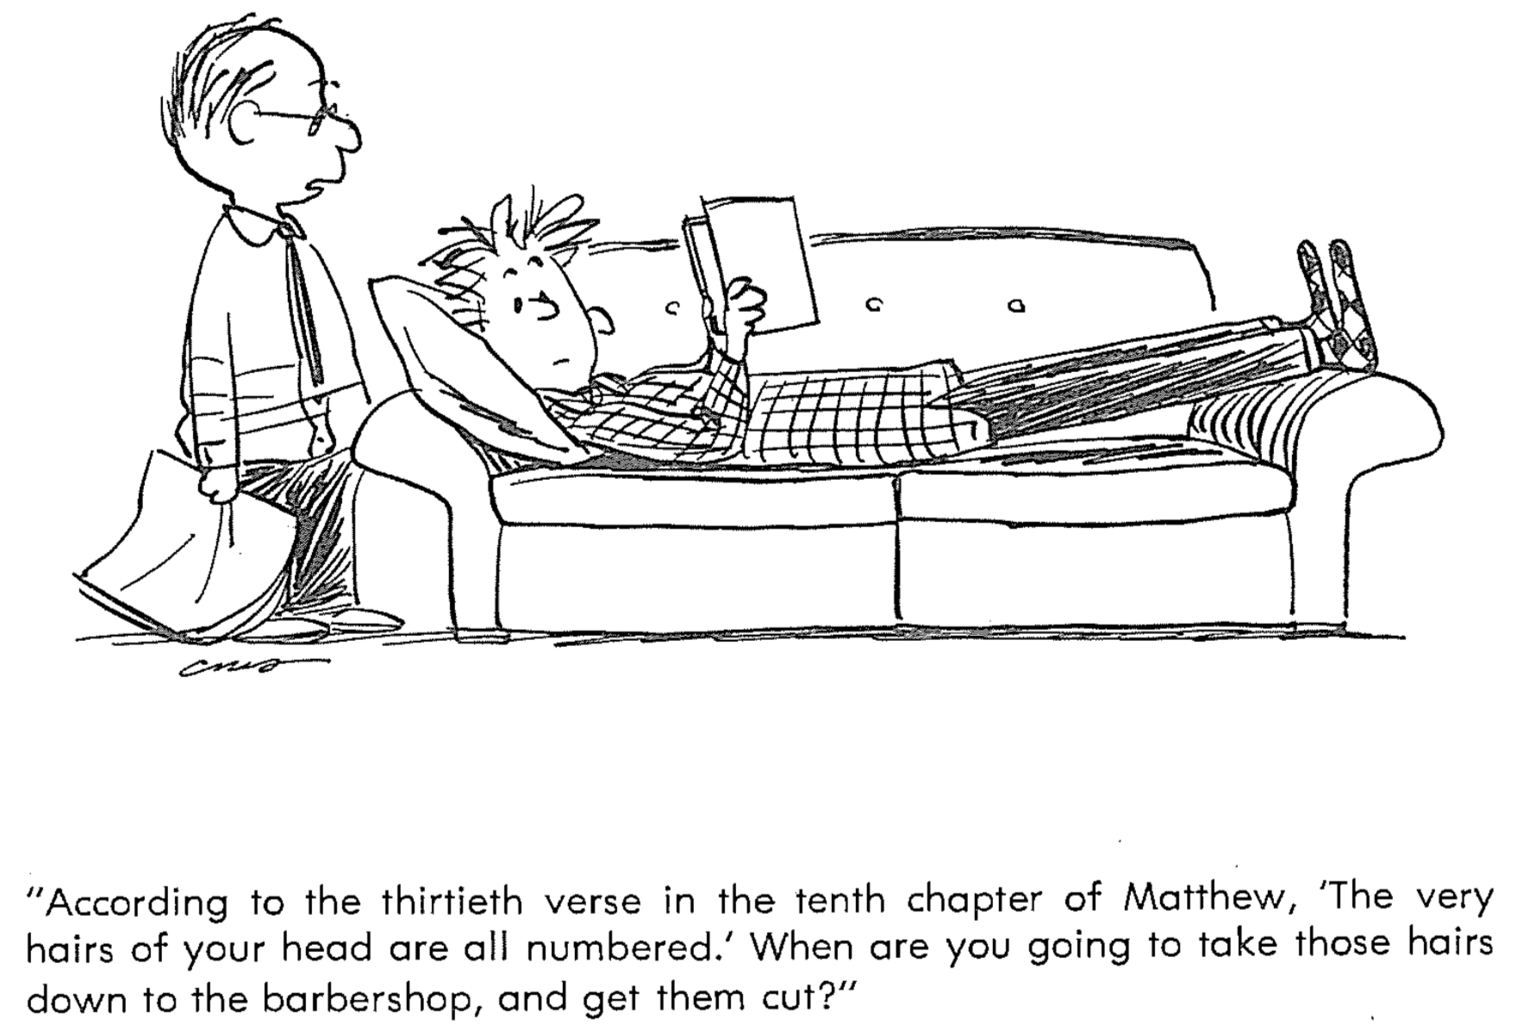

The reason to serve Jesus is that he has kingdom authority over the Church during Israel’s rejection (Matt 11–27).

Christ’s rejection in the Interadvent Age before his future reception includes ministry to Gentiles (11:1–16:12).

John's need for clarification anticipates his rejection by the entire nation, but Christ graciously invites Israel to accept him as Messiah (11:1-30).

The Pharisees reject Christ on behalf of the nation, which causes the kingdom to be delayed until Israel repents (Matt 12).

The result of the rejection is Christ teaching the Interadvent Age for Gentile salvation and new revelation to believers (13:1-52). See pages 79a-c, 80f-h.

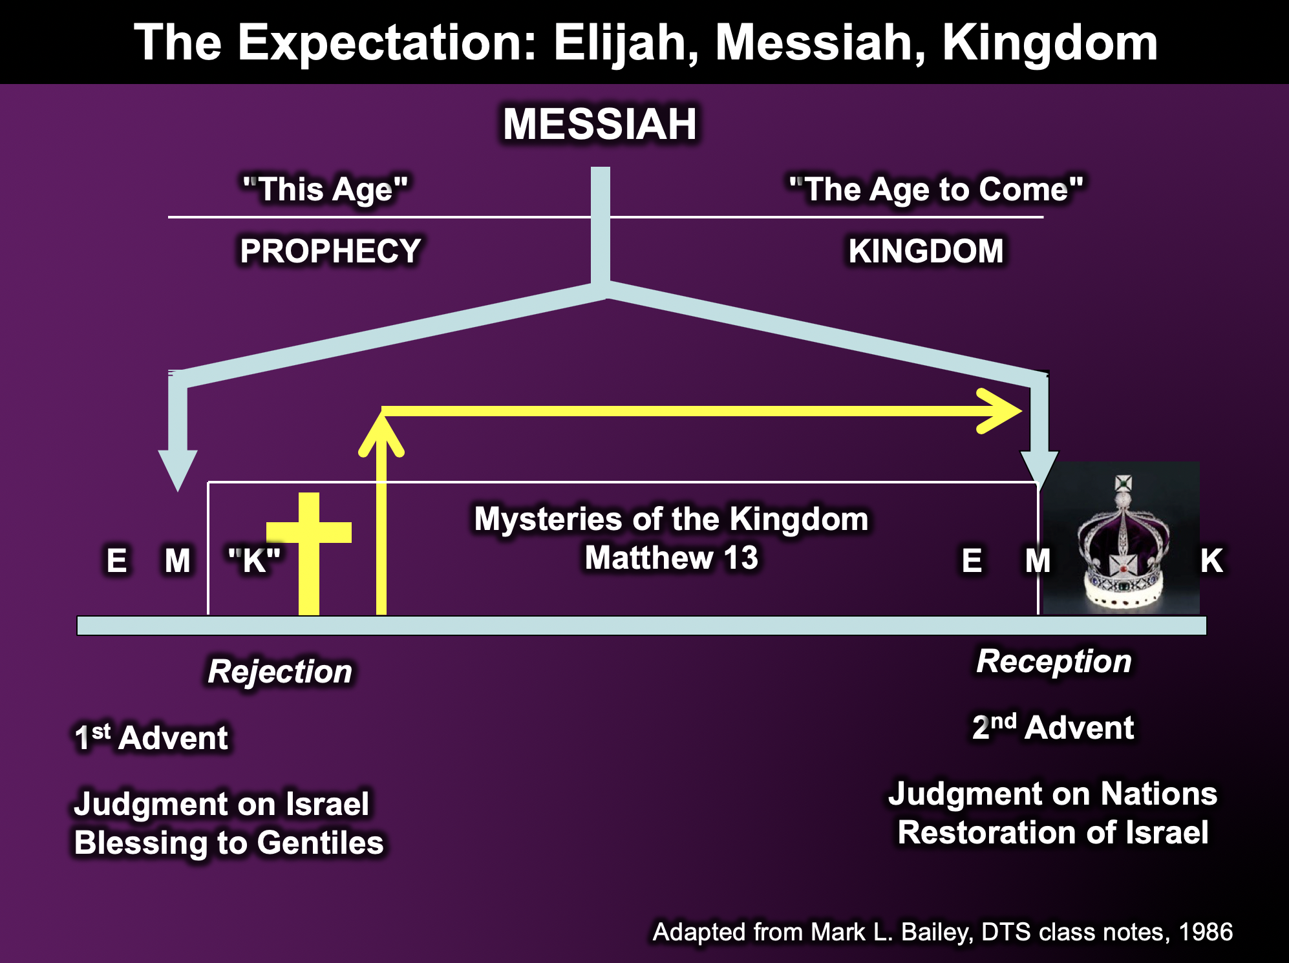

Other groups anticipate Israel’s rejection at the cross, so Jesus withdraws from the leaders to show that he is King only to a believing nation (13:53–16:12).

His own hometown of Nazareth rejects Christ in anticipation of the rejection by his own people, the Jews (13:53-58).

Herod rejects Christ in anticipation of the Roman rejection at the cross, so he withdraws to feed 5000 as the “new Moses” with spiritual food (Matt 14).

The scribes and the Pharisees reject Christ in anticipation of Israel's religious leaders, so he withdraws to feed 4000 Gentiles (Matt 15).

The Pharisees and Sadducees reject Christ in their demand for a sign, and he withdraws to warn his disciples against their teaching (16:1-12).

Christ prepares his disciples about his Person and plan to delegate his authority to them after his death (16:13–20:34).

Christ reveals His person as Messiah to His disciples privately through Peter's confession, preparing them for ministry after His death (16:13-17).

Christ reveals his program privately to his disciples about the church, his death and resurrection, and the coming kingdom in his Transfiguration (16:18–17:13).

Jesus would build his Church upon Peter’s declaration that he is King (16:18-20).

God’s plan for the Messiah to die and come back to life again would be fulfilled in order to establish the Church (16:21-28).

The transfiguring of Jesus prefigured the kingdom age by revealing Jesus as the rightful king of Israel, alone worthy of worship (17:1-13).

Christ instructs his disciples on many issues that they will face after his death to prepare them for ministry (17:14–20:34).

Faith, including trust that God will use Jesus’ death and resurrection, is shown by Jesus through healing an epileptic boy (17:14-23).

Responsibility shown in paying taxes is required of believers (17:24-27).

Humility now is vital for greatness in the kingdom (18:1-14).

Holiness must be sustained through church discipline (18:15-20).

Forgiveness must be shown to others like God showed to us (18:21-35).

Divorce must not be sought by misconstruing God’s mercy to those in oppressive marriages (19:1-12).

Children hold great value as members of God’s kingdom (19:13-15).

Sacrifice is required for being fully rewarded by God (19:16-30).

Rewards will be given based on faithfulness, not time served (20:1-16).

Models of sacrifice find their fullest example in Christ, who willingly died and rose (20:17-19).

Servanthood precedes glory (20:20-28).

Blindness in Israel, spiritually, can be healed by faith as easily as Jesus healed two physically blind men (20:29-34).

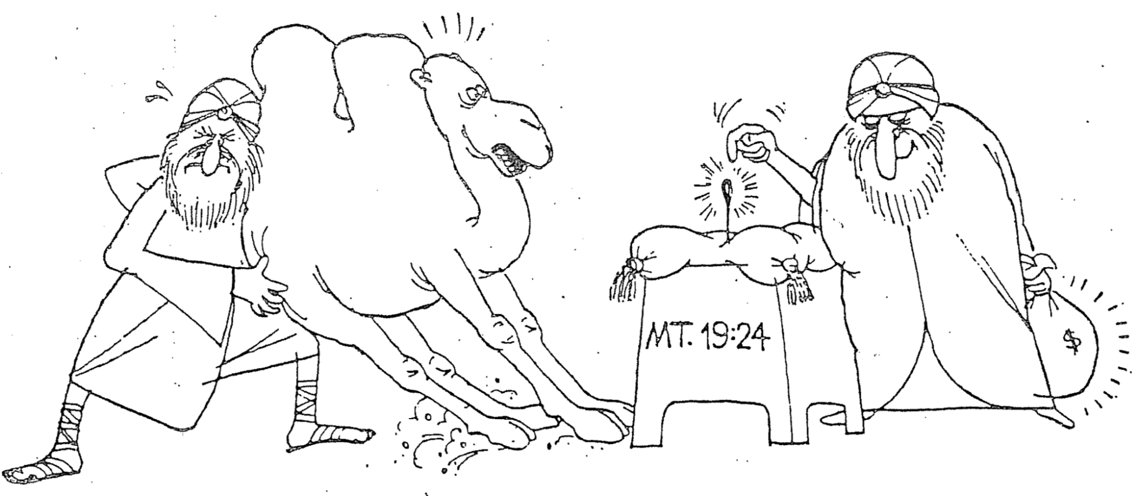

Christ's presentation and rejection as Israel's King in his vicarious crucifixion show why the kingdom is delayed until his return (Matt 21–27).

In the Triumphal Entry and cleansing of the temple, Christ officially presents Himself to the nation as Messiah and King (21:1-17).

The confrontation of Christ by the religious leaders reveals their unrepentant disbelief in him as Messiah (21:18–22:46).

Christ rejects the nation in his condemnation of the teachers of the Law and his lament over Jerusalem (Matt 23).

Christ’s Olivet Discourse reveals his return to establish the kingdom, delayed by the nation's unbelief (Matt 24–25). See pages 81-81a.

The setting is the disciples’ two questions (“when?” and “what?”) after Christ declares God's judgment on Jerusalem's temple for rejecting him (24:1-3).

The Tribulation Period, Second Coming, and judgments of Israel and the nations will precede the establishment of the kingdom (24:4–25:46).

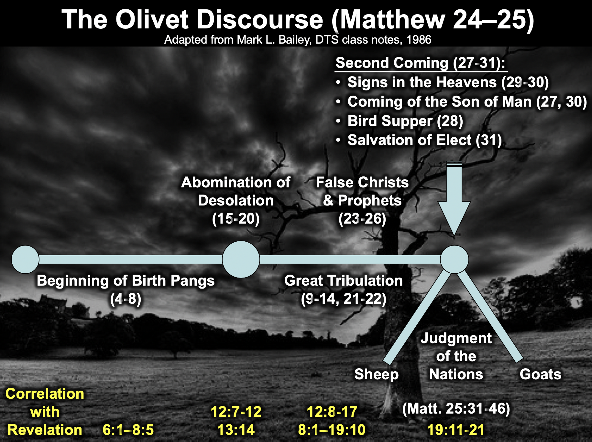

The crucifixion of Christ is Israel's ultimate act of the nation's rejection of Christ as Messiah and Passover Lamb for the nation's sin (Matt 26–27).

The preparations and Passover of Christ portray his preparation as the ultimate Passover Lamb for the nation's sin (26:1-46).

The crucifixion of Christ is Israel's ultimate act of the nation's rejection of him as Messiah (26:47–27:66).

The reason to serve Jesus as Messiah is that he rose from the dead (Matt 28).

The empty tomb provides a continual reminder of the fact that Christ is the Messiah confirmed by his victory over death (28:1-10).

The false guards’ report provides a flimsy excuse for rejecting Christ as Messiah (28:11-15).

The Great Commission shows that Christ’s highest priority is for us to make disciples of every nation until he returns (28:16-20).

The Lord’s Prayer
DON’T INTERRUPT ME, LORD, I’M PRAYING
A 2-person skit reflecting on the Lord’s Prayer by Clyde Lee Herring
Adapted from Bread magazine, Nazarene Publishing House
Adapted from http://www.murraymoerman.com/3downloads/don%27t_interrupt_me_lord_i%27m_praying.pdf

Our Father who art in Heaven....
Yes
Don’t interrupt me. I’m praying.
But you called me!
Called you? I didn’t call you. I’m praying. “Our Father who art in Heaven...”
There, you did it again.
Did what?
Called me. You said, “Our Father who art in Heaven.” Here I am.... What’s on your mind?
But I didn’t mean anything by it. I was, you know, just saying my prayers for the day. I always say the Lord’s Prayer. It makes me feel good, sort of like getting a job done.
All right, go on.
“Hallowed be thy name...”
Hold it! What do you mean by that?
By what?
By “Hallowed be thy name?”
It means... It means... Good grief. I don’t know what it means. How should I know? It’s just part of the prayer... By the way, what does it mean?
It means honoured, holy, wonderful
Ah! That makes sense. I never thought about what “hallowed” meant before.... “Thy kingdom come, thy will be done on earth as it is in Heaven.”
Do you really mean that?
Of course, why not?
What are you going to do about it?
Do? Nothing I suppose. I just think it would be rather good if you got control of everything down here as you have up there.
Have I got control of you?
Well, I go to church!
That isn’t what I asked you. What about your bad temper? You’ve really got a problem there you know. Then there’s the way you spend your money.....all on yourself; and what about the kind of books you read?
Stop picking on me! I’m just as good as some of the rest of those hypocrites down at the church!
Excuse me. I thought you were praying for my will to be done. If that is to happen, it will have to start with the ones who are praying for it. Like you, for example.
Oh, all right. I guess I do have some hang-ups now that you mention it. I could probably name some others.
So could I.
I haven’t thought about it very much until now, but I really would like to cut out some of those things. I would like to, you know, be really free.
Good! Now we’re getting somewhere. We’ll work together, you and I. Some victories can truly be won. I’m proud of you.
Look, Lord, I need to finish up here. This is taking a lot longer than it usually does.... ‘Give us this day our daily bread.’
You need to cut out the bread. You’re overweight as it is.
Hey, wait a minute! What is this? ‘Criticise Me Day?’ Here I was, doing my religious duty, and all of a sudden, you break in and remind me of all my hang-ups.
Praying is a dangerous thing. You could wind up changed, you know! That’s what I’m trying to get across to you. You called me, and here I am. It’s too late to stop now. Keep on praying. I’m interested in the next part of your prayer....... (pause) Well, go on.
I’m scared to.
Scared? Of what?
I know what you’ll say.
Try me and see
‘Forgive us our debts as we also have forgiven our debtors.’
What about Bill?
See! I knew it! I knew you would bring him up! Why, Lord? He’s told lies about me and cheated me out of some money. He has never repaid the debt he owes me. I’ve sworn to get even with him!
But your prayer? What about your prayer?
I didn’t mean it
Well, at least you’re honest, but it’s not much fun carrying that load of bitterness around inside, is it?
No, but I’ll feel better as soon as I get even. Boy, have I got some plans for old Bill! He’ll wish he never done me any harm.
You won’t feel any better. You’ll feel worse. Revenge isn’t sweet. Think of how unhappy you already are, but I can change all that.
You can? How?
Forgive Bill. Then I’ll forgive you. Then the hate and sin will be Bill’s problems and not yours. You may lose the money, but you will have settled your heart.
But, Lord, I can’t forgive Bill.
Then I can’t forgive you.
Oh, you’re right. You always are, and more than I want revenge on Bill, I want to be right with you......(pause…sigh). All right, all right. I forgive him. Help him to find the right road in life. Lord, he’s bound to be awfully miserable now that I think about it. Anybody who goes around doing the things he does to others has to be mixed up inside. Someway, somehow, show him the right way.
There now! Wonderful! How do you feel?
Hmmm. Well, not bad. Not bad at all. In fact, I feel quite tremendous! You know, I don’t think I’ll have to go to bed tense tonight for the first time since I can remember. Maybe I won’t be so tired from now on because I’m not getting enough rest.
You’re not through with your prayer. Go on.
Oh, all right. ‘And lead us not into temptation, but deliver us from evil.’
Good! Good! I’ll do just that. Just don’t put yourself in a place where you're tempted.
What do you mean?
Change some of your friends. Some of your so-called friends are starting to get to you. They’ll have you completely involved in the wrong things before long. Don’t be fooled. They advertise that they’re having fun, but for you it would be a ruin. Don’t use me for an escape hatch.
I don’t understand.
Yes, you do. You’ve done it a lot of times. You get caught in a bad situation. You get into trouble, and then you come running to me. ‘Lord help me out of this mess, and I promise you I’ll never do it again.’ You remember some of those bargains you tried to make with me?
Yes, and I’m ashamed, Lord, I really am.
Which bargain are you remembering?
Well, when the woman next door saw me coming out of the local pub. I’d told my mother I was going to the shop. I remember telling you ‘O God, don’t let her tell my mother where I’ve been. I promise I’ll be in church every Sunday.’
She didn’t tell your mother, but you didn’t keep your promise, did you?
I’m sorry, Lord, I really am. Up until now, I thought that just praying was enough. I didn’t expect you to answer like this.
Go ahead and finish your prayer.
‘For thine is the kingdom, and the power, and the glory, forever, Amen.’
Do you know what would bring me glory? What would really make me happy?
No, but I’d like to know. I want to please you now. Now I can see how good it would be to be a real follower of you.
You just answered the question.
I did?
Yes. The thing that would bring me glory is to have people like you truly love and follow me, and I see that happening between us. Now that some of these old sins are exposed and out of the way, well, there’s no telling what we can do together.
Lord, let’s see what we can make of me, ok?
Yes, let’s see.

Indicators that Matthew Wrote the First Gospel

External Indicator #1:  Testimony of Eusebius/Origin  Eusebius was a 4th century historian who quoted Origen, a 2nd century scholar and the earliest voice on which gospel was written first.  “Among the four Gospels, which are the only indisputable ones in the Church of God under heaven, I have learned by tradition that the first [gospel] was written by Matthew, who was once a publican, but afterwards an apostle of Jesus Christ, and it was prepared for the converts from Judaism, and published in the Hebrew language. The second is by Mark, who composed it according to the instructions of Peter, who in his Catholic [i.e., General] epistle acknowledges him as a son, saying, ‘The church that is at Babylon elected together with you, saluteth you, and so doth Marcus, my son.’ And the third by Luke, the Gospel commended by Paul, and composed for Gentile converts. Last of all that by John” (Eusebius, Eccl. Hist. 6.25.4 quoting Origen of the 2nd century).  External Indicator #3:  Placement First in the NT  Matthew’s gospel was placed first among the gospels so that it appears right at the beginning of the NT. It makes the natural bridge from Malachi because it continues the prophetic message to Jews. | External Indicator #2:  Papyrus of Fragments from Matthew 26 dated about AD 50  See C.P. Thiede, ‘Papyrus Magdalen Greek 17 (Gregory-Aland P64): A Reappraisal’, TynB 46 (1995) 29-42. Thiede’s article was originally published in ZPE 105 (1995) 13-20  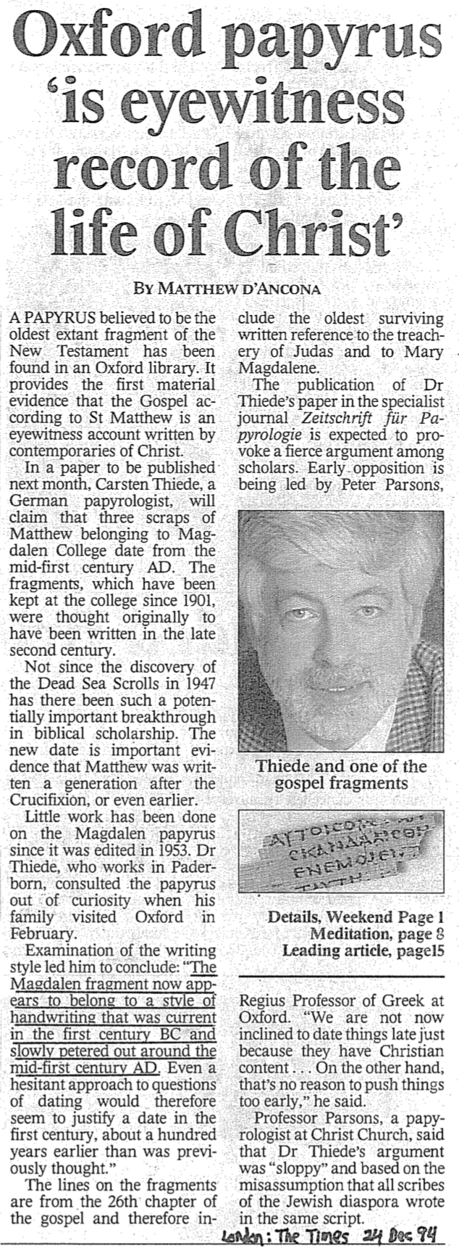
Internal Indicator:
Matthew wrote to Jews
Jews were the first to need a gospel since the church was entirely Jewish from AD 33-48. Jewish believers needed a gospel far more in the 40s and 50s than they did later when fewer Jews responded to the gospel message.

For a rebuttal to Thiede at the right, see:
Peter M. Head, “The Date of the Magdalen Papyrus of Matthew (P. Magd. Gr. 17 = P64): A Response to C.P. Thiede[1]”

Published in Tyndale Bulletin 46 (1995):251-85
(reprinted here with minor alterations)
at http://www.tyndalehouse.com/staff/Head/P64TB.htm

Head holds an AD 200 date for the fragment.
What Kind of Kingdom Did Isaiah (and Matthew) Envision?

Christians often talk about Jesus being king. It is especially discussed that he was born king at Christmas. But this raises two important questions:

1. What kind of kingdom does Jesus bring as king? Many (especially amillennialists) say this is only a spiritual kingdom with no earthly or physical aspects, but others (especially premillennialists) note many dimensions of the kingdom: spiritual, physical, political, etc.

2. What kind of kingdom did both John (Matt. 3:2) and Jesus (Matt. 4:17) mean when they preached, "Repent, for the kingdom of heaven is near"? Like the OT prophets, they said that Jews needed to turn from sin to enter the kingdom (Deut. 30:1-2). Had the nation repented, then this fulfilment would have occurred (Deut. 30:3-10). One should assume that this kingdom was the same kingdom that the OT prophets preached. Otherwise, Jesus and John would have misled the people.

Since Israel rejected this kingdom, Christ will not rule over it until the nation believes (see verses below in the “Spiritual” section). So after Israel finally believes in the future and Christ returns to establish his kingdom on earth (Rev. 19), what will this new period look like? Revelation 20:1-6 reveals the length of this era as 1000 years when saints will rule (cf. Rev. 5:10), and Satan will be bound from deceiving the nations (cf. Rev. 20:1-3). However, Isaiah provides the best overall picture of what the kingdom will be like, with more information than any other book in Scripture. This is the correct background one should know to understand Matthew’s concept of the kingdom.

I. Political

A. Jerusalem
1. Capital of the earth (2:2b)
2. A safe refuge for people (14:32; 25:4; 26:1-4; 32:18; 33:20-24; 35:9; 60:18; 62:8-9; 66:12)
3. City of glory without unbelievers (33:24b; 35:8-10; 52:1-3, 6)
4. Accessible (11:15-16; 33:21; 35:8; 60:15)

B. Israel’s Political Blessings
1. Enemies judged by Messiah (2:12-21; 24:21-23; 29:20-21; 45:14; 61:2; 66:24)
2. Exalted above the Gentiles (2:3; 14:1-2; 18:7; 49:22-23; 60:5, 14-17; 61:5-9; 62:1-4)
3. Serves as a nation of witnesses for God (44:8, 21)

C. Messiah’s Rule
1. His Second Advent precedes the kingdom (60:2; 61:11)
2. Extent of his rule
a. Rules on David’s throne as Davidic covenant fulfilled (4:2; 9:6-7; 16:5a)
b. Rules as King over the world (9:6-7; 11:3-5; 16:5; 24:21-23; 40:10)
c. Rules as King from Jerusalem (2:3; 24:23b; 33:17-22)
3. Nature of his rule
a. Rules gloriously (4:2; 24:23; 35:2; 40:5; 60:1, 2)
b. Rules wisely (11:2)
c. Rules meekly (42:3)
d. Rules righteously (32:1)
e. Rules nations with justice (9:7; 11:5; 16:5b; 32:1; 42:1, 4)
f. Rule unquestioned (11:4; 25:1-5; 29:17-21; 30:30-33; 42:13; 49:24-26; 66:14-19)
g. Rule in kingdom merges with eternal state (9:7; 33:20)

D. Other Rulers
1. Elders or rulers serve with Messiah in Jerusalem (24:23b; 32:1)
2. Judges serving as counselors (1:26)
3. Positions of responsibility given as rewards (40:10)

E. Worldwide peace rather than war (2:4; 9:4-7; 32:17-18; 55:12; 54:13; 60:18)
II. Physical

A. Earth and heavens renewed (65:17; 66:22)
1. Sun and moon
a. Light from both diminished in the Tribulation (13:10)
b. Sun still rises (41:25; 45:6; 59:19)
c. Moonshine equals the sun, which itself is seven times brighter (30:26)
d. Yet the sun and moon are less intense and not harmful (24:23a; 49:10)
e. Both sun and moon are finally eradicated in the eternal state (60:19-20)
2. Land of Israel
a. Borders enlarged (26:15; 33:17; 54:2-3; 61:7)
b. Land rebuilt after destruction (32:16-18; 49:8, 19; 61:4-5)
c. Much rainfall and water in the desert (30:23-25; 35:1-2, 6-7; 41:17-18; 49:10b)
d. Broad rivers flowing from the temple (33:20-21)
e. Animals blessed with much food (30:23)
f. Crops abundant (27:6; 35:1-2, 6-7) with the Genesis 3:17-19; Romans 8:19-22 curse on the earth removed (11:6-9; 35:9; 65:25)
g. Verdant trees replace thorn bushes and briers (55:13)
h. Mountain trees in previous desert wastelands (41:19)
i. Israel beautified and prosperous from the wealth of many nations (60:5; 61:6; 62:3; 66:10-12)
j. Glorified (60:1-9)
3. Jerusalem
a. Topographical changes with temple mount at the city’s high point (2:2)
b. Cloud of smoke and pillar of fire protects Jerusalem (4:5-6)
c. Temple mount holy (11:9; 27:13; 56:7; 57:13; 65:25; 66:20)

B. Humans living in unique circumstances
1. Some Israelites living in glorified bodies after tribulation (26:19-20)
2. Babies still born to those in mortal bodies (44:3; 61:9; 65:20, 23)
3. Longevity of life where immaturity is rare but death still exists (65:20)
4. Food for people plentiful (30:23; 62:8-9; 65:21-22)
5. Protection from harm with wild animals tamed (11:6-9; 35:9; 41:8-14; 65:25)
6. Work exists but is always protective (62:8-9; 65:21-23)
7. Blind, deaf, lame, and mute all healed (29:17-19; 35:5-6)
8. Illness in Jerusalem eradicated (33:24; 65:23)
9. Death eventually destroyed in Jerusalem (25:7)

III. Emotional

A. Strength replaces fear (35:3-4; 41:10, 13-14)
B. Joy and gladness replace weeping, sorrow, and sighing (9:1-4; 12:3, 6; 25:8-9; 30:29; 35:10; 42:10-11; 45:25; 52:8-9; 55:12; 60:15; 61:3, 7; 65:18-19; 66:10-11, 14)
C. Israel’s sentiment
1. The name “Israel” is replaced with the new names Hephzibah (Heb. “my delight is in her”) and Beulah (Heb. “married”; 62:2)
2. Israel no longer feels shame (25:8; 29:22)
3. Israel, the praise of the earth (43:4; 62:7, 10) due to unique “marriage” to the LORD (54:1, 4-7; 62:5 NIV margin)
4. Israel singing (14:7; 30:29; 42:10-11; 52:9)

IV. Intellectual
A. Knowledge fills the earth based on the fear of the Lord (2:3; 11:9; 33:6)
B. Knowledge of God’s work seen in mountain trees flourishing in the desert (41:19)
C People taught by the Lord himself (49:10; 54:13)
D. Teachers succeed in providing direction (30:20-21)
E. People listen, understand, and articulate God’s values (32:3-4)
V. Spiritual

A. Satan bound (14:15)

B. Gentiles (Church)
1. Converted (16:5; 18:7; 49:6; 55:5; 60:3)
2. Disciplined for sin (19:19-22)

C. Jerusalem
1. Righteousness and holiness in the city (1:26-27; 4:3-4; 11:4-5; 35:8-9; 42:1-4; 52:1; 60:21; 61:3b) and desert (32:16)
2. Justice in the city (29:18-24; 65:21-23) and desert (32:16)

D. Israel’s spiritual restoration
1. Israel cleansed by God’s judgment before the kingdom (1:25; 4:2-4; 29:1-4; 30:26b; 31:6-7)
2. Israel reunited and regathered to the land (11:10-13, 15-16; 43:1, 5; 49:6; 61:4; 65:8-9)
3. Israel victorious over enemies (2:12-21; 11:14; 24:21-23; 41:11-14; 45:14; 61:2; 66:14b)
4. Israel free from oppression (14:3-6; 42:6-7; 49:8-9)
5. Israel believing in Messiah (2:5; 10:20-22; 25:8-9; 26:2; 29:23; 40:9; 45:17, 25; 52:3, 6-7, 9-11; 54:7-10; 62:12)
6. Israel forgiven, redeemed and righteous (1:25-27; 2:3; 4:3-4; 33:24; 44:22-24; 45:25; 48:17; 63:16)
7. Israel is blessed and rewarded by Christ (19:25; 40:10; 62:11; 61:8)
8. Israel comforted by Christ (12:1-2; 40:1-2, 11; 49:12; 51:3; 65:18-19; 66:11-13)
9. Israel is filled/empowered by the Holy Spirit as never before (32:15; 44:3; 59:21)
10. Israel’s covenants fulfilled (42:6; 49:8; 54:10; 61:8)
a. Abrahamic (19:25; 41:8-10)
b. Davidic (9:7; 11:1-2; 55:3)
c. Palestinian (11:11-16; 65:9)
d. New (32:15; 44:3; 49:6; 59:21; 66:22)

E. Millennial worship
1. Israel worshipping the true God (12:1-6; 25:9–26:19; 56:7)
2. Jerusalem as the capital of nations’ (Gentile) worship (2:2-4; 11:12; 27:13; 30:29; 44:22-24)
3. The whole earth knows God–at least initially (11:9b)
4. Temple worship (56:5)
5. Priests and Levites serving the Lord (61:6; 66:21)
6. Animal sacrifices (56:7; 66:20-23)
7. Monthly New Moon celebrations (66:23)
8. Reinstitution of the Sabbath (56:4; 66:23)

F. Millennium absorbed into eternity
1. Kingdom age ends, though salvation does not (51:6, 8)
2. Prosperity forever as a sign of God’s blessing (55:13)
3. Temple eunuchs blessed forever (56:5)
4. Both the sun and moon are finally eradicated in the eternal state (60:19-20)
5. Divine covenant continues on to be fulfilled in eternity (55:3; 61:8)

Concluding Applications

- Since we will rule the world, we better start showing discernment now (1 Cor. 6:1-3)
- Since this world must last 1000 more years (Rev. 20:1-6), take good care of it.
- Work for Christ now before the 1000-year Sabbath comes with its restful service (Heb. 4:9-11).
The Kingdom Diagrammed
Spiritual
Kingdom
(saved
people)
Living
Beings
Universal Kingdom
(everything inside and outside the circle)

All People
(saved and unsaved all in the box)

Theocratic Kingdom
(OT Saints under law via Israel)
Saints prior to Moses
Unsaved Before Christ

Kingdom of Darkness
(shaded area of all ages with Unsaved People and Demons)

Church
Present Unbelievers

Angels

Millennial Believers
Millennial Unbelievers

Second Death (Hell)
Eternal
Life (Heaven)

Mystery Form of the Kingdom
Millennial
Kingdom

Kingdom Aspect | Description | Scripture
Universal Kingdom | All creation of every age | Ps. 145:13; 1 Chron. 29:12
Spiritual Kingdom | All saved of every age (white above) | Heb. 12:22-24; Col. 1:13b
Kingdom of Darkness | All unsaved of every age (dark above) | Col. 1:13a
Unsaved Before Christ | Unbelievers prior to Christ’s death | Gal. 3:21-22
Saints Before Moses | Those with faith in God (e.g., Noah) | Gen. 6:9; 15:6 (Abraham)
Theocratic Kingdom | God’s rule over Israel as mediators | Exod. 19:6
Mystery Form | Present saved & unsaved | Matt. 13:24-30, 47-50
Church | Saved between Pentecost & Rapture | Matt. 13:38
Present Unbelievers | Unbelievers in Church Age | 2 Cor. 2:15
Millennium | All people of Millennium | Isa. 65:20
Millennial Unbelievers | Unsaved of Millennium | Rev. 20:7-10
Millennial Believers | Saved of the Millennium | Zech. 8:23
Second Death | Unbelievers in Hell | Rev. 20:14
Eternal Kingdom | Spiritual Kingdom in new creation | Dan. 2:44; Rev. 21–22

The Davidic Covenant

Background

A. Most Christians today can’t understand the idea of Christ being king. This may be due to little Bible teaching on the subject and the decline of monarchies worldwide.

B. But the kingdom of God is actually the key theme of the Bible—starting in Genesis 1 itself. Here God showed himself as king over his newly created universe, and he also placed humans on earth to rule with him over creation (Gen. 1:26-27).

C. After man sinned (Gen. 3) and relinquished his rule (at least partially) over to Satan (2 Cor. 4:4), God gave a three-part promise to Abraham (2000 BC)—to give him and his descendants their own land, to make them a great and blessed nation, and to make the children of Abraham the source of divine blessing to the whole earth (Gen. 12:1-3).

- Around 1000 BC, God promised David wonderful things to fulfil his covenant with Abraham (2 Sam. 7). Here God enlarged and confirmed the seed promises to Abraham.

God’s Promises to David

A. The David Covenant essentially promises an eternal throne to David. The Messiah, the Eternal King, will reign on David's throne "forever." The key text is 2 Samuel 7:12-16. What can you learn here about God’s promise to David? List these things below:

B. All kings who would rule Israel must come from David’s line. Beginning with David's son Solomon, the kings of David's family did indeed rule, yet most were spiritual and moral failures disciplined by God (2 Sam. 7:14; cf. Ps. 89:29-37). But God still promised that the ultimate son of David, the Anointed One or Messiah, would someday bring worldwide peace from his throne in Jerusalem (Isa. 2:3; 9:6-7).

C. The foundation for messianic theology lies in the hope that one day, a Davidic king will meet the conditions and restore the full Davidic covenant (Jer. 33:14-22). Jesus Christ, the ideal Davidic king, will fulfil the Davidic covenant with a truly eternal kingdom. Christ came to build the spiritual temple in the hearts of all who believe in him (Eph. 2:19-22). At his Second Coming, he will rule from David’s throne (Matt. 19:28).

D. The Davidic Covenant comes as part of a sequence of covenants in the Old Testament. These covenants—with Adam, Noah, Abraham, Moses, David, and Jeremiah—form the narrative structure of the Old Testament.

Do You Agree or Disagree?
To explore your own ideas on this subject, answer any questions below that you can.

Does the Church replace Israel as the people of God?

If the Church is the “new Israel,” how then does God view national Israel today?

If the Church is the “new Israel,” what will happen to God’s land promises to Israel?

If the Church is the “new Israel,” does Israel have any promises awaiting fulfilment?

Will the nation of Israel be re-established and restored under her Messiah?

Are all the promises in the covenants fulfilled, or do we still await their fulfilment?

Is the kingdom present or future?

Covenant and Dispensational Contrasts

Issues | Covenant Theology | Dispensationalism
David Throne | Christ is the fulfilment of the Davidic promise and is reigning at the right hand of God now (Acts 2:30-36; 13:32-37; Ps. 2) | Christ is seated at the right hand of God, but his Davidic rule will not begin until he sits down on a literal throne in a literal Jerusalem on a literal earth (Luke 1:31-33)
Church & Israel | The Church is the new Israel. All promises to Israel are realized in the church (Gal. 3:28-29; Eph 2:11) | The Church has not replaced Israel. Israel will always have a future (Jer. 23:5-8; 31:35-40)

What Does This Mean to You?

FOR FURTHER STUDY
Blaising, Craig A. Dispensationalism, Israel and the Church: The Search for Definition. Grand
Rapids: Zondervan, 1992.

Gibson, Jonathan. The Story of a Kingdom: A Simple Explanation of the Whole Bible. 2004.
http://www.sok.org.uk/docs/SOK_Study_Guide.pdf

Kaynor, Keith. When God Chooses: The Life of David. Illinois: Regular Baptist Press, 1989.

Keathley IV, Hampton. The Relationship of the Church to Israel.
http://bible.org/docs/theology/dispen/ct.htm

Pentecost, Dwight D. The Biblical Covenants and Eschatology.
http://www.biblefragrances.com/studies/covenants.html

Smith, Lee. The Genealogy of Jesus Christ. http://www.arlev.clara.net/genealog.htm

St. Paul Center for Biblical Theology. David’s Son, David’s Lord.
http://www.salvationhistory.com/online/advanced/class1_lesson6_1.cfm

All graphics and images on the Davidic Covenant presentation are taken from these websites:
http://www.christcenteredart.com/
http://religion-cults.com/gallery.htm
http://biblia.com/bible
http://thebiblerevival.com/clipart.htm
Christmas for the Unexpected
Based on Tony Maalouf, Arabs in the Shadow of Israel: The Unfolding of God’s Prophetic Plan for Ishmael’s Descendants
(Grand Rapids: Trade Paperback, Kregel, Dec 2003)

One of the most amazing things about the first Christmas was that the Jews, who supposedly were eagerly awaiting their Messiah, largely missed the event. Only a handful of Jewish shepherds had a glimpse of the Baby Jesus. Ironically, it was the Gentile magi who sought long and hard to give this baby the worship he deserved. But who were these magi?

Most believers think of these wise men as coming from Mesopotamia (Babylon, Assyria, or Persia). This makes sense since the magi came “from the east” (Matt. 2:1) and these nations were geographically northeast of Israel. Also, the Babylonians are known to be stargazers, and the star the magi saw was “in the east” (Matt. 2:2).

However, three lines of evidence that are not often considered may indicate that the magi were, in fact, Arabs from the Arabian Peninsula, southeast of Israel.

Their Location

Biblically speaking, the “east” was not Mesopotamia but the land just east of Israel. Job lived in Uz and was deemed “the greatest of the people of the east” (Job 1:3). Some sources place Uz in the northeast, near Syria, while others place the region southeast of Israel, in the land of the Edomites, near Arabia. Perhaps both are true, but the descendants of the son of Ishmael named Kedar (Gen. 25:13) became the Arabian tribe living south and southeast of Israel (Ezek. 27:21). Interestingly, these Arabs were called "people of the east" (Jer 49:28)!

In any event, magi from “the east” could not have come from Mesopotamia since Assyria, Babylonia, and Persia were always called lands of the north (Jer. 1:13-15; 6:22; 25:9).

Their Gifts

Gifts given by the magi (Matt. 2:11) all came from the Spice Trade route southeast of Israel. Isaiah wrote, "And all from Sheba will come, bearing gold and incense" (Isa. 60:6; cf. Ps. 72:10). Sheba was the land of present-day southern Saudi Arabia. Also, frankincense was produced only in southern Arabia, although it was sold throughout the Middle East. Further, the major source of gold in antiquity was not Mesopotamia but far south on the Arabian Peninsula in the land of Ophir that is present-day Yemen.



Their Role

One final indicator of Arab magi is the biblical pattern of threats against God's redeemer from the covenant community itself that finds deliverance by Arabia! Joseph was threatened by his own brothers but was then saved from death by the Ishmaelites of Arabia, who brought him to Egypt (Gen. 37:27-28; Acts 7:9-10). He went on to become a redeemer of the nation.

Also, God later called Moses as deliverer, and Pharaoh tried to kill him after his murder of an Egyptian (Exod. 2:5). But opposition from Israel's own elders also contributed to forcing Moses to seek refuge in Midian of Arabia (Exod. 2:13-15; 5:21; Acts 7:25-29). God, therefore, used this area of Arabia to preserve the very deliverer of the Exodus. Even in the future tribulation, Israel will find refuge in the desert (Rev. 12:14), presumably in Arabia.

In other words, Scripture often notes how God raised up Arabs for his own purposes—even to save the people of God from death by their own countrymen! Such are the wonderful ways of our mighty God.

Conclusion

Arabs seeking the Jewish Messiah should cause us to ponder the wonder of Christmas again. The Jewish community largely missed their Messiah born right in their midst—only six kilometres south of Jerusalem—a short walk reached by horseback in but a few minutes. Do we also fail to see that the unlikely people often respond most readily to Jesus at this time of year? Who is your unlikely Gentile that God wants you to direct to the Saviour this Christmas?

Christmas Reflections from a Wise Man
A First-Person Monologue for Christmas

Main Idea: Jews ignored Christ, but Gentiles worshipped Him. How about you?

Part 1: Follow Star

Salam! I was asked to share some of my own experiences about a very unique birth. As far as I can remember, the story begins one starry night when I lived in Babylon…

OXO  OOO | My work that night began as did any other. My colleagues and I at the observatory set about our task to discern movements of the heavenly bodies. Others before us had taught us how to predict the daily positions of the moon and sun—and they plotted the paths of the five planets one could see with the naked eye. And the 1000 plus stars we could see? They remained relatively stationary as they traversed the sky each night. Other magi before us had already plotted them into 12 configurations for each month of the year…

Then Sheshbazzar, my fellow astronomer, suddenly had a curious and wonderful look on his face. “Do you see it?” he said. “Do you see that star in the southwest coordinates? It’s not on our charts!”

I looked intently at where he had pointed. Sure enough, it was a star, at least it looked like a star, but it was so low and brighter than all the others. I noticed that it hung directly over the land of Israel. I asked, “Do we have anything in the library about a star at that location?”

“No, wait. The ancient Jewish scroll of Numbers quotes one of our own magi. Yes, one of our ancestors, Balaam, was a diviner who spoke of a star. Remember? He said:

‘A star will come out of Jacob;
a sceptre will rise out of Israel’ [Num. 24:17].”

Sheshbazzar looked at me with curiosity, “A star will rise in Israel? How odd! And why the sceptre?”

“Sceptres go with kings!” I replied excitedly. “But isn’t Israel under Herod’s jurisdiction? He’s ruled Israel for 33 years already. Why would the star appear now?”

“Ah!” my friend said. “A new king! Perhaps one has just been born! Maybe Herod just had a son!”

OOX  OOO | “No, that wouldn’t make sense,” I said, “The Jews are looking for a descendant of David to be their king to free them from Rome. Herod is not a Jew but a collaborator with Rome. It must be another king…”

(Stops) Then it dawned on me. A miraculous star points to a miraculous birth—not just any birth. This new king of the Jews, just born, must be from God, the one the Jews have expected all these centuries! Perhaps he is divine Himself, for what human has a miraculous star attest to his birth?

“Something wonderful has happened this night!” I declared finally. “We must go at once to Israel to see this Babe with our own eyes—and offer the worship he is due!”

Part 2: Trip & Jerusalem

OOX  OOO | We desired to leave soon but had to receive permission from the king, gather supplies and leave our work in the hands of reliable associates. Our entire entourage finally ready, we set out by “desert ship” toward the west, still seeing the star in the distance. You do know what a “desert ship” is, do you not? This we also called a camel.
I laugh when I see our journey depicted as three men trekking alone in the desert. Had we travelled in this manner, our gifts would have ended in the hands of bandits rather than the Christ! No, we were a large group traveling slowly near the rivers (not the desert) for over five months from Babylon to Israel—a long train of camels led by a donkey, for camels are much too stubborn to lead.

And some think us kings. I wish this had been the case! No, we were searching for the King!

OOO  OXO | At any rate, the star still shone before us as we arrived at the hill country of Judea, but then, for some reason it disappeared. “Where should we go?” I asked. “Surely the king of the Jews would be born in the capital city,” Beltezer replied. So at last we arrived at Jerusalem, bearing the dust of a thousand miles.

And what a stir we caused! We did not intend to make such commotion, but someone in our group disclosed our purpose—that we had come to worship the new king of the Jews.

We thought this was good news—so much so, we bore the heat of the day for months. But we soon saw that Herod had not fathered another son recently. In fact, he recently killed one of his ten wives and two sons. The saying began to be told that it was safer to be Herod’s pig than to be his son!

When Herod heard why we had come to Jerusalem, he called the entire Sanhedrin to question us. I understand that many of them thought they would all be executed on the spot, for when Herod got angry, heads flew. But when he asked where Christ was to be born, they had an answer from Micah’s prophecy. The Messiah would be born in Bethlehem. In fact, this was common knowledge among all the people—at least any who went to synagogue—which certainly did not include Herod.

We had not intended to have an audience with Herod, but that very afternoon, we were secretly ushered into his court for questioning. I must say, I was impressed and fearful at the same time. But he, too, was disturbed. In fact, Matthew notes that Herod was “troubled” or “shaken.”

XOO  OOO | So Herod interrogated us, trying to sound objective and compassionate. We were treated quite well. But he seemed for some reason to be very concerned about the exact time the star appeared, though he did not tell us why. We told him it had been many months, and then he surprised us by actually encouraging us to go to Bethlehem. He told us to return and tell him the exact location so he could worship the child as well.

I thought we might have a Roman escort to Bethlehem. After all, it was only about a two-hour walk from Jerusalem. But I suppose Herod feared that this would cause an even greater stir in the city, so we were allowed to go by ourselves. Even more surprising was that not one member of the Sanhedrin desired to go. I remember thinking, “Aren't any of these Jews interested in the birth of their king? After all, this is their king, not the king of us Gentiles! Will no one investigate this miraculous birth—the appearance for which Israel has waited for centuries? Could it be that Jews are so caught up with their daily routine that they exert no effort to seek the very God of the Universe near them?” This kind of news one should shout from the mountain!

Part 3: Bethlehem

XOO  OOO | It was late, but we decided to go to Bethlehem anyway. As we were wondering how we would find an infant in Bethlehem, suddenly one of my fellow scholars shouted, “There it is again!” I looked up, and sure enough, the star had reappeared. In fact, it led us not only to Bethlehem but directly to the house we sought.

Soon, a common-looking peasant woman invited us into her humble dwelling. With crude walls, woodworking tools, and sawdust everywhere, I almost felt it was improper for us to give our lavish gifts of gold, incense, and myrrh. But we did. We bowed and worshipped a young toddler without hesitation.

The young couple was honoured by our visit. They had few visitors—only the lowest strata of society, shepherds. To my surprise, they asked us to stay the night—but we declined and stayed at an inn.

That night, each of us had a dream—the same dream. God warned us not to return to Herod. I tell you, this was a relief! So we went back to Jericho through the back route and on to Babylon from there. Such a long journey for such a short visit! But all the way, we marvelled at the privilege of visiting the very God who had visited us. But what an irony! Those who lived closest to Bethlehem had missed this great privilege. Jews ignored Christ, but Gentiles worshipped Him. How about you? The Jews who should have worshipped the newborn King ignored Him, but Gentiles like me embraced him as God. Have you? (MI restated) They had no room in their hearts for Him—just as there was no room for him months earlier at the inn.

Jesus’ Infant Journeys, Baptism & Temptation

Bible Visual Resource Book, 183

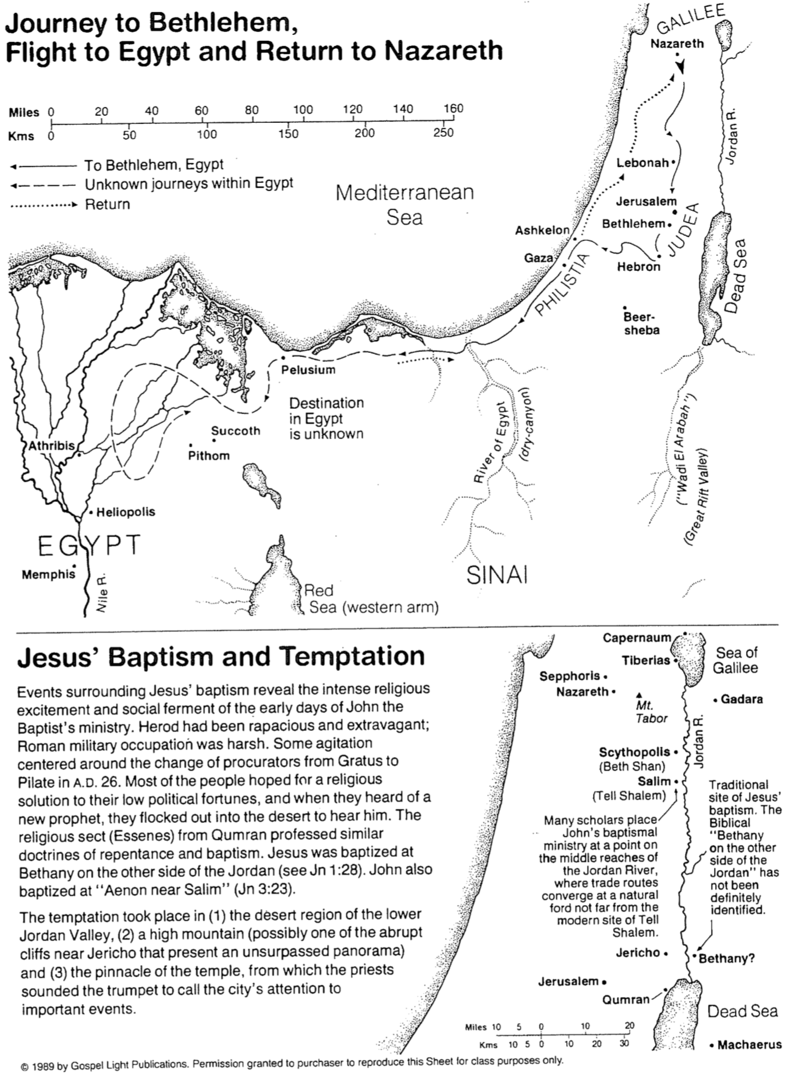

The Parables of Matthew 13
Adapted from Mark L. Bailey, Dallas Theological Seminary

Only after the Jewish leaders attributed Christ’s power to Satan (Matt. 12) did he begin to hide the truth from them in parables (13:3, 10-11). These parables in Matthew 13 show that, due to the nation’s rejection of the King, the kingdom would not come at that time in its political form. Why not? There was one unfulfilled requirement of the nation– repentance. The OT often noted that the nation must be a believing nation for the kingdom to begin (Deut. 30:1-10; Jer. 31:34; cf. John 3:3-5; Rom. 11:26-27). Thus, Jesus began to explain how the kingdom would first come in a form unforeseen (“mystery”) by the OT (i.e., spiritually before physically).

Parables by the Sea (outside the house to the multitudes)

1. The Soils (13:3-9, 18-23) Planting

Issue: Why have Israel and the leaders rejected the Messiah?

Main Idea: Productivity is determined by receptivity, which is a heart issue.

2. The Tares (13:24-30, 36-43) Planting

Issue: What accounts for the false religiosity in the world?

Main Idea: Satan’s counterfeit kingdom in the world will not be fully revealed until the judgment.

3. The Mustard Seed (13:31-32) Growth

Issue: Will this Interadvent kingdom survive?

Main Idea: Though starting small, the new program will grow to worldwide dimensions.

4. The Leavening Process (13:33) Growth

Issue: How will this new kingdom grow?

Main Idea: The kingdom will grow from an internal dynamic (Holy Spirit), not from external organisation (Judaism).

Parables in the House (inside the house to the disciples)

1. The Hidden Treasure (13:44) Value

Issue: How valuable should this newfound program of God be to us?

Main Idea: God’s kingdom is so valuable that a man should give up everything to be part of it.

2. The Pearl Merchant (13:45-46) Value

Issue: How valuable is this kingdom to Christ?

Main Idea: The kingdom was established through Christ’s total self-sacrifice.

3. The Dragnet (13:47-50) Responsibilities

Issue: How wide should the invitation to the kingdom be made?

Main Idea: Evangelism should be done without discrimination.

4. The Householder (13:52) Responsibilities

Issue: What are the responsibilities of disciples in the kingdom?

Main Idea: Edification/teaching should include both the old and the new truths about the kingdom program of God. (One key new truth is the church age composed of Jews and Gentiles without discrimination–a truth not taught in the OT; Eph. 3:3-6, 9 vs. Zech. 8:23.)

Why Parables?

Introduction

Why did Jesus speak in parables (Matt. 13:10)? Don’t teachers always want to be understood by their listeners (I do!)? When Jesus used parables, many people couldn’t understand them, but the following benefits resulted…

The Godly: Parables cause real believers to seek their sense (Matt. 13:11-12a).

Jesus said, “The secrets of the kingdom of heaven are given to you.”

By not teaching directly, Christ encourages those who really want to know his truth to ponder what he means.

The Rebellious: Parables hide truth from resistant unbelievers (Matt. 13:12b-15).

Christ’s highest teaching priority was not to be understood. It was to be believed!

Speaking plainly could have led to opposition from his enemies to the extent that they killed him prematurely.

Parables also hid the truth from listeners who had already decided to reject him. As such, they received less spiritual light and therefore less judgment for their rejection (Matt. 11:20-24).

The Seekers: Parables catch the attention of the apathetic to give them the truth.

Everyone loves a story. How much more so this is true of those with little education, which describes the majority of those listening to Jesus.

Jesus was a master teacher. He angered many with his words, but he never bored them!

Conclusion

We should follow the example of Jesus and be more concerned about the listeners' response to the message than about our need to be understood.

Jerusalem During the Ministry of Jesus
Bible Visual Resource Book, 191
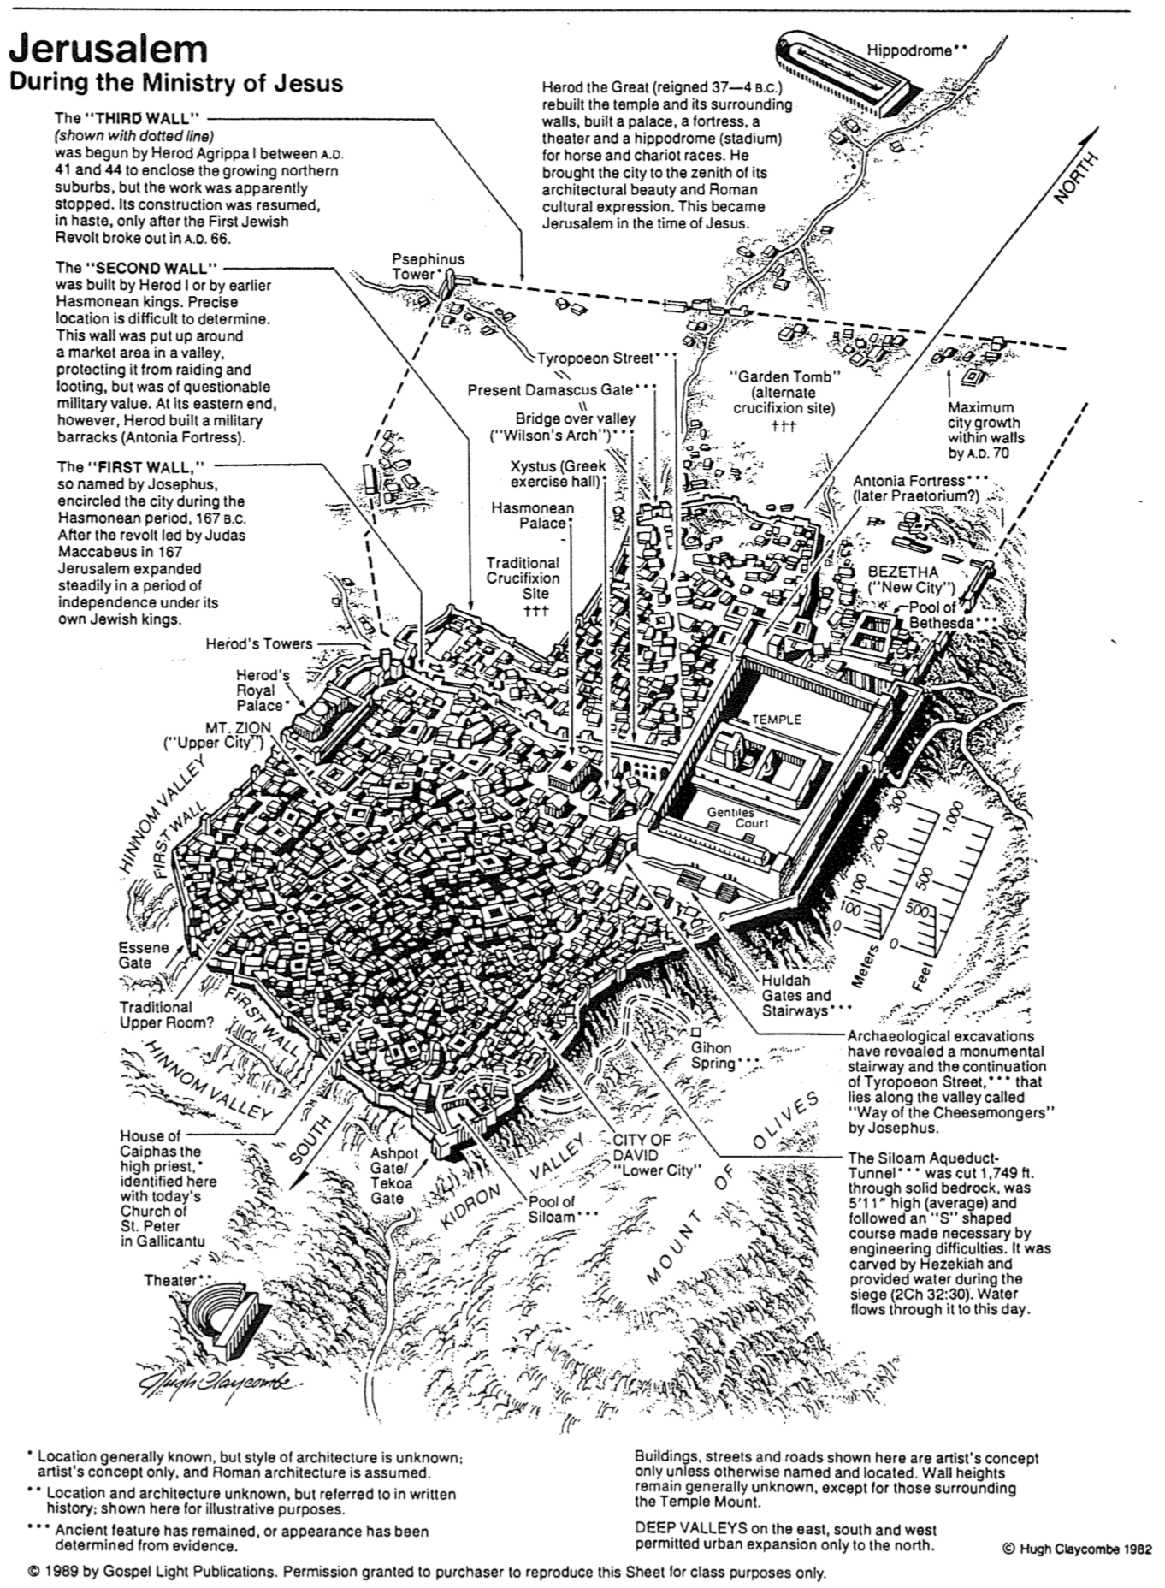
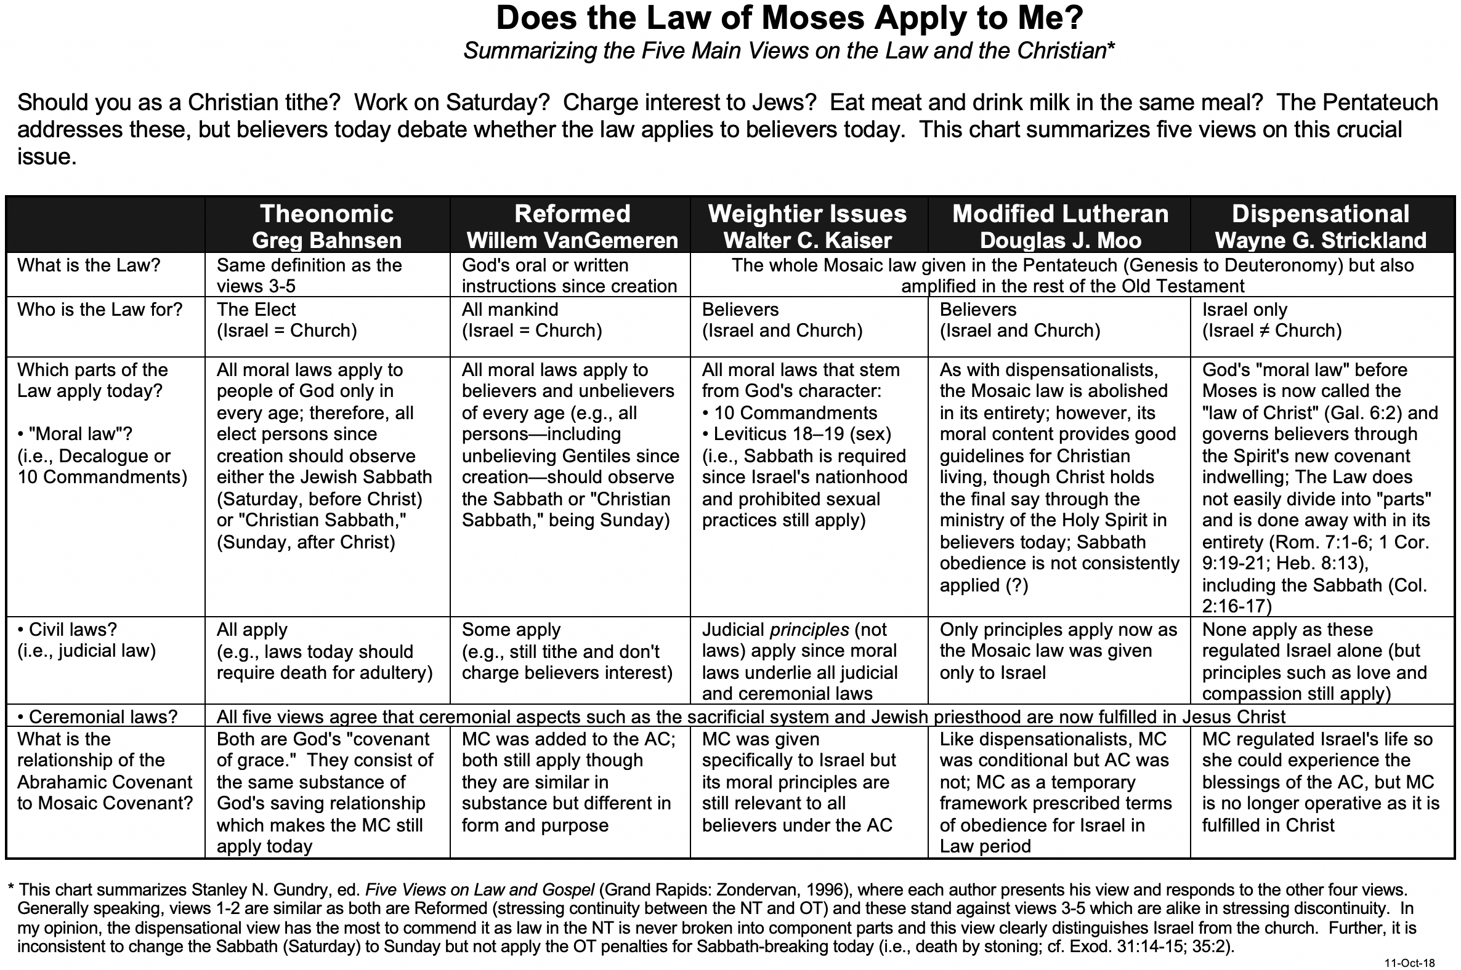
Does the Law of Moses Apply to Me?

Does the Law of Moses Apply to Me (2 of 2)?

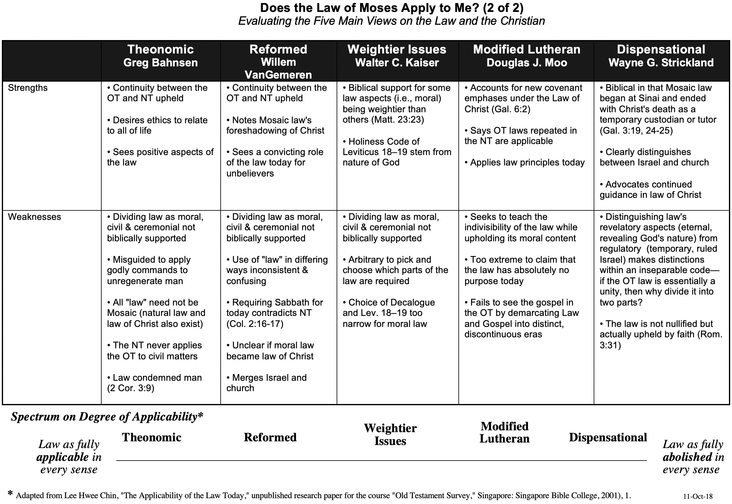
Should Christians Follow the Ten Commandments?
Adapted from my 1990 dissertation, “The Eschatological Significance of the Sabbath,” Dallas Seminary, 148-53

Despite the widespread belief that the Law is presently valid for believers, the New Testament treats the entire Law as abrogated. This is a major tenet of the Book of Galatians, written in response to the error of supposing that some of the law was still in effect. Paul's readers were falsely led into believing that most of the law was abrogated (e.g., the sacrificial system, dietary laws, etc.), but specific laws remained, particularly circumcision. Paul forcefully took issue with such teaching:
Mark my words! I, Paul, tell you that if you let yourselves be circumcised, Christ will be of no value to you at all. Again, I declare to every man who lets himself be circumcised that he is obligated to obey the whole law (Gal. 5:2-3).

The issue to be emphasized here is Paul's view of the law as a whole. His point is that if one must keep any part of it, he must keep all of it. Conversely stated, if the believer is free from the law, he is free from all of it. This applies whether the part referred to is circumcision, the Sabbath, or any other part.

The Pauline epistles uphold the abolition of the entire law, not only part of it. Paul affirmed emphatically that believers are dead to the law (Rom. 7:1-6) and not under its rule (Rom. 6:14; Gal. 3:19, 23-29; 4:25, 31; 5:18). This is because Christ is the fulfillment (cf. Matt. 5:17-18) and termination or end of the law (Rom. 10:4) since His death abolished the law (Eph. 2:15). Further, Paul taught that the Mosaic Covenant had passed away (2 Cor. 3:6-11) and that the Abrahamic Covenant both preceded and followed the period of the law since the law served only temporarily (Gal. 3:14-25). The result is that "now that faith has come, we are no longer under the supervision of the law" (Gal. 3:25). Also, "the fact that God has (manifestly) accepted Gentiles as sons demonstrates that the period of the law is at an end; the custodian has finished his task, and the son has become an heir (4:1-6)." Finally, in 1 Corinthians 9:20, Paul very clearly declares himself free from the law:
To the Jews, I became like a Jew to win the Jews. To those under the law, I became like one under the law (though I myself am not under the law) to win those under the law.

Paul could not have stated more clearly that he was not under the law. He makes the same claim for his Roman readers: "You are not under the law but under grace" (Rom. 6:14). The preceding verses represent only a select group of passages indicating that the law has been abolished and thus has no jurisdiction over the believer. Indeed, when comparing the Mosaic dispensation with "the dispensation in Christ, Paul found the former, glorious as it had been, to be worthless."
Paul and the Decalogue
While many cite the passages above to show the end of the law, the most pertinent to the present study are two texts that explicitly point to the end of the Ten Commandments in the present age. The first text is Romans 7. Here, Paul emphatically states that the believer has died to the law by being joined to Christ (v. 4) with the result that he is released from the law (v. 6). His following illustration specifies this "law" as the Decalogue refers to the tenth commandment which prohibits coveting (vv. 7f.). The purpose of this prohibition was to reveal Israel's inability to obey the law of God. Specifically, Paul claims freedom from the law because it has already fulfilled its purpose in exposing sin. Further, since the Decalogue is an essential unity, the abolition of one of its commandments (coveting) shows the abolition of them all. In other words, since his illustration indicates that believers are free from one of the Ten Commandments and the Decalogue is a unity, it follows that believers are also free from all the commandments, including the Sabbath.

Second Corinthians 3 is a second passage that even more clearly shows the believer's freedom from the Ten Commandments. In this chapter, Paul contrasts his apostolic authority as a minister of the New Covenant with that of his opponents at Corinth who, by implication, were ministers of the Old Covenant (cf. 2:17; 3:14). One reason the New Covenant is more glorious than the Old is because this New Covenant is internal, written on men's hearts through the Person or activity of the Spirit (3:3b). Conversely, the Old Covenant was engraved upon tablets of stone (3:3, 7). The crucial issue here is what was written on stone in the Old Testament. Was it the entire law? No, only the Ten Commandments were engraved upon the tablets at Sinai (Deut. 4:13; 5:22). In other words, Paul equates the Old Covenant with the Decalogue. This law had a fading glory (i.e., lacked permanent validity) "because only in Christ is it taken away" (v. 14b). Therefore, since Paul contrasts his continuing ministry of blessing with the ministry of cursing in the Ten Commandments, he in effect teaches the abolishment of the Decalogue as a system by which one should live, including the Sabbath. That the Sabbath is included within this abolished Decalogue also is supported in that the New Testament never enforces the death penalty for disobeying the Ten Commandments. It is inconsistent to argue for the continuance of the Sabbath requirement in the present age without a continued penalty for neglecting it.
Fulfilling the Law (Matt. 5:17-18)

The preceding four pages in these notes explain the end of the Law at the death of Jesus. However, some problem texts seem to indicate the continuity of the law and the Ten Commandments. The most quoted verses in this respect are Christ's words in Matthew 5:17-18:
Do not think that I have come to abolish the Law and the Prophets; I have not come to abolish them but to fulfill them. I tell you the truth, until heaven and earth disappear, not the smallest letter, not the least stroke of a pen, will by any means disappear from the Law until everything is accomplished.

At first glance, it appears that Jesus said the law would be in effect until the new heavens and the new earth. Equally tricky is Paul's statement in Romans 3:31 that faith does not nullify the law, but rather, one should "uphold the law." This law is deemed later in Romans as "holy, righteous, and good" (7:12). Similarly, Paul expresses a positive attitude towards law-keeping in Galatians 1:14 and Philippians 3:4-6.

A closer look indicates that the above passages can be reconciled with the many texts that reveal the abolishment of the law in the present age. First, the proper interpretation of what Jesus meant in Matthew 5:17-18 must be addressed. Because Jesus seems to have abrogated the entire law by His abrogation of the laws of clean and unclean (Mark 7:19), one could rightly wonder how He came not to abolish the law. Some suppose that He abolished only the ceremonial and civil law while confirming the moral law, but this fails to account for the continuance of the all-inclusive "not the smallest letter, not the least stroke of a pen" (v. 18; NASB).

The proper interpretation of Jesus' statement lies in considering precisely what Jesus said would not be abolished. He did not refer to the Law (Mosaic Code); He said He came not to abolish the "Law or the Prophets." The formula "the Law and/or the Prophets" refers not to a moral, ceremonial, or civil code but to a standard designation by the Jews of Jesus' day for the Old Testament canon as a whole. Therefore, in this saying, Christ claimed that He did not come to abolish the Old Testament as canon. Paul agreed that in the new dispensation the Old Testament would continue to be relevant for teaching, rebuking, correcting and training in righteousness (2 Tim. 3:16); therefore, the time in which Israel was related to God by the Torah would cease with John (Matt. 11:13). Rather than setting aside the Scripture as His opponents accused, Christ came to carry it out in complete obedience; the Old Testament pointed to Him as the One who would completely fulfill God's commands. Therefore, the issue here is not how long the law would remain in effect as the guiding covenant for Israel. Instead, the issue is whether the Old Testament would remain authoritative as part of the canon. With this interpretation in mind, Jesus' claim here is entirely consistent with the abrogation of the law taught in the rest of the New Testament.
Chiastic Structure in Matthew
Adapted from Gary W. Dereksen, “Matthew’s Chiastic Structure and Its Dispensational Implications,”
Bibliotheca Sacra 163 (Oct-Dec 2006): 423-37 (esp. p. 426)

Another way to see Matthew’s arrangement of material is to see him repeating earlier elements of his gospel in reverse order (called a “chiasm,” after the Greek letter that looks like our letter “X”). Thus, the first section A below parallels the last section called A’ (A prime), and likewise, B matches B’ in the second section and the second-to-last sections. Why this structure? This makes the central element (F) the focal point of the gospel: to highlight how Israel’s rejection of the kingdom has delayed the nation's earthly kingdom until later, when Jews repent. This chiastic structure was a common literary tool in biblical times to convey the central teaching of a work.

A. Demonstration of Jesus’ Qualifications as King (1–4)

B. Sermon on the Mount: Who Can Enter His Kingdom (5–7)

C. Miracles and Instruction (8–9)

D. Teaching the 12: Authority/Message for Israel (10)
Key Truth
E. Opposition: Israel Rejects King (11–12)

F. Parables of the Kingdom: Kingdom Postponed (13)

E.’ Opposition: Israel Rejects King (14–17)

D.’ Teaching the 12: Authority/Message for Church (18)

C.’ Miracles and Instruction (19–23)

B.’ Olivet Discourse: When the Kingdom Will Come (24–25)

A.’ Demonstration of Jesus’ Qualifications as King (26–28)

Judging versus Discerning

Jesus commands, “Do not judge others so that you will not be judged” (Matt. 7:1 NAU). However, Paul commands, “It isn’t my responsibility to judge outsiders, but it certainly is your responsibility to judge those inside the church who are sinning. God will judge those on the outside; but as the Scriptures say, ‘You must remove the evil person from among you’” (1 Cor. 5:12-13). How can we reconcile these seemingly incompatible commands?

Definitions

“Judging” is used in these two passages in two different ways. In the first text, Christ refers to acting negatively.

However, the judgment Paul commanded of the Corinthians is a positive action. One might even call this type of judging a use of “discernment.”

Contrasts between Making a Judgment and Showing Discernment

Issues | Judging | Discerning
Scripture | Matt. 7:1; Isa. 11:3b | 1 Cor. 5:12-13; Isa. 11:3a
Context | Takes things out of context | Sees an issue in context
Research | Does not do the hard research | Checks out the facts
Perspective | Negative: knows only the problem | Positive: knows what needs to change
Prayer | Prays rarely or wrongly about it | Prays for God to be glorified
Hypocrisy | Has little self-evaluation (Matt. 7:3-5) | Extends grace (Gal. 6:1b)
Shows | Concern only for self | Cares for others
Style | Critical spirit | Constructive spirit
Motivation | Prideful exaltation of self | Humbly exalts God (Rom. 12:3)
Source | Empowered by self | Empowered by the Spirit
Standard | Oneself or others strong in that area | God’s perspective or God’s Word
Emotions | Reactive | Evaluative
Objects | Judging unbelievers is improper  (1 Cor. 5:12a, 13a) | Judging believers (positively) is mandated (1 Cor. 5:12b, 13b)
Procedure | Talks publicly to others about the problem person | Talks privately to the problem person (Matt. 18:15)

Application

Think of the last questionable comment you made about someone else. Now circle or tick either the second or the third column above on each line to see if you were judging or discerning that person. What does God want you to do about this now?
Was the Kingdom Delayed?

Introduction

Scholars agree that Matthew wrote to prove Jesus is Israel’s Messiah, but the agreement ends here. We still must determine the nature of his kingdom, the timing of his rule, Israel's identity, and God’s response to Israel’s rejection of Christ as King—including whether God postponed or delayed the arrival of Israel’s kingdom.

Do You Agree or Disagree?
To explore your own ideas on this vital subject, please circle A, U, or D beside each statement below to show whether you Agree, are Unsure, or Disagree with the teaching.

Christ’s kingdom will have the same political nature as that promised by Isaiah A U D

Christ is ruling on the throne of David right now A U D

Matthew’s reference to “Israel” today designates all Christians A U D

God rejected Israel, so the nation has no prophetic future remaining A U D

God delayed the kingdom for ethnic Israel after the nation rejected Christ A U D

Contrasting the Major Views

Issues | Covenant View | Dispensational View
Nature of the Kingdom | Spiritual in the present age | Spiritual in the present age but also political after Christ returns
Time of Christ’s Rule | Present | Future (except progressives)
Israel | Believers (Jew & Gentile) identifying with Abraham’s faith | Ethnic descendants of Abraham through Isaac
Nature of God’s Rejection | Rejected ethnic Israel and replaced them with the church as the “new Israel” | Rejected ethnic Israel until the latter days when Jews will trust in Messiah
View on a kingdom postponement | Rejected by all covenant scholars since God no longer deals with ethnic Israel as an entity | Accepted by many dispensationalists but rejected by the progressive dispensationalists

Matthew’s Teaching

What kingdom was John talking about when he announced, “Repent of your sins and turn to God, for the Kingdom of Heaven is near” (Matt. 3:17 NLT)? Unless we have good reason to think otherwise, we should assume that John (and Jesus, 4:17) referred to the same kingdom that was lost in the OT times—a literal, political, geographical kingdom. This finds support in Matthew, where Jesus notes that the kingdom would be one in which “when the world is made new, and the Son of Man sits upon his glorious throne, you who have been my followers will also sit on twelve thrones, judging the twelve tribes of Israel” (19:28). See also pages 78b-d.

Note also that in Matt. 19:28 Christ saw this kingdom as future over which he would reign (see also pages 78f-g). While grammatically, “the Kingdom of Heaven is near” (Matt. 3:17) could also be rendered as “has come” (= is present now) or “is coming soon,” Matthew is clear that there was a conditional element here—to repent. This is consistent with numerous OT prophecies that declare Israel’s repentance as a requisite for the kingdom to arrive (e.g., Zech. 12:10-14). Since Israel did not repent, Jesus is not presently ruling over the nation from Jerusalem to fulfill Isaiah 2:4.

As to the nature of “Israel” and God’s rejection of the nation noted above, nothing in Matthew or the NT indicates that the identity of the nation ever changed to refer instead to the church. The term still refers today to ethnic descendants of Jacob (see pages 131-132 in the Romans notes).

But was the kingdom delayed? And what does this mean anyway? To say that the kingdom was postponed does not mean that God changed his mind as if he is fickle any more than God “changed his mind” not to destroy Nineveh. It simply means that the kingdom in its fullness did not arrive since Israel did not repent. Matthew’s gospel teaches the postponement of the kingdom in various ways:

The nation is encouraged to repent only until the climactic rejection of Christ in Matthew 12, when Israel’s leaders attribute his healing power to Satan. After this point, Jesus begins to speak in parables to introduce the present age between his two comings, which was not previously revealed in the OT.

In the parable of the landowner (Matt. 21:33-46), the vineyard that was spurned ends up being given to others, but it is the same vineyard—not something else (21:41). Thus, the same kingdom promised to Israel by God will be given to this “nation that will produce the proper fruit” (21:43), referring to the believing Israel of the last days.

A Problem and Response

But what about Matthew 21:43, where Jesus declared after the Jewish leaders rejected him, “I tell you, the Kingdom of God will be taken away from you and given to a nation that will produce the proper fruit”? Isn’t this “nation” the church?

This might seem plausible in light of Gentiles being called a nation (Rom. 10:19; 1 Pet. 2:9-10), but the use of the singular need not refer to the church. Instead, “Jesus was using the term ‘nation’ in the sense of generation (cf. Matt. 23:36),” so it more likely refers to a future nation of Israel that repents (cf. Matt. 21:18-22; Rom. 11:26-27).

Conclusion

The rejection of the Messiah by Israel forfeited that generation from experiencing the blessings of the kingdom. However, there remains a future nation in which all of Israel will be saved (Rom. 11:26-27) so that they can experience God’s promise of the kingdom. As noted many times in the OT (e.g., Isa. 65–66), Gentiles will also join that kingdom as well.

F. Parables of Kingdom: Kingdom Postponed (13)
E.’ Opposition: Israel Rejects King (14-17)
D.’ Teaching the 12: Authority/Message for Church (18)
C.’ Miracles and Instruction (19-23)
B.’ Olivet Discourse: When the Kingdom Will Come (24-25)
A.’ Demonstration of Jesus’ Qualifications as King (26-28)

Matthew 24–25 (The Olivet Discourse)

Although the Olivet Discourse is mentioned in Mark 13 and Luke 19, as well as in Matthew's gospel, the following outline follows Matthew's, as his account is the most complete of the three. The entire discourse relates to Israel as the church is not in view.

24:1-3 Questions: The disciples praise the magnificent temple built by Herod, but Christ prophesies of its soon destruction. They ask two questions: when will the temple be destroyed, and what will be the sign of Christ's return (ushering in the Millennium).

24:4–25:46 Answers: In Luke's account, Jesus answers the first question by prophesying the destruction of the temple by Titus in AD 70. Matthew records only Jesus' answer to the second question about Israel's future time period, prophesied as Daniel's 70th week.

24:4-26 Tribulation: Persecution and judgment will befall Israel.

24:4-8 First half: The beginning will have wars, rumors of wars, earthquakes, false Christs, etc. (cf. Rev. 6). However, this only begins the “birth pangs.”

24:9-14 Second half: As the judgments intensify the nation will wonder when the Messiah will return. Several will declare that he has come in certain places, but they will all be false.

24:15-26 Climactic sign: The rise of Antichrist, who will desecrate the temple and demand worship after breaking his covenant with Israel, is the ultimate sign of the Tribulation.

24:27-30 Second advent: When Christ returns, there will be no question that he came (in contrast to the false christs). His coming is described as lightning in the sky. Also, “every eye will see Him” (Rev. 1:7).

24:31 Regathering of Israel: Angels will regather Jews (“elect”) worldwide to judge the nation and lead Israel into the Millennium.

24:32-51 Parenthetical exhortations:

24:32-44 Fig tree (watchfulness/preparedness): Using the figure of a fig tree, Christ declares that the nation should pay attention to the signs of the times as it does to the signs of the approaching harvest of figs. Otherwise, his coming will be so sudden that men and women will be taken away into judgment without warning.

24:45-51 Faithful servant (faithfulness): Jesus warns Israel to be prepared for his return through the illustration of two servants: the faithful servant who was ready for his master’s return and the unfaithful servant who lived irresponsibly.

25:1-30 Judgment of Israel: Israel will experience judgment at the close of the Tribulation Period.

25:31-46 Judgment of Gentiles: Using the figure of separating sheep from goats, Jesus notes that Gentiles will be judged based upon their response to persecuted Jews (“my brothers” and “the least of these”) to determine whether they enter the Millennium. Those who mistreat Israel will be unbelievers who will experience the judgment of the Gentiles.

See the next page summary of the article by Bruce A. Ware, “Is the Church in View in Matthew 24–25?” Bibliotheca Sacra 138 (April-June 1981): 158-72. (He says “no”–only Israel.)

Is the Church in View in Matthew 24–25?

Jesus addresses the disciples in Matthew 24–25, but are they representative of Israel or the church? In other words, does this chapter relate to Israel or the church? The following discussion of this question summarizes Bruce A. Ware, “Is the Church in View in Matthew 24–25?” Bibliotheca Sacra (April-June 1981):158-72. Ware’s article argues against Robert Gundry's The Church and the Tribulation, which claims that Matthew refers to the church.

a. Some “Jewish elements” here could possibly relate either to Jewish saints who trust in Christ during the tribulation or to the church in the tribulation. These “Jewish elements” include:

(1) Persecution (24:9) by Jewish synagogue leaders (Mark 13:9; Luke 21:12) does elsewhere refer to synagogue persecution of Christians (John 16:2); however, this would more likely refer to persecution of Jewish tribulation saints who leave the synagogue to trust in Christ as Messiah than it would to Gentiles in the church.

(2) The message of the “gospel of the kingdom” (24:14) is used only two other times in Scripture, both of which concern Jesus preaching to Jews (Matt. 4:23; 9:35). While this could refer to Christians preaching, this is not required.

(3) “Pray that your flight will not take place…on the Sabbath” (24:20) may refer either to Jews or Christians since in Israel neither can travel on the Sabbath due to rabbinic restrictions.

b. The above is inconclusive, but other conclusive reasons show Israel is in view (not the church):

(1) The context argues for Israel. Matthew had previously described Israel’s rejection of Christ as Messiah, which resulted in God's rejection of Israel (21:43). It makes sense to see this discourse as further revelation concerning God’s response to the nation that rejected him. In fact, the preceding chapter 23 shows how Christ spoke serious words to Israel’s leaders. This concluded with his lament over Jerusalem in verses 37-39, and even the temple itself is addressed in 24:2. All this places the immediate context within a Jewish framework.

(2) Up to this point in Matthew 24:1, the disciples had no instruction on the rapture of the church. Christ first mentioned this two days later, on the night before his death, in John 14:1-3. In fact, Christ had explicitly taught them only two things about the church before this time: that he would build his church (16:18) and the right approach for dealing with sin in the church (18:15-18). So what would be on their minds most would not be the rapture of the church, but what would happen to Israel after the destruction of the temple.

(3) The “abomination that causes desolation” (24:15) is strictly a Jewish element as it relates back to Daniel 9:27. Daniel’s prophecy relates to Israel and a seven-year covenant the Antichrist will make with the nation, but break at the halfway point.

(4) The “false prophets” who mislead many (24:11, 24; Mark 13:22) elsewhere designate Jewish false prophets (Matt. 7:15; Luke 6:26; Acts 13:6; 2 Pet. 2:1 contrasts Israel’s false prophets with the church’s false teachers). Only in 1 John 4:1 can it most likely refer to Gentile false prophets, though not exclusively. Also, the singular form is used of “the false prophet” who will assist the beast (Rev. 16:13; 19:20; 20:10). Thus, the plural usage almost always refers to Jewish false prophets.

(5) The “false Christs”(lit. “false Messiahs”) and those claiming to be “the Christ” (24:5, 23-24) must also relate to Israel. A Christian is in no danger of following a false Christ since he already follows the true one. In contrast, “Israel is in danger of following false Christs because she has not yet followed the true Christ” (Ware, 169). Unbelieving Gentiles do not look for the Messiah anyway.

Therefore, Matthew’s account of the tribulation refers to Israel and not to the church. This doesn’t prove that the Rapture will be pretribulational just because Christians are not mentioned here (arguments from silence are always weak), but the passage does support the pretrib position.
Prophecies Fulfilled by Christ

He would be born of a Virgin (Isaiah 7:14 and Matthew 1:18).
He would be of the tribe of Judah (Genesis 49:10 and Luke 3:23, 33).
He would be of King David’s seed (Jeremiah 23:5 and Luke 3:23, 31).
He would be born in Bethlehem (Micah 5:2 and Matthew 21:11).
He would be a prophet (Deuteronomy 18:18-19 and Matthew 21:11).
He would teach with parables (Psalms 78:2 and Matthew 13:34).
He would be preceded by a messenger (Isaiah 40:3, Malachi 3:1, and Matthew 3:1-2).
He would enter Jerusalem on a colt (Zechariah 9:9 and Luke 19:35-37).
He would be betrayed by a friend (Psalms 41:9 and Matthew 26:47-50).
He would be betrayed for 30 pieces of silver (Zechariah 11:12 and Matthew 26:15).
He would be forsaken by his disciples (Zechariah 13:7 and Mark 14:50).
Betrayal money tossed into the temple would buy a field (Zechariah 11:13 and Matthew 27:5-7).
He would be accused by false witnesses (Psalms 35:11 and Matthew 26:59-60).
He would be silent before his accusers (Isaiah 53:7 and Matthew 27:12-14).
He would be beaten by his enemies (Isaiah 50:6, 53:5, and Matthew 27:26).
He would be spat upon and beaten (Isaiah 50:6 and Matthew 27:30).
He would be struck in the head with a rod (Micah 5:1 and Matthew 27:30).
He would be mocked (Psalms 22:7-8 and Matthew 27:29, 31).
His hands and feet would be pierced (Psalms 22:16, Luke 23:33, and John 20:25)—note that this was predicted hundreds of years before crucifixion was invented.
Men would gamble for his clothing (Psalms 22:18 and John 19:23-24).
He would intercede in prayer for his transgressors (Isaiah 53:12 and Luke 23:34).
He would suffer thirst (Psalms 22:15 and John 19:28).
He would be offered gall and water (Psalms 69:21 and Matthew 27:34).
He would cry, "My God, My God, why hast thou forsaken me!" (Psalms 22:1 and Matthew 27:46).
He would be cut down in his prime (Psalms 89:45 and 102:23-24).
None of his bones would be broken (Exodus 12:46, Psalms 34:20, and John 19:32-33).
They would look upon him whom they had pierced (Zechariah 12:10 and John 19:34).
He would be executed with thieves (Isaiah 53:12 and Matthew 27:38).
He would be buried in a rich man's tomb (Isaiah 53:9 and Matthew 27:57-60).

2 Sam. 7:13, 16; 1 Kings 2: 4, 45; 9:5; 1 Chron. 22: 8-10; 28:4-7; 2 Chron. 7:17-18; Ps. 89:3-4, 27-29, 34-37; 132:11; Isa. 9:6-7; 11:1, 10; Jer. 22:29; 23:5-6; 30:9; 33:20-21; Ezek. 34:23-25; 37:24-28; 43:6-9; Dan. 3:5; Hos. 3:5; Amos 9:11-12; Mic. 5:2, 4; Zech. 3:8, 9; 6:12, 13; 9:10; 12:8; 13:1; Matt. 1:1-18; Luke 1:30-33. These verses and this handout are adapted from a 2005 SBC class presentation.
Much of the information in this study can be found in Tony Maalouf, Arabs in the Shadow of Israel: The Unfolding of God’s Prophetic Plan for Ishmael’s Descendants (Grand Rapids: Trade Paperback, Kregel, 2003).
An Edomite named Uz lived in Seir southeast of Israel near Arabia (Gen. 36:28; cf. 1 Chron. 1:42), and Jeremiah listed Uz with nations of the south (Jer. 25:20). Lamentations 4:21 is the clearest verse of all: “Rejoice and be glad, O Daughter of Edom, you who live in the land of Uz.” Carl G. Rasmussen supports Uz being east Edom in The NIV Atlas of the Bible (Grand Rapids: Zondervan, 1989), 255.
See 1 Kings 9:28; 10:11; 22:48; 1 Chron. 29:4; 2 Chron. 8:18; Job 22:24; 28:16; Ps. 45:9; Isa. 13:12.
Douglas J. Moo, "Jesus and the Authority of the Mosaic Law," JSNT 20 (February 1984): 3-49; Roy L. Aldrich, "Causes for Confusion of Law and Grace," BS 116 (July-September 1959): 221-29; id., "Has the Mosaic Law Been Abolished?" 322-35; id., "The Mosaic Ten Commandments Compared to Their Restatements in the New Testament," BS 118 (July-September 1961): 251-58.
One may object to this reasoning based upon that fact that Paul used circumcision (in the so-called ceremonial law) rather than the Sabbath (in the so-called moral law), but Paul's teaching on the present applicability of the Ten Commandments is noted later in this discussion.
Douglas R. de Lacey, "The Sabbath/Sunday Question and the Law in the Pauline Corpus," in From Sabbath to Lord's Day: A Biblical, Historical, and Theological Investigation., ed. D. A. Carson, 159-95 (Grand Rapids: Zondervan, 1982), 166.
E. P. Sanders, Paul, the Law, and the Jewish People (Philadelphia: Fortress Press, 1983), 144.
This is certainly not to say that believers are now free to covet, for this is prohibited elsewhere in the New Testament (e.g., James 4:2). What Paul means is that the prohibition of coveting in the Decalogue revealed man's inability to follow God's commands.
Bernardin Schneider, "The Meaning of St. Paul's Antithesis 'The Letter and the Spirit,'" CBQ 15 (1953): 193-207.
Charles Hodge, A Commentary on 1 & 2 Corinthians, GCS, 428. See also Exodus 24:12; 31:18; 32:15-16 for other verses mentioning the tablets. Many argue that Paul's reference to "tablets of stone" serves as a figurative designation for the entire law or Old Covenant (e.g., Victor Paul Furnish, II Corinthians, AB, 200; Bultmann, 73-75; Frederick W. Danker, II Corinthians, ACNT, 54; Colin Kruse, The Second Epistle of the Paul to the Corinthians, TNTC, 91-93; Knofel Staton, Second Corinthians, SBS, 56-57). However, the passage compares in graphic terms the actual writing (content) on the cold, external tablets with that "written" on the warm, internal heart; thus, the comparison drawn is between the Decalogue and that which replaces it—the work of the Spirit in the inner man. However, even if the tablets represent the entire law (the Old Covenant is the implied contrast in verse 6 and specifically mentioned in verse 14), this still argues for the abolition of the Sabbath as part of that law.
De Lacey, "The Sabbath/Sunday Question and the Law in the Pauline Corpus," 167.
Ernest Best, Second Corinthians, Interp., 31.
Even Paul's statement that circumcision is nothing but rather what matters is "keeping the commandments of God" (1 Cor. 7:19) is inadequate proof that believers are to keep the Ten Commandments. There is no evidence that “commandments of God" refers exclusively or even primarily to the Decalogue (C. K. Barrett, 1 Corinthians, 169; de Lacey, "The Sabbath/Sunday Question and the Law in the Pauline Corpus," 176). Objection to the preceding presentation of Paul's view of the Decalogue may also be based upon his appeal to the fifth commandment in Ephesians 6:1-3. However, here, the primary motive for children obeying their parents is not the Decalogue, but because this is part of one's calling in Christ (4:1) and is right (v. 1b). The appeal to the Ten Commandments is at best a third motivation (ibid., 176).
For an evaluation of the penalties for each of the Ten Commandments, see Aldrich, "The Mosaic Ten Commandments Compared to Their Restatements in the New Testament," 251-58. He shows how the believer is not under the Decalogue, but instead "he is under the eternal moral law of God which demands far more than the Ten Commandments. It calls for nothing less than conformity to the character of God" (p. 257).
For a discussion of critical viewpoints on this verse see D. A. Carson, "Matthew," EBC, 8:142-44; W. D. Davies, "Matthew 5:17, 18," in Christian Origins and Judaism, 31-66.
For example, see David Wenham, "Jesus and the Law: an Exegesis of Matthew 5:17-20," Themelios 4 (1979): 92-96.
Matt. 7:12; 11:13; 22:40; Luke 16:16; John 1:45; Acts 13:15; 24:14; 28:23; Rom. 3:21. Other designations include "the Law of Moses and the Prophets and the Psalms" (Luke 24:44) or simply "Law" (Matt. 5:18; John 10:34; 12:34; 15:25; 1 Cor. 14:21; cf. Carson, EBC, 8:142; D. Martyn Lloyd-Jones, Studies in the Sermon on the Mount, 1:184, 187; Richard E. Clark, "An Exegesis of the Ten Commandments," Th.M. thesis, Dallas Theological Seminary, 1972, 68-69).
This interpretation is consistent with Matthew's use of πληρόω (“fulfill”; e.g., Matt. 2:15; 11:13), which refers to the prophetic nature of the Old Testament. When Christ came as the eschatological fulfilment of the Law, "the Law lost its main function of pointing ahead; it ceased to hold the center of the stage. Jesus, not the Law, is now the center of the Christian's (and Mt's) attention, devotion, and obedience—and that includes moral observance" (John P. Meier, Law and History in Matthew's Gospel, 87). For elaboration of this view see Carson, EBC, 8:143-44; Lloyd-Jones, 1:185-86; Robert Banks, "Matthew's Understanding of the Law: Authenticity and Interpretation in Matthew 5:17-20," JBL 93 (1974): 226-42, esp. 242; Moo, "Jesus and the Authority of the Mosaic Law," 3-49.
Louis A. Barbieri, Jr., “Matthew,” in The Bible Knowledge Commentary, eds. John F. Walvoord and Roy B. Zuck (Wheaton, IL: SP Pub., 1983), 2:71.

