The Love of God:
The Fellowship of the Spirit
Romans 8
Andrew B. Spurgeon
Crossroads International Church, Singapore
Message 9 • 8 October 2017

Introduction:
- The theme has been “Accept one another as Christ has accepted you”
- Today’s topic is the Love of God, as expressed in the fellowship of the Spirit
- People’s love often fails us, but not God’s love. Paul says, “I am confident that neither death, life, angels, rulers, present events, events to come, powers, heights, depths, nor any other created things is able to separate us from the love of God which is in Christ Jesus our Lord” (Rom 8:38–39)

Background:
- The resurrection of the Son Jesus Christ — through whom Paul received grace and apostleship (1:1–5)
- The gospel of God — the power of God for salvation to anyone who believes (1:16–17)
- The righteousness of God offered apart from the law restrictions and to anyone who trusts in Jesus Christ (3:21–23)
- The justification that is free to people but costly to his son who became the sacrifice (3:24–25a)
- The forgiveness of God of our former sins and present sins (3:25b–26)
- The fact God is the God of both the Jews and the Gentiles (3:29)
- The fairness of God who rewards anyone who trusts him, regardless of race (4:5)
- The blessedness of forgiving sin — to anyone who believes, Jews or Greeks (4:8–9)
- The credit of righteousness to anyone who trusts Jesus Christ — who was delivered to death for our sins and raised to life for our justification (4:25)
- The peace we have with God through the Lord Jesus Christ (5:1)
- The access we have unto his grace (5:2)
- The death of Christ for the ungodly (5:6)
- The salvation from the future wrath to come (5:9–10)
- The reconciliation of God (5:10)
- The reversal sin and death by life and salvation — the second Adam (5:12–19)
- The truth that we have been set free from sin and its mastery; instead, submitted to righteousness and God (6:11)
- The fact that we have been set free from the inability of the law and enabled to fulfill the law’s requirements by the Spirit (8:1–4)
- Since we have no condemnation (8:1)

The Greatest:
- The greatest, however, is the love of God.
- “God’s love has been poured into our hearts through the Holy Spirit, whom he has given to us” (5:5)
- “God demonstrated his love for us in the fact while we were sinners Christ died for us” (5:8)

Who is this Spirit?

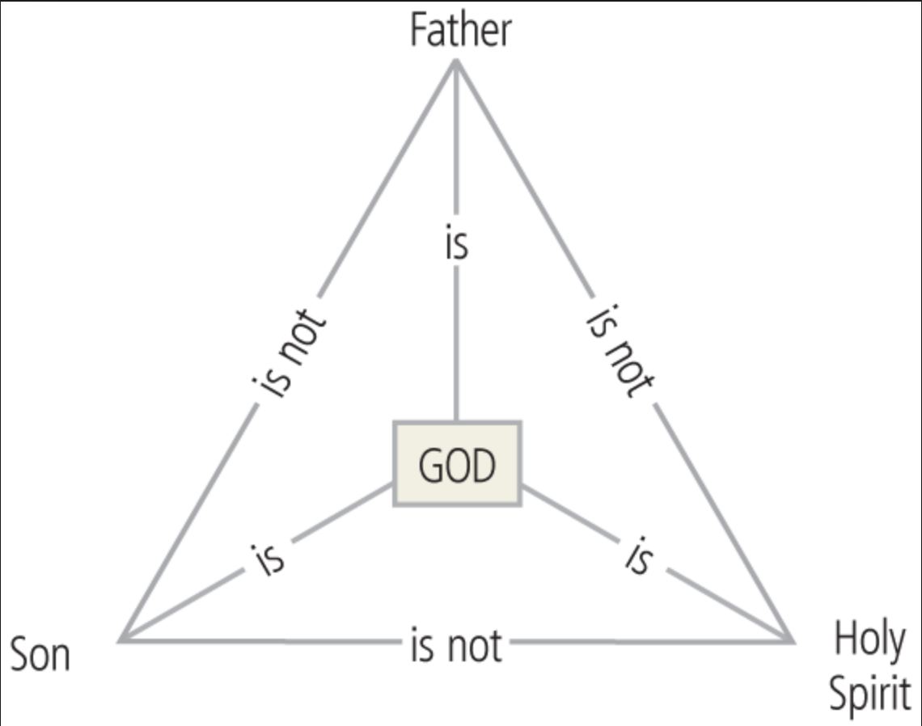

The Fellowship of the Spirit:
- The Spirit of God lives in our midst (8:9, 11; Jer 34; Ezek 36; Joel 2)
- When the Spirit of God lives in our midst, our bodies become dead (ineffective) to sin and our spirit revive to life and righteousness (8:10)
- The Spirit of God gives life to our dying bodies (8:11)
- The Spirit of God leads us with confidence (8:14–15)
- The Spirit of God assures us that we are God’s children and asks us to call God, ‘Abba, Father’ (8:14–15)
- The Spirit helps us with our weaknesses—when we don’t know how to pray or grieve beyond words, he translates it to God for us (8:26)
- The Spirit searches our inner most longings and intercedes for us in accordance with God’s will (8:27)
- The Spirit works every circumstance into the goodness of being conformed into the likeness of God’s Son (8:28–30)
- When God is working for us, nothing good will be held away from us (8:31–32)
- When God is on our side, no one can bring a charge against us (8:33)
- When God is on our side, no one can condemn us because Jesus is at his right side defending us (8:34)
- Nothing can separate us from Christ’s love for us; we remain conquerors (8:35–37)
- Nothing can separate us from God’s love for us, that is in Christ Jesus (8:38–39)

Conclusion:

Application:
What makes you doubt God’s love for you today? If he didn’t withhold his Son from us and if he didn’t withhold his Spirit from us, will he withhold anything else from us?

Download this sermon PPT and notes for free at BibleStudyDownloads.org/resource/new-testament-preaching/
Listen to this message online at cicfamily.com/sermon-listing/

