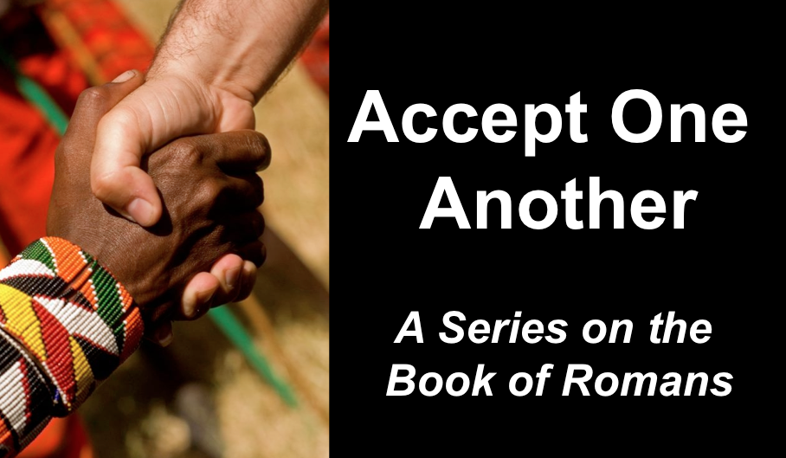
Death & Resurrection
Romans 5
Andrew B. Spurgeon
Crossroads International Church Singapore
Message 6 • 30 April 2017

Context:
- The theme of Romans: “Accept one another just as Christ has accepted you, for the glory of God” (Rom 15:7).
- But Paul wrote the letter as an evangelistic letter detailing the need for the gospel (1:18—3:21), the nature of the gospel (3:21—5:21), and the practical implications of the gospel (chaps. 6–15).

Gospel:
- The Gospel is the birth announcement of King David’s son, who resurrected from the dead and is the Son of God, Jesus Christ. Those who believe in him have salvation (1:1–4, 16–17).

Objections:
- I don’t need the gospel because I am not a sinner.
- I don’t need the gospel because I am a saint!
- I don’t need the gospel because I am privileged (I have the law & circumcision).
- I don’t need the gospel because I am not totally depraved.

Righteousness of God: “What proves God as trustworthy?” or “What proves God kept his role as the Creator God who took the first step towards redeeming his creation, the people?”

- God is upright because salvation rests on faith (1:17), i.e., apart from the law (3:21) although testified by the law and the prophets (3:21)
- God is upright because salvation is by the faithfulness of Jesus Christ (3:22)
- God is upright because salvation is offered to everyone who believes, without distinction—all have sinned (3:22–23)
- God is upright because salvation is a free gift based on God’s grace and redemption that is in Christ Jesus (3:24)
- God is upright because he appointed Jesus as the “mercy seat” because of Jesus’s faithfulness, in his blood—demonstrations of his uprightness (3:25a)
- God is upright because he overlooked [through Jesus’ work] sins committed beforehand (3:25b)
- God is upright because in his patience he demonstrates his uprightness in the present time, that is, by being the Judge and the one who justifies people by Jesus’ faithfulness (3:25b)

Ancestors testify: Abraham (Rom 4:1–6), David (4:7–8), and Abraham (4:9–22)

What we ought to believe . . .
1. Believe in him, i.e., God who raised Jesus from the dead (Rom 4:24), and
2. Believe that Christ was “handed over for our trespasses and raised for our ‘uprightness’” (Rom 4:25).

Romans 5—“What if there is no resurrection?”
The first Adam brought sin, death, and condemnation (5:12–14, 16)
The second Adam (Jesus Christ) brought grace/gift, life, and ‘uprightness’ (5:12–21)

How is this good news?
- Those who receive the grace/gift of salvation that is in Jesus Christ’s death and resurrection “have peace with God” (Rom 5:1, 6–11)
  - While we were weak, Christ died for us, the un-reverent people (5:6)
  - While we were sinners, Christ died for us (5:7–8)
  - While we were enemies, Christ reconciled us to God (5:10–11)

- Now that we are reconciled to God and made upright with God, we are saved from upcoming wrath (5:9) and we have peace with God (5:1)

So what should we do?
- We gain access by faith to this great salvation (5:2)
- We boast in the hope and glory of God (5:3, 12)
- We endure sufferings, knowing the result (5:4–5)

Download this sermon PPT and notes for free at BibleStudyDownloads.org/resource/new-testament-preaching/
Listen to this message online at cicfamily.com/sermon-listing/

