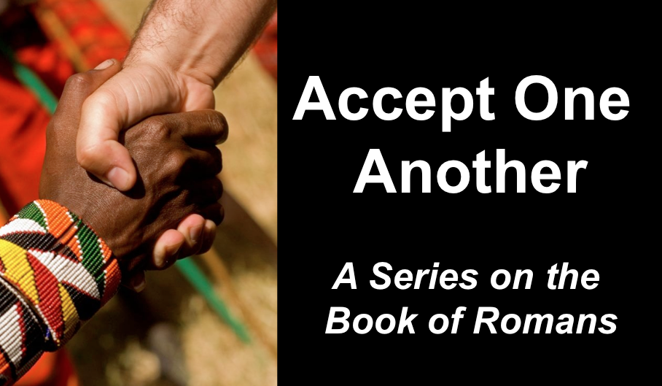
Abraham & David Testify to Faith
Romans 4
Andrew B. Spurgeon
Crossroads International Church Singapore
Message 5 • 2 April 2017

Context:
- Jewish pilgrims to Jerusalem during the coming of the Holy Spirit at Pentecost, returned to Rome and established the churches in Rome (Acts 2:10). They included Gentiles in their worship and congregation. But Emperor Claudius expulsed all the Jews from Rome (AD 44–49), the founders of the church in Rome left and the Gentile Christians filled the gap in the leadership. In AD 54, Emperor Claudius died, and Nero became the new Emperor. Jews, including Jewish Christians, returned. Tensions arose in the churches over customs. So Paul’s message to them was, “Accept one another just as Christ has accepted you, for the glory of God” (Rom 15:7).
- But Paul wrote the letter in an evangelistic letter: detailing the need for the gospel (1:18—3:21), the gospel (3:21—5:21), and the practical implications of the gospel (chaps. 6–15).

Gospel:
- The gospel is a birth announcement and a victory announcement (Rom 1:1–4).
- The gospel requires a response (Rom 1:16–17).

Objection 1:
- I don’t need the gospel because I am not a sinner.

Objection 2:
- I don’t need the gospel because I am a saint!

Objection 3:
- I don’t need the gospel because I am privileged (I have the law & circumcision).

Objection 4:
- I don’t need the gospel because I am not totally depraved.

Righteousness of God: Genesis 19:19; 20:5; 30:33 tell us that we are talking about “uprightness” of God, i.e., “What proves God is trustworthy?” or “What proves God kept his role as the Creator God who took the first step towards redeeming his creation, the people?”

- God is upright because salvation rests on faith (1:17), i.e., apart from the law (3:21) although testified by the law and the prophets (3:21)
- God is upright because salvation is by the faithfulness of Jesus Christ (3:22)
- God is upright because salvation is offered to everyone who believes, without distinction—all have sinned (3:22–23)
- God is upright because salvation is a free gift based on God’s grace and redemption that is in Christ Jesus (3:24)
- God is upright because he appointed Jesus as the “mercy seat” because of Jesus’s faithfulness, in his blood—demonstrations of his uprightness (3:25a)
- God is upright because he overlooked [through Jesus’s work] sins committed beforehand (3:25b)
- God is upright because in his patience he demonstrates his uprightness in the present time, that is, by being the Judge and the one who justifies people by Jesus’s faithfulness (3:25b)
Conclusion: No chance for anyone to boast! (3:27)

“This is our message: God, in Christ, is reconciling the world unto himself, not counting their transgressions against them” (2 Cor 5:19).
God is upright because salvation rests on faith (Rom 1:17), i.e., apart from the law (3:21), although testified by the law and the prophets (3:22).

Forefathers testify: Abraham (Rom 4:1–5), David (4:6–8), and Abraham (4:9–22)
- Abraham understood the difference between “wages” and “gifts.”
- Abraham trusted God for his gift; and God rewarded him.
- Abraham left a lesson: “To the one who doesn’t try on his/her own, but trusts God to consider him/her ‘upright,’ God does, i.e., he grants uprightness.”
- David says, “Blessed are those whose transgressions are forgiven and sins are covered; Blessed are those whose sins God doesn’t count against them.”
- Such blessedness is not only for the Jews or Gentiles; instead, it is to all those who have faith like Abraham.
- What is faith like Abraham’s? Believing in God who gives life to the dead and calls into being things that are not.
- How far did Abraham believe? *against all hopes/odds, *without wavering in his faith, *strengthened in his faith, and *fully persuaded in God.
- God accepts such a faith as ‘uprightness’ and rewards.
- Abraham’s story was for our behalf!

1. Believe in him, i.e., God who raised Jesus from the dead (Rom 4:24), and
2. Believe that Christ was “handed over for our trespasses and raised for our ‘uprightness’” (Rom 4:25).

Download this sermon PPT and notes for free at BibleStudyDownloads.org/resource/new-testament-preaching/
Listen to this message online at cicfamily.com/sermon-listing/

