SBC Retreat Michael Shen
12 July 2014 Interim Principal
Gratefulness
Romans Overview

Topic: Discipleship
Purpose: The listeners will offer their bodies to God with a grateful heart.

Introduction

Subject: How should we end this all-college retreat on discipleship?

Preview: The book of Romans is depicted in this diagram:
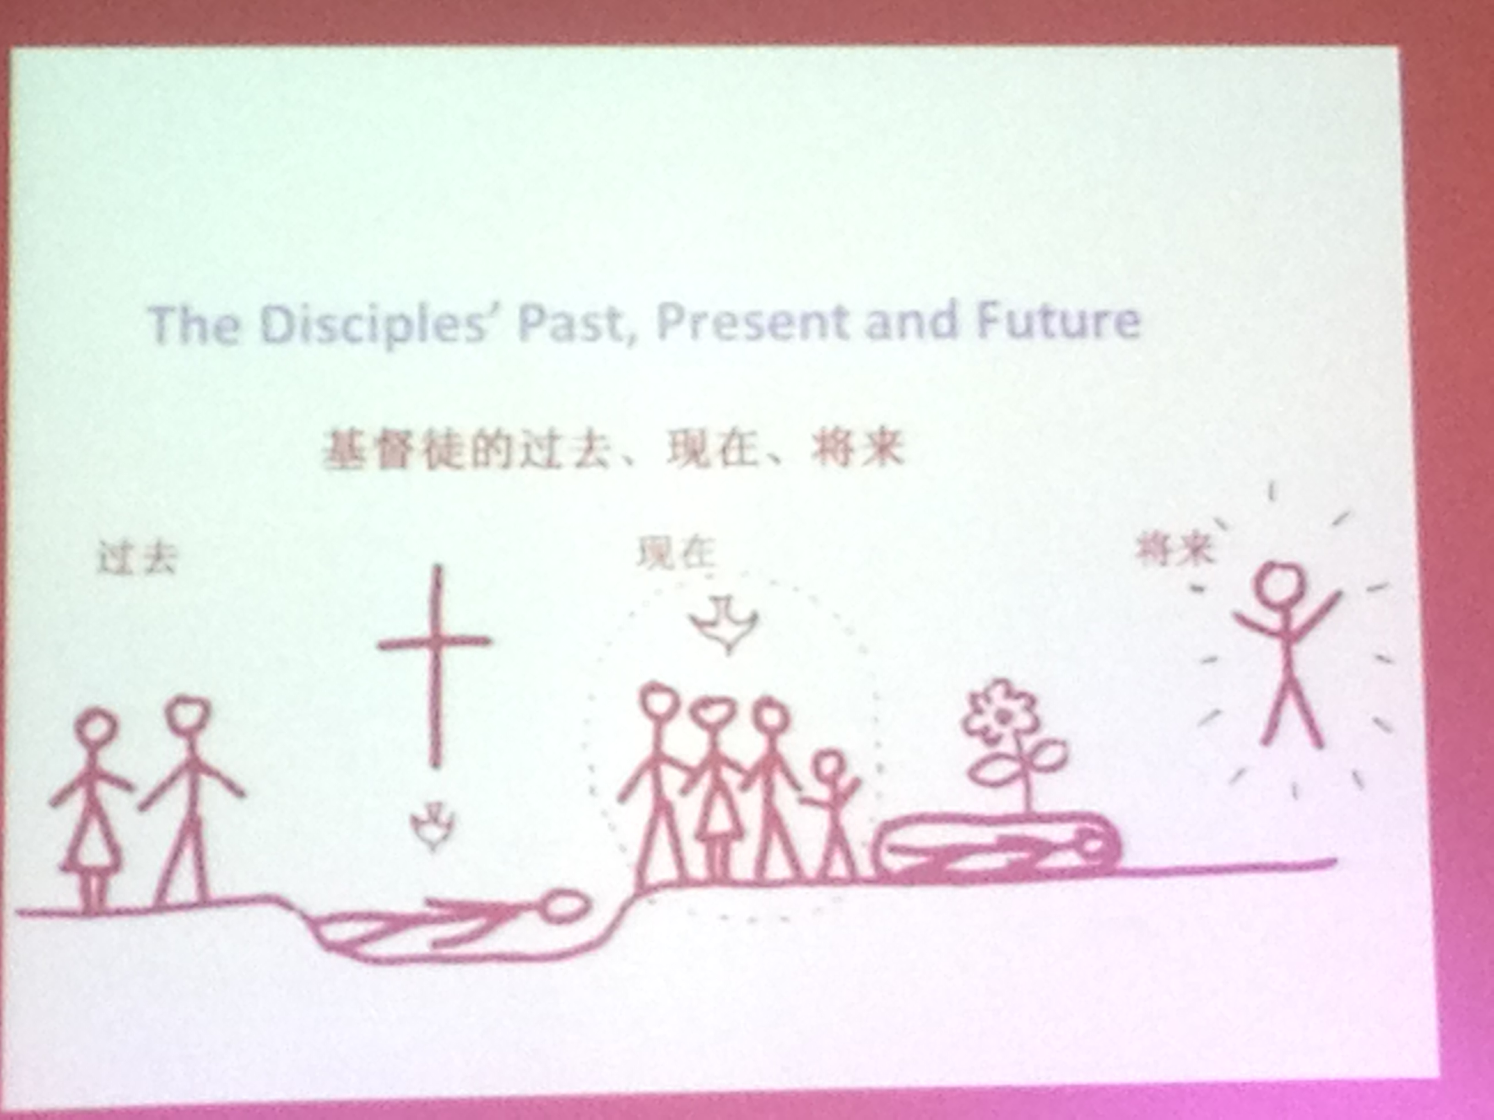

I. The Disciples’ Past, Present and Future

Past: Before our salvation, we were broken, hopeless, and angry (Rom. 1–3)

Present: But Christ died for us (Rom. 5:8) and we are united with him in a new status with the Spirit pouring out his blessing in our lives (Rom. 6–8).

Future: We will be glorified in the future.

II. Paul wrote Romans to handle the internal problem of disunity.

Shortly before Romans was written, Claudius had kicked the Jews out of Rome in AD 49. However, Claudius died in AD 54 and the Jews began returning, only to find that Gentiles now led the church.

Therefore, Paul wrote to help reconcile the problems within the church. The strong (Gentiles) needed to accept the weak (Jews), remembering that they did not eat pork.

The picture of the church above is one united by the Spirit.

III. The process of discipleship has key elements (Rom. 12:1-2)

We offer ourselves to God (12:1).

In China a young man fell into the cesspool while doing his business, as it was an old-style toilet and the boards were not secure. He struggled to get out, but the walls were slippery and gross, so no one helped him. Then there was a splash and—who do you think jumped in to save him?—his father!

God the Father also got dirty for us in the person of his own Son.

We commit not to be conformed by the world (12:2).

With gratitude we let God change us to be people who are more concerned for others than for ourselves (cf. Phil. 2:3-4).

We are called to live beyond reason like Jesus Christ!

We must choose between the Mass-Media Mind and the Mind of Christ.

Conclusion

How can we evaluate our input from the media and interaction with social media with wisdom?

Does it draw unnecessary attention to us instead of to Christ?

Is it compatible with the gospel?

Does it absorb your time as a distraction from being fishers of men?

Offer your body with a grateful heart (MI).

Don’t complain about the SBC food. I’ve been eating it for 30 years.

We are all wounded people who have been broken, but God is using us.

We may meet unpleasant things in the future, but God can make it a means of grace.

