Crossroads International Church Dr. Rick Griffith

4 May 2014 Series on Revelation Message 20 of 20

NLT 40 Minutes

**The New Jerusalem**

Title

***Revelation 21–22***

**Topic:** Heaven

**Subject:** What is the greatest truth about your eternal home?

**Complement:** Christ living with us encourages us to live for Christ.

**Purpose:** The listeners will serve Christ in light of their fantastic future until he returns.

**Song:** There is a Higher Throne

# Introduction

### Interest: The old adage says, “There’s no place like home.” But why is that?

No place like home

### Need: Most of us—when we’re away from our home for a while—long to go back. *Why* do you want to go home?

• Why?

#### Tell the person next to you what you most look forward to when getting back to your house. [Wait 30 seconds.]

#### Is it familiarity? Comfort? Your nice bed? The food? Relaxation? Your favorite chair?

### Intro MPI: How much more do we long for our eternal home! But what is the greatest truth about your eternal home? What do you long for most in heaven?

Greatest Truth

#### I wonder if it’s similar to what you long for most in your earthly home.

#### When I was a teenager and thought about heaven, I thought how great it would be in heaven to snow ski and be able to do whatever kinds of flips and jumps I wanted without ever getting hurt! Now my view of heaven has matured a bit…

Skiing

#### Now I hope for—more than anything else—when I’m away—I long for…relationships. One, specifically! Home is not home without my wife Susan. I’ll come back to Singapore in a few weeks without her and our apartment will be empty until she follows me 16 days later—not that I’m counting or anything!

Susan

#### Likewise, heaven is about relationships! One, specifically!

Relations

### Background: Today we will study our Ultimate Home in the last two chapters of the Bible. These follow Christ’s return and the millennium.

Future Benefits

#### The entire Bible is the background to these chapters. It shows a chiasm of man ruling with God (Gen. 1–2), God seeking to restore man to that rule (Gen. 3—Rev. 20), and now the rule finally restored in the final two chapters.

Timeline

Chiasm

#### Last week we explored some of the characteristics of the 1000-year reign of Christ with the saints in Revelation 20. Satan will be bound then. What else?

Satan Bound

##### Saints will judge angels.

Millennium Purposes

##### Saints will rule the earth in a restored world that will not yet be perfect but will fulfill God’s covenant to Abraham to restore Israel fully.

• Fulfill Abrahamic

##### Satan will then lead a final rebellion against Christ but then be judged.

Christ wins

Satan   
cast

##### In fact, all people will appear for judgment before the great white throne.

GWTJ

##### By this time in the book, all enemies of God are vanquished—whether human or Satan or his minions. So what’s left? Our home!

##### “Heaven is for Real” is a 2014 movie of a 2004 “visit” by a 4-year-old.

“For Real”  
(3 slides)

### Preview: Let’s see what our eternal home will be like (description) and then how we should live in response (prescription).

What?  
• How?

### Text: Revelation 21–22 tell us the best truth about our eternal home.

(So what will our eternal home be like? How can we sum it up?)

# I. God will once again live with man (21:1–22:6).

MP

[The uniqueness of our wonderful, eternal home in the New Jerusalem is that it will be where God returns to dwell with people.]

## The new heaven and earth without seas separating men will be created since the first heaven and earth had passed away (21:1).

21:1

### Should we take this description of a new earth literally (21:1)?

Literal?

#### What do we find in the text that would encourage us to think of this in any other than the normal sense of an actual place?

#### The passage is an obvious repetition of Genesis 1:1. As God created the first heaven and earth, so he will recreate the same in the future.

Gen. 1:1

#### Man ruled with God in the first earth—and we will do it again! (5 slides)

Rule  
(5 slides)

#### We’ll all get physical, glorified bodies—so doesn’t it make sense that these bodies will be in an actual, physical earth? Greeks thought Mercury could fly!

Bodies  
(4 slides)

#### Likewise, we will fly! I look forward to exploring this amazing new place!

Explore!

#### In fact, I believe it will actually be this present earth totally renewed!

Renewed

### Why won’t there be any seas (21:1b)?

No seas

#### Seas have long separated people from one another—and recent studies by creationists agree that the pre-Flood earth still had sea around a single continent called Rodinia.

Rodinia

#### This continent broke into our various continents at the Flood.

Breakup

#### Yet no more in the renewed earth!

## The New Jerusalem shows God dwelling with man (21:2–22:6).

New Jerusalem

### The city will descend to earth for God to dwell with man again (21:2-11).

21:2a

#### What historical context helps us understand this passage?

##### God’s presence was first in Eden, where he came to Adam and walked with him in the cool of the day.

Eden

##### Then his presence traveled with Israel in the tabernacle.

Tabernacle

##### But then God placed his hand upon Jerusalem as the city in which he would dwell. Under Solomon God’s own presence indwelt the Temple and remained among the people for about 1500 years, departing before the Exile to Babylon.

Figurative or literal

Temple

##### But then his presence will be in this city as beautiful as a bride dressed for her husband.

Brides

#### Why would the New Jerusalem *come out* of heaven (21:2)?

Coming Out?

##### Verse 3 answers this question, telling us that God has always longed to be with his people!

Clouds  
(2 slides)

21:3

##### We think of heaven in too “cloudy” terms! The idea is not “we go to God”—it’s that God will come to dwell with us!

##### Genesis 3:8-10 records fellowship with God broken. Now here we see fellowship with God resumed—forever!

Fellowship restored

#### Death and sorrow will be gone (21:4).

Death today

Sorrow

##### God judged man in Genesis 2:17 with death for disobedience, but there will be no disobedience in this city.

##### So no more death…

Surely die

##### No more sorrow…

21:4

Sorrow

##### He will wipe away every tear!

1995  
• Forgiven

##### It will be like the two officers in 1945—the English Field Marshall refused to shake the hand of the German Admiral who came to surrender. He committed suicide days later.

1945

##### Yet 50 years later their sons shook hands on this same spot in 1995. Heaven is even better with all sins forgiven and forgotten!

### It will have protection (wall), access for Israel (gates), and access for the church in its foundation (21:12-14).

New Jerusalem

#### Should we take these descriptions of the New Jerusalem literally (21:2)?

##### The city is described as a “bride beautifully dressed for her husband” (21:2; see also vv. 9-10). Several say that since the term “bride” often refers to the church (Isa. 54:5; Eph. 5:32; etc.), it would seem so here too (Hendriksen, 199). “Even in the Old Testament the Church is represented under the symbolism of a city (Isa. 26:1; Ps. 48; etc.)” (Hendriksen, 199).

Quotes

= The Church?

##### My response?

Cubed City Response

###### Contrary to popular belief, the church is never called the bride of Christ in the NT. Paul does use the husband-wife relationship to illustrate Christ’s love for the church (Eph. 5:32), but the word “bride” or “wife” is actually never used for the church.

• New Jer

= Bride

• Church not Bride

###### In fact, verses 9-10 denote the “bride” or “wife” as the New Jerusalem itself—not the church!

10

9

###### Also, Isaiah doesn’t mention the church; this is reading the NT back into the OT. Even a casual glance at the texts by Hendriksen show that they do not refer to the church but rather to Jerusalem (Ps. 48; Isa. 26:1) or Israel (Isa. 54:5).

Gen v. Bride

###### Finally, more than just the church will live in this city (Heb. 12:22-24) so it cannot be equated with the church. The inscription of the names of both the 12 tribes of Israel (21:12) and the 12 apostles (21:14) argue that both Israel and the church will inhabit the city—not simply the church.

Heb. 12:22-23

#### Verses 5-8 also emphasize the holiness of the city.

##### Everything in it is new (21:5-7)!

5-7

##### All evil is excluded (21:8)!

8

### The 2200-kilometer cube will recall God’s presence in the Holy of Holies (21:15-16).

Sit on Earth

#### The Holy of Holies was a perfect cube filled with God’s presence!

Holy of Holies

#### The city is a cube the size of 2/3 of the USA.

USA   
(2 slides)

SE Asia

#### It fits over SE Asia at 2200 kilometers on each side.

#### Over Jerusalem it covers the entire Middle East!

Middle East

### The wall, foundation, gates and street will be made of precious materials (21:17-21).

#### Verses 12-13 already noted that the 12 angels guard the 12 gates.

12-13

#### The foundation is amazing (21:14)!

14

#### The stones sound familiar!

Stones

High priest

#### This is because the high priest breast piece also had 12 stones.

#### It had the exact same stones (Exod. 28:15-21)!

Breast piece

#### The significance of this is highlighted by one writer…

God’s people

#### The gates are formed from a single pearl (21:21)!

Pearl Gate

### It will be lit by the presence of God (21:22-27).

Lit by God Glory

#### No temple is needed (21:22).

• No temple

#### Unlike Genesis where the sun and moon were created, these are not needed.

Gen 1:16  
• 22-23

#### Why not? Normal patterns of rest and work will not apply, so no sun or moon is necessary (21:23).

23   
Prohibited

#### You see, in Genesis, God named the darkness night but here there will be no night (21:25).

24-26

Gen. 1:5  
No night

#### In fact, glory will exist nowhere else (21:24-26)!

Gen closed  
Opened

#### Why? Instead of the first paradise closed, a new Paradise is opened (21:25)!

#### Other contrasts are evident (20:10; 21:27).

Contrasts

#### No sin and death will exist.

Cartoon

#### Why? No evil is allowed (21:27).

27

### Its tree of life will be on the banks of the river of life (22:1-6).

Title

#### There is a single river instead of many (22:1).

Gen barred  
• Access

Gen trees  
1

2

#### It flows down Main Street (22:2). We see later on in verse 14…

#### Rather than being barred from the tree of life, people may eat freely (22:14).

#### No curse like Genesis will exist (22:3). Cursed ground becomes gold dirt!

Gen curse  
• 3

#### No longer expelled from Eden, we will see his face (22:4).

Gen expel  
4

Gen broke

Restored

#### The rule over creation lost in Genesis will be restored (22:5).

(This tremendous truth of God living with us should impact us immensely. What should our response be? We should…)

MPI

# II. Live in light of the end (22:7-21).

MPII

[God shows him living with us in our eternal home so we will live for him now.]

Vacation Cartoon

Chinese character

[We won’t be taking a vacation so we should get ready to move permanently.]

[The Chinese character *wan* for finish or complete means “roof over head.”]

## Christ *encourages* us to live as if he can come any moment (22:7-17).

Any moment

Soon (7)

### His *first* announcement of his soon return promises *blessing* for obedience (22:7-11).

• Blessing

#### How can Jesus say that he is coming “soon” (NLT) when it has been 2000 years (22:7, 12, 20)?

##### The idea is what theologians call “imminency.” This means Christ can come at any moment.

Imminency

##### The word tacu/ß can mean “soon” in terms of time, but more often it means “pertaining to a very brief period of time, with focus on speed of an activity or event… ***quick, swift, speedy***” (BADG). It is used in Matthew 28:8 where “The women ran quickly from the tomb” (NLT).

Jesus Wins

“quickly”

• “soon”

##### The NAU of verses 7, 12, and 20 probably have the idea better: “I am coming quickly.” In other words, when the events of this book begin to be fulfilled, it won’t take long for them to reach their fulfillment with Christ’s return in chapter 19.

### His *second* announcement of his soon return promises *reward* for obedience (22:12-17).

Reward

#### Too often we think of reward as our rest in heaven—and 14:13 teaches this.

Gen rest

Rest

#### But God will reward us with the privilege of reigning with him forever (22:5)!

5

## Christ *warns* of adding to or subtracting from this prophecy (22:18-19).

Bible

### Both adding to and subtracting from Revelation shows our doubt in God’s Word.

18-19

### Liberals and Gospel of Judas add to the Bible.

Judas

Gnostic

### Those who take away from the Word will receive judgment.

Subtract

#### Subtractions include the second-century Marcion (only Luke and Paul), *The Jefferson Bible* (only sayings of Christ he liked), and The JW *New World Translation* (Jesus not God).

Marcion

#### Mormons add three more books and Joseph Smith had his own “Inspired Version” of the Bible.

Golden Plates

## Christ *promises* us his imminent coming and grace (22:20-21).

20-21

### His *third* announcement of his soon return assures *that Christ indeed gave this revelation* (22:20a).

Grace

### John replied to affirm Christ’s return and grace (22:20b-21).

Sum up?

(How can we sum up these two final chapters of the Bible with all they say about the New Heaven, New Earth and New Jerusalem?)

# Conclusion

### Christ living with us encourages us to live for Christ (Main Idea).

MI

### God’s presence in the New Jerusalem helps us serve Christ until his imminent return (MI restated). Do you focus on God’s presents or God’s presence?

Presents?  
Presence?

### MPs: God will once again live with us so we should live for him in light of the end!

MPII

MPI

### So my questions for you are these:

#### Have you come to the water? Jesus invites you to drink freely!

Come to the water!

#### Do you long for Christ’s return? Why or why not?

Long?

# Preliminary Questions

Soon (7)

**Verses Questions**

# Context: What did the author record just prior to this passage?

### Last week we explored some of the characteristics of the 1000-year reign of Christ with the saints in Revelation 20.

#### Satan will be bound.

#### Saints will judge the world and angels in a restored world that will not yet be perfect but will fulfill God’s covenant to Abraham to restore Israel fully.

#### Satan will then lead a final rebellion against Christ but then be judged.

#### In fact, all people will appear for judgment before the great white throne.

### By this time in the prophecy, all enemies of God are vanquished—whether human or demons or Satan or his minions.

### With evil destroyed, what then is left? Our home!

# Purpose: Why is this passage in the Bible?

### Yet there exist differences between the millennium and heaven (explain).

### These two chapters are completely good­—not a negative word—as we say now, “It’s all good!” when in fact right now that’s not true.

### But why do we have these chapters?

#### They help us end the Bible on a positive note?

#### They encourage us to go to heaven?

#### They help us long for Christ’s return?

#### They exhort us to live a holy life like these descriptions of heaven?

# Background: What historical context helps us understand this passage?

### God had already placed his hand upon Jerusalem as the city in which he would dwell. The pagan Jebusite city had been conquered by David 2000 years prior to these chapters being written.

### Under Solomon God’s own presence indwelt the Temple and remained among the people for about 1500 years, departing before the Exile to Babylon.

### Now his presence lives in each of us! Yet we still live in a sinful world and the present Jerusalem is anything but a holy city!

# Questions

### Should we take this description of a new earth literally (21:1)?

#### What do we find in the text that would encourage us to think of this in any other than the normal sense of an actual place?

#### We will all get actual, physical, glorified bodies—so doesn’t it make sense that these bodies will be in an actual, physical earth?

### Should we take these descriptions of the New Jerusalem literally (21:2)?

#### The city is described as a “bride beautifully dressed for her husband” (21:2; see also vv. 9-10). Several say that since the term “bride” often refers to the church (Isa. 54:5; Eph. 5:32; etc.), it would seem so here too (Hendriksen, 199). “Even in the Old Testament the Church is represented under the symbolism of a city (Isa. 26:1; Ps. 48; etc.)” (Hendriksen, 199).

#### My response?

##### Contrary to popular belief, the church is never called the bride of Christ in the NT. Paul does use the husband-wife relationship to illustrate Christ’s love for the church (Eph. 5:32), but the word “bride” or “wife” is actually never used for the church.

##### In fact, verses 9-10 denote the “bride” or “wife” as the New Jerusalem itself—not the church!

##### Also, Isaiah doesn’t mention the church; this is reading the NT back into the OT. Even a casual glance at the above texts will show that they do not refer to the church but rather to Jerusalem (Ps. 48; Isa. 26:1) or Israel (Isa. 54:5).

##### Finally, more than just the church will live in this city (Heb. 12:22-24) so it cannot be equated with the church. The inscription of the names of both the 12 tribes of Israel (21:12) and the 12 apostles (21:14) argue that both Israel and the church will inhabit the city—not simply the church.

### What is the point of all these amazing and detailed descriptions of the New Jerusalem? Should we look for the spiritual significance of each detail?

#### The whole chapter speaks of physical realities! We have the exact size of the city, descriptions of its walls and gates and foundation—should we just spiritualize all this?

#### The spiritualized view runs into great problems concerning authorial intent too. Would the original readers have spiritualized these things? I doubt it.

#### Also, are we then arguing against a physical heaven like eastern mystics? Hopefully even those who argue against a literal view of the New Jerusalem still believe heaven is a literal place. We only have one physical description of heaven, so we must be careful not to throw it away so easily.

### Why would the New Jerusalem come out of heaven (21:2)? Isn’t it heaven itself?

#### Verse 3 answers this question, telling us that God has always longed to be with his people!

#### The issue is not us going to be with God—it’s that God will come to dwell with us!

#### God did this in Eden, where he came to Adam and walked with him in the cool of the day.

### How can Jesus say that he is coming “soon” (NLT) when it has been 2000 years (22:7, 12, 20)?

#### The idea is what theologians call “imminence.” This means Christ can come at any moment.

#### The word tacu/ß can mean “soon” in terms of time, but more often it means “pertaining to a very brief period of time, with focus on speed of an activity or event… ***quick, swift, speedy***” (BADG). It is used in Matthew 28:8 where “The women ran quickly from the tomb” (NLT).

#### The NAU of verses 7, 12, and 20 have the idea better: “I am coming quickly.” In other words, when the events of this book begin to be fulfilled, it won’t take long for them to reach their fulfillment with Christ’s return in chapter 19.

# Tentative Subject/Complement Statements

Text

# Possible Illustrations

##### Yet there exist differences between the millennium and heaven (explain).

LORD’S SUPPER recalls Christ’s sacrifice

[Young Heroine Creates a Bridge to Safety](http://illustrationexchange.us2.list-manage2.com/track/click?u=181c69bf3d2275e6dc9157a34&id=71e17ddbcf&e=aa849ca33b)

Contributor: [Illustration Exchange](http://illustrationexchange.us2.list-manage2.com/track/click?u=181c69bf3d2275e6dc9157a34&id=c7aac0f599&e=aa849ca33b)

Topics: [Sacrifice](http://illustrationexchange.us2.list-manage1.com/track/click?u=181c69bf3d2275e6dc9157a34&id=f6b7e8befc&e=aa849ca33b) - [Communion](http://illustrationexchange.us2.list-manage2.com/track/click?u=181c69bf3d2275e6dc9157a34&id=17bd4b906b&e=aa849ca33b) - [Jesus, Savior](http://illustrationexchange.us2.list-manage1.com/track/click?u=181c69bf3d2275e6dc9157a34&id=434835f431&e=aa849ca33b)

In the aftermath of one of the most tragic ferry accidents in recent history, a story of heroism and selfless sacrifice is beginning to take shape. It's the story of a young woman, Park Jee Young, just 22 years old.

Two years ago, after the death of her father, Park dropped out of college to help support her family. She took a job with a ferry company, and was just recently promoted to serve on the ill-fated Korean ferry, the Sewol, which sank off the coast of South Korea last week (April 16, 2014).

The ferry was carrying 476 people, most of them high school students from the Danwon High School in Ansan City. The students were on a class trip to a nearby resort Island. After initial search and rescue attempts, more than 300 of the passengers are either dead or missing and presumed dead.

While nearly half of the ferry's 22 crewmembers have been arrested in connection with negligence and dereliction of duty, Park gave her life to save as many passengers as possible. CNN reports:

By witness accounts [she] helped passengers escape and distributed life jackets -- one after the other to students -- as the stricken ferry began to sink. When she ran out of jackets, she ran to the next floor to grab more. When she was asked why she wasn't wearing a life jacket, Park said that crew members would be last and that she had to help others first …

Even more amazingly, it was her quick thinking and assessment of the gravity of the situation which led so many to safety.

In an interview with CNN's Ashleigh Banfield, survivors described the scene and her actions. They recounted how the severe listing of the ship nearly immediately turned walls into floors. Passengers were panicked and disoriented. A large, open door now created a gaping hole in the new "floor," and it was too wide for passengers to safely step or jump over it. One crewmember was laying on the floor nearby, grasping a mic and instructing passengers to stay put, and telling them they would be fine if they just stayed where they were.

Park instinctively knew that staying put was not an option. Witnesses say she grabbed some keys from her fellow crewman and forced the door shut, then locked it to be sure it stayed that way. She then led nearly 50 desperate passengers across it, creating, as one grateful survivor described it, a "bridge to safety." She was standing right by the exit, he said, yet she refused to save herself, insisting that the needs of the passengers came first.

Alongside the flowers at her memorial is a simple message, "We will always remember your sacrifice."

**Application**:

Jesus is our "bridge to safety." While the whole world was saying stay put and everything will be fine, He realized the gravity of the situation and took action. He knew that staying put in our separation from God was not an option, so He gave His life to close the gap between us and God. Like Park Jee Young, He put himself last in order to save as many as possible.

Just as Park Jee Young's family "will always remember [her] sacrifice," we are called to perpetually remember Jesus' sacrifice each time we gather at the Lord's Table to observe communion.

"And he took bread, gave thanks and broke it, and gave it to them, saying, "This is my body given for you; do this in remembrance of me" (Luke 22:19).

D. (21:1–22:5) Prophecies of the Eternal State show the wonderful future of victors with Christ because He defeats the forces of evil.

1. (21:1) The new heaven and earth without continents separating men by sea are created since the first heaven and earth had passed away.

2. (21:2-8) The conditions in the new Jerusalem describe the absence of all unpleasant circumstances experienced on earth as man again has complete fellowship with God.

3. (21:9–22:5) The new Jerusalem is described as a city in the shape of a cube 1500 miles (2200 kilometers) each way with walls made of jewels and twelve gates, each made from a single pearl, lit by the presence of God, with the tree of life on the banks of the river of life.

The Bible’s Major theme: The Kingdom of God

The Bible has many themes: redemption, the glory of God, covenants, the sovereignty of God, worship, promise, etc.

But is there one theme that is more prominent than any other? I think there is one. This is the kingdom of God.

1. Proponents: Kenneth L. Barker, “The Scope and Center of Old and New Testament Theology and Hope,” in *Dispensationalism, Israel and the Church*, eds. Craig A. Blaising and Darrell L. Bock, 305; Eugene H. Merrill, *Kingdom of Priests: A History of Old Testament Israel* (Grand Rapids: Baker, 1987); J. Dwight Pentecost, *Thy Kingdom Come* (Wheaton: SP Pub., 1990), 9; Roy B. Zuck, ed., *A Biblical Theology of the Old Testament* (Chicago: Moody, 1991), ix; Klein, *EvTh* 30 (1970): 642-70; H. Schultz, *OT Theology* (Edinburgh, 1892), 1:56.

Others advocate a modified kingdom theme. Seebass (1965) says the theme is the rule of God; Georg Fohrer, *ThZ* 24 (1965), 161 advocates “the rule of God and the communion between God and man”; and R. Schnackenburg, *NT Theology Today* (New York, 1965) says the key biblical theme is a dual kingdom-covenant idea. I agree with Schnackenburg in this dual kingdom-covenant theme as the central focus of the OT—and of the entire Bible as well.

2. Statement: “I am in essential agreement with the authors’ stated center of biblical theology–basically the kingdom principle of Genesis 1:26-28. Most statements of a theological center are too limited (e.g., promise or covenant), too broad (God), or too man-centered (e.g., redemption or salvation-history). It seems clear that, although there are several great theological themes in Scripture, the central focus of biblical theology is the rule of God, the kingdom of God, or the interlocking concepts of kingdom and covenant (but not covenant alone). This theocratic kingdom is realized and consummated primarily through the mediatorial work of God’s (and David’s) messianic Son. Significantly, Ephesians 1:9-10 appears to indicate that God’s ultimate purpose in creation was to establish His Son–the ‘Christ’–as the supreme Ruler of the universe” (Kenneth L. Barker in Zuck, ed., ix).

This is similar to the sovereignty view, yet more complete in that it shows *how* God delegates limited rule to man in various ages until He gives ultimate rule to His Son (Ps. 2).

3. The Kingdom in Genesis 1

• Uncreated God (1:1)

• Creation by Word alone (1:4)

• Creation with ease

• Sun and moon [gods] created (1:16)

• Shared rule with man (1:26)

4. My View of the Bible’s Theme

The Bible narrates

*God’s restoring man to participate in His kingdom rule for His own glory*

mandated in Eden but lost in the Fall

and accomplished by redeeming man

through Israel’s role as a kingdom of priests,

through the Church proclaiming Christ,

and ultimately through the Messiah,

who will reign as Savior and King

in fulfillment of the Abrahamic Covenant

5. Key Texts: Gen. 1:26-28; 12:1-3; Exod. 19:5-6; Eph. 1:9-10; Rev. 22:5

|  |  |  |  |  |  |
| --- | --- | --- | --- | --- | --- |
|  | **Gen. 1:26-28** | **Gen. 12:1-3** | **Exod. 19:5-6** | **Eph. 1:9-10** | **Rev. 22:5** |
| **Event** | Creation Mandate | Abrahamic Covenant | Mosaic Covenant | Messianic Kingdom Rule | Saint’s Rule |
| **Mediator or Co-Ruler** **with God** | Man (Adam) | Abraham | Israel | Jesus Christ | Believers |
| **Subordinates**  **(what is ruled over)** | All creation except people (animals & nature) | All peoples | All peoples | All creation (people, animals & all nature) | All creation (animals & all nature) |
| **Passage** | “Then God said, ‘Let us make man in our image, in our likeness, and let them rule over the fish … birds … livestock … all the earth, and over all the creatures that move along the ground…’ God blessed them and said to them, ‘Be fruitful and increase in number; fill the earth and subdue it. Rule over the fish of the sea and the birds of the air and over every living creature that moves on the ground.’” | “…I will make you into a great nation and I will bless you; I will make your name great, and you will be a blessing. I will bless those who bless you, and whoever curses you I will curse; and all peoples on earth will be blessed through you.” | “Now if you obey me fully and keep my covenant, then out of all nations you will be my treasured possession. Although the whole earth is mine, you will be for me a kingdom of priests and a holy nation.” | “And he made known to us the mystery according to his good pleasure, which he purposed in Christ, to be put into effect when the times will have reached their fulfillment –to bring *all things* in heaven and on earth together under one head, even Christ.”  Note that “all things” includes both animals (Isa. 11:6-9) and nature (Matt. 17:27; Mark 4:36-41; 6:45-51; 11:2) | “And there will be no night there—no need for lamps or sun—for the Lord God will shine on them. And they will reign forever and ever” |

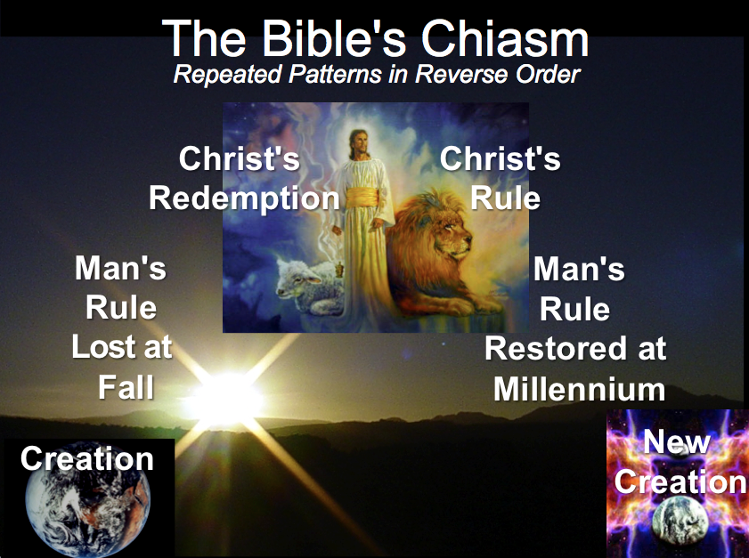

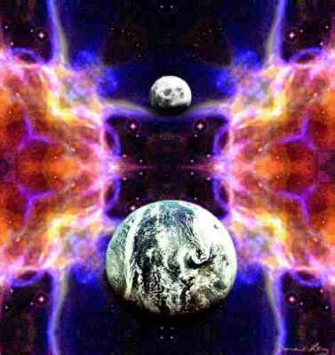

The New Heavens & New Earth

A. **Terminology**: The Bible uses the term “heaven(s)” in at least four ways:

### *Atmosphere:* The first “heavens” is the sky immediately above us (Gen. 1:6-8).

### *Outer Space:* The second “heavens” contains the sun, moon, and stars (Gen. 1:1, 14).

### *Abode of God and Saints:* Paul called this place the “third heaven” (2 Cor. 12:2) which he equated with paradise (v. 4). We will study this place in this section.

4. *Millennium:* This 1000 year period is sometimes called the “new heavens and new earth” (Isa. 65:17; 66:22) and the “kingdom of heaven” (Matt. 22:2; 25:1).

B. **New Heavens & New Earth**: We often refer to the eternal state of the redeemed as simply “heaven.” However, the scriptural term for our eternal home is the “new heaven and new earth” (Rev. 21:1). Some questions concerning this…

1. Is there an allusion to the first heaven and earth in Genesis 1 here? Yes! Revelation 20—22 contrasts with Genesis 1—3, best seen in this chart form adapted from Bruce Wilkinson and Kenneth Boa, *Talk Thru the Bible* (Nashville: Nelson, 1983), 515:

The Consummation of All Things

|  |  |
| --- | --- |
| **Genesis 1–3** | **Revelation 20–22** |
| “In the beginning God created the *heavens and the earth”* (1:1) | “Then I saw a *new heaven and a new earth”* (21:1) |
| Fellowship with God *broken* (3:8-10) | Fellowship with God *resumed* (21:3) |
| “In the day you eat of it you will surely *die”* (2:17) | “There will be *no more death”* (21:4) |
| “I will greatly *multiply your sorrow”* (3:16) | “There will be *no more... sorrow* or crying or pain” (21:4) |
| Husband and wife (2:18-25) | Lamb and bride (19:6-9) |
| “God made *two great lights”* (sun and moon; 1:16) | “The city *does not need the sun or the moon”* (21:23) |
| “The darkness He called *night”* (1:5) | “There will be *no night* there” (21:25; 22:5) |
| Satan *appears* as deceiver of mankind (3:1) | Satan *disappears* forever (20:10) |
| *Initial* triumph of the *serpent* (3:13) | *Ultimate* triumph of the *Lamb* (20:10; 22:3) |
| Defilement *enters* the garden (3:6-7) | Defilement *never* *enters* the city (21:27) |
| Trees and rivers (2:8-14) | Tree and river (22:1-2) |
| *Prohibition* from the tree of life (3:24) | *Access* to the tree of life (22:14) |
| “*Cursed* is the ground because of you” (3:17) | “*No longer* will there be any *curse”* (22:3) |
| Man *driven from God's presence* (3:24) | “They *will see His face”* (22:4) |
| Man's dominion *broken* in the fall of the first man, Adam (3:19) | Man's dominion *restored* in the rule of the new man, Christ (22:5) |
| First paradise *closed* (3:23) | New paradise *opened* (21:25) |
| First rest for God (2:1-3) | Final rest for man (14:13) |

Adapted from Bruce Wilkinson and Kenneth Boa, *Talk Thru the Bible* (Nashville: Nelson, 1983), 515.

Here we see the first three chapters of the Bible (where man’s fellowship with God is broken) compared to the last three chapters of the Bible (where man’s fellowship with God is restored). Do you know what to call the rest of Scripture in the middle (Gen. 4—Rev. 19)? It’s called missions!

2. Question: Does “then I saw a new heaven and a new earth, for the first heaven and the first earth had *passed away*, and there was no longer any sea” (Rev. 21:1) refer to a *different* galaxy and planet (annihilation and replacement of the present creation) or does it refer to this *same* planet and solar system which is judged with fire but renewed?

Answer:

a. Annihilation View: Some verses seem to indicate that the entire solar system will be destroyed or annihilated after the millennium (Walvoord, 305-6, 311; Hal Lindsey, *There’s a New World Coming*, 287):

1) “But the day of the Lord will come like a thief. The heavens will *disappear* with a roar; the elements will be *destroyed* by fire, and the earth and everything in it will be *laid bare*…That day will bring about the *destruction* of the heavens by fire, and the *elements will melt* in the heat. But in keeping with his promise we are looking forward to a new heaven and a new earth, the home of righteousness” (2 Pet. 3:10, 12b). Does this fit annihilation more than a partial destruction followed by a remade planet?

a) A figurative sense to the word “disappear” (pare,rcomai) means to “pass away, come to an end, disappear” (BAGD 626a). This may denote annihilation:

1] “I tell you the truth, until heaven and earth *disappear*, not the smallest letter, not the least stroke of a pen, will by any means *disappear* from the Law until everything is accomplished” (Matt. 5:18; Luke 16:17). The words of Scripture are assured from disappearing. A concept of renewal cannot be sustained here (unless it refers to disappearing *as we know it?*).

2] “… this generation will certainly not *pass away* until all these things have happened. Heaven and earth will *pass away*, but my words will never *pass away”* (Matt. 24:34-35; Mark 13:30-31; Luke 21:32-33).

3] “…the one who is rich should take pride in his low position, because he will *pass away* like a wild flower” (Jas. 1:10). But after death he *will* still exist.

4] “If anyone is in Christ, he is a new creation; the old *has gone*, the new has come!” (2 Cor. 5:17). Yet it doesn’t mean annihilation of consequences.

Summary: In the above verses, the idea of nonexistence can be seen in the word “disappear.” However, this word doesn’t necessarily indicate the total *removal* instead of the renovation of the present planet.

b) The word “destroyed” (lu,w) used three times in 2 Peter 3:10-12 may mean either to “break up into its component parts” or “to destroy, bring to an end, abolish, do away with” (BAGD 483d). The first sense is used of a ship breaking up (Acts 27:41), the breaking up of a meeting (Acts 13:43), and the destruction of the barrier between Jew and Gentile in the church (Eph. 2:14). The second meaning refers to destroying the works of the devil (1 John 3:8) and the abolishment of the Sabbath (John 5:18). Most, if not all, of the above texts seem to connote a nonexistence, but this is debatable.

2) At the time of the end, the sky will be rolled up like a scroll (Isa. 34:4; Rev. 6:14) as it will be said that “earth and sky fled from [God’s] presence, and there was no place for them” (Rev. 20:11). This may denote annihilation (though the Rev. 6:14 text relates to the Tribulation, so over 1000 years will still remain).

3) Christ said he was going to his “Father’s house” (heaven) to “prepare a place” for his disciples until his return (John 14:2-3). Since this “place” is being created now, it must be separate from the present creation rather than a renovation of it. (However, “place” probably refers to the New Jerusalem, which is completely new, while at the same time allowing for a renovation of our present earth.)

4) The New Jerusalem will not need a sun or moon (Rev. 21:23), so celestial bodies may have been annihilated. (But the text does not specifically say that a sun or moon will not exist—it only notes that the city is not dependent upon them.)

b. Renewal View: In contrast to the annihilation view, other verses seem to indicate that our same planet is judged and renewed without annihilation:

1) The final phrase of 2 Peter 3:10 notes that “the earth and everything in it will be laid bare” (NIV translation of euvreqh,setai, to “find, discover” BAGD 325a, c) implies continuing existence. This may mean “when the intervening heavens are burned away, the earth and its works, from the divine point of view, become visible. This provides an ironic contrast with the picture of the wicked trying to hide from God… (Isa. 2:19; Hos. 10:8; Rev. 6:15-16)” (Richard J. Bauckham, *Jude, 2 Peter* [Word Biblical Com.], 319). In other words, after God’s judgment of the earth, it is not entirely annihilated—only its sin exposed.

Response: The text is quite uncertain here with seven alternate readings. One of them is that the earth “will *not* be found” and thus explicitly teaches annihilation. In fact, all the other five options teach annihilation as well.

Rebuttal to Response: The NIV follows the best manuscript (a) and is the most unusual rendering (and thus likely the original text).

2) The term “new” may indicate quality rather than age:

It is interesting to note that in the eschatological anticipation of Isaiah the prophet there is the strong theme of retaining the earth in a revised form, or its preservation by recreation (Isa. 34:4; 51:6; 65:17; 66:22)… The remaking of the heavens and earth does not mean something entirely new, but something qualitatively better than the old. The word *new* is the word *kainos,* which refers to something of superior value, functionally superior, a rejuvenated form. Age does not automatically disqualify the attribution of the adjective *new,* for the new Jerusalem used old-world jewels… ‘New wine’ or fresh wine was still wine…” (John Gilmore, *Probing Heaven*, 82; cf. Ryrie, *Revelation*, 119).

Response: While “new” refers to a better quality, Gilmore’s illustration of wine is inadequate. New wine may be of better quality, but because it is fresh it is also newer in time. The same can be said for the new heavens and new earth. It will be better in quality as well as newer in time (Walvoord, 316).

Also, *kainos* can also mean “something not previously present” or something “unknown, remarkable” (BAGD 394a). It repeatedly has this idea (Mark 1:27; 16:17; John 13:34; Acts 17:19, 21; 1 John 2:7f.; Rev. 2:17; 3:12; 5:9; 14:3).

Rebuttal to Response: When the word contrasts something old, however, it may have the meaning of superior in kind. For example, it is used of the new covenant (Luke 22:20; 1 Cor. 11:25; 2 Cor. 3:6; Heb. 8:8; 13:9, 15), a new believer (Eph. 4:24; Gal. 6:15), and the results of being converted (2 Cor. 5:17). Also, the new entity (church) is composed of Jews and Gentiles (Eph. 2:15).

Isaiah uses *kainos* of the new heavens and new earth (Isa. 65:17; 66:22), meaning the millennial (cf. below) reconstruction of the earth altered previously existing elements. It would make sense that the same meaning of “remade from existing parts” is intended by Peter (2 Pet. 3:13) and John (Rev. 21:1).

3) The context of 2 Peter 3 mentions the “destruction of ungodly men” (v. 7). A different word is used, but that these unsaved men are not annihilated may argue for parallel meaning concerning the destruction of the elements (vv. 10-13).

4) The “elements will melt in the heat” of God’s final judgment of the earth after the millennium. Melting only changes the form of a substance but does not cause it to cease to exist. This would argue for a reforming of the earth.

5) The resurrection of the body will not be an entirely new body but a recreated old one (1 Cor. 15:35-54). This provides a natural parallel to the recreation of the old earth.

6) The present creation “waits in eager expectation” for the redemption of both itself and God’s children (Rom. 8:19-22). This argues for recreating the earth, not replacing it.

c. Conclusion: While one cannot be dogmatic on whether “new heaven and new earth” denotes an annihilation of the present creation or a renovation of it, the evidence seems to better support the renovation theory.

3. Question: Is John’s “new heaven and new earth” the same as Isaiah’s?

Answer: It has been thought that Isaiah 65:17; 66:22 uses the identical phrase "new heavens and new earth" used of heaven by Peter (2 Pet. 3:13) and John (Rev. 21:1). However, the latter two refer to “heaven” in the singular.[1] Also, even if the phrases were exactly the same, Isaiah is not required to point to the same referent since a term used in different contexts may not always have the same meaning. Even though my view is a minority view, I believe the authors refer to different time periods.

Most commentators see the new heavens and new earth in Isaiah 66:22 as the eternal state, (the same time as in Rev. 21:1).[2] Others like myself advocate Israel's restored earthly kingdom,[3] and Peters combines these two views by advocating an earthly kingdom in the eternal state.[4] Another perspective is more ambiguous, seeing only a time of a new radical theology.[5]

However, several reasons show that Isaiah’s new heaven and earth is the kingdom age that *precedes* John’s new heavens and new earth (Rev. 21–22). Isaiah’s "new heavens and new earth" has elements that are impossible in eternity and the context of Isaiah's passages indicates an earthly millennial scene.

**Contrasting Isaiah’s and John’s “New Heaven(s) and New Earth”**

|  |  |  |
| --- | --- | --- |
|  | **Isaiah’s New Heavens**  **and New Earth**  **(Isa. 65:17; 66:22)**[6] | **John’s New Heaven**  **and New Earth**  **(Rev. 21:1)** |
| *English Term Used* | Plural: “new heavens” | Singular: “new heaven” |
| *Time Period* | Millennium | Eternal State |
| *Life Span of Inhabitants* | Extended yet not infinite life (65:20) | Eternal Life |
| *Death* | Possible, though dying at 100 years old is “young” (65:20; cf. 66:24)! | No death (Rev. 21:4) since death is previously abolished at the great white throne judgment (Rev. 20:14) |
| *Marriage & Childbirth* | Possible (65:23) | Impossible (Matt. 22:30) |
| *Construction* | Building of houses and planting of vineyards (65:21) | Christ claimed that he himself would prepare a place for us (John 14:1f.). |
| *Animal Activity* | Peaceful cohabitation of wild animals (65:25a) | No animals are noted by John (except Rev. 19:11) or in other texts on heaven |
| *Associated City* | Protection by God in Jerusalem (65:25b) with other cities assumed | Focus is the new Jerusalem (Rev. 20–21) with no other cities assumed |
| *Gathering of Nations* | Brought to Jerusalem to see God’s glory (66:18-20; cf. Zech. 14:16-19) | God’s glory provides light for the nations (21:23-24) |
| *Priesthood & Temple* | Has a temple, priests, and Levites (66:20-21; cf. Ezek. 40—43) | Has no temple (21:22), so by implication no priests are needed |
| *Celebrations* | New Moon and the Sabbath (56:6-7a; 66:23)[7] | No need for these since there will be no need for rest in eternity[8] |
| *Time* | Still existent | Abolished with night (Rev. 22:5), so rest every seven "days" is absurd. |
| *Place of Worship* | Jerusalem (65:23) | Throne of God (22:3-4) |

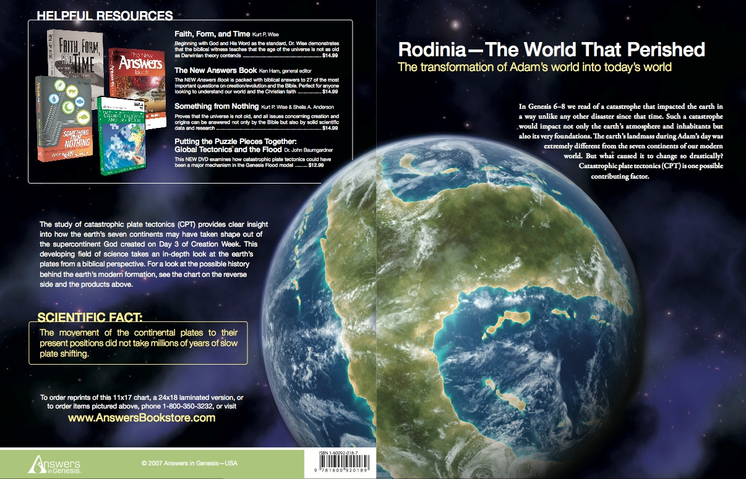

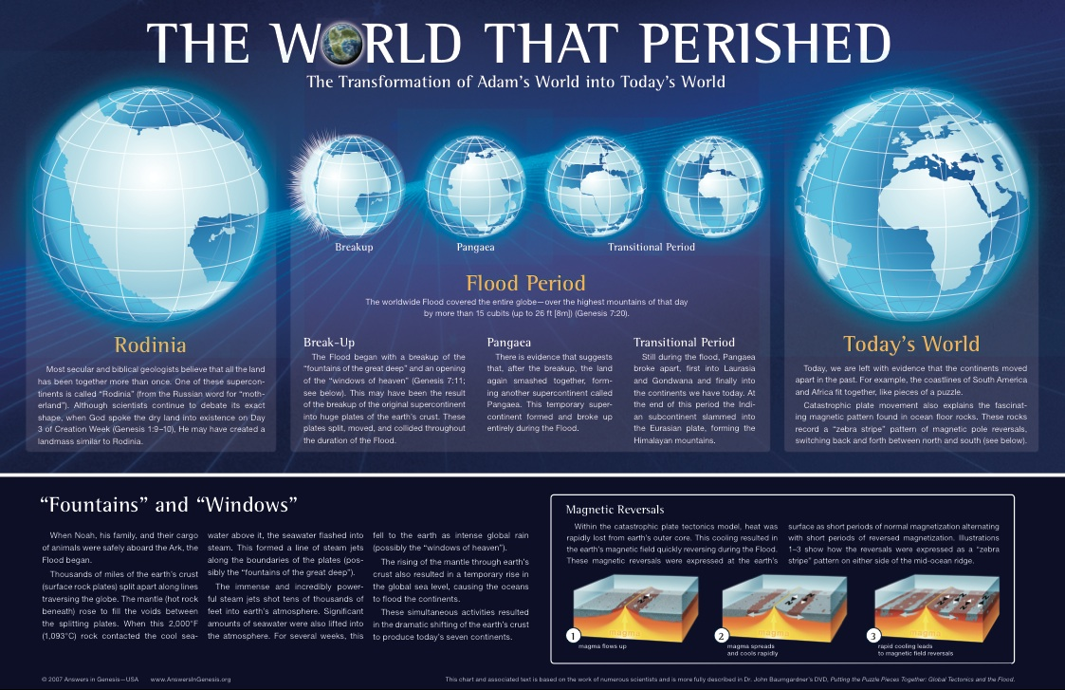

4. Question: Will the “new heaven and new earth” have the same stars as our present solar system? The new Jerusalem will not need the sun or moon to provide light (Rev. 21:23; 22:5) since this is provided by God. But does this mean that stars, planets and moons will not even exist as part of the entire new creation?

Answer:

a. It is true that the text does indicate that the sun and moon are not needed in the new Jerusalem. However, it may be stretching it to imply that celestial bodies are not needed outside this city to illumine the new earth.

b. However, another way to look at the phrase “new heaven and new earth” is to take the two as identical. In other words, heaven will have come to earth:

Since God will make the new earth his dwelling place, and since where God dwells there heaven is, we shall then continue to be in heaven while we are on the new earth. For heaven and earth will then no longer be separated, as they are now, but will be one (see Rev. 21:1-3).”[9]

Response: Technically, God will not dwell on the new earth as Hoekema claims but in the new Jerusalem (Rev. 21:2-3, 10-11, 22-24).

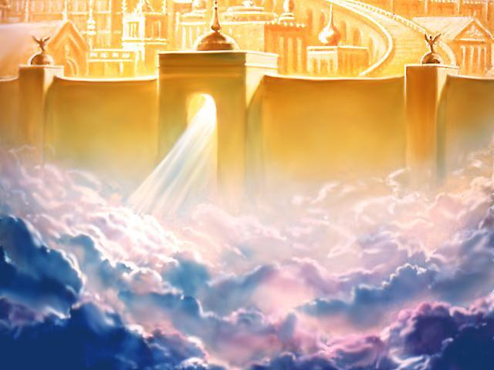

c. Up to this point in this study we have looked only in general at the relationship between the old heaven and earth to the new heaven and earth. But how do the heavenly designations relate to one another? It is difficult to tell from Revelation 21–22 the relationship between the new heaven (v. 1), the new earth (v. 1), heaven (v. 2), and the new Jerusalem (21:2–22:5).

1) Evidently each of these four are different parts, for the “new Jerusalem” comes down *out of heaven* (3:12; 21:2, 10), so it must be separate from it. (But this does not explain why God’s throne is in the new Jerusalem as in 22:1).

2) While “heaven” (v. 2) could be the same as the “new heaven” (v. 1), this also seems unlikely. Why would the present heaven itself need to be renewed or replaced? It would seem that the “new heaven” then refers to new galaxies.

3) Certainly the “new earth” (v. 1) is separate from the “new Jerusalem,” for the latter is a city rather than a planet. Some feel that this city will be so huge that it couldn’t be on the new earth (see next section) so it hovers above the actual city of Jerusalem on the renewed earth. Thus the new city actually serves as a satellite city from which the saints may come and go to and from the new earth.

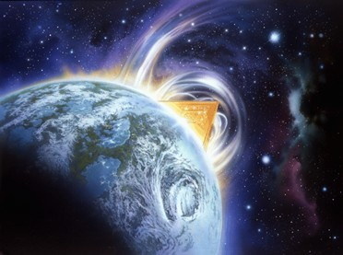

C. **The** **New Jerusalem**

1. *Figurative View*: Many scholars see this city as symbolic of the church (Morris, 242; Hendriksen, 199; Ladd, 276; Mounce, 370-71). These reasons are given:

1. The city is described as a “bride beautifully dressed for her husband” (21:2; see also vv. 9-10). Since the term “bride” often refers to the church (Isa. 54:5; Eph. 5:32; etc.), it would seem so here too (Hendriksen, 199). “Even in the Old Testament the Church is represented under the symbolism of a city (Isa. 26:1; Ps. 48; etc.)” (Hendriksen, 199).

Response: Contrary to popular belief, the church is never called the bride of Christ in the NT. Paul does use the husband-wife relationship to illustrate Christ’s love for the church (Eph. 5:32), but the word “bride” or “wife” is actually never used for the church. In fact, verses 9-10 denote the “bride” or “wife” as the new Jerusalem itself—not the church! Also, Isaiah doesn’t mention the church; this is reading the NT back into the OT. Even a casual glance at the above texts will show that they do not refer to the church but rather to Jerusalem (Ps. 48; Isa. 26:1) or Israel (Isa. 54:5). Finally, more than just the church will live in this city (Heb. 12:22-24) so it cannot be equated with the church. The inscription of the names of both the 12 tribes of Israel (21:12) and the 12 apostles (21:14) argue that both Israel and the church will inhabit the city—not simply the church.

b. “One wonders if John means to identify the heavenly Jerusalem with God’s redeemed people, even as the church is likened to the temple of God in the New Testament (1 Cor. 3:16; Eph. 2:21)” (Ladd, 276-77).

Response: The church is indeed called a temple (Eph. 2:21), but it is composed of believers each of whom is also a temple (1 Cor. 6:19). However, just because it is called a temple in the epistles does not mean that it is a city in Revelation. The epistles do not contain detailed descriptions like John has here. If it is not to be taken literally, then why all the very physical depictions, including walls, pearls, specific jewels, and even measurements?

c. The city and the bride are said to be one and the same. An angel told John, “‘Come, I will show you the bride, the wife of the Lamb.’ And he carried me away in the Spirit to a mountain great and high, and showed me the Holy City, Jerusalem, coming down out of heaven from God” (21:9b-10).

Response: The above observation (bride = city) is true. The problem is the identity of the bride. As noted earlier, the church is never called the bride of Christ. Also, Hebrews 12:22 clearly distinguishes the new Jerusalem from its inhabitants: “But you have come to Mount Zion, to the heavenly Jerusalem, the city of the living God…” Then the city and its inhabitants—angels, the church, OT saints (cf. Heb. 11:10), God, Christ—are specified in Hebrews 12:22-24 as separate.

d. “There is a good deal of vivid description, sometimes of a very material kind. But when John speaks of streets paved with gold, of a city whose gates are made of single pearls, and the like, we must not understand him to mean that the heavenly city will be as material as present earthly cities. It is his way of bringing out the important point that the ultimate state of affairs will be very precious. He is concerned with spiritual states, not with physical realities” (Morris, *Revelation*, 242).

Response: Morris’ “sometimes of a very material kind” is a gross understatement. The *whole chapter* speaks of physical realities! The spiritualized view runs into great problems concerning authorial intent too. Would the original readers have spiritualized these things? I doubt it. Are we then arguing against a physical heaven like eastern mystics? Hopefully even those who argue against a literal view of the new Jerusalem still believe heaven is a literal place. We only have one physical description of heaven, so we must be careful not to throw it away so easily.

e. Conclusion: The spiritualized view of the new Jerusalem is unlikely. Evidence for a literal view is clear from the following (some of this is review from above):

1) Physical measurements and specific descriptions (gates, walls, etc.) are given.

2) The city is called the bride but the church is not.

3) The city and its inhabitants are distinguished (Heb. 12:22).

4) The original readers would most likely have interpreted this literally.

5) Even those who argue *against* a literal view here generally believe in a literal heaven (though they deny that this description is it).

6) The alternate interpretations (i.e., that this is the church, all the redeemed, etc.) do not have contextual support either here or elsewhere in the NT.

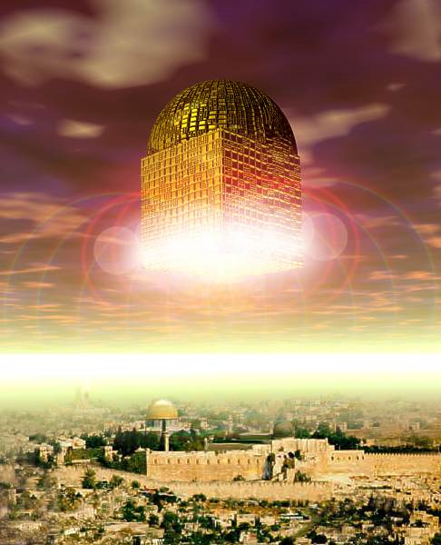

2. *Literal View*: A more natural view of the text takes the passage at face value (Walvoord, 313, 323-24; Ryrie, 120-22; Paul Lee Tan, *A Pictorial Guide to Bible Prophecy*, 210; Hal Lindsey, *There’s a New World Coming*, 289). It says it is a city, so why not?

a. Names: Besides the “new Jerusalem,” this city has several other titles:

• the bride (Rev. 21:9a)

• the wife of the Lamb (Rev. 21:9b)

• Jerusalem (Rev. 21:10)

• the Holy City (Rev. 21:2, 10; 22:19)

• Mount Zion (Heb. 12:22a; Rev. 14:1)

• the Heavenly Jerusalem (Heb. 12:22b)

• the city of the living God (Heb. 12:22c)

• the dwelling of God (Rev. 21:3) or “tabernacle of God” (NASB)

• the city of my God (Rev. 3:12), “my” referring to Jesus

• the heavenly country (Heb. 11:16a)

• the city (Heb. 11:16b)

Note that the numerous references to the city argues for a specific, literal city.

b. Inhabitants: Who will dwell in the new Jerusalem? Hebrews 12:22-24 mentions this city and then seems to give a rather full list of its inhabitants, although they are not specifically designated as such. These are listed in the following order:

1) *God* (v. 22a): The first thing John noted about this city is that it came from God in heaven so that God himself will dwell with men (Rev. 21:2-3). This wonderful aspect is often overlooked in our many questions about heaven. The best selling point for heaven is that we will be with God!

2) *Angels* (v. 22b): These number “thousands upon thousands of angels in joyful assembly.”

3) *Church Saints* (v. 23a): Each has his or her name written in the book of life (cf. Rev. 20:15).

4) *Redeemed Outside the Church Age* (v. 23b): These “spirits of righteous men made perfect” are distinguished from the church and probably mean those redeemed before Pentecost (Noah, Abraham, Rahab, etc.) and those saved in the Tribulation (Rev. 6:9-11; 7:1-17; 20:4).

5) *Christ* (v. 24a): He is noted as the mediator of a new covenant. John elsewhere promised that when we see him we shall be like him (1 John 3:2).

Question: If all these people are living in the city, then who lives in the new earth? and the new heavens? Or are these places simply locations to which we can make excursions from our “headquarters” at the new Jerusalem? This is boggling to even think about but we don’t have enough data to answer with any certainty.

c. Time: Will the heavenly Jerusalem exist only during the eternal state or during the millennium as well? Some advocate that the new Jerusalem will be present during the 1000 year millennium (e.g., Lindsey, 289; Pentecost, *Things to Come*, 577; William Kelly, *Lectures on Revelation*, 459f., and *Exposition of Revelation*, 248f.). Ryrie agrees, for while Revelation 21:1–22:5 relates to the eternal state,

[Some commentators] feel that 21:9-21 reverts to a description of the millennial state. This would seem incongruent with the chronological pattern of the book and this section. Perhaps the best way to understand this entire section is to regard the new Jerusalem as the abode of the redeemed of all ages. Conditions within the new Jerusalem are conditions of eternity. Of course the redeemed will be inhabiting the city during the millennium as well as during eternity. Always the conditions within the city are eternal, even when the city is related to the millennium… [21:9-27] describes the city’s relation to the millennial state. In other words, there seem to be two descents of the city, 21:1-8 being the one in relation to eternity and 21:9–22:5 the one in relation to the millennium (Ryrie, 118, 120)

Support:

1) It would seem inappropriate for the church to have been raptured and living with Christ for seven years which is followed by 1000 years on the old earth again. This would also be a major “let down” for believers!

2) Some factors in Revelation 21:9–22:5 seem to indicate a millennial rather than eternal scene:

a) The descent of the city is noted twice. All agree that the first descent in verse 2 relates to the eternal state since the earth will have no sea. In contrast, many millennial passages mention bodies of water. It is possible that the second descent (v. 9) denotes a different time period, if contextual factors support it.

b) The kings of the earth bringing their splendor into the heavenly city (Rev. 21:24, 26) is parallel to the same happening with the earthly Jerusalem (Zech. 14:16-19).

c) Leaves for the healing of the nations (22:7) would hardly be needed in the eternal state but would be handy in the millennium.

3) The book of Revelation is mostly chronological, but certain exceptions do occur. Some events in chapter 17 actually occur before some preceding chapters. Thus it is not totally out of character that 19:9f. occurs before 19:1-8.

Response:

1) Ryrie notes that the redeemed of all ages will live in the city. This logic would also imply that the same is true of the present—that all saved people who have died presently live in the city.

2) It is best to argue for a chronological approach unless clear factors mitigate against it. The city is not revealed until after the millennium (20:1-6), judgments (20:7-15), and creation of the new heaven and new earth (21:1).

3) Other passages relating to the millennium note that believers will reign with Christ not from the suspended city, but will reign on the earth (Rev. 5:10; 20:4-6). However, we also will reign from the new Jerusalem as well (22:5), though these are in two different time periods.

4) The description of the city in 21:2 matches that of 21:9, so the natural reading is that both relate to the same event.

5) The implication that no temple exists during this time (21:22) is inconsistent with the millennial age when Ezekiel’s temple will be on earth (Ezek. 40–43).

6) We do not know whether a return to a millennial earth after seven years with Christ in heaven will actually be a “let down” for us. After all, Christ himself will be reigning and we will reign with him.

7) The kingly splendor (21:24) finds a parallel to millennial descriptions, but just because the descriptions are similar, it does not mean they are the same. One clear difference is that Zechariah clearly had in mind the earthly Jerusalem whereas John’s vision related to the heavenly city.

8) Leaves for the “healing of the nations” (22:2) do not necessitate a millennium. The word here should be understood as “health-giving” since the root meaning carries the idea of serving or ministering. “In other words, the leaves of the tree promote the enjoyment of life in the new Jerusalem, and are not for the correcting of ills which do not exist…as indicated in verse 3” (Walvoord, 330).

9) It is not unthinkable that mortal and immortal believers could live together on the earth with the latter living in a separate place. Jesus mixed with his disciples for 40 days in his glorified body, so by God’s grace we could do the same.

Conclusion: It appears that the new Jerusalem will be in the eternal state and not in the millennium.

d. Size: Ancient people needed a city to guarantee security, so some scholars feel this “description of the church” in the form of a city of enormous size was given to comfort believers. However, this still doesn’t answer where believers will be for eternity. Is not a literal place needed to inhabit the saved from all ages? And would not heaven have to be very large (literally)! Just how large is it?

1) *City Size:* The width and length are equal at 2200 kilometers (Rev. 21:16). This is the same distance from Singapore (south) past Borneo to Sulawesi (east) to Manila (north) to China (west)! Such a city has never even been dreamed of being built on earth, for this place is roughly half the size of all southeast Asia!

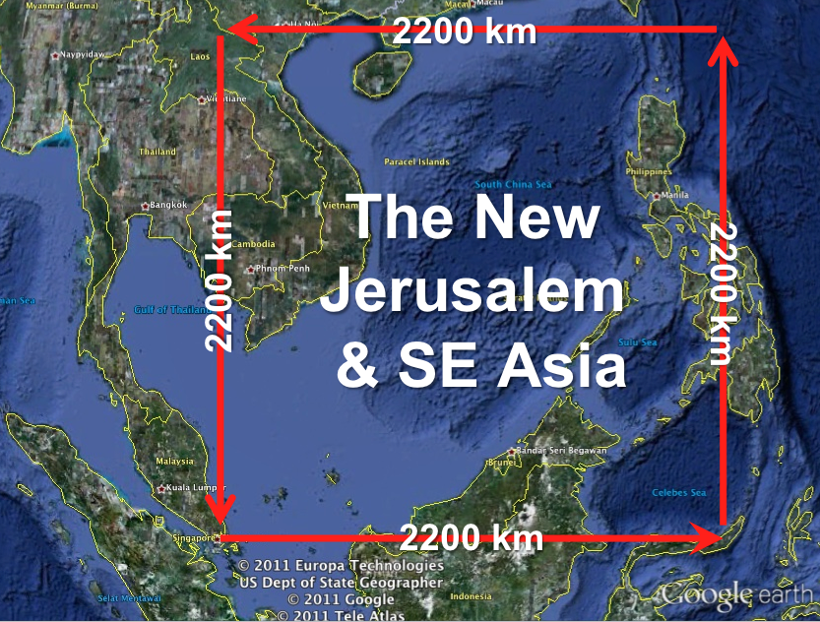

2) *Wall Size:* The wall measurement is 144 cubits or 65 meters (216 feet). But no adjective appears to show whether it means “thick” (NIV text) or “high” (NIV margin; Ryrie, 121). If “thick” is correct and the walls extend to the top of the city this would make the wall 11,616,000 feet high (2200 kilometers)! However, if the 65-meter reference is to the *height* of the walls, then the walls will extend up only 0.000018595% of the city height! Either case is beyond imagination.

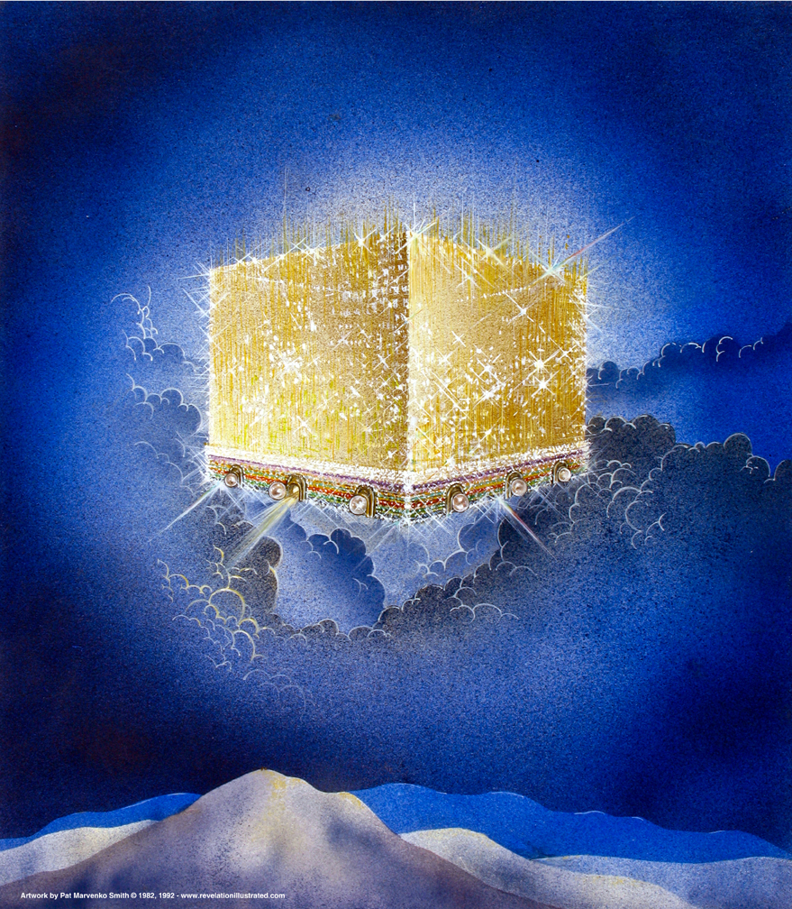

e. Shape: The height is the same as the width and length, but the actual shape of the city is not stated.

1) The three identical dimensions makes one think immediately of a cube—especially since it has walls (Rev. 21:12-14, 17-21; cf. Tan, 210). This also finds parallel in God’s earthly dwelling place within the cubed holy of holies in the tabernacle (Exod. 26:15?) and Solomon’s temple (1 Kings 6:20).

2) However, some see it as a pyramid shaped city (Hoyt, 226; cf. Walvoord, *Millennial Kingdom,* 334):

Christ, the chief cornerstone (Eph. 2:20), will appear at the top where the throne of God will be located, and from which there will issue the river of pure water (Rev. 22:1). From this point too will issue the light that floods the city and the surrounding region (Rev. 21:23).

3) J. Vernon McGee thinks that the city is a cube in space within a crystal sphere:

Several times attention is called to the fact that the city is like a crystal-clear stone or crystal-clear gold. This emphasis leads us to believe that the city is seen through the crystal. We live *outside* the planet called earth, but the Bride will dwell *within* the planet called the New Jerusalem. The glory of light streaming through this crystal-clear prism, will break up into a polychromed rainbow of breath-taking beauty (*Reveling Through Revelation*, 2:104-5).

Conclusion: The arguments for a pyramid shape could as easily be applied to a cube, but high walls seem out of place with a pyramid. McGee’s view is also unlikely as the *city itself* is clear as crystal (21:11) and no sphere is noted. It appears that the traditional cube shape is a better option.

f. Colors:

1) General: The overall impression of the city is indescribable, but John did his best: “It shone with the glory of God, and its brilliance was like that of a very precious jewel, like a jasper, clear as crystal” (21:11).

2) City: Gold as “pure as glass” or “like transparent glass” is used for both the buildings (v. 18b) and the street (v. 21b). While hues abound, yet everything has a sense of translucence—after all, there will not be any reason to hide anything! “Also, no one wants to be out of sight of Jesus for very long, and this way you can see Him twenty-four hours a day!” (Lindsey, 292).

3) Wall: The wall is made of jasper alone (v. 18a).

4) Gates: White is prominent since each of the twelve gates is made from a single pearl (21:21). Some who deny the literal view question the “size of the oyster” but this only shows their lack of confidence in God’s abilities.

5) Foundations: The foundations are made from 12 precious stones (Rev. 21:19-20). It seems that God likes green as the foundation is probably green more than any other colour. However, several of these stones come in a variety of hues, with the following options (numbers refer to layer in the foundation):

|  |  |  |  |  |  |  |  |  |
| --- | --- | --- | --- | --- | --- | --- | --- | --- |
| **Layer** | **Stones/Hues** | **Clear** | **Green** | **Blue** | **Red** | **Yellow** | **Brown** | **Purple** |
| Wall | Jasper (v. 11) | x |  |  |  |  |  |  |
| 12 | Amethyst |  |  |  |  |  |  | x |
| 11 | Jacinth |  |  | x | x |  |  |  |
| 10 | Chrysoprase |  |  |  |  |  |  |  |
| 9 | Topaz |  | x | x |  | x |  |  |
| 8 | Beryl |  | x | x |  |  |  |  |
| 7 | Chrysolite |  | x |  |  | x |  |  |
| 6 | Carnelian |  |  |  | x |  |  |  |
| 5 | Sardonyx |  |  |  | x |  | x |  |
| 4 | Emerald |  | x |  |  |  |  |  |
| 3 | Chalcedony |  | x |  |  |  |  |  |
| 2 | Sapphire |  |  | x |  |  |  |  |
| 1 | Jasper | x |  |  |  |  |  |  |

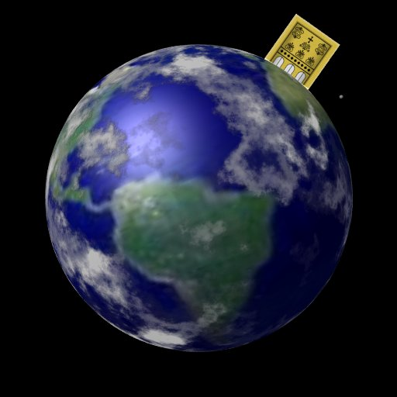

g. Location: Does the city rest on earth or is it suspended above the earth? Some point to the foundations as evidence that it will rest on the earth (Lindsey, 289).

However, others note that the new Jerusalem will hover over the earth as a satellite city (Walvoord, 312-13; Pentecost, *Things to Come*, 577). If indeed this heavenly city exists during the millennium with the present Jerusalem still existing, it seems likely that the new city will be at the spot of the old, though not squashing it! While the city is seen descending to the earth (Rev. 21:2, 10) it is never stated that it actually reached earth. This may also explain how believers with mortal bodies (who lived through the Tribulation) could live on earth at the same time as those in glorified bodies. The latter would dwell in the suspended city.

h. God’s Presence takes the place of any temple (Rev. 21:22), where he formerly dwelt on earth prior to the giving of the Holy Spirit. We will serve him and actually see him face to face (22:3-4). The traditional view of heaven sees *us as going up* to God, but Scripture records *God as coming down* to dwell with us (21:3)!

i. The River of Life flows from the throne of God (Rev. 22:1-5), presumably at the top of the city. Evidently the same tree of life that used to be in the Garden of Eden (Gen. 3:22, 24) is large enough to straddle the river that flows from “Main Street.” Incidentally, this is the only street mentioned in connection with the city.

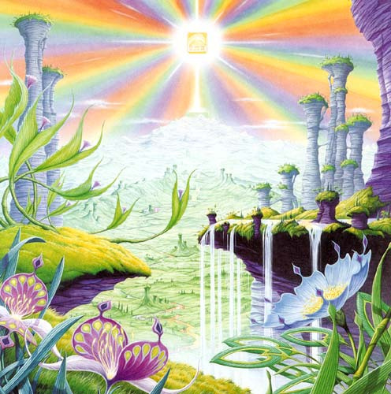

D. **Will There Be Degrees of Reward in Heaven?**

1. Most Christians assume varying degrees of reward in the new Jerusalem. (Actually the Bible emphasizes millennial rewards more than in the eternal state; cf. Joseph Dillow, *The Reign of the Servant Kings*). Yet it does seem to teach heavenly degrees of reward:

a. John encouraged a woman to deny hospitality to false teachers so that she could “receive a full reward” (2 John 8). This would indicate that a reward of a lesser degree was possible due to her action. In fact, he warns her, “Watch out that you do not lose what you have worked for…”

b. Certain rewards are promised people who serve in various capacities (cf. rewards and crowns below on this page). This would mean that those who do not do them would not receive these particular rewards. Therefore, the reward is not equal for all. In this light, Paul noted, “The Lord will reward everyone for whatever he does, whether he is slave or free” (Eph. 6:8).

2. What is the nature of the heavenly rewards? What will these rewards be like?

a. Rewards of Responsibility (cf. W. A. Criswell and Paige Patterson, *Heaven*, 208-14)

1) In Luke 19:11-27 (Parable of the Ten Minas) Jesus taught that before going on a journey, a nobleman gave each of his ten servants the same amount of money—one mina each. Upon returning, the master rewarded each accordingly with differing degrees of responsibility based on their faithfulness.

2) Matthew 25:14-30 (Parable of the Talents) records a similar story, except each man received a different amount of money to invest for his master (the one who buried his master’s money depicts an unsaved man, v. 30). This parable also depicts varying degrees of reward: “His master replied, ‘Well done, good and faithful servant! You have been faithful with a few things; I will put you in charge of many things. Come and share your master’s happiness’” (v. 21).

b. Rewards of Possession

1) Five crowns (*stephanos*) are noted as personal possessions in heaven (cf. p. 76). Thesecrowns are not kingly crowns (*diadems*) but victor’s wreaths made of vines or leaves (or even gold and silver in the form of a garland or wreath):

a) An *incorruptible crown* is for those who master their flesh (1 Cor. 9:25).

b) A *crown of hope or joy* is for those who bore fruit in others’ lives for Christ (1 Thess. 2:19). This is sometimes called the soul-winner’s crown.

c) A *crown of life* is for believers who patiently endure trials and suffering (James 1:12; Rev. 2:10).

d) A *crown of righteousness* is for one longing for Christ’s return (2 Tim. 4:8).

e) A *crown of glory* rewards spiritual shepherds who feed the flock (1 Pet. 5:4).

2) We too often view ownership as sinful, though this is not scriptural.

a) As joint-heirs with Christ (Rom. 8:17; Heb. 1:2), we own what He owns! This is joint-ownership in a communal sense but “to deny private property inevitably ends in denying privacy” (Gilmore, 302) much like the mystical idea of blending into the “Total One.” Ownership in heaven will not include the sinful possessiveness of earth.

b) We have a heavenly inheritance which is “imperishable and undefiled, and will not fade away, reserved in heaven for you” (1 Pet. 1:4 NASB).

3. However, a recent article argues against levels of reward (Craig L. Blomberg, “Degrees of Reward in the Kingdom of Heaven?” *Journal of the Evangelical Theological Society* 35 [June 1992]: 159-72). He provides some interesting thoughts:

a. The vineyard worker parable teaches that each worker received the same pay no matter how long he worked (Matt. 20:1-16). This teaches that all believers are rewarded equally since all receive pay by grace. The ending, “the last shall be first, and the first, last” (v. 16), means that all positions in heaven are interchangeable.

Response: Do they indeed receive pay by grace? In each case the pay was for work, not faith. The main point that “the last shall be first, and the first, last” (v. 16) may better indicate that God’s system of ranking people in heaven differs from that which man uses on earth.

b. Scholars do not agree on the form these differing heavenly rewards will take. Suggestions include capacity for service, added responsibilities, degree of bliss, possessions, and an enriched relationship with God.

Response: Our ignorance of the type of reward does not deny its existence (see preceding discussion for more details on types of reward).

c. If heaven is perfection, how can there be varying degrees of perfection?

Response: This may seem inappropriate from our vantage point since we are not God, but he has made many perfect things which differ in quality even in our present world. For example, plants are perfectly made yet less durable than jewels.

d. Blomberg considers passages generally used to teach rewards not convincing.

1) The crown passages speak of the reward of eternal life itself, not something in addition to it (1 Cor. 9:25; 1 Thess. 2:19; 2 Tim. 4:8; Jas. 1:12; 1 Pet. 5:4). [But this does not seem to be the normal reading of each passage.]

2) The texts about those who are the “least” or “greatest” relate only to the “present aspects of the kingdom” (Matt. 5:19; 11:11; 18:4; Mark 9:34-35; Luke 9:48). [No, for people here are compared with the least of the people there.]

3) The quality of each man’s works and their rewards (1 Cor. 3:11-15) relates to degree of shame or satisfaction at the judgment (cf. 1 John 2:28), not the lasting results of it which persist for all time in an everlasting hierarchy. [Even this is not correct, since verse 14 declares that “if what he has built survives, he will receive his reward.” It is true that the nature of the reward is not stated, so the belief that it is merely momentary satisfaction may be true or false—no one knows. However, 2 Corinthians 5:10 does indicate that each will be judged for his deeds and “will receive what is due him.”]

Other arguments of Blomberg should be considered. This article is worth reading. Perhaps we need to re-evaluate long-held views in this area.

E. **How Will Our Bodies Be Different Than They Are Now?** This is a mystery somewhat, but here’s some of my personal opinions…



1. We will have individual places for each believer to live (John 14:2)! The old KJV translation “in my Father’s house are many mansions” is unfortunate as the word simply means “dwelling places” (NASB) or “rooms” (NIV). Since the new Jerusalem is far from being a literal “house” (as it is a city), we will have neither rooms in a mansion nor “mansions in a house.” What kind of structure in the city we will live in is unstated. Perhaps more faithful ones will have better HDB flats (Heaven Development Board)!

2. We will have an ability to eat (Rev. 19:9?; 22:2?) but no need to do so!

3. We will be able to transport ourselves by thought as Jesus did in His glorified body (Luke 24:36).

Disagreeing with this is Hoyt, 229-31, who believes that saved humanity in the eternal state will be composed of two basic groups:

a. *Glorified (resurrected) saints* include…

1) Members of the Church in glorified (transformed) bodies (1 Cor. 15:51-54)

2) Old Testament saints and martyred tribulation saints whom “will experience glorification by resurrection (Rev. 20:4-6; Dan. 12:2; Isa. 26:19-21)” and a “special relation to the New Jerusalem (Heb. 12:22-24)” (Hoyt, 230)

b. *Mortal (unresurrected) saints* who will be saved in the Tribulation and enter the millennium in mortal bodies. Hoyt says that in heaven they’ll lack the sinful nature that they had in the millennium and still have the ability to procreate in their natural bodies on the new earth. Perhaps Isaiah 60:19-22 supports this.

Response: Hoyt correctly notes that the Scripture does not say that the unresurrected millennial redeemed will receive transformed, glorified bodies. However, he assumes (though unstated as an assumption) that God annihilates their sinful nature which is active in the millennium. I feel that the transformation of their bodies into glorified bodies is just as likely as the elimination of their sinful nature—both about which Scripture remains silent. Also, angels and people are not married in heaven (Matt. 22:30). Finally, death will still be possible for those with mortal bodies in the millennium (Isa. 65:20), but Hoyt assumes death will happen only to non-Christian children of those believers entering the millennium from the Tribulation.

4. We will have the ability to recognize one another (same race, sex, color): Don’t worry, you will still be Chinese! Many dispensationalists teach that the distinction between Israel and the church continues even throughout the eternal state (e.g., Hoyt, 232-33). Hoyt says that the church will have the highest position, OT and Tribulation saints second highest, and then those in natural bodies include Israel and the Gentiles. I need more study here, especially on the various heavenly groups in Hebrews 12:22-24.

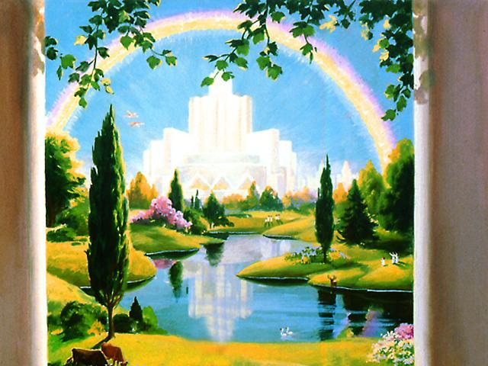

F. **What Will We Do in Heaven?** How will we occupy our time?

1. Oftentimes our focus is upon rest. Perhaps that’s because we work too hard here! (When I ask Singaporeans, “How are you?” most respond, “Busy” or “Tired.”)

2. It is true that Scripture refers to death as rest (Gen. 47:30; 1 Kings 1:21; Ps. 16:9; Dan. 12:13; Rev. 14:13).

3. However, the focus of Scripture is not rest, but service in heaven—restful work! Remember that Adam in the Garden of Eden was given purposeful work even before the Fall. In other words, work itself is not a curse—it’s those cursed weeds that make the toil so hard. Service has always been part of heaven’s environment.

a. The angels’ job description is service. They don’t just float around doing nothing!

1) “Are not all angels ministering spirits sent to *serve* those who will inherit salvation?” (Heb. 1:14). This ministry of service for God by ministering to man includes delivering messages to those on earth (Luke 1:11-20, 26-38).

2) Angels also serve God through *worship* (Isa. 6:3; Rev. 4:8-11; 5:8, 14), *singing* (Rev. 5:9-13; 15:1-4), and other ways. Since they are primarily servants, they refuse people to worship them (Rev. 22:9; cf. Col. 2:18).

b. The redeemed will also serve him in heaven:

1) “His servants will *serve* him” (Rev. 22:3b).

2) “They will *reign* forever and ever” (Rev. 22:5b).

3) “Jesus replied, ‘No one who puts his hand to the plow and looks back is fit for *service* in the kingdom of God’” (Luke 9:62).

4) “…they are before the throne of God and *serve* him day and night in his temple; and he who sits on the throne will spread his tent over them” (Rev. 7:15).

5) “and has made us to be a kingdom and priests to *serve* his God and Father —to him be glory and power for ever and ever! Amen” (Rev. 1:6).

6) “You have made them to be a kingdom and priests to *serve* our God, and they will reign on the earth” (Rev. 5:10).

7) The redeemed will also sing (presumably in key, finally, for some!):

a) “Then I heard every creature in heaven and on earth and under the earth and on the sea, and all that is in them, *singing:* ‘To him who sits on the throne and to the Lamb be praise and honor and glory and power, for ever and ever!’” (Rev. 5:13).

b) “And [the 144,000 redeemed Jews] sang a new song before the throne and before the four living creatures and the elders. No one could learn the song except the 144,000 who had been redeemed from the earth” (Rev. 14:3).

A Heavenly Advertisement

Free Beautiful Homes

To Be

Given Away

In a

Perfect City

with––

100% Pure Free Water

No Light Bulbs

Perpetual Lighting

Permanent Gold Pavement

Nothing Undesirable

Everything New

Perfect health

Immunity from Accidents

The Best of Society

Beautiful Music

Free Transportation

Secure a Contract Today—

For the New Jerusalem

There still remains *much* about heaven that we do not know and will not know until we arrive. In the meantime let’s praise God our place is reserved and say…

**“Amen! Come Lord Jesus!”**

**(Revelation 22:20)**

**Traditional versus Biblical Views of Heaven**

|  |  |
| --- | --- |
| **Traditions on Heaven** | **The Bible on Heaven** |
| Man dwells with God | God dwells with Man (Rev. 21:3) |
| We go to heaven | Heaven comes to us on Earth (Rev. 21:2) |
| Our bodies have wings | Our bodies are like Christ’s without wings (Luke 24:39-43; 1 John 3:2) |
| Live in clouds | Live in city (Rev. 21:2–22:6) |
| No Earth | New Earth (Rev. 21:1) |
| Peter at the gate | 12 angels at 12 gates (Rev. 21:12) |
| No animals | Animals (Rev. 19:11, 14)? |
|  |  |

**Does Major Sin Prove a Person is Unsaved?**

Rev 21v8 Wilkin Article

*Outline continued from major point “D” on page 443…*

E. (22:6-21) The conclusion to the prophecy reminds the readers that Jesus Christ’s coming is imminent that they might be ready to meet Him unashamedly.

**God guards His Word by judging those who tamper with it**

**A Stern Warning (22:18-19)**

**"I warn everyone who hears the prophecy of this book:**

**• If anyone adds anything to them, God will add to him the plagues described in this book.**

**• If anyone takes words away from this book of prophecy, God will take away from him his share in the tree of life and the holy city, which are described in this book"**

# Possible Applications

### Text

**The New Jerusalem**

***Revelation 21–22***

**Exegetical Outline (Steps 2-3)**

# *Exegetical Idea*: The reason God shows himself living with us in our eternal home in the New Jerusalem is to live for him in light of the imminent return of Christ.

# I. The uniqueness of our wonderful, eternal home in the New Jerusalem is that it will be where God once again lives with man (21:1–22:6).

## Unity: The new heaven and earth without seas separating men will be created since the first heaven and earth had passed away (21:1).

## The New Jerusalem shows God dwelling with man (21:2–22:6).

### The New Jerusalem will descend to earth so that God can once again dwell with man (21:2-11).

### It will have protection (wall), access for Israel (gates), and access for the church in its foundation (21:12-14).

### The 2200-kilometer cube will recall God’s presence in the Holy of Holies (21:15-16).

### The wall, foundation, gates and street will be made of precious materials (21:17-21).

### It will be lit by the presence of God (21:22-27).

### Its tree of life will be on the banks of the river of life (22:1-6).

# II. The reason God shows himself living with us in our eternal home in the New Jerusalem is to live for him in light of the imminent return of Christ (22:7-21).

## Christ *encourages* us to live as if he can come any moment (22:7-17).

### His *first* announcement of his soon return promises *blessing* for obedience (22:7-11).

### His *second* announcement of his soon return promises *reward* for obedience (22:12-17).

## Christ *warns* of adding to or subtracting from this prophecy (22:18-19).

## Christ *promises* us his imminent coming and grace (22:20-21).

### His *third* announcement of his soon return promises assurance *that Christ indeed gave this prophecy* (22:20a).

### John replied to affirm Christ’s return and grace (22:20b-21).

**Purpose or Desired Listener Response (Step 4)**

The listeners will serve Christ in light of their fantastic future until he returns.

**Homiletical Outline** (Cyclical inductive form)

# Introduction

### Interest: The old adage says, “There’s no place like home.”

### Need: *Why* do you want to go home?

### Intro to MPI: How much more is this true of our eternal home! What is the greatest truth about your eternal home?

### Background: The entire Bible is the background to these chapters. It shows a chiasm of man ruling with God (Gen. 1–2), God seeking to restore man to that rule (Gen. 3–Rev. 20), and now the rule finally restored in the final two chapters.

### Preview: Let’s see what our eternal home will be like (description) and then how we should live in response (prescription).

### Text: Revelation 21–22 tell us the best truth about our eternal home.

(So what will our eternal home be like? How can we sum it up?)

# I. God will once again live with man (21:1–22:6).

## The new heaven and earth without seas separating men will be created since the first heaven and earth had passed away (21:1).

## The New Jerusalem shows God dwelling with man (21:2–22:6).

### The city will descend to earth for God to dwell with man again (21:2-11).

### It will have protection (wall), access for Israel (gates), and access for the church in its foundation (21:12-14).

### The 2200-kilometer cube will recall God’s presence in the Holy of Holies (21:15-16).

### The wall, foundation, gates and street will be made of precious materials (21:17-21).

### It will be lit by the presence of God (21:22-27).

### Its tree of life will be on the banks of the river of life (22:1-6).

(This tremendous truth of God living with us should impact us immensely. What should our response be? We should…)

# II. Live in light of the end (22:7-21).

## Christ *encourages* us to live as if he can come any moment (22:7-17).

### His *first* announcement of his soon return promises *blessing* for obedience (22:7-11).

### His *second* announcement of his soon return promises *reward* for obedience (22:12-17).

## Christ *warns* of adding to or subtracting from this prophecy (22:18-19).

## Christ *promises* us his imminent coming and grace (22:20-21).

(How can we sum up these two final chapters of the Bible?)

# Conclusion

### Christ living with us encourages us to live for Christ (Main Idea).

### God’s presence in the New Jerusalem helps us serve Christ until his imminent return (MI restated). Do you focus on God’s presents or God’s presence?

### MPs: God will once again live with us so we should live for him in light of the end!

### Questions to Consider:

#### Have you come to the water? Jesus invites you to drink freely!

#### Do you long for Christ’s return? Why or why not?

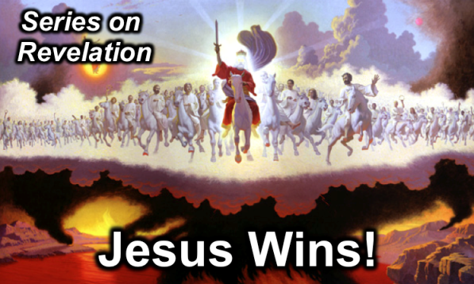

**Rick Griffith**

4 May 2014

Message 20 of 20

**The New Jerusalem**

***Revelation 21–22***

# Introduction

### The old adage says, “There’s no place like home.”

### What is the _______________ _____________ about your eternal home?

# I. God will once again _____________ with man (21:1–22:6).

## The new heaven and earth without seas separating men will be created since the first heaven and earth had passed away (21:1).

## The New Jerusalem shows God dwelling with man (21:2–22:6).

### The city will descend to earth for God to dwell with man again (21:2-11).

### It will have protection (wall), access for Israel (gates), and access for the church in its foundation (21:12-14).

### The 2200-kilometer cube will recall God’s presence in the Holy of Holies (21:15-16).

### The wall, foundation, gates and street will be made of precious materials (21:17-21).

### It will be lit by the presence of God (21:22-27).

### Its tree of life will be on the banks of the river of life (22:1-6).

# II. Live in light of the ___________ (22:7-21).

## Christ *encourages* us to live as if he can come any moment (22:7-17).

## Christ *warns* of adding to or subtracting from this prophecy (22:18-19).

## Christ *promises* us his imminent coming and grace (22:20-21).

# Conclusion

### ______________ living with us encourages us to live for ____________ (Main Idea).

### Have you come to the water? Jesus invites you to drink freely!

### Do you long for Christ’s return? Why or why not?

The Consummation of All Things

|  |  |
| --- | --- |
| **Genesis 1–3** | **Revelation 20–22** |
| “In the beginning God created the *heavens and the earth”* (1:1) | “Then I saw a *new heaven and a new earth”* (21:1) |
| Fellowship with God *broken* (3:8-10) | Fellowship with God *resumed* (21:3) |
| “In the day you eat of it you will surely *die”* (2:17) | “There will be *no more death”* (21:4) |
| “I will greatly *multiply your sorrow”* (3:16) | “There will be *no more... sorrow* or crying or pain” (21:4) |
| Husband and wife (2:18-25) | Lamb and bride (19:6-9) |
| “God made *two great lights”* (sun and moon; 1:16) | “The city *does not need the sun or the moon”* (21:23) |
| “The darkness He called *night”* (1:5) | “There will be *no night* there” (21:25; 22:5) |
| Satan *appears* as deceiver of mankind (3:1) | Satan *disappears* forever (20:10) |
| *Initial* triumph of the *serpent* (3:13) | *Ultimate* triumph of the *Lamb* (20:10; 22:3) |
| Defilement *enters* the garden (3:6-7) | Defilement *never* *enters* the city (21:27) |
| Trees and rivers (2:8-14) | Tree and river (22:1-2) |
| *Prohibition* from the tree of life (3:24) | *Access* to the tree of life (22:14) |
| “*Cursed* is the ground because of you” (3:17) | “*No longer* will there be any *curse”* (22:3) |
| Man *driven from God's presence* (3:24) | “They *will see His face”* (22:4) |
| Man's dominion *broken* in the fall of the first man, Adam (3:19) | Man's dominion *restored* in the rule of the new man, Christ (22:5) |
| First paradise *closed* (3:23) | New paradise *opened* (21:25) |
| First rest for God (2:1-3) | Final rest for man (14:13) |

Adapted from Bruce Wilkinson and Kenneth Boa, *Talk Thru the Bible* (Nashville: Nelson, 1983), 515.

**Thought Questions:**

1. Read Revelation 21–22 out loud. Then contrast the “two women”:

|  |  |
| --- | --- |
| **Harlot (Rev. 17)** | **Bride (Rev. 21)** |
| Text | Text |
| Text | Text |
| Text | Text |
| Text | Text |
| Text | Text |
| Text | Text |
| Text | Text |
| Text | Text |
| Text | Text |

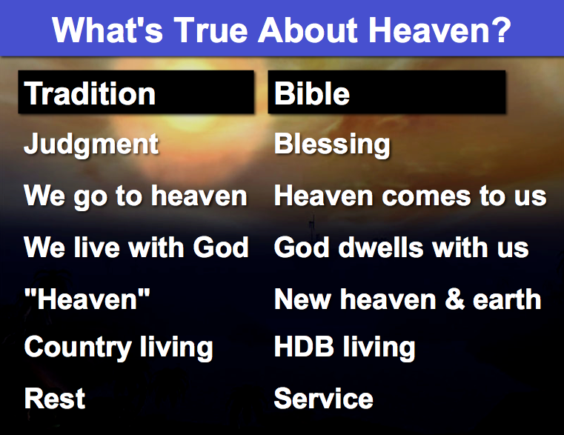

1. What traditions instead of the Bible have you believed?

Text

1. When you consider heaven, do you focus on God’s presents   
   or God’s presence? Why?

Text

Text

1. George N. H. Peters, *The Theocratic Kingdom*, 2:524-34, claims that Isaiah's "new heavens and new earth" refers to the eternal state because of the usage by Peter and John. However, he marshalls patristic and scriptural "evidence" but never discusses the passage at hand in Isaiah (this context is addressed in the next paragraph above).
2. Scholars who see the eternal state in view here include Rordorf, 46, n. 3; John L. McKenzie, *Second Isaiah*, AB, 200-201, 208, n. 22; Edward J. Young, *The Book of Isaiah*, NICOT, 3:536; Herbert Carl Leupold, *Exposition of Isaiah*, 2:378; Claus Westermann, *Isaiah 40–66*, 426-29. Nichol *et al.*, eds., *SDABC*, 4:332, 338, uses this text in an attempt to establish the perpetual obligation of the Sabbath, even in eternity. Sakae Kubo, *God Meets Man*, 65, agrees by stating that glorified believers in heaven will still meet every seventh day for worship.
3. John A. Martin, "Isaiah," *BKC*, 1:1120-1121; Feinberg, "The Sabbath and the Lord's Day," *BS* 95 (April-June 1938): 188-89; Unger, "The Significance of the Sabbath," *BS* 123 (January-March 1966): 59; Chafer, *Systematic Theology*, 4:111-12; id., *Grace*, 263; id., *Major Bible Themes*, rev. ed., 291. Bacchiocchi cites the verse as referring to "the Messianic age of the ingathering of all the nations" (*From Sabbath to Sunday*, 23). However, the official Adventist perspective on the Millennium sees it as a literal one thousand year period in which the righteous are in *heaven* judging angels and investigating the wicked deeds of the unrighteous in preparation for the Great White Throne Judgment. Simultaneously, Satan is bound *on earth* (not in the Abyss as in Rev. 20:3) which is unpopulated (*Questions on Doctrine*, 489-508). Ironically, though the major dispensational works mention no the Sabbath in the Millennium, many dispensationalists believe in a millennial Sabbath while Seventh-day Adventists do not.
4. Peters, 2:499-505, says by "new" Isaiah refers to an eternal and renewed earthly kingdom, noted in Rev. 21 (2:499).
5. R. N. Whybray, *Isaiah 40–66*, NCBC, 276, suggests that the prophecy "marks the beginning of a new radical theology, born of the despair of post-exilic life, which the apocalyptic writers later adopted and developed in even more critical times." This teaching dates chapters 40–66 many generations after Isaiah's time during the reign of Cyrus (*ca.* 538 BC; ibid., 20-22), and thus focuses on the time the prophecy rather than on its content.
6. Isaiah 66:22 makes a comparison between the endurance of new heavens and earth and the endurance of Israel, which may indicate that a specific time period is not in view here at all. However, if a time period is indeed envisioned, it certainly cannot be the eternal state for Israel will see bodies just slain by the LORD (66:17) and this will occur at the time of the celebration of the Sabbath and New Moon.
7. Sabbath observance will be true of both Jews (Isa. 56:2, 4-5, 8) and Gentiles (Isa. 56:3, 6-7; 66: 23; cf. Zech. 8:20-23). As uncomfortable as this may seem to the modern Sunday observer, this is what the authoritative text indicates. The Sabbath, although not in effect in the present dispensation, will again find divine approval in the next. This teaching also supports a premillennial view of Scripture, for Isaiah affirms that Israel has a future.
8. Nevertheless, Young suggests that worship in the new heavens and new earth (which he sees as heaven) "will be in accordance with and in observance of the prescribed seasons of the Old Testament dispensation” (Young, *Isaiah*, 3:536). Similarly, the *Seventh-day Adventist Bible Commentary* notes that "the Sabbath is an eternal institution” (Nichol *et al.*, eds., *SDABC*, 4:338). Kubo agrees by stating that glorified believers in heaven will still meet every seventh day for worship (Sakae Kubo, *God Meets Man*, 65).
9. Anthony Hoekema, *The Bible and the Future* (Grand Rapids: Eerdmans, 1979), 274.