Crossroads International Church Dr. Rick Griffith
Title
20 April 2014 Series on Revelation Message 18 of 20
NLT 40 Minutes
The Second Coming
Revelation 19:11-21

Topic: Second Coming
Subject: Why must Jesus return?
Complement: Jesus must return to claim his crown and defeat his enemies.
Purpose: The listeners will acknowledge Christ’s ultimate rule and power.
Meditation: Christ Our Life-Giver
Reading: 2 Peter 3:1-6
Song: “We Shall Behold Him” or “Jesus is Lord”

Introduction

Interest: Today we gather to celebrate Christ’s victory over death in his amazing resurrection! Death gave way to victory!
Empty Tomb

Still, many today doubt Jesus’s resurrection and return—and even attack them.
Attacks

Resurrection: The American Atheists are gathering in Salt Lake City this Easter weekend to challenge Christ’s authority seen in his resurrection—and thus his return.
Atheists

About 75 of them gathered two weeks ago to publicly resign from the Mormon Church.
March

It’s no accident that they meet today on Easter to show their contempt for the resurrection of Christ
People
Banner

They look like a sad lot to me—and they should be!

Return: Peter said that, the last days, scoffers would mock Christ’s return, creation, and the Flood (2 Pet. 3:3-6).
2 Pet. 3
(4 slides)

Still, almost half of Americans not only believe Jesus will return—they believe he will come back before 2050.
Pie Chart

Evidently half of the USA believes the return of Christ is important!

Need: Do you? Do you know why Jesus must come back?
Subject

Tell your neighbor why in the next 30 seconds.

Maybe the world doubts he will return because this is fuzzy in our thinking!

Subject: The OT saints looked to Christ’s first coming—and we look to his second coming. But why must Jesus return?
Focus

Background: The whole Bible and book of Revelation have been leading up to this climax of the book today!
• NT
• Why?

We are now after the three cycles of judgment in the seven-year Tribulation. That last cycle of bowl judgments was in Revelation 16.
Bowls
Cycles

Just before our text today the greatest entity of Satan—Babylon the Great, or the Great Prostitute—will be destroyed at the end of the future seven-year Tribulation (Rev. 17–18).
By Fire
Views
Harlot

No one knows for certain what this entity is—some say the world system, a religion, a city, or a nation—but we do know it has geographical boundaries, as it will be burned in an hour!

Earth will lament Babylon’s destruction but…
Mourns

This will then be followed by rejoicing in heaven, including the uniting of the Church finally with Christ in the image of a wedding (19:1-10).
Rejoices
Clouds

Christ will return to wed his bride, the church.

Like all weddings, a reception or wedding supper will follow.
Table
19:7-9

I think the wedding depicts the church in heaven with Christ during the terrible Tribulation calamities on earth—and the supper depicts the millennium to follow Christ’s return.
Clouds

Preview: But again, why must Jesus return? There are numerous reasons, but today we will focus on two key reasons Jesus must come back to earth.
• 2 reasons
Subject

Text: Revelation 19:11-21 gives us these two reasons.

(The first reason Christ must return is that…)

I. Christ must prove he is King (19:11-16).
MP
[Jesus needs to remove all doubt about his right to rule the earth.]
11
[All worldly authorities must give way as Christ alone can rule with integrity.]

Jesus will return as the Righteous Judge (19:11-12).
12

Douglas MacArthur uttered his famous “I will return” declaration when he had to withdraw from the Philippines. He was saying that, though he looked defeated at that point, he would come back as victor. He did! This is remembered today.
1942
1945
2014

How much more so this will be true of Jesus!

Jesus will return to Fulfill God’s Word (19:13).
13

Jesus will return as the Commander of Heaven’s Armies (19:14).
14

Jesus will return as the Ruling King (19:15-16).
15

As we saw earlier in this chapter, heaven will rejoice over the destruction of the world’s greatest systems. But that is still not enough.
16

Why? Jesus must still come and take his rightful place as ultimate King to set up his rule for 1000 years in the next chapter.
Future Benefits
MPI
(So the first reason Christ must return is to prove he is King. The remaining verses of chapter 19 show the second reason for the Second Coming, which is…)

II. Christ must prove he is Victor (19:17-21).
MP
[Jesus needs to remove all doubt about his power over his enemies.]

An angel will gather the world’s vultures to feast on the flesh of all men at the Battle of Armageddon (19:17-18). This is the Bible’s “Bird Feast.”
18
17

Christ’s simple word will throw Antichrist and the False Prophet alive into hell and kill all the world’s armies (19:19-21).

The Antichrist (beast from the sea) and False Prophet (beast from the earth) will lead this gathering of nations (19:19).
19

These two men are deemed beasts with world power in chapters 13 and 17.
Rev 13

Now we see them try to take on God himself!

Where will Christ’s coming take place (19:19)?

We saw that the sixth bowl (16:12) dries up the Euphrates for the kings of the east to cross the Euphrates. Why?
Euphrates Dried

Revelation 16:16 already declared that the armies of the world would gather together at Har-Magedon (“Hill of Megiddo”) on the Plain of Jezreel.
Megiddo Plain

The two most powerful world rulers are now powerless before the Lamb!
20

They are judged alive in hell.

In contrast, their army is killed.
21
Why?
(So why must Christ return?)

Conclusion

Jesus must return to claim his crown and defeat his enemies (MI).
MI

Main Points
MPI

Christ must prove he is King (10:11-16).
MPII

Christ must prove he is Victor (10:17-21).

Scripture sharply contrasts Christ’s two comings (explain).
Two Comings

How do you acknowledge Christ’s ultimate rule and power in your own life today?
Question

How do you answer Life’s Most Important Questions (explain)?
Most Imp. Question

Recognize his resurrection power!
20 slides
Black
Resurrect Power
Love His Appearing

Love his appearing (2 Tim. 4:7-8)!

Prayer

“We Shall Behold Him” (Susan’s solo)

Preliminary Questions
15
15

Verses Questions

Context: What did the author record just prior to this passage?

Just before our text today the greatest entity of Satan—Babylon the Great, or the Great Prostitute—will be destroyed at the end of the future seven-year Tribulation (Rev. 17–18).

This will then be followed by rejoicing in heaven, including the uniting of the Church finally with Christ in the image of a wedding (19:1-10).

Purpose: Why is this passage in the Bible?

Rejoicing over the destruction of the world’s greatest systems is still not enough.

Why? Jesus must still come and take his rightful place as ultimate King to set up his rule for 1000 years in the next chapter.

Background: What historical context helps us understand this passage?

Political rulers don’t walk. They ride. Today they ride in a limo, a tank, or a jet. Back in the first century they also rode—either a donkey if they came in peace, or on a horse if they come to conquer. Jesus last rode into Jerusalem in peace on a donkey at his Triumphal Entry; however, his return will be as conquering victor on a horse at his Second Coming.

The first-century world also did not exalt the governments we exult today. The days of the Roman Republic were centuries past, as were the days of Greek’s democracy. These ideas would later be revived, but the Roman Empire expanded under a monarchy of emperors on horses. Such emperors wielded near absolute power. In like manner, Christ’s return will not be to present himself for our vote. He alone is the creator worthy to reclaim his creation and remake it into a kingdom of righteousness. If he put it up for vote, we wouldn’t vote for righteousness, so he will rule with a rod of iron instead—yet this rule will not be marred by self-interest like today.

Questions

Why doesn’t this text specifically note the Rider to be Jesus?

This inductive approach heightens the effect for those reading this passage for the first time. They will wonder, “So who is this rider?”

Maybe not mentioning Jesus also tunes us into the other names or titles given to him instead.

So what are the designations of the Rider on the horse?

Name: “Faithful and True” (19:11)

“A name written on him that no one understood except himself” (19:12 NLT)

“King of kings and Lord of lords” (19:16)

Why is it so important that Christ return?

Jesus must complete his resurrection.

Jesus must fulfill many OT prophecies not fulfilled in his first coming.

Jesus must replace the rule of the world that will be destroyed in the Tribulation.

Where will Christ’s coming take place (19:19)?

Revelation 16:16 already declared that the armies of the world would gather together at Har-Megiddo on the Plain of Jezreel.

The Antichrist (beast from the sea) and False Prophet (beast from the earth) will lead this gathering of nations (19:19).

What does the “sharp sword of his mouth” indicate (19:21)?

Since this indicates judgment that kills his enemies, it must refer to his spoken word.

We tend to think that words are powerless—not with God!

Is this “appearing” of Christ at the Second Coming the same “glorious appearing” and “blessed hope” of Titus 2:13?

Walvoord, The Rapture Question, 173, notes that “many pretribulationalists interpret 2 Timothy 4:1 and Titus 2:13 as reference to the coming of Christ after the Tribulation” but then says this is not necessary as they may refer to the Rapture.

I prefer not to dabble in the intricacies of this issue, as it does not affect the Revelation 19 exegesis, so I leave this out of this particular sermon.

Tentative Subject/Complement Statements

Text

Possible Illustrations

Text
Nine Reasons Why Christ Must Return
John MacArthur
http://www.christianity.com/theology/end-times/nine-reasons-why-christ-must-return-11607117.html accessed 19 April 2014
Scripture is neither vague nor equivocal on the promise of Christ's return. A large portion (by some accounts, as much as one-fifth) of Scripture is prophetic, and perhaps a third or more of the prophetic passages refer to the Second Coming of Christ or events related to it. It is undeniably a major theme in the prophecy of both Old and New Testaments.
And regardless of what the scoffers say, Jesus is coming (2 Peter 3:3-10). World history is barreling toward the conclusion that God ordained. It isn't an end that will come as a result of nuclear war, environmental irresponsibility, or alien invasion; it is the one that comes by the purpose and plan of God, foretold in Scripture. Make no mistake--Christ will return!
Here are nine reasons from Scripture by which you can know that Christ is coming again.
The Promise of God Demands It
The Old Testament is full of Messianic promise--that promised is its main focus. From beginning (Genesis 3:15) to end (Malachi 4:2), the entire Old Testament is filled with prophecies of the coming Deliverer--at least 333 distinct promises, by one count.
Of the more than 100 prophecies dealing with the first advent of Christ, all of them were fulfilled precisely, literally. His riding on a donkey, the parting of his garments, the piercing of His hands and feet, and the vivid prophecies of His rejection by men in Isaiah 53--all these might have been interpreted symbolically by Old Testament scholars before Christ. But the New Testament record repeatedly reports that such things were fulfilled in the most literal sense, so "that the Scriptures of the prophets might be fulfilled" (Matthew 26:56; cf. 2:15; 4:14-16; 8:17; 12:17-21; 13:35; 21:4-5; 27:35; John 12:38; 15:25; 19:24, 28).
Scripture says God "cannot lie" and that He will not change His mind (Numbers 23:19; Titus 1:2). What He has promised, He will do. The truthfulness of the Bible is at stake in the Second Coming.
The Teaching of Christ Demands It
Christ's earthly teaching was filled with references to His Second Coming (Matthew 24; Luke 21). When He was on trial for His life, Jesus defended His own deity with a bold declaration of the Second Coming in the most triumphant terms. He told the High Priest, "You will see the Son of Man sitting at the right hand of Power, and coming with the clouds of heaven" (Mark 14:62).
On the night of His betrayal, Christ told the disciples, "I go to prepare a place for you. And if I go and prepare a place for you, I will come again and receive you to Myself" (John 14:2-3). Not only is the credibility of God at stake in the Second Coming, but so is the credibility of His Son. If Jesus doesn't return, He's a liar.
The Testimony of the Holy Spirit Demands It
Since "God ... cannot lie" (Titus 1:2), His promise guarantees Christ's return. Jesus is truth incarnate (John 14:6); so His teaching also infallibly confirms the fact of the Second Coming. And the Holy Spirit, who is called "the Spirit of truth" (John 14:17; 15:26), also testifies of the Second Coming of Christ through the New Testament writers.
Whether the apostle Paul (1 Corinthians 1:4-7; Philippians 3:20; Colossians 3:4; 1 Thessalonians 4:16-17; etc.), the apostle Peter (1 Peter 1:13; 1 Peter 5:4; 2 Peter 3), or the apostle John (1 John 3:2), again and again, through the inerrant Scriptures, the Holy Spirit adds His witness to that of the Father and the Son--Jesus is coming.
The Program for the Church Demands It
God is currently "taking from among the Gentiles a people for His name" (Acts 15:14) and gathering His elect into one great body, the church. The church's role is to be like a pure bride for God's own Son, ready to be presented to Him at His Second Coming.
Paul uses that wedding imagery in 2 Corinthians 11:2: "I am jealous for you with godly jealousy; for I betrothed you to one husband, that to Christ I might present you as a pure virgin." Marriage is a beautiful metaphor that pictures Christ's love and care for His church (Matthew 25; Ephesians 5:25-27; Revelation 19:6-9). And that's why we can be certain He will return to claim her, just as He promised (John 14:2-3). He will come back to get His bride.
The Corruption in the World Demands It
The world is a very wicked place, and when the "Son of Man [comes] in the glory of His Father with His angels ... [He] will recompense every man according to his deeds" (Matthew 16:27). "An hour is coming, in which all who are in the tombs shall hear His voice, and shall come forth; those who did the good deeds to a resurrection of life, those who committed the evil deeds to a resurrection of judgment" (John 5:28-29).
That blessed hope of every believer (Titus 2:13) is the terror of the world. For unbelievers, His coming means immediate, impartial judgment (1 Thessalonians 1:7-10; Jude 1:14-15; Revelation 19:11-16); for believers--unmitigated joy! Jesus must return in order to execute just retribution on sinners and carry out the judgment He has promised.
The Future of Israel Demands It
In Paul's day Gentiles were coming into the church in greater numbers than Jewish converts, and in Romans 11, Paul reminded them, "You, being a wild olive tree, were grafted in among them and became a partaker with them of the rich root of the olive tree" (v. 17). But the time is coming when the natural branches will be grafted back into the olive tree (vv. 23-24), a phenomenon that Paul expressly connected with the return of Christ (v. 26). That is the day when Israel will mourn over the One whom they pierced (Zechariah 12:10), and God will save them all (Romans 11:26).
The Vindication of Christ Demands It
It is inconceivable that the last public view the world would have of Jesus Christ would be that of a bleeding, dying, crucified criminal, covered with blood, spit, and flies, hanging naked in the Jerusalem twilight. Did you realize that after His resurrection, He never appeared in a public venue before unbelievers? Plenty of believers saw Him, touched Him, spoke to Him, and gave unanimous testimony that He was risen from the dead. But there is no record that unbelievers ever saw Him.
But the unbelieving world will see His glory displayed to everyone. Scripture says, "Christ also, having been offered once to bear the sins of many, will appear a second time for salvation without reference to sin, to those who eagerly await Him" (Hebrews 9:28; cf. Matthew 24:27). The Savior who was humiliated, taunted, and put to death in a public display of humanity's hatred of God will return as conquering Lord in view of the entire world (Luke 21:25-27). And every eye will see Him (Revelation 1:7).
The Destruction of Satan Demands It
Satan, though an already-defeated foe as far as Christians are concerned, still exercises a kind of dominion over this world (John 12:31; John 14:30; John 16:11; 2 Corinthians 4:4; Ephesians 2:2; Ephesians 6:12; 1 John 5:19). But Christ is the only rightful ruler of this world, and when He returns, He will overthrow and destroy Satan completely.
In Revelation 5, when Christ receives the seven-sealed scroll, the title deed of the earth, He unleashes judgment with the crack of each seal (Revelation 6). The seal judgments give way to the judgment of the seven trumpets (Revelation 8); the trumpet judgments lead to the judgment of the seven bowls (Revelation 16). Finally, after one last-ditch effort by Satan to retain his unlawful dominion over the earth, Christ Himself returns to vanquish the foe--He chains him, casts him into a bottomless pit, and finally confines him to an eternal lake of fire (Revelation 19). With that, Christ's victory over Satan the usurper is complete.
The Hope of the Saints Demands It
Only Christ's glorious, triumphant return can fulfill the hope of the saints--every true believer longs for that day. Paul characterizes Christians as those who "love his appearing" (2 Timothy 4:8). The apostle John says, "Now we are children of God; and it has not yet been revealed what we shall be, but we know that when He is revealed, we shall be like Him, for we shall see Him as He is" (1 John 3:2). The return of Christ will instantly usher in the fullness of our glorification.
John then adds these words: "And everyone who has this hope in Him purifies himself, just as He is pure" (v. 3). This is the test of a healthy eschatology: Is your hope a sanctifying influence on your soul? Are you looking beyond the commotion of this world with the realization that you could soon meet Christ face to face, and are you preparing your heart and soul for that? Are you eager and watchful? Are you filled with joyful hope and expectation? That is the attitude to which Scripture calls us.
The Second Coming is not supposed to make you stop what you're doing to wait for the Lord's return. And neither should it motivate you to focus all your attention on the events and political developments of this world. Instead, it should prompt you to holiness as you direct your heart toward Christ, whose coming every believer anticipates with joy.
Summary adapted from The Second Coming, by John MacArthur ©1999. All rights reserved. Reprinted by permission. Brief responses to interpretive questions may be found in The MacArthur Study Bible. More detailed treatments on questions pertaining to prophecy, the identity of Israel, etc. are found in his New Testament Commentary Series and in his full-length books and sermons on the return of Christ.
Widely known for his thorough, candid approach to teaching God's Word, John MacArthur is a fifth-generation pastor, a popular author and conference speaker, and has served as pastor-teacher of Grace Community Church in Sun Valley, California since 1969. John and his wife, Patricia, have four grown children and fourteen grandchildren. John's pulpit ministry has been extended around the globe through his media ministry, Grace to You, and its satellite offices in Canada, Europe, India, New Zealand, and Singapore. In addition to producing daily radio programs for nearly 2,000 English and Spanish radio outlets worldwide, Grace to You distributes books, software, audiotapes, and CDs by John MacArthur. In thirty-six years of ministry, Grace to You has distributed more than thirteen million CDs and audiotapes.
John is the president of The Master's College and The Master's Seminary, and he has written hundreds of books and study guides, each one thoroughly biblical and practical. Best-selling titles include The Gospel According to Jesus, Ashamed of the Gospel, Twelve Ordinary Men, and Twelve Unlikely Heroes.

Possible Applications

Text

B. (19:11-21) Christ’s Second Coming encourages believers under persecution that Christ will be Ultimate Victor.

1. (19:11-16) Christ returns to the earth accompanied by angels and saints in great power to right the wrongs committed by the Antichrist and False Prophet and show Himself the Sovereign King of kings and Lord of lords.
2. (19:17-21) Christ proves Himself Ultimate Victor by defeating the Antichrist, False Prophet, and their armies at the Battle of Armageddon to encourage believers persecuted by enemies.

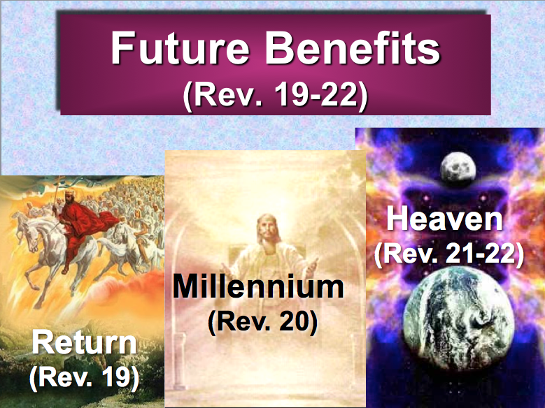

The Second Coming
Revelation 19:11-21

Exegetical Outline (Steps 2-3)

Exegetical Idea: The reason for Christ’s Second Coming is to reveal him as Sovereign King and Ultimate Victor.

I. The reason Christ will return to the earth accompanied by angels and saints in great power will be to show Himself the Sovereign King (19:11-16).

Jesus will return as the Righteous Judge (19:11-12).

Jesus will return as the Fulfiller of God’s Word (19:13).

Jesus will return as the Commander of Heaven’s Armies (19:14).

Jesus will return as the Ruling King (19:15-16).

II. The reason Christ will return will be to defeat the Antichrist, False Prophet, and their armies at the Battle of Armageddon to show himself as the Ultimate Victor (19:17-21).

An angel will tell gather the world’s vultures to feast on the flesh of all men at the Battle of Armageddon (19:17-18).

Christ’s simple word will throw Antichrist and the False Prophet alive into hell and kill all the world’s armies (19:19-21).

Purpose or Desired Listener Response (Step 4)
The listeners will acknowledge Christ’s ultimate rule and power.

Homiletical Outline (Cyclical inductive form)

Introduction

Interest: Many doubt Jesus’s resurrection and return.

Need: Do you know why Jesus must come back?

Subject: Why must Jesus return?

Background: The whole book of Revelation has been leading up to this climax of the book today!

Preview: There are numerous reasons, but today we will focus on two key reasons Jesus must return.

Text: Revelation 19:11-21 gives us these two reasons.

(The first reason Christ must return is that…)

I. Christ must prove he is King (19:11-16).

Jesus will return as the Righteous Judge (19:11-12).

Jesus will return as the Fulfiller of God’s Word (19:13).

Jesus will return as the Commander of Heaven’s Armies (19:14).

Jesus will return as the Ruling King (19:15-16).

(So the first reason Christ must return is to prove he is King. The remaining verses of chapter 19 show the second reasons for the Second Coming, which is…)

II. Christ must prove he is Victor (19:17-21).

An angel will gather the world’s vultures to feast on the flesh of all men at the Battle of Armageddon (19:17-18).

Christ’s simple word will throw Antichrist and the False Prophet alive into hell and kill all the world’s armies (19:19-21).

(So why must Christ return?)

Conclusion

Jesus must return to claim his crown and defeat his enemies (MI).

Main Points

How do you acknowledge Christ’s ultimate rule and power in your own life today?

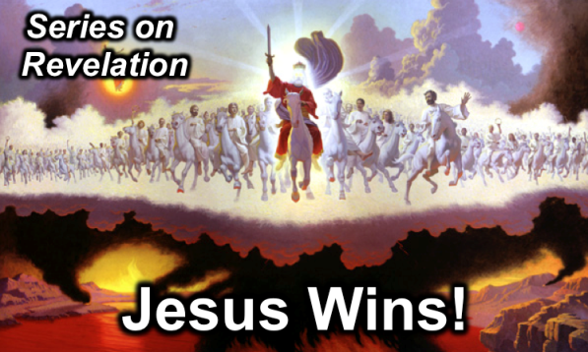
Rick Griffith
Easter 20 April 2014
Message 18 of 20

The Second Coming
Revelation 19:11-21

Introduction

Many today doubt Jesus’s resurrection and return.

___________ must Jesus return?

The whole book of Revelation has been leading up to this climax of the book today!

I. Christ must prove he is ______________ (19:11-16).

Jesus will return as the Righteous Judge (19:11-12).

Jesus will return as the Fulfiller of God’s Word (19:13).

Jesus will return as the Commander of Heaven’s Armies (19:14).

Jesus will return as the Ruling King (19:15-16).

II. Christ must prove he is ___________________ (19:17-21).

An angel will gather the world’s vultures to feast on the flesh of all men at the Battle of Armageddon (19:17-18).

Christ’s simple word will throw Antichrist and the False Prophet alive into hell and kill all the world’s armies (19:19-21).

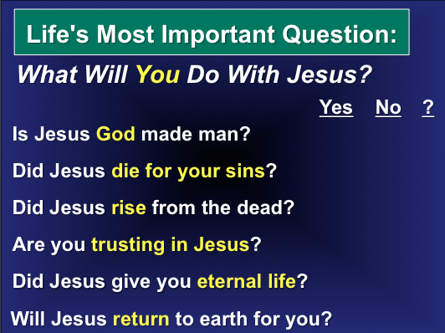
Conclusion

Jesus must return to claim his __________ and defeat his ___________ (Main Idea).

How do you acknowledge Christ’s ultimate rule and power in your own life today?

Thought Questions

- Read Revelation 19:11-21 aloud. Contrast these two arch enemies in several ways:

Antichrist | Christ

- In what practical way should the return of Christ affect your life?

