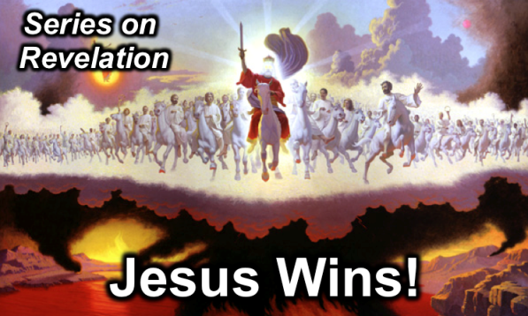
Lewis Winkler
9 February 2014
Message 10 of 20

The Seal Breaker
Revelation 5

Introduction
- No matter how bad things look today, God is still in control (Rev. 4).
- Chapters 4–5 are the transitional chapters from Christ’s sovereignty over the churches (Rev. 2–3) to Christ’s sovereignty over the future events (Rev. 6–22).

- ________ is worthy to break the seal (5:1-4)?
- The scroll is written on both sides to depict God has much to say about the future!
  - Papyrus has a unique quality where it is possible
  - This is the fullness of what God seeks to reveal about coming events.
- John longs to hear a message from God.
- What is so hard about breaking a seal? Anyone can easily break wax!
- The issue is not strength here—it is about worthiness to judge.
- John weeps at not knowing what God has in store, but do we get upset at not hearing from God?
- We actually have God’s information right in the Scriptures to hear from God!
- People gave their lives so that we can have the Bible in our language of English. Do we appreciate this?

- ____________ is worthy to break the seal (5:5-10)!
Jesus is worthy due to his nature and work.

  - Because of Who He Is (5-8):

    - He is the ________ of the tribe of Judah (5).
- Jesus is worthy because of who He is as the Lion of the tribe of Judah.
- Jesus fulfills the kingly and messianic lineage of Judah (5:5).

    - He is the ________ of David (5).

    - He is the ________ who was slain (6-8).
- Jesus is worthy because of what He has done as the Lamb slain from the foundation of the world (5:6).
- Jesus redeemed the world by shedding His blood.
- The seven horns depict his omnipotence.
- The seven eyes depict his omniscience.
- Since God alone is omnipotent and omniscient, Jesus is clearly God!

  - Because of What He Has Done (9-10):

    - He _____________ people from every tribe, tongue, and nation (9).

    - He made them a kingdom of _____________ (10).
- We are God’s representatives on earth from every tribe and nation and language and people with responsibility to represent God to every tribe and nation and language and people.
- We have the responsibility for holiness.
- “It is worth noticing that worship is reserved for God only. That the Lamb is worshipped is evidence of His full divinity” (Leon Morris).

- ____________ is worthy of all worship (5:11-14)!

Conclusion and Application

- Main Idea: Jesus is worthy to reveal the future and be worshipped because He is the Divine Messiah and redeemed us from the penalty of sin, making us a kingdom of priests.

- Not only this, but Jesus is the only one worthy to judge the world! Everyone else is under God’s judgment and thus not worthy to judge!

Personal Application:

- Have you truly trusted in Jesus Christ to forgive your sin and bring you into a right relationship with God?
This is the central issue in life.

- If so, does your life really reflect the fact that you are God’s representative on earth?
- Do you live in light of “What Would Jesus Do”?
- People say they love God, but Jesus seems to be the dividing Person (cf. Matt. 12:32-39). This was the experience of C.S. Lewis, who first was converted to theism before he became a Christian. Eventually he concluded, “If ever a myth had become fact, had been incarnated, it would be just like this…”

- Do you regularly worship and give Christ the thanks and honor He rightly deserves?

Thought Questions for Further Reflection and Home Group:

- Read the passage out loud together.

- Is there is anything that surprises or confuses you? If so, talk about it and see if you can come to a clearer understanding of what this chapter is teaching us.

- In verse 4, John weeps because no one can be found worthy to open the scroll. What does this say about his heart to know the things of God? How does your heart compare to his?

- How can you increase your desire to know God through His word?

- Would you say that you truly worship, appreciate, and honor Christ in your life?

- If so, share some of the specific ways that you seek to worship and honor Him. If not, how can you begin to do this more?

