CIC (19 Jan 14)/St. Andrews Cathedral (2 Feb 2014) Dr. Rick Griffith
Youngnak English Service Jeju, Korea (13 May 18) Single Message
NLT (Churches of Rev. 2–3) 25 Minutes

Is Your Heart Lukewarm Towards God?
Luxurious Yet Lukewarm Laodicea
Title
Revelation 3:14-22; Matt. 10:32-39

Topic: Compromise
Subject: How can you cure spiritual apathy?
Complement: Replace self-reliance with Christ-reliance.
Purpose: The listeners will replace self-reliance with Christ-reliance.
Meditation: God as friend
Reading: Matthew 10:32-39

Introduction

Interest: [The danger of apathy is real.]
Extremes

We’ve often been led to believe that “we are either hot or cold with God.”
Two options?

Is that true? Are there only two options?

Today we’re going to unpack one of the amazing statements of Jesus, where he said, “I know all the things you do, that you are neither hot nor cold. I wish that you were one or the other!" (3:15 NLT).
15

“"But… you are like lukewarm water, neither hot nor cold…" (3:16a NLT).
16a

If I understand this correctly, a Christian can be in the middle—neither hot nor cold but lukewarm.
Spectrum

Need: Are you lukewarm towards Christ?
Are you lukewarm?

How would you know if you are lukewarm?

Well, please let the penetrating eye of Christ test your spiritual temperature.

You might not even care about this question.

Subject: But suppose you do care if you might be apathetic. How, then, can you cure spiritual apathy?
How cure apathy?

The most important thing about you is what Jesus thinks of you, so…
Sand

What if Jesus could just write you a letter to let you know? What would Jesus say?
WWJS

He didn't write to you, but he did write to an apathetic church. Maybe we can learn something from reading someone else's mail!

Background: Jesus actually wrote seven letters to churches in Revelation 2-3.
Buildings

What was this last church, Laodicea, like?
Jesus Weeps

Laodicea was a wealthy but apathetic church [Review 3 slides.]
Map
(13 slides)

Preview: In this letter today we will see “three Rs” to cure apathy.
Cup

Text: Revelation 3:14-22 shows how to cure apathy.
• Text

(The first way to cure spiritual apathy is to…)

I. Recognize Christ’s authority (3:14).
MP
[Humbly realize the exalted state of the One we’re apathetic about!]

Recipients: Laodicea was luxurious and proud (3:14a).
Coins

They were proud of their money—their banking industry was world-renown.
Black robe

They were proud of their clothes—their black wool allowed them all to dress in black.

They were proud of their optical school—they sent an eye ointment throughout the Roman Empire.
Eye

Ruler: Jesus is the sovereign, faithful Creator (3:14b).
Circles

What does it mean that Jesus is the “Amen” (3:14b)?
Amen!

“Amen” means “so be it,” so Christ is the sovereign ruler who declares what will be.

When we say “Amen,” we don’t proclaim anything into reality. Instead, we acknowledge Christ’s authority. We say Amen but he is the Amen!

What does it mean that Jesus is the “faithful and true witness” (3:14c)?
Witness

The phrase in 1:5 means Jesus is the faithful source of the book of Revelation.

So he is a true witness of the evidence about to be shown about Laodicea.

What does it mean that Jesus is the “beginning of God’s [new NLT] creation” (3:14c)? Does this mean Jesus is created?
Ruler

We like to lower Christ to make ourselves look better. Nearby Colossae followed the error that Jesus was less than God some 35 years earlier. But a “created Jesus” would contradict the other descriptions of Christ as eternal in 1:18 and 2:8.

The better sense is that Jesus is the Creator himself. He is the authority to whom we will give an account of our lives!
MPI
(So the first way to cure spiritual apathy is to see our true relationship with Christ—he is God and we are not. The second way to cure spiritual apathy is to…)

II. Respond to Christ’s rebuke (3:15-16).
MP
[Jesus lovingly corrects us in our lukewarm state.]

Reality: We can be active but compromised (3:15-16a).
Pew

This is the rebuke by Christ: lukewarm, not cold or hot.
Circles

“I know all the things that you do…” [read 3:15]
Faucets
(2 slides)

Here the background in Laodicea is fascinating.

The city had poor water resources so it had its water channeled from nearby cities. With their vast wealth, the people of Laodicea built an elaborate aqueduct system.
• Hot

Map

Aqueduct

Hot water was piped from the nearby Hierapolis hot springs to the north. Cold water came via aqueduct from Colossae’s cold, refreshing springs to the east. However, to their horror, after the entire project was finished, they discovered that by the time the water reached Laodicea, it was lukewarm!
• Cold

Most people preferred drinks either hot or cold back then—and today too.
• Lukewarm

Drinks

What does hot, cold and lukewarm mean (3:15-16a)? I think this refers to spiritual fervor:
3 red faucets

“Hot” means we have a fire for Christ—an excitement about him. His command, of course, is for us to have a spiritual “fire” for him.
• Cold
• Reject
• Hot
• Fire

“Cold” indicates spiritual opposition where we reject Christ.
• Lukewarm
• Pretend

“Lukewarm” Christians compromise and only pretend to be walking with Christ.
Christ’s Preference

Why would Christ actually prefer for people to be either hot or cold (3:15b)?

Jesus prefers for us to honest with him since he knows our true spiritual condition anyway. It’s better to admit that we are “cold”—to say that we are rejecting him…
Rejecting Christ

…than it is to pretend that we are not. Lukewarm means apathetic.
Apathy

Result: Christ stops compromise (3:16b).
Spit

Laodicea’s lukewarm water and calcium made a visitor want to vomit!
Like

Pipes

What does it mean for Jesus to spit lukewarm people out of his mouth (3:16)?

Those who are spiritually complacent will not lose their salvation, for many other texts show us that those who genuinely know Christ have eternal life.
• Discipline?

• Lose salvation?

It seems better to see this as Christ taking away their privileges in discipline.

This is exactly what happened. Laodicea’s lukewarm spiritual attitude eventually led to the destruction of the city. Since the 13th century AD it has been in ruins.
Ruins

Ruins

Trees

Plant

Our “super trees” that catch water and desalination plant will someday also be ruins.

Lukewarm Christians sometimes think that Jesus’ demands on their life make them sick. But do you make Jesus sick? Is he sick of your apathy, your compromise, your unwillingness to take a stand on anything for him?
Sick of Jesus?

• Jesus sick of you?

MPI

(We’re talking about the cure for apathy. First we see the real Jesus and the real us in relationship. Then we heed his rebuke and discipline. The third way to cure spiritual apathy is to…)
MPII

III. Receive Christ’s riches and rule (3:17-22).
MPIII
[Christ’s solution to compromise is for us to rely on his generous offer instead of ourselves!]
Self-Sufficiency

Realize your sad state of spiritual self-sufficiency (3:17).
Circles

Repent by trusting in Christ’s riches (3:18-19).

Our world-renown banks do not have true “gold” that will last for eternity!
Gold
Coins

Our black clothes are nothing compared to the righteousness of Christ’s white robes!
Black
White

Our thinking we can see is nothing like the eye ointment Christ gives for spiritual sight!
Blind
Sight

There is no warning, but there is an invitation! Receive Christ into your life (3:20).
No rebuke

Like the painting, no handle is on the outside. Jesus is a gentleman who will not knock the door down to force his way into your life. You must open the door from the inside.
20a

Is the person inviting Christ inside a Christian or a non-Christian (3:20)?
Believer or Non-bel?

This was an appeal to Christians rather than to non-Christians, but does it really matter? Neither the believer nor the unbeliever were experiencing genuine fellowship with Christ! He says, “…if anyone hears my voice…”

The letter is written to believers who were living like unbelievers. The word’ for “dine” here refers to the main meal of the day—the evening dinner. “This mealtime was set aside for relaxation, enjoyment, and fellowship” (Swindoll, Letters to Churches…Then and Now, 53).
20b

Rule with Christ just as he rules with the Father (3:21-22).
Rule

Every believer will eat with Christ and rule with Christ.
Circles

This is the seventh promise in the seven letters to overcomers—to those who genuinely know Christ.
3:21
star
Subj.
(So how can we cure spiritual apathy in a nutshell? The main idea of the passage is simply this…)

Conclusion

Replace self-reliance with Christ-reliance (MI).
MI

Our text today has shown us the “three Rs”:
Three Rs

Relationship: Our pride falls short of Christ’s real authority (3:14).
MPI
MPII

Rebuke: Christ responds to apathy with discipline (3:15-16).
MPIII

Reliance: Replace self-reliance by receiving Christ’s riches and rule (3:17-22).
You?

How are you like luxurious yet lukewarm Laodicea?
Passion?

Have you lost your spiritual passion like a dating relationship gone sour?

Are you listening to God through his Word each day?
Listening?

What’s His solution for you?
Continuum
Mt 10
(3 slides)

In Matthew 10:32-39 Jesus calls us from apathy to radical commitment.
3:20

Will you let Christ into your life to have a vibrant relationship with him?

It’s as if Jesus himself is calling your mobile phone. Will you answer him?
Jesus on mobile

Will you listen to what the Spirit says to the churches—and to this church?
3:22

Prayer
Black
Crossroads International Church; St. Andrews Cathedral Dr. Rick Griffith
19 Jan & 2 Feb 2014 Message 7 of 7
NLT (Churches of Rev. 2–3) 40 Minutes

Is Your Heart Lukewarm Towards God?
Luxurious Yet Lukewarm Laodicea
Title
Revelation 3:14-22; Matt. 10:32-39

Topic: Compromise
Subject: How can you cure spiritual apathy?
Complement: Replace self-reliance with Christ-reliance.
Purpose: The listeners will replace self-reliance with Christ-reliance.
Meditation: God as friend
Reading: Matthew 10:32-39

Introduction

Interest: [The danger of apathy is real.]

DON’T INTERRUPT ME LORD, I’M PRAYING (a 2-person skit reflecting on the Lord’s Prayer by Clyde Lee Herring, adapted from Bread magazine, Nazarene Publishing House (http://www.murraymoerman.com/3downloads/don%27t_interrupt_me_lord_i%27m_praying.pdf)
Extremes
Lord’s Prayer

We’ve often been led to believe that “we are either hot or cold with God.”
Two options?

Is that true? Are there only two options?

Today we’re going to unpack one of the amazing statements of Jesus, where he said, “I know all the things you do, that you are neither hot nor cold. I wish that you were one or the other!" (3:15 NLT).
15

“"But… you are like lukewarm water, neither hot nor cold…" (3:16a NLT).
16a

If I understand this correctly, a Christian can be in the middle—neither hot nor cold but lukewarm.
Spectrum

Need: Are you lukewarm towards Christ?
Are you lukewarm?

How would you know if you are lukewarm?

Well, please let the penetrating eye of Christ test your spiritual temperature.

You might not even care about this question.

Subject: But suppose you do care if you might be apathetic. How, then, can you cure spiritual apathy?
How cure apathy?

The most important thing about you is what Jesus thinks of you, so…
Sand

What if Jesus could just write you a letter to let you know? What would Jesus say?
WWJS

He didn't write to you, but he did write to an apathetic church.

Background: [Laodicea was a wealthy but apathetic church.]

Today we end our seven-sermon series on the seven churches of Revelation 2–3.
Series

What was this last church, Laodicea, like? [Review 15 slides.]
Bkgrd
(15 slides)

Preview: We will see “three Rs” to cure apathy.
Cup

Text: Revelation 3:14-22 shows how to cure apathy.
• Text

(The first way to cure spiritual apathy is to…)

I. Recognize Christ’s authority (3:14).
MP
[Humbly realize the exalted state of the One we’re apathetic about!]

Recipients: Laodicea was luxurious and proud (3:14a).
Coins

They were proud of their money—their banking industry was world-renown.
Black robe

They were proud of their clothes—their black wool allowed them all to dress in black.

They were proud of their optical school—they sent an eye ointment throughout the Roman Empire.
Eye

Ruler: Jesus is the sovereign, faithful Creator (3:14b).
Circles

What does it mean that Jesus is the “Amen” (3:14b)?
Amen!

“Amen” means “so be it,” so Christ is the sovereign ruler who declares what will be.

When we say “Amen,” we don’t proclaim anything into reality. Instead, we acknowledge Christ’s authority. We say Amen but he is the Amen!

What does it mean that Jesus is the “faithful and true witness” (3:14c)?
Witness

We saw this in 1:5, where Jesus is the faithful source of the book of Revelation.

So he is a true witness of the evidence about to be shown about Laodicea.

What does it mean that Jesus is the “beginning of God’s [new NLT] creation” (3:14c)? Does this mean Jesus is created?
Ruler

We like to lower Christ to make ourselves look better. Nearby Colossae followed the error that Jesus was less than God some 35 years earlier. But a “created Jesus” would contradict the other descriptions of Christ as eternal in 1:18 and 2:8.

The better sense is that Jesus is the Creator himself. He is the authority to whom we will give an account of our lives!
MPI
(So the first way to cure spiritual apathy is to see our true relationship with Christ—he is God and we are not. The second way to cure spiritual apathy is to…)

II. Respond to Christ’s rebuke (3:15-16).
MP
[Jesus lovingly corrects us in our lukewarm state.]

Reality: We can be active but compromised (3:15-16a).
Pew

This is the rebuke by Christ: lukewarm, not cold or hot.
Circles

“I know all the things that you do…” [read 3:15]
Faucets
(2 slides)

Here the background in Laodicea is fascinating.

I told you before that the city had its water channels from nearby cities. With their vast wealth, the people of Laodicea built an elaborate aqueduct system.
Aqueduct

Hot water was piped from the nearby Hierapolis hot springs to the north. Cold water came via aqueduct from Colossae’s cold, refreshing springs to the east. However, to their horror, after the entire project was finished, they discovered that by the time the water reached Laodicea, it was lukewarm!
• Cold

• Lukewarm

Map

• Hot

Most people preferred drinks either hot or cold back then—and today too.
Drinks

What does hot, cold and lukewarm mean (3:15-16a)? I think this refers to spiritual fervor:
3 red faucets

“Hot” means we have a fire for Christ—an excitement about him. His command, of course, is for us to have a spiritual “fire” for him.
• Cold
• Reject
• Hot
• Fire

“Cold” indicates spiritual opposition where we reject Christ.
• Lukewarm
• Pretend

“Lukewarm” Christians compromise and only pretend to be walking with Christ.
Christ’s Preference

Why would Christ actually prefer for people to be either hot or cold (3:15b)?

Jesus prefers for us to honest with him since he knows our true spiritual condition anyway. It’s better to admit that we are “cold”—to say that we are rejecting him…
Rejecting Christ

…than it is to pretend that we are not. Lukewarm means apathetic.
Apathy

Result: Christ stops compromise (3:16b).
Spit

Laodicea’s lukewarm water and calcium made a visitor want to vomit!
Like

Pipes

What does it mean for Jesus to spit lukewarm people out of his mouth (3:16)?

Those who are spiritually complacent will not lose their salvation, for many other texts show us that those who genuinely know Christ have eternal life.
• Discipline?

• Lose salvation?

It seems better to see this as Christ taking away their privileges in discipline.

This is exactly what happened. Similar to Ephesus whose lampstand was removed, the lukewarm spiritual attitude at Laodicea eventually led to the destruction of the city. Since the 13th century AD the city has been in ruins.
Ruins

Trees

Plant

Chiasm

Ruins

Our “super trees” that catch water and desalination plant will someday also be ruins.

Lukewarm Christians sometimes think that Jesus’ demands on their life make them sick. But do you make Jesus sick? Is he sick of your apathy, your compromise, your unwillingness to take a stand on anything for him?
Sick of Jesus?

• Jesus sick of you?

MPI

(We’re talking about the cure for apathy. First we see the real Jesus and the real us in relationship. Then we heed his rebuke and discipline. The third way to cure spiritual apathy is to…)
MPII

III. Receive Christ’s riches and rule (3:17-22).
MPIII
[Christ’s solution to compromise is for us to rely on his generous offer instead of ourselves!]
Self-Sufficiency

Realize your sad state of spiritual self-sufficiency (3:17).
Circles

Repent by trusting in Christ’s riches (3:18-19).

Our world-renown banks do not have true “gold” that will last for eternity!
Gold
Coins

Our black clothes are nothing compared to the righteousness of Christ’s white robes!
Black
White

Our thinking we can see is nothing like the eye ointment Christ gives for spiritual sight!
Blind
Sight

There is no warning, but there is an invitation! Receive Christ into your life (3:20).
Open door
No rebuke

We already saw him give us an open door (3:8). Now our door is closed. Like the painting, no handle is on the outside. Jesus is a gentleman who will not knock the door down to force his way into your life. You must open the door from the inside.
20a

Is the person inviting Christ inside a Christian or a non-Christian (3:20)?
Believer or Non-bel?

This was an appeal to Christians rather than to non-Christians, but does it really matter? Neither the believer nor the unbeliever were experiencing genuine fellowship with Christ! He says, “…if anyone hears my voice…”

The letter is written to believers who were living like unbelievers. The word’ for “dine” here refers to the main meal of the day—the evening dinner. “This mealtime was set aside for relaxation, enjoyment, and fellowship” (Swindoll, Letters to Churches…Then and Now, 53).
20b

Rule with Christ just as he rules with the Father (3:21-22).
Rule

Every believer will eat with Christ and rule with Christ.
Circles

This is the seventh promise in the seven letters to overcomers—to those who genuinely know Christ [review all 7].
Victors
(7 slides)
Subj.
(So how can we cure spiritual apathy in a nutshell? The main idea of the passage is simply this…)

Conclusion

Replace self-reliance with Christ-reliance (MI).
MI

Our text today has shown us the “three Rs”:
Three Rs

Relationship: Our pride falls short of Christ’s real authority (3:14).
MPI
MPII

Rebuke: Christ responds to apathy with discipline (3:15-16).
MPIII

Reliance: Replace self-reliance by receiving Christ’s riches and rule (3:17-22).
You?

How are you like luxurious yet lukewarm Laodicea?
Passion?

Have you lost your spiritual passion like a dating relationship gone sour?

Are you listening to God through his Word each day?
Listening?

What’s His solution for you?
Continuum
Mt 10
(3 slides)

In Matthew 10:32-39 Jesus calls us from apathy to radical commitment.
3:20

Will you let Christ into your life to have a vibrant relationship with him?

It’s as if Jesus himself is calling your mobile phone. Will you answer him?
Jesus on mobile

Will you listen to what the Spirit says to the churches—and to this church?
3:22

Prayer
Black

Preliminary Questions

Verses Questions

Context: What did the author record just prior to this passage?

Jesus just has told the Philadelphia church that they had an open door to serve him.

We have now come to the last of Christ’s seven letters to the churches.

Purpose: Why is this passage in the Bible?

Our natural spiritual tendency is to “cool off” in our walk with Christ, degenerating from hot to cold.

This letter shows us our true state and warns us of the consequences.

Background: What historical context helps us understand this passage?

Matt. 10:32 “Everyone who acknowledges me publicly here on earth, I will also acknowledge before my Father in heaven. 33 But everyone who denies me here on earth, I will also deny before my Father in heaven.

Matt. 10:34 “Don’t imagine that I came to bring peace to the earth! I came not to bring peace, but a sword.

Matt. 10:35 ‘I have come to set a man against his father,
a daughter against her mother,
and a daughter-in-law against her mother-in-law.
36 Your enemies will be right in your own household!’

Matt. 10:37 “If you love your father or mother more than you love me, you are not worthy of being mine; or if you love your son or daughter more than me, you are not worthy of being mine. 38 If you refuse to take up your cross and follow me, you are not worthy of being mine. 39 If you cling to your life, you will lose it; but if you give up your life for me, you will find it.

Questions

What was the city of Laodicea like (3:14a)?
“3:14. The wealthy city of Laodicea was located on the road to Colosse about 40 miles southeast of Philadelphia. About 35 years before this letter was written, Laodicea was destroyed by an earthquake, but it had the wealth and ability to rebuild. Its main industry was wool cloth. There is no record that Paul ever visited this city, but he was concerned about it (Col. 2:1-2; 4:16)” (Walvoord, BKC).

What does it mean that Jesus is the “Amen” (3:14b)?

“Amen” means “so be it,” referring to Christ as the sovereign ruler who declares what will be.

When we say “Amen,” we don’t proclaim anything into reality. Instead, we acknowledge Christ’s authority. We say Amen but he is the Amen!

What does it mean that Jesus is the “faithful and true witness” (3:14c)?

This was noted in 1:5, where Jesus is identified as the faithful source of the book of Revelation.

So he is a true witness of the evidence about to be shown regarding Laodicea.

What does it mean that Jesus is the “beginning of God’s [new NLT] creation” (3:14c)? Does this mean Jesus is created?

Our tendency is to lower Christ to make ourself look better. Nearby Colossae had followed the error that Jesus was less than God some 35 years earlier. But this would be out of character with other descriptions of Christ as eternal in 1:18 and 2:8.

The better sense is that Jesus is the Creator himself. He is the authority to whom we will give an account of our lives!

What does it mean to be hot, cold and lukewarm (3:15-16a)? I think this refers to spiritual fervor:

“Hot” means we have a fire for Christ—an excitement about him. His command, of course, is for us to have a spiritual “fire” for him.

“Cold” indicates spiritual apathy where we reject Christ.

“Lukewarm” Christians are compromising ones who only pretend to be walking with Christ.

Why would Christ actually prefer for people to be either hot or cold (3:15b)?

Jesus prefers for us to genuinely honest with him since he already knows our true spiritual condition.

It’s better to admit that we are “cold”—to say that we are rejecting him than it is to pretend that we are not.

What does it mean for Jesus to spit lukewarm people out of his mouth (3:16)?

Those who are spiritually complacent will not lose their salvation, for many other texts show us that those who genuinely know Christ have eternal life.

It seems better to see this as Christ taking away their privileges in discipline.

This is exactly what happened, for the lukewarm spiritual attitude at Laodicea eventually led to the destruction of the city. Since the 13th century AD the city has been in ruins.

Is the person inviting Christ in from outside the door a Christian or a non-Christian (3:20)?

This was an appeal to Christians rather than to non-Christians, but does it really matter? Neither the believer nor the unbeliever were experiencing genuine fellowship with Christ! He says, “…if anyone hears my voice…”

The letter is written to believers who were living like unbelievers. The word’ for “dine” here refers to the main meal of the day—the evening dinner. “This mealtime was set aside for relaxation, enjoyment, and fellowship” (Swindoll, Letters to Churches…Then and Now, 53).

Tentative Subject/Complement Statements

Text

Possible Illustrations

Text

Possible Applications

Text

(3:14-22) Christ tells John to condemn the believers in Laodicea for their materialistic, selfish lifestyle so that they might repent and embrace Christ's Lordship in self-sacrifice (Luxurious Yet Lukewarm Church: Modern Materialistic Church).

(3:14a) Destination: Laodicea

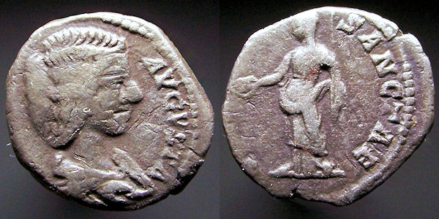

(3:14b) Description of Christ: He is the Amen, the faithful and true witness, the originator of God’s creation.

(absent) Commendation

(3:15-17) Rebuke: I know your lukewarm deeds and for those I will vomit you out of my mouth! You say, “I am rich and need nothing,” but really you are wretched, pitiful, poor, blind, and naked.

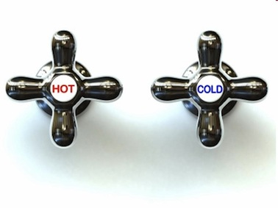
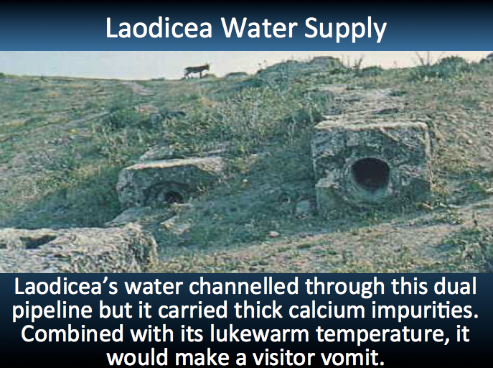

(3:18-20) Exhortation: Buy refined gold from me to become rich! Buy white clothing for your shameful nakedness, and eye salve to see! All those I love, I rebuke and discipline so repent! Listen! I seek mutual fellowship.

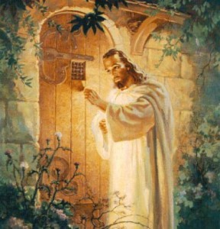

(absent) Warning

(3:21-22) Promise: The one who conquers will sit with me on my throne, just as I too conquered and sat down with my Father on his throne.

Luxurious Yet Lukewarm
Revelation 3:14-22
Exegetical Outline (Steps 2-3)

Exegetical Idea: The response to Christ condemning the believers in Laodicea for their materialistic, selfish lifestyle was to replace self-reliance with trust in Christ’s riches and fellowship with him.

I. Relationship: Jesus contrasts the faithless state of the Laodicea church with his own faithfulness (3:14).

Recipients: Laodicea was luxurious and proud (3:14a).

Ruler: Jesus is the sovereign, faithful Creator (3:14b).

Commendation (absent)

II. Rebuke: The response of Christ to compromised Christians is divine discipline (3:15-16).

Reality: We can be active but compromised (3:15-16a).

Result: Christ stops complacent compromise (3:16b).

III. Reliance: The solution to compromise is to replace self-sufficiency with trust in Christ’s riches and fellowship with him (3:17-22).

They needed to realize their sad state of spiritual self-sufficiency (3:17).

They needed to repent by trusting in Christ’s riches (3:18-19).

They needed to receive Christ into their lives (3:20).

They needed to rule with Christ just as he rules with the Father (3:21-22).

Purpose or Desired Listener Response (Step 4)
The listeners will replace complacent self-sufficiency with trust in Christ.

Homiletical Outline (Cyclical inductive form)

Introduction

Interest: The danger of becoming lukewarm is real.

Need: Are you lukewarm towards Christ? How would you know?

Subject: How can you cure spiritual apathy?

Background: The last of the seven churches in Revelation 2–3 was Laodicea, an apathetic church.

Preview: We will see “three Rs” to cure apathy.

Text: Revelation 3:14-22 shows how to cure apathy.

(The first way to cure spiritual apathy is to see the contrast in the…)

I. Recognize Christ’s authority (3:14).

Recipients: Laodicea was luxurious and proud (3:14a).

Ruler: Jesus is the sovereign, faithful Creator (3:14b).

(The second way to cure spiritual apathy is to see Christ’s…)

II. Respond to Christ’s rebuke (3:15-16).

Reality: We can be active but compromised (3:15-16a).

Result: Christ stops compromise (3:16b).

(The third way to cure spiritual apathy is change our…)

III. Receive Christ’s riches and rule (3:17-22).

Realize your sad state of spiritual self-sufficiency (3:17).

Repent by trusting in Christ’s riches (3:18-19).

Receive Christ into your life (3:20).

Rule with Christ just as he rules with the Father (3:21-22).

(How can we cure spiritual apathy?)

Conclusion

Replace self-reliance with Christ-reliance (MI).

Our text today has shown us the “three Rs”:

Relationship: Our pride falls short of Christ’s real authority (3:14).

Rebuke: Christ responds to apathy with discipline (3:15-16).

Resolution: Replace self-reliance by receiving Christ’s riches and rule (3:17-22).

How are you like luxurious yet lukewarm Laodicea? What’s His solution for you?

In Matthew 10:32-39 Jesus calls us from apathy to radical commitment.

Will you let Christ into your life to have a vibrant relationship with him?

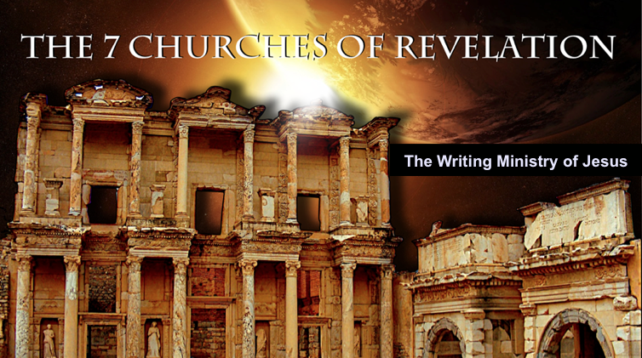
Rick Griffith
19 January 2014
Message 7 of 7

Luxurious Yet Lukewarm Laodicea
Revelation 3:14-22

Introduction

The danger of becoming lukewarm is real.

How can you cure spiritual ________________?

I. ___________________________ Christ’s authority (3:14).

Recipients: Laodicea was luxurious and proud (3:14a).

Ruler: Jesus is the sovereign, faithful Creator (3:14b).

(The second way to cure spiritual apathy is to see Christ’s…)

II. _____________________________ to Christ’s rebuke (3:15-16).

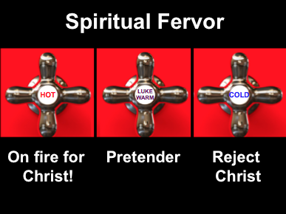
Reality: We can be active but compromised (3:15-16a).

Result: Christ stops compromise (3:16b).

(The third way to cure spiritual apathy is change our…)

III. ______________________________ to Christ’s rebuke (3:17-22).

Realize your sad state of spiritual self-sufficiency (3:17).

Repent by trusting in Christ’s riches (3:18-19).
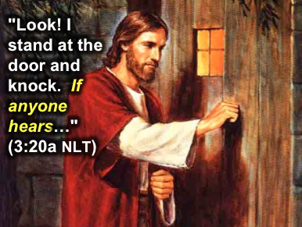

Receive Christ into your life (3:20).

Rule with Christ just as he rules with the Father (3:21-22).

(How can we cure spiritual apathy?)

Conclusion

Replace ________-reliance with ______________-reliance (Main Idea).

How are you like luxurious yet lukewarm Laodicea? What’s His solution for you?

In Matthew 10:32-39 Jesus calls us from apathy to radical commitment.

Will you let Christ into your life to have a vibrant relationship with him?

Thought Questions

- Read Revelation 3:14-22 aloud. Contrast Jesus with the Laodicean Christians:

Jesus | The Church

- In your own words, what does being lukewarm look like?

- Have you been lukewarm before? What did you do about it? What can you do now?

Luxurious Yet Lukewarm Laodicea
Revelation 3:14-22

Introduction

The danger of becoming lukewarm is real.

How can you cure spiritual ________________?

I. ________________________ Christ’s authority (3:14).

Recipients: Laodicea was luxurious and proud (3:14a).

Ruler: Jesus is the sovereign, faithful Creator (3:14b).

II. ________________________ to Christ’s rebuke (3:15-16).

Reality: We can be active but compromised (3:15-16a).

Result: Christ stops compromise (3:16b).

III. ________________________ Christ’s riches and rule (3:17-22).

Realize your sad state of spiritual self-sufficiency (3:17).

Repent by trusting in Christ’s riches (3:18-19).

Receive Christ into your life (3:20).

Rule with Christ just as he rules with the Father (3:21-22).

(How can you cure spiritual apathy?)

Conclusion

Replace ________-reliance with ______________-reliance (Main Idea).

How are you like luxurious yet lukewarm Laodicea? What’s His solution for you?

