Crossroads International Church Dr. Rick Griffith
Title
2014 Series on 7 Churches of Rev. 2–3 Message 5 of 7
NLT 40 Minutes
Distinguished Yet Dead
Revelation 3:1-6

Topic:
Subject: What does Jesus think of you?
Complement: Jesus knows your good, bad, and future.
Purpose: The listeners will assure that their faith in Christ is alive and well.
Meditation: God’s Purity
Song: Sanctuary

Introduction

How well do you know yourself?
Know yourself?

Jim Keenan is a motivational speaker who runs a website called asalesguy.com. I found this observation of his very insightful. He writes,
Keenan

“One of our biggest challenges in life is self-assessment. We think we know ourselves pretty well, however the science says different.

As a leader, personal self-assessment is critical to success. We have to be able accurately assess our abilities.

We all have blind spots. Our blind spots are those things that others know about us, that we are unaware of. Our blind spots are those things others see in us, that we can’t see in ourselves.

Johari‘s window sums it up nicely like this:
Chart

The Open – what others know about us and what we openly share with others

The Hidden – what we know about ourselves that others don’t know (what we keep hidden from sight)

The Unknown – what we don’t know about ourselves and what others don’t know

The Blind Spot – what others know about us, that we don’t know about ourselves

The blind spot is where we get tripped up. It’s the reason we fail and seem perplexed because we thought we did everything right. It’s the date that we thought went awesome yet they don’t want to go out with us again. It’s the co-worker feeling belittled after you thought you had a super productive meeting. The blind spot is the part of us we just don’t see that the rest of the world does that screws everything up.
Close up

Do you know your blind spot(s)? Ask around, everyone else does.”

I agreed with Keenan until this point. Why? Because others can even misjudge our blind spots. Jesus is the only one who really knows your blind spots! But…
Writing in sand

Subject: What does Jesus think of you?

What would he say of us as a church?
WWJS

Background: Christ knows people of every church so well that he holds each of them in the palm of his hand [review Rev. 2].
Rev 2–3
(9 slides)

Preview: As I studied the letter to Sardis this week, I thought of the 1966 Western film starring Clint Eastwood called “The Good, the Bad, and the Ugly.”
Good, bad & ugly

Text: Why? As it relates to each of us, Jesus knows the good, the bad, and the—you will fill in the blank. Anyway, Revelation 3:1-6 is our passage.
• Text
Good, bad & ___

(So what did Jesus think of Sardis—and what does He think of you, too? Today we’ll see first that…)

I. Jesus knows the good.
MP
[Christ can see every area where you are doing well.]

Jesus encouraged Sardis with the good news that he was sovereign and knew their faithfulness (3:1-2a).

Destination: Jesus knew all about the proud past and current wealth of Sardis (3:1a).
Sardis map

Sardis lay at the top of an almost impregnable acropolis. Since Sardis was built on a mountain and had an acropolis that was viewed as impregnable, “to capture the acropolis of Sardis” was proverbial in Greek to do the impossible. But the acropolis was conquered at least five times—and twice through lack of vigilance!
Sardis hill (2 slides)

The city had gold and therefore became wealthy and used part of that money to worship Artemis, virgin Goddess of the Hunt, Forests and Hills, and the Moon.
Artemis
(3 slides)

The gymnasium and synagogue also boasted the riches of the city—as did the road leading to Persia as Sardis lay on the strategic east-west trade route.
Artemis
(5 slides)

Description of Christ: Jesus directs the ministry of the Spirit among the churches (3:1b).

Holding the stars refers back to the description of Christ in 1:20.
Christ

There we see that “stars” refers to pastors, meaning that Jesus is authority over both the Spirit and the leaders of the churches.
1:20

Commendation: Jesus knew their good deeds and reputation (3:2a-b).
Commen-dation

Their good deeds are not listed (3:2a).

Their reputation was one of vibrancy (3:2b).

Christ knows all your good deeds and reputation.
???

There is a difference between deeds and reputation.

Deeds are what you really do for Christ—it stems from your character, which is who you really are.

Reputation is what others think you are.

To what extent does it matter to you what people think of you?
Care?

Ultimately, it matters little what you think of me—and I think of you.

But if you could get a real picture of yourself—instead of a false one—would you be interested in seeing it?

Jesus is the only one who really knows you! He knows every good thing you have ever done for him—even a cup of cold water given in his name. Isn’t that wonderful?
MPI

(However, Jesus not only knows the good, but…)

II. Jesus knows the bad.
MP
[Christ can see every area where you need to grow.]

Jesus warned Sardis with the bad news that if they didn’t live up to their reputation then he would oppose them (3:2c-3c).
Rebuke

Rebuke: Sardis looked like unbelievers who have no spiritual life (3:2c).
3:2

Being distinguished but dead is like a general who is honored with a statue, but only after he has died!
General

The insightful writer of yesteryear, A.W. Tozer, noted, “If the Holy Spirit was withdrawn from the church today, 95 percent of what we do would go on and no one would know the difference. If the Holy Spirit had been withdrawn from the New Testament church, 95 percent of what they did would stop, and everybody would know the difference.”
Tozer

Are we just filled with activity and no real life?

Exhortation: Look alive through obedience and repentance (3:2d-3b).
Exhortation

Wake up (3:2d).
Soldier asleep

Sardis was conquered twice on its blind side due to sleeping guards.
Conquered acropolis

Here are signs that your pastor caught you napping during his sermon…
Signs
(6 slides)

Actually, it’s worse that literal sleep!

Finish the deeds that were started (3:2e).
Wake up!

Obey (3:3a).

Repent (3:3b).

Warning: Christ will discipline if there is no improvement (3:3c).
Chart

Christ warns us to wake up too.

As an individual, where do you need to wake up?

As noted earlier, we all have blind spots.

I hope you care to see what your blind spots might be!
• Family

You might need to wake up to what’s really happening in your family. Years ago one of our men here woke up too late only to have his wife divorce him for his neglect.
• Bible

You might need to wake up to realize you are spiritually malnourished. It’s only the fifth day of the year to begin a regular program of Bible reading.

As a church, where do we need to wake up?
Cemetery

We need to wake up to see that Christ owns all we have. (Yes, offerings are way below what we need here and the bank balance is falling fast!)
• He owns

We need to wake up to see that caring for people means caring for their kids. We have four babies recently added to the church and one more coming—how can we manage this unless we wake up and get involved?
• Care for kids
MPII
MPI
(Jesus not only knows the good and the bad, but…)

III. Jesus knows the future.
MP
[Our future is not ugly but beautiful!]
Promise

Jesus promised believers at Sardis that they are victorious and secure to walk with him in purity (3:4-5).
Star

Every believer is a conqueror that will walk in purity with Christ (3:4-5a).

Every believer has eternal security (3:5b).

Christ will praise every believer before the Father and His angels (3:5c).

Christ has a fantastic future for you!
Fantastic Future

What applied to Sardis also applies to you!

Every believer should listen to what God’s Spirit is telling the churches (3:6).
Listen!
(3:6)

Are you listening to what the Spirit is telling the churches—including this one?
Jesus say
(So what would Jesus write to you? Jesus knows your good, bad, and future, so…)

Conclusion

Don’t sleep in church. Why not?
Don’t sleep

Jesus knows your good, bad, and future (Main Idea)!
MI

Exhortation/Application: How does Christ want to show himself alive in your life in 2014?
2014

Trust him to renew your life!
Will you wake up?

Preliminary Questions

Verses Questions

Context: What did the author record just prior to this passage?

We have made our way past the halfway point of the seven letters with Christ having finished his letter to the fourth church, Thyatira.

Purpose: Why is this passage in the Bible?

We can fool many people into thinking that we have genuine spiritual life (believing and therefore saved) when in fact we are spiritually dead (unbelieving and therefore lost).

Background: What historical context helps us understand this passage?

“3:1a. The important commercial city of Sardis was located about 30 miles southeast of Thyatira, on an important trade route that ran east and west through the kingdom of Lydia. Important industries included jewelry, dye, and textiles, which had made the city wealthy. From a religious standpoint it was a center of pagan worship and site of a temple of Artemis, which ruins still remain (cf. comments on 2:1 regarding another temple of Artemis). Only a small village called Sart remains on the site of this once-important city. Archeologists have located the ruins of a Christian church building next to the temple. In addressing the message to the church Christ described Himself as the One who holds the seven spirits of God and the seven stars, similar to the description in 1:4. Here Christ said He holds them, speaking of the Holy Spirit in relation to Himself (Isa. 11:2-5; cf. Rev. 5:6). As in 1:20 the seven stars, representing the pastors of the churches, were also in His hands (cf. 2:1)” (Walvoord, BKC).

“3:1-6 The letter to the church in Sardis. Sardis was a city with an illustrious past of which it was proud, but it had less to be proud of in John’s time. The capital of the ancient kingdom of Lydia, it reached the peak of its wealth about 700 BC under Gyges, known to the Assyrians as Gugu. The Jews called this king Gog, and he was thought of as symbolic of the evil powers to arise at the end of the age. He was slain in a surprise attack by the Cimmerians. The city sank into oblivion after the Persian conquest, but it recovered something of its prestige when, through the help of Tiberius, it was rebuilt following an earthquake in AD 17. The church in Sardis reflected the history of the city; once it had had a name for spiritual achievement, but now it was lifeless (1). Two other elements in the city’s life are echoed in the letter. Sardis was built on a mountain and had an acropolis which was viewed as impregnable. ‘To capture the acropolis of Sardis’ was proverbial in Greek to do the impossible. But no less than five times the acropolis was conquered, twice through lack of vigilance. The parallel with the church’s lack of wakefulness and its dire situation is striking (2-3). Sardis was also a centre for woollen goods and claimed to be first in the business of dyeing wool; this, too, seems to be reflected in vs 4-5” (New Bible Commentary, 1431).

Questions

What was the city of Sardis like? (See above)

What is the significance of Christ having “the sevenfold Spirit of God and the seven stars” (3:1 NLT)? It means that he controls the Spirit’s ministry (sevenfold Spirit) among the churches as well as the pastors (stars) of those churches.

What “deeds” had the church in Sardis done (3:2a)? None are mentioned, unlike the other churches such as Thyatira.

Why is “dead” contrasted with “wake up” (3:2d)? The church wasn’t spiritually dead—it was just asleep!

Does “dead” mean unsaved? If it did, then he would be telling these believers to trust Christ and become alive, but nothing is noted in this regard.

Wouldn’t “dead versus resurrected” be opposites—or “asleep versus wake up”?

The imagery here strikes me funny, unless we understand that the church was resting on its proud past instead of trusting Christ in the present. We should be careful of churches that are always talking about how much Christ used them in the days gone by! We need to see Jesus working among us today—right now.

This is a call to “wake up!” and see that Jesus is as much alive now as he was when he walked on the earth.

Are all Christians victorious—or only some of us (3:5)?

Tentative Subject/Complement Statements

Don’t sleep in church!

Possible Illustrations

Sleeping in church

Francis Chan balance beam

Jim Keenan is a motivational speaker who runs a website called asalesguy.com. I ran across it this week and found this observation of his very insightful. He writes,

One of our biggest challenges in life is self-assessment. We think we know ourselves pretty well, however the science says different.

As a leader, personal self-assessment is critical to success. We have to be able accurately assess our abilities.

We all have blind spots. Our blind spots are those things that others know about us, that we are unaware of. Our blind spots are those things others see in us, that we can’t see in ourselves.

Johari‘s window sums it up nicely like this:

The Open – what others know about us and what we openly share with others

The Hidden – what we know about ourselves that others don’t know. (What we keep hidden from site)

The Unknown – what we don’t know about ourselves and what others don’t know

The Blind Spot – what others know about us, that we don’t know about ourselves

The blind spot is where we get tripped up. It’s the reason we fail and seem perplexed because we thought we did everything right. It’s the date that we thought went awesome yet they don’t want to go out with us again. It’s the co-worker feeling belittled after you thought you had a super productive meeting. The blind spot is the part of us we just don’t see that the rest of the world does that screws everything up.

Do you know your blind spot(s)? Ask around, everyone else does.

Possible Applications

Are you sleeping on your watch? How would you know if you’re sleeping?

When we sleep, we are satisfied with the status quo.

When we sleep, we don’t have any real goals for the future.

How does Christ want to show himself alive in your life in 2014? Have you asked him?

I want to see him begin a work of biblical training in India in Hindi and in Sri Lanka in Sinhala!

I’m trusting Christ to revamp my website to provide Bible materials in 40 languages instead of 35.

I’m praying that God will bring our church to the next level in outreach to Myanmar and Bangkok.

(3:1-6) Christ tells John to write the believers in Sardis to commend their reputation for good deeds and to exhort them to rekindle their obedience to what they had been taught (Distinguished Yet Dead Church: Catholic Church during the Reformation-late 1700's)

(3:1a) Destination: Sardis

(3:1b) Description of Christ: He holds the seven spirits of God and the seven stars.

(3:1c) Commendation: I know your deeds.

(3:1d) Rebuke: You have a reputation that you are alive, but in reality you are dead.

(3:2-3a) Exhortation: Wake up and strengthen your incomplete deeds, obey and repent.

(3:3b) Warning: If you do not wake up, I will come like a thief against you.

(3:4-6) Promise: Those with clean clothes will walk with me in white and the conqueror will also dress in white and I will never erase his name from the book of life, but will declare his name before my Father and His angels.

Distinguished Yet Dead
Revelation 3:1-6
Exegetical Outline (Steps 2-3)

Exegetical Idea: The opinion Jesus had of the believers in Sardis was to commend their reputation for good deeds and to exhort them to rekindle their obedience to what they had been taught.

I. The opinion Jesus had of the believers in Sardis was one of encouragement with the good news that he was sovereign and knew their faithfulness (3:1-2a).

Destination: Jesus knew all about the proud past and current wealth of Sardis (3:1a).

Description of Christ: Jesus directs the ministry of the Spirit among the churches (3:1b).

Commendation: Jesus knows the good deeds and reputation of Sardis (3:2a-b).

Their good deeds are not listed (3:2a).

Their reputation was one of vibrancy (3:2b).

II. The opinion Jesus had of the believers in Sardis was one of warning with the bad news that if they didn’t live up to their reputation then he would oppose them (3:2c-3c).

Rebuke: Sardis looked like unbelievers who have no spiritual life (3:2c).

Exhortation: Look alive through obedience and repentance (3:2d-3b).

Wake up (3:2d).

Finish the deeds that were started (3:2e).

Obey (3:3a).

Repent (3:3b).

Warning: Christ will discipline if there is no improvement (3:3c).

III. The opinion Jesus had of the believers in Sardis was one of promises that all believers are victorious and secure to walk with him in purity (3:4-6).

Every believer is a conqueror that will walk in purity with Christ (3:4-5a).

Every believer has eternal security (3:5b).

Christ will praise every believer before the Father and His angels (3:5c).

Every believer should listen to what God’s Spirit is telling the churches (3:6).

Purpose or Desired Listener Response (Step 4)
The listeners will assure that their faith in Christ is alive and well.

Homiletical Outline (Cyclical inductive form)

Introduction

Interest: We all have blind spots.

Need: What’s your blind spot?

Subject: What does Jesus think of you?

Background: Christ knows people of every church so well that he holds each of them in the palm of his hand [review Rev. 2].

I. Jesus knows the good.

Jesus encouraged Sardis with the good news that he was sovereign and knew their faithfulness (3:1-2a).

Destination: Jesus knew all about the proud past and current wealth of Sardis (3:1a).

Description of Christ: Jesus directs the ministry of the Spirit among the churches (3:1b).

Commendation: Jesus knew their good deeds and reputation (3:2a-b).

Christ knows all your good deeds and reputation.

II. Jesus knows the bad.

Jesus warned Sardis with the bad news that if they didn’t live up to their reputation then he would oppose them (3:2c-3c).

Rebuke: Sardis looked like unbelievers who have no spiritual life (3:2c).

Exhortation: Look alive through obedience and repentance (3:2d-3b).

Wake up (3:2d).

Finish the deeds that were started (3:2e).

Obey (3:3a).

Repent (3:3b).

Warning: Christ will discipline if there is no improvement (3:3c).

Christ warns us to wake up too.

III. Jesus knows the future.

Jesus promised believers at Sardis that they are victorious and secure to walk with him in purity (3:4-5).

Every believer is a conqueror that will walk in purity with Christ (3:4-5a).

Every believer has eternal security (3:5b).

Christ will praise every believer before the Father and His angels (3:5c).

Every believer should listen to what God’s Spirit is telling the churches (3:6).

Christ has a fantastic future for you, so listen (3:6)!

Conclusion

Don’t sleep in church. Why not?

Jesus knows your good, bad, and future!

Exhortation/Application: How does Christ want to show himself alive in your life in 2014?

Trust him to renew your life!

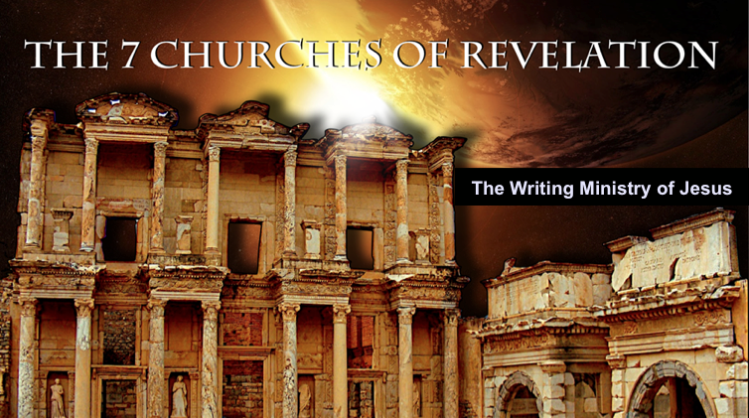
Rick Griffith
5 January 2014
Message 5 of 7

Distinguished Yet Dead:
Christ’s Letter to Sardis
Revelation 3:1-6

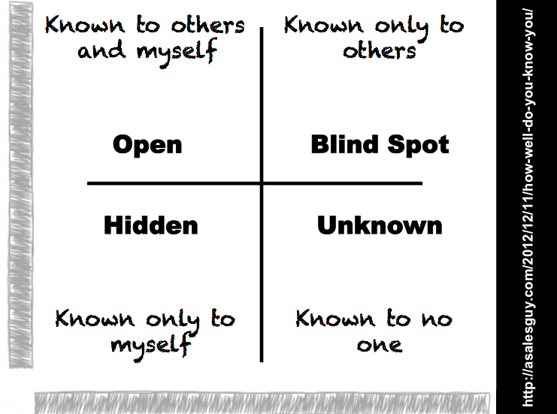
Introduction

We all have blind spots.

What’s your blind spot?

What does _________ think of you?

Christ knows people of every church so well that he holds each of them in the palm of his hand.

I. Jesus knows the_________.

Jesus encouraged Sardis with the good news that he was sovereign and knew their faithfulness (3:1-2a).

Destination: Jesus knew all about the proud past and current wealth of Sardis (3:1a).

Description of Christ: Jesus directs the ministry of the Spirit among the churches (3:1b).

Commendation: Jesus knew their good deeds and reputation (3:2a-b).

Christ knows all your good deeds and reputation.

II. Jesus knows the_________.

Jesus warned Sardis with the bad news that if they didn’t live up to their reputation then he would oppose them (3:2c-3c).

Rebuke: Sardis looked like unbelievers who have no spiritual life (3:2c).

Exhortation: Look alive through obedience and repentance (3:2d-3b).

Wake up (3:2d).

Finish the deeds that were started (3:2e).

Obey (3:3a).

Repent (3:3b).

Warning: Christ will discipline if there is no improvement (3:3c).

Christ warns us to wake up too.

III. Jesus knows the ________________.

Jesus promised believers at Sardis that they are victorious and secure to walk with him in purity (3:4-5).

Every believer is a conqueror that will walk in purity with Christ (3:4-5a).

Every believer has eternal security (3:5b).

Christ will praise every believer before the Father and His angels (3:5c).

Every believer should listen to what God’s Spirit is telling the churches (3:6).

Christ has a fantastic future for you, so listen (3:6)!

Conclusion

Jesus knows your good, bad, and _____________ (Main Idea).

How does Christ want to show himself alive in your life in 2014?

Thought Questions:

- Read Revelation 3:1-6 aloud. What did Jesus mean by the church being distinguished but “dead”? What evidences did he give of their lifeless state?

- How can we “wake up” as a church? What role can you have in this?

- How can you personalize Christ’s promises in verse 4? Put your name into the verse and read it aloud.

