Amman International Church Dr. Rick Griffith
11 Feb 2023 Single Message
NLT 30 Minutes
Title
What to Pray For
Philippians 1:9-11

Topic: Prayer
Subject: What should we pray for?
Complement: Pray for God’s character prayer list.
Purpose: The listeners will pray for character instead of only what they want.

Introduction

Interest: “Don’t Interrupt Me, Lord, I’m Praying: A 2-Part Skit Reflecting on the Lord’s Prayer” (http://www.murraymoerman.com/3downloads/don%27t_interrupt_me_lord_i%27m_praying.pdf)

Need: What do you typically pray for? What do you pray for most? Be honest! And tell the person next to you.

Healing? Is health most on your mind for others or yourself?

Wisdom?

Comfort? Do you pray that God would make life easier?

Something else?

Subject: What should we pray for? What subjects should be on our minds and lips most as we talk to God?

Background: In our Philippians series, we have covered the first 8 verses. So far, Paul told them he was praying for them but up to this point he hasn’t told them the content of his prayer. What did he pray for?

Preview: Let’s explore five things on God’s prayer list.

Text: Philippians 1:9-11 will give us these five things on God’s heart to talk to him about.

(What is the first thing to pray for?)

I. Pray to grow in love (Phil 1:9a).
[Ask God to make you increasingly selfless.]

Are you more loving this year than you were last year?

The best synonym for love is selflessness. I spoke to a woman my age who had just retired when we were shifting from Singapore to Jordan. I said, “Most people think of retirement as, ‘Well, I have served others for years—and now it’s time to serve myself!” She said, “Well, that’s my view!” I appreciated her honesty!

Jesus made it easy for us to see our highest goal—LOVE!

What do you think is the most important thing we do as a church? Worship? Evangelism? Fellowship? Bible study? Prayer? Once a man inquiring about our church asked me, “So what is most important to your church? What is unique?” If he had asked you, what would you have said? I told him one word: LOVE!

Some believe that happiness is most important. For example…

“The most important thing is to enjoy your life—it's all that matters”—Audrey Hepburn

“Happiness is the most important thing in the world, without it, you live a life of depression”—Marilyn Monroe was a woman so unhappy that she took her life at age 36.

Others say that family is most important: “The most important thing in life will always be family. The people right here, right now”—Vin Diesel

But Jesus declared love most important in Mark 12:29-31. One of the teachers of religious law was standing there listening to the debate. He realized that Jesus had answered well, so he asked, “Of all the commandments, which is the most important?” Jesus answered…

“The most important commandment is this: ‘Listen, O Israel! The Lord our God is the one and only Lord. 30 And you must love the Lord your God with all your heart, all your soul, all your mind, and all your strength.’

The second is equally important:
‘Love your neighbor as yourself.’ No other commandment is greater than these.”

This was our church’s vision when I was pastor: Love God first, love the church second, and love the nations, third.
(So pray for your love to grow. What is the second thing to pray for?)

II. Pray for discernment (Phil 1:9b).
[Ask God to give you insight into life issues.]

“But that love should be more than sentimental; it should be knowledgeable and discerning. Having genuine spiritual knowledge… of God and depth of insight into His ways enables Christians to love God and others more. (This Gr. word for “insight”… occurs only here in the NT.)” (Robert P. Lightner, “Philippians,” in The Bible Knowledge Commentary, 2:650).

What’ growing in your head?

We work hard to expand our knowledge of many things—finances, technical skill, and the like.

But the knowledge most needed is spiritual insight. Pray for that most!
(So pray for both love and discernment. What is the third thing to pray for?)

III. Pray for priorities (Phil 1:10a).
[Ask God to help you get excited about the right things.]

Do you follow your priorities? Actually, everyone does! That’s what makes them priorities!

“Action expresses priorities” (Gandhi). Our problem is not that we don't follow our priorities but that we have the wrong priorities.

So are your priorities in order? Do you follow the right priorities?

What should be the priority? God alone can show us what should be first in our lives.
(Reading on in the verse can help answer this. The fourth thing to pray for should be a huge priority…)

IV. Pray for purity of heart (Phil 1:10b-11a).
[Ask God for a righteous and blameless life.]

Phil 4:8 gives us a great list of what to think about to be pure in heart.

Let’s hold one another accountable not to depend on media or to look at anything vile (Psalm 101:2b-3a).

When my three sons were young, we had a rule in the house. If someone got killed or there was sex, we turned the TV off.

I follow the same rule when I see the 264 movie options on long-distance flights. Honestly, not many movies are left, but that’s OK.
(What’s the final item on God’s prayer list?)

V. Pray to glorify God (Phil 1:11b).
[Ask God to help you make him look good.]

What does it mean “to bring glory and praise to God”?

One of our biggest problems is that we live to make ourselves look good.

Check your motives for why you do what you do. Whom does it make look good?

Do you seek to make yourself look good?

That's called glory to self.

Instead, make God look good.

That's called glory to God.
(So what should we pray for? Let’s simplify this in one statement…)

Conclusion

Pray for God’s character prayer list (MI).

Don’t pray for what you want but pray for what God wants: “May your kingdom come, your will be done, on earth as it is in heaven” (restated MI).

Main Points: Here are the five items on God’s prayer list again.

Exhortation:

Which of these is most seen in your life? Thank God.

Which is your weakest request of God? Commit to changing that.

Prayer

Preliminary Questions

Verses Questions

Context: What did the author record just prior to this passage?

Paul expressed thanks for their partnership in the gospel.

He also told them he was praying for them—but not the content yet.

Purpose: Why is this passage in the Bible?

We need examples of what to pray for.

The Bible gives us sample prayers and lists of the most important things to talk to God about.

Background: What historical context helps us understand this passage?

Paul was under house arrest in Rome for nearly two years (*cf. Acts 28:30-31).

He was hoping to be released but wasn’t sure what would happen.

Questions

Can we assume that what Paul prayed for is a good list for us? I think so.

What word best sums up all five of these items of prayer? Character!

Tentative Subject/Complement Statements

Pray for what God wants you to pray for instead of what you want to pray about.

Possible Illustrations

The Lord’s Prayer

DON’T INTERRUPT ME, LORD, I’M PRAYING
A 2-person skit reflecting on the Lord’s Prayer
By Clyde Lee Herring
Adapted from Bread magazine, Nazarene Publishing House
Adapted from http://www.murraymoerman.com/3downloads/don%27t_interrupt_me_lord_i%27m_praying.pdf

Our Father who art in Heaven...
Yes
Don’t interrupt me. I’m praying.
But you called me!
Called you? I didn’t call you. I’m praying. “Our Father who art in Heaven...”
There, you did it again.
Did what?
Called me. You said, “Our Father who art in Heaven.” Here I am... What’s on your mind?
But I didn’t mean anything by it. I was, you know, just saying my prayers for the day. I always say the Lord’s Prayer. It makes me feel good, sort of like getting a job done.
All right, go on.
“Hallowed be thy name...”
Hold it! What do you mean by that?
By what?
By “Hallowed be thy name?”
It means... It means... Good grief. I don’t know what it means. How should I know? It’s just part of the prayer... By the way, what does it mean?
It means honoured, holy, wonderful
Ah! That makes sense. I never thought about what “hallowed” meant before. .... “Thy kingdom come, thy will be done on earth as it is in Heaven.”
Do you really mean that?
Of course, why not?
What are you going to do about it?
Do? Nothing I suppose. I just think it would be rather good if you got control of everything down here as you have up there.
Have I got control of you?
Well, I go to church!
That isn’t what I asked you. What about your bad temper? You’ve really got a problem there you know. Then there’s the way you spend your money.....all on yourself; and what about the kind of books you read?
Stop picking on me! I’m just as good as some of the rest of those hypocrites down at the church!
Excuse me. I thought you were praying for my will to be done. If that is to happen it will have to start with the ones who are praying for it. Like you, for example.
Oh, all right. I guess I do have some hang-ups now that you mention it. I could probably name some others.
So could I.
I haven’t thought about it very much until now, but I really would like to cut out some of those things. I would like to, you know, be really free.
Good! Now we’re getting somewhere. We’ll work together, you and I. Some victories can truly be won. I’m proud of you.
Look, Lord, I need to finish up here. This is taking a lot longer than it usually does.... ‘Give us this day our daily bread.’
You need to cut out the bread. You’re overweight as it is.
Hey, wait a minute! What is this? ‘Criticize Me Day?’ Here I was, doing my religious duty, and all of a sudden you break in and remind me of all my hang-ups.
Praying is a dangerous thing. You could wind up changed, you know! That’s what I’m trying to get across to you. You called me and here I am. It’s too late to stop now. Keep on praying. I’m interested in the next part of your prayer....... (pause) Well, go on.
I’m scared to.
Scared? Of what?
I know what you’ll say.
Try me and see
‘Forgive us our debts as we also have forgiven our debtors.’
What about Bill?
See! I knew it! I knew you would bring him up! Why Lord? He’s told lies about me, and cheated me out of some money. He never paid back that debt he owes me. I’ve sworn to get even with him!
But your prayer? What about your prayer?
I didn’t mean it
Well, at least you’re honest, but it’s not much fun carrying that load of bitterness around inside, is it?
No, but I’ll feel better as soon as I get even. Boy, have I got some plans for old Bill! He’ll wish he never did me any harm.
You won’t feel any better. You’ll feel worse. Revenge isn’t sweet. Think of how unhappy you already are, but I can change all that.
You can? How?
Forgive Bill. Then I’ll forgive you. Then the hate and sin will be Bill’s problems and not yours. You may lose the money, but you will have settled your heart.
But, Lord, I can’t forgive Bill.
Then I can’t forgive you.
Oh, you’re right. You always are; and more than I want revenge on Bill, I want to be right with you......(pause…sigh). All right, all right. I forgive him. Help him to find the right road in life. Lord, he’s bound to be awfully miserable now that I think about it. Anybody who goes around doing the things he does to others has to be mixed up inside. Someway, somehow, show him the right way.
There now! Wonderful! How do you feel?
Hmmm. Well, not bad. Not bad at all. In fact, I feel quite tremendous! You know, I don’t think I’ll have to go to bed tense tonight for the first time since I can remember. Maybe I won’t be so tired from now on because I’m not getting enough rest.
You’re not through with your prayer. Go on.
Oh, all right. ‘And lead us not into temptation, but deliver us from evil.’
Good! Good! I’ll do just that. Just don’t put yourself in a place where you can be tempted.
What do you mean?
Change some of your friendships. Some of your so-called friends are beginning to get to you. They’ll have you completely involved in the wrong things before long. Don’t be fooled. They advertise that they’re having fun, but for you, it would be ruin. Don’t use me for an escape hatch.
I don’t understand.
Yes, you do. You’ve done it a lot of times. You get caught in a bad situation. You get into trouble and then you come running to me. ‘Lord help me out of this mess and I promise you I’ll never do it again.’ Do you remember some of those bargains you tried to make with me?
Yes, and I’m ashamed, Lord, I really am.
Which bargain are you remembering?
Well, when the woman next door saw me coming out of the local pub. I’d told my mother I was going to the shop. I remember telling you ‘O God, don’t let her tell my mother where I’ve been. I promise I’ll be in church every Sunday.’
She didn’t tell your mother, but you didn’t keep your promise, did you?
I’m sorry, Lord, I really am. Up until now I thought that just praying was enough. I didn’t expect you to answer like this.
Go ahead and finish your prayer.
‘For thine is the kingdom, and the power, and the glory, forever, Amen’
Do you know what would bring me glory? What would really make me happy?
No, but I’d like to know. I want now to please you. Now I can see how good it would be to be a real follower of you.
You just answered the question.
I did?
Yes. The thing that would bring me glory is to have people like you truly love and follow me; and I see that happening between us. Now that some of these old sins are exposed and out of the way, well there’s no telling what we can do together.
Lord, let’s see what we can make of me, ok?
Yes, let’s see.

Possible Applications

Thank God for where you are doing the best in these five prayer items.

Ask God to help you in your weakest area.
What to Pray For
Philippians 1:9-11

Exegetical Outline (Steps 2-3)

Exegetical Idea: The content of Paul’s prayer for the Philippians was for their character according to God’s plan.

I. The content of Paul’s prayer for the Philippians was that they would grow in love (Phil 1:9a).

II. The content of Paul’s prayer for the Philippians was that they would have discernment (Phil 1:9b).

III. The content of Paul’s prayer for the Philippians was that they would follow the right priorities (Phil 1:10a).

V. The content of Paul’s prayer for the Philippians was that they would have purity of heart (Phil 1:10b-11a).

VI. The content of Paul’s prayer for the Philippians was that they would glorify God (Phil 1:11b).

Purpose or Desired Listener Response (Step 4)
The listeners will pray for character instead of only what they want.

Homiletical Outline (Cyclical inductive form)

Introduction

Interest: “Don’t Interrupt Me, Lord, I’m Praying: A 2-Part Skit Reflecting on the Lord’s Prayer”

Need: What do you typically pray for? What do you pray for most? Be honest! And tell the person next to you.

Subject: What should we pray for?

Background: Paul told them he was praying for them but up to this point he hasn’t told them the content of his prayer.

Preview: Let’s explore five things on God’s prayer list.

Text: Philippians 1:9-11

(What is the first thing to pray for?)

I. Pray to grow in love (Phil 1:9a).

Are you more loving this year than you were last year?

The best synonym for love is selflessness.

Jesus made it easy for us to see our highest goal—LOVE!
(So pray for your love to grow. What is the second thing to pray for?)

II. Pray for discernment (Phil 1:9b).

“But that love should be more than sentimental.”

We work hard to expand our knowledge of many things—finances, technical skill, and the like. But our greatest need is spiritual insight. Pray for that most!
(So pray for both love and discernment. What is the third thing to pray for?)

III. Pray for priorities (Phil 1:10a).

Do you follow your priorities? Actually, everyone does!

“Action expresses priorities” (Gandhi).

So are your priorities in order?

What should be the priority?
(Reading on in the verse can help answer this. The fourth thing to pray for should be a huge priority…)

IV. Pray for purity of heart (Phil 1:10b-11a).

Phil 4:8 gives us a great list of what to think about to be pure in heart.

Let’s hold one another accountable not to depend on media or to look at anything vile (Psalm 101:2b-3a).
(What is the last thing to pray for?))

V. Pray to glorify God (Phil 1:11b).

What does it mean “to bring glory and praise to God”?

One of our biggest problems is that we live to make us look good.

Check your motives for why you do what you do. Who does it make look good?
(So what should we pray for? Let’s simplify this in one statement…)

Conclusion

Pray for God’s character prayer list (MI).

Don’t pray for what you want but pray for what God wants: “May your kingdom come, your will be done, on earth as it is in heaven” (restated MI).

Main Points: Here are the five items on God’s prayer list again.

Exhortation:

Which of these is most seen in your life? Thank God.

Which is your weakest request of God? Commit to change that.

Prayer

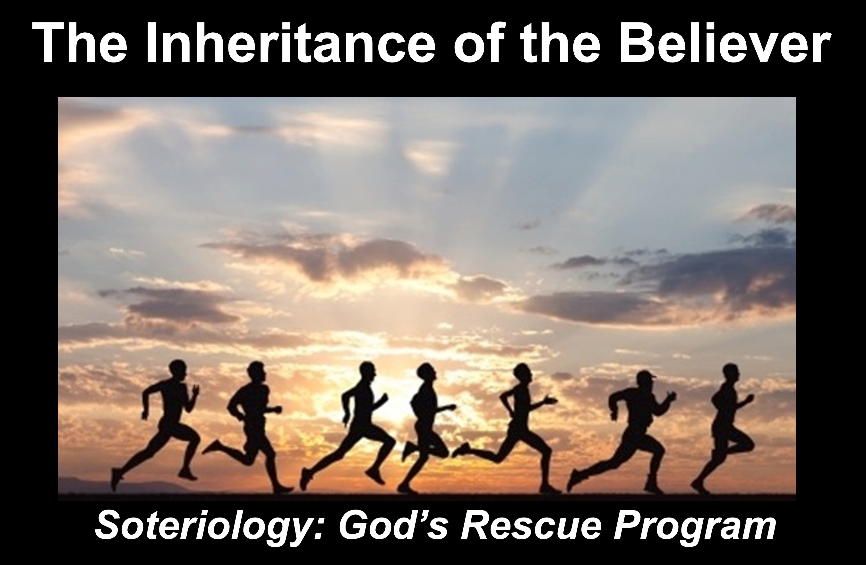

Rick Griffith
2023
Message of 4

Title
Passage

Introduction

Subject with a blank for the key word _______________

I. MP has a blank for the key word ________________ (verses).

SP has a blank for the key word ________________ (verses).

SP has a blank for the key word ________________ (verses).

SP has a blank for the key word ________________ (verses).

II. MP has a blank for the key word ________________ (verses).

SP has a blank for the key word ________________ (verses).

SP has a blank for the key word ________________ (verses).

SP has a blank for the key word ________________ (verses).

Conclusion

Main Idea has a blank for the key word ________________ (verses).

Application question

Thought Questions

- Read the passage aloud. Contrast:

Issue | Contrast

- Text-based question

- Application to your own Christian experience

Download this sermon PPT and notes for free at BibleStudyDownloads.org/resource/new-testament-preaching/

