Crossroads International Church Singapore Dr. Rick Griffith
21 Feb 2021 Message 4 of 23
NLT 30 Minutes
Title
Obey God—Not Man
Acts 4:1–5:11

Topic: Obedience
Subject: How should you respond to the challenges that your faith in Christ brings?
XX or XY
Empty Tomb
Series
4:1-7
4:3-7
(3 slides)
Church Circle
Acts 3
(3 slides)
Oppose
Light
Complement: Obey God rather than people.
Purpose: The listeners will obey God rather than people when they must make a choice.
Attribute: The God Worth Obeying
Meditation: Acts 4:18-20
Reading: Acts 4:32-37
Benediction: Jude 24
Songs: Here I Am to Worship, I Will Follow, Here I Am Lord

Introduction

Interest: It’s no secret that not everyone is exciting about us being Christians.

Science says every person has either XX or XY chromosomes—but believers in science like us are deemed homophobes.

Jesus lived and died and rose, but few seem interested to find out if the resurrection is really true—but we are opposed as if we believe in myths. I could go on…

Need: How do you respond when there is a price to pay for your faith?

How are you challenged at work because you are a Christian?

How’s your response to unbelieving family members when it may cost you?

Do you cave in? Get angry and demand your rights? Allow your voice to be cancelled due to fear?

Subject: How should you respond to the challenges that your faith in Christ brings? What should we do when the truth of the gospel is opposed?
• Subject

Background: Our series on Acts has shown that God did an amazing miracle in Acts 3 where a man who never had walked ended up jumping and praising God on his feet—now how will everyone respond? The witnesses were amazed, Peter preached, and the church grew from 3000 to 5000—but will this bring the rulers to Christ also?

Preview: Today we will see the responses in the early church to both external and internal threats only days or weeks after its founding at Pentecost.
Oppose & Respond
Peter & John

Text: These two forms of opposition took place in Acts 4:1–5:11.

(First, let’s see the eternal opposition to the gospel. How should you respond when the opposition comes from the outside?)

I. When unbelievers oppose you, obey God—not man (Acts 4:1-31).
• Obey God
[When non-Christians challenge your faith, don’t give in and deny your Lord.]

External opposition from the Sanhedrin led the church to obey God—not man (4:1-31).

Peter and John defied the Sanhedrin order to stop teaching Christ’s resurrection (4:1-22).

The Sadducees opposed Peter and John preaching Christ’s resurrection after the church grew to 5000 (4:1-7).

Peter preached the resurrected Jesus with the healed cripple beside him to the divided Sanhedrin (4:8-22).
4:8-10)
Choose
5:29
External
Jesus as Corner

What is a cornerstone (4:11 NLT, ESV) or capstone (4:11 NIV)?

The word here literally is simply “stone.” Romans constructed arches where the weight of both sides rested on the central stone at the top called the keystone—then the capstone was above it on top. The NLT and ESV see this as the cornerstone at the bottom. But imagine trying to construct an arch with all the other stones but then throw away any of these most vital stones! They form the foundation, the point of weight distribution and top.
Corner-stone
Capstone

Jesus is that stone on which the entire OT rests—the law, the sacrifices, the priesthood, the temple—everything!

Does Acts 4:12 mean that people must trust Jesus alone for salvation? What else could it mean? Who else has paid the price for our sin?
4:12
(2 slides)
Read
4:13-22

Does the refusal of Peter and John to obey the Sanhedrin mean that we also can choose to disobey authority when we wish (4:18-20)?
4:19

The NT commands us four times to obey authority.

Yet we are also to obey God.

But sometimes these two authorities clash—as they will do in the next chapter also. So we must choose to obey the lower authority of humans or the higher authority of God. The apostles acted like Daniel, who was told to pray to no “other god” except King Darius, who couldn’t hear his prayers anyway, so Daniel also obeyed the higher authority (Dan 6).
Dan 6

But we must be prepared to suffer for doing what is right—so God gave us the letter of 1 Peter, since Peter, after all, is the one of those who refused to obey the Sanhedrin.

The church boldly preached despite the opposition of the rulers (4:23-31).
Commit now
4:23-31

Commit now to obey God before temptations by unbelievers to obey man become too strong.

When I graduated from business school, my unbelieving parents wanted me to become a businessman—which is fine for most graduates—but God called me overseas, so I had to obey God by becoming a missionary. Obey God—not man.

When the US Supreme Court ruled to redefine marriage in 2015, “A broad coalition of Protestant, Catholic, Orthodox Christian, and Jewish leaders joined by civic and business leaders from around the nation have signed an open letter to the U.S. Supreme Court vowing they will not honor any decision by the Supreme Court that would force them to violate the biblical understanding of marriage as the union of one man and one woman.” Obey God—not man.

(So far we have seen external opposition to the gospel. In these cases, we must obey God rather than man. But how should you respond when the opposition comes from the inside?)

II. When believers oppose you, fear God—not man (Acts 4:32–5:11).
• Internal
[When Christians challenge your faith, honor Jesus instead of people honoring you.]

Internal deception by Ananias and Sapphira caused a fear of God (4:32–5:11).

Believers selflessly shared their belongings so that no one was needy (4:32-37).
4:32-37
(2 slides)

Ananias and Sapphira died trying to deceive but the church feared God (5:1-11).
5:1
Scales
• Obey
MI
Let Lead
to Fear
Family 20 Feb 1991
• Fear
MPs
Subject
Ravi

What was wrong with Ananias not giving all of the money from the sale of his property (5:1-2)? Not giving it all was not the problem—the issue was his attempt to deceive the Spirit himself (5:3-4).
5:1-11 Dark Path

Did Ananias lie to the Spirit (5:3) or to God (5:4)? Here is one of the clearest statements of the deity of the Spirit in the Bible as they are one and the same.
• HS
• God

What does it mean that fear seized the church (5:5, 11)?
Fear (5, 11)

That this happened both with the death of Ananias and his wife Sapphira underscores that the believers genuinely were afraid of what God might do to them—aren’t you?

One of my middle-aged students shared the story a few years back how her husband was a key leader in the church but abandoned his faith to sleep with a woman from China. Within a year he was dead as God took his life.

Let resistance by believers lead you to fear God.

Ravi Zacharias has proven to be a sexual predator—so fear God.

Ask hard questions and welcome hard questions from other believers.

When I graduated from business school, I told you that my parents opposed my mission direction to Asia. But the fuller story is that my church also opposed my missions goal! That was even harder as these were believers out of step with God. So I drew near to God—and here we are 41 years later! It took 14 years for my church to affirm my call.
Going into Missions

(So how should you respond to the challenges that your faith in Christ brings? What should we do when the truth of the gospel is opposed? Our response to opposition should be to…)

Conclusion

Obey God rather than people (Main Idea).

Main Points

When unbelievers oppose you, obey God—not man (Acts 4:1-31).

When believers oppose you, fear God—not man (Acts 4:32–5:11).

Say aloud, “I will ultimately account to Jesus himself for my life—not to people.”

This realization moves me to make hard decisions.

Susan and I have had to make some difficult choices in recent years. So here’s the deal…

As of yesterday, I have been a professor at Singapore Bible for 30 years—yes, we arrived in Singapore 30 years ago yesterday on 20 Feb 1991.

My goal has been to teach Bible and theology until age 70—which is 7 more years as I am now 63 years old.
Philemon Plan to 70

But the College recently decided to shift me to teach only preaching rather than my master degree specialty of theology and my PhD area in Bible Exposition.

So we have been praying whether to try to stay 7 more years in Singapore without teaching Bible and theology.
JETS Schedule
CIC Jim
Students
Cross on Globe

Singapore law also seeks to retire expatriates in their 60s so more Singaporeans can take these positions.

At the same time, Jordan Evangelical Theological Seminary (JETS) has invited us to move to Amman, Jordan to teach Bible and theology through translation into Arabic.
Invitation
Building

In 1990, I graduated with the president and founder, Dr Imad Shehadeh—and over the years he has asked four times if we would join with him there but the timing has never been right.
Imad
2001

But now we believe that is timing is right to make this shift before we get too old to shift to another culture. Jordan also gives us the potential to serve as long as we wish!
Jordan
Map

So we will be leaving Singapore on June 8, have a few weeks in the USA with churches and family, and join JETS in August.

I have never been more confident in the future of Crossroads International Church! Most of the past year, CIC has been in the able hands of Pastor Jim and Jacqui, along with our other elder Matt and his wife Karla. The Lord is raising up others of you also so that the church has never been in a stronger position—nor has it ever had this many people in the past 15 years.

The church leaders have known about our decision for 1-2 months and have given their blessing for us to be an extension of CIC into the Middle East. The past three decades I have been privileged to train students from 21 Asian nations—but now God has opened the door to serve at JETS that has students from 21 MENA nations (Middle East & North Africa). I am convinced that the best years for CIC are ahead!

Where is God telling you to “obey God—not man”?
Telling You?

How is he challenging you also to make changes for his glory—even if this was not part of your original plan?

Are you ready to say, “Here I am, Lord”?
Prayer

Prayer

Preliminary Questions

Verses Questions

Context: What did the author record just prior to this passage?

Peter healed a man lame from birth (3:1-10).

He then proclaimed Jesus as the resurrected Messiah (3:11-26).

Purpose: Why is this passage in the Bible?

In the eyes of Jewish leaders, was it a bigger problem healing the man—or crediting Jesus with this miracle? I think we know the answer!

Today’s text shows that opposition to our faith comes both the outside (externally) and from the inside (internally(—but in both cases we must obey God rather than man.

Background: What historical context helps us understand this passage?

The Jewish ruling council was called the Sanhedrin (4:15). It had two major parties: Sadducees who denied the resurrection (4:1-2) and Pharisees who held the orthodox belief in the resurrection. The former group are the focus of today’s text. They are called “rulers and elders of the people” (4:8).

The OT often predicted that the Messiah would be opposed. Acts 4 cites two key Psalms texts prophesying the rejection of Jesus:

Jesus is likened to the main stone in constructing a building (4:11 quotes Ps 118:22).

Jesus is the Anointed One (Messiah) by God but plotted against by worlding leaders (4:25-26 quotes Ps 2:1-2).

Questions

Why did the Jewish leaders have such a problem with Jesus (4:1-22)? Why did so few of them believe?

Theology: The apostles were “proclaiming in Jesus the resurrection of the dead” (4:2). Sadducees refused to believe in the resurrection of Jesus or of others.

Pride (5:17): Jesus and his disciples had none of the credentials that impressed them—no formal education or even the right accent—but thousands followed them instead of the Jewish rulers.

Guilt (5:28): The teaching of the apostles convicted the Jewish leaders of killing Jesus, but they refused to repent.

Power: The Sanhedrin had power to flog and imprison people but these men were humanly powerless and yet with far greater power ultimately.

Deception: Protecting Jerusalem became a higher priority than protecting truth. The Jewish leaders claimed to use their power to protect the city from the Romans destroying it, but in reality their teaching led to its destruction.

Prophecy: God said that this would happen to the Messiah and his followers.

What is a capstone (4:11)?

Romans constructed arches where the weight of both sides rested on the central stone at the top—this capstone thus became the most important! Stonecutters would carve these stones off site, mark them carefully, and others would haul them to the arch for assembly. But imagine trying to construct an arch with all the other stones but then throw away the most vital stone!

Jesus is that capstone on which the entire OT rests—the law, the sacrifices, the priesthood, the temple—everything!

Does Acts 4:12 mean that people must trust Jesus alone for salvation? What else could it mean?

How could the healed cripple stand with Peter and John at their trial the next morning (4:14)? He evidently was also put into prison with them! What a crime to get healed!

Does the refusal of Peter and John to obey the Sanhedrin mean that we also can choose to disobey authority when we wish (4:18-20)?

The NT commands us four times to obey authority.

Yet we are also to obey God.

Sometimes these two authorities clash—so we must choose to obey the lower authority of humans or the higher authority of God. The apostles acted in a similar way as Daniel, who was told to pray to no “other god” except King Darius, who couldn’t hear his prayers anyway, so Daniel also obeyed the higher authority (Dan 6).

But we must be prepared to suffer for doing what is right—so God gave us the letter of 1 Peter, since Peter, after all, is the one of those who refused to obey the Sanhedrin.

What was wrong with Ananias not giving all of the money from the sale of his property (5:1-2)? Not giving it all was not the problem—the issue was his attempt to deceive the Spirit himself (5:3-4).

Did Ananias lie to the Spirit (5:3) or to God (5:4)? Here is one of the clearest statements of the deity of the Spirit in the Bible as they are one and the same.

What does it mean that fear seized the church (5:5, 11)?

That this happened both with the death of Ananias and his wife Sapphira underscores that the believers genuinely were afraid of what God might do to them—aren’t you?

One of my middle-aged students shared the story a few years back how her husband was a key leader in the church but abandoned his faith to sleep with a woman from China. Within a year he was dead as God took his life.

Tentative Subject/Complement Statements

How do you respond when you see God at work? God’s work elicits either a response of belief or unbelief as there is no neutral ground.

Outlines

New Testament Survey (Rick Griffith)

External opposition of the Sanhedrin after Peter and John heal a beggar enables witness to three different audiences (3:1–4:31).

Peter and John heal a crippled beggar at the temple in the name of Jesus (3:1-10).

Peter witnesses to three audiences (3:11–4:31).

Peter indicts the Jews for agreeing to kill the Son of God (3:11-26).

Jesus could heal the cripple because he is innocent and living (3:11-16).

Jesus is Israel’s promised king (Christ=Messiah) who will return to restore the kingdom after the nation believes (3:17-26).

Peter rejects the Sanhedrin command to stop preaching so that the church grows to 5000 (4:1-22).

The Sadducees oppose Peter and John preaching Christ’s resurrection but the church grows to 5000 (4:1-7).

Peter preaches the resurrected Jesus with the healed cripple beside him to the divided Sanhedrin (4:8-22).

Peter encourages the church to boldly preach despite the opposition of the rulers (4:23-31).

Internal opposition from Ananias and Sapphira’s deceit backfires to cause a fear of God needed for church growth (4:32–5:11).

Believers share their possessions selflessly so that no one is in need (4:32-37).

Ananias and Sapphira try to deceive the church so that they both die the same day (5:1-11).

Miraculous healings by the apostles expand the church beyond Jerusalem to people from nearby towns who bring others for healing (5:12-16).

External opposition of the Sanhedrin again persecutes the apostles so God could provide escape from jail and joy from suffering for Christ (5:17-42).

Internal opposition regarding food distribution is squashed by delegating seven managers to show God's commitment to his Church (6:1-7).

Toussaint, “Acts,” Bible Knowledge Commentary

Wiersbe, Bible Exposition Commentary

Possible Illustrations

I have been discouraged by my authorities not to serve him like in Acts 4—FCC, parents, academia.

The personal data on each of us is already over 70 pages and is expected to grow four times by 2025. This will make our social credit score multiply into our political credit score—as well as financial and especially religious credit scores. Data is being collected worldwide now to prepare to persecute believers.

In the past month, we have seen the media accounts of believers continually banned, blacklisted, and deleted. Facebook, Twitter, Amazon, and Google all have banded together to cancel conservative viewpoints—especially of Christians.

The hosting company of our church website—Squarespace—a few months back jumped on the LGBT bandwagon so we jumped off that site and shifted everything to a Christian hosting service before we get banned and deleted.

My own website has been hacked with malware that automatically forwards searches for BibleStudyDownloads.org to a Viagra website.

Most of this month no files could be downloaded due to so-called violations of their policies. So I had to go from a $100/year plan to a $900/year plan! And it still doesn’t work! And now they want me to pay them an extra $300 to keep my site secure!

Possible Applications

Sometimes—like Peter and John—we have to do what people say is crazy but God says is his will.

Singapore and SBC both have mechanisms to replace older workers with those coming up the ranks—as well as foreigners being replaced with locals.

One example of this is SBC moving me out of teaching theology courses in 2009—and then in late 2020 informing me that I will no longer teach Bible courses as well.

At the same time, JETS invited us to Jordan to serve as long as we want there to teach both Bible and theology.

Where is God telling you to “obey God—not man”?

Obey God—Not Man
Acts 4:1–5:11

Exegetical Outline (Steps 2-3)

Exegetical Idea: The response to both external Sanhedrin opposition and internal deception was the church obeying and fearing God.

I. The response to external opposition from the Sanhedrin was the church obeying God instead of man (4:1-31).

Peter rejected the Sanhedrin command to stop preaching after the church grew to 5000 (4:1-22).

The Sadducees opposed Peter and John preaching Christ’s resurrection after the church grew to 5000 (4:1-7).

Peter preached the resurrected Jesus with the healed cripple beside him to the divided Sanhedrin (4:8-22).

Peter encouraged the church to boldly preach despite the opposition of the rulers (4:23-31).

II. The response to internal deception from Ananias and Sapphira was a fear of God needed for church growth (4:32–5:11).

Believers selflessly shared their belongings so that no one was needy (4:32-37).

The result of Ananias and Sapphira dying from trying to deceive the church was fear among the saints (5:1-11).

Purpose or Desired Listener Response (Step 4)
The listeners will obey God rather than people when they must make a choice.

Homiletical Outline (Cyclical inductive form)

Introduction

Interest: It’s no secret that not everyone is exciting about us being Christians.

Need: How do you respond when there is a price to pay for your faith?

Subject: How should you respond to the challenges that your faith in Christ brings?

Background: God did an amazing miracle in Acts 3—now how will everyone respond?

Preview: Today we will see the responses in the early church to both external and internal threats only days or weeks after its founding at Pentecost.

Text: These two forms of opposition took place in Acts 4:1–5:11.

(First, let’s see the eternal opposition to the gospel. How should you respond when the opposition comes from the outside?)

I. When unbelievers oppose you, obey God—not man (Acts 4:1-31).

External opposition from the Sanhedrin led the church to obey God—not man (4:1-31).

Peter and John defied the Sanhedrin order to stop teaching Christ’s resurrection (4:1-22).

The church boldly preached despite the opposition of the rulers (4:23-31).

Commit now to obey God before temptations by unbelievers to obey man become too strong.

(So far we have seen external opposition to the gospel. In these cases, we must obey God rather than man. But how should you respond when the opposition comes from the inside?)

II. When believers oppose you, fear God—not man (Acts 4:32–5:11).

Internal deception by Ananias and Sapphira caused a fear of God (4:32–5:11).

Let resistance by believers lead you to fear God.

(How should you respond to the challenges that your faith in Christ brings? What should we do when the truth of the gospel is opposed? Our response to opposition should be to…)

Conclusion

Obey God rather than people (Main Idea).

Main Points

When unbelievers oppose you, obey God—not man (Acts 4:1-31).

When believers oppose you, fear God—not man (Acts 4:32–5:11).

Say aloud, “I will ultimately account to Jesus himself for my life—not to people.”

This realization moves me to make hard decisions.

Where is God telling you to “obey God—not man”?

Prayer

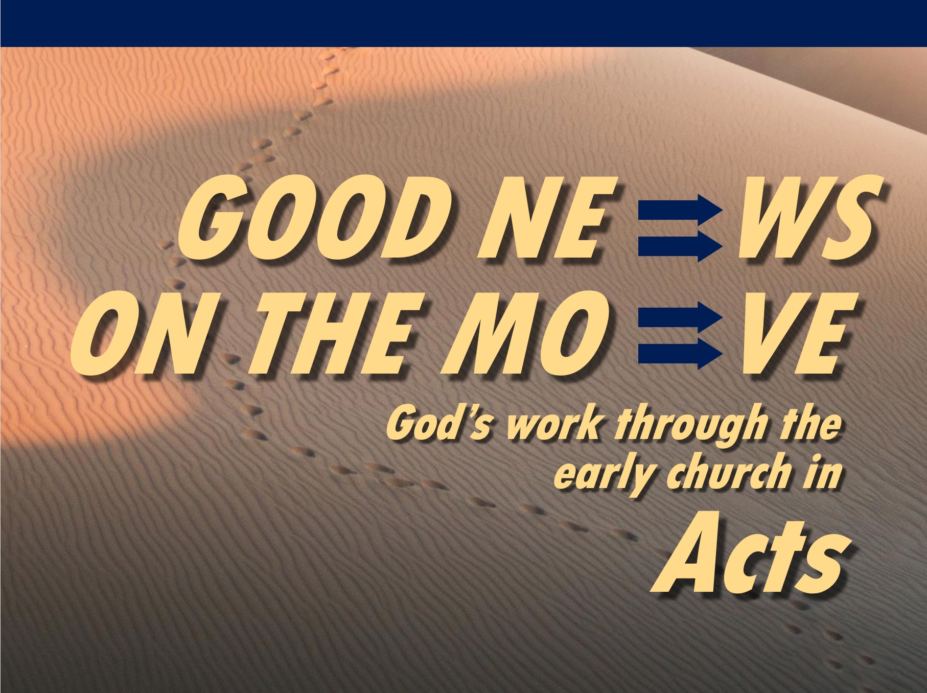
Rick Griffith
21 Feb 2021
Message 4 of 23

Obey God—Not Man
Acts 4:1–5:11

Introduction

It’s no secret that not everyone is exciting about us being Christians.

How do you respond when there is a price to pay for your faith?

How should you respond to the challenges that your faith in Christ brings?

I. When unbelievers oppose you, obey God—not man (Acts 4:1-31).

External opposition from the Sanhedrin led the church to obey God—not man (4:1-31).

Commit now to obey God before temptations by unbelievers to obey man become too strong.

II. When believers oppose you, fear God—not man (Acts 4:32–5:11).

Internal deception by Ananias and Sapphira caused a fear of God (4:32–5:11).

Let resistance by believers lead you to fear God.

Conclusion

Obey God rather than people (Main Idea).

Say aloud, “I will ultimately account to Jesus himself for my life—not to people.”

This realization moves me to make hard decisions.

Where is God telling you to “obey God—not man”?

Download this sermon PPT and notes for free at BibleStudyDownloads.org/resource/new-testament-preaching/

https://txvalues.org/2015/06/18/pastors-tell-supreme-court-we-must-obey-god-rather-than-men/

