El Dorado Park Community Church (14 June 2009) Dr. Rick Griffith
Crossroads International Church Singapore (7 Feb 2021) Message 2 of 23
NIV 30 Minutes
Title
The Power of the Spirit
Acts 2

Topic: Submission
• Big
• Own
Theme: Why submit to the Spirit?
Thrust: The Spirit put you into Christ’s body to reach the nations.
Purpose: The listeners will submit to the Holy Spirit for his purposes among the nations.
Songs: Holy Spirit (Getty), O Great God (Kauflin), Spirit of God Descend Upon My Heart

Introduction

Interest: [To see God do a work in our lives, we need a breakthrough.]

I wonder if you would agree with these statements:
Agree?

Most of us go through life trusting in our own strength.

Most of us go through life without ever trusting God to do something big. (Someone said that if you tell others your dream for your life and they don’t laugh, then it isn’t big enough!)

Most need a breakthrough past our monotony, but don’t trust God for it.
• Break

In 2006 we saw the need for an international church in Singapore to love, God, the church, and the nations, but we didn’t have the time to invest in it. But God began Crossroads. We're small, but by his grace CIC impacts people from 16 nations as we study Good News on the Move in Acts!
Series
CIC Vision

To see God work in our lives, we need to submit to him for a breakthrough.

Need: What kind of breakthrough do you need in your life?
You?

What are you trusting God for that only he could do?

Is it a relational breakthrough that you need? We are trusting God to radically change our adult sons in their secular thinking.

Do you need a breakthrough in your work or ministry?
Bkgrd

Background: In Acts 1, apostles saw the risen Christ, but that wasn’t enough. Jesus told them to wait in Jerusalem for their own breakthrough—God’s Spirit! He said in effect, ! “Don’t even move apart from the Spirit”—fulfilled in Acts 2.
Upper Room

Subject: Why submit to the Spirit? Because we also need a breakthrough of the Spirit! Why do we need the power of the Spirit to give us a breakthrough?
Subject

Preview: Today in Acts 2 we will see three reasons to submit to the Spirit.
• 3 reasons

Transition: The first reason we need to submit to the Spirit is because……

I. The Spirit reverses Babel (1-13).
MP

[The Spirit enabling people to speak other languages was God’s way of saying He cared enough to bring people together.]

Judgment: God separated people at the Tower of Babel when he confused human languages. Let’s read Genesis 11:1–9…
Gen 11
(6 slides)

Blessing: God united people at Pentecost when the baptism with the Spirit enabled the apostles to speak many languages (Acts 2:1-13).
2:1-13
(5 slides)
Languages

The Spirit enabled the believers to speak in languages they had never learned in a reversal of Babel’s judgment (1-4).

Warren Wiersbe notes, “Why did God do this? For one thing, Pentecost was a reversal of the judgment at the Tower of Babel when God confused man’s language (Gen. 11:1–9).
Reversal

God’s judgment at Babel scattered the people, but God’s blessing at Pentecost united the believers in the Spirit.
• United

At Babel, the people were unable to understand each other; but at Pentecost, men heard God’s praises and understood what was said.
• Understood

The Tower of Babel was a scheme designed to praise men and make a name for men, but Pentecost brought praise to God.
• Praise God

The building of Babel was an act of rebellion, but Pentecost was a ministry of humble submission to God. What a contrast!
• Submission

“Another reason for this gift of tongues was to let the people know that the Gospel was for the whole world. God wants to speak to every person in his or her own language and give the saving message of salvation in Jesus Christ. The emphasis in the Book of Acts is on worldwide evangelization, ‘unto the uttermost part of the earth’ (Acts 1:8). [automate] ‘The Spirit of Christ is the spirit of missions,’ said Henry Martyn, ‘and the nearer we get to Him, the more intensely missionary we must become’” (Wiersbe, BEC).
Whole World

The unbelieving Jews living throughout the Roman Empire who had come to Jerusalem for Pentecost was amazed at this miracle (5-13).
Amazing!

How many of you can speak another language besides English? Wouldn’t it be a work of God for me to speak your language without having learned it?
51 million

The Roman Empire had 55 million—with 4 million Jews spread throughout. All Jews were bilingual, but traveled to Jerusalem each Pentecost in spring. Imagine their shock to hear these Galileans speak their language!
Latin

God continues today to speak our languages!

More than our ethnicity, languages separate us. I am closer to an African or Asian that speaks English than I do to a fellow Caucasian who doesn’t speak English.

The Bible has been translated into more languages than any other book. This is one key way that God is bringing about his plan in the world to make one Church.
Faces

I get to see this every day in Singapore. Since 1991, I have invested myself in my students who teach in 52 languages at Singapore Bible College.
SBC Map

For 12 years I had them write papers in English until an idea hit me: “Hey, instead of them writing a research paper in English, then bloody them with my red pen and hand it back to them so they can toss it into the circular file—why not have them translate our class PPT into their native tongues?”
Trash
Translate
Implications

So that’s what I’ve done since 2003—and now we have 2,880 presentations in 52 languages! Guess what the students teach when they go home after they graduate? They don’t have the time to develop new material in their language, so they teach what I’ve taught them in class. It also has saved me substantial time in grading papers since I can’t read these languages!
MP
BSD

(So the first reason to submit to the Spirit is cause the Spirit reverses Babel. This shows God’s care for the nations. But the people didn’t quite see all this. Despite hearing actual languages, some actually accused the apostles of being drunk! But Peter’s defense was to share another reason to submit to the Spirit—because…)

II. The Spirit proves Jesus (14-41).
• MP

[The Spirit’s arrival shows Christ was alive to redeem those who trust in Him.]
Jesus

The Spirit’s indwelling showed Jesus is the risen Messiah able to save (14-41).
CIC
(2 slides)

The Spirit’s indwelling shows that God accepts anyone—not a select few (14-21).
Joel 2
(4 slides)

The Spirit’s indwelling proved that Jesus was Messiah raised to life (22-36).
Resurrect

When the crowd saw that all who repent and believe in Christ would also receive the Spirit, about 3000 trusted in Christ and were baptized (37-41).
2:36-41
(3 slides)

The Spirit proving Christ as Messiah has implications for all of us.
• Unbelieve

For unbelievers here, has Christ saved you?

I cannot prove to you that Christ can deliver you from sin—but the Spirit of God can! In fact, He must show you to trust Jesus for his forgiveness.

That’s what he did here where 3000 unbelievers turned to believers (2:41).
3000 Saved

For those who are already believers, has the Spirit changed you?
• Believer

First, do you believe that you have the Spirit? The NT says that every Christian has the Spirit indwelling us, as 1 Corinthians 12:13 says, “For with one Spirit we all have been baptized into the body of Christ…”
Indwelling
1 Cor 12:13

Also, even if you do know the Spirit indwells you, do you live like it? The very same power lives within you that we find in this account! How different your life should be as a result! Glorify God with your body (1 Cor 6:19-20).
1 Cor 6:19-20
MP
(But why do we need to submit to the Spirit? We’ve seen that the Spirit reverses Babel—God cares enough for us to speak our language. And we’ve seen that the Spirit proves Jesus can save us. Now, a third reason we need to submit to the Spirit is because…)

III. The Spirit unites us (42-47).
• MP

[People cannot become a unified church without God’s Spirit in control.]

Only through the Spirit’s indwelling could these disciples become the church (42-47).
42-47
(4 slides)

The key verse is verse 42 that includes four traits of their life together (42).
2:42
(2 slides)

The church was also filled with awe, miracles, sharing, community, worship, joy, good reputation, and growth (43-47). The key here is the word “together” where we find the first of many “progress reports” in Acts.
• Awe
2:43-47
(2 slides)

Has God’s Spirit succeeded at making you an active part of this local body?

Conclusion

The purpose for the baptism with the Spirit was to show Jesus as the risen Messiah can save people from all nations into Christ’s church (EI).
Passage Idea

Why do we need to submit to the Spirit (MPs)? We’ve seen three reasons…
MPs

The Spirit reverses Babel (1-13).

The Spirit proves Jesus (14-41).

The Spirit unites us (42-47).
MI

The Spirit put you into Christ’s body to reach the nations (Main Idea).

Do you know your role in God’s plan? Ask him and submit to him.
Volunteers

Prayer
Prayer

Study Questions (Step 1)

Context: What did the author record just prior to this passage?

Last Sunday Pastor Bob shared from Acts 1 on “The Power of Prayer.”

Purpose: Why is this passage in the Bible?

God wants to remind us that it’s not about us—our power, our strength, our will, our whatever—it’s about Him.

Background: What historical context helps us understand this passage?

Reversing Babel

Genesis 11 records how God judged the pride of man by confusing his single language into many different languages. This resulted in disuniting man so that he could not destroy himself by trying to be like God.

Now in Acts 2 we see God doing the opposite. He grants his servants the miraculous ability to praise Him in languages that they have never even learned! This, in effect, begins to reverse the effects of Babel.

The Holy Spirit

The book of Acts repeatedly notes the ministries of the Spirit. Just in chapter 1 we see the Spirit noted three times:

“Until the day [Jesus] was taken up to heaven, [Jesus gave] his chosen apostles further instructions through the Holy Spirit” (Acts 1:2).

Jesus commanded the disciples just before his ascension in Acts 1:4-5, “Do not leave Jerusalem until the Father sends you the gift he promised, as I told you before. ⁵ John baptized with* water, but in just a few days you will be baptized with the Holy Spirit.”

When Jesus’ disciples asked when he would restore the kingdom to Israel, ⁷ He replied in verse 7, “The Father alone has the authority to set those dates and times, and they are not for you to know. ⁸ But you will receive power when the Holy Spirit comes upon you. And you will be my witnesses, telling people about me everywhere—in Jerusalem, throughout Judea, in Samaria, and to the ends of the earth.”

In Acts 2 we will see the fulfillment of Christ’s promise, where the Holy Spirit does indeed baptize the believers:

The Spirit baptized (1:5). The Greek word baptizo has two meanings, one literal and the other figurative. The word literally means “to submerge,” but the figurative meaning is “to be identified with.” The baptism of the Spirit is that act of God by which He identified believers with the exalted Head of the church, Jesus Christ, and formed the spiritual body of Christ on earth (1 Cor. 12:12–14). Historically, this took place at Pentecost; today, it takes place whenever a sinner trusts Jesus Christ and is born again.

But how is this any different than the OT where we also see the Spirit active?

Old Testament | New Testament
Indwelt only some men of God, such as Joshua (Num. 27:18; cf. the testimonies of pagan kings in Gen. 41:38; Dan. 4:8; 5:11-14) | Indwells all believers in Christ (1 Cor. 12:13)
Came on persons (Judg. 3:10) | Comes in persons (1 Cor. 6:19)
Temporary indwelling: Samson (Judg. 13:10 vs. 16:20), Saul (1 Sam. 10:10 vs. 16:14) | Permanent indwelling (John 14:16)
Enabling or gifting limited to some people (Exod. 31:3) | Enabling or gifting unlimited (Eph. 1:3) as  it is for all believers (1 Cor. 12:7, 11, 18)
No baptism by the Spirit existed (Acts 1:5; John 7:37-39) | Baptism by the Spirit applies to all Christians (1 Cor. 12:13)
Filling of the Spirit for individuals (especially unlikely ones) | Filling of the Spirit for the entire body (Eph. 5:18)
Filling of the Spirit for leaders only for national good | Filling of the Spirit for leaders and followers for corporate good of the church
Filling of the Spirit for Jews only | Filling of the Spirit for Jews and Gentiles

Questions

Why were all of these Jews in Jerusalem? What was the day of Pentecost in the Jewish calendar (1)?

Does “the believers” here refer just to the 12? The 120? Or more than this? The last time a place was noted was 1:15, so we presume

Where is the “one place” where they were gathered (1)?

Why did God have them speak in different languages?

Why did God do this? For one thing, Pentecost was a reversal of the judgment at the Tower of Babel when God confused man’s language (Gen. 11:1–9). God’s judgment at Babel scattered the people, but God’s blessing at Pentecost united the believers in the Spirit. At Babel, the people were unable to understand each other; but at Pentecost, men heard God’s praises and understood what was said. The Tower of Babel was a scheme designed to praise men and make a name for men, but Pentecost brought praise to God. The building of Babel was an act of rebellion, but Pentecost was a ministry of humble submission to God. What a contrast!

Another reason for this gift of tongues was to let the people know that the Gospel was for the whole world. God wants to speak to every person in his or her own language and give the saving message of salvation in Jesus Christ. The emphasis in the Book of Acts is on worldwide evangelization, “unto the uttermost part of the earth” (Acts 1:8). “The Spirit of Christ is the spirit of missions,” said Henry Martyn, “and the nearer we get to Him, the more intensely missionary we must become.”

Tentative Theme/Thrust Statements (Step 5)

The power of the Spirit
The baptism with the Spirit (cf. Acts 1:4)
The indwelling of the Spirit

Possible Illustrations (Step 6)

My SBC students translate biblical teaching into 52 languages to help reverse Babel

Previous Intro

[Interest: Is Acts 2:1-4 relevant today?]

Last week I began a new series on the book of Acts, covering Acts 1. So today lets’ continue by reading Acts 2:1-4…

Now do you and I experience Acts 2 today?

Do you hear the wind blow right now?

Anyone have fire on their head—some of you say, “I hope not—especially in church!”

How many of us have ever praised God in the language that an unbeliever understood and ended up trusting Christ?

With some Scriptures we say, “Wow, that was cool back then—but this has no relevance to me today…”

Need: Do you see any relevance to Acts 2 to you personally? OK, then, let’s all go home (start walking away)…

Subject: The Spirit came at Pentecost, but how does that affect us today? What results from this baptism of the Spirit?

Background: The ministry of the Spirit in the OT was very limited compared to what we see in Acts 2…

Old Testament | New Testament
Indwelt only some men of God, such as Joshua | Indwells all believers in Christ (1 Cor. 12:13)
Came on persons (Judg. 3:10) | Comes in persons (1 Cor. 6:19)
Temporary indwelling: Samson (Judg. 13:10 vs. 16:20), Saul (1 Sam. 10:10 vs. 16:14) | Permanent indwelling (John 14:16)
Filling of the Spirit for individuals | Filling of the Spirit for the entire body
Filling of the Spirit for Jews only | Filling of the Spirit for Jews and Gentiles

Text: So today Acts 2 will show us how the Spirit’s ministry expanded significantly.

Preview: Today we will see three results from the Spirit at Pentecost—how this affects us today.

Transition: The first result of the Spirit’s ministry at Pentecost is that …

Possible Applications (Step 6)

Teaching: Many seek spiritual guidance today but neglect the teaching of the Bible. But like most churches, we had only about 20% of our adults show up for our adult teaching hour some years ago—so I cancelled it.
Life Together

Fellowship also was key in the Jerusalem church. Does it describe you? Please connect with people here rather than just come and go! Most churches have two types of people: pillars and caterpillars. The pillars hold the church up but the caterpillars just crawl in and out! Which one are you?

Outlines (Steps 2-5)
The Power of the Spirit
Acts 2

Commentaries

3. the inception of the church (chap. 2).
a. The descent of the Holy Spirit (2:1-13).
b. The discourse of Peter (2:14-40).

This sermon has basically one theme: Jesus is the Messiah and Lord (v. 36). Peter’s discourse may be outlined as follows:
OUTLINE
I. This is the fulfillment of prophecy (vv. 15-21)
A. A defense (v. 15)
B. An explanation (vv. 16-21)
II. Jesus is the Messiah (vv. 22-32)
A. His works attest that He is the Messiah (v. 22)
B. His resurrection attests that He is the Messiah (vv. 23-32)
III. Jesus, the glorified Messiah, poured forth the Holy Spirit (vv. 33-36)
IV. Application (vv. 37-40)

c. The description of the first church (2:41-47).

Exegetical Outline (Steps 2-3)

Exegetical Idea (CPT): The purpose for the baptism with the Spirit was to show that Jesus as the risen Messiah can save people from all nations into Christ’s church.

I. The purpose for the baptism with the Spirit was to reverse God’s judgment at Babel (1-13).

The Spirit enabled the believers to speak in languages they had never learned in a reversal of Babel’s judgment (1-4).

The unbelieving crowd of Jews living throughout the Roman Empire who had come to Jerusalem for Pentecost was amazed at this miracle (5-13).

II. The purpose for the baptism with the Spirit was to show that Jesus as the risen Messiah can save all who believe (14-41).

The Spirit’s indwelling fulfilled Joel’s prophecy that during the last period before Messiah’s return, his Spirit would come all of his people rather than just a select few (14-21).

The Spirit’s indwelling proved that Christ is Israel’s Messiah who was raised from the dead and thus able to send the Spirit (22-36).

When the crowd saw that all who repent and believe in Christ would also receive the Spirit, about 3000 trusted in Christ and were baptized (37-41).

III. The purpose for the baptism with the Spirit was to create the Church (42-47).

The activity of the church was teaching and a genuine fellowship shown in the Lord’s Table and prayer (42).

The church was filled with awe, sharing, community, joy, and growth (43-47).

Purpose or Desired Listener Response (Step 4)
The listeners will submit their lives to the Holy Spirit for his purposes among the nations.

Homiletical Outline (Cyclical inductive form)—Steps 5-6

Introduction

Interest: To see God give a breakthrough in our lives, we need to submit to him.

Need: What kind of breakthrough do you need in your life?

Background: In Acts 1, apostles saw the risen Christ, but that wasn’t enough. Jesus told them to wait in Jerusalem for their own breakthrough—God’s Spirit!

Subject: Why do we also need to submit to the Spirit?

Preview: Today in Acts 2 we will see three reasons to submit to the Spirit.

Transition: The first reason we need to submit to the Spirit is because…

I. The Spirit reverses Babel (1-13).

God judged humans at Babel when he confused our languages (cf. Gen. 11:1–9).

God blessed man at Pentecost when the baptism with the Spirit enabled the apostles to speak many languages (Acts 2:1-13).

God continues today to speak our languages!

II. The Spirit proves Jesus (14-41).

The Spirit’s indwelling showed Jesus is the risen Messiah able to save (14-41).

The Spirit proving Christ as Messiah has implications for all of us.

For unbelievers, has Christ saved you?

For believers, do you live as if God indwells you (1 Cor 6:19-20; 12:13)?

III. The Spirit unites us (42-47).

Only through the Spirit’s indwelling could these disciples become the church (42-47).

Has God’s Spirit succeeded at making you an active part of this local body?

Conclusion

The purpose for the baptism with the Spirit was to show Jesus as the risen Messiah can save people from all nations into Christ’s church (EI).

Why do we need to submit to the Spirit (MPs)? We’ve seen three reasons…

The Spirit put you into Christ’s body to reach the nations (Main Idea).

Do you know your role in God’s plan? Ask him and submit to him.

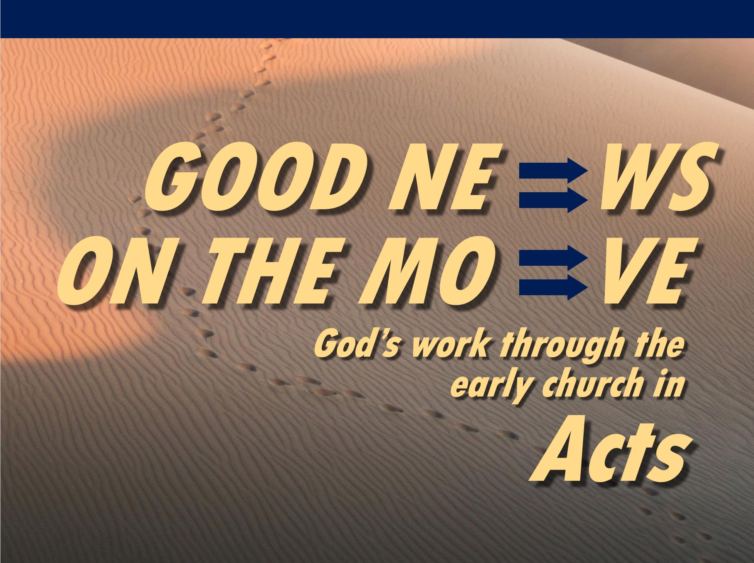

Rick Griffith
7 Feb 2021
Message 2 of 23

The Power of the Spirit
Acts 2

Introduction

In Acts 1, the disciples needed to submit to the Spirit to see a breakthrough.

Why do we also need to submit to the Spirit?

I. The Spirit reverses Babel (1-13).

God judged humans at Babel when he confused our languages (cf. Gen. 11:1–9).

God blessed man at Pentecost when the baptism with the Spirit enabled the apostles to speak many languages (Acts 2:1-13).

God continues today to speak our languages!

II. The Spirit proves Jesus (14-41).

The Spirit’s indwelling showed Jesus is the risen Messiah able to save (14-41).

The Spirit proving Christ as Messiah has implications for all of us.

For unbelievers, has Christ saved you?

For believers, do you live as if God indwells you (1 Cor 6:19-20; 12:13)?

III. The Spirit unites us (42-47).

Only by the Spirit’s indwelling could these disciples become the church (42-47).

Has God’s Spirit succeeded at making you an active part of this local body?

Conclusion

The purpose for the baptism with the Spirit was to show Jesus as the risen Messiah can save people from all nations into Christ’s church.

The Spirit put you into Christ’s body to reach the nations (Main Idea).

Do you know your role in God’s plan? Ask him and submit to him.

Download this sermon PPT and notes for free at BibleStudyDownloads.org/resource/new-testament-preaching/

* Or in; also in 1:5b.
Warren W. Wiersbe, The Bible Exposition Commentary (Wheaton, Ill.: Victor Books, 1996, c1989), Ac 2:2.
Warren W. Wiersbe, The Bible Exposition Commentary (Wheaton, Ill.: Victor Books, 1996, c1989), Ac 2:2.
John F. Walvoord, Roy B. Zuck and Dallas Theological Seminary., The Bible Knowledge Commentary : An Exposition of the Scriptures (Wheaton, IL: Victor Books, 1983-c1985), 2:357.
John F. Walvoord, Roy B. Zuck and Dallas Theological Seminary., The Bible Knowledge Commentary : An Exposition of the Scriptures (Wheaton, IL: Victor Books, 1983-c1985), 2:358.
John F. Walvoord, Roy B. Zuck and Dallas Theological Seminary., The Bible Knowledge Commentary : An Exposition of the Scriptures (Wheaton, IL: Victor Books, 1983-c1985), 2:360.

