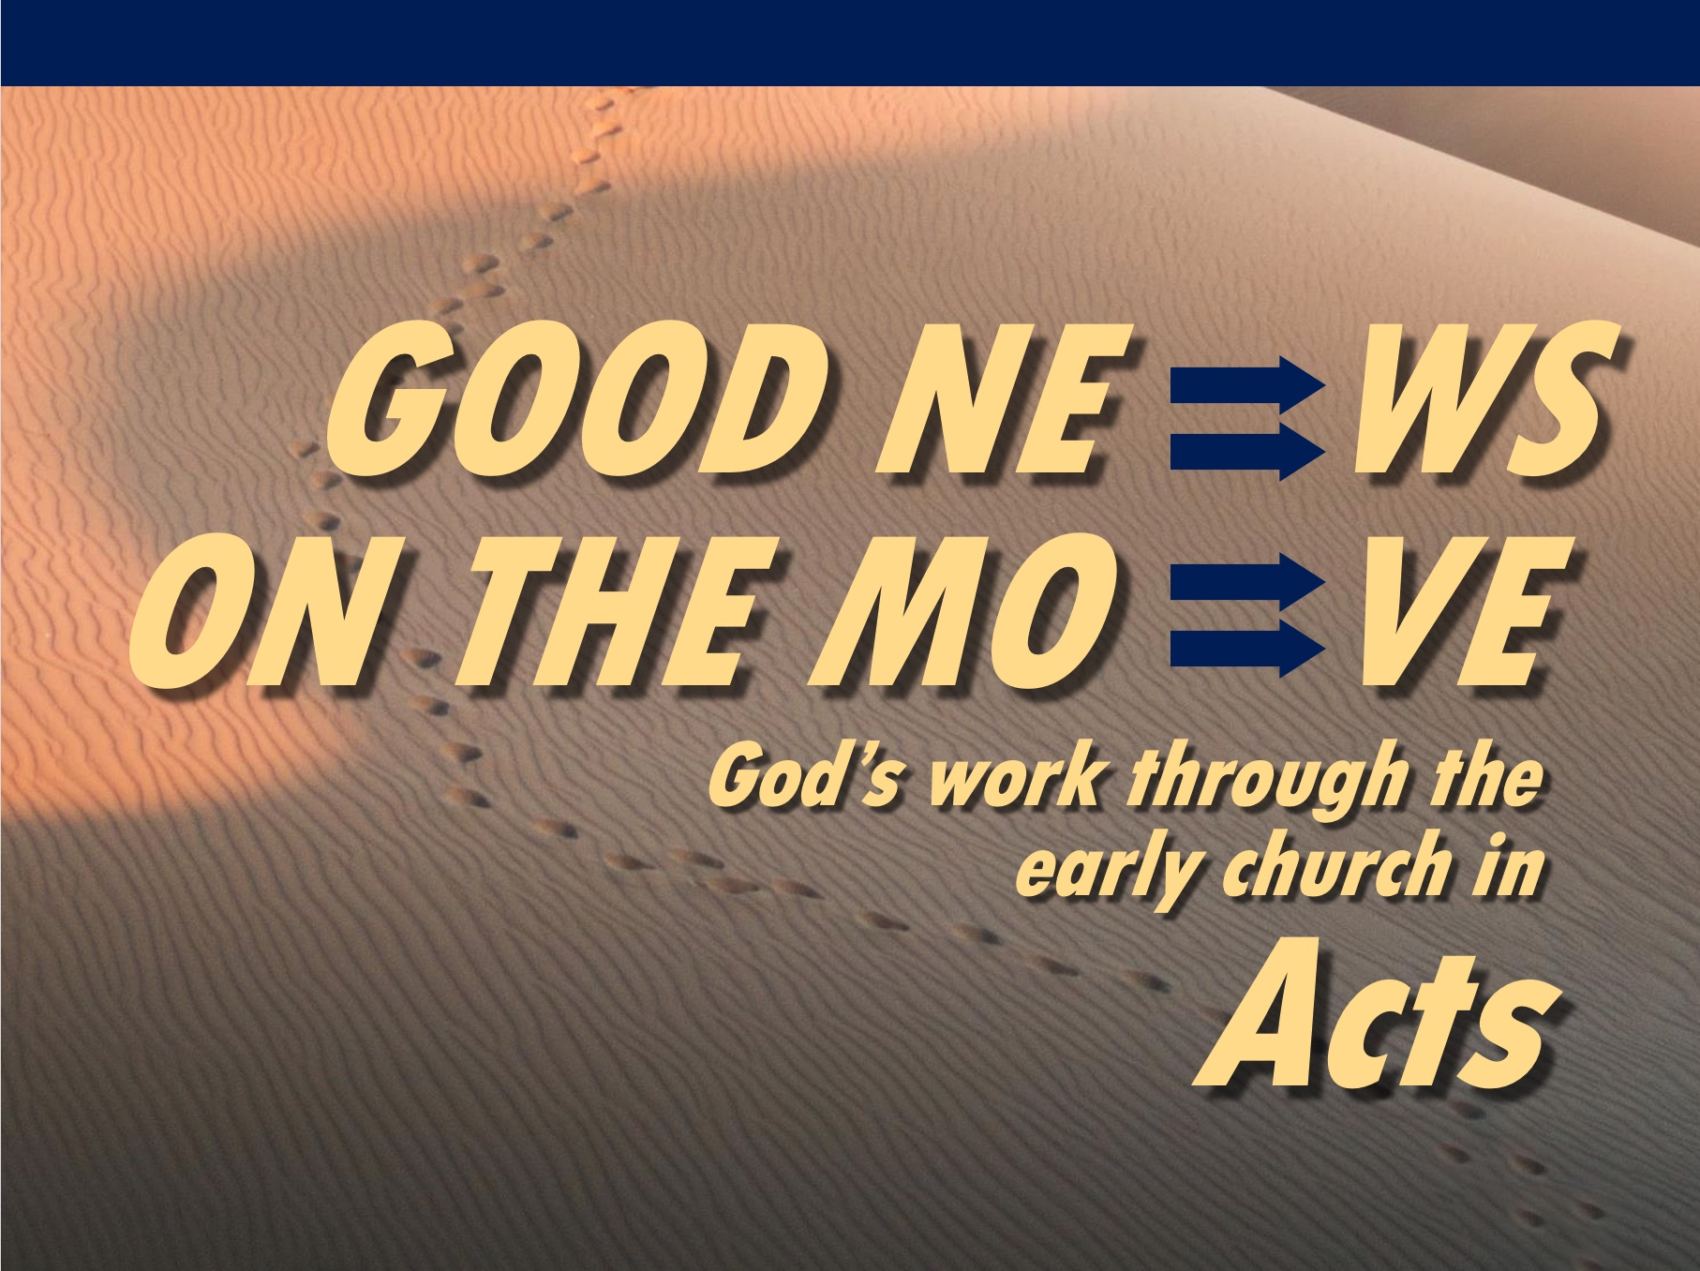

Matt Lyle
11 July 2021
Message 23 of 25

Following God
Sets us Free
Acts 25–26

Introduction

Life is filled with waiting.

We will see that Paul is through waiting.

I. The wait is over (25:1-12).

Jewish leaders used the new governor as an opportunity to kill Paul (25:1-7).

Paul used the new governor and trial as an opportunity to go to Rome (25:8-12).

When you are called by God, you should pursue that calling with a single-minded focus (application).

Use change as an opportunity to examine your life in relation to God’s calling (application).

II. The world will not understand (25:13-22).

Festus did not understand arguments against Paul (25:13-19).

Festus did not understand why Paul wanted trial in Rome (25:20-22).

The world does not know that Jesus is alive. The world is foolish.

III. Jesus is the Messiah (26:1-32).

Paul shared his life before he knew Jesus (26:1-11).

Paul testified how he met Jesus (26:12-18)

Paul testified of the impact of meeting Jesus (26:19-23, 29).

The world will not understand our faith (26:24-28, 30-32).

Conclusion

When we know Christ, risen from the grave, and then follow his will, we will be free, even if in chains.
(Main Idea).

Let your life reflect your hope in Jesus and his resurrection.

Be ready to explain your hope in Jesus and his resurrection.

Personal Testimony Grading Criteria (1 -Poor to 5-Excellent)

Introduction
Gets attention on the main idea (an interesting “Ho Hum!”)
Raises curiosity or need (“Why bring that up?”)
1 2 3 4 5

Pre-Conversion Life explains your problem(s)
Struggles are realistic, specific & relate to your main idea
1 2 3 4 5

Conversion shows how Christ solved your problem(s)
Notes what the gospel is (substitutionary atonement, resurrection)
Explains the story how & when you trusted Christ (not just “God”)
1 2 3 4 5

Post-Conversion Life shows positive results
Specific changes in present tense (“For Instance!”)
1 2 3 4 5

Conclusion (“So What?”) related to main idea & “real”
1 2 3 4 5

https://www.cru.org/sg/en/train-and-grow/share-the-gospel/evangelism-principles/preparing-your-personal-testimony.html

https://www.cru.org/sg/en/train-and-grow/share-the-gospel/evangelism-principles/how-to-tell-your-story-worksheet.html

Download this sermon PPT and notes for free www.cicfamily.com/

