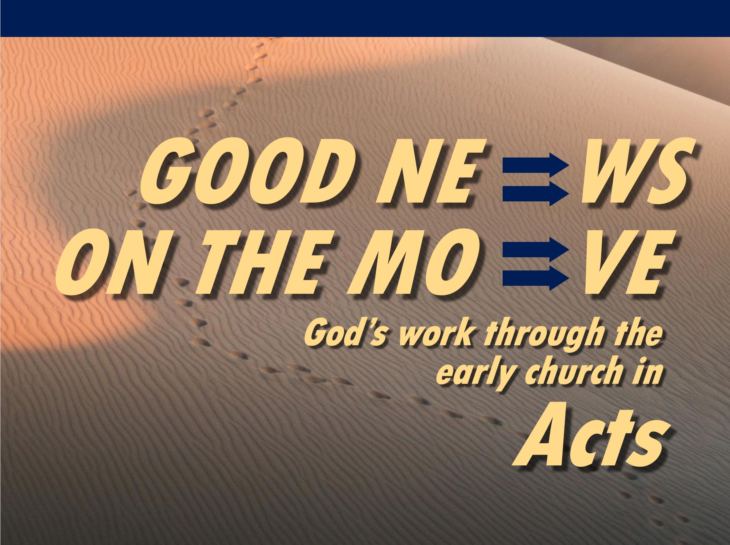

Matt Lyle
20 June 2021
Message 20 of 25

The Need for Prophecy
Acts 21:1-16

Introduction

If you knew the future, what would you do?

Prophecy is a divine message mediated through an individual that is directed at a person or people group and intended to elicit a specific response.

A Biblical Timeline of History:
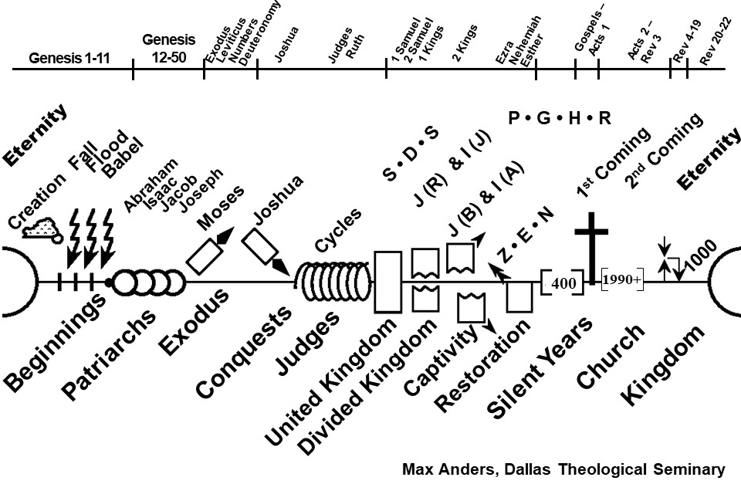
- S•D•S: Saul, David, and Solomon were Kings of the United Kingdom
(After King Solomon, the Kingdom split into the Northern and Southern Kingdom).
- I is the Northern Kingdom of Israel, ruled by Jeroboam, taken into captivity by Assyria
- J is the southern Kingdom of Judah ruled by Rehoboam, taken into captivity by Babylon.
- Z•E•N: After the 70-year exile, Zerubbabel rebuilt the temple, Ezra led a second group of exiles returning to Jerusalem, and Nehemiah rebuilt the city walls of Jerusalem.
- P•G•H•R: In the silent years after Malachi, the Promised Land was ruled by the Persian Empire, Greek, Hasmonaean dynasty, and Roman empire.

I. The reason the Tyrian church prophesied that Paul should not go to Jerusalem was to prepare him for what lies ahead (20:1-6).

Paul was returning to Jerusalem (20:1-3).

Paul was warned not to return to Jerusalem (20:4-6).

II. The prophecy of Agabus prepared Paul to suffer for the Lord’s will (20:7-16).

Philip’s daughters prophesied a message unknown to us (20:7-9).

Agabus prophesied Paul would be imprisoned by the Jews and turned over to Gentiles (20:10-12).

Paul’s response to the prophecy was to submit to the Lord’s will (20:13-16).

Conclusion

Prophecy prepared Paul for suffering
(Main Idea).

We can expect to suffer for Christ (Rom 8:17; Col 1:24; Phil 1:29).

Because we are called to His purpose, we have a blessed assurance even when we suffer.

Download this sermon PPT and notes for free at www.cicfamily.com

