Hope Presbyterian Church Singapore (11 April 2021) Dr. Rick Griffith
Crossroads International Church Singapore (6 June 2021) Message 19 of 23
NLT 30 Minutes
Title
Farewell to Ephesus: Elder Roles
Acts 20

Topic: Elders
Subject: What are elders supposed to do?
Complement: Elders should be selfless shepherds against false teachers.
Map
Synagogue
Biblical Pattern
Good News on Move
NT Elders
Moses
What to Do?
Our Church Elders
Purpose: The listeners will shepherd the flock they have under their care.
Attribute: God as Shepherd
Meditation: Psalm 23
Reading: Acts 20:28
Benediction: Hebrews 13:21
Songs: O Church Arise (Getty), Shepherd of My Soul (Martin Nystrom CCLI 24054), Psalm 23 (Stuart Townend CCLI 1585970)

Introduction
Games

Interest: Today we address elders. No—not the old folks who play games—but the main leaders of the local church. But Christians differ on what elders should do.
Old Jewish Man

Some believe that all the elders do is serve communion.

Others think elders only carry on church traditions.

Elders sign papers and checks in the minds of others.

Some believe that elders function to give the impression to the congregation that the church isn't a "one-man show."

Need: Do you know what elders are supposed to do?
What to Do?

Can you name one Scripture on elder duties?

We have no excuse to be ignorant of elder roles since the NT addresses the issue many times.

But you say, “Nice that this message doesn’t apply to me! I can catch up on my sleep!” No, what we will see today does not only apply to elders. Each of us is older than someone else who looks up to us—so think of those who look to you, no matter how old you are. Let’s shepherd the flock we each have under our care—whether the whole church as elders, or our families, or friends.
Older than You

Subject: So what are elders supposed to do? To answer this, let’s consider some background.

Elders Background: Elders have been around for millennia.

Moses had elders in 1400 BC (Exodus 3:16).

Synagogues were led by elders from 600 BC to Jesus.

Every NT church had elder leadership—whether Jewish, Gentile, or mixed—whether in Israel or modern-day Turkey or Greece or the Mediterranean Island of Crete.

Acts Background: Paul modeled the elder lifestyle before he preached it to others in Acts where the Good News was on the Move.

Then came Paul's ASIAN THRUST…recorded in Acts 18-21.
AD 53-57

//// Again, this trip began overland from Syrian Antioch…revisited many of the earlier churches…made a horseshoe-shaped route around the Aegean, back down into Greece, retraced that route back around the horseshoe, remaining at Troas, then returning by sea to Syrian Antioch.
• East
• Ephesus
• Ampi-theatre
• Passion
Paul
• Presence
MP

//// Paul spent a very long time living and ministering to the church the EPHESUS. Luke reports that Paul raised a young man from the dead in Ephesus. Many important letters –– our Epistles –– were written from Ephesus.

//// One of the most dramatic events recorded for us took place at the Ephesian AMPHITHEATRE where he confronted the souvenir makers of the city…those who manufactured small idols of the Goddess Diana, whose temple in Ephesus was one of the seven wonders of the ancient world.

//// LENGTH OF THIS TRIP: ALMOST FIVE YEARS BETWEEN A.D. 53 AND 57.
• AD 53-57

So Paul had previously ministered in the Ephesian church for two years (Acts 19; 20:31).
Ephesus Map

He then ministered in Macedonia and Greece and Troas and coastal towns near Ephesus (20:1-15).

Paul stopped by the coastal town of Miletus while traveling to Jerusalem at the end of his third missionary journey (Acts 20:16,17a).

Knowing that he would soon die (20:25), Paul requested the Ephesian elders to come to him to hear his parting words (17b-18a).

Preview: In our text today from Acts 20:18b-35, Paul shows first how he modeled being an elder and then what the elders were specifically supposed to do.

Text: Today we will observe Paul's example and instructions to elders concerning their job description found in Acts 20:18b-35.

(Paul knew that the success of the church at Ephesus would rest upon the faithfulness of the men who led the flock. But before charging the men with their responsibilities, Paul elaborated on his own life as an example.)

I. Paul modeled shepherding for the elders (20:18b-27).
[He knew that more is caught than taught—so he set an example of care for them.]

Paul cared like an elder in his past ministry at Ephesus (18b-21).

Paul cared by his presence—where he was (18).

I once knew an elder who resigned due to the increased traveling responsibilities of his job. Through this he actually showed his commitment to the men.

As elders we must be available men.

Paul cared in his passion—what he felt (19).

He lived in brokenness.

He endured many trials that came with caring for people.
• Proclaim

Paul cared in his proclamation—what he preached (20-21).

We must teach the basics: repentance towards God and faith in Christ.

Elders must not neglect evangelism.
MP
Internal Wolf
External Diagram
• Pastoring
Suit
• Wolves

Paul cared like an elder in his present situation (22-27).
• Persecute

Paul cared despite persecution—where he was going (22-23).
• Priorities

Paul cared by his priorities—what he valued (24-27).
20:24

(In light of Paul’s example, what specifically should elders do? He gives the Ephesian elders [and us] his charge in the following verses.)

II. Elders should follow Paul’s shepherding example (20:28-38).
[They must lead the sheep like Paul cared for people.]

Elders have three shepherding tasks to lead the church (28).

Pastoring: Guard their own life (28a-b).

Watching our own lives includes maintaining our family relationships.

Our wives are the best barometers of how we are doing.

Guard (protect) the congregation (28b).
• Admin

Administration: Oversee (“look after”) the affairs of the church (28c).
• Teaching

Teaching: Shepherd the church sacrificially (28d).

These tasks will protect the church from false teachers (29-31).
External
Acts 20:29

External false teachers will destroy some believers (29).

God hates false teaching, and we must hate what God hates.

God is truth—so whatever is not true cannot be allowed into the church.

Internal false teachers will draw some away from Christ (30-31).

They look great—but they’re wolves right there among the sheep.
Internal Diagram

Let's warn a factious (heretical) man only twice before we expel him from the body (Tit 3:10-11).

Elders must serve selflessly (32-38).
Selfless

Selfless service is founded on God’s grace and Word (32).

Selfless service is based on hard work instead of greed (33-38).

Be careful how others interpret the way we spend our money to avoid showing covetousness or greed (33-34a).

Set an example for the church in selfless giving (34b-38).
Subject
(We started this study asking this question: What are elders supposed to do? The Bible is very specific about the roles of elders. Essentially, the main idea is this…)

Conclusion
MI

Elders should be selfless shepherds against false teachers (Main Idea).

Main Points: Watch Paul and mimic Paul!
MPs

Acts 20 actually applies to us all. So how can you better shepherd the flock under your care—whether the whole church as elders, or your family, or friends?
What About You?
5 Ps
Prayer

Paul modeled the five Ps—which is your weakness?
3 Circles

Shepherds must pastor, administrate, and teach—where are you weakest?

Prayer

Preliminary Questions

Verses Questions

Context: What did the author record just prior to this passage?

The riot at Ephesus in Acts 19 was the last event Paul experienced there.

This was followed by travel through Macedonia to Corinth and the need to retrace his steps back near Ephesus for his safety.

Purpose: Why is this passage in the Bible?

Elders are the highest office in the church—and as leaders go, so goes the church.

The NT emphasizes the qualifications for elders in several texts, but only in Acts 20 do we find an extensive explanation of their role.

Background: What historical context helps us understand this passage?

All organizations need leaders—but what model did they follow in the early church?

Every Jewish synagogue had elders lead them—noting their age, maturity, and shepherding.

But Gentile churches called their leaders overseers—noting their “looking over” (literally) or guarding from attackers.

The NT combines both the Jewish and Gentile concepts as it uses the terms elders and overseers interchangeably.

In Acts 20, Paul was nearing the end of his third missionary journey where he followed up on the churches but also had to escape Greece to save his life (20:3).

Questions

Why so many details about Paul’s travels (1-12)? These give context regarding the many places and people Paul touched.

Why didn’t Paul go back to Ephesus but had the elders meet him at Miletus (16-17)? He figured he could minister longer to them if they came to him and perhaps had to stay close to the ship that had harbored only briefly there.

Why did Paul brief the elders on their roles (18-35)? We all need to hear the basics over and over.

Tentative Subject/Complement Statements

Text

Outlines

New Testament Survey (Rick Griffith)

Toussaint, “Acts,” Bible Knowledge Commentary

Wiersbe, Bible Exposition Commentary

Possible Illustrations

Text

PPT Text Boxes
Title

Possible Applications
Title
Title
Title
Title
Title
Title
Title
Title
Title
Title
Title
Title
Title
Title
Title
Title
Title
Title
Title
Title
Title
Title
Title
Title

Text
Elder Roles
Acts 20

Exegetical Outline (Steps 2-3)

Exegetical Idea: The way Elders should follow Paul’s shepherding example was to be selfless shepherds against false teachers.

I. The setting for Paul’s speech to the Ephesian elders was his selfless travels through Macedonia, Greece, and Asia Minor (20:1-17).

Paul ministered in Macedonia and Greece and Troas and coastal towns near Ephesus (20:1-15).

Paul stopped by the coastal town of Miletus while traveling to Jerusalem at the end of his third missionary journey (Acts 20:16,17a).

Knowing that he would soon die (20:25), Paul requested the Ephesian elders to come to him to hear his parting words (17b-18a).

II. The way Paul modeled shepherding for the elders was to care for the Ephesians in the past and present (20:18b-27).

Paul cared like an elder in his past ministry at Ephesus (18b-21).

Paul cared by his presence—where he was (18).

Paul cared in his passion—what he felt (19).

Paul cared in his proclamation—what he preached (20-21).

Paul cared like an elder in his present situation (22-27).

Paul cared despite persecution—where he was going (22-23).

Paul cared by his priorities—what he valued (24-27).

III. The way Elders should follow Paul’s shepherding example was to be selfless shepherds against false teachers (20:28-35).

Elders have four shepherding tasks to lead the church (28).

Guard their own life (28a).

Guard (protect) the congregation (28b).

Oversee (“look after”) the affairs of the church (28c).

Shepherd the church sacrificially (28d).

These tasks will protect the church from false teachers (29-31).

External false teachers will destroy some believers (29).

Internal false teachers will draw some away from Christ (30-31).

Elders must serve selflessly (32-38).

Selfless service is founded on God’s grace and Word (32).

Selfless service is based on hard work instead of greed (33-38).

Be careful how others interpret the way we spend our money to avoid showing covetousness or greed (33-34a).

Set an example for the church in selfless giving (34b-38).

Purpose or Desired Listener Response (Step 4)
The listeners will shepherd the flock they have under their care.

Homiletical Outline (Cyclical inductive form)

Introduction

Interest: Christians differ on what elders should do.

Need: Do you know what elders are supposed to do?

Subject: So what are elders supposed to do?

Background: Paul modeled the elder lifestyle before he preached it to others.

Preview: Paul shows first how he modeled being an elder and then what the elders were specifically supposed to do.

Text: Today we will observe Paul's example and instructions to elders concerning their job description found in Acts 20:18b-35.

(Paul knew that the success of the church at Ephesus would rest upon the faithfulness of the men who led the flock. But before charging the men with their responsibilities, Paul elaborated on his own life as an example.)

I. Paul modeled shepherding for the elders (20:18b-27).

Paul cared like an elder in his past ministry at Ephesus (18b-21).

Paul cared by his presence—where he was (18).

Paul cared in his passion—what he felt (19).

Paul cared in his proclamation—what he preached (20-21).

Paul cared like an elder in his present situation (22-27).

Paul cared despite persecution—where he was going (22-23).

Paul cared by his priorities—what he valued (24-27).

(In light of Paul’s example, what specifically should elders do? He gives the Ephesian elders [and us] his charge in the following verses.)

II. Elders should follow Paul’s shepherding example (20:28-38).

Elders have four shepherding tasks to lead the church (28).

Guard their own life (28a).

Guard (protect) the congregation (28b).

Oversee (“look after”) the affairs of the church (28c).

Shepherd the church sacrificially (28d).

These tasks will protect the church from false teachers (29-31).

External false teachers will destroy some believers (29).

Internal false teachers will draw some away from Christ (30-31).

Elders must serve selflessly (32-38).

Selfless service is founded on God’s grace and Word (32).

Selfless service is based on hard work instead of greed (33-38).

(The Bible is very specific about the roles of elders. Essentially, the main idea is this…)

Conclusion

Elders should be selfless shepherds against false teachers (MI).

Main Points: Watch Paul and mimic Paul!

How can you better shepherd the flock under your care—whether the whole church as elders, or our families, or friends?

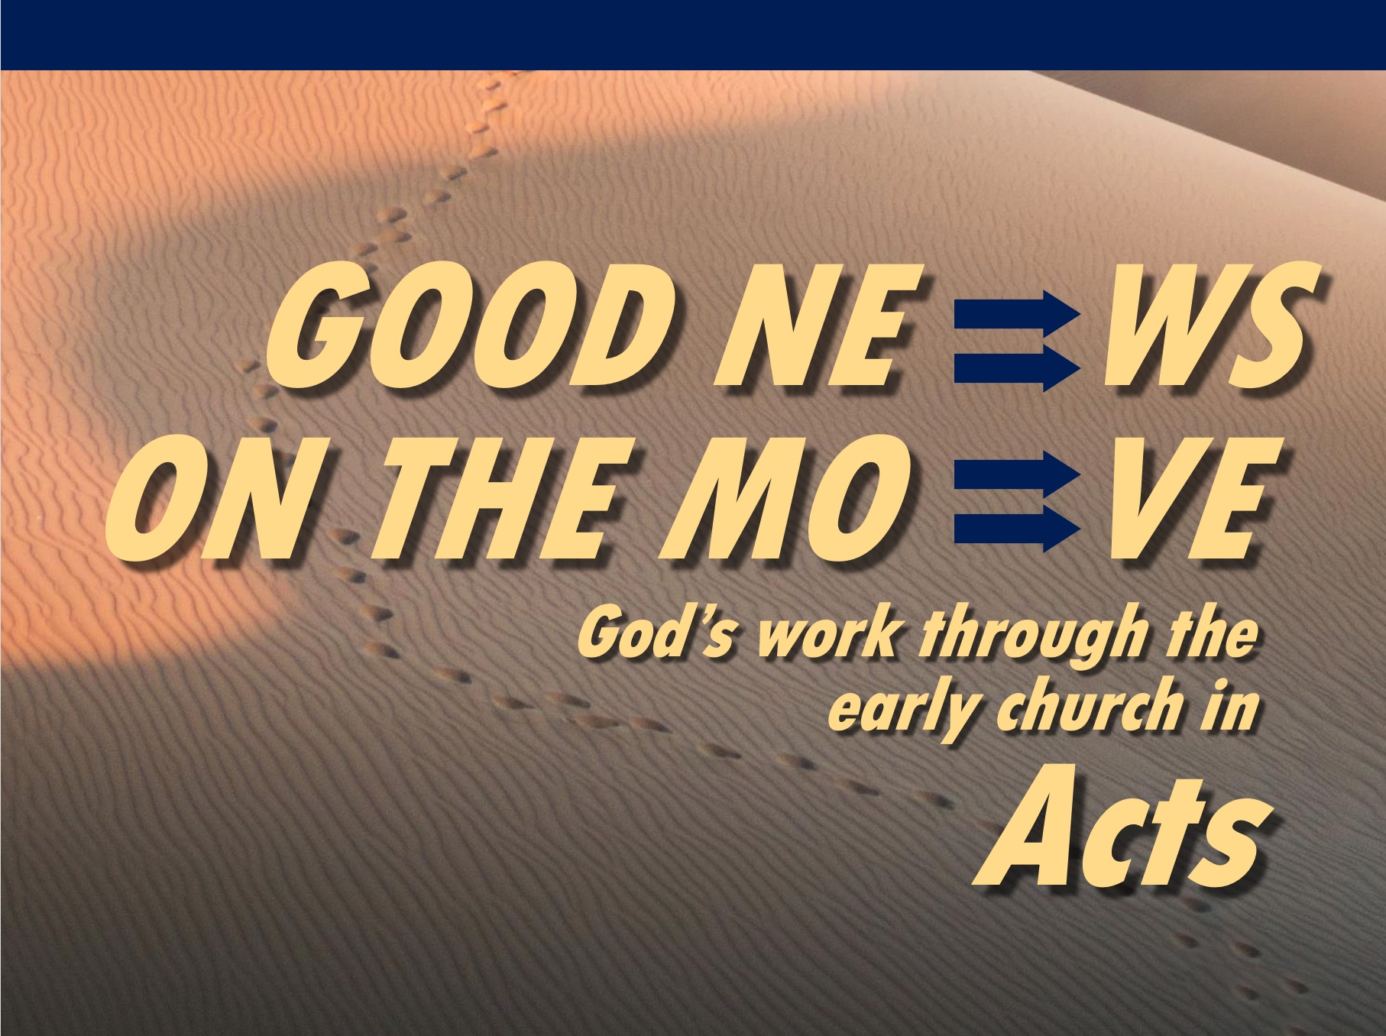
Rick Griffith
6 June 2021
Message 19 of 23

Elder Roles
Acts 20

Introduction

What’s an elder to do?

Paul modeled the elder lifestyle before he preached it to others.

I. Paul modeled shepherding for the elders (20:18b-27).

Paul cared like an elder in his past ministry at Ephesus (18b-21).

Paul cared by his presence—where he was (18).

Paul cared in his passion—what he felt (19).

Paul cared in his proclamation—what he preached (20-21).

Paul cared like an elder in his present situation (22-27).

Paul cared despite persecution—where he was going (22-23).

Paul cared by his priorities—what he valued (24-27).

II. Elders should follow Paul’s shepherding example (20:28-38).

Elders have four shepherding tasks to lead the church (28).

Guard their own life (28a).

Guard (protect) the congregation (28b).

Oversee (“look after”) the affairs of the church (28c).

Shepherd the church sacrificially (28d).

These tasks will protect the church from false teachers (29-31).

External false teachers will destroy some believers (29).

Internal false teachers will draw some away from Christ (30-31).

Elders must serve selflessly (32-38).

Selfless service is founded on God’s grace and Word (32).

Selfless service is based on hard work instead of greed (33-38).

Conclusion

Elders should be selfless shepherds against false teachers (Main Idea).

Watch Paul and mimic Paul!

How can you better shepherd the flock under your care—whether the whole church as elders, or our families, or friends?

Download this sermon PPT and notes for free at BibleStudyDownloads.org/resource/new-testament-preaching/

