Crossroads International Church Singapore Dr. Rick Griffith
18 April 2021 Message 12 of 23
NLT 30 Minutes
Title

Our Unstoppable God
Acts 12:1-24
Jews
Lady in Despair
Topic: Suffering
Subject: How does God respond to those who reject the gospel?
Complement: God judges oppressors while expanding his church.
Purpose: The listeners will trust in God’s timing and way to deal with those who reject him.
Attribute: Our Unstoppable God
Meditation: Romans 8:28
Reading: 1 Peter 4:14-19
Benediction: 1 Peter 5:6
Songs: A Mighty Fortress (Luther), The Perfect Wisdom of Our God (Getty), He Will Hold Me Fast (Matthew Merker & Ada Habershon)
Alternates: Is He Worthy? (Peterson), The Lord is My Salvation (Getty), Christ Our Hope in Life and Death (Keith Getty, Matt Papa)

Introduction (Simple inductive form)
Acts
Video

Interest/Background: The video “Acts in 3 Minutes” reveals that Acts shows a pattern of Jewish rejection. Today Jews are still the most resistant people group.

“The Persecution of the Church at Jerusalem (12:1–24): The purpose of this section of Acts is to confirm Israel’s rejection of the Messiah. Luke has skillfully woven this theme throughout the entire book and it can be seen up to this point in 4:1–30 (esp. 4:29); 5:17–40; 6:11–8:3; 9:1–2, 29. This animosity of Israel set the stage for the first missionary journey.”
Jew Attack
• 5 texts

Our passage today is framed by two bookends of famine relief based in Antioch to the north. We ended last week with the final verse of Acts 11 that says the Antioch church sent famine relief to the mother church in Jerusalem through Barnabas and Saul. They return to Antioch in 12:25, so our text today shows what happens in the middle section. This is the last depiction of Jewish resistance to the church before the big Gentle push of Acts 13.
Hearts
• 12:1-24
Antioch Map

Need: But would the resistance of Jews stop God’s plan to save humanity? Hardly!
Unstopped
(3 slides)

We tend to think of ourselves as being unstoppable.

But God is the Unstoppable God.
Question

Intro MPI: How did the Jews continue to reject Jesus?
Rejection
• Result

Preview: Today let’s see how Jews rejected Jesus and what happened as a result—and then see the same pattern today of the results of rejecting Jesus.

Text: Acts 12:1-24 will show us this two-step pattern.
Unstopped God

Keep in mind our Unstoppable God as we continue our Acts study called Good News on the Move.
Acts Series Slide

(So how did the Jews continue to reject Jesus?)

I. Herod opposed Christ (12:1-22).
MP
[Jews rejected Christ through Herod Agrippa I.]

Herod murdered James (12:1-2).
• James Martyred

“The martyrdom of James (12:1–2)… Artfully, Luke contrasted the love of the church at Antioch for the saints at Jerusalem with the coldhearted enmity of Herod and the Jews for the church. The Herod mentioned here is Agrippa I, a ruler popular with the Jews for he was partly Jewish, being of Hasmonean descent. His kingdom covered basically the same area as that of his grandfather Herod the Great. He was known for doing everything possible to curry the favor of the Jews, so he found it politically expedient to arrest Christians and to execute James, the brother of John. Herod Agrippa I died in AD 44.”
Ps 31
Map

Therefore, Roman historical records help us know that this account takes place in AD 44—about 11 years after the death and resurrection of Christ. The contrast between Antioch’s love for Christians and Herod & the Jews hatred is at this chapter break.
Contrast

(Another way that Herod opposed Christ was that…)

Herod imprisoned Peter unsuccessfully (12:3-19a).
Peter Prison

Herod imprisoned Peter with the intent to kill him later also (12:3-4).

But God answered the prayers of the believers for Peter’s release (12:5-19a).

(A third and final way that Herod opposed Christ was that…)

Herod accepted worship that only God deserves (12:19b-22).
Upraised Arms
• Worship

Herod ended up in a powerful position of controlling the food supply (12:219b-20).

Herod accepted worship only fit for God (12:21-22).

(So what happened as a result? How did God respond to these who rejected the gospel?)

II. God judged Herod but prospered the church (12:23-24).
MP
[Instead of Peter dying like James, Herod died while the church became more alive!]
• Judged

Herod died by being eaten by worms (12:23).
• Expanded

The church grew both in numbers and geographically (12:24).
Progress Reports

(How does God respond today to those who reject the gospel?)

III. God judges oppressors while expanding his church (Main Idea).
MI
[Jesus actually uses his persecutors to build his followers.]

His pattern over the centuries has been to lift up the humble and put down the proud.

The Psalms tell us to find refuge in God.
Love the Lord, all you godly ones!
For the Lord protects those who are loyal to him,
but he harshly punishes the arrogant.
²⁴ So be strong and courageous,
all you who put your hope in the Lord! (Ps 31:23–24 NLT)

Hitler sought to exterminate the Jews but committed suicide in 1945 and Israel became a nation instead in 1948.
Ezek/Hitler
(4 slides)

He uses difficulty to help us love him.
Thorn
(2 Cor 12)

My unbelieving parents were the greatest training ground for spiritual growth.

Paul’s “thorn in the flesh” (2 Cor 12:7-10) was God’s means to teach him that when we admit our weakness, God shows his strength. So “the thing that you most pray that God would remove in your life is that which you most want to keep”—Dr Don Sunukjian , DTS
Singapore to Jordan
Iran & Jordan
What About You?
Unstop-pable God
JETS

Often the places of greatest trial are the places of greatest growth.

Nepal had the fastest growing church in 2015.

Iran has the fastest growth in the world now.
MENA

MENA has a vibrant church with too few leaders.

Training leaders is the reason we are shifting to JETS.

(How does God respond to those who reject the gospel?)

Conclusion
MI

God judges oppressors while expanding his church (Main Idea).

He is our unstoppable God! No one can ruin his plan no matter how they may reject it—nor how much we suffer (restatement).

Main Points from this passage see two key movements:

Herod opposed Christ (12:1-22)

God judged Herod but prospered the church (12:23-24).

Exhortation: How will you trust in God’s timing and way to deal with those who reject him?

Are you suffering for Jesus right now?

How can your difficulties propel you to greater growth?

Will you let God deal with his opposers as he wishes?
Prayer

Prayer before He Will Hold Me Fast

Preliminary Questions

Verses Questions

Context: What did the author record just prior to this passage?

Peter had just extended the gospel message to the Gentiles with the first Roman believer, Cornelius (Acts 10), but then had to defend this change (11:1-18).

This was followed by the first Crossroads International Church in Antioch at the crossroads of Jewish and Gentile lands (11:19-30).

But this international church had not lost sight of its mother church in Jerusalem that would otherwise suffer from famine—so the believers in Antioch sent a gift to the elders in Judea (11:30).

Purpose: Why is this passage in the Bible?

The three key events of 12:1-24 (death of James, escape of Peter, and death of Herod) all were difficult and yet led to the word of God increasing and spreading (12:24). This chapter could therefore be about how God uses trials to build his church. This includes both pride (12:1-4, 18-23) and humility (12:5-17).

“The Persecution of the Church at Jerusalem (12:1–24): The purpose of this section of Acts is to confirm Israel’s rejection of the Messiah. Luke has skillfully woven this theme throughout the entire book and it can be seen up to this point in 4:1–30 (esp. 4:29); 5:17–40; 6:11–8:3; 9:1–2, 29. This animosity of Israel set the stage for the first missionary journey.”

Background: What historical context helps us understand this passage?

“The martyrdom of James (12:1–2)… Artfully, Luke contrasted the love of the church at Antioch for the saints at Jerusalem with the coldhearted enmity of Herod and the Jews for the church. The Herod mentioned here is Agrippa I, a ruler popular with the Jews for he was partly Jewish, being of Hasmonean descent. His kingdom covered basically the same area as that of his grandfather Herod the Great. He was known for doing everything possible to curry the favor of the Jews, so he found it politically expedient to arrest Christians and to execute James, the brother of John. Herod Agrippa I died in AD 44. His son, Herod Agrippa II, was king of Judea from AD 50–70. Paul was on trial before Agrippa II and his sister Bernice (25:13–26:32). (See the chart on the Herods at Luke 1:5.)”

Therefore, Roman historical records help us know that this account takes place in AD 44—about 11 years after the death and resurrection of Christ.

Questions

Why would Herod killing James please the Jews (1-3)? The leaders hated the church as much as they hated Jesus.

What did Herod share in common with the Jewish leaders (2)? Herod was half Jewish and they had a common hatred of anything that threatened their power sharing.

How could Peter be seized during the Feast of Unleavened Bread but have trial after Passover when Passover in fact preceded this Feast (3-4)? These are often merged together as they are adjacent feasts.

Why did God allow James to die but God delivered Peter? God owns the entire universe and therefore has the right to glorify his name by both death and deliverance.

Why would Herod exalt himself to actually receive worship (22)? We all worship either God or ourselves.

Tentative Subject/Complement Statements

The way that God built the early church was by the Jewish rejection of Christ.

The result of Jewish rejection of Christ was God’s judgment on Herod and prospering the church.

The result of Herod murdering James, imprisoning Peter, and receiving worship was Herod's death by worms while the church grew.

Outlines

New Testament Survey (Rick Griffith)

Believers should witness to all the world because God expanded the kingdom message to Rome to reach the end of the known world (Acts 9–28).

God saved Saul who preached even beyond Judea and Samaria in Damascus of Syria as God's tool to reach Jews and especially Gentiles (9:1-31).

Progress Report #4: “Then the church throughout Judea, Galilee and Samaria enjoyed a time of peace. It was strengthened; and encouraged by the Holy Spirit, it grew in numbers, living in the fear of the Lord” (9:31).

God protected believers in Samaria and in Gentile cities of Caesarea and Antioch despite Jerusalem church racism as he was committed to the uttermost part (9:32–12:24).

Peter reached Gentiles in Joppa, Lydda, and Caesarea [all in Samaria] despite racist Jerusalem believers as God’s kingdom message is for all (9:32–11:18).

The Gentile church in Antioch alleviated famine in the Jerusalem church to show God's blessing on its ministry (11:19-29).

God avenged Herod's murder of James and imprisonment of Peter at Jerusalem in Peter's miraculous escape and Herod's death by worms (12:1-24).

Progress Report #5: “But the word of God continued to increase and spread” (12:24).

God expanded the church to Asia Minor in Paul and Barnabas’s two missionary journeys and the Jerusalem Council approved witness to Gentiles (12:25–16:5).

The first missionary journey of Paul and Barnabas extended the kingdom message to Cyprus and Asia Minor (12:25–14:28).

The Jerusalem Council decision not to require the Law for Gentiles was directed by God to expand the kingdom message through the Roman Empire (15:1-35).

The second missionary journey of Paul and Silas strengthened Asia Minor churches and Barnabas and John Mark went to Cyprus due to a ministry conflict (15:36–16:5).

(Note: Second Missionary Journey = Acts 15:36–18:22)

Progress Report #6: “So the churches were strengthened in the faith and grew in numbers” (16:5).

God extended the church to the Aegean area after keeping Paul from Asia so he could first evangelize Macedonia and Achaia (16:6–19:20).

Paul was called to Macedonia after Phrygia and Galatia but kept from Asia by the Spirit as God planned the kingdom message first to reach Europe (16:6-10).

The second missionary journey became the third as God directed Paul, Silas, Luke, and Timothy to extend the church into Macedonia, Achaia, and Ephesus (16:11–19:20).

The end of the second missionary journey extended the church into Macedonia and Achaia (16:11–18:22).

Luke helped Paul plant churches in the Macedonian cities of Philippi, Thessalonica, and Berea (16:11–17:15).

Paul evangelized Athens and Corinth in Achaia and then left Priscilla and Aquila in Ephesus while he returned to Antioch (17:16–18:22).

The third missionary journey began by confirming churches in Galatia, Phrygia, and Ephesus with miracles and exorcisms (18:23–19:20).

(Note: Third Missionary Journey = Acts 18:23–21:16)

Progress Report #7: “In this way the Word of the Lord spread widely and grew in power” (19:20)

God extended the kingdom message to Roman rulers after Paul’s third missionary journey led to his trip to Rome as a prisoner (19:21–28:31).

Paul’s third journey had Luke and started no new churches but strengthened Aegean area believers, especially in Ephesus, until it ended in Jerusalem (19:21–21:16).

The uproar at Ephesus proved Christianity innocent of wrongdoing but idolatry useless (19:21-41).

Paul bade farewell to the Ephesian church by exhorting the elders to care for the flock in light of future apostasy (20:1-38).

Paul continued to Jerusalem despite prophecies of suffering ahead of him (21:1-16).

Paul's journey to Rome had three captivities where God extended the kingdom message among rulers to Rome as a sending base to the end of the world (21:17–28:31).

Paul's Jerusalem captivity spread the gospel to his own Jewish people, a Roman officer, and a new Sanhedrin with Roman protection to Caesarea (21:17–23:22).

Paul's Caesarean captivity extended the kingdom message to Governor Felix, Porcius Festus, and King Agrippa II all under Roman support (23:23–26:32).

Paul's captivity in Rome extended the gospel to Gentile passengers and Malta dwellers en route to Jews and Gentiles unhindered in Rome (Acts 27–28).

Progress Report #8: “For two whole years Paul stayed there [in Rome] in his own rented house and welcomed all who came to see him. Boldly and without hindrance he preached the kingdom of God and taught about the Lord Jesus Christ” (28:30-31).

Toussaint, “Acts,” Bible Knowledge Commentary

Wiersbe, Bible Exposition Commentary

Possible Illustrations

Text

PPT Text Boxes
Title

Possible Applications
Title
Title
Title
Title
Title
Title
Title
Title
Title
Title
Title
Title
Title
Title
Title
Title
Title
Title
Title
Title
Title
Title
Title
Title

Text

Our Unstoppable God
Acts 12:1-24

Exegetical Outline (Steps 2-3)

Exegetical Idea: The way God responded to Jewish rejection of Christ was judgment on Herod and prospering the church.

I. The way that Jews rejected Christ were through the arrogant means of Herod Agrippa I (12:1-22).

Herod murdered James (12:1-2).

Herod imprisoned Peter unsuccessfully (12:3-19a).

Herod imprisoned Peter with the intent to kill him later also (12:3-4).

But God answered the prayers of the believers for Peter’s release (12:5-19a).

Herod accepted worship that only God deserves (12:19b-22).

Herod ended up in a powerful position of controlling the food supply (12:219b-20).

Herod accepted worship only fit for God (12:21-22).

II. The way God responded to Jewish rejection of Christ was judgment on Herod and prospering the church (12:23-24).

Herod died by being eaten by worms (12:23).

The church grew both in numbers and geographically (12:24).

Purpose or Desired Listener Response (Step 4)
The listeners will trust in God’s timing and way to deal with those who reject him.

Homiletical Outline (Simple inductive form)

Introduction (Simple inductive form)

Interest/Background: Acts shows a pattern of Jewish rejection. Today Jews are still the most resistant people group.

Need: But would the resistance of Jews stop God’s plan to save humanity? Hardly! He is the Unstoppable God.

Intro MPI: How did the Jews continue to reject Jesus?

Preview: Today let’s see how Jews rejected Jesus and what happened as a result—and then see the same pattern today of the results of rejecting Jesus.

Text: Acts 12:1-24 will show us this two-step pattern.

(How did the Jews continue to reject Jesus?)

I. Herod opposed Christ (12:1-22).

Herod murdered James (12:1-2).

Herod imprisoned Peter unsuccessfully (12:3-19).

Herod accepted worship that only God deserves (12:20-22).

(So what happened as a result? How did God respond to these who rejected the gospel?)

II. God judged Herod but prospered the church (12:23-24).

Herod died by being eaten by worms (12:23).

The church grew both in numbers and geographically (12:24).

(How does God respond today to those who reject the gospel?)

III. God judges oppressors while expanding his church (Main Idea).

He uses difficulty to help us love him (unbelieving parents).

Often the places of greatest trial are the places of greatest growth (Nigeria, Iran, MENA, JETS).

(How does God respond today to those who reject the gospel?)

Conclusion

God judges oppressors while expanding his church (MI).

Main Points from this passage see two key movements:

Herod opposed Christ (12:1-22)

God judged Herod but prospered the church (12:23-24).

Exhortation: How will you trust in God’s timing and way to deal with those who reject him?

Are you suffering for Jesus right now?

How can your difficulties propel you to greater growth?

Will you let God deal with his opposers as he wishes?

Prayer before He Will Hold Me Fast

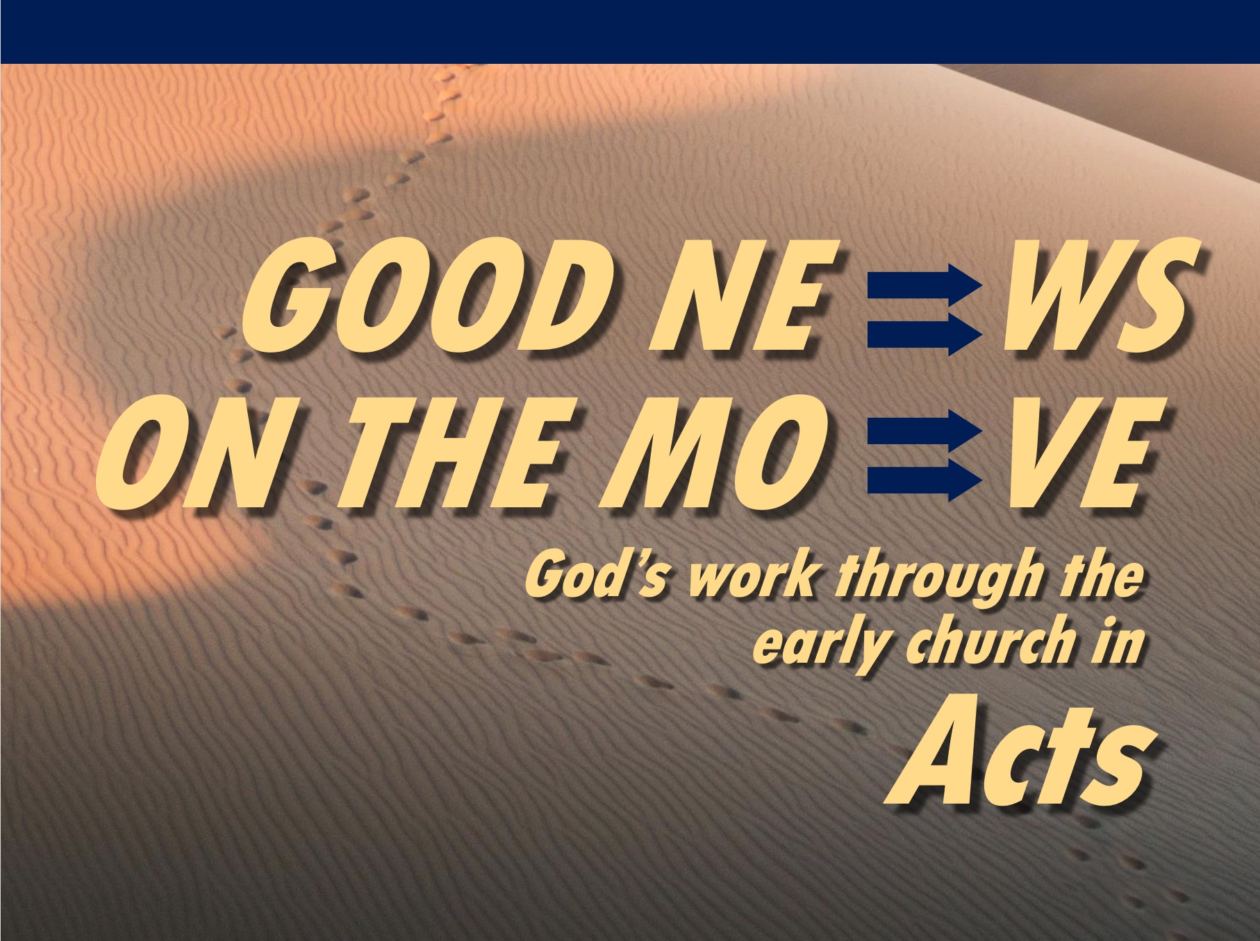
Rick Griffith
18 April 2021
Message 12 of 23

Our Unstoppable God
Acts 12:1-24

Introduction

Acts shows a pattern of Jewish rejection.

But no one can stop God’s plan to save humanity as He is the Unstoppable God.

How did the Jews continue to reject Jesus?

I. Herod opposed Christ (12:1-22).

Herod murdered James (12:1-2).

Herod imprisoned Peter unsuccessfully (12:3-19).

Herod accepted worship that only God deserves (12:20-22).

(So what happened as a result? How did God respond to these who rejected the gospel?)

II. God judged Herod but prospered the church (12:23-24).

Herod died by being eaten by worms (12:23).

The church grew both in numbers and geographically (12:24).

III. God judges oppressors while expanding his church (Main Idea).

He uses difficulty to help us love him.

Often the places of greatest trial are the places of greatest growth.

(How does God respond today to those who reject the gospel?)

Conclusion

God judges oppressors while expanding his church (Main Idea).

How will you trust in God’s timing and way to deal with those who reject him?

Are you suffering for Jesus right now?

How can your difficulties propel you to greater growth?

Will you let God deal with his opposers as he wishes?

Download this sermon PPT and notes for free at BibleStudyDownloads.org/resource/new-testament-preaching/

Stanley D. Toussaint, “Acts,” in The Bible Knowledge Commentary: An Exposition of the Scriptures, ed. J. F. Walvoord and R. B. Zuck, vol. 2 (Wheaton, IL: Victor Books, 1985), 384.
Stanley D. Toussaint, “Acts,” in The Bible Knowledge Commentary: An Exposition of the Scriptures, ed. J. F. Walvoord and R. B. Zuck, vol. 2 (Wheaton, IL: Victor Books, 1985), 384.
Stanley D. Toussaint, “Acts,” in The Bible Knowledge Commentary: An Exposition of the Scriptures, ed. J. F. Walvoord and R. B. Zuck, vol. 2 (Wheaton, IL: Victor Books, 1985), 384.
Stanley D. Toussaint, “Acts,” in The Bible Knowledge Commentary: An Exposition of the Scriptures, ed. J. F. Walvoord and R. B. Zuck, vol. 2 (Wheaton, IL: Victor Books, 1985), 384.

