The Crucifixion of Jesus
(1 of 5)
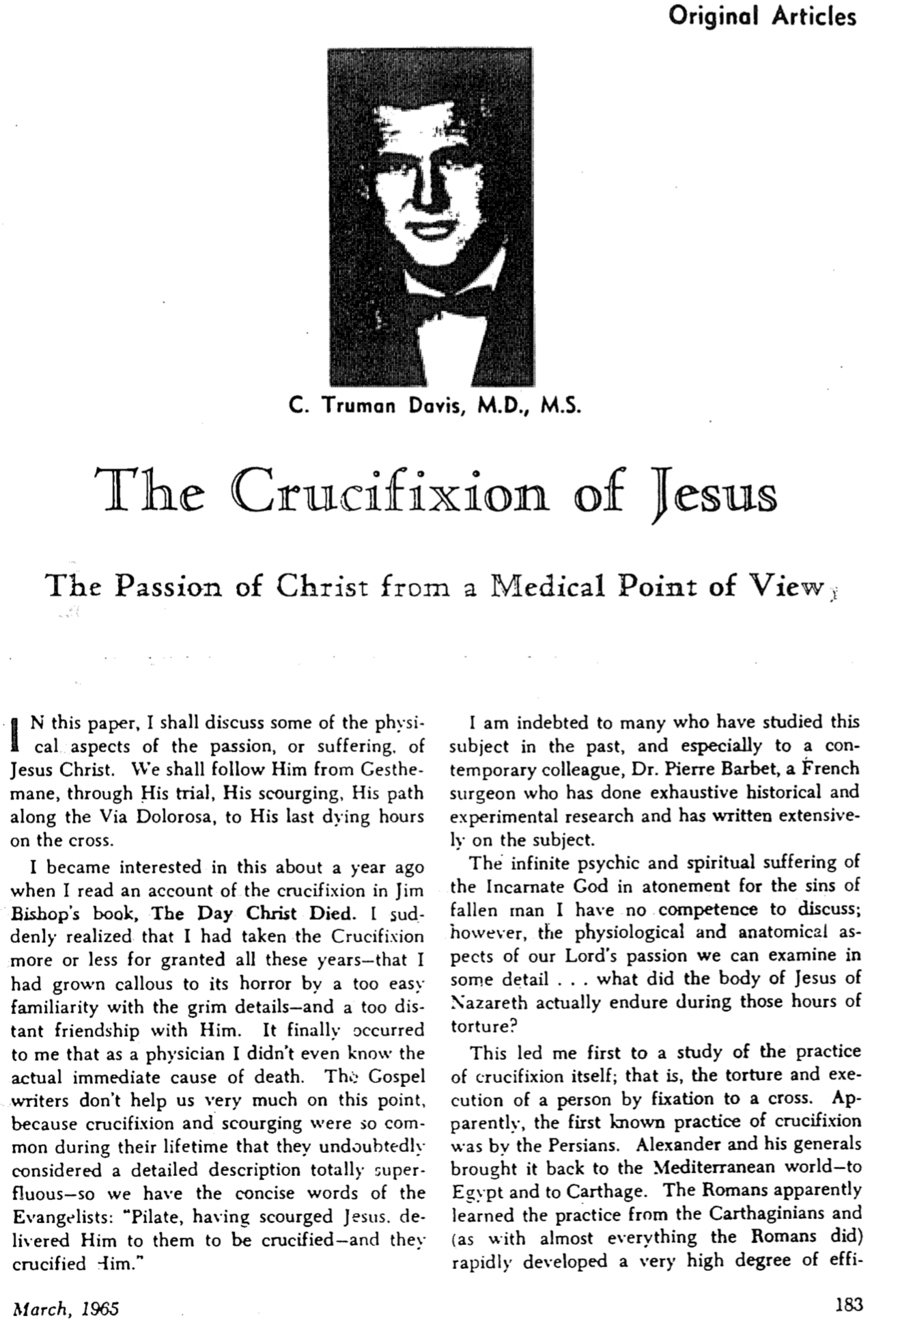

The Crucifixion of Jesus (2 of 5)

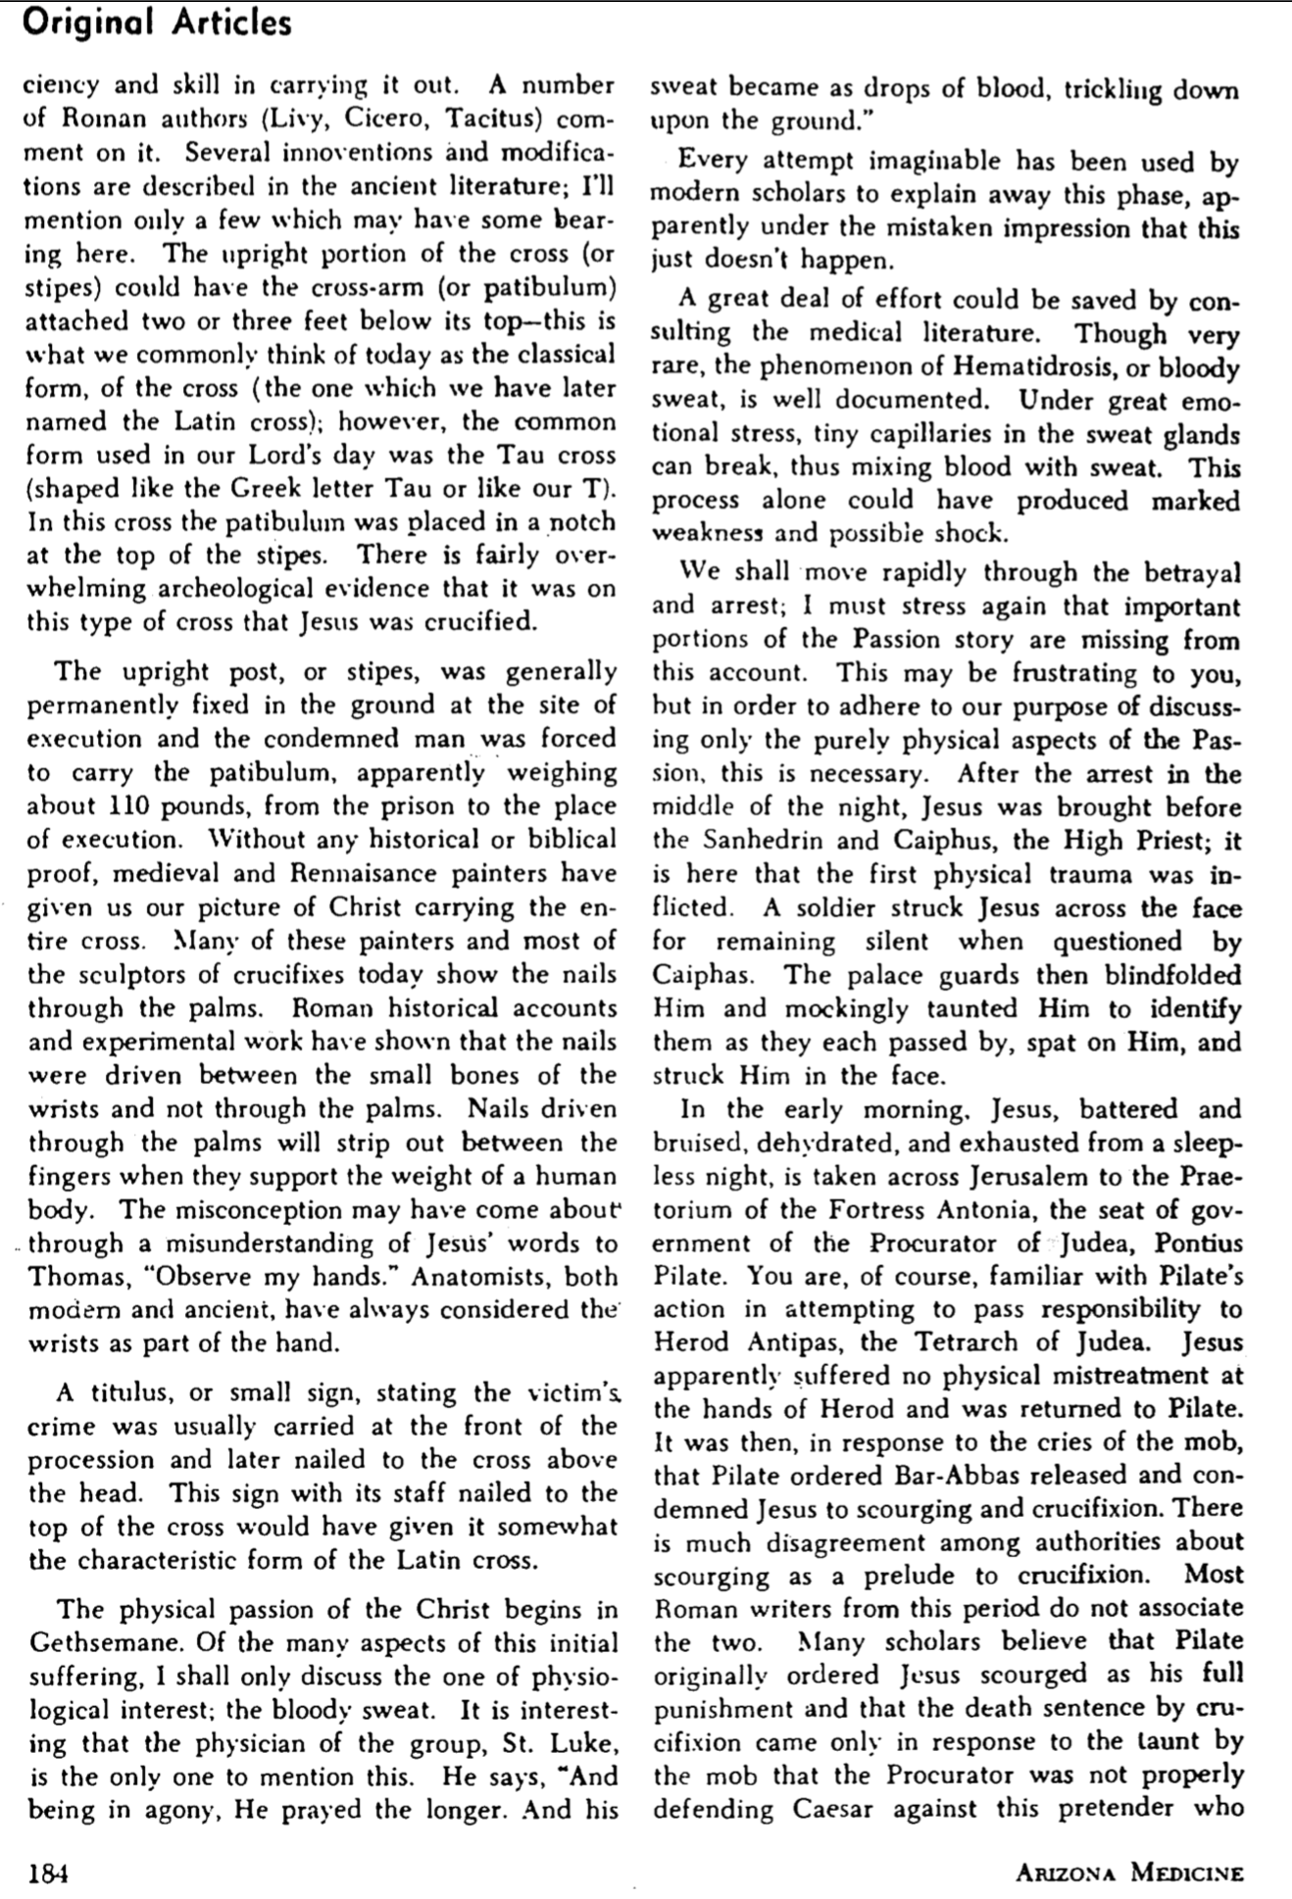

The Crucifixion of Jesus (3 of 5)

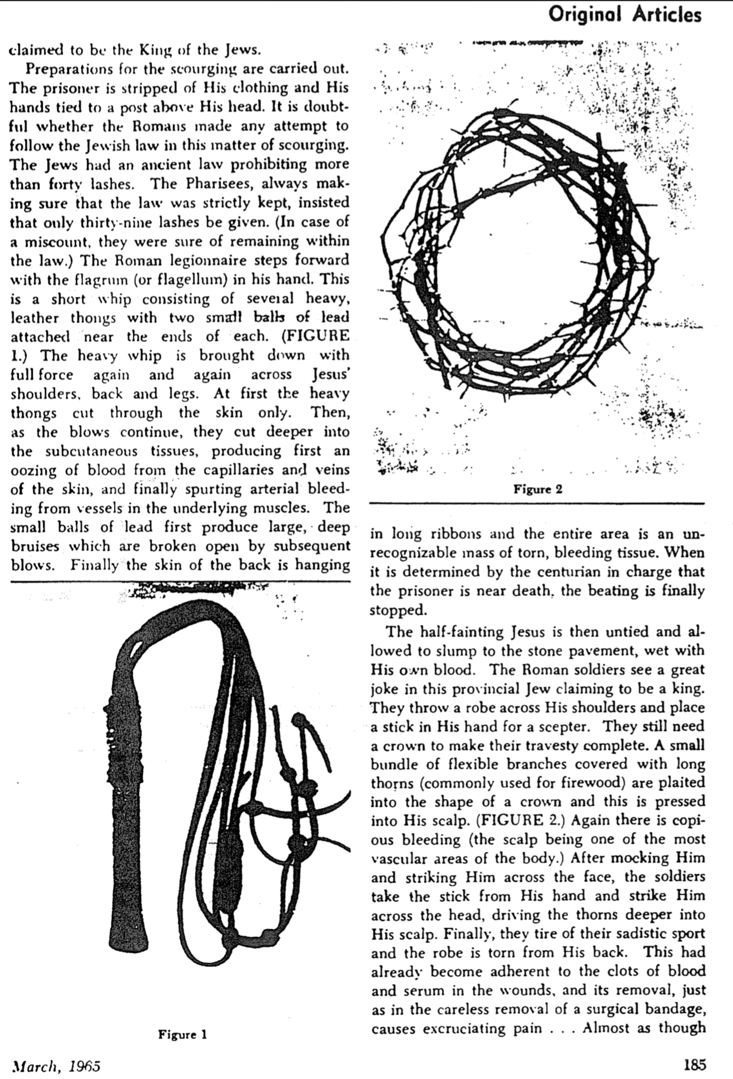

The Crucifixion of Jesus (4 of 5)

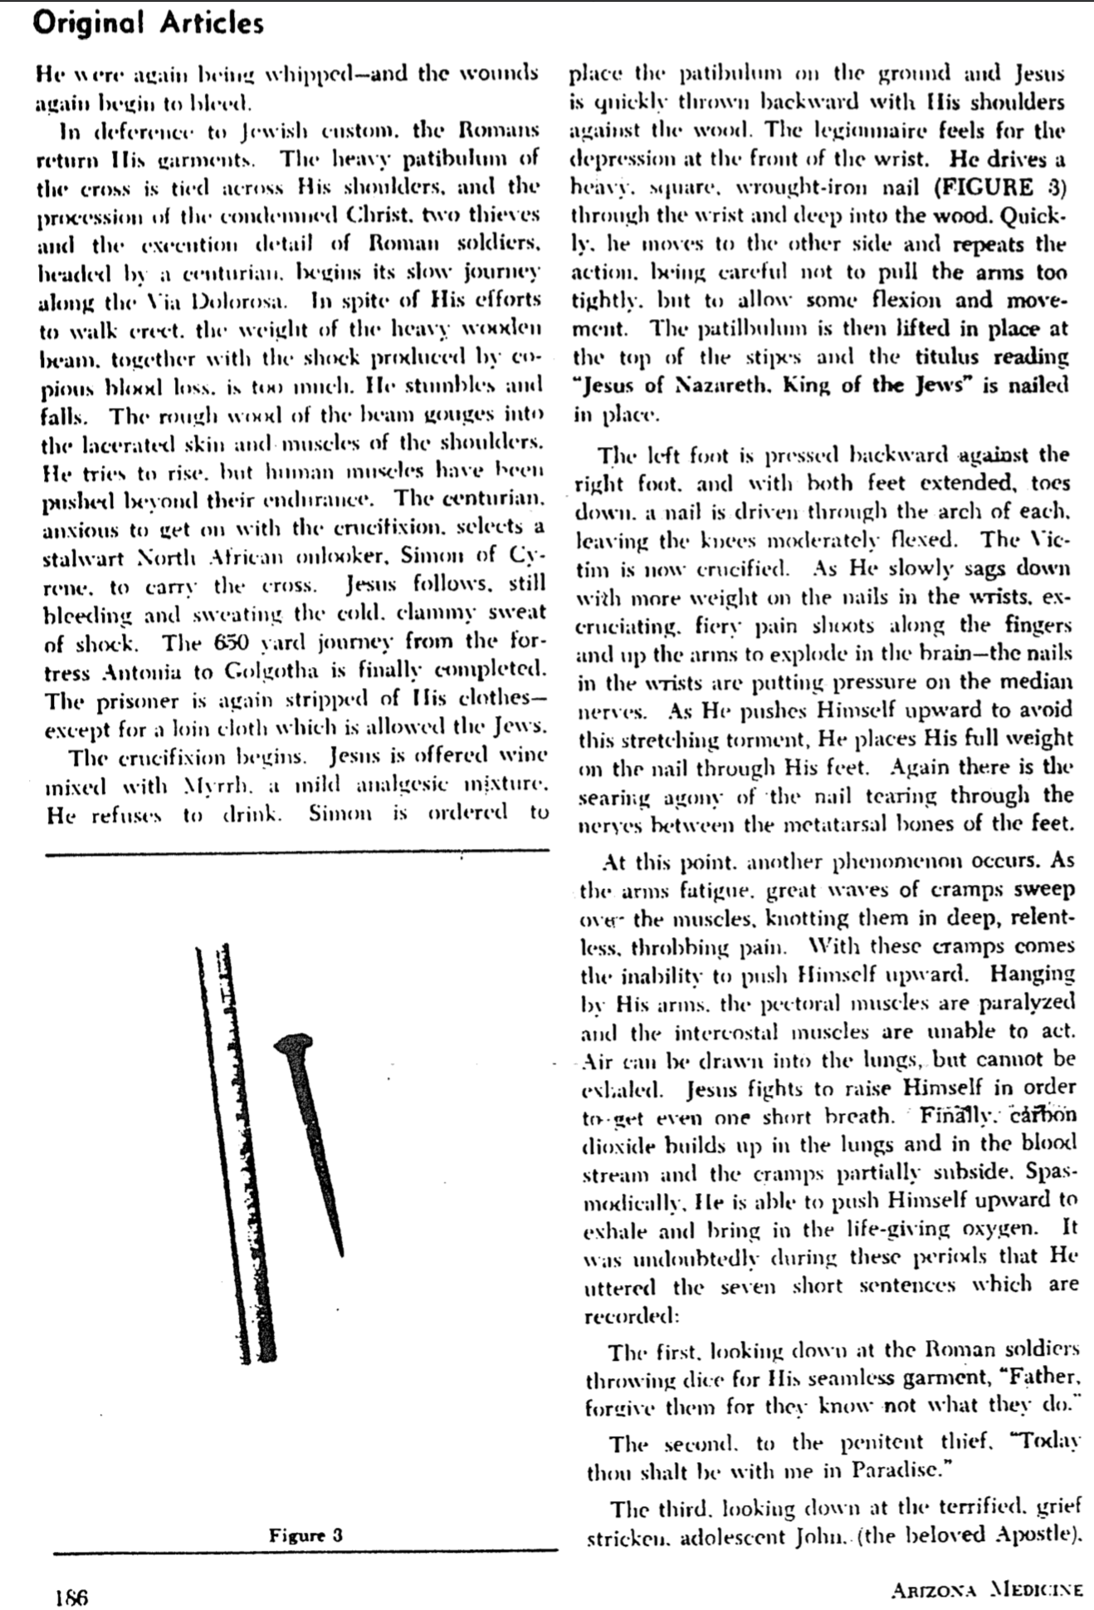

The Crucifixion of Jesus (5 of 5)

