https://journal.rts.edu/article/sharpening-your-greek-a-primer-for-bible-teachers-and-pastors-on-recent-developments-with-reference-to-two-new-intermediate-grammars-part-i/

Sharpening Your Greek: A Primer for Bible Teachers and Pastors on Recent Developments, with Reference to Two New Intermediate Grammars

**Gregory R. Lanier**  
**Assistant Professor of New Testament**  
**Reformed Theological Seminary, Orlando**

On the first day of “summer Greek” I had students open their newly-purchased Greek New Testaments (GNT hereafter) and — after giving them a short introduction to the alphabet — asked them to take turns reading aloud John 1:1–18. Though we only made it through verse three, and though they stumbled through nearly all of it, the point was simply this: you are not learning Greek so that you can memorize paradigms, plough through a 400-pg introductory grammar, do workbook exercises, take some quizzes, get a grade, and move on with your life. The goal is not word studies or parsing or identifying case endings or picking the right genitive category. Those are *means* but not the *end*. The τέλος is something far greater: to love reading the GNT as the inspired Word of God for the rest of your life and ministry. To read, say, John 1 as it came from the apostle’s own hand and stand in awe.

Being no fool, I know that many students who start and even finish a series of courses on Greek will soon, and sometimes intentionally, allow the weeds of daily ministry challenges to choke out whatever facility they once had. But many men and women who, having once tasted the gift of the study of biblical languages and shared in the spirit of seeing the fruit of such work for the kingdom of God, do not. They retain a desire to keep growing in how they responsibly engage with the GNT. This primer on some recent developments in Greek is for them.

The need for such continuing education for those in ministry is constant. However, the proximate stimulus for this piece is the nearly simultaneous publication of two books on intermediate Greek syntax in 2016. In attempting to bring us all up-to-date on contemporary research into κοινή, the authors of both works make compelling cases for — or sometimes simply presuppose — certain positions on important topics that may be quite different from what most pastors or Bible teachers in our neck of the woods once learned. Such findings have significant implications.

Acknowledging that even those who *do*“keep their Greek” are not falling over one other to read a combined 850 pages of intermediate grammar, I will structure this piece in two parts. In Part One, I will review each book individually and then reflect on them jointly. In Part Two, I will summarize nine recent developments in the study of Greek: (1) verbal aspect, (2) tense, (3) *Aktionsart*, (4) middle voice and so-called “deponency,” (5) lexical semantics, (6) CBGM and changes to NA-28/UBS-5, (7) pronunciation, (8) discourse analysis, and (9) software tools. The primer, though lengthy, is structured in such a way that its sections are largely self-contained and can be digested individually or used as a reference later on. It does not pretend to be exhaustive but, rather, aims to encourage the reader of the GNT to go the next level in sharpening his/her tools.

**Part One: Reviews**

In June and August 2016, a cadre of NT scholars following in a great Baptist tradition going back to A.T. Robertson[[1]](https://journal.rts.edu/article/sharpening-your-greek-a-primer-for-bible-teachers-and-pastors-on-recent-developments-with-reference-to-two-new-intermediate-grammars-part-i/" \l "_ftn1) released two intermediate Greek textbooks. Andreas J. Köstenberger, Benjamin L. Merkle, and Robert L. Plummer[[2]](https://journal.rts.edu/article/sharpening-your-greek-a-primer-for-bible-teachers-and-pastors-on-recent-developments-with-reference-to-two-new-intermediate-grammars-part-i/" \l "_ftn2) published *Going Deeper with New Testament Greek: An Intermediate Study of the Grammar and Syntax of the New Testament*(Nashville: B&H Academic, 2016; 550pp). Acknowledging they became aware of the other project only after embarking on their own (p. xv), David L. Mathewson and Elodie Ballantine Emig published *Intermediate Greek Grammar: Syntax for Students of the New Testament* (Grand Rapids: Baker Academic, 2016; 307pp). Both teams of authors serve at key Baptist seminaries[[3]](https://journal.rts.edu/article/sharpening-your-greek-a-primer-for-bible-teachers-and-pastors-on-recent-developments-with-reference-to-two-new-intermediate-grammars-part-i/" \l "_ftn3) and — apparently independently — set out to update and improve upon the justly famous 1996 grammar of yet another Baptist, Daniel B. Wallace,[[4]](https://journal.rts.edu/article/sharpening-your-greek-a-primer-for-bible-teachers-and-pastors-on-recent-developments-with-reference-to-two-new-intermediate-grammars-part-i/" \l "_ftn4) as well as other early-1990s grammars that remain influential.[[5]](https://journal.rts.edu/article/sharpening-your-greek-a-primer-for-bible-teachers-and-pastors-on-recent-developments-with-reference-to-two-new-intermediate-grammars-part-i/" \l "_ftn5) Though there has been an explosion of work on the GNT and κοινή in the intervening twenty years, few if any *intermediate*-level grammars have emerged. Both volumes aim to fill that void. Let us examine them individually and then jointly.

1. **Köstenberger/Merkle/Plummer, *Going Deeper with New Testament Greek***

*Going Deeper* has arguably become the more well-known volume already and received an uncommon number of endorsements for a book of this genre. Philosophically the authors aim to produce a volume that a student could *read* with comprehension and enjoyment (versus simply putting it on the shelf as a reference) and that a Greek instructor could use turn-key. They largely succeed at the former aim, as all three authors write well and strike, on the whole, a good balance between theory and practice. To achieve the latter aim, they have included in each chapter some unique features: an up-front “going deeper” section to whet the reader’s appetite on a given subject,[[6]](https://journal.rts.edu/article/sharpening-your-greek-a-primer-for-bible-teachers-and-pastors-on-recent-developments-with-reference-to-two-new-intermediate-grammars-part-i/" \l "_ftn6) practice exercises, vocabulary lists (15–49x frequency in the GNT),[[7]](https://journal.rts.edu/article/sharpening-your-greek-a-primer-for-bible-teachers-and-pastors-on-recent-developments-with-reference-to-two-new-intermediate-grammars-part-i/" \l "_ftn7) a built-in reader with running syntactical notes, and supplemental teacher aids (quizzes, etc.) provided on the companion website.[[8]](https://journal.rts.edu/article/sharpening-your-greek-a-primer-for-bible-teachers-and-pastors-on-recent-developments-with-reference-to-two-new-intermediate-grammars-part-i/" \l "_ftn8) The built-in reader sections, while tempting to skip for those pressed for time, should not be neglected, as the authors have done a great job providing comments on the selected Scripture portions that not only integrate material from the chapter but also offer broader insights.[[9]](https://journal.rts.edu/article/sharpening-your-greek-a-primer-for-bible-teachers-and-pastors-on-recent-developments-with-reference-to-two-new-intermediate-grammars-part-i/" \l "_ftn9)

The book includes fifteen chapters tackling major issues in Greek syntax: two on general issues, four on nouns/adjectives, six on verbs, one on “everything else” and two on general exegetical practices. The organization of the chapters is sometimes a bit puzzling,[[10]](https://journal.rts.edu/article/sharpening-your-greek-a-primer-for-bible-teachers-and-pastors-on-recent-developments-with-reference-to-two-new-intermediate-grammars-part-i/" \l "_ftn10) but the cumulative effect works out in the end.

The first chapter on “Greek Language & Textual Criticism” is a distinctive and refreshing starting point for a book like this. It provides a competent survey of the history of κοινή and introduces some basic principles of textual criticism, which would serve as a refresher to someone who has had prior exposure to the transmission history of the GNT but would not supplant more detailed introductions to textual criticism found in standalone volumes.

The next four chapters cover nominative/vocative/accusative, genitive, dative, and the article/adjective. The discussions of each major case are well-informed and supported by examples for which they provide an English translation[[11]](https://journal.rts.edu/article/sharpening-your-greek-a-primer-for-bible-teachers-and-pastors-on-recent-developments-with-reference-to-two-new-intermediate-grammars-part-i/" \l "_ftn11) and, occasionally, some commentary. Each chapter focuses — as do prior grammars — on discussing various syntactical categories for each case. For example, the authors outline eight categories for the accusative and sixteen for the genitive.[[12]](https://journal.rts.edu/article/sharpening-your-greek-a-primer-for-bible-teachers-and-pastors-on-recent-developments-with-reference-to-two-new-intermediate-grammars-part-i/" \l "_ftn12) They do, however, consciously reduce the number of categories, as a response to the tendency in Wallace’s grammar (among others) to proliferate them.[[13]](https://journal.rts.edu/article/sharpening-your-greek-a-primer-for-bible-teachers-and-pastors-on-recent-developments-with-reference-to-two-new-intermediate-grammars-part-i/" \l "_ftn13) (We will return to this below.) The treatment of the article is particularly helpful in dispelling common misconceptions regarding use/non-use of the article and providing balanced discussions of the Granville Sharp Rule, Colwell’s Rule, and Apollonius’s Canon. Throughout these chapters they include numerous summary charts that, for the visually-inclined, help summarize a lot of data concisely.

Their introductory chapter on the verb system (ch. 6) features the interesting choice to lead with person, number, voice, and mood — saving the tense and aspect discussion for later. The decision to delay those more hotly-debated topics in an *intermediate* grammar is an interesting one,[[14]](https://journal.rts.edu/article/sharpening-your-greek-a-primer-for-bible-teachers-and-pastors-on-recent-developments-with-reference-to-two-new-intermediate-grammars-part-i/" \l "_ftn14) but the authors appear to do this in order to ground the reader in some basic categories — finite/non-finite, transitive/intransitive, modality, subject-verb agreement, etc. — before kicking the tense and aspect hornets’ nest. There may be wisdom in this approach, but it was admittedly peculiar to read their entire discussion of, say, the indicative mood  without any real reference to tense and aspect.[[15]](https://journal.rts.edu/article/sharpening-your-greek-a-primer-for-bible-teachers-and-pastors-on-recent-developments-with-reference-to-two-new-intermediate-grammars-part-i/" \l "_ftn15)

The authors then spend an entire chapter on tense and verbal aspect (ch. 7) and provide a competent overview of the issues involved. They join many recent grammarians in affirming that Greek is *aspect prominent* and endorse the definitions of aspect provided by a wide range of scholars.[[16]](https://journal.rts.edu/article/sharpening-your-greek-a-primer-for-bible-teachers-and-pastors-on-recent-developments-with-reference-to-two-new-intermediate-grammars-part-i/" \l "_ftn16) They affirm three distinct aspects (imperfective; perfective; stative, which they treat as a hybrid of the other two) and supplement their discussion on aspect theory with one on how aspect is morphologized (that is, encoded in the spelling of the inflected verb) as well as how aspect relates to the role a given verb may play at the discourse level (e.g., main line vs. supporting information). Somewhat surprisingly, the aspect discussion is followed by *one paragraph* on tense or “time of action”! With respect to the long-standing debate between (a) those such as Stan Porter, Con Campbell, and Rod Decker[[17]](https://journal.rts.edu/article/sharpening-your-greek-a-primer-for-bible-teachers-and-pastors-on-recent-developments-with-reference-to-two-new-intermediate-grammars-part-i/" \l "_ftn17) who argue that tense/time-of-action *is not* part of the semantics of the verb but is purely pragmatic (determined by contextual factors) and (b) those such as Buist Fanning[[18]](https://journal.rts.edu/article/sharpening-your-greek-a-primer-for-bible-teachers-and-pastors-on-recent-developments-with-reference-to-two-new-intermediate-grammars-part-i/" \l "_ftn18) who argue that tense *is*, in some way, part of a verb’s semantics in the indicative, Köstenberger/Merkle/Plummer basically side with Fanning but are sympathetic to some of the insights of the other view:

Within the above-sketched aspectual framework, time is indicated in NT Greek in the indicative by the presence or absence of the augment. … In addition, time may be indicated by contextual information such as so-called ‘deictic indicators’ (p. 236).

After this short note on tense, the authors spend a few pages discussing “type of action”[[19]](https://journal.rts.edu/article/sharpening-your-greek-a-primer-for-bible-teachers-and-pastors-on-recent-developments-with-reference-to-two-new-intermediate-grammars-part-i/" \l "_ftn19) conveyed by a lexeme itself and its context, which helps continue to clear the air of some misconceptions about “punctiliar” aorists or “continuous” presents. While lengthier discussions of both tense and type of action would have been justified, the irenic tone of the authors amid this (at times overheated) debate is quite welcome, as they attempt to draw on the best from each of the major scholars involved. We will revisit each issue in Part Two below.

The next two chapters deal with the present/imperfect/future (ch. 8) and aorist/perfect/pluperfect (ch. 9). They spend a good deal of time going through the various categories of use (e.g., nine different kinds of presents, five futures, seven aorists, and six perfects), and on the whole their discussions are illuminating and supported with good examples. It is, however, a bit striking that their discussions of various syntactical features that would, at least per Porter/Campbell/Decker, militate against their conviction that tense is morphologized in the verb — e.g., “historical present,” proleptic aorist, futuristic present — are somewhat brief.[[20]](https://journal.rts.edu/article/sharpening-your-greek-a-primer-for-bible-teachers-and-pastors-on-recent-developments-with-reference-to-two-new-intermediate-grammars-part-i/" \l "_ftn20) They follow these chapters with robust treatments of the participle (ch. 10) and infinitive (ch. 11), offering a clear and robust refresher course on their complexities.

The “everything else” chapter (ch. 12) — though a bit cumbersome insofar as it treats so many disconnected things — provides generally sound discussions of pronouns, prepositions, conjunctions, adverbs, and particles. Their comprehensive chart on prepositions+case is quite useful (p. 408–410), as is their functionally-oriented discussion of conjunctions.

The authors then move into a discussion of Greek exegesis beyond the word. This practice has become increasingly common in introductory and intermediate grammars, and for good reason: as the authors note, one of the most important findings of modern linguistics is the importance of broader units of a text for the task of interpretation. Whereas most grammars (their own included) spend *a lot* of time on identifying categories and nuances of meaning at the word or phrase-level, Köstenberger/Merkle/Plummer make a valiant effort to instruct the reader on how to analyze the GNT at the sentence and discourse-level. They cover Greek clause construction (independent-dependent; conditionals;[[21]](https://journal.rts.edu/article/sharpening-your-greek-a-primer-for-bible-teachers-and-pastors-on-recent-developments-with-reference-to-two-new-intermediate-grammars-part-i/" \l "_ftn21) subject-predicate-complement; and so on) and offer short introductions to sentence diagramming (with examples), arcing,[[22]](https://journal.rts.edu/article/sharpening-your-greek-a-primer-for-bible-teachers-and-pastors-on-recent-developments-with-reference-to-two-new-intermediate-grammars-part-i/" \l "_ftn22) and phrase diagrams.[[23]](https://journal.rts.edu/article/sharpening-your-greek-a-primer-for-bible-teachers-and-pastors-on-recent-developments-with-reference-to-two-new-intermediate-grammars-part-i/" \l "_ftn23) They conclude with about two pages on discourse analysis, which proves far too short to be illuminating. The follow-up chapter (ch. 14) on how to do proper word studies is a helpful complement to the preceding chapter and features four principles that, in my mind, should be written on the heart of every reader of the GNT: “don’t make any word mean more than the author intends”; “prioritize synchrony over diachrony”; “do not confuse words and concepts”; and “do not view word study tools as inerrant” (pp. 478–480).

The authors conclude this substantial work with several exhortations to “help students think deliberately about how to become people who spend their entire lives reading, studying, and teaching from the GNT” (p. 491). They recommend using a “reader’s edition” of the GNT (versus interlinear), making a restrained use of digital tools, reading the GNT devotionally, and developing the habit of working with the original languages every time you prepare a lesson or sermon. To each of these I can simply say a hearty “Amen.”

1. **Mathewson/Emig, *Intermediate Greek Grammar***

The authors of *Intermediate Greek Grammar* share similar motivations and conclusions with the authors of *Going Deeper*, but the resulting product is quite different. Mathewson and Emig outline several important philosophical principles underlying the book: provide an accessible treatment of particular areas of κοινή that need “updating” (especially aspect); promote a “minimalist” approach to Greek syntax that retains a reverence for the inspiration of Scripture while avoiding “maximalist” tendencies of uncovering “the most meaning possible in each grammatical form or construction” (p. xvii);[[24]](https://journal.rts.edu/article/sharpening-your-greek-a-primer-for-bible-teachers-and-pastors-on-recent-developments-with-reference-to-two-new-intermediate-grammars-part-i/" \l "_ftn24) treat κοινή like any normal language, recognizing that one-to-one “literal” rendering of Greek into English is never 100% possible (nor is it for any other language); clearly distinguish semantics (meaning of a grammatical unit) from pragmatics (function/use in a given context); and focus less on assigning  grammatical labels/categories — a task they describe somewhat sarcastically as “pin the label on the grammatical construction” (p. 2) — and more on *explaining* how a given syntactical construction is being used in context. Compared to *Going Deeper*, Mathewson and Emig’s final product is spartan but still thorough. Each chapter is quite simple: technical description of the grammatical concept; a limited number of sub-sections focused not so much on categories as on ranges of use (though the distinction is sometimes thin); a few illustrative examples including the Greek, a translation, and brief comments; and one “for practice” example.

The book includes thirteen chapters and is organized in a more familiar way, moving from nouns/pronouns, to adjectives/adverbs, to prepositions, to verbs, and finally to clauses.

The first chapter covers the entire case system for nouns and is well-informed. The authors provide interesting perspectives on the nominative (least-marked form that simply *designates* an entity without specifying relationship),[[25]](https://journal.rts.edu/article/sharpening-your-greek-a-primer-for-bible-teachers-and-pastors-on-recent-developments-with-reference-to-two-new-intermediate-grammars-part-i/" \l "_ftn25) genitive (heavily-marked form that *restricts*), dative (form that *establishes relationship*), and accusative (form that *limits*, usually with reference to a verbal action). Perhaps rightly, the authors take prior grammarians to task for over-emphasizing fine distinctions in categories (e.g., instrumental>means vs. instrumental>agent vs. instrumental>cause for dative) that they believe are often pointlessly specific and usually debatable anyhow. Instead, they paint with a broader brush and encourage the reader to understand the basic profile of the syntactical construction rather than spend all their effort picking the right category. For instance, in contrast to Wallace’s *thirty-three* categories of the genitive,[[26]](https://journal.rts.edu/article/sharpening-your-greek-a-primer-for-bible-teachers-and-pastors-on-recent-developments-with-reference-to-two-new-intermediate-grammars-part-i/" \l "_ftn26) they provide five (descriptive, possessive-source, subjective-objective, epexegetical, and partitive). On the whole the chapter is thought-provoking, though at times it suffers from unevenness in level of detail.[[27]](https://journal.rts.edu/article/sharpening-your-greek-a-primer-for-bible-teachers-and-pastors-on-recent-developments-with-reference-to-two-new-intermediate-grammars-part-i/" \l "_ftn27)

The next two chapters on pronouns and adjectives (chs. 2 and 3) are pretty standard. However, one significant contribution the authors make is a higher degree of incorporation of discourse-level analysis in the syntactical discussions themselves, rather than saving them for the end. For instance, their discussion of the role of personal, demonstrative, and relative pronouns in structuring discourses is quite helpful.

The chapter on the article (ch. 4) departs from prior grammars (esp. Wallace) in being more hesitant to draw hard-and-fast rules about use/non-use. As in other discussions throughout the volume, the authors prefer to place more weight on context than on the syntactical feature in itself, which provides a welcome balance to other approaches that seem to suggest that figuring out arthrous vs. anarthrous constructions is almost mathematical. The chapter on prepositions (ch. 5) follows a similar path in encouraging readers of the GNT to avoid “overinterpreting” the theological freight of a preposition.[[28]](https://journal.rts.edu/article/sharpening-your-greek-a-primer-for-bible-teachers-and-pastors-on-recent-developments-with-reference-to-two-new-intermediate-grammars-part-i/" \l "_ftn28) While encouraging students to avoid the temptation to “insist on precise distinctions and fine shades of meaning between prepositions” (p. 92) such as ἐκ/ἀπό or εἰς/ἐν, they nevertheless provide a fairly standard summary of the range of meaning of the major prepositions.

In contrast to *Going Deeper*, this volume places a discussion of tense and aspect up-front in their sequence of chapters on the Greek verb (ch. 6). The authors openly side with Porter/Campbell/Decker on the non-temporal nature of the Greek verb’s syntax even in the indicative:

Time and kind of action are indicated not by the verb tense-forms but by the broader context … Though there is still some disagreement on the issue of whether Greek indicative verb tenses indicate time, our grammar will side with advocates of verbal aspect [citing Porter].[[29]](https://journal.rts.edu/article/sharpening-your-greek-a-primer-for-bible-teachers-and-pastors-on-recent-developments-with-reference-to-two-new-intermediate-grammars-part-i/" \l "_ftn29)

They, like Köstenberger/Merkle/Plummer, argue for three aspects (perfective, imperfective, and stative), but they defend their position on tense by — following Porter’s strategy — providing a series of examples that seem to militate against the standard view that, say, aorist indicatives encode *past-time* reference and present indicatives encode *contemporaneous-time* reference. Their discussion of the importance of aspect in discourse structuring is helpful. In keeping with their approach for the noun/adjective system, the authors largely attempt to avoid assigning categories to verbs (e.g., ingressive aorist, gnomic present, and the like), but it is worth noting that they end up using similar language to describe broader “uses” (e.g., “aorist used of extended action,” p. 122). On the whole, their treatment of the verb system will be stimulating reading even for those who may disagree with them.

The subsequent four chapters provide detailed descriptions of voice[[30]](https://journal.rts.edu/article/sharpening-your-greek-a-primer-for-bible-teachers-and-pastors-on-recent-developments-with-reference-to-two-new-intermediate-grammars-part-i/" \l "_ftn30)/person/number (ch. 7), mood (ch. 8), infinitives (ch. 9), and participles (ch. 10). Each chapter does an admirable job bringing to bear their views on verbal aspect both within and outside the indicative mood, which is a major step forward for intermediate grammars even if one disagrees with them at times.[[31]](https://journal.rts.edu/article/sharpening-your-greek-a-primer-for-bible-teachers-and-pastors-on-recent-developments-with-reference-to-two-new-intermediate-grammars-part-i/" \l "_ftn31)

The authors next include very helpful chapters on clause construction (chs. 11–12), with a particularly learned treatment of conjunctions and subordinate clauses. Their final chapter on discourse considerations (ch. 13) is far more robust than that found in *Going Deeper* and includes summaries of four main discourse features that any student of the GNT should master: *cohesion* (how conjunctions, repetition, pronouns, etc. bring unity to a pericope/chapter), *textual boundaries* (how transitions, shifts in aspect, and other features mark changes in subject matter to define textual units), *prominence*(how aspect, constituent order within a clause, use of unnecessary pronouns, and deictic markers push information in a discourse to the background or foreground), and *participants* (how characters in a narrative are brought to and from the main “stage”). The interested reader would still need to go to a standalone volume to know *how to do* discourse analysis, but their introduction provides a helpful starting point. The book ends somewhat abruptly here, followed by an appendix on principal parts of key verbs in the GNT.[[32]](https://journal.rts.edu/article/sharpening-your-greek-a-primer-for-bible-teachers-and-pastors-on-recent-developments-with-reference-to-two-new-intermediate-grammars-part-i/" \l "_ftn32)

**III. Interacting with Both**

As has been indicated at various points above, *Going Deeper* and *Intermediate Greek Grammar* attempt to do the same basic thing — provide a more up-to-date intermediate grammar that is conversant with post-90s advances — but have their own strengths and weaknesses. *Going Deeper*is obviously longer, but the added length is a benefit in some cases: its treatments of various syntactical constructions are generally more robust, and the additional content (vocabulary lists, extended examples, etc.) make it a one-stop-shop for the student and instructor. The slightly disorganized treatment of the verbal system is a weakness, even if (on the whole) the authors’ approach to tense and aspect is the more balanced of the two. *Intermediate Greek Grammar*, on the other hand, is much shorter and, on the whole, less enjoying to read; it best serves as a reference. It does a better job than *Going Deeper*, however, at integrating discourse features and verbal aspect *into the discussions*, which goes a long way towards helping the reader move from theory to the “so what.”

At the end of the day, Wallace’s longer grammar still deserves to be on the shelf of every serious student of the GNT, as its wealth of information remains unsurpassed (even by the combination of these two volumes). Yet I would commend either of these new grammars to the Bible teacher, pastor, and student, since they do make helpful contributions, each in its own unique way. However, if forced to pick one, I would probably go with Köstenberger/Merkle/Plummer for its readability and fullness.

Before moving on from the book reviews, it is important to pause and reflect on five key areas of common ground shared by both volumes that, I believe, are quite significant for the serious student of the GNT. Emerging out of two decades of substantial research on κοινή, Köstenberger/Merkle/Plummer and Mathewson/Emig independently arrive at the same basic place on the following key issues:

* *Advocating for aspect prominence of the Greek verbal system*. Though they land on different sides of the *tense* debate, both sets of authors argue with some definitiveness that verbal aspect is the key to understanding the Greek verbal system. While recent introductory grammars have become more conversant on this, such a move is a meaningful departure from (or, at least, a substantial clarification of) prior intermediate grammars. This is significant because students who have come through their Greek instruction in the past, say, ten years have become more aware of the tense-aspect debate but are stuck in a strange limbo. Some introductory grammars treat aspect but are burdened with inaccuracies (e.g., Mounce); many major commentaries (even recent ones) presuppose tense-prominence and speak very little about aspect; the pre-1990s intermediate grammars tend to confuse categories of tense, aspect, and *Aktionsart*; but contemporary GNT scholarship is increasingly aligned about aspect prominence (even if disagreement lingers on tense). In other words, the student may be left perplexed about what page we are on. Both of these books help plow a clearer path forward.
* *Rejecting*“*deponency*.” We will cover this in detail below, but it is striking that both volumes make decisive strides in the direction away from the so-called “deponent” Greek verb and towards treating such middle-only verbs as true middles. In doing so, they add their voice to a burgeoning minority that deserves to be heard.
* *Emphasizing contextual sensitivity over*“*pinning the category*”*on the syntactical donkey*. As indicated above, both books to varying degrees bring some much-needed sanity to a learning environment plagued by proliferation of categories that are, admittedly, nearly impossible to memorize and keep straight. One is awestruck by the 100+ categories for cases, adjectives, verb tenses, prepositional phrases, infinitives, participles, and so on found in modern grammars from Robertson and BDF to Wallace. Köstenberger/Merkle/Plummer attempt simply to reduce them by consolidation (which is a start), while Mathewson/Emig try to move away from them altogether. Either way, they share the same basic philosophy. Greek words do not come to us from, say, Paul with labels (Logos Bible Software notwithstanding!). Thus, the task of the student is not done when he/she has (probably through consulting Wallace or another grammar, which do not always agree on the nomenclature, definition, or assignment of the labels anyhow) picked a label, such as “accusative of time” or “genitive of space.” Even assuming that the label has been picked accurately, this is simply the starting point, not the destination. The student should focus more time on *what is it doing in the context*? than simply *what is it*?
* *Promoting analysis over translation*. Throughout each book, the authors regularly emphasize that many of the subtleties of the Greek — ranging from aspect in non-indicative verbs to the middle voice — are not always straightforward to pick up in simple English translations. Translators should do their best, but sometimes it is nearly impossible to render in short glosses such things that, on the whole, English lacks. Thus, the pastor/teacher should focus as much, if not more, time focusing on exegesis and explanation than on simply producing their own English translation. The student should *work the Greek*, not simply try to make a stilted translation and move on. This is not a new insight, but the authors present it in a refreshing way. We have dozens of very good English translations, so producing one’s own (i.e. in sermon preparation) is really only a starting point. Where we want to get, rather, is a real understanding of the Greek text *as Greek*. This takes more work, but the benefits are substantial.
* *Pressing beyond local syntax towards the broader unit of meaning*. Most grammars (both introductory and intermediate) tend to take an atomistic approach: focusing on categorizing and explaining individual words or short phrases. This is, of course, necessary, but one notable shift in both of these volumes is their desire to teach the GNT reader to move beyond the word-level to allow the discourse-level to impact their understanding of syntax at a micro-level.

With this as a launching point, we now move to our “primer.”

**Part Two: Primer**

The primer that follows covers in some detail nine issues which the present author believes should be on the radar screen of every pastor or Bible teacher. I will do my best to present a thorough summary and evaluation of the “state of the question,” with some reflection (by no means exhaustive) on some of the implications.

1. **The Κοινή Verb System**

Without a doubt the Greek verbal system has received the most scrutiny in recent decades.[[33]](https://journal.rts.edu/article/sharpening-your-greek-a-primer-for-bible-teachers-and-pastors-on-recent-developments-with-reference-to-two-new-intermediate-grammars-part-i/" \l "_ftn33) Among the various topics receiving intense study, four stand out: aspect, tense, *Aktionsart*,[[34]](https://journal.rts.edu/article/sharpening-your-greek-a-primer-for-bible-teachers-and-pastors-on-recent-developments-with-reference-to-two-new-intermediate-grammars-part-i/" \l "_ftn34) and the middle voice. We will survey each in turn, but first we must establish the groundwork for how the study of the Greek verb got to this point.

It comes as a surprise to few students of Greek that English (along with German and French) is more or less *tense prominent*. Our verbs primarily, though not exclusively, encode *when* an action occurs, or its “location in time” with respect to the speaker: past (prior to the time horizon of the speaker), present (contemporaneous to the speaker), and future (after the time horizon of the speaker). These location-in-time encodings can be overridden — such as when a speaker shifts tenses in indirect speech reporting or uses a present-tense form of a verb to narrate something that happened in the past — but in general they have prominence in English. We shift tenses by changing endings or adding helping verbs:

[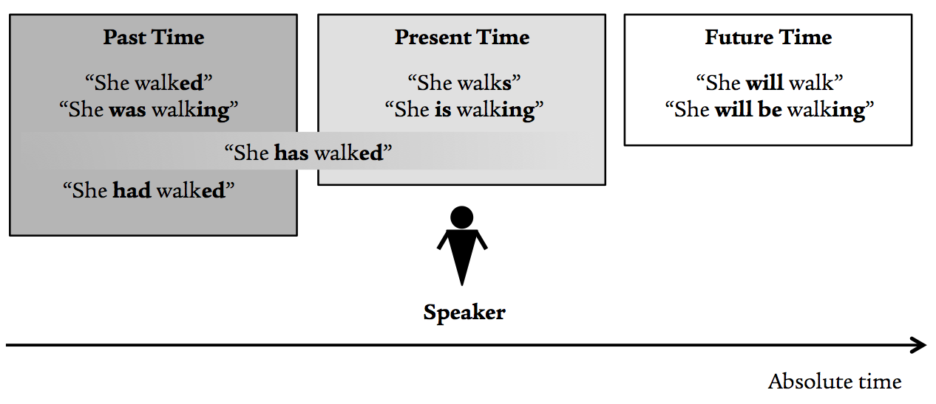](https://journal.rts.edu/wp-content/uploads/2016/12/Graphic1.png)

While English verb morphology *can* approximate verbal aspect (e.g., with –ing), such features are usually vague and easily confused with, say*,*kind of action. Thus, while it is not entirely true that English has no aspect altogether, it is widely agreed that tense is prominent. The same is true, basically, for German and French. However, numerous other languages, including many Slavic languages, are not tense prominent at all.[[35]](https://journal.rts.edu/article/sharpening-your-greek-a-primer-for-bible-teachers-and-pastors-on-recent-developments-with-reference-to-two-new-intermediate-grammars-part-i/" \l "_ftn35)

The implications of this for the study of κοινή are substantial, as recent research has pointed out. For two centuries Greek grammars have been written by scholars whose native language is tense prominent but, as scholars have argued for over twenty years now, Greek appears to be *aspect prominent* instead. That is, grammars have been describing an aspectual verb system (Greek) in languages that are tense-driven without fully realizing the disconnect.

Beginning largely with Porter and Fanning in the late 1980s (who were influenced by Comrie and others previously),[[36]](https://journal.rts.edu/article/sharpening-your-greek-a-primer-for-bible-teachers-and-pastors-on-recent-developments-with-reference-to-two-new-intermediate-grammars-part-i/" \l "_ftn36) the GNT scholarly community has come to recognize that the inflected meaning of a Greek verb (e.g., what an aorist active indicative third singular verb means in context) is constituted by three factors:

|  |  |  |
| --- | --- | --- |
| **Aspect** | **Tense (proper)** | ***Aktionsart*** |
| Subjective portrayal of or vantage-point towards the verbal action (not how the action actually takes place) | Location in time, whether absolute (past, present, future), or relative (before, during, after), or N/A | How the verbal action actually takes place, based on the lexeme, literary context, and event itself |

Of these three, *aspect* is considered prominent and appears across all verb forms, both within and outside the indicative mood. *Tense (proper)* remains debated, which we will discuss below. *Aktionsart*, which has often been confused with aspect and/or tense by various grammarians in the past, is a complementary feature combining both semantics (lexical/syntactical) and pragmatics (contextual use).

The astute observer will recognize that the use of “tense” in the way outlined above introduces a problematic ambiguity in how we label the so-called “tenses” that any first-year Greek student memorizes. What we call Greek “tenses” — present, imperfect, future, aorist, perfect, pluperfect — do not map 1:1 to “tense (proper)” but also crossover into aspect.[[37]](https://journal.rts.edu/article/sharpening-your-greek-a-primer-for-bible-teachers-and-pastors-on-recent-developments-with-reference-to-two-new-intermediate-grammars-part-i/" \l "_ftn37) Moreover, two of the standard aspectual categories sound confusingly like “tenses”: imperfective (aspect) vs. imperfect, and perfective (aspect) vs. perfect. Thus, following the lead of Köstenberger/Merkle/Plummer and Campbell, in what follows I will use the term “tense-form” to describe the *morphology* (how a verb is spelled) and “tense (proper)” to describe *location-in-time*. This is still far from ideal, but it is a start.

1. *Aspect*

For the English-speaker, even defining verbal aspect present challenges, since it is not typically how we conceptualize the verb. So, we will begin with a few definitions from key scholars to help flesh out the issue:

* *Bernard Comrie*(non-biblical linguist): “aspects are different ways of viewing the internal temporal constituency of a situation.”[[38]](https://journal.rts.edu/article/sharpening-your-greek-a-primer-for-bible-teachers-and-pastors-on-recent-developments-with-reference-to-two-new-intermediate-grammars-part-i/" \l "_ftn38)
* *Buist Fanning*: “Verbal aspect … is that category in the grammar of the verb which reflects the focus or viewpoint of the speaker in regard to the action or condition which the verb describes. It shows the perspective from which the occurrence is regarded or the portrayal of the occurrence apart from the actual or perceived nature of the situation itself.”[[39]](https://journal.rts.edu/article/sharpening-your-greek-a-primer-for-bible-teachers-and-pastors-on-recent-developments-with-reference-to-two-new-intermediate-grammars-part-i/" \l "_ftn39)
* *Stanley Porter*: “Synthetic verbal aspect [is] a morphologically-based semantic category which grammaticalizes the author/speaker’s reasoned subjective choice of conception of a process.”[[40]](https://journal.rts.edu/article/sharpening-your-greek-a-primer-for-bible-teachers-and-pastors-on-recent-developments-with-reference-to-two-new-intermediate-grammars-part-i/" \l "_ftn40)
* *Rodney Decker*: “[The] choice of aspect is subjective, based on the speaker’s choice as to how he wants to portray an action and is expressed internally in the morphology of the chosen verb form.”[[41]](https://journal.rts.edu/article/sharpening-your-greek-a-primer-for-bible-teachers-and-pastors-on-recent-developments-with-reference-to-two-new-intermediate-grammars-part-i/" \l "_ftn41)
* *Constantine Campbell*: “An author or speaker views an action, event, or state either from the *outside* or from *within*. … Verbal aspect represents a subjective choice. … An author chooses which aspect to use when portraying a particular action, event, or state.”[[42]](https://journal.rts.edu/article/sharpening-your-greek-a-primer-for-bible-teachers-and-pastors-on-recent-developments-with-reference-to-two-new-intermediate-grammars-part-i/" \l "_ftn42)
* *Köstenberger/Merkle/Plummer*: “Verbal aspect is the *subjective perspective* or *viewpoint* from which an author communicates the action of a given verb.”[[43]](https://journal.rts.edu/article/sharpening-your-greek-a-primer-for-bible-teachers-and-pastors-on-recent-developments-with-reference-to-two-new-intermediate-grammars-part-i/" \l "_ftn43)
* *Mathewson/Emig*: “[Aspect conveys] *how the author chooses to conceive of or view the action*. Aspect concerns the *author’s perspective* on an action.”[[44]](https://journal.rts.edu/article/sharpening-your-greek-a-primer-for-bible-teachers-and-pastors-on-recent-developments-with-reference-to-two-new-intermediate-grammars-part-i/" \l "_ftn44)

In short, verbal aspect is concerned not with *when* or *how*an action occurred in reality, but with how the writer chooses to portray that action specifically in terms of the relationship between him/her (or the reader) and the unfolding of that action. Common to nearly all the above definitions is the use of a “spatial” metaphor to articulate aspect[[45]](https://journal.rts.edu/article/sharpening-your-greek-a-primer-for-bible-teachers-and-pastors-on-recent-developments-with-reference-to-two-new-intermediate-grammars-part-i/" \l "_ftn45): (a) describing an event “from the outside,” that is, viewing it as a whole event, with the beginning-middle-end all in view at once (external viewpoint), or (b) describing an event “from within,” that is, viewing it as it were developing right before one’s eyes, with the beginning having already taken place but the ending not yet in sight (internal viewpoint).

A few pictorial analogies may help, though they are not flawless. The first example has become standard in discussions of verbal aspect. The other two offer different angles on aspect, and they work best if one approaches the “external viewpoint” graphics as not merely the final product but as capturing the sense of *completeness* of the entire verbal action represented in the photo.

[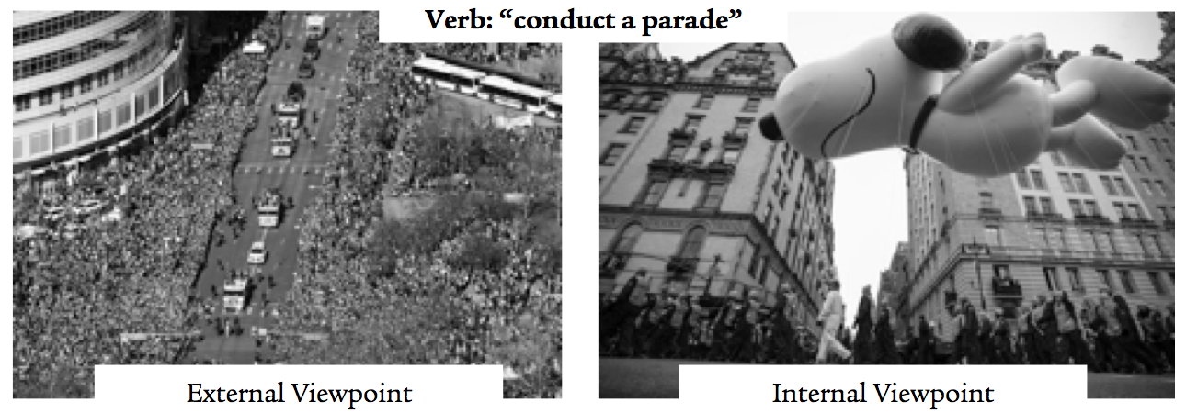](https://journal.rts.edu/wp-content/uploads/2016/12/Graphic2.png)

[](https://journal.rts.edu/wp-content/uploads/2016/12/Graphic3.png)

[](https://journal.rts.edu/wp-content/uploads/2016/12/Graphic4.png)

In short, aspect deals with how “the speaker chooses to view or portray the action (1) as in its development, as in process of being carried out; or (2) as a single whole, as summarized in one event from beginning to end.”[[46]](https://journal.rts.edu/article/sharpening-your-greek-a-primer-for-bible-teachers-and-pastors-on-recent-developments-with-reference-to-two-new-intermediate-grammars-part-i/" \l "_ftn46)

Nearly all scholars in present discussions agree that both of these aspects are present in Greek, along with a debated third.

*Perfective aspect*—the external viewpoint. With a perfective verb (not to be confused with a verb in the “perfect” tense-form), the author chooses to portray the verbal action with a sense of *completeness*, from the outside, without reference to or emphasis on its development. It is a summary or all-encompassing vantage point on the verbal action in which the beginning and ending are in view (usually) but not emphasized, nor any point along the way.

*Imperfective aspect*—the internal viewpoint. With an imperfective verb (not to be confused with a verb in the “imperfect” tense-form), the author chooses to portray the verbal action with a sense of *incompleteness*, from the inside, as if it were developing right in front of you. The imperfective aspect emphasizes the unfolding of the verbal action as if he/she (or the reader) were in some sense watching it take place.

We can diagram these two aspects as follows[[47]](https://journal.rts.edu/article/sharpening-your-greek-a-primer-for-bible-teachers-and-pastors-on-recent-developments-with-reference-to-two-new-intermediate-grammars-part-i/" \l "_ftn47):

[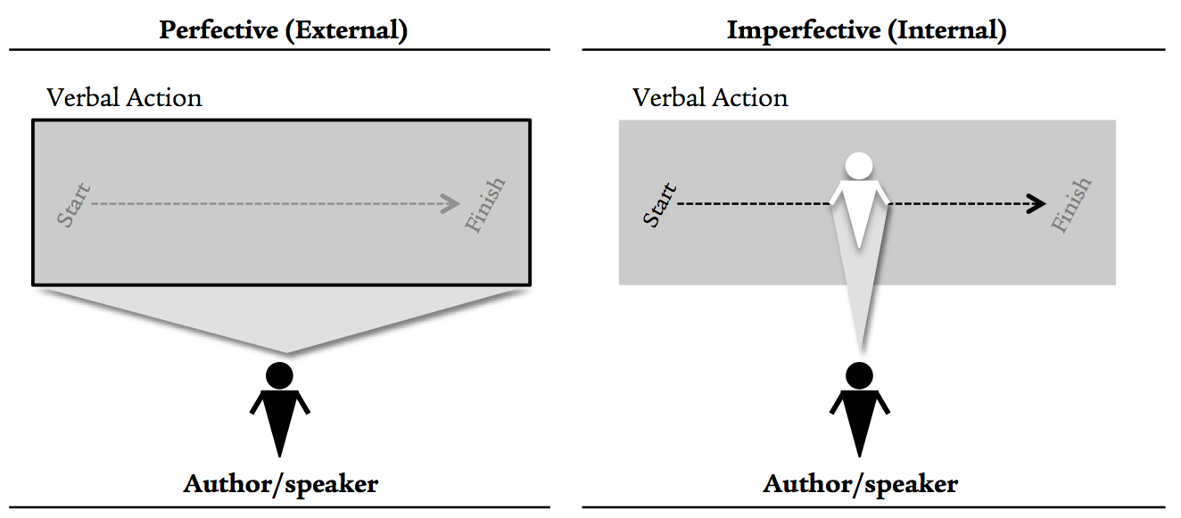](https://journal.rts.edu/wp-content/uploads/2016/12/Graphic5.png)

*(Stative) aspect*—a combination? The third possible aspect, also denoted “combinative” by some scholars, remains debated,[[48]](https://journal.rts.edu/article/sharpening-your-greek-a-primer-for-bible-teachers-and-pastors-on-recent-developments-with-reference-to-two-new-intermediate-grammars-part-i/" \l "_ftn48) which is why I leave it in parentheses. For those who advocate that it is a true aspect, the *stative* combines elements of the external and internal vantage-points: the verbal action is understood to have a measure of completeness (regardless of time) that yields a state of affairs that is still unfolding, with emphasis placed on the latter. Here another diagram may help:

[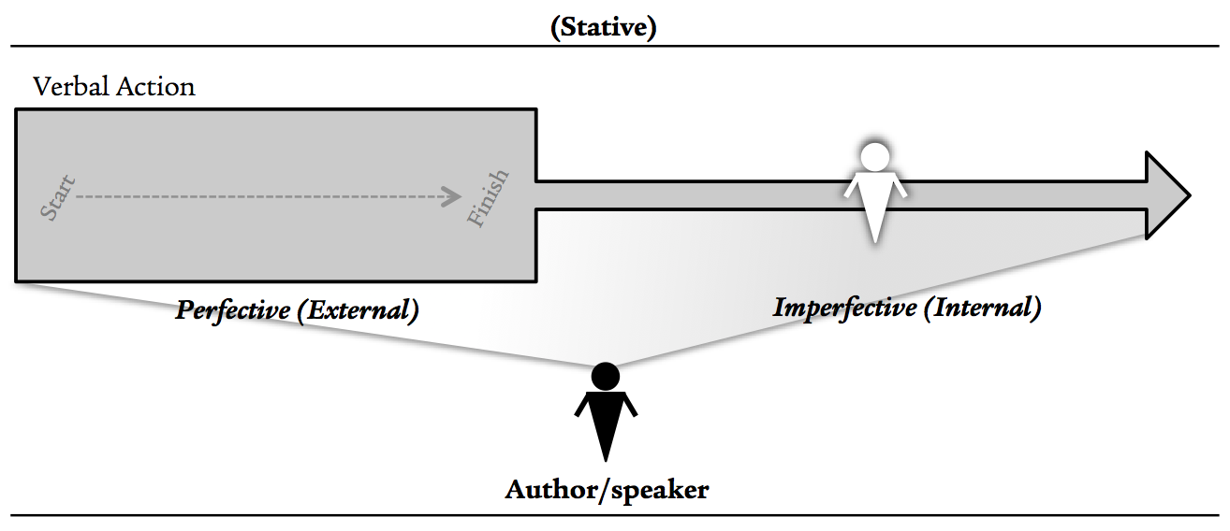](https://journal.rts.edu/wp-content/uploads/2016/12/Graphic6.png)

In a three-aspect system (as outlined above), our familiar κοινή tense-forms fall into place as follows:

|  |  |  |
| --- | --- | --- |
| **Perfective** | **Imperfective** | **(Stative)** |
| Aorist | Present | Perfect |
| Future[[49]](https://journal.rts.edu/article/sharpening-your-greek-a-primer-for-bible-teachers-and-pastors-on-recent-developments-with-reference-to-two-new-intermediate-grammars-part-i/" \l "_ftn49) | Imperfect | Pluperfect |

It is widely agreed that verbal aspect in Greek is semantically encoded — and thus morphologized (that is, included in the spelling)[[50]](https://journal.rts.edu/article/sharpening-your-greek-a-primer-for-bible-teachers-and-pastors-on-recent-developments-with-reference-to-two-new-intermediate-grammars-part-i/" \l "_ftn50) — across all moods and verb forms.[[51]](https://journal.rts.edu/article/sharpening-your-greek-a-primer-for-bible-teachers-and-pastors-on-recent-developments-with-reference-to-two-new-intermediate-grammars-part-i/" \l "_ftn51) This is accomplished with an aspectual *prefix* and/or *infix*.[[52]](https://journal.rts.edu/article/sharpening-your-greek-a-primer-for-bible-teachers-and-pastors-on-recent-developments-with-reference-to-two-new-intermediate-grammars-part-i/" \l "_ftn52) Perfective aspect is marked with -σ- (active/middle) or -θ- (passive). Imperfective aspect is unmarked. (Stative) aspect is marked by reduplication (λυ-) and -κ- (active). We can demonstrate these patterns with the following representative λύω chart[[53]](https://journal.rts.edu/article/sharpening-your-greek-a-primer-for-bible-teachers-and-pastors-on-recent-developments-with-reference-to-two-new-intermediate-grammars-part-i/" \l "_ftn53):

[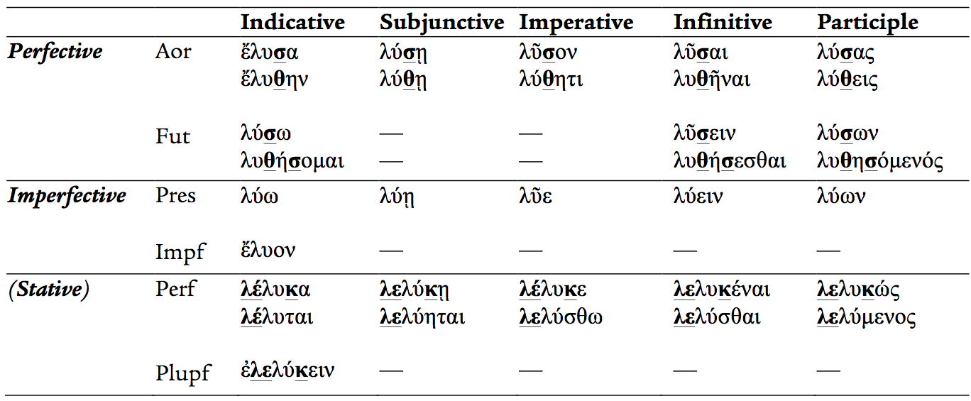](https://journal.rts.edu/wp-content/uploads/2016/12/Graphic7.png)

As can be observed from the chart, aspect markers (bold/underline) are present across all five verb forms, corroborating the contention that aspect is always relevant even outside the indicative, even if it is difficult to bring out in a single English gloss. For instance, in some cases an adverbial aorist (perfective) participle may be, from a relative-time perspective, chronologically prior-to the action of the main verb (in whatever tense-form), due the sense of “completeness” conveyed by the aspect; in other cases, perfectivity may describe a holistic action viewed from the outside *in the context of which* the main verb is operating.[[54]](https://journal.rts.edu/article/sharpening-your-greek-a-primer-for-bible-teachers-and-pastors-on-recent-developments-with-reference-to-two-new-intermediate-grammars-part-i/" \l "_ftn54) As another example, imperfective aspect with an imperative verb may suggest that action being commanded (or prohibited) has a sense of ongoing development or durative/repeated activity (e.g., “flee [φεῦγε] to Egypt,” Matt 2:13), while a perfective imperative simply takes a summary view of the commanded action shows no concern for how it actually unfolds (e.g., “save [σῶσον] yourself, if you are the son of God,” Matt 27:40).

1. *Tense (proper)*

Commonplace within the study of Greek is the notion that absolute time — that is, *when* something is portrayed as happening relative to the time horizon of the speaker — is only relevant, if at all, in the indicative mood.[[55]](https://journal.rts.edu/article/sharpening-your-greek-a-primer-for-bible-teachers-and-pastors-on-recent-developments-with-reference-to-two-new-intermediate-grammars-part-i/" \l "_ftn55) As mentioned in Part One, the playing field has long been divided between two positions. Some argue that Greek tense-forms (aorist, etc.) do not “semantically encode temporal reference alongside aspect,” [[56]](https://journal.rts.edu/article/sharpening-your-greek-a-primer-for-bible-teachers-and-pastors-on-recent-developments-with-reference-to-two-new-intermediate-grammars-part-i/" \l "_ftn56) but rather tense (proper) is a pragmatic feature that is determined by context, especially additional words in a sentence indicating time. In other words, for Porter *et al*., the familiar dictums that aorists refer to *past-tense* actions or presents to *present-tense* actions are mistaken; there are too many exceptions to the rule. Others argue that the Greek tense-forms *do* encode tense (proper), but that these can be overridden for various reasons; the exceptions, in other words, prove the rule (!). Importantly, everyone agrees that that Greek *does* communicate not only aspect but also tense (proper); the debate, however, revolves around how the latter is grammaticalized.[[57]](https://journal.rts.edu/article/sharpening-your-greek-a-primer-for-bible-teachers-and-pastors-on-recent-developments-with-reference-to-two-new-intermediate-grammars-part-i/" \l "_ftn57)

One way through the maze that I find helpful is to maintain aspect prominence but, for the indicative, to understand tense (proper) as a semantic feature that is capable of being overridden for various reasons.[[58]](https://journal.rts.edu/article/sharpening-your-greek-a-primer-for-bible-teachers-and-pastors-on-recent-developments-with-reference-to-two-new-intermediate-grammars-part-i/" \l "_ftn58) All three aspects, and the tense-forms that belong to each, have a default temporal value that accounts for perhaps 75-80% of instances; while aspect cannot be overridden, the default time-of-action can, as with “historical present” or “proleptic aorist.”[[59]](https://journal.rts.edu/article/sharpening-your-greek-a-primer-for-bible-teachers-and-pastors-on-recent-developments-with-reference-to-two-new-intermediate-grammars-part-i/" \l "_ftn59) Tense (proper) is morphologized only for past-time through the ἐ- augment or “past-time indicator,” which, as shown in the chart above, appears in the indicative mood as follows:

Perfective              aorist tense-form                   **ἔ**λυσα, **ἔ**λυθην

Imperfective         imperfect tense-form                **ἔ**λυον

(Stative)                pluperfect tense-form               **ἐ**λελύκειν

Thus, the default tense (proper) of each tense-form in the indicative, along with their typical morphological patterns, may be summarized as follows:

[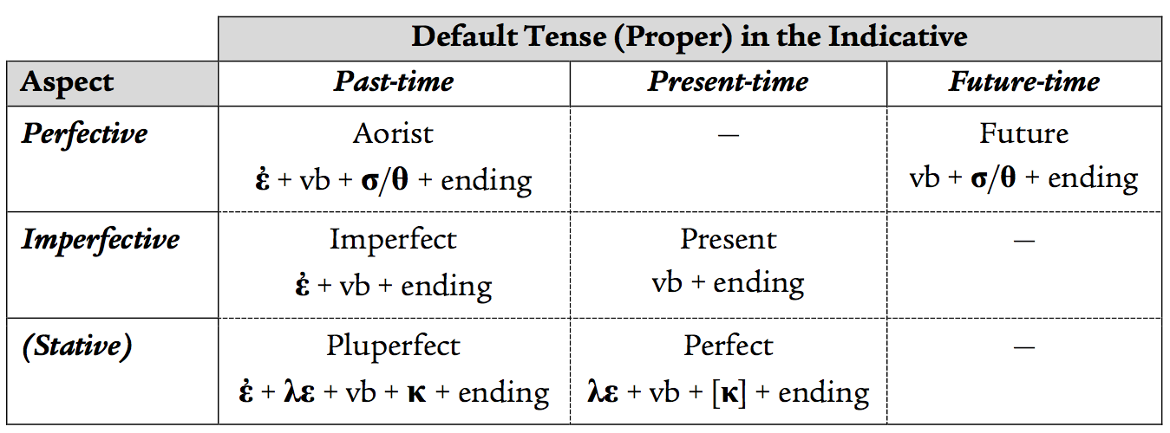](https://journal.rts.edu/wp-content/uploads/2016/12/Graphic9.png)

The assignment of the perfect tense-form to “present-time” may be surprising for those less familiar with verbal aspect, but upon reflection it makes sense. As indicated above, the perfect tense-form conveys (stative) aspect by focusing on the unfolding implications (default: *in the present*) of a verbal action that is otherwise conceived from an external perspective (e.g., completeness). Often this verbal action is in the recent past, but it does not have to be. Rather, it is simply understood as a whole or completed action (perhaps even contemporaneous with the speaker) that yields an ongoing state of being.

It is also notable that Greek features three tense-forms whose default time-of-action is in the past; some have even argued that the basic sense of Greek for tense (proper) is not past-present-future, but rather past (three tense-forms) vs. non-past (three tense-forms).

1. *Aktionsart*

A final feature that impacts inflected meaning of a Greek verb is kind-of-action, or *Aktionsart*. Recent research into verbal aspect has also helped clarify the distinction between it and *Aktionsart* and, thus, exposed points where prior Greek grammarians often confused the two.[[60]](https://journal.rts.edu/article/sharpening-your-greek-a-primer-for-bible-teachers-and-pastors-on-recent-developments-with-reference-to-two-new-intermediate-grammars-part-i/" \l "_ftn60) *Aktionsart* refers not to the author’s subjective portrayal of a verbal action (=aspect) or to the time when an action occurred (=tense [proper]) but, rather, to *how*the verbal action actually takes place. That is: does it happen all at once? Does it happen over a period of time? Is it repetitive? And so on. *Aktionsart* is not morphologized in the Greek verb but is a function of three things: the lexical meaning(s) of the verb itself, how the event actually occurs in reality (if indicative), and the surrounding literary context where the verb is used. While grammarians may tend to promulgate fine distinctions among various *Aktionsarten*, in the spirit of simplicity (following the lead of Mathewson/Emig), I would argue that three categories basically cover the waterfront: instantaneous, progress/telic, and continuous. One should, however, keep in mind a broader distinction between verbs used transitively (that is, an “agent” acting on “patient”) and those used intransitively (that is, only an “agent” acting, without an explicit “patient”). The following chart illustrates the key distinctions in *Aktionsart*:

[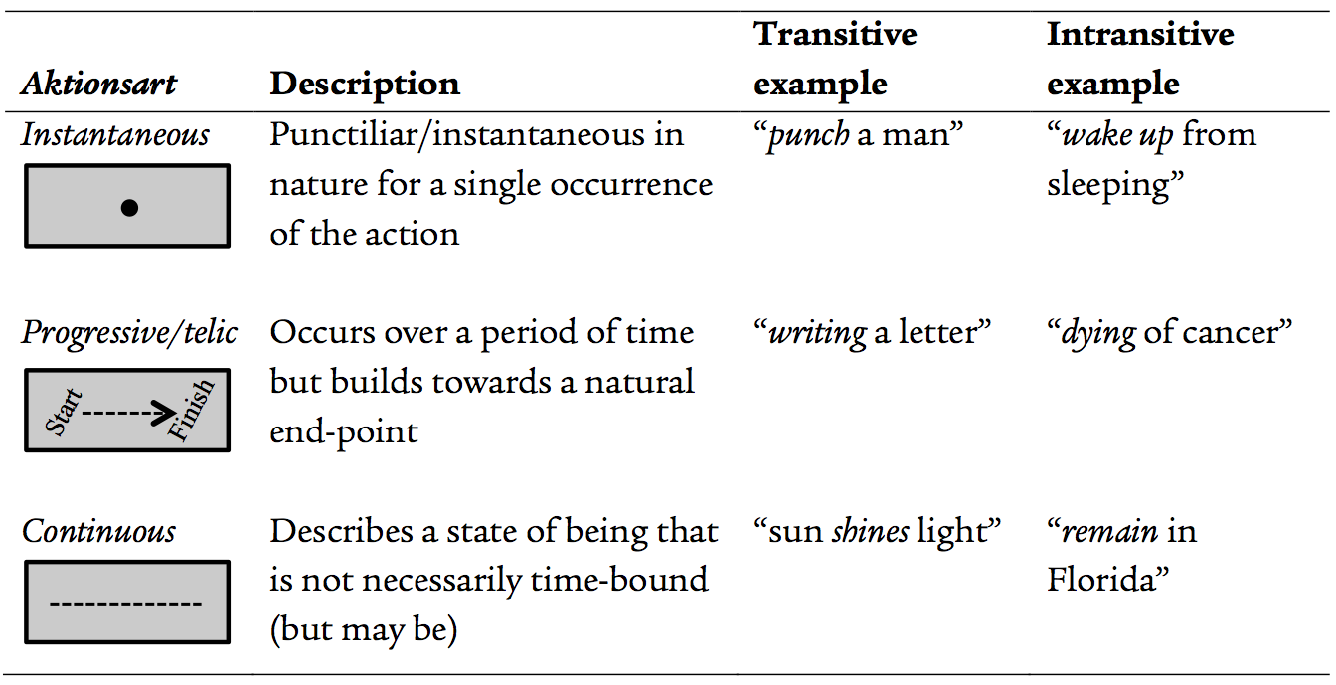](https://journal.rts.edu/wp-content/uploads/2016/12/Graphic10.png)  
Many verbs by virtue of their lexical meaning tend to gravitate to only one *Aktionsart*; for instance, due to the inherent nature of the verbal action that they describe, μένω and ζάω are usually continuous and πίπτω tends to be instantaneous, regardless of tense-form. Others can be used in any of the *Aktionsarten*, forcing the interpreter to pay special attention to context and their lexicons. Thus, one can say that an aorist verb is “punctiliar” but *not because it is aorist*; rather, it is an *Aktionsart*distinction (instantaneous) versus an aspectual one. Or one might say that a present verb is “iterative,” but again this is *not because it is present*; rather, it arises from the combination of imperfective aspect and instantaneous *Aktionsart*.

To summarize, the job of the interpreter of the GNT is to understand the inflected meaning of any given verb as a combination of the three features outlined above: aspect, tense (proper), and *Aktionsart*.[[61]](https://journal.rts.edu/article/sharpening-your-greek-a-primer-for-bible-teachers-and-pastors-on-recent-developments-with-reference-to-two-new-intermediate-grammars-part-i/" \l "_ftn61) Only the former two are directly encoded in the verb’s inflected form (e.g., imperfect active indicative first plural), so the student must be sensitive also to a given word’s semantic range as well as the broader context. It is not so simple as spotting a present tense-form and drawing a conclusion about “continuous” or “progressive” (which are *Aktionsart* distinctions) and present time-of-action (which can be overridden). All factors must be taken into consideration, but especially verbal aspect.

The challenge we find ourselves in, however, is that many popular introductory grammars and most scholarly commentaries have yet to incorporate recent linguistic insights into how they approach Greek verbs *in practice*. Decker’s grammar makes a good start, as it organizes the teaching of the verb system around aspect; it will be unsatisfactory, however, for those who still hold to tense (proper) as a semantic feature.[[62]](https://journal.rts.edu/article/sharpening-your-greek-a-primer-for-bible-teachers-and-pastors-on-recent-developments-with-reference-to-two-new-intermediate-grammars-part-i/" \l "_ftn62) Moreover, Köstenberger/Merkle/Plummer make the suggestion (following Nicholas Ellis)[[63]](https://journal.rts.edu/article/sharpening-your-greek-a-primer-for-bible-teachers-and-pastors-on-recent-developments-with-reference-to-two-new-intermediate-grammars-part-i/" \l "_ftn63) that instructors of Greek should teach students first to identify verbal aspect and only then the tense-form (and, from there, tense [proper] in the indicative). While appealing at first blush, the challenge is that *you do not know what the aspect is until you identify the morphology/tense-form itself*, and it is precisely there that the standard nomenclature about “tenses” muddies the waters. Commentators will eventually catch up, one would expect. Whatever the case, much work remains to be done on how to go about moving from an English tense-prominent system to a Greek aspect-prominent system in both our learning and exegesis of κοινή — which will no doubt continue to be exacerbated by the confusing use of “tense” for tense-forms (“present,” etc.). But some progress is being made.

We have covered a lot of theoretical ground that, for those who are less familiar with these issues, may seem daunting. It is! Before moving on, then, it is necessary to illustrate the principles outlined above with some representative examples. With 28,000+ verbs in the GNT and 95,000+ in the LXX, we must obviously be selective. The interested reader will need to consult the works cited above for more.

* Aorist — perfective aspect, default past-time, non-punctiliar

|  |  |  |
| --- | --- | --- |
| Rom 5:14 | **ἐ**βασίλευ**σ**εν ὁ θάνατος ἀπὸ Ἀδὰμ μέχρι Μωϋσέως. | Death reigned from Adam until Moses. |

Contrary to the common traditional opinion that aorist verbs are “once-for-all” or “punctiliar,” the aorist of βασιλεὐω is clearly neither, since the “reign” of death here lasted for centuries! The perfective aspect views the entire situation from Adam to Moses as one constituted by, from start-to-finish, the reign of death due to sin. Interestingly, the verb’s *Aktionsart* is flexible; it is occasionally used in the LXX to indicate how a king begins to reign (or even how one is appointed by others to reign; e.g., 1 Sam 15:35) but usually describes the totality of one’s reign (e.g., 2 Sam 8:15). The context of Rom 5:14, particularly the start-finish temporal indicators (ἀπό…μέχρι), corroborates the conclusion drawn regarding aspect.[[64]](https://journal.rts.edu/article/sharpening-your-greek-a-primer-for-bible-teachers-and-pastors-on-recent-developments-with-reference-to-two-new-intermediate-grammars-part-i/" \l "_ftn64)

* Aorist — perfective aspect, overriding the default past-time

|  |  |  |
| --- | --- | --- |
| Matt 3:17 | ἰδοὺ φωνὴ ἐκ τῶν οὐρανῶν λέγουσα· οὗτός ἐστιν ὁ υἱός μου ὁ ἀγαπητός, ἐν ᾧ **εὐδόκησα**.[[65]](https://journal.rts.edu/article/sharpening-your-greek-a-primer-for-bible-teachers-and-pastors-on-recent-developments-with-reference-to-two-new-intermediate-grammars-part-i/" \l "_ftn65) | Behold, a voice from heaven saying, “This is my beloved son, with whom I am well-pleased.” |

The aorist of εὐδοκέω cannot, in this context, refer to a situation in which God the Father “*was*” well-pleased with the Son in the past only (what would that even mean?), nor is it likely to be “punctiliar” or “once-for-all,” given the verb’s typically continuous *Aktionsart*. Thus, the default past-time of the aorist is being overridden here. The aspect, however, remains key: God is describing how, holistically (e.g., from an external viewpoint) he is pleased with the entirety of Jesus’ life, past-present-future. Thus, it makes all the sense in the world to use perfective (aorist) rather than imperfective (e.g., εὐδοκεῖ, cf. Ps 149:4), since the latter would somehow suggest that God’s being-pleased with Jesus is in the process of unfolding, which would make little theological sense. Here, then, we see a clear case where *translation* is not the end of the process. In English we are almost forced to render this verb with a present-tense verb, but a short English gloss like “I am well-pleased” cannot by itself bring out the perfectivity of the aspect; at best, it leaves it open for interpretation. The job of the exegete, then, is to bring out the aspectual force in teaching.

* Aorist — perfective aspect, overriding the default past-time

|  |  |  |
| --- | --- | --- |
| John 13:31 | λέγει Ἰησοῦς· νῦν **ἐδοξάσθη** ὁ υἱὸς τοῦ ἀνθρώπου καὶ ὁ θεὸς **ἐδοξάσθη** ἐν αὐτῷ· | Jesus said, “Now the son of man is glorified and God is glorified in him, |
| John 13:32 | καὶ ὁ θεὸς **δοξάσει** αὐτὸν ἐν αὐτῷ | and God will glorify him in himself.” |

Given the temporal indicator νῦν, it is obvious that Jesus is not referring to an act of glorifying that happened in the past; yet, the aorist passive is used rather than the present (cf. Luke 4:15). Hence, Jesus must be referring to something happening in the present-time (from his viewpoint) but viewing it holistically, from an external perspective, rather than as an unfolding process. He is in some way giving a preview that the entire series of events (from Judas’ betrayal through the arrest) that constitutes the “glorify” action. What is further fascinating is that the future is used in the next verse v32 (δοξάσει), thus maintaining perfective aspect but shifting perspective to a future time frame *relative to* the present one.

* Present, imperfect, and aorist — narrative structuring via aspect

|  |  |  |
| --- | --- | --- |
| Matt 3:6 | καὶ **ἐβαπτίζοντο** ἐν τῷ Ἰορδάνῃ ποταμῷ ὑπ᾿ αὐτοῦ **ἐξομολογούμενοι** τὰς ἁμαρτίας αὐτῶν. | And they were being baptized by him in the river Jordan, confessing their sins. |
| Matt 3:7 | **Ἰδὼν** δὲ πολλοὺς τῶν Φαρισαίων καὶ Σαδδουκαίων **ἐρχομένους** ἐπὶ τὸ βάπτισμα αὐτοῦ **εἶπεν** αὐτοῖς. | But seeing many of the Pharisees and Sadducees coming to his baptism, he said to them. |

The main verb of v6 is the imperfect indicative ἐβαπτίζοντο, which aspectually portrays the action of John’s baptism as something unfolding; the default past-time is also maintained. The imperfectivity of the present participle indicates that the confession of sins is being portrayed as simultaneously unfolding alongside the baptism (versus an aorist participle, which might imply temporal sequence). As we move to v7, we also see how the imperfective verbs in v6 play the role of providing background information, for the narrator shifts attention (δέ) to the main action that is conveyed with two aorist (perfective) verbs, one which is an adverbial participle (ἰδων) and one which is the main indicative (εἶπεν). The focus in this entire scene, then, falls on John’s verbal conflict with the religious authorities (their arrival, like the activity of baptism, is also portrayed with an imperfective verb), which stands in sharp relief to the masses of repenting Jews in the background.

* Perfect — (stative) aspect, non-past tense (proper)

|  |  |  |
| --- | --- | --- |
| Gal 5:10 | ἐγὼ **πέποιθα** εἰς ὑμᾶς ἐν κυρίῳ ὅτι οὐδὲν ἄλλο **φρονήσετε**. | I am convinced about you in the Lord that you will think nothing else. |

In the context of the argument so far in Galatians 5, it would make little sense for the perfect πέποιθα to convey that Paul “became convinced” at some point in the past (which has present effect), as is traditionally understood of the perfect. Rather, Paul’s choice of aspect here portrays the entirety of his confidence in the church (not the temporal process by which he arrived at such confidence) and, in particular, the ongoing state of that confidence. This latter emphasis on incompleteness, in turn, helps to frame Paul’s shift to the *future* tense-form (φρονήσετε) with respect to that in which he places his confidence (namely, the response of the Galatians).[[66]](https://journal.rts.edu/article/sharpening-your-greek-a-primer-for-bible-teachers-and-pastors-on-recent-developments-with-reference-to-two-new-intermediate-grammars-part-i/" \l "_ftn66)

1. *“Deponency” and the Middle Voice*

As mentioned at the end of Part One, both recently-published grammars join an increasing chorus of scholars calling for an end to the use of “deponency” when referring to certain kinds of Greek verbs. For over a century, Greek grammars have taught that a variety of verbs, which appear to lack active morphology  but, rather, usually appear only as middles, should be called “deponent.” That is, they have “laid aside” their active form, and the middle plays the role of the active.[[67]](https://journal.rts.edu/article/sharpening-your-greek-a-primer-for-bible-teachers-and-pastors-on-recent-developments-with-reference-to-two-new-intermediate-grammars-part-i/" \l "_ftn67) The active form “has been discarded in a particular tense, but the meaning that would have been intended by that form has been transferred to another voice, [namely the middle].”[[68]](https://journal.rts.edu/article/sharpening-your-greek-a-primer-for-bible-teachers-and-pastors-on-recent-developments-with-reference-to-two-new-intermediate-grammars-part-i/" \l "_ftn68) Mounce defines “deponent” as a “verb that is middle or passive in form but active in meaning.”[[69]](https://journal.rts.edu/article/sharpening-your-greek-a-primer-for-bible-teachers-and-pastors-on-recent-developments-with-reference-to-two-new-intermediate-grammars-part-i/" \l "_ftn69) The lexical form of such verbs will accordingly use –μαι rather than the more familiar active –ω, since the latter is unused. Well-known examples include ἀποκρίνομαι, δέχομαι, βούλομαι, γίνομαι, ἔρχομαι, and πορεύομαι. Some have claimed that the majority of verbs that appear in the GNT with middle or passive morphology are actually *active* in meaning.[[70]](https://journal.rts.edu/article/sharpening-your-greek-a-primer-for-bible-teachers-and-pastors-on-recent-developments-with-reference-to-two-new-intermediate-grammars-part-i/" \l "_ftn70)

Given the entrenched status of “deponency” in the study of κοινή, recent critiques of “deponency” should be given serious consideration. Before turning to the key arguments, it is first worth observing at the outset that the situation with respect to active/middle/passive morphology is actually far more complex than the simplistic middle-taking-active-meaning theory of “deponency” implies. Consider the following example verbs and their voices, focusing on indicatives:

[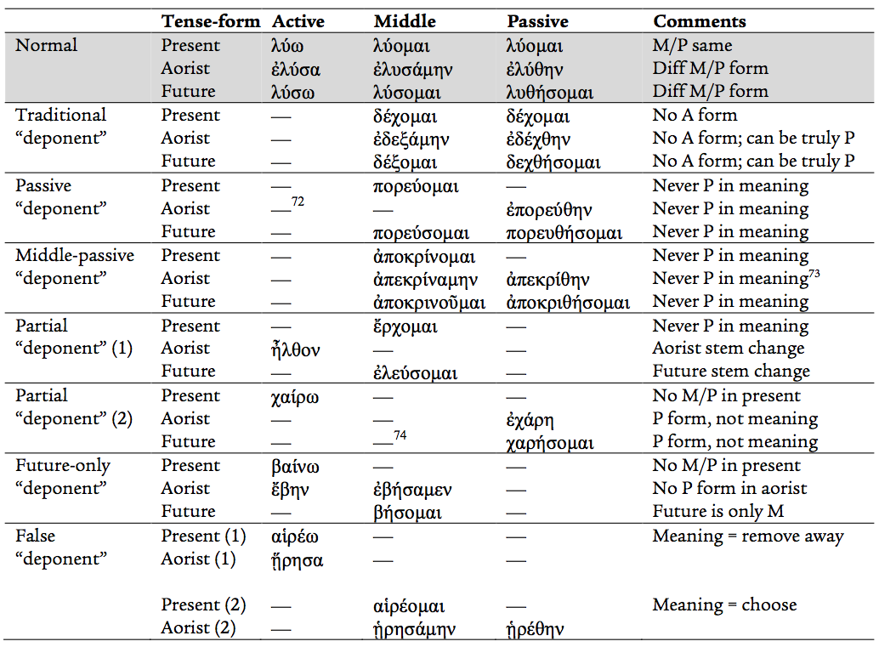](https://journal.rts.edu/wp-content/uploads/2016/12/Graphic11.png)  
Such observations form the starting-point for a growing minority of scholars who argue that “deponency” itself should be laid aside and that such verbs should be treated as *true middles*, rather than as “deponents” that always have active meanings. Let us summarize the key arguments.[[75]](https://journal.rts.edu/article/sharpening-your-greek-a-primer-for-bible-teachers-and-pastors-on-recent-developments-with-reference-to-two-new-intermediate-grammars-part-i/" \l "_ftn75)The chart reveals fascinating patterns, and other examples could be adduced. Some traditional “deponents” (e.g., δέχομαι) have middle/passive morphology but do not *always* convey what has traditionally been called “active” meaning; rather, they can also express true passive voice as well.[[74]](https://journal.rts.edu/article/sharpening-your-greek-a-primer-for-bible-teachers-and-pastors-on-recent-developments-with-reference-to-two-new-intermediate-grammars-part-i/" \l "_ftn74) Others may have middle-only morphology in one tense-form but passive-only in another, despite not having a truly passive sense (e.g., πορεύομαι and ἀποκρίνομαι). Some are middle-only in the present but capable of having active morphology in other tense-forms (e.g., ἔρχομαι), while others are the opposite and have active morphology in the present but only middle or passive in other tense-forms (χαίρω and ἀναβαίνω). And some verbs change meaning altogether when they switch from active to middle in the same tense-form (e.g., αἱρέω/αἱρέομαι). So the voice situation can be, put succinctly, rather convoluted.

* *Teaching/reading Greek through an English lens*. Most grammarians in the past century have been quick to note that the Greek middle is, at the outset, a bit of a foreign thing to English-speakers (or German and French, for that matter). Such languages lack an explicit grammatical constructions for expressing the middle voice and, instead, operate on an *active vs. passive* Greek, thus, grammaticalizes something that is essentially absent altogether in these other languages. Hence, the root issue for any student of Greek is simply this: what is the middle voice *in Greek*to begin with? What does it convey? The temptation to treat so many verbs as “deponent” — that is, middle/passive in form but “active in meaning” — actually begs the question entirely. How do you know it is “active in meaning” if you have not clearly distinguished the voices clearly *in Greek*? This leads to a second issue.
* *Mistakenly applying a Latin term*. The choice to *label*these verbs “deponent” may have been an (unintentional) error at the outset that has muddied the waters about the *concept* as well. The term is borrowed from Latin, where it is used to explain how verbs with passive-only morphology play the role of an active verb.[[76]](https://journal.rts.edu/article/sharpening-your-greek-a-primer-for-bible-teachers-and-pastors-on-recent-developments-with-reference-to-two-new-intermediate-grammars-part-i/" \l "_ftn76) The phenomenon, then, looks similar on the surface to our situation in κοινή. But the problem is that Latin (like English) lacks a middle voice altogether, whereas Greek has all three! Thus, a Latin grammatical category has been smuggled into Greek[[77]](https://journal.rts.edu/article/sharpening-your-greek-a-primer-for-bible-teachers-and-pastors-on-recent-developments-with-reference-to-two-new-intermediate-grammars-part-i/" \l "_ftn77) to explain a syntactical feature — the oddities of the middle voice — *that is not in Latin at all*! This has only perpetuated the confusion about “middle form but active meaning.” Moreover, the meaning of *deponere* (“lay aside”) in itself assumes that the Greek verbs in question at one point in time actually did have an active form but, by the time we get to κοινή, have somehow lost them. Recent research has shown, however, that this is simply not the case for nearly all of these verbs; they never had an active form that could be “laid aside.”
* *Collapsing the middle in Greek*. Amid the context outlined above, English grammars have typically tried to position the κοινή middle as a tweener between active and passive and collapsed it entirely into closest proxy we have, namely, “reflexive” (e.g., “John shaved [himself]). For the English-speaker (or Latin student), this approximation seemed logical enough. But grammarians then surveyed Greek middles and found that most of them seem to lack this “reflexive” sense. As a consequence, it was concluded that the middle must actually lack any real force in Greek altogether, confirming the hypothesis that nearly all so-called “deponent” middles are, ultimately, simply “active in meaning.” The problem, as recent scholars have pointed out, is that Greek normally achieves reflexivity with the reflexive pronoun ἑαυτοῦ across all voices.[[78]](https://journal.rts.edu/article/sharpening-your-greek-a-primer-for-bible-teachers-and-pastors-on-recent-developments-with-reference-to-two-new-intermediate-grammars-part-i/" \l "_ftn78) The middle voice, then, has been collapsed without reason.
* *Rebuilding the middle voice as* “*subject-affectedness*.” Helped along by the seminal work of Rutger Allan, it has become clearer that the basic sense behind the Greek middle is not “reflexivity” (though that can be *part*of it) but, more broadly, “subject-affectedness.”[[79]](https://journal.rts.edu/article/sharpening-your-greek-a-primer-for-bible-teachers-and-pastors-on-recent-developments-with-reference-to-two-new-intermediate-grammars-part-i/" \l "_ftn79) That is to say, the middle voice in Greek conveys a variety of different ways in which the agent is self-involved in the *doing* *of*or *result of* the verbal action. The subject is “internal to the process” and is “affected” — indirectly or directly impacted in some way — by the action: doing it for his/her own interest; being fully involved in the process; doing it to oneself; allowing it to be done to oneself; and so on. The challenge, then, is that Greek words directly morphologize this middle-ness of “subject-affectedness” in the verb form itself, but in (for example) English it may very well take several words to bring out the sense, not a simple word-for-word gloss. But the whole notion of “deponency” has short-circuited things by assuming that a simple English *gloss*, which may be active in form, exhausts the *meaning* of the Greek middle. Such a move, in light of recent research, appears fallacious. We should not confuse the *meaning of Greek* with an English translational shorthand, any more than we would for anything else in Greek.[[80]](https://journal.rts.edu/article/sharpening-your-greek-a-primer-for-bible-teachers-and-pastors-on-recent-developments-with-reference-to-two-new-intermediate-grammars-part-i/" \l "_ftn80)
* *Recognizing that most middle-only verbs in Greek are not actually*“*active in meaning*.” In view of all of the above, recent research has revisited traditional “deponent” verbs and concluded that, upon close inspection, a compelling case can be made that they do seem to exhibit this sense of subject-affectedness and are not, simply, “active in meaning.” Miller provides a helpful taxonomy of dozens of common so-called “deponents” in the GNT that can better be understood as true middles bearing a variety of senses: reciprocity, reflexivity, self-involvement (in the outcome), self-interest, direct recipient (e.g., sensory verbs), state-of-being in which the subject is the “center of gravity” of the action, and so on.[[81]](https://journal.rts.edu/article/sharpening-your-greek-a-primer-for-bible-teachers-and-pastors-on-recent-developments-with-reference-to-two-new-intermediate-grammars-part-i/" \l "_ftn81) In other words, such verbs seem inherently to carry a middle sense in certain contexts; put differently, the *Aktionsart*of certain verbs — a combination of lexical meaning and context — causes them naturally to default to the middle voice.[[82]](https://journal.rts.edu/article/sharpening-your-greek-a-primer-for-bible-teachers-and-pastors-on-recent-developments-with-reference-to-two-new-intermediate-grammars-part-i/" \l "_ftn82) A few examples may clarify[[83]](https://journal.rts.edu/article/sharpening-your-greek-a-primer-for-bible-teachers-and-pastors-on-recent-developments-with-reference-to-two-new-intermediate-grammars-part-i/" \l "_ftn83):

ἀποκρίνομαι  the one answering is involved in the outcome of his/her answer

ἀρνέομαι        in most cases the act of denial directly impacts the person doing the denying and the one being denied

δέχομαι          inherently receiving/accepting something invovles self-interest or impacts oneself

βούλομαι        the subject is inherently affected by the act of willing/desiring

ἡγέομαι          holding an opinion or thinking is inherently self-involved

In short, while active voice *can* include subject-affectedness (with or without the reflexive pronoun), the middle voice in Greek is explicitly *marked* for it.

* *Clarifying our understanding of middle-passive morphology*. One piece of the puzzle that has remained somewhat perplexing through all of this is the following. As any first-year Greek student knows, most tense-forms (present, imperfect, perfect, pluperfect) do not make a *morphological* distinction between middle and passive but use the same endings for both. Context dictates whether a given instance is truly middle or passive, for spelling alone does not answer that question. In the aorist or future, however, we have a distinct passive spelling (with the θ infix). The problem arises when some verbs use *passive* forms apparently in lieu of *middle* forms (e.g., χαίρω> ἐχάρην) but without a clear passive sense, as traditionally understood (e.g., “X is being [verb]ed by Z”). How are these to be explained? A compelling case has been made that these distinct aorist/future passive (θ) forms were latecomers to Greek and began “taking over” for the middle.[[84]](https://journal.rts.edu/article/sharpening-your-greek-a-primer-for-bible-teachers-and-pastors-on-recent-developments-with-reference-to-two-new-intermediate-grammars-part-i/" \l "_ftn84) In other words, these distinct spellings started playing the same kind of game (only in reverse) as the other tense-forms, where the middle morphology serves as the passive as well. In both situations, then, context dictates the true voice where morphology is ambiguous. If so, it may be better to understand Greek not as an *active vs. passive* polarity (as with English) but as an *active vs. middle*polarity, where the middle is actually a *spectrum of subject-affectedness* from low to high. At the “high” end, context indicates that the subject is so “affected” that he/she is actually the direct recipient of the action from a different (stated or implied) agent. In short, in four tense-forms, the entire middle spectrum is spelled the same; in two tense-forms, a distinct θ spelling *can* explicitly mark this “high” end (the traditional “passive”), but not always. The following rough diagram attempts to illustrate this:

[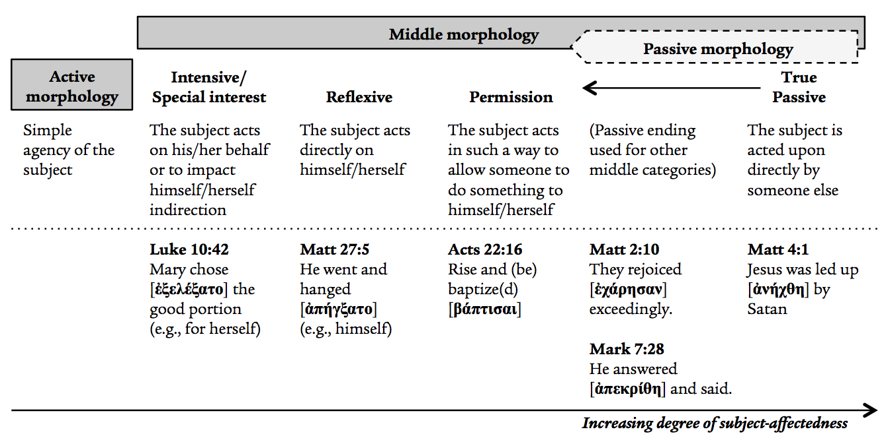](https://journal.rts.edu/wp-content/uploads/2016/12/Graphic12.png)

Surveying all the above considerations, there has been a recent push to move away from “deponency” altogether and treat such verbs as true middles. For instance, Pennington concludes, “Let the middle voice have a voice. As a principle, we should assume a middle form is truly middle unless there is contrary evidence.”[[85]](https://journal.rts.edu/article/sharpening-your-greek-a-primer-for-bible-teachers-and-pastors-on-recent-developments-with-reference-to-two-new-intermediate-grammars-part-i/" \l "_ftn85) Köstenberger/Merkle/Plummer remark, “[We are] recognizing the wide use of the category of ‘deponency’ by other Greek scholars, [but are] seeking to bring students to a better understanding of most (and perhaps all) supposed deponent verbs as actually Greek middles.”[[86]](https://journal.rts.edu/article/sharpening-your-greek-a-primer-for-bible-teachers-and-pastors-on-recent-developments-with-reference-to-two-new-intermediate-grammars-part-i/" \l "_ftn86) Mathewson/Emig write, “The concept of deponency is unnecessary, and what we have traditionally called deponent verbs should be seen as true middles with middle meaning.”[[87]](https://journal.rts.edu/article/sharpening-your-greek-a-primer-for-bible-teachers-and-pastors-on-recent-developments-with-reference-to-two-new-intermediate-grammars-part-i/" \l "_ftn87) Conrad urges students, “assume it is ‘middle’ unless the context or construction points clearly to passivity; respect the differences between ancient Greek and any modern language.”[[88]](https://journal.rts.edu/article/sharpening-your-greek-a-primer-for-bible-teachers-and-pastors-on-recent-developments-with-reference-to-two-new-intermediate-grammars-part-i/" \l "_ftn88) Finally, Decker’s recent introductory grammar does not mention “deponency” at all but, in line with the preceding discussion, encourages students to see such verbs as “middle-only” and parse them accordingly (either as middle or passive, depending on morphology and contextual usage).[[89]](https://journal.rts.edu/article/sharpening-your-greek-a-primer-for-bible-teachers-and-pastors-on-recent-developments-with-reference-to-two-new-intermediate-grammars-part-i/" \l "_ftn89) This may very well the best path forward.

In short, the English translation for many of these verbs may, ultimately, be “active” *in English*, but that is not the end of our task, as argued in Part One. We must work to draw out the full sense of the middle.[[90]](https://journal.rts.edu/article/sharpening-your-greek-a-primer-for-bible-teachers-and-pastors-on-recent-developments-with-reference-to-two-new-intermediate-grammars-part-i/" \l "_ftn90)

[**Click here to continue reading**](https://journal.rts.edu/article/sharpening-your-greek-a-primer-for-bible-teachers-and-pastors-on-recent-developments-with-reference-to-two-new-intermediate-grammars-part-ii/)

[[1]](https://journal.rts.edu/article/sharpening-your-greek-a-primer-for-bible-teachers-and-pastors-on-recent-developments-with-reference-to-two-new-intermediate-grammars-part-i/" \l "_ftnref1) *A Grammar of the Greek New Testament in Light of Historical Research* (4th ed.; Nashville: Broadman, 1934). Each of these new publications acknowledge a huge debt of gratitude to Robertson.

[[2]](https://journal.rts.edu/article/sharpening-your-greek-a-primer-for-bible-teachers-and-pastors-on-recent-developments-with-reference-to-two-new-intermediate-grammars-part-i/" \l "_ftnref2) Plummer hosts the popular “Daily Dose of Greek” website (http://dailydoseofgreek.com).

[[3]](https://journal.rts.edu/article/sharpening-your-greek-a-primer-for-bible-teachers-and-pastors-on-recent-developments-with-reference-to-two-new-intermediate-grammars-part-i/" \l "_ftnref3) Southeastern Baptist Theological Seminary (Köstenberger, Merkle); Southern Baptist Seminary (Plummer); Denver Seminary (Mathewson, Emig).

[[4]](https://journal.rts.edu/article/sharpening-your-greek-a-primer-for-bible-teachers-and-pastors-on-recent-developments-with-reference-to-two-new-intermediate-grammars-part-i/" \l "_ftnref4) *Greek Grammar Beyond the Basics: An Exegetical Syntax of the New Testament* (Grand Rapids: Zondervan, 1996; 827pp.). An abridged form is published as *The Basics of New Testament Syntax: An Intermediate Greek Grammar*(Grand Rapids: Zondervan, 2000). Wallace is a professor at Dallas Theological Seminary.

[[5]](https://journal.rts.edu/article/sharpening-your-greek-a-primer-for-bible-teachers-and-pastors-on-recent-developments-with-reference-to-two-new-intermediate-grammars-part-i/" \l "_ftnref5) Stanley E. Porter, *Idioms of the Greek New Testament* (2nd ed.; Sheffield: JSOT Press, 1994); and Richard A. Young, *Intermediate New Testament Greek: A Linguistic and Exegetical Approach* (Nashville: Broadman & Holman, 1994). Both groups of authors are strongly influenced by Porter, but Wallace is more often their explicit sparring partner on key issues.

[[6]](https://journal.rts.edu/article/sharpening-your-greek-a-primer-for-bible-teachers-and-pastors-on-recent-developments-with-reference-to-two-new-intermediate-grammars-part-i/" \l "_ftnref6) Perhaps taking a cue from (though implementing it more effectively than) William D. Mounce, *Basics of Biblical Greek: Grammar* (3rd ed.; Grand Rapids: Zondervan, 2009).

[[7]](https://journal.rts.edu/article/sharpening-your-greek-a-primer-for-bible-teachers-and-pastors-on-recent-developments-with-reference-to-two-new-intermediate-grammars-part-i/" \l "_ftnref7) Obviating the need for, say, Bruce M. Metzger’s *Lexical Aids for Students of New Testament Greek* (3rd ed.; Grand Rapids: Baker, 1998).

[[8]](https://journal.rts.edu/article/sharpening-your-greek-a-primer-for-bible-teachers-and-pastors-on-recent-developments-with-reference-to-two-new-intermediate-grammars-part-i/" \l "_ftnref8) http://www.deepergreek.com

[[9]](https://journal.rts.edu/article/sharpening-your-greek-a-primer-for-bible-teachers-and-pastors-on-recent-developments-with-reference-to-two-new-intermediate-grammars-part-i/" \l "_ftnref9) The pericopae covered are as follows: (ch. 1) Mark 1:1–13; (2) Matt 18:10–20; (3) Rom 3:19–31; (4) Jude 1–3, 17–25; (5) John 2:1–11; (6) James 5:12–20; (7) Matt 2:19–23; 6:9–13; (8) Acts 2:37–47; (9) John 11:30–44; (10) 1 Pet 5:1–11; (11) 1 Tim 6:11–19; (12) Tit 2:1–10; (13) Heb 5:11–6:6.

[[10]](https://journal.rts.edu/article/sharpening-your-greek-a-primer-for-bible-teachers-and-pastors-on-recent-developments-with-reference-to-two-new-intermediate-grammars-part-i/" \l "_ftnref10) E.g., the first chapter on the verb features lengthy discussions on subjunctive and imperative moods; present, imperfect, and future constitute one chapter, while by aorist and perfect constitute another; pronouns, prepositions, conjunctions, adverbs, and particles are combined into in one chapter.

[[11]](https://journal.rts.edu/article/sharpening-your-greek-a-primer-for-bible-teachers-and-pastors-on-recent-developments-with-reference-to-two-new-intermediate-grammars-part-i/" \l "_ftnref11) One notable feature is the tendency to switch among a variety of English translations (NIV, ESV, HCSB, NKJV, NASB) without any clear reasoning why they prefer one over another for a given example.

[[12]](https://journal.rts.edu/article/sharpening-your-greek-a-primer-for-bible-teachers-and-pastors-on-recent-developments-with-reference-to-two-new-intermediate-grammars-part-i/" \l "_ftnref12) Incidentally, while the authors perhaps wisely avoid going into too much detail on the objective/subjective genitive debate for πίστις Χριστοῦ, I find it disappointing that they bury their discussion almost entirely in a brief note within the graded reader (p. 114). For what it is worth, they land on objective genitive but do not argue why (simply citing Moo, Schreiner, Dunn, and Murray).

[[13]](https://journal.rts.edu/article/sharpening-your-greek-a-primer-for-bible-teachers-and-pastors-on-recent-developments-with-reference-to-two-new-intermediate-grammars-part-i/" \l "_ftnref13) To drive this point home, the authors provide a lengthy appendix (pp. 511–523) in which they tabulate and compare the syntactical category labels used in major 20th C grammars (incl. Robertson, Dana & Mantey, Moule, Blass-Debrunner-Funk, Brooks & Winbery, Porter, Young, Wallace, and Black).

[[14]](https://journal.rts.edu/article/sharpening-your-greek-a-primer-for-bible-teachers-and-pastors-on-recent-developments-with-reference-to-two-new-intermediate-grammars-part-i/" \l "_ftnref14) As we will see, Mathewson/Emig do precisely the opposite.

[[15]](https://journal.rts.edu/article/sharpening-your-greek-a-primer-for-bible-teachers-and-pastors-on-recent-developments-with-reference-to-two-new-intermediate-grammars-part-i/" \l "_ftnref15) Apart from a single table at the end of the chapter (p. 213) that simply sets up the next.

[[16]](https://journal.rts.edu/article/sharpening-your-greek-a-primer-for-bible-teachers-and-pastors-on-recent-developments-with-reference-to-two-new-intermediate-grammars-part-i/" \l "_ftnref16) We will cover this more fully in Part Two.

[[17]](https://journal.rts.edu/article/sharpening-your-greek-a-primer-for-bible-teachers-and-pastors-on-recent-developments-with-reference-to-two-new-intermediate-grammars-part-i/" \l "_ftnref17) Stanley E. Porter, *Verbal Aspect in the Greek of the New Testament, with Reference to Tense and Mood* (Studies in Biblical Greek 1; New York: Peter Lang, 1989). Constantine R. Campbell, *Basics of Verbal Aspect in Biblical Greek* (Grand Rapids: Zondervan, 2008). Rodney J. Decker, *Temporal Deixis of the Greek Verb in the Gospel of Mark with Reference to Verbal Aspect* (Studies in Biblical Greek 10; New York: Peter Lang, 2001).

[[18]](https://journal.rts.edu/article/sharpening-your-greek-a-primer-for-bible-teachers-and-pastors-on-recent-developments-with-reference-to-two-new-intermediate-grammars-part-i/" \l "_ftnref18) Buist M. Fanning, *Verbal Aspect in New Testament Greek* (Oxford: Clarendon Press, 1990).

[[19]](https://journal.rts.edu/article/sharpening-your-greek-a-primer-for-bible-teachers-and-pastors-on-recent-developments-with-reference-to-two-new-intermediate-grammars-part-i/" \l "_ftnref19) I find it puzzling that the authors choose not to use the technical term *Aktionsart* (mentioned only once, and not even in this chapter). They may have reasons for avoiding it, since the label remains debated, but to fail even to mention it (almost) altogether is a somewhat glaring omission.

[[20]](https://journal.rts.edu/article/sharpening-your-greek-a-primer-for-bible-teachers-and-pastors-on-recent-developments-with-reference-to-two-new-intermediate-grammars-part-i/" \l "_ftnref20) E.g., They simply remark in a footnote that the unexpected use of an unaugmented present verb for a past-time situation is “rhetorical, not semantic or syntactical” (p. 261 n 21). But that is precisely the point to be proven, not presupposed.

[[21]](https://journal.rts.edu/article/sharpening-your-greek-a-primer-for-bible-teachers-and-pastors-on-recent-developments-with-reference-to-two-new-intermediate-grammars-part-i/" \l "_ftnref21) I find their restrained treatment of conditionals — encouraging students to focus more on context than on simply *classifying* first, second, and third-class conditionals — to be a breath of fresh air.

[[22]](https://journal.rts.edu/article/sharpening-your-greek-a-primer-for-bible-teachers-and-pastors-on-recent-developments-with-reference-to-two-new-intermediate-grammars-part-i/" \l "_ftnref22) Popularized by John Piper (http://www.biblearc.com).

[[23]](https://journal.rts.edu/article/sharpening-your-greek-a-primer-for-bible-teachers-and-pastors-on-recent-developments-with-reference-to-two-new-intermediate-grammars-part-i/" \l "_ftnref23) Denoted the “tab method” by Dr. Bob Cara at RTS-Charlotte. For what it is worth, the present author finds sentence diagramming and arcing to induce sweaty palms and a headache. The “tab method” is far simpler (and, thus, more likely to be used by a busy student or pastor) and, incidentally, seems to be the implicit method of choice for much scholarly research.

[[24]](https://journal.rts.edu/article/sharpening-your-greek-a-primer-for-bible-teachers-and-pastors-on-recent-developments-with-reference-to-two-new-intermediate-grammars-part-i/" \l "_ftnref24) They comment further, “Inspiration does not somehow transform the language into something more than it was before” (p. xix)

[[25]](https://journal.rts.edu/article/sharpening-your-greek-a-primer-for-bible-teachers-and-pastors-on-recent-developments-with-reference-to-two-new-intermediate-grammars-part-i/" \l "_ftnref25) Unfortunately they fail to define “markedness,” which is not likely a linguistic concept familiar to most of their target audience.

[[26]](https://journal.rts.edu/article/sharpening-your-greek-a-primer-for-bible-teachers-and-pastors-on-recent-developments-with-reference-to-two-new-intermediate-grammars-part-i/" \l "_ftnref26) Wallace, *Greek Grammar*, 72.

[[27]](https://journal.rts.edu/article/sharpening-your-greek-a-primer-for-bible-teachers-and-pastors-on-recent-developments-with-reference-to-two-new-intermediate-grammars-part-i/" \l "_ftnref27) E.g., their discussion of πίστις Χριστοῦ is rather short (one paragraph on p. 16; they refuse to pick between objective and subjective) but their discussion (in a later chapter) on accusatives in passive constructions spans multiple pages (pp. 146–148).

[[28]](https://journal.rts.edu/article/sharpening-your-greek-a-primer-for-bible-teachers-and-pastors-on-recent-developments-with-reference-to-two-new-intermediate-grammars-part-i/" \l "_ftnref28) Gently rebuking some tendencies to postulate too much “prepositional theology,” they remark, “theology cannot merely be read off of prepositions; it must be derived from larger expressions of thought. Certainly, any important theological concept will be communicated and supported by sentences, paragraphs, and larger units of discourse rather than ‘nuanced’ in prepositions. Prepositions at most allow for, support, or point to important theological teachings; they do not ‘prove’ them or bear these theological concepts” (p. 91–92).

[[29]](https://journal.rts.edu/article/sharpening-your-greek-a-primer-for-bible-teachers-and-pastors-on-recent-developments-with-reference-to-two-new-intermediate-grammars-part-i/" \l "_ftnref29) This statement itself is not entirely a fair representation of the landscape of the debate (which is unfortunate for an intermediate-level grammar). Nearly all recent scholars who argue that the Greek verb’s syntax does, to some degree, encode temporal reference nevertheless agree that verbal aspect is prominent and, thus, should *also* be considered “advocates of verbal aspect” (e.g., Fanning).

[[30]](https://journal.rts.edu/article/sharpening-your-greek-a-primer-for-bible-teachers-and-pastors-on-recent-developments-with-reference-to-two-new-intermediate-grammars-part-i/" \l "_ftnref30) Including an excursus on so-called “deponency” (p. 151–152), about which more below.

[[31]](https://journal.rts.edu/article/sharpening-your-greek-a-primer-for-bible-teachers-and-pastors-on-recent-developments-with-reference-to-two-new-intermediate-grammars-part-i/" \l "_ftnref31) However, most of their discussions would benefit from more precision in how they describe things; for instance, they regularly use “aorist-tense” but mean “perfective,” and at times they will say “tense/aspect” (as if there is no difference). This is not entirely their fault, for (as we will discuss below) much confusion arises from the standardized use of “tense” as a label for aorist/present/perfect/etc. morphology, even in aspect-prominent systems. *Going Deeper* makes strides here by more clearly distinguishing “tense-form” (for the morphological labels we are stuck with for now), “tense” proper (location in time), and “aspect “ (perfective, imperfective, stative).

[[32]](https://journal.rts.edu/article/sharpening-your-greek-a-primer-for-bible-teachers-and-pastors-on-recent-developments-with-reference-to-two-new-intermediate-grammars-part-i/" \l "_ftnref32) Which is a bit of a peculiar addition since every introductory grammar includes the same material.

[[33]](https://journal.rts.edu/article/sharpening-your-greek-a-primer-for-bible-teachers-and-pastors-on-recent-developments-with-reference-to-two-new-intermediate-grammars-part-i/" \l "_ftnref33) The most thorough up-to-date analysis is provided by Steven F. Runge and Christopher J. Fresch (eds.), *The Greek Verb Revisited: A Fresh Approach for Biblical Exegesis* (Bellingham, WA: Lexham Press, 2015). This book publishes the papers from a conference held in Cambridge, England, entitled “Linguistics & the Greek Verb” (July 10–11, 2014), which I was privileged to attend. Buist Fanning kicked off the conference with a charitable review of the past two decades of debate with Stan Porter. Interestingly, both Campbell and Porter were noticeable absences.

[[34]](https://journal.rts.edu/article/sharpening-your-greek-a-primer-for-bible-teachers-and-pastors-on-recent-developments-with-reference-to-two-new-intermediate-grammars-part-i/" \l "_ftnref34) Roughly “kind of action.” Various proposals have been put forward for a better English technical term to replace the German, but none have stuck. Some scholars (including the authors of *Going Deeper*, as noted above) avoid the label but capture the same sense by calling this feature “type of action” or something similar. For simplicity we will use the technical label, acknowledging that it is debated.

[[35]](https://journal.rts.edu/article/sharpening-your-greek-a-primer-for-bible-teachers-and-pastors-on-recent-developments-with-reference-to-two-new-intermediate-grammars-part-i/" \l "_ftnref35) One of my first-year Greek students is a Bible translator for a Cambodian dialect, and she was delighted to delve into the aspect/tense debate from the outset because her target language is entirely aspectual and has no tense distinctions at all.

[[36]](https://journal.rts.edu/article/sharpening-your-greek-a-primer-for-bible-teachers-and-pastors-on-recent-developments-with-reference-to-two-new-intermediate-grammars-part-i/" \l "_ftnref36) Technically the aspect debate was first broached within NT/Greek scholarship years earlier by Mateos and McKay (see a brief overview of the history of aspect theory in D.A. Carson, “An Introduction to the Porter/Fanning Debate,” Pages 18–25 in *Biblical Greek Language and Linguistics: Open Questions in Current Research* [eds. Stanley E. Porter and D.A. Carson; Sheffield: JSOT Press, 1993]), but it the Fanning/Porter debate from 1990 onward put it on the map for most scholars.

[[37]](https://journal.rts.edu/article/sharpening-your-greek-a-primer-for-bible-teachers-and-pastors-on-recent-developments-with-reference-to-two-new-intermediate-grammars-part-i/" \l "_ftnref37) An unfortunate legacy of applying labels derived from tense-prominent languages (like English) to a non-tense-prominent language like Greek!

[[38]](https://journal.rts.edu/article/sharpening-your-greek-a-primer-for-bible-teachers-and-pastors-on-recent-developments-with-reference-to-two-new-intermediate-grammars-part-i/" \l "_ftnref38) Bernard Comrie, *Aspect* (Cambridge Textbooks in Linguistics; Cambridge: Cambridge University Press, 1980), 3. Though dated, this short book remains influential, as it studies verbal aspect across numerous languages, with no special preference for Greek.

[[39]](https://journal.rts.edu/article/sharpening-your-greek-a-primer-for-bible-teachers-and-pastors-on-recent-developments-with-reference-to-two-new-intermediate-grammars-part-i/" \l "_ftnref39) Fanning, *Verbal Aspect*, 84–85.

[[40]](https://journal.rts.edu/article/sharpening-your-greek-a-primer-for-bible-teachers-and-pastors-on-recent-developments-with-reference-to-two-new-intermediate-grammars-part-i/" \l "_ftnref40) Porter, *Verbal Aspect*, xi.

[[41]](https://journal.rts.edu/article/sharpening-your-greek-a-primer-for-bible-teachers-and-pastors-on-recent-developments-with-reference-to-two-new-intermediate-grammars-part-i/" \l "_ftnref41) Rodney J. Decker, “‘The Poor Man’s Porter’: A Condensation and Summary of Verbal Aspect in the Greek of the New Testament, with Reference to Tense and Mood (by Stanley E. Porter)” (unpublished paper, October, 1994), 5.

[[42]](https://journal.rts.edu/article/sharpening-your-greek-a-primer-for-bible-teachers-and-pastors-on-recent-developments-with-reference-to-two-new-intermediate-grammars-part-i/" \l "_ftnref42) Campbell, *Basics*, ” 19–20 (emphasis original).

[[43]](https://journal.rts.edu/article/sharpening-your-greek-a-primer-for-bible-teachers-and-pastors-on-recent-developments-with-reference-to-two-new-intermediate-grammars-part-i/" \l "_ftnref43) Köstenberger/Merkle/Plummer, *Going Deeper*, 230 (emphasis original).

[[44]](https://journal.rts.edu/article/sharpening-your-greek-a-primer-for-bible-teachers-and-pastors-on-recent-developments-with-reference-to-two-new-intermediate-grammars-part-i/" \l "_ftnref44) Mathewson/Emig, *Intermediate Greek Grammar*, 112 (emphasis original).

[[45]](https://journal.rts.edu/article/sharpening-your-greek-a-primer-for-bible-teachers-and-pastors-on-recent-developments-with-reference-to-two-new-intermediate-grammars-part-i/" \l "_ftnref45) Chris Thomson’s contribution to Runge/Fresch, *Greek Verb Revisited*, has questioned the usefulness of such “spatial” metaphors, but for many students they still have explanatory power.

[[46]](https://journal.rts.edu/article/sharpening-your-greek-a-primer-for-bible-teachers-and-pastors-on-recent-developments-with-reference-to-two-new-intermediate-grammars-part-i/" \l "_ftnref46) Fanning, *Verbal Aspect*, 35.

[[47]](https://journal.rts.edu/article/sharpening-your-greek-a-primer-for-bible-teachers-and-pastors-on-recent-developments-with-reference-to-two-new-intermediate-grammars-part-i/" \l "_ftnref47) Note that the dashed arrow with “start” and “finish” is illustrative at this point; we will refine this further when we turn to *Aktionsart*.

[[48]](https://journal.rts.edu/article/sharpening-your-greek-a-primer-for-bible-teachers-and-pastors-on-recent-developments-with-reference-to-two-new-intermediate-grammars-part-i/" \l "_ftnref48) E.g., Campbell denies that “stative” exists and lumps all such verbs into “imperfective”; Köstenberger/Merkle/Plummer and Mathewson/Emig treat “stative” as a distinct aspect.

[[49]](https://journal.rts.edu/article/sharpening-your-greek-a-primer-for-bible-teachers-and-pastors-on-recent-developments-with-reference-to-two-new-intermediate-grammars-part-i/" \l "_ftnref49) The future remains debated, and many scholars consider it aspectually vague. While Wallace argues tentatively that it offers “an external portrayal, something of a temporal counterpart to the aorist indicative” (*Greek Grammar*, 566), others argue it is in a class of its own and do not treat it as having any of the aspects (Mathewson/Emig, *Intermediate Greek Grammar*, 137; Köstenberger/Merkle/Plummer, *Going Deeper*, 230). While acknowledging that firm conclusions are hard to come by, I will include the future in the “perfective category” in what follows, for three reasons: (a) the morphological similarities between the future tense-form and the aorist (discussed below); (b) the temporal futurity (which no one disagrees on) of the future tense-form in itself connotes completeness *from the perspective of the speaker/audience for whom the future verbal action is viewed at a distance*; (c) instances where a future seems to suggest ongoing action are best explained by appealing to *Aktionsart* rather than imperfectivity. Here I agree with Wallace (567 n 1) but hold to it lightly (as does he).

[[50]](https://journal.rts.edu/article/sharpening-your-greek-a-primer-for-bible-teachers-and-pastors-on-recent-developments-with-reference-to-two-new-intermediate-grammars-part-i/" \l "_ftnref50) Here I agree with Campbell that “verbal aspect in Greek is … a *synthetic semantic category*. What this means is that aspect is realized in the morphological forms of verbs” (*Basics*, 20).

[[51]](https://journal.rts.edu/article/sharpening-your-greek-a-primer-for-bible-teachers-and-pastors-on-recent-developments-with-reference-to-two-new-intermediate-grammars-part-i/" \l "_ftnref51) Even for athematic (-μι) verbs, though κ-aorists may appear on the surface to be an exception.

[[52]](https://journal.rts.edu/article/sharpening-your-greek-a-primer-for-bible-teachers-and-pastors-on-recent-developments-with-reference-to-two-new-intermediate-grammars-part-i/" \l "_ftnref52) Some grammars describe the latter as a “suffix,” but that is not technically correct, since the inflected endings (e.g., 1s/2s/3s, or Case/Number/Gender) are the true “suffixes.” These rules hold true unless, of course, the infix “disappears” due to liquids, square of stops issues, and so forth. Technically the infix is still there, but letter-combination rules have hidden it.

[[53]](https://journal.rts.edu/article/sharpening-your-greek-a-primer-for-bible-teachers-and-pastors-on-recent-developments-with-reference-to-two-new-intermediate-grammars-part-i/" \l "_ftnref53) Expanding upon (and revising) that found in Köstenberger/Merkle/Plummer, *Going Deeper*, 232–233.

[[54]](https://journal.rts.edu/article/sharpening-your-greek-a-primer-for-bible-teachers-and-pastors-on-recent-developments-with-reference-to-two-new-intermediate-grammars-part-i/" \l "_ftnref54) See a helpful discussion on this re: πορευθέντες in Matt 28:19–20 in Mathewson/Emig, *Intermediate Greek Grammar*, 214.

[[55]](https://journal.rts.edu/article/sharpening-your-greek-a-primer-for-bible-teachers-and-pastors-on-recent-developments-with-reference-to-two-new-intermediate-grammars-part-i/" \l "_ftnref55) Relative time (antecedent, concurrent, subsequent) is sometimes relevant for adverbial participles.

[[56]](https://journal.rts.edu/article/sharpening-your-greek-a-primer-for-bible-teachers-and-pastors-on-recent-developments-with-reference-to-two-new-intermediate-grammars-part-i/" \l "_ftnref56) Constantine Campbell, “Verbal Aspect and *Aktionsart*,” Pages 105–133 in *Advances in the Study of Greek: New Insights for Reading the New Testament* (Grand Rapids: Zondervan, 2015), 114. His recent discussion strikes a helpful tone that avoids unnecessary either-or’s among the various parties (esp. Porter/Fanning). However, I remain unconvinced by his proposal of “remoteness” (another spatial metaphor) to describe the pragmatic feature of temporal reference.

[[57]](https://journal.rts.edu/article/sharpening-your-greek-a-primer-for-bible-teachers-and-pastors-on-recent-developments-with-reference-to-two-new-intermediate-grammars-part-i/" \l "_ftnref57) Following the debate further on this point would require us to delve too far into linguistic theory than is likely helpful for this primer. Porter on linguistic grounds rejects a semantic system that cannot account for all the data, so for him the exceptions to normal tense (proper) patterns are unacceptable; Campbell essentially follows suit but is somewhat more flexible. Fanning, on the other hand, is more concerned with *actual observed uses* rather than cramming everything into a purely theoretical system.

[[58]](https://journal.rts.edu/article/sharpening-your-greek-a-primer-for-bible-teachers-and-pastors-on-recent-developments-with-reference-to-two-new-intermediate-grammars-part-i/" \l "_ftnref58) Such an approach draws on insights both from Campbell (who argues that “remoteness” is “semantic [and] normally express[es] temporal reference on the pragmatic level” [“Verbal Aspect,” 115]) *and* Köstenberger/Merkle/Plummer (who argue that the tense-forms *do* encode aspect and tense [proper] but that the latter can be canceled). Campbell, in other words, seems to affirm that the *default* values for “remoteness” of the various tense-forms are the same as traditionally understood, though pragmatic considerations can override the default. Thus, the more “friendly” views of Campbell (and Decker) are actually, on close inspection, closer to Fanning *et al*. than often admitted.

[[59]](https://journal.rts.edu/article/sharpening-your-greek-a-primer-for-bible-teachers-and-pastors-on-recent-developments-with-reference-to-two-new-intermediate-grammars-part-i/" \l "_ftnref59) This, of course, would not (and does not) satisfy purists like Porter.

[[60]](https://journal.rts.edu/article/sharpening-your-greek-a-primer-for-bible-teachers-and-pastors-on-recent-developments-with-reference-to-two-new-intermediate-grammars-part-i/" \l "_ftnref60) For a helpful summary, see Campbell, “Verbal Aspect.” This is particularly problematic in Mounce’s popular introductory grammar, which regularly describes aspect with words such as “continuous” that are better suited for *Aktionsart*.

[[61]](https://journal.rts.edu/article/sharpening-your-greek-a-primer-for-bible-teachers-and-pastors-on-recent-developments-with-reference-to-two-new-intermediate-grammars-part-i/" \l "_ftnref61) Though I might quibble with his understanding of tense (proper), Campbell’s *Basics* provides an excellent method for analyzing verbs in the GNT along these three dimensions.

[[62]](https://journal.rts.edu/article/sharpening-your-greek-a-primer-for-bible-teachers-and-pastors-on-recent-developments-with-reference-to-two-new-intermediate-grammars-part-i/" \l "_ftnref62) Rodney J. Decker, *Reading Koine: An Introduction and Integrated Workbook* (Grand Rapids: Baker Academic, 2014). Porter’s recent grammar does the same but has been considered far too complex for most introductory students (Stanley F. Porter, Jeffrey T. Reed, and Matthew Brock O’Donnell, *Fundamentals of New Testament Greek* [Grand Rapids: Wm. B. Eerdmans, 2010]).

[[63]](https://journal.rts.edu/article/sharpening-your-greek-a-primer-for-bible-teachers-and-pastors-on-recent-developments-with-reference-to-two-new-intermediate-grammars-part-i/" \l "_ftnref63) See his contribution on pedagogy and aspect in Runge/Fresch, *Greek Verb Revisited*.

[[64]](https://journal.rts.edu/article/sharpening-your-greek-a-primer-for-bible-teachers-and-pastors-on-recent-developments-with-reference-to-two-new-intermediate-grammars-part-i/" \l "_ftnref64) Though the verb is never used in the imperfect in the NT or LXX (and only 1x in the perfect across both corpora), a quick TLG search reveals several dozen examples in each tense-form; hence, Paul had other tense-form options at his disposal.

[[65]](https://journal.rts.edu/article/sharpening-your-greek-a-primer-for-bible-teachers-and-pastors-on-recent-developments-with-reference-to-two-new-intermediate-grammars-part-i/" \l "_ftnref65) The initial ευ does not lengthen when the past-time prefix (ε) is added because it is a diphthong.

[[66]](https://journal.rts.edu/article/sharpening-your-greek-a-primer-for-bible-teachers-and-pastors-on-recent-developments-with-reference-to-two-new-intermediate-grammars-part-i/" \l "_ftnref66) It is also worth noting that the next verse shifts from two present indicatives to another perfect.

[[67]](https://journal.rts.edu/article/sharpening-your-greek-a-primer-for-bible-teachers-and-pastors-on-recent-developments-with-reference-to-two-new-intermediate-grammars-part-i/" \l "_ftnref67) “Deponent” comes from the Latin *deponere* (“shed, remove, take off”).

[[68]](https://journal.rts.edu/article/sharpening-your-greek-a-primer-for-bible-teachers-and-pastors-on-recent-developments-with-reference-to-two-new-intermediate-grammars-part-i/" \l "_ftnref68) Neva F. Miller, “A Theory of Deponent Verbs,” Pages 423–30 in *Analytical Lexicon of the Greek New Testament* (Eds. Barbara Friberg, Timothy Friberg and Neva F. Miller; Grand Rapids: Baker, 2000), 425.

[[69]](https://journal.rts.edu/article/sharpening-your-greek-a-primer-for-bible-teachers-and-pastors-on-recent-developments-with-reference-to-two-new-intermediate-grammars-part-i/" \l "_ftnref69) Mounce, *Basics*, 152.

[[70]](https://journal.rts.edu/article/sharpening-your-greek-a-primer-for-bible-teachers-and-pastors-on-recent-developments-with-reference-to-two-new-intermediate-grammars-part-i/" \l "_ftnref70) Mounce, *Basics*, 153 (“Actually, the vast majority of middle forms in the New Testament, approximately 75%, are deponent”). Similarly, in his influential intermediate grammar Porter concludes: “The majority of middle voice forms in the Greek of the NT may well be deponent, although there is a surprisingly large number of ambiguous instances” (*Idioms*, 71); see below, however, where Porter has updated his position.

[[71]](https://journal.rts.edu/article/sharpening-your-greek-a-primer-for-bible-teachers-and-pastors-on-recent-developments-with-reference-to-two-new-intermediate-grammars-part-i/" \l "_ftnref71) TLG yields a single aorist active indicative (ἐπόρευσε, possibly for rhyming purposes in Euripides’ *Medea*). I was unable to identify any aorist middle indicatives (out of 3,300 occurrences), though aorist middle *participles* are common.

[[72]](https://journal.rts.edu/article/sharpening-your-greek-a-primer-for-bible-teachers-and-pastors-on-recent-developments-with-reference-to-two-new-intermediate-grammars-part-i/" \l "_ftnref72) Aorist middle is far less common than aorist passive in the NT/LXX (11 vs. 237), but not in broader Greek usage (see TLG).

[[73]](https://journal.rts.edu/article/sharpening-your-greek-a-primer-for-bible-teachers-and-pastors-on-recent-developments-with-reference-to-two-new-intermediate-grammars-part-i/" \l "_ftnref73) A future middle (e.g., χαρεῖμαι) is possible but very rare (0x NT; 2x LXX; <5 in TLG out of 3,800+).

[[74]](https://journal.rts.edu/article/sharpening-your-greek-a-primer-for-bible-teachers-and-pastors-on-recent-developments-with-reference-to-two-new-intermediate-grammars-part-i/" \l "_ftnref74) See the passives of δέχομαι in Lev 19:7; 22:23; Sir 35:16.

[[75]](https://journal.rts.edu/article/sharpening-your-greek-a-primer-for-bible-teachers-and-pastors-on-recent-developments-with-reference-to-two-new-intermediate-grammars-part-i/" \l "_ftnref75) What follows is a summary of the arguments presented in Köstenberger/Merkle/Plummer, *Going Deeper,*196–197; Mathewson/Emig, *Intermediate Greek Grammar*, 151—152; Constantine R. Campbell, “Deponency and the Middle Voice,” Pages 91–104 in *Advances in the Study of Greek: New Insights for Reading the New Testament* (Grand Rapids: Zondervan, 2015); Jonathan T. Pennington, “Is Deponency a Valid Category for Koine Greek?” Presented at the Biblical Greek Language and Linguistics Group, Annual Meeting of the Society of Biblical Literature, Atlanta, November, 2003; *ibid*., “Deponency in Koine Greek: The Grammatical Questions and the Lexicographical Dilemma,” *Trinity Journal* 24 (2003): 55–76; Bernard A. Taylor, “Deponency and Greek Lexicography,” Pages 167–76 in *Biblical Greek Language and Lexicography: Essays in Honor of Frederick W. Danker* (Eds. Bernard A. Taylor, John A.L. Lee, Peter R. Burton, and Richard E. Whitaker; Grand Rapids: Wm. B. Eerdmans, 2004); Miller, “Theory”; Carl W. Conrad, “New Observations on Voice in the Ancient Greek Verb,” Unpublished whitepaper (2002). As many of these scholars have observed, Robertson called into question deponency nearly a century ago (*Grammar*, 811–812), but many apparently failed to listen.

[[76]](https://journal.rts.edu/article/sharpening-your-greek-a-primer-for-bible-teachers-and-pastors-on-recent-developments-with-reference-to-two-new-intermediate-grammars-part-i/" \l "_ftnref76) The converse is also possible: a verb with active morphology taking on a passive meaning.

[[77]](https://journal.rts.edu/article/sharpening-your-greek-a-primer-for-bible-teachers-and-pastors-on-recent-developments-with-reference-to-two-new-intermediate-grammars-part-i/" \l "_ftnref77) Which is understandable, given that classical education in times past included instruction in both languages.

[[78]](https://journal.rts.edu/article/sharpening-your-greek-a-primer-for-bible-teachers-and-pastors-on-recent-developments-with-reference-to-two-new-intermediate-grammars-part-i/" \l "_ftnref78) As a rough indicator, [vb-active] + ἑαυτοῦ is used about 7x as often as [vb-middle] + ἑαυτοῦ in the GNT (and about 4x as often in the LXX).

[[79]](https://journal.rts.edu/article/sharpening-your-greek-a-primer-for-bible-teachers-and-pastors-on-recent-developments-with-reference-to-two-new-intermediate-grammars-part-i/" \l "_ftnref79) Rutger J. Allan, *The Middle Voice in Ancient Greek: A Study in Polysemy* (Ph.D. Dissertation, University of Amsterdam, 2002), 11–12. The dissertation can be found online at http://dare.uva.nl/record/1/198742.

[[80]](https://journal.rts.edu/article/sharpening-your-greek-a-primer-for-bible-teachers-and-pastors-on-recent-developments-with-reference-to-two-new-intermediate-grammars-part-i/" \l "_ftnref80) More on this below in §5.

[[81]](https://journal.rts.edu/article/sharpening-your-greek-a-primer-for-bible-teachers-and-pastors-on-recent-developments-with-reference-to-two-new-intermediate-grammars-part-i/" \l "_ftnref81) Miller, “Theory,” 427–429.

[[82]](https://journal.rts.edu/article/sharpening-your-greek-a-primer-for-bible-teachers-and-pastors-on-recent-developments-with-reference-to-two-new-intermediate-grammars-part-i/" \l "_ftnref82) Mathewson/Emig note, “Most of these verbs probably have middle forms to reflect the semantics of the verb itself: involvement, interest, or participation of the subject in the action. That is, the subject-focused meaning of certain verbs lends itself to middle forms” (*Intermediate Greek Grammar*, 152). Similarly Campbell comments that voice may be a “pragmatic outworking of the combination of morphology, lexeme, and context. In this way, voice may seen in parallel to *Aktionsart*” (“Deponency,” 102).

[[83]](https://journal.rts.edu/article/sharpening-your-greek-a-primer-for-bible-teachers-and-pastors-on-recent-developments-with-reference-to-two-new-intermediate-grammars-part-i/" \l "_ftnref83) For a longer list, see Pennington, “Deponency,” 64–65.

[[84]](https://journal.rts.edu/article/sharpening-your-greek-a-primer-for-bible-teachers-and-pastors-on-recent-developments-with-reference-to-two-new-intermediate-grammars-part-i/" \l "_ftnref84) Taylor, “Deponency,” 171. Chrys Caragounis argues that “the original distinction between the middle and the passive begane to wane after [Attic] times. … The passive [for aorist and future] won owing to … the fact that the passive forms … were more regular and thus easier than the middle forms. … With the triumph of the passive over the middle, the passive endings … evidently came to represent both passive and the middle voices” (*The Development of Greek and the New Testament: Morphology, Syntax, Phonology, and Textual Transmission* [Grand Rapids: Baker, 2006], 153).

[[85]](https://journal.rts.edu/article/sharpening-your-greek-a-primer-for-bible-teachers-and-pastors-on-recent-developments-with-reference-to-two-new-intermediate-grammars-part-i/" \l "_ftnref85) “Is Deponency Valid,” 7.

[[86]](https://journal.rts.edu/article/sharpening-your-greek-a-primer-for-bible-teachers-and-pastors-on-recent-developments-with-reference-to-two-new-intermediate-grammars-part-i/" \l "_ftnref86) *Going Deeper*, 197.

[[87]](https://journal.rts.edu/article/sharpening-your-greek-a-primer-for-bible-teachers-and-pastors-on-recent-developments-with-reference-to-two-new-intermediate-grammars-part-i/" \l "_ftnref87) *Intermediate Greek Grammar*, 152.

[[88]](https://journal.rts.edu/article/sharpening-your-greek-a-primer-for-bible-teachers-and-pastors-on-recent-developments-with-reference-to-two-new-intermediate-grammars-part-i/" \l "_ftnref88) “New Observations,” 13.

[[89]](https://journal.rts.edu/article/sharpening-your-greek-a-primer-for-bible-teachers-and-pastors-on-recent-developments-with-reference-to-two-new-intermediate-grammars-part-i/" \l "_ftnref89) *Reading Koine*, 252–253.

[[90]](https://journal.rts.edu/article/sharpening-your-greek-a-primer-for-bible-teachers-and-pastors-on-recent-developments-with-reference-to-two-new-intermediate-grammars-part-i/" \l "_ftnref90) Updating his view since *Idioms* (see prior footnote), Porter writes, “In our view, every verb expresses the meaning of its voice form, even when other forms — such as the active voice — may not exist. That is, in interpreting the meaning of a verb form, we should try to understand its voice. Often in English an active-voice translation is used for a Greek middle-voice form … which does not mean that the Greek voice itself has left no nuance of its presence. The Greek middle voice is still being expressed, even if the English translation does not capture its complete sense in Greek” (Porter/Reed/O’Donnell, *Fundamentals*, 125).

https://journal.rts.edu/article/sharpening-your-greek-a-primer-for-bible-teachers-and-pastors-on-recent-developments-with-reference-to-two-new-intermediate-grammars-part-ii/

Sharpening Your Greek: A Primer for Bible Teachers and Pastors on Recent Developments, with Reference to Two New Intermediate Grammars, Part II

**Gregory R. Lanier**  
**Assistant Professor of New Testament and Dean of Students**  
**Reformed Theological Seminary, Orlando**

**II. Other Important Topics**

We turn our attention from (some of) the complexities of the Greek verbal system to a handful of other topics about which the pastor or Bible teacher should be informed.

1. *Lexical Semantics and the Question of What a Word “Means”*

A perennial challenge in the study of the GNT is determining what a given word means. Consider, for instance, the long-standing debates about significant lexemes such as δικαιόω–δικαιοσύνη, σάρξ, πιστεύω, ἱλασμός–ἱλαστήριον–ἱλάσκομαι, παρθένος, μονογενής, λογίζομαι, προορίζω, and more. Entire theological positions have stood or fallen on the “meaning” of such words. And under the surface has bubbled, in light of the postmodernist critique, a challenge to the very notion of “meaning” itself; what does it mean to “mean” anything at all? What exactly are we doing when we discuss a Greek word’s “meaning” in the first place? Recent decades have seen an explosion of work on Greek lexical semantics and lexicography. It would be nearly impossible to summarize the complexities of these sub-fields in a primer such as this. I will, therefore, simply outline some of challenges posed by lexical semantics and offer a few suggestions in light of them.

*Challenges facing anyone who wants to figure out what a Greek word* “*means*.”[[1]](https://journal.rts.edu/article/sharpening-your-greek-a-primer-for-bible-teachers-and-pastors-on-recent-developments-with-reference-to-two-new-intermediate-grammars-part-ii/#_ftn1) There are two basic occupational hazards facing anyone who studies the GNT at the lexical level, and failure to reflect on them in a serious way leads to a variety of missteps in exegesis. The first is polysemy; the second is an error that is easy to make (unduly influenced by lexicons) in equating English *glosses* with the *meaning* of a Greek lexeme. Let us unpack both hazards in turn.

First, despite our best efforts to put Greek words into tidy, self-contained boxes, it is really without question at this point that the vast majority of Greek lexemes[[2]](https://journal.rts.edu/article/sharpening-your-greek-a-primer-for-bible-teachers-and-pastors-on-recent-developments-with-reference-to-two-new-intermediate-grammars-part-ii/#_ftn2) are polysemic: they have a range of *senses* or possible meanings, not just one.[[3]](https://journal.rts.edu/article/sharpening-your-greek-a-primer-for-bible-teachers-and-pastors-on-recent-developments-with-reference-to-two-new-intermediate-grammars-part-ii/#_ftn3) The word ἁμαρτία, for instance, does not *mean* “sin,” but rather it has an entire semantic range (or domain) of which “sin” (that is, the largely Judeo-Christian concept often labeled with that word *in English*) is only part; the range also includes various kinds of wrongdoings, errors, misdeeds, failures to achieve a goal, mental mistakes, law-breaking, and so forth. Another famous example is the keyword of the Reformation δικαιόω, which has a far broader range of meaning than we want to admit, as attested by the flexibility with which it is used in Matt 11:9; Luke 7:29; 18:14; Acts 13:38–39; Rom 3:4; 3:20; 6:7; Gal 2:16; Jas 2:24–25. The same is true for nearly every English (or French, German, Spanish, etc.) word. “Bridge,” for instance, does not *mean* “roadway structure spanning between two fixed points” but involves a semantic domain heavily influenced by context.[[4]](https://journal.rts.edu/article/sharpening-your-greek-a-primer-for-bible-teachers-and-pastors-on-recent-developments-with-reference-to-two-new-intermediate-grammars-part-ii/#_ftn4) In short, few if any words in the GNT (or in any language) have hard-coded, inherent, single meanings; rather, their range of meaning is a function of their *use* within a given linguistic community. Where any given instance of a lexeme in Greek (or English) falls within its semantic range is, thus, a function of a variety of features: immediate literary context (or co-text), an author’s style and normal range of use, genre, broader context (an entire corpus), common usage in that time period and culture, and so forth. In short, determining the answer to the seemingly simple question — what does that word mean? — can be complicated.

Second, due to how Greek is typically taught — and how lexicons typically operate — most readers of the GNT hold to a view of lexical meaning that is impoverished: namely, that an English *gloss* (that is, a word-for-word translational equivalent) is what a Greek lexeme *means*. We typically learn simple equivalents for our Greek vocabulary words, which is fine for starters. However, due to the pressures of life and ministry, we often fail to move beyond them, and confusion and/or misinterpretation arises when we encounter an instance of a given word for which our memorized gloss does not fit. We can, of course, hover over it in our Bible software or look up the word in a physical lexicon, but this does not necessarily fix the problem. As several lexicographers have complained over the past decade or so, the standard Greek lexicons — while monumental works in their own right and rightly put to good use in our exegesis — also operate largely on a gloss, rather than a definition, basis.[[5]](https://journal.rts.edu/article/sharpening-your-greek-a-primer-for-bible-teachers-and-pastors-on-recent-developments-with-reference-to-two-new-intermediate-grammars-part-ii/#_ftn5) That is to say, most lexicons offer a short list of one-word English substitutions for a Greek word. [[6]](https://journal.rts.edu/article/sharpening-your-greek-a-primer-for-bible-teachers-and-pastors-on-recent-developments-with-reference-to-two-new-intermediate-grammars-part-ii/#_ftn6) Such glosses are, of course, quite useful, but three issues arise when one equates the *meaning* of a Greek word with an *English gloss*.

* For most Greek words, each possible English glosse is at best a *partial* In light of the semantic range discussion above, linguists admit that in general few words in a source language map perfectly on-to-one to a single word in a target language, but rather one-to-many. A given English gloss may cover *part* of the semantic range of the Greek word, but not all; other English words with their own semantic ranges — sometimes overlapping, sometimes not — may be better fits for certain instances of the Greek word. There is, in fact, an entire network of semantic ranges that are interacting between the source and target languages. A simple illustration using the familiar Greek adjective ἀγαθός (102x GNT; 612x LXX) may help. Most of us learn “good” as its gloss, but a close study of its usage reveals that other English words are a better fit in numerous instances (narrowed to four in the diagram). However, each of these English glosses has its own range of meaning that shades into other Greek and English words beyond the one in question, and so on:

[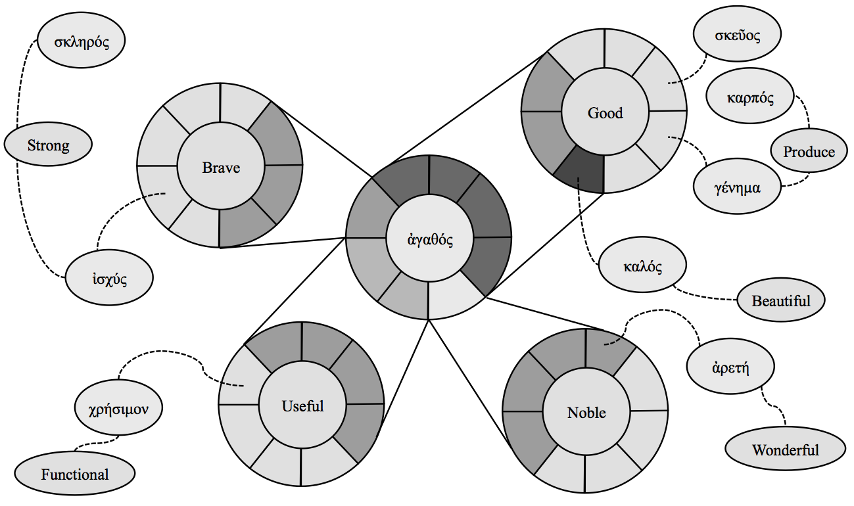](https://journal.rts.edu/wp-content/uploads/2016/12/Graphic13.png)

* Further compounding this is the fact that for both κοινή and English, semantic ranges are not static but evolve as the broader language and its various cultural milieux change. One only needs to read the KJV (or Chaucer!) to uncover hundreds of English words that are no longer used *today* the way they once were used; some are completely unrecognizable. The same is true for Greek. While the κοινή period is somewhat well-defined, there was no point at which everyone sat down and decided what all the words meant for that time period, but rather the language was in a flux from the Homeric and Classical periods through the Hellenistic period and into the Byzantine period. Some words are more stable than others, of course, but one only need to look into the shifts in meaning of, say, δόξα or διαθήκη in secular and Jewish-Christian Greek usage to confirm the broader point. In other words, a gloss-based approach to lexical meaning involves two moving targets on top of the one-to-many problem outlined above. Both complexities can be illustrated using the famous example of σάρξ (150x GNT; 208x LXX):

[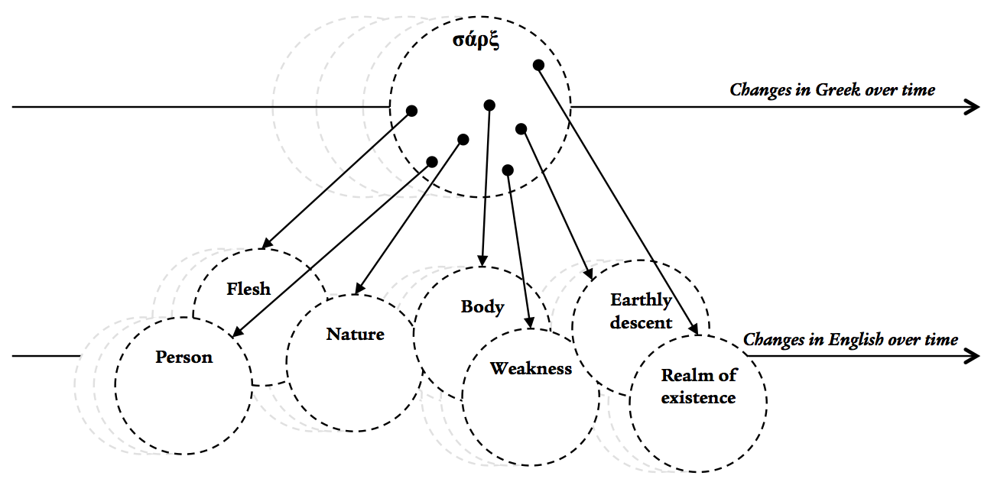](https://journal.rts.edu/wp-content/uploads/2016/12/Graphic14.png)

First-year Greek students likely learn “flesh” as the English for this lexeme, but this only works some of the time. Even when it does, one wonders whether “flesh” (in the KJV sense) still makes sense to modern readers. Some English translations have moved on to something like “human nature” as a gloss, but even this has an expiration date, given the attempt by certain ideologies in the West to reject any notion of a “human nature” and substitute in its place a self-chosen identity that is socially or individually constructed.

* Finally, limiting our understanding of Greek lexemes to an English word-for-word equivalent yields what one might call the *reverse semantic overhang* In short, any English gloss, due to its own semantic range, brings to the table connotations that are not at all part of the range of meaning of the underlying Greek word. There is, in other words, a portion of the English gloss’s range of meaning that is left overhanging when compared to the Greek word. Take, for example, the typical choice by English Bibles to use “visit” as the gloss for ἐπισκέπτομαι (Luke 1:68, 78; 7:16; Acts 15:14). In American English, “visit” carries with it a sense of, perhaps, a holiday trip to “visit” the Grand Canyon; in British English, it may carry the sense of afternoon tea with a friend. Neither of these semantic overhangs remotely capture the sense of a definitive intervention by God in salvation/judgment that the Greek conveys in these contexts. Another classic example that regularly comes up in small group Bible studies is the difference between the semantic range of the English word “fear” and the Greek φόβος (or Hebrew יראת), particularly when dealing with the common phrase “fear of the Lord.”[[7]](https://journal.rts.edu/article/sharpening-your-greek-a-primer-for-bible-teachers-and-pastors-on-recent-developments-with-reference-to-two-new-intermediate-grammars-part-ii/#_ftn7) While “fear” is an adequate simple gloss for the word in many cases, the baggage of a haunted-house-or-horror-movie kind of “fear” that comes along with the word is quite out of place with what the Bible is typically communicating.

The point of all of this[[8]](https://journal.rts.edu/article/sharpening-your-greek-a-primer-for-bible-teachers-and-pastors-on-recent-developments-with-reference-to-two-new-intermediate-grammars-part-ii/#_ftn8) is not to cause us to throw up our hands and give up, descending into the death spiral of lexical indeterminacy. Rather, it is simply to point out the possible theoretical and practical pitfalls that may arise when the busy pastor or Greek student operates with an underdetermined view of word meaning.

*Suggestions for those in ministry*. What, then, should we do to shore up our grasp of lexical semantics when working with the GNT (short of getting a degree in lexicography)? I would offer the following suggestions:

* *Constantly check oneself to avoid lexical fallacies*. Despite the best efforts of scholars to stamp out the abuse of biblical language in ministry, [[9]](https://journal.rts.edu/article/sharpening-your-greek-a-primer-for-bible-teachers-and-pastors-on-recent-developments-with-reference-to-two-new-intermediate-grammars-part-ii/#_ftn9) common fallacies still creep into our preaching and teaching, often unnoticed. Many of these pitfalls are no doubt familiar to those in ministry, but it is worth being reminded of them. Three seem to have particular staying power: word-concept fallacy (equating a theological idea with a specific lexeme and assuming the use of the lexeme always engages the concept); etymological and/or root word fallacy (assuming that the meaning of a Greek word is the sum of its parts or its meaning at some other point in time);[[10]](https://journal.rts.edu/article/sharpening-your-greek-a-primer-for-bible-teachers-and-pastors-on-recent-developments-with-reference-to-two-new-intermediate-grammars-part-ii/#_ftn10) and illegitimate totality transfer (importing the entire semantic range of a word into a given instance).[[11]](https://journal.rts.edu/article/sharpening-your-greek-a-primer-for-bible-teachers-and-pastors-on-recent-developments-with-reference-to-two-new-intermediate-grammars-part-ii/#_ftn11)
* *Work towards increasing one’s*“*feel*”*for semantic range*. This is no easy task, as, at the end of the day, it requires reading a lot of Greek. One easy step down the path is to add Louw & Nida’s semantic domain oriented lexicon to one’s toolkit.[[12]](https://journal.rts.edu/article/sharpening-your-greek-a-primer-for-bible-teachers-and-pastors-on-recent-developments-with-reference-to-two-new-intermediate-grammars-part-ii/#_ftn12) It is particularly useful for understanding words whose semantic ranges overlap (and/or are synonymous) with a given word being studied. This allows one to think through the possible implications of why the author (say, Paul) used *this word* instead of *that word*, which may have worked in the context as well. What does this intentional choice among possible synonyms imply about the chosen word’s meaning in context?
* *Be thoughtful in doing word studies*. Examining a lexicon or two and maybe a theological dictionary (with caveats) are great initial steps (and often sufficient, if one is pressed for time and uses the right resources). Going deeper may involve the step of typing the word into Bible software and skimming through *at the verse level* (and, if pressed for time, an ESV translation rather than the Greek) the various places in the GNT where the word is used. That is a perfectly fine start. But simply reading short snippets of text — especially if limited to English — for a given word may still yield a truncated view of its semantics. To grasp fully the semantic range of the word requires reading more context *in Greek*of each of its uses, not just the phrase in which it appears. This, of course, takes time, so one has to prioritize how deep to go, and thereby adjust his/her level of certainty in proportion to the level of depth attained.
* *Know when to pick your lexical battles*. A fuller appreciation of the complexities of how words convey meaning — and how to bridge the gap from one language to another — should give us reason to be more thoughtful in how we engage in debates. Much theological energy (and often friendly fire) can be expended debating whether, say, κεφαλή *means* “source” or “authority,” or whether βάπτω/βαπτίζω *means* “dip,” “pour,” “sprinkle,” or “immerse.” But given the complexities —on the Greek and English sides of the coin — of how the semantic ranges of words interact with linguistic shifts, literary context, authorial distinctives, and so forth, we would be wise to continue reminding ourselves that definitive theological conclusions hinge on more than just an English gloss. In other words, we should be careful not to overexegete a single word if it is not warranted.
* *Avoid saying things like*“*this word in the original*literally means*X in English*.”[[13]](https://journal.rts.edu/article/sharpening-your-greek-a-primer-for-bible-teachers-and-pastors-on-recent-developments-with-reference-to-two-new-intermediate-grammars-part-ii/#_ftn13) Whether one says this out of an urge to show off or out of genuine desire to clarify, it is misleading at best and inaccurate at worst. Not only do such definitive pronouncements instill (or stoke) a latent suspicion among one’s congregants that they cannot trust their English translation, they also run roughshod over how words work. It is far better to say such things as, “The word Paul uses here, which the ESV/NIV renders with X, can carry the sense of Y, and it is often used in contexts dealing with Z. This helps us be more precise about what he is getting at here, which is something like…” and so on. Such an approach is not only more pastoral, it is also more accurate — and more linguistically humble.

1. *CBGM and What Is Changing in the Critical GNT Editions*

We turn our attention now to a topic that has not received as much attention within evangelical circles as it should: namely, the changes in goal, method, and output behind the newest critical editions of the GNT, NA-28 and UBS-5.[[14]](https://journal.rts.edu/article/sharpening-your-greek-a-primer-for-bible-teachers-and-pastors-on-recent-developments-with-reference-to-two-new-intermediate-grammars-part-ii/#_ftn14) Before getting there, it is important first to survey where we have come from. As most Greek students have been taught in preceding generations, prior NA (blue) and UBS (burgundy) critical editions — which are the basis of all modern English translations apart from those in the KJV/Majority-Text tradition — have been edited using standard text-critical principles. Starting from the Westcott-Hort base text that, as is well-known, highly privileged Vaticanus and Sinaiticus (among other witnesses),[[15]](https://journal.rts.edu/article/sharpening-your-greek-a-primer-for-bible-teachers-and-pastors-on-recent-developments-with-reference-to-two-new-intermediate-grammars-part-ii/#_ftn15) successive generations of scholars have revised the base eclectic text as new manuscripts (especially papyri) became available over time. The choice of which variant readings — recently estimated to be 480,000–540,000![[16]](https://journal.rts.edu/article/sharpening-your-greek-a-primer-for-bible-teachers-and-pastors-on-recent-developments-with-reference-to-two-new-intermediate-grammars-part-ii/#_ftn16) — to place in the main text versus the apparatus has traditionally been made by the editors on the grounds of external evidence and internal evidence.

External evidence focuses on weighing various manuscripts — that is, *actual* papyrus or parchment artifacts that contain a portion of the GNT (a distinction that will become important below) — based on their quality, not just their quantity. Quality, in turn, has traditionally been pegged primarily to the “text-type” or “text-family” to which any given manuscript/artifact is deemed to belong: the so-called “Alexandrian” witnesses (א, B, A [non-gospel portions], C [some portions], and most papyri) are usually deemed superior; “Byzantine” and related witnesses are viewed with a healthy degree of suspicion; “Western” witnesses (D, old Latin, old Syriac) are early but usually expansive and, thus, deemed lower quality; and “Caesarean” (if a real text-type to begin with) are largely ignored.

Internal evidence comes alongside the external to help further adjudicate among variants found among the manuscripts, focusing on unintentional scribal errors (*homoioteleuton*, *homoioarchton*, permutation, haplography, dittography, transposition), intentional scribal changes (harmonization, conflation, correction), and authorial style or writing patterns. By studying such possible explanations, applying the so-called “canons” of textual criticism,[[17]](https://journal.rts.edu/article/sharpening-your-greek-a-primer-for-bible-teachers-and-pastors-on-recent-developments-with-reference-to-two-new-intermediate-grammars-part-ii/#_ftn17) and integrating external evidence, a reader of the GNT can make an informed decision on a variant and, thus, “establish the text.” While not every pastor or Bible teacher does this every time they prepare a sermon, lesson, or translation, all (in principle) have been taught this basic approach, and it has served quite well for decades.

Furthermore, this method that students learn in their Greek training basically matches what editors themselves have traditionally done to produce the critical editions themselves. Thus, students can use the same toolset to decide (using Metzger’s *Commentary* as aide)[[18]](https://journal.rts.edu/article/sharpening-your-greek-a-primer-for-bible-teachers-and-pastors-on-recent-developments-with-reference-to-two-new-intermediate-grammars-part-ii/#_ftn18) whether they agree or disagree with the UBS committee. Commentators, likewise, often speak in the same terms regarding “Alexandrian” witnesses and whatnot, and translations committees too have used the same method in determining when to go with NA/UBS or to modify it and make a footnote. In other words, everyone has been singing from the same sheet of music.

However, this is fast becoming no longer the case, but few outside academic circles are even aware.

Summarizing the sea change behind our GNT editions is not a simple task, for even specialists still have a hard time getting their heads around it. I will focus on articulating as simply and clearly as possible what is changing along three dimensions: goal, method, and output.

*Goal*. Within text-critical circles there has been a running debate about what exactly the goal should be for studying textual variants of the GNT. For the better part of the 20th century, the editors have attempted to sift through the thousands of Greek (and other) manuscripts to approximate, as closely as possible, the “original” text. That is: what Paul or John or whomever actually wrote (≈ the “autographs,” which are, of course, lost). This goal, however, has undergone a marked shift in the past decade. Leading text critics now propose that our goal should be identifying the “initial” text (*Ausgangstext*): the earliest recoverable approximation of whatever text stands as the headwaters of the subsequent stream of textual transmission.[[19]](https://journal.rts.edu/article/sharpening-your-greek-a-primer-for-bible-teachers-and-pastors-on-recent-developments-with-reference-to-two-new-intermediate-grammars-part-ii/#_ftn19) This shift may seem subtle, but it exposes an important revision to our understanding of the earliest stage of transmission of the apostolic writings: there is a gap between the “autographs” and the earliest-reconstructible *Ausgangstext* that, based on the evidence we have, is ultimately unbridgeable. For instance, if Paul wrote in 50–60 AD and our earliest extant artifactual witnesses are early 200 AD, we can at best reconstruct the *Ausgangstext* as of a few decades prior to 200 AD, assuming the scribes of the extant witnesses copied older exemplars with some level of accuracy. From that *Ausgangstext* we can use text-critical deductions to get us closer to the original author, but such a move from *Ausgangstext* to “original” can only be achieved by educated inference. Put differently, the difference between what, say, Paul actually penned (or his amanuensis) — which, for evangelicals, is the nexus of inspiration/inerrancy — and what we can reconstruct as the “initial” stage of the subsequent scribal tradition may be small (or zero) … or quite large. We simply do not — and, according to some leading text critics, *cannot*—know.[[20]](https://journal.rts.edu/article/sharpening-your-greek-a-primer-for-bible-teachers-and-pastors-on-recent-developments-with-reference-to-two-new-intermediate-grammars-part-ii/#_ftn20) No one, of course, is saying that the *Ausgangstext* is completely unrecognizable relative to what Paul actually wrote. Rather, the issue is an epistemological one regarding on what grounds we can make upstream deductions, and how much confidence we should have in doing so.

In light of this shift in objective, many (but not all) textual critics have further argued that the real goal of the endeavor is not really to reconstruct the *Ausgangstext* anyhow — though it serves as a key starting point — but rather to study textual variants primarily for the insight they give us into the reception history of each GNT writing. A textual variant, then, is not a problem to be resolved in order to get back to what Paul actually wrote but, rather (or perhaps *chiefly*), a window into the world of early Christianity. Variant readings show us what various scribes, and thereby the communities they represent, thought about the text and its meaning.

This latter sub-goal is not bad in itself; textual variants both large and small do provide interesting insights into how early Christians were reading the GNT (e.g., the manuscript turbulence surrounding the various endings of Mark is a fascinating glimpse into this). However, the shift in overarching goal — from “original” to “initial” text — *is* a substantial change. It is also one whose implications for an evangelical approach to the GNT have not been fully digested. For now, one can continue to treat NA-28/UBS-5 just as one has always treated an edition of the GNT — as an imperfect reconstruction of the autographs, about which we can have a tremendously high degree of confidence — but we will have to play a few more innings to see just how much the underlying philosophical shift in textual criticism will impact things.

*Method*. Here we enter into yet murkier waters, but they are important to understand. For the past several years, a talented team of NT scholars and textual critics (under the auspices of the Institut für Neutestamentliche Textforschung [INTF])[[21]](https://journal.rts.edu/article/sharpening-your-greek-a-primer-for-bible-teachers-and-pastors-on-recent-developments-with-reference-to-two-new-intermediate-grammars-part-ii/#_ftn21) has been engaged in producing the *Editio Critica Maior* (ECM).[[22]](https://journal.rts.edu/article/sharpening-your-greek-a-primer-for-bible-teachers-and-pastors-on-recent-developments-with-reference-to-two-new-intermediate-grammars-part-ii/#_ftn22) The ECM project, beginning with the Catholic Epistles (Acts is due to be released next), aims to produce the first thoroughly critical edition of the GNT based on the most comprehensive and representative set of data available. The ECM leverages technological tools as well as a far more robust set of textual data — namely, full collations of hundreds of manuscripts — unavailable to prior generations of editors of the GNT. By the time the project concludes in the 2030s, each book of the GNT will be covered by the ECM, and the results will, in turn, feed directly into the “hand editions” (NA and UBS) that are used by all. The ECM project in itself is a massively important undertaking that has been a long time coming, and its results will impact NT studies for the next hundred years.

The engine driving the ECM is the point at hand. In sharp contrast to the UBS committee of yesteryear, which, as discussed above, operated on the basis of text-types and so forth that a pastor or second year Greek student could, in principle, repeat for themselves, the editors of the ECM have adopted an entirely new method for analyzing this mountain of textual data. Developed by Gerd Mink, the Coherence-Based Genealogical Method (CBGM)[[23]](https://journal.rts.edu/article/sharpening-your-greek-a-primer-for-bible-teachers-and-pastors-on-recent-developments-with-reference-to-two-new-intermediate-grammars-part-ii/#_ftn23) marks a significant advance in methodological rigor but also involves a number of substantial shifts with which we are still coming to terms. Describing the CBGM is not for the faint of heart, but I will do my best to present a (slightly-oversimplified) account.[[24]](https://journal.rts.edu/article/sharpening-your-greek-a-primer-for-bible-teachers-and-pastors-on-recent-developments-with-reference-to-two-new-intermediate-grammars-part-ii/#_ftn24)

* “*Texts*,” *not* “*manuscripts*.”[[25]](https://journal.rts.edu/article/sharpening-your-greek-a-primer-for-bible-teachers-and-pastors-on-recent-developments-with-reference-to-two-new-intermediate-grammars-part-ii/#_ftn25) The starting point for the CBGM is a subtle but significant shift in the raw data for consideration. Rather than focusing, as with the traditional approach, on tangible artifacts (and their age, provenance, etc.), the CBGM focuses on texts — that is, the words that a given artifact contains. The object of study is family tree or “genealogy” of a given *text* rather than the genealogy of a given tangible *artifact* (like P75or Sinaiticus). A given text can be an “ancestor” of — and, thus, be the input to — another text regardless of which of the two physical manuscripts are older or whether the scribe of one used the other as an exemplar. [[26]](https://journal.rts.edu/article/sharpening-your-greek-a-primer-for-bible-teachers-and-pastors-on-recent-developments-with-reference-to-two-new-intermediate-grammars-part-ii/#_ftn26) Put differently, the quality of the text of a manuscript (≈ how accurately it reflects the *Ausgangstext*) is independent of the piece of papyrus or parchment on which it is documented. A medieval manuscript may contain a *text* that is actually prior to (an “ancestor” of) the *text* found on an uncial that, from an artifact perspective, pre-dates it by centuries. This in itself is mostly old news; textual critics have recognized this for a long time. However, the shift is that the CBGM by and large treats the actual manuscripts as somewhat irrelevant and ascribes virtually no weight to them; the text on them is all that matters. Gone, then, are text-types, “Alexandrian” priority, text-critical weight placed on a manuscript’s paleographical dating, and so forth. This feature of the CBGM merits illustration:

[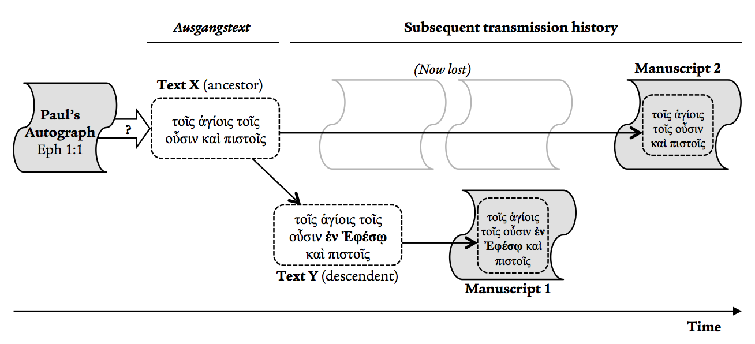](https://journal.rts.edu/wp-content/uploads/2016/12/Graphic15.png)

In this highly simplified example, Text X is superior to (as the ancestor of) Text Y; however, Manuscript 2 (which contains Text X) is *later than*Manuscript 1 (which contains Text Y), due to the vicissitudes of the transmission history. Thus, the CBGM would in this case prioritize Text X over Text Y, ignoring the fact that Manuscript 2 (where it is found) may be a medieval minuscule and Manuscript 1 may be Alexandrinus. This is the reverse of the traditional method, which would tend to privilege Manuscript 1 over 2.

* *Comparison of readings to construct a local stemma for a variation unit*. With this principle in mind, the critic using CBGM will analyze all the various readings for a “variation unit” (that is, a portion of, say, James 5:10) [[27]](https://journal.rts.edu/article/sharpening-your-greek-a-primer-for-bible-teachers-and-pastors-on-recent-developments-with-reference-to-two-new-intermediate-grammars-part-ii/#_ftn27) to determine their family tree, which captures how one reading led to the next one(s). How does he/she determine such “genealogical” relationships and the “flow” from ancestor > descendent1 > descendent 2 > etc.? It can vary for each variation unit and the scholar, but generally a combination of the standard “internal evidence” and text-critical canons (outlined above) are used, along with data elsewhere within the CBGM (which is designed to be iterative and adjust as each decision on a given unit is made). For instance, when faced with ten options for the variation unit at the end of James 5:10, the critic may determine the following genealogy of the reading, called a “local stemma”[[28]](https://journal.rts.edu/article/sharpening-your-greek-a-primer-for-bible-teachers-and-pastors-on-recent-developments-with-reference-to-two-new-intermediate-grammars-part-ii/#_ftn28):

[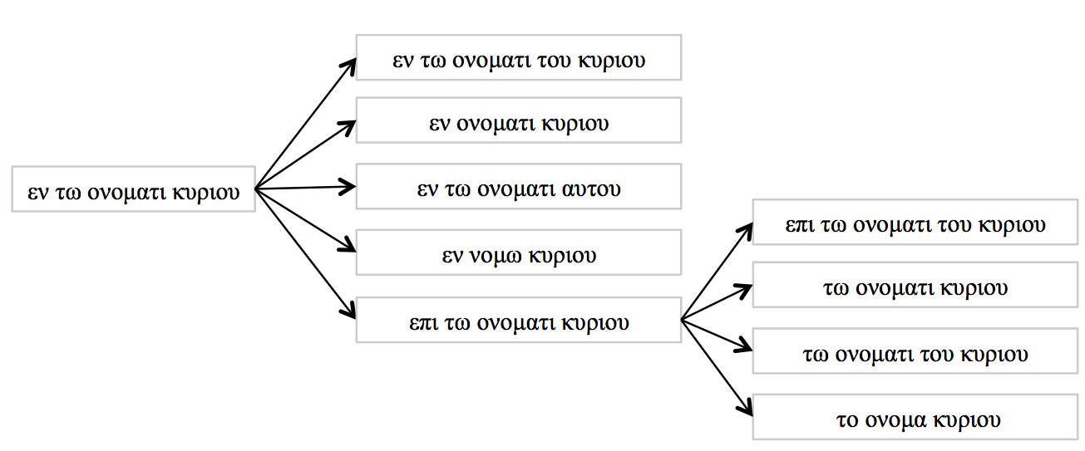](https://journal.rts.edu/wp-content/uploads/2016/12/Graphic16.png)

Usually the editor is able to construct such a stemma, but occasionally the genealogical relationship between two readings is left undetermined (until further data is incorporated).

* *Comparison of all variation units between two given textual witnesses to determine their genealogical coherence*. The next step is to use the CBGM database to compare full texts (found in manuscripts themselves, like Sinaiticus or 33 — but, recall, the actual manuscripts are somewhat irrelevant) at each variation unit. When comparing two texts — say X and Y — at a given variation unit (let us call it A, such as the final phrase of James 5:10 above), there are four possibilities. The reading for unit U found in X may be prior-to (ancestor) to that of Y (XU à YU); posterior-to (descendent) (XU ß YU); equivalent to (XU = YU); or undetermined (XU –?– YU). For instance, if X(James 5:10) reads επι τω ονοματι κυριου and Y(James 5:10) reads το ονομα κυριου, then X à Y at James 5:10. Using the technology underlying CBGM, the editor is able to compare all the hundreds of variation units for that pair of witnesses to determine the percent of times they are equivalent (=) or derivational (ß/à). The percentage of times they are equivalent is denoted within CGBM as the “pre-genealogical coherence.” The percentage of times they are not equivalent but, rather, the reading of one is an ancestor of the other factors into “genealogical coherence.” The genealogical coherence helps the editor determine whether, based on the math, the text X is *on the whole* an ancestor to or descendent of the text Y. Here is a real example for James as a whole, comparing two real textual witnesses[[29]](https://journal.rts.edu/article/sharpening-your-greek-a-primer-for-bible-teachers-and-pastors-on-recent-developments-with-reference-to-two-new-intermediate-grammars-part-ii/#_ftn29):

|  |  |  |  |  |  |
| --- | --- | --- | --- | --- | --- |
| **Total units** | **X = Y** | **% pre-geneal. coh.** | **X à Y** | **X ßY** | **Undeter.** |
| 746 | 649 | 86.9% | 64 | 19 | 14 |

Given that the number of X à Y readings is higher than X ß Y, the editor would (absent any other data from CBGM — recall, it is iterative) initially determine that X is an ancestor of Y (regardless of the dates/provenances/etc. of the manuscripts containing X and Y) and, thus, closer to the *Ausgangstext*.

* *From genealogical coherence of X and Y to sub-stemmata and global stemmata*. Running such analyses over a small set of textual witnesses (say, W, X, Y, and Z) enables the editor to produce a tentative “sub-stemma” or family tree of those texts. That is to say, a “local stemma” (illustrated above) reflects a single *reading* at a variation unit, while a “sub-stemma” takes all the local stemmata into consideration to produce a small family tree of witnesses (each of which is the sum of all the variation units). From there, the CBGM can compute a global stemma for a large number of witnesses. The sub-stemmata and global stemmata, in turn, provide additional information that allows the editor to go back in and adjust their analysis of individual readings and local stemmata. For instance, let us say the CBGM determines text Q is most likely an ancestor of text R for 1 John (e.g., the percentage of variation units that are Q à R is higher than Q ß R). If, however, it is determined from other historical evidence that the scribe producing the manuscript containing Q actually used a manuscript containing R as his exemplar (that is, MQ ß MR), the editor would have to revisit both Q and R to adjust course.[[30]](https://journal.rts.edu/article/sharpening-your-greek-a-primer-for-bible-teachers-and-pastors-on-recent-developments-with-reference-to-two-new-intermediate-grammars-part-ii/#_ftn30)

The net effect of these iterative computations is the generation of the set of textual readings deemed closest to the *Ausgangstext*. As with prior editions of NA/UBS, this “initial text” is not, of course, found on any single existing manuscript in its entirety. It is a reconstruction based on all the analysis of textual flow at the local and global level. One benefit of the CBGM is that we can now compare (for the Catholic Epistles, at present) the percentage of equivalence between the text represented by *A* and the text found in any witness collated in the database. A snapshot comparing the pre-genealogical coherence (equivalence) of *A* with the text found on a few notable manuscripts is as follows:

|  |  |  |  |  |  |  |  |  |
| --- | --- | --- | --- | --- | --- | --- | --- | --- |
|  | **James** | **1 Peter** | **2 Peter** | **1 John** | **2 John** | **3 John** | **Jude** | **Total** |
| *A* — Alexandrinus | 89.8% | 93.5% | 88.9% | 91.1% | 89.1% | 91.55 | 94.0% | **91.2%** |
| *A* — Vaticanus | 96.6% | 94.6% | 95.8% | 96.6% | 98.0% | 96.8% | 95.0% | **96.0%** |
| *A* — Sinaiticus | 93.1% | 88.1% | 86.2% | 90.8% | 87.3% | 94.7% | 88.9% | **90.0%** |
| *A* — 1739 | 92.6% | 92.0% | 92.7% | 95.5% | 94.1% | 90.5% | 90.5% | **93.0%** |

As one can see, the genealogical coherence between *A* and this sample set is quite high, particularly for Vaticanus.

*Output*. As noted already, the recent revisions to NA-28 / UBS-5 have incorporated the results of the CBGM/ECM for the Catholic Epistles.[[31]](https://journal.rts.edu/article/sharpening-your-greek-a-primer-for-bible-teachers-and-pastors-on-recent-developments-with-reference-to-two-new-intermediate-grammars-part-ii/#_ftn31) This in itself is significant, for the NA/UBS text has not been updated since NA-26 (1979) / UBS-3 (1975),[[32]](https://journal.rts.edu/article/sharpening-your-greek-a-primer-for-bible-teachers-and-pastors-on-recent-developments-with-reference-to-two-new-intermediate-grammars-part-ii/#_ftn32) only the apparatus. There are three main groups of updates to NA-28/UBS-5 over NA-27/UBS-4. First, the critical text itself has undergone thirty-three total revisions:  five in James; eight in 1 Peter; ten in 2 Peter; four in 1 John; two in 2 John; one in 3 John; three in Jude. [[33]](https://journal.rts.edu/article/sharpening-your-greek-a-primer-for-bible-teachers-and-pastors-on-recent-developments-with-reference-to-two-new-intermediate-grammars-part-ii/#_ftn33) The vast majority are minor (e.g., παιδία to τεκνία at 1 John 3:7). Only two are deemed significant:

Jude 5  
NA-27/UBS-4            [ὁ] **κύριος** ἅπαξ λαὸν ἐκ γῆς Αἰγύπτου σώσας  
NA-28/UBS-5             **Ἰησοῦς**      ἅπαξ λαὸν ἐκ γῆς Αἰγύπτου σώσας

2 Pet 3:10  
NA-27/UBS-4             καὶ γῆ καὶ τὰ ἐν αὐτῇ ἔργα        εὑρεθήσεται  
NA-28/UBS-5             καὶ γῆ καὶ τὰ ἐν αὐτῇ ἔργα **οὐχ** εὑρεθήσεται

Some English translations (e.g., ESV, NET[[34]](https://journal.rts.edu/article/sharpening-your-greek-a-primer-for-bible-teachers-and-pastors-on-recent-developments-with-reference-to-two-new-intermediate-grammars-part-ii/#_ftn34)) had already placed “Jesus” into the text and “Lord” into the footnote at Jude 5, but KJV and NIV, for instance, read “Lord.” Future editions of NIV, say, may likely embrace the new NA/UBS reading. The variant at 2 Pet 3:10 has long proven vexing, given the peculiar use of εὑρεθήσεται here.[[35]](https://journal.rts.edu/article/sharpening-your-greek-a-primer-for-bible-teachers-and-pastors-on-recent-developments-with-reference-to-two-new-intermediate-grammars-part-ii/#_ftn35) What is notable about this change is that the reading now presented as the *Ausgangstext* in NA-28/UBS-5/ECM is not actually found in any extant Greek witnesses, only in some Sahidic Coptic and Syriac witnesses. While this emendation has been entertained by commentators in the past as a possible solution to this *crux*, rarely have any translations incorporated it in the text. Now, perhaps, they will.

Second, the new editions have removed square brackets [ ] where, in prior editions (thirty-three times in the Catholic Epistles), the UBS committee indicated it was not completely convinced about a reading but, due to its pedigree in the manuscript tradition, retained it in the body text rather than place it in the apparatus. Many of these previously bracketed texts have been removed from the main text altogether and placed as a variant reading in the apparatus (e.g., ἀμήν at 2 Peter 3:18). Third, the editors have more or less replaced the brackets with a new text critical siglum, the rhomboid ◆, which marks forty-three places where two readings for a given variation unit are deemed equal alternatives; in short, the editors were unable to choose one over the other. One ends up in the main text, with the other in the apparatus, but the reader should treat them as both equally probable.[[36]](https://journal.rts.edu/article/sharpening-your-greek-a-primer-for-bible-teachers-and-pastors-on-recent-developments-with-reference-to-two-new-intermediate-grammars-part-ii/#_ftn36)

*Implications*. Given the newness of all the above changes in goal and method, it is unsurprising that there has been little discussion outside a small circle of text critics about the long-term implications of the CBGM as the process unfolds over the next 15-20 years. Thinking through them all would be a dedicated study in its own right;[[37]](https://journal.rts.edu/article/sharpening-your-greek-a-primer-for-bible-teachers-and-pastors-on-recent-developments-with-reference-to-two-new-intermediate-grammars-part-ii/#_ftn37) for now, I will simply pose a few questions/reflections.

* There are a lot of positives with the CBGM. The data set alone is a substantial improvement over what we had previously. The project has made great strides towards the previously unicorn-like dream of having thousands of manuscripts digitized, collated, and analyzable. The CBGM, for the text critic, also provides a method to hypothesize how specific textual variants emerged (and possibly even when) in the transmission history.[[38]](https://journal.rts.edu/article/sharpening-your-greek-a-primer-for-bible-teachers-and-pastors-on-recent-developments-with-reference-to-two-new-intermediate-grammars-part-ii/#_ftn38) Moreover, the results for the Catholic Epistles indicate just how high-quality prior editions of the GNT (going back to Westcott and Hort and their contemporaries) have been. I would argue that our confidence in the text has, in the end, gone up with the ECM’s findings.
* The ECM project began with the Catholic Epistles in part due to their relatively more stable textual tradition. Additionally, one could argue that the implications of modifying the critical text (which had been unchanged for nearly forty years) in this section of the GNT poses the least risk of ruffling feathers. One wonders, however, just how substantial the revisions may be in the ECM for Acts, the Gospels, and Paul — which, for most in the evangelical world, tend to harbor more emotional/theological investment. We can only wait to find out.
* Most contemporary English translations (outside the KJV-tradition) have used NA-26 or NA-27 as their base text. Presumably at some point the English translation committees will update their volumes,[[39]](https://journal.rts.edu/article/sharpening-your-greek-a-primer-for-bible-teachers-and-pastors-on-recent-developments-with-reference-to-two-new-intermediate-grammars-part-ii/#_ftn39) and when they do so, how will they approach the changes made to NA-28 (or NA-29 and beyond)? Will they embrace them? How will they signal the ◆ readings in the English text and footnotes, if at all?
* How will (or should) students learn to do textual criticism in the future? This issue is particularly challenging. As outlined above, for decades students have been taught a fairly straightforward method for weighing major manuscripts and internal evidence to determine whether they agree with the NA/UBS critical text. However, the CGBM producing the critical text that future Greek students will purchase is operating according to an entirely different method. This method is, as all readily admit, rather complex to understand,[[40]](https://journal.rts.edu/article/sharpening-your-greek-a-primer-for-bible-teachers-and-pastors-on-recent-developments-with-reference-to-two-new-intermediate-grammars-part-ii/#_ftn40) let alone teach. More importantly, one would need to have access to significant analytical tools — and abandon a manuscript-focused mentality (and text-types) in favor of the more abstract text-focused mentality — in order to reproduce the thought process behind a given judgment on a textual variant in the ECM/NA-28/UBS-5.[[41]](https://journal.rts.edu/article/sharpening-your-greek-a-primer-for-bible-teachers-and-pastors-on-recent-developments-with-reference-to-two-new-intermediate-grammars-part-ii/#_ftn41) Take the 2 Pet 3:10 example shown above. The old-school approach would look at the various options, weight א, B, papyri, minuscules, and Byzantine witnesses (most of which disagree) and come to some conclusion. However, this conclusion is quite unlikely to be that the lone attested witness for +οὐκ (sa in NA-27; the Syriac is not even mentioned) offers the best reading. Yet that is precisely what NA-28/UBS-5 print in the main text! The student is at a loss, then, for explaining *why* that reading is preferred when, on the traditional approach, it seems to be the *least* preferred! Even the full ECM volume — which, incidentally, is prohibitively expensive for most non-specialists to purchase — sheds little light on it, and the (apparently) forthcoming commentary volume remains to be seen. In short, we are facing a situation in which the method currently being taught to students (and taught to scholars/pastors in the past) will no longer correspond to the method underlying the new editions of the critical GNT they are/will be working with![[42]](https://journal.rts.edu/article/sharpening-your-greek-a-primer-for-bible-teachers-and-pastors-on-recent-developments-with-reference-to-two-new-intermediate-grammars-part-ii/#_ftn42) It is encouraging that the total number of changes to the text itself, at least for the Catholic Epistles, was fairly small; however, the underlying method is, nevertheless, changing substantially.
* Related to the prior point, one wonders what use Metzger’s justly famous *Textual Commentary* will have in the future. It constitutes, in essence, the editorial committee’s notes from how they decided among variations in the 1970s and 1980s; its A-B-C ratings (in the UBS volumes only) have also been a helpful data point for years. However, as Elliott rightly notes, for those portions of the NA/UBS editions that incorporate the outcome of the CBGM/ECM project, “the tried and trusted *vade mecum*of old, Metzger’s *Commentary* … is only partially useful.”[[43]](https://journal.rts.edu/article/sharpening-your-greek-a-primer-for-bible-teachers-and-pastors-on-recent-developments-with-reference-to-two-new-intermediate-grammars-part-ii/#_ftn43) It may have helpful things to say about the internal evidence that *might* have impacted the ECM team’s decision for a given local stemma, but any appeal it makes to specific manuscripts is, now, almost entirely outdated.
* Finally, how will the shift in goal, from “original” text to “initial” text impact the way Reformed/evangelical folks who hold to biblical inspiration approach the critical GNT? Majority-text/KJV-only debates aside, most inerrantists who make use of the NA/UBS volumes have functionally equated the eclectic text found therein with, for all intents and purposes, the inspired autographs. Yes, we know that the critical edition is not itself inerrant or infallible — thus necessitating the need to make one’s own text-critical judgments — but we have embraced it as the next-best-thing we have (much like our approach to the Masoretic Text). The philosophical shift underlying the ECM project, however, is meaningful. The goal is no longer positioned as “getting back to what Mark wrote” but, rather, “getting back as early as possible, given the extant data, to what the early church received as coming from Mark.” Much effort needs to be devoted to thinking through the epistemological and doctrine-of-Scripture implications of such a change with respect to the GNT text coming out of the project.

The preceding discussion has been lengthy due to the numerous complexities involved. However, anyone who aims to study or teach the GNT in years to come must be informed about what is going on with the very GNT we are studying and teaching!

1. *Pronunciation of Greek*

There has been a friendly (for the most part) debate within NT circles in the past few years regarding how to pronounce κοινή.[[44]](https://journal.rts.edu/article/sharpening-your-greek-a-primer-for-bible-teachers-and-pastors-on-recent-developments-with-reference-to-two-new-intermediate-grammars-part-ii/#_ftn44) Most students in the West have been taught (to the extent that a Greek teacher encourages consistent pronunciation to begin with!) the Erasmian system, whereby each consonant, vowel, and diphthong generally has a distinctive sound. It is no secret, however, that modern Greek (and Byzantine before that) sounds markedly different. Recent phonological research has concluded that Desiderius Erasmus may have gotten Greek phonology basically correct for the Classical period, but his system may very well be wrong for the Hellenistic period in which the GNT was written. In short, the older “continental” or Erasmian system which most NT Greek students learn may be wrong; pronunciation of κοινή, it appears, may be closer to Byzantine/Modern Greek than to Classical.[[45]](https://journal.rts.edu/article/sharpening-your-greek-a-primer-for-bible-teachers-and-pastors-on-recent-developments-with-reference-to-two-new-intermediate-grammars-part-ii/#_ftn45)

What are the differences between what a student usually learns in the Erasmian system (taught in, say, Mounce) and what most academics now agree is more accurate for the time period? Several competing systems have been proposed. The following is a rough guide, acknowledging that there is not yet uniformity among scholars on how closely κοινή pronunciation should correlate to Modern. Other systems have been put forward that may differ in the details from this summary (e.g., Caragounis, Allen-Daitz).[[46]](https://journal.rts.edu/article/sharpening-your-greek-a-primer-for-bible-teachers-and-pastors-on-recent-developments-with-reference-to-two-new-intermediate-grammars-part-ii/#_ftn46)

* *Rough breathing***:**not pronounced
* *Consonants*
  + Differences:

[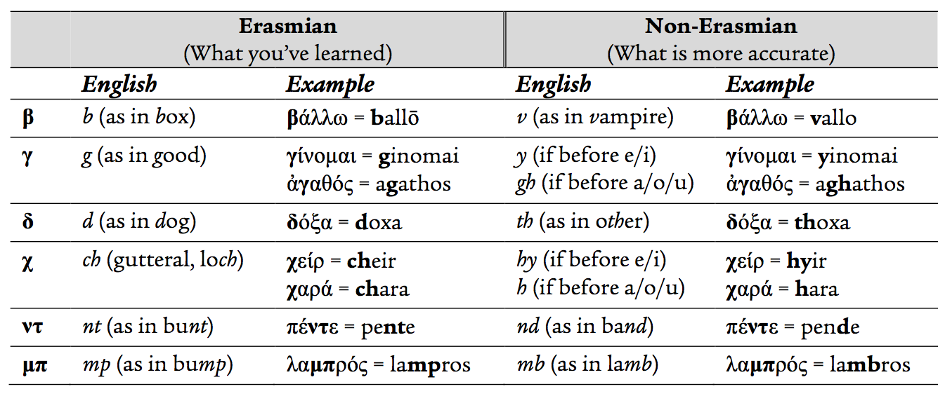](https://journal.rts.edu/wp-content/uploads/2016/12/Graphic17.png)

* Similarities: everything else, including γ-nasal
* *Vowels and diphthongs*
  + Differences

[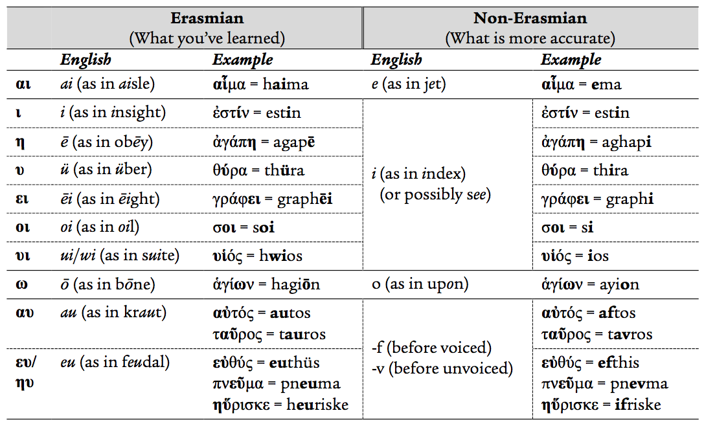](https://journal.rts.edu/wp-content/uploads/2016/12/Graphic18.png)

* Similarities: α, ε , ο, ου[[47]](https://journal.rts.edu/article/sharpening-your-greek-a-primer-for-bible-teachers-and-pastors-on-recent-developments-with-reference-to-two-new-intermediate-grammars-part-ii/" \l "_ftn47)

Why does all this matter? Many would argue that it does not, since we are usually reading the text silently rather than reading it out loud or speaking it as a living language. The primary argument in favor of retaining the Erasmian pronunciation — even if it is historically inaccurate — is pedagogical: it is considered easier for first-year Greek students to learn case endings, verb inflections, and vocabulary words if they consistently read (out loud or in their heads) them in such a way that makes clear distinctions between letters and, especially, vowels. The argument in favor of moving away from Erasmian pronunciation is twofold: respect for historical authenticity, and euphony (or ease of pronunciation). The jury is still out on this, and I imagine in most seminary classrooms Erasmian will still be used for the foreseeable, while at academic conferences we will increasingly see a Babel-like situation unfolding as some folks make the plunge while others do not.

I would argue, however, that it is important for the advanced Greek student, at a minimum, to be aware that there is a debate at all, which many introductory grammars paper over. Even if one retains Erasmian for personal or classroom use, some basic familiarity with the more accurate phonology is beneficial for understanding numerous textual variants.[[48]](https://journal.rts.edu/article/sharpening-your-greek-a-primer-for-bible-teachers-and-pastors-on-recent-developments-with-reference-to-two-new-intermediate-grammars-part-ii/#_ftn48) Some variations arise via i[o]tacism: the tendency, as shown in the vowel table above, for so many vowels and diphthongs to take on the pronunciation of the iota. Others arise from similarities in omega and omicron, among others. A famous example is ἔχ**ο**μεν (present active indicative) vs. ἔχ**ω**μεν (present active subjunctive) at Rom 5:1, though there are many more. One might also surmise that understanding pronunciation in a more accurate way may help with recognizing euphony, wordplay, rhyme, assonance, and so forth in the Greek text. Finally, knowing the variations also helps the budding scholar understand his or her Byzantine-studies peers — and avoid offending modern Greeks!

1. *Discourse Analysis*

“Discourse” has become somewhat of a buzzword in Greek studies, but for good reason. Much work has been done in this area (also known as “text-linguistics”), helping equip the student of the GNT to move beyond simplistic word studies towards a more robust understanding of how larger sections of text “work.”[[49]](https://journal.rts.edu/article/sharpening-your-greek-a-primer-for-bible-teachers-and-pastors-on-recent-developments-with-reference-to-two-new-intermediate-grammars-part-ii/#_ftn49) It is a vast and growing field, so I will intentionally limit the discussion simply to a listing of some of the various discourse features that merit one’s attention:

|  |  |  |
| --- | --- | --- |
| Forward-pointing device  Backward-pointing device  Point/counterpoint set  Metacomment  Historical present  Indirect speech | Change in addressee  Redundancy  Argument flow linkages  Constituent order shifts  Near/far distinction  Boundary markers | Thematic addition  Overspecification  Backgrounding  Foregrounding  Mainline/supporting line |

As even this simple list indicates, discourse-level analysis is fairly different from (and builds upon) the local-level syntactical analysis — prepositional phrases, genitive absolutes, adjectival participles, and so on — that one typically learns in advanced Greek. Another key feature of discourse analysis is the guiding principle (almost a mantra, for some practitioners) that “choice implies meaning.” That is to say, when a Greek writer chooses to use one conjunction instead of another, or to break a standard syntactical or word-order pattern, or to use one aspect instead of another that might be expected — such choices may be significant for meaning.[[50]](https://journal.rts.edu/article/sharpening-your-greek-a-primer-for-bible-teachers-and-pastors-on-recent-developments-with-reference-to-two-new-intermediate-grammars-part-ii/#_ftn50)

To learn more about discourse features and how to analyze them within the GNT, I would point the interested party to the two most helpful and practical places to start: Steven Runge’s *Discourse Grammar* and Stephen Levinsohn’s *Discourse Features*.[[51]](https://journal.rts.edu/article/sharpening-your-greek-a-primer-for-bible-teachers-and-pastors-on-recent-developments-with-reference-to-two-new-intermediate-grammars-part-ii/#_ftn51) Someone in ministry who desires to advance his/her competency in Greek would benefit greatly from reading one of these volumes in addition to either of the recent intermediate grammars discussed in Part One.

1. *Electronic Tools*

Little needs to be said about the usefulness of the “Big Three” software packages that own the lion’s share of the market within biblical studies today (Logos, BibleWorks, Accordance).[[52]](https://journal.rts.edu/article/sharpening-your-greek-a-primer-for-bible-teachers-and-pastors-on-recent-developments-with-reference-to-two-new-intermediate-grammars-part-ii/#_ftn52) Though expensive, such tools are practically essential for any serious student of the GNT today.

I find it interesting, however, that both Köstenberger/Merkle/Plummer and Mathewson/Emig (from Part One) register reservations about the use or abuse of software packages, and I would add my voice to theirs. As in many areas of life, the pace of technological advancement has, perhaps, outstripped the pace of reflection about possible downsides of such technology among those who study, teach, and preach the Bible. At the risk of sounding like a crank,[[53]](https://journal.rts.edu/article/sharpening-your-greek-a-primer-for-bible-teachers-and-pastors-on-recent-developments-with-reference-to-two-new-intermediate-grammars-part-ii/#_ftn53) I would lodge a few observations or cautions.

First, upon completing a difficult course of study in Greek (or Hebrew), students may find — as ministry consumes more and more time — that a software package can become a Siren singing to them. Software offers the tantalizing opportunity to quit *reading* and *studying* their GNT for real and simply resort to using the trackpad or touchscreen to hover over words on the screen and have the computer give automated parsing and glosses. Once that Siren song has been heard, it is hard to avoid turning something that was designed to be a supplemental tool into a crutch that upholds an increasingly crippled grasp of Greek. From there it becomes a prosthesis that one cannot live without. Soon enough a student can barely recognize a vocabulary word or parse a participle (let alone remember what those things do) on his/her own, and with a seemingly inexorable march the software has taken the place of one’s brain.

I am a realist, and I know that many, if not most, students of Greek follow this well-trodden path.[[54]](https://journal.rts.edu/article/sharpening-your-greek-a-primer-for-bible-teachers-and-pastors-on-recent-developments-with-reference-to-two-new-intermediate-grammars-part-ii/#_ftn54) I would, however, encourage students to fight against it. Double-clicking on a word here or there to access a snippet of a lexicon, or looking at various pie charts of word frequencies, or hovering over something to find out it is genitive plural: none of these tasks *in themselves* confer real insight into what Paul is saying in Galatians 2, anymore than merely looking up “wherefore,” “art,” and “Romeo” can help someone truly understand Shakespeare. The tools are there to assist, not replace, one’s wrestling with the whole text in all its fullness. Poking around in the software and looking at a smattering of words in isolation is a recipe for a lifetime of lexical fallacies smuggled into sermons and masked with the false confidence of saying, “I consulted the Greek.” One wonders if such an approach, in the end, does more harm than good. I would encourage students, rather, to read *a lot of Greek* on paper, to handicap themselves, to throw away the crutches, to wrestle with the text – and maybe find out it is actually enjoyable! This can be done with the computer, too, but it requires Odyssean strength to avoid the Siren’s call to let the computer do all the thinking for you. In the end, what is the fun in that anyhow?

Second (and related), I would caution Bible software users about data overload. This is simultaneously a critique of the software developers. One wonders whether it is truly necessary or even helpful for a Bible software package to offer immediate access to dozens if not hundreds of commentaries and books on the same screen as the Bible. It sounds very appealing, but it takes a very disciplined person to use such resources responsibly. A few pitfalls can emerge. While it is convenient to have one-click access to what a host of commentaries say about, say, James 5:2, such convenience comes at the cost of missing what each scholar says elsewhere about James in general, or the whole chapter, or methodology, or presuppositions — none of which will show up in the little snippet that gets loaded by the software for the verse. It seems odd for us to encourage someone to study a Bible verse *in context* but not a paragraph from a commentary. Moreover, while a pastor or student can just as easily emerge from a library with a stack of fifteen commentaries and read everything they say about a given pericope before ever analyzing the pericope on their own, how much easier is it to do this in, say, Logos? As preachers or teachers, we are not fundamentally called to regurgitate what NICNT, PNTC, NAC, and NIVAC say about a pericope, but to expound what the Bible says to our people. That is, secondary sources are to assist us in analyzing the primary source, not *become the primary source*. However, I fear that for many, this one-click access to mountains of secondary sources (exacerbated, no doubt, by the tendency among the software packages to cram as much as possible to the left/right/top/bottom of the actual text window containing the Bible) can cause them to get this ordering of priorities out of balance. Finally, in a world in which slow, deliberate reflection on Scriptural truth is crowded out by the incessant torrent of data from all angles, one wonders whether, say, 5,132 resources[[55]](https://journal.rts.edu/article/sharpening-your-greek-a-primer-for-bible-teachers-and-pastors-on-recent-developments-with-reference-to-two-new-intermediate-grammars-part-ii/#_ftn55) accessible via a drop-down menu is necessarily a good thing. Has too much technology replaced the reading of whole books (seeking transformation and insight) with a quick-and-easy trawl through a collection of snippets (seeking mere data)?

In short, I find Bible software packages to be wonderfully helpful, and I do not at all discourage their use *per se*. However, to become a reader of the GNT who is competent and responsible with the text requires a lot of effort reading the GNT (and LXX, and other Greek writings), refining one’s understanding of grammar and lexical semantics, and so on. Software can help this, but it should not replace it. At the end of the day, there are few things more enriching and satisfying than working a Greek passage over and over again until you know it cold — using the scholarly sources to check your work — and then stepping up to proclaim God’s truth. Poking around in Accordance and taking a commentator’s word for it is a meager substitute.

Circling back to where I started, our goal is to love reading and studying the Greek Testament for the rest of our lives. Doing so requires keeping our κοινή tools sharp. One does not decide to become a master carpenter, buy an expensive table saw, allow it to get completely dull and rusty, resort to ordering prefab cabinets from Ikea for the rest one’s life — and still consider oneself a master carpenter. A rusty saw becomes a dangerous saw if one does end up trying to use it, and prefab cabinets are never as fulfilling or enjoyable as the outcome of the process of laboring-sweating-breathing-sawdust-and-glue-fumes. This primer has been offered with that in mind: to encourage those in ministry and students to rekindle their love for the GNT, to sharpen their tools, and maybe, just maybe, realize that it is worth the effort.

[[1]](https://journal.rts.edu/article/sharpening-your-greek-a-primer-for-bible-teachers-and-pastors-on-recent-developments-with-reference-to-two-new-intermediate-grammars-part-ii/#_ftnref1) Here I am drawing in part on the helpful survey by Constantine Campbell, “Lexical Semantics and Lexicography,” Pages 72–90 in *Advances in the Study of Greek: New Insights for Reading the New Testament* (Grand Rapids: Zondervan, 2015).

[[2]](https://journal.rts.edu/article/sharpening-your-greek-a-primer-for-bible-teachers-and-pastors-on-recent-developments-with-reference-to-two-new-intermediate-grammars-part-ii/#_ftnref2) Technical terms are probably the only exception (but most of them have a range of meaning as well as a specific technical sense).

[[3]](https://journal.rts.edu/article/sharpening-your-greek-a-primer-for-bible-teachers-and-pastors-on-recent-developments-with-reference-to-two-new-intermediate-grammars-part-ii/#_ftnref3) However, there is a peculiar sub-movement within biblical studies in favor of monosemy (e.g., Gregory P. Fewster, *Creation Language in Romans 8: A Study in Monosemy*[Linguistic Biblical Studies 8; Leiden: Brill, 2013]).

[[4]](https://journal.rts.edu/article/sharpening-your-greek-a-primer-for-bible-teachers-and-pastors-on-recent-developments-with-reference-to-two-new-intermediate-grammars-part-ii/#_ftnref4) E.g., space of the nose between the eyes; feature of a guitar; control area of a ship; card game; portion of a song typically between verse and chorus; dental apparatus; stretch of land between two bodies of water; roadway structure that spans between two fixed points; and so on.

[[5]](https://journal.rts.edu/article/sharpening-your-greek-a-primer-for-bible-teachers-and-pastors-on-recent-developments-with-reference-to-two-new-intermediate-grammars-part-ii/#_ftnref5) A “definition” is a full semantic *description* of a lexeme’s range of meaning that can facilitate cross-language analysis. For instance, a definition of ἁμαρτία might be something like, “state of unrighteousness, moral failure, or error arising from an inward condition or an action; being considered ‘in the wrong’ by an external moral authority.” Such a definition could be rendered in any language to convey the same content. By contrast, glosses for ἁμαρτία in English might be “sin, transgression, error, misdeed, fault, wrongdoing, evildoing.”

[[6]](https://journal.rts.edu/article/sharpening-your-greek-a-primer-for-bible-teachers-and-pastors-on-recent-developments-with-reference-to-two-new-intermediate-grammars-part-ii/#_ftnref6) This critique applies especially to Liddell-Scott-Jones (though it is still one of the best lexicons for ancient Greek) and BAGD, but the revised edition of the latter (BDAG) makes some improvements. Of the recent LXX lexicons (Johan Lust, Erik Eynikel, and Katrin Hauspie, *Greek-English Lexicon of the Septuagint* [Rev ed.; Stuttgart: Deutsche Bibelgesellschaft, 2003]; Takamitsu Muraoka, *A Greek-English Lexicon of the Septuagint* [Leuven: Peeters, 2009]), Muraoka makes the greater strides in providing both glosses and clear definitions. Brill’s massive new lexicon (Franco Montanari, Madeline Goh, and Chad Schroeder [eds.], *The Brill Dictionary of Ancient Greek* [Leiden: Brill, 2015]) is also gloss-oriented — and translates the Greek glosses into English from Italian, no less!

[[7]](https://journal.rts.edu/article/sharpening-your-greek-a-primer-for-bible-teachers-and-pastors-on-recent-developments-with-reference-to-two-new-intermediate-grammars-part-ii/#_ftnref7) This happened, in fact, recently in my own church small group when dealing with the repeated notion of “wisdom is the fear of the Lord” in the Proverbs.

[[8]](https://journal.rts.edu/article/sharpening-your-greek-a-primer-for-bible-teachers-and-pastors-on-recent-developments-with-reference-to-two-new-intermediate-grammars-part-ii/#_ftnref8) We did not even cover intentional/unintentional ambiguity, cross-linguistic interference, and other issues of relevance to the study of the GNT.

[[9]](https://journal.rts.edu/article/sharpening-your-greek-a-primer-for-bible-teachers-and-pastors-on-recent-developments-with-reference-to-two-new-intermediate-grammars-part-ii/#_ftnref9) Three classics on semantics and Christian ministry should continue to be required reading and, for the most part, have yet to be surpassed: D.A. Carson, *Exegetical Fallacies* (Grand Rapids: Baker Books, 1996); Moisés Silva,*Biblical Words and Their Meaning: An Introduction to Lexical Semantics* (Grand Rapids: Zondervan, 1994); James Barr, *The Semantics of Biblical Language* (Oxford: Oxford University Press, 1961).

[[10]](https://journal.rts.edu/article/sharpening-your-greek-a-primer-for-bible-teachers-and-pastors-on-recent-developments-with-reference-to-two-new-intermediate-grammars-part-ii/#_ftnref10) I am reminded of a particularly painful example of this, whereby a very learned and respected guest preacher at our church in England waxed poetic for about 15 minutes — using PowerPoint slides, no less — to explain how μακροθυμέω means “long” (μακρο-) of “anger” (θυμός). (It doesn’t).

[[11]](https://journal.rts.edu/article/sharpening-your-greek-a-primer-for-bible-teachers-and-pastors-on-recent-developments-with-reference-to-two-new-intermediate-grammars-part-ii/#_ftnref11) For example, assuming every given use of ἀγάπη means “divine, covenantal, predestining, adoptive, salvific, marital, eternal love.”

[[12]](https://journal.rts.edu/article/sharpening-your-greek-a-primer-for-bible-teachers-and-pastors-on-recent-developments-with-reference-to-two-new-intermediate-grammars-part-ii/#_ftnref12) J.P. Louw and Eugene Nida, *Greek-English Lexicon of the New Testament Based on Semantic Domains* (2 vols.; New York: United Bible Societies, 1999).

[[13]](https://journal.rts.edu/article/sharpening-your-greek-a-primer-for-bible-teachers-and-pastors-on-recent-developments-with-reference-to-two-new-intermediate-grammars-part-ii/#_ftnref13) Regardless of whether one is using the traditional meaning of “literally” or the contemporary colloquial use (=“actually”).

[[14]](https://journal.rts.edu/article/sharpening-your-greek-a-primer-for-bible-teachers-and-pastors-on-recent-developments-with-reference-to-two-new-intermediate-grammars-part-ii/#_ftnref14) *Nestle-Aland: Novum Testamentum Graece*(28th rev. ed.; eds. Barbara and Kurt Aland, Johannes Karavidopoulos, Carlo M. Martini, and Bruce M. Metzger; Stuttgart: Deutsche Bibelgesellschaft, 2013); *The Greek New Testament* (5th rev. ed.; eds. Barbara and Kurt Aland, Johannes Karavidopoulos, Carlo M. Martini, and Bruce M. Metzger; London: United Bible Societies, 2014).

[[15]](https://journal.rts.edu/article/sharpening-your-greek-a-primer-for-bible-teachers-and-pastors-on-recent-developments-with-reference-to-two-new-intermediate-grammars-part-ii/#_ftnref15) Brooke F. Westcott and Fenton Hort, *The New Testament in the Original Greek* (New York: Harper & Brothers, 1881).

[[16]](https://journal.rts.edu/article/sharpening-your-greek-a-primer-for-bible-teachers-and-pastors-on-recent-developments-with-reference-to-two-new-intermediate-grammars-part-ii/#_ftnref16) Peter J. Gurry, “The Number of Variants in the Greek New Testament: A Proposed Estimate,” *New Testament Studies* 62/1 (2016): 97–121. His estimate is the first to use a thorough and reproducible method based on extensive manuscript evidence (from the Catholic Epistles). Importantly, he puts this number in perspective by demonstrating that the high number is not really due to scribal inaccuracy but to frequency of copying.

[[17]](https://journal.rts.edu/article/sharpening-your-greek-a-primer-for-bible-teachers-and-pastors-on-recent-developments-with-reference-to-two-new-intermediate-grammars-part-ii/#_ftnref17) E.g., the reading that best explains the others is usually preferred; *lectio brevior* (shorter is usually better, as scribes tend to expand versus contract—but not always); *lectio difficilior* (the more difficult reading is usually better, as scribes tend to smooth things out rather than make them more obscure).

[[18]](https://journal.rts.edu/article/sharpening-your-greek-a-primer-for-bible-teachers-and-pastors-on-recent-developments-with-reference-to-two-new-intermediate-grammars-part-ii/#_ftnref18) Bruce M. Metzger, *A Textual Commentary on the Greek New Testament* (2nd ed.; Stuttgart: Deutsche Bibelgesellschaft, 1994 [1971]).

[[19]](https://journal.rts.edu/article/sharpening-your-greek-a-primer-for-bible-teachers-and-pastors-on-recent-developments-with-reference-to-two-new-intermediate-grammars-part-ii/#_ftnref19) The most thorough essay discussing this shift in understanding is Michael W. Holmes, “From ‘Original Text’ to ‘Initial Text’: The Traditional Goal of New Testament Textual Criticism in Contemporary Discussion,” Pages 637–688 in *The Text of the New Testament in Contemporary Research: Essays on the Status Quaestionis* (eds. Bart D. Ehrman and Michael W. Holmes; Leiden: Brill, 2013).

[[20]](https://journal.rts.edu/article/sharpening-your-greek-a-primer-for-bible-teachers-and-pastors-on-recent-developments-with-reference-to-two-new-intermediate-grammars-part-ii/#_ftnref20) Klaus Wachtel, one of the leaders of the CBGM/ECM project, summarizes: “The initial text is neither the same as the archetype nor the authorial text. The archetype marks the beginning of the manuscript tradition, being itself a manuscript now lost. It is separated from the authorial text by a span of time which may be called the initial phase of transmission. We cannot say what exactly happened to the authorial text in the initial phase. Oral tradition may have had an impact, or revisions, perhaps by the author himself, or other kinds of editorial work on the text. The initial text, as a hypothesis about the text from which the manuscript tradition started, is the result of a methodical attempt to get as close as possible to the authorial text, carried out in the knowledge that *this aim cannot ultimately be reached*” (“The Coherence Method and History,” *TC: A Journal of Biblical Textual Criticism* 20 [2015]: 1–6 [2]; emphasis added).

[[21]](https://journal.rts.edu/article/sharpening-your-greek-a-primer-for-bible-teachers-and-pastors-on-recent-developments-with-reference-to-two-new-intermediate-grammars-part-ii/#_ftnref21) “Institute for New Testament Textual Research.”

[[22]](https://journal.rts.edu/article/sharpening-your-greek-a-primer-for-bible-teachers-and-pastors-on-recent-developments-with-reference-to-two-new-intermediate-grammars-part-ii/#_ftnref22) The first editions were released piecemeal in the 1990s/2000s, but the definitive edition for the Catholic Epistles was released as *Novum Testamentum Graecum: Editio Critica Maior, IV Die Katholischen Briefe* (2nd ed.; eds. Barbara Aland, Kurt Aland, Gerd Mink, Holger Strutwolf, and Klaus Wachtel; 2 vols.; Stuttgart: Deutsche Bibelgesellschaft, 2014).

[[23]](https://journal.rts.edu/article/sharpening-your-greek-a-primer-for-bible-teachers-and-pastors-on-recent-developments-with-reference-to-two-new-intermediate-grammars-part-ii/#_ftnref23) A brief description can be found at https://www.uni-muenster.de/INTF/Genealogical\_method.html.

[[24]](https://journal.rts.edu/article/sharpening-your-greek-a-primer-for-bible-teachers-and-pastors-on-recent-developments-with-reference-to-two-new-intermediate-grammars-part-ii/#_ftnref24) For more detail, consult Peter J. Gurry, “How Your Greek New Testament Is Changing: An Introduction to the Coherence-Based Genealogical Method (CBGM),” Presented at the Tyndale House, Cambridge, April 8, 2015 (also forthcoming in the *Journal of the Evangelical Theological Society*); Tommy Wasserman, “The Coherence Based Genealogical Method as a Tool for Explaining Changes in the Greek New Testament,” *Novum Testamentum* 57 (2015): 206–218; Gerd Mink, “The Coherence-Based Genealogical Method (CBGM)—Introductory Presentation,” Provided by the Institut für Neutestamentliche Textforschung, Münster (August 3–6, 2008) at http://www.uni-muenster.de/INTF/cbgm\_presentation/download.html.

[[25]](https://journal.rts.edu/article/sharpening-your-greek-a-primer-for-bible-teachers-and-pastors-on-recent-developments-with-reference-to-two-new-intermediate-grammars-part-ii/#_ftnref25) For a summary of this categorical distinction between texts and manuscripts, see Wachtel, “Coherence Method,” 1.

[[26]](https://journal.rts.edu/article/sharpening-your-greek-a-primer-for-bible-teachers-and-pastors-on-recent-developments-with-reference-to-two-new-intermediate-grammars-part-ii/#_ftnref26) I am leaving the issue of contamination (which can reverse ancestor-descendent relations) out of this description in the interest of simplicity.

[[27]](https://journal.rts.edu/article/sharpening-your-greek-a-primer-for-bible-teachers-and-pastors-on-recent-developments-with-reference-to-two-new-intermediate-grammars-part-ii/#_ftnref27) For the Catholic Epistles, the total number of variation units is 3,043 (e.g., James is approx. 750). Variation units can be as short as one word or as long as a phrase. There are approximately 7,600 words in James–Jude, so the average variation unit is 2.5 words. One of the limitations of the CBGM is that it (at least initially) treats all variation units equally, regardless of length or relative importance.

[[28]](https://journal.rts.edu/article/sharpening-your-greek-a-primer-for-bible-teachers-and-pastors-on-recent-developments-with-reference-to-two-new-intermediate-grammars-part-ii/#_ftnref28) This example is derived from data found at http://intf.uni-muenster.de/cbgm2/LocStem1.html; for more on this variant, see *Editio Critica Maior*, 91.

[[29]](https://journal.rts.edu/article/sharpening-your-greek-a-primer-for-bible-teachers-and-pastors-on-recent-developments-with-reference-to-two-new-intermediate-grammars-part-ii/#_ftnref29) Produced using the publicly-accessible CBGM tool (which is limited but still helpful), found at http://intf.uni-muenster.de/cbgm2/

[[30]](https://journal.rts.edu/article/sharpening-your-greek-a-primer-for-bible-teachers-and-pastors-on-recent-developments-with-reference-to-two-new-intermediate-grammars-part-ii/#_ftnref30) Another key part of the CBGM is detecting contamination, incidental/random agreements, and other noise that helps to re-shape the overall picture of the textual flow; such details are omitted here for simplicity.

[[31]](https://journal.rts.edu/article/sharpening-your-greek-a-primer-for-bible-teachers-and-pastors-on-recent-developments-with-reference-to-two-new-intermediate-grammars-part-ii/#_ftnref31) For a fuller discussion of the revisions to NA/UBS, see J. Keith Elliott, “A New Edition of Nestle-Aland, Greek New Testament,” *Journal of Theological Studies* 64/1 (2013): 47–65.

[[32]](https://journal.rts.edu/article/sharpening-your-greek-a-primer-for-bible-teachers-and-pastors-on-recent-developments-with-reference-to-two-new-intermediate-grammars-part-ii/#_ftnref32) When the NA and UBS projects began to share an identical text.

[[33]](https://journal.rts.edu/article/sharpening-your-greek-a-primer-for-bible-teachers-and-pastors-on-recent-developments-with-reference-to-two-new-intermediate-grammars-part-ii/#_ftnref33) Outlined in more detail on pp. 50\*-51\* in NA-28 and p. 3\* in UBS-5.

[[34]](https://journal.rts.edu/article/sharpening-your-greek-a-primer-for-bible-teachers-and-pastors-on-recent-developments-with-reference-to-two-new-intermediate-grammars-part-ii/#_ftnref34) The NET footnote is worth citing: “The reading Ἰησοῦς (Iēsous, ‘Jesus’) is deemed too hard by several scholars, since it involves the notion of Jesus acting in the early history of the nation Israel. However, not only does this reading enjoy the strongest support from a variety of early witnesses (e.g., A B 33 81 1241 1739 1881 2344 *pc* vg co Or1739mg), but the plethora of variants demonstrate that scribes were uncomfortable with it, for they seemed to exchange κύριος (kurios, ‘Lord’) or θεός (theos, ‘God’) for Ἰησοῦς (though P72 has the intriguing reading θεὸς Χριστός [theos Christos, ‘God Christ’] for Ἰησοῦς). In addition to the evidence supplied in NA27 for this reading, note also 88 322 323 424c 665 915 2298 eth Cyr Hier Bede. As difficult as the reading Ἰησοῦς is, in light of v. 4 and in light of the progress of revelation (Jude being one of the last books in the NT to be composed), it is wholly appropriate.”

[[35]](https://journal.rts.edu/article/sharpening-your-greek-a-primer-for-bible-teachers-and-pastors-on-recent-developments-with-reference-to-two-new-intermediate-grammars-part-ii/#_ftnref35) In addition to variations on ευρισκω, other major scribal variants include various forms of κατακαυω, καυω, and αφανιζω (see *Editio Critica Maior*, 252).

[[36]](https://journal.rts.edu/article/sharpening-your-greek-a-primer-for-bible-teachers-and-pastors-on-recent-developments-with-reference-to-two-new-intermediate-grammars-part-ii/#_ftnref36) Technically, the ECM has a gap at such points and two branches of the textual tradition feeding it (*Editio Critica Maior*, 34\*). In NA-28, one of the alternative “branches” is listed in the text and the other in the apparatus. Somewhat surprisingly, the UBS text shows the ◆ but the apparatus largely omits any mention of the alternate readings (so they are practically useless sigla). The introduction notes, “at most places…there is no apparatus unit because the textual differences are of no relevance for translation and exegesis” (4\*; thereafter directing the reader to an appendix).

[[37]](https://journal.rts.edu/article/sharpening-your-greek-a-primer-for-bible-teachers-and-pastors-on-recent-developments-with-reference-to-two-new-intermediate-grammars-part-ii/#_ftnref37) Gurry has lodged his own *methodologically*-oriented reservations in “How,” 2–3.

[[38]](https://journal.rts.edu/article/sharpening-your-greek-a-primer-for-bible-teachers-and-pastors-on-recent-developments-with-reference-to-two-new-intermediate-grammars-part-ii/#_ftnref38) However, the theory behind CBGM, which separates *text*from tangible historical *artifact*(which has a real date and location of origin), raises questions about how one can move from conclusions on the former to conclusions on the latter. As Gurry notes, the abstraction underlying the global stemmata cannot “cannot give direct evidence about scribal habits. A potential ancestor in the CBGM is not necessarily the same as the scribe’s exemplar” (“How,” 2).

[[39]](https://journal.rts.edu/article/sharpening-your-greek-a-primer-for-bible-teachers-and-pastors-on-recent-developments-with-reference-to-two-new-intermediate-grammars-part-ii/#_ftnref39) The ESV “Permanent Edition” debacle notwithstanding!

[[40]](https://journal.rts.edu/article/sharpening-your-greek-a-primer-for-bible-teachers-and-pastors-on-recent-developments-with-reference-to-two-new-intermediate-grammars-part-ii/#_ftnref40) Stephen Carlson wryly comments, “I have to admit that the CBGM looks like a mysterious black box whose inner workings seem inscrutable” (“Comments on the Coherence-Based Genealogical Method,” *TC: A Journal of Biblical Textual Criticism* 20 [2015], 1).

[[41]](https://journal.rts.edu/article/sharpening-your-greek-a-primer-for-bible-teachers-and-pastors-on-recent-developments-with-reference-to-two-new-intermediate-grammars-part-ii/#_ftnref41) Wachtel’s comment misses the point: “if the critical apparatus is worthy of its name, it will present the evidence in a way that enables exegetes to put the editor’s decisions to the test” (“Coherence Method,” 1). Yes, that is true, *but only if the exegete can reproduce the method in order to test its results*.

[[42]](https://journal.rts.edu/article/sharpening-your-greek-a-primer-for-bible-teachers-and-pastors-on-recent-developments-with-reference-to-two-new-intermediate-grammars-part-ii/#_ftnref42) Moreover, it is worth noting that the ECM team was somewhat surprised to discover that many Byzantine minuscules — which, in times past, were usually deemed inferior on the whole (except by KJV-only folks) — actually proved to be quite close to the *Ausgangstext*(sometimes up to 92+% agreement). Some Byzantine manuscripts, in other words, contain an earlier *text* in some cases than has traditionally been assumed. Thus, as the editors note, “all passages in which the Byzantine text differed from the primary line [=*Ausgangstext*] had to be reconsidered” (*Editio Critica Maior*, 34\*). This is quite a departure from the general skepticism afforded Byzantine witnesses under traditional text-critical practice.

[[43]](https://journal.rts.edu/article/sharpening-your-greek-a-primer-for-bible-teachers-and-pastors-on-recent-developments-with-reference-to-two-new-intermediate-grammars-part-ii/#_ftnref43) Elliott, “New Edition,” 58.

[[44]](https://journal.rts.edu/article/sharpening-your-greek-a-primer-for-bible-teachers-and-pastors-on-recent-developments-with-reference-to-two-new-intermediate-grammars-part-ii/#_ftnref44) Here I am drawing on Randall Buth, “Notes on the Pronunciation System of Koiné Greek” (2012), available at http://www.biblicallanguagecenter.com/wp-content/uploads/2012/08/Koine-Pronunciation-2012.pdf; Chrys C. Caragounis, “The Error of Erasmus and Un-Greek Pronunciations of Greek,” *Filología Neotestamentaria*8 (1995): 151–185; Constantine R. Campbell, “Pronunciation,” Pages 192–208 in *Advances in the Study of Greek: New Insights for Reading the New Testament* (Grand Rapids: Zondervan, 2015). I would also like to thank my students Michael Schrimsher and Ezra Ahn for their helpful research on the topic.

[[45]](https://journal.rts.edu/article/sharpening-your-greek-a-primer-for-bible-teachers-and-pastors-on-recent-developments-with-reference-to-two-new-intermediate-grammars-part-ii/#_ftnref45) How does one know? Mostly via the study of inscriptions, papyri, and other artifactual evidence where an unexpected letter appears in the place of what “should” be there (η for ε; or ω for an ο).

[[46]](https://journal.rts.edu/article/sharpening-your-greek-a-primer-for-bible-teachers-and-pastors-on-recent-developments-with-reference-to-two-new-intermediate-grammars-part-ii/#_ftnref46) The charts provided are my own synthesis of the data provided in Campbell, “Pronunciation” (who cites John Lee) and Buth, “Notes.”

[[47]](https://journal.rts.edu/article/sharpening-your-greek-a-primer-for-bible-teachers-and-pastors-on-recent-developments-with-reference-to-two-new-intermediate-grammars-part-ii/#_ftnref47) Note, however, that there remains debate about ο/ω; some argue that both are pronounced long rather than short (as shown in the chart).

[[48]](https://journal.rts.edu/article/sharpening-your-greek-a-primer-for-bible-teachers-and-pastors-on-recent-developments-with-reference-to-two-new-intermediate-grammars-part-ii/#_ftnref48) See the extensive study by Caragounis (*Development*, ch. 8). For example, he lists 155 (!) textual variants in Papyrus-66 (of John) where ι is written instead of the correct ει (or vice versa); e.g., ιμι instead of ειμι, λεγι instead of λεγει, εχι instead of εχει, and so on (502–505).

[[49]](https://journal.rts.edu/article/sharpening-your-greek-a-primer-for-bible-teachers-and-pastors-on-recent-developments-with-reference-to-two-new-intermediate-grammars-part-ii/#_ftnref49) For a helpful survey of the state of the question, see Constantine R. Campbell, “Discourse Analysis II: Levinsohn and Runge,” Pages 163–191 in *Advances in the Study of Greek: New Insights for Reading the New Testament* (Grand Rapids: Zondervan, 2015). He along with others registers the caution that Runge and Levinsohn (mentioned below) often tend to focus on the clause/sentence level of analysis, that is, at a middle point between the word and the paragraph. A robust approach to a discourse would entail understanding the details at the word level, sentence level, paragraph level, and composition level.

[[50]](https://journal.rts.edu/article/sharpening-your-greek-a-primer-for-bible-teachers-and-pastors-on-recent-developments-with-reference-to-two-new-intermediate-grammars-part-ii/#_ftnref50) Though one should also avoid *overexegeting* such phenomena. The debate about “default patterns” (e.g., for constituent order in a clause) is ongoing, so what appears “abnormal” today may, in future years, prove to be “normal” on further analysis. So one should, as always, exercise caution before placing too much exegetical (let alone theological) emphasis on the fact that, say, a genitive is fronted.

[[51]](https://journal.rts.edu/article/sharpening-your-greek-a-primer-for-bible-teachers-and-pastors-on-recent-developments-with-reference-to-two-new-intermediate-grammars-part-ii/#_ftnref51) Steven E. Runge, *Discourse Grammar of the Greek New Testament: A Practical Introduction for Teaching and Exegesis* (Peabody, MA: Hendrickson, 2010); Stephen H. Levinsohn, *Discourse Features of New Testament Greek: A Coursebook on the Information Structure of New Testament Greek* (Dallas: SIL International, 2000).

[[52]](https://journal.rts.edu/article/sharpening-your-greek-a-primer-for-bible-teachers-and-pastors-on-recent-developments-with-reference-to-two-new-intermediate-grammars-part-ii/#_ftnref52) For those on a budget, I would recommend StepBible.org as a robust and *free* tool that gives the user access to a morphologically-tagged Hebrew OT and Greek NT along with an assortment of other tools.

[[53]](https://journal.rts.edu/article/sharpening-your-greek-a-primer-for-bible-teachers-and-pastors-on-recent-developments-with-reference-to-two-new-intermediate-grammars-part-ii/#_ftnref53) Let the record reflect, however, that my B.S. is in Computer Science; that I am a recovering web developer and SQL programmer; and that I am as much a power-user of Accordance as the next person.

[[54]](https://journal.rts.edu/article/sharpening-your-greek-a-primer-for-bible-teachers-and-pastors-on-recent-developments-with-reference-to-two-new-intermediate-grammars-part-ii/#_ftnref54) The fact that many students of Greek (or Hebrew) ultimately forget much of it if they do not stay on top of things does not, in the end, mean they should not undertake it to begin with. One outcome of in-depth language study is a better understanding of English and a sharpened ability to do a close reading of a text — paying attention to structure, logical flow, syntax, and so on. Even if the Greek itself is forgotten, much of these other skills may remain. That being said, mostly-forgotten Greek *can be* a dull knife that, if used wrongly, can do more harm than good. As I tell my first year Greek students, a little bit of Greek knowledge often means you know just enough to be dangerous! I am reminded of the prominent blogger who made an argument about how we are free to refer to Godhead as “Mother” because *Spirit* is neuter in Greek and feminine in Hebrew; this blogger presumed this was quite clever but did not realize that this is a fundamental misunderstanding of grammatical gender.

[[55]](https://journal.rts.edu/article/sharpening-your-greek-a-primer-for-bible-teachers-and-pastors-on-recent-developments-with-reference-to-two-new-intermediate-grammars-part-ii/#_ftnref55) Offered in the Logos “Collector’s Edition” package at the time of writing (at a price of approx. $10,800).