http://ntresources.com/blog/?p=1398

On diagramming and Acts 14:1
Posted on November 15, 2011 by Rod Decker
Huffman’s Handy Guide that I reviewed (briefly) earlier today includes in its subtitle, The Handy Guide to Greek New Testament Grammar, Syntax, and Diagramming. One of the comments on that post asked about the diagramming in that book. Huffman shows “semantic diagramming” or “semantic phrasing,” not the traditional grammatical diagram. There is a place for both since they accomplish very different things. The value of the older grammatical diagramming is to show the syntax of a text: how does every part contribute to the meaning of the text? (The newer semantic variety focus on how the phrases or clauses [depending on who is using it] relate to each other in terms of their meaning—their semantic role in the sentence—rather than the grammatical/ syntactical relationship of each word.)
As I was preparing for a 2d year class tomorrow in which the students will have read Acts 14:1–18 before coming to class, I observed a classic example of the value of diagramming. Syntactically v. 1 is quite puzzling to most beginning students, but a diagram shows the relationships and functions of the various constituents.
Εγένετο δὲ ἐν Ἰκονίῳ κατὰ τὸ αὐτὸ εἰσελθεῖν αὐτοὺς εἰς τὴν συναγωγὴν τῶν Ἰουδαίων καὶ λαλῆσαι οὕτως ὥστε πιστεῦσαι Ἰουδαίων τε καὶ Ἑλλήνων πολὺ πλῆθος.
Here’s the result of some of my class prep:
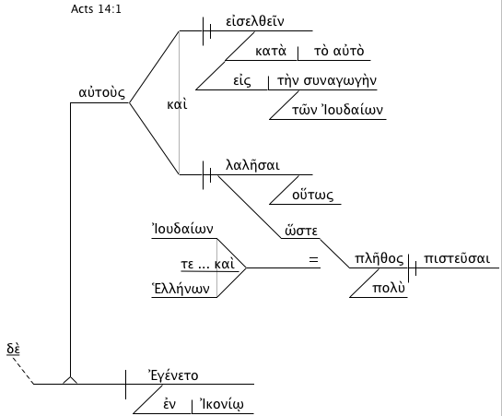
As we work through this verse I’ll add the following:
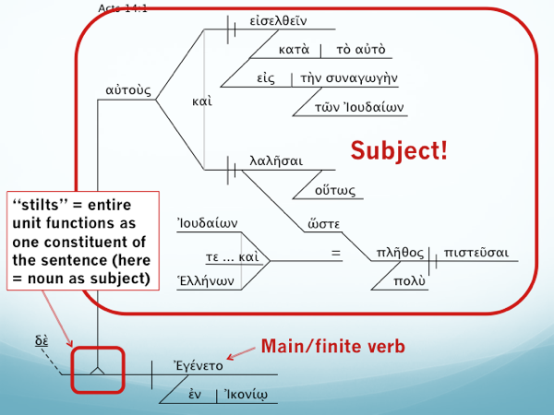
I don’t expect students to be able to create these diagrams in first year or in third semester, though I would if I taught the 4th semester which is an exegetical method class. (I’d also expect them to be able to do semantic phrasing.) But one of my colleagues teaches that class (and he also diagrams).
And BTW, a big thanks to Roy Brown of Accordance who has recently made some very helpful upgrades to the diagramming module in Accordance, and to Joel Brown for helping me troubleshoot my implementation of that module. You can see the results above.

