**https://academic.logos.com/the-meaning-of-words-part-1-words-and-concepts/**

**The meaning of words (Part 1): words and concepts**

March 10, 2017 by [paulhimes](https://academic.logos.com/author/paulhimes/) [13 Comments](https://academic.logos.com/the-meaning-of-words-part-1-words-and-concepts/#comments)



**Introduction**

A little knowledge can be a dangerous thing, especially when it comes to biblical words in the original Hebrew and Greek. Quite often preachers of God’s Word put too heavy a load on biblical words, expecting them to carry a major point of their sermon all on their own.

Yet the value of words lies not in their ability to create, in isolation, a new theological understanding, but rather in the fact that they contribute to sentences which then, in turn, alter our theological perception.

James Barr so painstakingly pointed this out over fifty years ago:



It is the sentence … which is the linguistic bearer of the usual theological statement, and not the word (the lexical unit) or the morphological and syntactical connection. Neither the Christian preaching nor the religious structure of ancient Israel … consisted primarily (if at all) in the issuing either of new words or of new word-concepts or of new conceptual ‘content’ for old words. The newness or uniqueness of the structure consisted rather in new combinations of words, in which it was often possible for the semantic value of the words to be changed only slightly or not at all, and for the new or distinctive concept to be indicated by the word-combination. (Barr, 2004, p.263)

Barr’s point is that the Apostles did not need to invent new words or create ex nihilo new additions to a word’s range of meanings in order to advance their new theological ideas based on the work of Jesus Christ. Such advancement was done at the sentence level, not the word level.

Barr may have somewhat overstated his case. We do not wish to downplay the impact, even the lexical impact, that the Gospel itself may have had on the Apostles as they strove to write down the sheer indescribable wonder of the Kingdom of God. Such words as δικαιοσύνη, at the very least, take on new significance and implication.

Occasionally even Paul, finding existing Greek words insufficient to convey a concept, may have created an entire word from scratch, e.g., θεόπνευστος, “God-breathed.” (The word does not appear anywhere in published Greek literature up through the first century except for Second Timothy, though it does appear within the Papias material embedded in Eusebius.)

Nonetheless, one should assume that the inspired writers of Scripture, far from manifesting a “Holy Spirit language” which infused hitherto unknown theological meanings into words, utilized instead the semantic ranges of their day while relying on combinations of words to transmit their radical theological ideas. That is, they used words in such a way that their audience—usually a mix of Hellenistic Jews and Gentiles, most of them probably possessing a working knowledge of at least the Greek Old Testament—could understand.

That the New Testament was written in the Koine (or “common”) Greek of the day is almost universally accepted. As my doctoral advisor David Alan Black aptly summarizes, “The New Testament writers do on occasion rise to the literary heights of the Atticists, but on the whole the language of the New Testament parallels so closely the language of the papyri that there can be no doubt that it was written in the same vernacular Koine Greek” (Black, 1995, p.161).

Words are the building blocks of the sentence and so deserve to be studied on their own. Yet all sorts of mistakes lie waiting to ambush the careless expositor, mistakes that are all the worse because they may actually sound good from the pulpit to those unfamiliar with the Greek language (e.g., the common statement that “The Lord loves a ‘hilarious’ giver,” based on ἱλαριός [2Cor 9:7](https://biblia.com/bible/esv/2%20Cor%209.7)). The classic manual for helping preachers and students avoid such mistakes is D. A. Carson, [*Exegetical Fallacies*](https://www.logos.com/product/6874/exegetical-fallacies-second-edition?utm_source=academic.logos.com&utm_medium=blog&utm_content=2017-03-10-himes-meaning-part1&utm_campaign=promo-logospro2017) (Grand Rapids, MI: Baker, 1984).

For anybody (like myself) who grew up in a foreign country speaking a second language, the question of how we know what words mean is not merely academic. Failure to understand how words work within our current social context will result in misunderstanding.

When it comes to handling God’s Word, there is an even greater danger that stems from the misuse of words, namely the danger of declaring “Thus saith the Lord” when, in fact, God has not spoken. The first half this discussion will focus on the difference between words and concepts, while the second half will introduce the reader to the idea of semantic range and how it interacts with context to determine meaning.

**Words and Concepts: What’s the Difference?**

The conflation of “word” and “concept” in the [*Theological Dictionary of the New Testament*](https://www.logos.com/product/8491/theological-dictionary-of-the-new-testament?utm_source=academic.logos.com&utm_medium=blog&utm_content=2017-03-10-himes-meaning-part1&utm_campaign=promo-logospro2017) was the chief foil of James Barr’s [*The Semantics of Biblical Language*](https://www.logos.com/product/47470/james-barr-collection?utm_source=academic.logos.com&utm_medium=blog&utm_content=2017-03-10-himes-meaning-part1&utm_campaign=promo-logospro2017).

Indeed, “The difficulty here is made much greater by what is one of the most irritating things about *TWNT*, the habit of the writers of saying ‘concept’ (*Begriff*) for the linguistic entity usually called a word” (Barr, 2004, p.210).

Modern scholars are sometimes guilty of the same mistake. For example, one of the most trusted modern systematic theologies states, “The word [πρόγνωσις] means more than simply having advance knowledge or precognition of what is to come. It appears to have in its background the Hebrew concept of ידע(yada), which often meant more than simple awareness. It suggested a kind of intimate knowledge—it was even used of sexual intercourse” (Erickson, 2004, p.382).

[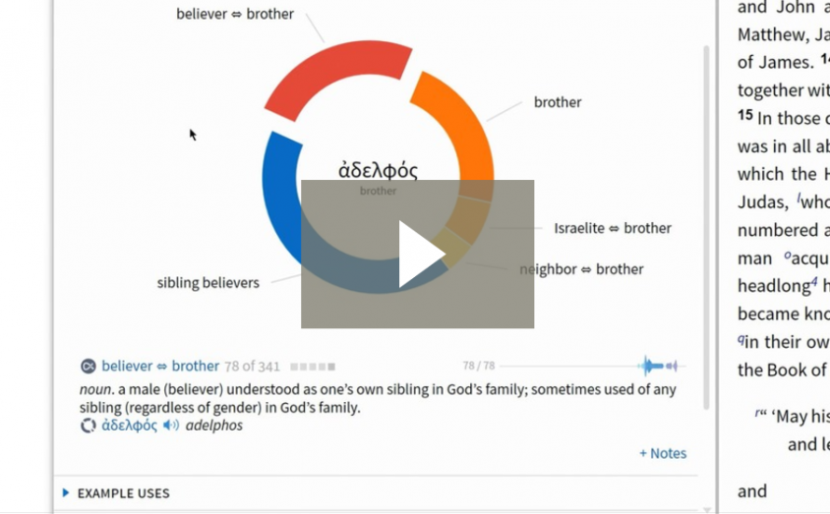](https://www.logos.com/logos-pro/sense-section)

Sense Section, a Logos Pro Tutorial

Yet there is no such thing as “the Hebrew concept of ידע” simply because “ידע” is a word, not a concept (and even Erickson shows awareness that this word points to different types of concepts, from “the state of possessing simple awareness of a person or object” to “the state of possessing intimate knowledge of somebody” to “engaging in sexual intercourse”).

It would have been more accurate to say, “The Hebrew word ידע can point to multiple concepts, including concepts which include more than simple knowledge. “By definition, “Concepts … are abstract entities” (Katz, 1972, p.38; cf. Church, 1951, pp.110-113).

I will take this a step further and suggest that “concepts are ideas, both abstract and concrete, which can be represented by words.” A concept cannot be tied down to a single word, because words change meaning over time while concepts are (if the reader will pardon some Platonic speculation) eternal in the mind of God.

In other words, the concept “a mode of transportation on four wheels that runs on gasoline designed to seat 1-6 passengers” is “out there” regardless of which word represents it, whereas words such as “automobile,” “car,” *kuruma* (Japanese), and *voiture* (French) are not inseparably tied to that concept, but may at a particular state of a language’s development point to that concept.

Already the astute reader will recognize just how “fuzzy” the relationship between word and concept becomes. The fact is, the concept “a mode of transportation on four wheels that runs on gasoline designed to seat 1-6 passengers” can be reflected in both the word “car” and the word “truck,” yet almost everybody would acknowledge that “cars” and “trucks” are two different things.

[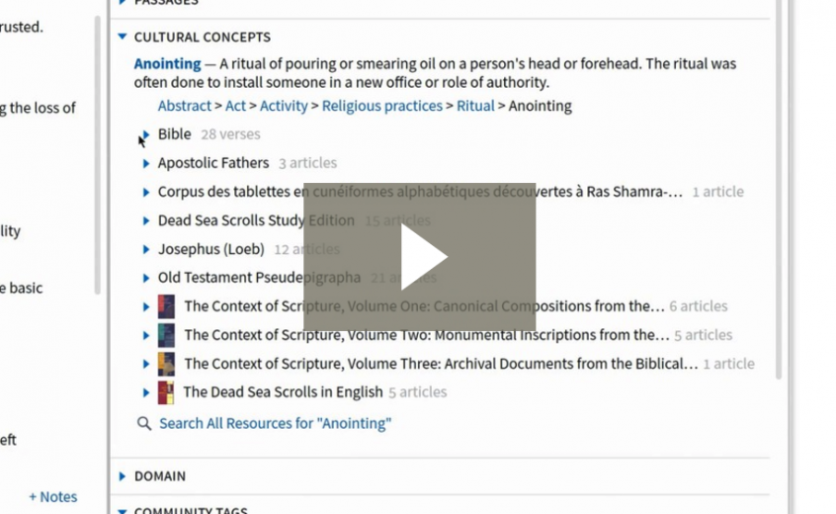](https://www.logos.com/logos-pro/cultural-concepts?utm_source=academic.logos.com&utm_medium=blog&utm_content=2017-03-10-himes-meaning-part1&utm_campaign=promo-logospro2017)

Cultural Concepts, a Logos Pro Tutorial

They may also point to other concepts in the same time period or may share the same concept with other words. As time progresses, the same word may cease pointing to one concept and point to another instead, making arguments based on etymology rather dangerous (more on this in the second post).

[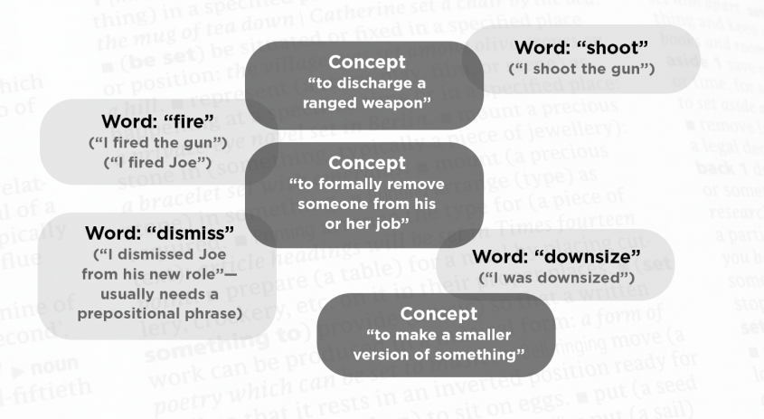](https://academic.logos.com/files/2017/03/image00-1-e1489005941973.png)

**Key Points**

In light of this discussion, here are two key points for the study of biblical words and concepts.

**One word, multiple concepts**

First, a *word* can point to multiple concepts, but usually not all at once. In my hermeneutics class, I have my students think of all the possible meanings of the English word “play” (just the verb), and they are usually able to come up with a minimum of six, sometimes more.

So “play” can mean “take part in a formal dramatic production” (e.g., “I played Hamlet in the college production”) or “participate in a structured athletic competition” (“He played football in high school”) or simply “to casually amuse oneself” (“go outside and play”).

Very rarely are any of those meanings implied at the same time. Playing Hamlet in the college dramatic production generally does not involve an athletic competition (though which of us would not pay good money to see Shakespeare combined with football?). Furthermore, playing in a football game may involve the opposite of amusement, especially when one is injured!

The point is that when we use a word, we usually only have one meaning in mind—the exceptions are those infamous puns, double entendres, and occasional deliberate ambiguities. When we give people the impression that a particular word has a whole bunch of meanings all at the same time, we are committing what is commonly referred to as the “illegitimate totality transfer” fallacy.

Likewise, when a biblical author uses a word, he almost certainly intends the reader to understand only one concept (though we cannot rule out occasional deliberate ambiguity).

**One concept, many words**

Secondly, on the other side of the coin, if you’re studying a *concept* in the Bible, you need to understand all the words and expressions that can point to that concept. In other words, you cannot claim to have completed a study of “God’s affection for his people” if the only passages you study are those that contain ἀγάπη.

You would also have to study φιλέω (e.g., [John 16:27](https://biblia.com/bible/esv/John%2016.27)), as well as passages where neither ἀγάπη nor φιλέω occur but God’s love is still clearly being evidenced, such as Jesus’ death on the cross. As David Alan Black warns, “A theological concept cannot be discussed in an article about a single word” (Black, 1995, p.123).

So how, then, do we figure out what words mean? That will be the focus of the second post, as we look at “context” and “semantic range.”

[](https://academic.logos.com/files/2017/03/0-copy.jpg)

*Paul Himes is professor of Bible and Ancient Languages at Baptist College of Ministry (Menomonee Falls, WI). He received his Ph.D. in New Testament in 2014 under Dr. David Alan Black at Southeastern Baptist Theological Seminary. He is the author of* [Foreknowledge and Social Identity in 1 Peter](http://www.amazon.com/dp/B00OU6YCBS?tag=3755-20) *(Pickwick, 2014).*

**Bibliography**

Barr, J. (2004) *The Semantics of Biblical Language*, reprint. Eugene, OR: Wipf & Stock.

Black, D. A. (1995)[*Linguistics for Students of New Testament Greek*](https://www.logos.com/product/42780/linguistics-for-students-of-new-testament-greek-a-survey-of-basic-concepts-and-applications?utm_source=academic.logos.com&utm_medium=blog&utm_content=2017-03-10-himes-meaning-part1&utm_campaign=promo-logospro2017), 2nd ed. Grand Rapids, MI: Baker.

Church, A. (1951) “The Need for Abstract Entities,” *American Academy of Arts and Sciences Proceedings* 80, pp. 100-112. Reprinted as Church, A. (2001) “Intensional Semantics,” pages 61-68 in *The Philosophy of Language*, ed. A. P. Martinich, 4th ed. New York: Oxford University Press.

Erickson, M. J. (2004) [*Christian Theology*](https://www.logos.com/product/43191/millard-j-erickson-collection#001?utm_source=academic.logos.com&utm_medium=blog&utm_content=2017-03-10-himes-meaning-part1&utm_campaign=promo-logospro2017), 2nd ed. Grand Rapids, MI: Baker.

Katz, J. J. (1972) *Semantic Theory.* New York: Harper & Row.

**https://academic.logos.com/the-meaning-of-words-part-2-context-and-semantic-range/**

**The Meaning of Words, Part 2: Context and Semantic Range**

March 31, 2017 by [paulhimes](https://academic.logos.com/author/paulhimes/) [15 Comments](https://academic.logos.com/the-meaning-of-words-part-2-context-and-semantic-range/#comments)



*This is the second of a two-part series on words and their meanings.*[*1*](https://academic.logos.com/the-meaning-of-words-part-2-context-and-semantic-range/#easy-footnote-bottom-1)[*Part 1*](https://academic.logos.com/the-meaning-of-words-part-1-words-and-concepts/)*discussed the difference between “words” and “concepts.” In Part 2 we will examine the interaction of “context” (the words surrounding a particular word) with “semantic range” (the complete gamut of how a word is being used by the speakers of a particular language at a particular point in time).*

**Introduction**

“*When I use a word*,” Humpty Dumpty said, in a rather scornful tone, “it means just what I chose it to mean—neither more nor less.” “The question is,” said Alice, “whether you *can* make words mean so many different things.” “The question is,” said Humpty Dumpty, “which is to be master—that’s all.”[2](https://academic.logos.com/the-meaning-of-words-part-2-context-and-semantic-range/#easy-footnote-bottom-2)

“Context is king” runs the common mantra in biblical studies, and to a certain degree this is true. Yet the “king” cannot rule without some sort of legitimization from the people, and that’s where “semantic range” comes in. If “context is king,” then “semantic range is parliament,” for semantic range represents the will of the people.

In other words, language is a *social* construct.[3](https://academic.logos.com/the-meaning-of-words-part-2-context-and-semantic-range/#easy-footnote-bottom-3)

Consequently, without denying the existence of idiolect,[4](https://academic.logos.com/the-meaning-of-words-part-2-context-and-semantic-range/#easy-footnote-bottom-4) anybody who wishes to communicate must make sure that how they use a word has at least *some* overlap with how their dialogue partner uses it.

**Individual Lexicons**

I will illustrate this with two examples from the adventures of a former missionary to Japan (one quite talented in language!) who is very dear to me (and granted permission for these stories to be posted).

In the first example, this missionary was preaching on Jesus’ statement “I am the Light of the world.” To illustrate, he spoke of spelunking during his college days, noting how dark it was in a cave without a light, how easy it was to get lost in a cave (even when he and his friends had a map), etc.

Confused expressions greeted him, for rather than using the word *hora-ana* (“cave”), he accidentally used the word *ana-guma* (“badger), thus regaling a dazed audience with tales of how, in his college days, he would get lost exploring the insides of a badger, despite having a map of the insides of the badger, etc. Obviously, context was not enough to prevent miscommunication.



In the second example, the missionary had both context and etymology on his side, but to no avail. Attempting one day to witness to a lady, who had a young boy with her, the missionary endeavored to make friends with the young boy, who was clearly scared of the foreigner. Gesturing at the young boy, the missionary attempted to say, “He seems not to like me” by combining the word for “dislike” (*ya*) with the adjective for “seems to be” (*ra-shii*).

Unfortunately, when combined in such a manner vocally, the resulting word was radically different and did not possess “seems to dislike” as part of its semantic range. What the missionary said to the horrified lady was, “He seems to be morally repugnant.” The lady stalked away in shock, much to the missionary’s confusion.

**What of Context?**

In other words, *context is not enough* to facilitate clear communication, if in fact a word is not being used in accordance with how others use it. The assertion that “Context is King,” then, is *in and of itself* insufficient. As E. D. Hirsch states,

It is sometimes said that ‘meaning is determined by context,’ but this is a very loose way of speaking. It is true that the surrounding text or the situation in which a problematical word sequence is found tends to narrow the meaning probabilities for that particular word sequence; otherwise, interpretation would be hopeless. And it is a measure of stylistic excellence in an author that he should have managed to formulate a decisive context for any particular word sequence within his text. But this is certainly not to say that context determines verbal meaning. At best a context determines the guess of an interpreter (though his construction of the context may be wrong, and his guess correspondingly so). To speak of context as a determinant is to confuse an exigency of interpretation with an author’s determining acts. *An author’s verbal meaning is limited by linguistic possibilities but is determined by his actualizing and specifying some of those possibilities*.[5](https://academic.logos.com/the-meaning-of-words-part-2-context-and-semantic-range/#easy-footnote-bottom-5)

From a slightly different perspective, [NT scholar Daniel Wallace](https://www.logos.com/products/search?q=daniel+wallace&Author=2951%7cDaniel+B.+Wallace&redirecttoauthor=true?utm_source=academic.logos.com&utm_medium=blog&utm_content=2017-03-31-meaning-of-words-part2&utm_campaign=promo-logospro2017) aptly states, “Often linguists say that the word being examined should have the meaning of ‘X’ with ‘X’ being only what one can determine from the context. But this is an unreasonable demand on any word. If *every word* in a given utterance had the meaning ‘X’ then we simply could not figure out what any utterance ever meant.”[6](https://academic.logos.com/the-meaning-of-words-part-2-context-and-semantic-range/#easy-footnote-bottom-6)

When we examine a sentence, then, each word is not a blank slate, “x,” to be filled with whatever context demands of it. Rather, each word has, at that moment of time, a number of concepts that it can point to *based on how people are, at that moment, using the word*. Furthermore, the concepts the word reflects, as well as the very form of the word, may change over time. This is why etymology should not be relied on except in rare circumstances.

[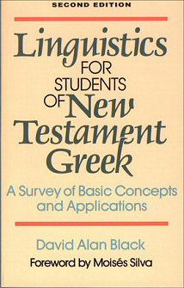](https://www.logos.com/product/42780/linguistics-for-students-of-new-testament-greek-a-survey-of-basic-concepts-and-applications?utm_source=academic.logos.com&utm_medium=blog&utm_content=2017-03-31-meaning-of-words-part2&utm_campaign=promo-logospro2017)

Consequently, communication can only occur when substantial overlap exists between how one person uses a word and how another person uses a word. Context will delineate which of the possible meanings is the correct one.[7](https://academic.logos.com/the-meaning-of-words-part-2-context-and-semantic-range/#easy-footnote-bottom-7) Yet if neither of them are drawing from the possible meanings of the semantic range reflected in that language (or at least that particular dialect), miscommunication occurs.

**Enter Semantic Range**

Consider the following sentence: “Little Jimmy has been getting quite good at the violin. Do you want to come see him play in tomorrow night’s performance?” Now, the average speaker of English will be fully aware that “play” has multiple meanings, but can there be any doubt what the word means in this context? The word “violin” and the expression “tomorrow night’s performance” both make it clear that Little Jimmy is not throwing a football or sitting down to a friendly game of monopoly.

Yet, on the other hand, what would happen if in the above sentence the speaker replaced the word “play” with “belch”? The listener would most likely be confused and ask for clarification (or flee away in horror), simply because the word “belch” is not a word associated with the structured performance of musical instruments (at least not in the kind of concerts I’m familiar with!). We cannot force the word “belch” to mean what people usually mean by “play.” Despite what Humpty Dumpty claimed, it is the masses, not the individual, that determines the meanings of words.

In other words, when we have conversations with other people, we usually try to use words in such a way that they will understand. Exceptions do exist, especially in poetry, and since words do change meaning it is clear that somebody, somewhere, had to try something new; language is not static. For a fascinating discussion of this very point, see Peter J. Leithart’s book, [*Deep Exegesis: The Mystery of Reading Scripture*](https://www.logos.com/product/30089/deep-exegesis-the-mystery-of-reading-scripture?utm_source=academic.logos.com&utm_medium=blog&utm_content=2017-03-31-meaning-of-words-part2&utm_campaign=promo-logospro2017)*.*[8](https://academic.logos.com/the-meaning-of-words-part-2-context-and-semantic-range/#easy-footnote-bottom-8)

[](https://www.logos.com/product/30089/deep-exegesis-the-mystery-of-reading-scripture?utm_source=academic.logos.com&utm_medium=blog&utm_content=2017-03-31-meaning-of-words-part2&utm_campaign=promo-logospro2017)

Nonetheless, radical semantic change is slow and not easily detectable within small periods of time—we *usually* do not wake up one morning to realize that “professor” has suddenly become slang for “communist infiltrator.”

**Bible Study and Semantic Range**

So how does this practically affect our study of words in the Bible? First of all, serious study should not overly rely on lexicons at the expense of the literature of *Koine* Greek. As John A. L. Lee has convincingly demonstrated, too often lexicons do not conduct original research but merely repackage the work of those that have gone before.[9](https://academic.logos.com/the-meaning-of-words-part-2-context-and-semantic-range/#easy-footnote-bottom-9) Obviously lexicons are helpful tools; my point is that they are not infallible.

Secondly, in order to understand a word’s semantic range, its use in *Koine* should be examined in the following order: 1. the NT itself; 2. the Septuagint; 3. Josephus; 4. other 1st century writers such as Philo, Plutarch, and the various papyri (if you have access to how a word is used in the papyri, this should trump Plutarch and other “fancier” writers since the papyri represents how the common man and woman of the day spoke and wrote).



After the NT, the LXX and Josephus take priority simply because they represent Jewish authors writing in Greek about biblical matters, and thus can be expected to possess significant parallels with the NT authors. Furthermore, as far as the LXX goes, we have to assume that the apostles had thoroughly immersed themselves in both its message and terminology.

Consequently, when the Apostle Paul speaks of Jesus as our ἱλαστήριον ([Rom 3:25](https://biblia.com/bible/esv/Rom%203.25)), one should naturally expect that he wished to invoke images of the actual physical Mercy Seat in the OT tabernacle, which is almost exclusively how the word is used in the LXX (cf. also [Heb 9:5](https://biblia.com/bible/esv/Heb%209.5)).[10](https://academic.logos.com/the-meaning-of-words-part-2-context-and-semantic-range/#easy-footnote-bottom-10)

**Semantic Range and Context**

Yet although one should look at semantic range *in addition* to context in order to determine meaning, ironically one cannot understand the semantic range of a particular word in the Bible without looking at its use in various *other* contexts. Yet when looking at a particular context, the reader should already know the semantic ranges of *most* of the words in order to understand the meaning of a particular word.

Occasionally, a sentence will be too difficult to puzzle through precisely because the reader does *not* know the semantic ranges of words or the significance of specific syntactical constructions. Consequently, when learning both written and vocal languages, one must always work from the *simpler* to the *more complex*, gaining insight as one continues to immerse oneself in the language.

This can be illustrated with a “tourist” analogy. At the most primitive level of communication, a completely lost foreigner looking for the train station in Tokyo would probably not (contrary to popular perception) resort to raising his voice, but rather to gestures imitating a train (“charades”).

Having established, through the use of gestures, that “train” is *densha*in Japanese, he can now make educated guesses as to the words surrounding *densha* in a sentence, especially those words that occur frequently in simple contexts. Some of his guesses will be wrong, but his guesses will improve the more he is immersed in the language. As his understanding of the meaning of both words and sentences improves, so will his ability to make educated guesses regarding the meaning of new words within different contexts.

Furthermore, his guesses will be more likely to be correct in simpler sentences than in complex sentences. After all, the English word “car” would be more easily understandable to a non-native speaker in the sentence “The car was in an accident” (accompanied by gestures) than “Tony Stewart short-shifted his car while expertly slipstreaming past the lead.”[11](https://academic.logos.com/the-meaning-of-words-part-2-context-and-semantic-range/#easy-footnote-bottom-11) So, when examining how a word is used in a particular biblical text, how a word is used elsewhere in simpler and non-controversial texts is better evidence than how a word is used in complex and murkier texts.

Thus, the more comprehensive one’s grasp of the language (i.e., semantic ranges and syntactical constructions), the more likely somebody can determine from a specific context the meaning of a particular word. Both a knowledge of context and semantic range are necessary; once again, if “context is king,” then “semantic range is parliament.”

**Goodbye Etymology?**

Since we are relying on semantic range and context to determine meaning, very rarely do we have to worry about etymology, the history of a word. Etymology simply does not factor into the way society normally uses language. For example, as a baby develops and learns the meanings of words, he or she does not do so based on an inherent knowledge of the history of a word,[12](https://academic.logos.com/the-meaning-of-words-part-2-context-and-semantic-range/#easy-footnote-bottom-12) but rather based on *how people in the same room are using the word!*[13](https://academic.logos.com/the-meaning-of-words-part-2-context-and-semantic-range/#easy-footnote-bottom-13)

To be sure, a baby experiences trial and error: “da-da” may alternately refer to a toy truck, an older sister, or even the family dog before the baby “gets it right.” At no point in the development of a child, however, does he or she stop and think, “I will use this word based on how the word was morphologically constructed 500 years ago.” Generally speaking, neither do adults.

Having said that, etymology can be helpful in two cases. First, “The etymology of a word may help to determine its meaning, but only if it can be demonstrated that the speaker was aware of that etymology.”[14](https://academic.logos.com/the-meaning-of-words-part-2-context-and-semantic-range/#easy-footnote-bottom-14) Secondly, for extremely rare words or words such as θεόπνευστος which appears nowhere else in Greek literature prior to the 2 Timothy, etymology may be our only clue as to its meaning.[15](https://academic.logos.com/the-meaning-of-words-part-2-context-and-semantic-range/#easy-footnote-bottom-15)

**Compound Word Fallacy**

Notwithstanding rare examples such as θεόπνευστος, a corollary to the etymological fallacy is the idea that a compound word automatically has the same semantic range as the combination of the meanings of the two words it derived from. Granted, obviously there will be a connection. Yet with compound words, the whole is not equal to the sum of its parts.

In other words, προστρέχω, for example, should not be understood as: “=[semantic range of πρός] + [semantic range of τρέχω],” as if the compound word would *automatically* have the meaning of “running in accordance with something” instead of “running up to someone or something.”[16](https://academic.logos.com/the-meaning-of-words-part-2-context-and-semantic-range/#easy-footnote-bottom-16) As Turner and Cotterell state, “We should not, however, be beguiled . . . into thinking that compound lexemes always are, or even usually, bear a meaning that is little more than a summation of the separate meanings of the elements of which the word is composed.”[17](https://academic.logos.com/the-meaning-of-words-part-2-context-and-semantic-range/#easy-footnote-bottom-17) Compound words must be studied in their own right, not on the basis of their morphology.[18](https://academic.logos.com/the-meaning-of-words-part-2-context-and-semantic-range/#easy-footnote-bottom-18)

**Summary**

In summary:

1. Words and concepts are different, and their relationship will change over time
2. A single word can point to different concepts at different times (rarely at the same time)
3. Multiple words can point to the same concept (which means you need to study more than one word to understand a concept)
4. Both a knowledge of semantic range (how a word is used elsewhere) and context are key to determining meaning
5. Etymology can be helpful but should only be used as a last resort in determining meaning.

One final point for the linguistically-inclined (or any “gluttons for punishment”). Language is fluid, and as we pointed out earlier, there are some brave souls who will use words in ways they haven’t been used before. In other words, as Relevance Theory points out regarding the interrelation between words and concepts, these relationships may be somewhat modified on the fly to create what Robyn Carston calls an “*ad hoc* concept.”[19](https://academic.logos.com/the-meaning-of-words-part-2-context-and-semantic-range/#easy-footnote-bottom-19)

So, anybody can, in theory, utilize words to create a new concept for the listener or hearer (by “new” I mean “one which the reader had not thought of before”). Carston gives the example of somebody who uses the expression “Ken’s a (real) *bachelor*,” which would not point to the normal meaning of “bachelor” as simply an unmarried man, but rather to a different concept, that of a particular lifestyle.[20](https://academic.logos.com/the-meaning-of-words-part-2-context-and-semantic-range/#easy-footnote-bottom-20)

Furthermore, an author may use a word in an unfamiliar way and then use multiple words to explain what he or she means, or even introduce a totally new concept to somebody with multiple words, and then associate that concept with a specific word or phrase (e.g., Paul Bloom gives us the excellent example of teaching somebody who is not a hockey fan the meaning of “hat trick”).[21](https://academic.logos.com/the-meaning-of-words-part-2-context-and-semantic-range/#easy-footnote-bottom-21)

No doubt this happens in the NT, but it is not the word itself which introduces a radically new concept, but the explanation surrounding the word. This, then, brings us back full circle to Barr’s point: theology is generally performed at the sentence level, not the word level.

**Suggested Readings**

Thanks again for reading my posts on The Meanings of Words, part 1 and part 2. If you want to learn more, here is a list of suggested readings:

Barr, James. [*The Semantics of Biblical Language*](https://www.logos.com/product/47470/james-barr-collection?utm_source=academic.logos.com&utm_medium=blog&utm_content=2017-03-31-meaning-of-words-part2&utm_campaign=promo-logospro2017). Reprinted. Eugene, OR: Wipf&Stock, 2004.

Black, David Alan. [*Linguistics for Students of New Testament Greek: A Survey of Basic Concepts and Applications*](https://www.logos.com/product/42780/linguistics-for-students-of-new-testament-greek-a-survey-of-basic-concepts-and-applications?utm_source=academic.logos.com&utm_medium=blog&utm_content=2017-03-31-meaning-of-words-part2&utm_campaign=promo-logospro2017). 2nd ed. Grand Rapids, MI: Baker, 1995.

Bloom, Paul. *How Children Learn the Meaning of Words*. Cambridge, MA: MIT Press, 2000.

Carson, D. A. [*Exegetical Fallacies*](https://www.logos.com/product/6874/exegetical-fallacies-second-edition?utm_source=academic.logos.com&utm_medium=blog&utm_content=2017-03-31-meaning-of-words-part2&utm_campaign=promo-logospro2017). Grand Rapids, MI: Baker, 1984.

Cotterell, Peter, and Max Turner. *Linguistics and Biblical Interpretation*. Downers Grove, IL: InterVarsity, 1989. (Note: if you could only afford one book on this list, I would recommend Cotterell and Turner over the others (with a close second being Black, *Linguistics for Students of New Testament Greek*).

Carston, Robyn. *Thoughts and Utterances: The Pragmatics of Explicit Communication*. Malden, MA: Blackwell, 2002.

Green, Gene L. “Lexical Pragmatics and Biblical Interpretation.” *Journal of the Evangelical Theological Society* 50 (2007): 799-812.

_______. “Lexical Pragmatics and the Lexicon.” *Bulletin for Biblical Research* 22 (2012): 315- 333.

Gutt, Ernst-August. *Relevance Theory: A Guide to Successful Communication in Translation*. Dallas, TX: Summer Institute of Linguistics, 1992.

Hirsch, E. D., Jr. *Validity in Interpretation*. New Haven: Yale University Press, 1967.

Lee, John A. L. *A History New Testament Lexicography*. Studies in Biblical Greek 8. New York: Lang, 2003.

Leithart, Peter J. [*Deep Exegesis: The Mystery of Reading Scripture*](https://www.logos.com/product/30089/deep-exegesis-the-mystery-of-reading-scripture?utm_source=academic.logos.com&utm_medium=blog&utm_content=2017-03-31-meaning-of-words-part2&utm_campaign=promo-logospro2017). Waco, TX: Baylor University Press, 2009.

Lyons, John. *Introduction to Theoretical Linguistics*. Cambridge: Cambridge University Press, 1968. Warning: of all the books listed here, Lyons is easily the most technical! Approach at your own risk!

Silva, Moisés. [*Biblical Words and Their Meaning: An Introduction to Lexical Semantics*](https://www.logos.com/product/41551/biblical-words-and-their-meaning-2nd-ed?utm_source=academic.logos.com&utm_medium=blog&utm_content=2017-03-31-meaning-of-words-part2&utm_campaign=promo-logospro2017). Revised and Expanded ed. Grand Rapids, MI: Zondervan, 1994.



*Paul Himes is professor of Bible and Ancient Languages at Baptist College of Ministry (Menomonee Falls, WI). He received his Ph.D. in New Testament in 2014 under Dr. David Alan Black at Southeastern Baptist Theological Seminary. He is the author of* [Foreknowledge and Social Identity in 1 Peter](http://www.amazon.com/dp/B00OU6YCBS?tag=3755-20) *(Pickwick, 2014).*