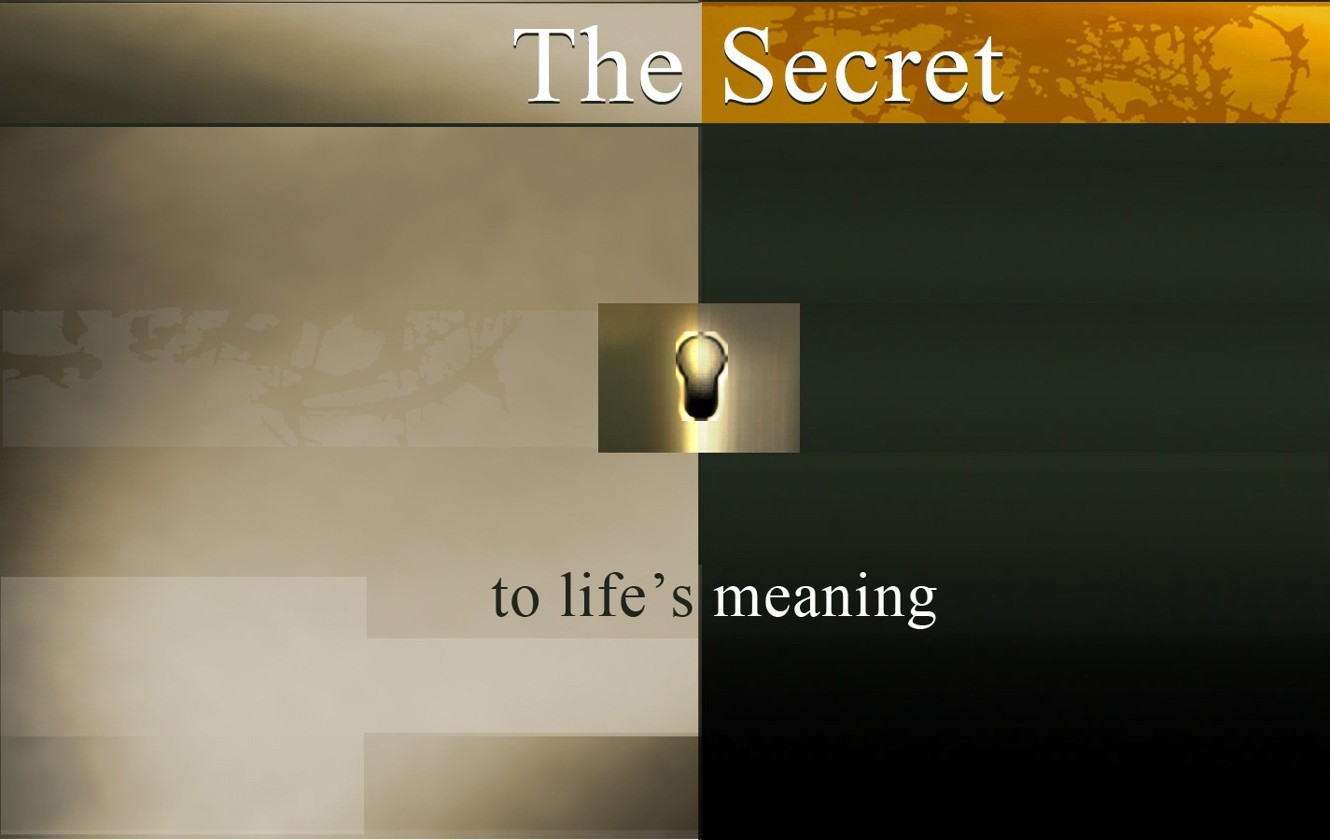

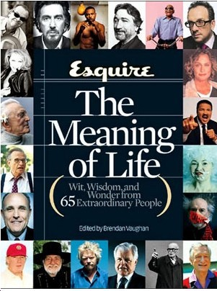
What is THE SECRET to life's meaning?

Some people think that the secret to having a successful and meaningful life is found in . . .
- Being rich
- Having a great job
- Being well--educated
- Having power
- Doing great things


These things aren't necessarily wrong, but they don't give
us true meaning and lasting happiness.

Why?

Because the secret to life's meaning is found in having a personal relationship with the God who created us.

The Bible explains how we can know God in a personal way . . .

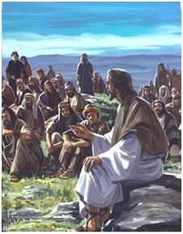
TRUTH 1: God Loves You

God really does love you, and He has shown this in the most dramatic way possible by sending His own Son, Jesus Christ, to earth.

"For God loved the world so much, that He gave His one and only Son, that whoever believes in Him should not perish but have eternal life." John 3:16

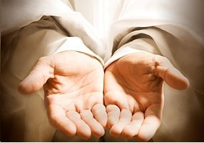
The eternal life God offers us is not only a life with Him forever, but also a rich and meaningful life now.
Jesus Christ said:
"I came that they might have life and that they might have it abundantly." John 10:10
We don't have to keep living like we have been. Our future can be different. Jesus can change us and give us a life worth living.
But first we must understand . . .

TRUTH 2: We All Have A Sin Problem

Because God is holy (without any sin), He cannot simply ignore our sin.


The Bible says:
"For all have sinned and fall short of God's glory." Romans 3:23
What is sin? Sin is anything we do that offends God's holy character. And in spite of our best efforts, we still fall short of God's perfect standards.

Religion

GOD

Being
Good Philo---
sophy

Man


Since we are all guilty of sin, this keeps us from having a personal relationship with God.
The Bible warns us:
"The wages of sin is death."
Romans 6:23
The wages-the return or penalty for
our sin-is "death," that is, the experience of spiritual separation from God. Eventually there is physical death and then separation from God for all eternity.
Fortunately God has an answer for our sin problem . . .

TRUTH 3: God's Answer is the Cross

God's answer to our sin problem was to send Jesus

Christ to die for our sins on the cross.
The Bible says:
"God demonstrates His own love toward us, in that while we were yet sinners, Christ died for us." Romans 5:8
GOD

MAN



This means Christ died in our place. Because the penalty for our sins has been paid, we can be forgiven.

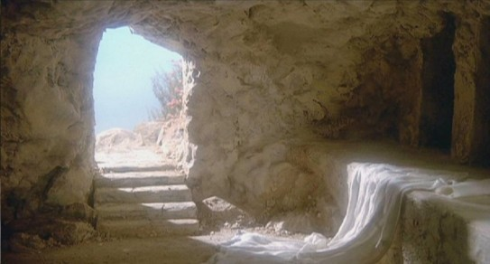
Afterwards Jesus was resurrected from the dead. This proves He is the Son of God and that His death was sufficient to pay for our sins.
In the Bible we read:
". . . that Christ died for our sins according to the Scriptures,
and that He was buried, and that He was raised on the third day according to the Scriptures."
1 Corinthians 15:3--4
What then does God ask us to do?


TRUTH 4: Faith is the Key

What God asks is that you believe in the Lord Jesus Christ, trusting that His death on the cross paid for your sins. When you do that, you receive eternal life as a gift.
The Bible says:
"For the wages of sin is death, but the gift of God is eternal life in Christ Jesus our Lord." Romans 6:23
You cannot get to heaven by trying to live up to God's holiness. But He is offering to forgive all your sin and to give you eternal life, if you will receive it as a free gift.


Because none of us deserves such a gift as this, the Bible describes God's offer as GRACE.
"For by grace are you saved through faith, and that not
of yourselves. It is the gift of God, not as a result of works,
so that no one can boast." Ephesians 2:8--9
We can do nothing but believe,
and God gets all the glory! Consider an illustration:




Imagine There Are Three People

Each one responds to God in a different way:
The first person rejects God. He either does not believe God exists or he has no interest in knowing God.
The second person believes God exists, but depends on his own efforts or in religion to work his way to God.
The third person realizes that he cannot work his way to God and trusts in Christ alone to save him by grace.

God
God
God

Self
1

Self
2
Self---Effort
or Religion

3

Self
Faith in Christ alone


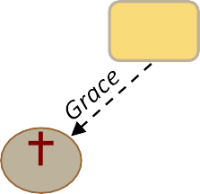
The third circle is God's plan. This is the secret to life's meaning and a personal relationship with God.

Which circle represents your life?


Taking the Step of Faith

The following explains how you can begin a personal relationship with God by trusting Christ as your Savior.
You may wish to use the following suggested prayer as a way of expressing your faith in Christ (more
important than your words is the attitude of your heart):
"Lord Jesus, I believe You are the Son of God who died on the cross for my sins and rose again. As of this moment, I am trusting in You-and You alone-as my Savior and only hope of my sal--vation. Thank You for forgiving me and giving me the promise of eternal life. Help me become what You want me to be. Amen."


If you trusted Christ as your Savior just now, you have taken the most important step you will ever take in your life. You have entered God's family and have become His child.
The Bible says,
"But as many as received Him
-who believed in His name-to them He gave the right
to become children of God."
John 1:12

Since God cannot lie, you can count on His promise to you!

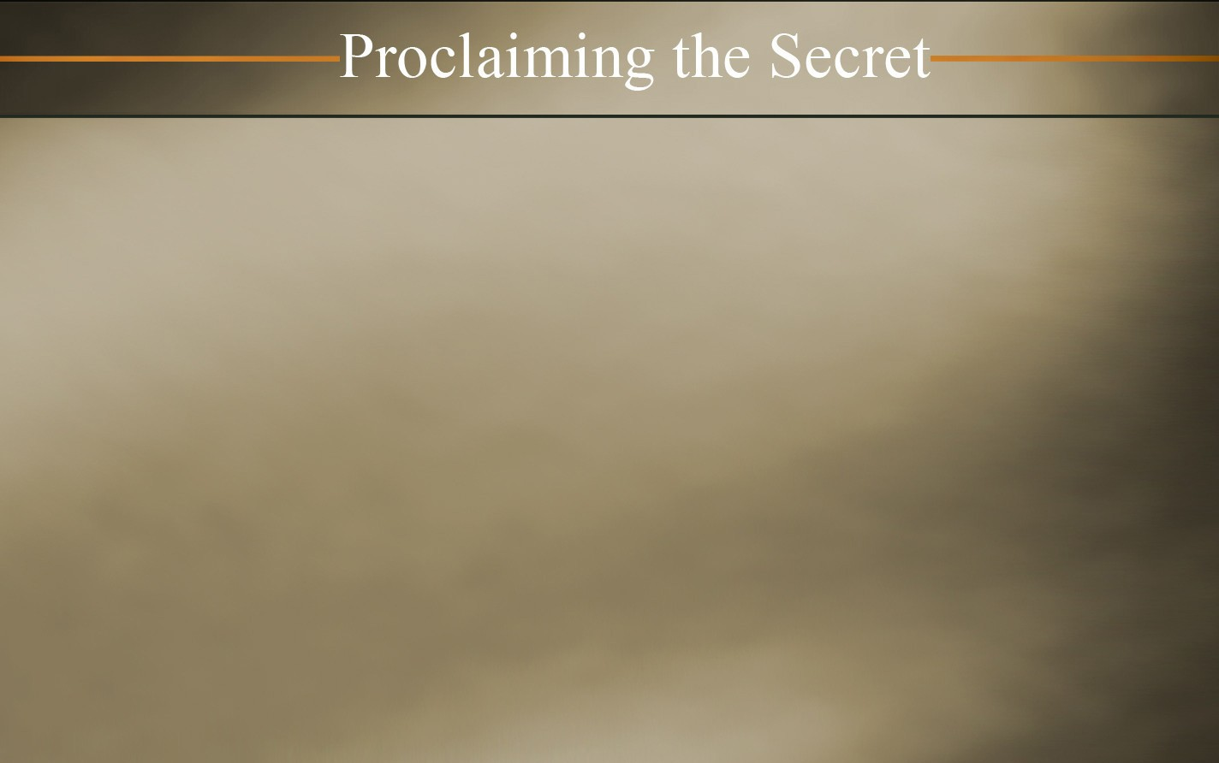

Once you receive God's gift of eternal life, there are two important steps for you to take in your new life as a disciple of Christ. First, to begin growing spiritually, find a Bible--believing church near you where you can worship with other believers. Second, contact us at Proclaiming the Secret, so we can send you a free booklet to help you grow in Christ.

Email: info@proclaimingthesecret.org
Please visit our website at: www.proclaimingthesecret.org

© 2011 by Proclaiming the Secret
Cover Design by Graphics

