Towards a Shared Land Theology
A Response to the Presentation by Rev Dr Munther Isaac
Singapore Bible College, 17 July 2019
Download this handout and PPT 25 at the Future (Eschatology) link at BibleStudyDownloads.org

In an academic world of theological abstractions devoid of real application to life, Dr Isaac has produced a paper that certainly strikes the heart. He does not discuss the biblical land from an ivory tower but from the realities of his ancestors living in the land for generations. As a fellow scholar-pastor-director, we have much in common.

Definitions

What is a “Christian Zionist”? Is anyone who believes in a future for Israel therefore considered by this term that Dr Isaac uses in a negative sense? He does not define the term, though perhaps he defines it denoting in his reference in the fourth paragraph as one who believes the “simplistic notion that the Bible asserts that ‘God gave the promised land to the Jewish people as an eternal possession.” He implies that one who takes this quote from Genesis 17:8 at face value therefore deserves the Christian Zionist label.

What is a Palestinian? Is Dr Isaac claiming a genealogical connection to the Canaanite people that Joshua uprooted? Likely not. He does not define his term.

The land was renamed Palestina by the Romans from AD 135-390 following the Second Jewish Revolt. Before that, for 1600 years it was called Israel or Judah. Emperor Hadrian called the land of Israel “Palestina” to link it to the Philistines, even though the Philistines disappeared from the land eight centuries earlier in 700 BC. Israelites had possessed this land from about 1500 BC, long before the Philistine migration from Crete in the 12th century BC.

So what, then, is a Palestinian? History shows that various Arab peoples intermarried and moved into this land centuries after Joshua conquered the land. These Arabs have adopted the second-century AD Roman designation as “Palestinians.”

Even if Palestinians did descend from the pre-Conquest people of the land, Genesis 15:16-21 is clear that God uprooted these people due to their sin: “’In the fourth generation your [Abram’s] descendants will come back here, for the sin of the Amorites has not yet reached its full measure.’ When the sun had set and darkness had fallen, a smoking firepot with a blazing torch appeared and passed between the pieces. On that day the Lord made a covenant with Abram and said, ‘To your descendants I give this land, from the river of Egypt to the great river, the Euphrates—the land of the Kenites, Kenizzites, Kadmonites, Hittites, Perizzites, Rephaites, Amorites, Canaanites, Girgashites and Jebusites.’”

Responses to Dr Isaac’s Arguments

Arguments of Dr Isaac are numbered below with my response to each.

The Land Belongs to God.

Indeed, the whole Cosmos belongs to God. This is not in dispute. Therefore, God told Israel not to sell it to other Jews, let alone to Gentiles (Lev 25).

Yet as the rightful Owner, God is free to assign any people the place he chooses (Acts 17:26). He chose Israel for this land—and he also chose to give 80 times as much land to the Arab peoples. This is his sovereign choice.

What Were the Boundaries of the Promised Land?

The boundaries are specified in Genesis 15:18 where God says, “On that day the Lord made a covenant with Abram and said, ‘To your descendants I give this land, from the river of Egypt to the great river, the Euphrates.’” The contrast between the “river of Egypt” and the “great river” leads us to believe that the former refers to the Wadi (seasonal stream) of Egypt, not the Nile. Certainly the Nile, the longest river in the world, would not be simply deemed a “river” in contrast to the “great river Euphrates.”

Did Israel ever live in a territory this large? No, but that does not mean that it was not gifted by God. Dr Isaac notes that it “is essentially a promise of the ancient world as Abraham knew it.” However, the text is not so flexible. It explicitly denotes that the land promised to the Jewish people does not include Egypt, the Hittite Kingdom (modern Turkey), or Mesopotamia. God says regarding the return of Messiah, “In that day the LORD will thresh from the flowing Euphrates to the Wadi of Egypt, and you, O Israelites, will be gathered up one by one” (Isa 27:12).

Can God give more than he promised? Indeed, since he is God. Dr Isaac aptly notes verses that show that Israel’s future role in God’s plan has a universal thrust. However, this does not mean that he will not also fulfill his original promise of land from the Wadi of Egypt to the Euphrates.

The Land Has Demands.

Dr Isaac rightfully notes that Israel could not remain in the land apart from holiness and true worship. Thus, God expelled Israel for its injustice and idolatry.

But does this mean that God has canceled his promise to give the land to Abraham’s descendants as an eternal possession (Gen 17:8)? No. It means that Israel will not possess the full land apart from trusting in the Messiah.

Inheritance—Forever?

Dr Isaac notes that “eternal promises can indeed be ‘revoked’ by God” (p. 7) since God’s promise includes responsibility and accountability.

This means the entire land will not be possessed by a godless Israel. Only the nation trusting in Jesus will possess the land eternally. But God promises that such a faithful nation will happen when they will look on the One they pierced and repent of killing him (Zech 12:10). Israel’s trust in the Lord Jesus will come out of a difficult 7-year Tribulation period preceding the return of Christ:
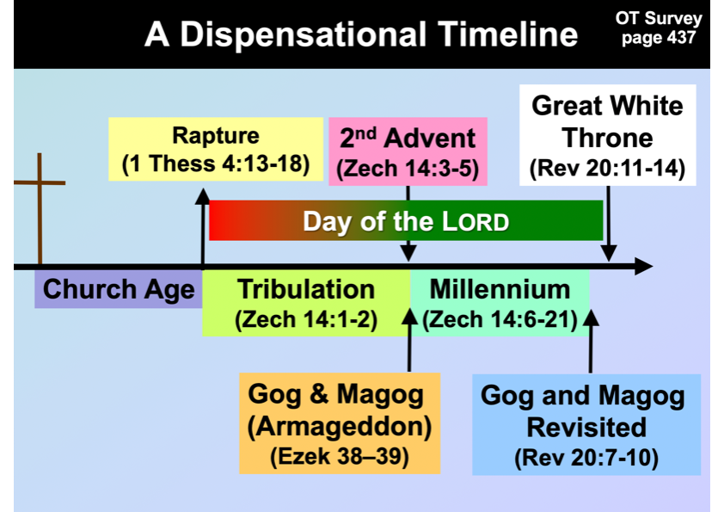

Who is Israel in the Bible?

Dr Isaac claims that God electing the ethnic descendants of Jacob to be Israel would make him a racist (p. 7). Wow. I have never heard such an accusation of God electing a nation on genealogical grounds. Can the pot tell the Potter who he is supposed to choose (Rom 9:20-21)? Besides, throughout the OT, God certainly is not racist, for we see God extending his grace to others who can join with Israel—Egyptians in the Exodus with Israel, Caleb the Kenite, Rahab the Jebusite, Ruth the Moabite, etc.

Certainly, ethnic descent is insufficient for salvation in the OT, for many Jews became idolaters and certainly were not saved. However, they were still Jews. They were just unsaved, godless members of Israel.

Dr Isaac rightfully claims, based on the example of Ruth, that Gentiles who trust in Jesus therefore became part of Israel since God accepts Gentiles by faith (p. 8). This certainly was true in the OT where Gentiles could be part of ethnic Israel. However, we do not see this in the NT where the church has no ethnic dimensions, being composed of Jews and Gentiles (Gal 3:28). Yet note that these are still Jews and Gentiles. It’s just that they are members together in the church, despite their differences. The same is true of Paul’s other contrasts: slave and free are both equal in the church but slaves did not immediately become free at salvation, men and women are equal as to salvation despite their many other differences, etc.

What promise did Gentiles receive as Abraham’s seed (Gal 3:29)? It is not the land, as this would put over a billion Christians in Israel! The context in 3:14 and the entire Galatian letter shows that “(1) Gentiles might receive the blessing given to Abraham; as already stated (3:8) this is a reference not to personal or national blessings but to the promised blessing of justification apart from works of the Law, available to all who believe; (2) all who thus believe might receive the promise of the Spirit, that is, the Holy Spirit, who was promised (cf. v. 2).”

Dr Isaac notes that by the Day of Pentecost, Jews had become “a multiethnic religion” since “there were devout Jews from every nation under heaven living in Jerusalem” (Acts 2:5). They also spoke their “own native language.” But mother tongue is not the same as ethnicity. And one’s geographical place of living does not define one’s ethnicity. Our world today has Japanese Peruvians whose ethnicity is Japanese, yet who speak Spanish instead of Japanese. Overseas Chinese often cannot speak Mandarin, but they are still ethnically Chinese. We must not confuse nationality with mother tongue and the place one lives. I have lived in Singapore for 28 years but am still a Caucasian American.

In short, the word “Israel” appears over 600 times in the Bible, but never once refers to a person without a genealogical connection to Abraham and Jacob—except those proselytes who left their Gentile background and incorporated into the nation of Israel. After all, God changed Jacob’s name to Israel, so it makes sense that his offspring would bear his name—whether godless or godly, all were still Israelites.

Is there a prophetic future for Israel taught in the Bible? Or has God fulfilled all of his promises to the ethnic descendants of Jacob? The OT has dozens of verses that claim that God will restore Israel to their ancient land. For example…

Leviticus 26:44-45—"Yet in spite of this, when they are in the land of their enemies, I will not reject them, nor will I so abhor them as to destroy them, breaking My covenant with them; for I am the Lord their God. But I will remember for them the covenant with their ancestors, whom I brought out of the land of Egypt in the sight of the nations, that I might be their God. I am the Lord."

Deuteronomy 30:3-5—"Then the Lord your God will restore you from captivity, and have compassion on you, and will gather you again from all the peoples where the Lord your God has scattered you. If your outcasts are at the ends of the earth, from there the Lord your God will gather you, and from there He will bring you back. And the Lord; your God will bring you into the land which your fathers possessed, and you shall possess it; and He will prosper you and multiply you more than your fathers."

Jeremiah 31:35-36—“This is what the LORD says, he who appoints the sun to shine by day, who decrees the moon and stars to shine by night, who stirs up the sea so that its waves roar- the LORD Almighty is his name: "Only if these decrees vanish from my sight," declares the LORD, "will the descendants of Israel ever cease to be a nation before me." Israel will never be replaced by the Church or any other entity such as Jesus, for Israel shall never cease to be a nation before God.

Even Jesus does not replace Israel. Yes, both were called God’s servants (Isa 41:8; 42:1), but so was the pagan Cyrus (Isa 41:2)! Use of the same terms does not indicate the same identity, but only like characteristics. Isaiah 11 even says that God will restore Israel to the land twice: “In that day the Root of Jesse will stand as a banner for the peoples; the nations will rally to him, and his place of rest will be glorious. ¹¹In that day the Lord will reach out his hand a second time to reclaim the remnant that is left of his people from Assyria, from Lower Egypt, from Upper Egypt, from Cush, from Elam, from Babylonia, from Hamath, and from the islands of the sea” (NIV).

Unlike the 539 BC return which led to another exile in AD 70, God says, “I will plant Israel in their own land, never again to be uprooted from the land I have given them” (Amos 9:15). This full return is yet to come.

Zechariah 14:16-17 shows the exalted place Israel will have in the world. After Messiah’s return (14:4), “Then the survivors from all the nations that have attacked Jerusalem will go up year after year to worship the King, the LORD Almighty, and to celebrate the Feast of Tabernacles. If any of the peoples of the earth do not go up to Jerusalem to worship the King, the LORD Almighty, they will have no rain.”

Numerous other verses can be listed. Israel’s restoration prophesized by the OT prophets is being partially fulfilled now and will be completely fulfilled when the Messiah returns. Hosea 3:4-5 promises that the nation will initially be restored without a king. The Lord will gather his people to himself worldwide (Isa 43:5-6) and then, personally, bodily, literally, and visibly return to earth (Zech 14:4).

Jesus will then set up his kingdom on earth (Rev 5:10) with its center at Jerusalem (Isa 2:1). It will be related to the Jews with new boundaries (Ezek 47-48) but will benefit the entire world. A redeemed nation of Israel will be the center of government to spread the gospel to the nations of the world (Micah 4:1). Restoration means that the same people exiled (Israel) must be the same people restored (Israel). Israel is not Jesus or the Church.

The Prophecies and the Realities Today

Dr Isaac doubts that “the events of 1948” fulfilled prophecy (p. 9). Those “events” were the beginning of the restoration of a country after nearly 2000 years away from their homeland—a feat never accomplished by any nation in history.

He lists many unfulfilled prophecies, which is understandable. Not all of God’s promises have been fulfilled yet. But this should not cause doubt about unfulfilled promises, since God has an excellent track record of fulfilling his promises! Instead, it should create faith that he will continue to fulfill future promises as he has done in the past (Ps 105:8-11).

But the process of these prophecies being fulfilled is just that—a process. Ezekiel 37 gives us the process of a two-stage restoration: step 1 in a worldwide gathering in unbelief without the Spirit (37:1-8), and step 2 in a national restoration under the ministry of the Spirit (37:9-14). We are not witnessing the full restoration of Israel in our day, but we are witnessing 7 million of the world’s 15 million Jews returning to their ancient homeland. Most still do not trust Jesus as Messiah, but this is exactly what Ezekiel prophesied. To Jews yet to come, God promises, “I will put my Spirit in you and you will live, and I will settle you in your own land…” (37:14a NIV; cf. Zech 8:20-23; Rom 11:26-27).

The Land: Inclusive and Universal

Another helpful point brought out by Dr Isaac is that Gentiles in the future will have an inheritance within the borders of Israel. But note that being “allotted an inheritance among the Israelites” (Ezek 47:21-23) still maintains the distinction between these Gentiles and the people of Israel.

This is exactly what Genesis 12:1-3 promises—that Abraham’s descendants will be a blessing to the entire world. Yet this will not happen until the unbelieving Israel becomes a believing Israel. Israel will be forgiven, redeemed and righteous (Isa 1:25-27; 2:3; 4:3-4; 33:24; 44:22-24; 45:25; 48:17; 63:16)

The New Testament and the Land

I commend Dr Isaac for showing Jesus as the focus of the Bible. No one—Jew or Gentile—will experience the blessing of the land apart from faith in Christ.

As Dr Isaac noted, Jesus refused to call the unbelieving Jews of his day “Abraham’s children” since they needed to “do the works Abraham did” (John 8:39). This “work,” of course, in John’s gospel, is believing in Christ. These leaders were constantly called Jews in John 8, but they were unbelieving Jews.

Thus, being “Abraham’s children” refers to placing faith in Jesus. This enables one to enter God’s spiritual family or be saved as the people of God. Paul also makes the argument in Galatians 4.

But is the Church “now replacing Israel as the representative of God on earth” (p. 12)? Such a statement goes beyond the explicit statement of the text. Rather, God is expanding his promise to Israel in Genesis 12:1-3 to be a blessing to the nations. He is doing exactly as he promised. Also, he can do more than he promises if he wishes. He wishes to bless Israel in fulfilling his promises to the nation, plus bless Gentiles in the Church along with his covenant nation of Israel.

Jesus is indeed the “true vine” (John 15:1). But his being “Israel in the land” is foreign to the context. Jesus simply means that his disciples need to be connected to him instead of to other “vines” or false sources of nourishment.

Jesus, the Kingdom, and the Land

Did the gospel writers believe that Jesus established the Davidic kingdom on earth “through his ministry, death, and resurrection” (p. 13)? Dr Isaac gives no Scripture to support this contention.

Rather, even after the resurrection, the disciples were still looking for Israel’s earthly kingdom: “Lord, are you at this time going to restore the kingdom to Israel?” (Acts 1:6). Jesus answered not that such an earthly kingdom would not come, but only that we should be his witnesses until it comes.

Jesus even promises places of rule to his disciples in Matthew 19:28, which obviously has not happened yet. It is earthly and future.

The type of the kingdom offered to Israel remains the same and was even offered once again to the nation after the resurrection (see Acts 3:19). Peter reaffirms Isaiah’s teaching that the kingdom would be for a believing nation of Israel—so they could repent even then for “times of refreshment” to come.

Paul and the Abrahamic Inheritance

Does only Jesus inherit the land, according to Galatians 3:16? If so, then only Jesus inherits the Spirit, since this is the promise in the context (3:14). The point is not land for Jesus, but that because of the work of Christ, all believers receive the Spirit. The land idea is not mentioned in this passage.

The olive tree of Romans 11 is not Israel, as if the Israel branch is grafted into Israel. The tree signifies people of the Abrahamic covenant, showing that both believing Jews and believing Gentiles share in this covenant. As to the land, one could say that Gentiles will eventually share in the land as well, once God grafts a believing Israel back into that covenant by faith.

Admittedly, there exist many details in Romans 9–11, but one clear truth here is that Paul continually contrasts Israel (ethnic Jews) with the Church (composed of both Jews and Gentiles). Perhaps this overview can help:
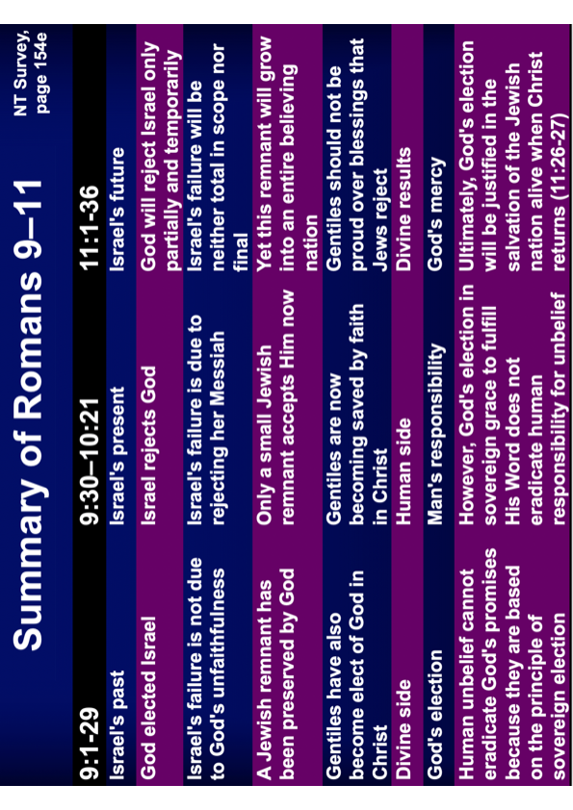

Incorporation Theology

It would be difficult to argue that Paul did not consider the believing Corinthians Gentiles any longer, as Dr Isaac claims. This is reflected in major translations that render ethne as “when you were pagans” (NAS, NIV, NLT, etc.) rather than “when you were Gentiles” (Dr Isaac’s translation). Paul certainly considered the Ephesians Gentiles (Eph 2:11; 3:1). Gentiles simply refers to non-Jews. Once a non-Jew, always a non-Jew, unless one was circumcised in the OT (Gen 17).

Thus, Gentiles join in the Abrahamic covenant as the spiritual seed of Abraham, since they are not circumcised, which was required to become a Jew and a member of Israel. This is an expansion of the promises to Abraham, for Gentile Christians will indeed inherit the whole earth. But God will remain faithful to his promises to Israel even as he will fulfill his promises to the Church.

To illustrate this, my father had three sons. Each is promised a land inheritance of his amazing home in Hawaii. However, all are married, and thus their wives also are grafted into the blessings, even though they are not related by blood.

What’s the point of my illustration? God gave Abraham’s descendants the Promised Land as an eternal inheritance (Gen 17:8). He will fulfill this promise to believing Jews descended from Abraham (Rom 11:26). But he will do even more than this. He will allow believing Gentiles to live and share in that inheritance, so they will indeed share the land as promised in Ezekiel 47:21-23, though these Gentiles are not related by blood.

Israel Today

Dr Isaac’s clarification that he is not calling for the destruction of Israel is much appreciated (p. 19). Few, if any, people have been persecuted like the Jews.

He is also correct that Jews do not have the right to live in Israel because they lived there previously.

The premise on which Israel has the right to the land is far better than precedent. It is based on the divine promise (Gen 12:1-3; 15:18, 17:8; Jer 31:35-38; etc.). It is also founded in God’s explicit prediction that the descendants of Abraham will be restored to the land in unbelief—clearly taught in Ezekiel 37, which unfortunately, is the clearest passage on this but not addressed by Dr Isaac.

In the past century, Israel has gone to the table with the Palestinians five times to offer how to share the land—the latest being last month in June 2019. All five times, the Palestinians have either not shown up (as of June 2019) or have rejected Israel’s offers.

Even more telling than this is Joel 3:2, where God says that at the return of Jesus (see the end of Joel 2), he will judge the Gentile nations “for dividing my land.” In a real sense, the land is already divided, but the offers of Israel to divide it further continue to be rejected by the Palestinians.

Justice Matters

It certainly does! Israel has a responsibility to treat all citizens with fairness, including Palestinians. God holds all governments responsible for justice.

At the same time, Israel should be commended for being the most consistent democracy in the Middle East. One wishes that Jews living in Muslim Iran had the rights of Gentiles living in Israel.

The Land and the Political Reality

Indeed, God is not a racist. He created all people in his image, and all deserve justice. We should support the rights of all people.

This is the point of Gentiles living among Israel in the kingdom era with the land boundaries of Ezekiel 47–48.

Sharing the Land: The Land of Peace, Justice, and Reconciliation

My heart goes out to Palestinian Christians like Dr Isaac who live with realities that I can only imagine. He is correct that Israel must treat all citizens with equity, including the Arab citizens who comprise 20% of Israel.

Yet security must also be sought along with justice. As far as I know, Israel is the only country today with neighbors digging dozens of tunnels under its border to send in assassins. Israel is the only country whose neighbor (Gaza) has lobbed thousands of rockets and mortars into their territory. Israel is the only country whose neighbors believe it has no right to exist. Israel, therefore, has both the right and responsibility to protect all its citizens.

Conclusion

In a sense, Dr Isaac and I both agree on the same goal of justice for all people—whether in Israel or outside it. We also both agree that God has been faithful to Israel and will be faithful to Christians as well. Likewise, we agree that the land of Israel is to be shared by Jews and Gentiles alike.

However, we come to the same conclusions through different theologies and differ on whether there exists a prophetic future for Israel. I still maintain that God did give the land to Israel but the nation is responsible for using it to be a blessing to the nations.

The present worldwide Christian concern for justice is justified. However, justice must not overshadow the commission Christ gave in all four gospels and Acts—a mandate not for justice but to bring the gospel to the nations so that justice will follow. Let’s keep the main thing the main thing.

I thank my brother, Dr Isaac, for traveling from the Middle East to Singapore to present his understanding of the land and share his heart.

Key OT Passages about the Land
David Larsen, Israel, Gentiles and the Church, 26 (adapted in Jeremiah texts)

Perhaps more than with any religious group (including Christians), the heart of Judaism lies in the land of its forefathers. The land and the people are inseparable to Jews, for they experienced God’s very presence indwelling the temple in Jerusalem for centuries (966-586 BC). This emphasis on the land of Canaan is repeated numerous times in the Old Testament:

Genesis | 12:7; 13:14-17; 15:7-21; 17:1-8; 24:7; 28:13-15 | Jeremiah | 12:14-17; 16:14-15, 18; 18:16; 23:5-8; 30:18-21; 31:10-14, 21-40; 32:37-41; 33:10-13
Exodus | 12:25; 13:5, 11; 32:13; 33:1 | Ezekiel | 11:17-21; 17:22-24; 34:11-31; 37:1-14
Numbers | 11:12; 14:15-16, 23; 32:8 | Hosea | 13:9–14:9
Deuteronomy | 1:8; 6:10; 9:28; 12:20; 19:8; 27:3 | Micah | 2:12
Joshua | 23:5 | Zephaniah | 2:19-20
Isaiah | 5:25-26; 11:11-12; 66:19-20 | Zechariah | 12:10-11

Which books have the greatest emphasis on the land?

Why do you think this is so?

Israel’s Future in Deuteronomy 28–32

Adapted from Wilbur M. Smith, “Prophecies Regarding Israel,” Moody Monthly (December 1958), 39 (Quoted by Larsen, 23-24)

Deuteronomy 28–32 summarizes Israel’s future from Moses’ time to a time yet future. These prophecies are repeated throughout the Old Testament.

31:16-21 | Israel will turn away from the Lord (began after Joshua’s death)
28:15-60 | God will judge Israel in the land for her apostasy (period of judges and divided kingdom)
28:32-39, 48-57 | Israel will be taken captive (by Assyria and Babylon)
28:33 | Israel’s enemies will possess her land for a time (Babylon, Persia, Greece, Romans, Catholic Crusades, Muslims, Britain, etc.)
28:38-42; 29:23 | The land will remain desolate (AD 70 to AD 1948)
28:63-67; 32:26 | Israel will be scattered among the nations “from one end of the earth to the other” (28:64; AD 70 to AD 1948)
28:62 | Israel will be “few in number” (today Jews comprise of 1% of the world’s population)
28:44-45 | Though punished, Israel will not be destroyed if she repents
28:40-41; 30:1-2 | Israel will indeed repent in her tribulation (trials have continued throughout the ages but will increase in the 72 month Great Tribulation)
30:3-10 | God will regather Israel from the nations and bring her back to her divinely given land (it began in the late 1800s in unbelief as predicted in Ezekiel 37:7-8 and continues even today)
30:3-13; 28:1-14 | Israel’s obedience will be blessed in numerous ways (worldwide acclaim and prosperity in the millennial kingdom)

Donald K. Campbell, “Galatians,” in The Bible Knowledge Commentary, 2 vols., eds. John F. Walvoord and Roy B. Zuck (Colorado Springs, CO: Chariot Victor, 1983), 2:598.

