Thinking Skills

Athletes and dancers are taught to think about their every move. As leaders, we need to step back and evaluate how we think, make decisions, and process information. It is also important that we observe and evaluate the thinking patterns of others, especially those on our leadership teams.

Researcher Edward De Bono helps us visualize how people think by relating to six imaginary hats. They are . . .

The White hat —

The Red hat —

The Black hat —

The Yellow hat —

The Green hat —

The Blue hat —

Which hat do you normally wear?

Do you change hats from time to time? If so, when?

White Hat Thinkers . . .

• are concerned with facts and figures;
• are non-emotional
• are computer-like
• don’t like hunches, intuition, or opinions

Contribution:
“These are the FACTS on this matter.”

Red Hat Thinkers . . .

• are emotional
• express feelings
• feel no need to justify their feelings
• go with hunches, intuition, and impressions

Contribution:
“This is how I FEEL about the matter.”

Black Hat Thinkers . . .

• are negative
• dwell on why something cannot be done
• are usually critical
• confirm facts but sow doubt

Contribution:
“This is what’s WRONG with this matter.”

Yellow Hat Thinkers . . .

• are optimistic
• focus on benefits and the positive
• look to the future
• offer new ideas and encourage others

Contribution:
“That’s a great IDEA . . . let’s go for it.”

Green Hat Thinkers . . .

• are creative
• open to new ideas
• seek out alternatives and options
• focus on bringing about change

Contribution:
“Let’s try an entirely NEW approach to this matter.”

Blue Hat Thinkers . . .

• are concerned about organization
• direct and control discussions
• ask questions
• seek to negotiate

Contribution:
“What do you THINK about this matter?”

Black Hat Thinkers . . .

• are negative
• dwell on why something cannot be done
• are usually critical
• confirm facts but sow doubt

Contribution:
“This is what’s WRONG with this matter.”

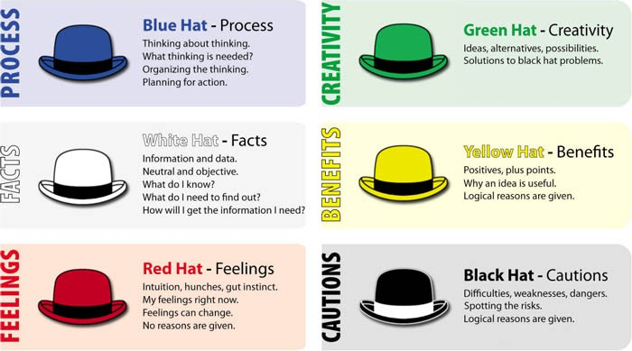

Six Hat Lecture Notes

White Hat Thinkers . . .

• are concerned with facts and figures;
• are non-emotional
• are computer-like
• don’t like hunches, intuition, or opinions

Unique ability to separate fact from fiction, for example, they may say, “We are a Christian nation, but 50% of our people are unchurched, and another 25% are nominal. So, we’re not as Christian as we think.”

They are fond of saying things like
“What are the facts?”
“Show me the statistics.”
“These are the FACTS on this matter.”

Red Hat Thinkers . . .

• are emotional
• express their feelings
• feel no need to justify their feelings
• go with hunches, intuition, and impressions

They are fond of saying things like
“Don’t ask me why, I just don’t feel good about this decision.”
“I have a hunch this is going to turn out okay.”
My gut feeling is that the timing isn’t right.”
“This is how I FEEL about the matter.”

Black Hat Thinkers . . .

• are logical, but always negative
• dwell on why something cannot be done
• are usually critical
• confirm facts but sow doubt

They are fond of saying
“Yes, people appear to have bought into the vision,
but most people aren’t sharing their true feelings.”
“Attendance is up, but we’re compromising the Bible.”
Granted we have more people, but more people just bring more problems.”
“This is what’s WRONG with this matter.”

Yellow Hat Thinkers . . .

• are optimistic
• focus on benefits and the positive
• look to the future
• offer new ideas and encourage others

They are fond of saying
“That’s a great IDEA . . . let’s go for it.”
“The sky is always darkest before the sunrise, it’ll be okay.”
That’s a great idea, Ricky.”
“It’s a long show, but God is faithful.”

Green Hat Thinkers . . .

• are creative
• open to new ideas
• seek out alternatives and options
• focus on bringing about change

They are fond of saying
“Let’s try an entirely NEW approach to this matter.”
Let’s see if we can come up with three new ways to meet this challenge.”
“What else could we do?”
What are some other alternatives that we haven’t thought about?”

Blue Hat Thinkers . . .

• are concerned about organization
• direct and control discussions
• ask questions
• seek to negotiate

They are fond of saying
“What do you THINK about this matter?”
“Sounds too good to be true, what might go wrong?
“Let’s plan this out step-by-step.”
“You may be right, but let’s hear from everyone else.”

Case Studies

Imagine that you are all members of your church’s leadership team. Try wearing some of the hats by play-acting the way each hat would react to the following situations.

- The weekly worship attendance at your church is averaging 135 people, but the sanctuary only seats 150 people comfortably. The pastor has suggested the church start a second worship service in order to make room for more people. Do you think this is a good idea or not? Discuss this idea with the rest of the team the way a person would wearing your hat.

- The worship pastor has recommended that the children’s choir sing during the morning worship service. The problem is he wants the children to sing a cute Christian rap song, but it may offend some adults. Should the children’s choir be allowed to sing? If so, can they use the rap song? Discuss this with the rest of the team the way a person would wearing your hat.

- The board has just been informed that two recent graduates of the church’s senior high youth group want to get married. They are both eighteen and, unfortunately, are pregnant. The problem is complicated by the fact that both are children of key families in the church. The senior pastor has counseled with them, and has agreed to perform the wedding. However, he doesn’t feel they should be allowed to be married in the church’s sanctuary since they are pregnant before being married. He wants to do the wedding in the church’s large fellowship hall. The two families are quite upset and want the board to allow the wedding to be held in the churches beautiful sanctuary. What do you think? Discuss this with the rest of the team the way a person would wearing your hat.

- The college pastor of your church wants to start a coffee house outreach ministry as a way to reach students from the local college. He has asked for permission to remodel the church’s basement into a coffee house at a cost of about $20,000. What do you think? Discuss this with the rest of the team the way a person would wearing your hat.

- The senior pastor has announced his retirement at the end of this year after serving your church for 25 years. One of the members of your board has suggested the church give him a year’s severance pay as a thank your for the years of faithful service. He has found that it is normal for a church to grant two weeks pay for every year of service to a departing pastor. What do you think? Discuss this with the rest of your team the way a person would wearing your hat.

- The community around your church is deteriorating, which is causing some people to leave your church. The pastor feels the church must relocate or die. What do you think? Discuss this with the rest of the team the way a person would wearing your hat.

