Singapore Bible College
Doctor of Ministry

Leadership Essentials for Church Transformation

Day 1, Topic 1: Class Introductions Get Acquainted Time

Instructor

Dr. Gordon E. Penfold (gordonpnfld@gmail.com) B.S, M.S. (Colorado State University, 1972, 1973), Th.M. (Dallas Theological Seminary, 1981) and D.Min. (Talbot Theological Seminary, 2011).

Gordon grew up in a “church” environment. However, he does not remember hearing the gospel until he was a freshman engineering student at Colorado State University. Two men associated with the Navigators clearly shared the gospel with him. On March 28, 1969, Gordon trusted Jesus Christ as his Savior. He then attended First Baptist Church in Fort Collins, Colorado, where a real, living church captured his heart, mind, and ministry imagination!

Dr. Penfold dreamed of becoming a consulting structural engineer. However, the Lord began to stir his heart to invest his life in people who will live forever as opposed to building and bridges that are temporary (see Revelation 6:14). Thus, after a bachelor's and master’s degree in engineering and six and a half years working as a structural engineer, he left his professional engineering vocation to become a fulltime pastor.

Gordon pastored four turnaround churches along with three intentional interims, a total ministry spanning thirty-six years. He has trained pastors across the United States, Ukraine, Russia, Armenia, and Thailand. His dissertation, “Characteristics of Turnaround Pastors among Evangelical Churches in the Rocky Mountain States,” led to the publishing of Re:Vision: The Key to Transforming Your Church (Baker Books), co-authored with Dr. Aubrey Malphurs. He and Dr. Gary McIntosh introduced Turnaround Pastor Boot Camps© in 2012, a work he continues with Drs. Lavern Brown and Gary Westra. Together these three continue to lead groundbreaking research into effective pastoral ministry practices. They published their innovative research in a new book called Pastor Unique: Becoming a Turnaround Leader (WestBow Press, summer 2016). Gordon serves as the executive director of Fresh Start Ministries that assists plateaued, declining, and conflicted churches. He also is the co-founder of Turnaround Pastor, Inc. and is the Second Vice President of the Great Commission Research Network, an organization dedicated to understanding effective Great Commission ministry practices and the extension of those ministry practices worldwide.

Gordon is married to Beth, his wonderful wife of forty-six years. They have three grown children and four grandchildren. All their children are deeply immersed in ministry as they serve our Lord Jesus Christ. Gordon’s life is, indeed, blessed of God!
Course Description

Leadership Essentials for Church Transformation: A significant number of ministries start well but finish poorly. Poor pastoral leadership is often at the core of this ineffectiveness. Church leaders must recognize their biblical responsibility to be the stewards of Christ's mission and vision for the church they pastor. In the case of leaders who serve multiple churches or who serve in leadership roles over many pastors, understanding and applying critical transformational leadership principles proven to lead in ministry revitalization and effectiveness are even more crucial. Pastoral training and equipping is at the heart of effective ministry. Through his research and pastor training in the United States and his international training ministry, Gordon has observed the same basic needs for effective ministry regardless of language or ethnicity. This module will focus on the characteristics of effective pastoral ministry practices and needs that lead to church and or ministry transformation.

Course Objectives

This course has two primary objectives: (1) to equip the students for more effective ministry using the tools gained in this course of study and (2) to equip the students in effective ministry practices so that they will be able to train others to do the same.

By the end of this course, each student will . . .

- Understand the key role pastors and leaders play in producing effective ministry.
- Gain insight into the process of ministry transformation.
- Cultivate personal and ministry development plans that will impact ministry effectiveness both in one’s personal life and vocational ministry.
- Develop a clear understanding of ministry best practices and personality best practices.
- Discover the key role that mission and vision play in an effective ministry of revitalization.
- Develop skills in preparing and articulating a biblically-based mission and vision.
- Develop skills needed to train others in these same ministry best practices.

Course Requirements

The class includes lectures, discussions, writing activities, and in-class exercises to sharply hone each student’s abilities to lead churches and ministries into effective ministry and revitalization.

1. Reading (due 4 November 2019 at the Start of the Module Week)

Your required 1800 pages of reading for this module is divided into three areas:

- Required books and articles are listed in the Bibliography. Each of these must be read in its entirety. These add up to 1252 pages.

- Suggested books can be read up to a minimum of 548 pages. You should read at least two of these books from the list at the end of this syllabus.

- Proposal books are those which you read in the area of your proposed dissertation topic. These pages will provide the balance of your reading page requirement.

- Read the article about Orchard Church (http://www.theorchardcommunity.com/whoweare/ourstory/). Please write a one-page summary of the items that spoke to you about the challenges of church revitalization. Your comments will become the basis of a discussion during class. This written discussion is due on 4 November 2019.

- On or before the first day of the module, email to Ting Ting (dmin@sbc.edu.sg) and Dr. Gordon E. Penfold (gordonpnfld@gmail.com) an annotated list of the books you have read in the areas above. Share in two paragraphs what you deem to be the strengths and weaknesses of each book. Due 4 November 2019.

2. Complete the Malphurs/Penfold Pastoral Leadership Survey (PLS) by 21 October 2019.

This document will be sent to you as a separate attachment.

Complete and return this document to Dr. Penfold no later than 21 October 2019. You must complete all parts of this survey, including a complete DISC Profile and a Keirsey Temperament Sorter II. You may find a free KTS II at http://thechangeworkscoaching.com/images/KeirseyQuestionnaire_Sample_Ans_Sheet_Scoring_Instructions_Form.pdf. Click the link and follow the prompts.

Include the results of these surveys on the Malphurs/Penfold form. Also, complete the Workplace Motivators survey (found on the same website as the DISC Profile). Return both completed surveys electronically to Dr. Penfold.

Note: A friend provided the DISC and Workplace Motivators to you at no cost. Please complete them both, even if you have previously taken the DISC. If you have already taken the Myers-Briggs Temperament Indicator or KTS II, you may use those results on the PLS.

3. Complete the “Bottlenecks of Ministry” Survey (21 October 2019)

This document will be sent to you as a separate attachment.

Complete the “Bottlenecks of Ministry” Survey and return it to Dr. Penfold no later than 21 October 2019. Feel free to add your thoughts about ministry bottlenecks to the survey. Completing this survey is as much for Dr. Penfold’s benefit as it is for you. This survey will help him better understand you and your ministry context. Please feel free to discuss any particular issues you face!

4. Complete Your Daily Schedule (due 21 October 2019)
Complete your daily schedule. How do you spend your time over the course of a typical week? You may use either the “General Schedule” (Schedule A) or the “Personal Daily Schedule” (Schedule B) provided on pages 17-18. At the end of the module week, complete a revised schedule (Schedule C, Your Modified Personal Schedule) as it should be to maximize your ministry potential. I know you may serve in several different ministries. I wish to see how you invest your time. Please return this to me by 21 October 2019.

5. Complete the Birkman Profile (optional) (due 21 October 2019)
The Birkman Profile is a tool recently researched and developed to produce coaching protocols to help pastors and Christian leaders engage in productive and effective ministry best practices. I strongly urge you to avail yourself of this tool. The cost of this instrument is $150, which will include the use of the instrument itself and a 1½ hour personal coaching session with me before our class time together. Taking the Birkman is entirely optional. If you cannot afford this, I completely understand. Please contact me if you wish to do the Birkman. I will arrange for payment in advance and will also schedule a debrief with you before our time together in Singapore.

6. Complete a Personal Development Plan and a Ministry Development Plan (due at the beginning of class on 4 November 2019)

The student will craft a Personal Development Plan. In this exercise, the student will prepare an overall life goal, which includes general goals, spiritual goals, health goals, wealth goals, family goals, and career goals.

A worksheet is on page 15 of the syllabus entitled “My Personal Goals.” This sheet provides a basic outline for this part of your preparation. The total of all your responses should be no longer than two pages. The more concise your responses, the better! Prayerfully look at each section and ask the Lord, “What do you want me to accomplish in my life?” Some items may change as you mature in your ministry, but this plan should become a guiding set of principles for your ministry development for life. If you have already completed a process like this, feel free to use what you have already completed.

A second worksheet is on page 16 of the syllabus. It’s entitled “My Ministry Goals.” The objective is for you to prayerfully consider the goals the Lord would have for you and your ministry. If you serve a church, what does the Lord desire for your church? If you work in another ministry, what would the Lord desire for you to accomplish in that ministry? This plan will include nine turnaround goals for your church or ministry. These include three short-range goals (1-3 years), three intermediate-range goals (4-6 years), and three long-range goals (7-10 years). Write your responses concisely on no more than one page. Prepare this document in advance of class.

At the end of our module week, rework this section based on what you learned in class during our time together. You will use Your Modified Personal Schedule on page 19.

8. Post-course Project (due 15 February 2020)

The project may be related to your dissertation project. However, if you do work toward your dissertation, I would like you to include some work on either church or ministry revitalization as it applies in your ministry context. The final post-course project proposal must be approved by 15 December 2019, so you have two months to complete it by 15 February 2020.

The project needs to be forty (40) pages in length. In the project, you must state the following:

  - The Problem: What issue do you wish to address?
  - Literature Review: What significant works address this ministry issue?
  - Your Research Process: How do you propose to evaluate the issue you are working to resolve? Include the metrics you wish to measure and the measurement techniques you will employ in the ministry analysis.
  - Your Research Findings: Provide a brief summary of your research findings.
  - The Solution(s): What solutions do you propose to address the need you are seeking to address? Your solutions must be concrete and specific. Use SMART goals to define your solutions. A discussion on SMART goals will take place in class.

Course Grading

The four components of this module have the following value towards the final grade: reading (20%, assignment #1 above), pre-course assignments (20%, assignments #2-6 above), classroom participation and module assignments (20%, assignment #7 above), and post-course project (40%, assignment #8). The normal late penalties apply so that not meeting deadlines can result in failing the module leading to needing to retake it or dismissal from DMin studies.

Course Procedure

Students must number these successive files with the convention below to keep the file names the same throughout with the exception of the words to the right of the edition.

1. Thread

Students must stay on the same email thread instead of starting new emails. This will keep all on the same page (literally!) to clarify the issues to be addressed and save time looking up old emails. You must work with Dr. Penfold to submit an approved final edition of the proposal for your post-course project by 15 December 2019. After this date, the late paper policy below from the Student Handbook will be implemented.

2. Names of Files

Most professors receive many papers, so a file name like “Research Paper.docx” is too ambiguous. Instead, name your digital file as student name-short paper name-edition-initials of the person making the latest changes.docx. For example, a dissertation proposal called “Clara_Wong-Church_Growth-1-CW.docx” means that Clara Wong is submitting her first edition of her dissertation proposal with the longer title “Paradigms of Church Growth in Singapore: A Case Study.”

3. Editions

After Dr. Penfold makes changes to it, he will use the Word format tracker (Review > Track Changes ON) and return an edited file to Clara with the different name ending as “Clara_Wong-Church_Growth-2-GP.docx.” Then Clara can see the changes the professor made in the right-hand column, as well as comments and questions that the student needs to address.

At this point, Clara copies edition 2-GP as a new file with 3-CW in the file name. Then she works only on this new file while keeping the previous 2-GP in a folder on her computer for future reference if needed. NOTE: NEVER edit an OLD edition of your file. Only make changes to the last edition so that the latest changes will be incorporated into the next edition. This system keeps track of changes in each edition and helps all see from the file name itself whose paper it is, what it is about, the edit date, who edited it, etc. Students who keep the various editions in a digital folder will see that they naturally fall into alphabetical order to assure they are editing the latest edition.

Finally, please do NOT “accept all changes” in the file, as this forces the editor to look up what was supposed to be changed. Do not accept or reject any changes in the side column at all, as this is the professor’s responsibility.

Late Assignments (from Student Handbook 4.2.2)

The guideline for late papers or reading assignments imposes a penalty of one-third grade or 3% deduction per week:

Before or on the deadline 0
One week after the deadline -3% (e.g., a 90% becomes 87%)
Two weeks after the deadline -6%
Three weeks after the deadline -9%
Four weeks after the deadline -12%
Five weeks after the deadline -15%
Six or more weeks after the deadline -100% (no credit for assignment)

Module Schedule: (Note: The schedule is an outline we will attempt to follow).

Day 1 | Topics | Class Activity
Day 1 | Class Introductions | Get acquainted time
Day 1  Monday  Topic 1 | The Biblical Basis for Church Revitalization  Introduction to the Ministry of Transformation | Grasp the concept of “transformation” as it is woven through the pages of Scripture.  Grasp the foundational principles that must drive ministry.  Understand the roles and responsibilities of the biblical leader in the church.
Day 1  Monday  Topic 2 | Divine Design, Direction and Development  Exploring the Three Ds and Their Impact on Life and Ministry  - Introduce the Concept of Divine Design  - Show the need for continual Developing in the roles that God entrusts to us.  - Perceive the Direction God leads us as we walk with Him. | Discuss and discover the impact of the Three Ds on our lives and ministries. Understanding these three key concepts will enable the students to evaluate their lives and ministries.
Day 1  Monday  Topic 3 | An Introduction to Church Transformation  Understanding the Crucial Elements Needed for Church Revitalization  - An introduction to the essential elements needed for church transformation  - An overview of the latest research into effective ministry practices | Discuss essential elements that enhance the prospects for church (or ministry) revitalization.  Understand the latest research into effective leadership skills that produce effective change.
Day 1  Monday  Topic 4 | There’s Hope for Your Church and Ministry—Part I  Understanding Christ’s Desire for His Leaders and His Church  1. What is Christ’s desire for His church?  2. Understanding the overall process of revitalization  3. Recap of Day 1 | Review Christ’s design for fruitfulness.  Grasp an overall picture of the process of revitalization.  Understand the necessity of Hope!  Review the topics of Day 1
Day 2 | Topics | Class Activity
Day 2  Tuesday  Topic 1 | The Pastor’s Worth  Understanding the Power of Your Identity in Christ | Effective ministry is rooted in an often overlooked issue: Our worth before God. This module will explore our worth in the eyes of God!
Day 2  Tuesday  Topic 2 | Mission, Vision and Core Values  Grasping the Concepts of Mission, Vision and Core Values  1. Bring clarity to the Mission  2. Begin the process of clarifying ministry core beliefs and core values.  3. Understand the essence of ministry vision | Sharpen our understanding of the Mission of the Church  Begin a discussion of Core Beliefs and Core Values  Begin a discussion of vision and how to develop a biblically-based vision
Day 2  Tuesday  Topic 2 (continued) | Mission, Vision and Core Values  Grasping the Concepts of Mission, Vision and Core Values  - Continue the discussion of mission, vision, and values.  - Develop an initial set of core beliefs and core values for “God” and “Prayer.”  - Grasp the concept and necessity of vision for effective ministry | Work to establish a basic familiarity with biblically-based core beliefs and core values.  Work specifically in class to develop core beliefs and core values for “God” and “Prayer.”  Develop an initial statement of vision for your ministry.
Day 2  Tuesday  Topic 2  (continued) | Mission, Vision and Core Values  Grasping Vision for Your Ministry  - Focus primarily on vision  - Developing a vision for your ministry context. | Explore with the students how to develop ministry vision in their local context.  Review the topics of the day.

Day 3 | Topics | Class Activity
Day 3  Wednesday  Topic 1 | God Expects You to Lead  Leadership: Understanding an Essential Role of a Pastor | Our “inherited “view of pastoral ministry has reduced the role of the pastor to that of a caregiver. In this section of the course, we will focus on the biblical role of the pastor as a leader.
Day 3  Wednesday  Topic 2 | There’s Hope for Your Church—Part 2  You Have Real Personality  1. DISC  2. KTS-II  3. Birkman Method | Understand your personality and grasp how your personality impacts others.  Understand the personality of others and how their personalities impact you.  Understand how to leverage your personality for maximum effectiveness in ministry.
Day 3  Wednesday  Topic 3 | Goals and Ministry Alignment  Goals and Ministry Alignment for Maximum Ministry Impact  - Have each student identify the critical parts of their ministry and their church’s ministry  - Evaluate ministry effectiveness in light of the mission and vision of the church.  - Develop essential adjustments necessary for ministry effectiveness. | Churches often overflow with activity. The question is, “How does one evaluate the effectiveness of ministry in a local context?” Does the ministry align with the mission and vision of the church?
Day 3  Wednesday  Topic 4 | Developing a Ministry Map  Putting Together a Viable Ministry Plan for Church Transformation  - Taking steps to build a comprehensive plan and program for effective ministry  - Constructing logical and reasonable conclusions.  - Case Study | Lecture and hands-on work in developing a viable ministry plan for the local church or parachurch ministry.  Present a case study of an effective “Ministry Map” and the outcome of such a venture
Day 3  Wednesday  Topic 5 | Interviews with two Transformational Leaders (3:00-5:00 pm)  Daw Ching and Zhiwen Ng
Day 4 | Topics | Class Activity
Day 4  Thursday  Topic 1 | Leading Change  Understanding the Process of Leading a Declining Ministry into Positive Change  - Understand the dynamics of leading change in a plateaued or declining church or ministry  - Developing a simple structure for leading transitions  - Understanding the difference between first and second-order change  - Review of the day’s subjects | Recognize the need for change and grasp the importance of a “willingness” to change.  .  Present a method of leading change in plateaued or declining congregations. This step-by-step introduction will help leaders avoid many of the snares and traps that plague ministries of revitalization.  Review and reflect on the materials for the day.
Day 4  Thursday  Topic 2 | Conflict Resolution and Biblical Peacemaking  The Theology and Practice of Peacemaking | Give a biblical foundation for the origins, styles, and types of conflict.  Give biblical practices for handling each of the different kinds of conflict discussed in class.
Day 4  Thursday  Topic 3 | Leading Change Through Conflict  Understanding the dynamics of change management in conflict. | Grasp the principles of leadership in change management.  The “Berry Buckets of Change Management”
Day 4  Thursday  Topic 4 | The Lifecycle of the Church  Understanding the Lifecycle of a Church | Discuss and understand the rhythms of church life, church growth, and church decline. This understanding will help pastors to approach their churches wisely as they seek to lead change. (Restart)
Day 4  Thursday  Topic 5 | Essentials for Finishing Well  Recognizing essential elements for staying on track in your ministry | Many attempts will arise that will attempt to derail your ministry and make it less effective. Here we will understand the challenges and ways to overcome them.
 | Review and Summary:  Beginning to Put Together the Revitalization Process | Work on personal and ministry development plans.

Day 5 | Topics | Class Activity
Day 5  Friday  Topic 1 | No Pain, No Gain  Understand the cost of revitalization. | Church or ministry revitalization is not for the faint of heart. We must count the cost before proceeding.
Day 5  Friday  Topic 2 | Scheduling Your Ministry; Setting Your Priorities, Using Your Spiritual Gifting, and Delegating Responsibilities  Understanding Your Gifting, Mastering Your Schedule, and Delegating Responsibilities | Most pastors and Christian leaders feel tremendous pressure “to do all that their constituents demand.” How can one possibly handle the pressures? Recognizing gifting, setting a schedule, and delegating responsibilities all play key roles in leading revitalization efforts.
Day 5  Friday  Topic 3 | Recruiting a Mentor or a Coach  The use of coaches or mentors is a key component for church growth and ministry effectiveness. | We will discuss the need for coaches and mentors and how to discover them for your ministry health.
Day 5  Friday  Topic 4 | Coaching Clusters: The Value of Peer to Peer Learning | Many pastors and Christian leaders feel isolated and alone. A coaching cluster with peer to peer learning can be a powerful means of encouraging pastors and Christian leaders to do well and finish well, especially through the dark times of ministry.  We will discuss what a coaching cluster is, how it functions, and how it can help develop long-term helpful habits for ministry.
Day 5  Friday  Topic 5 | Review the Personal and Ministry Development Plans
Day 5  Friday  Topic 6 | Course Debrief | Course Evaluation
Day 5  Friday  Topic 7 | The Triumph of Christ | A simple reminder that the Lord, the Lamb, wins!  Pastor Unique

Bibliography

Required Reading (1221 pages)

Brown, Lavern E., Gordon E. Penfold, and Gary J. Westra. Pastor Unique: Becoming a Turnaround Leader. Bloomington, IN: WestBow, 2016. 311 pp.

Hodge, Scott, “Sharp Curve Ahead." Leadership, (2005).
http://www.theorchardcommunity.com/whoweare/ourstory/ 7 pp.

Hybels, Bill. Courageous Leadership. Grand Rapids, MI: Zondervan, 2012. 253 pp.

Malphurs, Aubrey, and Gordon E. Penfold. Re:Vision: The Key to Transforming Your Church. Grand Rapids, MI: Baker, 2014. 275 pp.

McIntosh, Gary L. There’s Hope for Your Church: First Steps for Restoring Growth and Health. Grand Rapids, MI: Baker, 2012. 195 pp.

———. Taking Your Church to the Next Level: What Got You Here Won't Get You There. Grand Rapids, MI: Baker, 2009. 211 pp.

Recommended Reading (Select most of your books from this section. Read no less than 748 pages total from this section for a total of 2000 pages. Feel free to read other volumes not listed here that may apply to your dissertation topic.)

Borden, Paul D. Assaulting the Gates: Aiming God’s People at the Mission Field. Nashville, TN: Abingdon, 2009. 195 pp.

———. Direct Hit: Aiming Real Leaders at the Mission Field. Nashville, TN: Abingdon, 2006. 159 pp.

———. Hit the Bullseye: How Denominations Can Aim the Congregation at the Mission Field. Nashville, TN: Abingdon, 2003. 195 pp.

———. Make or Break Your Church in 365 Days: A Daily Guide to Leading Effective Change. Nashville, TN: Abingdon, 2009. 215 pp.

Burns, Bob, Tasha D. Chapman, and Donald C. Guthrie. Resilient Ministry: What Pastors Told Us About Surviving and Thriving. Downers Grove, IL: IVP, 2013. 313 pp.

Collins, Jim. Good to Great: Why Some Companies Make the Leap and Others Don’t. New York: Harper Business, 2001. 286 pp.

Hendricks, Howard G., and William D. Hendricks. As Iron Sharpens Iron: Building Character In A Mentoring Relationship. Chicago: Moody, 1995. 272 pp.

Hunter III, George G. The Celtic Way of Evangelism: How Christianity Can Reach the West Again. Nashville, TN: Abingdon, 2000. 137 pp.

Hesselgrave, David J. Paradigms in Conflict: 10 Key Questions in Christian Mission Today. Grand Rapids, MI: Kregel, 2005. 355 pp.

Kotter, John. Leading Change. Boston: Harvard University Business Press, 2012. 186 pp.

Kouzes, James M., and Barry Z. Posner. The Leadership Challenge. San Francisco: Jossey-Bass, 2007. 368 pp.

Malphurs, Aubrey. Leading Leaders: Empowering Church Boards for Ministry Excellence. Grand Rapids, MI: Baker, 2005. 243 pp.

Malphurs, Aubrey. Look Before You Lead: How to Discern & Shape Your Church Culture. Grand Rapids, MI: Baker, 2013. 268 pp.

———. Values-Driven Leadership: Discovering and Developing Your Core Values for Ministry. Grand Rapids, MI: Baker, 1996. 197 pp.

Mancini, Will. Church Unique: How Missional Leaders Cast Visions, Capture Culture, and Create Movement. San Francisco: Jossey-Bass, 2008. 253 pp.

McIntosh, Gary L. Beyond the First Visit: The Complete Guide to Connecting Guests to Your Church. Grand Rapids, MI: Baker, 2006. 184 pp.

———. Biblical Church Growth: How You Can Work with God to Build a Faithful Church. Grand Rapids, MI: Baker, 2003. 188 pp.

Osborne, Larry. Sticky Teams: Keeping Your Leadership Team and Staff on the Same Page. Grand Rapids, MI: Zondervan, 2010. 221 pp.

Patterson, Kerry, Joseph Grenny, Ron McMillan, and Al Switzler, Crucial Conversations: Tools for Talking When Stakes Are High. New York: McGraw Hill, 2012. 231 pp.

Patton, Jeff. If It Could Happen Here—: Turning the Small-Membership Church Around. Nashville: Abingdon, 2002. 134 pp.

Putnam, Jim and Bobby Harrington with Robert Coleman. Discipleshift: Five Steps that Help Your Church to Make Disciples Who Make Disciples. Grand Rapids: Zondervan, 2013.

Rainer, Thom, Autopsy of a Deceased Church: 12 Ways to Keep Yours Alive. Nashville, TN: B & H, 2014. 101 pp.

Rainer, Thom S. High Expectations: The Remarkable Secret for Keeping People in Your Church. Nashville, TN: B & H, 1999. 213 pp.

Rainer, Thom, and Eric Geiger. Simple Church. Nashville, TN: Zondervan, 2006. 256 pp.

Rutland, Mark, ReLaunch: How to Stage a Comeback. Colorado Springs: David C. Cook, 2013. 294 pp.

Sande, Ken. The Peacemaker: A Biblical Guide to Resolving Personal Conflict. Grand Rapids: Baker, 2004. 305 pp.

Stanley, Andy. Deep and Wide: Creating Churches Unchurched People Love to Attend. Grand Rapids, MI: Zondervan, 2012. 249 pp.

———. Visioneering. Sisters, OR: Multnomah, 1999. 272 pp.

Stetzer, Ed, and David Putnam. Breaking the Missional Code: Your Church Can Become a Missionary in Your Community. Nashville, TN: B & H, 2006. 244 pp.

Stetzer, Ed, and Mike Dodson. Comeback Churches: How 300 Churches Turned Around and Yours Can Too. Nashville, TN: B & H, 2006. 226 pp.

Swindoll, Charles R. Church Awakening: An Urgent Call for Renewal. New York: FaithWords, 2010. 282pp.

Warren, Rick. Purpose Driven Church: Growth Without Compromising Your Message & Mission. Grand Rapids, MI: Zondervan, 1995. 398 pp.
Precourse Assignment:
My Personal Goals

In future years I want others to remember me as . . .
(Overall Life Mission in 25 words or less)

Briefly stated, this Mission Statement means that . . .
(expand on the short statement above in one-half page.)

In the next five years, I hope to accomplish . . . (Basic Life Goals)

General Goals Spiritual Goals

Goal #1: Goal #1:

Goal #2: Goal #2:

Goal #3: Goal #3:

Family Goals Health Goals

Goal #1: Goal #1:

Goal #2: Goal #2:

Goal #3: Goal #3:

Wealth Goals Career Goals

Goal #1: Goal #1:

Goal #2: Goal #2:

Goal #3: Goal #3:

Precourse Assignment

My Ministry Goals
Write out Your Nine (9) Turnaround Goals for your church or ministry:

Three Short Range Goals (1-2 years)

Three Mid-Range Goals (3-5 years)

Three Long-Range Goals (5-7 years)
- General Schedule

Please give an account of how you spend your time in ministry. Below are normal areas of ministry that consume our time. How many hours do you spend on each task an average each week in each of these areas? Bring the completed General Schedule with you to class 4 November 2019.

SERMON PREP
WORSHIP PREP
SUNDAY REPONSIBILITIES
PLANNING/ADMINISTRATION

MEETINGS
SMALL-GROUP MEETINGS
VISITING CHURCH MEMBERS
VISITING NEW PEOPLE
PRAYER
COUNSELING
TIME IN THE COMMUNITY
OTHER
OTHER
OTHER

Please complete and print out Schedule B (found below) based on your current ministry activities. Bring the completed Schedule B with you to class 8 November 2019.

Complete Schedule C (also found below) before the beginning of class on Friday, 8 November 2019. You will need to show any needed changes to your work habits that will enable you to minister more effectively. For example, you may have to schedule specific times to be out in the community meeting people who are not yet Christ-followers rather than simply spending your entire day inside your office studying.

- Personal Daily Schedule as it now exists

Time | Sunday | Monday | Tuesday | Wednesday | Thursday | Friday | Saturday
6:00 am

7:00

8:00

9:00

10:00

11:00

12:00

1:00 pm

2:00

3:00

4:00

5:00

6:00

7:00-9:00

9:00-11:00

Other

- Your Modified Personal Schedule

Your New Personal Daily Schedule as you should arrange it for you to complete your mission and vision as you now understand it.

Time | Sunday | Monday | Tuesday | Wednesday | Thursday | Friday | Saturday
6:00 am

7:00

8:00

9:00

10:00

11:00

12:00

1:00 pm

2:00

3:00

4:00

5:00

6:00

7:00-9:00

9:00-11:00

Other

Day 1: Class Introductions

See attached syllabus (pages 1-19)

Introduction

“Would you tell me, please, which way I ought to go from here?”

“That depends a good deal and where you want to get to,” said the Cat.”

“I don’t much care where,” said Alice.

“Then it doesn’t matter which way you go,” said the Cat.

Alice’s classic encounter with the Cheshire Cat in Lewis Carroll’s Alice’s Adventures in Wonderland reveals the close connection between purpose and priority. Live with purpose and you know where you want to go. Live by priority and you’ll know what to do to get there.

When each day begins, we each have a choice. We can ask, “What shall I do? Or “What should I do?” Without direction, without purpose, whatever you “shall do” will always get you somewhere. But when you’re going somewhere on purpose there will always be something you “should do” that will get you where you must go. When your life is on purpose, living by priority takes precedence.

Day 1, Topic 1: The Biblical Basis for Church Revitalization

Introductory Thoughts

There is little biblical evidence that speaks to the issue of church revitalization.

However, God weaves the concept of transformation, renewal, and revitalization throughout the fabric of the Word of God. In essence, the whole of the work of God with humanity revolves around the work of transformation and renewal.

Key Passages:

2 Corinthians 5:17 New Creation

Romans 12:1-2 Daily Transformation

Romans 8:18-23 Restoration of Creation

Revelation 22:1-5 Creation of the New Heaven and the New Earth

Where to we begin?

Let’s begin with the greatest Revitalization Specialist in the Universe—our Lord Jesus Christ.
First, we need to understand that the Savior’s approach had a number of components that we often overlook. The same characteristics of His leadership style should be reflected in our leadership style (obviously to a lesser degree!).

KEY CONCEPTS

- CORE BELIEFS
- CORE VALUES/CORE BEHAVIORS
- MISSION
- VISION
- ALIGNMENT

- What are Core Beliefs?
- Core beliefs are those beliefs that significantly impact who you are
- Core beliefs “define” who you are.
    - If someone read your core beliefs and knew nothing else about you, they would know who you are at your very center.
    - If one of your Core Beliefs were not true, was changed or removed, you would cease to be who you are.
- Core beliefs are the biblical foundation for all you do.
- You do what you do because you believe these things are true.
- Core beliefs impact, in some way or another, virtually everything you do.

- What are Core Values/Behaviors?
- Ministry principles by which you live
- The things for which you will spend your lives
- The values/behaviors for which you are prepared to die
- One Core Value/Behavior per Core Belief
- Core Values are what we will DO in light of what we believe.

- What is MISSION?
- a: a ministry commissioned by a religious organization to propagate its faith or carry on humanitarian work
- a: a body of persons sent to perform a service or carry on an activity: such as: a group sent to a foreign country to conduct diplomatic or political negotiations*

- HTTPs://www.Merriam-Webster.com

- What is MISSION?
- Your God-given task
- Biblically-based
- Unchanging
- Why we exist

- What is Vision

A vision is a “clear and challenging picture of the future of a ministry as you believe that it can and must be.”—Aubrey Malphurs

“Moving a church in a direction by passion—that’s vision.”
Bob Humphrey

Vision is a word picture of what it will look like when you accomplish your mission.

- Alignment
- The process of bringing our actions in alignment with our Core Beliefs, Values, Mission and Vision
- The process of either changing ministries to align or removing that ministry from our ministry portfolio.
- We will use light to illumine the process.

Diffused Light:

Direct Light:

Laser Light:

The problem with too many churches and ministries is .

Our Lord’s Core Beliefs and Core Values

Here is a summary of passages that give some hint to Christ’s Core Beliefs, Core Values/Behaviors, Mission, Vision, and Ministry Alignment for His ministry. Of necessity, these thoughts are abbreviated. I would challenge you to flesh out these concepts further as you continue your walk with the Lord.

The Lord Jesus Christ is the supreme Agent of Transformation for all time. He changes individuals, churches, leaders, kings, and nations. His ultimate triumph over sin and death was achieved at the cross and through his subsequent resurrection and ascension. Listed below are a few passages that hint at his purpose, mission, and vision.

- Genesis 3—the fall and the promised redemption after the fall (v. 15).
- Genesis 12—fulfilling Abrahamic and attendant covenants, including the promise to become a blessing to the nations.
- Matthew 16:18—He came to launch the church—a movement of redemption.
- Mark 1:38—He came to preach the Gospel.
- Mark 10:45—He came to serve and to give his life a ransom for many.
- Luke 9:51—Christ did not avoid the cross, but “resolutely set out for Jerusalem” where His cross awaited Him.
- Luke 19:10—Jesus came to seek and to save the lost.
- John 1:1, 14—He, the Word, might tabernacle (live) among us.
- John 1:17—He portrayed grace and truth.
- John 19:30—He wrote “paid in full” across the sin of humanity, a gift of forgiveness that must be appropriated by faith.
- 1 Corinthians 15:55-57—He destroyed our enemies: sin and death.
- 2 Corinthians 5:18-20—He instituted the ministry of reconciliation and endowed believers with that ministry.
- 2 Corinthians 5:21—He became a substitute on the cross for sinners.
- Galatians 3:13—He redeemed us from the curse of the law by becoming a curse for us.
- Philippians 2:5-11—The humbled Christ is now exalted so that all should bow and confess that He is Lord to the glory of God the Father (see also Rev.5:13).
- Revelation 21-22—to restore paradise lost

Many of these passages speak to His purpose and His mission in life. But His vision is greater yet. I believe that in His High Priestly Prayer in John 17, we have an even greater glimpse of His vision. His vision includes being glorified through the cross (17:1), giving life to as many as the Father had given Him (17:2), glorifying the Father through His finished work (17:4), and returning to His pre-creation glory (17:5). Hebrews 12:2 instructs us to look “unto Jesus, the author and finisher of our faith, who for the joy that was set before Him endured the cross, despising the shame, and has sat down at the right hand of the throne of God.” Jesus’ vision included not just time, but beyond time to eternity.

Here are some additional passages that inform us about the Core Beliefs, Core Values/Core Behaviors

- Matthew 4:1-10—When Jesus suffered temptation, His response was, “It is written.”
- Matthew 4:13-17—Christ brought life, light, and hope to those living in despair.
- Matthew 5:18— “For assuredly, I say to you, till heaven and earth pass away, one jot or one tittle will by no means pass from the law till all is fulfilled.”
- Matthew 7:29—He taught them as one having authority, and not as the scribes.
- Matthew 8:2—Jesus ministered to an outcast leper, touching and healing him.
- Matthew 9:10-13—Much to the consternation of the Pharisees, Jesus ate with tax collectors and sinners proving that He came to call sinners to repentance.
- Matthew 26:39—Under the looming shadow of the cross, the Savior submitted Himself to the Father’s will.
- Matthew 28:18-20—Jesus pronounced the Great Commission of the church.
- Mark 3:14—Jesus appointed twelve, that they might be with Him and that He might send them out to preach,
- Luke 4:14—Christ ministered in the “power of the Spirit.”
- Luke 4:16-21—The Lord announced that He fulfilled Isaiah’s prophecy concerning His ministry.
- John 1:18—Christ came to reveal the character of the Father.
- John 3:16-17—Christ is God’s love-gift to the world coming, not as judge, but as Savior.
- John 4:23-24—The true worship of God must be in spirit and in truth.
- John 5:39—Christ appealed to the Scriptures to defend Himself.
- John 10:9—Jesus is the door of salvation for all who seek God.
- John 10:30-38—Christ claimed to be God and appealed to Scripture for His defense.
- John 14:6—Christ is the way, the truth, and the life.
- John 14:9—The Lord identifies Himself with the Father: “He who has seen me has seen the Father.”
- John 20:27-28—The resurrected Savior receives worship from Thomas.
- Romans 3:10-18—God provides a summary of the absolute sinful corruption of humanity.
- Galatians 1:4—Christ gave Himself to deliver us from this present evil age.
- Colossians 1:17; 2:9—All the fullness of God dwells in Christ.
- 1 Timothy 2:5—The Man Christ Jesus is the only mediator between God and humanity.
- Hebrews 1:3—Christ is the exact image of God.
- Hebrews 2:7-10—The Savior

Core Beliefs, Core Values/Core Behaviors

Christ’s life was governed by certain Core Beliefs that manifest itself in Core Values/Core Behaviors.

These core beliefs and core values/behaviors include the following (of necessity, a somewhat abbreviated list). He believes in the following:

What did Christ believe about God?

Core Belief: God _________ and God _____________.
Core Value: Therefore, Jesus, The God-Man, entered the sinful world and spoke the Word of God with authority (John 1:14; Matt 4:1-10; 7:29). The phrase, “It is written,” flowed readily from His lips!

What did Christ believe about the Holy Scriptures?

Core Belief: The Bible is the _______________ and ________________ Word of God.
Core Value: Therefore, Christ further revealed and affirmed the trustworthiness of Scripture is (Matt 5:18), and applied this Scripture in all areas of His life including times of temptation, testing, and life threats (Matt 4:1-10; Matt 26:39; John 5:37)

What did Christ believe about the Trinity?

Core Belief: The _______________ is __________________ and _____________ Himself is the Second Person of the Trinity.
Core Value: Therefore, Jesus, as the Second Person of the Trinity (Matthew 28:18-20), served under the authority of the Father (John 10:30-38) in the power of the Spirit (Luke 4:14).

What did Christ believe about worship?

Core Belief: The is worthy of worship
Core Value: Therefore, Jesus demanded that only God be worshiped and accepted worship (Matt 4:9-10; Matt 8:2; John 4:23-24; John 20:27-28).

What did Christ believe concerning the need for humanity?

Core Belief: Sinners, separated from God, need a ___________ and a __________ to God.
Core Value: Therefore, Jesus is THE mediator and the only bridge between a holy God and sinful humanity (1 Tim2:5; John 14:6; John 10:9)

What did Christ believe about His role as the Second Person of the Trinity?

Core Belief: Christ is the Godhead’s __________, _________________of the Trinity to humankind (John 10:30; John 14:9; Hebrews 1:3)
Core Value: Therefore, He perfectly demonstrated the God’s full character to fallen humanity (John 1:18, Luke 19:10; Mark 10:45; John 3:16-17; Gal 1:4).

What did Christ believe about the heart of God toward lost humanity?

Core Belief: The Godhead longs to ________________ with His errant creatures.
Core Value: Therefore, Christ lived out the fullness of the heart of God toward His creation. (Matthew 4:13-17; Matt 9:10-13; Luke 4:16-21; John 1:14, 17; John 3:16; John 19:30; 2 Peter 2:1).

- Christ’s Mission

Closely associated with His core beliefs and core values/behaviors is Christ’s mission. Mission answers the “what” question.

Listed below are statements that refer to Christ’s mission.

  - Christ came to proclaim the authoritative, inerrant Word of God (Matt 5:18).
  - Christ came to be the full representation of the Godhead to lost and dying humanity (Col 2:9; Hebrews 1:3).
  - He determined to fulfill the covenants and promises given in the Old Testament.
  - He proclaimed the Good News of the gospel (Luke 4:18).
  - He came to “finish” redemption (John 19:30)
  - As the sinless God-Man, He offers the only bridge to God through His substitutionary death (John 14:6; 2 Cor 5:21; 1 Tim 2:5)
  - He came to perfectly express love, grace, mercy, and truth to humankind (John 1:17; Col 1:17).
  - Christ came to prepare disciples who would, in turn, continue Christ’s work of worldwide redemption (Matt 28:18-20).
  - In light of Israel’s stubborn resistance to His overtures, Christ came to establish and build His church (Matt 16:18).
  - He came to do the will of the Father and consequently aligned His life and ministry to please His Father (Heb 2:7-9).
  - Of necessity, He subjected Himself to death on the cross prior to exaltation to His pre-creation glory (John 17:5).
  - He came, not to be served, but to serve and give his life a ransom for many and to seek and to save that which is lost (Mark 10:45; Luke 19:10).
  - Christ purposed to bring many sons (disciples) to glory (Heb 2:10).
  - As God, He rightly received worship (John 4:23-24; John 20:28).
  - Christ came ultimately to restore paradise lost (Rev 21-22).
  - Christ trained and committed His ministry to His disciples

Here is a statement of Christ’s mission

Christ’s mission was to . . .

- Represent the triune God to humanity.
- Perfectly obey the Father.
- Provide a sinless, substitutionary sacrifice for the sin of humanity
- Equip the apostles and disciples to carry out an ever-expanding ministry to the world through building His church.
- Finish His work and return to heaven, as He awaits the time for His second advent.

- Christ’s Vision for Ministry

His vision was, in accordance with his covenants and promises, to bring an innumerable company of believers to glory from every nation, tribe, people and language (Heb 2:10; Rev 7:9) through hi finished work, resulting in the thunderous ovations of praise, honor and glory due the Triune God from all creation for all eternity.

Overview of the Process

Christ enjoyed a clear sense of direction

Mission + Core Beliefs + Core Values/Behaviors Vision Ministry Alignment

Alignment is the way we align life with our vision.

- Alignment of His life and ministry with His mission, core values, and vision

Here are some examples of ministry alignment.

- John 4:4—Jesus needed to go through Samaria. He had an appointment with a woman!
- Luke 9:51—Now it came to pass, when the time had come for Him to be received up, that He steadfastly set His face to go to Jerusalem,
- John 5:30—"I can of Myself do nothing. As I hear, I judge; and My judgment is righteous, because I do not seek My own will but the will of the Father who sent Me.
- John 8:26—Jesus spoke the words given Him by the Father.
- John 8:29— “I always do those things that please Him.”
- Philippians 2:7-8—Christ became obedient unto death, even the death of the cross.
- John 17:4 “I have glorified You on the earth. I have finished (telioo—complete, finish, accomplish) the work which You have given Me to do.

Therefore, if these five critical elements of leadership are found in our Lord Jesus Christ, do you suppose that they ought to be present in your own life as well.

Biblical Foundations for Turnaround (Transformational) Vision

Q1. What does the Bible teach about turnaround pastor ministry?

Q2. What does the Bible teach about transformational leadership?

Examples of Transformational, Vision-Driven Ministry



Core Belief, Core Values/Behaviors, Mission, Vision, and Alignment drove these leaders to accomplish the significant tasks before them!

Moses’ Vision

His vision was to take a nation of Hebrews and to move them from the slavery of Egypt to the freedom of the Promised Land.

Consider Deuteronomy 8:7-9

Hezekiah’s Vision

His vision consisted of two parts. The scars of his past drove him powerfully and emotionally
- to separate the nation from the reprehensible deeds of his father and
- to return Israel to spiritual fruitfulness through restored worship and consecration to the Lord God of Israel

2 Kings 16:12-4

2 Chron 29:3-11

Elijah’s Vision

The prophet’s vision for transformation is plainly seen when he confronted the Prophets of Baal on Mount Carmel. His vision:

To destroy Baal worship and restore the nation to the worship of YHWH, the God of Israel.

Paul’s Vision

To glorify God by reaching a growing number of unreached people groups with the Gospel through 1), preaching the Gospel, 2) planting churches, and 3) developing an ever-expanding leadership base who in turn would 1) preach the Gospel, 2) plant churches and 3) develop an ever-expanding leadership base!

Pastors and Revitalization in the New Testament

The Seven Churches of Revelation

Three Steps Toward Revitalization

Observations concerning the Seven Churches

    - The messengers are the of the churches.

    - The leaders needed renewing

    - This would lead to .

    - The lessons applied to the leader are then passed on to .

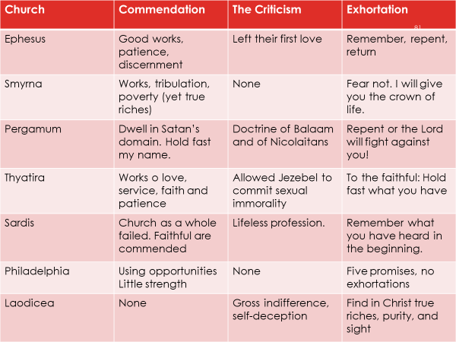

Evaluate the following two leaders:

Solomon

Jeroboam I

We can that their lives did not align with their .

Summary:

Day 1, Topic 2: Divine Design, Direction, and Development

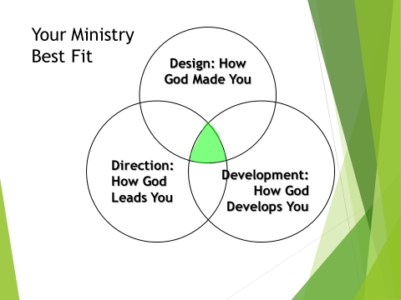

Defining Terms

- Divine Design: Understand how God has uniquely and intentionally wired you for ministry

- Direction: What does God want to do with your design?

- Development: How do you prepare for your ministry?

False Assumptions

- Anyone can be a pastor.
- Every pastor can become a turnaround pastor.

Divine Design

God’s “call” for vocational ministry

Are you gifted for pastoral or vocational ministry?

Prior Life Experiences

- Heritage
- Heroes
- High Points
- Hard Times

Current Life Experiences

- Age
- Marital Status
- Gender
- Ethnicity
- Education
- Health
- Finances
- Second Occupation
- Ministry Experience

Natural and Spiritual Gifts

He gives gifts to all.

. . . He makes His sun rise on the evil and on the good, and sends rain on the just and on the unjust.
Matthew 5:45

Passion

Temperament (we will expand on this later).

Direction

Ephesians 2:10

You must have a clear sense of your won

- Core Beliefs
- Core Values
- Mission
- Vision
- Alignment

All your personal preferences ought to be aligned with your church or mission’s core statements!

Development

Where are leaders developed?

- Churches (Quote from Re:Vision)*
- Seminaries
- Denominations
- Mission Agencies

Words of Encouragement

We can grow and develop throughout our lives.

We are a work in progress!

2 Timothy 3:14

Phil 4:9

Day 1, Topic 3: An Introduction to Church Transformation
Understand the Crucial Elements Needed for Church Revitalization

OVERVIEW:
LEADERSHIP AND TURNAROUND

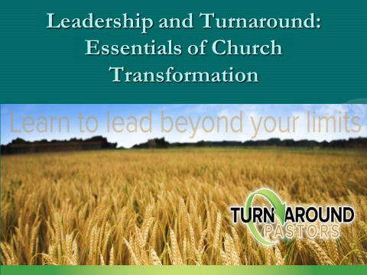

How does one go about changing a dying church with a lot of history?

How does one go about leading a church that is off center?
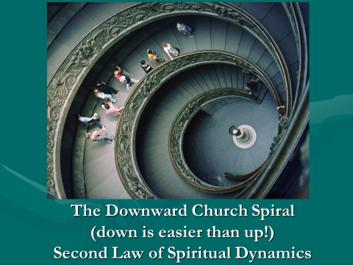

In America, one has at least an 85% chance of pastoring a .

The Three Ds: The Backdrop for Re-envisioning Leaders

Understand your Divine Design

Direction

Development

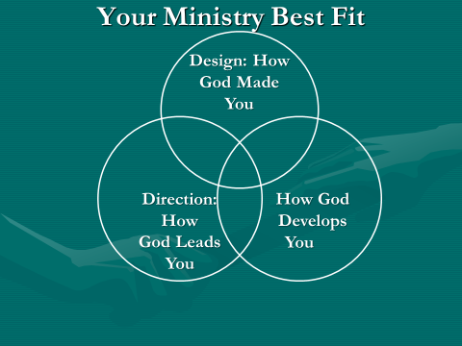

Matt Chandler discusses our lack of proper preparation for pastoral ministry.

When I graduated, I felt I had all the information I would need to accomplish all that God would demand of me as a pastor. I had a verse for everything. For the next few years, as an associate pastor over college students and as an itinerant preacher, I found very few gaps in my training and was extremely pleased with what I had paid so dearly for in money, hours and study.

But, my perceptions changed quickly when I became the lead pastor of the Village. It didn’t take me long (about a month and a half) as a twenty-eight-year-old pastor to figure out that I had more to learn than I had time to learn. The gaps in my training weren’t biblical, theological, or even philosophical. My gaps were in the areas of leadership and people. In the five years of theological training we never talked about how to hire the right people or remove people who need to be removed. There was never a class on how to build a board or work with an existing board. There wasn’t one seminar offered on how to set salaries, conduct performance reviews, or create clear job descriptions.

Although the Scripture taught me the spirit by which I was to interact with people and the grace I was to show even my enemies, I was at a loss regarding the practical aspects of leading a team—and a team of leaders at that.

Our Development:

But you must continue in the things which you have learned and been assured of, knowing from whom you have learned them.
2 Timothy 3:14

The things which you learned and received and heard and saw in me, these do, and the God of peace will be with you.

Philippians 3:9

A Painful Reality: In America, Pastors who take a new church stand an 85% chance of inheriting a church that is plateaued or declining in worship attendance.

First, you must embrace . . .

Your Mission Matthew 28:18-20

Vision: Your ministry must communicate a clear, compelling vision with passion.

Know where you want your church to be in two, five, and ten years and move that direction.

Essential Keys

1. Seek the Face of God. Nehemiah 1

2. Pray and ask the Lord for His direction, for His vision. Nehemiah 1

3. Survey the church situation (Nehemiah)

4. Develop great .

5. Recognize your Employer!

Prov 29:24

1 Thess 2:4

Lifeway Christian Research (LCR) asked over two hundred pastors to keep a record of the way they spent their time in a 168-hour week. Roughly half of them were in the top five percent of congregations for conversion growth; the other half were in congregations reporting no significant conversion growth.
Note some of the differences in the way pastors invested their time!

6. Preach Well: TAPs spent an average of 22-hours in sermon preparation vs 4 hours for NTAP—LCR).

When I began to preach, people looked up to preachers. In New York City, the sermons of New York ministers were published in The New York Times. People admired the church . . . That was 65 years ago. Today that has changed. Today the preacher has lost the respect of the people, lost its authority. We live in a day in which the wind is against us. All the games are away games.
--Haddon Robinson Distinguished Professor, Gordon-Conwell Theological Seminary, 4/27/2012, at Biola University

7. Meet people outside the church (TAP—5 hours sharing the Gospel vs 0 hours for NTAPs). You may have to restructure your schedule to accommodate this change!

8. Delegate responsibility to others. (NTAP—33 hours in pastoral care, TAP—10 hours).

9. Develop a team.

10. Develop new leadership.

11. Learn good skills

12. Become a problem solver.

13. a mentor or a coach.

14. Know your spiritual gift mix and use your primary gifts.

15. Empower others to use their gifts.

16. Lead without being domineering. Be directive, not passive, but lead. (Tell not suggest).

17. Love the Lord and your people deeply.

18. Be more innovative than traditional.

19. Embrace necessary change

20. Be more of a leader than a manager.

21. Count the cost for you, your spouse, and your children.

Turnaround Is Possible! There is hope for your church!

Day 1, Topic 4: There’s Hope for Your Church—Part 1

Note: this material comes from Gary McIntosh’s book, There’s Hope for Your Church
Used by permission

Introduction:

Bottleneck Responses

Turning Around a Church or Ministry: The Process

Why Is There Hope?

1. Christ said, .

2. God desires us to be .

Gen 1:28

Gen 9:1

Gen 35:11

Exodus 1:7—Obedience

Col 1:6

3. God revitalizes .

Rev 2:7ff

Why Is Hope Important?

“The death rate in the week between Christmas, 1944, and New
Year’s, 1945, increased in camp beyond all previous experience.
In his opinion, the explanation for this increase did not lie in the
harder working conditions or in the deterioration of our food
supplies or a change of weather or new epidemic. It was simply
that the majority of the prisoners had lived in the naïve hope that
they would be home again by Christmas. As the time drew near
and there was no encouraging news, the prisoners lost courage and
disappointment overcame them. This had a dangerous influence on
their powers of resistance and a great number of them died.”—Victor
Frankl, Man’s Search for Meaning, 74-75.

With hope, we thrive; without it, we die.

Three Fogs Covering Hope

- The Fog of _______________

- When we are __________, we lose ____________.
- Elijah and Jezebel. 1 Kings 19

- The Fog of _____________

- When we are _____________, we lose ________.
- Moses striking the rock. Numbers 20

- The Fog of __________

- When we are ______________, we lose __________.
- King Saul when Samuel failed to appear. 1 Samuel 13

We Keep Hope Alive By …

- Keeping a spiritual focus Nehemiah 4:9

• We ____________ to God.

- Managing the process

• We set up a __________.

Step #1: Keep A Spiritual Focus

- Take time to __________ each day.

• We lose hope when we focus on ourselves.

- Keep the big _____________ in view.

• We lose hope when we focus too narrowly.

- Focus on the Positive

• We lose hope when we focus on problems.

Stay away from negative people. They have a problem for every solution.
--Albert Einstein

Step #2: Manage the Process

- Revive Yourself

• Remember: To turn your around, you must first turn
around.

- Affirm your Calling, your gifting.

• Remember: What God has called you to do, he has gifted you to do; what God has gifted you to do, he has called you to do.

- Develop a Learning posture.

• Remember: Leaders are Learners.

- Establish life goals.

Remember: Nothing happens until you write it down.

- Build relationships.

• Remember: People buy into your vision when they buy into you.

- Review your vision daily.

• Remember: Vision is an inside job.

- Recruit a Support team.

•Remember: If they want to , run with them;
If they want to , walk with them;
If they want to , find someone else.

- Have a regularly scheduled vision meeting.

• Remember: People need to be reminded a regularly where you re headed.

- Preach your vision every other week.

• Remember: People move in the direction of their predominant thoughts.

- Get some Rest and Relaxation (R & R).

• Remember: Even Jesus took time away from people.

- Breaking Through: Develop a Turnaround Plan

Gary McIntosh, There’s Hope for Your Church (Grand Rapids, Baker, 2012), 164. (Used by permission)

Take a few minutes to write down some things that spoke to you about your ministry.
  - Where are you stuck?
  - Where are the areas you need to work?

Day 2, Topic 1: The Pastor’s Worth



Please note that this Pastor Unique diagram is slightly different than the Divine Design, Development, and Direction diagram. We are focusing in this section on “Who God Says You Are.”
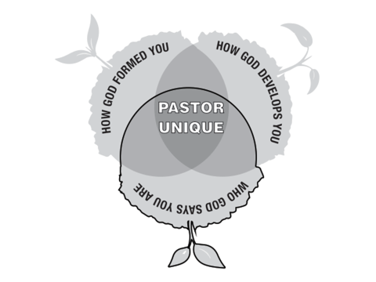
- We are Specially Created by God Genesis 1:26-28

26 Then God said, "Let Us make man in Our image, according to Our likeness; let them have dominion over the fish of the sea, over the birds of the air, and over the cattle, over all the earth and over every creeping thing that creeps on the earth."
27 So God created man in His own image; in the image of God He created him; male and female He created them.
28 Then God blessed them, and God said to them, "Be fruitful and multiply; fill the earth and subdue it; have dominion over the fish of the sea, over the birds of the air, and over every living thing that moves on the earth."
Genesis 3:26-28

We are God’s .

We bear God’s .

- We are priceless beyond measure 1 Peter 1:18-19

Knowing that you were not redeemed with corruptible things, like silver or gold, from your aimless conduct received by tradition from your fathers, but with the precious blood of Christ, as of a lamb without blemish and without spot.

1 Peter 1:18-19

We were redeemed not by the wealth of the world

We were redeemed by the Blood of Christ, the blood of the Lamb!

- We are Precious Gift Ephesians 4:7-11

But to each one of us grace was given according to the measure of Christ's gift. Therefore He says: "When He ascended on high, He led captivity captive, And gave gifts to men.” . . . And He Himself gave some to be apostles, some prophets, some evangelists, and some pastors and teachers.

Ephesians 4:7-8, 11

The Father gives the Son as Head of the Church Ephesians 1:22

The Son gives Christian leaders as a .
Summary

We are God’s craftsmanship.

We bear God’s image.

We are priceless beyond measure.

Christ dispensed you as a measure of His royal treasury.

Day 2, Topic 2: Developing a Biblically Based Vision for Ministry



Photo: https://pixabay.com/photos/compass-bearing-compass-navigation-3072376/

An Eight-Step Process:

Developing a Plan for the Future

©2019 by Gordon E. Penfold and Turnaround Pastors, Inc. All rights reserved. This document may not be reproduced or retransmitted by any means without the express written consent of Gordon E. Penfold.

Introduction:

I once heard Leith Anderson of Wooddale Church in Eden Prairie, Minnesota, describe the following accounts. The church was offered a church camp. The camp was debt-free and had experienced a great ministry. The value of the real estate alone was over one million dollars. The church considered the offer and said, "We’re sorry, but we are unable to assume the responsibilities of operating a camp. We are a church, and the Lord has not called us into the camping business. We must refuse your offer.”

A few months later, the church was approached by a Christian school with a similar offer. The school campus was debt-free and was also valued at more than a million dollars. The school had a competent staff and a growing enrollment. The church’s response was the same. “We are a church, and the Lord has not called us into the Day School business. We are sorry, but we must refuse your offer.”

Now the average Christian in the pew would be saying, “What’s wrong with you? Are you out of your mind?!” Obviously, the church was not out of its mind. On the contrary, the Church was very much in the will of God. The Church had determined its mission and would not be led away from that mission by even the most attractive offers.

Wooddale Church’s purpose (mission) statement reads, “Our purpose as a church is to bring people in right relationship to God and to one another.”

Most churches, who are plateaued or declining, or who are deeply conflicted, struggle with clarity of mission and vision. We desire to help churches to discover a biblically-based mission and vision that will ignite the process of moving a church from plateau, decline, or deep conflict towards revitalization, hope, and fruitful ministry!

The goal of this process is to help you work through your church’s mission, core beliefs, and core values to arrive at a biblical based and Spirit-directed vision for your ministry. Aubrey Malphurs and Gordon Penfold describe vision in the following way. “Vision is a clear, exciting picture of God’s future for your ministry as you believe it can and must be” ( Re:Vision—the Key to Transforming Your Church, 154).


https://pixabay.com/photos/wagon-wheel-wood-iron-companions-334076/

The study will cover at least eleven weeks (please note that most churches stretch this into twenty-two or more weeks, so don’t be in a hurry!) when dealing with mission, core beliefs, and core values. Each week you will look at numerous passages to try and understand core beliefs, keys to the reason for your existence. Follow the directions given in each section of this process. Each segment represents a spoke on the wheel. At the end of each section, you will be asked to summarize what you have studied. Each class or group will try to assemble all the spokes to determine the hub into which each spoke fits.

After this initial time of discovery, you will examine your church’s strengths as well as your community needs. These two sections will connect God’s purposes with your community needs and church strengths. Out of this study will flow a clear understanding of your mission and a clear snapshot of the vision for the next season of your ministry.

The studies are designed to be completed by individuals in your church. These people will then participate in class and small-group time reserved for a lively discussion. Finally, a task force of 5-7 people will sharpen and hone your work as you lay out a portrait of your next season of ministry.

You will use the Word of God and be led by the Spirit of God in this venture. The passages and the study questions are designed to make you think and reason biblically. We desire that this study will evoke a tremendous amount of discussion both in and out of your class or small-group.

Our desire ought to be to know and to do the Will of God in His church. My prayer is that you will have the greatest impact for Christ we can possibly have, all to the glory and praise of Him who has begotten us to a living hope by the resurrection from the dead.

Gordon E. Penfold, D.Min
Pastor
Executive Director of Fresh Start Ministries
Co-founder, Turnaround Pastor, Inc.

July 30, 2015
Revised: June 30, 2019

Please note that I am deeply indebted to Dr. Bill Hoyt who provided training for me in this area. The initial training took place with CBAmerica in Loveland, Colorado, July 2009. This material is used with Dr. Hoyt’s permission. I have since added a great deal of my own material to what he provided. Dr. Lavern Brown also provided materials used in the church and community assessment portion of this workbook. Turnaround Pastor, Inc. is indebted to each contributor to this work!

Our united prayer is that this material will help you and our ministry thrive for the sake of Christ and His mission.

Gordon E. Penfold

The Role of Mission, Values, and Vision in Transformational Leadership

Pastors are often bewildered by what steps they need to take next.

The Importance of Vision



Mission
Mission answers the question, “why?”
Why do we exist as a church?

Vision
Vision answers the “how” question.
Vision is a clear, exciting picture of God’s future for your ministry as you believe it can and must be.—Malphurs & Penfold, Re:Vision—the Key to Transforming Your Church, 154.

Nothing precedes purpose. The starting pointy for every church should be the question, ‘Why do we exist?’ Until you know what your church exists for, you have no foundation, no motivation, and no direction for your ministry. If you are helping a new church get started, your first task is to define your purpose. It’s far easier to set the right foundation at the start of a new church than it is to reset it after a church has existed for years.
However, if you serve in an existing church that has plateaued, is declining, or is simply discouraged, your most important task is to redefine your purpose. Forget everything else until you have established it in the minds of your members. Recapture a clear vision of what God wants to do in and thorough your church family. Absolutely nothing will revitalize a discouraged church faster than rediscovering its purpose.

Vision answers the question, “how?”
With the mission (why) in mind, vision paints a picture of the path to get there.

Overview of the Process

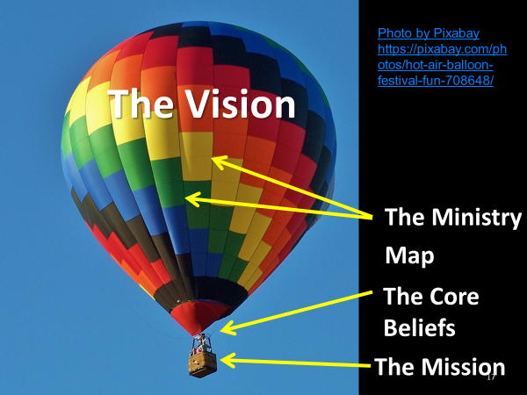

The balloon “payload” is the Mission. That’s what needs to be delivered. The Core Values and Core Beliefs provide the strands that connect the payload to the vision. The Ministry Map gives shape to the whole structure. The Ministry Map provides the direction for the day to day, week to week, and year to year ministry of the church. The Vision produces the “lift” necessary to deliver the payload.

The Process of Developing a Biblically Based Vision

Developing vision for a church requires an eight-step process found below:

Step 1. The Mission
+
Step 2. Core Beliefs
+
Step 3. Core Values
+
Step 4. Our Church Strengths
+
Step 5. Our Community Needs
+
Step 6. Determine God’s Direction

Step 7. Our Vision for Ministry

Step 8. Complete Your Ministry Map

Foundations for Developing a Ministry Plan for Yourself and the Church

1. Understand (know) God--Be Deeply Immersed in the Word of God and Prayer

2. Understand (know) your Gifting

3. Understand (know) your Congregation

4. Understand (know) your Community

5. Understand the enemy of your souls.

6. Understand your mission

7. Count the cost.

Note: Your vision for ministry will affect how each of these seven foundations will function in your church, your community, and your ministry.

What is Ministry Mapping?

- Brief History of Strategic Planning
  - Great Mission and Vision Statements
    - No impact
  - Mission and Vision Statements don’t motivate
  - Values motivate
  - Clarify and articulate your values

Two Problems

Typically, Strategic Planning does not start .

Does not go far .

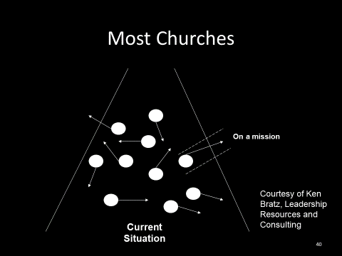

Why Create a Ministry Map?

- To create unity around a commonly understood, widely supported mission and vision
  - “The problem with most churches is not a lack of vision, but too many visions” (Leith Anderson)

- Judges 21: 25 In those days there was no king in Israel; everyone did what was right in his own eyes.

- To achieve greater effectiveness and satisfaction by establishing specific ministry plans and clear ministry outcomes

The Mapping Process results in:

  - Core Beliefs briefly stated and effective for teaching your people the basic truths upon which your church stands and ministers
  - Core Values based on your Core Beliefs ensuring that your church keeps the main things the main things
  - A sound Biblical understanding of your church’s Mission
  - A clear, concise and compelling vision of what it will look like as your church fulfills its God-given Mission
  - A focus that leads to ministry effectiveness by enabling you to evaluate everything you do by its contribution to your accomplishing your Mission and Vision

This is fundamentally a Spiritual Process

- We build upon your Biblical beliefs.
- We are guided by your core values.
- We agree on your Biblical mission.
- We bathe the process in prayer.
- We seek the Spirit’s wisdom.

We listen . . .

To God through the Scripture
To God through His Spirit (prayer)
To each other
To knowledgeable and experienced people as they lead the process

Option 1: Work intensely with a coach (contact Gordon if you need help or have questions).

Option 2—Working within the church leadership

The Process

- Share the process with the church or ministry
- Ask people to look at the passages and state the essential truths that each passage teaches in the particular area of study.
- Encourage church members to write out their own statements of Core Beliefs
- Bring the results to the study group that will develop the core belief/values statements.

Teach the planning process
  - SMART Goals
    - S
    - M
    - A
    - R
    - T

- Create the Annual Plan
  - One or two primary SMART Goals
    - From Key Measurement Areas
      - Conversions
      - Attendance
      - Assimilation
      - Lay Involvement
      - Small-Group Involvement
      - Leader Development
      - Tithers

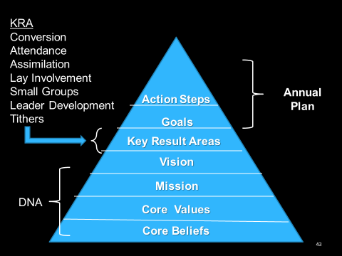

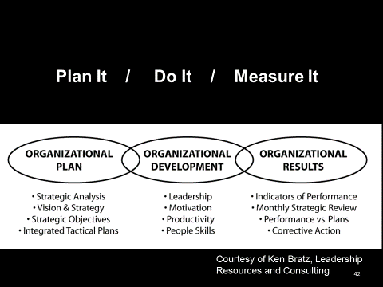

Breakout Session

Exercise 1: Please write down the core values for your church as you understand them:

Exercise 2: Please write down the vision for ministry for the church you serve. Be as clear and succinct as possible.

Compare your responses with others in your group. How close are your answers?

Step 1: The Mission



The Main Thing is to keep the MAIN THING the Main Thing!

THE GREAT COMMISSION

Matthew 28:18-20 is known as the Great Commission. Carefully read this passage of Scripture. Observe at least seven different facts that you see in these verses. Record your observations below. (Please note that the only command [imperative] given in verse 19 is “make disciples.” The term “Go” is a participle and can be translated, “as you go,” or “while you are going.” As an imperatival participle, it can mean simply, “Go,” with the emphasis on ordering your life with the intention of making disciples. There are two other participles in verse 19, baptizing and teaching.)

1.

2.

3.

4.

5.

6.

7.

What is required for the Great Commission to be fulfilled by us?

Examine the following passages and answer the question: “What is a disciple?”

1. Luke 14:26 Disciples love Jesus above all else.

Matthew 10:37

.2 John 8:30-32 Disciples live by . . .

The following flow from the firsts three passages:

3. Disciples live by the Holy Spirit’s power.

4. Disciples are submitted to the Father.

5. Disciples live in obedience to the Lord Jesus Christ.

6. John 15:8, 16 Disciples actively engage in and support evangelism.

7. John 13:34-35 Disciples fellow believers as Jesus loves them.

In your own words, what would be the difference between a disciple and a convert?

Compare Matthew 28:18-20 with Luke 24:44-49. What are some striking similarities between the two passages? What are some notable differences?

John 20:21 is another statement that relates to our purpose in the world. Note four or five truths from this passage that have a direct bearing on our commission.

Acts 1:8 is Jesus’ Last Will and Testament before His departure for glory (note that Acts is a continuation of Luke’s Gospel). Please carefully read this passage and its surrounding context. Is the phrase, “You shall be witness to Me,” a command or a statement of fact (you may need some help with this question)?

What is the implication of your answer?

Understanding God’s Heart for the World

Romans 3:10-28 is God’s evaluation of the human race! How does verse 3:11b specifically relate to our relationship with the world in light of Matthew 28:18-20?

According to Matthew 11:19 and Luke 7:34, what was the Lord’s attitude toward sinners? What should our attitude be, and why?

Jesus issued a very tender invitation in Matthew 11:28-30. Do people outside church fellowship perceive this same attitude on the part of our congregation today?

What motivated our Savior in His ministry, according to Mark 10:45?

Matthew 20:28?

Luke 19:9-10?

What is the implication of these verses when coupled with John 20:21?

In John 4:17-23, Jesus met the woman at the well. How did He deal with her need? Did He turn His back on her past? Describe the woman’s testimony in 4:28-29, 39.

Was Christ effective in His ministry to the woman?

Matthew 4:19 is an interesting verse. Take off the blinders for a minute and see what the Lord is saying in the text. Which part is the command? How does the second half of the verse relate to the first?

Who is the target?

AUDIENCE & PARTICIPANTS

Read Luke 4:42-44. Is the Gospel limited to just one place or one culture?

How did the early church respond to the Great Commission, as seen in the following passages?

Acts 1:8

Acts 3:12-26

Acts 5:41-42

Acts 13:1-3

What is significant in this last passage that is different from the preceding passages in Acts? What implication does that have for your church?

THE MESSAGE

One of the great deceptions that has taken place in the church is that only the “professionals” are capable of preaching the Gospel. According to Acts 8:1-4, who did the work of preaching the Gospel after the church was scattered from Jerusalem? What implication does that have for you?

What are the essential elements of the Gospel? (Hint: The Gospel is defined only once in Scripture in 1 Corinthians 15:3-11).

According to 1 John 5:11-13, what is the quintessential requirement for salvation?

FURTHER STUDY FOR THE ADVENTURERS ONLY:

Carefully read 2 Corinthians 5:17-21 and answer the following questions and explain your answer:

Is there anyone beyond the grasp of God’s grace?

Find a definition of “reconciliation” in a Bible dictionary or encyclopedia. In light of this passage and the definition of reconciliation, how should you view those around you?

What is an ambassador, and what does he do?

Therefore, what is to be our ministry in this world? At work? With our neighbors? When we are involved in recreation?

Other observations:

What was the fruit of Paul’s missionary efforts in Acts? Was it just making “converts?” No! It was the establishment of churches. What was Jesus’ double promise in Matthew 16:18? Starting churches was the practical way of fulfilling the Great Commission!

SUMMARY: (for all the passages used in this lesson)

After looking at the passages for this week, summarize in a brief statement the mission of the church as you have viewed it in the material. Remember, keep it simple and clear!

Here are two examples of a mission statement. Please do not use it as our own, but it will give you an idea of a mission statement.

“We are a family of faith, lovingly adopting lost children.”

“The purpose of our church is to glorify God by finding, keeping, and building people.”
Gary McIntosh, One Size Doesn’t Fit All

“Our mission is to make more and better disciples.” Holyoke, Colorado

The Mission of our Church is . . .

For Adventurers Only

Try to state your mission in eight words or less in the following format: Verb, target, outcome. Here are some examples from Canoeing the Mountains Note: these are secular statements, but they will give you an idea about how to do this. “Save endangered species from extinction” and “Improve African children’s health.”

Verb:

Target:

Outcome:

Steps 2-3. Discovering Our Core Beliefs, Core Values/Behaviors

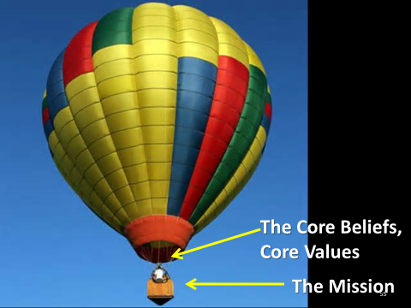

Step 2: Core Beliefs

Core Beliefs are not (clarity begins by understanding what they are not)

  - Core beliefs are not a comprehensive recitation of fundamental theological beliefs.
  - Core beliefs are not a doctrinal statement rehearsing your entire belief system.
  - Core beliefs are not your statement of faith.
  - Core beliefs are not values. Values flow from your core beliefs.

Core Beliefs are . . .

- Core beliefs are those beliefs that significantly impact who you are
- Core beliefs “define” who you are.
  - If someone read your core beliefs and knew nothing else about you, they would know who you are at your very center.
  - If one of your Core Beliefs were not true, was changed or removed, you would cease to be who you are.
- The “leading edge” of declaring a vital, deep and often complex Biblical truth

- “Taught through” annually.

Printed and are used a part of the process of “introducing” the church to an inquirer or potential member. They would be reviewed as part of a new member orientation process.

- Part of a cluster of “defining declarations” – your Core Beliefs, Core Values, Mission and Vision Statements

Example of the Process: Core Belief Development on Prayer

Two Examples of Final Statements of the Core Belief on Prayer for Two Different Churches

- Through prayer, Christ-followers align themselves to God’s will, releasing His power to accomplish His purposes.”—Bill Hoyt: Growing Healthy Churches

- Prayer: Prayer connects Christ-followers intimately with the Person, purposes, and power of God.

Note: The second Core Belief aligned well with our Vision Statement: Our vision is to glorify God by connecting intimately with God, deeply with one another, and intentionally with people who do not know Christ.

Step 3: Core Values

Core Values flow directly from your Core Belief statements.

Core Values

- Not an academic statement listing your entire value system
- Identification and articulation of those values that significantly impact who you are and what you do.
- The things that motivate you and shape what you do, not what you say.
- Ministry principles by which you live
- The things for which you will spend your lives
- The values you are prepared to die for
- One Core Value per Core Belief
- Briefer than Core Beliefs
- Core Values are what we will do in light of what we believe.

- The verbal construct…

Not “We believe...,” “Therefore we value…”

“We believe…,” Therefore we will…”

  - Express values in terms of behavior
  - Core Values should be expressed in nine words or less.

Core Beliefs and Core Values—The Process

- Each person writes a statement on their own
- The team puts all the statements together
- The team shows them all
- The team formulates one statement—a core belief
- Then a team member or facilitator works to sharpen the wording
- Repeat the same process with the core value.

Engage in the Process for Developing Core Beliefs and Core Values

- Develop a set of statements that identify your biblically-based Core Beliefs.
- In each section, study carefully the passages presented. Focus only on passages that deal with the selected subject.
- Take no more than two weeks to cover each section. You may use the first week to discuss some of the questions you have. Then use the second week to write out a statement about God.
- Bring your statement to your group and try and write a concise core belief statement by combining your efforts.

Follow the guidelines spelled out below.

- Take the passages listed that deal with each of the Core belief areas. Read them, pray about them, and wrestle with them.
- Prepare a preliminary statement of a Core belief -- in 15 words or less.
- Avoid wasted words (like “that”) and superfluous adjectives.
- Avoid “churchy language,” Christian jargon, unnecessary Biblical or theological words.
- State Biblical and theological concepts in words that the unsaved, unchurched, untaught, and uninitiated can readily understand.
- Use Biblical and theological words when . . .
  - They are the clearest, most accurate, and richest words we can use.
  - The concept is so fundamentally crucial that we intentionally want to create “a teaching moment.”
- Whenever possible use present tense, active voice verbs.
  - Avoid verbs like “is” and “are” in favor of verbs like wants, loves, directs, frees, calls, sends, saves, instructs, and so forth.
- Avoid lists

Worksheet #1

Here are the passages that relate to our Core Belief about God.

What values about God’s person and character stand out in each of the passages?

Genesis 1:1

Deuteronomy 6:4-5

Isaiah 43:10-11

Psalm 90:2

Psalm 102:25-27

John 3:16-17

1 Corinthians 8:4-6

2 Corinthians 13:14

1 Peter 1:1-3a

1 Peter 1:15-16

1 John 1:5

Do you see any common themes or repeated themes? If so, please list them below.

Based on your observations, write out a core belief statement about God. Keep your statement to 15-words or less.

Your Core Belief: We believe . . .

Core Value/Behavior: Therefore, we will . . .
Worksheet #2

Here are the passages that relate to our Core Belief about Jesus.

What values about Christ’s person and character stand out in each of the passages?

Luke 4:16-19

John 1:1-3

John 14:3

John 14:6-7

Ephesians 1:3-10

Philippians 2:6-11

Col 1:15-20

Col 2:9-10

1 Tim 2:5-6

2 Peter 3:9

Do you see any common themes or repeated themes? If so, please list them below.

Based on your observations, write out a core belief statement about Jesus. Keep your statement to 15-words or less.

Your Core Belief: We believe . . .

Core Value/Behavior: Therefore, we will . . .

Worksheet #3

Here are the passages that relate to our Core Belief about the Holy Spirit.

What values about the Holy Spirit stand out in each of the passages?

John 14:25-26

John 16:7-15

Acts 1:4-8

Acts 5:3-4

Romans 8:9-11

1 Corinthians 2:10-14

1 Corinthians 6:19

1 Corinthians 12:7-11

Gal 5:22-25

Ephesians 3:16-19

Ephesians 5:18-21

Do you see any common themes or repeated themes? If so, please list them below.

Based on your observations, write out a core belief statement about the Holy Spirit. Keep your statement to 15-words or less.

Your Core Belief: We believe . . .

Core Value/Behavior: Therefore, we will . . .

Worksheet #4

Here are the passages that relate to our Core Belief about the Bible.

What values about the Bible stand out in each of the passages?

Deut 8:3

Nehemiah 8:2-6

Isaiah 55:10-11

Jeremiah 15:16

Psalm 119:105

Matthew 22:29

Luke 8:11-15

Luke 11:28

Luke 24:30-32

John 20:30-31

Acts 17:11-12

Romans 15:4

2 Tim 3:16-17

Hebrews 1:1-2

Hebrews 4:12

1 Peter 1:23-25

2 Peter 1:20-21

Rev 22:18-19

Do you see any common themes or repeated themes? If so, please list them below.

Based on your observations, write out a core belief statement about the Bible. Keep your statement to 15-words or less.

Your Core Belief: We believe . . .

Core Value/Behavior: Therefore, we will . . .

Worksheet #5
Here are the passages that relate to our Core Belief about the Church.

What values about the church stand out in each of the passages?

Matthew 16:17-18

Matthew 28:18-20

Acts 2:38-47

Acts 6:7

Romans 12:4-8

1 Corinthians 1:10

1 Corinthians 12:12-31

1 Corinthians 14:26

Ephesians 1:22-23

Ephesians 4:3-6

Ephesians 4:11-16

Col 1:8

Heb 10:24-25

Do you see any common themes or repeated themes? If so, please list them below.

Based on your observations, write out a core belief statement about the Church. Keep your statement to 15-words or less.

Your Core Belief: We believe . . .

Core Value/Behavior: Therefore, we will . . .

Worksheet #6
Here are the passages that relate to our Core Belief about Worship.

What values about worship stand out in each of the passages?

Ex 34:14

Judges 7:12-15

2 Samuel 15:30-32

1 Chronicles 16:29

2 Chronicles 29:27-31

Job 1:20-22

Psalm 95:6-7

Isaiah 6:1-9

Jeremiah 26:2-3

John 4:19-24

Rom 12:1

1 Corinthians 10:31

Ephesians 5:19-20

Phil 2:9-11

Heb 10:24-25

Rev 5:1-14

Rev 7:11-12

Do you see any common themes or repeated themes? If so, please list them below.

Based on your observations, write out a core belief statement about Worship. Keep your statement to 15-words or less.

Your Core Belief: We believe . . .

Core Value/Behavior: Therefore, we will . . .

Worksheet #7
Here are the passages that relate to our Core Belief about Humanity.

What values about Humanity stand out in each of the passages?

Gen 1:26-28

Gen 3:1-7

Gen 3:8-19

Psalm 8:3-8

Psalm 139:13-14

Jeremiah 1:5

2 Corinthians 5:17-18

Do you see any common themes or repeated themes? If so, please list them below.

Based on your observations, write out a core belief statement about Humanity. Keep your statement to 15-words or less.

Your Core Belief: We believe . . .

Core Value/Behavior: Therefore, we will . . .

Worksheet #8

Here are the passages that relate to our Core Belief about Sin and Salvation.

What values about sin and salvation stand out in each of the passages?

Psalm 51:1-5

Isaiah 59:1-3

Isaiah 64:6

John 3:16-18

John 11:25-27

Acts 4:10-12

Romans 1:16-17

Romans 3:19-24

Romans 4:4-8

Romans 6:23

2 Corinthians 5:21

Ephesians 1:7-8

Ephesians 2:1-10

1 Pet 2:24-25

1 John 1:5-8

1 John 2:2

1 John 3:4-6

Do you see any common themes or repeated themes? If so, please list them below.

Based on your observations, write out a core belief statement about Sin and Salvation. Keep your statement to 15-words or less.

Your Core Belief: We believe . . .

Core Value/Behavior: Therefore, we will . . .

Worksheet #9

Here are the passages that relate to our Core Belief about Edification.

What values about edification stand out in each of the passages?

Acts 4:32-35

Romans 14:19

Romans 15:2-3

1 Corinthians 8:1

1 Corinthians 10:23

Ephesians 4:11-16

Ephesians 4:29

Colossians 1:28

Do you see any common themes or repeated themes? If so, please list them below.

Based on your observations, write out a core belief statement about Edification. Keep your statement to 15-words or less.

Your Core Belief: We believe . . .

Core Value/Behavior: Therefore, we will . . .

Worksheet #10
Here are the passages that relate to our Core Belief about Prayer.

What values about prayer stand out in each of the passages?

Matthew 6:7-13

Matthew 7:7-11

Luke 18:1-8

John 15:7-8

John 16:23-24

Acts 12:5-19

Acts 13:1-3

James 5:16-18

Do you see any common themes or repeated themes? If so, please list them below.

Based on your observations, write out a core belief statement about the Prayer. Keep your statement to 15-words or less.

Core Value/Behavior: Therefore, we will . . .

An Example Using Prayer

Here are the passages that relate to our Core Belief about Prayer.

What values about prayer stand out in each of the passages?

Matthew 6:7-13

Matthew 7:7-11

Luke 18:1-8

John 15:7-8

John 16:23-24

Acts 12:5-19

Acts 13:1-3

James 5:16-18

Do you see any common themes or repeated themes? If so, please list them below.

Based on your observations, write out a core belief statement about the Prayer. Keep your statement to 15-words or less.

Core Value/Behavior: Therefore, we will . . .

Examples of Core Belief Statements about God

One Comprehensive Statement

- We believe God, the loving Father, Son, and Holy Spirit wants all people to be saved.

- We believe the God of grace and love desires to be in relationship with all people.

- One eternal God Who passionately loves His creation, Who deservedly (rightly, justifiably, worthily) desires our love in return.
CORE VALUE: Therefore, we will . . . return His love passionately.—Terry J.

- We believe the One True God, Father, Son and Holy Spirit, fervently pursues (chases) relationships with His Creation.
Core Value: Therefore, we will passionately pursue God and others because of Him (on His behalf).—Barb M.
- God: the only eternal, holy Creator of the universe pursues a personal relationship with us.
CORE VALUE: Therefore, we will . . . live for Him pursuing others that they might know Him. Sam C.

Three Statement Model

- God the Father is the creator and sustainer of all.
- God the Son, Jesus Christ, purchased our forgiveness and frees us to live Christ-centered lives.
- God, the Holy Spirit, gifts us with faith and empowers us for a life of love and service.

Four Statement Model

- The only true God lives eternally in community as Father, Son, and Holy Spirit.
  - The Father creates all people for a loving relationship with Him.
  - Jesus, through His death and resurrection, enables sinful people to enjoy a life-changing relationship with the Holy God.
  - The Holy Spirit lives in all Christ-followers, molding them into His likeness and empowering them to serve others

- The eternal, triune God is:
- Father Almighty, Creator, and Master of all
- Jesus the Son, the crucified, risen and reigning Savior
- Holy Spirit who creates faith, motivates for mission and empowers for fruitful service

Steps 4-7. Developing a Vision for the Local Church
How to develop a widely shared unifying vision in small and medium-sized congregations.

Defining Terms (review)

- What do we mean by “mission”?

- What do we mean by “vision”?

Mission answers the question, “why?”

Why do we exist as a church?

Vision answers the question, “how?”

Vision paints a picture of the path to get there.

A longer statement that explains…
  - What is this church going to do
  - In this community
  - With these resources
  - To reach those people
Unique to each church and limited in time

The Problem

- Vision is essential because it determines how focus and resources will be allocated.
- Vision is difficult because it requires the ability to balance “big picture” and “fine detail.”
- Vision is difficult because it is a group process, especially in small churches
- Vision is challenging because it is never finished.
- Bible college and seminary don’t teach pastors how to develop and organize ministry around vision.
- Your congregants will fill the “vision vacuum” with their own vision is there is no central, compelling vision.
Here are some sample “vision thoughts” that are inappropriate.

- “The church is here to protect me from the world.”
- “The church is here to help me raise my children.”
- “The church is here to change the political culture”
“In those days Israel had no king; everyone did what was right in his own eyes” (Jdg. 21:25).

Three Elements of Vision
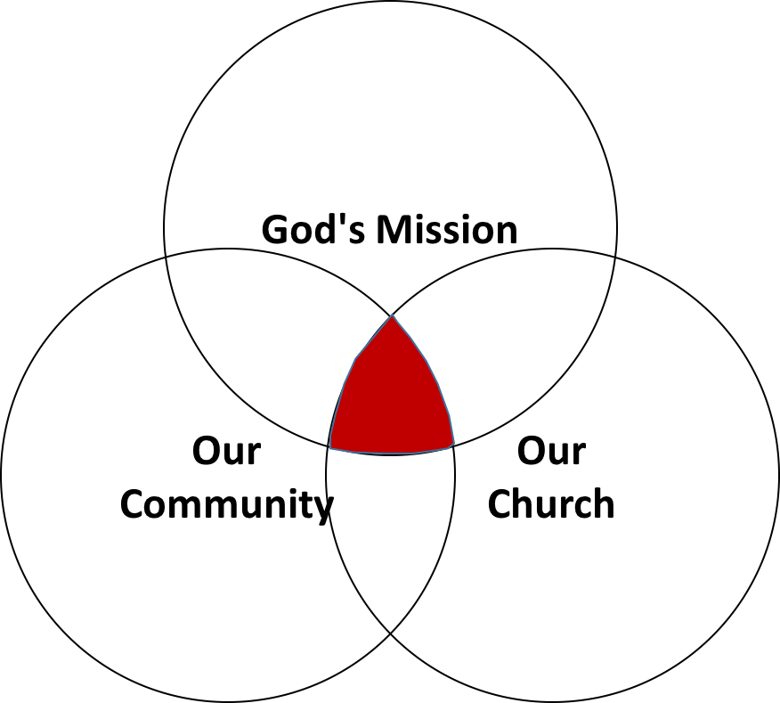

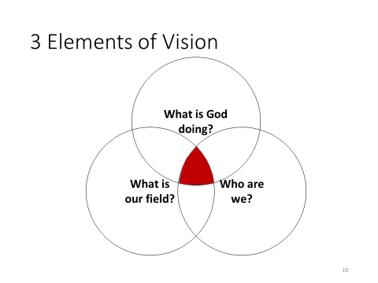


Step 4. Our Church Strengths

The fourth step in developing vision is to articulate your church's role in the “big story.” For example, if you favor some variety of kingdom thought, you might use a scenario like this:
- Evangelism: we recruit citizens into God’s kingdom by persuasively presenting the gospel.

- Discipleship: we train believers how to live as a witness for the gospel and prepare them to serve as kingdom administrators.

Your church's role in the “big story:”
  - Evangelism: "recruiting" kingdom citizens
  - Discipleship: training kingdom administrators
Vision explains how your church fulfills the mission

Assumptions

- Jesus wants to build his Church at your church
- He’s already provided what you need for the next step

Figuring out what God wants your church to do starts with identifying what he’s given you to use.

Process:

1. Identify all the resources Jesus has entrusted to the church
- Begin Invite staff (paid and unpaid) to join the assessment
- Invite church leaders to join the assessment.
- Invite church leaders to join the assessment

- Write an assessment report for later reference

- Pastor's strengths, passions, experiences, interests, and expertise?
- People's spiritual gifts, passions, experiences, interests, expertise, redemptive relationships?
- Prayer warriors, bridge builders, apologists, evangelists
- Material and financial resources?
- Reputation in the community?
- Acquired congregational wisdom?
- Differentiate your resources from other churches
- Rank the top 3 to 5 that could be most easily redeployed to bridge-building or outreach activities

Exercise: What Resources has Jesus given your church?

- People
- Passions
- Abilities
- Opportunities
- Property
- Public reputation
- Special relationships
- Finances
- Spiritual maturity
- Prayer life
- Facilities
- Worship services
- Evangelistically minded
- Service-oriented
- Bridge-building events
- Location
- Calendar
- Yourself
- Other

Step 5. Our Community Needs

Here is a six-step process for assessing your community.

- Appoint a Task Force to identify the people groups in your community.
- Train the Task Force
- Try to identify receptive people groups in your community.
- Evaluate your ministry options
- Facilitate a group process to evaluate and identify where your outreach will begin
- Launch your ministry options.

- Appoint a Task Force to identify the people groups in your church and your community.

- Appoint a task force of seven people to study the demographic makeup of your church.
- Ask them to find out what group or groups of people your church primarily attracts and which group or groups your church has difficulty reaching.
- Ask them to identify underserved, unwanted (there are groups that churches don’t want to serve!), or unreached groups within your community (a later slide will say more about this).
- What insights and recommendations can they suggest so that your church could be more effective in its outreach?
  - Use MissionInsite, the Census Bureau statistics, or some other tool to aid in understanding the makeup of your community
  - Check with your local schools, the Mayor’s office, social services, and other advocacy groups who serve your community.
- Which groups will be most open to the Gospel and easiest for us to reach?

- Provide Training for your Task Force.

- Train them to consult with
  - Consult with community leaders
  - Consult with first responders
  - Consult with service agencies
  - School administrators and teachers
  - Take a “missionary tour” of your community. Ask the Lord to help you see the people who live in your community.
  - How many different groups can you identify within the “average drive” of the church?
  - Poll the congregation to identify community needs

- Train them to interview people in the community to discover needs.
- Teach them to view the community with “Harvest Eyes” (John 4:35-36) and “Harvest Prayer” (Matthew 9:37-38).

- Try to identify receptive people groups in your community

Jesus’ instructed his Disciples to concentrate their efforts on receptive groups.

“As you enter the house, give it your greeting. If the house is worthy, give it your blessing of peace. But if it is not worthy, take back your blessing of peace. Whoever does not receive you, nor heed your words, as you go out of that house or that city, shake the dust off your feet”(Matthew 10:12-24).

"…one of the major mistakes is to fail to do adequate research to understand the people [the churches] are seeking to reach with the gospel. It is important for a church to study the community and culture as well as the Scriptures."
- Gary McIntosh, Biblical Church Growth

Look for the following:

- Linked (kinship/friendship) to credible Christians
- People like those already in your church
- People with needs you can meet
- Groups in which any religion is growing
- People undergoing a cultural change
- Those who are dissatisfied with their lives
- People experiencing major life transitions
- Visitors to your worship service
- People in constant need of services and intervention
- People who experience chronic anxiety
- People who are experiencing major unfavorable life change
- People who are overlooked by other churches and agencies
- People who are “on the bubble” (they are in need but do not qualify for public help)
- Ethnic enclaves

E4 E3 E2 E1

E1. No cultural, ethnic or linguistic barriers – only the need to believe
E2. More like us: share a common language, culture, worldview
E3. Similar to us: common language (not mother tongue), ethnicity and culture differ but of the same "cultural family"
E4. Different than us: different language, culture, and worldview

  - Focus your ministries, bridge building, and outreach activities on clearly defined groups of responsive people.

- Evaluate Your Ministry Options

Determine which receptive groups will be easiest for your church to reach
- A group of people who are similar to those in the church; especially important in smaller churches
- Smaller churches should confine themselves to one or two groups who happen to be “closest” to the congregation.
- Larger churches will have the resources to build bridges to several different and perhaps very diverse groups within the community.

“Churches grow as they identify people with needs that the church can minister to, either by extending ministries already in place or building new ministries.”
        - George Hunter

- Facilitate a group process to evaluate and identify where your outreach will begin

- Assemble 15 to 30 influencers and officers
- The task force reports its findings, and you report yours
- The group works in small clusters to evaluate ministry potential

Clusters of 3 to 5 people (no couples!) answer the following questions and prepare to report back to the whole group:

- “Which of these groups are most like us?”
- “Which of these groups are we passionate about?”
- “What resources tell us this is God’s 'next step' for us?”
- “What do we have to start doing or do differently to reach this group?”
- “Can we do this?”
- “Will we do this?”

Facilitate group discussion until everyone is settled on and committed to ministering to a maximum of two target groups (but it is okay to settle on just one!)

- Focus your ministries, bridge building, and outreach activities on clearly defined groups of responsive people.

- Prayerfully launch your ministry initiative(s)

Step 6. Determining God’s Direction for Your Church

The first step in guiding your church toward a vision that everyone owns is to ensure that everyone understands the mission. In addition, the church must understand two things:
- What is God doing?
- How do we fit into God’s direction?

Why?

Because the most important and most difficult change you must lead is not in what people do, but in how they think.

This change is near the fountainhead of behavior.

How do we change the way they think?

We don't – but God will through his Word and his Spirit.

So, we cooperate with God to bring both the Word and His Spirit to bear on the hearts and minds of those we lead.

As you completed the Mission, Core Belief and Core Values section of this workbook, you completed these first steps in the process.

Step 7. Write Your Vision Statement

- Future-oriented
- Measurable
- A “big picture” statement of how

An example of a vision statement for Pathways Church:

“Over the next five years, Pathways Church will touch 15,000 people with God’s love, lead 1,500 to saving faith in Jesus, and baptize 500. We will provide ministries and resources to meet the spiritual, emotional, and physical needs of African immigrant families, and to the working poor living in the Winterhaven section of town.”

Step 8. Complete Your Ministry Map

As you prepare your Ministry Map, be sure to use SMART Goals.

Specific
Measurable
Aligned with Mission and Vision
Results-Oriented
Time Constrained

Examples of the Ministry Map statements:

We will build relationships with people in our community by providing GED education for 40 individuals in our community for each of the next five years.

We will provide an after-school care program to minister to the needs of 50 children and their single parents in our neighborhood that will develop godly, respectful and resourceful young men and women who will positively impact our community for Christ.
Breakout Session:

Your stated mission is this: Our mission is to make more and better disciples of all nations.

Your vision statement is: Southside Community Church exists to be and to make disciples of Jesus Christ who love God, love others and serve the world.”

The scenario: Your church was in decline for eleven years. Four years ago, the church began to make the main thing the main thing. Your neighborhood is changing and numerous refugee groups are being resettled in your community. Nevertheless, your church decided to stay in minister in your community.

A new challenge has arisen as the government is settling refugees from Syria in your backyard. People in the neighborhood have spoken violently against this, but to no avail. As a church, you feel compelled by the Great Commission to try to reach these refugees who really don’t want to be in the US.

Your mission, should you accept it, is to develop SMART Goals that will begin to enable you to penetrate this resistant population in order to reach them with the Gospel of Jesus Christ. Develop smart goals and action steps that will open doors as the Lord leads.

Vision resides where God's mission, receptive people, and church resources overlap.

©2015 2019 by Gordon E. Penfold and TAP, Inc. This document may not be reproduced or retransmitted by any means without the express written consent of Gordon E. Penfold.

You may contact Gordon Penfold at gordonpnfld@gmail.com. You may also find information at turnaroundpastor.com and startingfresh.net. Please feel free to contact him for ministry and church needs.

Day 2, Topic 3: You Have Real Personality

Your Personality and Your Ministry

This workshop is intended to address individual behaviors and provide each person information that will allow them to make course corrections in their day-to-day interactions with others to enhance the process of communication in your place of ministry.

- Understand your work behavioral tendencies and develop an understanding of how these styles may affect others.
- Understand, respect, appreciate, and value individual differences.
- Enhance your effectiveness in accomplishing better communication through style flexibility.

Behavior Versus Personality

Personality is defined as “the pattern of collective character, behavior, temperamental, emotional, and mental traits of an individual.” Personality is very complex and consists of multiple factors.

Behavior is defined as “one’s actions or reactions under specified circumstances.” Behavior is observable.

The distinction, then, we could make is that personality is our overall way of looking at a person – the totality of qualities, cultural values, beliefs, emotional make-up, skills, abilities, and traits particular to an individual. Behavior, on the other hand, is the way we respond to a specific situation. It is the outward expression of who we are.

General Introduction:

- Hippocrates – 400 BC – Observed four different areas of behavior
  - Blood
  - Black Bile
  - Yellow Bile
  - Phlegm
- Jung - 1921 – refined the four types
- Marsten – 1928 – Published “Emotions of Normal People” and identified the behavioral theory we use today

Personality Types: Lion, Otter, Golden Retriever, and Beaver

When it comes to personality profiles, most have heard of Myers-Briggs, Ned Herrmann’s Whole Brain, Galen’s four temperaments, DISC assessment, and the Keirsey Temperament Sorter. One of the lesser known profiles, but just as insightful, was developed by Dr. Gary Smalley and Dr. John Trent. They base their personalities around animal characteristics. Not only are these entertaining but they are very easy for children to grasp as well. People often say, “that person sure is a ‘beaver,’” or “you’re such a ‘lion-otter.’”
Personality Types: Lion, Otter, Golden Retriever, and Beaver

While these personality types are certainly broad categories, I find them very easy to remember and communicate. This is extremely beneficial when dealing with family members, employees, and/or people in general. Knowing their temperaments can make the home, work environment, meetings, and projects run much smoother.

Write down what you see from the slides on the screen:

Slide 1

Slide 2

Slide 3

How the DISC works:

Listed below are the characteristics of each temperament and how they line up with Galen’s and the DISC for comparison:

Lion (Choleric/Dominance)

Strengths– Visionary, practical, productive, strong-willed, independent, decisive, leader

Weaknesses– Cold, domineering, unemotional self-sufficient, unforgiving, sarcastic, cruel

Otter (Sanguine/Influence)

Strengths– Outgoing, responsive, warm, friendly, talkative, enthusiastic, compassionate

Weaknesses– Undisciplined, unproductive, exaggerates, egocentric, unstable

Golden Retriever (Phlegmatic/Steadiness)

Strengths– Calm, easy-going, dependable, quiet, objective, diplomatic, humorous

Weaknesses– Selfish, stingy, procrastinator, unmotivated, indecisive, fearful, worrier

Beaver (Melancholy/Compliance)

Strengths– Analytical, self-disciplined, industrious, organized, aesthetic, sacrificing

Weaknesses– Moody, self-centered, touchy, negative, unsociable, critical, revengeful

Often you’ll find that people have a primary character type and a secondary type. Take a look at yourself. Which one is your primary and which one is your secondary? Some naturally go together and make for a wonderful set of strengths. Also, be sensitive to the weaknesses in yourself and in others.

1. How the DISC Works

Task Oriented

C D

Responds Takes Action

S I

People Oriented

2. People who represent the various profiles and percentages of each group

Task Oriented

C D

Responds Takes Action

S I

People Oriented

Descriptors:

D

I

S

C

Desires of Each Personality Type

Task Oriented

C D

Responds Takes Action

S I

People Oriented

Representatives

Task Oriented

C D

Responds Takes Action

S I

People Oriented

Task Oriented

C D

Responds Takes Action

S I

People Oriented

3. What the DISC Personality Profile Demonstrates

Chart I (Most) Adapted Style

Graph I is generated from your “Most” responses
Your “Most” responses illustrate the behavior you exhibit in your “focus” environment.
Graph I is your “mask” graph
We tend to adapt our behavior to meet the demands of our environment. Graph I represents the behavior you project to others. It may not be the same as your natural behavior.

Graph I is the most changeable
Graph I can change depending on the demands from your environment. Many times, success can be directly related to your ability to read an environment and adapt the correct behavior to win.
Graph I is your “focus” graph
Graph I illustrates the behavior in your “focus” environment. It may change between work and home or can be situational. For example, meetings tend to demand certain types of behavior depending on your role, which may not be the same as your Basic (Natural) Style.

Chart II (Least) Natural Style

Graph II is generated from your “Least” responses
When you select adjectives that are “Least” like you the system moves you away from that type of behavior. For example, if you select words that describe you least, such as bold, daring or determined, your plot point on that factor will move down. Identifying what you are “least” like allows the process to determine your natural behavior.
Graph II is your natural behavior
When you are under pressure, your behavior will reflect your natural style because you do not have the energy to adapt or mask your behavior. Also, when you are totally at ease and have no need to adapt, others will see your natural behavior.

Graph II is the least changeable
Graph II will seldom change significantly because this represents the “real” you.
Graph II can change if you experience a significant emotional event
A significant emotional event can cause change in Graph II. For example, divorce, death of a loved one or loss of employment can significantly impact a person’s emotions and change Graph II.

PERCEPTION
“Perception is all there is.
There is no reality.
There is only perceived reality.”
Tom Peters

What do you see?



Behavioral Styles

INFLUENCE
+ Emotional
+ Enthusiastic
+ Optimistic
+ Persuasive
+ Animated
+ Talkative
+ People oriented
+ Stimulating

Disorganized
Undisciplined
Manipulative
Excitable
Reactive

Vain

DOMINANCE
+ High ego strength
+ Strong-willed
+ Decisive
+ Efficient
+ Desires change
+ Competitive
+ Independent
+ Practical

Pushy
Impatient
Domineering
Attacks first
Tough
Harsh
High
Fast Pace

ASSERTIVENESS

STYLE
FLEXIBILITY

STEADINESS
+ Dependable
+ Agreeable
+ Supportive
+ Accepts change slowly
+ Contented
+ Calm
+ Amiable
+ Reserved
Unsure
Insecure
Awkward
Possessive
Conforming
Wishy-Washy

COMPLIANT
+ Perfectionist
+ Sensitive
+ Accurate
+ Persistent
+ Serious
+ Needs much information
+ Orderly
+ Cautious
Picky
Stuffy
Critical
Judgmental
Fears criticism
Slow to make decisions

Low
Slower Pace

RESPONSIVENESS
Low
Task Oriented
High
Relationship Oriented

©Leadership Resources and Consulting / www.lrandc.com . Used by permission.

Recognizing DISC Styles
DOMINANCE

The “D” is looking for: Results

Emotion: Anger

Quick observations: Extroverted, task oriented

Communication: Direct

Overextension: Impatient

Body Language:
Stance – Forward leaning, hand in pocket
Walks – Fast, always going somewhere
Gestures – A lot of hand movement when talking, big gestures

Communication Clue: Doesn’t want others’ opinions, only facts
D
INFLUENCE

The “I” is looking for: The “Experience”

Emotion: Trust/Optimism

Quick observations: Extroverted, People-oriented

Communication: Indirect

Overextension: Disorganized

Body Language:
Stance – Feet spread, two hands in pockets
Walks – Weaves, people focused, may run into things
Gestures – A lot of big gestures and facial expressions when talking

Communication Clue: Talks with hands
COMPLIANCE

The “C” is looking for: Information

Emotion: Fear

Quick observations: Introverted, task-oriented

Communication: Direct

Overextension: Critical

Body Language:
Stance – Arms folded, one hand on chin
Walks – Straight line
Gestures – Very reserved, little or no gestures

Communication Clue: Asks detailed questions
STEADINESS

The “S” is looking for: Security

Emotion: Non-emotional

Quick observations: Introverted, people-oriented

Communication: Indirect

Overextension: Possessiveness

Body Language:
Stance – Leaning back, hand in pocket
Walks – Steady, easy pace
Gestures – Will gesture with hands

Communication Clue: Has a “poker” face
I
C
S

Blending Your Ministry Strengths
©2007 Target Training International, Ltd - Used by permission

 | D | I | S | C
Value to the Team | Takes Initiative | Contacts people | Performs specialized follow-through | Concentrates on details
Major Strength | Strength of purpose; goal oriented, gets things done | Enthusiasm; gets people motivated, involved | Good people skills; good team player or leader | Thoroughness, accuracy in analyzing all the data
Major Weakness | Can be insensitive to feelings of others; impatient | Impulsiveness; may not focus attention on detail/ facts | May sacrifice results for harmony; reluctant to initiate | Overly cautious; can be too thorough and lose sight of time
Motivated by: | Results; challenge, action | Recognition; approval, visibility | Relationships; appreciation | Being right; quality
Time Management | Focus: Now; efficient use of time . . . likes to get to the point. | Focus: Future; tends to rush to the next exciting thing | Focus: Present; spends time in personal interaction sometimes to the detriment of the task | Value to the team
Communication | One-way . . . not as good a listener, better at initiating communication | Enthusiastic, stimulating, often one-way, can inspire others. | Two-way flow, a good listener | Good listener, especially in relation to tasks
Decision Making | Impulsive; always makes decisions with goal in mind | Intuitive, quick. Lots of wins and losses | Relational; makes decisions more slowly, due to input from others | Reluctant, thorough; needs lots of evidence
Behavior Under Tension | Autocratic | Attacks | Acquiesces | Avoids
Would Improve Effectiveness by | Listening | Pausing | Initiating | Declaring

Leading Your Ministry Team

 | D | I | S | C
How to relate to a | Be Direct:  - Start with results/ benefits first  - Provide details only as needed | Be Enthusiastic  - Be Positive, friendly  - Provide praise  - Validate their self –worth  - Give them the feeling, “I need you.” | Be Relational  - Use friendship  - Be easy-going  - Be low-key on objectives  - Don’t push | Be Analytical  - Give clear facts  - Present ideas objectively
How to convince a | Key Question:  What?  - Focus on results/ bottom line  - Answer their question, “What are the benefits?” | Key Question:  Who?  - Provide emotion/ be enthusiastic  - Share testimonies or significant people  - Answer their question, "Who else has done this?” | Key Question:  Why?  - Be friendly with them  - Take time with them  - Answer their question, “Why do you want things to change? | Key Question:  How?  - To them it is important to do it right, so show them step by step how to do it  - Answer their question, “How do you want me to do this?”
How to manage a | Goals/Results  - Give them the what—let them determine the how  - Let them have control, be in charge of something | Group/Recognition  - Consult/counsel with them about ideas, projects, people  - Recognize their efforts in front of others  - Let them have fun | Group/Together  - Doing things together is important  - Always maintain the relationship  - Let them have peace—minimize conflict | Goals/Quality  - How to do it the best way is important  - Be available to work closely with them  - Let them have time to do things right
How to disagree with a | Agree with Their Goal + Test  Ask: Why do you think this is the best way? Have you considered other alternatives to reach your goal? | Agree on Their Vision + Time  Allow time to pass. They get excited about so many things; they’ll move on to something else. | Together  Take time to convince them that the disagreement will not disturb the relationship | Facts  Gather our facts. They will not be swayed by emotional appeals or verbal persuasiveness

 | D | I | S | C
1. Results orientation | 1 | 4 | 2 | 3
2. Listening ability | 4 | 3 | 1 | 2
3. Approachable | 4 | 1 | 2 | 3
4. Future orientation | 1 | 2 | 3 | 4
5. Sensitivity to criticism | 4 | 3 | 2 | 1
6. Tendency to use logic | 3 | 4 | 1 | 2
7. Express aggression | 1 | 2 | 3 | 4
8. Trusts others | 3 | 1 | 2 | 4
9. Verbal skills | 3 | 1 | 2 | 4
10. Self-Discipline | 3 | 4 | 1 | 2
11. Ego strength | 1 | 2 | 3 | 4
12. Consistency in performance | 3 | 4 | 1 | 2
13. Expectations of self | 3 | 4 | 2 | 1
14. Expectations of others | 1 | 4 | 3 | 2

Day 3, Topic 1: God Expects You to Lead
Three Observable Realities

- Churches don’t want their pastors to ; they want them to .

- Leadership isn’t a recipe, a checklist or a series of steps; it is a .

- Churches don’s want ; they want the to keep working.

Shepherds lead their flocks

God Intends for Pastors to Lead!

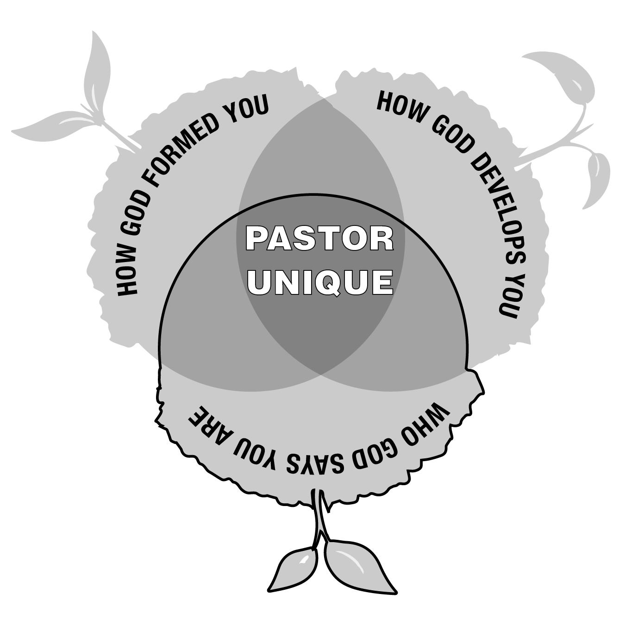

The History of Pastoral Ministry

- Sacerdotalism—pastors became intermediaries (2nd Century)
- Pastors became priests dispensing grace (4th Century)
- Pastors became dispensers of “pastoral care (early Middle Ages)
- The Reformation added preaching a teaching to the pastoral role.

Richard Baxter: “The leader ‘served as every person’s evangelist, catechist, teacher, overseer, counselor, disciplinarian, liturgist, and preacher (Sunday morning and evening); he took it on himself to minister to all sick people and to visit from house to house.”
- Finney and revivalism added evangelism to pastoral expectations.
- Professionalism
- Counseling
- And so forth!

The Pastoral Challenge

The greatest difficulty facing pastoral leadership is defining the role. Is the pastor to be a prophet, teacher, resource person, enabler, religious expert, preacher, counselor, therapist, CEO, facilitator, leader, equipper, administrator, shepherd, social activist, or all the above?

New Testament Words Used to Describe the Pastor

- Elder (1 Peter 5:1-4)
- Overseer (1 Timothy 3:2)
- Shepherd (pastor) (Acts 20:28-30)
- Teacher (Ephesians 4:11)

The ancient kings of Mesopotamia used shepherd terminology as a metaphor for their sovereign authority!

- Lugizaggissi “born for shepherding”
- Shushim “Enlil . . . Elected to be shepherd of the country and the four corners of the world”
- Hammurabi called himself a shepherd.

David was God’s Shepherd-King

David was taken from following the sheep (1 Samuel 16:11). He was “a man skillful in playing, a mighty man of valor, a man of war, prudent in speech, and a handsome person and the Lord is with him” (1 Samuel 16:18).

Jesus is the Good Shepherd

“But you, Bethlehem Ephrathah, though you are little among the thousands of Judah, yet out of you shall come forth to Me The One to be Ruler in Israel . . . And He shall stand and feed His flock In the strength of the LORD, In the majesty of the name of the LORD His God” (Micah 5:2, 4).

“I am (Ego eimi) the good shepherd. The good shepherd gives His life for the sheep” (John 10:11)
In this passage, we see His care for His sheep.

The Great Shepherd Leads Psalm 23

The Pastor is to be shepherd and shepherds lead!

Psalm 23:1 The LORD is my shepherd; I shall not want.

2 He makes me to lie down in green pastures; He leads me beside the still waters.

3 He restores my soul; He leads me in the paths of righteousness For His name's sake.

4 Yea, though I walk through the valley of the shadow of death, I will fear no evil; For You are with me; Your rod and Your staff, they comfort me.

5 You prepare a table before me in the presence of my enemies; You anoint my head with oil; My cup runs over . . .

Everything Rises and Falls with Leadership

The Lord holds leaders accountable for their ministry.

Old Testament Kings 2 Kings 21:10-13

Scribes and Pharisees Matthew 23:13-36

“that on you may come all the righteous blood shed on the earth, from the blood of righteous Abel to the blood of Zechariah, son of Berechiah, whom you murdered between the temple and the altar.” Matthew 23:35

The Pastor’s and the Church’s Accountability

Remember those who rule (hegeomai-lead or rule) over you, who have spoken the word of God to you, whose faith follow, considering the outcome of their conduct.
Hebrews 13:7

Obey those who rule (hegeomai-lead or rule) over you, and be submissive, for they watch out for your souls, as those who must give account. Let them do so with joy and not with grief, for that would be unprofitable for you.
Hebrews 13:17

Addressed first to the messenger of each of the seven churches.

Then to “he who has an ear, let him hear what the Spirit says to the churches.”
Revelation 2-3

Day 3, Topic 2: Mission, Vision and Core Values
Grasping vision for your Ministry Context

Developing Vision
How to create a shared, unifying vision in small and medium sized congregations.

Defining Terms (review)

- What do we mean by “mission”?
- What do we mean by “vision”?

Purpose answers the question “why?”

The over-arching reason. The telos. The end result we strive to accomplish.

Mission answers the question “what?”

What is to occur to lead to the fulfillment of the Purpose, to get to the ultimate goal?

Vision answers the question, “how?”

With both the purpose (telos) and the mission (what) in mind, vision paints a picture of the path to get there.

A longer statement that explains…
  - What is this church going to do
  - In this community
  - With these resources
  - To reach those people
Unique to each church and limited in time

The Problem

- Vision is essential because it determines how focus and resources will be allocated.
- Vision is difficult because it requires the ability to balance “big picture” and “fine detail.”
- Vision is difficult because it is a group process, especially in small churches
- Vision is challenging because it is never finished.
- Bible college and seminary don’t teach pastors how to develop and organize ministry around vision.
- Your congregants will fill the “vision vacuum.”
- “The church is here to protect me from the world”
- “The church is here to help me raise my children”
- “The church is here to change political culture”
“In those days Israel had no king; everyone did what was right in his own eyes” (Jdg. 21:25)

3 Elements of Vision

1. God’s Mission

The first step in guiding your church toward a vision that everyone owns is to ensure that everyone understands the mission. You must explain two truths to the church:
- What is God doing?
- How do we fit in?

Why?

Because the most important and most difficult change you must lead is not in what people do, but in how they think.

This is near the fountainhead of behavior.

How do we change the way they think?

WE don't – but God will through his Word and his Spirit.

So, we cooperate with God to bring both to bear on the hearts and minds of those we lead.

Tell the “big story”
- Naturalism: everything that exists is the result of naturally occurring processes in a closed universe
- Hinduism: everything is an illusion created by impersonal forces into which all individuality will one day be reabsorbed
- What is Buddhism’s story?
- What is the Bible account? All things are created by, through, and for Christ

1.1.1 The Bible’s “big story,” like any other story, unfolds along a plot line.
- The “little stories” advance the “big story.”
- The “big story” lends sense to the “little stories.”

Your task as a turnaround pastor is to guide people through a transition in their thinking by showing them how their “little story” connects to the metanarrative.
- Move them from a self-referential to a theocentric worldview.
- A self-centric understanding of God, the world, salvation, and the church views all things as orchestrated to insure a blessed and happy life.
- A God-centric view sees each person as a servant assigned to participate in moving the “big story” forward.

1.1.2 Master the art of connecting your preaching text to the “big story”

“Do not be conformed to this world, but be transformed by the renewal of your mind…”
1.2 “Big Story” Approaches

- The Incarnation: God's self-revelation to us reaches its highest culmination in the Incarnation. The "Word became flesh" in the Messiah. Everything leads up to this in the Bible, or from it.
- The Two Covenants: The early church divided the Bible into two parts: the “Old Covenant” and the “New Covenant” to reflect the coming of the Messiah.
- The Old looks forward to his coming, the New looks back on it.
- This is prominent in Reformed and Reformed Baptist theology
- Christo-centric: In Luke 24:27 it says of Jesus: "And beginning with Moses and all the Prophets, he explained to them what was said in all the Scriptures concerning himself." The Christo-centric approach to the biblical metanarrative relates the entire Bible to Jesus.
- Salvation history: The Bible is the story of God's self-revelation to the world through a chosen people. The history of this relationship between God and the "chosen people" becomes a way to understand the biblical metanarrative. The major events in the story-line of this history are: Creation, the Fall, Abraham, the Exodus, Israel, Israel's exile, Israel's Restoration in the Messiah, and the Final Consummation. Or, stated more simply: Creation, Sin, Exile, Restoration.
- Worldview: A worldview provides an interpretive framework for understanding the world.
- Bible as Drama: We can also understand God's Big Story as a drama. Every drama revolves around a problem that needs to be resolved. In the Bible, we see the elements of this drama as: Paradise, Sin, a Resolution Promised, a Resolution Obtained.
- Covenant progress: The Bible records a series of covenant promises made to Eve, Abraham and David. It then describes how God honored these promises and worked through them to bring salvation to the world. This is typical of Dispensationalism, which traces the development of the Abrahamic covenant, particularly the promise in Genesis 12:3.
- Presence of God: The Presence of God had been given in Paradise, was lost in the Fall and is being restored in Christ. See Gordon D. Fee, Paul, the Spirit and the People of God (1996).
- Mission of God: The Bible describes the mission of God to redeem the world. Christopher J. H. Wright traces this theme in: The Mission of God: Unlocking the Bible's Grand Narrative (2006).
- Kingdom of God: God's mission to the world results in the reign of God. See John Bright's Kingdom of God (1953).

1.3 Sample metanarrative

Genesis | Revelation
- God creates a perfect world | - God recreates a perfect world
- God creates man in his image | - The image of God is restored in man
- Man appointed to rule the creation | - The God-Man rules all creation
- God and man enjoy direct fellowship | - God and man enjoy direct fellowship

Exercise

1. Write out the metanarrative scheme you will use to reorient the way your congregation thinks:
- A single declarative sentence if possible
- At most a short paragraph of two to three sentences

2. Identify key texts that will anchor your preaching and teaching

2. Our Church

The second step in developing vision is to articulate your church's role in the “big story.” For example, if you favor some variety of kingdom metanarrative, you might use a rubric like this:
- Evangelism: we recruit citizens into God’s kingdom by presenting the gospel in persuasive
- Discipleship: we train believers how to live as a witness to the and prepare them to serve as kingdom administrators
2.1 Assumptions
- Jesus wants to build his Church at your church
- He’s already provided what you need for the next step

- Tabernacle in the Wilderness
- Offering for the saints in Jerusalem
  - Process

Figuring out what God wants your church to do to do starts with identifying what he’s given to work with

2.2.1 Identify all the resources Jesus has entrusted to the church
- Begin this process on your own. God-given resources to consider:
- Invite staff (paid and unpaid) to join the assessment
- Invite church leaders to join the assessment
- If you do a “Journey Wall” consider adding this

2.2.2 Write an assessment report for later reference

- Pastor's strengths, passions, experiences, interests and expertise?
- People's spiritual gifts, passions, experiences, interests, expertise, redemptive relationships?
- Prayer warriors, bridge builders, apologists, evangelists
- Material and financial resources?
- Reputation in the community?
- Acquired congregational wisdom?
- Identify the resources
- Differentiate your resources from other churches
- Rank the top 3 to 5 that could be most easily redeployed to bridge building or outreach activities

Exercise: What Resources has Jesus given your church?

- People
- Passions
- Abilities
- Opportunities
- Property
- Public reputation
- Special relationships
- Finances
- Spiritual maturity
- Prayer life
- Facilities
- Worship services
- Evangelistically minded
- Service oriented
- Bridge building events
- Location
- Calendar
- Other

3. Our Community

The third step in developing a widely held, unifying vision is to identify the receptive groups in your community.

"…one of the major mistakes is to fail to do adequate research to understand the people [the churches] are seeking to reach with the gospel. It is important for a church to study the community and culture as well as the Scriptures."
- Gary McIntosh, Biblical Church Growth

Jesus’ instructed his Disciples to concentrate their efforts on receptive groups.
“As you enter the house, give it your greeting. If the house is worthy, give it your blessing of peace. But if it is not worthy, take back your blessing of peace. Whoever does not receive you, nor heed your words, as you go out of that house or that city, shake the dust off your feet (Matthew 10:12-24).”

Example: Mark 5

3.1 Process
  - Identify the receptive groups in your community

- Linked (kinship / friendship) to credible Christians
- People like those already in your church
- People with needs you can meet
- Groups in which any religion is growing
- People undergoing cultural change
- Those who are dissatisfied with their lives
- People experiencing major life transitions
- Visitors to your worship service

  - Assign a task force to identify the receptive groups in your community.

E4 E1

E1. No cultural, racial or linguistic barriers – only the need to believe
E2. More like us: share a common language, culture, worldview
E3. Similar to us: common language (not mother tongue), ethnicity and culture differ but of the same "cultural family"
E4. Different than us: different language, culture and worldview

  - Determine which groups will be easiest for your church to reach
  - Focus your ministries, bridge building and outreach activities on clearly defined groups of responsive people.

    - Identify potentially receptive groups:

“Churches grow as they identify people with needs that the church can minister to, either by extending ministries already in place or building new ministries.”
George Hunter

  - How many different groups can you identify within the “average drive” of the church?
  - What types of people or groups does your church tend to attract?
  - Who are the underserved, unwanted, or unreached groups in your community?
  - Organize your church around regular and passionate prayer for ‘missionary eyes’ to see the harvest fields.

3.1.2 Organize a Task Force to dig deeper
3.1.2.1 Train them to gather information from the public

  - Consult with community leaders
  - Consult with first responders
  - Consult with service agencies
  - A “missionary tour” of your community
  - Poll the congregation to identify community needs

Recruit a group of 7 to 10 people (thought leaders, influencers, officers) and train them to go out and poll community representatives who can help them identify groups in the community that experience chronic anxiety or are in need.

They will interview community leaders (mayor, city manager, city council), first responders (fire, police), service agencies (child welfare, women’s shelters, recovery programs, hospital social workers), schools (principals, superintendent, counselors), local news and other influential or knowledgeable people in the community.

They will interview these people to seek their help in identifying:

- People in constant need of services and intervention
- People who experience chronic anxiety
- People who are experiencing major unfavorable life change
- People who are overlooked by other churches and agencies
- People who are “on the bubble” (they are in need by do not qualify for public help)
- Ethnic enclaves

3.1.2.2 Take the Task Force on a “missionary tour” of the community
3.1.3 Poll the congregation to identify community needs

3.2. Facilitate group Discussion to determine which receptive groups will be easiest for your church to reach
- Assemble 15 to 30 influencers, thought leaders, officers
- You report your findings
- The Task force reports its findings
- You facilitate group process to evaluate ministry options

3.2.1 Clusters evaluate outreach potential to receptive groups:

Clusters of 3 to 5 people (no couples!) answer the following questions and prepare to report back to the whole group:

- “Which of these groups are most like us?”
- “Which of these groups are we passionate about?”
- “What resources tell us this is God’s 'next step' for us?”
- “What do we have to start doing or do differently to reach this group?”
- “Can we do this?”
- “Will we do this?”
3.2.2 Facilitate group Discussion until everyone is settled on and committed to ministering to a maximum of two target groups (but it is okay to settle on just one!)

Write Your Vision Statement

- Future oriented
- Measurable
- A “big picture” statement of how

“Over the next five years Pathways Church will touch 15,000 people with God’s love, lead 1,500 to saving faith in Jesus, and baptize 500. We will provide ministries and resources to meet the spiritual, emotional, and physical needs of African immigrant families and to the working poor living in Winterhaven section of town.”

Vision resides where God's mission, receptive people, and church resources overlap.
Day 3, Topic 3
Goals and Ministry Alignment for Maximum Ministry Impact

Goal Setting and Ministry Alignment

I. Goal Setting

- The General Electric S.M.A.R.T. System

1. Introduction

The research shows that “focused” (goal-oriented) people:

- harder
- Get tasks done more .
- Stay married longer
- Have deeper networks of friends
- Earn more
- Don’t themselves
- Are seen as more .
- Are seen as .

The emotional satisfaction that comes from (1) deciding and (2) clearing tasks from a list creates several problems.

Problems:
  - Focus on easy tasks at the expense of important tasks
  - Hasty decisions
  - Less likely to reconsider an unwise decision
  - Authoritarian impulse
  - Close-mindedness
  - Preference for conflict over cooperation

2. Cautions

- When you set goals (or make decisions), be mindful of whether the goal (or decision) you’re settling on makes you feel good.
AVOID MOOD MAINTENANCE!
- If you are prone to be more concerned about being productive in the moment than you are about doing the right things over the long haul, you need a system to counterbalance that tendency.

Metrics

  - LEAD rather than LAG measures
  - S.M.A.R.T. Goals + Stretch Goals
  - Accountability Culture

Breakout Exercise

Take a few minutes and write down some areas of your personal life that you need to address.
Also, write down some ministry challenges in your personal ministry context that prove to be challenging.

Lag and Lead Goals

LAG and LEAD measures

  - LAG measures indicate you’ve already achieved a goal

  - LEAD measures indicate if you’re likely to achieve a goal

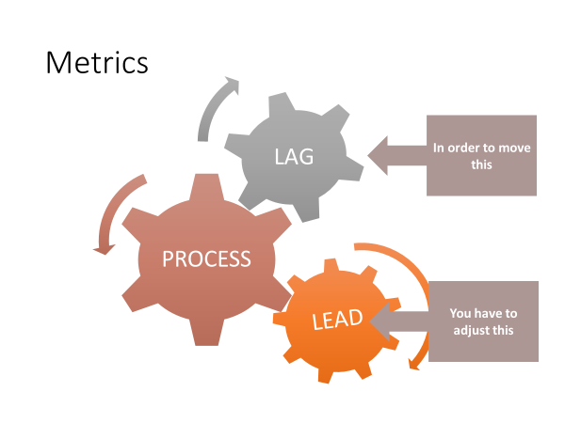

Lag Lead

- Increase average monthly attendance 3% by 12/31 next year | - Increase visitor retention from 4% to 10%.  (Increases average monthly attendance by 2%)
- Reduce “back door” losses from 15 per year to 5 per year by 12/31 next year | - We will visit every family that falls into the “preparing to leave” category

3. Implementing the S.M.A.R.T. system

In the 1940s General Electric began a decades-long process of developing a corporate goal-setting system that eventually became a model that is followed by organizations around the world. In this model, goals must be provably within reach and described in a way that suggests a concrete plan.
Making a goal specific and proving it achievable involves figuring out the required steps. The timeline creates discipline that aspiration cannot.

3.1 Implementation – use the process yourself

This is an adaptation to the GE Smart Goal process. The labels are tweaked to bring about a more “aligned process.

A Sample S.M.A.R.T. Goal
“Making yourself break a goal into its SMART components is the difference between hoping something comes true and figuring out how to do it.”
- Charles Duhigg,
Smarter Faster Better
The following table illustrates what a S.M.A.R.T. Goal looks like when it’s fleshed out. A goal that is specific, measurable, achievable, and results-oriented is far more likely to be achieved when it includes a time commitment. When the timeline consists of the appropriate intermediate steps, you have a plan that will move you toward achieving the goal!

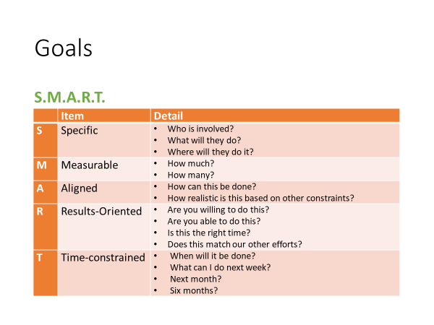

 | Item | Detail
S | Specific | - Add two new small groups for new people attending our congregation.  - Train for new small group leaders  - Use our existing groups to raise new leaders who are willing to invest in new lives.
M | Measurable | - All two new groups bring our total small-groups to eight.  - We will add 16 new believers to our small-group ministry.
A | Aligned
R | Results-Oriented
T | Time-constrained

3.2 Implementation – train staff and hold them accountable
You will have to train your leaders and volunteers to produce SMART goals for their ministries and events. Those who tend to be “big picture” types with little patience for details may resist, but if you frame this as a request for their help – so that you can manage more effectively – they should in time work with you. (If they won’t there’s an alignment problem that needs to be addressed, see below). Continually ask your team

- “Is this concrete?”
- “What are the specifics?”
- “Is this results-oriented?”
- “Show me your timeline?”
- Stretch Goals
1. A caveat about SMART goals

SMART goals will not ensure that your ministry accomplishes anything significant. If you or the majority of your team members spend most of the time working on insignificant goals, you will remain stalled on the plateau.

- People who crave the sense of accomplishment
- Those who are afraid to risk striving for big goals
  - Shallow ego needs
  - Your organization penalizes failure
- Those who don’t connect their goals with the organization’s mission

2. Stretch goals as a solution

“A stretch is a concept that would have produced smirks, if not laughter, in the G E of three or four years ago, because it essentially means using dreams to set business targets-with no real idea of how to get there. If you do know how to get there, it's not a stretch target.”
- Jack Welch, Letter to G.E. Shareholders, 1993

a. Purpose of stretch goals
The purpose of insisting that your church or ministry teams commit to stretch goals is to shake them out of complacency and promote new ways of thinking.

  - “Provide a Christian school to minister to orphans in our city.”
  - “Provide Vacation Bible School for every village in our province.”
  - “Begin a church in a neighboring city where there is no gospel witness. Transplant half of our congregation to the new church.”
  - “Cancel worship services every 5th Sunday to send every member to serve in the community.”

b. Two challenges with stretch goals

1) Studies have shown that if a stretch goal is audacious, it can spark innovation.
2) It can also cause panic and convince people that success is impossible
There is a fine line between an ambition that spurs innovation, creativity, and energy and one that destroys morale.

- Integrate STRETCH and SMART goals
STRETCH goals push us out of the “tried and true.” SMART goals break big dreams into a series of realistic, short-term objectives. Together they put the impossible within reach. Research in the world of sports, business, and self-management shows that when methodical planning is applied to daunting challenges, people are motivated to achieve things they did not think possible!

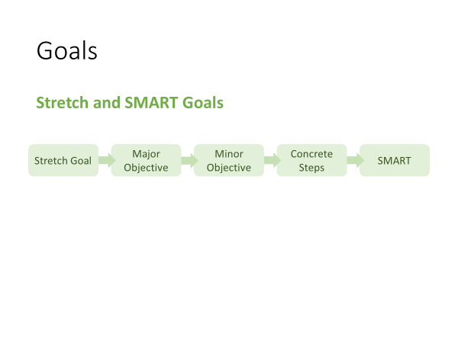

- Develop a list of your biggest dreams.
(Become a catalytic church planter supervising multiple church planting teams)
- Describe major objectives that at first glance seem impossible
(Become part of a church planting team)
- Segment major objectives into smaller objectives
(Understand the essential steps of church planting)
(Learn to lead in each stop of the planting process)
(Shadow a director of church planting for one year)
(Develop a group of people who will be prayer and financial supporters for planting multiple churches in ).
- Break the smaller objectives into concrete steps
- Create a to-do list that pairs stretch and SMART goals

Those of you who are detail-oriented won’t lose sight of the big picture, thereby avoiding the trap of using task lists to perform “mood maintenance.” Those of you who are big picture oriented won’t lose sight of all the little parts, thereby avoiding the trap of letting important details slip through the cracks.
EXERCISE
Use the following table to create a SMART STRETCH goal that at first blush seems impossible, but one which will propel your ministry forward in significant ways.

 | Item | Detail
S | Specific
M | Measurable
A | Actionable
R | Realistic
T | Timeline

Day 3, Topic 3: Alignment



Laser Light

- A device that produces a narrow and powerful beam of light (Merriam-Webster)
- Organized
- Monochromatic

II. Ministry Alignment
- Introduction
- Definition
A church is fully-aligned for effective, efficient ministry when all …
- events
- strategies
- programs
- staff
- ministries
- systems
- expenditures
- literature
- policies
- procedures
… work together to fulfill the vision to accomplish the mission.

- The Need
Leading a church is a lot like leading cats. In the absence of a comprehensive ministry plan that (1) is developed to fulfill a vision that (2) flows from a biblical vision and shared values, people will fill the void with their own plans. This typically results in their neglect or disregard of what others are doing.
Chaos ensues as cats you pursue!
- Signs of misalignment
- People only Discuss their own “stuff” in meetings.
- Plans and budgets aren’t related to the church’s (agreed upon) direction.
- Your church’s vision statement is absent from promotional material for your various ministries.
- Ministry leaders and their team can’t explain how their work contributes to the mission and vision of the church.
- Lots of quarrels for resources between ministries
- Doctrinal inconsistencies among various ministries.
- Ministries collect their own offerings and support their own projects.
0
- Signs of alignment: You will see your staff (paid and volunteer)
- Champion the church’s vision
- Imbue the vision to their ministry team
- Scheduled events advance the vision
- Activities designed to dovetail with the vision
- Resources allocated to support the vision
- Regular re-evaluation of themselves, their team and their programming

- The process

When the church’s ministries are aligned, people will be walking together in the same direction! They will still be cats – independent, uniquely gifted, and occasionally unpredictable – but they’ll be moving toward a common destination.

- Overview

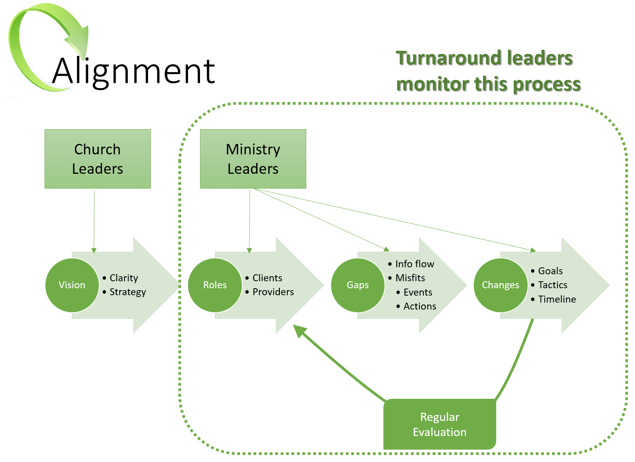

ROLES
- Clients
- Providers
GAPS
- Information Flow
- Misfits
CHANGES
- Goals (include your metrics)
- Tactics
- Timelines
- The process: Create a culture of asking Four Alignment Questions
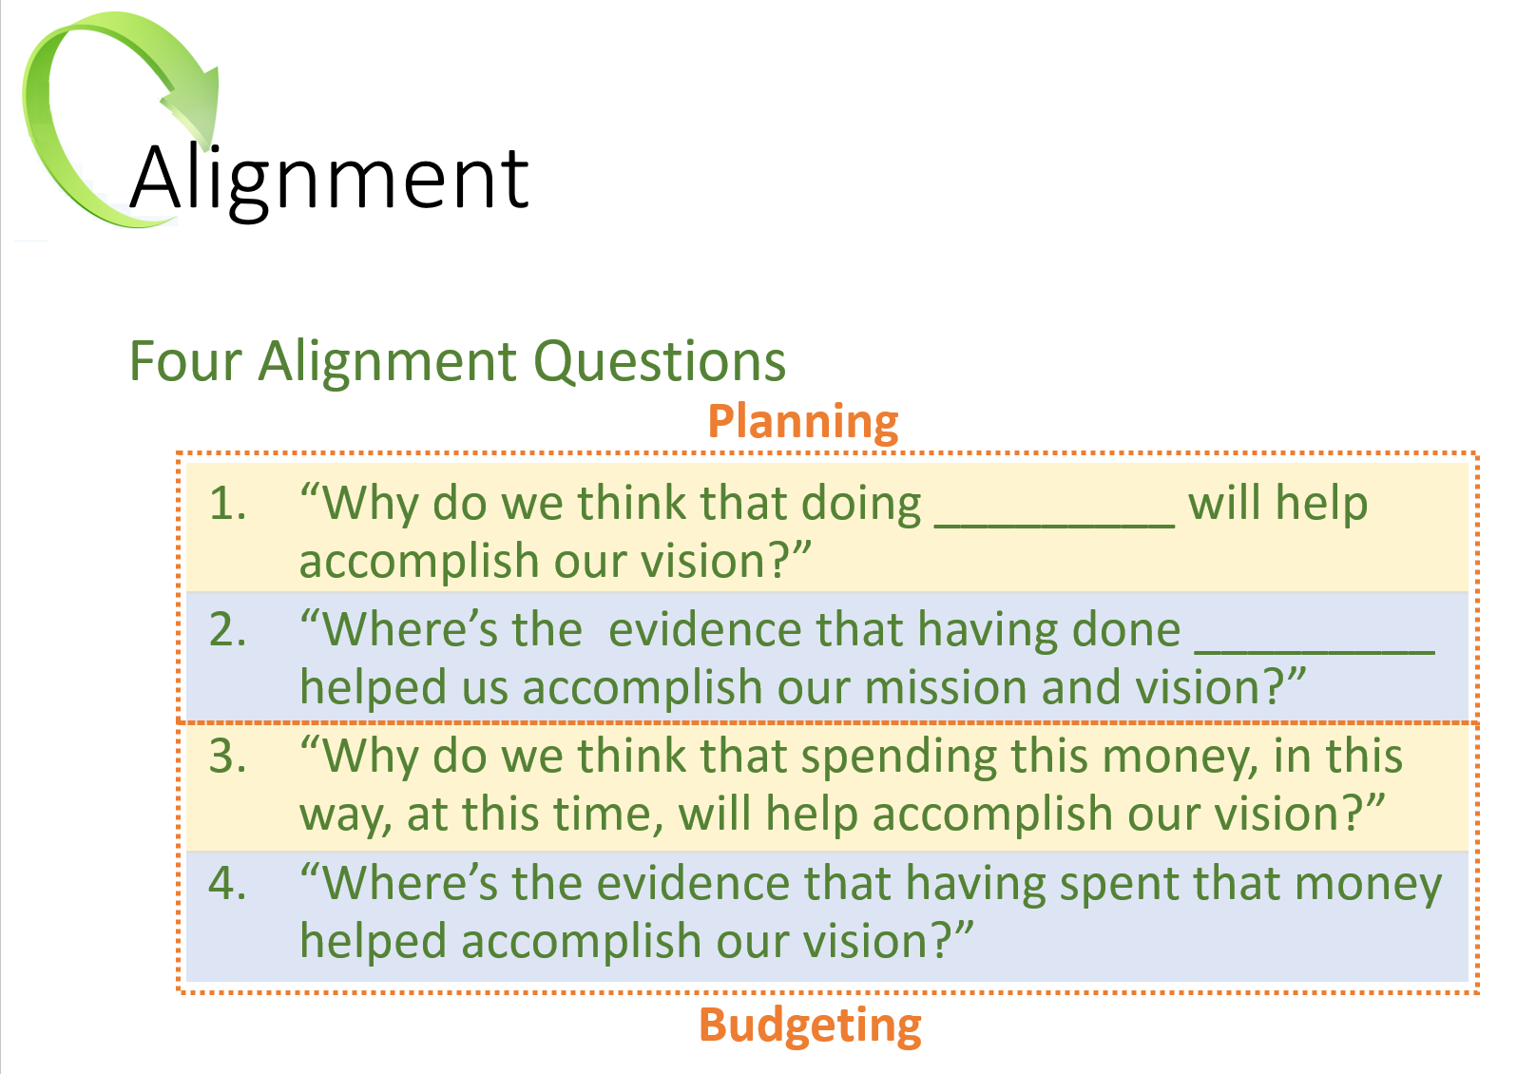
Asking and answering these questions during the planning, debriefing, and budgeting phases will help you develop your own set of “best practices.” In time, you will accumulate a body of knowledge about what works and what doesn’t.

- “We know that if we do these things, they will lead to accomplishing our vision.”
- “We know that we need to avoid doing those things because either they don’t help us accomplish our vision, or they actually hinder us.
- Process: Create a culture of evaluating everything the church does:
Develop metrics that will identify if a ministry, an event, a program, or a procedure contributes to the fulfillment of its mission and vision.

Sample Measurements
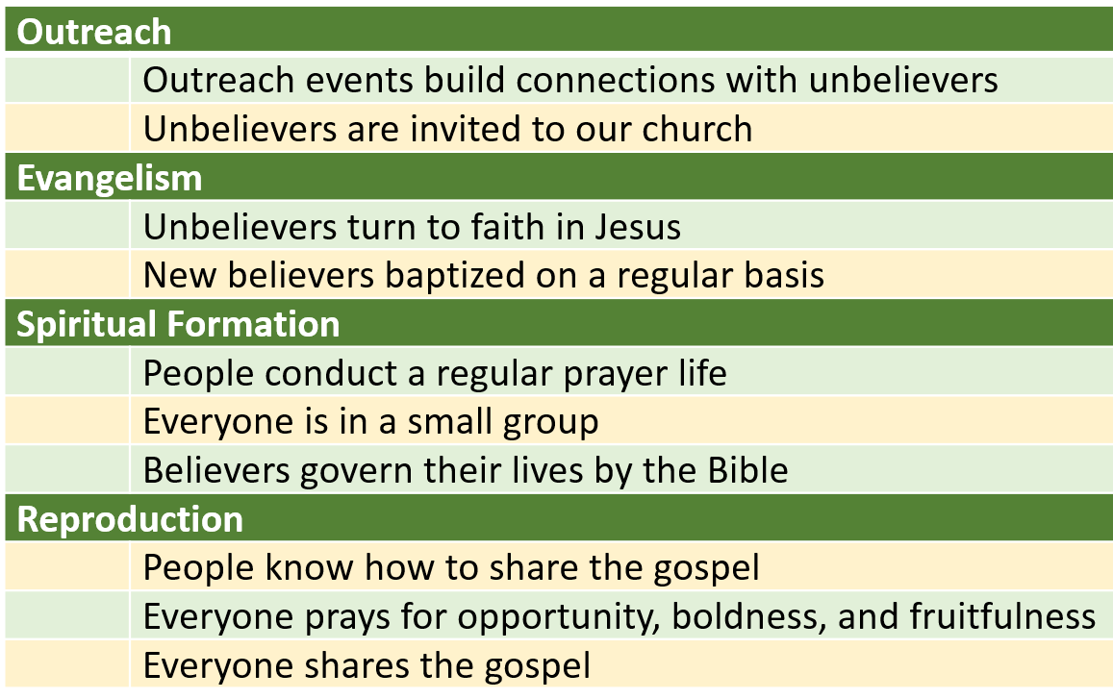
Develop your own concept or matrix for the various broad categories of your church’s ministries, and sketch out a brief description of how each contributes to the mission and the vision. Then, these descriptors will serve as reference points that you (and your team) will use to evaluate the church for alignment.

- Process: Conduct an audit to identify which components are aligned and which are not.
A ministry audit looks at the church from several angles. Among them are:
- Events and Activities
- Ministries
- Staff
A ministry audit can be overwhelming. Create a simple system to keep track of everything at a glance. Your system should help you track the details and help you avoid becoming lost in them!

One useful system identifies the major ministries that must function at a high level to help you achieve your mission and vision. In the following sample, we use four main ministry initiatives. We list them across the top of a page. Then we list every activity and event down the page; some may be church-wide, or they may be confined to a specific ministry (e.g., Men’s or Youth Ministry). Determine which major initiative each activity or event supports.

Sample Audit of Events

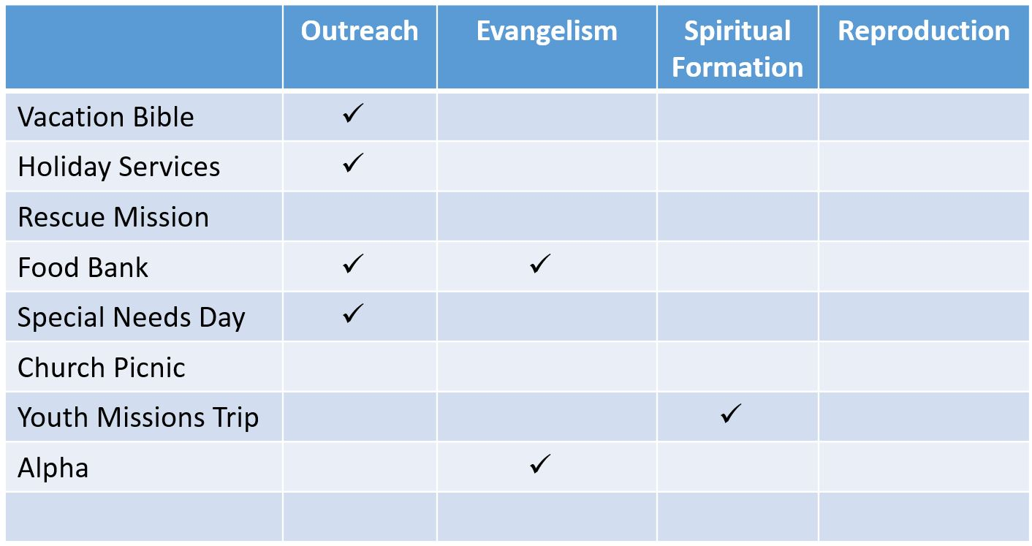

After you’ve audited every event in your church, you may see significant gaps. Note in this sample audit that no ministries help advance the cause of “Reproduction.” You may notice that other initiatives are overly weighted, like “Outreach” in our example. And you’ll find events that don’t contribute to anything (like the Annual Church Picnic!); you’ll need to be careful with some of those! (Example: PVCC float in the annual community parade)

Repeat this process by auditing all the church’s
- Programs
- Ministries
- Systems
- Expenditures
- Policies and procedures
- External communications (“marketing literature”)

Audit of Ministries

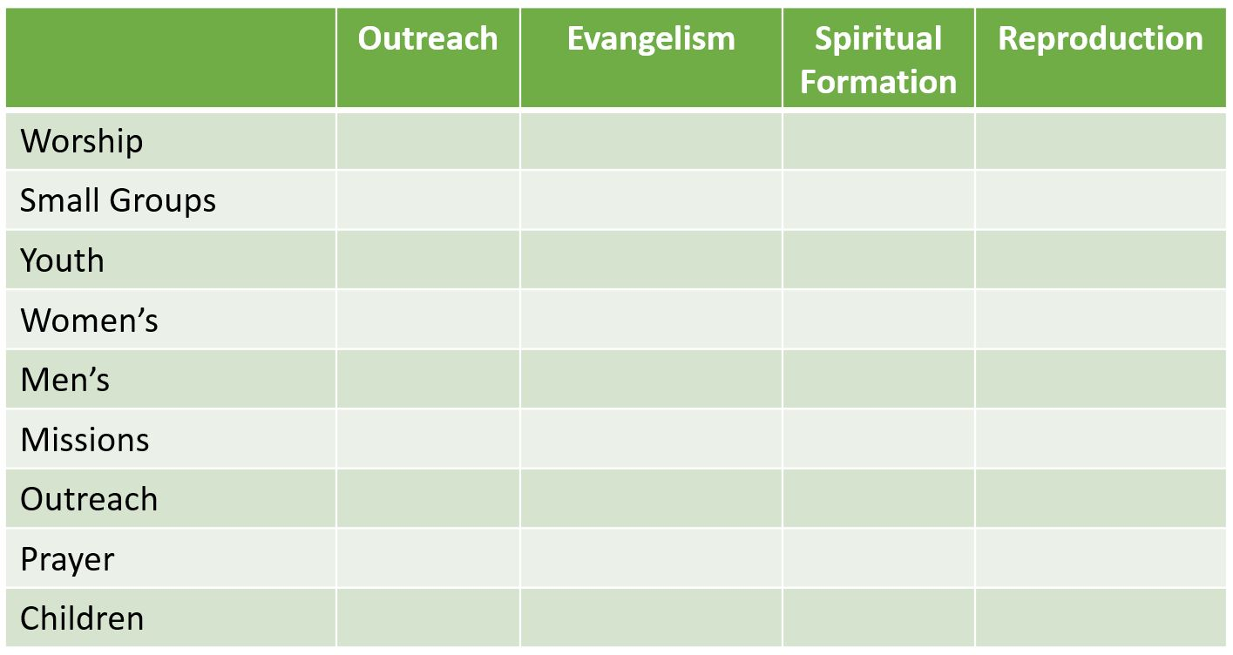

Audit Staff Responsibilities

Finally, use the same process to audit all staff (paid and unpaid), church officers, and ministry leaders. List them by name and identify their areas of responsibility. If you find out that no one on staff has primary responsibility for the church’s Evangelism initiative, you have identified why there’s so little evangelistic activity in your church. You have also identified the need for a significant staff realignment!

Day 3, Topic 4: Developing a Ministry Map

Establish Smart Goals.

List the action steps required to achieve each goal.

- Establish church-wide SMART Goals in each Key Measurement Area
  - Conversions
  - Attendance
  - Assimilation
  - Lay Involvement
  - Small-Group Involvement
  - Leader Development
  - Tithers

- Typically, at least one SMART Goal for each Measurement Area
- Every staff person (paid, unpaid, full or part-time) and ministry will establish SMART Goals that contribute to the church-wide goals
- Lead them in developing one SMART Goal
  - Typically, conversions
- Review, critique and refine their work on the remaining goals

- Action Plan consists of the Action Steps required to achieve their SMART Goal
  - If the Action Plan is too detailed it will be counter-productive
  - But it must be detailed enough to cover all the main activities required

- The creation of a System is often a basic Action Step in an initial Action Plan
  - Focus them on no more than three systems in one Ministry Year
  - Foundational Cluster of Systems to Address
    - Evangelism
    - Assimilation
    - Lay Involvement

Breakout Session
Establish a goal and create your Action Steps to achieve the goal.

Your goal:

Smart goals and stretch goals:

Action Plan:

Evangelism

Assimilation

Lay Involvement

Case Study: FC South of Denver

Deeply conflicted

The associate pastor described this church as a hurricane that periodically drops a tornado.

Day 3, Turnaround Church Leaders’ Interviews

Day 4, Topic 1: Leading Change

Introduction – the most difficult task pastors face

1. Turnaround leadership demands proficiency in every area
- Envision the future
- Influence others to join the future
- Strategize a path to the future
- Execute strategy so the change is accomplished
- Manage conflict successfully
- Sustain passion
- Maintain momentum

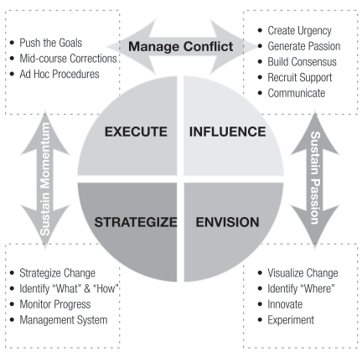

2. Turnaround leadership is personally challenging
2.1 The Change Component
As we've identified in our research, the Change Usual score is a hallmark distinction between TAP and NTAP pastors. NTAPs have lower scores, which indicate their need to focus on the task at hand without distraction.
The inevitable chaos that accompanies change challenges them. Under stress, pastors may resist rapid shifts in direction and timely midcourse corrections. If the pressure is severe enough, they may refuse to adjust to new demands or to change their methods.
They may balk and refuse to move forward. They may give disjointed instructions and deal poorly with members they see as sources of resistance. Both TAPs and NTAPs will eventually need help in implementing systems to support ministry once growth occurs. To move forward, they may give disjointed instructions and deal poorly with members they see as sources of resistance. Both TAPs and NTAPs will eventually need help in implementing systems to support ministry once growth occurs.
2.2 The Challenge Component
This Component measures, among other things, image maintenance in social settings. It also evaluates how we impose demands on ourselves and others. ￼ People with low Challenge scores want to look good in front of a crowd. Image maintenance behaviors are often accompanied by risk aversion, which may result in pastors who avoid the "heavy lifting" of change leadership. People with low Challenge scores want to look good in front of a crowd. Image maintenance behaviors are often accompanied by risk aversion, which may result in pastors who avoid the "heavy lifting" of change leadership. People with low Challenge scores want to look good in front of a crowd. Image maintenance behaviors are often accompanied by risk aversion, which may result in pastors who avoid the "heavy lifting" of change leadership.
Accepting risk, managing acceptable loss ratios, and mitigating conflict are more difficult for pastors with low Component scores if they fear that these will make them look bad. They may settle for more modest goals rather than settling on (the much needed) BHAGs (big hairy audacious goals) because failure will be deemed personal.
Those with high Challenge scores embrace lofty goals. But rather than building morale, their tendency to criticize themselves and others demoralizes, sucking energy out of the change initiative. The tendency to second guess themselves, their plans, and the competence or goodwill of others may attenuate their ability to persevere for long periods when progress is not self-evident.
2.3 The Freedom Component
The Freedom Usual Component is another hallmark distinction between TAPs and NTAPs. It assesses the degree to which our ways of thinking and responding are conventional or independent.
High Freedom scores reflect independent thinking and action; it reflects a bias for initiative and the need to avoid being micromanaged. Change leaders must have these qualities because, by definition, change requires independent thought – breaking out of the paradigm that, while once useful, has led the organization into the cul-de-sac it seeks to escape. They must also be able to act independently and take the initiative if they are to overcome the institutional inertia that resists movement.
However, when change leaders with a High Freedom score experience distress, they may react counter-productively and become unpredictable. This will produce uncertainty and self-protective behavior in others. They may reject ideas simply for the sake of being "the maverick." In the transition phase, these behaviors harm the church. This is a reminder that meeting our Needs to avoid destructive Stress Responses is not selfish, but helpful to both the pastor and the church.
Pastors with Low Freedom scores prefer convention and tradition. This puts them in a difficult place from which to lead change. They gravitate toward precedence and consensus. These propensities attenuate their ability to engage in independent thought and develop creative solutions. The ability to manage resistance and deal with conflict may be compromised in leaders who feel constrained by group expectations. This is a reminder that one "best ministry practice" is putting people around you who think differently than you – in this instance, "free thinkers."

3. Turnaround leadership is possible
- Pastors who develop strategies to manage their unproductive behaviors and employ best ministry practices are very likely to succeed as change leaders.
- Pastors who sequence the stages of the change process correctly will enjoy a higher degree of success as change leaders.
- Pastors who engage a coach and continue to develop their leadership skills are more likely to succeed as change leaders.
- Pastors who cultivate their spiritual lives and take the time to prepare the church spiritually and theologically are more likely to succeed as change leaders.
Preparing to lead turnaround

1. Prepare yourself
- Understand how your personality helps or hinders change leadership
- Retain a coach who will walk with you through the challenge
- Read widely on change leadership to develop a model that fits you

2. Prepare your congregation (Video Gary McIntosh)
- Redefine _____________________.
- Create _____________________ - dissonance so they see better ways to ministry.
- Make hard _____________________ - "the future of a church is directly tied to a pastor's ability to suffer pain (3:00 in the vid)
- Refocus on the _____________________.
- You have to start _____________________.

A Transition Model
This Transition Model, adapted from William Bridges, focuses on the internal transitions people must make to embrace change. Your goal is to help the members embrace new ways of thinking about their Christian identity and the church's mission.

The Bridges Transition Model
Phase 1: An Ending | Phase 2: Neutral Zone | Phase 3: New Beginning
The Pastor’s Leadership Tasks
- Help people deal with loss  - Prepare them (mentally) to move on | - Help them learn new ways to think & act  - Use the confusion to encourage innovation | - Help them develop a new identity  - Guide them in Discovering new purpose that makes the change work
People Will Experience
- Fear  - Denial  - Anger  - Sadness  - Frustration  - Loss | - Resentment for the change  - Doubt about the change  - Low morale & productivity  - Disorientation  - Uncertainty  - Anxiety about the future | - High energy  - Openness to learning  - Renewed commitment  - Passion about their role  - Willingness to sacrifice
Leadership Interventions
- Check your ego at the door  - Listen with empathy  - Reflect understanding  - Don’t try to “fix” them  - Show them how they fit in  - Stand apart from emotions  - Remind them of God’s faithfulness and provision | - Give frequent feedback  - Talk up the big picture  - Given them short-term wins  - Let them vent their feelings  - Revise staff workloads  - Build team morale  - Rely on champions to move people to Phase 3  - Discipline as needed | - Link their personal goals with the church’s goals  - Highlight success stories in public worship services  - Take time to celebrate the big transition  - Don’t forget the stragglers  - Get ready for the next vision and transition

Notes About the Transition Model

Day 4, Topic 2: Conflict Resolution and Biblical Peacemaking

Four major sections of this training:

Part 1: The Theology of Peacemaking
Part 2: The Practice of Peacemaking
Part 3: Your Personality and Peacemaking
Part 4: Intervention in Deeply Troubled Churches

Part 1: The Theology of Peacemaking

I. The God of Peace

A. God is the “God of peace.”

The God of Peace is present with us Romans 15:33
The God of Peace will destroy the enemy of peace Romans 16:20
The God of Peace wants us to imitate Him Philippians 4:9
The God of Peace transforms us 1 Thess 5:23
The God of Peace completes us in Christ Jesus Heb 13:20-21
The God of Peace imparts peace to us Judges 6:24

B. God’s Design for Peace

1. God offers peace to us through Christ (Justification) John 14:27
John 16:33
John 20:19-21
Acts 10:36

2. God desires us to live at peace with one another.
(Interpersonal0 Psalm 133:1
Romans 14:16-19
Eph 2:14-17
Eph 4:3
Col 3:15

3. God desires for us to live at peace with ourselves
Sanctification
It begins with righteousness Isa 32:17
It continues with faith and obedience Isa 26:3
Isa 48:18

4. God desires us to live at peace with our Enemies Matthew 5:9
Matthew 6:43-45
Proverbs 16:7
Romans 12:17-21
Hebrews 12:14

C. The Roots of Conflict

Observations:

1. Conflict is pervasive!

Conflict characterized the paragons of the faith

Abraham and Lot over grazing rights Gen 13:5-11

Some of the apostles doubted Jesus’ resurrection Matt 28:20-28

Conflict over language and culture Acts 6:1-8

Paul and Barnabas (over mission and vision) Acts 15:36-41

Peter and Paul and kosher practices Gal 2:11-21

Deep divisions in the church at Corinth 1 Cor 1:12-13

Our attitude? John 13:34-35

Christ desires unity in the church: “They may be
one, just as you, Father, are in me and I in you.” John 17:21

2. The Peace Chapters Gen 1-2, Rev 21—22

3. The Theology of Conflict (survey of conflict in the Bible)

Conflict Defined: Conflict is a difference in opinion or purpose that frustrates someone’s goals or desires. (Ken Sande, The Peace Maker, 29)

Church Conflict Defined: Church conflict is a difference of opinion over mission, vision, and values that frustrate a person’s goals or desires.” (Brown, Penfold, Westra, Pastor Unique, 154).

4. The Entry of Sin into the Universe

Satan’s name: Adversary, one who withstands

Murderer John 8:44
Liar John 8:44
Confirmed and practicing sinner 1 John 3:8

Promotes false lifestyle Eph 2:1-3
Promotes false religion 1 Tim 4:1-3

Satan’s Description Ezek 28:11-17

Seal of perfection
Full of wisdom
Perfect in beauty
In Eden (certainly not true for the King of Tyre!)
Gloriously clothed
Prepared for music (timbrels and pipes)
Created

Satan’s Position (makes sin all the more untenable.)

Anointed Cherub who covers (close to God)
Walked in the midst of fiery stones (close to God)
Perfect in all your ways

Satan’s Sin (Lucifer—Day Star- bright enough to be seen above the sun) Isaiah 14:12-17

Pride
I will ascend into heaven
I will exalt my throne above the stars of God (Cp. Job 38)
I will sit on the mount of the congregation on the farthest sides of the north
I will ascend above the heights of the clouds
I will be like the most high
Puffed up with pride 1 Tim 3:6

Extended to other angels Rev 12:14

5. The entrance of sin into humanity Gen 3:1-6

Temptation

Has God said?

Illust: “When Satan talks to us about God, he lies. When he talks to God about us he tells the truth”—Warren Wiersbe

Shall not eat nor touch
You will not surely die.
You will be like God! (N.B. Satan’s own desires are manifest in temptation)
Vs. 6—Lust of the eyes, lust of the flesh,
pride of life 1 John 2:15-16

Consequences Gen 3:7-19

Adam and Eve’s eyes were opened. (7)
Sewed leaves
Hid from God (8)
God sought them! (9)
Fear of God (10)
Adam: Blamed the woman
Adam blamed God, “The woman you gave me.”
Eve blamed the serpent . . . and the serpent didn’t have a leg to stand on!

The conflict between the seed of the serpent and the seed of the woman

Victory promised—the Seed of the woman over the seed of
serpent (15)
Childbirth issues
Marriage issues (wife derives her self-worth from husband, husband from work)
Cursing of ground
Toil
Thorns and thistles

The conflict between man and God Matt 16:21-23

D. Conflict in the Christian Life

Introductory Thoughts:

Note: Interpersonal Conflict: The History of the World is the history of conflict.

Spiritual Conflict: Human History is the history of conflict between Satan, God, and man.

Principle: All conflict can be traced back to spiritual conflict.

Maps of War: http://www.mapsofwar.com/ind/imperial-history.html

The Five Types of Conflict: Conflict arises in the following five areas.
1. The conflict between people and God (Genesis 6:3)

If we don’t have peace with God, we will not have peace with others.

2. Personal (self-condemning)—individuals struggle with accepting God’s forgiveness.

Isa 26:3
John 14:1, 27
Pilate’s wife Matt 27:19

3. The conflict of Spiritual Warfare—Conflict with Satan and his ungodly host
Eph 6:10-20
Rev 12:10

4. Interpersonal (Matthew 5:21-26; Matthew 18:15-18—more on this later)

5. Conflict with our Enemies Matthew 5:43-48
Romans 12:16-21

6. The Pervasiveness of Conflict (Conflict is Inevitable)

As previously Discussed, conflict is inevitable. We have the four “peace chapters.” Conflict is Discoverable in every other chapter of the Bible. The balance of Scripture deals with problems. For example, the epistles of the New Testament deal with church issues. They were not merely nice letters written in a vacuum! They are written to real people with real interpersonal issues! Please examine the following passages. Which type of conflict do you discover in each passage?

Please note: The causes of conflict are complex and often deep. We usually see the surface issues and miss the deeper issue or issues. This fact becomes apparent as you look over these passages. To properly handle conflict, we must carefully assess each situation before trying to serve as peacemakers.

Passage | Type of Conflict?
 | With God | Personal | Spiritual Warfare | Interpersonal | With Enemies
Genesis 4:6-8

Genesis 4:19-24
Genesis 6:6

2 Sam 24:1
1 Chronicles 21:1
Psalm 23:3-4

Psalm 32:3-4

Malachi 4:5-6

Matthew 20:20-28

Acts 6:1-6

Acts 15:36-41

1 Cor 1:10-13

Galatians 2:11-21

Phil 4:2

Rev 2:4

E. Flash Points: Problems that Ignite Conflict

- Loss of Mission and Vision. (many churches filled with conflict do so because they do not have a clear sense of mission and vision. This is a predominant issue in plateaued and declining churches.

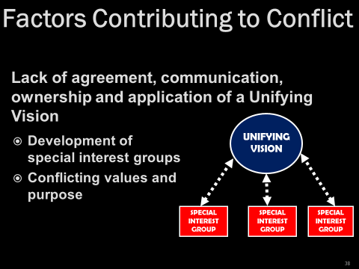

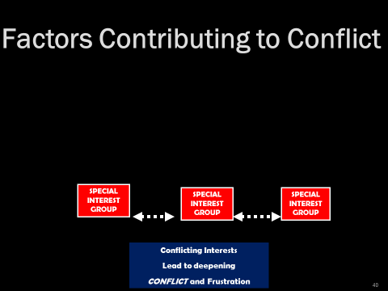

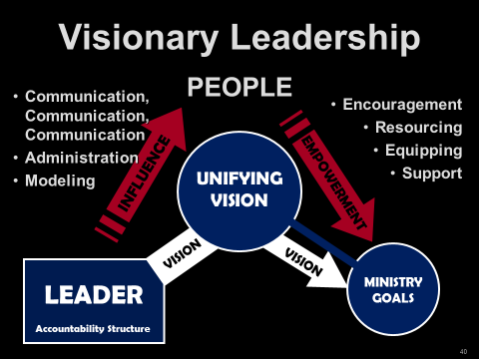

- Sinful attitudes that lead to sinful actions James 4:1-12
Matt 15:19

3. Sins of commission

- Failure to submit to the Spirit (a fundamental problem)
Gal 5:16-23

“Fruit of the Flesh” (contrast with the Fruit of the Spirit)

  - Jealousy
  - Envy
  - Greed/ Covetousness Luke 12:12-13
  - Maliciousness
  - Deceit
  - Pride
  - Lack of love
  - Lack of mercy
  - Adultery
  - Lewdness
  - Hatred/ Prejudice
  - Selfish Ambition
  - Drunkenness

4. Interpersonal Relationships Galatians 2:1-14
5. Language barriers Acts 6:1-6

6. Cultural Differences Galatians 2

7. Misunderstandings from poor communication Joshua 22:10-34

8. Incorrectly judging motives Joshua 22:10-34

9. The tongue James 3:1-12

Reckless words Prov 12:18

Grumbling & complaining 1 Cor 10:10
James 5:9

Lying Eph 4:25

Gossip Prov 16:28

Slander Titus 2:3
(diabolos—Devil, Matt 4:1) 2 Tim 3:2-5

Worthless talk Eph 4:29

10. Differences in values, goals, gifts, calling Acts 15:39
1 Cor 4:12

11. Competition for limited resources Genesis 13:1-12

12. “Ownership

13. The decline in membership and church vitality

14. Traditionalism

15. Ineffective pastor

16. Controlling or micromanaging governing board

17. Stubborn, rebellious church members

18. Poor fit between pastor and congregation

19. Conflict between the Pioneers (Old Guard) and homesteaders (new people)

20. Other

Part 2: The Practice of Peacemaking in the Local Church

1. Foundational Assumptions

A. Christ desires harmony to exist in the Body of Christ, the local church.

B. The primary objective of Conflict Resolution is the restoration of broken relationships.

C. In the event of a failure to achieve repentance, confession, and forgiveness, the offending parties must be dismissed from the fellowship until such time as these biblical responses take place.

2. 4 Levels of Conflict Resolution for the Believer (Four Dimensions of Peace)

A. Peace with God Romans 5:1-5
Mark 5:5

B. Peace with ourselves

How do we gain Peace from self-condemnation?
Recognize our position in Christ Jesus Col 1:19-20

Trust in God Isa 26:3

Prayer with Thanksgiving Phil 4:6-7

Consequences of not submitting and repenting Psalm 32:3-5

C. Peace with others—Making Peace in the Church (Individuals)

1) Recognizing God’s Methods of Handling Conflict (more on this later)

Scripture rarely uses words we would translate as “confront.”

Encourage 1 Tim 3:2
Correction 2 Tim 3:16
Warn 1 Thess 5:14
Admonish (teach, instruct, warn) Titus 2:3-4
Rebuke Luke 17:3
2 Tim 4:2
Reasoned Acts 17:17
Exhort 1 Thess 5:14
Not quarrel, but be gentle 2 Tim 2:24

D. Peace with Difficult People Romans 12:17-21

E. Our First Response to Conflict 1 Peter 4:8

F. Essential Keys for Biblical Conflict Resolution

- Keep the Circle Small.

- Own your own.

- Apply the proper passages: Maintain a clear understanding of the conflict issues and the appropriate responses to each. Each passage is conflict specific with specific prescriptions and remedies. Matthew 18:15-18 is not the cure-all for every conflict!

- You know, you go!

3. Major Conflict Passages: Specific Passages with Specific Prescriptions for Peacemaking

Passage: Matthew 5:21-26

Problem:

A believer realizes that he/she has offended another

Persons Involved:

Offender and one assumed to be offended

Party (Parties) Responsible for Resolution:

The one who caused the offense

Process:

1. Leave your offering (resolution is more important than giving!)
2. One who has offended seeks forgiveness

Purpose:

Reconciliation

Result:

Reconciliation and harmony

Passage: Matthew 18:15-18

Problem:

One believer has sinned against another believer

Persons Involved:

1. The offender and the person offended

2. One or two additional witnesses

3. The entire church.

Party (Parties) Responsible for Resolution:

Process:

1. The offended party meets alone with the offender. Resolution: Praise the Lord!
2. No resolution, 1-2 witnesses
3. The offender is taken before the church. Reconciliation or dismissal from church

Purpose:

Result:

Passage: Galatians 6:1, 10

Problem:

A believer is overtaken (detect, overtake, surprise) in a fault (false step, transgression, sin).

Persons Involved:

1. The observer

2. Those from the church who are spiritual

3. The individual caught in sin

Party (Parties) Responsible for Resolution:

1. The observer

2. Those who are spiritual

3. The individual caught in sin

Process:

1. The observation

2. Spiritual preparation

3. Gently approaching the guilty party

Purpose:

Restoration to useful Christian living

Result:

1. Restoration

2. Dismissal if there is no repentance

Passage: Titus 3:1-11 (primarily 3:10-11)
Romans 16:17-18

Problem:

A divisive individual who disrupts the church

Persons Involved:

The individual and the church

Party (Parties) Responsible for Resolution:

The individual and the church

Process:

1. Give an initial warning

2. If there is no repentance and there is a second incidence of disruption, give a second warning.

3. If there is a third incident disruption, the member is removed from the church by the church.

Purpose:

1. Repentance and Restoration

2. If there is no repentance, then repeat offender will be removed from the church so that harmony will be restored.

Results:

Harmony in the church body

Passage: 2 Thessalonians 3:6-15

Problem:

A believer is behaving in a disorderly manner: not providing for one’s needs, a busybody

Persons Involved:

The church and the disorderly brother or sister.

Party (Parties) Responsible for Resolution:

The church and the disorderly brother or sister.

Process:

1. Recognize the condition

2. Do not keep company with them

3. Admonish the disorderly to become orderly

Purpose:

Repentance and restoration to full fellowship

Result:

That the disorderly brother would be shamed into repentance

Passage: 1 Corinthians 6:1-11

Problem:

One believer in a church has sued another believer in the church in a civil matter.

Persons Involved:

The two combatants and the church

Party (Parties) Responsible for Resolution:

The two combatants and the church

Process:

1. Recognize the church’s position.

- The church will judge the world
- The church will judge

2. Hold a “trial.”

3. Appoint the “least” in the body as “judge” or appoint the most esteemed believer as the “judge.” (Your view of this issue will depend on whether you take verse 4 as a question or as a simple statement. The Greek text has no punctuation, so either translation is possible).

4. Allow oneself to be defrauded rather than to defraud Christ.

5. Allow oneself to be cheated rather than defraud Christ.

Purpose:

1. To treat the with respect.

2. To settle the dispute dividing the church.

Result:

1. The issue is settled.

2. The name of Christ is honored.

3. Those outside the church will

Passage: 1 Timothy 1:19-20
2 Timothy 2:16-17

Problem:

False doctrine and those who teach blasphemy (slanderous, abusive speech)

Persons Involved:

Believers who slander and teach false doctrine and the church

Party (Parties) Responsible for Resolution:

Believers who slander and teach false doctrine and the church

Process:

1. Recognize the deadly poison

2. Deliver blasphemers to Satan so that they learn not to blaspheme.

Purpose:

To protect the church from blasphemy and false teaching

Result:

The church is protected from blasphemy and false teaching

Passage: 1 Corinthians 5:1-8

Problem:

Immorality in the church

Persons Involved:

Church and the immoral person

Party (Parties) Responsible for Resolution:

Process:

1. Recognize the sin of immorality

2. Confront. If repentance, PTL. If not, dismissal from the church. Turn one over to Satan for the destruction of the flesh.

Purpose:

Cleanse the church from moral uncleanness.

Result:

The church will be cleansed from .

Gossip: Proverbs 26:20-22
2 Corinthians 12:20

Gossip compounds all the issues mentioned in the preceding sections. Both Testaments, Old and New, warn of the tongue’s destructive power.

Dennis Maynard wrote a trilogy dealing with attacks on clergy based on twenty-five case studies of churches attacking their shepherds. The following chart rises from his book. The chart shows how opposition grows from the “facts” to a pastor’s removal. I have seen this type of character assassination, and I’ll bet you have, too. It’s ugly and distasteful. Gossip plays a significant role in this diabolical movement. The concepts are found in his book; the chart is my creation [Brown, Penfold, Westra, Pastor Unique: Becoming a Turnaround Leader (Bloomington, IN, Westbow Press), 171.]

Here’s an overview of the process divisive individuals use to control and manipulate the church. The following chart shows how bullies, clergy killers, and church killers use gossip to destroy individuals, churches, and ministries.

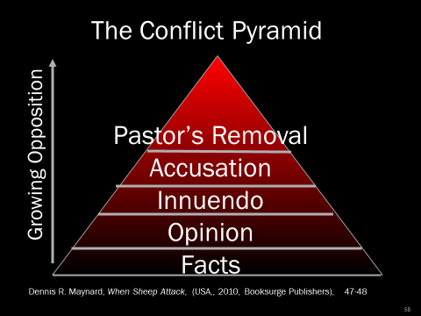

(Pastor Unique, 171)

Church bullies use this practice with particular deftness to control and ruin churches!

Part 3: Your Personality and Peacemaking

1. Handling Conflict Satan’s Way

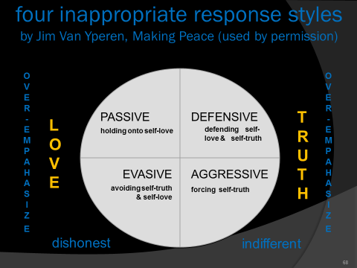

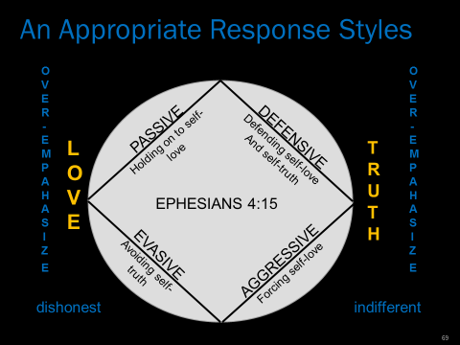

2. Additional notes:

Phil 2:14-15
Matt 22:39
1 Cor 13:5
Matt 7:12

Summary:

What if people don’t respond to overtures of peace?

For Believers: Biblical responses of Discipline

For our Enemies: Rom 12:20-21gives the attitude with which we respond to them.

Part 4: Intervention in Deeply Conflicted Churches

Step 1: Assess the Need for Reconciliation

What particular passages apply to the conflicts found in (name of) Church?

What steps have been neglected?

What steps are necessary to resolve the conflicts at Church?

On the part of each individual

On the part of the Church?

What are the consequences of inaction?

What will be the possible consequences of action?

Step 2: Major Steps Towards Reconciliation

1. Recognize the Need for Reconciliation

2. Seek to handle the needs biblically within the body.

3. If the problem is deeply entrenched, call in an outside mediator to help facilitate the reconciliation process.

A. Find a seasoned mediator

B. The Church must vote to place themselves under the mediator during the reconciliation process.

4. Have the Church begin to prepare for handling the conflict

A. Biblical Peacemaking

1) The mediator helps the church through the immediate problem

2) The mediator helps the church develop healthy ways of handling future conflict

B. Spiritual Preparation

1) Apply 1 Corinthians 13 to each member of the church

2) Provide Bible studies during the preparation period (see Preparing for Reconciliation).

C. Develop an understanding of the Church.

1) Understand the pastor

2) Understand the people

3) Understand the dynamics of the conflict.

4) Understand the community

5) Understand the history of the church

6) Conduct an extensive church assessment

5. Understand the biblical methods of church conflict resolution

6. Present the Findings and Recommendations of the inquiry to the church body.

7. After a thorough examination of the church membership, leadership, community, history, and the current problems, the mediator brings the church to a time of Sacred Assembly (see (Nehemiah 8:18, 9:1-4 for an example of a Sacred Assembly where Israel dealt with sin issues). A Sacred Assembly Schedule can be as follows (this is taken from an actual Sacred Assembly conducted in Dec 2015):

Step 3: The Sacred Assembly

A Sacred Assembly

Reminders of our “Place”

John 19:1-3, 16-30
Eph 5:22-33
Philippians 2:5-11

Own Your “Own”
Nehemiah 1 Nehemiah owned the sins of Israel
Daniel 9:1-19 Daniel owned the sins of Israel
Psalm 51 David owned his own sin
2 Corinthians 10:1-6

A Season of Prayer

A Time of Sharing Victories

A Time of Confession Wrong Done to Others (Matthew 5:21-26)

A Tim of Confronting Sins Against One Another (Matthew 18:15-18)

A Time of Inviting the Lord Jesus Christ to once again reign in this congregation Revelation 3:20

A Time of Reflection

The Lord’s Supper (only if there has been genuine reconciliation)

Step 4: Observe a Celebration (Reflection) Sunday

During these Sundays, I have often said, “Satan has had you in his grasp. Satan has used you to bring reproach on the Name of the Lord Jesus Christ. However, you are no longer at his beck and call. You have been set free from his clutches. Never, never forget where you have been; and never let yourselves be brought into this position again.” Romans 8:1

Ground Rules for the Resolution Process in the Sacred Assembly

1. Pray fervently that the Lord would have the freedom to deal with each heart.

2. Come prepared to do business before God and with one another.

3. No interruptions when someone is speaking.

4. The speaker must use the first person singular when addressing an issue, i.e., "I, me, my." They must speak only for themselves and not for the group.

5. You may address another individual only if you are addressing a specific sin committed against yourself by another individual.

6. No hitting below the belt by using caustic terms.

7. The speaker must speak to the opposing person specifically. They must face each other when speaking.

8. A person cannot speak twice until everyone has had the opportunity to speak once.

9. Before a speaker can talk on their topic, they must repeat the last statement of the previous speaker to ensure they are listening.

10. A person can only address one issue at a time.

11. A speaker must complete his or her comments within a three to five-minute time limit.

12. Each speaker must speak the truth in love (Ephesians 4:15). Each one must come with a sincere heart seeking genuine reconciliation.

13. Each one must come prepared to repent, confess, seek forgiveness, and be prepared to forgive and restore relationships.

The Process of Intervention

THE ROLE OF THE PEACEMAKER

The Church Contacts a Consultant/Peacemaker

The Consultant/Peacemaker Contacts the Denominational Office

The Consultant Secures and Invitation to the Church

The Church Votes to the Consultant/Peacemaker

The Consultant/Peacemaker Sends an Assessment Packet to the Church

The Consultant Assembles the Assessment Team

Church Returns Assessment Materials

Consultant/Peacemaker Provides Data and Manuals to Assessment Team

Assessment Team Reviews Data and Schedules Onsite Evaluation

Onsite Evaluation and Resulting Prescriptions

Preparation for Reconciliation

Sacred Assembly

Follow Up

Day 4, Topic 3: Leading Change in the Midst of Conflict

Conflict: Pastors Must Stand Apart

To lead a stagnant or deteriorating church forward, the pastor must learn to distance himself from the church’s emotional system but stay connected in order to exert positive leadership.

A Church Is a System
A church is more than the sum of its parts. It isn't just a collection of people bound by common goals, shared rules and regulations, and agreed upon meetings. It is a living organism with its own personality, mores, and values which operate in concert to create a unique identity that distinguishes it from every other church. It is a system. The Bible uses the human body as a metaphor for the system paradigm.
Rather, speaking the truth in love, we are to grow up in every way into him who is the head, into Christ, from whom the whole body, joined and held together by every joint with which it is equipped, when each part is working properly, makes the body grow so that it builds itself up in love (Ephesians 4:15-16).
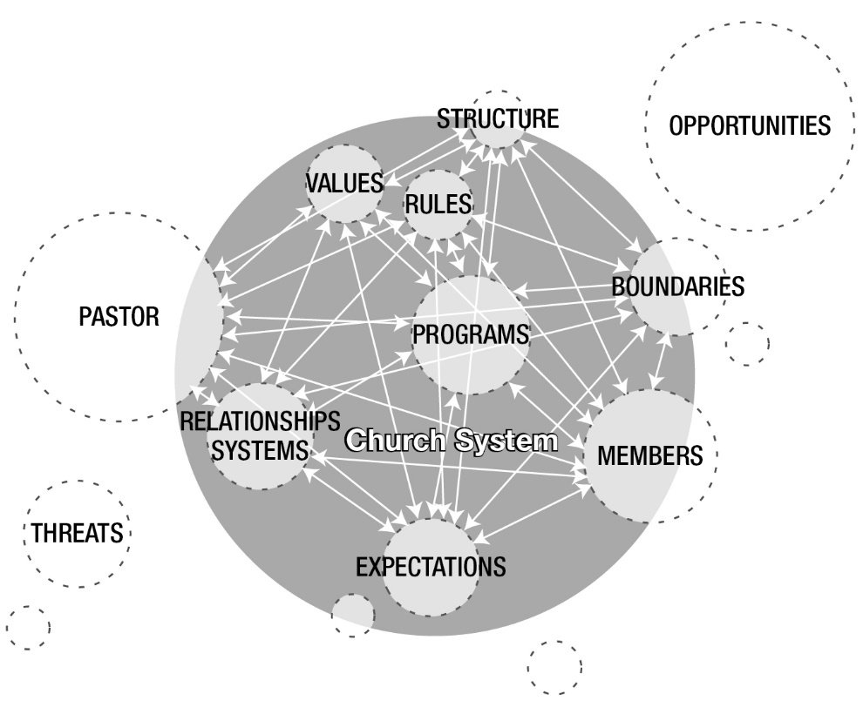You can think of a church system as a collection of parts that work together for specific purposes (whether intentional or unintentional).
- Structure
- Rules of operation
- Policies & procedures
- Relationship policies (between people)
- Boundaries
- Environment

Primary Tasks
The two primary tasks of any system are:
- Maintain the status quo.
- Reduce anxiety.

When something creates tension, systems automatically react to reduce anxiety and restore the status quo. Regardless of where it comes from, everyone is affected.
For the body does not consist of one member but of many. . .. But God has so composed the body, giving greater honor to the part that lacked it, that there may be no division in the body, but that the members may have the same care for one another. If one member suffers, all suffer together; if one member is honored, all rejoice together. (1 Corinthians 12:14-26)

The anxious church
Many issues cause anxiety in the church:
- Conflict over leadership preferences (1 Corinthians 2-3)
- Gross sins Disclosed (1 Corinthians 5)
- Presence of false teachers (Galatians)
- Racial and cultural tensions (Acts 15:1-29)
- Problems between members (Philippians 4).
- Suffering and hardship (Hebrews & 1 Peter)

Here’s the problem:
When anxious moments arise, the elements that create the system ensure that it will react counterproductively.
Rather than capitalizing on the anxiety as an opportunity for personal and corporate, churches will seek "quick fixes" to reduce the anxiety and attempt to restore the status quo instead of creating a new, healthier "normal." Typical, unhelpful processes of an anxious church include:

1. Reacting
Members focus on the crisis.

2. Closing ranks
The desire for good feelings promotes group-think over individuality; the church expresses a "self" of its own to which all are required to submit. Dissent is Discouraged, peace is valued more than progress, and individual thought is stifled.
This produces an appeasement strategy toward troublemakers.
The principled few who insist on growth rather than appeasement are branded as heartless or unfeeling. Eventually, the group organizes around the "problem" member.
Closing ranks masks the fact that the problem member isn't the "real" problem. The underlying problem is how the church responds to anxiety.

3. Blaming
Anxious people and systems blame others instead of assuming personal and corporate responsibility.
Rather than permit people who insist on responsibility, integrity, honesty, and personal boundaries – which forces the church to remain anxious while it finds healthy solutions, the system pushes for an unhealthy “quick fix " so equilibrium can be restored.

4. THE Quick fix
Chronically anxious churches are impatient. The thinking that produces blaming assumes that first-order (simple) changes can easily solve problems. The focus is on symptom relief rather than fundamental change.
When the pastor or an influential leader refuses to be drawn into the emotional system’s demand for a quick fix, insisting instead on fundamental second-order change, the church will sabotage that person.

5. LackING well differentiated leadership
The system insists on symptom relief, quick fixes, and a return to the status quo. Under these pressures, pastors who lack ego strength and the ability to stand outside of the system may succumb. In that case, they are no longer leading; they tinker with technique, turn a few knobs, and cobble together ad hoc solutions to tough problems.
For example, many churches experience anxiety over declining income.
The "quick fix" is usually a combination of tried and true failures:
- Notices in the bulletin
- Platform announcements
- Perhaps a letter to members
- A couple of sermons on tithing

A well-differentiated pastor will stand outside the system, reject the quick fix, and insist on dealing with the underlying problem:
- Confronting church officers who are not tithing.
- Reducing expenditures for unproductive ministries, programs, events.
- Greater emphasis on spiritual formation
- Focus a series of sermons on the mission and vision
- Eliminate unnecessary tasks so the pastor can take a part-time job.

These more productive solutions will temporarily increase anxiety in the system. As a result, they will be met with initial resistance, but if the pastor withstands the resistance, he will move the church from cyclical or chronic anxiety to a genuine resolution of the underlying problem.

A turnaround pastor will not give in
Catering to the demand for a quick fix deprives the church of the chance to encourage, promote, or even force members to deal with their own emotional and spiritual maturity.
Pastors with high ego needs (inappropriate sources of self-worth) need to be aware of how their image maintenance behaviors will work against the need to stand apart as a differentiated self. You need to be aware of how you respond when others label you as heartless or indifferent – and they will if you decide to stand apart. You should also be aware of how you tend to react when you become aware that others are sabotaging you when you attempt to produce necessary change. If challenges to your authority provoke a harmful response, you'll need to learn to manage that.
Gridlocked by Anxiety
Gridlocked systems manifest several predictable characteristics:
- An unending treadmill of trying harder at useless behaviors
- Looking for simple answers rather than thoughtfully reframing questions
- Either/or thinking that creates false dichotomies.

These keep people locked into futile thought patterns and responses. To find new "shores" those patterns need to be broken. But this requires imagination and risk-taking.

The Pastor Who Stands Apart
Most leadership training emphasizes people, policies, and systems as objects to be motivated or moved. Little, if any, thought is given to how the pastor’s presence and responses bring about meaningful change. Might this be a partial explanation why 70 percent of change initiatives fail in business and industry?
When pastors are self-aware, and when they identify and provide for their needs, they become more effective turnaround leaders. Anxious churches need pastors who stand apart, refusing to get sucked into the reactive, huddling, blaming, quick-fix mentality. They need pastors who stand outside the system but stay connected to the people, so they can lead growth rather than manage anxiety. They need pastors who:
- Take time to calmly think and make well-reasoned decisions that are congruent with their vision.
- Lead change rather than being led from crisis to crisis.
- Take well-defined stands even at great personal cost.
- Recognize and deal with sabotage and bullies.

This is the profile of a pastor who isn’t motivated by a need for approval. The pastor ignores the slight when called "cold" or "unfeeling" or "insensitive." This is a pastor who resists the challenge, resolved to stand firm on principle.
The irony is that although the group needs a strong leader, the system processes ensure that such a leader will not be forthcoming.

The Myth of the Caring Pastor
A widespread myth that shapes the pastor’s view of ministry within a therapeutic culture is the fallacy that feeling deeply for others helps them mature. This leads to the idea that trying to understand (when they are behaving inappropriately) is more important than being mindful of who you are and the principles on which you stand. This idea is problematic on two levels:
- This view of empathy focuses on weakness and immaturity. It allows the other to avoid personal accountability. It also allows the pastor to avoid the risk of an unpleasant confrontation with a weaker brother.
- It overlooks the fact that the pastor’s primary responsibility is to precipitate maturity, not comfort the congregation.

Empathy is an essential skill that pastors should master. But the fact remains that sensitivity does not lead others to become more self-aware. Appreciating their plight does not motivate them to assume responsibility for themselves.

Summary
A pastor who stands apart is not an autocrat and does not order others around, even though a refusal to be co-opted by the anxious church's anxiety may be perceived that way. This pastor is clear about who he or she is and knows what Jesus has commissioned us to do. This is the pastor who avoids the swirling anxiety by standing firm on biblical principles.
Self-differentiation is a new leadership paradigm for most pastors. Viewing the local church as a system requires a bit of training at the conceptual and behavioral levels. Most likely, you’ll need to work with a coach to develop these abilities:
- Separate yourself from the church’s emotional system.
- Maintain a calm, clear commitment to your mission, vision, and values when you’re thrown into the furnace.
- Be exposed and vulnerable to harsh criticism without striking back or defending yourself.
- Maintain the physical and emotional stamina needed to overcome systemic inertia.
- Regulate your emotions in the face of reactive sabotage.
- Risk displeasing others for the sake of the system’s growth

Day 4, Topic 4: The Lifecycle of the Church
LIFE CYCLE CHARACTERISTICS OF A CHURCH
Churches are born, they mature but without careful Biblical nutrition, missional vision, and spiritual leadership, they can and will die. Below you will see the characteristics of a church at various states in its lifestyle. Most struggle to understand where their church is and how it can change. Fresh Start exists to help churches get a new lease on life and extend the life of the congregation. Dr. Penfold specializes in this area of ministry.

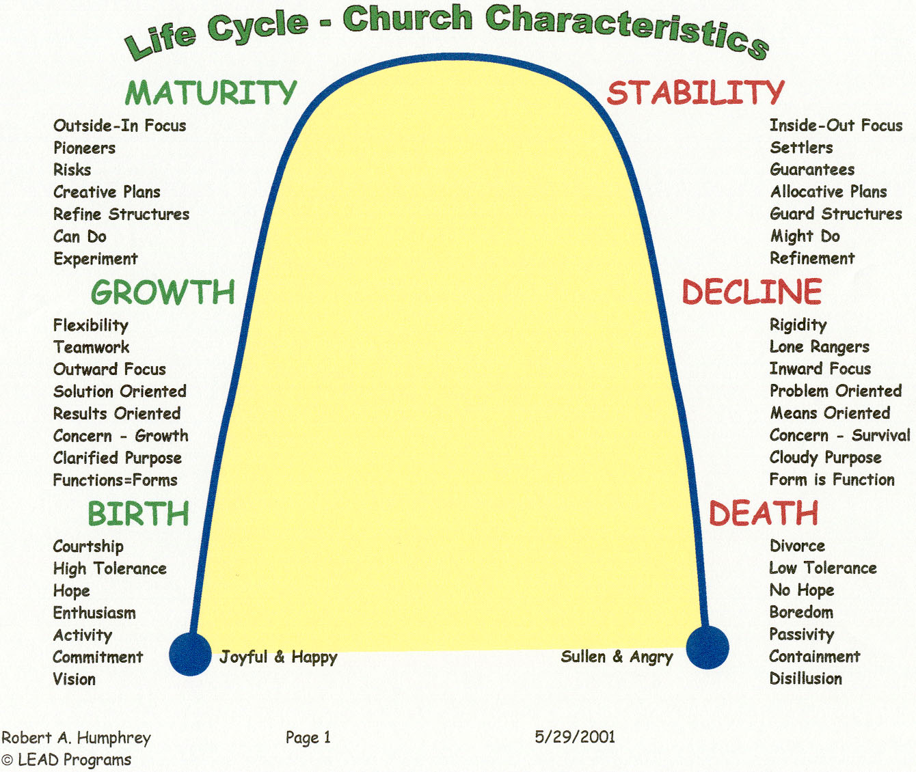

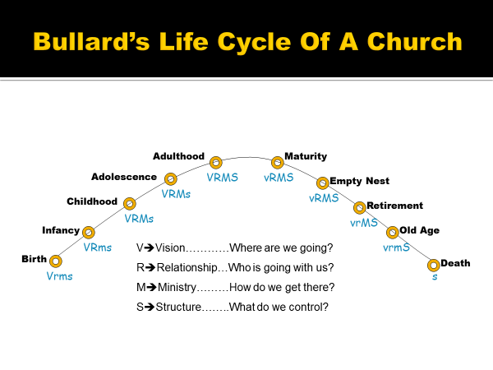

Day 4, Topic 5: Essentials for Finishing Well

1. Develop a Dream Team

2. Maintain Mission Clarity

3. Avoid Mission Drift

4. Embrace Biblical Coe Belief and Core Values

5. Maintain Vision Clarity

6. Make New Leader Development a Priority

Aubrey Malphurs and Will Mancini address the crying need to develop new leaders.

The solution to the leadership crisis is to do a much better job of leadership development—not the preparation of better senior pastors or church staffs alone but the development of committed leaders at every level within the organization. A godly senior pastor and an excellent staff can accomplish only so much. The church’s aim should be to train as many leaders as possible and to have competent leadership at every level of ministry.

The leader must train and equip leaders if the work is to progress. Leadership development enables a more impactful and versatile ministry. Consider a pyramid. The volume of a pyramid is equal to (one base x second base x height)/3 or b1 x b2 x h/3.


h3
b2
b1

The pyramid on the left is a model of the Great Pyramid of Giza shown on the right. If the model measures 1foot by 1 foot and the height is 0.63 feet, the volume contained by the model pyramid is 0.2 cubic feet. The same shaped pyramid with a 10-foot by a 10-foot base increases its volume capacity to 212 cubic feet, an increase of 1,060 times the volume of the smaller pyramid! However, the Great Pyramid, with dimensions of 756 feet x 756 feet x 481 tall, contains a capacity of 91,636,272 cubic feet, the equivalent of 2104-acre feet of water. The volume is the equivalent of one acre of ground covered with 2,104 feet of water! The proportions of the pyramids are geometrically congruent. However, the volumetric capacity of the more extensive base increases by the power of three.

In the church, the capacity of the church for ministry increases in direct portion to the size of the leadership base. Developing leaders in a restart is not an option. The capacity of a church to minister increases in direct proportion to the leadership base. The principle: Expand the leadership base; expand the church.

Peter Wiwcharuck makes a simple but profound statement: “Success without a successor is a failure!”

7. Establish Essential, Workable Systems for the Church

Systems needed for a smooth-running church include the following 10-essentials:

    - Evangelism
    - Inspiring Worship
    - Visitor Assimilation
    - Lay Mobilization
    - Spiritual Formation
    - Leader Development
    - Congregational Care
    - Effective Communication
    - Functional Leadership
    - Corporate Prayer

8. Preach with Hope and Grace

9. Reproduce

The Lifecycle of Pastoring

Introduction:

Phase One: The __________________ Phase

Phase Two: The __________________ Phase

Phase Three: The __________________ Phase

Phase Four: The __________________ Phase

Phase Five: The __________________ Phase

Phase Six: The __________________ Phase

Reversing the trend:

The Life Cycle of a Career

Survival

Success

Significance

Sovereign Foundation | Inner Life  Growth  Conversion | Ministry Maturity (about 30) | Life Maturity  (50-60) | Convergence (60-70) | Afterglow  (70-90)
Day 4, Review and Summary

Day 5, Topic 1: No Pain, No Gain: Understanding the Cost of Revitalization

Peter Wagner talks about the “price” pastors must pay if they want to grow. “First, a pastor must want the church to grow and be willing to pay the price.” Leading Your Church to Grow, 45.

Discussion from the article written by Hodge, Scott, “Sharp Curve Ahead." Leadership (2005).

http:// www.christianitytoday.com/le/2005/fall/26.62.html or you may find the article at http://www.theorchardcommunity.com/story

Principles from the Transformation

1.

2.

3.

4. The journey required a change in staff.

Church researchers Ed Stetzer and Mike Dodson state emphatically, “Comeback churches changed staff. Let that sink in—six of seven comeback churches experienced staff change prior to their comeback. It is an inescapable fact that most comeback churches changed staff.”

5.

6.

7.

8.

9.

10.

11.

12.

13.

Therefore, we also, since we are surrounded by so great a cloud of witnesses, let us lay aside every weight, and the sin which so easily ensnares us, and let us run with endurance the race that is set before us,
looking unto Jesus, the author and finisher of our faith, who for the joy that was set before Him endured the cross, despising the shame, and has sat down at the right hand of the throne of God.
Hebrews 12:1-2

Day 5, Topic 2: Scheduling Your Ministry: Setting Your Priorities, Using Your Gifts, Delegating Responsibilities

Monday Morning Meltdown



The concept of “pastoral care” had its roots in the Dark Ages. People thought that only the pastor (or priest) could handle the Scriptures, pray, visit the sick, perform weddings, funerals, comfort the afflicted, and so on. There was an unnecessary and unbiblical division between the “clergy and the laity.” This type of thinking carried over into the Reformation. Richard Baxter in The Reformed Pastor (first published in 1656) portrays the view seen by many to be the normative view of the ministry in the sixteenth century. Baxter was a Puritan leader in Kidderrminster, England. His job description for a pastor is described by George Hunter III in Radical Outreach (105-6). The leader “served as every person’s evangelist, catechist, teacher, overseer, counselor, Disciplinarian, liturgist, and preacher (Sunday morning and evening); he took it on himself to minister to all sick people and to visit from house to house.”
Baxter’s view and the view of Christendom permeated the church for nearly 1800 years! That same attitude persists in churches today. In the past I, too, fell prey to this kind of thinking. In one church, I did more than I should have done. In so doing, I actually crippled the congregation!

Congregational Care—Not Pastoral Care
NKJV Eph 4:11 And He Himself gave some to be apostles, some prophets, some evangelists, and some pastors and teachers,
12 for the equipping of the saints for the work of ministry, for the edifying of the body of Christ,

KJV Eph 4:11 And he gave some, apostles; and some, prophets; and some, evangelists; and some, pastors and teachers;
12 For the perfecting of the saints, for the work of the ministry, for the edifying of the body of Christ:

A question for the church: Do you desire a “maintenance” pastor or a “growth” pastor.
My comment to the search team: “If you are looking for a maintenance pastor, find someone else!”

Romans 12:3-8

“If you do something that someone else in the church can do, you are robbing them of a blessing.”
Duane Ayers—veteran pastor of more than 45-years’ fulltime ministry

Since I worked on research for my dissertation and having worked with multiple churches, a few things always bob to the surface. One issue that repeatedly arises is this bottleneck for effective ministry called “pastoral care.” God’s antidote for this potent ministry killer is called congregational care! Congregational care is the biblical notion that the congregation is responsible for the care of its members and the outreach ministries of the church, not the pastor! Ephesians 4:11-12 is perhaps the most explicit passage that deals with congregational care. Here the church leadership is charged with the responsibility of “equipping the saints” so the saints can do the “work of ministry.” That is congregational care.
Churches that do well are churches that have these two elements in place. The pastor uses his primary gifts, and the congregation provides the congregational care for the body. The leadership unleashes the potential of the church members for ministry. They empower and encourage the body of Christ to be the body of Christ!
As a pastor or ministry leader, do you feel the need to be involved in every part of ministry? Do you need to have your finger in every piece of the pie? Then you need to change
God has not called pastors or Christian leaders to do it all. Pastors are not able! Christ has called the body of Christ to be the body of Christ. He has called us together to engage the world with the Gospel, to serve one another with joy gladness. This style of ministry is effective and brings glory to God and usefulness to each church member. By the grace and power of God, churches will accomplish ministry together. That is congregational care. That is New Testament ministry!

The Necessity of Delegation

A load shared is half a load . . . the necessity of delegation

Exodus 18:13-27

Two Problems

The Leader

The people

The Solution

Ex 18:19-20

Ex 18:21-23

Worthy (heil)

Reverent

Truthful

Honest

Acts 6:1-7—The Magnificent Seven

The Problem Acts 6:1

The Secondary Problem Acts 6:2

The Proposed Solution Acts 6:3-4

Picking the Seven Acts 6:5-6

The Prosperity of the Ministry Acts 6:7

How Many Leaders do I Need? Gary’s Book—leaders of 1000’s, 100’s, 50’s and 10’s

Leadership Tools—MANAGING TIME & SETTING PRIORITIES

God loves you . . . and everyone else has a wonderful plan for your life.

Rick Warren—Purpose Driven Life

Why have priorities?

The Lord Jesus had priorities Matthew 20:28
Luke 19:9-10

What are biblical priorities?

Scheduling Your Priorities

1. You will find that there are more tasks and more work to be done in the ministry than you can possibly accomplish. You will have numerous questions:

- Where do I begin?
- How can I most wisely spend my time?
- How can my gifts and abilities best be used for the glory of God?
- How am I able to balance my responsibilities at home, work, and the church?

2. God will give you enough time. Ephesians 2:10

Remember that a schedule . . .

- is an attempt to control the details of your life.
- will be interrupted!
- can be modified.

PRINCIPLE: Schedule your work, but don’t let your schedule stand in the way of opportunities to minister in the Name of the Lord.

MAXIM: You make your schedule, or your congregation will.

Your Assignment:
Prepare a schedule that fits your core values, mission, and vision.
Please list ministries you should delegate to others to free up directed ministry time.

Day 5, Topic 3: Recruiting a Mentor or a Coach

The Need for Mentoring and Coaching

In the classic work, As Iron Sharpens Iron, Howard Hendricks, noted teacher and mentoring expert and Bill Hendricks, president of the Hendricks Group, raised the banner of mentoring before the Christian community. Their remarks trace the root of the term “mentor” and the current need for mentoring in our culture.

Wherever you turn today, you will find men looking for a guide, a coach, a model, an advisor. They are looking for someone who knows about life.

In essence, they are looking for a mentor. When the Greek warrior Odysseus went off to fight in the Trojan War, he left his young son, Telemachus, in the care of a trusted guardian named Mentor. The siege of Troy lasted ten years, and it took Odysseus another ten years to make his way home. When he arrived, he found that the boy Telemachus had grown into a man—thanks to Mentor’s wise tutelage.

Based on this story, we now speak of a mentor as someone who functions to some extent as a father figure (in the best sense of the term), a man who fundamentally affects and influences the development of another, usually younger man. (Howard G. Hendricks and William Hendricks, As Iron Sharpens Iron: Building Character in a Mentoring Relationship (Chicago: Moody Press, 1995), 17-18.

They continue,

Mentoring is defined by the relationship. That being the case, we have to define a mentor not in terms of any formal roles that he carries out, but in terms of the character of his relationship with the other person, and the functions that that relationship serves. (Hendricks and Hendricks, 158)

According to Hendricks, a mentor is an older, more experienced person who is a guide, model, or advisor. This is the classic view of a mentor.

The Distinction Between Coaching and Mentoring

Since this book was penned, mentoring, like so many other areas of our society, has undergone a great deal of refinement. Mentoring is not the only term currently in use. Coaching is used as a further refinement in the realm of personal and professional development. The concepts of mentors and coaches have taken on their own special meaning in ministry and business circles. So our objective is to provide workable definitions of “coach” and “mentor” as they apply to ministry. We will begin with a discussion as to how these terms are used in business and ministry circles today.
Don Hahn, President of Hahn Training, LLC, defines coaching and mentoring in the following way:

Coaching and mentoring are the 2 highest levels of professional development available in today’s workplace . . . It is easy to become confused about the differences between coaching and mentoring. Often times the two terms are used interchangeably when, in fact, there are some very specific distinctions. In mentoring, the course of action is usually provided by the mentor, whereas in a true coaching engagement, it is the coachee who creates the action plan. (http://www.champtrainer.com/documents/Similarities%20and%20Differences%20in%20Coaching%20and%20Mentoring.pdf, Don Hahn, “Similarities and Difference in Coaching & Mentoring,” accessed August 12, 2013.)

In Hahn’s definition, a mentor provides a course of action for a protégé (he defines this term below), whereas a coach has the protégé develop his own course of action.
Many other voices join the chorus to agree with this distinction. These include Management Mentors (http://www.management-mentors.com/resources/coaching-mentoring-differences/), accessed August 12, 2013) and the English coaching and mentoring Brefi Group. The Brefi Group provides a sharp distinction as they describe mentoring and coaching.

Coaching: helping another person to improve awareness, to set and achieve goals in order to improve a particular behavioural performance.

Mentoring: helping to shape an individual’s beliefs and values in a positive way; often a longer-term career relationship from someone who has ‘done it before.’ (http://www.brefigroup.co.uk/coaching/coaching_and_mentoring.html, accessed August 12, 2013.

This group echoes the fundamental distinctions between coaching and mentoring prevalent today. Mentoring is imparting information, whereas coaching helps an individual to discern their personal goals and objectives.
Christian coaches Bob Logan and Sherilyn Carlton describe coaching in the same manner.

Sometimes we just need an outside set of eyes and ears to give us a sense of perspective.

And coaching isn’t about being an expert. Is there knowledge involved? Absolutely. But the most crucial knowledge focuses on areas like listening skills and asking good questions. Coaches don’t need to have all the right answers so they can tell people what to do. It’s not about listening to the coach—it’s about helping others learn to listen to God for themselves. ( Bob Logan and Sherilyn Carlton, Coaching 101, Discover the Power of Coaching, (St. Charles, IL. ChurchSmart Resources, 2003), 19).

Their definition agrees with the basic tenets we’ve already observed. Coaching is about listening and asking good questions to help the protégé determine the direction God is leading them.
Perhaps the best way to understand coaching and mentoring is by comparing them in the following chart.

Chart 16. Contrasting Mentoring and Coaching for Pastors and Christian Leaders

Areas of Difference | Coaching | Mentoring
Duration | Short term | Long term
Relationship | Impersonal | Personal
Method | Asking directed questions to help protégé determine his or her own course of action | Giving direction from the mentor’s past experiences
Age Difference | Does not matter | Usually, the mentor is older with more experience
Focus | Self-discovery of solutions | Directed towards solutions that have been successful in the past in the life of the mentor

Definitions of Coaches and Mentors

So, for the purposes of this volume, we will define “mentor” and “coach” in the following ways:

- A mentor is one who promotes the development of life and ministry skills for a protégé primarily by imparting wisdom and skill from lessons learned from the mentor’s own life and ministry experience.
- A coach is one who promotes the development of life and ministry skills for a protégé primarily through asking probing questions about a protégé’s life, divine design, direction and development so that the protégé grows primarily through self-discovery.

Examples of Mentors and Protégés in Scripture

Requirements for today:

Combination:

Why?

Characteristics to seek in a Mentor/Coach

Characteristics to seek in a Protégé

Day 5, Topic 4: Coaching Cluster: The Value of Peer to Peer Learning

Pastor Clusters

What is a Pastor Cluster?

I am indebted to Dr. William Hoyt and Dr. Paul Borden of Growing Healthy Churches for the training they have offered on Pastor Clusters. Their ministry has greatly influenced me in this arena.

Typical Names

Typical Names for Pastor Clusters
Clusters
Peer-to-peer Learning Communities
LLC: Leadership Learning Communities
LEAD Teams

A Pastor Cluster is a . . .

- Group of ministry peers
- Led by ministry practitioner mentor
- Meeting regularly for:
  - Learning
  - Encouragement
  - Accountability
  - Dreaming

Why a Pastor Cluster?

- Takes advantage of what experienced mentors have to offer younger and less experienced pastors
- The economy of time for mentors
- Multiplies impact for the same investment of time and money
- It is financially wise
  - To help pastors continue to learn after seminary of Bible College.
  - To fill in the leadership blanks left by formal education
  - To develop pastor’s effectiveness as leaders
  - For accountability
  - For mutual support, encouragement, friendship, and fellowship

Organizing Principles

1.

2.

3.

Style of Cluster Meetings

Each cluster chooses their preferred meeting day(s), times and model.
  - Day and a half model – “Town and Country Model”
  - One day model – “Metropolitan Model”
  - Half-day model – “Metropolitan Model” for “busy Type A” pastors
  - Virtual meeting model—meet online

Frequency and Location of Cluster Meetings

Frequency
  - Typically, monthly
    - 10-12 months annually
Location
  - A single, regular meeting place
  - Rotate through the locations of each cluster member
  - Select two or three strategically situated locations and rotate through them

Cluster Mentors

- Typically selected by the denominational executive
- Pastors who have a track record of leading a growing church or a turnaround pastor
- Sign a formal covenant clarifying the expectations of both the Region and the mentor.
- Often but not always paid a small stipend for their time
- The denominational executive seeks formal action by the Mentor’s Board, approving the mentor’s service to the Region as a mentor.
- Formal board “blessing” protects mentor when members are critical of time spent on mentoring.
- Creates value in the eyes of the church leadership

Learning Materials for the Cluster

Cluster Expectations

Cluster Meeting Agenda

- L.E.A.D.
  - Learning
  - Encouragement
  - Accountability
  - Dreaming
Learning

  - Commitment to being a life-long learner
  - Personal and spiritual health and maturity
  - Ministry skills
  - Exegeting the culture
  - Visioneering
  - Strategic Ministry Planning Skills
  - Discussion of book
  - Emphasis on adaptation and application to their ministry
  - Not a book review but a “what am I going to do about what I have learned from this book.”
  - Often leads to the accountability and or the dreaming component of agenda

  - Book discussion questions
  - What leadership principles did you note while reading this book? How do you see them applying to you and your leadership in your church?
  - As you were reading, did you find yourself saying, “Oh, I need to do that,” or “I could do that. That would be a good thing to do in my setting?”
  - Was there any part of the book where you found yourself thinking, “That will never work in my church?”
  - Were there places where you found yourself thinking, “I know that. I am already doing that?”
  - What are you going to apply to your ministry? What questions do you have about how to use it in your context?

  - Understanding church systems
  - Church Systems
    - Evangelism
    - Inspiring Worship
    - Visitor Assimilation
    - Lay Mobilization
    - Spiritual Formation
    - Leader Development
    - Congregational Care
    - Effective Communication
    - Functional leadership
    - Corporate Prayer

Cluster Meeting Agenda Example

Book—McIntosh, Beyond the First Visit

- Assimilation System
  - Defining and identifying visitors
  - Tracking visitors
  - Strategy for moving people from “visitor” to fully assimilated constituent
  - Definition of a “fully assimilated person.”
  - Training
  - Goals and milestones

- Learning
  - Inevitably, real-life questions emerge from the meetings.
  - Listen, discuss, learn, and seek biblically-centered solutions
    - Some of the most significant times of learning occur during these times of impromptu discussion

Encouragement

  - NOT commiseration - “poor you-poor me.”
  - Not whine and dine
  - Give affirmation
  - Sometimes you must give reproof
  - Inspire growth and improvement
  - Care and prayer

Accountability

  - The expectation that they will establish specific, measurable goals
    - Ministry
    - Personal
  - Coach them in developing those goals
    - Specific
    - Measurable
    - Aligned
    - Results-oriented
    - Time constrained
  - Ask them about the relationships they are building with those who are lost. Are they making progress?
  - Ask them about their schedules. Are they in control of their time, or have they relinquished control to others?

Dreaming

  - Need to dream again
    - John 4:35
      - "Do you not say, 'There are still four months and then comes the harvest'? Behold, I say to you, lift up your eyes and look at the fields, for they are already white for harvest!”
    - Psalm 51:10 Create in me a clean heart, O God, and renew a steadfast spirit within me.
    - Matthew 9:37-38 “37 Then He said to His disciples, ‘The harvest truly is plentiful, but the laborers are few. Therefore, pray the Lord of the harvest to send out laborers into His harvest.’” We must once again see the harvest!

- Dreaming
  - Personal dreams
  - Ministry dreams
  - Specific goals and action steps
(SMART goals)

Reading List

- Intentionally, extremely top-heavy on leadership
  - Include both secular and Christian books on leadership
- Essential Secular Classics

Book Example—Good to Great

Good to Great is a business book that has shaped the thinking of many in terms of turnaround. In research for the book, Jim Collins and his team studied companies that had made the leap from being mediocre companies to being great companies, that is, companies that turned around. In so doing, Collins and his team of researchers tried to identify the shared traits of companies that emerged out of the shadows to become companies that far outstripped the competition. He cataloged the research in this bestselling volume. The findings of the study were stunning. “Our five-year quest yielded many insights, a number of them surprising and quite contrary to conventional wisdom, but one giant conclusion stands above the others: We believe that almost any organization can substantially improve its stature and performance, perhaps even become great, if it conscientiously applies the framework of ideas we’ve uncovered.” Collins and his team identified six characteristics found in companies that made the leap from “good” to “great.” They are:
  - Level 5 Leadership . . . Self-effacing, quiet, reserved, even shy—these leaders are a paradoxical blend of personal humility and professional will. They are more like Lincoln and Socrates than Patton or Caesar.
  - First Who . . . Then What . . . We found instead that they first got the right people on the bus, the wrong people off the bus, and the right people in the right seats—and then they figured out where to drive it. The old adage “People are your most important assets,” turns out to be wrong. People are not your most important asset. The right people are.
  - Confront the Brutal Facts . . . You must maintain unwavering faith that you can and will prevail in the end, regardless of the difficulties, AND at the same time have the discipline to confront the most brutal facts of your current reality, whatever they might be.
  - The Hedgehog Concept. To go from good to great requires transcending the curse of competence . . . If you cannot be the best in the world at your core business, then your core business absolutely cannot form the basis of a great company. It must be replaced with a simple concept that reflects deep understanding of three intersecting circles (see below for a description of the three intersecting circles).
  - Culture of Discipline . . . When you are disciplined people, you don’t need hierarchy. When you have disciplined thought, you don’t need bureaucracy. When you have disciplined action, you don’t need excessive controls. When you combine a culture of discipline with an ethic of entrepreneurship, you get the magical alchemy of great performance.
  - Technology Accelerators. Good-to-great companies think differently about the role of technology. They never use technology as the primary means of igniting a transformation. Yet, paradoxically, they are pioneers in the application of carefully selected technologies.

Collins describes the three intersecting circles (see the Hedgehog Concept) in the following manner:
More precisely, a Hedgehog Concept is a simple, crystalline concept that flows from deep understanding about the intersection of the following three circles:

1. What you can be best in the world at? . . . 2. What drives your economic engine? . . . 3. What are you deeply passionate about? The Good to Great Companies focused on those activities that ignited their passion.”

In ministry, these circles can be easily identified in the Great Commission and the Great Commandment. The church is God’s instrument of redemption in a fallen world. That is what the church is to be best at doing. The Spirit of God with the Word of God powered by the love of God must drive our engine. Finally, the church is to be deeply passionate about reaching the world with the Gospel.
Collins continues by describing Level 5 leadership.
- Humility + Will = Level 5.
Level 5 leaders are “modest and willful, humble and fearless. To quickly grasp this concept, think of United States President Abraham Lincoln (one of the few Level 5 presidents in United States history), who never let his ego get in the way of his primary ambition for the larger cause of an enduring great nation.
- Ambition for the Company: Setting Up Successors for Success
- A Compelling Modesty
- Unwavering Resolve . . . to Do What Must Be Done
- The Window and the Mirror: Level 5 leaders look out the window to apportion credit to factors outside themselves when things go well (and if they cannot find a specific person or event to give credit to, they credit good luck). At the same time, they look in the mirror to apportion responsibility, never blaming bad luck when things go poorly.

Thus, Collins identifies turnaround leaders as leaders who are humble but driven, who are good managers of people, who understand reality, who are sharply focused on their company’s mission, who are modest and yet ambitious, and who are not afraid to take responsibility for their company or their own actions.

Reading List: Rocky Mountain Church Network (an example)

2011 – 2012
- Good to Great: Why Some Companies Make the Leap..., and Others Don't
Jim Collins
- Winning On Purpose: How To Organize Congregations to Succeed in Their Mission
Bill Easum, Thomas G. Bandy, Dr. John Kaiser
- Direct Hit: Aiming Real Leaders at the Mission Field
Paul D. Borden
- Taking Your Church to the Next Level: What Got You Here Won't Get You There
Gary L. McIntosh
- Spiritual Leadership: A Commitment to Excellence for Every Believer
J. Oswald Sanders
- Fusion: Turning First-Time Guests into Fully-Engaged Members of Your Church
Nelson Searcy, Jennifer Henson
- Leading Change
John P. Kotter
- Sticky Teams: Keeping Your Leadership Team and Staff on the Same Page
Larry Osborne
- *Overcoming the Dark Side of Leadership
Gary L. McIntosh & Samuel D. Rima

2012-2013

2012-2013 Suggestions:
- Make or Break Your Church in 365 Days: A Daily Guide to Leading Effective Change
Paul D. Borden
- StandOut: The Groundbreaking New Strengths Assessment from the Leader of the Strengths Revolution
Marcus Buckingham
- The Apostolic Congregation: Church Growth Reconceived for a New Generation
George G Hunter III
- The Advantage: Why Organizational Health Trumps Everything Else In Business
Patrick Lencioni
- You Lost Me: Why Young Christians Are Leaving Church...and Rethinking Faith
David Kinnaman
- ReChurch: Healing Your Way Back to the People of God
Stephen Mansfield
- The Triumph of Christianity: How the Jesus Movement Became the World's Largest Religion
Rodney Stark
- The Truth about Leadership: The No-fads, Heart-of-the-Matter Facts You Need to Know
James M. Kouzes & Barry Z. Posner
- Maximize: How to Develop Extravagant Givers in Your Church
Nelson Searcy & Jennifer Dykes Henson
- Humilitas: A Lost Key to Life, Love, and Leadership
John Dickson
- The Art of the Start: The Time-Tested, Battle-Hardened Guide for Anyone Starting Anything
Guy Kawasaki
- The Next Christians: Seven Ways You Can Live the Gospel and Restore the World
Gabe Lyon

Day 5, Topic 5: Review the Personal and Ministry Development Plans

See pages 15-16 of this manual

Day 5, Topic 6: Course Debrief

Day 5, Topic 7: The Triumph of Christ

Gary Keller with Jay Papasan, The One Thing: The Surprisingly Simple Truth Behind Extraordinary Results, (Austin, TX, Bard Press, 2012), 146-47.
Aubrey Malphurs and Gordon E. Penfold, Re:Vision: The Key to Transforming Your Church (Grand Rapids, Baker) 46-47.
Malphurs, Penfold, 45.
Adapted from Malphurs and Penfold, 49.
Larry Osborn, Sticky Teams: Keeping your leadership and staff on the same page, (Grand Rapids, MI: Zondervan, 2010), 13-14, In the foreword written by Matt Chandler.
Leith Anderson, Conservative Baptist Annual Meetings, Spokane, Washington, July 2001.
Rick Warren, Purpose Driven Church (Grand Rapids, Zondervan), 81.
This form is suggested by Tod Bolsinger, Canoeing the Mountains: Christian Leadership in Uncharted Territory (IVP, Downers Grove, 2015) 130.
George Hunter, III, Radical Outreach (Nashville: Abingdon Press, 2003), 105-6.
Linus J. Morris, The High Impact Church (Houston: Touch Publications, 1993) 264.
TAPs scored 23.8 and NTAPs 28.4 compared with 50.0 for the general population. This presents an interesting question that begs further research: are pastors more risk averse than the average church member? Although church members resist change, they may be more willing to bet the house when they’re finally convinced it’s time to move. Bridges, 130-132, “But the good news is that while the changes we are facing differ from any we’ve experienced before, the transition process by which people get through change is well-mapped. There are many things about this new world that we cannot yet understand, but we do know what change does to people and how to help them get through it.” According to Bridges, it is easier for companies to make situational changes than it is for people to make because of the psychological transitions needed to adjust to the organizational changes. Bridges, 160-163, distinguishes change and transition. “Change is situational: the move to a new site, the retirement of the founder, the reorganization of the roles on the team, the revisions to the pension plan. Transition, on the other hand, is psychological; it is a three-phase process that people go through as they internalize and come to terms with the details of the new situation that the change brings about.”
Although we don’t have hard research data to prove it, we suspect that the need to validate one’s ego by one’s works is also at work here. For more on this, see Chapter 2, “The Pastor’s Worth.”
Bridges, 130-132, “But the good news is that while the changes we are facing differ from any we’ve experienced before, the transition process by which people get through change is well-mapped. There are many things about this new world that we cannot yet understand, but we do know what change does to people and how to help them get through it.” According to Bridges, it is easier for companies to make situational changes than it is for people to make because of the psychological transitions needed to adjust to the organizational changes. Bridges, 160-163, distinguishes change and transition. “Change is situational: the move to a new site, the retirement of the founder, the reorganization of the roles on the team, the revisions to the pension plan. Transition, on the other hand, is psychological; it is a three-phase process that people go through as they internalize and come to terms with the details of the new situation that the change brings about.”
Aubrey Malphurs and Will Mancini, Building Leaders: Blueprints for Developing Leadership at Every Level of Your Church. (Grand Rapids, Baker Publishing Group, 2004), Loc. 173.
https://pixabay.com/en/pyramid-egypt-egyptian-ancient-2690230/
https://pixabay.com/en/egypt-cairo-giza-pyramid-kephren-3333792/
Peter Wiwcharuck, Building Effective Leadership (Alberta, Canada: International Christian Leadership Development Foundation, 1987), 23
Ed Stetzer and Mike Dodson, Comeback Churches: How 300 Churches Turned Around and Yours Can Too (Nashville, TN: B & H Pub. Group, 2007), 177.
Malphurs and Penfold, 187-191.
Collins, 5.
Ibid., 12-13.
Ibid., 95-96.
Ibid., 22-35.
Gordon E. Penfold, “Defining Characteristics of Turnaround Pastors among Evangelical Churches in the Rocky Mountain States” (D.Min diss., Biola University, 2011).

