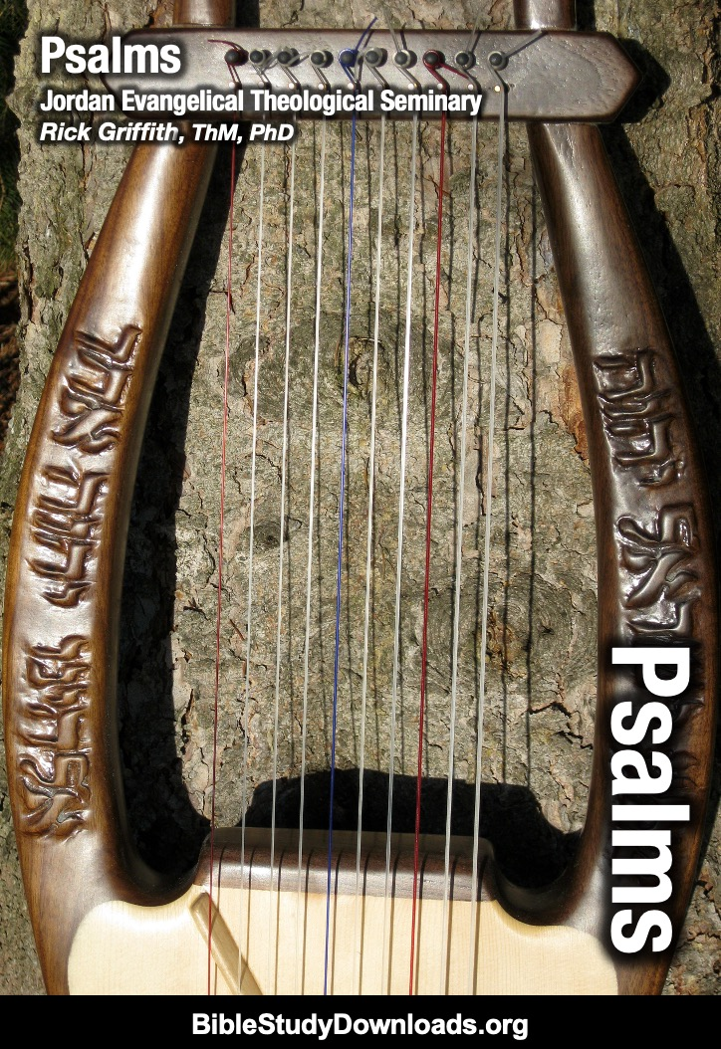

**The Book of Psalms**

***Jordan Evangelical Theological Seminary***

**Rick Griffith, ThM, PhD**

**Fifth Edition**

**© May 2025**

1st printing (100 copies; 1st ed., March 1991)

2nd printing (20 copies; March 1996)

3rd printing (20 copies; 2nd ed., new 7,16-20,22-24,26-28,40,46-48, Aug. 98)

4th printing (20 copies; 3rd ed., new 16-23, March 00)

5th printing (10 copies; Feb 02)

6th printing (10 copies; Apr 02)

7th printing (30 copies; March 03)

8th printing (10 copies; April 06)

9th printing (10 copies; Aug 08)

10th printing (20 copies; June 11) IBC Honolulu

11th printing (20 copies; Sep 12)

12th printing (digital copies; 4th ed., Jan 23)

13th printing (digital copies; 5th ed., May 25)

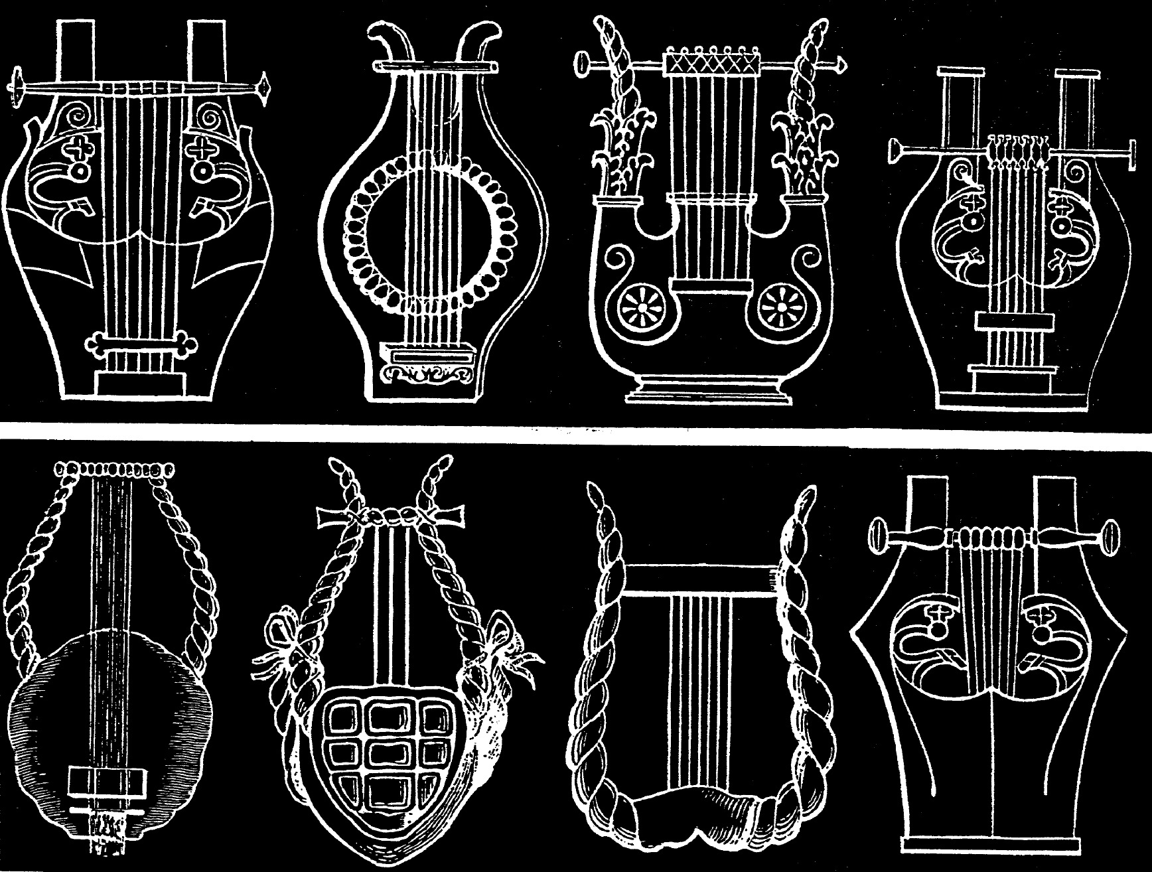

**Contents**

Syllabus 1

Introduction 381

Argument 382

Summary Statement for the Book 383

Individual Psalms Classified Generally 384

Components of the Six Types of Psalms 385

The Psalms in History 389

Hebrew Poetry & Parallelism 390

Hermeneutics & Figures in Psalms 391

Worship in Israel 393

Questions on the Psalms 394

Psalms Help Us Worship Holistically 397

Individual Lament Psalms (Psalms 3, 51) 398

Communal Lament Psalms (Psalm 137) 402

Songs of Trust (Psalms 16, 23) 403

Reading the Psalms Publicly 406

Seven Steps to Preaching Expository Sermons 407

Declarative Praise Psalms 410

Descriptive Praise Psalms (Hymns) 413

Declarative Praise Psalms (Psalm 138) 414

Descriptive Praise Psalms (Psalm 135) 415

Psalm 64 Sermon Manuscript 416

Title: “When the Finger’s Pointing at You…” 416

Kingship (Enthronement) Psalms 93, 97 422

Psalms Relating to Jerusalem 425

Royal and Messianic Psalms (Psalm 2) 426

Psalms in the New Testament 436

**Syllabus**

**I. Description**

The Book of Psalms will be examined both for what it meant to the original readers/singers and us today. Attention will be given to the literary structure of the work as well as to the interpretation of various problematic passages. Time will be allocated for discussing the application of our culture within the church's theological reflection.

**II. Objectives**

By the end of the course, everyone will be able to…

A. Show knowledge of the historical and cultural background of the Book of Psalms.

B. Articulate the uniqueness of the various literary categories of psalms.

C. Answer questions relating to problematic passages within the Psalter.

D. Lead a decent devotional on a particular psalm.

**III. Bibliography**

Alden, Robert L. *Psalms*. Vol. 2: *Songs of Dedication (Psalms 51-100).* Everyman’s Bible Commentary. Chicago: Moody, 1975.

Allen, Leslie C. *Psalms 101—150.* Word Biblical Commentary, vol. 21. Waco, TX: Word, 1983.

Allen, Ronald Barclay. *Praise! A Matter of Life and Breath.* Nashville: Nelson, 1980.

Anderson, A. A. *The Book of Psalms.* 2 vols. The New Century Bible Commentary. Edited by Ronald E. Clements. Grand Rapids: Eerdmans, 1972.

Anderson, Bernhard W. *Out of the Depths.* Rev. ed. Philadelphia: Westminster, 1983.

Bellinger, W. H., Jr. “Let the Words of My Mouth: Proclaiming the Psalms.” *Southwestern Journal of Theology* 27 (Fall 1984): 17-24.

Craigie, Peter C. *Psalms 1–50.* Word Biblical Commentary, vol. 19. Waco, TX: Word, 1983.

Kidner, Derek. *Psalms 1—72.* Tyndale Old Testament Commentary. Leicester, England: InterVarsity, 1973.

______. *Psalms 73—150.* Tyndale Old Testament Commentary. Leicester, England: InterVarsity, 1975.

Parsons, Greg W. “Guidelines for Understanding and Proclaiming the Psalms.” *Bibliotheca Sacra* 147 (April-June 1990): 169-87.

Ross, Allen P. “Principles of Hebrew Exegesis in the Psalms.” Class handouts from the course OT 104. Dallas Theological Seminary, 1986.

_______. "Psalms." In *The Bible Knowledge Commentary*. 2 vols. John F. Walvoord and Roy B. Zuck, eds. 1:779-899. Wheaton: SP Pub., Victor Books, 1985.

Smith, Ralph. “The Use and Influence of the Psalms.” *Southwestern Journal of Theology* 27 (Fall 1984): 5-16.

Westermann, Claus. *The Psalms: Structure, Content, and Message.* Minneapolis: Augsburg, 1980.

**Psalms**

|  |  |  |  |  |  |
| --- | --- | --- | --- | --- | --- |
| **Praising and Petitioning God** | | | | | |
|  | **Book 1**  **(1–41)** | **Book 2**  **(42–72)** | **Book 3**  **(73–89)** | **Book 4**  **(90–106)** | **Book 5**  **(107–150)** |
| **Number of Psalms** | **41** | **31** | **17** | **17** | **44** |
| **Authors**  **and Number of Psalms Authored** | **David-37**  **Anon-4** | **David-18**  **Korah-7**  **Anon-4**  **Solomon-1**  **Asaph-1** | **Asaph-11**  **Korah-3**  **Ethan-1**  **Heman-1**  **David-1** | **Anon-14**  **David-2**  **Moses-1** | **Anon-28**  **David-15**  **Solomon-1** |
| **Prominent Type** | **Lament-22** | **Lament-21** | **Lament-9** | **Praise-12** | **Praise-22** |
| **Closing Doxology** | **41:13** | **72:18-19** | **89:52** | **106:48** | **150:1-6** |
| **Possible Compiler** | **David** | **Hezekiah or Josiah** | | **Ezra or Nehemiah** | |
| **Possible Compilation Dates** | **c. 1020-**  **970 BC** | **c. 970-610 BC** | | **Until c. 430 BC** | |
| **Span of Authorship** | **About 1000 Years (c. 1410-430 BC)** | | | | |

**Key Word: Praise**

**Key Verse: “Praise the LORD. I will extol the LORD with all my heart in the council of the upright and in the assembly” (Psalm 111:1).**

**Summary Statement:**

**Praise and petition God for who He is and what He has done in providing wisdom, protection, Messianic fulfillment, and His Word to be humble before Him in trust and thanksgiving.**

**Application:**

**Praise God for who He is as well as for what He’s done.**

**Honestly state your complaint to God since He knows you fully anyway.**

**Psalms**

**Introduction**

**I. Titles**

A. Hebrew: The Hebrew Bible calls this the *Book of Praises* (סֵפֶר תֲּהִלִּים), abbreviated to *Praises* תֲּהִלִּים] or תֱּלִּים or (תֲּלִּין. Although the word “praise” occurs often in the Psalter, Psalm 145 is the only psalm with the *title* “praise” (תֲּהִלִּים). However, Westermann notes that every lament psalm includes praise (except maybe Psalm 88) since all lament psalms progress beyond petition and lament to praise God (*The Praise of God in the Psalms*, 74).

B. Greek: The Septuagint (LXX) translated the Hebrew word *mizmor* (מִזְםוֹר) as “psalm” (ψαλμός)—the technical word for a song sung to the accompaniment of a plucked (i.e., stringed) instrument.

C. English: Three English titles (The Psalms, The Psalter, and The Book of Psalms) are derived from the Greek and Latin titles (*Psalmoi, Psalterian,* and *Liber Psalmorum*, respectively).

**II. Authorship**

A. External Evidence: Many scholars have challenged the superscriptions of many psalms, especially recently. Much of the debate centers on the use of the Hebrew preposition l, *lamed*, which can be translated "to," "for," "of," and several other ways (e.g., "A Psalm *to* David," "A Psalm *for* David," "A Psalm *of* David," etc.). However, its "use to designate authorship has been well attested in the Northwest Semitic inscriptions, other Semitic dialects such as Arabic, and other biblical passages such as Habakkuk 3:1 ('of Habakkuk')" (Ross, *BKC*, 1:782). Therefore, the traditional meaning that attributes authorship to these men is well substantiated.

B. Internal Evidence: Fifty psalms are anonymous, but the Psalter names seven different authors in 100 of the psalms (in descending order regarding the number of psalms each contributed):

1. David (the second king of Israel), whose name means "Beloved of Yahweh" (73 pss. mostly in Books I and II), wrote the most psalms

2. Asaph (a famous musician and Levite from Gershom), "Collector" (12 pss.: Pss. 50, 73–83)

3. The sons of Korah (a guild of singers and composers who descended from Levi in the line of Kohath), "Bald" (10 pss.: Pss. 42, 44–49, 84, 85, 87)

4. Solomon, (third king of Israel and son of David and Bathsheba), "Peaceful" (2 pss.: Pss. 72, 127)

5. Moses (Israel’s leader out of Egyptian bondage and author of the oldest psalm), "Son of the Water" (Ps. 90)

6. Heman the Ezrahite (like the sons of Korah, he was a Levite from the family of Kohath), "Faithful" (Ps. 88)

7. Ethan the Ezrahite (a Levite from the family of Merari), "Enduring" (Ps. 89)

**III. Circumstances**

A. Date: The various psalms were written over nearly 1000 years from the time of Moses (Ps. 90; ca. 1410 BC) to the postexilic period under Ezra and Nehemiah (Ps. 126; ca. 430 BC).

B. Recipients: The Book of Psalms served as a hymnal for the nation of Israel during its worship at the Temple and as a devotional guide for the Jewish people.

C. Occasion: David and Asaph organized Israel's worship around 1000 BC. Some of King David's hymns were probably collected at that time and used in the first temple under Solomon. Since *Book of Praises* was the original name of the entire Book, the collection was probably named such as the hymnbook of the second temple built by Zerubbabel with its worship re-established by Nehemiah (Neh. 12:46). The reason people need this collection is straightforward: We must praise and petition God for who He is and what He has done in providing wisdom, protection, Messianic fulfillment, and His Word to be humble before Him in trust and thanksgiving.

**IV. Characteristics**

A. Psalms is the most diverse book of the Old Testament.

1. The *content* of the Psalms covers a tremendous breadth of material (jubilation, war, peace, worship, judgment, messianic prophecy, praise, and complaint).

2. The *events* stretch back to Creation and the patriarchal, theocratic, monarchical, exilic, and post-exilic periods.

B. Psalms is the longest book in the Bible in terms of chapters and in words:

|  |  |  |  |
| --- | --- | --- | --- |
| **Book** | **Chapters** | **Verses** | **Words** |
|  |  |  |  |
| Psalms | 150 | 2461 | 43,743 |
| Jeremiah | 52 | 1364 | 42,659 |
| Ezekiel | 48 | 1273 | 39,407 |
| Genesis | 50 | 1533 | 38,267 |
| Isaiah | 66 | 1292 | 37,044 |

http://www.kneeholedesk.com/Pages/Did_You_Know/Books_of_the_Bible.html

C. Psalms is the most quoted book of the Old Testament in the New Testament (119 times or more).

D. Psalm 23 is the most quoted and memorized poem in history.

E. Psalms is likely the most beloved book in the Bible, having ministered to more people in more situations over a longer period than any other biblical book.

**Argument**

Classification by Book: Psalms is a songbook that facilitates the worship of Israel, particularly in a corporate setting. However, the reason for placing the psalms into five books (listed below) has long perplexed scholars. Each book concludes with a doxology, but why certain psalms are classified into each book is unknown, partly due to the difficulty in categorizing each psalm. The fivefold division has been explained in at least three ways:

1. The Jews believed that the five sections *mirror the Pentateuch* (cf. Jensen’s chart, next page), but these appear to have no correspondence.

2. Herbert C. Leupold and A. A. Anderson both postulate that the divisions have resulted in one book at a time from *chronological* *development* (cf. Jensen on the next page and Ralph Smith on p. 389). This is probably the better explanation.

**Summary Statement for the Book**

**Praise and petition God for who He is and what He has done in providing wisdom, protection, Messianic fulfillment, and His Word to be humble before Him in trust and thanksgiving.**

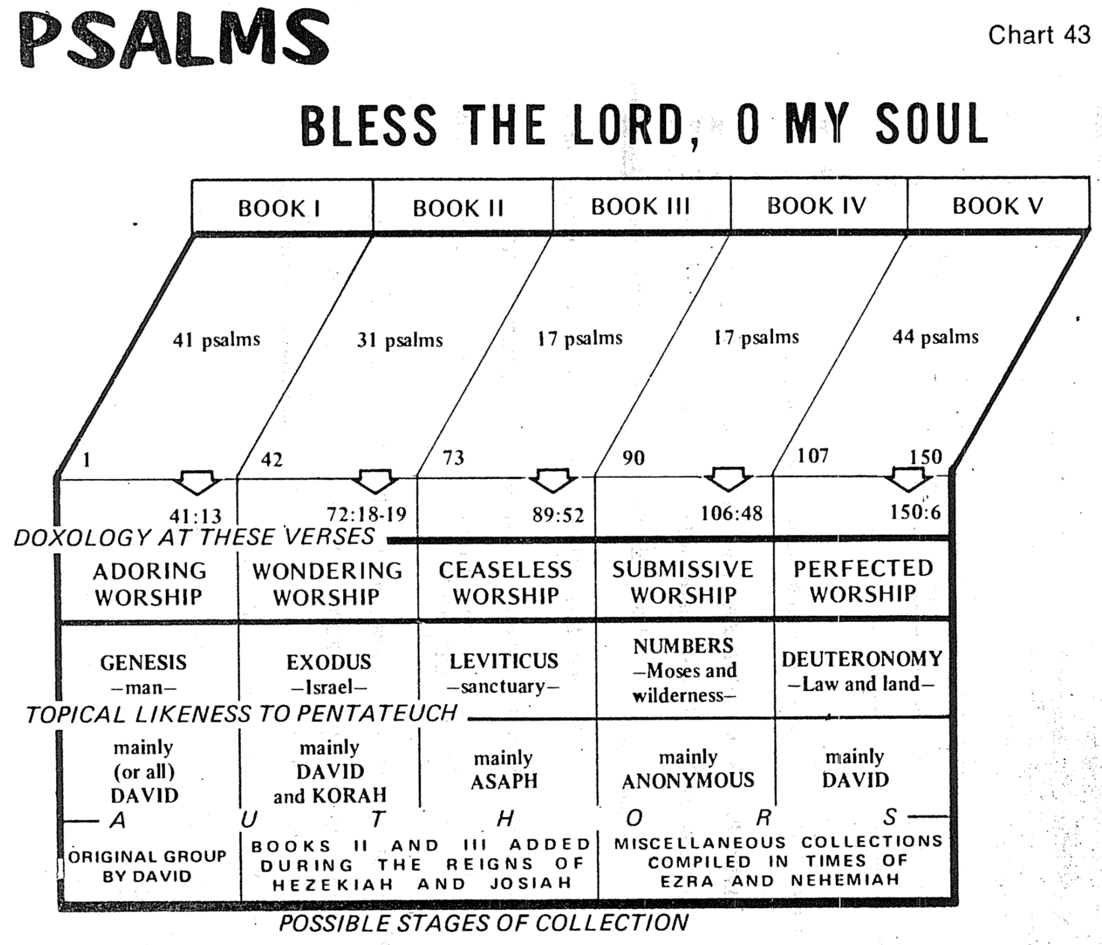

Irving L. Jensen, *Jensen’s Bible Charts*

**Individual Psalms Classified Generally**

Classification by Individual Psalm: Several attempts at classifying the individual psalms have been made, but probably Westermann, *The Praise of God in the Psalms* (Richmond: John Knox Press, 1965), 25-35, has the best broad divisions. He suggests that two broad categories—either "praise" or "lament" (petition)—describe every individual psalm. These two broad categories break down further into the following outline (abbreviations supplied by me):

|  |  |  |  |  |  |
| --- | --- | --- | --- | --- | --- |
| **Praise** | | | **Lament (Petition)** | | |
| **Declarative** | | **Descriptive** | **Individual** | | **People** |
| **Individual** | **People** |  | **Open** | **Heard** |  |
| **DPI** | **DPP** | **DSP** | **LIO** | **LIH** | **LOP** |
| **1** | **2** | **3** | **4** | **5** | **6** |

In outline form, the above chart can be described in the following manner:

**I. Praise (P): *Worship of God* for what He has done or who He is**

A. Declarative Praise (DP): Worship of God for what He has done–*Actions of God*

1 1. Declarative Praise of the Individual (DPI): Worship of God for what He has done for an individual

2 2. Declarative Praise of the People (DPP): Worship of God for what He has done for the congregation

3 B. Descriptive Praise (DSP): Worship of God for who He is–*Attributes of God.*

These are not divided into the individual and people/congregation subcategories since the distinction of the subject cannot be made except in a few of these psalms)

**II. Lament/Petition (L): *Request from God* based on what He has done or who He is**

A. Lament (Petition) of the Individual (LI): Request of God by one person

4 1. Lament (Petition) Not Answered (Open) (LIO): Request of God before the answer

5 2. Lament (Petition) Heard (LIH): Testimony of an answered request of God

6 B. Lament (Petition) of the People (LP): Request of God by the entire congregation

This classification results in six types of psalms as listed by number in the left-hand column above. Each of these six types has specific components that commonly occur, but not always. These are listed on the next page in their respective categories.

**Components of the Six Types of Psalms**

Claus Westermann

(Arrows indicate similar sections)

**Type (see previous page):**

|  |  |  |  |  |  |
| --- | --- | --- | --- | --- | --- |
| **6** | **2** | **4** | **5** | **1** | **3** |
| Petition of the people | Declarative praise of the people | Petition of the individual (open) | Petition of the individual (heard) | Declarative praise of the individual | Descriptive  Praise |
| Introductory petition | (Let Israel say so) | Introduction | ———— |  |  |
| Lament | Looking back to the time of need | Lament | Lament |  |  |
| Confession  of confidence | Report of the deliverance | Confession of confidence | Confession of confidence |  |  |
| Petition |  | Petition | Petition |  |  |
| (Double wish) |  | Double wish | (Double wish) |  |  |
|  |  | (Confidence of being heard) | (Confidence of being heard) |  |  |
| Vow of praise |  | Vow of praise | Vow of praise | Announcement |  |
|  |  |  |  | Introductory summary |  |
|  |  |  | Praise (declarative) | Report of deliverance 1. Looking back to  the time of need 2. I cried 3. He heard 4. He drew me out |  |
|  |  |  |  | Vow of praise | Call to praise |
|  |  |  |  | Praise (descriptive) | Praise  1. Yahweh is great  (a) the Creator  (b) the Lord of history  2. Yahweh is good  (a) he saves  (b) he gives bread |
|  |  |  |  |  | Conclusion |

**Classification of Each Psalm**

F. Duane Lindsey, DTS Class Handout

Dr. F. Duane Lindsey believes that the previous six Westermann categories should be expanded, as several psalms have a didactic or teaching theme (as opposed to being either praise or lament). Therefore, he adds a third primary type of psalms called Didactic Psalms. He also breaks down the lament psalms and descriptive praise psalms into further categories. Note that the numbers at the top of the chart refer to the six basic types of psalms by Westermann.

|  |  |  |  |  |  |  |  |  |  |  |  |  |  |  |  |  |  |  |  |  |  |  |  |  |  |  |  |  |
| --- | --- | --- | --- | --- | --- | --- | --- | --- | --- | --- | --- | --- | --- | --- | --- | --- | --- | --- | --- | --- | --- | --- | --- | --- | --- | --- | --- | --- |
| **LAMENT** | | | | | | | | | | | **DECLARATIVE PRAISE** | | | | **DESCRIPTIVE  PRAISE 3** | | | | | | | | **DIDACTIC** | | | | | |
| **LAMENT PSALMS** | | | | | | | **SONGS OF TRUST** | | | | **ACKNOWLEDGEMENT PSALMS** | | | | **Hymns Proper** | | **Songs of God’s Kingship** | | **Songs  of Zion** | | **Royal Psalms** | | **Wisdom Psalms** | | **Torah Psalms** | | **Other** | |
| **4** |  | | **5** | | **6** | |  | | | | **1** | | **2** | |
| **Lament of the Individual**  **Open—Heard** | | | | | **Lament of the People** | | **Trust of the Individual** | | **Trust of the People** | | **Individual Thanksgiving** | | **Communal Thanksgiving** | |
|  | | 5 | | 3 | |  | | 4 | |  | |  | |  | |  | |  | |  | | 2 | | 1 | |  | |  | |
|  | | 7 | | 6 | |  | |  | |  | |  | |  | | 8 | |  | |  | |  | |  | |  | |  | |
|  | | 12 | | 9/10 | |  | | 11 | |  | |  | |  | |  | |  | |  | |  | |  | |  | |  | |
| 14 | |  | | 13 | |  | | 16 | |  | |  | |  | |  | |  | |  | |  | |  | | 15? | |  | |
| 17 | |  | |  | |  | |  | |  | | (18) | |  | |  | |  | |  | | 18 | |  | |  | |  | |
|  | |  | |  | |  | |  | |  | |  | |  | | 19:1-6 | |  | |  | | 20 | |  | | 19:7-14 | |  | |
|  | |  | |  | |  | |  | |  | | (21) | |  | |  | |  | |  | | 21 | |  | |  | |  | |
| 25 | |  | | 22 | |  | | 23 | |  | | (22) | |  | | 24 | |  | |  | |  | |  | |  | |  | |
| 26 | |  | | 27 | |  | | (27) | |  | |  | |  | |  | |  | |  | |  | |  | |  | |  | |
|  | |  | | 28 | |  | |  | |  | | 30 | |  | | 29 | |  | |  | |  | |  | |  | |  | |
|  | |  | | 31 | |  | |  | |  | | 32 | |  | | 33 | |  | |  | |  | |  | |  | |  | |
| 36? | | 35 | |  | |  | |  | |  | | 34 | |  | | 36? | |  | |  | |  | | 36? | |  | |  | |
| 38 | |  | |  | |  | |  | |  | |  | |  | |  | |  | |  | |  | | 37 | |  | |  | |
| 39 | |  | |  | |  | | 40:1-11 | |  | |  | |  | |  | |  | |  | |  | |  | |  | |  | |
| 40:12-17 | | | |  | |  | |  | |  | |  | |  | |  | |  | |  | |  | |  | |  | |  | |
| 41 | |  | |  | |  | |  | |  | |  | |  | |  | |  | |  | |  | |  | |  | |  | |
| 42/43 | | | |  | | 44 | |  | | 46? | |  | | 46? | |  | | 47 | | 46? | | 45 | |  | |  | |  | |
| 51 | |  | |  | |  | |  | |  | | 52? | |  | |  | |  | | 48 | |  | | 49 | |  | | 50 | |
| 53 | |  | | 54 | |  | |  | |  | |  | |  | |  | |  | |  | |  | |  | |  | | 52 | |
| 55 | |  | | 56 | |  | |  | |  | |  | |  | |  | |  | |  | |  | |  | |  | |  | |
| 57 | |  | |  | | 58 | |  | |  | |  | |  | |  | |  | |  | |  | |  | |  | |  | |
| 59 | |  | |  | | 60 | |  | |  | |  | |  | |  | |  | |  | |  | |  | |  | |  | |
| 61 | |  | |  | |  | | 62 | |  | |  | | 65 | |  | |  | |  | |  | |  | |  | |  | |
| 63? | |  | | 64 | |  | | 63? | |  | | 66:13-20 | | 66:1-12 | | (66) | |  | |  | |  | |  | |  | |  | |
|  | |  | |  | |  | |  | |  | |  | | 67 | |  | |  | |  | |  | |  | |  | |  | |
|  | | 69 | |  | |  | |  | |  | |  | | 68? | |  | |  | |  | |  | |  | |  | | 68 | |
|  | | 70 | |  | |  | |  | |  | |  | |  | |  | |  | |  | |  | |  | |  | |  | |
| 77 | | 71 | |  | | 74 | |  | |  | |  | | 75? | | 78? | |  | | 76? | | 72 | | 73 | |  | |  | |
|  | |  | |  | | 79 | |  | |  | |  | |  | |  | |  | |  | |  | | 78? | |  | |  | |
|  | |  | |  | | 80 | |  | |  | |  | |  | |  | |  | |  | |  | |  | |  | | 81 | |
|  | |  | |  | | 82 | |  | |  | |  | |  | |  | |  | |  | |  | |  | |  | |  | |
|  | |  | |  | | 83 | |  | |  | |  | |  | |  | |  | | 84 | |  | |  | |  | |  | |
| 88 | | 86 | |  | | 85 | |  | |  | |  | |  | |  | |  | | 87 | | 89 | |  | |  | |  | |
|  | |  | |  | | 90 | |  | |  | | 92 | |  | |  | | 93 | |  | |  | | 91 | |  | |  | |
|  | |  | |  | | 94 | |  | |  | |  | |  | |  | |  | |  | |  | |  | |  | |  | |
|  | |  | |  | |  | |  | |  | |  | |  | | 95 | | 96 | |  | |  | |  | |  | |  | |
|  | |  | |  | |  | |  | |  | |  | |  | |  | | 97 | |  | |  | |  | |  | |  | |
|  | |  | |  | |  | |  | |  | |  | |  | |  | | 98 | |  | |  | |  | |  | |  | |
|  | | 102 | | | |  | |  | |  | |  | |  | | 100 | | 99 | |  | |  | | 101 | |  | |  | |
|  | |  | |  | |  | |  | |  | |  | |  | | 103 | |  | |  | |  | |  | |  | |  | |
|  | |  | |  | |  | |  | |  | |  | |  | | 104 | |  | |  | |  | |  | |  | |  | |
| 108 | |  | |  | | 106 | |  | |  | | 107 | |  | | 105 | |  | |  | |  | |  | |  | |  | |
| 109 | |  | |  | |  | |  | |  | |  | |  | | 111 | |  | |  | |  | | 110 | | 112 | |  | |
|  | |  | |  | |  | |  | |  | |  | |  | | 113 | |  | |  | |  | |  | |  | |  | |
|  | |  | |  | | 115? | |  | | 115? | |  | |  | | 114 | |  | |  | |  | |  | |  | |  | |
|  | |  | |  | |  | |  | |  | | 116 | |  | | 117 | |  | |  | |  | |  | |  | |  | |
| 120 | |  | |  | |  | |  | |  | | 118 | |  | |  | |  | |  | |  | |  | |  | | 119 | |
|  | |  | |  | | 123 | |  | | 125 | | 121 | | 124 | |  | |  | |  | | 122 | |  | |  | |  | |
|  | |  | |  | | 126 | |  | |  | |  | |  | |  | |  | |  | |  | |  | | 127 | |  | |
| 130 | |  | |  | | 129? | | 131 | | 129? | |  | | 129? | |  | |  | |  | |  | | 132 | | 128 | |  | |
|  | |  | |  | |  | |  | |  | |  | |  | |  | |  | |  | |  | |  | | 133 | | 134? | |
| 139? | |  | |  | | 137 | | 139? | |  | | 138 | |  | | 136 | |  | |  | |  | | 139? | |  | |  | |
| 140 | |  | |  | |  | |  | |  | |  | |  | | 139? | |  | |  | |  | |  | |  | |  | |
| 141 | |  | |  | |  | |  | |  | |  | |  | |  | |  | |  | |  | |  | |  | |  | |
| 142 | |  | |  | |  | |  | |  | |  | |  | |  | |  | |  | |  | |  | |  | |  | |
| 143 | |  | |  | |  | |  | |  | |  | |  | | 145 | |  | |  | | 144 | |  | |  | |  | |
|  | |  | |  | |  | |  | |  | |  | |  | | 146 | |  | |  | |  | |  | |  | |  | |
|  | |  | |  | |  | |  | |  | |  | |  | | 147 | |  | |  | |  | |  | |  | |  | |
|  | |  | |  | |  | |  | |  | |  | |  | | 148 | |  | |  | |  | |  | |  | |  | |
|  | |  | |  | |  | |  | |  | |  | |  | | 149 | |  | |  | |  | |  | |  | |  | |
|  | |  | |  | |  | |  | |  | |  | |  | | 150 | |  | |  | |  | |  | |  | |  | |
|  | | **50** | | | | **17** | | **10** | | **4** | | **14** | | **8** | | **26** | | **6** | | **6** | | **11** | | **12** | | **4** | | **4** | |

These total 172 psalms due to an overlap.

**Special categories or topics:**

Alphabetical psalms: 9/10, 25, 34, 37, 111, 112, 119, 145

Creation psalms: 8, 19, 29, 33, 104, 148

Exodus psalms: 44, 66, 68, 74, 77, 78, 80, 81, 83, 95, 105, 106, 114, 135, 136

Imprecatory psalms: 7, 35, (55), 58, 59, 69, (79), 83, 109, 137, 139:19-22

Innocence psalms: 7, 15, 17, 26

Penitential psalms: 6, 32, 38, 51, 102, 130, 143

Pilgrim psalms: 15? 24? 42-43, 50? 78? 81? 84, 87? 91? 95? 100? 120-134

Torah psalms: 1, 15? 19:7-14, 24? 119, 134?

**Themes of Each Psalm**

*Talk Thru the Bible*

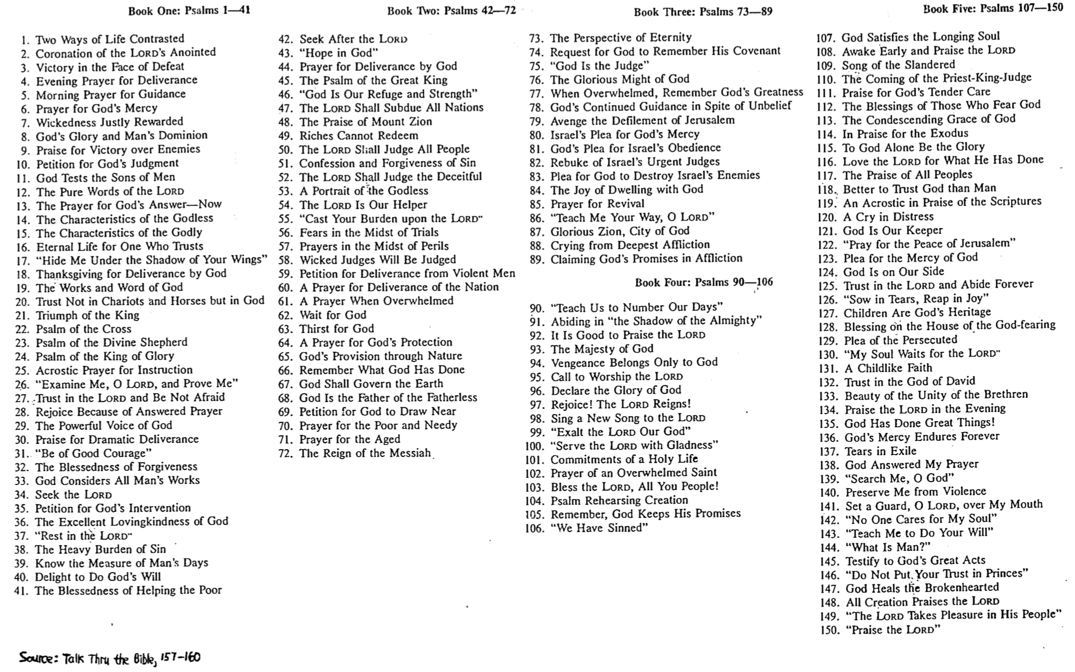

**Fulfilled Messianic Prophecies in the Psalms**

*Talk Thru the Bible, 155*

|  |  |  |
| --- | --- | --- |
| PSALM | PROPHECY | FULFILLMENT |
| 2:7 | God will declare Him to be His Son | Matthew 3:17 |
| 8:6 | All things will be put under His feet | Hebrews 2:8 |
| 16:10 | He will be resurrected from the dead | Mark 16:6-7 |
| 22:1 | God will forsake Him in His hour of need | Matthew 27:46 |
| 22:7-8 | He will be scorned and mocked | Luke 23:35 |
| 22:16 | His hands and feet will be pierced | John 20:25, 27 |
| 22:18 | Others will gamble for His clothes | Matthew 27:35-36 |
| 34:20 | Not one of His bones will be broken | John 19:32-33, 36 |
| 35:11 | He will be accused by false witnesses | Mark 14:57 |
| 35:19 | He will be hated without a cause | John 15:23 |
| 40:7-8 | He will come to do God’s will | Hebrews 10:7 |
| 41:9 | He will be betrayed by a friend | Luke 22:47 |
| 45:6 | His throne will be forever | Hebrews 1:8 |
| 68:18 | He will ascend to God’s right hand | Mark 16:19 |
| 69:9 | Zeal for God’s house will consume Him | John 2:17 |
| 69:21 | He will be given vinegar and gall to drink | Matthew 27:34 |
| 109:4 | He will pray for His enemies | Luke 23:34 |
| 109:8 | His betrayer’s office will be fulfilled by another | Acts 1:20 |
| 110:1 | His enemies will be made subject to Him | Matthew 22:44 |
| 110:4 | He will be a priest like Melchizedek | Hebrews 5:6 |
| 118:22 | He will be the chief cornerstone | Matthew 21:42 |
| 118:26 | He will come in the name of the Lord | Matthew 21:9 |

**The Psalms in History**

Ralph Smith, “The Use and Influence of the Psalms,” *Southwestern Journal of Theology* 27 (Fall 1984): 5-16

**I. The Origin of the Psalms** (Smith, 10-11)

A. The Singing Community

1. Praise (Moses in Exod. 15:1-18)

2. Lament (Deborah in Jud. 5:19)

B. David

1. Praise (1 Chron. 23:1–27:1)

2. Lament (2 Sam. 1:17-27)

C. Others

**II. Compilation Hypothesis of A. A. Anderson** (Smith, 11)

A. Davidic (Pss. 3–41): emphasizes the name of Yahweh (272 times) over Elohim (15 times)

B. Davidic (51–72): all have titles except 66–67, 71–72 (72:20 but 18 Davidic psalms follow!)

C. Korahite (42, 44–49) and Elohistic Asaphite (50, 73–83)

D. Yahwistic Asaphite (84–85, 87–88), David (86), Ethan (89)

E. Final Divisions (90–150)

1. Enthronement (95–99): also called messianic or kingdom psalms

2. Davidic (108–110, 138–145)

3. Ascent (120–134)

4. Hallelujah (111–118, 146–150)

F. Arrangement into Five Books (1–41; 42–72; 73–89; 90–106; 107–150)

1. Psalms extolling the Law added (1, 119)

2. Psalm 2 extolling the Messiah added

**III. Usage by Christians** (Smith, 7-9)

A. First to Fourth Centuries (Clement of Alexandria, Origen, Dionysius of Alexandria, Jerome)

B. Fourth to Fifth Centuries

1. Ambrose, Augustine

2. Pope Gregory I

3. St. Patrick, “Apostle of Ireland”

C. Sixth to Sixteenth Centuries (Eastern Church)

D. Sixteenth Century Reformation

1. Luther

2. Edward VI and the Church of England

E. Vatican II (1963-65)

F. Modern Disuse (3 reasons)

1. Time: No one has the time to read or recite the psalms each week or month

2. Relevance: The gap between biblical times and our age must be bridged

3. Theology: Some texts are deemed “sub-Christian” (e.g., Ps. 51:11; 109:6, 19; 137:9)

**Hebrew Poetry & Parallelism**

**I. Hebrew Poetry**

A. Uniqueness of Psalms compared to Job, Proverbs, Ecclesiastes, and Song of Solomon

B. Characteristics of Hebrew Poetry

1. Stress Patterns or Rhythm (Kidner) or Meter (Ross): Accented words per line appear, though no one knows if Hebrew poetry contains a metrical pattern since the pronunciation of ancient Hebrew has not been preserved.

2. Evocative Language: A concentrated form of discourse, utilizing earthly and militaristic images, symbols, figures, emotive vocabulary, and multiple meanings, enables the psalmist to convey several things simultaneously (Ross, *BKC*, 1:780).

3. Acrostic Arrangement: Sometimes, it has an alphabetical sequence, with each verse beginning with a different consecutive letter of the Hebrew alphabet (Pss. 9–10 [one poem], 25, 34, 37, 111–112; 145). Psalm 119 is divided into 22 strophes of eight verses each.

4. Thought Rhyme (Parallelism): The sense is repeated rather than sound (see below).

**II. Parallelism**

A. **Definition**: Parallelism is “the repetition of meaning in parallel expressions” (Ross, *BKC*, 1:780).

B. **Advantages**: Repetition of thought has some benefits.

1. It makes understanding easier since truths or expressions are repeated, in other words. This keeps us from the error of thinking that a different point is being made in the second line.

2. It allows translations “to reproduce its chief effects with very little loss of either force or beauty” (Kidner, 1:4).

C. **Types** of Parallelism

1. Synonymous: The second line “reinforces the first, so that its content is enriched, and the total effect becomes spacious and impressive” (Kidner, 1:3).

“Then Israel entered Egypt;

Jacob sojourned in the land of Ham” (105:23 Ross translation)

“He does not treat us as our sins deserve

or repay us according to our iniquities” (103:10)

2. Antithetic: The second line presents a contrasting truth to the first line.

“The wicked borrow and do not repay,

but the righteous give generously” (37:21)

3. Emblematic: One of the lines explains the other by metaphorical comparison.

“As a father has compassion on his children,

so the LORD has compassion on those who fear him” (103:13)

4. Synthetic: The second line develops the idea of the first (a general category developed by Lowth but broken down here using Ross’ categories).

a. Incomplete *with* Compensation: Lines are *equal* in length, with only some terms parallel.

“You will destroy their offspring from the earth

and their children from among the sons of men” (21:10 Ross translation)

b. Climactic: Each line builds upon the previous one with increasing intensity (stair-step parallelism). This is a type of incomplete parallelism with compensation.

“Ascribe to the LORD, O holy ones (heavenly beings)

Ascribe to the LORD glory and strength

Ascribe to the LORD the glory due His name

Worship the LORD in the beauty of His holiness” (29:1-2 Maranatha Song!)

c. Incomplete *without* Compensation: Lines are of *different* lengths, with only some terms parallel.

“O LORD, do not rebuke me in Your anger

or discipline me in Your wrath” (6:1)

d. Formal: The second line is *all* compensation, so it simply continues the thought of the first (so actually, there’s no parallelism!).

“I have installed My King

on Zion, my holy hill” (2:6)

**Hermeneutics & Figures in Psalms**

**I. Tips for Interpreting the Psalms**

A. Pay attention to repeating refrains, phrases, or ideas to identify the structure and outline the psalm correctly.

B. Summarize the message of the psalm in a sentence.

C. Consider the historical notations in the text and title to discover the historical setting.

D. Classify the psalm using one of F. Duane Lindsey’s categories (Psalms notes, 386).

E. Consider the progress of revelation to correctly interpret incomplete theology (e.g., 51:11, “…do not…take your Holy Spirit from me”).

F. Reword figures of speech to give their meanings (see next page).

G. Use New Testament allusions and quotations of the psalm for understanding, but do not read back into the text what the original author and audience would not have understood.

**II. Common Figures of Speech in Psalms**

A. Figures of Comparison

1. Simile: denotes ***resemblance*** between two different things, yet they have something in common (“x is *like* y”).

“He shall be like a ***tree*** planted by streams of water” (1:3)

2. Metaphor: denotes ***representation*** between two things that are unlike, yet have something in common (“x *is* y”)

“The LORD God is a ***sun*** and ***shield****”* (84:11)

3. Hypocatastasis: denotes ***implication*** between two different things, yet they have something in common (“x” alone is stated, but the context implies that “x” is like y)

“***Dogs*** have surrounded me” (22:16)

4. Anthropomorphism: God compared to man’s ***bodily*** part(s)

“Hide your ***face*** from my sins” (51:9)

5. Zoomorphism: God compared to ***animals***

“In the shadow of your ***wings*** I used to rejoice” (63:7)

6. Personification: ***Inanimate*** objects are given properties or characteristics of living things

“Their ***mouths*** lay claim to heaven, and their ***tongues*** take possession of the earth” (73:9)

B. Figures of Substitution

1. Metonymy: ***substituting*** one word for another (the most common figure in Psalms)

“They flatter with their ***tongue***” (5:9)

2. Synecdoche: substituting a ***part*** for the whole or vice versa

“But you are… my Glorious One, who lifts up my ***head****”* (3:3)

C. Figures of Addition

1. Parallelism: saying the *same concept* in different words in parallel lines (explained and illustrated in detail on previous pages)

2. Repetition: the exact *same word* or words are used twice or more

*“****My God, My God***, why have you forsaken me?” (22:1)

D. Figures of Omission

1. Ellipsis: ***omission*** of a word or words in a sentence

“When you make ready ***[your arrows]*** upon your strings” (21:12)

2. Aposiopesis: sudden ***silence*** or breaking off what is being said

“My soul is greatly troubled; but You, O LORD, ***how long–?****”* (6:3)

**Worship in Israel**

Adapted from Allen P. Ross, “The Psalms and Israel’s Worship” (Dallas Seminary class handout, 1985)

**I. The Nature of Worship (Fourfold)**

A. Aesthetic Sense: Drama, symbolism, and ritual ceremony all appeal to our aesthetic instincts. Jews lived in booths, ate communal offerings, put blood on doorposts, and did other symbolic acts that taught well (a similar methodology is developed in the excellent book, *Let’s Make a Memory*, by Shirley Dobson & Gloria Gaither).

B. Intellectual Sense: Worship must emphasize understanding or knowledge to (1) keep it free from superstition, and (2) enable people to see that ours is a rationally ordered universe.

C. Moral Sense: Ethical and moral content must be present in ritual through reading/meditation of Scripture and fellowship to inspire truth in living.

D. Corporate Sense: “Worship is a communal activity. There is a place for personal piety and devotion, but the purpose of such must be the participation in the congregation of the righteous. The results of private meditations will be the sharing in the corporate assembly.”

**II. The Five Component Features of Worship**

A. Sacrifice and Offering: the way something became holy (things were clean, unclean, or holy), where the external rite expressed an inward disposition (faith) necessary to please God, since without sacrifice, there was no worship!

1. Consecration/Voluntary/Dedicatory

a. Burnt: the entire animal was burnt to signify God’s total acceptance of the sacrifice

b. Grain (Meal): recognition that everything the worshipper had belonged to God

c. Fellowship (Communal, Peace): shared meal signifying one’s blessings was to share

d. Drink: wine poured on the ground signifying total dedication (cf. Phil. 2:17)

2. Cleansing/Obligatory/Expiatory

a. Sin: forgiveness for unintentional sin (Num. 15:22) vs. deliberate sin (15:30-36; cf. willful violations of any of the 10 commandments had the death penalty)

b. Guilt (Reparation): covered violations that needed restitution to God or man

B. Reading of the Word: priests were required to read the Torah every service

C. Prophetic Exhortation: priests also gave expositions of the passage

D. Prayer: both spontaneous and private, and also planned and public

E. Praise: given to God for who He is (descriptive) or what He has done (declarative)

**III. Occasions for Worship**

A. Individual Cultic Activities

1. Fulfillment of Religious Obligations (e.g., Firstfruits, tithes): Deut. 26

2. Times of Illness and Disease (e.g., leprosy): Lev 13–15

3. Legal Procedures (e.g., Temple refuge for manslaughter but involved forfeit of liberty)

4. Atonement for Sin (e.g., deception, rash oaths, touching unclean things, etc.)

5. Fulfilling Special Vows/Presenting Special Offerings: 1 Sam 1:24-28; 2 Sam 15:7-9  
—In rudimentary form, this special vow is seen in Gen. 28:18-22

B. Communal Cultic Activities

1. Regular Celebrations (e.g., daily offering, new moon, and feasts)

2. Special Services (e.g., during military conflict, drought, famine, fasts, prayers)

**Questions on the Psalms**

Adapted from a Class Presentation by Yudith, Cheng Geok, Ka Fat, and Alex on 27 September 2005

1. **Introduction**

Question: Why have the Psalms endured through the ages?

* 1. What are the Psalms?
  2. Who wrote them?

|  |  |  |  |  |  |
| --- | --- | --- | --- | --- | --- |
| **Book** | **1** | **2** | **3** | **4** | **5** |
| Chapters | 1-41 | 42-72 | 73-89 | 90-106 | 107-150 |
| Number of Psalms | 41 | 31 | 17 | 17 | 44 |
| Chief Author | David | David / Korah | Asaph | Anonymous | David/ Anonymous |

* 1. When were they written?

1400 BC 1000 BC 971 BC 931 BC 722 BC 500 BC

Moses David Solomon Divided Exile Restoration

Kingdom

*Most Psalms were written here*

* 1. How were they put together?

|  |  |  |  |  |  |
| --- | --- | --- | --- | --- | --- |
| **Book** | **1** | **2** | **3** | **4** | **5** |
| Chapters | 1-41 | 42-72 | 73-89 | 90-106 | 107-150 |
| Possible  Compiler | David | Hezekiah or Josiah | | Ezra or Nehemiah | |
| Possible dates of compilation | c. 1020 –  970 BC | c. 970 – 610 BC | | Until c. 430 BC | |

* 1. To what do the superscriptions refer?
* Musical Instruments
* Musical Headings
* Melody Indicators

1. **What place did the Psalms have in OT times?**
   1. The Psalms were central to worship and permeated the life of the Israelites.

* Israelites commanded by God to worship him with their whole being, their heart, soul and strength (Deut 6:5)
* God’s covenant relationship with his people was reinforced through a pattern of worship was based on service & sacrifice
* Music was an integral part of sacrificial service with particular psalms associated with certain sacrifices as well as with certain days of the week.

|  |  |  |  |  |  |  |  |
| --- | --- | --- | --- | --- | --- | --- | --- |
| Day | 1 | 2 | 3 | 4 | 5 | 6 | Sabbath |
| Psalm | 24 | 48 | 82 | 94 | 81 | 93 | 92 |

* 1. The Psalms provided the Israelites with an understanding of God through worship.
* The different names of God in the Psalms reflected his relationship with his people.

|  |  |  |
| --- | --- | --- |
| **Title** | **Description** | **References** |
| Jehovah | Lord | 11:7 |
| Elohim | God Most High | 68 |
| Jehovah-Elohim | Lord God | 59:5 |
| Jehovah-Adonai | the Sovereign Lord or Master | 2:4 |
| Jehovah-Eloheenu | the Lord our God | 95:7 |
| Jehovah-Elyon | the Lord most High | 7:17 |
| Jehovah-Hoseenu | the Lord our Maker | 95:6 |
| Jehovah-Rohi | the Lord my Shepherd | 23:1 |
| Jehovah-Tsebaoth | the Lord of hosts | 103:21 |
| Abhir | Mighty One | 132:2 |
| Kadosh | Holy One | 71:22 |
| Olam | Everlasting | 90:2 |

* The people were always reminded of the character & personality of their God.

|  |  |  |  |
| --- | --- | --- | --- |
| **Attribute** | **References** | **Attribute** | **References** |
| Creator | 8:3 | Sovereign over nature | 18:7; 135:5-7 |
| King (of glory) | 29, 96-99 | Righteous | 119:137 |
| Shepherd | 23, 80 | Omniscient | 139:1-6 |
| Lord of history | 44, 78, 106 | Omnipresent | 139:7-10 |
| Redeemer | 78:35 | Shield | 3:3; 18:30 |

* The Psalms gave the Israelites a hope for the future.
  1. The Psalms reminded the Israelites of their covenant relationship with God

|  |  |  |  |  |  |  |
| --- | --- | --- | --- | --- | --- | --- |
|  | | **Book 1** | **Book 2** | **Book 3** | **Book 4** | **Book 5** |
| Doxology | | 41:13 | 72:18-19 | 89:52 | 106:48 | 150:6 |
| Correspondence to Pentateuch | Pentateuch | Genesis | Exodus | Leviticus | Numbers | Deuteronomy |
| Jensen | Man | Israel | Sanctuary | Moses & Wilderness | Law & Land |
| Wilkinson &  Boa | Man  &  Creation | Deliverance &  Redemption | Worship  &  Sanctuary | Wilderness  & Wandering | Scripture  &  Praise |
| Worship Theme | Adoration | Wondering | Unceasing Praise | Submissive | Perfected |

1. **How did the Israelites worship God through the Psalms?**
2. Characteristics of Hebrew Poetry

* Parallelism
* Imagery

1. Types of Psalms

* Hymn
* Penitential
* Wisdom
* Royal
* Messianic
* Lament
* Imprecatory
* History

**4. How are the Psalms relevant for Christians today?**

1. Worship under the new covenant
2. The Psalms are valuable as they guide us to worship with Scripture
3. Comparison between Psalms and Hymns
4. Contrasts Between Psalms and Contemporary Songs
5. Psalms help us worship holistically

**Psalms Help Us Worship Holistically**

Effects of reading Psalms on the whole person

Engage our Emotions

(Correctly respond in different situations)

Inform our Mind (Know who

God is and what He has done)

Direct our Will

(Obey wholeheartedly)

God is Spirit, and his worshipers must worship in Spirit and in truth (John 4:24)

**Bibliography**

Arnold, Bill T., and Beyer, Bryan E. *Encountering the Old Testament.* Grand Rapids: Baker, 1998.

Bullock, Hassell C. *Encountering the Book of Psalms.*  Grand Rapids: Baker Academic, 2001.

Dolphin, Lambert. *Names of God.* 16 September 2005. *<*http://www.ldolphin.org/Names.html>

Flanigan, J. M. *What the Bible Teaches: Psalms*. Ritchie Old Testament Commentaries. Scotland: John Ritchie. 2001.

Jensen, Irving L. *Psalms: A Self-Study Guide*. Chicago: Moody, 1990.

Jensen, Irving L. *Jensen’s Survey of the Old Testament.*  Chicago: Moody, 1997.

Keathley, J. Hampton III. *The Names of God*. 16 September 2005. <http://www.bible.org/page.asp?page_id=220>

Lockyer, Herbert (ed). *Nelson’s New Illustrated Bible Dictionary.*  Nashville: Nelson, 1995.

Longman, Tremper III. *How to Read the Psalms.* Downers Grove, IL: Intervarsity, 1988.

McClendon, James, Jr. *Doctrine: Systematic Theology*, Vol. 2. Nashville, TN: Abingdon, 1994.

*NIV Bible Commentary*, Vol. 1, Old Testament. Grand Rapids, MI: Zondervan, 1994.

*iLumina Gold: Digitally Animated Bible and Encyclopedia Suite.* Orlando, FL: Tyndale, 2003.

Wilkinson, B. and Boa, K. *Talk Thru the Bible.* Nashville, TN: Nelson, 1983.

Wood, D. R. W (ed). *New Bible Dictionary.* 3rd Edition. Downers Grove, IL: Intervarsity, 1962.

*Adapted from a Class Presentation by Yudith, Cheng Geok, Ka Fat, and Alex on 27 September 2005*

**Individual Lament Psalms (Psalms 3, 51)**

**I. Importance**

**II. Essential Parts of the Individual Lament Psalm (Petition Psalm)**

A. Address and Introductory Cry: mention God’s name with an imperative calling for help

B. Lament Proper: description of distress or misfortune, either brief or extended

C. Confession of Trust (optional): contrast of the psalmist's plight with a statement of confidence in the LORD as he turns to God

D. Petition: prayer for help and deliverance (aiming to motivate God to respond), repeating or developing the introductory cry for help

E. Vow of Praise (Declarative Praise): promise (rehearsal) to praise God when he sees his prayer answered; sudden shift; often cohortative (“let us”)

The fundamental structure common to all lament psalms includes three basic elements: (1) the one who laments, (2) God, and (3) the others (cf. Westermann, 169-170). The above five-point pattern for the individual lament is for the most part fixed and in the same order (with some exceptions), the confession of trust being the only technically optional part (although even it is rarely absent). Also, within the lament proper the elements may vary considerably from psalm to psalm or even be missing entirely.

**III. Sample Outlines of Individual Lament Psalms**

**Psalm 3** **Psalm 22** **Psalm 51**

A. Address/Lament 1-2 1-2, 6-8, 11-18 3-6

B. Confession of Trust (Confidence) 3-6 3-5, 9-10 18-19

C. Petition 7 19-21 1-2, 7-12

D. Vow of Praise (Declarative) 8 22-31 13-17

**IV. Components in Psalm 3**

Superscription ( identifies the psalm as David's when he fled from Absalom)

A. Address and Introductory Cry (1a) mentions the divine name YHWH.

B. Lament Proper (1b-2) describes David's distress because of his enemies, who denied that God would deliver him

C. Confession of Trust (3-6) asserts David's confidence in the LORD despite his enemies' opposition.

D. Petition (7) records his prayer for God to arise and deliver him (aiming to motivate God to respond), thus developing the introductory cry for help.

E. Declarative Praise (8) is a benediction.

**Sermon Outline on Psalm 3**

***Title: “Confidence Amidst Opposition”***

Individual Lament (Heard) Psalm

**Message (Exegetical Idea): David complains about being opposed, but then praises God for answering his prayer.**

**Introduction**

1. Provide an attention-grabbing introduction about opposition at home, in the workplace, in society, etc.

2. Raise the listener’s need to hear what you have to say by using “you” statements such as, “Are *you* being opposed? How are *you* handling it?”

3. Introduce your subject (“How to respond to opposition”) or main idea (“When tempted to complain about opposition, praise God for His protection”).

**I. David complains that both people and God have failed him (1-2).**

A. David laments his numerous adversaries (1).

B. David laments that others feel he has no hope of deliverance even from God (2).

**II. David praises God for His powerful protection and answer to his cry (3-6).**

A. David acknowledges God's protection and ability to restore him to his position (3).

B. David finds comfort in God's answer to his cry (4).

C. David experiences rest in God's sustaining power (5).

D. David claims peace even against incredible odds (6).

**III. After asking God to deliver him, David praises Him for victory (7-8).**

A. David petitions the LORD for deliverance and anticipates a great victory (7).

B. David praises the LORD for the blessing of victory (8).

**Conclusion**

1. Restate your main idea (“What I’ve been saying is this…”) with both the question (“How to respond to opposition”) and the answer (“Answer opposition with praise”), and your major points, if appropriate.

2. Closing application/motivation: Praise God for his protection right now.

**Exegetical Outline on Psalm 51**

***Title: “Whiter Than Snow”* (Kidner’s Title)**

Individual Lament (Open) Psalm

**Division into Parts**

Superscription

1-2 Petition (for God's mercy)

3-6 Confession

7-12 Petition (for transformed life)

13-17 Vow of Praise

18-19 Affirmation

**Message (Exegetical Idea)**

David petitions for forgiveness based on God’s mercy and confesses his sinfulness so that he may proclaim God's character and God may accept righteous sacrifices.

**Structure**

**I. The psalmist petitions God for mercy and complete forgiveness based upon His loyal, compassionate character (1-2).**

A. He asks God's mercy and forgiveness due to His loyal, compassionate character (1).

B. He asks God for complete forgiveness for his sin (2).

**II. David confesses his unforgettable sin against God and acknowledges his complete sinfulness in contrast to God's desire for truth and wisdom (3-6).**

A. He confesses his actions as an unforgettable sin committed primarily against God (3-4).

1. David confesses his actions as sin, which he could not forget (3).

2. David confesses that his sin was an evil done primarily against God (4).

B. He acknowledges that while he has always been utterly sinful, God’s will for him is to demonstrate truth and wisdom (5-6).

1. David acknowledges that he has always been utterly sinful (5).

2. David acknowledges God's desire for him to demonstrate truth and wisdom (6).

**III. David petitions God for forgiveness, joy, and a submissive will based on God's forgetting all his sins, his clean conscience, and the Spirit's indwelling (7-12).**

A. He requests forgiveness so that he can be free from a guilty conscience (7).

B. He requests a joyful disposition from sensing God's forgiveness (8).

C. He requests God to forgive and forget all his sins (9).

D. He requests a transformed inward man into a guiltless and consistent disposition (10).

E. He requests the Holy Spirit's indwelling to remain for God’s presence to be near (11).

F. He requests a joyful and submissive disposition by remembering God's deliverance (12).

**IV. David vows to teach unbelievers God's character so that by seeing God's regard for humility more than sacrifices, they will believe in God (13-17).**

A. He promises to teach God's mercies and wonderfully perfect character to unbelievers to convert them (13-15).

1. David promises to teach rebellious people about God's mercy to convert them (13).

2. David promises to teach about God's perfect character if He forgives his murder (14).

3. David promises to declare to others how wonderful God is (15).

B. He declares that God is more concerned about humility than sacrifices (16-17).

1. David declares to God that He is not primarily concerned with sacrifices (16).

2. David declares to others that God is primarily concerned with humility (17).

**V. David affirms that when God protects the people of Jerusalem, He will delight in the righteous sacrifices that will be offered to Him (18-19).**

A. He requests God to protect Jerusalem's inhabitants as evidence of His faithfulness to His people (18).

B. He affirms that God will delight in the righteous sacrifices offered up to Him (19).

**Communal Lament Psalms (Psalm 137)**

**I. Essential Parts of the Communal Lament Psalm**

A. Address and Introductory Petition to God

B. Lament Proper

C. National Confession of Trust

D. Petition Proper and Motivation

E. Vow of Praise

**II. Differences Between Communal and Individual Laments**

This structure parallels the individual lament psalm except for some minor differences:

A. The lament proper section often includes a threefold outline: the foes, *the nation ["we"]*, and God. Individual laments are singular, whereas communal laments are plural (e.g., "individual confession of trust" versus "national confession of trust").

B. In the *lament* over personal suffering, the *enemy* is seen as *the cause of suffering,* whereas in the individual lament, the enemy is not the [primary] cause of the problem (Westermann, 186).

C. The *complaint* against God in the communal lament has a *more dominant* role than in the individual lament (Westermann, 183).

D. Communal laments are more positive, whereas individual laments have "negative petitions" (e.g., "Be not silent, O God of my praise").

**III. Psalm 137**

A. Structure

1) Lament Proper (1-3)

2) Confession of Trust (4-6)

3) Petition Proper (7)

4) Curse Upon Enemy (8-9)

B. Explanation

The psalm is exilic, as it mentions the taunts of the Babylonian captors (vv. 1-3) while the people long for Jerusalem (vv. 4-6). In verses 4-6, the confession is directed toward Jerusalem, albeit indirectly toward the Lord.

The psalmist petitions God to remember how Edom gloated over the nation's defeat when the Babylonians invaded Jerusalem [v. 7], implying that God should also destroy Edom.

The following verses [vv. 8-9] contain a curse against Babylon for taking Israel into captivity. (In a sense, this is also a petition for national destruction, although directed towards Babylon, not towards the LORD.) This is unusual since curses are not common in Lament Psalms.

**Songs of Trust (Psalms 16, 23)**

**(Lament Psalms, Psalms of Confidence)**

**I. Characteristics**

A. These are the most positive of the lament psalms, if you can call them laments at all.

1. Lindsey (Psalms notes, 386) classifies these as a form of lament psalms with the title “Songs of Trust.” These are both of the individual (Pss. 4, 11, 16, 23, 27?, 40:1-11, 62, 63?, 131) and of the people (Pss. 46?, 115?, 125, 129?).

2. Craigie calls these psalms (at least Pss. 4, 11, 16) “Psalms of Confidence” because of their extensive reliance upon God in time of difficulty.

B. The normal Lament Proper section is missing or, at best, very short in these psalms.

**II. Psalm 16**

Title: God is Provider and Protector

Setting: Uncertain (though the danger is probably past)

I. God has been my provider in the past (1-8).

II. God is my protector now in the face of death (9-11).

Exegetical Decision: Does the “portion” in verse 8 mean:

1) land” (NIV, Alden?) or

2) God (NASB, Anderson?, Craigie?; cf. Ps. 73:26; 119:57; 142:5)

Possible Main Ideas (both see verse 8 as the key to the psalm):

1) Mine: “God’s provision and protection help us live with confidence.”

2) Don Sunukjian (Dr Rick’s preaching professor): “When our lives are filled with God, our confidence and joy can never be shaken.”

**III. Psalm 23: Responding to God’s Provision and Protection**

**Interpretive Options**

1. Does the banqueting scene of verse 5:

(a) continue the shepherd imagery of verses 1-4 (Koehler, *ZAW* 68 [1956]: 227-34),

(b) figuratively depict a banqueting victor (Alden, 1:60),

(c) relate to a thanksgiving banquet (Craigie, 208), or

(d) refer to a literal sacrificial banquet (Vogt)?

The second is preferable as sheep do not sit at a table or drink from a cup (first view), and the final two views do not consider the presence of the enemies. Koeh/Vogt cited by Craigie

2. Is the “house” (v. 6) speaking of the tabernacle (Ross, *BKC*, 1:812), the temple David hoped to build (Craigie, 208), or heaven (Alden, 1:61)? The first seems best as the second depends upon the date for the psalm (which is uncertain) and the last reads a NT meaning into “forever,” which for most Hebrews meant “permanently” or “all one’s life.” Elsewhere in the OT, “house of the LORD” refers either to the tabernacle or temple, so the meaning of “heaven” here is unlikely.

***Using the Study Above and Moving from Exegetical to Homiletical Structures…***

**Psalm 23**

**Responding to God’s Provision and Protection**

**Exegetical Outline** (adapted from Allen Ross)

**Exegetical Idea: The response of David to God’s goodness and love shown in *providing* for and *protecting* him was to commune with God at the tabernacle for the rest of his life.**

**I. The manner that God showed His goodness and love was by providing for David as a shepherd does for his sheep (1-4).**

A. The LORD provided quality *physical provisions* (food and rest) that satisfied David (1-2a).

B. The LORD provided *spiritual refreshment,* that quieted and restored David’s soul (2b-3a).

C. The LORD provided *guidance in holiness* to protect His own name (3b).

D. The LORD provided *safety* while leading David through dangerous circumstances (4).

**II. The manner in which God showed His goodness and love was by protecting David so that he was honored like a banqueting victor before his enemies (5).**

A. The LORD protected & exalted David like a banqueting victor before humbled enemies (5a).

B. The LORD honored David (5b).

C. The LORD provided more blessings than David could possibly enjoy (5c).

**III. The response of David to God’s continued goodness and love was to commit to commune with the LORD at the tabernacle the rest of his life (6).**

A. David expressed confidence that the LORD’s goodness and love would be demonstrated towards him for the rest of his life (6a).

B. David’s response was to commit to commune with God at the tabernacle the rest of his life (6b).

**Homiletical Exposition** (cyclical inductive form)

Introduce Subject: How should we respond to God’s goodness towards us?

**I. God shows His goodness by providing everything His people need.** *Principle*

A. David saw that God provided for him as a shepherd provides for his sheep (1-4). *Text*

B. None of us can say that God has not properly provided for all our needs (examples). *Appl.*

(There’s a second way God demonstrates His goodness towards us…)

**II. God shows His goodness by protecting His people from harm.** *Principle*

A. The LORD protected David from his foes and even honored him before them (5). *Text*

B. Each of us has witnessed God’s protective hand (examples). *Appl.*

(So what should be our attitude about God’s providing and protecting hand towards us?)

**III. Respond to God’s goodness by publicly communing with Him.** *Principle*

A. David sought to regularly and publicly commune with God at the tabernacle (6). *Text*

B. Regularly fellowship with God at church in response to His provision and protection. *Appl.*

Main Idea: God’s goodness to us should result in a desire to commune with Him at church.

**Reading the Psalms Publicly**

**I. Priority**

A. Good Scripture reading habits are foundational to good preaching—if you can’t read, then you can’t preach, especially without notes!

B. Public Scripture reading is the most important part of the worship service, but the part that seems to get the least amount of preparation. The choir practices, the preacher rehearses his sermon, the ushers plan out which aisles they’ll serve, etc., but the readers “wing it.”

ILL: Read Luke 5:17-26 with poor intro, too fast, in a flat voice

**II. Problems**

Break into small groups to come up with these and more suggestions

A. Too often, the Scripture reading has nothing to do with the message of the morning.

B. We introduce the reference poorly, so people have to ask one another where we are.

C. We begin reading before people have a chance to find the passage.

D. We don’t give the necessary background information to understand the text (Acts 14:21).

E. Difficult words are sometimes mispronounced due to a lack of preparation.

F. We emphasize the wrong words at times (e.g., accent “gave” not “for” in Gal. 2:20; accent “me” not “before” in Exod. 20:3).

G. The passage is often read with a flat tone of voice.

H. It’s hard to teach people to read well who have an “I already know how to read” attitude.

I. We feel we always have to end every reading with the trite cliché, “May God add His blessing to the reading of His Word.”

Send students out to practice reading

**III. Principles**

A. Introduction: Always announce your text three times for those who did not catch it initially.

B. Variety: Vary your speed of speaking and volume. Read to children—they’re merciless!

C. Voice: Practice reading with expression and pronounce names correctly!

D. Familiarity: Read the passage aloud so many times that you almost have it memorized.

E. Patience: Wait until you hear the pages stop turning before you begin to read.

F. Context: Provide the necessary context before beginning to read or, better yet, even before announcing your text.

G. Training: Select 5 people at church who are good readers and give them this mini-seminar.

Read Luke 5:17-26 correctly

**IV. Practice**

A. Narrative: Triumphal Entry (Mark 11:1-10)

B. Prophecy: Heaven’s Throne Room (Revelation 4:1-11)

C. Lament: Petitioning Help (Psalm 70)

**Seven Steps to Preaching Expository Sermons**

Adapted from Robinson, *Biblical Preaching* and Don Sunukjian (DTS), and Ramesh Richard, *Scripture Sculpture*

**1. Study the Text.**

a. Choose the Passage no later than Tuesday in your preaching week, making sure it is not too short or too long for a single message.

b. Exegete the Passage (Analyze the Parts) and Gather Your Notes.

1) Pray for wisdom and read the translation most of the church members use. List every question you think the average member would ask. (Otherwise, 15 study hours later, you will have all the answers but will have forgotten the questions!) Answer these questions.

2) Read a few other translations and note the differences and additional questions.

3) Read the original text if you can; use tools and do brief word studies on important words.

4) Consult the commentaries.

a) Look up difficulties in Greek or Hebrew commentaries (if you can read them!).

b) See the *Expositor’s Bible Commentary* for both the big picture and problem areas.

c) Read a sermonic commentary (by Stott, Wiersbe, Boice, Criswell, Swindoll, etc.).

d) Listen to tapes on the passage (but this takes much more time than reading).

**2. Structure: Determine the Exegetical Outline.**

a. Reword each verse Z1+X+Z2+Y form and remove all figures of speech (Homiletics notes, pp. 33-34). If the text exceeds 15-20 verses or is a narrative, then write statements for groupings of 3-5 verses.

b. Group similar statements under main titles to show big divisions (“hunks”) in the passage.

c. Write out each “major hunk” tentatively, then make sure the various subpoints (3.a. above) really do fit under each major hunk. Subdivide the subpoints further if you wish.

e.g., Go from: I. to: I. then to: I.

II. A. A.

B. 1.

II. 2.

A. B.

B. II. etc.

Don't go from: I. to produce: I.

A. A.

1. 1.

2. 2.

B.

II. etc.

**3. CPT: Summarize your main points in a subject/complement sentence called the central proposition of the text (CPT) or “exegetical idea” (EI).**

**4. Purpose Bridge**

a. Submit the Exegetical Idea to Three Developmental Questions (Homiletics notes, pp. 38-39): Which of the following is needed most in your sermon for your particular audience?

1) *Explain it:* What do I need to explain?

2) *Prove it:* Do my listeners believe it?

3) *Apply it:* Where does this concept show up in real life?

b. Write the Desired Listener Response: what you want the hearers to know, feel, or do in measurable results (observable behavior) during or after the sermon (Homiletics notes, pp. 86, 148, 156, 170).

**5. CPS: Write the Central Proposition of the Sermon or Homiletical Idea (HI).**

a. Consider how *your listeners* need to understand and apply the exegetical idea.

b. Convert the exegetical idea into a concise, memorable sentence called the “big idea” (Homiletics notes, p. 40).

**6. Structure the Sermon.**

a. Outline the Sermon (Homiletics notes, pp. 47-49, 138):

1) Place the Main Idea: Considering your purpose on Step 4, have the main idea appear where it should best occur in the sermon.

a) Deductive: The main idea is given at the beginning, then developed (p. 50).

i) This outline is clear but less interesting. It closely follows the exegetical subpoints.

ii) Examples: an idea to explain, a proposition to prove, a principle to apply.

b) Inductive: The main idea revealed at the conclusion (Homiletics notes, pp. 49, 51).

i) This outline is less clear, but more interesting. Exegetical points need reworking.

ii) This outline is also better for hostile audiences in that it builds up to a conclusion.

iii) Examples: subject to complete, problem to explain, story to tell, cause and effect.

2) Place the Applications: Considering your purpose from Step 4, position the applications where they best fit within the sermon.

a) Simple: The entire text is explained before any of it is applied (pp. 49-50, top).

a) Cyclical: Applications appear within the body as the text unfolds (pp. 46, 49 bottom).

3) Write out your main points with their verse references following the order of the passage.

4) Develop each of these points with two things in mind: the developmental questions in Step 4 and answers to the key issues you raised in your preliminary questions in Step 1.

b. Plan for Oral Clarity (pp. 64-73): Remember that you know the sermon in outline form, but your listeners don’t (p. 67).

* This is what you mean to say… but this is what the listeners hear…

I.

A. I.A.B.II.

B.

II.

To alleviate this problem, you must clearly emphasize your major points in several ways:

1) Add restatements of the major points—rephrasing them to give the same idea (p. 68).

2) Add transitions in parentheses between the major points (p. 68).

3) Add illustrations to support and clarify the main points (pp. 64-66).

4) Add applications which show how the main idea relates to real life (pp. 70-73).

5) Give the interpretation of verses first, then read them (p. 68, pt. 5).

6) Underline the verse references wherever you plan to read the Scripture (pp. 87, 157).

c. Prepare the Introduction and Conclusion (Homiletics notes, pp. 74-77):

1) The introduction should achieve three key objectives. It should:

a) Gain favorable attention.

b) Create interest in listening further (touch a need or arouse some curiosity).

c) Orient listeners either to the main idea or to the subject (or to the first main point).

2) The conclusion should accomplish three objectives. It should:

a) Summarize the major points of the message and restate your main idea.

b) Apply the passage in areas not already touched upon in the body of the sermon.

c) Exhort the listeners to obedience (recalling applications stated earlier).

**7. Preach: Manuscript and Practice the Message until it is Internalized.**

a. Manuscript the entire message (including the verses) to force the best possible word-choice and to preserve the message for future use (pp. 78-90).

b. Memorize your Subject, MI, and MPs, and the general flow of the message.

c. Internalize the sermon by preaching it 6-8 times, each time weaning yourself more from the notes. Practice gestures standing up with a makeshift pulpit in front of your mirror.

**Declarative Praise Psalms**

Intro: Read MacArthur’s intro to *The Ultimate Priority, 1-2*

Read Tozer’s comment in Carroll’s *How to Worship Jesus Christ*, ix-x

**I. Praise: Why it’s so Difficult and Some Solutions**

A. Praise has fallen on hard times. Why is worship so difficult and rare?

1. We live in a “me-focused generation where the self is prominent.

“Magazine evolution”: The marketing slogans:

1960s *Life* “You deserve a break today” (Macs)

1970s *People* “My husband deserves the very best!”

1980-90s *Self* “I deserve the very best!” (now)

2. We’re afraid of being labeled “charismatic.” This is an unbiblical “pendulum swing.”

Jesse at GFEGC, given his Pentecostal background, didn’t want *any* music—only a sermon!

3. We’re too rushed to worship genuinely. Personal quiet times often give way to studies, and corporate worship services take time to be creative.

4. Unconfessed sin.

5. Enemy opposition. Satan laughs at our meetings but cringes at our praise.

6. Physical and emotional tiredness. A cold morning shower and sufficient rest go a long way here.

7. Discipline to go to bed and get up on time is also important. John Wesley would excuse himself each evening with the words, “It is now ten o’clock. I must retire. I have an appointment at four in the morning with my Lord.” (Carroll, 96)

B. What can be done about this lack of praise?

1. Get alone where you cannot be seen by others so you can freely stand, sit, kneel, prostrate yourself, talk out loud, weep, etc., without inhibition.

2. Use a musical background, especially the praise music of the Maranatha singers. Hymns can also be used.

3. Read devotional material on praise and worship. The best books I know of are:

Carroll, Joseph S. *How to Worship Jesus Christ.* Memphis, Tennessee: Riverside Press, 1984.

Hayford, Jack; Killinger, John, and Stevenson, Howard. *Mastering Worship.* Portland, OR: Multnomah, 1990. 152 pp. US$12.95. *An excellent guide for creatively planning worship services.Gangel Review BS 593:125.*

MacArthur, John, Jr. *The Ultimate Priority.* Chicago: Moody, 1983.

Stanley, Charles. *How to Listen to God.* Nashville: Nelson, 1985.

(Read Carroll’s testimony about Tozer’s 2 & 1/2 hrs. prayer before preaching on page 93)

Tozer, A. W. *The Knowledge of the Holy.* New York: Harper & Row, 1961

________. *The Pursuit of God.* Harrisburg, Penn.: Christian Pub., 1948.

________. *The Root of the Righteous.* Harrisburg, Penn.: Christian Pub., 1955.

________. *Worship.*

4. Pray the entire Book of Psalms back to God. Personalize a psalm or portion of a psalm each day by changing all third-person references about God (“He”) to second-person references (“You”) and appropriate third-person references about others (“they”) to first-person (“I,” “me”).

**II. Distinguishing Modern Thanksgiving from Biblical Praise**

Area of Comparison Modern Thanksgiving Biblical Praise

Object of the sentence The speaker The One praised

Sentence illustration “I am so thankful…” “You are so gracious…”

Focus Self God

**III. The Gaze-Glance Principle**

A. Follow the Gaze-Glance Principle. This is a straightforward, biblical approach to seeking God’s guidance.

B. Most of us pray by mentally gazing at *our circumstances* and glancing up to God for help. When a struggle enters our lives, we usually *gaze* at this request with occasional glances at God for His help. We ask him to remove the problem because we are only seeking His hand. We're only seeking what He can give us.

C. But the Bible tells us to shift our focus. We should gaze at God and only glance at our request. This is seeking His face instead of seeking His hand. When and if He removes the problem becomes His business, so we don't end up resenting Him. God wants us to gaze *upon Him* and glance at our requests!

D. Where has your focus been concerning the issue that concerns you?

• Have you been gazing at God or gazing at your problem?

• Have you been seeking God's face or seeking God's hand?

• Where’s your gaze?

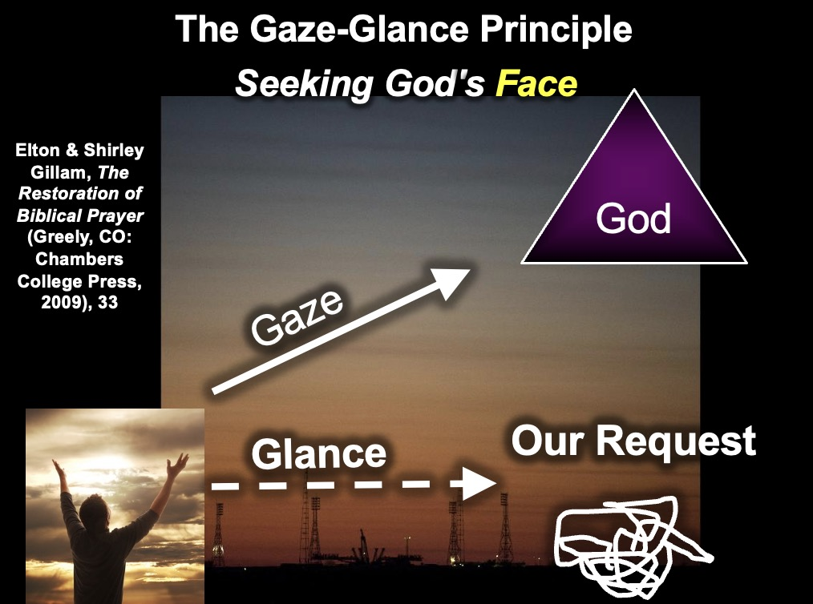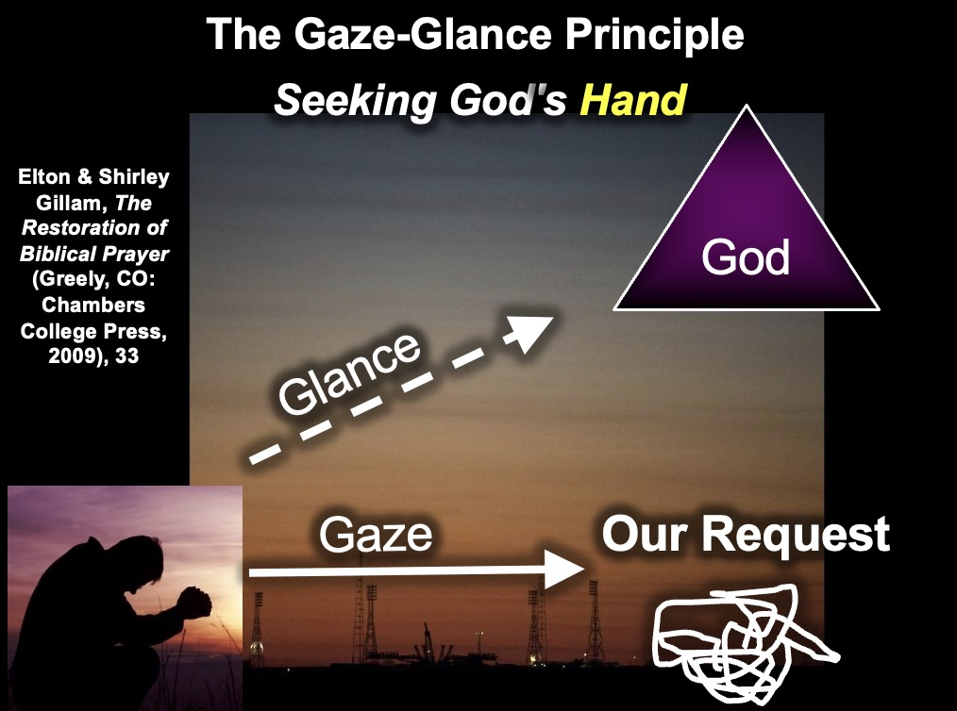

OS-23-Isa40-42—slides 79-80

**IV. Review of the Two Types of Praise Psalms (cf. class notes, 7)**

A. Declarative praise psalms worship God for *what He has done*. Here, thanksgiving and acknowledgement are offered to God for His acts for the righteous.

B. Descriptive praise psalms worship God for *who He is.* Here, praise is offered to God for revealing His nature through what He has made.

**V. Declarative Praise Psalms**

A. These psalms are also called Thanksgiving, Acknowledgement, or Todah (communal meal) Psalms because they emphasize community witness and involvement in God’s goodness towards the worshiper.

B. Declarative praise can be individual (Pss. [18], [21], [22], 30, 32, 34, 52? 66:13-20, 92, 107, 116, 118, 121, 138) or communal (Pss. 46? 65, 66:1-12, 67, 68? 75? 124, 129?).

C. The components of individual and communal declarative praise is virtually the same (adapted from class notes on Westermann, 6, and Ross notes, 119). Compare these elements with Ross’ outline of Psalm 138 (page 31 of these class notes):

1. Announcement or Proclamation to Praise God: This intention to praise God frequently begins with “I will…” (30:1; 34:1) or “Give thanks to the Lord” (107:1; 118:1), where the psalmist shares with others his feelings about what God has done for him. In modern terms, we often refer to this as one’s “testimony.”

2. Introductory Summary: Here is generally a single sentence summarizing the praise: e.g., 30:1b, “for you lifted me out of the depths”

3. Report of Deliverance: This generally has four elements:

a. Looking back at the time of need: e.g., 30:1c, “and did not let my enemies gloat over me.”

b. “I cried” section: e.g., 30:2a, “I called to you for help.”

c. “He heard” section: e.g., 30:2b, “and you healed me.”

d. “He drew me out” section: e.g., “O LORD, you brought me up from the grave…”

3. Renewed Vow of Praise: In the first section (Proclamation to Praise), the psalmist promises to praise God. Here he fulfills that promise by declaring the saving deeds of God: e.g., 30:4-12, “Sing to the Lord, you saints of his; praise his holy name…”

4. Descriptive Praise or Instruction (common, but not essential):

a. Frequently, the psalmist’s preceding declarative praise shifts to descriptive praise of God and his attributes that explain his testimony.

b. Occasionally, a didactic section replaces the descriptive praise where lessons learned from one’s experience are taught to the congregation.

**Descriptive Praise Psalms (Hymns)**

**I. Components of Descriptive Praise Psalms (Hymns)**

The general pattern is not stereotyped but still generally has a recognizable structure. Compare these elements with Ross’ outline of Psalm 135 (page 32 of these class notes):

A. Prologue: “Hallelujah” or another such expression: e.g., “O LORD, our LORD, how majestic is your name in all the earth!” (8:1) or “The heavens declare the glory of God…” (19:1).

B. Call to Praise: This extended section invites worshipers to join in praise to God.

C. Cause for Praise: This second major section provides the reason for and substance of the praise. This generally has two parts:

1. A *summary statement* extolling two things: God’s greatness (e.g., as Lord of creation) and God’s goodness or grace (e.g., His dealings in history).

2. Specific *illustrations* of why God should be praised at that particular point in time.

D. Conclusion: The closing includes a renewed call to praise for the reasons expressed in the psalm, or an exhortation, a petition, or a lesson.

E. Epilogue: “Hallelujah”

**II. Examples**

A. The most important thing that anyone can do on earth or in heaven is to ascribe worth to God (worship = “worth”ship). Therefore, the compiler(s) of the books of Psalms decided to place many of these hymns at the end of the collection (the last six psalms).

B. The total list of these hymns includes Psalms 8, 19:1-6, 24, 29, 33, 36, (66), 78? 95, 100, 103, 104, 105, 111, 113, 114, 117, 135, 136, 145, 146, 147, 148, 149, 150. Those underlined may best illustrate the above components.

**Declarative Praise Psalms (Psalm 138)**

Allan P. Ross, 1986 class notes on Psalms, 126

**Division into Parts**

1-2 Proclamation to Praise

3 Report of Deliverance

4-6 Praise for God’s Intervention on the Earth

7-8 Lesson for the Psalm: Trust

**Message (Exegetical Idea)**

After encouraging himself to praise the LORD’s loyal love and goodness for the answer to his prayer, and after announcing the hope that all kings acknowledge God’s favor to the lowly, the psalmist voices his confidence that the LORD will deliver him.

**Structure**

I. David vows to praise the LORD’s loyal love and goodness because He has answered his prayer (1-3).

A. He will praise the LORD’s loyal love and truth before the leaders of the sanctuary (1-2).

B. He will praise the LORD because his prayer was answered (3).

1. Report: The LORD answered his call.

2. Result: He was strengthened.

II. David anticipates the praise of all the kings of the earth for the LORD because He delivers the lowly and does not judge by human standards of greatness (4-6).

A. All the kings will give thanks because they have heard of His glory (4).

B. All the kings will sing to the LORD, for His glory is great (5).

C. All praise will be given because the LORD does not judge by human standards, but delivers the lowly (6).

1. The LORD is high above all.

2. The LORD respects the lowly and rejects the haughty.

III. David develops his faith by expressing his confidence that the LORD will deliver him according to His loyal love (7-8).

A. He is convinced that the LORD will deliver him out of the midst of trouble (7).

B. He is convinced that the LORD will perfect His loyal love (8a).

C. He prays that the LORD will not let him down (8b).

**Descriptive Praise Psalms (Psalm 135)**

Allan P. Ross, 1986 class notes on Psalms, 122

**Division into Parts**

1-3 Call to Praise

4-18 Cause for Praise: The LORD is the True God, Lord of Nature, Helper of Israel, Stronger than Pagan Gods

19-21 Conclusion: A Renewed Call to Praise

**Message (Exegetical Idea)**

The psalmist calls upon the priests of Israel to praise the LORD because He is the true sovereign Lord of creation and history.

**Structure**

Prologue: Hallelu-Yah!

I. The Call to Praise: The psalmist calls the priests to praise the LORD because He is good (1-3).

A. General: The servants of the LORD should praise (1).

B. Specific: The priests of the LORD are to praise (2).

C. Reason: The LORD is good and praise is delightful (3).

II. The Cause for Praise: The psalmist explains that they should praise the LORD because He is sovereign over creation and history (4-18).

A. Summary Statement: The LORD is sovereign (4-6).

1. He chose Israel as a peculiar treasure (4-6).

2. He is greater than the pagan gods (5).

3. He is sovereign in heaven, earth, sea, and the deeps (6).

B. Specific Illustrations:

1. His sovereignty is seen in creation (7).

2. His sovereignty is seen in past history (8-12).

a. He spoiled Egypt (8-9).

1) He smote their firstborn (8).

2) He sent signs and wonders (9).

b. He spoiled many and mighty nations (10-11).

1) General Statement: He struck many kings (10).

2) Specific Statement: He struck down Sihon and Og (11).

c. He gave Israel their inheritance (12).

3. His sovereignty is seen in the future history of Israel (13-14).

a. The LORD is eternal (13).

b. The LORD will judge His people (14).

C. Specific illustrations that He is mightier than pagan gods (15-18).

1. The gods of the pagans are created by men (15).

2. The gods of the pagans are powerless to see, hear, or save (16-18).

III. The Conclusion: The people of God are called on to bless the LORD (19-21).

Epilogue: Hallelu-Yah!

**Psalm 64 Sermon Manuscript**

**Title: “When the Finger’s Pointing at You…”**

I preached the following sermon on Psalm 64 at a church one month before becoming pastor of that same church. This message is provided as a sample sermon manuscript for this course’s sermon assignment. Please follow the guidelines on the two-page expository preaching tips (Homiletics class notes, pp. 25-26). For this assignment, you may select any psalm except those covered in detail thus far in class (i.e., any psalm except Psalms 3, 16, 22, 23, 51, 137).

**————————————————**

During my third year in seminary, my wife, Susan, worked as the administrative assistant to the vice-president of a real estate development corporation in Dallas, which built apartment complexes. The company paid her extremely well, and in addition to a generous paycheck, she received a $ 6,000 bonus after working only three months.

Not only was her work a super job, but to top it off, her boss was a Christian, active in another Bible church in the city. This man had a tremendous ministry to refugees in the area, and I thoroughly enjoyed talking to him every time there was a company party. He was warm and friendly, and I especially enjoyed speaking with him about spiritual things, as there was an affinity between us that I did not share with any of the non-Christians in the company.

He was a delight, his wife was super, the job paid well, and the hours were just right. To paraphrase what David once said, "The lines had fallen for us in pleasant places!"

Ten months later, Susan and her employer sat next to each other before a judge who would render a verdict on the lawsuit brought against Susan by her employer.

It was a pathetic scene. The employer had fired Susan only a few weeks earlier, a total shock in itself. Our money had been spent on school fees, and our checking account balance had dwindled down to $6.12, so she applied for unemployment insurance. She was pregnant and unemployed, and therefore had the unenviable task of finding a decent job that would last only seven months before our first baby arrived. Many tears were shed during those three weeks of searching before she found a job, but the ultimate blow came when we received notice of a court hearing initiated by her former employer.

So we found ourselves facing the judge, witnessing unbelievable accusations from her former employer. He had convictions that no one should ever apply for unemployment, "since so many starving people exist in the world." Our ears could hardly believe themselves as we heard slanderous remarks proceed from the mouth of her formerly fair and reasonable boss. "She's incompetent…" "She can't add up numbers…" "She shouldn't be allowed unemployment but should have to pay the $400 unemployment money back…"

What would you do in such a situation? One believer suggested that we report the boss to the Better Business Bureau. When another Christian from our church heard of our plight, he called to offer these consoling words, "Hey, I know of a good Christian lawyer who will help you take him to court and 'sue the pants off him.'" We agonized over that situation! It's never a picnic to be publicly slandered by another…

I wish this account of slander were an isolated situation, but this is an issue we all have to address. In fact, maybe you, too, are the victim of a verbal barrage aimed at you by someone else. As long as we live on earth, we will have people speaking evil of us, but how should we respond when it happens?

Today's passage addresses the issue of how a believer should respond when verbally attacked by others. We will first examine the problem, then the solution. The Scripture will spell out the painful reality of slander, followed by God's remedy for these situations. What should we do when people slander us? The answer is found in Psalm 64, where we'll read about how David reacted in a similar situation. Please turn to the 64th Psalm, a psalm of David. Psalm 64…

Let's first examine the problem presented in verses 1-6. David experiences the pain of being slandered by others. His dilemma lies in the stinging realization that others are accusing him of bringing about his ruin. Notice how David requests God's protection and complains to God about his plight. First, he requests protection, then he complains.

First, let's see how he requests God's protection in verses 1 and 2. Notice how he cries out to God in his anguish,

"Hear me, O God, as I voice my complaint."

And then he prays for protection,

"Protect my life from the threat of the enemy.

Hide me from the conspiracy of the wicked,

from that noisy crowd of evildoers."

David did the best thing he could do in such a situation. When outnumbered in a conspiracy against him, he brought the matter before God. I think this is where some of us often fail in knowing how to deal with being slandered: we get exhausted thinking through all the possible strategies to protect ourselves before ever asking God for **His** protection.

Notice also that he complains to the Lord. I've had some people tell me that it's wrong to complain to God. Not so. God wants to hear the deepest needs of our hearts! He complains about a noisy crowd who's out to get him, translated "tumult" in the New American Standard and "insurrection" in the KJV. The point is that David is outnumbered, and he doesn't know what to do.

After requesting God's protection in verses 1-2, David complains to God about his plight in verses 3-6. He complains about four things:

First of all, he complains that enemies are throwing accusations at him. Notice what is said about the enemies in verse 3, that they

"sharpen their tongues like swords and aim their words like bitter arrows."

Obviously, his enemies don't have a Stanley file to whittle their tongue down to a sharp object. The point here (no pun intended) is that his slanderers worked painstakingly to achieve the kind of abusive speech which would, like a sword or arrow, pierce and strike down David suddenly and ruthlessly. Remember zealous Peter in the Garden of Gethsemane? He went after the head of the High Priest's slave, Malchus, with his sword. That's the idea, except the swords here really are **words** destined to destroy.

The second thing David complains about is that accusers secretly and fearlessly speak malicious words about him. Take a look at verse 4,

"They shoot from ambush at the innocent man;

they shoot at him suddenly, without fear."

The word translated "innocent" here is the same word used to describe righteous Job. It refers to one who, although oppressed by slanders, in God's sight is innocent of the attacks directed at him.

The archery imagery continues here, where you can almost see the men directing treacherous words towards innocent David from their hiding places like an archer would shoot an arrow from an opening in a wall.

I once saw a documentary on the castles of England. It mentioned that the English devised an ingenious strategy. Archers could stand at a single spot behind the wall and either shoot through a crack on the right or the left. They had nothing to fear since no one could reach them. This is how David depicted his enemies, except he was on the outside of the wall, and every crack in the wall seemed to be firing malicious words at him. It looked like David's slanderers had nothing to fear since no one could even see where they were.

The third thing David complains about is in verse 5 and the beginning of verse 6. Slanderers are working together to think up secret, evil plans against him:

"They encourage each other in evil plans,

they talk about hiding their snares;

they say, 'Who will see them?'

They plot injustice and say,

'We have devised a perfect plan!'"

Here we see the slanderers working together on secret schemes to trap an innocent man. This reminds me of a plot once conceived in a church with which I was associated, where a group of people in the congregation became convinced that God desired to use them to oust the pastor. They met in several secret meetings to solidify their evil intent, using prayer against the unsuspecting minister of the gospel. This particular group even passed around a petition in the community to slander the pastor before non-believers.

You might wonder, "How is it that even those who supposedly love God can be so slanderous?" David answers the question at the end of verse 6 with his fourth complaint: Evil men plan malicious schemes from their wicked thoughts,

"Surely the mind and heart of man are cunning."

The word here for "cunning" (or "deep" in the New American Standard and King James) is also used in Ecclesiastes of wisdom which you can't attain, and in Job of the mysteries which only God knows. David reflects here that only God knows his enemies' thoughts. David cannot even defend himself against his accusers, as he is unaware of what they will say.

Perhaps you are currently facing a situation where someone is spreading slanderous rumors about you. Maybe David's four complaints sound all too disgustingly familiar to you.

First, like David, people are slandering you to ruin your reputation. You know that you're about to be bypassed in the company because of a jealous supervisor who won't be honest about your good work. I once had a supervisor who felt very threatened by my presence. Morey wouldn't teach me any more than was necessary. I ended up losing the job because he slandered me to the owner. Perhaps you even have a very **close** friend who is spreading rumors about you, a believer who used to be very close to you and whom you really trusted.

Secondly, like David, accusers secretly and fearlessly speak malicious words about you. I was even falsely accused of being involved in a homosexual relationship with a man whom I was discipling. Perhaps you are in a very vulnerable position and thus are an easy target.

Thirdly, perhaps like David, critics work together on a plan to hurt you when you don't suspect trouble. Maybe you're familiar with the Sawi Indians, with whom the renowned missionary Don Richardson shared the gospel. Of all their values, they esteemed treachery above all else. Joseph's brothers also put their heads together to undo him, leaving him for dead. Maybe out of envy, someone would like to see you out of the way, too.

Fourthly, your situation might be similar to David's, in that connivers are planning malicious schemes against you from their wicked thoughts. Proverbs 23:7 says about the selfish man, "as he thinks within himself, so he is." Some people struggle to believe that others have pure motives because they can't imagine having such a motive themselves. Perhaps you are the victim of such corrupt thoughts which lead to corrupt words leveled against you.

Can you relate to any of these situations? I hope you can't, but I know that for some of you, your backs are against the wall as hungry dogs revile and attack you.

Well, we've talked enough about the problem, but what do you do when you're in such dire straits? Should you aim right back at them with equally vicious arrows? Should you plan a counterattack? Should you give your attacker the cold shoulder? David first brought it to the Lord in prayer in verses 1-6, but then he "turned the other cheek" and let them have it, right? No, in the next section, we'll observe that he left his problem with the LORD…

Verses 7-9 record David's solution and our solution to slander. The solution: when slandered, we should leave the vengeance to God. If there's anything you remember from this message, let it be this principle: ***Don't take revenge!*** When you're faced with your accusers, don't retaliate, don't plan a vendetta, but instead let the LORD deal with them. When you leave it in His hands, you know what will happen? Verses 7-9 cite four results of leaving it in God's hands:

The first result of leaving those who reproach us in His hands is that God will suddenly judge those who slander us. Notice verse 7,

"But God will shoot them with arrows;

suddenly they will be struck down."

The archery imagery used of the enemies in verses 3-4 reappears here about God who will "strike them down" by defeating their plans. We saw in verses 3-4 the wicked shooting at the innocent, but notice who's doing the shooting here! **God** takes up the offense for His people so that **He** shoots arrows at the wicked! God is not a benevolent grandfather who's afraid of dealing out justice that fits the crime.

Remember the church members I mentioned earlier, those who slandered the pastor in an attempt to get him ousted? Well, the pastor made it his conviction not to retaliate, but to leave it in the Lord's hands. And as it turned out, the whole 200 of them were ousted, not the pastor! Returning to the story of Joseph and his brothers, you know the final chapter there. The brothers who worked together on an evil plan were pierced to the heart by God through grief over what they had done to Joseph, and it was only Joseph's mercy that spared them. God takes care of those who slander us when we leave it in His hands.

I should note one other thing. The text affirms **that** God will judge slanderers, but it doesn't say **when**. "Suddenly" here doesn't mean "immediately" but only swiftly and surprisingly to the slanderer. Even the author of these words, David, lived as a fugitive for 14 years until God's arrows finally caught up with Saul, the pursuer. Be confident that as you leave your attackers in God's hands, He'll see that justice fits the crime, but let Him do it in His own time.

So, the first result of not retaliating is that God will judge. Notice the second result of leaving the situation in His hands in the first part of verse 8: God will cause their speech to boomerang upon them,

"He will turn their own tongues against them

and bring them to ruin."

Their own words will come back upon them in judgment. We've seen this word for "tongue" before in verse 3. Another wordplay appears here where the tongue that they sharpened for others will return to pierce itself!

I began this message with the story of my wife's former employer, who denounced her before the judge. Well, Susan's boss got caught in his own words by God's design, just like this verse says. The judge asked him for evidence of her negligence, and he responded, "She can't add." "May I see the figures?" the judge asked. "I don't have them," he responded. "What were the numbers she miscalculated?" "I don't know." "What should the figures have been?" "I don't know." We just sat quietly and spoke only when necessary while God vindicated us…

Dr. Bill Bright, as president of Campus Crusade for Christ in such a visible position, seemed always to get attacked from non-Christians and Christians alike. Yet he had a personal policy never to respond to slander but to let God deal with his accusers. That's an excellent standard to follow. God never forgets, and He knows how to trip up those pointing the finger at us.

A third result of letting God deal with those who speak malicious words against us is that people will scorn those who slander us. You can observe this at the end of verse 8,

"All who see them [the accusers] will shake their heads in scorn."

The question that the enemies posed in verse 5 is answered here. After setting up plans to ruin the righteous, they declare in arrogance, "Who will see them?" The answer? **Everyone** will see them, wagging their heads! Scorn will come upon **them**, not the intended victim! Those of you with King James Bibles will notice that rather than "shake their heads in scorn," it says "flee away." This is also a good translation since the word in Hebrew can have either meaning. The point is that people will scorn those who scorn us, those who desire to please God.

Perhaps you're familiar with the 18th-century French philosopher, Voltaire. He wrote the comedy *Candide,* which ridiculed everything Christians believe. In arrogance, he announced that within 100 years Christianity would no longer exist, but fifty years after his death, his home was being used to print Bibles! He ended up being a scorner who was eventually scorned by others.

A fourth and final result of allowing God's hand to deal with our incriminators is found in verse 9: People will stand in awe of God and give Him praise,

"All mankind will fear;

they will proclaim the works of God

and ponder what he has done."

"Fear" here means to stand in awe of God's "works," referring to His judgment of the wicked. You'll remember that verse 4 refers to the wicked who, in their arrogance, do not fear evil. Here we see **all** men fearing, but in a different sense. They fear **God** in humility!

The word for "ponder" refers to gaining insight as a result of seeing God's activity. It's used in Isaiah 41:20, where people see God's restoration of the land of Israel, ponder it, and conclude that God Himself did it. David's purpose in using it here is to say, "Hey, when you allow God to vindicate you, people will look up, take notice, and stand in awe of God because He does the job just right. People will praise Him!"

After all, isn't God's glory more critical than seeking your revenge? Aren't you more concerned that God uses even your difficulties to be a testimony for Him than you are in avenging yourself? He is a refuge during those times when we navigate the troubled seas, and He deserves all praise for being our shelter and hope.

During those times when others verbally attack us, we need to remember that His grace is sufficient. ***Psalm 64 has shown us that the best solution to being slandered is to leave the vengeance to God, trusting in His grace and justice.*** When slandered, we should follow the example of David, who did not take vengeance into his own hands but rather sought vindication from the Lord.

When you think about it, it makes sense to let God be the judge. He's much more qualified than we are in giving what's fair! He knows all the variables, every angle, every side of the story.

So what do you do when someone trumps up a charge against you? David summed up what we should do in a slander situation in verse 10,

"Let the righteous rejoice in the LORD and take refuge in him;

let all the upright in heart praise him!"

We need to rejoice in God, we need to find our refuge in Him, and we need to praise Him.

Will you bow in prayer with me now? Before we pray, I'd like to ask you, "How will you respond to that person who is slandering you now?" How can we entrust it to God's care? Three suggestions: pray for your accusers, refrain from retaliation, and trust in God's timing and justice.

Should God allow you to defend yourself, well, speak up in meekness and humility like Job, but don't **demand** an opportunity even to have a chance to speak in your defense. Glorify God's name by not retaliating and leaving the responsibility to Him.

Thank you, Father, that you are the vindicator of the righteous. When we are accused, Lord, help us learn some new insights about ourselves and how we appear to others. Most of all, give us the strength to leave each situation in your hands, for your sake, Amen.

**Kingship (Enthronement) Psalms 93, 97**

**I. Definition of Enthronement Psalms**

A. Recent Critical Views of the Enthronement Psalms

1. Four major authors fit under this category. Abbreviations include:

K Kraus, H.-J. *Worship in Israel.*

M Mowinckel, Sigmund. *The Psalms in Israel’s Worship.*

S Sabourin, Leupold. *The Psalms: Their Origin and Meaning.*

W Westermann, Claus. *Praise and Lament in the Psalms.*

2. Psalms these authors normally classify as Enthronement Psalms are 47, 93, 96, 97, 98, 99 (S:117, 443). Mowinckel adds Psalms 81 and 95 to this list (M:106).

3. These psalms all have in common a salutation of the LORD’s kingship, such as “the LORD reigns” (47:8; 93:1; 96:10; 97:1; 98:6; 99:1) or references to God as king (47:2).

4. These authors see one of three kinds of background situations for these psalms:

a. The Enthronement Festival of Yahweh: Mowinckel sees these psalms as stemming from a great New Year festival when the autumn rains came each year, which the Old Testament calls the Feast of Tabernacles (S:119).

(1) He interprets *Yhwh malak* (“The Lord reigns,” 93:1) as "Yahweh *has become king"* in an annual festival where the LORD is ceremonially enthroned in a mythical, unhistorical sense (S:118). These psalms celebrate "Yahweh as the king, who has just ascended his royal throne to wield his royal power" (M:106).

(2) He says enthronement psalms depict "the mythical conception of creation as a primeval struggle against the watery chaos, victory over the gods, [and] Yahweh's act of judgment (or "rule") on his enemies or on the gods…" (S:118).

(3) He also cites as evidence parallel accounts of customs and expressions in other nations (e.g., in the Canaanite Baal myth) and post-biblical literature references to the existence of this festival (R:143).

b. The Mount Zion Festival of the Kingship of God: Kraus sees the "kingship of God" relating to the Davidic Covenant and a royal festival on Mount Zion (S:124). Kraus responds to Mowinckel's view in three ways (S:121):

(1) *Malak*  (“to reign”) does not always mean "to become king" (as Mowinckel suggests) but it can mean "to be king" (1 Kings 1:11). “The LORD reigns” means God *is* king—not He has just *become* king (an unknown Hebrew tense).

(2) Mowinckel implies that Israel worshiped God like pagans worshiped deities.

(3) Mowinckel’s description of the Ark’s procession has no connection to any cultic act of enthronement; no one has ever proved that an “enthronement festival” existed!

c. The Covenant Festival of Yahweh: Weiser calls Mowinckel's Enthronement Festival the "Covenant Festival of Yahweh" (S:129). He supposes it was an autumn feast celebrated at New Year, when God showed Himself in three ways:

(1) "God's coming from, or his going from… [97:1]

(2) Cosmic disturbances which accompany this coming of God [97:2-6]

(3) God's (wrathful) intervention [97:10] (S:135)”

d. Westermann recommends consulting Kraus' work (W:145) but concludes that "there is no proper category of the enthronement psalms" (W:150).

B. The standard view of the enthronement psalms views them as depicting *God’s universal and sovereign reign in the present age.* LaSor, Hubbard, and Bush represent this view in *Old Testament Survey*, 514-15:

Enthronement psalms (47, 93, 96-99) celebrate the reign of God as Lord of the nations. Two components are characteristic: an exhortation in the plural, calling the nations and creation to praise Yahweh; [and secondly] the reasons for the praise—God’s coming (97:2-5), saving deeds to Israel (99:6f.), strength (97:4), glory (96:6), justice (99:4), and victory (47:3…).

C. Dispensational Views of the Enthronement Psalms (also called “theocratic psalms”)

1. Alva J. McClain holds to the above perspective, referring to the present universal reign of God (*The Greatness of the Kingdom*, 22ff.).

2. Ross (*BKC*, 1:861) sees a double reference to the enthronement psalms, including the universal reign perspective above, but going a step further to include *Messiah’s earthly reign in the future*:

No doubt [enthronement psalms] were used in Israel’s worship to praise God’s sovereignty, but they are also prophetic pictures of the consummation of the ages when the LORD will establish His righteous millennial rule on the earth through the Messiah.

3. Evidence for Ross’s explanation is found in the following two psalms.

**II. Examples of Enthronement Psalms**

A. Other psalms studied thus far in this course are distinguished by their *form* or outline. In contrast, the unifying theme of enthronement psalms is their *content,* especially the expression “the LORD reigns.”

B. Psalm 93 contains several elements identifying it as an enthronement psalm:

a. "The Lord reigns" (v. 1a) identifies YHWH (and no one else) as king.

b. YHWH is said to be "robed in majesty" (v. 1b), referring to royal robes of kingship. These garments express the glory of God and his creative and saving deeds (S:199).

c. The King's dominion is over the world and is immovable or "firmly established" (v. 1c).

d. YHWH reigns from an eternal throne (v. 2). This verse "acclaims God's kingship as a permanent reality" (S:199).

e. The King's might is greater than that of the seas (v. 3) and thunder (v. 4), alluding to the Canaanite Baal imagery. YHWH is more powerful than Yam, the god of the sea.

f. The King's decrees proceeding from his throne in heaven are irrevocable (v. 5).

g. Verses 1-2 and 3-4 are related in their identification of YHWH as the ruler of the world. Verses 3-4, as stated above, are a statement affirming that YHWH is greater than any Canaanite god, Yam in particular. The psalmist declares that even though the seas are powerful ("lifted up"), Yahweh is "mightier than the breakers of the sea" (v. 4), which illustrates the reign of God in the first two verses through Baal imagery. Similarly, his throne (v. 2) symbolized his victory over the forces of chaos, represented by the sea (vv. 3-4).

h. Verse 5 supports the rest of the psalm through the mention of God's "statutes" and "house." By "statutes," the psalmist refers to YHWH's kingly decrees over the world (v. 1b), including the seas (vv. 3-4). The "house" designates the LORD's throne from which his divine statutes proceed in holiness and for eternity.

C. Psalm 97 possesses several themes of Yahweh's kingship:

a. He reigns as king over the earth (v. 1).

b. His throne is characterized by righteousness and justice, elements which are true of the just ruler (v. 2).

c. He will unleash judgment at his coming as judge and king (vv. 3-5).

d. As King, his glory is seen by all people (v. 6).

e. Even "other gods" must recognize his kingship by worshiping YHWH alone (vv. 7, 9).

f. As a benevolent King, he guards the lives of his faithful subjects in distress (v. 10).

g. Psalm 97 appears to incorporate elements of both historical and eschatological contexts. The clouds, thick darkness (v. 2) and lightning (v. 4) remind us of his holiness shown at Mount Sinai through the dense cloud (cf. Ex 19:9), thunder and lightning (cf. Ex 19:16). Also, the heavens showing his righteousness (v. 6) allude to his work at creation (Gen 1).

h. However, the eschatological situations may be observed in the references to fire which consumes his foes (v. 3; cf. Is 66:15,16) and the mention of the mountains melting like wax (v. 5; cf. Rev. 16:20), incidents describing the coming of YHWH as both king and judge (S:202). Therefore, this psalm contains both "near" and "far" elements, which confirm God's righteous right to rule the world.

**Psalms Relating to Jerusalem**

**I. Psalms of Zion**

A. Songs of Zion are Psalms 46, 48, 76, 84, 87, and 122 (also a pilgrim psalm). References to Zion (Jerusalem) also include Ps. 125:1; 126:1; 128:5; 129:5; 132:7, 13-14; 133:3; 134:3.

B. These psalms praise Zion (Jerusalem) as God’s dwelling place, for this city was the only place the temple stood (although it has been destroyed and rebuilt). Sacrifice was to be offered only at the temple in Jerusalem—never at the high places. Zion served as the center of Israel’s religious, cultural, and political life. Thus, it is appropriate that certain psalms extolled the city and the God over the city.

**II. Pilgrim Psalms (Psalms of Ascent, Processional Hymns)**

A. The pilgrim psalms (pss. 120—134) were sung by Israelites en route to Jerusalem for their pilgrimage taken three times each year (Passover/Unleavened Bread, Pentecost, and Tabernacles; cf. “The Feasts of Israel” chart, Leviticus class notes, 17). The pilgrim begins his journey in Meshech (120:5), Psalm 121 speaks of his confidence in God’s protection while approaching Jerusalem, and then after arriving, the pilgrim exhorts other pilgrims to pray for Jerusalem’s safety (Ps. 122:2).

B. This grouping of psalms is not technically a literary type but instead fits into many of the other literary types (cf. Lindsey’s chart in Psalms notes, 386). Their common characteristic is not literary structure but rather their placement together with the heading “A song of ascents” (NIV) and their references to a journey to Jerusalem (i.e., 122:1-2; 132:7).

C. The alternate designation “song of ascents” has been taken to mean “the literary and rhythmical structure of the songs themselves, the last word of a verse or half-verse being repeated in the next literary unit (cf. Ps. 121). But this literary device is not common to all these psalms” (Ross notes, 150). The ascending is better seen as geographical since Jerusalem was located in the hill country of Judah and those going there spoke of “going up to Jerusalem” (cf. Isa. 30:29; Jer. 31:6; Micah 4:2).

**Royal and Messianic Psalms (Psalm 2)**

**I. Introduction**

A. The royal psalms are not grouped together because they share the same literary structure (i.e., form or outline), but because they all relate to Israel’s king.

B. “The king was supremely important in ancient Israel, as he was in all the ancient Near East. He had the power to direct the destiny of the nation for good or for evil. In many instances, he is seen as the representative of the nation. It is not surprising, then, to discover a number of psalms written for situations in the king’s experience” (Ross notes, 131).

C. Not every psalm that mentions the king is a royal psalm, for royal terminology affected the life of every Israelite and is found to some extent in many other psalm types. Royal psalms include only those “written for some momentous occasion in the life of the king, occasions such as his coronation, his wedding, his charter, or his military campaigns” (*ibid.*). These psalms are 2, 18, 20, 21, 45, 72, 89, 101, 110, 132, 144.

D. A king in Israel was required to fulfill certain qualifications to qualify as a legitimate king (*ibid.*), including:

1. He needed to be elected by the LORD ( installed by God Himself), having not obtained office through force or trickery. David understood this election and, as a result, resisted two opportunities to kill Saul and take the kingship from “the LORD’s anointed” (1 Sam. 24:7; 26:16).

2. He must have been anointed by the LORD’s prophet. The title “Messiah” literally means “anointed one,” the anointing serving as a sign of the special relationship between God and the king as the mediator of the Davidic Covenant (e.g., Ps. 132:10, 17).

a. “Often the anointing conferred power so that the monarch could exercise authority in His office. This power…came with the Spirit which came upon the man (see 1 Sam. 16:13, 14).”

b. The anointing also conferred the title “son” upon the king, as in the case of the description of Solomon in the passage on the Davidic Covenant (2 Sam. 7:14). This designation is used once of the king in the Royal Psalms (72:1) and especially in the New Testament in reference to Jesus as Messiah. This did not confer divinity upon kings since they had to be *declared* to be God’s son (Ps. 2:7) and had to obey the Law as a servant of the LORD (cf. 18 title; 89:3, 20; 144:10).

E. Royal Psalms fall into various types:

1. Non-Prophetic Royal Psalms (Pss. 18, 20, 21, 101, 144) refer only to the human king(s) of Israel without reference to Jesus Christ.

2. Prophetic Royal (Messianic) Psalms directly or indirectly refer to Jesus Christ as their subject and fall into five types (Delitzsch; cf. Ross, *BKC*, 1:789-90, adapted):

a. Purely Prophetic Psalms (Ps. 110) refer solely and directly to Christ in His coming kingdom without any reference to *another* son of David. Psalm 110 is the only one of this type, which Christ applied only to Himself (Matt. 22:44).

b. Eschatological Psalms (Pss. 96—99) or Enthronement Psalms also refer to the coming kingdom but do so without mention of *any* Davidic king (including Christ). These have already been addressed in the course, but are mentioned here to illustrate how they fit as a subcategory of Prophetic Royal (Messianic) Psalms.

c. Typological Prophetic Psalms (Pss. 2; 22; 34:20; 45; 72) refer to Jesus Christ as the type of a contemporary king (the antitype) who describes his own experience but with ultimate fulfillment in Christ. A type of Judas may also fit here (109:8 with Acts 1:20).

**II. A Royal Psalm Illustrated**

**Psalm 2**

**Submission to the Davidic King**

Descriptive Praise Royal Psalm

**Message: The rebellious rulers of the earth should submit to the sovereign Father and the Davidic King since the latter’s appointment as vice-regent includes universal dominion and defeat of all rebels.**

**I. The rulers of the nations foolishly rebel at Armageddon against the Father and His vice-regent, the Messiah, to be free from the Lord's rule in the Millennium (1-3).**

A. David [cf. Acts 4:25] is amazed and asks why nations foolishly attempt a rebellion (1).

B. National rulers unite themselves against the Father and His vice-regent, the Messiah (2).

C. They resolve to free themselves from the LORD's rule (3).

**II. The LORD despises the puny rebellion of the rulers at Armageddon and terrifies them by declaring the Messiah is appointed as vice-regent in the kingdom (4-6).**

A. As sovereign ruler of the universe, the LORD despises the puny rebellion of human rulers (4).

B. The Father terrifies the rulers with His angry declaration that He has appointed His Davidic King, the Messiah, as vice-regent (5-6).

**III. The Davidic King affirms God's promise to Him of a privileged position as vice-regent with universal dominion and defeat of all rebels (7-9).**

A. The Davidic King confirms that God placed Him in a privileged position as vice-regent (7).

B. The LORD has promised Him universal dominion (8).

C. The LORD has promised Him swift defeat of all rebels (9).

**IV. The rebellious kings should wisely submit to the LORD's** **authority, resulting in kingdom blessings, instead of rebelling, leading to destruction at Armageddon (10-12).**

A. The author warns the rebellious kings to act wisely (10).

B. He instructs them that a wise response is one of submission to the LORD's authority (11).

C. He warns that rebellion against the Davidic King will result in sudden destruction (at Armageddon), but loyalty will result in (kingdom) blessing (12).

**III. Significant Messianic Psalms**

**Psalm Theme**

**2 Universal rule/judgment**

"Kings … take their stand against His Anointed One" (v. 2; cf. Acts 4:25-26)

"I have installed My King" (v. 6)

"You are My Son" (v. 7; cf. 2 Sam. 7:14=Davidic Covenant; Acts 13:33; Heb. 1:5)

"I will make the nations Your inheritance" (v. 8)

"You will rule them with an iron scepter" (v. 9)

**16 Resurrection**

"…my body will rest secure, because you will not abandon me to the grave, nor will you let your Holy One see decay" (vv. 9b-10; Acts 2:25-31).

**22 Death**

"My God, my God, why have you forsaken me?" (v. 1a)

"All who see me mock me; they hurl insults, shaking their heads: 'He trusts in the LORD; let the LORD rescue him…" (v. 8a)

"I am poured out like water, and all of my bones are out of joint…" (v. 14a)

"My tongue sticks to the roof of my mouth…" (v. 15a)

"Dogs have surrounded me; a band of evil men has encircled me…" (v. 16a)

"…they have pierced my hands and my feet" (v. 16b)

"I can count all my bones; people stare and gloat over me" (v. 17)

"They divide my garments among them and cast lots for my clothing" (v. 18)

**45 Eternal throne**

"Your throne, O God, will last forever and ever…" (vv. 6-7; cf. Heb. 1:8-9)

Wedding elements (cf. Rev. 19:6-9)

**72 Prosperous reign in righteousness and peace**

"He will rule your people with righteousness" (v. 2)

"The mountains will bring prosperity to the people" (v. 3)

"He will defend the afflicted…" (v. 4)

"He will endure as long as the sun…" (v. 5)

**89 Eternal Davidic throne**

Eternalness/unconditional nature of the Davidic Covenant: "I have established David's line forever…" (vv. 3-4, 27-29, 35-37, 49)

Asaph appeals to God to remember His covenant while a Davidic king is defeated

**110 Dominion, priesthood, and victory**

Dominion: "The LORD (Father) says to my Lord (Son):

'Sit at My right hand until I make Your enemies a footstool for Your feet'"

(v. 1; cf. Mark 16:36; Acts 2:34-35; Heb. 1:13)

Priesthood: "You are a priest forever, in the order of Melchizedek" (v. 4; cf. Heb. 7:17, 21); Therefore, the offices of priest and king merge in Messiah.

Victory: "He will crush kings on the day of His wrath. He will judge nations" (vv. 5-6; cf. Rev. 16:16; 19:13-15).

**132 Eternal Davidic throne**

"The Lord swore an oath to David, a sure oath that He will not revoke:

'One of your own descendants… will sit on your throne forever and ever'"

(vv. 12-13; i.e., Davidic Covenant continual line promised)

"Here I will make a horn grow for David and set up a lamp for My Anointed One" (v. 17).**Wisdom Psalms (Psalms 1, 139)**

**I. Introduction**

The major themes of the wisdom psalms are fourfold (Ross notes, 164):

A. The fear of the Lord and the veneration of the *Torah* (Pss. 15?, 19:7-14, 119, 134). These teachings emphasize that a healthy respect for God Himself and the Word of God is essential to wise living.

B. The *contrasting lifestyles* of the righteous and the wicked (Pss. 1, 37). The righteous are godly with an untarnished, prosperous life resulting from following the covenant (fearing the LORD). However, the wicked are seen as godless fools concerned with self-indulgence.

C. The reality and inevitability of *retribution* (Pss. 1, 49, 73). These wisdom psalms grapple with the issue of injustice in this life by reminding us that wickedness will be judged, either in this life or in the life to come.

D. *Miscellaneous* counsels pertaining to everyday conduct (Pss. 36?, 78?, 91, 112, 127, 128, 133, 139?). Wisdom texts give basic, practical advice: be prudent in speech, refrain from anger, be influenced by good (not bad) friends, trust in the LORD and not in your own understanding, shun evil and do good, live in harmony, integrity, generosity, etc.

**II. Sample Wisdom Psalm Outline**

**Psalm 1**

**The Prosperity of a Godly Life**

Didactic Wisdom Psalm

**Message: The prosperity and protection of the godly man, instead of the worthlessness and judgment of the ungodly man, affirm the wisdom of obeying God's Word.**

**I. The psalmist affirms the prosperity of the man who obeys God's Word instead of heeding ungodly counsel to encourage obedience to God's Word (1-3).**

A. A godly man avoids the harmful influences of ungodly people (1).

1. A godly man does not rely upon the counsel of ungodly people (1a).

2. A godly man does not ally himself with ungodly people (1b).

3. A godly man does not join scoffers in their scorn of the righteous (1c).

B. A godly man meditates on Scripture's wisdom rather than drawing on human means (2).

1. A godly man draws upon the wisdom of Scripture rather than human means (2a).

2. A godly man constantly meditates upon Scripture (2b).

C. A godly man who meditates upon Scripture prospers in his spiritual refreshment and godly traits during life's perplexities (3).

1. A godly man who meditates upon Scripture has continual spiritual refreshment (3a).

2. His life will eventually exhibit godly traits (3b).

3. Like an evergreen, these traits continue through the perplexities of life (3c).

4. All of his activities will come to their divinely-directed fulfillment (3d).

**II. In contrast to the godly, the worthlessness of the ungodly will be judged as an admonition to live godly (4-5).**

A. Ungodly people are worthless and unstable, like chaff (4).

B. Ungodly people will be judged and separated from the godly (5).

**III. Message: The lifestyle of the godly is protected by God, but the ungodly lifestyle will not endure, making the godly life preferable (6).**

**An Exegetical Outline for**

**Psalm 139**

**God’s Omniscience and Omnipresence**

Didactic Wisdom Psalm

Message: Knowing that the LORD superintended his development in the womb and foreordained the events in his life with loving intentions, David realizes that the LORD knows every detail of his life in advance and that it is impossible to hide from that penetrating presence, all of which leads him to affirm passionately his loyalty to the LORD and to submit to divine guidance.

**I. David realizes that every aspect of his life is known and controlled by Yahweh’s penetrating knowledge (1-6).**

A. He avows that he is the object of Yahweh’s penetrating knowledge (1).

B. He explains that Yahweh knows every aspect of his life (2-4).

1. Yahweh knows his every move and discerns the motivation for them (2).

2. Yahweh has become familiar with and concerned about his life activities (3).

3. Yahweh knows his words before he can frame them (4).

C. He concludes that Yahweh’s penetrating knowledge controls him (5-6).

1. Yahweh restricts his actions and imposes his will on him (5).

2. Yahweh’s knowledge is so extraordinary that it is beyond his control (6).

**II. David realizes that it is impossible to escape from Yahweh’s presence and control, no matter how far or fast he may go, in the dark or in the light (7-12).**

A. He avows that there is no place he can go to escape Yahweh’s presence (7).

B. He explains that there is no place in Yahweh’s universe where he can escape the control of this omniscient God (8-10).

1. Yahweh is present everywhere from the heavens above to Sheol below (8).

2. Yahweh is present everywhere from east to west and continually guides him (9-10).

C. He concludes that even the darkness cannot conceal him from Yahweh (11-12).

1. David proposes the possibility that oppressive darkness conceals him (11).

2. David recognizes that since darkness and light are the same to Him, darkness will not conceal him from Yahweh (12).

**III. David joyfully acknowledges that Yahweh superintended his physical and spiritual formation in the womb and foreordained his life with loving intentions (13-18).**

A. He avows that Yahweh created his secret inner being and carefully planned his physical constitution (13).

B. He praises Yahweh because he is one of His many wonderful works, explaining that Yahweh superintended his formation in the womb and ordained his life (14-16).

1. Yahweh is continually praised for all his marvelously unique and awe-inspiring works (14).

2. Yahweh superintended David’s intricate formation in the secrecy of the womb (15).

3. Yahweh foreordained all of David’s details before he was born (16).

C. He joyfully concludes that Yahweh’s innumerable intentions for him are comforting, even in the reality of awakening from sleep (17-18).

**IV. David’s loyalty to Yahweh by opposing God’s wicked enemies and submitting his life to His penetrating examination will lead him in the right way (19-24).**

A. He petitions God to slay the wicked rebels who use God for their own purposes (19-20).

1. David calls on God to slay the wicked (19).

2. David identifies the wicked as those who use God for wicked purposes (20).

B. He affirms loyalty to God by passionately separating himself from God’s enemies (21-22).

1. David rhetorically affirms his hatred for God’s enemies (21).

2. David passionately affirms that his hatred is complete (22).

C. He petitions God to examine his life and prove his loyalties, asking to be guided in the enduring way of God (23-24).

1. David calls on God to search and know his loyalties (23).

2. David desires God to expose anything that would be grievous (24a).

3. David asks to be guided on God’s enduring way of life (24b).

Now let’s see what this psalm’s outline might look like for preaching purposes…

**Homiletical Outline for Psalm 139**

Message: God’s omniscience, omnipresence, and guidance is a great comfort to those who are loyal to Him but a warning to those who oppose Him.

**I. The LORD knows all about us (1-6).**

**II. The LORD is always with us (7-12).**

**III. The LORD has lovingly guided our lives since before birth (13-18).**

**IV. We can find great comfort in these truths if we are loyal to Him (19-23).**

*Note: The outlines on pages 418-423 are shortened from a class handout by Allen P. Ross, Dallas Theological Seminary, OT 104 Exegesis of Psalms, Summer 1986.*

**Imprecatory Psalms**

**I. The Definition**

A. Imprecatory psalms are those in which the psalmist utters strong prayers for judgment, calamity, or curses upon his enemies. They are “cries for vengeance” or “sudden transitions in the psalms from humble devotion to fiery imprecation” (Kidner, 1:25).

B. In simplest terms, the imprecations are those passages that often make you a bit uneasy! These include Psalm 7:7, 35:1-8; 55:9, 15; 58:6-11; 59:5, 11-13; 69:22-28; 79:5-7, 12; 83:9-18; 109:6-15; 137:8-9; and 139:19-22. All but two of these psalm texts were written by David. Imprecations outside of the Psalms are also common (e.g., Num. 10:35; Judg. 5:3; Jer. 11:20; 15:15; 17:18; 18:21-23; 20:12; Rev. 6:9-10).

**II. The Problem and Attempted Solutions**

A. The Problem: Those of us who have the New Testament are faced with a difficult problem: how do we reconcile imprecations with newer revelation that commands us to love and share the gospel with an ungodly world? For example:

|  |  |
| --- | --- |
| **The Book of Psalms says…** | **The New Testament says…** |
| *Hate and ask God to kill enemies:*  “If only you would slay the wicked, O God!  …Do I not hate those who hate you, O LORD?…I have nothing but hatred towards them;  I count them my enemies” (139:19-22). | *Love and pray for (not against) enemies:*  “You have heard that it was said, ‘Love your neighbor and hate your enemy.’ But I tell you: Love your enemies and pray for those who persecute you” (Matt. 5:44). |
| *Kill the children of unbelievers:*  “Let no one extend kindness to [a wicked man], or take pity on his fatherless children” (109:12).  “Happy is he who…seizes [Babylonian] infants and dashes them against the rocks” (137:8-9) | *Love the children of unbelievers:*  Don’t divorce an unbelieving spouse so the children of this mixed marriage can be under the influence of a godly parent and will be “clean” and “holy” (1 Cor. 7:14). |

B. Unacceptable Solutions

1. The imprecations are *those of his enemies* and not David’s.

Response: We may wish this were true, but this view overlooks the text entirely.

2. The imprecations *express* *only David’s personal feelings,* not those of the Spirit.

Response: This perspective raises more difficult problems than it solves, especially those related to inspiration (cf. 2 Pet. 1:20-21).

3. The imprecations prophetically *express only the Holy Spirit’s feelings,* not David’s.

Response: Hebrew grammar requires a jussive (wish or prayer). While *some* imprecations are prophetic (e.g., 5 NT texts quote Ps. 69), David still bears responsibility.

4. In Old Testament times, *spiritual life was inferior* to that experienced now.

Response: The one who wrote most of the imprecations (David) is also the only person in Scripture called a “man after God’s own heart” (1 Sam. 13:14). Besides this, are we really to think that we are more spiritual than Noah, Abraham, Moses, Hannah, Samuel, Elijah, Isaiah, Jeremiah, Daniel, Ezekiel, etc.? See also Deuteronomy 30:11-14.

5. The imprecations *address demons*, not humans. Spiritual foes are personified as evil men through the use of figures of speech.

Response: This presents difficulties when the children of the evil men are also cursed (e.g., Ps. 109:9-10, as seen above). If the “evil men” are actually spiritual forces, then who are the “children” of these spiritual forces?

All 5 of these explanations for difficulties presented by imprecatory psalms must be rejected. David is doing what he *seems* to be doing—calling curses on enemies.

**III. Toward an Alternative Solution**

A. The psalmist’s *imprecatory language is justified* for the following reasons:

1. *God’s* *holiness is demonstrated* in these prayers that wickedness be judged (Ps. 7:7-13; 58:12; cf. Tozer, *Knowledge of the Holy*, 110-111).

2. *Zeal for God* and not personal vengeance is the psalmist’s concern (139:21-22). David saw attacks against him as attacks against God since he was God’s representative.

3. *Abhorrence of sin and evil* is a greater concern in the Psalms than it is for many believers today. If we hated sin as much as David did, we would be more zealous to see it judged. (He also saw the sinner as the cause of his sins, not the victim of his sins.)

4. *Imprecations relate to temporal judgment,* not eternal. David’s desire was to protect God’s name in this life, not to see evil persons eternally judged.

5. The *Avenger is always Yahweh*—David never requests permission to take vengeance into his own hands (7:7; 35:1; 58:7; 59:6).

6. *Vindication* is never confused with vindictiveness.

7. God Himself approves of cursing Israel’s enemies as part of the *Abrahamic Covenant,* so the psalmist is doing only what God has authorized (Gen. 12:1-3).

B. The purposes of the imprecations are to:

1. demonstrate God’s justice and righteous judgment to the wicked (58:12).

2. demonstrate God’s sovereign authority over the wicked (59:14; 83:19).

3. lead the wicked to seek Yahweh (83:16).

4. establish the righteous (7:10).

5. lead the righteous to praise God (35:18, 28).

C. Also helpful in understanding imprecations is to see them within the context of the theme of the entire psalm. Isolating the judgment part of a psalm leads to an overly negative emphasis.

D. Remember that this form of Hebrew literature contains many figures of speech, including hyperbole (exaggeration).

E. Objections to imprecations frequently stem from two false presuppositions:

1. The welfare of man is the chief end of man.

2. Man has rights that even God must respect.

**IV. Conclusion**

Those who have difficulty accepting the existence of imprecations even after knowing these facts probably have problems with divine wrath in any sense, both in the Old and New Testaments. Indeed, God allowed these curses to be included within His holy Word for our benefit since, as Paul says, “*All* Scripture is inspired and profitable…” (2 Tim. 3:16-17). The imprecations should be taught and applied in their true light—that God is holy and must judge sin, which is a message not proclaimed enough in today’s churches.

(This study is heavily indebted to F. Duane Lindsey, “The Psalms Arranged According to Special Groupings,” class handout in OT 104 Exegesis of Psalms, Dallas Theological Seminary, Summer 1986, 119-20.)

**Psalms in the New Testament**

Both Quotations and Allusions

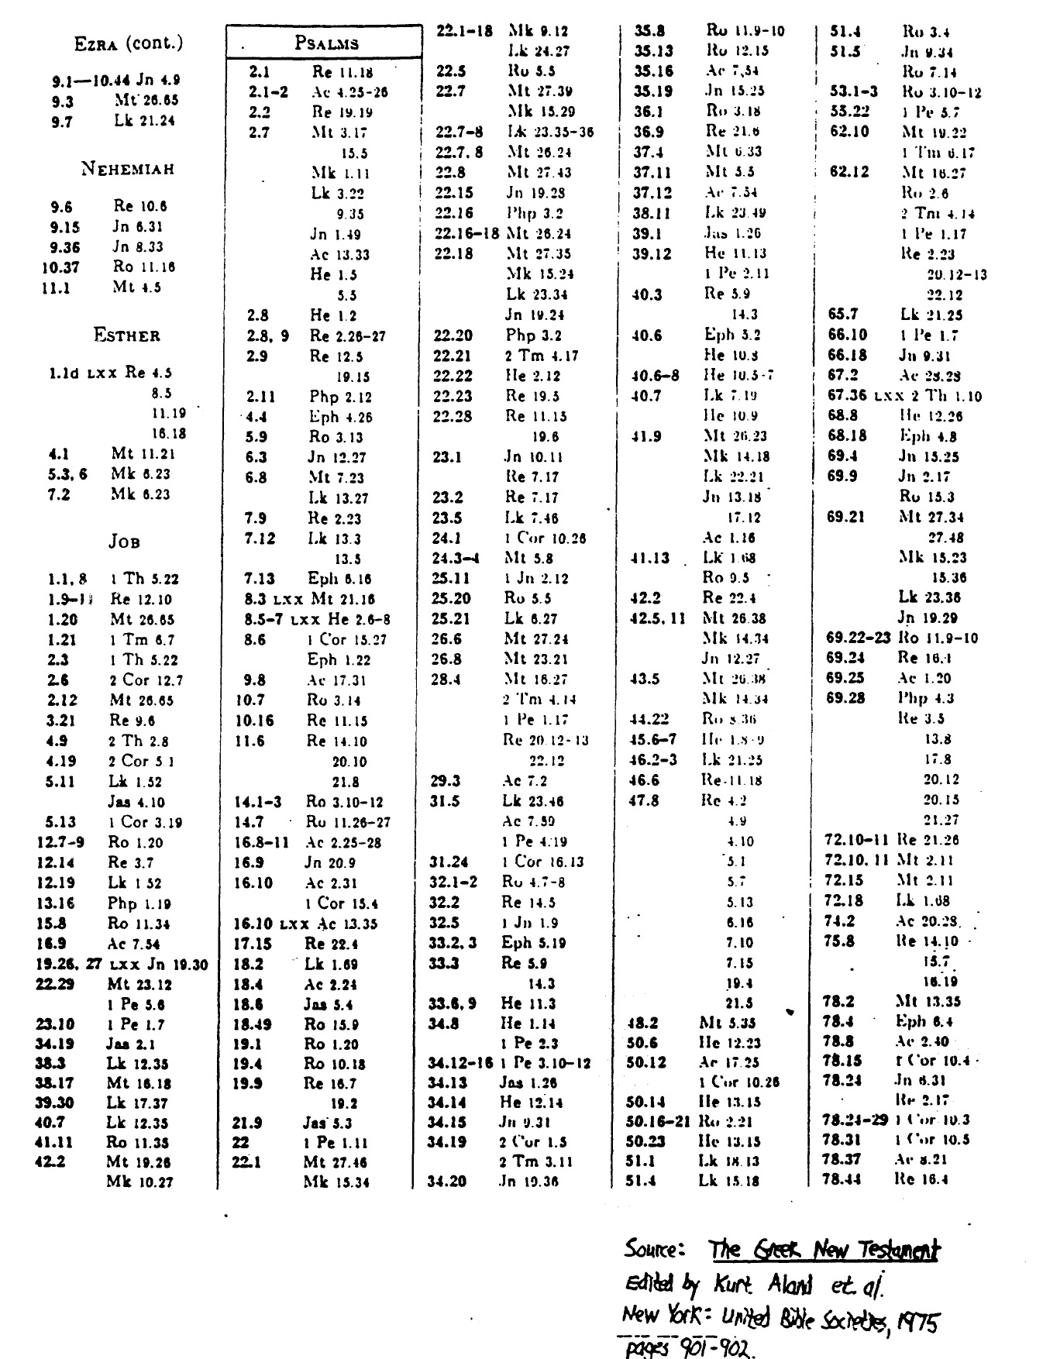

**Psalms in the New Testament (continued)**

Both Quotations and Allusions

