

Spiritual Gifts and

Pneumatology: The Study of the Holy Spirit

Jordan Evangelical Theological Seminary (JETS)
Rick Griffith, ThM, PhD

Twentieth Edition
© September 2025

1st-26th printings (795 copies; 1st-13th eds. July 95-July 12)
27th printing (20 copies; 14th ed. Jan 16)
28th printing (30 copies; 15th ed. Nov 21)
29th printing (digital; 16th ed. Nov 21)
30th printing (digital; 17th ed. Dec 22)
31st printing (digital; 18th ed. July 25)
32nd printing (digital; 19th ed. Aug 25)
33rd printing (digital; 20th ed. Sept 25)



Table of Contents
My Biographical Sketch H
Course Grading J
Research Paper Grade Sheet J
Research Paper Checklist K
Pneumatology (Study of the Holy Spirit) i
The Personality and Deity of the Holy Spirit i
What Do You Think of the Holy Spirit? i
The Personality of the Spirit ii
Biblical Evidence for the Doctrine of the Trinity iii
The Work of the Spirit ix
The Spirit in Relationships ix
Blasphemy Against the Spirit xiv
The Indwelling & Sealing of the Spirit xvi
Interpretive Issues on Spirit Baptism xviii
The Baptism and Filling with the Spirit xxii
Walking by the Spirit xxiii
How the Spirit Leads Us xxiv
Holy Laughter xxv
Differences Between Emotional and Spiritual Laughter xxx
Anatomy of Deception xxxi
Normal Christian Meetings vs. Laughter Meetings xxxii
Why are Charismatics Growing So Much in Singapore? xxxiii
Being Slain in the Spirit xxxiv
Other Ministries of the Spirit xl
Sins Against the Spirit xli
The Eschatology of the Spirit xlii
Fruit and Gifts of the Spirit Contrasted xlii
Fruit of the Spirit Defined xliii
Fruit of the Spirit Compared xliv
Discerning & Using Your Spiritual Gifts A
Spiritual Gifts 1
Introduction 1
Objectives of the Sessions 1
Names of Those in My Discussion Group 1
Abbreviations Used in This Series 1
Basic Issues in 1 Corinthians 12 2
Distinguishing Natural Talents from Spiritual Gifts 2
The Basis and Nature of Spiritual Gifts 3
Why Study and Know Our Gifts? 3
Scriptural Commands Associated With Gifts 4
Spiritual Gifts Lists Worksheet 5
Lists of Spiritual Gifts in the New Testament 6
Overview and Categorization of the Gifts Chart 7
Abilities Sometimes Called Gifts 8
Author Comparison Chart 9
Dangers Associated with Spiritual Gifts 13
Temporary Gifts 14
Views on the Duration of Gifts 14
Scriptural Support for Temporary Gifts 16
Transitional Diagrams 19
Apostleship 20
Word of Wisdom 21
Word of Knowledge 22
Prophecy 23
Prophecy Versus Teaching 27
Distinguishing of Spirits 28
Speaking in Tongues 29
Tongues in Acts and 1 Corinthians 33
Tongues versus Prophecy 34
Interpretation of Tongues 35
Miracles 36
Healing 37
Power Evangelism 38
Temporary Gift Study Guide 42
Permanent Gifts 43
Permanent Gift Study Guide 43
How Many Gifts Does Each Believer Have? 44
Problem Passages 45
Gifts and Ministries 46
Speaking Gifts Comparison Chart 47
Teaching vs. Evangelism 48
Teaching 49
Evangelism 50
Contrasting the Pastor-Teacher and Exhorter 51
Pastor-Teacher 52
Exhortation 53
Serving Gifts Comparison Chart 54
Administration 55
Faith 56
Giving 57
Service 58
Showing Mercy 59
Application 60
Spiritual Gifts Inventory 60
Spiritual Gifts Inventory Worksheet 62
Spiritual Gifts Inventory Group Record 63
Spiritual Gifts Inventory Explanatory Supplement 64
How to Discern Your Spiritual Gifts 65
Questions to Help Discern Your Gifts 66
Ministry Opportunities at Our Church 68
How to Make Your Spiritual Gift Really Count 69
Guidelines for Using Your Spiritual Gift 70
Readings on Spiritual Gifts 71
Thomas R. Edgar—The Cessation of the Sign Gifts 71
F. David Farnell—Does the New Testament Teach Two Prophetic Gifts? 80
Jack Deere—Did Miraculous Gifts Cease With the Apostles? 94
Robert A. Pyne’s Response to Deere’s Book 110
John F. MacArthur, Jr.—The Issue of Tongues 111
Wayne A. Grudem—Why Christians Can Still Prophesy 124
Completed Handouts 129
Basic Issues in 1 Corinthians 12 129
Distinguishing Natural Talents from Spiritual Gifts 130
The Basis and Nature of Spiritual Gifts 131
Why Study and Know Our Gifts? 131
Dangers Associated with Spiritual Gifts 132

Syllabus

I. Course Description

Non-Christians often blame tragedies on God. Likewise, Christians often blame excesses on the Holy Spirit. Who is He and what does He really do in our world? This two-part course explores what the Bible says about the person and work of the Spirit. Part 1 addresses His deity and ministries relating to the believer (e.g., baptism, filling, sealing, indwelling, sanctifying, fruit) and the unbeliever (e.g., calling, conviction, regenerating). Part 2 covers His gifting the saints with special abilities to serve Christ, including the controversial gifts of prophecy, tongues, miracles, and healing.

This course will follow a blended learning approach. This means that we have two means of instruction: (1) face-to-face classroom learning via the instructor supplemented by outside reading, as well as (2) web-based individual learning via two websites:

(a) All course PowerPoint and notes can be downloaded at the Holy Spirit link at http://www.biblestudydownloads.com. Please note that it is available in both English and Arabic.

(b) Online at https://eu.hismoodle.com/login/?theme=rocket&school=jets&lang=en you will find the quizzes.

II. Course Objectives

By the end of the Pneumatology course (Part 1), the student should be able to…

- Prove the personhood and deity of the Holy Spirit, showing why each is important.

- Explain the various ministries of the Holy Spirit relating to the believer (e.g., baptism, filling, sealing, indwelling, sanctifying, fruit).

- Explain the various ministries of the Holy Spirit relating to the unbeliever (e.g., calling, conviction, regenerating).

- See the value of Internet learning by taking quizzes online.

By the end of the Spiritual Gifts course (Part 2), the student should be able to…

- Define the various spiritual gifts and discern these gifts in yourself and others.

- Explain reasons for differing views on the spiritual gifts and evaluate these biblically.

- Feel acquainted enough with pneumatology to teach it to others confidently.

- See the relevance of pneumatology to personal holiness, world mission, contemporary events, and MENA culture and religions.

III. Course Requirements

A. Readings (33%) of the next day’s class notes and/or pertinent articles will be assigned for each session. Please stay up on your readings. On each online quiz, you will report whether you did your reading since the last quiz, including reading for the day of the quiz.

B. Quizzes (33%) must be taken by midnight the night before the class period for which they are assigned. Half of the quiz grade will ask if you completed the readings since the last quiz (50 points per quiz), and half will generally comprise five questions (10 points each or 50 points total). There are no makeup quizzes. Each quiz can be taken anytime to the due date, but will expire at midnight the night before class. Take this quiz by yourself (closed book, closed Bible, closed notes, and an open mind). Also, do not wait until just before the quiz closes, as the server cannot handle everyone taking it simultaneously. Furthermore, when taking the quizzes, do not let the timer reach zero. This will delete all of your answers! Instead, click the “submit my answers” button before the time limit so that your answers will be recorded in the database. Finally, please do not discuss the quiz with other students, as they may not have taken it yet.

C. Position Papers (33%) will address controversial topics. These will be short (2-3 pages, single or double spaced), explaining alternate views on a topic, and your logic and Scripture for holding your view. Cite sources from varying viewpoints—but these notes may not be used as a source (except bibliographies).

Ass. #1: Prophecy. Define the gift of prophecy, noting any differences between OT and NT prophecy. Address from Scripture if NT prophecy is sometimes fallible (cf. Wayne Grudem or Michael Moriarty) or always infallible (cf. David Farnell), and if it still exists today. Cite sources from varying perspectives.

Ass. #2: Tongues. Explain from the NT what the gift of tongues is, including its purpose. Show whether the tongues of Acts are the same as those of 1 Corinthians and whether a “private use” for self-edification is biblically justified. Explain whether the genuine gift is available today. Cite sources from varying perspectives.

Ass. #3: Spiritual Gifts Inventory (required). Take this self-diagnostic inventory (pp. 60-61) to help discern your own spiritual gift(s). Then transfer your results to the Spiritual Gifts Inventory Worksheet (p. 62, top only) and bring them both to class for discussion.

N.B. Each of the preceding requirements has a 3% grade penalty per class day late. Also, points may be deducted for not including your full name on assignments, exceeding the page limit, and improper grammar and spelling (including my name!).

IV. Bibliography

* Asterisks show books requested to be on reserve in the library (if available)

A. General Works (and works difficult to classify as charismatic or non-charismatic)

*Carson, D. A. Showing the Spirit: A Theological Exposition of 1 Corinthians 12—14. Grand Rapids: Baker, 1987. 229 pp.
Carson holds to charismatic beliefs in some areas and no charismatic views in others.

*Erickson, Millard J. Christian Theology. 3 vols. in 1. Grand Rapids: Baker, 1983, 1984, 1985. 1302 pp.
Evangelical (e.g., upholds inerrancy), exhaustive, readable, good with alternate views, useful for preaching and teaching due to Erickson’s extensive pastoral experience, considers the central theme of theology to be the magnificence of God, footnoted (better than the endnoting in Enns but not as helpful as them in bibliography and transliteration of Greek and Hebrew), no charts or glossary like in Enns and unfortunately holds to the progressive creationist view. Erickson is dean and professor of theology at Bethel Theological Seminary. Nondispensational premillennial, moderate Calvinist viewpoint.

Ferguson, Sinclair. The Holy Spirit: Contours of Christian Theology. Downers Grove, IL: IVP, 1996.

Flynn, Leslie B. 19 Gifts of the Spirit. Wheaton: Victor, 1974.
An excellent, thorough, and balanced treatment in a popular, interesting style by a Conservative Baptist pastor. Includes several illustrations and a chapter on each gift.

Gothard, Bill. “How to Identify Spiritual Gifts.” Institute in Basic Youth Conflicts Seminar Syllabus. Oak Brook, IL: IBYC (now Institute in Basic Life Principles), 1981.

*Moriarty, Michael G. The New Charismatics: A Concerned Voice Responds to Dangerous New Trends. Grand Rapids: Zondervan, 1992.

*Packer, J. I. Keep in Step with The Spirit. Old Tappen, NJ: Revell, 1984. 301 pp.
A balanced presentation of how to genuinely walk in the power of the Spirit.

Turner, Max. The Holy Spirit and Spiritual Gifts. UK: Hendriksen, 1996.

B. Charismatic Sources

Bennett, Dennis and Rita. The Holy Spirit and You. Plainfield, NJ: Logos, 1971.
The Episcopal priest who introduced the charismatic movement into mainline denominations (founders of “Neo-Pentecostalism”).

Bridge, Donald and Phypers, David. Spiritual Gifts and the Church. London: IVP, 1973.

*Bruner , Frederick Dale. A Theology of the Holy Spirit: The Pentecostal Experience and the New Testament Witness. Grand Rapids: Eerdmans, 1970. 390 pp.

Bugbee, Bruce; Cousins, Don; and Hybels, Bill. Network: The Right People… In the Right Places… For the Right Reasons. Barrington, IL: Willow Creek Community Church and Grand Rapids: Zondervan, 1994. 150 pp.
This guide helps people understand not just their gifts but also their passion, style, spiritual maturity, and availability. It lists 23 gifts and includes numerous self-diagnostic surveys—including practical guides how to serve after one has discovered his/her gift.

*Deere, Jack. Surprised by the Power of the Spirit: A Former Dallas Seminary Professor Discovers That God Speaks and Heals Today. Grand Rapids: Zondervan, 1993.

___________ . Surprised by the Voice of God: How God Speaks Today Through Prophets, Dreams, and Visions. Grand Rapids: Zondervan, 1995. 256 pp. US$19.00

Graham, Billy. The Holy Spirit. Waco, TX: Word, 1978.

*Green, Michael. I Believe in the Holy Spirit. London: Hodder & Stoughton, 1975; and Grand Rapids: Eerdmans, 1975. 223 pp.

*Grudem, Wayne. The Gift of Prophecy: In the New Testament and Today. Eastbourne, Great Britain: Kingsway, 1988; and Westchester, IL: Crossway, 1988. 351 pp.

___________ . Systematic Theology: An Introduction to Biblical Doctrine. Leicester, England: IVP and Grand Rapids: Zondervan, 1994. 1264 pp. Holds to a non-cessation view of the gifts but a non-Pentecostal interpretation of Spirit baptism. Very readable and interacts well with evangelical scholars of various views. Arabic version available at The Program for Theological Education by Extension in Amman, Jordan (pteemail@ptee.org).

Horton, Harold. The Gifts of the Spirit. Burbank, CA: World Map, 1934; reprint, 1979.

Hyatt, Eddie L. 2000 Years of Charismatic Christianity: A 20th Century Look at Church History from a Pentecostal/Charismatic Perspective. P.O. Box 700276, Chicota, TX 74170: Hyatt International Ministries, Inc., 1996. 209 pp.

Kraft, Charles H. “What Kind of Encounters Do We Need in Our Christian Witness?” Subtitle: “Power encounter must be biblically balanced with truth and commitment encounters, if we are to succeed in our world mission.” Evangelical Mission Quarterly 27 (July 1991): 258-65.

Smedes, Louis D., ed. Ministry and the Miraculous: A Case Study at Fuller Theological Seminary. Pasadena, CA: Fuller Theological Seminary, 1987. 80 pp. Paper, US$6.95. Reviewed by Robert P. Lightner in Bib Sac 145 (April-June 1988): 221.

Springer, Kevin, ed. Power Encounters Among Christians in the Western World. Introduction and afterward by John Wimber. San Francisco: Harper & Row, 1988. xviii+218 pp. Reviewed by Ken L. Sarles in Bib Sac 146 (October-December 1989): 460-61.

Wagner, C. Peter. How to Have a Healing Ministry Without Making Your People Sick. Eastbourne: Monarch, n.d. [?]

________. “Healing Without Hassle.” Leadership 6 (Spring 1986).

________. “A Third Wave?” Pastoral Review, July-August 1983.

________. “The Third Wave Goes Public,” Christian Life, January 1986.

________. The Third Wave of the Holy Spirit. Ann Arbor, MI: Vine Books, Servant, 1988. 133 pp. Reviewed by Ken Sarles in Bib Sac 147 (January-March 1990): 111.

________. “What Happens When You See Jesus,” Christian Life, April 1986.

________. Your Spiritual Gifts Can Help Your Church Grow. Glendale, CA: Gospel Light, 1979.

*White, John. When the Spirit Comes with Power. London: Hodder & Stoughton, 1989.

Williams, Don. Signs, Wonders, and the Kingdom of God: A Biblical Guide for the Reluctant Skeptic. Ann Arbor, MI: Vine Books, Servant Pub., 1989.

*Wimber, John. Power Evangelism. London: Hodder & Stoughton, 1985; rev. ed., San Francisco: Harper and Row, and London: Hodder & Stoughton, 1992.

________, with Springer, Kevin. Power Healing. San Francisco: Harper & Row, 1987, and London: Hodder & Stoughton, 1987. Reviewed by Roy B. Zuck in Bib Sac 145 (January-March 1988): 102-4.

________, with Springer, Kevin. Power Points: Your Action Plan to Hear God’s Voice, Believe God’s Word, Seek the Father, Submit to Christ, Take Up the Cross, Depend on the Holy Spirit, Fulfill the Great Commission. New York: Harper Collins, 1991. 222 pp. $15.95. Reviewed by Robert Pyne in Bib Sac 149 (Oct-Dec 1992): 505-6.

Yohn, Rick. Discover Your Spiritual Gift and Use It. Wheaton, IL: Tyndale, 1974.

C. Non-Charismatic Sources

Babcock, Neil. A Search for Charismatic Reality. Portland, OR: Multnomah, 1985. (The personal testimony of a charismatic pastor who left the movement.)

Bridges, Donald. Power Evangelism and the Word of God. Eastbourne, England: Kingsway, 1987.

Derickson, Gary W. “The Cessation of Healing Miracles in Paul’s Ministry.” Bibliotheca Sacra 155 (July-September 1998): 299-315.

Doyle, Robert, ed. Signs and Wonders and Evangelicals. Hornebusge West, N.S.W., Australia: Lancer Books, 1987. 130 pp. $6.50 pb. Reviewed by Ken Sarles in Bib Sac 146 (October-December 1989): 457-58. He says it is the best critique to date.

*Edgar, Thomas R. Miraculous Gifts. Neptune, NJ: Loizeaux, 1983.

*________. “The Cessation of the Sign Gifts.” Bibliotheca Sacra 145 (October-December 1988): 371-86. (Excellent article—concise and readable, copied on pp. 71-79.)

*________. Satisfied by the Promise of the Spirit: Affirming the Fullness of God’s Provision for Spiritual Living. Grand Rapids: Kregel, 1996. 283 pp. (Responds to Deere’s Surprised by the Power of the Spirit and updates Edgar’s Miraculous Gifts.)

*Enns, Paul. The Moody Handbook of Theology. Chicago: Moody, 1989. 688 pp. CBD for US$21.95.
Most handbooks of theology are fairly brief works of about 150 pages consisting of brief articles that explain doctrines, heresies, movements, and leading men in the field of theology. This massive work is divided into five parts that cover biblical theology (in 16 chapters that survey the theology of all major biblical sections), systematic theology (bibliology, theology proper, christology, etc.), historical theology (surveying the major theological teachings of the ancient, medieval, Reformation, and modern eras), dogmatic theology (with chapters on Calvinistic, Arminian, covenant, dispensational, and Catholic theology), and contemporary theology. It has 45 chapters and an epilogue, 55 simple-to-understand charts, a 24-page glossary of terms and names, and several indexes (persons, subjects, and Scripture references), endnotes identifying sources quoted, and helpful bibliographies. Dispensational premillennial. Enns does not, however, address recent developments in “progressive dispensationalism” that have come about since 1989 through Robert Saucy, Darrell Bock, and Craig Blaising.

*Farnell, F. David. “Is the Gift of Prophecy for Today?” (Four Part Series) “The Current Debate about New Testament Prophecy.” Bibliotheca Sacra 149 (July-September 1992): 277-303; “The Gift of Prophecy in the Old and New Testaments.” Bibliotheca Sacra 149 (October-December 1992): 387-410; “Does the New Testament Teach Two Prophetic Gifts?” Bibliotheca Sacra 150 (January-March 1993): 62-88; “When Will the Gift of Prophecy Cease?” Bibliotheca Sacra 150 (April-June 1993).

Gaffin, Richard B., Jr. Perspectives on Pentecost. Presb. & Reformed, 1974?. 127 pp.

Geisler, Norman. Signs and Wonders. Wheaton, IL: Tyndale, 1988.

Gross, Edward N. “Understanding the Miraculous Gifts in the Scripture.” Christian News, February 2, 1987, pp. 13-15. Reviewed by John A. Witmer in Bib Sac 144 (October-December 1987): 464.

*MacArthur, John, Jr. Charismatic Chaos. Grand Rapids: Zondervan, 1992. 415 pp.

_________. The Charismatics: A Doctrinal Perspective. Grand Rapids: Zondervan, 1978. 224 pp.

McRae, William. The Dynamics of Spiritual Gifts. Grand Rapids: Zondervan, 1976.

*Ryrie, Charles Caldwell. The Holy Spirit. Rev. ed. Chicago: Moody, 1965; rev. & expanded, 1997. 223 pp.
Expands and updates his former book by the same title (Moody, 1965), which has been a standard non-charismatic Bible College text. Brief and readable. Now 80 pages longer, addressing “Holy Laughter,” anointing, and prophecy [too briefly] with expanded indexes. A clear, biblical evaluation of an important area of theology.

Sarles, Ken L. “An Appraisal of the Signs and Wonders Movement.” Bibliotheca Sacra 145 (January-March 1988): 57-82. (See also his reviews of books above.)

Stafford, Tim. “Testing the Wine from John Wimber’s Vineyard.” Christianity Today, 8 August 1986, p. 18.

Unger, Merrill F. The Baptism & Gifts of the Holy Spirit. Chicago: Moody, 1974. 189 pp.

________. New Testament Teaching on Tongues. Grand Rapids: Kregel, 1971.

*Walvoord, John F. The Holy Spirit: A Comprehensive Study of the Person and Work of the Holy Spirit. Van Kampen, 1954; reprint, Grand Rapids: Zondervan, 1965. 288 pp.
This older (non-charismatic) work does not address the mainline charismatic movement, errant prophecy, holy laughter, and other recent issues. However, it provides a most thorough biblical treatment of pneumatology, so it is worth our attention.

________. “The Holy Spirit and Spiritual Gifts.” Bib Sac 143 (April-June 1986): 109-22.

*________. The Holy Spirit in the Church Today. Chicago: Moody, 1973. 63 pp.
A brief treatment documenting the ministries of the Holy Spirit from Scripture.

*Warfield, Benjamin Breckenridge. Counterfeit Miracles. Edinburgh: Banner of Truth Trust, 1918; reprint, 1983.

Required Reading

*Deere, Jack. Surprised by the Power of the Spirit: A Former Dallas Seminary Professor Discovers That God Speaks and Heals Today. Grand Rapids: Zondervan, 1993. 299 pp. CBD for US$13.50.
This recent work includes Deere’s personal experience and interaction with Scripture often cited to support cessationism. As a former Cessationist, Deere clearly understands Cessationist arguments. Required readings from him are copied on pages 94-109 and 133-43.

*Edgar, Thomas. “The Cessation of the Sign Gifts.” Bibliotheca Sacra 145 (October-December 1988): 371-86. (Reproduced in notes, 71-79.)
Concise and readable. Provides the other side to Deere’s view above. Edgar argues that some gifts have ceased based upon Scripture and the history of the church.

*________. Satisfied by the Promise of the Spirit: Affirming the Fullness of God’s Provision for Spiritual Living. Grand Rapids: Kregel, 1996. 283 pp.
Responds to Deere’s Surprised by the Power of the Spirit and updates Edgar’s Miraculous Gifts. Required readings from him are copied on pages 144-51.

*Grudem, Wayne. Systematic Theology: An Introduction to Biblical Doctrine. Leicester, England: IVP & Grand Rapids: Zondervan, 1994. 1264 pp.
An evangelical, massive work in simple English but with fresh insights. Includes a bibliography of other systematic theologies by perspective and page numbers, as well as personal application questions and popular hymns and choruses with each topic. Grudem teaches at Trinity International University in Deerfield, IL. Nondispensational premillennial, posttribulational, moderate Calvinist viewpoint. Unfortunately, Grudem teaches errant but inspired prophecy (called “inaccuracies of detail,” p. 1052) and an imminent but posttribulational return of Christ (pp. 1100-1105). Arabic version available at The Program for Theological Education by Extension in Amman, Jordan (pteemail@ptee.org).

V. Course Schedule
Quizzes cover only the readings for that week (generally five questions each worth 10 points). Content from class sessions is not quizzed. One additional question will also ask if you completed the reading for that week for 50 points, so that each quiz has a possible 100 points. Sessions 1-6 apply to the Holy Spirit course, while sessions 7-12 address the Spiritual Gifts course.

Session | Sunday | Subject | Assignment | pp.
1 | 22 March | Syllabus & Introduction | No assignments (in class = notes, i)
2 | 22 March | Pneumatology: (notes, i, xvi-xvii )  Spirit Personality & Deity | Notes, ii-xiii (Deity, Relationships & Prayer) | 12
3 | 22 March | Spirit Ministries to the Unbeliever: Blasphemy, Holy Laughter, & Grace | Notes, xiv-xv (Blasphemy), xxv-xxxii (Holy Laughter), xxxix (The Spirit & Grace) | 11
Session | Monday | Subject | Assignment | pp.
4 | 23 March | Spirit Indwelling, Sealing, Leading, & Slaying | Notes, xvi-xvii (Indwelling & Sealing), xxiv (Leading), & xxxiii- xxxviii (Slaying by the Spirit)  Quiz 1 | 9
5 | 23 March | Spirit Baptism, Filling, & Fruit | Notes, xviii-xxiii (Baptism & Filling), xl-xliv (Ministries, Sins Against, & Fruit)  Grudem, 763-787 | 11
6 | 23 March | Gifts:  Intro & Lists | Grudem, 1016-31 (notes, 152-159) | 16
Session | Tuesday | Subject | Assignment | pp.
7 | 24 March | Dangers & Durations of Gifts | Deere, 229-52 (notes, 94-110) = 23  Quiz 2 | 23
8 | 24 March | Foundational Gifts I: Apostle, Word of Wisdom, Word of Knowledge | Edgar, “Cessation,” 371-86 (notes, 71-79)  Assignment #1: Prophecy | 16
Session | Wednesday | Subject | Assignment | pp.
9 | 25 March | Foundational Gifts II:  Prophecy, Discernment | Grudem article (notes, 124-28) = 5  Farnell (notes, 80-93) = 28  Quiz 3 | 19
10 | 25 March | Sign Gifts: Miracles, Healing,  Tongues, Interpretation | Deere, 99-115 (notes, 133-143)  (Deere argues miracles here today)  Assignment #2: Tongues | 17
Session | Thursday | Subject | Assignment | pp.
11 | 26 March | Speaking Gifts:  Teaching, Evangelism, Pastor-Teacher, Encouragement | Edgar “Conclusion,” Satisfied, 250-64 (notes, 144-51)  Quiz 4 | 15
12 | 26 March | Service Gifts: Administration, Faith, Giving, Service, Mercy  Discerning Your Gifts | Assignment #3: Spiritual Gifts Inventory & Worksheet (notes, 54-70) | 25

VI. Other Matters

A. Contacting Me: You can contact me at drrickgriffith@gmail.com or by WhatsApp at +962 7 9725-6010.

B. Copying Class Notes: This is allowed as long as you give credit where credit is due and until you’re rich from it. You may also copy all course PPT and translate them into other languages.

My Biographical Sketch



The Griffith Family

Kurt & Cara (38) & Kadon (2), Stephen & Katie (36) with Jesse (6) & Norah (4), John & Chloe (32)

Background

“Never say ‘never.’” Rick and Susan Griffith both learned this age-old tip the hard way.

Rick recalls sitting in his elementary school classes thinking, “If there’s one thing I’ll never become, it’s a teacher. Imagine saying the same stuff over and over, year after year!”

Yet after trusting Christ in junior high and beginning to teach the Word of God, Rick’s attitude changed. After his business degree at California State University, East Bay, a Master of Theology degree (Pastoral Ministries), and a Doctor of Philosophy degree (Bible Exposition) from Dallas Theological Seminary in Texas, Dr. Griffith soon found himself on the other end of the classroom—and loving it!

From Yucaipa, California, Susan also learned not to say “never.” As she earned her Bachelor of Arts degree in piano at Biola University, several friends married and worked to put their husbands through three more years of seminary training. “I’ll never do that!” she exclaimed. Soon afterward, she invested three years (1981-1983) singing with her future husband in the Crossroads, Campus Crusade's traveling music team in Asia. This nine-member Philippines-based group shared Christ in the Philippines, China, Hong Kong, Korea, Japan, Macau, Thailand, Malaysia, Indonesia, and Singapore.

In December 1983, Susan’s “never” became a reality. She and Rick were married, and like Jacob and Rachel of old, Susan also worked for her mate. During these seven seminary years, Rick served as a pastor, corporate chaplain, and International Students church consultant. Susan taught women's Bible studies and often ministered by singing. Their primary church in Texas is Christ Chapel Bible Church in Fort Worth.

They have three sons: Kurt (38 yrs.) works in IT with his business analysis wife Cara in Seattle at their HR consulting firm Tandem Motion with two grandsons (2022 & 2025), Stephen is a United B777 pilot trainer (36 yrs.) with wife Katie in Denver with two grandkids (2019 & 2021), and John (Griff) and his wife Chloe work in IT graphic design in California (32 yrs.), respectively.

Ministry

From 1991 to 2021, the Griffith home was in Singapore, where Rick served as Doctor of Ministry director with 26 other full-time faculty at Singapore Bible College. SBC has 495 students from 26 countries and 25 denominations, as well as many professionals. He began by teaching Old and New Testament Survey, Old and New Testament Backgrounds, Eschatology (the study of future things), Evangelism, Pastoral Epistles, Psalms, Homiletics (preaching), Hebrew Exegesis, and four Old Testament exposition courses. Then, for years, he also taught Pentateuch, Gospels, Eschatology (theology of the future), Ecclesiology (theology of the church), and Pneumatology (theology of the Holy Spirit). In recent years, he mostly taught Bible Exposition classes, including Homiletics, OT Foundations, and OT & NT Survey. He also wrote three Advanced Studies in the Old and New Testament courses at Internet Biblical Seminary (www.internetseminary.org).

Dr. Griffith loves the variety and strategic nature of his teaching. He has invested his life into Anglicans from Sri Lanka, Lutherans from Singapore, Presbyterians from Korea, Conservative Baptists from the Philippines, and missionaries from Campus Crusade, OMF, and Operation Mobilisation—sometimes all in one class! One class had 17 of the 20 students training for ministry outside of Singapore. Nearly all SBC graduates entered pastoral or missionary ministries due to Asia’s shortage of trained leaders.

Ministry opportunities abound. Over the years, Rick and Susan conducted premarital counseling for students with their home’s open door to students and guests traveling through Singapore. In 1992, they also helped start International Community School, an expatriate Christian K-12 school in Singapore, now with more than 400 students. WorldVenture has seconded them to these organizations over the years.

Dr. Griffith also enjoys several other partnerships. He also serves as Translation Coordinator for "The Bible... Basically International" seminars; web author & editor, Internet Biblical Seminary; and itinerate professor for 73 trips throughout Asia and the Middle East at Lanka Bible College (Sri Lanka), Myanmar Evangelical Graduate School of Theology, Union Bible Training Center (Mongolia), and Biblical Education by Extension training in three restricted access countries. In 2021, he joined Jordan Evangelical Theological Seminary as a Professor of Bible Exposition and has been Academic Dean since 2024.

Dr. Rick also began Crossroads International Church, Singapore, where “Pastor Rick” served as pastor-teacher from 2006-2021. See CICFamily.com.

In 2009, Dr. Rick began BibleStudyDownloads.org to offer free courses for download. It has 46,000 pages of course notes in Word and pdf, and over 146,000 English PowerPoint slides and 473,000 PowerPoint slides translated by 800 students into 54 languages, such as Albanian, Ao Naga, Arabic (122,000 slides), Bangla, Bisaya, Burmese, Chin Tedim, Chiru, Chinese, Czech, Dutch, English, French, German, Gujarati, Hindi, Ilonggo, Indonesian, Italian, Japanese, Kachin, Karen, Khmer, Kiswahili, Korean, Liangmai, Lotha, Malay, Malayalam, Mao, Mizo, Mongolian, Moyon, Nepali, Nias, Norwegian, Paite Chin, Polish, Portuguese, Romanian, Rongmei, Russian, Sinhala, Spanish, Sumi Naga, Swedish, Tagalog, Tamil, Tangkhul, Tenyidie, Thai, Ukrainian, Vaiphei, and Vietnamese.

Field

Jordan is 98% Muslim but promises freedom of religion and has diplomatic ties with Israel. Since its founding in 1991, JETS has trained half of the pastors of Jordan’s 60 evangelical churches.

Passion

Rick’s passion is for God’s leaders to preach and live the Word of God as God’s servants:
- Teaching obedience to Christ’s words is key to our commission to make disciples (Matt 28:20).
- Paul’s legacy to Timothy focused on exposition: “Preach the Word” (2 Tim 4:2-3; cf. Acts 6:1-16).

However, recent trends include the following:
- Christians are biblically illiterate due to a “famine for hearing the words of the Lord” (Amos 8:11).
- Attempting to be “relevant,” pastors preach what people want to hear, not what they need.

Research Paper Grade Sheet

Student Topic Box

The first four sections below cover the paper’s content (70% of the grade). The Form grade (the other 30%) is based on Kate L. Turabian, A Manual for Writers of Term Papers, Theses, and Dissertations, 9th ed. (Chicago: Univ. of Chicago Press, 2018). Follow the seminary standards guide and the checklist on the following two pages.

1 2 3 4 5
Poor Minimal Average Good Excellent

Introduction
Purpose (descriptive title, paper addresses what issue?)
Scope of the issue defined/narrowed down
Procedure for addressing the issue introduced

Body
Wide research (other views included, good sources)
Individual work (<20% quotes; careful citation)
Key Bible texts noted and addressed adequately
Development (proves points, not just lists the verses)
Interpretation of passages is accurate (exegesis)

Conclusion
Solution given to the issue raised in the introduction
Main points reviewed or restated
Length (1/2 to 1 page, no unnecessary info.)

Miscellaneous
(These can be addressed anywhere in the paper)
Application (shows why the topic is important)
Depth & Insight (leaves any questions unanswered?)
The Internet is not used for more than 20% of sources

Form
Format (Contents & title page, length, pages numbered)
Spelling and typographical errors, punctuation
Grammar (agreement of subject/verb and tenses)
Footnotes (not endnotes; proper form; biblio. included)
Logical (not a collection of thoughts or repetitive)
Sections agree with the Contents page; no orphan headings

Summary

Number of ticks per column ____ ____ ____ ____ ____

Multiplied by point values of the column x 1 x 2 x 3 x 4 x 5

Equals the total point value for each column ____ ____ ____ ____ ____

Net points ______ minus 3 points per day late (____ points) equals % grade of %

Comments: 21st ed. (1 July 2025)
Research Paper Checklist

* Asterisks show the most common mistakes students make on research papers. Give special attention to these areas!

1. General Format
1.1 Obtain your own copy of the handout "Why Write Papers?" by Dr. Henry Baldwin.
1.2 The most complete and widely used format guide is Kate L. Turabian, A Manual for Writers of Term Papers, Theses, and Dissertations, 6th ed. rev. by John Grossman and Alice Bennett (Chicago & London: Univ. of Chicago Press, 1937, 1955, 1967, 1973, 1987, 1996). 308 pp.
1.3 Questions not answered by Turabian can probably found in The Chicago Manual of Style.
1.4 Staple the pages in the upper left corner rather than using report folders or attaching the paper at the top centre.

2. Preliminaries
2.1 The title page should follow the typical format in Turabian.
2.1.1 Only “SINGAPORE BIBLE COLLEGE” and the TITLE should be in capital letters.
2.1.2 Please include your mailbox number after your name.
2.1.3 The same size type (and font) should be used throughout the paper.
2.2 The margins should not change (e.g., should not be in outline form) but should be 2.5 cm on all sides.
2.3* Include a Table of Contents.
2.3.1 The Contents page should include only the first page number of each section.
2.3.2 Subtitles within the Contents page should be indented.
2.3.3 Note this is called a “Table of Contents” and not a “Table of Content.”
2.3.4 “Table of Contents” should not be an entry on the Table of Contents.
2.4 Page numbers should be at the top right in the preliminaries (except no number on Title Page and Table of Contents) and at the bottom centre from the first page to the end.

3. Body & Style
3.1* Provide an introduction that summarizes the problem(s) your paper aims to answer.
3.2* Check your grammar for confusion of tense, plural, verb/noun, etc. (cf. section 9)
3.3 Use a spell checker if you have one on your computer to avoid careless spelling mistakes.
3.4 Double-space the paper throughout in prose form (not outline form).
3.5* Write in the third person rather than the first person (“This author…” and not “I” or “we” or “us”).
3.6 Follow these guidelines for headings within the text:
3.6.1 Headings should match your Contents page.
3.6.2 Headings should not have periods (full stops or colons) after them.
3.6.3* Headings should not be in outline form (no “I,” “II,” “A,” “1,” “a,” “-,” etc.).
3.6.4 Avoid widow headings (at the bottom of a page without the first sentence of a paragraph).
3.6.5 Don’t repeat a heading on the next page even if it covers the same section of the paper.
3.6.6 Each research paper should have at least 2-3 headings or divisions.
3.6.7 As an exception to 3.6 above, in short papers (6-8 pages) which do not have chapters, (1) main headings should be centred capitals, followed by (2) subheadings which are underlined centred small letters, (3) underlined left column small letters, (4) non-underlined left column small letters, and finally (5) underlined small letters which begin an indented paragraph. If only two levels are needed then (2) above may be skipped.
3.7* Do not clutter your paper with unnecessary details that do not contribute to your purpose.
3.8* Make every statement a full sentence within the text (the exception is headings).
3.9 Critically evaluate your sources; do not believe a heresy just because it’s in print!
3.10 Make sure your reasoning is solid and logical.
3.11* Provide a conclusion which solves/summarizes the problem addressed in the introduction

4. Abbreviations
4.1* Do not use abbreviations in the text or footnotes (except inside parentheses).
4.2 Cite from 1-3 verses inside parentheses in the text but 4 or more verses in the footnotes.
4.3* Use proper biblical book abbreviations with a colon between chapter and verse.
4.4 Do not start sentences with an Arabic number. Write “First Kings 3:16…” (not “1 Kings 3:16…”).
4.5 Write out numbers under ten in the text (e.g., “three”); abbreviate those over ten (e.g., “45”).
4.6 “For example” (e.g.) and “that is to say” (i.e.) are abbreviated only within parentheses.

5. Quotations
5.1* When quoting word-for-word use quotation marks and footnote the source. Do not plagiarise!
5.2 Use proper quotation formats with single quotation marks within double ones.
5.3 Use indented single-spaced block quotations (no quotation marks) when three or more lines.
5.4* Avoid citing long texts of Scriptures or other sources so the paper mostly reflects your own thinking.
5.5 Provide biblical support for your position rather than simply citing your opinion.
5.6 If your source quotes a more original source, then quote the original in this manner: R. N. Soulen, Handbook, 18 (cited by Rick Griffith, New Testament Backgrounds, 7th ed. [SBC, 1999], 165).
Research Paper Checklist (2 of 2)

6. Punctuation
6.1 Periods & commas go before quote marks and footnote numbers (e.g., “Marriage,” not “Marriage”,)
6.2 Periods & commas go outside parentheses (unless a complete sentence is within the parentheses). For example: “Jesus wept” (John 11:35). but never “Jesus wept.” (John 11:35)
6.3 A space should not precede a period, comma, final parenthesis, semicolon, apostrophe or colon.
6.4 A space should not follow a beginning parenthesis or beginning quotation mark.
6.7 A space should always follow a comma and two spaces always follow a period.

7. Footnotes
7.1* The first reference to a book includes (in this order) the author's given name first then family name, title (in italics or underlined but not in quotes), publication data in parentheses (place, colon, publisher, comma, then year), volume (if more than one), and page number. For example: Ralph Gower, The New Manners and Customs of Bible Times (Chicago: Moody, 1987), 233. Notice that in footnotes a full stop (period) is used only once at the end of the citation. Indent the first line of each footnote entry.
7.2* Cite later references to the same book but a different page number with only the author's family name (not given name) and new page number. For example: Gower, 166.
7.3 If the next citation has the same book and same page number, then type “Ibid.” (Latin abbreviation for “in the same place”). For example: Ibid. However, if a different page number is referred to, then “Ibid.” should be followed by a period and comma. For example: Ibid., 64.
7.4 If the next citation is by the same author but a different work, type “Idem” (Latin abbreviation for “by the same author”) before the new book. For example: Idem, Marriage and Family, 221.
7.5* Encyclopedia, Bible dictionary, or other books with multiple authors under an editor should first cite the article’s author, then article title within quotes, book, editor, publication data in parentheses, volume, and page. For example: P. Trutza, “Marriage,” The Zondervan Pictorial Encyclopedia of the Bible, 5 vols., ed. Merrill C. Tenney (Grand Rapids: Zondervan, 1975, 1976), 4:92-102. (If needed, look up the author’s name after the Contents page by tracing the initials at the end of the article.)
7.6 Footnote numbers are raised with no parentheses and go after a quotation’s punctuation (e.g., period).
7.7 Always cite your footnote numbers in sequence rather than using a former number again.
7.8 Use only numbers as footnotes references (don’t use letters or *#@^% etc.).
7.9 Cite translations in parentheses within the text rather than the footnotes—for example, “trust” (NIV).
7.10 Cite book, chapter, and paragraphs of primary (ancient) sources with Arabic numerals and full stops (e.g., “Josephus, Jewish Antiquities 18.1.3,” not “Josephus, Jewish Antiquities, Book XVIII, Chapter 1, Section 3”).
7.11 Page numbers may be added to primary sources in parentheses. For example: War 2.1 (Whiston, 44).

8. Bibliography
8.1 Alphabetize all sources by family name without numbering the sources.
8.2 Make entries single-spaced with the second line indented and with a double space between entries.
8.3 Do not cite an author’s title in a footnote or the bibliography (no “Dr.,” “Rev.” etc.).
8.4 Cite book references differently than in the footnotes by including the author's family name first (not given name), title (in italics or underlined but not in quotes), publication data without parentheses (place, colon, publisher, comma, then year), and volume (if more than one). For example: Gower, Ralph. The New Manners and Customs of Bible Times. Chicago: Moody, 1987. Use full stops (not commas) after each first name, title, and date; don’t use parentheses (but do use them in footnotes). Indent each line after the first line in an entry.
8.5* Encyclopedia, Bible dictionary, or other books with multiple authors under an editor should first cite the article’s author, then article title within quotes, book, editor, publication data, volume, and page. Cite these articles as follows: Trutza, P., “Marriage,” The Zondervan Pictorial Encyclopedia of the Bible. Ed. Merrill C. Tenney. 5 vols. Grand Rapids: Zondervan, 1975, 1976. 4:92-102. (You may need to find the author’s name after the Contents page by tracing the initials at the end of the article.)
8.6 Put the bibliography on a separate page rather than tagging it on to the conclusion.
8.7 Consult as many sources as you have pages in your paper (e.g., 8 sources for an 8-page paper).
8.8* Include the bibliography even if the lecturer has assigned the sources.
8.9 Primary sources should be listed under the ancient author’s name, followed by the translator’s name. For example: Josephus. The Works of Josephus. Translated by William Whiston…
8.10 Primary sources with several or unknown authors should be listed by editor and/or translator’s name. For example: Danby, Herbert, trans. The Mishnah. Oxford: University, 1933.

9. Common Grammatical and Spelling Mistakes
9.1 “Respond” (verb) is used for “response” (noun). “The respond” should be “The response.”
9.2* Events in biblical times should be noted in the past tense.
9.3 Write “BC” dates before “BC” but “AD” dates after “AD” (“AD 70” and “70 BC” but never as “70 AD” or “BC 70”).
9.4 Always capitalize the words “Christian,” “Bible,” “Christ,” “Word of God,” and “Scripture(s).”
9.5 The current trend is to avoid capitalization, especially in the adjectives “biblical,” “scriptural,” etc.
9.6 Avoid words in all CAPITALS in the text (except acronyms and 3.6.7).

Pneumatology

The Study of the Holy Spirit

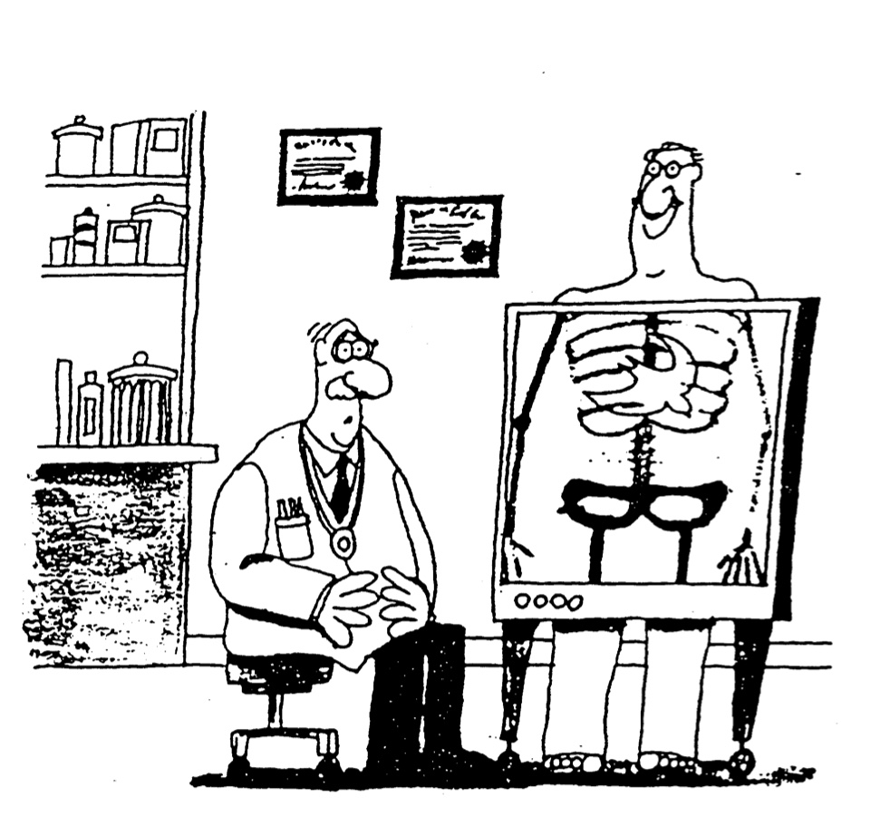
Name ____________________________________

What Do You Think of the Holy Spirit?

Please circle one of these three responses to each of the following questions:
(A) Agree, (U) Unsure, or (D) Disagree.

Control
1. A U D The Spirit puts thoughts into our minds.
2. A U D The Spirit removes thoughts from our minds.
3. A U D The Spirit will never override people’s bodily movements against their will.

4. A U D The Spirit does not cause us to do things that result in division in a local church (Eph. 4:3-4; 1 Cor. 12:13).

5. A U D The Spirit always works in our lives in what we consider to be an orderly manner (John 3:8 “wind goes where it wills”; Acts 8:39).

Prayer
6. A U D I have a personal relationship with the Spirit (John 14:16-17).
7. A U D It’s alright to pray to the Holy Spirit (as well as to the Father).
8. A U D It’s alright to pray to Jesus Christ (as well as to the Father).

Manifestations

9. A U D The Spirit sometimes uses our own psychological manifestations which we think are from Him (e.g., one thinking he has the gift of tongues when he really doesn’t).

10. A U D The Spirit sometimes works in our lives in ways which are not mentioned in the Bible (non-biblical, though not anti-biblical). See 1 Cor. 2:10.

Filling
11. A U D We cannot sin when we are filled with the Spirit.
12. A U D Every Christian has, at some time, been filled with the Spirit (e.g., at salvation).
13. A U D We should pray to be filled with the Spirit.
14. A U D Mature believers are filled with the Spirit.
15. A U D Those filled with the Spirit are mature believers.
Tongues
16. A U D I was baptized in the Holy Spirit after my conversion (I had a “second blessing”).
17. A U D I have spoken in tongues in the biblical way (exercised the biblical gift of tongues).
18. A U D I have had a glossalalia experience (ecstatic speech which was not real tongues).
19. A U D The biblical gift of tongues must be in a foreign language unknown to the speaker.
20. A U D The gift of tongues is being distributed by the Spirit today.
Prophecy
21. A U D Biblical prophecy is always inerrant (i.e., true prophecy never has errors).
22. A U D Prophecy can be exercised by any Christian.
23. A U D Some NT prophecy is less authoritative than OT prophecy.
24. A U D Some spiritual gifts have ceased.
The Personality of the Spirit

Importance
Why must we believe that the Holy Spirit is a person? What follows logically if He is a “fluid” (Mormons) or an influence or “force” (Jehovah’s Witnesses and New Age)?

Evidence for the Personality of the Spirit
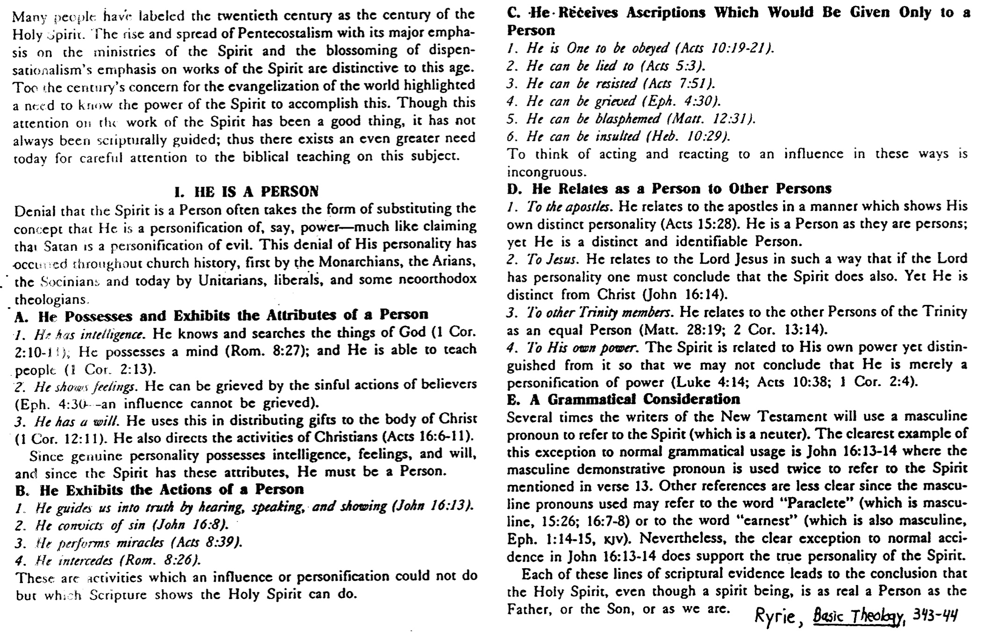

Biblical Evidence for the Doctrine of the Trinity
(Adapted from Dr. R. Walter Martin; cf. Colossians notes, 194-99)

Introduction

“Many people think that the Trinity is impossible to understand, that it is a logical and conceptual impossibility. The cults vehemently deny the Trinity, asserting that it is a doctrine of Satan. The non-Christian religions make sport of the doctrine, saying that Christians believe in three gods.

“But it is possible to understand the Trinity. We may not have exhaustive knowledge of the doctrine. But we can know it enough to state it clearly and understand it deeply....”1

How to Prove the Trinity

1. Begin the investigation into Scripture by starting from scratch, assuming nothing.

2. Demonstrate that the Bible teaches that only one God exists (Isa. 44:6; 1 Tim. 2:52).

3. Correctly define the Trinity: “Within the nature of the one, true God exists three Person(age)s: the Father, the Son and the Holy Spirit, who share the same attributes, are the same substance (nature, essence or reality) and are in effect the one, true God.”

4. Decide if Jesus is a lunatic (one who made false claims unknowingly), a liar (one who made false claims knowingly), or who he said he was (one who spoke the truth).3 Assuming Christ spoke only the truth, we must believe what he says. This is recorded in the Bible, so may we use only the Bible as our only authoritative source concerning this doctrine?

5. Show the person the reasonableness of this proposition: If three biblical Persons are all called God and share the same attributes of God, but there exists only one God, they are, in effect, the one, true God. (If this can be demonstrated, then the Trinity is true.)

6. The Bible conclusively proves the above proposition in the following passages that identify the same attributes/titles with the Father, the Son, and the Holy Spirit:

Attribute/Title Father Son Holy Spirit
Called “God” (deity) 2 Pet. 1:174 Heb. 1:6-85 Acts 5:3-46
Worshipped as God Matt. 4:107 John 20:288 None9
Indwells believers 1 Cor 3:16a10 Col. 1:2711 1 Cor 3:16b12
Is the truth John 3:3313 John 14:614 1 John 5:615
Raised Christ Acts 3:2616 John 10:1717 Rom. 8:1118
Omniscient (all-knowing) Ps. 139:1-519 John 16:320 1 Cor 2:10-1121
Omnipotent (all-powerful) Matt. 19:2622 Phil. 4:1323 Zech. 4:624
Omnipresent (everywhere) Jer. 23:2425 Matt. 18:2026 Ps. 139:7-1227
Has personhood John 3:1628 John 1:9-1829 John 14:1730
Helper (Paraclete) 2 Cor 1:3-6 1 John 2:1 John 14:2631
Forgives sin Isa. 45:2532 1 John 2:1233
Forgets sin Jer. 31:3434 Heb. 8:12 Heb. 10:1735
Immutable (changeless) Mal. 3:636 Heb. 13:837
Eternal Exod. 15:1838 John 1:1-239
“I Am” Exod. 3:14 John 8:58 40
“Alpha and Omega” Rev. 1:8 Rev. 22:13, 16
“First and the Last” Isa. 44:6 Rev. 1:17
Holy Isa. 6:341 Mark 1:2442 Luke 11:13

Note: Underlined verses are translated correctly in the Jehovah’s Witness New World Translation.

7. Additional evidence from both the Old and New Testament reaffirms the verses on the preceding chart to support the doctrine of the Trinity:

a. Old Testament Evidence:

1) The title Elohim (“God”) always appears in the plural (2570 times!), thus supporting the teaching of Scripture elsewhere that God is more than one Personage (Gen. 1:1ff.).

2) Plural personal pronouns (“Us” rather than “Me”) are used for God (Gen. 1:26; 3:22; 11:7; Isa. 6:8).

3) The three Persons of the Trinity appear together in the same passage as distinct from one another (Isa. 48:16; 59:20-21; 63:7-10).

4) Distinctions within the nature of God as Father, Son, and Holy Spirit are evident in:
a) Immanuel (Messiah) means “God with us” (Isa. 7:14).
b) The Son is called “the mighty God” (Isa. 9:6).
c) The Father delegates sovereign authority to the Son (Ps. 2:7).
d) The Father sent the Holy Spirit (Ps. 104:30).
e) One LORD is distinguished from the LORD (Gen. 19:24; Hos. 1:7).
f) The Spirit of the Lord (Holy Spirit) is distinct from the Father and Son (Isa. 48:16).
g) The Redeemer (who must be divine) is distinguished from the LORD (Isa. 59:20).
h) The Father sent the Angel of Jehovah, or pre-incarnate Christ, who is called God yet distinguished from Him (Gen. 16:7-13; 18:1-21; 19:1-28; 32:30; Mal. 3:1).

b) New Testament Evidence:

1) Jesus Christ is called the God incarnate (John 1:14) and the Son of God (Matt. 16:16) but He was conceived by the Holy Spirit (Matt. 1:18, 20); however, He is never called “the Son of the Holy Spirit.” Therefore, the Spirit must be God since God conceived Mary to produce the Son of God!

2) The three Persons of the Trinity are distinguished at the baptism of Christ, where the Father spoke from heaven and the Holy Spirit descended as a dove (Matt. 3:16-17).

3) The Father and the Comforter (Holy Spirit) are distinguished from Christ Himself (John 14:16-17).

4) The Great Commission command to baptize “in the name (singular) of the Father, the Son, and the Holy Spirit” breaks the rules of grammar by using a singular noun (“name”) with three (i.e., a plural number of) genitives (Matt. 28:19). Again, in this trinitarian prescription for baptism, the three Persons are distinguished.

5) Many other passages distinguish between the Persons in the Godhead by listing all three in the same passage (John 3:21-24; 4:2-31; 15:26; Rom. 8:9; 1 Cor 12:3-6; 2 Cor 1:21; 13:14; Eph. 1:17; 2:13-22; 3:14-19; 2 Thess. 2:13-14; Jude 20-21; Rev. 1:4-5).

Misunderstandings of the Trinity

1. Tritheism: three persons who are three gods

2. Modalism: one person who manifests himself in three different ways

3. Unitarianism: one person who is the only God

4. Nonsense: one person who is at the same time three persons

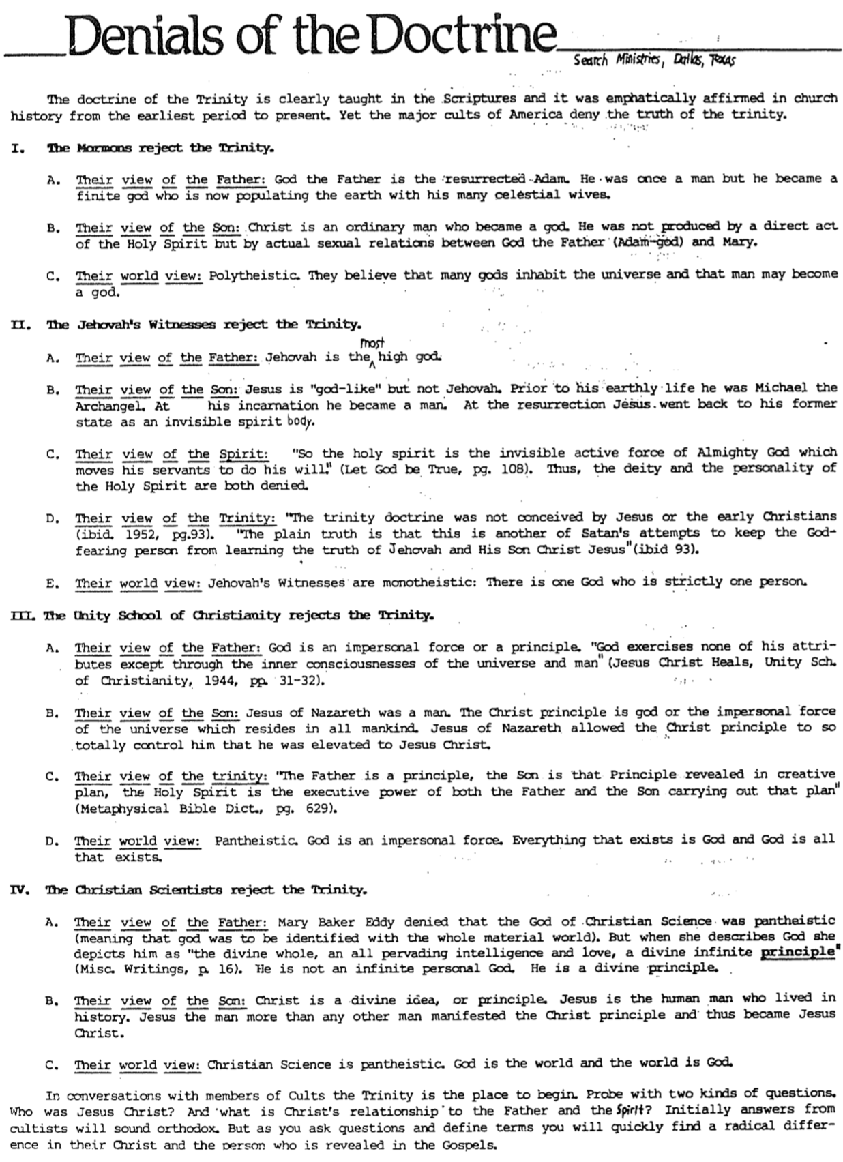
Denials of the Doctrine
(Search Ministries)

Different Views of God Diagrammed
(Search Ministries)
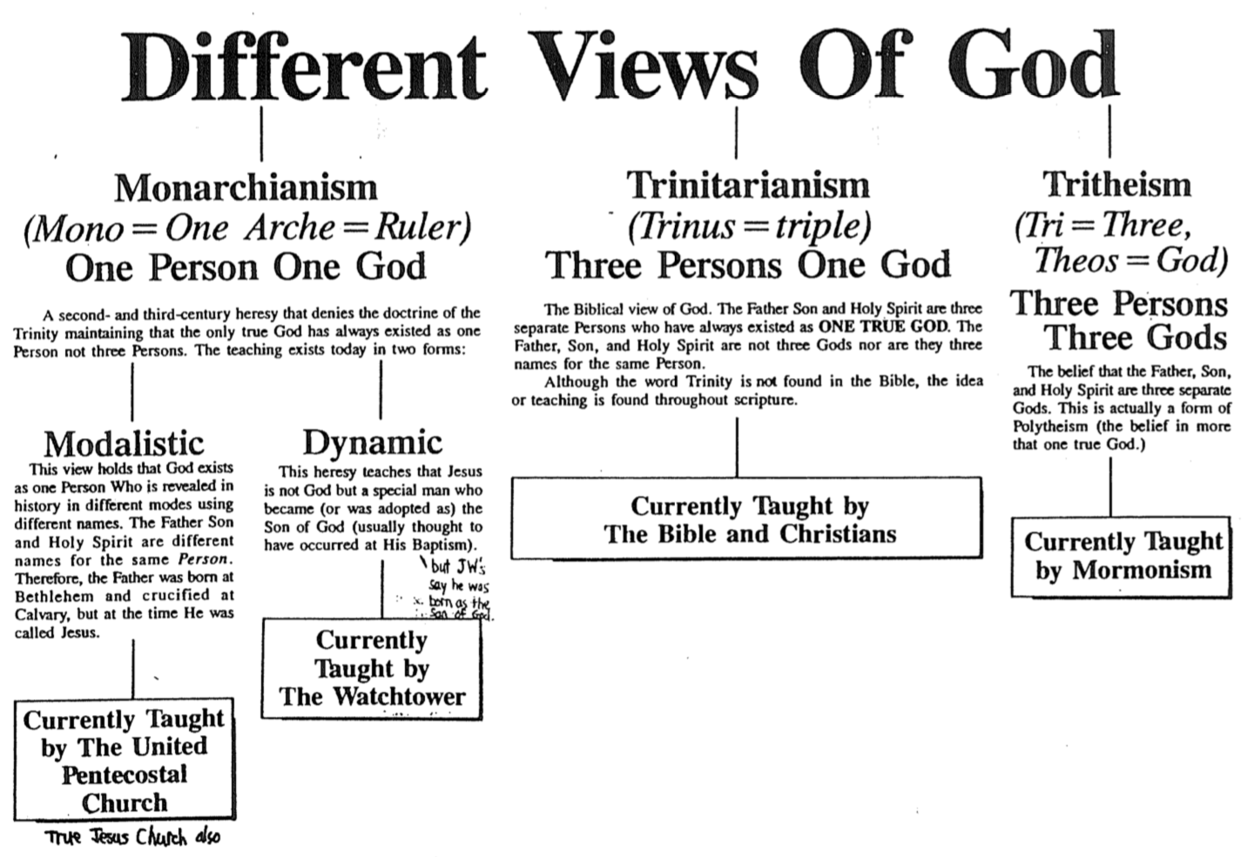
Illustrations of the Trinity

No illustration of the Trinity can be adequate, but the following illustrations depict some of its aspects:

1. The triple point of water: Water in a vacuum tube at zero degrees centigrade will contain liquid, ice, and vapor, yet each part will still be H2O, the same substance.

2. An Egg: An egg comprises three parts: the white, yolk, and shell. However, it is one egg.
Problem: Illustrates “parts” of God which are unscriptural

3. The Sun: The Sun is unapproachable (the Father) but is the source of beneficial light (the Son), which in turn gives power to make plants grow (the Spirit).
Problem: Impersonal illustration, whereas God is a personal being

4. A Man: A man can simultaneously be a father, son, and husband, although he is but one man.
Problem: Approaches modalism since it indicates three different functions for one man.

5. A Diagram: Here is the best Trinity diagram that I have seen (Charles Ryrie, Basic Theology, 55):

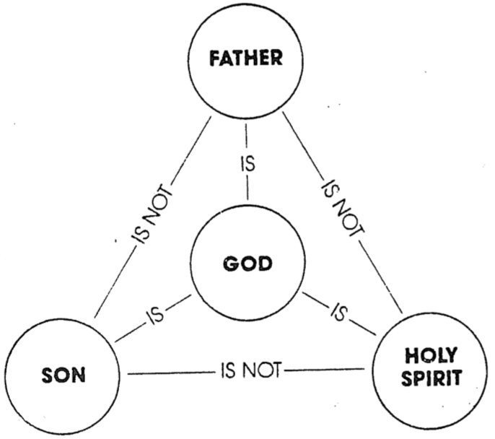

Conclusion

“A popular statement about the Trinity goes like this, ‘Try to understand the Trinity, and you will lose your mind, but fail to understand the Trinity, and you will lose your soul.’ This betrays a misunderstanding of the doctrine. The Trinity is not a logical contradiction. For God to be three persons, yet one essence, is logically possible. We do know the what of the Trinity: God is three persons but one essence. But the how of the Trinity–the exhaustive knowledge of how the persons of the Trinity relate to one another–that is a mystery. It is what we can know, coupled with what we cannot know, that compels us to worship such a great God.”43

Trinity Study Endnotes

Note: Underlined verses are translated correctly in the Jehovah’s Witness New World Translation. Those with double underlines are particularly clear even in this distorted version of the Bible.

1 “The Trinity.” An unpublished study outline by Search Ministries, Dallas, TX.
2 Deut. 4:39b; Isa. 43:10; 44:8; 45:22; Mark 12:29; Gal. 3:20; Eph. 4:5-6; Jas. 2:19; 1 Cor 8:4-6.
3 For a full explanation of the “Liar, Lunatic, Lord” apologetic, see Josh McDowell's Evidence that Demands a Verdict (San Bernardino, CA: Here's Life Publishers, 1979), 103-107.
4 1 Cor 1:3; Eph. 6:23; Phil. 1:12; 2:10; Col. 3:17.
5 Matt. 1:23; 4:6-7; Mark 2:1-12; John 1:1, 14; 5:18; 10:30; 12:44-45; 14:9-11; 15:23; 17:11, 21; 20:28; Rom. 9:5; Phil. 2:8-11; Col. 1:15-19; 2:9; Tit 2:13; Heb. 1:1-4; 2 Pet. 1:1; 1 John 5:20; Rev. 1:8 with 1:17-18.
6 Matt. 1:18 with 16:16; 2 Cor 3:17.
7 Exod. 20:3-5.
8 Matt. 2:2, 8, 11; 28:17; Heb. 1:6.
9 No explicit NT text (that I know of) encourages us to worship the Spirit or pray to Him.
10 2 Cor 6:16.
11 Rom. 8:10.
12 John 14:17; 1 Cor 6:19.
13 John 7:28; 8:26.
14 John 1:14; 8:32 with 8:36.
15 John 15:26; 16:13.
16 1 Thess. 1:10; Col. 2:12.
17 John 2:19-21.
18 Acts 17:31.
19 Matt. 10:29-30.
20 Col. 2:3; Heb. 4:13; Rev. 2:23.
21 Isa. 11:2.
22 Gen. 18:14; Job 42:4; Jer. 32:17; Zech. 8:6; Mark 10:27; Lk 1:37; 18:27.
23 Col. 1:17; Heb. 1:3.
24 Perhaps also 1 Cor 12:13.
25 Job 22:12-14; Eph. 4:6.
26 Matt. 28:20; Col. 1:27.
27 John 14:17.
28 Matt. 6:9-13.
29 Phil. 2:6-8.
30 The Holy Spirit is not a “vapor” or a “divine influence.” Only a person is referred to by the personal pronoun “He” (John 16:8), and only a person can be quoted (Acts 13:2).
31 Mark 2:7; Ps. 103:3a, 12; Isa. 1:18; 44:22; 53:5; Jer. 31:34.
32 Mark 2:1-11; Acts 10:43; 13:38.
33 John 15:26.
34 Isa. 43:25.
35 The Father’s words (Jer. 31:34) are attributed to the Son (Heb. 8:12) and Spirit (Heb. 10:17). The author could not exercise this freedom unless all three are one.
36 James 1:17.
37 Heb. 1:12.
38 Ps. 41:13; Rev. 1:8.
39 Col. 1:15; Rev. 22:13.
40 John's seven “I am” statements are 6:35; 8:12; 8:58; 10:11; 11:25; 14:6; 15:1.
41 1 Pet. 1:15-16; Rev. 4:8; 15:4
42 Parallel in Luke 4:34; cf. Luke 1:35; John 6:69; Acts 2:27; 13:35; Rev. 3:7.
43 “The Trinity.” An unpublished study outline by Search Ministries, Dallas, TX.

The Spirit in Relationships
Adapted from Charles Ryrie, The Holy Spirit, 2d ed.

I. The Holy Spirit in Relation to Creation

A. Notice how the creative work of the Holy Spirit soon became a ministry of providence.

Work of Creating | Work of Sustaining
Created the world (Gen. 1:2, 26 “Elohim” & “us”) | Does not create but only sustains (Ps. 104:30)
Created man directly (Job 33:4) | People come from their parents (Gen. 5:1-3’ Matt. 1;1-17)

B. Question: How do the above contrasts relate to a theology of rest?

Answer: God (Father, Son, and Spirit) presently rests from His creative work but not from His sustaining work (cf. John 5:17).

II. The Holy Spirit in Relation to Man

A. “Holy Spirit” appears only 3 times in the OT, and, although very active, he is mostly in the NT. Note this contrast of the work of the Spirit in the Old and New Testaments as He relates to man:

Old Testament | New Testament
Indwelt only some men of God, such as Joshua (Num. 27:18; cf. the testimonies of pagan kings in Gen. 41:38; Dan. 4:8; 5:11-14) | Indwells all believers in Christ (1 Cor. 12:13)
Came on persons (Judg. 3:10) | Comes in persons (1 Cor. 6:19)
Temporary indwelling: Samson (Judg. 13:10 vs. 16:20), Saul (1 Sam. 10:10 vs. 16:14) | Permanent indwelling (John 14:16)
Enabling or gifting limited to some people (Exod. 31:3) | Enabling or gifting unlimited (Eph. 1:3) as  it is for all believers (1 Cor. 12:7, 11, 18)
No baptism by the Spirit existed (Acts 1:5; John 7:37-39) | Baptism by the Spirit applies to all Christians (1 Cor. 12:13)
Filling of the Spirit for individuals (especially unlikely ones) | Filling of the Spirit for the entire body (Eph. 5:18)
Filling of the Spirit for leaders only for national good | Filling of the Spirit for leaders and followers for corporate good of the church
Filling of the Spirit for Jews only | Filling of the Spirit for Jews and Gentiles

B. Question: How do these contrasts affect our interpretation of OT Scripture (e.g., Ps. 51:11)?

Answer: OT prayers such as “do not take your Spirit away from me” (Ps. 51:11) are inappropriate today due to the new ministries of the Spirit.
III. The Holy Spirit in Relation to Revelation and Inspiration

 | Revelation | Inspiration
Definition | “The disclosure of that which was previously unknown” (Ryrie, The Holy Spirit, 2d ed., 41) | “God’s superintending human authors so that, using their own individual personalities, they composed and recorded without error His message to man in the words of their original writings in the Bible” (Ryrie, The Holy Spirit, 2d ed., 42)
Meaning | “Unveiled, disclosed” | “God breathed”
Concerns | Material (the content God shows) | Method (how the material was recorded)
Scope | Bible, prophecies, nature, Christ (not all revelation is in the Bible) | Bible

IV. The Holy Spirit in Relation to Jesus Christ

A. Birth of Christ

1. Scripture clearly teaches that Jesus was conceived of the Holy Spirit (Matt. 1:20; Luke 1:35).

2. But why must this be so?

a. He had to be born as the Son of God, thus becoming the God-man who could bear man’s sin.

b. He had to be born without a sinful nature.

1) Problem: But how could this be since his mother was a sinner? Even if Jesus didn’t receive a sinful nature from an earthly father, wouldn’t an earthly mother such as Mary pass this on to Him?

2) No. Each of us receives our sinful nature not from our mother but from our father. Romans 5:12-19 notes that Adam’s sin was passed to the future generations, not Eve’s (even though she was the first mother of creation).

B. Life of Christ

- Anointed for ministry by the Spirit (Luke 4:18; Acts 4:27; 10:38; Heb. 1:9)
- Filled with the Spirit (Luke 4:1)
- Sealed with the Spirit (John 6:27)
- Led by the Spirit (Luke 4:1)
- Rejoiced in the Spirit (Luke 10:21)
- Empowered by the Spirit (Matt. 12:28; Luke 4:14-15, 18)
- Sustained in death (Heb. 9:14; cf. Ryrie, The Holy Spirit, 48-49)
- Raised by Spirit? (Rom. 1:4?; 8:11?; 1 Pet. 3:18?)
Charles Ryrie, The Holy Spirit, 2d ed., 66

V. The Holy Spirit in Relation to Prayer

A. Glory of Christ and Worship of the Spirit

1. Question: Should we worship the Holy Spirit? Or would this detract from the glory due to Jesus Christ?

2. What are the implications if we can worship the Spirit or if we cannot?

3. Support: Some groups encourage worship of the Spirit.

a. The Westminster Confession of Faith (AD 1643-1646) encourages worship of the third person of the Trinity:

CHAPTER 21: OF RELIGIOUS WORSHIP, AND THE SABBATH-DAY

2. Religious worship is to be given to God, the Father, Son, and Holy Ghost; and to him alone; not to angels, saints, or any other creature: and, since the fall, not without a Mediator; nor in the mediation of any other but of Christ alone.

3. Prayer, with thanksgiving, being one special part of religious worship, is by God required of all men: and, that it may be accepted, it is to be made in the name of the Son, by the help of his Spirit, according to his will, with understanding, reverence, humility, fervency, faith, love, and perseverance; and, if vocal, in a known tongue.

b. J. I. Packer says, "Is it proper to pray to the Spirit? There is no example of doing this anywhere in Scripture, but since the Spirit is God, it cannot be wrong to invoke and address him if there is good reason to do so" (Keep in Step With the Spirit [Old Tappan, N.J.: Revell, 1984], p. 261).
c. Wayne Grudem, Systematic Theology, 380-81, also encourages prayer to the Spirit:

4. Should We Pray to Jesus and to the Holy Spirit? A survey of the prayers of the New Testament indicates that they are usually addressed neither to God the Son nor to the Holy Spirit, but to God the Father. Yet a mere count of such prayers may be misleading, for the majority of the prayers we have recorded in the New Testament are those of Jesus himself, who constantly prayed to God the Father, but of course did not pray to himself as God the Son. Moreover, in the Old Testament, the trinitarian nature of God was not so clearly revealed, and it is not surprising that we do not find much evidence of prayer addressed directly to God the Son or God the Holy Spirit before the time of Christ.

Though there is a clear pattern of prayer directly to God the Father through the Son (Matt. 6:9; John 16:23; Eph. 5:20) there are indications that prayer spoken directly to Jesus is also appropriate. The fact that it was Jesus himself who appointed all of the other apostles, suggests that the prayer in Acts 1:24 is addressed to him: “Lord, who knows the hearts of all men, show which one of these two you have chosen....” The dying Stephen prays, “Lord Jesus, receive my spirit” (Acts 7:59). The conversation between Ananias and "the Lord" in Acts 9:10-16 is with Jesus, because in verse 17 Ananias tells Saul, ‘The Lord Jesus…has sent me that you may regain your sight." The prayer, “Our Lord, come!” (1 Cor. 16:22) is addressed to Jesus, as is the prayer in Revelation 22:20, "Come, Lord Jesus!” And Paul also prayed to "the Lord" in 2 Corinthians 12:8 concerning his thorn in the flesh. [Footnote: The name Lord (Gk. kyrios) is used in Acts and the Epistles primarily to refer to the Lord Jesus Christ.]

Moreover, the fact that Jesus is "a merciful and faithful high priest" (Heb. 2:17) who is able to "sympathize with our weaknesses" (Heb. 4:15), is viewed as an encouragement to us to come boldly before the "throne of grace" in prayer "that we may receive mercy and find grace to help in time of need" (Heb. 4:16). These verses must give us encouragement to come directly to Jesus in prayer, expecting that he will sympathize with our weaknesses as we pray. There is therefore clear enough scriptural warrant to encourage us to pray not only to God the Father (which seems to be the primary pattern, and certainly follows the example that Jesus taught us in the Lord's Prayer), but also to pray directly to God the Son, our Lord Jesus Christ. Both are correct, and we may pray either to the Father or to the Son.

But should we pray to the Holy Spirit? Though no prayers directly addressed to the Holy Spirit are recorded in the New Testament, there is nothing that would forbid such prayer, for the Holy Spirit, like the Father and the Son, is fully God and is worthy of prayer and is powerful to answer our prayers. (Note also Ezekiel's invitation to the "breath" or "spirit" in Ezek. 37:9.) To say that we cannot pray to the Holy Spirit is really saying that we cannot talk to him or relate to him personally, which hardly seems right. He also relates to us in a personal way since he is a "Comforter" or "Counselor" (John 14:16, 26), believers "know him" (John 14:17), and he teaches us (cf. John 14:26), bears witness to us that we are children of God (Rom. 8:16), and can be grieved by our sin (Eph. 4:30). Moreover, the Holy Spirit exercises personal volition in the distribution of spiritual gifts, for he "continually distributes to each one individually to each one as he wills" (1 Cor. 12:11, author's translation). Therefore, it does not seem wrong to pray directly to the Holy Spirit at times, particularly when we are asking him to do something that relates to his special areas of ministry or responsibility.

In fact, through the history of the church several well-used hymns have been prayers to the Holy Spirit (see two at the end of chapter 30, pp. 655-56; one at chapter 52, pp. 1047-48; and one at chapter 53, pp. 1087-88). But this is not the New Testament pattern, and it should not become the dominant emphasis in our prayer life.

4. Response:

a. Notice that Article 2 of the Westminster Confession of Faith above encourages prayer to the Son through the mediation of the Son and in the name of the Son!

b. The fact that several hymns encourage us to pray to the Spirit does not mean that this should be a biblical precedent. It only argues that some advocate it.

c. We have already established that the Spirit is indeed God (see previous study). However, in contrast to the emphasis of numerous reformed and charismatic churches today, Scripture is clear that the Spirit is not to be glorified.

1) Jesus noted that the Spirit would glorify Him: “He [the Spirit of truth] will bring glory to me by taking what is mine and making it known to you” (John 16:14).

2) Paul added, “We… are the circumcision, we who worship by the Spirit of God, who glory in Christ Jesus, and who put no confidence in the flesh” (Phil. 3:3).

d. However, as Grudem notes above, the Spirit is intimately involved in our lives in numerous ways. Also, since He prays for us, He certainly understands our hearts when we pray to Him and presumably places these requests and praises before the Father and the Son.

B. The Role of the Holy Spirit in Our Praying

1. Romans 8:26-27 says, “In the same way, the Spirit helps us in our weakness. We do not know what we ought to pray for, but the Spirit himself intercedes for us with groans that words cannot express. And he who searches our hearts knows the mind of the Spirit, because the Spirit intercedes for the saints in accordance with God’s will.”

2. Response:

a. This verse applies to all Christians, as the entire chapter indicates His ministries for us all (v. 23 says we all await our adoption and vv. 29-30 speak of our predestination, calling, justification, etc.). This is not a ministry of the Spirit only for a select few.

b. While some (e.g., Grudem, 381) say that we are the speakers, the verse says it is the Spirit who speaks, not us. Since the Spirit is the subject, nothing in the verse says anything about humans speaking. The Spirit intercedes “for” us, not “through” us, as charismatics claim.

c. When the Spirit does speak, He does so with inaudible, nonuttered, internal groanings. “The word alaletos has the idea of ‘unexpressed,’ ‘wordless,’ [BAGD 34] or ‘unutterable’ [Liddell/Scott 60]. Cranfield feels that the choice lies between ‘ineffable,’ ‘that cannot be expressed in ordinary speech,’ or ‘unspoken,’ with the next verse suggesting the latter. The a in alaletos is similar to the English prefix ‘un-’ (a-laletos = un-spoken); the expression means ‘unspoken’ or ‘inaudible.’ Since it is in combination with the word ‘groanings,’ there is little possibility that any audible utterance is meant in the verse’” (Thomas R. Edgar, Satisfied by the Promise of the Spirit [Grand Rapids: Kregel, 1996], 178-79).

d. We should oppose the idea that special gifts for prayer or praise to God is the possession of certain Christians. Every Christian has this privilege since we all have equal access to God through Christ.

Blasphemy Against the Spirit

I. The Problem Stated

A. Christ’s Statement

1. “And so I tell you, every sin and blasphemy shall be forgiven men, but the blasphemy against the Spirit will not be forgiven. Anyone who speaks a word against the Son will be forgiven, but anyone who speaks against the Holy Spirit will not be forgiven, either in this age or in the age to come” (Matt. 12:31-32).

2. “I tell you the truth, all the sins and blasphemies of men will be forgiven them. But whoever blasphemes against the Holy Spirit will never be forgiven; he is guilty of an eternal sin” (Mark 3:28-29).

3. This statement does not appear in Luke’s account of this story (Luke 11:14-22).

4. Hebrews 6:4-6 seems to speak of the same sin.

B. Unacceptable Interpretations

1. Using Christ’s name in vain

2. A sinful lifestyle that causes a Christian to lose his salvation forever (not repentable)

3. Cessationists will not go to heaven

4. This sin could only happen during His earthly ministry and thus cannot happen today. Jesus isn’t physically here performing miracles—it has to be committed to His face.

5. A non-Christian’s unbelief which lasts until death

II. The Problem Solved

A. The Context: Jesus was accused of casting out demons by Satan’s power on at least three occasions. Once it took place near Capernaum (Matt. 9:34) and another time in Judea or Perea (Luke 11:14-23). However, the climactic event took place in Galilee and indicated the leaders’ utter refusal to believe (Matt. 12:22-37; cf. Mark 3:20-30). This resulted in Christ’s turning to parables, especially concerning the mysterious form of the kingdom (Matt. 13).

Note now the setting for the story in Matthew’s account:

1. Christ’s healing of the blind/mute (Matt. 12:22; cf. Luke 11:14)

2. The audience’s conclusion: “He’s Messiah!” (Matt. 12:23)

3. The Pharisee’s accusation: “He’s demonic!” (Matt. 12:24)
4. Christ’s threefold response (Matt. 12:25-29)

a. Satan never fights against himself (25-26)

b. Jewish exorcists don’t cast demons out by Satan’s power, so neither did Jesus (27)

c. Since God’s power had overcome Satan’s, God’s kingdom had come (28-29)

B. The Nature of the Sin

1. Blasphemy is something spoken with the tongue but revealing what is in the heart

2. The statement is spoken against the Spirit—not Christ (Matt. 12:31-32a)

3. The sin has eternal results because those who commit it refuse to repent (Matt. 12:32b). Therefore, this sin can be committed only by non-Christians.

4. This is the willful sin of attributing Christ’s miracles to Satan despite seeing His person and power.

5. Note that this is a different sin than the one mentioned in 1 John 5:16-17, which mentions “a sin that leads to death.” In this case, the issue is not that the sin is unforgiven, but only that it results in physical death. The sin noted there appears to relate to the context in teaching a serious error about Christ (Grudem, 509). Alternatively, it could relate to treating Christ’s name in such an unholy manner that God takes the sinner to heaven as He did with Corinthian believers who so abused the Lord’s Supper (1 Cor. 11:30).

III. Suggestions for Counseling

A. Make sure the person has placed genuine faith in Christ’s atoning death.

B. Assure the Christian with this concern that if it is indeed a concern, then it shouldn’t be! People who commit this sin don’t care if they do!

The seal below is one of the few intact ancient letters found by archaeologists. It reveals how letters were sealed during New Testament times. After being folded carefully many times, wax was placed over the edges and stamped with the sender’s seal. This guaranteed both the security and the ownership of the letter by the sender. This illustrates how the Spirit Himself is the believer’s seal, assuring both his eternal security and his ownership by God! For further explanation, see the following two pages.
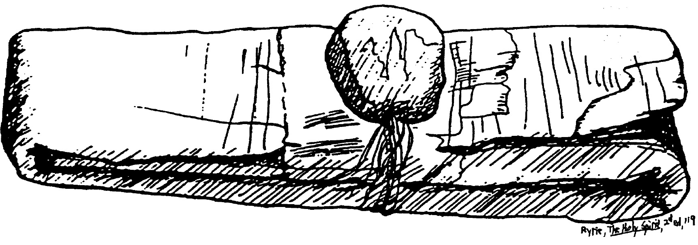

Figure 15.1 An ancient papyrus and seal

The Indwelling & Sealing of the Spirit (Rom. 8)
(cf. Romans notes,155q-r)

I. Confusion: All or Part at Salvation?

A. Sometimes Christians pray that they will receive the Spirit at some point after salvation.

1. The reception of the Spirit came after salvation in some passages in Scripture:

Acts 2 (cf. 1:4-5)

Acts 8:14-17

(Acts 19:1-7 refers to OT believers in Messiah)

2. Christians sometimes point to these verses for support that the Spirit does not indwell all believers. They contend that every Christian must seek His indwelling.

B. The Issue: Do we receive all or part of God when we become a Christian? (In other words, can God be divided up into parts, each of whom comes at different times?)

II. The Indwelling of the Spirit (adapted from Charles Ryrie, The Holy Spirit, 67-73)

A. The Spirit indwells even carnal believers (1 Cor. 3:16; 6:19).

B. Since the Spirit is a gift given indiscriminately (Acts 11:17; cf. 10:44), believers cannot earn Him (John 7:37-39; Rom. 5:5; 1 Cor. 2:12; 2 Cor. 5:5).

C. Absence of the Spirit indicates an unregenerate state (Rom. 8:9b; Jude 19; cf. 1 Cor. 2:14).

D. The Spirit abides forever (John 14:16), though Christians can grieve Him (Eph. 4:30).

E. The obedience requirement for the indwelling (Acts 5:32) is the obedience of faith in Christ.

F. The times when the Spirit was withdrawn due to sin (1 Sam. 16:14; Ps. 51:11; Luke 11:13) all occurred before Pentecost when He was given permanently (Acts 2; cf. John 14:16).

G. The delay of giving the Spirit to the Samaritans (Acts 8:14-17) is not the norm for today:

1. The Spirit came at the same time as salvation for Gentiles (Acts 10:44), so if a pattern is to be followed for Gentiles today then this would be it.

2. The reason the Spirit indwelt the Samaritans after salvation: This was the first time any Samaritans were saved, so God delayed the Spirit’s coming until Jews could verify it. This tied them into the church as a whole to prevent two types of Christians.

H. The anointing of the Spirit is given to all believers (2 Cor. 1:21; 1 John 2:20, 27). No passage teaches that certain Christians are anointed and others are not.

“The difference between the anointing and indwelling seems to lie in their distinct purposes. The indwelling brings the presence of God into the life of the believer. The anointing, as far as the believer is concerned, is that he might be taught (1 John 2:20, 27). Actually, this seems to be the only purpose specified in the believer’s case. However, if one may use the example of the anointing of Christ [Luke 4:18; Acts 4:27; 10:38; Heb. 1:9] and Old Testament priests [Exod. 30:32-33; cf. anointing of kings 1 Sam. 10:1; Zech 4:14], then another purpose emerges—that of service. But…the full experience of the anointing depends on being filled with the Spirit” (Ryrie, 73).
III. The Sealing of the Spirit (cf. Eldon Woodcock, “The Seal of the Holy Spirit” Bibliotheca Sacra 155 [April-June 1998]: 139-63)

A. Agent: God is the agent of the sealing (i.e., He is the one who seals the believer), according to 2 Corinthians 1:22 (cf. John 6:27).

B. Sphere: “The Holy Spirit is the seal. The believer is sealed with or in the Spirit. In Ephesians 1:13 there is no preposition expressed” (Ryrie, 80). In other words, technically we are not sealed “by” the Spirit but “with” the Spirit.

C. Extent: All believers are sealed:

1. All the Corinthian believers (carnal and spiritual alike) were sealed (2 Cor. 1:22).

2. Christians are nowhere exhorted to seek a sealing.

3. The believer’s sealing is the basis for the exhortation not to grieve the Spirit (Eph. 4:30).

D. Time: Since all Christians are sealed, this must happen at salvation.

E. Intent: There exist two purposes for the sealing of Christians:

1. Security: It assures that since God gave us His Spirit, He will give us our entire inheritance in heaven as well (2 Cor. 1:22b; Eph. 4:30), including redeeming our bodies (Eph. 1:13-14).

2. Ownership: It shows that God owns us (2 Cor. 1:22b, “seal of ownership”)

IV. Security and Assurance

 | Eternal Security | Assurance of Salvation
Basic Meaning | Being saved from the penalty of sin forever (once saved, always saved) | Knowing that we are saved from the penalty of sin forever
Definition | “The work of God which guarantees that the gift of salvation, once received, is forever and cannot be lost” (Ryrie, Basic Theology, 328) | “The realization of the truth of eternal security or perseverance” (Ryrie, Basic Theology, 328)
Spirit’s Ministry | Sealing (Eph. 1:13-14) | Assuring (Rom. 8:15-17)
Believer’s… | Position as child of God (Rom. 8:16b) | Practice of confidence (Rom. 8:16a)
Recipients | All Christians possess | Some Christians doubt
Permanence | Can’t be lost (John 6:39-40; 10:27-29; Rom. 8:30, 38-39; Heb. 7:25) | Can be lost (for this reason John wrote 1 John 5:11-13)
Songs | “I Know Whom I Have Believed” | “Blessed Assurance”

Clarification: Preservation is largely the same as eternal security, but perseverance focuses more on the believer who perseveres (through the decree and power of God). In contrast, security focuses on God—it is God who secures our salvation (Ryrie, Basic Theology, 328).

V. Conclusion

A. We are secure in Christ with the Spirit’s presence, and He will never leave us (Heb. 13:5)!

B. The Holy Spirit guarantees us that once we have Him, it is only a matter of time before we will have our entire heavenly inheritance.

C. A believer has security whether or not he has assurance.
Interpretive Issues on Spirit Baptism
(cf. 1 Corinthians notes, 161x-z)
- The Issue Stated

  - Both John and Jesus promised the disciples that they would be baptized with the Spirit, which was fulfilled on the Day of Pentecost (Acts 2). The Spirit is not mentioned as the agent (the one who baptizes) in these references in the Gospels and Acts, but all translations show him to be the agent in 1 Corinthians 12:13. The translation of “baptized with the Spirit” in the Gospels/Acts is accepted by both charismatic and non-charismatic interpreters.
  - However, a difference of opinion occurs regarding 1 Corinthians 12:13, translated as follows:

“For we were all baptized by* one Spirit into one body—whether Jews or Greeks, slave or free—and we were all given the one Spirit to drink” (NIV, *Marginal Note: Or with, or in)

“For by* one Spirit we were all baptized into one body, whether Jews or Greeks, whether slave or free, and we were all made to drink of one Spirit” (NASB, *Marginal Note: Or in)

Because of the added phrase “into one body,” both interpretive camps see a need to render the “by one Spirit” phrase differently than in the gospels. The Pentecostal choice is “in one Spirit,” but the non-Pentecostal view is “by one Spirit.” Both “in” and “by” are acceptable grammatically, but theology and the rest of the verse must also be considered to make the best decision.

- The Choices Reviewed
The phrase Baptizo en Pneumati can be translated in three different ways:

  - “Baptized in the Spirit”: This translation makes the Spirit the element (or sphere) into which a believer is spiritually baptized. This standard Pentecostal interpretation is advocated by some commentaries on 1 Corinthians (e.g., Gordon D. Fee, NICNT, 606; Leon Morris, TNTC, 174; Robertson/Plummer, ICC, 272; cf. NIV and NASB margins). These commentaries translate the next phrase “so as to become one body” (instead of the NIV “into one body”) with the idea that the Church is the end or goal of the baptism.
  - “Baptized by the Spirit”: This option makes the Spirit the agent or the one who does the baptizing. Most, if not all, reputable translations and paraphrases follow this interpretation (NIV, NASB, KJV, NKJV, Amplified, GNB, RSV, LB, Phillips, etc.). They all note that believers are baptized “into one body” so that the Church is the element (or sphere).

  - “Baptized with the Spirit”: This makes the Spirit the instrument in the baptism, a meaning which is used consistently in the Gospels and Acts. However, few (if any) translations render it this way in 1 Corinthians 12:13, though it is grammatically possible (cf. NIV margin; MacArthur, Charismatic Chaos, 231-32; my view on the next few pages).
* Some may hope that all three views exist at the same time (cf. David Lowery, “1 Corinthians,” in The Bible Knowledge Commentary, 2:533). However, this is unlikely as the sphere (element) in the text is specifically designated to be the body of Christ.
** Note that the concept of a “Baptism of the Holy Spirit” is not a scriptural designation since the Greek preposition en (ἐν) only very rarely means “of” (an exception is Rom. 5:15 ἡ δωρεὰ ἐν χάριτι “the gift of grace”).

- The Significance of the Issue
Why does it make any difference whether the translation is “in the Spirit” or “by the Spirit”?

  - The issue affects whether we must have a post-conversion Spirit baptism (a so-called “second blessing”) after our salvation, evidenced by speaking in tongues (cf. Acts 2:4). The “in the Spirit” view makes 1 Corinthians 12:13 teach a different baptism than the gospels/Acts and thus divides the Church into the “haves” and the “have-nots” (those with a special baptism experience versus “non-Spirit-baptized” believers).

  - The issue affects whether the baptizing and filling of the Spirit are separate (non- charismatic) or the same (charismatic) experiences.

  - The issue affects distinctions regarding whether the Church began on the day of Pentecost (non-charismatic) or not (charismatic). The latter view produces a much different conception of what is meant by the body of Christ, for it has the problem of explaining how the Church existed in the OT without any baptizing work of the Spirit. (Other problems also result from having the Church exist prior to Acts 2.)

- Reasons why “baptized with the Spirit into one body” may be the best solution

  - One phrase (baptizo en pneumati) describes the same work of the Spirit throughout the NT. The other uses of baptizo en pneumati contrast John the Baptist as an agent of baptism with Christ as an agent of baptism (Matt. 3:11; Mark 1:8; Luke 3:16; John 1:33; Acts 1:5; 11:16). Each of these references clearly mention Christ as the agent who “will baptize you with the Holy Spirit.” While the sphere into which Christ baptizes is not stated, this sphere is clearly indicated in 1 Corinthians 12:13 as the body of Christ, the Church. Thus, both the agent and the sphere are noted in Scripture, leaving us with the Spirit as the instrument.

  - In none of the six cases above is the Spirit the sphere (element) into which people were baptized, so why would He be the element in 1 Corinthians 12:13?
    - It makes much better sense to see the Spirit and Christ working together as dual agents to baptize believers into Christ’s body, reflected in “View B” on the next page and translated this way in most Bibles. (All reputable translations adhere to this view. While this itself is not determinative, note that a unanimous opinion exists against the Pentecostal interpretation of the verse.)

    - Perhaps it is even better to interpret baptizo en pneumati as indicating instrument/means. This way the same phrase is used in a consistent manner throughout the New Testament. Perhaps significantly, “Nowhere in the Bible is the Holy Spirit spoken of as the baptizer” (MacArthur, Charismatic Chaos, 231).

  - The Corinthian church did not become one body because of the Spirit baptism. Rather, it only joined the already existing universal church when these Corinthians were saved.

  - The translation of “in the Spirit” with its associated “so as to become one body” sheds doubt on whether all believers have received this Spirit baptism, which would contradict Romans 8:9.

Summary of Interpretations on Spirit Baptism

 | Gospel/Acts | 1 Corinthians 12:13
 | Matt. 3:11; Mark 1:8; Luke 3:16; John 1:33; Acts 1:5; 2:33; 11:16 | View A  Pentecostal Interpretation | View B  All Bible Translations, Non-Pentecostal View | View C  Non-Pentecostal View  —My View
Translation: How is baptizo en pneumati rendered? | “will baptize you with the Holy Spirit” | “We were all baptized in one Spirit so as to become one body” | “We were all baptized by one Spirit into one body” | “We were all baptized with one Spirit into one body”
Agent: Who baptizes? (“by…”) | Christ | (Unstated) | Holy Spirit  (under Christ) | (Unstated)—but the gospels show Him to be Christ
Instrument: With what or whom is the believer baptized? | Holy Spirit  —Matt. 3 says all are baptized either with the Spirit (v. 11, believers) or with fire (v. 12, unbelievers) | (Unstated) | (Unstated) | Holy Spirit
Sphere: Into what element is the baptism? | (Unstated) | Holy Spirit | Body of Christ | Body of Christ
Goal: To what end or purpose is the baptism? | (Unstated) | Body of Christ | (Unstated) | (Unstated)
Body: How is eis hen soma translated? | N/A | “so as to become one body” (goal or end) | “into one body” (sphere) | “into one body” (sphere)— same use in Rom. 6:3-4; Gal 3:26-27
Correlation of Gospels/Acts with  1 Cor 12:13 | — | Inconsistent | More consistent | Most consistent
Resulting Theology | N/A | Not all Christians have Spirit baptism (we should seek it) | All Christians already have Spirit baptism (we shouldn’t seek it) | All Christians already have Spirit baptism (we shouldn’t seek it)

Spirit Baptism & 1 Corinthians 13:8
Agent: by
Body?
Spirit
Christ
?
Spirit
Goal: so as to become
“with one Spirit”
Body
Spirit
Christ?
?
“by one Spirit”
Body
?
Spirit
?
“in one Spirit”
?
Christ?
one body
Instrument: with
Sphere: into
Translation:
“with the Spirit”
“with the Spirit”
Charles C. Ryrie, The Holy Spirit, 2nd ed., 113, 147

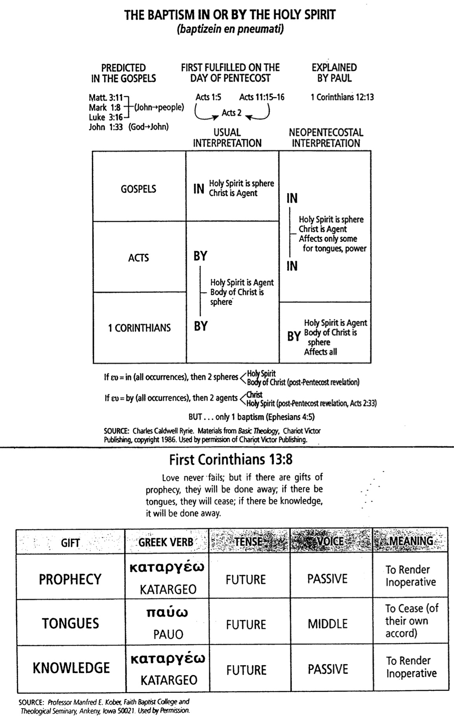
The Baptism and Filling with the Spirit

One key issue that must be clear to understand the Scripture’s teaching on charismatic issues is the biblical distinction between the Holy Spirit’s ministries of baptizing and filling:

 | The Baptism  with the Holy Spirit | The Filling  with the Holy Spirit
Definition or | The Spirit’s work of placing believers into | The Spirit’s work of empowering
Purpose | the body of Christ | (controlling) believers for service and
 |  | equipping them with Christ’s character
Scripture | Prophesied (Matt. 3:11; Mark 1:8; | “Walk by the Spirit” (Gal. 5:16)
 | Luke 3:16; John 1:33; Acts 1:5); | “Keep in step with the Spirit” (Gal. 5:25)
 | Fulfilled (Acts 2:1ff.; cf. 11:15-16); | Be “led by the Spirit” (Gal. 5:18)
 | Explained (1 Cor 12:13)
Key Passage | 1 Corinthians 12:13 | Ephesians 5:18
Tense | Aorist: past event, action undefined | Present: continuous, action repeated
Mood | Indicative: a statement of fact | Imperative: a command to heed
 | (“were baptized”), never commanded or | (“be filled”), shown how to receive the
 | shown “how to get the baptism” | filling by yielding ourselves to Christ
Time Occurs | At salvation | At and after salvation
 | “promise...is for all” (Acts 2:38-39) when
 | they believed (Acts 11:16-17)
 | “every spiritual blessing” (Eph. 1:3)
 | “complete in him” (Col. 2:9-10)
 | Believers have been given “everything
 | pertaining to...godliness” (2 Pet. 1:3)
Frequency | Not repeated (a one-time experience) | Repeated (throughout one’s life; compare
 |  | Acts 9:17; 13:9)
Participants | All Christians (spiritual and carnal) | Spiritual Christians
 | (“we were all baptized” 1 Cor 12:13;
 | cf. Gal. 3:2, 14; 4:6)
Permanence | Eternal: cannot be undone | Temporal: can be lost (Acts 2:4; 4:8,
 |  | 31)
Prerequisites | Faith in Christ | Yielding to Christ
OT | No: never happened before Pentecost | Yes: OT believers sometimes empowered
occurrences? |  | for service by the Spirit but not indwelt
Results | Position: | Practice:
 | Placed in the body of Christ (Church) | Praise, worship, thanksgiving,
 |  | submissiveness (Eph. 5:19-21);
 |  | Christlike character (Gal. 5:22-23);
 |  | Evangelistic involvement (Acts 2:4 w/
 |  | 2:41; 4:31 w/ 5:14; 6:3 w/ 6:7)
Commanded? | No | Yes
Sought? | No (Acts 11:15-16) | Yes
Walking by the Spirit
1 Corinthians 2:14–3:3
Adapted from the booklet How to Be Filled with the Holy Spirit (Campus Crusade for Christ)*


S
Natural Man Spiritual Man


S
Carnal Man

Throne (control center)
Interests
S Self

Christ

- Typically, the phrase “walking in the Spirit” is used regarding this ministry of the Spirit, but this phrase designates the sphere (which is the body of Christ). A better term is “walking by the Spirit,” which more accurately conveys dependence, as the phrase is a dative of means (Ryrie, The Holy Spirit, 1st ed., 100).
How the Spirit Leads Us

A Singaporean friend gave me a booklet in 1981 that has had a profound impact on me. George Mueller was a German missionary to England in the mid-1800s, with whom many Christians are acquainted. He founded several orphanages for the Lord and saw God answer over 50,000 prayers recorded in his lifetime (he kept a meticulous journal of his requests and God’s answers). I know of no other human source that can help us seize the will of God more than Mueller. Here are his steps on how the Spirit guided him during his lifetime, which spanned over 92 years (1805-1898).

1. I SEEK AT THE BEGINNING to get my heart into such a state that it has no will of its own regarding a given matter. Nine-tenths of the trouble with people is just here. Nine-tenths of the difficulties are overcome when our hearts are ready to do the Lord's will, whatever it may be. When one is truly in this state, it is usually but a little way to the knowledge of what His will is.

2. HAVING DONE THIS, I do not leave the result to feeling or simple impression. If I do so, I make myself liable to great delusions.

3. I SEEK THE WILL of the Spirit of God through, or in connection with, the Word of God. The Spirit and the Word must be combined. If I look to the Spirit alone without the Word, I lay myself open to great delusions also. If the Holy Ghost guides us at all, He will do it according to the Scriptures and never contrary to them.

4. NEXT, I TAKE into account providential circumstances. These often plainly indicate God's will in connection with His Word and Spirit.

5. I ASK GOD in prayer to reveal His will to me aright.

6. THUS, THROUGH PRAYER to God, the study of the Word, and reflection, I come to a deliberate judgment according to the best of my ability and knowledge, and if my mind is thus at peace, and continues so after two or three more petitions, I proceed accordingly.

In trivial matters and in transactions involving the most important issues, I have found this method always effective.

Source: George Mueller, “How I Ascertain the Will of God,” from “An Hour with George Mueller: The Man of Faith to Whom God Gave Millions” ed. A. Sims (Warren Myers, P.O. Box 125: Singapore), ca. 1981.

______

We tend to want to jump right to step 5, don't we?

Step 1 is the hardest, but it's also the most important.

Holy Laughter

I. History

A. In 1993 Randy Clark, pastor of Vineyard Christian Fellowship in St. Louis, Missouri, was depressed but helped by Rodney Howard-Browne, a South African evangelist who had moved his ministry to the USA in Tulsa, Oklahoma.

B. On January 20, 1994, the Airport Vineyard church in Toronto, Ontario, Canada, pastor John Arnott requested Howard-Browne to lead a four-day conference. These meetings showcased weeping, laughing, groaning, swaying with “drunkenness,” and other strange expressions such as people walking around like chickens and roaring like lions. The conference lasted months and this phenomenon became dubbed “The Toronto Blessing.” Howard-Browne has become the “evangelist” to spread it throughout the world, so now he is the key figure. It has so swept the world that an estimated 200-400 German Protestant churches and 5,000 of the estimated 50,000 Anglican and Protestant churches in the UK have experienced it (“IDEA” magazine?).

C. In September 1995 thousands of Singaporeans converged on the Singapore Indoor Stadium to witness the event sponsored jointly by 40 Singapore churches. People fell down, laughed hysterically, and even were floored en mass by Howard-Browne. The final evening at the national Stadium drew a crowd of 12,000. Reaction has been mixed.

D. John Wimber eventually withdrew his support of the movement due to its excesses. Several Pentecostal and charismatic leaders also do not support it.

II. Biblical Evaluation (for complete citations of sources, see the following bibliography)

A. Scripture warns against being a “sign seeker”: “A wicked and adulterous generation asks for a miraculous sign” (Matt. 12:39; cf. Luke 11:29; John 4:48). The Laughter Movement emphasizes God’s work primarily through our emotions—a sign warned against by Christ Himself. Does not God primarily work in the ordinary events of life? Advocates and critics both cite parallels to the 18th-century revivals under Finney and Edwards, noting that the Toronto experience is not something new. Yet this neglects that such is new in Christian circles in our day, causing many to want to “see a sign” (or “better,” to experience it).

B. Believers already possess all they need in Christ (Eph. 1:3; cf. Ps. 84:11), so why should they feel they don’t already have a “blessing”? Our relationship with God is not hindered by a “lack of the Blessing,” but by sin (Isa. 59:2).

C. Paul warned Titus to “avoid foolish controversies” (Titus 3:9) since they are “unprofitable and useless.” What could be more foolish than Christians acting like animals—clucking and walking like chickens, hooting like owls, hopping like kangaroos, mooing like cows, soaring like eagles, hissing and moving like snakes, barking like dogs, roaring like lions, and oinking like pigs with uncontrollable laughter? Such actions were a sign of judgment in Jeremiah 51:37-39. Also, are such actions consistent with God’s desire that we be conformed to the image of Christ (Rom. 8:29)?

D. This movement, like many which preceded it, will pass as another charismatic fad. Why not invest time, energy, and money into the Word of God and people which will last forever (Matt. 24:35)? Proponents argue for the movement based on Gamaliel’s recommendation to leave the early church alone to see if it would succeed (Acts 5:38-39); however, though this advice is in the Bible, it is not biblical as it is false reasoning by an opponent of the gospel. Even though it will pass, it still must be evaluated biblically. Biblical admonitions remind us to “contend for the faith” (Jude 3) and “test the spirits” (1 John 4:1).

E. Whereas in the Gospels (Matt. 9:35) and Acts (14:3), spectacular occurrences validated the message of Jesus and the apostles, during these “holy laughter” meetings here in Singapore no gospel content was shared at all. The message of Christ was entirely replaced by devotion to bizarre experiences, despite the fact that the gospel itself is the power of God (Rom. 1:16).

F. The NT commands that “everything should be done in a fitting and orderly way” (1 Cor. 14:40). The “holy laughter” meetings are characterised by disruptive and disorderly (hysterical) laughter, people walking around clucking like chickens, and people falling down “slain in the Spirit”—all which can hardly be described as fitting and orderly. In contrast, the true God is “not a God of disorder but of peace” (1 Cor. 14:33a).

G. The so-called “blessing” encourages believers to set aside their minds in direct violation to the Bible which commands engagement of one’s intellect in prayer and singing (1 Cor. 14:15) and in evaluation of spirits (1 John 4:1). No wonder that many believers dabbling in New Age heresies have experienced “holy” laughter (Smith, 6). Guy Chevreau’s defense of the movement even makes this bold claim: “It is the experiential reality of God that stands at the centre of biblical faith” (emphasis his, p. 43).

H. Miracles are not necessarily evidences of God’s power, for Satan’s workers can also perform miracles (Matt. 7:22), especially in the last days (Matt. 24:24; 2 Thess. 2:9). Many pagan groups have identical phenomena, such as Hindu cults, New Agers, the ancient Chinese Qigong practice and the Subud practice of moving the consciousness beyond the mind. Bhagwan Shree Rajneesh, in Dance Your Way to God, advocates, “Just be joyful… God is not serious… this world cannot fit with a theological God… so let this be your constant reminder, to laugh your way to God” (cited by Clements, 16). Psychotherapy has also had the same manifestations (ibid.). Finally, the fact that some have genuinely experienced the hand of God in their lives does not validate the experience; rather, it demonstrates that God can work despite man’s abuses in His name.

I. Rodney Howard-Browne denies the deity and humanity of Christ, both of which are cardinal doctrines of the Christian faith (John 1:1, 14).

J. The “falling down” experiences are of no benefit, in contrast to the compassionate, miraculous deeds of Christ and the apostles that genuinely helped people. The scriptural accounts of falling down (Gen. 15:12; 1 Sam. 19:24; Ezek. 3:23; Dan. 8:17; 10:9; John 18:6; Acts 9:4; Rev. 1:17) are cited as support (Jackson, 3). These “fallings” are not the same experience. Each example cited responded to a direct confrontation by an angel or God Himself, resulting in a conscious falling down in worship and awe (John 11:32; Acts 9:4; 22:7; 1 Cor. 14:25). In only three accounts (Dan. 8:15-27; Acts 10:9-16; Rev. 1:17) did the recipient lose consciousness, and each case was exceptional in that they had to do with significant revelations from God (Packer, “Falling,” 4). Also, scriptural “fallings” occurred whether the recipient was open to it or not, in contrast to the Laughter Movement which requires openness to receive the “falling.” Not one of the revivals in the book of Acts records people falling down (Acts 2:1-42, 46-47; 4:4; 5:14; 6:7; 9:35; 11:20-21; 12:24; 14:1; 19:17-20). Finally, in the Scriptures above people fell forward with humility before God. The only likeness to the present phenomenon where people fall backwards without a sense of repentant humility is the account of the Roman soldiers who fell backwards without any sense of humility, then proceeded to arrest Jesus (John 18:6)!

K. Howard-Browne sees himself as the source of spiritual blessing, not allowing anyone else to pray for others at his meetings. This focus on the man rather than the message is unscriptural (1 Cor. 1:10-31; 2:2; 3:4-7, 21; 4:6). Numerous persons in attendance have been nauseated at his arrogant spirit. Also, Howard-Browne’s practice of laying hands on almost everybody is contrary to Scripture (1 Tim. 5:22) and is a practice similar to that desired by Simon the Sorcerer who also sought to “dispense the Holy Spirit” for personal ends (Acts 8:18-19). Surely Howard-Browne does not have a monopoly on the Holy Spirit.

L. The focus on pleasure rather than holiness is like those who followed Christ for food rather than having their hearts changed (John 6:26-27). Genuine revivals show repentance, not laughter.

M. Scripture encourages hearing over seeing as one cannot evaluate results only for truth (Deut. 13:1-5; 2 Cor. 5:7; Rom. 10:13-15).
N. Rodney Howard-Browne does not care about the source of the phenomenon: “As long as something is happening it really does not matter if it is of God, of man or of the devil” (Rodney Howard-Browne, “Personal Freedom Outreach Letter,” P.O. Box 26062, St. Louis, MO, USA, pp. 3-5). In contrast, 1 John 4:1 tells us, “Dear friends, do not believe every spirit, but test the spirits to see if they are from God, because many false prophets have gone out into the world” (cf. 2 Cor. 11:4). We are warned that this particularly will be the case in the last days (1 Tim. 4:1).

O. Defenders of the movement cite scriptural examples of shaking (Dan. 10:7; Ps. 99:1; 114:7; Jer. 5:22; 23:9; Hab. 3:16; Acts 4:31; Jas. 2:19), but shaking in the Bible is from holy fear, not a violent and indiscreet type characteristic of the present phenomena. Even the Toronto supporter Bill Jackson admits that the movement’s shaking is “related more to prophetic ministry and impartation of spiritual gifts.” He admits that it has parallels more with George Fox (1624-1691, founder of the Quakers) than with Scripture (Jackson, 5). Jackson gives no biblical support of shaking being associated with the impartation of spiritual gifts, for every believer has in fact been gifted since salvation—and without any shaking phenomenon (1 Cor. 12:7, 11, 18).

P. Toronto advocates cite biblical support for crying (Neh. 8:9; 2 Chron. 34:27; Acts 2:37), but these biblical examples of crying are always a response to conviction over sin. This is not the experience of the Laughter Movement, where crying and laughing appear together. Even Howard-Browne notes that these are inappropriate: “One night I was preaching on hell, and laughter just hit the whole place. The more I told the people what hell was like, the more they laughed” (Charisma magazine, August 1994, p. 24). Would not crying be a more appropriate response, given the remorse of the rich man in hades (Luke 16:23-24)?

Q. The biblical emphasis lies with joy rather than laughter. These two are not the same, for joy is an inner attribute or fruit of the Spirit (Gal. 5:22) whereas laughter is an emotional response of the emotions (cf. James 4:9). Laughter in Scripture can be either in merriment or scorn, but is almost always seen in a negative light: Abraham and Sarah’s laughter was one of unbelief (Gen. 17:17; 18:12) and believers were warned against laughter (Luke 6:25; James 4:9). Very rarely is laughter seen in positive terms (Gen. 21:6; Luke 6:21). Even Psalm 126:1-2, which notes that Israelites rejoiced at the end of their seventy years of captivity with laughter, is an emotional response with no spiritual significance. Laughter is not a fruit, a gift, or an attribute of the Spirit that can be imparted.

R. Biblical revivals had no laughing phenomenon. This includes the largest recorded in Scripture, when 3000 were saved (Acts 2:41) and another 2000 men came to faith weeks later (Acts 4:4). David Packer notes that not one of the revivals in the Bible records laughing (cf. Josh. 5:2-9; 1 Sam. 7:5-6; 1 Kings 18:21-40; 2 Kings 11—12; 22—23; 2 Chron. 14:2-5; 30:1-27; 33:12-19; Jonah 3:4-10; Ezra 10; Luke 3:2-14; John 4:28-42; Acts 19:18-20; cf. Packer, “Laughter,” 2). Even so-called parallels to 18th-century revivals are lacking as these revivals under Finney and Edwards centred around biblical, powerful preaching with repentance in the listeners. The Laughter movement, in contrast, has either a false gospel preached, no preaching at all, or uncontrollable laughter at the Word of God being preached.

Jonathan Edwards cited five signs based on 1 John 4 to show that God is at work: “First, God is at work when a person’s esteem for the true Jesus is raised. Second, God is at work when Satan’s kingdom is being attacked. Third, God is at work when people come to love the Scripture more. Fourth, God is at work when men are lead away from falsehood into truth. Fifth, God is at work when there is an increase in love for God and for man” (Jonathan Edwards, Works of Jonathan Edwards [Banner of Truth], 2:266-68; cited by Packer, “Falling,” 5). The Laughter Movement falls far short of such characteristics.
III. Bibliography

Benfold, Gary. “Jonathan Edwards and the ‘Toronto Blessing.’” Published Abroad 13 (7 March 1995). my Against the phenomenon.

Carden, Paul. “Newswatch: ‘Toronto Blessing’ Stirs Worldwide Controversy, Rocks Vineyard Movement.” Christian Research Journal 17 (No. 3, Winter 1995).

Cheong, Eddy. “Deceiving the Elect: A Scriptural and Critical Analysis of the Laughter Movement.” E-mail: eddys@pop.jaring.my Against the phenomenon.

Clements, Roy. “Toronto: A Personal Appraisal.” Now (Cambridge: Word Alive, June 1995): 16-17. A middle-view concerning the phenomenon.

Chevreau, Guy. Catch the Fire: The Toronto Blessing, An Experience of Renewal and Revival. USA: HarperCollins, 1994 and UK: Marshall Pickering, 1994. 224 pp. US$8.95 CBD. A key work which highlights the history in detail and supports the phenomenon.

Dager, Albert James. “Holy Laughter: A Special Report.” Media Spotlight (Redmond, WA, 1995).

Fearon, Mike. A Breath of Fresh Air: A Balanced and Informed Perspective on the Unusual Phenomena Sweeping the Worldwide Church. Guildford, Surrey, England: Eagle, 1994. 258 pp. SBC #270.82 FEA. A British journalist’s attempt at an objective look at the phenomenon, including some of its false theology.

Jackson, Bill. “What in the World is Happening to Us? A Biblical Perspective on Renewal/” Unpublished paper. Urbana, IL: Vineyard Campaign, April 1994. 17 pp. An official publication supporting the phenomenon.

MacArthur, John F. Reckless Faith: When the Church Loses Its Will to Discern. Wheaton, IL: Crossway, 1994. Against the phenomenon.

Owens, Ron. “The ‘Toronto Revival.’” Special Report 1 (Richmond, VA: Southern Baptist Convention Home Mission Board, Winter 1994). 3 pp. A personal account of a visit to the Toronto meetings by the leader of the Prayer and Spiritual Awakening division of the Home Mission Board of the SBC; against the phenomenon.

Packer, David Lee. “A Biblical Understanding of Laughter and Laughing Before the Lord.” Unpublished paper in Singapore: International Baptist Church, May 1995. 3 pp. Against the phenomenon.

________. “A Brief Bible Study on Issues Surrounding the Phenomena Called ‘Being Slain in the Spirit.’” 5 pp. Unpublished paper in Singapore: International Baptist Church, March 1995. Against the phenomenon.

Payne, Tony. “Toronto Revisited.” The Briefing 157 (Kingsford, NSW, 1995): 2-3. Against the phenomenon.

Randles, Bill. Weighed and Found Wanting. A book against the phenomenon.

Roberts, Dave. The “Toronto” Blessing. Eastbourne, England: Kingsway, 1994. 187 pp. SBC #270.82 ROB.

Sly, Randy. “Are You Ready for a New Wave from God?” Current Thoughts and Trends 10 (No. 3, March 1994): 38-41. Supports the phenomenon.

Smith, Warren. “Holy Laughter or Strong Delusion?” SCP Newsletter 19 (Fall 1994). Against the phenomenon.

Van Leen, Adrian. “Finding Balance.” Impact 19 (No. 3 June/July 1995).

Other Sources

Author Unknown. Holy Laughter and the Toronto Blessing: An Investigative Report. CBD US$7.95. Against the phenomenon.

Author Unknown. A Time to Laugh: The Holy Laughter Phenomenon Examined. CBD US$8.95. Against the phenomenon.

An excellent 28 minute documentary video shows the various holy laughter phenomena, including Howard-Browne “conversing in tongues” with Kenneth Copeland. This video also evaluates the heretical theology of the movement. Ask for the “Watching the New Wave” video, 1995, when writing Sure Hope SA Inc., P.O. Box 43 Surrey, SA 5069 Australia. Tel. (08) 369-0059. Please ask for the documentation that accompanies the video.
Differences Between Emotional and Spiritual Laughter

Adapted from Eddy Cheong, “Deceiving the Elect,” unpublished study via e-mail: eddys@pop.jaring.my

Laughter as an Emotional Response | Spiritual Laughter as Seen in the Laughter Movement
The Source is from the human soul | The source is a spirit other than the Holy Spirit. Laughter is not an attribute, fruit or gift of the Holy Spirit that can be imparted.
Has no spiritual significance | Integral part of the Laughter Movement (being “touched by the Spirit”)
A response to stimuli (e.g. good news). Duration depends on the length of the stimulus | Part of the spiritual anointing and move of the Laughter Phenomenon. Part of Counterfeit Joy. Duration spirit dependent—Laughter up to 23 hours recorded!
Controllable | Usually uncontrollable
Not accompanied by other manifestations | Invariably accompanied by other manifestations—e.g., crying, howling, barking like dogs, roaring like lions (not necessarily in the same person)
Does not spread in geometric fashion | Spreads in geometric fashion
Not imparted by spiritual channels | Imparted by laying of hands, blowing, waving of hands, etc. Requires openness to receive.
No fixed pattern of distribution | Only seen in Laughter Phenomenon meetings and in non-Christian religions
Does not disturb church service | Present even when the Word of God is being read
Sounds natural | Ranges from the natural to eerie and bordering on the hysterical. Congregation told to start in the flesh and hook up to the spiritual.

Anatomy of Deception
A Comparative Study of Eve’s Deception with the Modus Operandi of the Laughter Movement
Adapted from Eddy Cheong, “Deceiving the Elect,” unpublished study via e-mail: eddys@pop.jaring.my

 | EVE | LAUGHTER MOVEMENT
Step One:  Make the person bypass or side-step God’s Word by lies and half-truths | Half Truth: “Did not God really say, ‘You must not eat from any tree in the garden?” (Gen. 3:1)  Lie: “‘You will not surely die,’ the serpent said to the woman” (Gen. 3:4) | Do not subject the Holy Spirit to doctrine, open up your mind, chop off your head. Be open to any move of the Spirit.
Step Two:  Open the person up to his or her emotions | “When the woman saw that the tree was good for food and pleasing to the eyes and also desirable for gaining wisdom…”  (Gen. 3:6) | Attractive testimonies and show of counterfeit joy, laughter, God paying off debts…
Step Three:  A counterfeit high | Good Feelings: “… she took some and ate it…”  (Gen. 3:6) | Good Feelings: counterfeit joy, instant closeness to God, etc.
Step Four:  Try to deceive others | “She also gave some to her husband, who was with her, and he ate it”  (Gen. 3:6) | More testimonies of good feelings and active evangelisation of Laughter Movement and a different gospel

2 Tim. 3:13 (NIV)

“…evil men and impostors will go from bad to worse, deceiving and being deceived”
Normal Christian Meetings vs. Laughter Meetings

Adapted from Eddy Cheong, “Deceiving the Elect,” unpublished study via e-mail: eddys@pop.jaring.my

NORMAL CHRISTIAN MEETING | LAUGHTER MEETING
Few manifest | Many Manifest
Manifestations are a response to God’s moving but themselves are not from God. | Manifestations are initiated in an ungodly spiritual move (the flesh).
Manifestations not allowed to disturb the service | Manifestations part of the service
Deliverance mandatory | No deliverance of manifestations
Manifestations attributed to demonic spirits | Manifestations supposedly “signs and wonders”
Feels good after deliverance (after getting it out) | Feels good after experience, especially with laughter (after getting it in)
Manifestations are variable | Manifestations are fairly standard (but laughter is invariably present). Do not be fooled if manifestations are mild. The source is still the same. There is no such thing as a mild demon!

Why are Charismatics Growing So Much in Singapore?

John Clammer, The Sociology of Singapore Religion: Studies in Christianity and Chinese Culture, 54
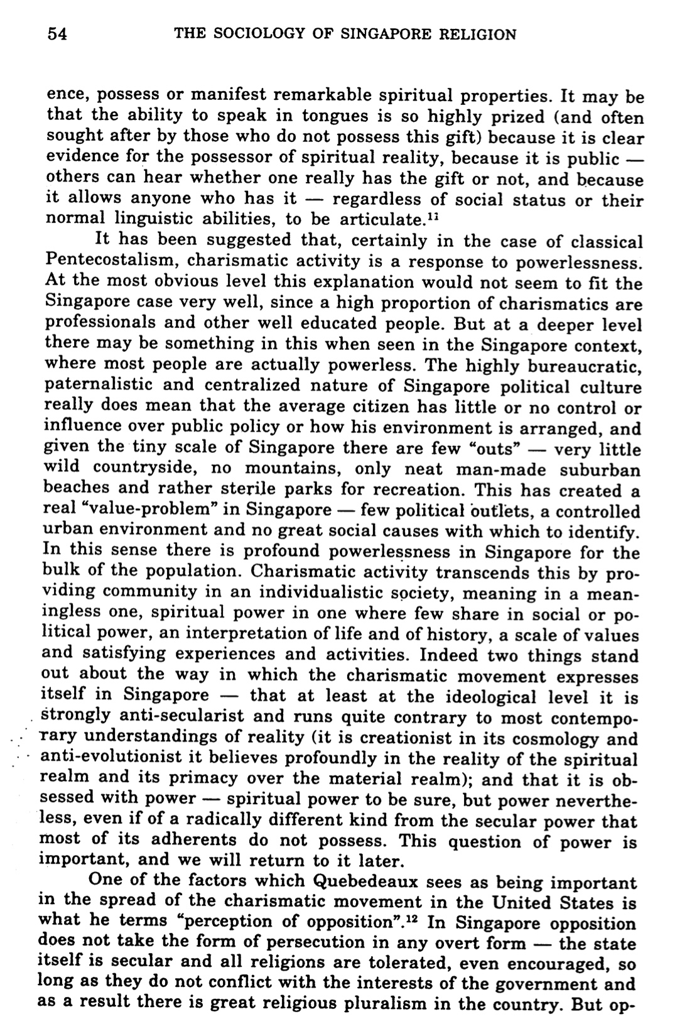

Being “Slain in the Spirit”
An Open Letter to Singapore Baptist Church Pastors by Dr. David Packer

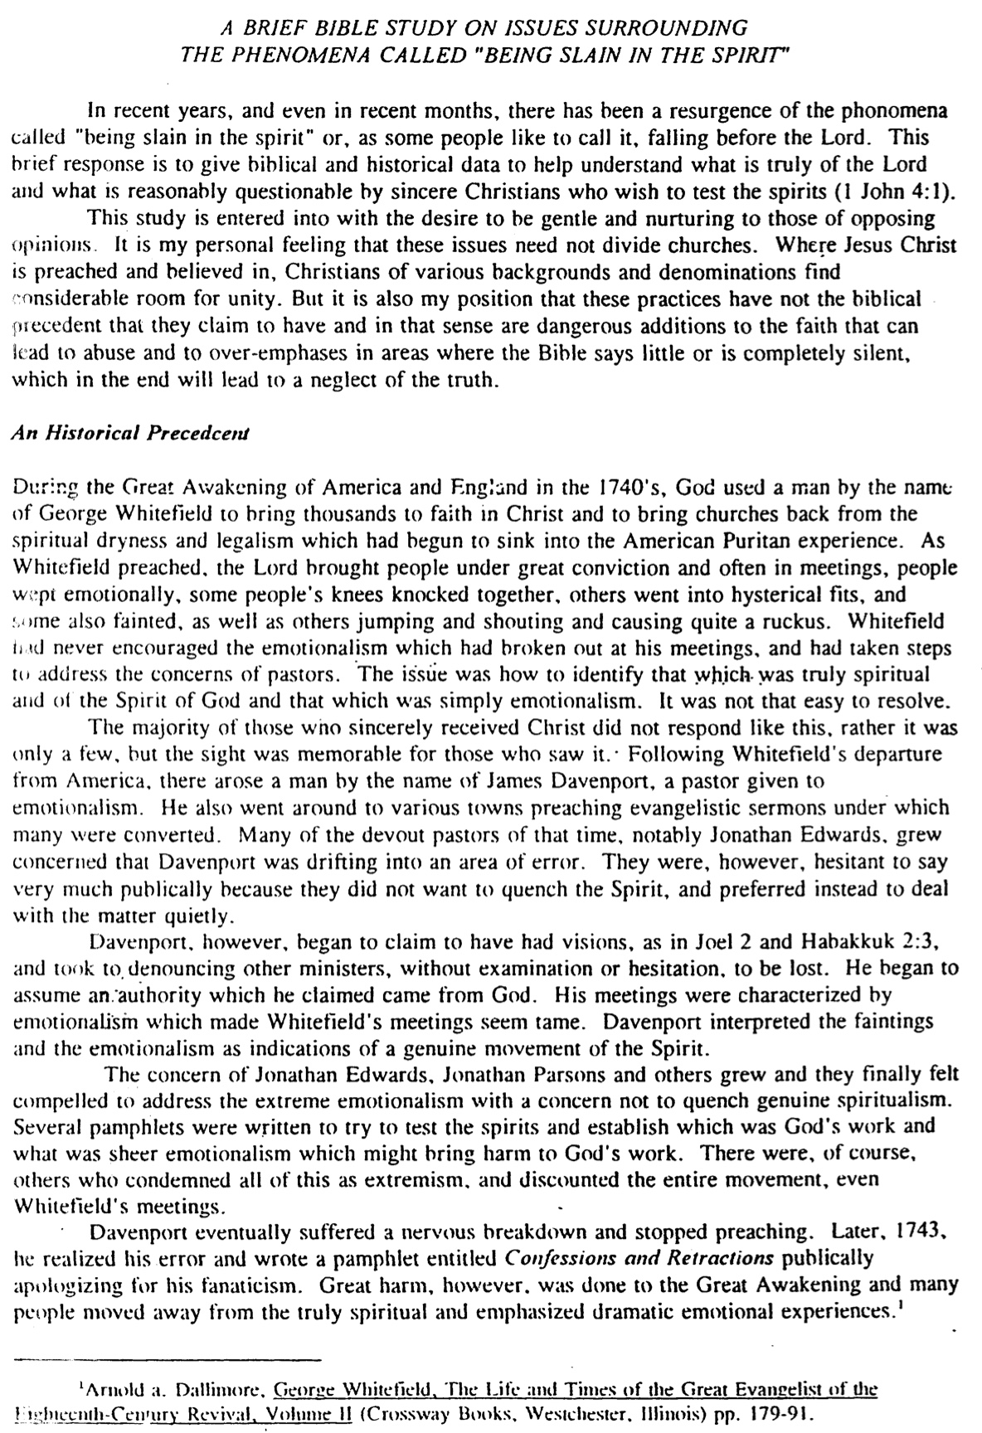
Being “Slain in the Spirit” (Packer, 2 of 5)

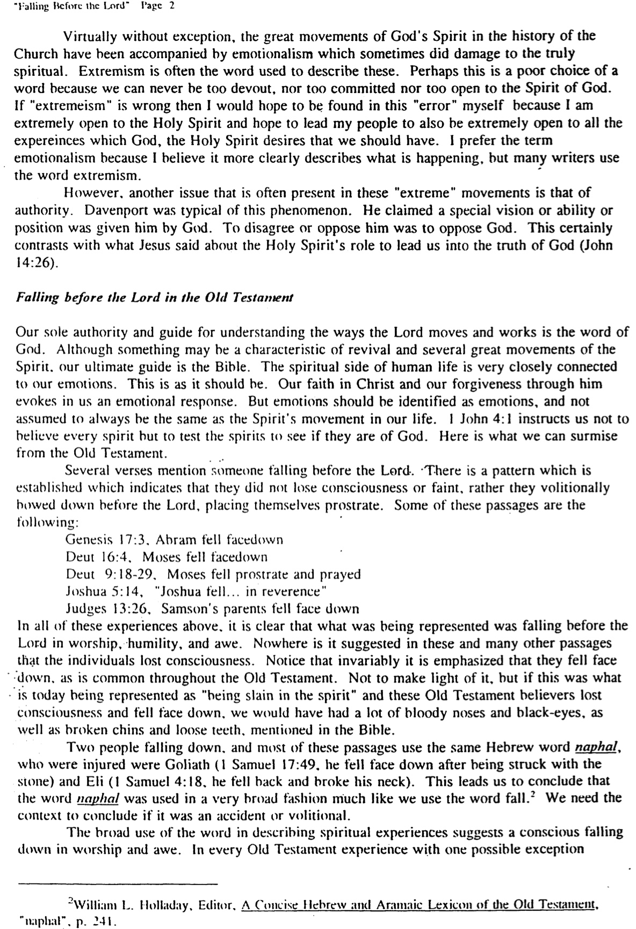
Being “Slain in the Spirit” (Packer, 3 of 5)

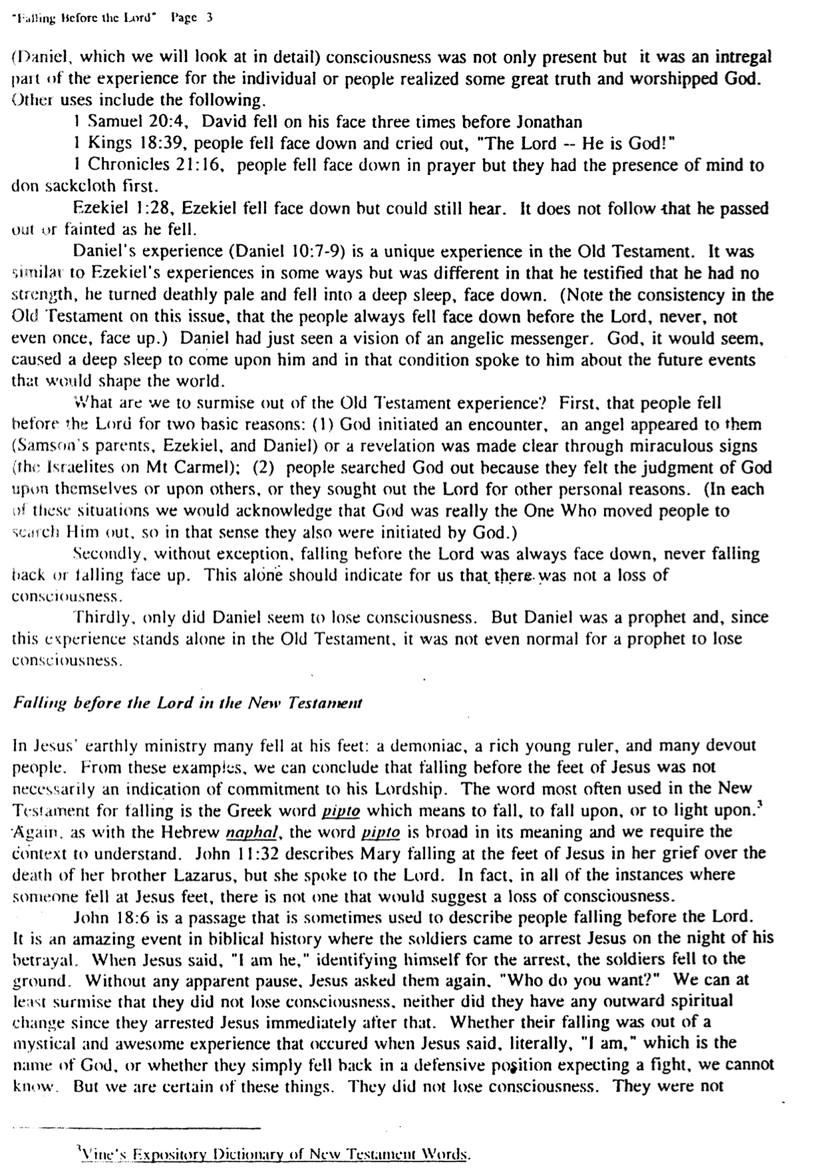
Being “Slain in the Spirit” (Packer, 4 of 5)

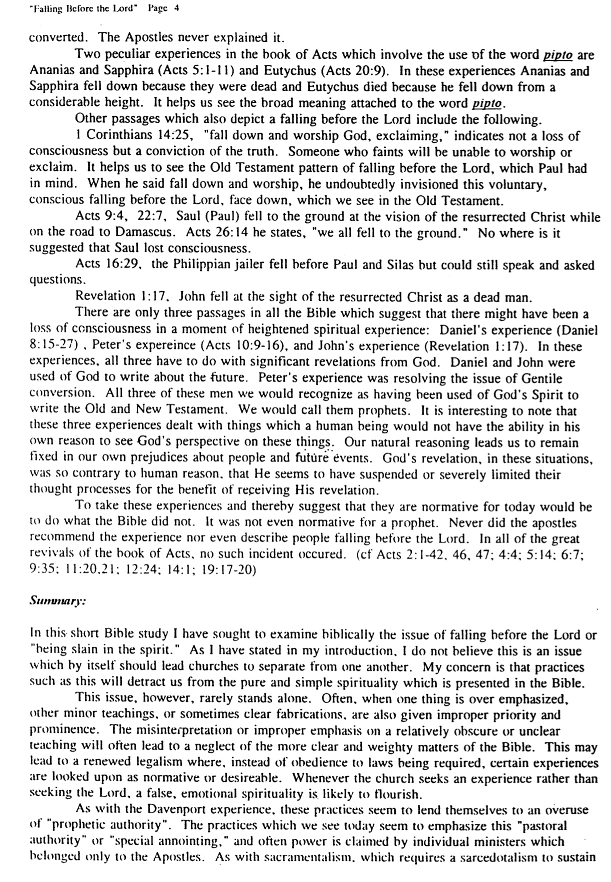
Being “Slain in the Spirit” (Packer, 5 of 5)
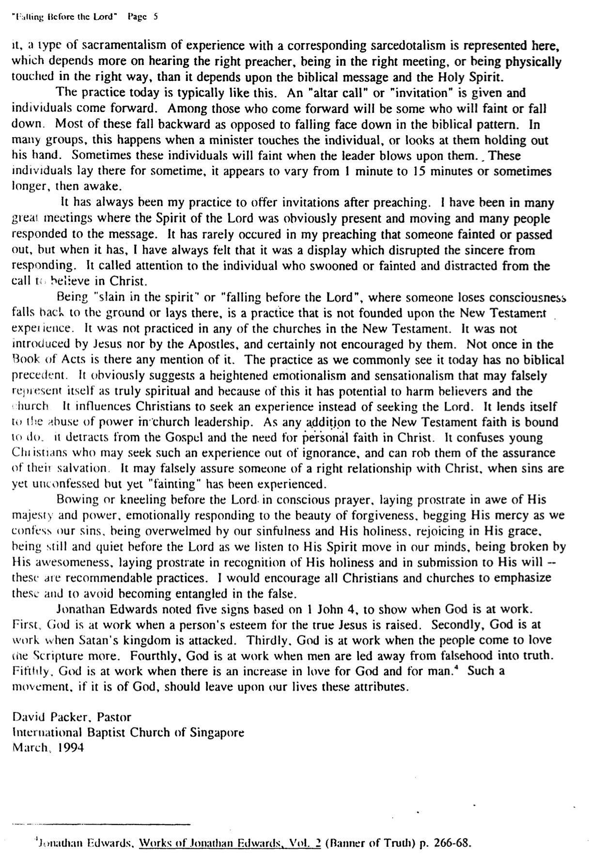

The Spirit & Grace
Adapted from Charles C. Ryrie, The Holy Spirit, 2d ed. (Chicago: Moody, 1997), 75-76

 | General Grace | Special Grace
Basic Meaning | Blessings from the Spirit which all people experience | Blessings from the Spirit which lead unbelievers to salvation
Definition | “The unmerited favor of God toward mankind displayed in His general care for them” (Ryrie, The Holy Spirit, 2d ed., 75) | “The work of the Holy Spirit which effectively moves men to believe in Jesus Christ as Saviour” (Ryrie, The Holy Spirit, 2d ed., 85)
Spirit’s Ministries | Natural revelation (Rom. 1:18-20)  Good gifts (Ps. 145:9)  Restraint of sin (2 Thess. 2:6-7)  Conviction of sin (John 16:8-11) | Call to Christ (Rom. 1:1; 8:28; 1 Tim. 6:12; 2 Pet. 1:3, 10)
Former Name | Common Grace | Efficacious Grace

General Grace
Charles Ryrie, The Holy Spirit, 2d ed., 77
Other Ministries of the Spirit
Adapted from Ryrie, The Holy Spirit, 1st ed., 104-7

I. Teaching

A. All truth is learned through the teaching ministry of the “Spirit of truth” (John 16:13a), even if teachers are involved (1 John 2:27), such as those with the gift of teaching (Rom. 12:7).

B. He does not originate the message but teaches only what Christ wants (John 16:13b).

C. The Spirit especially teaches prophecy (“things to come”) to willing believers (John 16:13c).

D. He glorifies Christ in His teaching ministry (John 16:14-15). If the Holy Spirit receives the glory then something has gone amiss.

II. Guiding (cf. p. xxiv)

A. Being led by the Spirit is one of the signs of being a son of God (Rom. 8:14).

B. The NT has many examples of His guidance (Acts 8:29; 10:19-20; 13:2, 4; 16:6-7; 20:22-23).

C. How does the Spirit guide us?

1. Bible

2. Other believers

3. Prayer

“The child of God need never be walking in the dark; he is always free to ask and receive directions from the Spirit Himself” (Ryrie, 1st ed., 105).

III. Assuring

A. “For you did not receive a spirit that makes you a slave again to fear, but you received the Spirit of sonship. And by him we cry, ‘Abba, Father.’ The Spirit himself testifies with our spirit that we are God’s children. Now if we are children, then we are heirs—heirs of God and co-heirs with Christ, if [Gr. ‘since’] indeed we share in his sufferings in order that we may also share in his glory” (Rom. 8:15-17).

1. Highlight, circle, or underline all words above that assure you as a believer through the Holy Spirit that you are permanently saved and forever part of God’s family.

2. Heir means we share in both the Father’s life (“children”) and possessions (“glory”).

B. The Spirit Himself is our firstfruits (Rom. 8:23) and deposit of eternal blessings (2 Cor. 1:22; 5:5; Eph. 1:14), which is very much in line with his sealing ministry (Eph. 1:13-14).

IV. Praying

A. “In the same way, the Spirit helps us in our weakness. We do not know what we ought to pray for, but the Spirit himself intercedes for us with groans that words cannot express. And he who searches our hearts knows the mind of the Spirit, because the Spirit intercedes for the saints in accordance with God’s will” (Rom. 8:26-27; cf. p. xiii).

B. The Spirit and Father are so united that the Spirit’s prayers need not be audible!

C. What implications are here about praying to the Spirit rather than to the Father (see pp. xi-xiii)?
Sins Against the Spirit

The following sins against the Holy Spirit are listed in order from the most severe to the least severe (yet also the least common to the most common):

Sin | Key Text | Meaning | Examples
Blasphemy | Matt 12:31-32 | Disbelief in Christ to the point of attributing the work of the Spirit in Jesus to Satan | Pharisees and some (though few) unbelievers today
Resisting | Acts 7:51 | Rejecting the clear drawing of the Spirit to salvation | Sanhedrin and other unbelievers
Insulting | Heb. 10:29 | Deliberate rejection of God’s grace following knowledge of the truth | Some Jewish believers who rejected Christ to return to Judaism
Lying to | Acts 5:3-4 | Deliberate misrepresentation of  facts for personal gain | Ananias, Sapphira, and any other Christian who lies to fellow believers in Christ
Quenching | 1 Thess. 5:19 | Seeking to suppress (lit. “throw water upon”) the Spirit’s leading within the body of Christ  = saying no when the Spirit says yes | Disrespect for spiritual authorities (vv. 12-13a), hampered relationships (vv. 13b-15), complaining (v. 16), prayerlessness (v. 17), ungratefulness (v. 18), despising genuine prophecies without testing them (vv. 20-21), all evils (v. 22)
Grieving | Eph. 4:30 | Allowing something in one’s life which is contrary to the holiness of the Spirit  (Walvoord, 200)  = saying yes when the Spirit says no | Lying (v. 25), anger (vv. 26-27), stealing (v. 28), unwholesome talk (v. 29), bitterness, brawling, slander, malice (v. 31). Most of these relate to speech.

The Eschatology of the Spirit
Ryrie, The Holy Spirit, 2d ed., 188

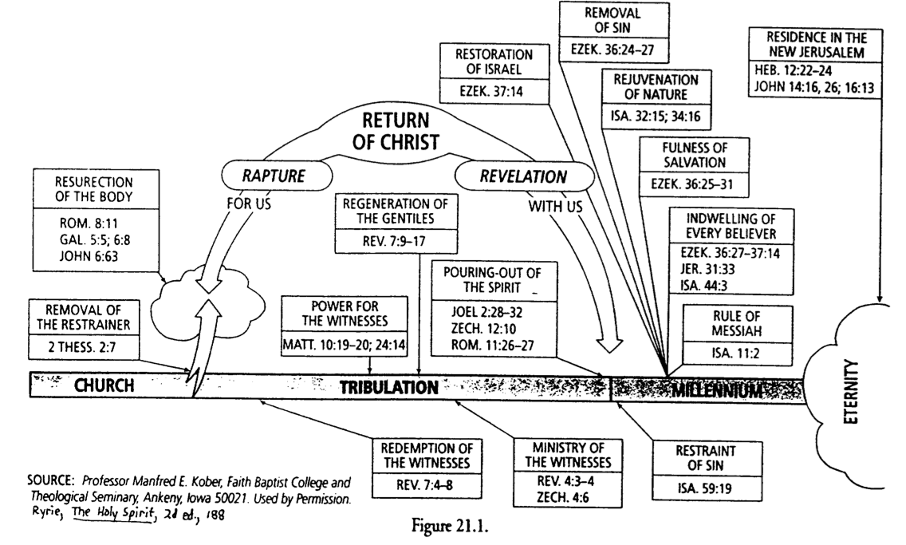

Fruit and Gifts of the Spirit Contrasted

Gifts | Fruit
Abilities | Christ-likeness
Relate to service | Relate to character
Means to an end | The end itself
What a Christian has | What a Christian is
Plural: many | Singular: one (love)
Often misused in the church | Rarely misused in the church
No believer possesses all | Every believer should strive for all
Will cease (temporary) | Will last (permanent)

Fruit of the Spirit Defined
(cf. Galatians notes, 174f)

Most of us cannot recognize the type of tree we are looking at by seeing only its leaves and branches. But when we see fruit on it, identifying it is simple.

The same is true of Christians. The unmistakable fruit of God’s Spirit in our lives is powerful evidence that one has truly trusted Christ. Galatians 5:22-23 notes that this fruit (singular) is love, but love includes the other eight traits as well…

Inner Life | Love | Unconditional and unselfish commitment to others; active service to them
Inner Life | Joy | Deep happiness stemming from a personal relationship with God, including a sense of fulfilling His will
Inner Life | Peace | Wholeness, tranquility of mind, sense of well-being, based on forgiveness

Social  Relationships | Patience | Longsuffering, steadfastness, forbearance, willingness to wait for others like God waits for us
Social  Relationships | Kindness | Excellence of character towards those of fragile nature in personality and need
Social  Relationships | Goodness | Sense of ideal character, righteousness softened by love

Principles  of  Conduct | Faithfulness | Fidelity towards others, reliable since God is reliable towards us
Principles  of  Conduct | Gentleness | Meekness, tamed and trained, submissive to God’s will and considerate to others
Principles  of  Conduct | Self-Control | Self-mastery, priority of others’ concerns over selfish desires

Fruit of the Spirit Compared
(cf. Galatians notes, 174g)

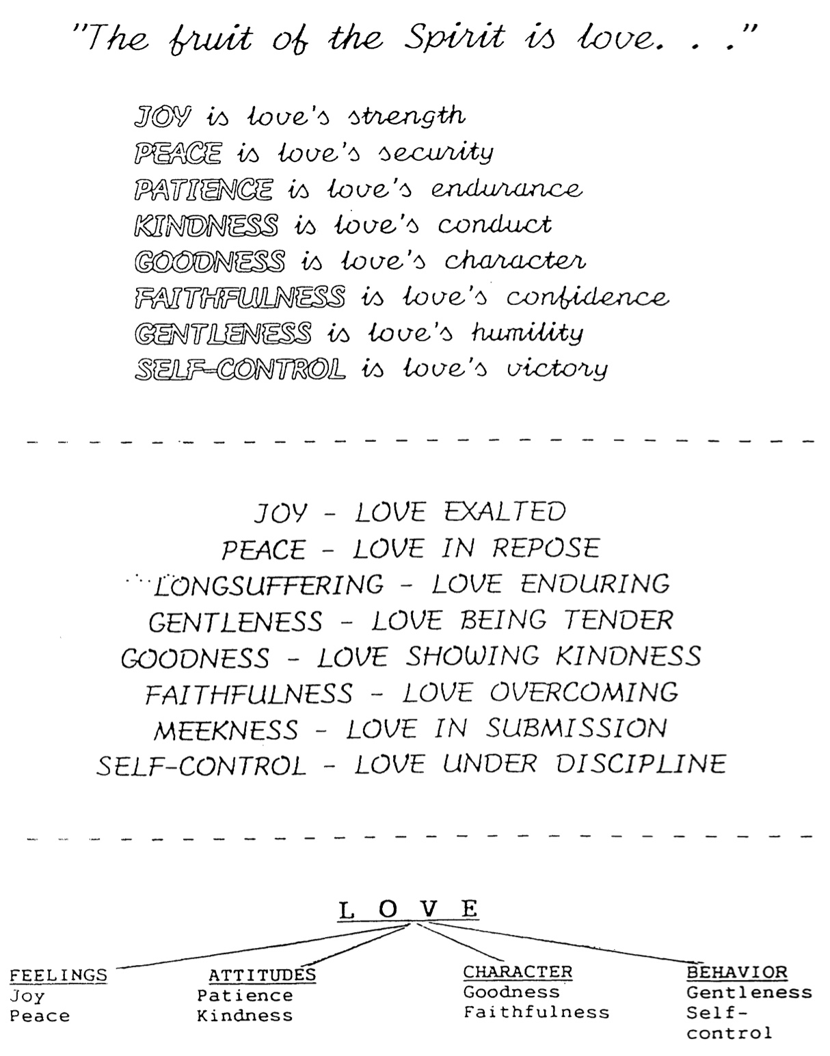

Discerning & Using Your Spiritual Gifts



Overview of the Sessions

* Indicates Small Groups This Session

PART I: INTRODUCTION

Session # Date Handout # Topic

1* Let's Talk About Some Basics
1 Objectives of the Sessions
Names of Those in My Discussion Group
Abbreviations Used in This Series
2 Basic Issues in 1 Corinthians 12
Distinguishing Natural Talents From Spiritual Gifts

2 So Why Are We Here Anyway?
3 The Basis and Nature of Spiritual Gifts
Why Study and Know Our Gifts?
4 Scriptural Commands Associated with Gifts
5 Worksheet to Help List the Spiritual Gifts

3 Listing the Spiritual Gifts
6 Lists of Spiritual Gifts in the New Testament
7 Overview and Categorization of the Gifts Chart
8 Abilities Sometimes Called Gifts

4* Various Views & Spiritual Gift "Dangers"
9 Author Comparison Chart
13 Dangers Associated With Spiritual Gifts

PART II: TEMPORARY GIFTS

5* Introduction to the Temporary Gifts
14 Views on the Duration of Gifts
16 Scriptural Support for Temporary Gifts
19 Transitional Diagrams

6* Foundational Gifts: Part 1
20 Apostleship
21 Word of Wisdom
22 Word of Knowledge

7* Foundational Gifts: Part 2
23 Prophecy
28 Distinguishing of Spirits

8* Sign Gifts: Part 1
29 Speaking in Tongues
35 Interpretation of Tongues

9* Sign Gifts: Part 2
36 Miracles
37 Healings
42 Temporary Gift Study Guide

PART III: PERMANENT GIFTS

Session # Date Handout # Topic

10* Speaking Gifts: Part 1
43 Permanent Gift Study Guide
44 Gifts & Ministries
47 Speaking Gifts Comparison Chart
49 Teaching
50 Evangelism

11* Speaking Gifts: Part 2
52 Pastor-Teacher
53 Encouragement

12* Serving Gifts: Part 1
54 Serving Gifts Comparison Chart
55 Administration
56 Faith

13* Serving Gifts: Part 2
57 Giving
58 Service
59 Showing Mercy

PART IV: DISCERNING AND USING YOUR SPIRITUAL GIFTS

14 Discerning Your Spiritual Gifts: Part 1
60 Spiritual Gifts Inventory
65 How to Discern Your Spiritual Gifts
44 How Many Gifts Does Each Believer Have?
45 Problem Passages

15* Discerning Your Spiritual Gifts: Part 2
62 Spiritual Gifts Inventory Worksheet
62 Spiritual Gifts Inventory Small Group Discussion
64 Spiritual Gifts Inventory Explanatory Supplement
66 Questions to Help Discern Your Gifts
68 Ministry Opportunities at Our Church

16 Using Your Spiritual Gifts
63 Spiritual Gifts Inventory Class Record
70 Guidelines for Using Your Spiritual Gift (Swindoll)

Objectives of the Sessions

1) Discover what spiritual gifts are, and learn their purpose for today and for the foundation of the Church in the first century.

2) Study each of the gifts in small groups and apply them to our lives individually whether they may be our gifts or not.

3) Learn how to detect spiritual gifts in others so that we can encourage them in these areas.

4) Take a spiritual gifts inventory to help discern which gifts may be our own gift(s).

5) Begin at least one new area of service for Christ related to our spiritual gift(s).

Names of Those in My Discussion Group

GROUP #1 GROUP #2 GROUP #3 GROUP #4

Abbreviations Used in This Series
All of these sources are good lexicons (dictionaries) for Greek word studies*

BAGD Bauer, Walter; Arndt, William F.; Gingrich, F. Wilbur; Danker, Frederick W. A Greek-English Lexicon of the New Testament and Other Early Christian Literature. Chicago, IL and London: The University of Chicago Press, 1958; reprint ed., 1979.

Strong Strong, Augustus. "Greek Dictionary." Thomas, Robert L., ed. New American Standard Exhaustive Concordance of the Bible. Nashville, TN: Holman, 1981.

Thayer Thayer, Joseph Henry. Greek English Lexicon of the New Testament. Grand Rapids, MI: Zondervan Corporation, 1962.

Vine Vine, W. E. An Expository Dictionary of New Testament Words. Old Tappan, NJ: Fleming H. Revell Co., 1940; reprint ed., 1966.

* See the instructor of this series for the "Selected Annotated Bibliography," which explains each of these books and several others helpful in studying spiritual gifts.
Basic Issues in 1 Corinthians 12
Answers on pages 129-130

DIRECTIONS: Read through the following questions about spiritual gifts (don't answer them yet), then look for the answers as someone in your group reads 1 Corinthians 12:1-18 aloud. Include the verses where each answer is found as your group answers each question.

1) What are spiritual gifts?

Note: Spiritual Gifts are Not:
a) Place of Service
b) Age Group Ministry
c) Natural Talents

2) Who has spiritual gifts? Who gives spiritual gifts? Who decides the gift for each person?

The Involvement of the Whole Trinity (vv. 4-6):
God the __________ gives (distributes) the spiritual gifts (v. ___)
God the __________ assigns the place of the ministry of the gifts (v. ___)
God the __________ gives the energy operative through the gifts in the place of ministry (v. ___)
(Earl Radmacher, "Spiritual Gifts" tape, Campus Crusade for Christ)

3) Where are the spiritual gifts to be used?

4) When do Christians receive their spiritual gifts? (Must be deduced from vv. 7, 11, and 18)

5) Why are spiritual gifts given?

Distinguishing Natural Talents from Spiritual Gifts

Natural Talents Spiritual Gifts

Who has them?

How are they obtained?

When are they obtained?

Who benefits from them?

The Real Issue: Does it really make any difference whether a believer thinks his ability is a natural talent or a spiritual gift? (____ & ____)

____ : We shouldn't add to God's Word by calling an ability a "spiritual gift" if the Bible doesn't call it a gift, but . . .

____ : Both natural talents and spiritual gifts are:
1) given ____ God, and
2) to be used ____ God!!

The Basis and Nature of Spiritual Gifts
Greek words relating to Spiritual Gifts
Answers on page 131

1) Charisma (χάρισμα) is the most popular word for spiritual gifts (Rom. 12:6; 1 Cor. 1:7; 12:4, 9, 28, 30, 31; 1 Tim 4:14; 2 Tim 1:6; 1 Pet. 4:10)
Translations: "gift" or "spiritual gift" (1 Tim 4:14 only), but literally means "gifts of grace."

Roots: ______ means ________ (The basis of receiving our spiritual gifts is grace)
______ means ________ (The result of exercising our spiritual gift is joy)

Other uses of the word charisma in the New Testament (Vine):
a) gift of salvation (Rom. 5:15, 16; 6:23; 11:29)
b) truth which is imparted through human instruction (Rom. 1:11)
c) celibacy and marriage (1 Cor. 7:7)
d) gracious deliverances in answer to the prayers of fellow believers (2 Cor. 1:11)

2) Diakonia (διακονία) refers to a place of service (1 Cor. 12:5 ) & category of gifts (1 Pet. 4:11).
Translations: "service" (NIV), "ministries" (NASB)

3) Energema (ἐνἐργημα) concerns the energy operating through the gifts (1 Cor. 12:6; Rom. 12:3)
Translations: "working" (NIV), "effects" (NASB)

4) Phanerosis (φανέρωσις) denotes the evidence of the Spirit in believers (1 Cor. 12:7).
Translations: “manifestation" (NASB, NIV)
Infinitive: phaneroein (φανερόειν) "to make visible or known"
Secular Usage: "disclosure, announcement" (BAGD; cf. 2 Cor. 4:2)

5) Pneumatikoi (πμευμάτικοι) refers to the Spirit as the Source of gifts (1 Cor. 12:1; 14:1)
Translations: "spiritual gifts " (NASB), but a more literal translation would be "spiritual things," "things of the Spirit," or simply "spirituals"
Root: pneuma (πμεῦμα) "Spirit"

6) Doma (δώμα) is a gift given by Christ only to the church after His Ascension (Eph. 4:7-8, 11), not during the Old Testament (i.e., only Christians have gifts, not Old Testament saints).

Why Study and Know Our Gifts?

1) MINISTRY TO THE CHURCH BODY - Ministering in the area of our gifts results in:
a) edification of the body—_____________ and ___________________ (1 Cor. 14:12).
b) mobilizing the church for _____________ to a lost world.
c) encouraging other believers to ____________ and _________________ their gifts.

2) PERSONAL FULFILLMENT - Exercising our gifts results in:
a) ministering in areas of ______________, reducing frustration and wasted time.
b) assisting us in establishing ______________ for study, growth, and ministry (Eph. 4:13).
c) a sense of _____________ and _______________ in the body of Christ (1 Cor. 12:14-17).

3) OBEDIENCE TO GOD'S WORD - Scripture gives several commands relating to gifts:
a) "Do not _______________ the spiritual gift within you..." (I Tim 4:14a).
b) "Now concerning spiritual gifts, brethren, I do not want you to be _________" (1 Cor. 12:1).
c) "And since we have gifts that differ according to the grace given us, let us ______________ them accordingly..." (Rom. 12:6a).
d) "As each one has received a special gift, ______________ it in serving one another, as good stewards of the manifold grace of God" (1 Pet. 4:10).

Scriptural Commands Associated With Gifts

Although God has gifted certain members of the Body of Christ with particular gifts, this does not imply that each believer should serve only in his or her "gifted" area. Scripture also commands every believer to minister to others in "non-gifted" capacities that may normally function under another's gift. Some examples are cited below.

Associated Spiritual Gift Command Given to All Believers

Teaching "Let the word of Christ richly dwell within you, with all wisdom teaching and admonishing one another..." (Col. 3:16a)

Evangelism "Go therefore and make disciples of all the nations, baptizing them in the name of the Father and the Son and the Holy Spirit" (Matt. 28:19)

Pastor-Teacher "Brethren, even if a man is caught in any trespass, you who are spiritual, restore such a one in a spirit of gentleness, looking to yourselves, lest you too be tempted" (Gal. 6:1)

Exhortation "But encourage one another daily, as long as it is called Today, so that none of you may be hardened by sin’s deceitfulness" (Heb. 3:13a)

Administration "But let all things be done properly and in an orderly manner" (1 Cor. 14:40)

Faith "And without faith it is impossible to please Him..." (Heb. 11:6a)

Giving "On the first day of the week let each one of you put aside and save, as he may prosper, so that no collections be made when I come" (1 Cor. 16:2)

Service "… Serve one another in love (Gal. 5:13)

Showing Mercy "And so, as those who have been chosen of God, holy and beloved, put on a heart of compassion, kindness, humility, gentleness and patience" (Col. 3:12)
Spiritual Gifts Lists Worksheet
(cf. Romans notes, 155ff)

DIRECTIONS: List in the vertical columns the scriptural names of all of the spiritual gifts found in the six Scripture passages below, putting the gifts listed in more than one passage side by side horizontally, but in their respective columns. Then derive the total list of all the gifts, listing them in the left hand column. Warning: Different names may refer to the same gift in different passages! Then designate which (if any) gifts you believe are no longer in existence today.

All the Gifts | 1 Pet.  4:10-11 | Rom.  12:6-8 | Eph  4:11 | 1 Cor. 12:28 | 1 Cor. 12:29-30 | 1 Cor. 12:8-10
1
2
3
4
5
6
7
8
9
10
11
12
13
14
15
16
17
18
19
20
21
22
23
24
25

How many
gifts are
there?

How many
gifts exist
today?

Lists of Spiritual Gifts in the New Testament
(cf. Ephesians PPT, slide 41)

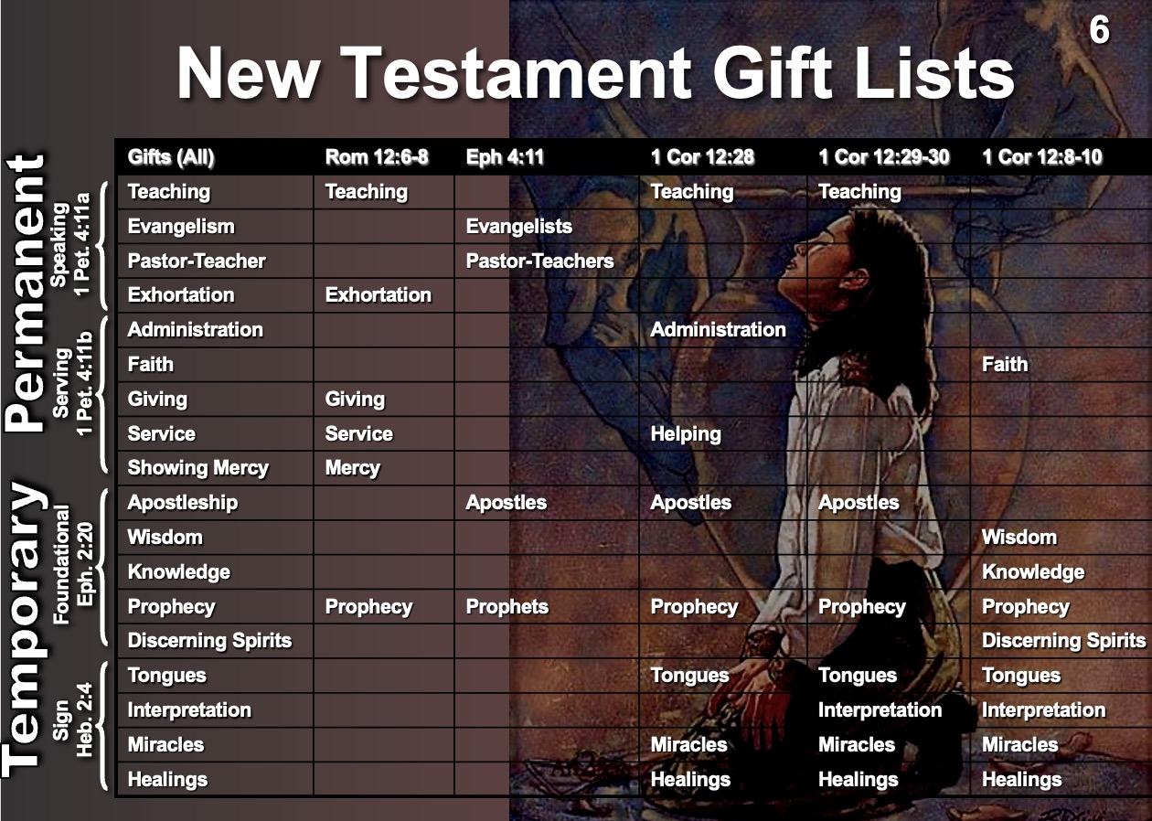
Overview and Categorization of the Gifts Chart

The Bible does not define the spiritual gifts, but the following definitions are based on several passages that describe the gifts. For more details, please consult the individual study sheet for each gift on pages 20-59.

SPIRITUAL GIFTS and  REFERENCES in the gift lists | APOSTLESHIP  Eph. 4:11; 1 Cor. 12:28-29 | PROPHECY: 1 Cor. 12:10, 28-29;  Eph. 4:11; Rom. 12:6 | TEACHING  Rom. 12:7; 1 Cor. 12:28-29 | EVANGELISM  Eph. 4:11 | PASTOR-TEACHER  Eph. 4:11 | EXHORTATION  Rom. 12:8 | ADMINISTRATIONS (Leading)  Rom. 12:8; 1 Cor. 12:28 | FAITH  1 Cor. 12:9 | GIVING  Rom. 12:8 | SERVICE (HELPS)  Rom. 12:7; 1 Cor. 12:28 | SHOWING MERCY  Rom. 12:8 | DISTINGUISHING SPIRITS  1 Cor. 12:10 | WORD OF WISDOM  1 Cor. 12:8 | WORD OF KNOWLEDGE  1 Cor. 12:8 | SPEAKING IN TONGUES  1 Cor. 12:10, 28, 30 | INTERPRETING TONGUES  1 Cor. 12:10, 30 | MIRACLES  1 Cor. 12:10, 28-29 | HEALINGS  1 Cor. 12:9, 28, 30
DEFINITIONS OF EACH GIFT:  The God-given ability to… | Establish and nurture the Church on earth by divine revelation, unquestioned authority, and authentication by miracles. | Receive divine revelation and declare it without error to God’s people in their own language. | Study and communicate the Bible with clarity so that lives are changed. | Proclaim the gospel with ease and conversions, and to train others in sharing with the lost. | Shepherd (guard, comfort, lead) and feed (teach, exhort) a group  of believers. | Apply Scripture to people’s lives in order to lead them into God’s will. | Preside over groups to achieve objectives with wisdom and organization. | See what God wants done and lead people to do it despite obstacles. | Provide money or possessions for God’s work with joy, wisdom,  and generosity. | Provide practical help in behind-the-scenes ways to assist up-front ministries. | Provide understanding, sympathy, and compassion to those suffering physically or emotionally. | Judge an oral declaration from someone claiming to be a prophet  as from a divine, human, or demonic source. | Receive and present God’s wisdom within our New Testament by apostles and prophets. | Teach doctrinal truth received by revelation from God by a first-century teacher. | Speak revelation in a foreign language unknown by the speaker to unbelieving Jews as a sign that can be translated for believers. | Receive by divine revelation and declare in the language of the church the translation of a message in tongues. | Perform an event of supernatural power, palpable to the senses, accompanying God’s servant to authenticate God’s commission. | Miraculously cure any illness, restore health, and even raise the dead apart from natural means.
Duration | Temporary |  | Permanent |  |  |  |  |  |  |  |  | Temporary
Words | Verbal |  |  |  |  |  | Non-Verbal |  |  |  |  | Verbal |  |  |  |  | Non-Verb.
Focus | Speaking |  |  |  |  |  | Serving |  |  |  |  | Signifying
Category | Support |  |  |  |  | Service |  |  |  |  |  | Sign
Need Met | Word Taught |  |  |  |  | Personal Needs |  |  |  |  |  | Word Validated
Result | Leadership |  |  |  |  | Healthy Body Life |  |  |  |  |  | Founding the Church
Nature | Public (to many) |  |  |  |  | Private (to few) |  |  |  |  |  | Public (to many)
Visibility | High |  |  |  |  | Low |  |  |  |  |  | High
Perceived | With Honor |  |  |  |  | Without Honor |  |  |  |  |  | With Honor
Minister | To the Body |  |  |  |  | Within the Body |  |  |  |  |  | To the Body & World
Purpose | Equip Saints |  |  |  |  | Encourage Saints |  |  |  |  |  | Authenticate Saints

Abilities Sometimes Called Gifts

Several authors of books on spiritual gifts maintain that some abilities are indeed spiritual gifts which this series does not refer to as gifts. It seems that the important question to ask is: "How would you know whether an ability was a spiritual gift or not? By what criteria would you judge?" Undoubtedly, the surest basis on which to make such a distinction is simply whether the Bible designates an ability as a spiritual gift or not. Several passages of Scripture list the gifts for us but the abilities addressed on this handout appear in none of these lists. Nevertheless, the following abilities are still called gifts by various authors:

Hospitality is sometimes designated a spiritual gift based upon 1 Peter 4:9, "Be hospitable to one another without complaint (NASB)." Leslie Flynn writes,

Though hospitality is not included in any of Paul's lists of gifts, the context in which hospitality is mentioned seems to earn it consideration as a separate gift. After Peter speaks of hospitality in verse 9, he immediately goes on in the next two verses to say that whatever gift a person has should be faithfully exercised. The link in Peter's thinking between hospitality and gifts strongly implies that hospitality is a gift... The gift of hospitality is that supernatural ability to provide open house and warm welcome for those in need of food and lodging (Flynn, 104).

However, it should also be noted that while hospitality is mentioned in the context of spiritual gifts, so are several other commands such as being of a sound mind for prayer (v. 7) and loving one another (v. 8). To be consistent, Flynn's logic would lead to a teaching regarding the gifts of "prayer" and "loving!" Rather, Peter's argument flows from addressing the church as a whole (vv. 7-9) to addressing individuals in light of their spiritual gifts. The command to be hospitable applies to the entire church (cf. Matt. 25:35; Rom. 12:13; Heb. 13:2), not only to those with a "gift of hospitality." It would be better to see this ability as functioning under the gift of service as an ability some have to meet the practical needs of others by especially using their home.

Craftsmanship is listed as a gift by Yohn (pp. 19, 20) who cites that those enabled by God to design and construct the tabernacle had this "gift" (Exod. 31:1-11). Among those so gifted Yohn lists the silversmith, goldsmith, coppersmith, stonemason, jeweler, carpenter, cabinetmaker, tailor, dressmaker, designer, interior decorator, engineer, draftsman, artist, and mechanic! However, these abilities seem to be natural talents which God bestows to be used in conjunction with the gift of service. Those with the gift of service willingly and joyfully serve to meet practical needs though their talents. Yohn admits that this ability is not mentioned in the New Testament.

Music was a gift possessed by both David and Solomon, according to Rick Yohn (pp. 103-108). He cites six different Old Testament uses of this gift: instrumentalists (2 Chron. 34:12), singers (1 Chron. 15:19), composers (2 Chron. 29:30), choir directors (Neh. 29:30), music instructors (1 Chron. 15:22), and instrument makers (2 Chron. 7:6; 29:26, 27). Yohn's New Testament "examples" of the gift (1 Cor. 14:26; Col. 3:16) in context are not really gifts at all, but commands for the entire church to sing. Musical talent is an ability that God may use with several different gifts: teaching, exhortation, evangelism, service, etc.

Other Abilities labeled "gifts" (all by Wagner) include celibacy (1 Cor. 7:7, 32-34), voluntary poverty (1 Cor. 13:3), martyrdom (1 Cor. 13:3; Acts 7:60), intercession, exorcism (pp. 262, 263), and ability to remember names (pp. 73, 74)! However, 1 Corinthians 7:7 infers that both celibacy and marriage are blessings from God for different individuals, and 1 Corinthians 13:3 better describes the ultimate expressions of the gift of giving. Wagner considers the list of gifts endless, simply confusing the distinctions between natural talents and gifts.
Author Comparison Chart

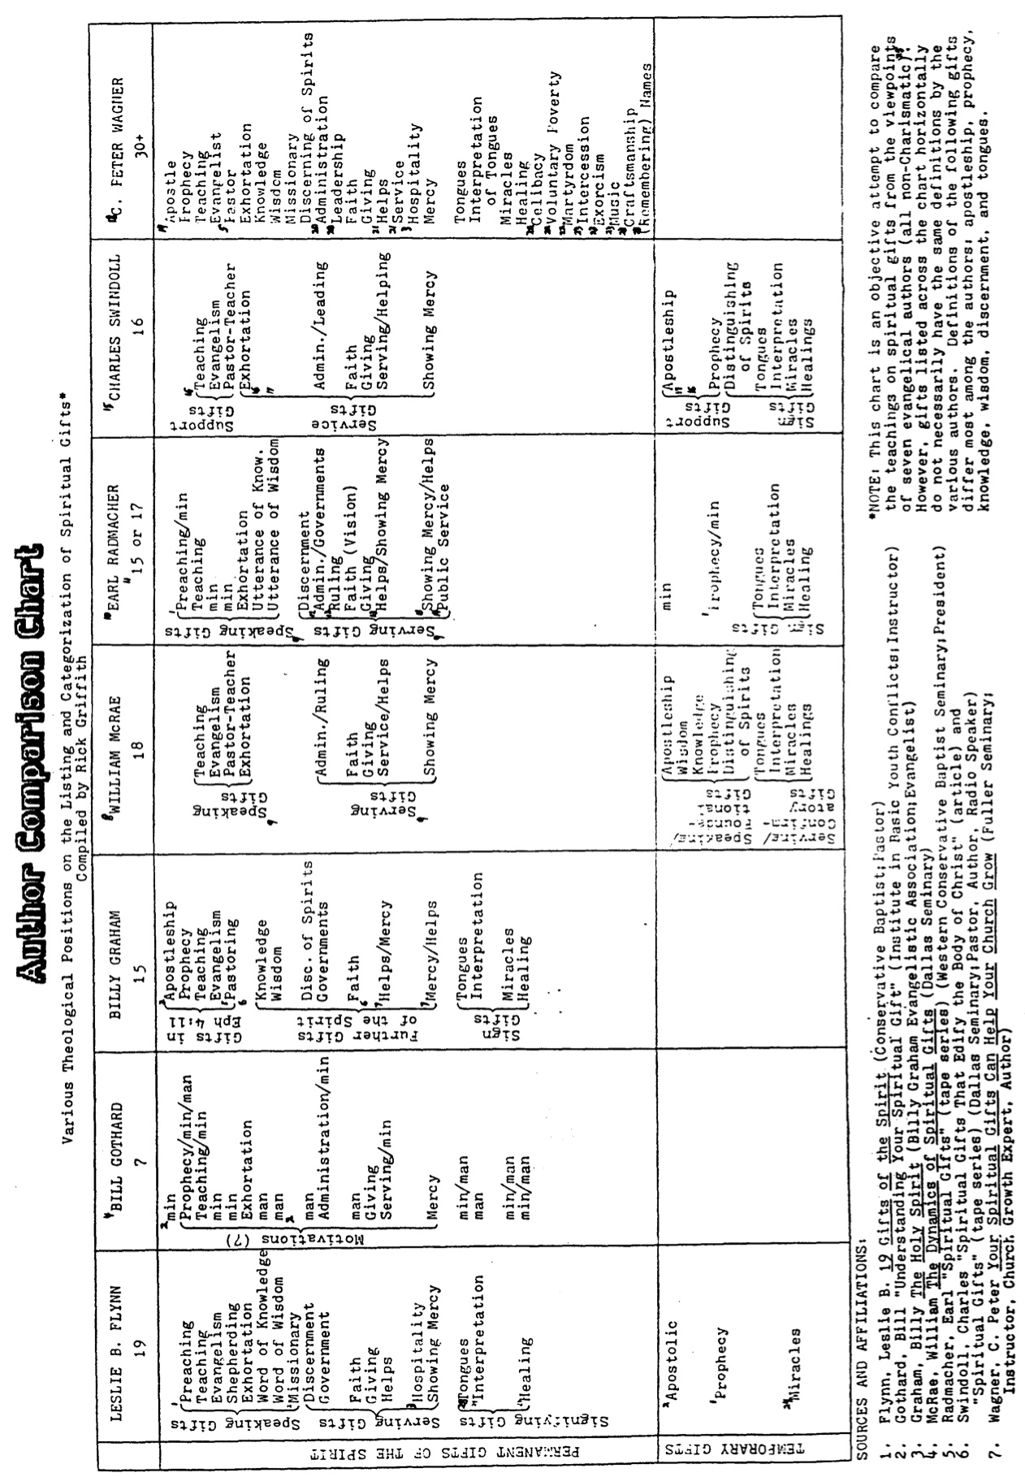
Author Comparison Chart Endnotes

1. Both Flynn and Radmacher teach that although prophecy ceased in the first century, the gift exists today as the "gift of preaching." Flynn classifies it under the speaking gifts category. Radmacher sees it as a ministry, not a spiritual gift ("Spiritual Gifts" tape, Campus Crusade for Christ).

2. Flynn suggests that the apostolic gift was a speaking gift foundational in nature (ceased in the first century), but that its modern equivalent continues today as the "gift of missionary" (p. 38). Both Gothard and Graham designate those sent out by the church for ministry as modern "apostles."

3. Flynn and Wagner consider "hospitality" as a separate gift because Peter's exhortation to "be hospitable to one another without complaint" (1 Pet. 4:9) is immediately followed by an encouragement for them to employ their gifts in serving one another (1 Pet. 4:10-11). Wagner defines the gift as “the special ability that God gives to certain members of the Body of Christ to provide open house and warm welcome for those in need of food and lodging” (Wagner, 263).

4. Gothard categorizes the gifts threefold ("How to Identify Spiritual Gifts," 1):

7 Motivation Gifts in Romans 12:6-8 (defined as "unique 'energizings' of the Holy Spirit within a believer which give that believer the desire and the power to concentrate on a particular aspect of spiritual concern")

10 Ministry Gifts in Ephesians 4:11; 1 Corinthians 12:28 (defined as "opportunities for recognized Christian service through the church")

9 Manifestation Gifts in 1 Corinthians 12:7-11 (defined as "supernatural results of the Holy Spirit's work in our lives and also in the lives of those to whom we minister")

5. Whereas it looks like there are five gifts listed in Ephesians 4:11, "actually there are only four, because the last two constitute a single gift [pastor-teacher]. The word 'and' [kai] which joins "pastors and teachers" is an entirely different word from the other four occurrences of the word 'and' [de] in this verse. This indicates that it may be taken as a hyphen. Also the word 'some' occurs four times; it precedes the word "pastors" but it does not precede the word 'teachers'" (Zuck, pp. 7-8). Although this indicates that this is a "dual" gift, Graham and Wagner both divide the gift into separate gifts of "pastoring" and "teaching."

6. Graham makes no mention of the gifts of exhortation or giving in his book, The Holy Spirit. The assumption, then, may be that he is not convinced of their validity or importance.

7. "Helps is the gift of showing mercy" (Graham, 135). [Italics mine.]

8. The listing/categorization of the gifts in this spiritual gifts series follows that of Bill McRae.

9. McRae (p. 86) and Radmacher ("Spiritual Gifts" tape, Campus Crusade for Christ) consider the mentioning of "speaking" and "serving" in 1 Peter 4:10-11 as references not to individual gifts, but to two general categories of gifts. I agree.

10. Radmacher ("Spiritual Gifts" tape, Campus Crusade for Christ), like Gothard ("Understanding Your Spiritual Gifts", 5), does not consider the titles in Ephesians 4:11 as references to gifts, but rather to offices. He says, "There are professionals in the ministry: apostles, prophets, evangelists, and pastor-teachers" (Radmacher, "Spiritual Gifts," tape, Campus Crusade for Christ).

11. "I take it that there are a total of 15 or 17 [gifts] depending on how you divide those two [helps/showing mercy and governments/ruling]" (Radmacher, "Spiritual Gifts" tape, Campus Crusade for Christ).

12. "The gift of administration...is called 'ruling' in Romans 12 and...'governments' in 1 Corinthians 12. You may make one or two out of that. They're very similar though there is a distinction" (Radmacher, "Spiritual Gifts" tape, Campus Crusade for Christ).

13. "The gift of helps...is called 'showing mercy' in Romans...You may make them one or you may make them two. They're very similar" (Radmacher, "Spiritual Gifts" tape, Campus Crusade for Christ).

14. "[Public service is] the gift which is being demonstrated in Acts chapter 6 by those men called 'deacons'" (Radmacher, "Spiritual Gifts" tape, Campus Crusade for Christ ).

15. Chuck Swindoll (p. 2), Charles Ryrie (pp. 83-92), and John Walvoord (pp. 38-54) all agree to the number and nature of these gifts. Therefore, this column also portrays the positions of both Ryrie and Walvoord as well.

16. "'Word of knowledge' and 'speaking' [are] most likely linked to [teaching]" (Swindoll, 2).

17. "'Word of wisdom' [is] linked to this gift [apostleship]" (Swindoll, 2).

18. Wagner does not choose to categorize the gifts.

19. Wagner defines the gift of apostleship as "the special ability that God gives to certain members of the Body of Christ to assume and exercise general leadership over a number of churches with an extraordinary authority in spiritual matters that is spontaneously recognized and appreciated by those churches" (Wagner, 261). He cites Chuck Smith of the Calvary Chapel movement based in Costa Mesa, California as an example (pp. 209-210).

20. Wagner is the only author on the chart who clearly defines "administration" ("governments") and "leadership" ("ruling") as separate gifts:

Administration: "the special ability that God gives to certain members of the Body of Christ to understand clearly the immediate and long range goals of a particular unit of the Body of Christ and to devise and execute effective plans for the accomplishment of those goals" (Wagner, 262).

Leadership: "the special ability that God gives to certain members of the Body of Christ to set goals in accordance with God's purpose for the future and to communicate these goals to others in such a way that they voluntarily and harmoniously work together to accomplish those goals for the glory of God" (Wagner, 260, 262).

21. Wagner is the only author on the chart who defines "helps" and "service" as separate gifts:

Helps: "the special ability that God gives to certain members of the Body of Christ to invest the talents they have in the life and ministry of other members of the Body, thus enabling the person helped to increase the effectiveness of his or her spiritual gifts" (Wagner, 262).

Service: "the special ability that God gives to certain members of the Body of Christ to identify the unmet needs involved in a task related to God's work, and to make use of available resources to meet those needs and help accomplish the desired goals" (Wagner, p. 259).

22. Wagner cites the following Scriptural support for these gifts: celibacy (1 Cor. 7:7, 32-34), voluntary poverty (1 Cor. 13:3), and martyrdom (1 Cor. 13:3; Acts 7:60). In reference to the "gift of martyrdom" he candidly writes,"...it is the only gift you use only once! But it is broader...an attitude toward suffering and death that is quite unusual" (Wagner, 67).

23. Wagner suggests no Scriptural support for these gifts, but writes, "Are all the gifts mentioned in the Bible? Because none of the three primary lists is complete, and the three lists together are not complete, it is reasonable to conclude that the list of all the gifts mentioned in the Bible... may not be complete either... This is what I mean by an open-ended approach to the gifts. I do not doubt that there are even more than 27 of them. Some might want to add the gift of music and make it 28 or craftsmanship and make it 29. I ran into another gift recently which might be called the 'gift of names.' Jerry Falwell, pastor of the renowned Thomas Road Baptist Church in Lynchburg, Virginia, is extraordinary in many ways. But one of them is that he knows the names of most of his 16,000 members! In fact, he can speak in another city, meet people afterwards, go back a year later, and remember the majority of the people by name. He himself says, 'I have to give God the credit for this... It's a gift from God'" (Wagner, 73-74).

24. Flynn classifies four gifts under two categories: tongues and interpretation as both speaking and signifying gifts, and miracles and healing as both serving and signifying gifts (p. 32).

25. Very few (if any) Charismatic authors have written books and articles dealing with all the spiritual gifts. Most Charismatic material addresses only the gifts of prophecy, tongues, distinguishing of spirits, miracles, and healing; therefore, a complete representation of a Charismatic viewpoint is not reflected on the chart. Wagner's column probably comes closest to the views of most Charismatics although he does not claim to be Charismatic himself.

Dangers Associated with Spiritual Gifts
Attitudes and Actions to Avoid
Answers on page 132

1) Division resulting from __________ and ___________ .

a) Viewing your gift as __________ (a problem of inferiority).

i.e., "______ gift is not like ___________!" (1 Cor. 12:15-16).

b) Viewing your gift as __________ (a problem of pride).

i.e., "______ gift is not like ___________!" (1 Cor. 12:21).

2) Confusion with _________ ___________ .

3) Seeking _________ (controversial) gifts while neglecting ___________ gifts.

4) Seeking __________ ministering gifts while neglecting _____________ ministering gifts.

5) Willing to be _________ of spiritual gifts because of the subject's complexity and the widely varying views of respected scholars (1 Cor. 12:1).

6) Focusing upon __________ as a more significant evidence of the Holy Spirit than the __________ of the Holy Spirit (Gal. 5:22-23).

"Doing" overemphasized to the neglect of "__________ ."

"Service" overemphasized to the neglect of "__________ ."

7) ____________ opportunities for service in "_________" areas because you don't have that particular gift which would make the service easier on you (2 Tim 4:5).

8) Supposing that spiritual gifts are _________ for service, for holiness, for sincerity, for maturity, or for anything else!

9) Believing that there is any correspondence between spiritual gifts and _____________ .

10) Supposing that God has _____________ your spiritual gift because He has not chosen to use it at the present time.

"for the gifts and the calling of God are irrevocable" (Rom. 11:29).

11) Seeking ___________ and overlooking ____________ (Rom. 12:9ff.; 1 Cor. 13:1ff.).

"By this shall all men know that you are my disciples, if you __________ ________

_______________ " (John 13:35).

Views on the Duration of Gifts

The Nature of the Debate: Have any of the spiritual gifts disappeared since the first century?

The Various Views: There are three major views regarding this question. My own responses to some of the arguments are in brackets [ ], and other rebuttals are in section 3.

1. Some Cite Arguments that No Gifts Passed Away (Non-Cessationist)
(i.e., all gifts are permanent):

a. The argument that some gifts passed away begins with Scripture (the temporary nature of apostleship) but then moves into deductions from Scripture [but see pages 16-18].

b. The Bible does not state that any gift has passed away [but see pages 16-18].

c. The Bible never says divine authentication of the preaching of the gospel was needed only in apostolic times [true, but this was the biblical pattern. See 3.a. below and 2 Cor. 12:12].

d. The "dramatic" and "less dramatic" gifts appear side-by-side in Scripture (1 Cor. 12:28) [but this neither argues for nor against cessationism—all gifts were present then].

e. The supernatural was the norm in the early church (book of Acts), so why not today also? [But why assume God must work in the same way in all ages? This hasn’t been His pattern throughout Scripture, so why expect it to remain the same from NT times to the present?]

f. The epistles say much about gifts but never tell us how to phase them out [but this is not our job].

g. In 1 Corinthians 13:8-13, Paul looks forward not to the passing of the apostolic age but to the final glorious fulfillment of the promises of God [but see pages 16-18].

h. The decline in supernatural activity in the second to nineteenth centuries was due not to the passing away of certain gifts, but due to the unfaithfulness and lack of spiritual vitality in the church as a whole [such reasoning would argue that the most carnal NT church, Corinth, wouldn’t have any gifts, which is not true at all (1 Cor. 1:7)].

i. Resistance to miracles during the Reformation and today reacts to the crude religious magic of the medieval church and is an expression of rationalism (cf. Wimber, Power Evangelism). [But 1 John 4:1 commands us to be rational by testing the spirits to see if they are of God.]

j. The theory that some gifts disappeared means that the experiences of some sincere and godly Christians today are counterfeit [but sincerity and godliness do not guarantee orthodoxy, as seen both in Scripture (e.g., Peter in Gal. 2:1-10) and church history (e.g., Jonathan Edwards’ disbelief in original sin, Luther the Monk on salvation before being saved)].

k. Supernatural gifts are being claimed by Christians in many different traditions today, sometimes in the most unusual of places. Therefore, God has not abandoned His people. [But supernatural abilities are given by Satan as well as by God (2 Thess. 2:9; Rev. 13:13), so widespread miracles may indicate the closeness of Christ’s return (Matt. 24:24).]

l. Paul told the Corinthians that they would be gifted until the Lord’s return: “You are not lacking any spiritual gift as you wait for the revealing of the Lord Jesus Christ” (1 Cor. 1:7).

2. Some Cite Arguments That All Gifts Passed Away (Total Cessationist)
(i.e., all gifts were temporary):

a. The disappearance of the miraculous gifts after the first century can also apply to all the gifts [but Scripture does not indicate that all the gifts ceased].

b. The NT emphasis is not upon finding our gift (a 20th century mindset) but upon correctly using the gift that we know we have [yes, but this doesn't indicate a cessation of all gifts].

c. The qualifications for church leaders in 1 Timothy 3 and Titus 1 deal primarily with spiritual character rather than spiritual abilities [true, but while ability is less important than character, it still plays a vital role in church life, even if it doesn’t in leadership selection].

d. Signs, wonders, miracles, and gifts in Hebrews 2:4 all confirmed the apostolic message, then passed away. The word for "gifts" (μερισμοῖς, "distributions, apportionments") is a general word, broadening the gift activity beyond the miraculous gifts in Acts 2 [but see 3.i. below].

e. The New Testament emphasizes obeying the commands of Scripture more than using gifts [true, but this does not argue for the disappearance of all the gifts].

f. The fruit of the Spirit has precedence over gifts [yes, but they're not mutually exclusive].

3. Some Cite Arguments that Some Gifts Passed Away (Partial Cessationist)
(i.e., some gifts were temporary and some permanent):

a. The biblical pattern for miracles was to authenticate God's messengers (re: 1.c.).

b. The reason NT writers did not distinguish between "dramatic" and "less dramatic" gifts as we do today is because they lived when miracles were the norm in the church (re: 1.d.).

c. The book of Acts cannot be considered the norm for the church in all areas, especially since it covered a critical transition period in God's plan (re: 1.e.).

d. The reason the epistles do not tell us how to "phase out" gifts is because "phasing out" the spiritual gifts is not the believer's responsibility but God's (re: 1.f.).

e. The absence of the miracles from the second to nineteenth centuries is not related to gifts—miracles today can still be performed by God apart from any spiritual gift (re: 1.h.).

f. Even sincere, godly Christians can be deceived into holding experiences above the Word of God. The spirituality of a believer is not the best test of doctrinal integrity (re: 1.j.).

g. Deception is universal with most "miracles" unverified in distant places. Why can’t miracle workers empty hospitals where God could receive the most glory for the healings (re: 1.k.)?

h. Teaching the spiritual gifts does not necessarily imply that gifts are more important than character (re: 2.c.) or scriptural commands (re: 2.e.). All three are necessary. Balance!

i. The word for "gifts" in Hebrews 2:4 can just as easily apply to the temporary, non- miraculous gifts as they can to all spiritual gifts. Some of these non-miraculous gifts are elsewhere indicated as foundational in nature, therefore being temporary (e.g., prophecy in Ephesians 2:20; re: 2.d.).

j. 1 Corinthians 13:8-13 indicates that prophecy, knowledge and tongues will disappear before the church body matured under the ministry of the apostles (re: 1.g.; see pages 16-17).

k. It argues too much to say 1 Corinthians 1:7 teaches all gifts until the Lord’s return. The verse speaks of the present situation in Corinth in light of the imminent return of the Lord, without reference to the distant future. To argue for a distant future one would also have to conclude that this church would exist in Corinth until the Lord’s return.

l. Ephesians 2:20 and Revelation 22:18-19 both provide evidence for the temporary nature of apostleship and prophecy (see page 18).

NOTE: The best arguments for temporary gifts are explained more in the next three pages.
Scriptural Support for Temporary Gifts
(cf. 1 Corinthians notes, 161b-c)

NOTE: The next two pages may be the most technical in the entire series as they deal with some very difficult passages. So hold your hat! They are essentially a summary of Robert L. Thomas, “Tongues…Will Cease,” Journal of the Evangelical Theological Society 17 (1974): 81-89.

1 Corinthians 13:8-13 indicates that the "partial" (spiritual gifts of prophecy, knowledge, and tongues) will be done away with before the "perfect" (NASB) comes. However, what is meant by the "perfect?" This word (to teleion) can mean "complete," "perfect," or "mature" so three major views exist, viewing to teleion as:

________________________________________________________________________________
Crucial Questions Canon (Bible) Rapture Body (Church)
________________________________________________________________________________

13:8 What is the nature of:

a) prophecy & knowledge? revelatory non-revelatory revelatory
b) tongues? confirmatory non-confirmatory confirmatory

When do these gifts cease? with canon at Christ's coming with canon

13:10 What is to teleion? the "complete" the "perfect" the "mature"
(the canon) (Christ's coming) (the body)

13:11 What does growth to before and after before and after before and after
manhood represent? completed canon Christ's coming body's maturity
(indicated by canon)

13:12 What are partial and before and after before and after before and after
full sight and knowledge? completed canon Christ's coming body's maturity
(completed by parousia )
________________________________________________________________________________

1. The Canon View sees to teleion as "the complete, the totality," referring to "the completed Scriptures." Therefore, prophecy, knowledge, and tongues ceased before the New Testament was finished and no longer exist today.

 | Strengths |  | Weaknesses
a. | Revelational knowledge context (vv. 8-9). | a. | Unreconcilable with Christ's coming (the parousia) in verse 12.
b. | Confirmatory nature of tongues (cf. 14:22). | b. | The context does not refer to a completed New Testament. It's also doubtful that Paul ever envisioned one.
c. | Contrasts with partial nature of prophecy and knowledge. | c. | "The whole" (to ek pantos) better contrasts "partial" than to teleion in that both are quantitative.
d. | to teleion often means "complete."
e. | "Complete" best contrasts "partial" (v. 10).
2. The Rapture View sees to teleion as "the perfect" (as opposed to "the complete" above), referring to the coming of Christ at the Rapture. Therefore, prophecy, knowledge and tongues will cease only when Christ comes and exist today as legitimate gifts.

 | Strengths |  | Weaknesses
a. | Adequately explains “knowing fully” in verse 12. | a. | Inadequately explains the gradual maturing development of verse 11.
b. | "Face to face" (v. 12) well describes seeing Christ at His coming (cf. 1 Cor. 1:7) and has OT parallels to seeing God personally. | b. | Fails to recognize the distinctions between the revelatory nature of prophecy and knowledge and the confirmatory nature of tongues (cf. 14:22).
c. | "Perfect" well describes the condition at the parousia (Rapture). | c. | Paul never uses to teleion as "the perfect" in the absolute sense.
d. | to teleion often means "perfect" in secular, philosophical Greek (e.g. Plato) as well as James 3:2. | d. | "Perfect" (a qualitative term) poorly contrasts "partial" (a quantitative term, v. 10).

3. The Body View sees to teleion as "the mature," referring to the maturity of the body of Christ. "It pictures the Christian church collectively, growing up as one body, beginning with its birth, progressing through different stages of development during the present [relative maturity, v. 11] and reaching maturity at the parousia [ultimate maturity, v. 12; Thomas, 86]." By using the ambiguous term to teleion Paul left open two possibilities, the church being: (1) relatively complete at the completion of the New Testament or (2) ultimately complete at Christ's return. This view ultimately comes to the same conclusion as the Canon View.

 | Strengths |  | Weaknesses
a. | Parallel 1 Cor. passages contrast to teleion (meaning "mature") with "babes, child" (νήπιος; 2:6 & 3:1; 14:20; cf. Heb. 5:13-14). | a. | "Mature" (a qualitative term) poorly contrasts "partial" (a quantitative term, v. 10).
b. | Consistent with both the relative maturity of v. 11 and the absolute maturity of v. 12. | b. | Assigns a double sense for to teleion which may be unlikely.
c. | Best fits the "body and gifts context" of 1 Cor. 12-14 and similar to Eph. 4:1-16.
d. | Has the same strengths of a., b., & c. in the Canon View.

Implications of the Body View: While this is a difficult text, the Body View has the least problems. There is no NT evidence that Paul knew which would come first: Christ's coming or the completion of the canon (as the Old Testament was complete). His use of the somewhat ambiguous term to teleion would allow room for either possibility: the completion of the canon or the Rapture.

However, Paul did recognize that the church would be progressing in maturity during the period of direct revelation and miraculous authentication (represented by childhood in v. 11a) until the time of the completion of the canon (represented by the body's maturity in v. 11b). Thus, the church would continue to grow until the time of the parousia when maturity will be complete, with the body of Christ conformed to His image. Since the canon was completed before Christ's return, this means that while some gifts would continue, prophecy, tongues, and the gift of knowledge ceased when the canon was finished in the first century.
Other Passages Indicating Some Gifts were Temporary

Hebrews 2:3-4 indicates that various gifts (v. 4) authenticated the message of Christ and the apostles. The Greek in verse 3b for "was confirmed" (ἐβεβαίωθη) is an aorist verb (past tense), inferring that even at the latest likely date of writing (AD 67-69), the sign gifts were previous gifts which fulfilled their purpose and then passed away. Perhaps this is why Paul could not heal Epaphroditus (Phil. 2:27-30), Timothy (1 Tim. 5:23), or Trophimus (2 Tim. 4:20b).

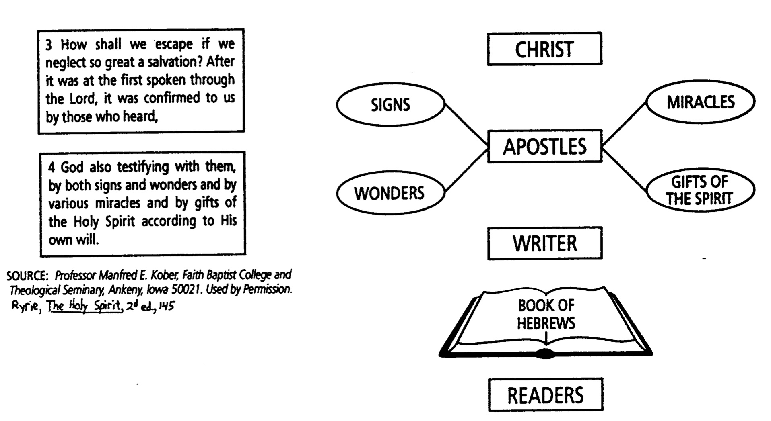

Ephesians 2:20 shows that apostles and prophets were the foundation of the church. A look at the nature of these gifts (see pp. 20-28) indicates that both the apostles and prophets disappeared from the church, having made no provision for successors—except in the case of Judas (Acts 1:15f.).

However, James and other apostles who were martyrs were not replaced (Acts 12:2). Given that no NT passages support apostolic succession, the gift of apostleship was then temporary in nature.

Revelation 22:18-19 warns against claiming additional prophetic revelations following the writing of the book of Revelation. Many today suppose that God personally gives them prophecies, thus adding to His Word and violating His warning in these verses.

Additional evidence for the temporary nature of some gifts can be found on the gift study guides for each gift. Please refer to the “Temporary Nature” sections of each temporary gift for further discussions on how these nine gifts were of a temporary nature. Also consult:

Edgar, Thomas R. Miraculous Gifts. Neptune, NJ: Loizeaux, 1983. 366 pp.

________. Satisfied by the Promise of the Spirit: Affirming the Fullness of God’s Provision for Spiritual Living. Grand Rapids: Kregel, 1996. 283 pp. (A response to Deere’s book, Surprised by the Power of the Spirit and an update on Edgar’s Miraculous Gifts.)

________. “The Cessation of the Sign Gifts.” Bibliotheca Sacra 145 (October-December 1988): 371-86. This is copied on pages 71-79 of these notes.

Farnell, F. David. “When Will the Gift of Prophecy Cease?” Bibliotheca Sacra 150 (April-June 1993): 171-202.

MacArthur, John. Charismatic Chaos. Grand Rapids: Zondervan, 1992. 415 pp.

McRae, William. Dynamics of Spiritual Gifts. Grand Rapids: Zondervan, 1976, pp. 90-99.
Transitional Diagrams

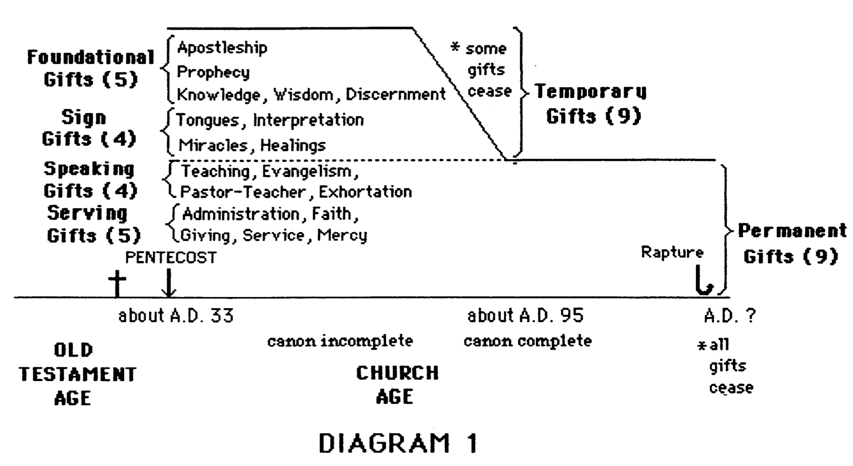

From Ephesians PPT, slide 245:

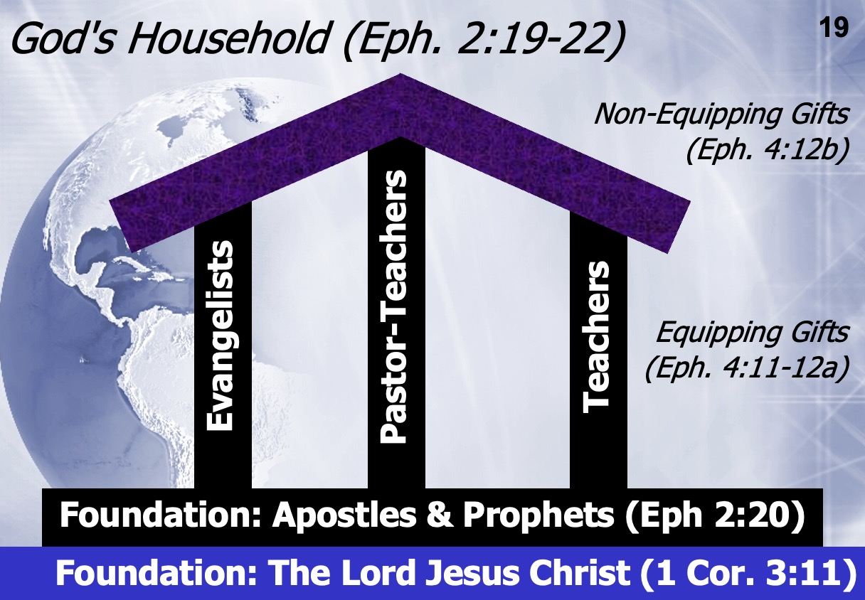

Temporary Foundational Gift

Apostleship

In Lists: 1 Corinthians 12:28, 29; Ephesians 4:11
Greek: apostolos (ἀπόστολος) is from apo “from” plus stello “I send,” i.e., one sent forth, a delegate, a messenger sent forth on a mission with orders from his superior, an apostle.

"The term 'apostle' means an envoy or delegate or ambassador. It was very familiar to the Jewish mind and referred to a special emissary, sent out with legal authority to act on behalf of the one who sent him" (MacArthur, Liberated for Life, 11). However, its use in the New Testament (with a few exceptions) is very restrictive, referring to a specific office and gift limited to only a few men. Here are the four different scriptural uses of the word apostolos from most common to least common usage (translations are in quotes). Only the first clearly indicates the gift, but the second is possible.

1) The twelve disciples plus Paul: "apostles" (Luke 6:13; 9:10; 1 Cor. 15:5), including Matthias (Acts 1:23-26) and later Paul (Gal. 1:1, 12, 15-17).

2) Church planters other than the twelve: "all the apostles" who saw Christ resurrected (1 Cor. 15:7) probably indicates more persons than the Twelve (v. 5) and may include Barnabas (Acts 14:4, 14), Jesus' brother James (Gal. 1:19), Andronicus and Junias (Rom. 16:7), Silvanus (Silas) and Timothy (1 Thess. 1:1; 2:6-7), and Apollos (1 Cor. 4:6, 9). Yet each of these texts is debatable.

3) Missionaries: "messengers" (2 Cor. 8:23; Phil. 2:25), "one who is sent" (John 13:16).

4) Jesus: "Apostle" (Heb. 3:1).

Definition: The divinely ordained gift to establish the Church on earth by divine revelation, unquestioned authority, and authentication by miracles.

Characteristics:
1. Chosen directly by Christ (Luke 6:13; Acts 9:15; Rom. 1:5; Gal. 1–2; 1 Tim. 2:7) or by the Holy Spirit (Acts 13:2).
2. Had miraculous powers as "divine credentials" of their office (2 Cor. 12:11-12; Acts 5:12-17).
3. Received direct revelation from God (Gal. 1:12; Eph. 3:1-6; Col. 1:25-27; 1 Cor. 7:10; 11:23ff; 15:3ff.; 2 Cor. 12:1-7; Jude 17-18).
4. Teachings possessed unquestioned authority as the commandments of God (1 Cor. 4:19-21; 5:3-4; 14:37-38; 2 Cor. 13:2-3, 10; 2 Pet. 3:15-16).
a. Exercised divine authority over all the churches in doctrinal matters (Acts 15:1-29).
b. Did not err in doctrine, but could (and did!) err in practice (Rom. 7:14-25; Gal. 2:11-13).
5. Laid the foundation of the Church (Eph. 2:20).
a. Prior to Pentecost announced the kingdom of God (Mark 3:13-15).
b. After Pentecost used by God to open the doors of salvation to Jews (Acts 2:38-41), to Samaritans (Acts 8:14-17), and to Gentiles (Acts 10:44-45).
6. Witnessed the resurrected Christ (Acts 1:22; 1 Cor. 9:1).
7. Had the most important office and gift in the Church (1 Cor. 12:28).
8. Equipped the saints for service (Eph. 4:11-12) by pioneer church planting (Acts 13–14).

Scriptural Examples: See #1-2 in the uses of apostolos section above.

Temporary Nature: See #1-6 in the Characteristics section above.

Other Viewpoints:
1. Apostleship died out in the first century, but a "missionary gift" (cross-cultural church planting) exists today (Flynn, 38-47; Graham, 138-39).
2. Apostleship exists today, defined as a ministry (not a gift) in which one is "sent forth from the church for specific Christian service" (Gothard, "Understanding Your Spiritual Gift," 5).
3. The "Gift of Apostle" (ability to exercise authority over several churches) and the "Gift of Missionary" (ability to minister cross-culturally) exist as separate gifts today (Wagner, 204-7).

Temporary Foundational Gift

Word of Wisdom
Utterance of Wisdom, Wisdom

In Lists: 1 Corinthians 12:8
Greek: logos (λόγος) “a word (as embodying an idea)” (Strong)
"the expression of thought, not the mere name of an object" (Vine)
sophia (σοφία) "wisdom" (BAGD)

The common meaning of the word "wisdom" today refers to a superior ability to apply knowledge to one's experience (discernment in life). This same meaning appears in Scripture (Matt. 12:42; Acts 6:3, 10; 7:10; etc.) However, this does not seem to be Paul's use of the word in 1 Corinthians. The "wisdom" associated with this gift refers not to natural (human) intellect for two reasons:
1) All of the spiritual gifts are supernatural (not human) enablements, and
2) Paul uses sophia 17 times in 1 Corinthians (1:17, 19, 20, 21a, 21b, 22, 24, 30; 2:1, 4, 5, 6a, 6b, 7, 13; 3:19; 12:8), usually contrasting man's "wisdom" with God's true wisdom. This wisdom of God concerns the whole system of revealed truth.

The other lists of gifts where "word of wisdom" is not found (cf. Rom. 12:6-8; 1 Cor. 12:28, 29-30; Eph. 4:11) mention the most important gifts first, these gifts almost without exception being the gifts of apostleship and prophecy. This pattern of listing the greater gifts first may also indicate the key importance of "word of wisdom" (and its counterpart, "word of knowledge") in relation to the other gifts since these two gifts are also listed first (1 Cor. 12:8-10).

Definition: The God-given ability of apostles and prophets to receive and present God’s wisdom within our New Testament.

Characteristics:
1. A characteristic gift of the apostles and prophets (1 Cor. 12:8 with 1 Cor. 12:28, 29-30).
2. Extremely important gift to be highly valued (1 Cor. 12:8 with 1 Cor. 12:28, 29-30).
3. Concerned not with the impartation of human wisdom, but with "God's wisdom in a mystery, the hidden wisdom, which God predestined before the ages to our glory; the wisdom none of the rulers of this age has understood" (1 Cor. 2:6b-8a). Throughout the book of 1 Corinthians "wisdom" relates to spiritual insight, especially received by direct revelation.
4. In order that the church may be edified through this gift, the spiritual (doctrinal) understanding given to those with the gift was to be spoken (thus, "word of wisdom”).
5. Revelational in nature since Paul stated, "for to us [the apostles] God revealed [His wisdom] through the Spirit..." (1 Cor. 2:10).

Scriptural Examples: Apostles (1 Cor. 2:6-11) and prophets (1 Cor. 13:2)

Temporary Nature: Since the gift of word of wisdom "was a characteristic gift of apostleship and prophesying— foundational gifts not present today—and as it involved direct revelation from God—no longer experienced today—we conclude that the gift of wisdom existed only in the first century in the apostolic age, before the completion of the canon of Scripture. It was a 'foundational gift'" (McRae, 65). This quote does not imply that people today cannot have God's wisdom in the general sense (especially as received from the Word of God). Wisdom passed from the church only in the technical sense through the passing away of this spiritual gift to receive and deliver revelation.

Other Viewpoints/Definitions:
1. The "proclamation of wisdom, speaking wisely" (BAGD 1. a. b.).
2. The "ability to apply knowledge to vexing situations, to weigh their true nature, to exercise spiritual insight into the rightness or wrongness of a complex state of affairs..." (Flynn, 92).
3. The "ability to make God's will known to men...the capacity to apply spiritual principles to contemporary problems" (Yohn, 92; cf. LaHaye, 245).
4. The "supernatural revelation, by the Spirit, of Divine Purpose; the supernatural declaration of the Mind and Will of God; the supernatural unfolding of His Plans and Purposes concerning things, places, people: individuals, communities, nations" (Horton, 61).

Temporary Foundational Gift

Word of Knowledge
Utterance of Knowledge, Knowledge

In Lists: 1 Corinthians 12:8
Greek: logos (λόγος) “a word (as embodying an idea)” (Strong)
"the expression of thought, not the mere name of an object" (Vine)
gnosis (γνῶσις) "knowledge"; frequently suggests inception or progress in knowledge (Vine); appears ten times in 1 Corinthians (1:5; 8:1a, 1b, 7, 10, 11; 12:8; 13:2, 8; 14:6).
Root: ginosko (γινῶσκω) "to come to know, recognize, perceive" (Strong)

Gift lists where "word of knowledge" is not found (cf. Rom. 12:6-8; 1 Cor. 12:28-31; Eph. 4:11) mention teaching as second only to apostleship and prophecy (which correspond to word of wisdom; cf. pp. 20, 23). Similarly, the high place given the gift of knowledge (second only to word of wisdom) in the 1 Corinthians 12:8-10 list may therefore show that this gift was associated with the gift of teaching. How could a first century teacher in the church know what to teach when there existed no written, infallible New Testament? Perhaps the word of knowledge accompanied the first century gift of teaching.

Definition: The first century teacher's divine enablement to understand, expound, and apply doctrinal truth received by direct revelation from God.

Characteristics:
1. Refers not to knowledge in the sense of natural (human) intellect, for all spiritual gifts are supernatural enablements.
2. A characteristic gift of the first century teachers (1 Cor. 12:8 with 1 Cor. 12:28, 29-30).
3. Extremely important gift to be highly valued (1 Cor. 12:8 with 1 Cor. 12:28, 29-30).
4. In order that the church may be edified through this gift, the spiritual (doctrinal) understanding given to those with the gift was to be spoken (thus, "word of knowledge").
5. There may be a revelational nature to this gift (1 Cor. 13:2; 14:6).
6. Whereas word of wisdom related to the apostles and prophets, word of knowledge seems to be more related to first century teachers.

Scriptural Examples: Peter displayed supernatural knowledge that was received directly from God, but presumably not by an audible revelation (Matt. 16:13-17).

Temporary Nature:
Both the gifts of prophecy and knowledge were to be "done away" before the coming of the "perfect" (1 Cor. 13:8-10). Since prophecy was a foundational gift (Eph. 2:20), it follows "that the gift of knowledge was a foundational gift, present in the early church when the doctrinal foundation was being laid by the teachers. It was particularly needful for the teacher to have such a gift as he was without the written Word of God in its entirety. As the New Testament was written and became available, this gift would no longer be necessary" (McRae, 66).

Other Viewpoints/Definitions:
1. The "supernatural revelation by the Holy Spirit of certain facts in the mind of God" (Horton, 44).
2. The "divine enablement to perceive and systemize the great truths presented by God in His Word" (McQuay, 4; cf. Radmacher, "Spiritual Gifts," Campus Crusade; Flynn, 90-91).
3. "More practice [than the utterance of wisdom], the application of divine wisdom to daily life" (J. Oswald Sanders, 97).
4. The "special ability that God gives to certain members of the Body of Christ to discover, accumulate, analyze and clarify information and ideas that are pertinent to the growth and well-being of the Body [also called the gift of scholar]" (Wagner, 260).
5. "The ability to learn the facts of God's creative universe and relate them to his revealed Word" (LaHaye, 245).
6. The "ability to understand correctly and to exhibit clearly the spiritual wisdom of God revealed to and by the apostles" (McRae, 65).

Temporary Foundational Gift (cf. 1 Corinthians notes, 161d-h; Malachi notes, 663-666)

Prophecy
Prophesying, Inspired Utterance
In Lists: Romans 12:6; 1 Corinthians 12:10, 28, 29; Ephesians 4:11
Greek: propheteia (προφητεία) comes from pro “forth” and phemi “I speak,” i.e., speak forth.
“In the Septuagint [the 250 BC Greek translation of the Hebrew OT], ['prophetes,' the noun form of 'prophetia'] is the translation of the word 'roeh,' a seer; 1 Sam 9:9, indicating that the prophet was one who had immediate intercourse with God. It also translates the word 'nabhi', meaning either one in whom the message from God springs forth or one to whom anything is secretly communicated” (Vine).
Prophets spoke uninterpreted messages of God (2 Pet. 1:20-21). Some OT prophets did not fully understand the person or time to whom their message was directed (1 Pet. 1:10-12). NT prophets spoke divine revelation on the impulse of sudden inspiration to exhort the church (1 Cor 14:29-31), as contrasted with teachers, who systematically instructed hearers in a better understanding of the Scriptures (Acts 28:30-31).
Definition: “The special ability...to receive and communicate an immediate message of God to His people through a divinely anointed utterance” (C. Peter Wagner, Your Spiritual Gifts Can Help Your Church Grow, 228).
Characteristics of those with the gift of prophecy:
- Spoke both predictively (“fore-telling,” Acts 11:27-28; 21:10-14) and proclamation or preaching (“forth-telling,” Acts 15:32; 1 Cor 11:4-5), but always from divine origin (2 Pet. 1:21).
- Received messages by divine revelation (1 Cor 14:26, 29-30; Eph. 3:5).
- Did not interpret God's message, but just declared it (2 Pet. 1:20-21).
- Declarations were 100% accurate, totally free from error (Deut 18:14-22)—the implication is that after weighing it for truth, it should be rejected if any error is taught (1 Cor 14:29).
- Generally directed messages to believers (1 Cor 14:22) for exhortation (1 Cor 14:3), edification (1Cor 14:3-5, 26), consolation (1 Cor 14:3), and teaching (1 Cor 14:19, 22, 31).
- Could have evangelistic results for unbelievers in a church service (1 Cor 14:23-25), though not its main emphasis (1 Cor 14:22).
- Served as the second most important gift in the Church (1 Cor 12:28; Eph. 4:11), to be emphasized especially over tongues (1 Cor 14:1, 5, 29).
- Differs from non-inspired proclamations by teachers (Rom. 12:8) or pastor-teachers (Eph. 4:11).
Scriptural Examples: Agabus (Acts 11:27-28; 21:10-11), Barnabas, Simeon, Lucius, Manaen, Paul (Acts 13:1), Philip's four daughters (Acts 21:9), Judas and Silas (Acts 15:32).
Temporary Nature: Prophecy was foundational to the Church (Eph. 2:20). Revelation 22:18-19 closes the Scripture with a warning to never add to His completed revelation. Jude 3-4 also appears to suggest a closed canon, implying that God no longer speaks prophetically. However, two future witnesses are yet to come during the Great Tribulation who will both prophesy (Rev. 11:3). If true prophecies which add to God's revelation do not exist today, the warning “do not despise prophetic utterances” (1 Thess. 5:20) cannot be disobeyed except about disobeying biblical commands. Prophecy is equal in authority to the Bible, for it is God’s inerrant word in spoken form rather than written form.
Other Viewpoints:
- Preaching: Revelational prophecy ceased with the completion of the canon, but today “prophesying has come to mean the proclamation of the written Word of God...” (Leslie Flynn, 19 Gifts of the Spirit, 53; Earl Radmacher, “Spiritual Gifts” tape, Campus Crusade for Christ; Billy Graham, 139- 141; John MacArthur, The Church, 139; Alan Redpath, The Royal Route to Heaven, 142-43; C. K. Barrett, 1 Corinthians, 316).
- Exhortative Preaching: Non-revelatory prophecy is evident today in powerful, exhortative-type preaching (Gothard, “Understanding Your Spiritual Gift,” 5).
- Revelational prophecy exists today (Charismatics, Wagner—see definition above, 228).

- Any Christian involved in “telling something that God has spontaneously brought to mind” (Wayne A. Grudem, “Why Christians Can Still Prophesy: Scripture Encourages Us to Seek this Gift yet Today,” Christianity Today [September 16, 1988]: 29; cf. Grudem’s 1988 book, The Gift of Prophecy). His article is reproduced in my Spiritual Gifts notes, 124-28.
Grudem’s view has become popular in both charismatic and non-charismatic settings, so it deserves scrutiny. His main points are dangerous—if you believe him, then you must believe the following:
a. OT prophets have their counterparts in NT apostles (not NT prophets) in their authoritative function of writing Scripture.

Response:
    - It is true that both wrote Scripture, but this does not lower the value of NT prophets. It only affirms that NT apostles received revelation directly from God. It does not mean that the NT prophets did not also receive divine revelation.
    - NT prophets rank second after apostles (1 Cor 12:28) and thus held a very high status. In fact, they formed the foundation of the church along with the apostles (Eph. 2:20).
    - Continuity between OT and NT prophets is affirmed by Peter, who noted that NT prophecy was of the same nature (Acts 2:17-18; cf. Joel 2:28).
    - “The apostles were a very restricted group who existed during one period. They were promised that they would be on twelve thrones judging the twelve tribes of Israel (Matt. 19:28) and their names will be on the foundation of the heavenly city (Rev. 21:14). The Old Testament prophets are promised none of these things. Everything about the apostles shows their uniqueness” (Edgar, Satisfied by the Promise of the Spirit, 62).
b. OT and NT prophecy are different in nature. OT prophets spoke with absolute divine authority, but “this ordinary [NT] gift of prophecy had less authority than that of the Bible, and even less than that of recognized Bible teaching in the early church” (p. 30). There exist two kinds of NT prophecy: infallible “apostolic” prophecy and fallible “congregational” prophecy.
Response:
- Grudem’s argument begins with a broad, secular definition of prophecy meaning “one who speaks on the basis of some external influence” (p. 30). Scripture often employs secular Greek terms but attaches a more specific meaning to them (e.g., for logos, agape, etc.). We do not determine the nature of OT prophecy from secular usage but only Scripture; the NT (not secular Greek usage) is also our guide for determining the nature of NT prophecy.
- Identical terms for OT and NT prophecy are used (cf. LXX), so we should assume these are of the same nature unless good exegetical grounds can be shown for a difference. Would God use the same terms with completely different meanings, leading to confusion?
- We should test and not despise prophecies (1 Thess. 5:20-21), but this hardly argues for less authority than OT messages. It is identical to the OT requirement to test true prophecies to make sure they come true under penalty of death (Deut. 13:1-5; 18:14-22). Only the death penalty is not reiterated in the NT. The parallel of “Thus saith the Lord” is still used in the NT as “The Holy Spirit says” (Acts 21:11).
- Paul’s disregard for the Spirit’s warning to avoid Jerusalem (Acts 21:4) is not “fallible but inspired” prophecy, as Grudem claims. It may indicate a fallible Paul. He felt compelled by the Spirit (20:22-23), but maybe he was mistaken. Perhaps God wanted him to live longer than he did. Apostles sometimes erred in practice (e.g., Peter withdrew from Gentiles in Galatians 2; Paul struggled with sin in Rom 7:14-25), but they did not err in doctrine.
- Grudem says, “If prophecy had equaled God’s word in authority, [Paul] would never have had to tell [the Thessalonians] not to despise it” (p. 30); but this statement shows great ignorance of the massive rejection of OT prophets (Matt. 23:37; Heb. 11:33-40). People reject God’s inspired word even today despite His warnings.
- The stipulation that prophets were to “weigh what is said” (1 Cor 14:29) is interpreted by Grudem as “sift the good from the bad” (p. 31). But is this the intent of Paul? The discernment was to judge whether the message itself was from God, not to pick and choose which parts were good and bad. This is why God provided the gift of discernment (1 Cor 12:10), for false prophets could be among them (12:3).
- The stipulation that prophets were allowed to interrupt one already speaking (1 Cor 14:30) does not indicate fallibility in their messages as Grudem claims (p. 31). Why can’t God stop one person from declaring an inspired message when enough has been said? “A prophecy which is truly from God is evidenced by an orderly and rational manner of presentation” (Farnell, 86). True prophets remained in control of their mind in contrast to pagan ones. This verse says nothing at all about the content or reliability of the prophecy.
- The idea that early church prophets had less authority than teachers is erroneous (cf. Grudem, 34). True, elders were to teach, but even this emphasizes the high standing attributed to prophecy, with which few (if any) elders were gifted. In fact, prophecy appears first when listed with teaching (Acts 13:1), indicating prophecy’s prominence. The spiritual gifts are listed in order of importance in 1 Corinthians 12:28, with prophets ahead of teachers. Surely, if the gift included erroneous material inspired by the Holy Spirit, it would not be given such priority! The high place ascribed to prophecy is clear in that it is the only gift mentioned in each gift list in the NT (cf. Spiritual Gifts notes, 6). Please see the other contrasts between prophecy and teaching in 1 Corinthians notes, page 161h.
c. God is the author of error because He brings ideas to believers’ minds, but they mess up in passing along the message.
Response:
- Grudem amazingly accuses the Holy Spirit of error (called “inaccuracies of detail”) when Agabus prophesies that Jews would bind Paul, though Romans bound him (Acts 21:10-11, 33). However, the Jews instigated the riot, which led to the Romans binding Paul (21:27f.), so the Spirit was not wrong in its message through Agabus.
- Agabus also prophesied that the Jews would hand Paul over to the Gentiles (21:11b). The fact that they preferred to kill him in no way argues for “inaccuracy in detail” by the Spirit as Grudem alleges, for the Jews did hand him over, though involuntarily.
- Grudem essentially teaches that a message can be inspired but erroneous, which is incredible to imagine. Will God really speak error? If so, what about our Bible? This is akin to saying Scripture is inspired but not inerrant in its original manuscripts. While there have always been false (erroneous) prophecies from Satan, it is incredible that evangelicals now actually believe in “inspired but erroneous” messages from God himself!

- If NT “congregational prophecy” was “simply a very human—and sometimes partially mistaken—report of something the Holy Spirit brought to someone’s mind” (Grudem, The Gift of Prophecy…, 14), who can determine the authoritative (accurate) from the non-authoritative (mistaken) messages of God?

d. Any Christian may prophesy. As defined earlier, this new view on prophecy is simply “telling something that God has spontaneously brought to mind” (Grudem, “Why Christians Can Still Prophesy,” 29). Since any Christian can share something that the Lord has impressed in his/her mind, prophecy can be exercised by any believer.
Response:
- “Are all apostles? Are all prophets?” (1 Cor 12:29). The obvious answer is “no” since God distributes the gifts as He wills (12:11, 18) and therefore has not given the potential of the same gift to every believer. Thus, this verse is clear that not every Christian should or can have the gift of prophecy.
- “Follow the way of love and eagerly desire spiritual gifts, especially the gift of prophecy” (1 Cor 14:1; cf. v. 39) does not exhort each believer to prophesy. If it did, it would contradict 1 Corinthians 12:29 (quoted above), which says that it is not God’s will for all to prophesy. Instead, this is written in the second person plural (“all of you”) to encourage the whole church to promote prophecy over tongues. This is consistent with Paul’s limitation of no more than three prophets speaking per service (14:29).
- Grudem supposes that even the discernment of prophecy can be exercised by any believer (The Gift…, 60-62; cf. 1 Cor 14:29), but the most logical antecedent of “the others” is the “prophets” noted in the first part of the verse. Paul used allos (“another of the same kind”) rather than heteros (“another of a different kind”; i.e., not a prophet). Grudem notes, “Especially hard to believe is the idea that the teachers, administrators, and other church leaders without special gifts of prophecy would sit passively awaiting the verdict of an elite [prophetic] group” (p. 62). But is this so hard to imagine? “Inspired spokesmen were in the best position to judge spontaneously whether a new utterance agreed with Paul’s teaching… The responsibility of New Testament prophets to weigh the prophecies of others does not imply that true prophets could give false prophecies, but that false prophets could disguise their falsity by occasional true utterances” (Farnell, 84-85).
Summary of Prophetic Views
Grudem’s View | Biblical View
Prophecy is declaring anything (true or false) that the Spirit brings to one’s mind | Prophecy is declaring God’s inspired and inerrant revelation to others
The above definition was invented in 1988 by Wayne Grudem | The above definition has been the teaching of the church for 20 centuries
OT prophets are parallel to NT apostles | OT prophets are parallel to NT prophets
God changed the definition of prophecy from the OT to the NT | God kept the meaning of prophecy consistent between the two testaments
God gives some prophecies with errors | God gives all prophecies without errors (2 Pet. 1:20-21)
Any believer can prophesy | Only those with the gift of prophecy can prophesy (1 Cor 12:29)
There’s two kinds of NT prophecy (fallible and infallible) | There’s one kind of NT prophecy (infallible)
Fallible prophecy can be inspired | Fallible prophecy is false prophecy (Deut. 13:1-5; 18:14-20)
God sometimes lies | God always tells the truth since He cannot lie (Heb. 6:18)

Prophecy versus Teaching
Since both prophecy and teaching communicate God’s Word, is there any difference between them? Grudem says one key difference is that “prophecy has less authority than teaching” (Wayne A. Grudem, “Why Christians Can Still Prophesy: Scripture Encourages Us to Seek this Gift Yet Today,” Christianity Today [September 16, 1988]: 34). The following cites more biblical contrasts:

 | Teaching | Prophecy
Value | Inferior: Teaching is listed after prophecy in the leadership structure of the church at Antioch (Acts 13:1) | Superior: Prophecy has a long OT history of declaring an uninterpreted word of God (2 Pet. 1:20-21) whereas teachers must interpret it
Relation to the Other Gift | A less important gift: listed after prophecy in the priority of the gifts (1 Cor 12:28) | The second most important gift, superseded only by apostleship (1 Cor 12:28)
Authority | Less authoritative than prophecy since God’s written word must be interpreted by the teacher | More authoritative than teaching since the spoken word is divinely inspired and uninterpreted (2 Pet. 1:20-21)
Source of Truth is … | God’s Word (Col. 3:16) | God’s Spirit (2 Pet. 1:21)
Revelatory Nature | Uninspired explanation of already revealed truth (Acts 15:35; 11:12,  26; Rom. 2:21; 15:4; Heb. 5:12) | Inspired foretelling the future or “forthtelling” (declaring doctrinal truth) received by revelation (1 Cor 14:19, 26,  29-30; Eph. 3:5)
Style | Systematic | Spontaneous (Acts 11:28; 21:4, 10-11)
Limitations | No limitation on teaching is given in church services | Two or three prophetic messages in each service (14:29a), speak in turn (14:30-31), weigh what is said (14:29b, 32)
Leadership Requirements | Required of elders (1 Tim. 3:2;  5:17; Tit. 1:9) since the church needs continued teaching of truth through its history | Not required of elders as this would provide too high a standard; also, revelation need not continue after the canon is complete (Rev. 22:18-19)
Foundation for the Church | Not foundational in nature for the Church—the foundation is not in interpreted messages but in divinely spoken and written messages from God provided by apostles and prophets | Foundational for the Church along with apostleship (Eph. 2:20), which means that it need not continue through Church history since the foundation is provided once-for-all (e.g., no apostles today)
Cessation | No hint is given in the NT that this gift has ceased or will do so in the church age | The gift will cease by someone other than self: passive voice (1 Cor 13:8a; cf. Spiritual Gifts notes, 29)

Note: I believe this chart provides a more credible contrast between the two gifts than offered by Grudem on page 34 of his article cited above. While he rightfully upholds the value of teaching, his biblical examples do not actually contrast teaching with prophecy. Rather, they only show the great importance that teaching had in the early church.

Temporary Foundational Gift

Distinguishing of Spirits
Discerning Spirits, Discernment

In Lists: 1 Corinthians 12:10
Greek: diakrisis (διάκρισις) "distinguishing, differentiation...ability to distinguish between spirits in 1 Corinthians 12:10" (BAGD); "the act of judgment" (Strong); the noun form is also found in Romans 14:1; Hebrews 5:14.

"DIAKRISIS...a distinguishing, a clear discrimination, discerning, judging, is translated 'discernings' [KJV] in 1 Corinthians 12:10, of discerning spirits judging by evidence whether they are evil or of God" (Vine).

Verb: diakrino (διακρίνω) is dia "through" and krino "judge;" some NASB translations are “decide” (1 Cor. 6:5), “pass judgment” (1 Cor. 14:29), “discern” (Matt. 16:2), etc.

What it means to “discern spirits” is much debated, especially on what is meant by "spirits." Basically, it means being able to determine between the sources of different types of spiritual insight. This is especially true of those who could tell whether one who claimed to speak inspired utterances from God actually was telling the truth. Since God expected prophets to exercise this type of wisdom and insight (1 Cor. 14:32), this may indicate that at least the New Testament prophets had this gift, though perhaps others as well.

"Tongues must be interpreted; prophecy must be discerned" (Gangel, 92).

Definition: The God-given ability to judge an oral declaration from someone claiming to be a prophet as from a divine, human, or demonic source.

Characteristics of those with the gift of distinguishing of spirits:
1. Ability to evaluate the truth of a prophet's oral declaration (1 Cor. 14:29).
2. Possibly all prophets had this gift (1 Cor. 14:32).
3. Ability to confront spiritual heresy (1 Cor. 14:29).

Scriptural Examples: Prophets in the church at Corinth (1 Cor. 14:29-32)

Scriptural Commands: 1 Thess. 5:20-21; 1 John 4:1

Temporary Nature: The prophecy handout explains reasons why the gift of prophecy passed from the church in the first century. Assuming this to be true, it makes sense that the gift of discerning of spirits was also foundational in nature since it served to evaluate true prophecies.

"In the midst of many forms of oral revelation, it was essential in the early church to have divine assistance in detecting the false amidst the true. Satan then, as now, attempted every deceiving device. [This gift] was apparently the ability given by the Holy Spirit to discern the true from the false sources of supernatural revelation given in oral form. As the New Testament had not been completed, there was no written Word to appeal to except the Old Testament. With the coming in of the completed New Testament, the written Word made this work of the Spirit no longer necessary" (Walvoord, 188).

Other Viewpoints:
1. Revealing false motives in others (Flynn 153, 154; Radmacher, "Spiritual Gifts" tape, Campus Crusade for Christ; Acts 5:39; 8:20-23; 13:10, 11).
2. Distinguishing between mental disorders and demonic possession (Bridge and Phypers; Acts 16:16-22).
3. Discerning spiritual truth from spiritual error in someone's teaching (Flynn, 153).
4. Discerning proposed courses of action as from divine, human, or satanic origin (Kinghorn, 11).

Temporary Sign Gift (cf. 1 Corinthians notes, 161i-m)

Speaking in Tongues
Speaking with Tongues, Strange Tongues, Tongues, Speaks in a Tongue,
Speaks with Other Tongues, Tongues of Men, Various Kinds of Tongues

In Lists: 1 Corinthians 12:10, 28, 30
Greek: glossa (γλῶσσα) "tongue," "language" (BAGD 1., 2.)

The word glossa has three different meanings in the New Testament:
1. The tongue as an organ of speech (Mark 7:33; Rom. 3:13; 14:11; 1 Cor. 14:9, etc.)
2. Something shaped like a tongue, such as forked flames of fire (Acts 2:3)
3. A language:
a. Understood by the speaker (1 Cor. 14:10; Rev. 5:9)
b. Not understood by the speaker (Acts 2:4; 10:46-47; 19:6; 1 Cor. 12:10, 28; 13:1, 8; 14:1-40)

Speaking in tongues is only in Mark 16:17 and Acts and 1 Corinthians (cf. 3b above). Some teach a fourth glossa as an "ecstatic utterance" (emotional speaking not in a foreign language). They seek to support this based upon Romans 8:26 ("…the Spirit Himself intercedes for us with groanings too deep for words"), 1 Corinthians 13:1 ("If I speak with the tongues of men and of angels...") and 1 Corinthians 14:2 ("...one who speaks in a tongue does not speak to men but to God… no one understands him; he utters mysteries with his spirit”). They say Acts glossa are "languages," but 1 Corinthians glossa are "ecstatic utterances."

This interpretation fails on several accounts:
1. Romans 8:26 says that it is the Spirit who speaks, not us—and He does so with inaudible, nonuttered, internal groanings (Edgar, “Cessation,” 384).
2. 1 Corinthians 13:1 does not teach that anyone can speak an angelic language, but only that if one could speak any earthly or heavenly language, this ability would be useless without love.
3. To "speak mysteries" (1 Cor. 14:2) means the speaker and others cannot comprehend the foreign language he is using; it does not indicate that the tongue is not a known language (cf. v. 10).
4. The only description of tongues speaking in the NT (Acts 2:4-11) is in real human languages.
5. Paul uses glossa three other times (Rom. 3:13; 14:11; Phil. 2:11) outside of 1 Corinthians, each time referring to intelligible speech. Therefore, glossa in the NT always refers to known languages.

Definition: A God-given ability to speak divine revelation in a foreign language unknown by the speaker to unbelieving Jews in their language (as a sign) that a gifted interpreter can translate to edify the church.

Characteristics:
1. Unique among the spiritual gifts in the following respects:
a. The only spiritual gift with restricted use (except 2-3 prophets per service, 1 Cor. 14:29):
1) Only to be spoken by 2-3 people at a church gathering, each in turn (1 Cor. 14:27)
2) Only to be exercised if an interpreter is present (1 Cor. 14:28), although each speaker should pray to be able to interpret his message (1 Cor. 14:13). This is not a command to pray for the gift of interpretation (ability to understand others' tongues messages)!
3) Only to be spoken by men in the church, never women (1 Cor. 14:34-35)
b. The only gift in which the believer uses a language unknown to him (1 Cor. 14:2, 11)
c. The only gift ever given to groups of people—on three unique occasions (Acts 2, 10, 19)
d. The only gift ever over-emphasized in a New Testament church (1 Cor. 14)
e. The only gift ever said to be misused in a New Testament church (1 Cor. 14).
f. The only gift mentioned as gradually ceasing in and of itself (1 Cor. 13:8b; see below)
g. The only gift which is useless for edification when exercised apart from another spiritual gift, i.e., the gift of interpretation of tongues (1 Cor. 14:5, 11, 13, 27, 28)
2. Audible speech (Acts 2:4, 11; 1 Cor. 13:1; 14:2ff) in known languages (Acts 2:4-11)
3. Least important of all of the gifts (1 Cor. 12:28), especially inferior to prophecy (1 Cor. 14)
4. Can be controlled by voluntarily refraining from speaking (1 Cor. 14:27-28)
5. Not given to all believers (1 Cor. 12:30)
6. Only understood by God, not men (1 Cor. 14:2, 28), so prayer in a tongue (1 Cor. 14:14) is a negative action rather than praise (Acts 2:11; 10:46; cf. Edgar, Miraculous Gifts, 181, 186-99)
7. Revelational (1 Cor. 14:16) since God Himself is speaking (14:21)—presumably without error!
8. There may be a twofold purpose of tongues:
a. Sign (Mark 16:17) to unbelievers (1 Cor. 14:21-22), including Jews (Acts 2:4-11) and Gentiles (Acts 10:44-48; 19:1-7; 1 Cor. 14:22-24) to authenticate the message of salvation in Christ (Heb. 2:3, 4). They authenticated God's activity in evangelistic settings (Acts 19:6).
b. Edification to the church when translated (1 Cor. 12:7; 14:5, 12, 17, 19, 26).

Note: Another commonly taught purpose is for self-edification, based upon 1 Corinthians 14:4. However, self-edification is merely an accompanying circumstance or by-product of exercising this gift (or any gift!). Gifts are given not for selfish ends but for the “common good” (1 Cor. 12:7).

Scriptural Examples: Apostles at Pentecost (Acts 2:4, 11), Gentile believers (Acts 19:46), converted disciples of John (Acts 19:6), Corinthians (1 Cor. 12-14), and Paul (1 Cor. 14:18)

Temporary Nature: In 1 Corinthians 13:8, "to be done away" (καταργηθήσονται) in the passive voice indicates that something outside of prophecy or knowledge would end their use. However, for tongues "to cease" (παύσονται) in the middle voice indicates that "the subject is both the performer and receiver of the action" (Goetchius, The Language of the New Testament [New York: Charles Scribner's Sons, 1965], 100). This indicates that the gift of tongues would stop in and of itself without any object acting upon it. The gifts of prophecy and knowledge were to be "done away" at the coming of the “complete” (“perfect”; 1 Cor. 13:10), which probably refers to the relative maturity of the Body of Christ at the completion of the New Testament since they fulfilled their purpose by providing us with God's Word in written form (see pp. 16-17). However, tongues ceased by itself after fulfilling its purpose as a sign to Israel (Isa. 28:11, quoted in 1 Cor. 14:21) and to unbelieving Gentiles (1 Cor. 14:22-24).

"God was thereby giving notice to Israel that He was moving from the Jews to the Gentiles as His people. Paul explains this in detail in Romans 11 and Jesus had prophesied it in Matthew 21:33-43... In 70 AD Israel was wiped out in fulfillment of Deuteronomy 28:63-65. They were dispersed into every nation on the face of the earth, and since that day there has been no Biblical purpose for the gift of tongues" (Radmacher, Controversial Spiritual Gifts, 18). Also, Hebrews 2:3-4 says "signs" (including tongues) authenticated the apostolic message.

How then can one explain "speaking in tongues" today? It must not be the biblical gift of tongues, but ecstatic speaking, which is often called "glossolalia" (glossa "tongue" + lalia "speech"). Gibberish then and now serves not as a sign but only underscores the Corinthians’ or our pagan backgrounds. Today’s phenomenon (ecstatic utterances) may be attributed to one of two sources:

1. Self: Highly emotional experiences for many people have caused them to suddenly burst out in a gibberish, ecstatic speech, which has often been confused with the biblical gift of tongues. This has been studied extensively by psychologists as a psychological phenomenon.

2. Satan: The devil is a master counterfeiter, even appearing as an angel of light if necessary (2 Cor. 11:4), so the more closely ecstatic speaking resembles true tongues, the more suspect it may be! Satan is especially interested in convincing believers to rely upon any experience more than the Word of God. Ecstatic speaking is characteristic of many cults and religions, including Mormonism, Jehovah's Witnesses, Islam, Buddhism, Hinduism and pagan African cults.

But how about, “Do not forbid speaking in tongues” (1 Cor. 14:39)? This applies only to the true gift of tongues—not to ecstatic utterances. Nothing in the NT prohibits us from limiting ecstatic speech.

Other Viewpoints:
1. Tongues today edifies oneself in a “private prayer language,” as well as “public tongues” to communicate immediate messages from God to the church (charismatics; Wagner, 253).
2. Tongues exist today not as a gift, but as a "manifestation" (result in someone else's life). This is a supernatural result “of the Holy Spirit's work in our lives and also in the lives of those to whom we minister." So "various tongues" means that as a tongues speaker speaks, "another's spirit is freed to communicate with God" (Gothard, "Understanding Your Spiritual Gift," 5).
Questions on Tongues Speaking

1. Why can’t tongues be a special prayer language for private use?

a. The purpose of the gifts is that they might edify others (1 Cor. 12:7; 14:26). The one mention of tongues edifying self is a negative action in comparison to prophecy’s positive result of building up others (14:4). Self-edification is not to be the goal of exercising a spiritual gift, but simply an accompanying circumstance (cf. 1 Cor. 13:5).

b. The purpose of tongues was to serve as a sign to unbelievers (1 Cor. 14:22). J. B. Phillips translates this, “That means that tongues are a sign of God’s power, not for those who are unbelievers but for those who already believe” (The New Testament in Modern English, rev. ed., NY: Macmillan, 1972). He explains this misinterpretation thus, “This is the sole instance of the translator’s departing from the accepted text. He felt bound to conclude, from the sense of the next three verses, that we have here either a slip of the pen on the part of Paul, or, more probably, a copyist’s error” (Phillips, 552). Phillips fails to mention, however, that not one of the thousands of NT manuscripts reads with his own invented reading! Nor can an error by Paul be reconciled with an inerrant text. Despite Paul’s clear teaching that tongues serve as a sign to unbelievers, most charismatics today see this as a sign to them as believers that God is at work in their lives. Examples of tongues usage includes both outside (Acts 2, 10, 10) and inside the assembly (1 Cor. 14), but the clearly stated purpose is as a sign to unbelievers. One could infer from this that God only grants a tongues utterance to an assembly when an unbeliever is present (14:23), but even in this case it should be translated so that believers could be edified (14: 5, 12, 17, 19, 26).

c. One who speaks in a tongue does so “to God” (1 Cor. 14:2), but Paul clearly says that prayer with understanding is superior to prayer in a tongue because prayer without understanding, by comparison, is a negative action (1 Cor. 14:14-15).

d. Tongues was not given to all (1 Cor. 12:30), so why would God give a special prayer language to only some of His children? While some may ask the same question (“Why did only some receive it?”) of any of the gifts, prayer is a privilege shared by all.

e. God’s provision of the gift of interpretation of tongues (1 Cor. 12:30) shows that tongues were not for devotional use. Tongues should never be used without interpretation (14:26-28), which indicates that a private use is out of character with the purpose of the gift. Even though a tongues speaker should seek to understand what he is saying (14:13), this person has no guarantee that he does indeed understand. While very few who claim such a “private prayer language” ever seek to understand their utterances, Paul noted that prayer with understanding is better (1 Cor. 14:19).

f. The use of every gift is public, not private. In every case where gifts were used, the body is assembled. But how are we to understand 1 Corinthians 14:28 in this respect: “If there is no interpreter, the speaker should keep quiet in the church and speak to himself and to God”? Is this not a private use? No, for every time in Scripture that tongues are spoken they are uttered within the context of a group—even the speaking of 1 Corinthians 14:28 takes place “in the church” (cf. 14:19 which is not clearly contrasted with private use).

g. Paul said that he spoke in tongues more than the Corinthians (14:18). Did this not indicate a private usage? No, for Paul never stated the circumstances or location of this practice. He then notes, “but in the church” intelligible speech is better than unintelligible speech (v. 19). Is this not a comparison between private and public tongues? No, rather he contrasts tongues used outside of the assembly as a sign to unbelievers (vv. 20f.) with tongues needing interpretation in the assembly. In both cases tongues are public.
2. Why isn’t speaking in tongues proof that one has been baptized with the Spirit?

a. Receiving at least one spiritual gift is an evidence that one has received Christ (i.e., been baptized with the Spirit; 1 Cor. 12:7, 11, 18), but nowhere does the Bible say this gift must be tongues. The “gift” of Acts 2:38 is not tongues but the Spirit Himself.

b. All Christians are baptized with the Spirit (1 Cor. 12:13), but not all believers are to speak in tongues (1 Cor. 12:30); therefore, a connection between the two cannot be maintained.

c. Scripture records the salvation experience of dozens of individuals; however, on only two accounts did salvation result in tongues (Acts 10, 19).

3. Why shouldn’t I seek the gift of tongues?

a. You shouldn’t seek any spiritual gift since the Holy Spirit is the one who decides which gift each believer should possess (1 Cor. 12:7, 11, 18).

b. Even if you were to seek a gift, it is clear that tongues would not be that gift since it is the least important of the spiritual gifts (1 Cor. 12:28).

c. There are only five passages in the NT which mention tongues-speaking (Mark 16:17; Acts 2:4-11; 10:46; 19:6; 1 Cor. 12—14). None of these passages indicate that the speakers ever sought for the gift. In fact, Peter and the saved Jews were amazed that it happened (Acts 10:45). Therefore, the biblical pattern is not to seek the gift—except in the case of the Corinthians, who were rebuked for it (1 Cor. 14:1-2, 39).

4. Should the use of the gift of tongues in Acts be the pattern for the church today?

a. The problem with this question is that it assumes a single pattern of tongues-speaking in Acts, which the following chart shows did not exist. It was bestowed at differing times in relation to salvation and to separate groups. The only common element is that in each occurrence, it served as a sign to Jews.

b. Interpretive problems have often arisen when establishing doctrinal beliefs based only upon the material in the Book of Acts. A proper understanding of Acts can only be obtained when one recognizes that it is a transitional book and therefore not intended to set norms for the post-apostolic age. This is especially true in regard to speaking in tongues in Acts:

Text | Speakers | Audience | Time | Purpose
2:1-4 | Apostles+ | Unsaved Jews at Pentecost | After salvation | Validate for Jews the fulfillment of Joel 2
8:14-17 | Samaritans | Saved Jews doubting God's plan (Peter+) | After salvation | Validate for Jews God's acceptance of Samaritans
10:44-47 | Gentiles (Cornelius+) | Saved Jews doubting God's plan (Peter+) | At salvation | Validate for Jews God's acceptance of Gentiles
19:1-7 | OT believers in Messiah | Jews needing gospel message confirmed | At salvation | Validate for Jews God's message through Paul
Chart adapted from Stanley D. Toussaint, “Acts,” in The Bible Knowledge Commentary, 2:408

Notice that in each case above, tongues were given on unique occasions to validate God’s work for Jews who were in attendance. As far as we know, the biblical gift of tongues was not given to groups of believers ever happened again. Thus, no norm can be established from Acts.
Tongues in Acts and 1 Corinthians

Speaking in tongues in Acts has both similarities and differences with the tongues of 1 Corinthians. While the tongues themselves are the same, the circumstances were different.

Comparisons | Tongues in Acts | Tongues in 1 Corinthians
Known foreign languages used | Languages of the Roman world were spoken (Acts 2:7-11) | Since the same term (glossa) is used, we should assume the nature of the gift is the same
Both functioned as a sign to unbelievers | The listeners were exhorted to receive forgiveness (Acts 2:38) | Unbelievers in the assembly needed translation for blessing (1 Cor.14:21-22)
Source is God rather than self | The tongues speakers were not trying to get the gift (Acts 2:2) | Tongues is among the gifts of the Spirit (1 Cor. 12–14)
Contrasts | Tongues in Acts | Tongues in 1 Corinthians
Speaker’s Control | Uncontrolled | Controlled
Given to… | Groups only | Individuals who are gifted
Phenomenon | Wind and fire (Acts 2:2) | None
Frequency per person | One-time | Repeated
Those who understand | Native speakers | Those gifted in interpretation
Interpretation | No corollary gift | Yes (corollary gift of interpretation)
Dates | AD 33-53 (Acts 2–19) | AD 56
When occurred | Generally at salvation | Generally after salvation
Use | Always used properly | Often misused
Restrictions | None | Some: only 2-3 per service, each in turn, need interpreter (1 Cor. 14:27)

Tongues versus Prophecy
(cf. 1 Corinthians notes, 161m)

The Apostle Paul felt that one of the best ways to teach the proper emphasis regarding the gift of tongues was to contrast tongues with prophecy. Most of 1 Corinthians 14 is devoted to showing the superiority of prophecy over tongues. Paul’s teaching here is summarized in the following chart along with other relevant passages.

 | Tongues | Prophecy
Value | Inferior (14:5a) | Superior (14:1)
Relation to Other Gifts | The least important gift (12:28) | The second most important gift (12:28)
Language Used | Foreign (14:10) | Vernacular (14:19)
Corollary Gift | Interpretation of tongues (12:30; 14:27-28) | Discerning of spirits  (12:10; 14:29)
Speaker’s Knowledge of Language | Unknown: “utters mysteries with his spirit…my spirit prays but my mind is unfruitful” (14:2b, 14) | Known: “pray with my spirit [and] with my mind” (14:15, 19)
Value (without Interpretation) | Harmful: people cannot understand and thus are not edified (14:16-17, 23, 28) | Great: people can understand and thus are edified (14:5b, 24-25)
Edification (without Interpretation) | Self only (14:4a; cf. 10:24; 12:7, 11) | Entire church (14:4b)
Direction of Speech | To God (14:2) | To men (14:3)
Result in Others | Revelation, knowledge, prophecy, word of instruction (14:6) | Strengthening, encouragement, and comfort (14:3b)
Type of Communication | Speaking (14:6), prayer (14:14), praise (14:16), singing? (14:15b) | Foretelling the future, “forthtelling” or declaring doctrinal truth (14:19)
Purpose | Sign to unbelieving Jews (14:21-22a) | Message to believers (14:22b)
Limitations | Two or three tongues messages in each service (14:27a), speak in turn (14:27b), someone must interpret (14:27c-28) | Two or three prophetic messages in each service (14:29a), speak in turn (14:30-31), weigh what is said (14:29b, 32)
Exhortation | Negative: Do not forbid tongues (14:39b) | Positive: Be eager to prophesy (14:39a)
Agent of Cessation | Self: middle voice (13:8b) | Someone other than self: passive voice (13:8a)
Temporary Sign Gift

Interpretation of Tongues
Interpretation

In Lists: 1 Corinthians 12:10, 30
Greek: hermeneuo (ἑρμηνεύω) "explain, interpret, translate" (BAGD)
diermeneuo (διερμηνεύω) "translate, explain, interpret" (BAGD)

The forms of hermeneuo which refer to the gift of interpretation of tongues are found in 1 Corinthians 12:10, 30; 14:5, 13, 26, 27. Each reference implies or states specifically that the interpretation refers only to translating the gift of tongues into the language of those who listened to the tongues message. An analysis of all other uses of hermeneuo (John 1:38, 42; 9:7; Luke 24:27; Acts 9:36; Heb. 7:2) reveals that this translation is always from one language (e.g., Aramaic or Hebrew) into another (e.g., Greek). One possible exception may be Luke 24:27, where Christ explained the Scriptures to the disciples on the road to Emmaus. Therefore, the New Testament does not substantiate the claim that this gift sometimes translates into ecstatic speech.

Sometimes the gift has been referred to simply as the "gift of interpretation." This has led some to believe that it merely refers to a natural ability to learn and translate languages easily, but the gift entails much more, as 1 Corinthians 14:13 makes the purpose of this gift clear: to interpret or translate the gift of tongues to make God's message understandable to other believers. (However, the following verse teaches that God desires the tongues speaker himself to understand as well.)

The gift of interpretation of tongues is unique among the gifts in that it serves no purpose apart from another gift, namely, speaking in tongues. Both gifts are mutually dependent upon one another for the church to be edified. As the speaker of tongues does not realize the foreign language he is using, so the interpreter also does not recognize it, except by supernatural enablement from the Holy Spirit. Therefore, the interpretation is just as much a miracle as the exercising of tongues!

Definition: The God-given ability to receive by divine revelation and to declare in the language of the church the translation of a message in tongues.

Characteristics of the gift of interpretation of tongues:
1. Corollary gift to tongues, always to follow messages in tongues in order to edify the church (1 Cor. 14:5, 13, 27). One with this gift should be identified before a church service which will include tongues.
2. Always translated a foreign language in tongues into the language which the church understood (see hermeneuo study above).
3. Not characteristic of all believers, nor even of all who speak in tongues (1 Cor. 12:30).
4. Should be requested of God by those who speak in tongues (1 Cor. 14:13).
5. Can be controlled by voluntarily refraining from speaking (1 Cor. 14:27).
6. Church services should be restricted to one interpretation for each tongues message (1 Cor. 14:27), probably to prevent confusion.

Scriptural Examples: Some Corinthian believers (1 Cor. 12:30; 14:27).

Temporary Nature: Since the gift of tongues was temporary, it follows that interpretation of tongues was temporary, in accord with the completion of revelation contained in God's Word (Rev. 22:18-19).

Another Viewpoint:
The gift exists today and "when the tongue was a foreign language, would be the ability to translate by someone who did not know the language. In the case of ecstatic utterance, the gift would be to interpret the non-linguistic sounds" (Flynn, 180, charismatics).
Temporary Sign Gift

Miracles
Effecting/Working of Miracles/Power, Wonders, Signs

In Lists: 1 Corinthians 12:10, 28, 29
Greek: dunamis (δύναμις) "deed of power, miracle, wonder " (BAGD 4.)
NASB: "miracle(s)" (19 times), "power" (80 times), other words (22 times)
teras (τέρας) "…omen, wonder " (BAGD)
NASB: "wonders" (16 times, only in the plural and only with semeion)
semeion (σημεῖόν)
1) "the sign or distinguishing mark by which something is known, token, indication” (BAGD 1; cf. 2 Thess. 3:17; 1 Cor. 14:22)
2) "a sign consisting of a wonder or miracle, an event that is contrary to the usual course of nature” (BAGD 2.; cf. John 20:31-32);
NASB: "sign(s)" (74 times), "miracle" (2 times), "distinguishing mark" (1 time)

Of these three Greek words referring to miracles, only the word dunamis is used in the specific references to the gift of miracles in the NT lists of spiritual gifts (1 Cor. 12:10, 28, 29). However, teras and semeion are often used together (Acts 2:19, 43; 4:30; 5:12, etc.) and in conjunction with dunamis, thus, "miracles, wonders, and signs" (Acts 2:22; 2 Cor. 12:12; Heb. 2:4). It may be thought that the miracle (dunamis) results in a wonder where people marvel (teras) for the purpose of an authenticating sign (semeion).

Many teachers (including me) have taught that miracles in the Bible occurred only in four time periods: Moses-Joshua, Elijah-Elisha, Daniel, and Jesus-Apostles (e.g., Phillips, Moody [July/August 1982]: 72-74). However, few of us teach this now as we see that God has performed miracles throughout Scripture.

Definition: "[Performing] an event of supernatural power [dunamis], palpable to the senses [teras], accompanying the servant of the Lord to authenticate the divine commission [semeion]" (Flynn, 161).

Characteristics of those with the gift of working miracles:
1. Ability to perform supernatural acts contrary to natural laws, such the immediate blinding of another person (Acts 13:8-11), declaring God's fatal judgment upon another (Acts 5:9-11), and the exorcism of demons (Acts 8:6-7; 19:12).
2. Performing acts that are immediately observable by eyewitnesses—actions that leave no doubt in the minds of others whether an event beyond human capacity occurred (John 9:7-9).
3. Although the miracle is obvious, it does not necessarily cause others to always believe (Acts 5:12-18; 6:8ff.; John 20:30-31).
4. Authenticated a commission from God (2 Cor. 12:12) and the salvation message (Heb. 2:3-4).
5. The first of the lesser gifts (1 Cor. 12:28).
6. Can be counterfeited by Satan (2 Thess. 2:9), though not as powerful (Acts 19:13-16).

Scriptural Examples: Paul (2 Cor. 12:12), Philip (Acts 8:6-7), Stephen (Acts 6:8)

Temporary Nature: Hebrews 2:3-4 (AD 62) indicates that miracles were performed by those who heard Christ to confirm God's salvation. Aorist (past) tenses are used, seeming to indicate that these acts no longer occurred. It should also be said that if someone considers the gifts of miracles and healings temporary this doesn't mean "that God does not perform miracles or heal today. He is simply saying that the gifts are no longer given because the particular purpose for which they were originally given (i.e., to authenticate the oral message) has ceased to exist" (Ryrie, 87; italics mine).

Other Viewpoints:
1. Miracles and the gift of miracles exist today (charismatics, Wagner, 237-238).
2. Miracles and the gift exist only in remote areas approximating New Testament situations where the Bible is unavailable and God's power over demons must be shown (Flynn, 165).
3. God is not doing miracles today, not distributing the gift, and never will (Neighbour, 51—but he has since changed his view).

Temporary Sign Gift

Healing
Gift of Healings, Gifts of Healing

In Lists: 1 Corinthians 12:9, 28, 30
Greek: iama (ἶαμα) "healing," used by Herodotus with the meaning of remedy (BAGD).

While Vine claims that the verb form of iama is used not only of literal, physical healing (Matt. 15:28; Acts 9:34), but figuratively, referring to spiritual healing (Matt. 13:15; John 12:40; Acts 28:27; Heb. 12:13; 1 Pet. 2:24), a careful examination of the gift of healing will show that this gift refers only to physical healing, not spiritual healing. Interestingly, this gift only appears in the plural form in New Testament (i.e., "gifts of healing" or "gift of healings"), perhaps emphasizing the broad scope of physical ailments healed by those with this gift. Some Christians believe that God should heal all believers, but this lacks scriptural support (2 Cor. 12:7-10).

Definition: The supernatural ability to miraculously cure any illness, restore health, and even raise the dead apart from natural means.

Characteristics of those with the gift of healings (McRae, 69-70, adapted on point "i"):
1. “Healings by our Lord and the apostles were:
a. Instantaneous (Mark 1:42)
b. Complete (Matt. 14:36)
c. Permanent (Matt. 14:36)
d. Of constitutional diseases (e.g., leprosy, Mark 1:40), not psychological illnesses
e. In unbelievers who exercised no faith and did not even know who Jesus was (John 9:25)
f. Not for the purpose of relieving people from their suffering and sickness. If this were so, it would have been cruel and immoral for our Lord to leave the cities, where the sick sought healing, for the solitude of the country (Luke 5:15-16)
g. Secondary to preaching the Word of God (Luke 9:6)
h. Intended to confirm Him and the apostles as the messengers of God and their message as a Word from God (John 3:2; Acts 2:22; Heb. 2:3, 4)
i. Always successful except once when the disciples' lack of faith was the cause (Matt. 17:20)
j. Even of the dead. The supreme demonstration of this gift was raising the dead (Mark 5:39-43; Luke 7:14; John 11:44; Acts 9:40). If these are the earmarks of the gift of healing, many who claim to have this gift are quickly discredited.”
2. Performance of healings which are immediately observable by eyewitnesses—actions which leave no doubt in the minds of others whether an event beyond human capacity occurred.
3. Even public healings do not always necessarily cause others to believe (Acts 3:1-4:4).
4. Second most important of the lesser gifts (1 Cor. 12:28).

Scriptural Examples: Peter (Acts 3:6-8; 5:15, 16; 9:40), Philip (Acts 8:6, 7), Paul (Acts 14:8-10; 19:11, 12; 18:8, 9).

Temporary Nature: Since the Word of God needs no confirmation as truth, the confirmatory gift of healings is no longer needed today. Perhaps healings may be included under the miracles which had ceased before the writing of the book of Hebrews (2:3-4). Although Paul had this gift, near the end of his life (AD 67) he left his traveling companion Trophimus sick at Miletus without healing him (2 Tim. 4:20b). It seems that God confirmed His message through this gift only in the early days of the church until the NT was completed and that even during Paul's lifetime it may have been passing away (cf. Gary W. Dericksen, “The Cessation of Healing Miracles in Paul’s Ministry,” Bibliotheca Sacra 155 [July-September 1998]: 299-315). Our task, even in remote areas without the written revelation, is to evangelize and teach God's truth more than to rely upon healings. God still heals today, but not through this gift. James 5:16-17 should be our guide for treating sickness today.

Other Viewpoints:
1. Both healings and the gift of healings exist today (Charismatics, Wagner, 238-242).
2. Healing and the gift exist today only in remote areas approximating New Testament situations where the Bible is unavailable and God's power over demons must be shown (Flynn, 165).
Power Evangelism

I. The Thesis and History: Signs and Wonders

A. Thesis: “My hope and goal is to provide a new perspective on old information—a new understanding of biblical accounts of the supernatural, and how they apply to us today…it is the actual doing the works of Christ—including signs and wonders—that is intended to be a part of the normal Christian life” (John Wimber, Power Evangelism, 11, emphasis his).

B. History: Twentieth Century Charismatic Phenomena in Three Stages:

 | First Wave | Second Wave | Third Wave
Names | Pentecostalism | Neo-Pentecostalism  Charismatic Renewal | Signs & Wonders Movement  Wimber Movement  Vineyard Movement  Power Evangelism  Power Encounter Movement  (“Charismatic” term avoided)
Key Leaders | Charles Parham (TX)  William Seymour (CA) | Dennis Bennett  (Episcopal priest) | John Wimber  C. Peter Wagner (Fuller)  Jack Deere
Historical Beginnings | 1901 (Parham)  1906 (Seymour)  1914 (AOG) | 1959 (Roberts)  1960 (Bennett)  1967 (Catholics) | 1979 (Wimber’s experience)  1985 (Wimber’s book)  1993 (Deere’s book)
Denomination  Origin | Holiness  (Sectarian) | Mainline & Catholic  (Ecumenical) | Evangelical + Charismatic  (Church planting/infiltration)
Social Class | Poor, black | Middle, white | Middle-Upper, white
Major Center | Azusa Street Mission | St. Mark’s Episcopal | Vineyard Church
Origin | Los Angeles, CA | Van Nuys, CA | Anaheim, CA
Worship Style | Emotional excess  Spontaneity  “Spirit of Confusion” | Orderliness  Formal  “The Quiet Spirit” | Free with Emotion  Informal  “The Involved Spirit”
Results: New… | Forms of worship (dance, theater, hymnody, singing  in tongues) | Social experiences (small groups, innovative disciple-ship, community) | Interest in Holy Spirit (prayer, Bible study, meditation, fasting,  spiritual warfare)
II. The Man: John Wimber

A. Frustration with carnal Christianity (lack of the miraculous)

B. “Even as a successful pastor, I remained uneasy, always sensing the gap between the early disciples’ experience as they spread the gospel of the kingdom of God, and what my congregation experienced” (p. 15).

C. In 1974 he resigned as co-pastor of Yorba Linda Friends Church to become founding head of the Department of Church Growth at what is now called the Charles E. Fuller Institute of Evangelism and Church Growth in Pasadena, California. At this time he also became an adjunct professor at Fuller Theological Seminary’s School of World Mission in Pasadena, California. From 1981-1986 Wimber taught the course at Fuller called “MC:510 The Miraculous and Church Growth” with C. Peter Wagner, professor of Church Growth. The “exorcisms,” “healings,” and “words of knowledge” in the course led to it being canceled.

D. For many years Wimber pastored the Vineyard Christian Fellowship in Anaheim, California (near Disneyland!) until his death in 1997. His first experience of a “power encounter” at the church was shortly after he began to pastor the church in 1979 (pp. 36-37)

III. The Arguments (summarizing some chapters of Power Evangelism)

A. Dependence upon the kingdom theology of George Eldon Ladd’s A Theology of the New Testament and The Gospel of the Kingdom. Simply stated, this thesis is that “two kingdoms, the kingdom of God and the kingdom of Satan, are in conflict, and Christians have been drafted in Christ’s army to do battle against Satan” (p. 97).

B. The Power Encounter

1. Definition: “a visible, practical demonstration that Jesus Christ is more powerful than the false gods or spirits worshipped or feared by a people group” (p. 29 [quoting Wagner])

2. Scriptural examples: Christ exorcising a demon-possessed boy (Mark 1:21-28), Elijah’s confrontation with the prophets of Baal on Mt. Carmel (1 Kings 18), Paul and Barnabas’ revealing of secret sins (Acts 13:6-12).

3. “Among primitive peoples, there is the need to see the superior power of the gospel demonstrated for them to believe” (p. 30).

4. Commenting on the bestowal of the gift of tongues at Pentecost, he writes, “Often a power encounter that leads to conversion occurs first in those who are evangelizing, then in those who are evangelized” (p. 35).

5. The power encounter generally involves praying over a person who falls to the ground and gets converted to Christ (p. 38), resulting in fear among the unbelieving (p. 39). At times this is accompanied by a revelation of specific sins in the unsaved (p. 40).

C. Power Evangelism

1. Definition: “By power evangelism I mean a presentation of the gospel that is rational but also transcends the rational. The explanation of the gospel comes with a demonstration of God’s power through signs and wonders. Power evangelism is a spontaneous, Spirit-inspired, empowered presentation of the gospel. Power evangelism is that evangelism which is preceded and undergirded by supernatural demonstrations of God’s presence… in words of knowledge…, healing, prophecy, and deliverance from evil spirits” (p. 46).

2. He cites several statistics of many who “trust Christ” but never become church members and concludes, “Although there is always a need for more workers to reap the harvest, the current situation in Western societies indicates a need also for more powerful ways of reaching people with the gospel” (p. 50; emphasis mine). Thus, the power evangelism which generally happens in non-Western societies is also needed to combat the secularism, rationalism, materialism and mechanism in Western countries like the USA.

3. Wimber feels that Christian growth encompasses three elements: intellectual growth about God, character growth, and growth in faith for miracles (p. 54). This third element is lacking in most believers, although the charismatic churches worldwide have incredible church growth because of this element.

4. “Since 1978 the Vineyard Christian Fellowships have grown to include 140 congregations, mostly in the United States and England, with over 40,000 members. The majority of our members are new converts (mostly young people) who have experienced a power encounter” (p. 55).

D. Divine Appointments are arranged by God for all who are sensitive to His voice. This means that God specifically tells believers what to do and say, as well as where to go to minister to specific people through a “word of knowledge.”

E. Signs and Wonders and Worldviews: The Western worldview is anti-supernatural, which has caused doubt about signs and wonders until recent years.

F. Answering the question “What Shall I Do?” (chap. 10), Wimber suggests three applications:

1. “Go home and be one”: make it a regular practice to pray over people for healing (p. 148).

2. “Disciples of Jesus first”: get discipled in power evangelism by someone experienced in this area, read “good Christian literature,” and go to conferences; but first be a disciple of Jesus to not miss out on “the opportunity to receive his lordship in our hearts” (p. 150).

3. “Waiting on God”: “allowing him to speak, act, lead—always yielding our right to control whatever situation we’re in. There is something very simple, almost childlike, about power evangelism. God gives impressions, and we act on them. If he does not speak to us, then we wait—something difficult for action-oriented Western people to do” (p. 150).

IV. Bibliography (see the sources listed in the syllabus for this course)

V. Specific Errors of the “Signs and Wonders” Movement

A. As a whole, the movement faults reason and exalts experience. Wimber prefers to cite stories of unbelievers won to Christ through the miraculous rather than to provide a biblical theology of miracles. His writings lack any systematized theology (though Jack Deere has helped to fill in the void somewhat here).

B. Wagner’s approach to church growth counts only bodies (outward, quantitative) and must also include spiritual growth (inward, qualitative) to be complete (Ken L. Sarles, “An Appraisal of the Signs and Wonders Movement,” Bibliotheca Sacra 145 [January-March 1988]: 59).

C. Wimber does not recognize the transitional nature of the Book of Acts. He assumes that what happened in Acts should be the normal Christian experience today. Even what he claims to be the norm for the Book of Acts is not true. “Eight times in Acts, powerful, effective evangelism is directly related to miraculous signs. But on twenty-two other occasions, there is no such link. In other words, the common feature of all apostolic evangelism is the spoken message (the kerygma)” (Donald Bridges, Power Evangelism and the Word of God [Eastbourne, England: Kingsway, 1987], 232).

D. Wimber believes that since signs and wonders were abundant in Scripture, they should be commonplace today. But why must this be so? Why must we assume that because God worked one way in the past, He must work in the same way today?

E. The cessation view of gifts (i.e., that some passed away) is supported on several fronts:

1. Apostles & Prophets: Few, if any, Protestants believe in apostolic succession. Since the gift of apostleship passed away in the first century, is it not possible that other gifts also were temporary? That no-one is willing to claim prophetic revelations equal with Scripture today is evidence that they believe the gift of prophecy ceased as well.

2. Experience: Church history bears out the cessation of the miraculous gifts, except for a few alleged instances—especially among heretical sects. “Why then is there such a dearth of evidence if the gifts continued throughout church history?” (Sarles, 73).

3. Likeness to Biblical Miracles: No one today has yet demonstrated an ability to perform miracles at will like those performed by the apostles. “Do missionaries blind their opponents as Paul did? Do church leaders discern hypocrisy and pronounce immediate death as in Acts 5:1-11? Do evangelists amaze an entire city with miracles as did Philip (8:5-8)? Are they then taken to another place of ministry by the Holy Spirit (vv. 39-40)? Are entire multitudes healed by merely being in the shadow of the healer (5:15)? Do prophets give specific prophecies which come to pass soon after (11:27-28)?” (Edgar, “Cessation,” 376—or p. 74 in these notes).

4. Several other passages support the idea of temporary gifts (Eph. 2:20; Heb. 2:3-4). For many additional verses see Edgar’s article, 379-83.

F. Wimber teaches that all Spirit-filled Christians should be performing miracles. However, the New Testament shows that only the apostles (2 Cor. 12:12) and very few others (e.g., Philip) could perform miracles.

G. The teaching that growth in faith for miracles (his third and most emphasized area where believers should grow) produces more spiritual Christians has not been shown. While charismatic churches are growing faster than non-charismatic, this is not necessarily accompanied by true discipleship. Jesus confronted crowds that sought not Him but either a glimpse of the miraculous or bread for their stomachs. Oftentimes today people substitute a craving for the supernatural for a faith in the Bible alone.

H. Wimber assumes that power encounters always produce faith in unbelievers, but Scripture does not bear this out (1 Kings 18; John 11; Acts 4:16-17).

I. “The greatest demonstration of God’s supernatural power is the inner transformation of human character in spite of outward circumstances” (Sarles, 81).

J. The emphasis upon signs and wonders exalts these spiritual gifts above the more important gifts (1 Cor. 12:28).

VI. Application

A. Ask whether you are willing to believe God based upon faith without seeking a sign: “For we walk by faith and not by sight” (2 Cor. 5:7). Also, recognize that Jesus Himself noted that “an evil and adulterous generation seeks a sign” (Matt. 12:39).

B. Know and use the spiritual gift which God has already given you. (Complete the Spiritual Gifts Inventory and Worksheet).
Temporary Gift Study Guide
For the Gift of ________________

Scriptural Examples (Who in the New Testament may have had this gift? List the Scripture references and their names.)

Definition (From the above passages, how would you define this gift? What is it?)

Characteristics (What may be some common personal traits of those having this gift?)

Temporary Nature (Which passages of Scripture may indicate that this gift fulfilled its purpose in the first century?)

Other Viewpoints (What differing perspectives are you familiar with regarding this gift? How would you evaluate them?)

Permanent Gift Study Guide
For the Gift of ________________

Scriptural Examples (Who in the New Testament may have had this gift? List Scripture references and their names.)

Definition (From the above passages and your own knowledge and past experience, how would you define this gift? What is it?)

Characteristics (What may be some common personal traits of those having this gift? What type of person is he/she?)

Misunderstandings (From the "Characteristics" section above, what may be some wrong perceptions by those without this gift as they view the gifted person's traits?)

Personal Examples (Whom do you know that may have this gift?)

Scriptural Commands (How are all Christians to obey commands which are associated with his gift? List Scripture references and the commands.)

Ministry Opportunities (Do you know of any specific areas of service where someone with this gift could be used?)

Personal Application (The Key: Be very specific)

1) How can you encourage someone else who may have this gift? Specify the person's name and
your specific strategy.

2) If this gift may be a spiritual gift of yours, where can you begin to use this gift to build up the
Body of Christ?

3) If this is not a spiritual gift of yours, what specific commands associated with this gift should
you begin to obey, and how?

How Many Gifts Does Each Believer Have?

Support for the “One Gift” Position (Gothard, “Understanding Spiritual Gifts,” 7)

1. The word “gift” always appears in the singular wherever the Scripture refers to the giftedness of a specific Christian:

a. “Do not neglect your gift…” (1 Tim. 4:14; italics mine).

b. “And for this reason I remind you to kindle afresh the gift of God which is in you…”
(2 Tim. 1:6 NASB; italics mine).

c. “As each one has received a special gift, employ it in serving one another, as good stewards of the manifold grace of God” (1 Pet. 4:10 NASB; italics mine).

2. Gifts are compared to the parts of a body, each with its own purpose (1 Cor. 12:12f.).

3. Each person is to concentrate fully on the gift God has given him (Rom. 12:3-8). This would not be possible if he had more than one gift.

Support for the “Multiple Gift” Position

1. The passages above (1 Tim. 4:14; 2 Tim. 1:6; 1 Pet. 4:10) do not specifically state that each believer has only one gift. They only say that every Christian does have a gift, or at best that Timothy had only one gift (but see below for more on this).

2. We must be careful not to stretch the symbolic language of 1 Corinthians 12 too far in its implications. Even if we do, just as each part of the body may have several purposes (e.g., the mouth can eat, speak, and kiss), so too may the same be said of individuals in the church body.

3. Romans 12:6 does not state that each Christian is to “concentrate fully on the gift God has given him.” The NIV renders it, “We have different gifts, according to the grace given us…” Verses 6-8 show only various ways in which believers are to exercise their gift(s).

4. Scripture seems to mention several individuals who had more than one gift:

a. Paul prophesied (Acts 18:8), taught (Acts 18:11), exhorted (Acts 14:22) and had a pastor’s heart (Philemon 8-20).

b. Timothy had the gifts of pastor-teacher (Phil. 2:19-22) and service (1 Thess. 2:7-9).

c. Dorcas is characterized by the ability to give, serve, and show mercy (Acts 9:36, 39).

d. Barnabas may have been gifted in teaching (Acts 11:26), evangelism (Acts 13:49f.), pastor-teacher (Acts 9:26-27), exhortation (Acts 4:36b), faith (Acts 11:24), and giving (Acts 4:36-37).

Conclusion: The arguments better support the multiple gift view. This does not mean that each Christian does have multiple gifts. It only allows for this possibility.

For gifts which are sometimes confused with one another due to their similarities, please consult pages 66-67.

Problem Passages

“But earnestly desire the greater gifts...” (1 Cor. 12:31b; cf. 14:1)

1. Problems:

a. Why would Paul encourage us to seek to obtain certain gifts in light of teaching that the Holy Spirit decides the gifts each believer receives (1 Cor 12:11,18)?

b. What is meant by “the greater gifts”?

2. Solution:

a. Paul doesn’t say that the “desiring” relates to obtaining certain gifts. It is actually unstated and must be supplied.

b. Paul is not commanding individuals (this is not second person singular—”you”) but the church as a whole (it is second person plural—“you all”).

c. Therefore, this is a command not for individuals to ask for specific gifts but for the church to emphasize the most important gifts (just mentioned in order of importance in verse 28).

“… I long to see you that I may impart some spiritual gift to you…” (Rom. 1:11)

1. Problem: Can Paul really “dish out” spiritual gifts contrary to 1 Corinthians 12:12,18?

2. Solution:

a. Apostles could not distribute spiritual gifts, so Paul must mean that he desired to: (a) exercise his own spiritual gift(s) on their behalf, or (b) bestow upon them other spiritual favors (i.e. blessings).

b. Even if apostles could grant certain gifts, since there exist no more apostles today, this verse would not be a problem for the modern church.

“Do not neglect the spiritual gift within you, which was bestowed upon you through prophetic utterance with the laying on of hands by the presbytery”
(1 Tim. 4:14; cf. 2 Tim. 1:6).

1. Problems:

a. This is a similar problem as in Romans 1:11 above (could Paul distribute gifts?).

b. What is “prophetic utterance” and are some gifts bestowed through prophetic utterance?

2. Solution:

a. Since this “spiritual gift” was given in connection with Timothy’s ordination it is better
understood as an “awareness of his own abilities” (Bible Knowledge Commentary, 2:750), referring to his new ministry as pastor-teacher.

b. The nature of a “prophetic utterance” is explained in detail elsewhere (notes, 23-25) as an inerrant message from God equal in authority to Scripture. Since hardly anyone today claims such authority, this issue is also rarely (if ever) relevant for our day.
Gifts and Ministries

Spiritual Gift | A God-given ability to… | Ministries of Service
Teaching | Study and communicate the Bible with clarity | Elder, Bible college lecturer, author, teacher in parachurch, care group, Sunday School, etc.
Evangelism | Proclaim the gospel with ease and conversions, and to train others in sharing with the lost | Witnessing one-on-one and in Bible studies, prisons, etc.; itinerant preaching; writing tracts; films
Pastor-Teacher  Shepherding | Shepherd (guard, comfort, lead) and feed (teach, exhort) a group of believers | Care group or youth group leader, Christian psychologist, pastor, letter writing
Exhortation  Encouragement  Counseling | Apply Scripture to people’s lives to lead them into God’s will | Marriage or family counselor, youth advisor, follow-up, psychologist, home visitation
Administration  Leadership, Ruling  Organization  Management | Preside over groups to achieve objectives with wisdom and organization | Organize & implement events, chair committees, SS superintendent, church/ parachurch administrator
Faith  Vision | See what God wants done and do it despite obstacles | Launch ministries: music team, training institute, Bible school, building project, missions, churches
Giving  Contribution | Provide money or things for God’s work with joy, wisdom, and generosity | Give to church, the poor, missions, special projects, establish foundations
Service  Helps  Ministering | Provide practical help in behind-the-scenes ways to assist up-front ministries | Hospitality, music, crafts, preparing Lord’s table, deacon, custodian, flowers, secretarial, etc.
Showing Mercy  Compassion  Lovingkindness  Sympathy | Provide understanding, sympathy, and compassion to those suffering physically or emotionally | Caring for sick, afflicted, orphans, widows, new or unwed mothers, divorcees, imprisoned, etc.

Passages where found: Rom. 12:5-7; 1 Cor. 12:8-10, 28-30; Eph. 4:11; 1 Pet. 4:10

Speaking Gifts Comparison Chart

 | Teaching | Evangelism | Pastor-Teacher | Exhortation
Shares... | Biblical Learning | Faith & Testimony | Heart & Bible | Optimism
Need Met in Recipients... | Scriptural Truth | Salvation & Equipping for Evangelism | Shepherding | Encouragement
Sensitive to Needs… | Doctrinally | for Conversion | Spiritually  (overall needs) | Spiritually  (specific needs)
Ministers to Those Needing… | Instruction | Saving Faith | General Spiritual Direction | Urging in Practical Steps
General Trait: | Accuracy in the Word | Heart for the Lost | Shepherd Heart | Uplifts Others

The New Testament does not specifically designate which gifts are “speaking gifts” and “serving gifts” as such. However, immediately following Peter’s encouragement for each believer to be involved in using his or her spiritual gift in the body of Christ (1 Pet. 4:10) the Apostle addresses two categories of believers concerning their spiritual gifts. In 1 Peter 4:11 he writes,

If anyone speaks, he should do it as one speaking the very words of God. If anyone serves, he should do it with the strength God provides, so that in all things God may be praised through Jesus Christ. To him be glory forever and ever. Amen. (NIV)

Therefore, since these general classifications do exist, it will be helpful to study each gift to determine under which category it fits best. Does each gift primarily involve a ministry of declaring the Word of God (“speaking gifts”) or assisting those who declare the Word (“serving gifts”)?

It seems that the four “speaking gifts” in the chart above best describe ministries of proclaiming the Word (as opposed to ministries which indirectly help the proclamation of the Word). All four gifts would be nearly impossible without verbal communication. For this reason they are classified in this study as “speaking gifts.”

Teaching vs. Evangelism

Directions: This little mini-quiz is just to get you thinking about the gifts of teaching and evangelism. Match each of the following characteristics with the gift of teaching, evangelism, both or neither! (Oh, yes—Be sure to do this with a partner!!!)

Teaching Characteristics Evangelism
1. Generally has an itinerant (traveling) ministry
2. Apt at explaining salvation clearly
3. Communicates the whole Word of God
4. Relates better with unbelievers than the other gift
5. Primarily a speaking gift
6. Loves ice cream at church socials
7. Ministers mostly to large groups
8. Generally is a young Christian
9. Has the deeper burden for the lost
10. Concern for the accuracy of words
Permanent Speaking Gift
Teaching

In Lists: Romans 12:7; Ephesians 4:11 (with pastoring); 1 Corinthians 12:28, 29
Greek: didaskalia (διδάσκαλια) "the act of teaching, instruction " (BAGD 1.)

Teaching is mentioned in virtually all of the lists of spiritual gifts in the New Testament. (Swindoll says it is in every list.) Therefore, its frequent occurrence in the lists and the fact that the gifted teacher declares God's Word make it one of the most important of the spiritual gifts.

Before the New Testament was completed at the end of the first century, teachers could only expound from the Old Testament. Perhaps the best explanation regarding how they knew what to teach is that God granted them another (revelatory) gift, the "word of knowledge" (1 Cor. 12:8). See the word of knowledge handout for a detailed explanation of this gift.

"A person with the gift of teaching will be marked by two distinct characteristics. He will have a keen interest in the personal study of the Word and in the disciplines involved in studying the Scriptures. These may include language study, principles of interpretation, methods of Bible study, history, geography and theology. Also, he will have the capacity to communicate clearly the truths and applications of the Word so that others learn and profit. After you have heard a 'teacher' teach, your response should be, 'I see what he means.'...Do not confuse natural talent with the spiritual gift. Happy is the case when they overlap in the same person, but we should never assume that one is qualified to teach Sunday School because she is a public schoolteacher" (McRae, 48, 49). Teachers without the spiritual gift have difficulty communicating spiritual truth.

"The gifted teacher is not necessarily more intelligent than others, but continues to advance in his/her knowledge and absorption of Biblical truth. Accuracy and clarity accompany this gift" (Swindoll, 4).

Definition: "The ability to communicate the Scriptures with clarity, ease, wisdom, and efficiency… explains God's Word with understanding" (Swindoll, 4).

Characteristics more prominent in those with the gift of teaching (Gothard, adapted from "Understanding Your Spiritual Gift," 3):
1. The belief that teaching is foundational to others' gifts (Acts 2:42).
2. An emphasis on the accuracy of words (Gal. 3:16).
3. A testing of the knowledge of those who teach them.
4. A delight in research to validate truth (Luke 1:4).
5. The validating of new information by established systems of truth (Luke 1:1-3).
6. The presentation of truth in a systematic sequence (Luke 1:1-3).
7. A resistance to Scripture taken out of context.

Misunderstandings of those without the gift of teaching (Gothard, "Understanding Your Spiritual Gift," 3):
1. The emphasis on the accuracy of... interpretation may appear to neglect its...application.
2. The research of others may appear to be dependent upon more than the teaching ministry of the Holy Spirit (through meditation).
3. The use of knowledge in testing others may appear to be pride of learning.
4. The concern to impart details of research may appear unnecessary to those listening.
5. The need to be objective in research may appear to lack warmth and feeling when speaking.

Scriptural Examples: Apostles (Acts 2:42; 4:18; 5:21, 25, 42), Antioch Men (13:1), Paul & Barnabas (11:26; 15:35), Apollos (18:24-26), Paul (18:11; 19:10; 20:20; 28:30-31)

Scriptural Commands: Matt. 28:19-20; Col. 3:16; 2 Tim. 2:2; Tit. 2:3; Heb. 5:12

Ministry Opportunities: Sunday School teacher (in any age group), seminary or Bible college professor, pastor, elder, small group Bible study leader, growth group leader, author, etc.
Permanent Speaking Gift

Evangelism
Evangelist
In Lists: Ephesians 4:11
Greek: euangelistes (εὐαγγελίστής) "preacher of the gospel, evangelist " (BAGD)

- This noun is found only three times in the NT (Acts 21:8; Eph. 4:11; 2 Tim. 4:5).

- "Lit., a messenger of good (eu, good, angelos, messenger), denotes a preacher of the Gospel" (Vine); "a bringer of good tidings, an evangelist " (Thayer)

Whereas the gift of teaching is a ministry among the saved, the evangelism gift is directed primarily to the unsaved. However, God also desires those with this gift to equip other members of the Body for this work of service (Eph. 4:11-12). Exercising this gift can be either public (cf. Philip in Acts 8:5-6, 12) or private (cf. Philip in Acts 8:26-40). However, in the New Testament personal evangelism is the rule, and mass evangelism the exception. Perhaps some with the gift of evangelism minister better with groups while others with the gift are more effective with individuals.

Definition: The ability both to proclaim the gospel with ease resulting in conversions, and to train others in effectively sharing Christ with the lost.

Characteristics more prominent in those with the gift of evangelism:
1. The ability to present the gospel easily, confidently, and clearly (Acts 8:30).
2. A conviction about praying especially for lost (Rom. 10:1).
3. Witnesses unusual success in being used to bring others to Christ (Acts 8:6, 12, 38).
4. An ability to share the gospel frequently and with many kinds of people (Acts 8:5, 12, 30).
5. A keen insight in proper methods of presenting the gospel (Acts 8:30).
6. An interest in and an unusual ability in relating to unbelievers and new Christians.
7. Knows how non-Christians think and feel, so spends time with them and is accepted by them.
8. An unusual responsiveness to the Spirit's promptings to share Christ on the spot (Acts 8:30).
9. An itinerant ministry, or one with many non-Christian contacts (Acts 8:5, 12, 30, 40).
10. A desire to encourage and equip others in effectively sharing their faith (Eph. 4:11-12).
11. Views evangelism as the Christian's highest priority (1 Cor. 9:19-23).
12. Experiences an unusually great joy in seeing others come to know Christ as Savior.

Misunderstandings of those without the gift of evangelism:
1. Excitement in sharing personal witnessing victories may be judged by others as being proud of "successes" in evangelism.
2. Witnessing to those with whom follow-up is unlikely may appear as insensitive to their need for follow-up.
3. Sensitivity to methodology in presenting the gospel may seem to others as over-meticulous.
4. Systematic follow-up of new believers (e.g., using the same materials for all new Christians) may be viewed as over-simplistic.
5. Desire to "move on" after a group has been evangelized may appear as having left too soon.
6. Conviction in maintaining evangelism as his/her highest priority may be taken as callousness to other areas of spiritual service.
7. Frequent association with non-Christians may be viewed as worldliness (adapting their lifestyle). Jesus was also misunderstood in this respect as being a "friend of sinners."

Scriptural Examples: Philip (Acts 8:5-6, 12, 26-40; 21:8), Paul and Barnabas (Acts 13:4—14:1), Peter (Acts 2:37-41)

Scriptural Commands: Matt. 28:18-20; Mark 16:15; 2 Tim. 4:5

Ministry Opportunities: Training Christians in evangelism methods; preaching at evangelistic outreaches, camps, universities; door-to-door, hospital and institutional visitation; films, Home Bible studies, letter writing, music, phoning, prison ministry, radio, TV, tracts, illusion.
Contrasting the Pastor-Teacher and Exhorter

Those with the gifts of pastor-teacher and exhorter have many common traits, which often cause these gifts to be confused. Both counsel, both teach to some extent, both are definitely relational, and both involve speaking (are speaking gifts).

However, for the sake of clarification, several differences exist between the two:

 | Pastor-Teacher | Exhorter
Duration of Ministry to an Individual | Long-term | Short-term
Type of Person Ministered to | “All”  —broad | “Movers”  —narrow
Number of People Ministered to | Group Shepherding  (this includes individuals) | Individual
Attitude Towards “Slow Movers” | Patience | Less Patient
Teaching Process | Scripture to Experience | Experience to Scripture
Emphasis Concerning the Word of God | Instruction | Application
Responsibility | High | Low
Permanent Speaking Gift
Pastor-Teacher
Shepherding, Pastor, Pastoring, Being a Pastor

In Lists: Ephesians 4:11
Greek: poimen (ποιμήν) "pastor" (only once in the New Testament in Ephesians 4:11; BAGD)
"shepherd" (17 times in the New Testament; BAGD)
verb: poimaino (ποιμαίνω) "herd, tend, (lead to) pasture" (BAGD), "to feed" (Thayer)

The Greek construction of "pastors and teachers" in Ephesians 4:11 reveals that this is a reference to only one gift. The gift of pastor-teacher is the only "dual gift" in the church, and, though every teacher need not be a pastor, every pastor must be a teacher. Thus, the responsibilities of those with this gift are two-fold:

Shepherding: provision, protection, warning, encouragement, leadership
Teaching: study and research, instructing in the Word (doctrines, principles, applications)

One might say that those with the gift of pastor-teacher also seem to possess some qualities characteristic of those with gifts in teaching, exhortation, and showing mercy. When these traits are lacking, a pastor without this gift will have a difficult time in his ministry. Yet being a pastor is only one ministry possible to those who have this gift (see below).

Definition: "The ability to shepherd (guard, comfort, lead the flock) along with feeding (teaching, instructing, exhorting) them as their undershepherd" (1 Pet. 5:1-4; Swindoll, 7).

Characteristics more prominent in those with the gift of pastor-teacher:
1. Helps Christians wandering spiritually to find their place back in the fellowship (Gal. 6:1).
2. A concern regarding false cults which may lead believers astray (Phil. 3:2).
3. An ease at expressing warmth to individuals (Phil. 2:20).
4. The foresight to foresee potential personal problems of others (Philemon 12).
5. The ability to be a sensitive listener before offering advice (Acts 9:26-27).
6. A satisfaction in being with people as opposed to doing things with them.
7. Often is entrusted with personal information from others which they share with few people.
8. An ability to abhor one's sin while also accepting him as a special individual (Philemon 10).
9. Biblically counsels individuals whose problems result from Scriptural violations.
10. A concern which enables people to sense consistent support during difficult times (Phil. 2:22).
11. The qualities of one with the gift of teaching (see teaching gift handout).

Misunderstandings of those without the gift of pastor-teacher:
1. Seeking to reconcile straying believers may appear as neglecting more consistent members.
2. Expressing warmth to others may arouse suspicion on their part.
3. Verbalizing future pitfalls to others may be taken by them as a negative or judgmental spirit.
4. Focusing on others' needs may appear as a lack of personal struggles.
5. Consistent acceptance of and attention to those with habitual sin patterns may appear to others as an unproductive use of time.
6. Verbalizing how Scriptural violations caused problems may be seen as over-simplistic.

Scriptural Examples: Barnabas (Acts 9:26-27), Timothy (Phil. 2:19-22), Epaphras (Col. 1:7; 4:12-13), Paul (Philemon 8-20)

Scriptural Commands: Gal. 6:1-2; 2 Thess. 3:14-15; John 21:16

Ministry Opportunities: Youth counselors, Christian psychologists, pastors, Home Bible study (nurture/growth) group leaders, letter writing.
Permanent Speaking Gift
Exhortation
Encouragement, Admonishment, Paraclete, Counseling

In Lists: Romans 12:8
Greek: parakaleo (παρακαλέω) para "beside" kaleo "to call," "…call to one's side…" (BAGD)
-a verb meaning "to call on, entreat...to admonish, exhort, to urge one to pursue some course of conduct (always prospective, looking to the future, in contrast to the meaning to comfort, which is retrospective, having to do with trial experienced)" (Vine).

paraclete (παράκλητος) one "...called to one's side [aid]” (Thayer); "one who appears in another's behalf, mediator, intercessor, helper” (BAGD); the noun form of parakaleo is used of God the Father (“God of all comfort ”; 2 Cor. 1:3-7), Jesus, the “Advocate’ (1 John 2:1) and the Holy Spirit, or “Helper,” "Comforter" (John 14:16).

“Exhorters possess a marked ability to encourage, comfort and assure other believers as well as point out practical areas of need and disobedience. While the teacher communicates facts and truths of the Word of God, the exhorter is able to encourage the hearer to act upon that which he has heard. The teacher gives the what of the Scripture, while the exhorter gives the how” (Swindoll, 5).

A Noteworthy Scriptural Example - Barnabas (Original name: “Joseph”)
1) Renamed Barnabas, meaning “Son of Exhortation/Encouragement” (Acts 4:36-37)
2) Endorsed Saul, an unwelcome convert (Acts 9:26-28; Gal. 2:9)
3) Accepted alien believers, the Gentiles (Acts 11:19-24)
4) Enlisted Paul, a promising teacher (Acts 11:25-26)
5) Developed Paul as a gifted assistant (Acts 12:25; 13:42ff)
6) Restored Mark, a youthful deserter (Acts 13:13; 15:36-41; 2 Tim. 4:11)
Summary: Barnabas never wrote a word in the NT, but he encouraged Paul, who wrote at least 13 of our New Testament letters, and Mark, the author of our second Gospel (Flynn, adapted, 84-88).

Definition: "The ability to appeal for action, drive home specific truths from the Scriptures and lead others into an active realization of the will of God for their lives" (Swindoll, 5).

Characteristics more prominent in those with the exhortation gift (expanded and adapted from Gothard, "Understanding Your Spiritual Gift," 4 ):
1. A desire to visualize specific achievement and prescribe precise steps of action (Col. 1:28-29).
2. A tendency to avoid systems of information which lack practical application (Tit. 3:9a).
3. The ability to see how tribulation can produce new levels of maturity (2 Cor. 1:5; 12:9).
4. An ability to discern a person's level in spiritual growth and relate on that level (1 Cor. 3:1).
5. The discovery of insights from experience which can be validated…in Scripture.
6. An enjoyment with those eager to follow steps of action (Acts 11:25-26).
7. A grief when teaching is not accompanied with practical steps of action (Tit. 3:9b).
8. A delight in personal conferences [discussions] that result in new insights.

Misunderstandings of those without the gift of exhortation (Gothard, "Understanding Your Spiritual Gift," 4):
1. The emphasis on steps of action may appear to oversimplify the problem.
2. The urgency in giving steps of action may appear as having overconfidence in them.
3. The use of Scripture for practical application may appear to take it out of context.
4. The emphasis on steps of action may appear to disregard the feelings of those being counseled.

Scriptural Examples: Barnabas (see above), Paul (Acts 14:22; 1 Thess. 2:11)

Scriptural Commands: Col. 3:16; 1 Tim. 4:13; Tit. 2:4; Heb. 3:13; 10:25

Ministry Opportunities: Counselor, psychologist, visitation, youth advisor, follow-up.

Serving Gifts Comparison Chart

 | Administrations | Faith | Giving | Service | Showing Mercy
Shares... | Organizational Ability | Vision | Possessions | Abilities | Concern
Need Met... | Leadership | Belief | Monetary | Assistance | Understanding
Sensitive to Needs… | Managerially | Visually | Materially | Practically | Emotionally
Ministers to Those Needing… | Structure | Hope | Finances & Material Things | Aid in Everyday Tasks | Comfort
General Trait: | Orderliness | Confidence in God | Generosity | Availability | Compassion

How do we know that these five gifts are those the Scripture refers to when it exhorts "whoever serves..." to use their gifts (cf. 1 Pet. 4:11b)? As stated on the “Speaking Gifts Comparison Chart,” the specific "serving gifts" can only be determined by evaluating whether the gift primarily concerns declaring the Word of God or assisting those who involve themselves in a ministry of the Word.

It seems that the five gifts discussed on this comparison chart more properly fit into the latter category, the "serving gifts." This doesn't mean that no speaking is involved in the use of these gifts, but only that speaking the Word of God doesn't have as important a role as it does with the four "speaking gifts."

Those that have one of these "serving gifts" free up time for those with "speaking gifts" to have more time in their ministries related to the proclamation of the Scriptures. For example, administrators, custodians, and secretaries in the church assist elders, pastors, evangelists and counselors to better use their time in ministering to the needs of others through the Bible. These distinctions would be similar to the work of the seven men who cared for the physical needs of the saints in order to allow the apostles to involve themselves primarily in a ministry of prayer and the Word (cf. Acts 6:1-6).
Permanent Serving Gift
Administrations
Administration, Government(s), Leadership,
Leading, Ruling, Management, Organization

In Lists: Romans 12:8; 1 Corinthians 12:28

Greek: Romans 12:8 proistemi (προΐστημι) pro “before” histemi “to stand” i.e., “to set or place before; to set over...to be a protector or guardian; to give aid” (Thayer); “be at the head (of), rule, direct...manage, conduct” (BAGD 1.).

Greek: 1 Corinthians 12:28 kubernesis (κυβερνήσις, verb) “a governing, government” (Thayer); “administration” (BAGD) from kubernetes (κυβερνήτης, noun) “captain,” “steersman,” “pilot” (BAGD; Acts 27:11; Rev. 18:17)

“In 1 Corinthians 12:28, 'Administrations' is taken from the term kubernesis, meaning the work of serving as a steersman or pilot of a ship. The kubernetes steered the ship through rocks and shoals safely to the harbor” (Swindoll, 5).

"The one who has this gift has the unique ability to organize and administer with great ease and efficiency. This person is sensitive to the details involved in matters of organization...the ability to organize and direct toward certain goals would be an essential characteristic of those who have this gift. The gift is usually accompanied with a good measure of common, practical sense and tact in dealing with others, along with personal zeal and an intense concern that matters be handled 'properly and in an orderly manner' (1 Cor. 14:40)" (Swindoll, 5).

Definition: "The… ability to preside, govern, plan, organize, and administer with wisdom, fairness, example, humility… confidence, ease and efficiency" (Flynn, 127).

Characteristics more prominent in those with the gift of administration (Gothard, adapted from "Understanding Your Spiritual Gift," 5):
1. An ability to see the overall picture and to clarify long-range goals.
2. A motivation to organize that for which he is responsible (Acts 6:1-7).
3. A desire to complete tasks as quickly as possible.
4. An awareness of the resources available to complete a task [knows people's unique gifts].
5. An ability to know what can or cannot be delegated.
6. A tendency to assume responsibility if no structured leadership exists.
7. A willingness to endure reaction from workers in order to accomplish the ultimate task.
8. A fulfillment in seeing all the pieces together and others enjoying the finished product.

Misunderstandings of those without the gift of administration (Gothard, adapted from "Understanding Your Spiritual Gift," 5):
1. The ability to delegate responsibility may appear as laziness in avoiding work.
2. The willingness to endure reaction may appear as callousness.
3. The neglect in explaining why tasks need to be done may prompt workers to feel ... misused.
4. The viewing of people as resources may appear that projects are more important than people.
5. The desire to complete tasks swiftly may appear to be insensitive to the schedule, weariness or priorities of workers.

Scriptural Examples: Titus (Tit. 1:5), the “Seven” (Acts 6:1-7; 21:8), Elders (1 Tim. 5:17). James (Acts 15:1-29, esp. vv. 13-21).

Scriptural Commands: 1 Cor. 14:40; 1 Tim. 3:4, 5, 12

Ministry Opportunities: Organizing & implementing church events, projects; chairing boards (e.g., deacon, elder) & committees (e.g., building, C.E.); administrator at churches, Christian colleges, seminaries, organizations; church wedding hostess, Sunday School superintendent.

Permanent Serving Gift
Faith
Vision
In Lists: 1 Corinthians 12:9
Greek: pistis (πίστις) "faith," "trust" (BAGD)
Verb: pistoo (πιστόω) "feel confidence, be convinced" (BAGD 2.)

"Primarily, firm persuasion, a conviction based upon hearing…is used in the New Testament always of faith in God or Christ, or things spiritual" (Vine).

"Faith is the assurance that the things which God said in His Word are true; and that God will act according to what He has said in His Word. This assurance, this reliance on God's Word, this confidence, is Faith" (George Mueller).

"Faith is believing that something is so, when it isn't so, so that it will be so!" (Anonymous)

Definition: "The Spirit-given ability to see something that God wants done and to [be involved in accomplishing it while sustaining] unwavering confidence that God will do it regardless of seemingly insurmountable obstacles" (Flynn, 141).

Scriptural Definition: "Now faith is being sure of what we hope for and certain of what we do not see" (Heb. 11:1 NIV).

Characteristics more prominent in those with the gift of faith:
1. A conviction to pursue God's best in spite of "insurmountable" obstacles (Rom. 4:21).
2. A delight with outward circumstances that cause the meeting of needs to appear humanly impossible.
3. An ability to dream great dreams and tackle great tasks for God (Matt. 17:20).
4. A keen perception in knowing God's will for certain projects--a self-perception of "being in partnership with God" (Rom. 8:31).
5. An ability to thank God in advance as though the answer to prayer was an accomplished fact (John 11:41-42).
6. A focus on the future more than the past.
7. Knowledge of when a helpless situation is not a hopeless situation.
8. An ignorance of (or unconcern with) the details necessary in order to accomplish the task dreamed about.
9. A high priority placed on believing prayer.
10. An ability to inspire others to trust God for significant things.

Misunderstandings of those without the gift of faith:
1. Consistent pursuing of projects for God's glory may appear to others as arrogant pursuance of personal goals.
2. Delight with "impossible circumstances" may be viewed as an inability to see things realistically.
3. Convictions regarding what is considered to be God's will (but cannot be validated specifically as His will in Scripture) may appear as over-reliance upon mere personal perceptions.
4. Future mindset may be taken as unconcern with present circumstances.
5. Disinterest with the details involved in the accomplishment of the vision may be viewed as insensitivity by those responsible for the details.

Scriptural Examples: Stephen (Acts 6:5), Barnabas (Acts 11:24), Philemon (Philem. 5,6)
Historical Examples: George Mueller, Bill Bright, Hudson Taylor
Scriptural Commands: Rom. 12:3; 1 Cor. 4:2; 2 Cor. 5:7; Heb. 11:6

Ministry Opportunities: Launch tape ministries within churches; start music teams; establish Bible schools, colleges, or seminaries; open missions or Sunday Schools in neglected areas; begin a Vacation Bible School, Boy's Brigade, or Pioneer Girls; lead others in dreaming God's dreams for building projects, missionary enterprises, and whatever glorifies Him!
Permanent Serving Gift
Giving
Contribution

In Lists: Romans 12:8
Greek: metadidomi (μεταδίδωμι) is from meta "among, after, or with" and didomi "to give" meaning, "to give a share of," "impart" (Vine; cf. Luke 3:11; Rom. 1:11; Eph. 4:28; 1 Thess. 2:8)

Those with this gift are commanded in Romans 12:8 to give with haplotes (ἁπλοτης), translated "liberality" (NASB), "simplicity" (KJV), and "generously" (NIV). It also has the idea of "sincerity, uprightness, frankness...liberality" (BAGD) or perhaps even "joyful eagerness" (Gangel, 83). It is derived from a Greek word meaning “without folds,” referring to a piece of cloth unfolded, thus emphasizing openness in giving (Flynn, 117).

Definition: "The capacity to give of substance to the work of the Lord or to the people of God consistently, liberally, sacrificially, and with such wisdom and cheerfulness that others are encouraged and blessed" (McRae, 50-51).

Characteristics more prominent in those with the gift of giving:
1. Alertness to valid needs that may be overlooked by others (Phil. 4:15,16).
2. A willingness to contribute generously and sacrificially of personal possessions, as opposed to giving only of one's excess wealth (2 Cor. 8:3).
3. A forgetfulness of acts of generosity, without false pretense (Acts 5:1-2).
4. An avoidance of public attention for contributions (Matt. 6:1-4).
5. A delight in sharing resources with others while not viewing it as a duty (2 Cor. 9:7).
6. Views resources as belonging to God alone and self as only a steward of those resources.
7. May be wealthy (but most are not; 2 Cor. 8:2), yet does not love money (1 Tim. 6:10).
8. A deep realization that God is the provider of personal needs.
9. An enjoyment in meeting needs without pressure appeals (2 Cor. 8:4).
10. A joy when the gift given has been an answer to specific prayer (2 Cor. 8:2).
11. A need to feel a part of the work to which contributions are made.
12. An attempt to give in order to motivate others in giving (2 Cor. 11:9).

Misunderstandings of those without the gift of giving:
1. The need to focus on the values of personal investments may appear to others as excessive over-attention on temporal values.
2. Contributing sacrificially, generously, and cheerfully may appear to others as motivated by desire for personal recognition.
3. The desire to give in order to increase a ministry's (or person's) effectiveness may be taken as an attempt to control the work (or person).
4. Lack of response to pressure appeals may be interpreted as insensitivity to material needs.
5. Giving in order to encourage others to give may appear as lacking generosity and unnecessary pressure.
6. The accompanying divine material blessing may arouse jealousy on the part of those who are less faithful in giving.

Scriptural Examples: Dorcas (Acts 9:36, 39), Barnabas & Others (Acts 4:32-37), some Philippians (Phil. 4:14-19), some Macedonians (2 Cor. 8:1-5; 11:9)

Scriptural Commands: Mal. 3:8-10; Matt. 6:3, 4; Luke 6:38; Rom. 12:13; 1 Cor. 16:2; 1 Tim. 5:4; James 2:15,16

Ministry Opportunities: Giving to churches, pastors, evangelists, missionaries, missionary organizations, the poor, special projects (building funds, office needs, Sunday School, etc.); establishing foundations.

Permanent Serving Gift
Service
Serving, Ministering, Helping, Helps

In Lists: Romans 12:7; 1 Corinthians 12:28
Greek: Romans 12:7 "service" (NASB)
diakonia (διακονία, noun) "service, ministering" (Thayer)
diakoneo (διακονέω, verb) "wait on someone ...at table” (BAGD 1)
The verb means to serve, wait upon, minister to one, wait at a table, and offer food and drink to guests, supply food and the necessities of life. We get our English word "deacon" from the Greek word diakonos (διάκονος).

Greek: 1 Corinthians 12:28 "helps" (NASB)
antilempsis (ἀντιλήψις) is anti "instead of" plus lambano "to take or lay hold of so as to support" (Vine); "helpful deeds" (BAGD).

Definition: "The extraordinary ability to serve faithfully behind the scenes in practical ways so as to assist in the work of the ministry" (Swindoll, 4).

"These ministries, though often missed by the public eye, form the backbone of an effective local church. They guard the public declaration of the Word from interruption, delay and unnecessary demands. It is to be noted that all Christians are to be available to help and assist, but not all are able to do it with unending joy, ease, and efficiency. Most often, these folk are very observant, able to notice needs and take care of them without others having to call their attention to them. They usually loathe the limelight!" (Swindoll, 4-5).

Characteristics more prominent in those with the gift of service (Gothard, adapted from "Understanding Your Spiritual Gift," 2):
1. A tendency to feel inadequate and unqualified for spiritual leadership (1 Tim. 4:14-15).
2. The alertness to detect and meet practical needs. Enjoys manual projects (2 Tim. 4:13).
3. The motivation to meet needs as quickly as possible (avoids delegating).
4. The physical stamina to fulfill needs with disregard for weariness (Phil. 2:22).
5. The willingness to use personal funds to avoid delay (1 Cor. 16:17).
6. The desire to sense sincere appreciation and the ability to detect insincerity.
7. The desire to complete a job with evidence of unexpected extra service (Phil. 2:21).
8. An involvement in a variety of activities with an inability to say "no."
9. A preference for short-range projects and frustration with long-range goals (1 Tim. 4:16).
10. A frustration when limitations of time are attached to jobs.

Misunderstandings of those without the gift of service (Gothard, "Understanding Your Spiritual Gift," 3):
1. Quickness in meeting needs may appear to be pushy.
2. Avoidance of red tape may result in excluding others from jobs.
3. Their disregard for personal needs may extend to their own family’s needs.
4. Eagerness in serving may prompt suspicion of self-advancement.
5. May react to others who do not detect and meet obvious needs.
6. Insistence on serving may appear to be a rejection of being served.
7. Desire to sense sincere appreciation may result in being easily hurt.
8. Quickness to meet needs may interfere with the spiritual lessons God is teaching those with needs.
9. Meeting practical needs may be judged as a lack of interest in spiritual matters.

Scriptural Examples: Dorcas (Acts 9:36, 39), Onesimus (Philem. 10-13), Onesiphorus (2 Tim. 1:16-18), Mark (2 Tim. 4:11), Stephanas, Fortunatus, & Achaicus (1 Cor. 16:15-18)

Scriptural Commands: John 13:14-15; Luke 22:26, 27; 1 Pet. 4:10

Ministry Opportunities: Music, hospitality, craftsmanship, artwork, assisting teachers, private intercession, letter-writing, preparing the Lord’s supper elements, deacon or church board member, church custodian, flowers, secretarial, construction, kitchen ministry, bus ministry, and many more!

Permanent Serving Gift
Showing Mercy
Lovingkindness, Compassion, Sympathy
In Lists: Romans 12:8
Greek: eleeo (ἐλεέω) "to have mercy or pity... on someone" (BAGD)
"eleeo signifies, in general, to feel sympathy with the misery of another, and especially sympathy manifested in act, (a) in the Active Voice, to have pity or mercy one... (b) in the Passive Voice, to have pity or mercy shown one, to obtain mercy" (Vine).

Those with this gift are commanded in Romans 12:8 to show mercy with hilarotes (ἱλαρότης), meaning "cheerfulness" (NASB) and "...gladness, graciousness" (BAGD).

"This gift meets the needs of the bereaved, the lonely, the miserable, the depressed and the infirmed. There is far more demonstrated in this gift than the 'milk of human kindness.' Connected with this gift is the 'inner awareness' of the proper time to speak or remain silent, to visit or stay away, to use the Scriptures or refrain until a more opportune moment, to smile or weep, agree or disagree. It is always done 'with cheerfulness'" (Swindoll, 6).

"Many people shrink from the ill and weak; they consign these people to an institution. In this area of daily life, mercy is a rare virtue. Wherever a person has this gift, he is a great hope for sick and neglected people. To be sure, merciful people are quickly besieged by those in need [so] it is important for all who have this talent to use it" (Grossman quoted by Gangel, 99).

Definition: "The ability to demonstrate sympathy, understanding, compassion, patience, and sensitivity toward those who suffer or undergo periods of severe pressure and emotional anxiety" (Swindoll, 6).

Characteristics more prominent in those with the gift of showing mercy (Gothard, "Understanding Your Spiritual Gift," 5):
1. The ability to feel an atmosphere of joy or distress in an individual or group.
2. An attraction to and an understanding of people who are in distress (Phil. 2:26).
3. A desire to remove hurts and bring healing to others (Acts 9:36).
4. A greater concern for mental distress than physical distress.
5. An avoidance of firmness unless he sees how it will bring benefit [i.e., a difficulty using discipline, even when it is appropriate and needed].
6. A sensitivity to words and actions which will hurt other people (then a tendency to take up an offense, but to keep it bottled up within).
7. An ability to discern sincere motives in other people.
8. An enjoyment and unity with those who are sensitive to the needs and feelings of others.
9. A closing of his spirit to those who are insincere or insensitive.

Misunderstandings of those without the gift of showing mercy (Gothard, adapted, "Understanding Your Spiritual Gift," 6, adapted):
1. The avoidance of firmness may appear to be weakness and indecisiveness.
2. The sensitivity to the spirit and feelings of others may cause some to feel he is guided by emotions rather than logic.
3. The demonstration of affection and understanding to distressed members of the opposite sex may be easily misinterpreted. (Take care! You must be firm!)
4. The sensitivity to behavior which causes hurts may appear to be taking up another's offense.
5. The ability to detect insincere motives may cause some to feel he/she is hard to get to know.

Scriptural Examples: Dorcas (Acts 9:36, 39), Epaphroditus (Phil. 2:25-30), Paul, Silas, & Timothy (1 Thess. 2:7-9)

Scriptural Commands: Matt. 25:31-40; Luke 10:37; Gal. 6:2; Col. 3:12; James 1:27

Ministry Opportunities: Caring for and visiting new mothers, unwed mothers, divorcees, the sick, afflicted, orphans, widows, bereaved, imprisoned (in hospitals, homes, prisons, etc.).

Name ________________________ Date ________________________

Spiritual Gifts Inventory
(cf. Romans notes, 155bb-gg for six pages)

This inventory has been designed not to test your knowledge of spiritual gifts, but rather, your interest and experience in using your gift(s). Answer each of the following 90 questions according to the scale below. (Record your responses on scratch paper if you want to use this inventory again.) Do not answer what you would like to be true for yourself, but what is actually true for you. (Be honest!) Should a question ask if you enjoy doing something that you have never experienced, answer according to how much you think you would enjoy it. After you have finished, transfer your responses onto the Spiritual Gifts Inventory Worksheet to tabulate your scores. Do not record your responses directly on the worksheet so that you can take the inventory objectively.

0 1 2 3 4 5
Never Very Rarely Seldom Sometimes Usually Always
(or only once) (hardly ever) (infrequently) (occasionally) (often) (or almost always)

1. I feel motivated to study the Bible in order to give an orderly presentation of Scripture.
2. I enjoy giving a public testimony of how Christ changed my life.
3. I like to give of myself even when it causes me inconvenience if it will help other believers grow in their relationship with Christ.
4. I have a warm heart towards people and enjoy "coming alongside them" to encourage growth.
5. I desire to complete tasks and projects as quickly as possible.
6. I have joy in thanking God in advance while praying as if my request was already answered.
7. I delight in donating things to others in the body of Christ.
8. I enjoy helping with practical tasks that need to be done at church.
9. I enjoy going out of my way to help individuals in distress.
10. I am concerned about the accuracy of words in scriptural matters.
11. I feel I need to give people opportunity to become Christians after I share the gospel.
12. I like taking on the responsibility of nurturing new Christians in their spiritual growth.
13. I like helping others with goals and steps of action to develop a deeper commitment to Christ.
14. I find fulfillment in organizing people with various abilities in order to achieve a common goal.
15. I enjoy trusting God for goals even when external circumstances cause the accomplishment of these goals to appear humanly impossible.
16. I am very concerned that my financial investments in God's work be of high quality.
17. I like to volunteer for "behind the scenes" manual tasks such as cleaning, typing, ushering, etc.
18. I feel compelled to console a person who is embarrassed or who needs comfort.
19. I am interested in researching what the Bible says in order to discern the truth concerning what has been presented to me (I carefully evaluate what I'm taught).
20. I like to go where non-Christians often pass or congregate so that I may win them to Christ.
21. I enjoy going out of my way for new people at church in order to make them feel welcome.
22. I enjoy spending time with people who are eager to follow strategies to enable them to change a personal behavior pattern or to pursue a particular goal.
23. I delight in organizing people to accomplish projects (i.e., being used to "see all the pieces come together" and to see others enjoying the finished product).
24. I love to dream great dreams and tackle great tasks for God.
25. I enjoy contributing money or possessions in order to encourage others also to contribute.
26. I can easily sense whether others really appreciate my help with projects.
27. Not only do I feel sympathetic with people experiencing physical discomfort, but I also have sympathy with those undergoing mental stress.
28. I find that I am willing to be criticized as stubborn or narrow-minded for sticking to God's Word when others' opinions differ from what I see the Bible saying.
29. I am concerned to use the proper approach when giving the gospel to different kinds of people.
30. When a fellow Christian strays from the Lord, I feel compassionate to help him return to Christ.
31. I love conversations which give me insights into how I can better meet people's spiritual needs.
32. I can endure criticism from people under my leadership in order to accomplish the ultimate task.
33. I love praying until God miraculously changes situations (or until something is clearly not His will).
34. I am not greatly concerned that my donations will prevent me from having enough money, so I trust God by contributing sacrificially.
0 1 2 3 4 5
Never Very Rarely Seldom Sometimes Usually Always
(or only once) (hardly ever) (infrequently) (occasionally) (often) (or almost always)

35. I like to avoid delegating those responsibilities that I think I may be able to do myself.
36. I prefer not to be a firm disciplinarian.
37. I find joy in harmonizing and arranging biblical content.
38. I enjoy encouraging and teaching other Christians how to be more effective in witnessing.
39. I want to know others well so I can most effectively guide them and meet their spiritual needs.
40. When encouraging others, I’m very concerned how that person responds to my efforts to help.
41. I desire to move on to a new challenge after fully completing the previous project.
42. Seeing my vision accomplished is more important to me than seeing details needed to achieve it.
43. I feel that Christians' offerings should be at least a tithe, but probably more.
44. I delight to assist others with everyday tasks to help them be more effective in their ministries.
45. I sympathize with others so much that I fail to confront them with truth when they need it.
46. I show ability at effectively communicating a spiritual truth that someone else shared with me.
47. I experience a great joy when leading someone to Christ.
48. My experience has shown that others look to me for guidance in their spiritual growth.
49. Believers come to me for Christian counsel because I can apply the Scriptures to their situations.
50. I have an ability to see the overall picture and clarify long-range goals.
51. Others say I have an unusual ability to rely on God's promises despite “impossible” situations.
52. I am "unusually generous" when donating to the Lord's work (i.e., compared to my income).
53. I get asked to assist in practical projects because I like to help and will "go the extra mile."
54. I am very understanding and sympathetic with those experiencing grief and affliction.
55. I have had others comment on how clearly I expound the Scriptures.
56. I find it natural and easy to invite others to commit themselves to Christ as Savior.
57. I can abhor a person's sin while at the same time lovingly accept that person as an individual.
58. I experience grief when teaching lacks practical application (e.g., specific steps of action).
59. I will delegate a responsibility if I can find someone else who can do it better.
60. I can discern projected plans for the future as to whether or not they may be God's will.
61. I have been one of the first to contribute to people who need food, clothing, or money.
62. I recall the likes and dislikes of others which enables me to effectively meet their practical needs.
63. I am able to remove hurts, renew hope and bring healing to others.
64. I continually test others’ preaching or teaching with what the Bible says about that subject.
65. I explain the gospel clearly (because I know it well) and confidently (I am bold).
66. I am patient with believers who are making slow progress in their Christian growth.
67. I can easily apply God's truth to a person's circumstances so that he/she is encouraged.
68. I assume leadership in managing if no structured leadership exists, but I'm not domineering.
69. I find it easy to trust God even when others lack confidence in His workings.
70. I need to feel a part of the work to which I contribute financial support.
71. I am very alert to detect and meet small, unnoticed details that require attention.
72. I show much sensitivity to words and actions that may dishearten and hurt others.
73. I have a resistance to scriptural quotations used out of context.
74. Compared to most Christians, I experience unusual success in bringing others to know Christ.
75. I take responsibility to protect weak Christians from influences that may undermine their faith.
76. I can gently rebuke others without condemning or discouraging them.
77. I work well under pressure and get to the heart of the matter quickly to take decisive action.
78. Raising another's expectations that God will do the improbable is an ability that I exercise.
79. I experience great joy when my gift (money or possessions) was an answer to specific prayer.
80. I am easily overextended in helping with a variety of projects because it is difficult to say "no."
81. I naturally sense when others are hurting inside.
82. I tend to see how scriptural truths relate to one another as a whole.
83. I witness to strangers even though I know that I won't be able to follow them up.
84. I can easily express warmth to individuals even though I may not know them very well.
85. I find it easy to call forth the best in others (their potential).
86. I easily discern and employ the abilities and gifts of others to meet practical needs.
87. I have a unusual prayer capacity to tap into God's resources on behalf of others.
88. I can sense when certain appeals for money are not worthy appeals.
89. I get frustrated when time limitations are placed on what I have to do (like this inventory!).
90. I can cheerfully spend time consoling those who need a listening ear.
Name ________________________ Date ________________________

Spiritual Gifts Inventory Worksheet

Directions

1. Transfer your answers from the Spiritual Gifts Inventory onto the corresponding blanks below. Do not record your responses directly onto this sheet while answering the inventory questions because this will tend to make you more biased in your self-evaluation. The inventory had ten questions for each gift: five related to interest or preference (questions 1-45) and five related to experience or ability (questions 46-90).

2. Add up your scores in the vertical columns to determine a total score for each gift and put each sum on the blank in the Total Score line. The highest possible score for each gift is 50.

3. Rate each gift on the Gift Rating line by assigning the highest Total Score a rating of 1, the second highest a 2, etc. Give tied scores the same rating and go to the next highest score.

1 ____ 2 ____ 3 ____ 4 ____ 5 ____ 6 ____ 7 ____ 8 ____ 9 ____
10____ 11 ____ 12 ____ 13 ____ 14 ____ 15 ____ 16 ____ 17 ____ 18 ____
19 ____ 20 ____ 21 ____ 22 ____ 23 ____ 24 ____ 25 ____ 26 ____ 27 ____
28 ____ 29 ____ 30 ____ 31 ____ 32 ____ 33 ____ 34 ____ 35 ____ 36 ____
37 ____ 38 ____ 39 ____ 40 ____ 41 ____ 42 ____ 43 ____ 44 ____ 45 ____
46 ____ 47 ____ 48 ____ 49 ____ 50 ____ 51 ____ 52 ____ 53 ____ 54 ____
55 ____ 56 ____ 57 ____ 58 ____ 59 ____ 60 ____ 61 ____ 62 ____ 63 ____
64 ____ 65 ____ 66 ____ 67 ____ 68 ____ 69 ____ 70 ____ 71 ____ 72 ____
73 ____ 74 ____ 75 ____ 76 ____ 77 ____ 78 ____ 79 ____ 80 ____ 81 ____
82 ____ 83 ____ 84 ____ 85 ____ 86 ____ 87 ____ 88 ____ 89 ____ 90 ____
____ ____ ____ ____ ____ ____ ____ ____ ____ Total Score
____ ____ ____ ____ ____ ____ ____ ____ ____ Gift Rating

Small Group Discussion Questions

1. What did the inventory show as your gift(s)? Did you score higher in speaking or serving gifts?

2. Do you agree with the inventory results? Do the others in your group agree?

3. What commitment will you make to the Lord to develop your gift(s)? Be specific concerning where and how you think it can be used. Be sure to share this with your small group.
Class ________________________ Date ________________________

Spiritual Gifts Inventory Group Record

Directions: After completing the Spiritual Gifts Inventory and the Spiritual Gifts Inventory Worksheet, please print your name and record your personal gift ratings for each gift below. Then circle those ratings of the gifts which you think may be your own spiritual gifts.

 | Teaching | Evang. | Pastor-Teacher | Exhort. | Admin. | Faith | Giving | Service | Mercy
Example: Rick Griffith | 1 | 6 | 2 | 3 | 2 | 8 | 4 | 5 | 7
1
2
3
4
5
6
7
8
9
10
11
12
13
14
15
16
17
18
19
20
21
22
23
24
25
26
27
28
29
30
Total “1”s per column

Discussion Questions:

1. What does these inventory results indicate as our church’s strengths? weaknesses? Do you agree? Why or why not?

2. How is our church doing at seeing people’s gifts and plugging them into ministries they enjoy? (Or are we just desperate for any unqualified volunteer?) How can we improve here?

3. Do you feel cared for and useful in our church body? How? If not, what can we do?
Spiritual Gifts Inventory Explanatory Supplement

The Purpose of the Spiritual Gifts Inventory

The Spiritual Gifts Inventory is a self-diagnostic test which, if taken honestly, will fairly accurately measure strengths and weaknesses in relation to the spiritual gifts. It is designed to help evaluate interests and preferences (questions 1-45) as well as experience and ability (questions 46-90). Each of the nine gifts receives a final score, which has helped hundreds of believers to discern areas of strength, either (1) confirming what they already knew about themselves, or (2) pointing out "hidden" areas of interest and potential which should be developed. However, there are some limitations and cautions concerning the use of this inventory that are explained below.

The Limitations of the Spiritual Gifts Inventory

1) Single Indicator: This inventory really serves as only one possible indicator of what may be your spiritual gifts. Obviously, considering the opinions of others who know you well also has great value. You might want to have your spouse or close friend take the inventory, evaluating you by simply replacing occurrences of the word "I" with your name, then compare your evaluation of yourself with the other person's evaluation of you. It might surprise you!

2) Easily Misinterpreted: Scripture clearly teaches that the Holy Spirit distributes the spiritual gifts (1 Cor. 12:7, 11, 18), so this inventory does not decide which gifts apply to you. Be careful not to automatically assume that the column with the highest total score indicates your gift. However, on the other hand, it does indicate that in comparison to the other gifts your strongest areas of ability and interest seem to be associated with that particular gift.

3) Pastor-Teacher Scoring: In that this gift is the only "dual gift" (half of which is tested under the questions for the teaching gift) only the "pastor" aspect of this gift is covered in the questions associated with this gift. One should look at scores for both teaching and pastor-teacher to obtain an accurate self-appraisal of the gift of pastor-teacher.

4) Subjective: One inevitable characteristic of all self-diagnostic tests is subjectivity. Therefore, the results of the Spiritual Gifts Inventory are influenced by certain variables which may distort the "actual picture." For one thing, some people are just more critical of themselves than others (holding higher standards especially in the area of their gift!). Some tend to read too much into each question. Also, if you recently experienced success in a particular area you will tend to rate yourself higher in that area. (The opposite applies to areas of recent failure where you may score lower than the "real you.") Taking the inventory at "non-emotional" or "non-transitional" periods will produce the most accurate results. Also, taking the inventory again after a time lapse may provide further confirmation of your score.

5) Trait Orientation: The Spiritual Gifts Inventory measures only traits which, to some degree, are true of all of us. This has led some people to the idea that they must have a "portion" of all of these gifts! Nothing could be further from the truth; however, experience with the inventory has revealed that more spiritually mature Christians generally will score higher on most gifts than new believers. The reason is that they have had more experience in spiritual matters and have had a longer time to develop godly characteristics as a way of life in several areas. This is why, for comparison purposes, only the "Gift Rating Column" (not the "Total Score Column") should be used when comparing scores with others. The Spiritual Gift Inventory certainly is not the perfect diagnostic tool; however, application of good common sense and a prayerful heart will enable the inventory to help you be most effective for our Lord.

How to Discern Your Spiritual Gifts

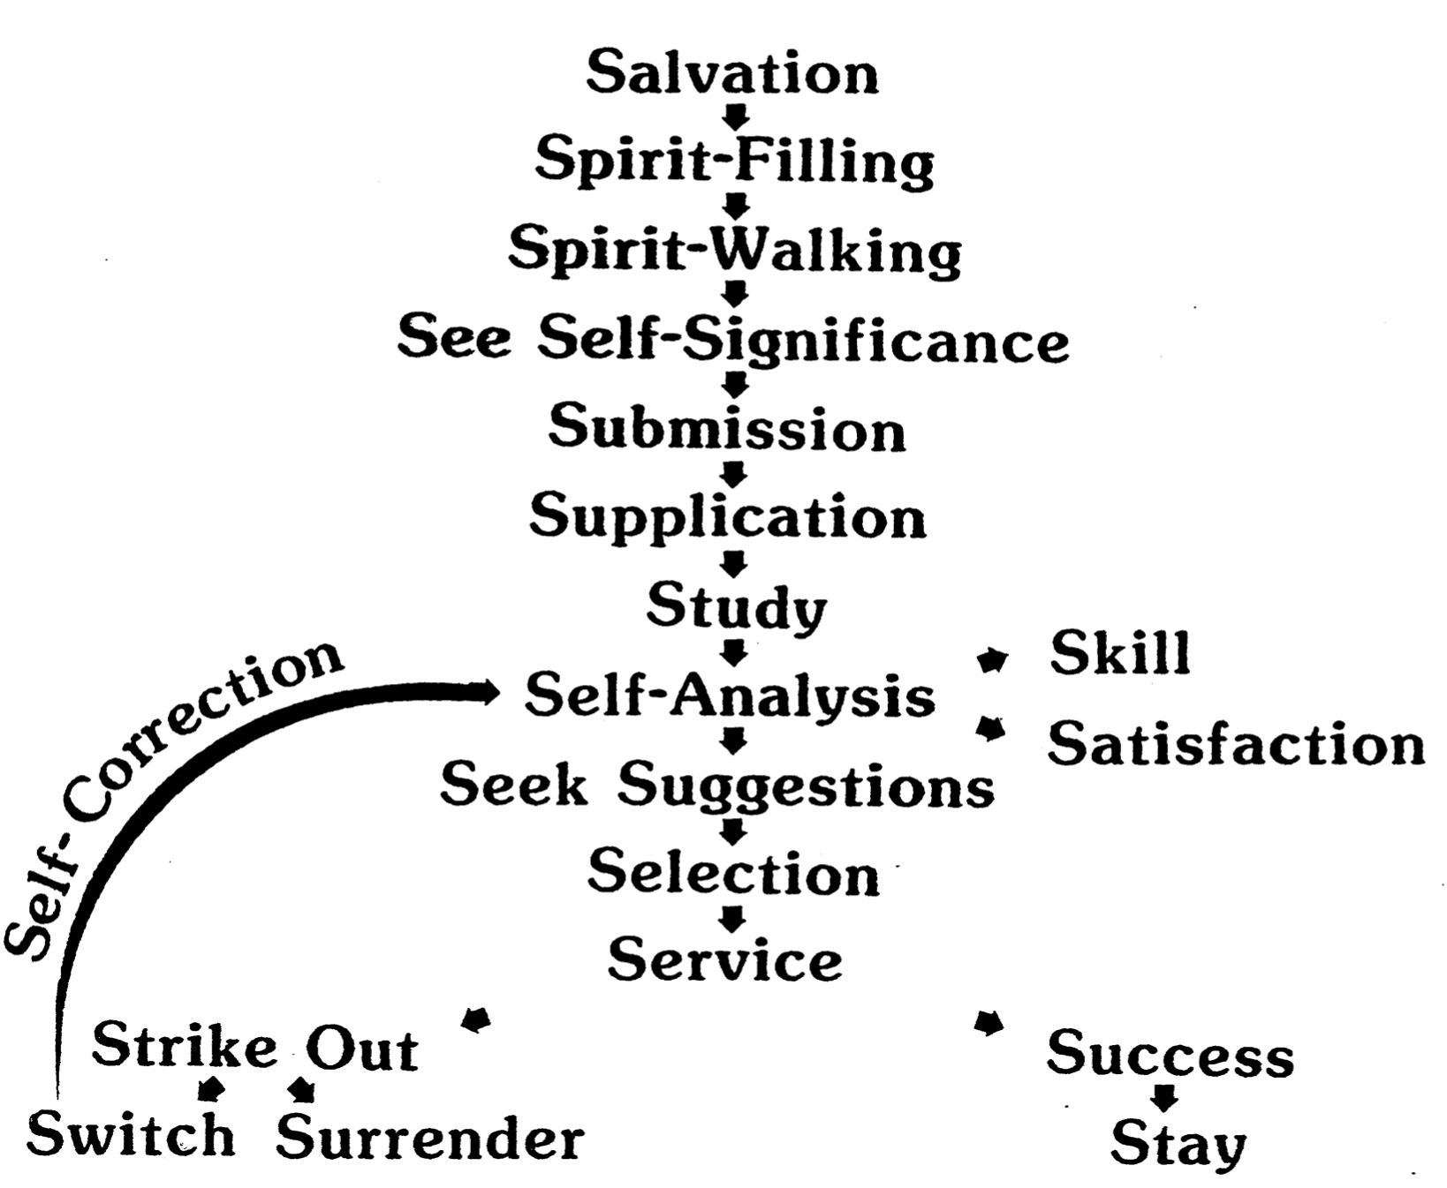

Questions to Help Discern Your Gifts

The following questions contrast various gifts to enable you to determine more accurately what may be your own gift(s). This should be especially helpful if you have already narrowed them down to a few. However, contrasting two gifts doesn't necessarily imply that you can't have both, or neither! For example, if you have no strong leaning towards one answer on a question below it may be that you possess both gifts! Hopefully, by seeing the various gifts contrasted, you'll develop a better understanding of the nature of each gift.

Teaching or Evangelism
Which brings you a greater joy: instructing Christians in the Word of God (teaching) or imparting spiritual truth to non-believers to lead them to salvation in Christ (evangelism)?

Teaching or Exhortation*
Do you enjoy teaching in order to participate in research (teaching) or as an opportunity to counsel others (exhortation)?

On finding solutions to human problems, do you usually begin with Scripture and relate it to human experiences (teaching) or do you usually begin with human experiences and relate them to Scripture (exhortation)?

Evangelism or Exhortation
Which is a greater concern of yours as it relates to counseling: to counsel the lost in order to bring them to Christ (evangelism) or to counsel believers in order to stimulate them to obedience (exhortation)?

Pastor-Teacher or Teaching
Which is a stronger motivation for you in teaching the Scriptures: the privilege of being involved in accurately presenting truth (teaching) or the privilege of being used in "nourishing other's needs" through God's Word (pastor-teacher)?

Pastor-Teacher or Exhortation
Do you find it fairly easy to encourage those who seem to be making slow progress in their spiritual growth (pastor-teacher) or do you find this difficult and discouraging (exhortation)?

Exhortation or Administration*
When conflicts arise among two Christians for whom you are responsible, are you more inclined to change one's responsibilities to solve the problem (administration) or would you focus on changing the believer's attitude (exhortation)?

Administration or Showing Mercy*
Do you desire harmony in a group in order that it may run smoothly (administration) or because of the joy and fellowship which results in a oneness of spirit (showing mercy)?

Do you receive greater joy in being able to openly and freely discuss a problem (showing mercy) or in designing steps to solve the problem (administration)?

Administration or Service
When facing tasks are you more inclined to do the whole job yourself (service) or to enlist others to help you (administration)? Isa. delegation difficult (service) or easy (administration) for you?

Faith or Administration
In being involved in a great project for God, which would you enjoy more: providing the initial and sustained vision to see it completed (faith) or providing the leadership to coordinate the resources necessary to complete the task (administration)?

Giving or Service
What type of involvement appeals to you more in being used to see a project completed for the Lord: contributing of your material means for the project (giving) or contributing of your time and abilities to see the project accomplished (service)?

Service or Exhortation*
Do you enjoy counseling individuals in order to give them steps of action (exhortation) or in order to discern what their practical needs are so that you can meet their needs (service)?

Service or Showing Mercy*
Are you more comfortable in helping to meet the practical needs of others (service) or in meeting their mental and emotional needs (showing mercy)?

Showing Mercy or Teaching*
Are you motivated to do research in order to establish correct doctrine (teaching) or in order to understand doctrinal differences among Christians and how to bring harmony and oneness (showing mercy)?

Are you more concerned with the Scriptural pattern of a worship service (teaching) or with the atmosphere of a worship service (showing mercy)?

Showing Mercy or Exhortation*
Which emphasis is more important to you: spiritual healing or spiritual growth?

If the answer is spiritual healing: Are you interested in healing for the sake of preventing unnecessary suffering (showing mercy) or for the purpose of challenging one on to spiritual maturity through healing (exhortation).

If the answer is spiritual growth: Are you interested in spiritual growth primarily that by growing spiritually one may eliminate suffering and disharmony caused by wrong responses (showing mercy) or primarily for the sake of that person's spiritual maturity (exhortation)?

Which is more important: that you are able to sense a genuine concern and interest in a person helping you (showing mercy) or that the person can give you steps of action in solving a problem (exhortation)?

When ministering to another's needs, do you generally encourage him/her regarding hurts from something which already occurred in the past (showing mercy) or do you encourage him/her in areas of growth looking primarily to the future (exhortation)?

* Adapted from the Institute in Basic Youth Conflicts by Bill Gothard, "Understanding Your Spiritual Gifts," 6-8.

Ministry Opportunities at Our Church

Scripture teaches that God has gifted each member of this church body with a spiritual gift "for the common good" (1 Cor. 12:7). This, of course, implies that each of us would benefit the church most when we function primarily in a ministry which employs these strong traits. Isn’t this true for you? Why not consider some of the current needs in these areas right now?

Concerning this gift ... our church has these needs... so talk to ... at ...

Teaching

Evangelism

Pastor-Teacher

Exhortation

Administration

Faith

Giving

Service

Showing Mercy
How to Make Your Spiritual Gift Really Count
1 Corinthians 13:1-7

Truth: The way to make your spiritual gift really count is to use it in selfless love for others.

Introduction

Issue: How can you make your spiritual gift really count?
The real issue is not what gift you have, but how you use it for the sake of Christ.

The Corinthian believers were very gifted, but were really messing up in how they used their gifts.
a. Some used their gifts with a spirit of inferiority (12:14-20).
b. Some used their gifts with a spirit of superiority (12:21).
c. Both attitudes were wrong since we all need one another (12:22, 27).

The even “better way” to use their gifts (12:31b) introduces chapter 13.

I. Any gift used to its maximum helps no one if not exercised in love (13:1-3).

A. Speaking every earthly and heavenly language without love helps no one (12:1).

B. Using very important gifts without love helps no one (12:2).

C. Using a serving gift, such as giving without love, helps no one (12:3).

II. Loving use of the gifts is seen when they are used to benefit others (13:4-7).
If you use your gifts in love then people will be helped.

A. Using gifts in love means serving others with characteristics which unite the body (13:4a).

1. Serving others in love means doing it with patience.

2. Serving others in love means doing it with kindness.

B. Using gifts in love means serving without seven divisive actions (13:4b-5).

C. Using gifts in love means we get excited about the right things in our church (13:6).

D. Using gifts in love means not becoming easily discouraged from helping others (13:7).

Application

The issue of motivation (A. W. Tozer):
“Ask not what a man does to determine whether his work is sacred or secular.
Ask why he does it. The motive is everything.
Let a man sanctify the Lord God in his heart, and he can thereafter do no secular act.”

The best way to make your spiritual gift really count is to use it in love, which means to use your abilities for the sake of others.

The best way I can make my spiritual gift count for eternity is by…

Guidelines for Using Your Spiritual Gift
A sermon on 1 Timothy 4:11-16 by Chuck Swindoll

I. Introduction

II. Attitudes and Guidelines

A. Four "Adolescent" Attitudes that Accompany the Teaching of Spiritual Gifts:

1. I am waiting for the sudden inspiration of God ("the right feeling") and then I will exercise my gift.
1 Cor. 12:4-7

2. My gift is the most (or least) important of all.

3. I refuse all other involvements except those related to my area of giftedness.
2 Tim. 4:5
Titus 1:5
Titus 1:10, 13

4. I quit either because I am in conflict with someone or I am not appreciated.
2 Tim. 4:7, 14-17
1 Tim. 4:14

"Spiritual gifts are wanting only because they're being neglected, not because they're not available! There's plenty of manpower, plenty of ability..."

B. Guidelines in Five Words How to Stop Neglecting Your Gift (1 Tim. 4):

1. Information (v. 11)
a. Believe that you have a spiritual gift.
b. Make a spiritual gifts notebook
c. Teach others about spiritual gifts.
d. Pray that God will give you clear direction in the area of your spiritual gift.

2. Toleration (v. 12)

3. Attention (v. 13)

4. Confirmation (v. 15)
Prov 27:19
Prov 27:17

5. Evaluation (v. 16)

III. Conclusion: Stay alert, be available, don't wait, give it a try, start today.

IV. Personal Application Questions

A. What do you foresee as the greatest hindrance from you exercising your gift? (i.e., If one thing would prevent you from using your gift, what would that be? Pride? Inadequacy? Lack of training? Fear? etc.)

B. What new area of ministry should you begin in response to what you now know about your spiritual gift(s)?

Readings on Spiritual Gifts
Thomas R. Edgar, “The Cessation of the Sign Gifts” BSac 145:580 (Oct 1988):371 at https://www.the-highway.com/cessation_Edgar.html

Referring to the charismatic movement, Hollenweger states that "in the not too distant future there will be more Christians belonging to this type of Christianity than to the Anglican community. They will number almost as many as all other Protestants together." He feels that the numerical and perhaps the spiritual center of Christianity will shift to "Indigenous Non-white" or "Third World Pentecostal" churches. The validity of such a prevalent force is an issue that cannot be ignored.
The Essential Question: From God or Not from God?
As with any other doctrinal issue it is important to know the truth or the error of the "charismatic" position. This is not a purely doctrinal matter, since in the charismatic movement in all its various forms, such as Pentecostalism, neo-Pentecostalism, "power evangelism," and the "signs and wonders" movement, emphasis is placed on phenomena and subjective experiences. These experiences, which transcend doctrinal considerations and doctrinal boundaries, are the raison d'etre of the movement. They are not merely the daily outworking of one's doctrine as distinct from his doctrinal position, but are usually crisis events that allegedly go beyond normal, traditional Christian experience. These so-called "spiritual" experiences are either from God or not from God. There can be no neutral or partially true position. Either they are biblically true or they are false experiences. If they are biblically false then the issue is much more serious than merely another view of the Christian life, since the charismatic movement involves a spiritual experience that attempts to be in direct contact with supernatural forces. Whether the charismatics are correct can only be determined from the Scriptures and other relevant facts. By the very nature of the issue, the "gifts," such as tongues, healings, and signs and wonders, so prevalent in today's charismatic movement, are either from God or not from God. There can be no middle ground.
Evidence Contrary to the Validity of the Phenomena
Several factors give evidence that the phenomena of the charismatic movement are not the gifts and activities of the Holy Spirit in the New Testament. On the other hand charismatic proponents have given no evidence, other than their assumption, that these are the same phenomena. That their numbers are growing, that the followers are enthusiastic, and that there are alleged miracles are not evidence that the phenomena are from the Holy Spirit, since all these occur in other religions. To argue that the New Testament gifts could occur today or that no verse rules out such a possibility is not enough; it must also be shown that the modern charismatic "gifts" are the same as in the New Testament. The proponents of the charismatic movement have been unsuccessful in proving either the first (the possibility of the gifts today) or the second (that these are the same phenomena). Are all phenomena automatically from the Holy Spirit simply because someone makes such an assertion, unless a verse can be found that directly states they are not? It is not enough merely to assert that charismatic phenomena are New Testament phenomena. There must be evidence that they are the same.
The Evidence Of History
If the miraculous gifts of the New Testament age had continued in the church, one would expect an unbroken line of occurrences from apostolic times to the present. If they are of God, why should such miracles be absent for centuries?
The entire controversy exists because the miraculous gifts of the New Testament age did cease and did not occur for almost 1,900 years of church history and certainly have not continued in an unbroken line. Questions about their presence today as well as differing opinions, even among charismatics, regarding the nature of tongues, prophecy, and certain other gifts are due to the fact that they ceased. Chrysostom, a fourth-century theologian, testified that they had ceased so long before his time that no one was certain of their characteristics.
History contradicts the charismatics. Though some have attempted to prove that tongues and other miraculous gifts have occurred in the postapostolic history of the church, the very paucity and sporadic nature of alleged occurrences is evidence against this claim. Referring to alleged instances of tongues-speaking, Hinson, a church historian, sums up the situation this way: "The first sixteen centuries of its history were lean ones indeed. . . . if the first five centuries were lean the next were starvation years for the practice in Western Christendom and doubtful ones in Eastern Christendom."
After a few alleged instances in the second century there is a gap of almost 1,000 years before a few more occur. Obviously it would not have been difficult to produce evidence for these gifts during the apostolic age. Why then is there such a dearth of evidence if the gifts continued throughout church history? The alleged instances are even more rare if restricted to genuine believers, and if hearsay evidence is omitted. If instances of the gift of healing rather than supposed answers to prayer are considered, the alleged instances all but vanish. That these miraculous workings ceased in the past can hardly be refuted, and this is recognized by many charismatics. Dayton feels that many charismatics actually prefer to grant that certain gifts ceased, since they regard today's phenomena as a latter-day pouring out of the Spirit.
Explanations are unrealistic. It is one thing for a doctrine such as justification by faith to be temporarily lost due to man's frailty. It is another thing entirely for miraculous signs and wonders to be missing. Those at Pentecost were not expecting to speak as they did.
In Acts no tongues speaker was previously aware of the existence of the gift; yet they spoke. They could hardly have had faith in their ability to perform miracles or to speak in tongues, since they were unaware of such gifts. They did not obtain or lose the ability because of their belief or lack of belief in the charismata. If God gave these gifts during the history of the church, they would have occurred regardless of man's frailty. To argue that the gifts faded away in the postapostolic church because of a failure to believe in miracles evades the facts of history and has no biblical support.
First Corinthians 12-14 implies that the early church was only too inclined toward such gifts rather than against them. In almost every religion men have been inclined toward the miraculous rather than toward rejecting obvious miracles. And yet some argue that miracles ceased or nearly so in the early church—an era when belief in the supernatural was rampant and when the signs and wonders actually occurred—because of disbelief in miracles! Yet it is claimed that in the most rationalistic of ages, when no miracles were occurring, 19- and 20th-century Christians believed to the extent that the gifts reoccurred, and reoccurred on the scale of today's claims. Since modern Christians are so receptive to signs and wonders and modern man is so willing to believe the charismatic claims, on what basis can one assume that the early Christians would refuse to do so? Those willing to believe religious miracles are always plentiful. To claim that this "miraculous infusion" of the Spirit gives joy, purpose, power for service, and revitalization of the church, and at the same time claim that such a tremendous working was ignored, rejected, and allowed to drop out of the early church which experienced it, is illogical. The only reasonable explanation for the lack of these gifts in church history is that God did not give them. If He had given them, they would have occurred.
Since these gifts and signs did cease, the burden of proof is entirely on the charismatics to prove their validity. Too long Christians have assumed that the noncharismatic must produce incontestable biblical evidence that the miraculous sign gifts did cease. However, noncharismatics have no burden to prove this, since it has already been proved by history. It is an irrefutable fact admitted by many Pentecostals. Therefore the charismatics must prove biblically that the sign gifts will start up again during the Church Age and that today's phenomena are this reoccurrence. In other words they must prove that their experiences are the reoccurrence of gifts that have not occurred for almost 1,900 years.
"Latter day" Explanations are Inadequate.
Many Pentecostals hold that the sign gifts did cease and that they have reoccurred in these "latter days." This must be demonstrated from Scripture, however. There is no biblical evidence that there will be a reoccurrence in the church of the sign gifts or that believers will work miracles near the end of the Church Age. However, there is ample evidence that near the end of the age there will be false prophets who perform miracles, prophesy, and cast out demons in Jesus' name (cf. Matt. 7:22-23; 24:11, 24; 2 Thess. 2:9-12). During the Church Age there will be false leaders who fashion themselves as ministers of righteousness (2 Cor. 11:13-15). During the Tribulation period, there is no indication that believers, other than the two witnesses of Revelation 11:3-12, will perform miracles. Those performed by the two witnesses are exceptional, and their actions are comparable to those of Old Testament prophets rather than to those of the apostles. The two witnesses are not part of the church, and if they were, they could hardly be considered typical of the church.
The "latter rain" arguments are incorrectly based on verses that actually are referring to seasonal rainfall in Israel. Hosea 6:3 and Joel 2:23, for example, refer not to some unusual outpouring of the Holy Spirit in the last days of the Church Age. They refer instead to spring rains, in contrast to early rains in the fall.
The arguments based on the expression "in the last days" in Acts 2:16-21 are also invalid. If the "last days" referred to in Acts 2:17 includes the day of Pentecost, the beginning of the Church Age, and "if this is that" (v. 16) includes Pentecost, then it cannot mean at the same time the "last days"of this Church Age. On the other hand if the "last days" do not include Pentecost, then Pentecost was not a fulfillment of Joel's prophecy, and Acts 2:16-21 refers specifically to Israel and is still future. Either way this passage gives no evidence for a reoccurrence of miraculous gifts during the "last (latter) days" of the church. The present charismatic movement is characterized by phenomena that began in the church about 100 years ago, which apart from any historical connection or evidence are claimed to be the same as the miracles performed in the apostolic age. It is simply naive to accept this claim without some direct historical link or solid biblical evidence that these present phenomena are the same as those in the days of the apostles. The most reliable evidence would be a direct historical link with the apostolic gifts due to their continuity in the church. However, as already argued, history testifies to the contrary. The gifts ceased and there is no reason to expect their presence or reoccurrence today.
Lack Of Similarity With The New Testament
For any phenomena to make credible claim to be the same as the gifts and miracles of the apostolic age there must be great similarity between the two. Any phenomena can be intentionally duplicated or copied. Therefore similarity alone cannot prove the modern phenomena are genuine. Conversely a lack of similarity is definitely evidence against the claim that they are the same as the New Testament gifts and miracles.
An examination of the New Testament reveals that the modern charismatic phenomena are not sufficiently similar to those of the apostolic age. Where are the tongues of fire and the rushing of a mighty wind as on the day of Pentecost? Do missionaries blind their opponents as Paul did? Do church leaders discern hypocrisy and pronounce the immediate death of members as in Acts 5:1-11? Do evangelists amaze an entire city with miracles as did Philip (8:5-8)? Are they then taken to another place of ministry by the Holy Spirit (vv. 39-40)? Are entire multitudes healed by merely being in the shadow of the healer (5:15)? Do prophets give specific prophecies which come to pass soon after (11:27-28)?
The miracles and signs of the apostolic age were clearly and overtly miraculous. Even the opponents of the gospel could not refute the miracles of the apostolic age. But today's "signs and wonders" cannot be verified even by those who are neutral or friendly to the movement. A detailed comparison with specific individual gifts shows an amazing lack of similarity between the New Testament gifts and the modern "charismatic" gifts.
The gift of healing. The New Testament gift of healing is a specific gift to an individual enabling him to heal. It is not to be confused with healing performed by God in answer to prayer. New Testament healings include those with verifiable afflictions and handicaps such as the man who was crippled from birth (Acts 3:1-10). The healings were instantaneous, complete, and obvious to all. The man crippled from birth had never walked, but he was instantly able to walk and jump. The healings in the apostolic age never failed regardless of the faith of the recipient. They did not depend on direct physical contact (5:15). There were no preliminaries, healing meetings, or incantations. The healer merely stated to the individual, even when the individual was unaware of the intention to heal (3:1-10), something equivalent to the words, "In Jesus' name, stand up and walk." The healings were usually in public, performed on unbelievers, and often en masse.
The modern charismatic movement made little impact on the basis of speaking in tongues alone. It was not until "healing" was added that the movement began to grow in significant numbers.
Today's healers admittedly often fail. This is blamed on the lack of faith of the sick rather than on the healer. The alleged healings are seldom instantaneous or complete. They usually are not healings of objectively verifiable illnesses; they often pertain to internal disorders such as "emotional healing." Rather than being irrefutable, they are unverified or even denied by those neutral. They involve healing meetings, preliminaries, incantations, and usually repeated visits. They are not performed in the streets, en masse, or at a distance. In a crowd they are usually performed on only a select few. They are never performed on those who are not aware of the "healer" or his intention to "heal."
There is little correspondence between modern-day charismatic "healings" and the healings recorded in the New Testament. The differences are so vast that many of today's healers are careful to point out that they do not have the gift of healing, but are merely those to whom God often responds with healing. No one heals today in such a way that it is clearly the New Testament gift of healing.
Exorcism of demons. The miraculous ability to exorcise demons directly also needs to be differentiated from answers to prayer (James 5:14). The exorcisms in Acts concerned those clearly recognized as "possessed," including a girl with a mantic gift (Acts 16:16-18). They were clearly differentiated from those who were merely ill (5:16). They were not nebulous cases of emotional problems such as "personality meltdown," frustration, tension, the "demon of worry," the "demon of drugs or alcoholism," as is often the case in alleged exorcisms today. Such can hardly be considered demonism in the New Testament sense.
The New Testament instances of exorcism never failed, were without preliminaries, were instantaneous, were usually performed in public, often en masse, usually on unbelievers, and in the case of the mantic girl (Acts 16:16-18) apart from any cooperation of the demonized. Today's "exorcisms" often fail, often require repeated sessions, are usually unverified as demonism, are never en masse, seldom if ever occur in public, and are only on the cooperative "faithful." Many cases are similar to common psychiatric or religious counseling sessions that are claimed to be "demon exorcism." This is not to suggest that genuine cases of demon possession may not exist. The point is that merely claiming to exorcise demons gives no evidence that one is actually doing so.
Raising the dead. Dorcas had been dead for some time when Peter apart from fanfare instantaneously raised her (Acts 9:40). The incident regarding Eutychus (20:7-12) concerns a boy who fell three stories and was dead. Paul with no fanfare pronounced him alive. In the apostolic age with all the miracles, exorcisms, healings en masse, and so on, there are only these two low-profile incidents of raising the dead. This action was apparently rare even for the apostles. There is no reason to expect this today. No modern-day "raising of the dead" has been verified. Wimber refers to a man who fell, hit his head, was apparently unconscious for three minutes, and "came to" with a bump on his head. After Wimber and others prayed the bump eventually went away. This is incredible, not as a miracle, but that anyone would consider this as a possible raising of the dead. Would anyone have been convinced by such a "miracle" that Jesus was the Son of God or that the apostles represented God?
The gift of tongues. The nature, purpose, and other characteristics of the gift of tongues, including a complete exegetical discussion and refutation of the concept of private or devotional tongues is included elsewhere. The tongues of the apostolic age were genuine miracles, since they were the ability to speak previously unlearned foreign languages, rather than the "charismatic tongues" of today, which can easily be duplicated. The only passage describing the nature of tongues speaking is Acts 2:4-11, where they are definitely languages. Peter stated that the tongues-speaking in Cornelius's house (10:46) was the same as on the day of Pentecost (11:17). And there is no reason to assume the instance in Acts 19:6 was different. Since 1 Corinthians 14 repeatedly states that the tongues-speaking in Corinth was in an assembly of believers, why then was it mysterious and why was there lack of understanding? It was because the believers did not understand the foreign languages of the tongues-speakers. The mystery was not because the tongues in 1 Corinthians differed in nature from the tongues in Acts.
New Testament tongues were verifiable foreign languages. The term glw'ssa means "language" and is never used for ecstatic speech. By contrast, today's "tongues" have never been verified as actual languages. All objective studies by impartial linguists indicate that they do not have the characteristics common to languages.
The New Testament gift of tongues is specifically said to be a sign for unbelievers (1 Cor. 14:22). This is how it functioned at Pentecost. All instances were public, not private. The people who spoke in tongues in Acts (2:4; 10:46; 19:6) were not previously aware that the ability or gift existed, and in Acts 10:46 and 19:6 the people were not previously aware of the gospel of Jesus Christ. They could not have been seeking or in any way exercising belief in such a gift, and yet they received it. There is no indication that the New Testament speakers spoke in a trance; they were in control of the phenomenon. Perhaps the most outstanding contrast is usage. The gift of tongues in the New Testament functioned, as did all the other gifts, for ministry to others (1 Cor. 12:1-30; 1 Pet. 4:10), rather than primarily for the benefit of the speaker as in the modern charismatic movement.
There is no similarity between today's tongues and the New Testament gift. Today's charismatic proponents are wrong regarding the nature, purpose, use, and every other aspect of tongues. There is no reason to assume merely on the basis of their claim that they are correct in identifying their tongues-speaking—which can easily be duplicated and is common to man—as the New Testament gift of tongues.
Conclusion. The "charismatic gifts" of today are not similar to the New Testament phenomena either in general perspective or in the details. There is no evidence to conclude that they are the same; there is every reason to conclude that they are not. The historical fact that the New Testament gifts ceased long ago and the fact that there is no historical link whatever between the charismatic phenomena and the New Testament gifts require the same conclusion. The only remaining possibility for giving credence to the modern charismatic claims would be to produce direct statements of Scripture that the apostolic phenomena will always be present in the church, or that they will specifically be in the modern church despite their cessation through most of church history. Even if this were produced, there must also be evidence that the charismatic phenomena are somehow the same phenomena referred to in the passages. However, there is no specific biblical evidence such as this. There is no biblical statement that requires a denial of historical fact or that requires an equation of such dissimilar entities merely on the assertion of the proponents. All objective evidence is contrary to the charismatic claims. It is not sufficient to assert that by faith their claims must be taken contrary to the evidence. This is existential naivetT, not faith. Faith is trust in biblical evidence rather than in experience.
Biblical Evidence For Cessation
No Bible verse specifically states that tongues, signs, and wonders will continue throughout the Church Age. Nor is there a verse that specifically states they will cease at the end of the apostolic age. However, this does not mean that one cannot take a position on this issue. Many doctrines, such as the Trinity, are not directly stated but are derived from the study and correlation of passages of Scripture. There are several indications in the Scriptures that the gifts of tongues, healing, and miracles (signs and wonders) will not continue. The charismatic movement in all its forms rests not on exegetical evidence that the gifts will continue, but on the assumption contrary to history that since they occurred in the apostolic age they should also occur today. The foundation for this assumption is nonexistent.
The New Testament church was not characterized by power and miracles as the charismatics assume. It was characterized by the problems addressed in the epistles (including, e.g., the problems that beset the Corinthian church) and the problems of the churches described in Revelation 2 and 3. Miracles were performed with very few exceptions only by the apostles (Acts 2:43; 5:12). Those who "turned the world upside down" were the apostles, not the churches as a whole. The charismatics assume that the church today should be like their imaginary church. They assume that the entire church today should be able to do all the apostles did in the New Testament.
If the church as a whole had performed miracles, it is only an assumption, apart from evidence, that this should be true today. This assumption is not interpretation. The assumption that the miraculous events recorded in the Book of Acts should occur today is "a distinct hermeneutic, a distinctively Pentecostal manner of appropriating the Scriptures." This development of theology on the basis of narrative rather than on direct teaching of Scripture is always a precarious methodology.
General biblical evidence. Moses performed a series of miracles. However, they did not continue throughout the Old Testament nor were other believers expected to do the same. The Old Testament prophets occasionally performed miracles, but Israel in general was not expected to do so, nor did the miracles continue throughout Israel's history. The fact that some individuals on special occasions in biblical history performed miracles did not result in others doing the same or in a continuity of those miracles. So there is no reason to assume that since the apostles and a few members of the early church performed miracles, they are to be expected today.
Specific biblical evidence. In addition to evidence from history there is also specific biblical evidence that certain gifts were temporary. The term "apostle," commonly used in ancient times in the sense of "representative," in a few passages describes representatives of a local church. This is not the New Testament gift of apostleship. Nor can this term, contrary to its normal meaning and contrary to the New Testament descriptions, be equated with the modern missionary merely on the basis of etymology. The only individuals in the New Testament who clearly possessed the miraculous gift of apostle of the Lord Jesus Christ and could perform miracles as required of an apostle (2 Cor. 12:12) were the Twelve and Paul. Perhaps Barnabas and James can be included. Almost every branch of the church, including most Pentecostals, has held that apostles in this sense have not continued in the church. The charismatic reliance on the narrative of Acts is often avoided when defining "apostles" or "prophets," as too restrictive. These gifts can be precisely delineated, however. Imprecise use of Scripture is a common failing among charismatics. No matter how one tries to broaden the term "apostle," there is little doubt that apostles such as the Twelve and Paul did not continue. If they did not, then all things are not as they were in the New Testament church, all miraculous gifts did not continue as in the beginning church, and at least one gift in the New Testament did not continue.
In addition the New Testament sets standards for an apostle that preclude the continuance of this gift. Not only must an apostle be able to perform miracles (2 Cor. 12:12), not only was the early church very careful about granting anyone, even Paul, the title of "apostle" (Gal. 2:1-10), but also an apostle must have seen the resurrected Lord (1 Cor. 9:1-2; Acts 1:22-26). Paul explicitly stated that he was the last one to see the resurrected Lord (1 Cor. 15:8), and he specifically connected this fact with his apostleship. This requirement for apostleship refers to genuine appearances of the resurrected Christ and not to "visions." There have been no resurrection appearances since the apostolic age. Paul clearly stated that the last appearance was to him. (Revelation 1:12-18 refers to a vision, and is not an appearance of the resurrected Lord in bodily form on earth.) Therefore apostles in the sense of the Twelve and Paul cannot occur today.
When Paul wrote that all gifts were given to the church (1 Cor. 1:7) and benefited the church, he did not mean that all believers were apostles or performed miracles, but that the apostolic, miraculous ministry was experienced by and benefited the Corinthian church. Paul wrote in Ephesians 2:20 that the apostles and prophets are the foundation for the universal church. This at least implies that they were only for the beginning, and this accords with the other specifics mentioned above. Since "apostle" in the full sense of the gift was only a temporary gift and did not continue in the church, the biblical precedent is established that some gifts given in the apostolic age did not continue and were only temporary. It is contrary to Scripture to assume that all gifts and all happenings of the apostolic church are to continue and to be expected in today's church.
Since the ones who performed the miracles were only in the beginning church, it is logical that the miracles themselves were only for the apostolic age. Since the ability to perform such miracles was evidence of apostleship (2 Cor. 12:12), then with rare exceptions others could not have performed such signs and wonders, and they would not continue when the apostles ceased. In addition to this implication the temporary nature of miracles is directly supported by Scripture. Mark wrote that the apostles went forth in accord with the Lord's instructions and preached (aorist tense) everywhere and the Lord confirmed their word with signs. This is all placed in the past at the time of Mark's writing (Mark 16:20; the time of the present participle is relative to the past tense of the main verb). The same is true in Hebrews 2:3-4, which says miracles were performed by eyewitnesses of the Lord (apostles), and were performed by God to confirm the word of the eyewitnesses. All this was past at the time Hebrews was written (the main verb is past tense and the participle is relative in time to the main verb "was confirmed"). In both cases the signs, wonders, and miracles are referred to as being in the past at the time of writing; they were not referred to as occurring at that time. In both passages miracles were performed by the apostles (eyewitnesses) and are described as intended by God as evidence to authenticate the apostles' preaching.
James 5:14 does not instruct the sick to look for a healer or for someone with the ability to heal. Rather it instructs the sick to call for the elders and they are to pray for him. This is basically in accord with the procedure in noncharismatic churches, but is in direct contrast to what would be expected if the gift of healing were available for believers. Either the gift was not to be used to heal believers, or the only other option is that it had ceased.
Conclusion. There is ample biblical evidence that the miraculous gifts ceased with the apostolic age. To assume that such gifts are permanent is contrary to the Scriptures in general and to the biblical precedent that some gifts such as full apostles of the Lord definitely ceased. History is against the charismatic claims. The dissimilarity between the New Testament gifts and the alleged gifts of the charismatics also contradicts their claims. The assumption that because these gifts existed in the apostolic age they should also exist today is a gratuitous assumption contrary to objective evidence. It is also an assumption contrary to scriptural principles and specific biblical evidence. There is no teaching in Scripture that the church should look for such miraculous gifts, nor are they referred to in the passages discussing the fruit of the Spirit (Gal. 5:22-23), spiritual warfare (Eph. 6:10-18), the life of faith (Eph. 5:18; Col. 3:12-17), and requirements for church leaders (1 Tim. 3:1-13; Titus 1:5-9) as necessary for the believer to lead a spiritual life.
Characteristics That Refute Charismatic Claims
Various present-day forms of the charismatic movement are offshoots of Pentecostalism. All have the same basic ideology and all have arisen because of the modern Pentecostal movement. The primary focus for the individual, no matter how their theologians may describe it, is experiential. Many people in the charismatic movement emphasize the miraculous nature of this experience seemingly for personal benefit more than service to others.
Theological Associations
In Pentecostalism the doctrine of Christian perfectionism assumed a specific form in the inaccurate concept of a postconversion crisis experience, a "second blessing." This teaching with its concept of an effusion of power from the Holy Spirit resulted in the expectancy of and search to obtain overt "power" as described in Acts.
The movement crosses all theological boundaries. Speaking in tongues is present in non-Christian religions such as Buddhism and Hinduism, and in cults such as Mormonism. Healing, miracles, and exorcisms are also common in non-Christian religions. In conventional Christian circles the charismatic movement includes Protestants and Roman Catholics, liberals and conservatives, and individuals in many denominations. Those who believe in the inspiration of the Bible, justification by faith, and many other doctrines—as well as those who do not—are also involved.
Questionable Theology
The concept of the "second blessing" or "baptism or fullness of the Spirit" presupposes that while Jesus' death on the cross paid for sin, it is insufficient to empower for service, to enable one to be spiritual, or to give effectiveness in prayer. This differs drastically from the teaching of the New Testament. The view that only those who speak in tongues have real communication with God is contrary to the biblical teaching that all believers have full access to God. Romans 8:26 states that all believers are helped in prayer by the Spirit with inaudible, non-uttered, internal groanings.
The tongues movement presupposes that communication with the spiritual realm is more direct when it is apart from the mind. Such a concept, though found in various religions, is contrary to biblical Christianity. This emphasis on a level of communication that bypasses the mind and is not direct communication from the believer to God is a dangerous teaching. This interest in "supernatural" events, not primarily as convincing signs but as the daily experience of believers that supposedly places them in contact with the supernatural, is dangerous. This middle-level, spirit realm, called the "excluded middle," is an area of charismatic emphasis.
The emphasis on experience, particularly in this level above the rational, often results in emphasizing "experience" over Scripture. In a recent nationally televised program on the subject of televangelism several charismatically oriented evangelists appealed to the "call" as the license for a sinning preacher to continue his ministry. They made no appeal to the Scriptures.
Similarities To Non-Christian Religions
The modern-day charismatic movement is disturbingly similar to practices common in paganism, while at the same time it lacks correspondence to biblical miracles. Trancelike states and communications on a level apart from the mind are common in paganism. An emphasis on physical healing and exorcism for the benefit of adherents is common. The experience of a power or force "overcoming" the participants is similar to pagan practice. The bizarre and often wild practices of early Pentecostalism seem similar to pagan religion.
The idea of contact and interest in the spirit world, the "excluded middle" between God and man, is also common to pagan religions.
The Effects Of The Movement
All groups and doctrinal persuasions of Christendom have experienced theological and moral problems with both their leaders and laymen. As other Christians have experienced, so a number of charismatic leaders have led lives that are morally or ethically contrary to Scripture. If not more common, this is at least as common as among noncharismatics. Therefore it may be safely concluded that all the alleged miracles and so-called tongues-speaking have not produced any genuine spiritual advance over noncharismatics. It has produced enthusiasm for the miraculous, but this is not to be equated with spirituality.
All these supposedly miraculous events have produced no advance in biblical knowledge or spiritual living. The basic doctrines common to the movement are not original with charismatics. Their main claim to biblical knowledge is the assumption that the current church should be like the early church. Since the movement has not produced more spiritual believers or any advance in biblical or theological knowledge, what has it accomplished? Is it not amazing that a movement that claims to have restored power for service, ability to communicate with God more than others have, ability for self-edification, power to heal and perform other miracles, and ability to prophesy and receive direct revelation, has produced no significant advance in spirituality or in biblical or theological knowledge? Is it not inconsistent that a movement which claims to be in direct contact with the Holy Spirit, to have all gifts such as prophecy, apostleship, and the word of knowledge, to communicate directly with God by tongues-speaking and other means, can at the same time include Roman Catholics, conservative and liberal Protestants, amillennialists, premillennialists, Calvinists, Arminians, those who deny the verbal inspiration of the Bible, and those who reject Christ's vicarious atonement on the cross?
Apparently the Holy Spirit is not concerned with communicating any information to correct all these differences, many of which are crucial and some of which are incorrect. All this direct communication with the Spirit has apparently done nothing to correct even basic errors. It has not even produced unity among charismatics regarding the nature and purpose of many of the gifts. This movement has solved no theological issue, produced no advance in biblical knowledge, and has not produced more spiritual Christians. Would such an effusion of the genuine Spirit of God produce so little? Other than enthusiasm there seems to be no spiritual advantage to this movement and the noncharismatics are not missing out on any genuine spiritual benefit. On the negative side the movement has split churches, and through its televangelists the movement has had one of the most significant negative impacts on the testimony of the church in recent history. These characteristics are evidence that the charismatic phenomena are not the New Testament phenomena, that the genuine gifts are not present.
Conclusion
In every attempt to prove that the New Testament gifts exist today, the charismatic movement fails. The objective evidence of history and lack of correspondence with the New Testament indicate that the genuine miraculous gifts ceased and have not reoccurred. Biblical evidence indicates that these gifts ceased with the apostolic age. The theological associations and results of today's so-called miraculous gifts are contrary to gifts given by God. The movement has not produced Christians who are more spiritually mature, as would be expected of a genuine occurrence of the New Testament gifts. Apparently a Christian experiences no spiritual loss by not becoming involved in the charismatic movement.
On the other hand there is a dangerous similarity to non-Christian practices, there is a dangerous interest in supernatural phenomena that give no evidence of being from God, and there is a disturbing interest in the spiritual world somewhere between God and man. Since evidence points to the cessation of the miraculous gifts in the apostolic age, no one can be confident that the charismatic phenomena are from God. Since believers are warned to avoid contact with the intermediate spiritual world and since they should do only what they are confident God approves, no one should experiment in the realm of the charismatic phenomena.

Author
Thomas R. Edgar Professor of New Testament Literature and Exegesis Capital Bible Seminary, Lanham, Maryland.

F. David Farnell, “Does the New Testament Teach Two Prophetic Gifts?”
(1 of 14)

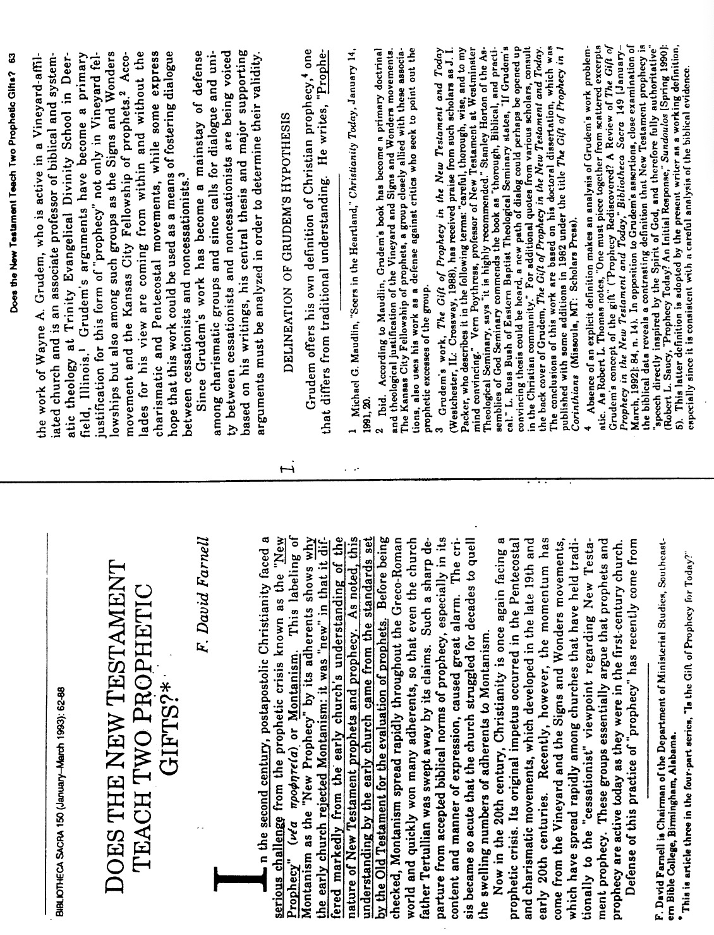
F. David Farnell, “Does the New Testament Teach Two Prophetic Gifts?” (2 of 14)

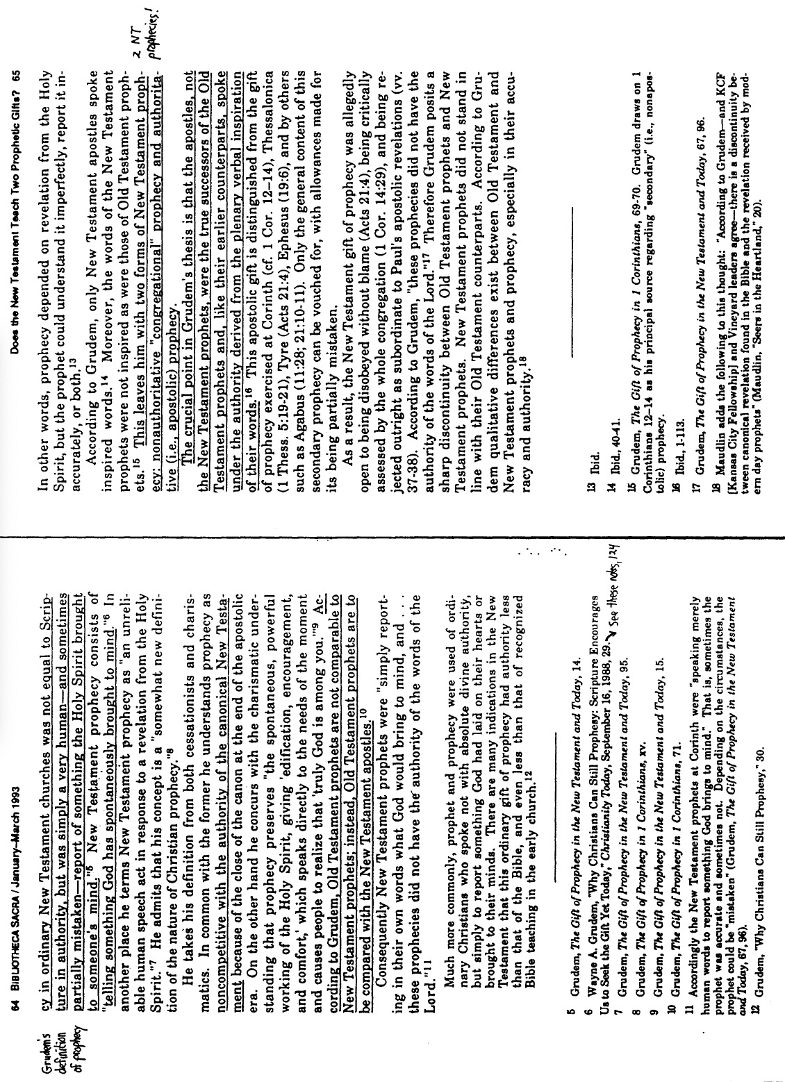
F. David Farnell, “Does the New Testament Teach Two Prophetic Gifts?” (3 of 14)

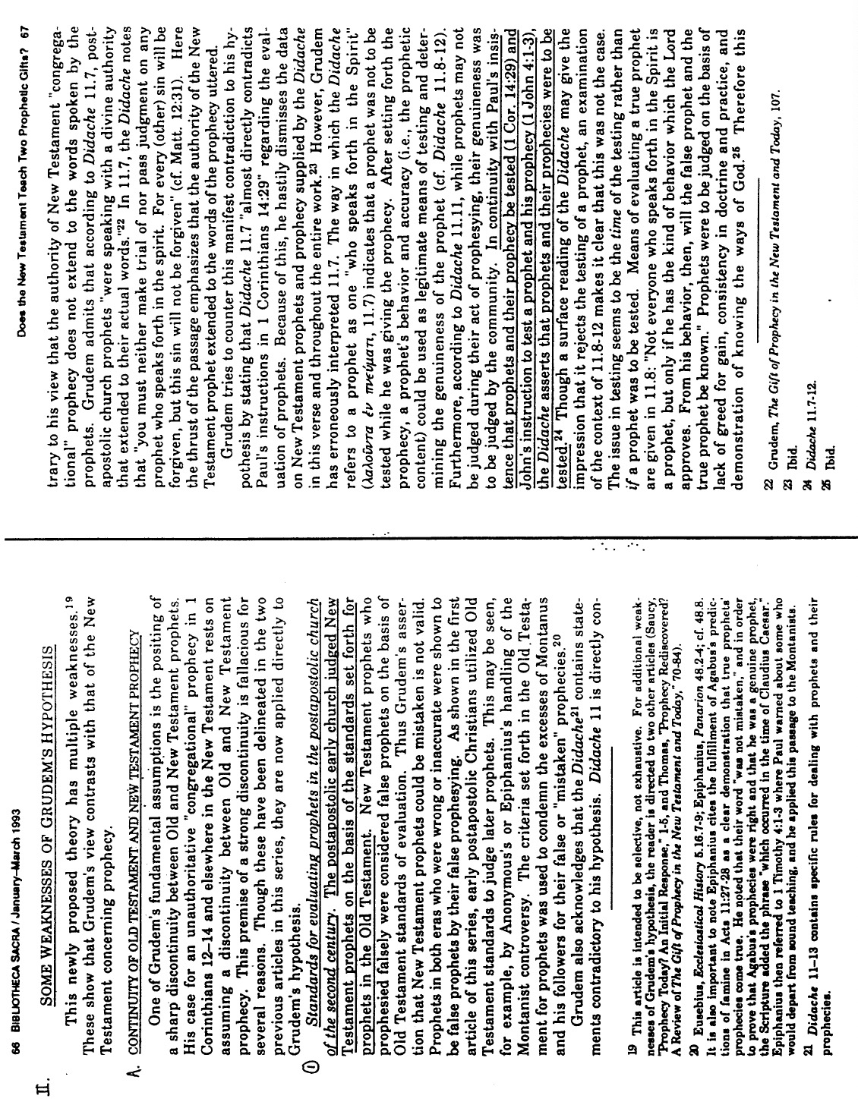
F. David Farnell, “Does the New Testament Teach Two Prophetic Gifts?” (4 of 14)

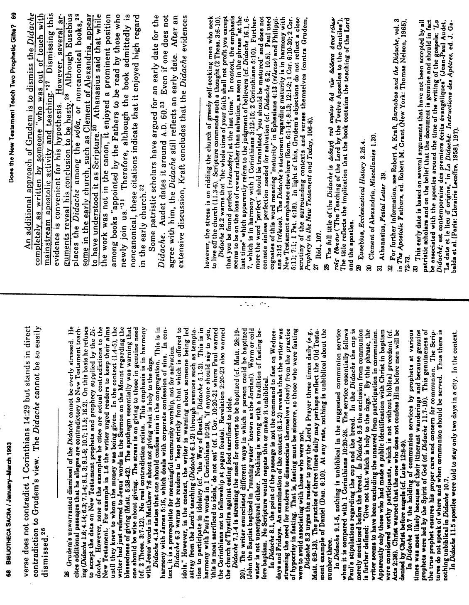
F. David Farnell, “Does the New Testament Teach Two Prophetic Gifts?” (5 of 14)

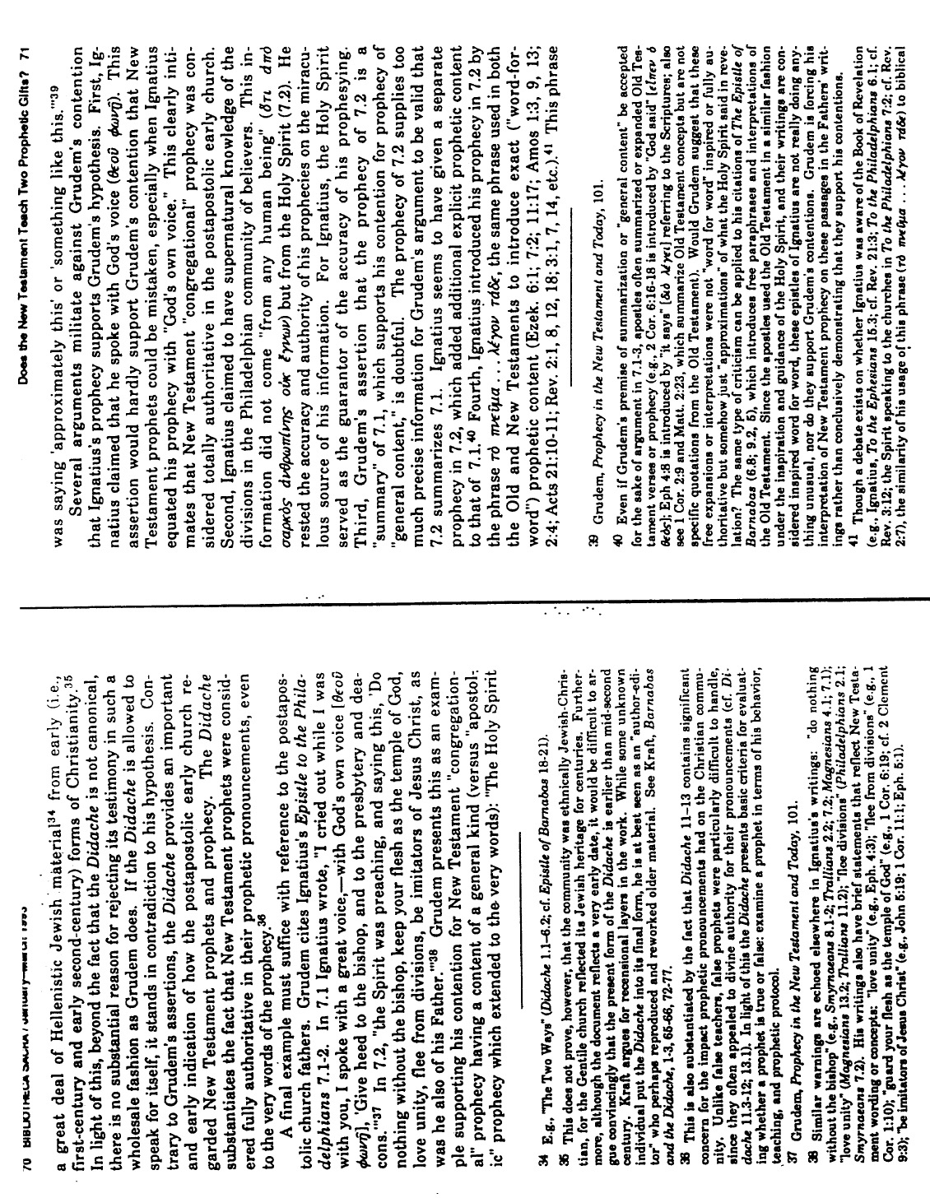
F. David Farnell, “Does the New Testament Teach Two Prophetic Gifts?” (6 of 14)

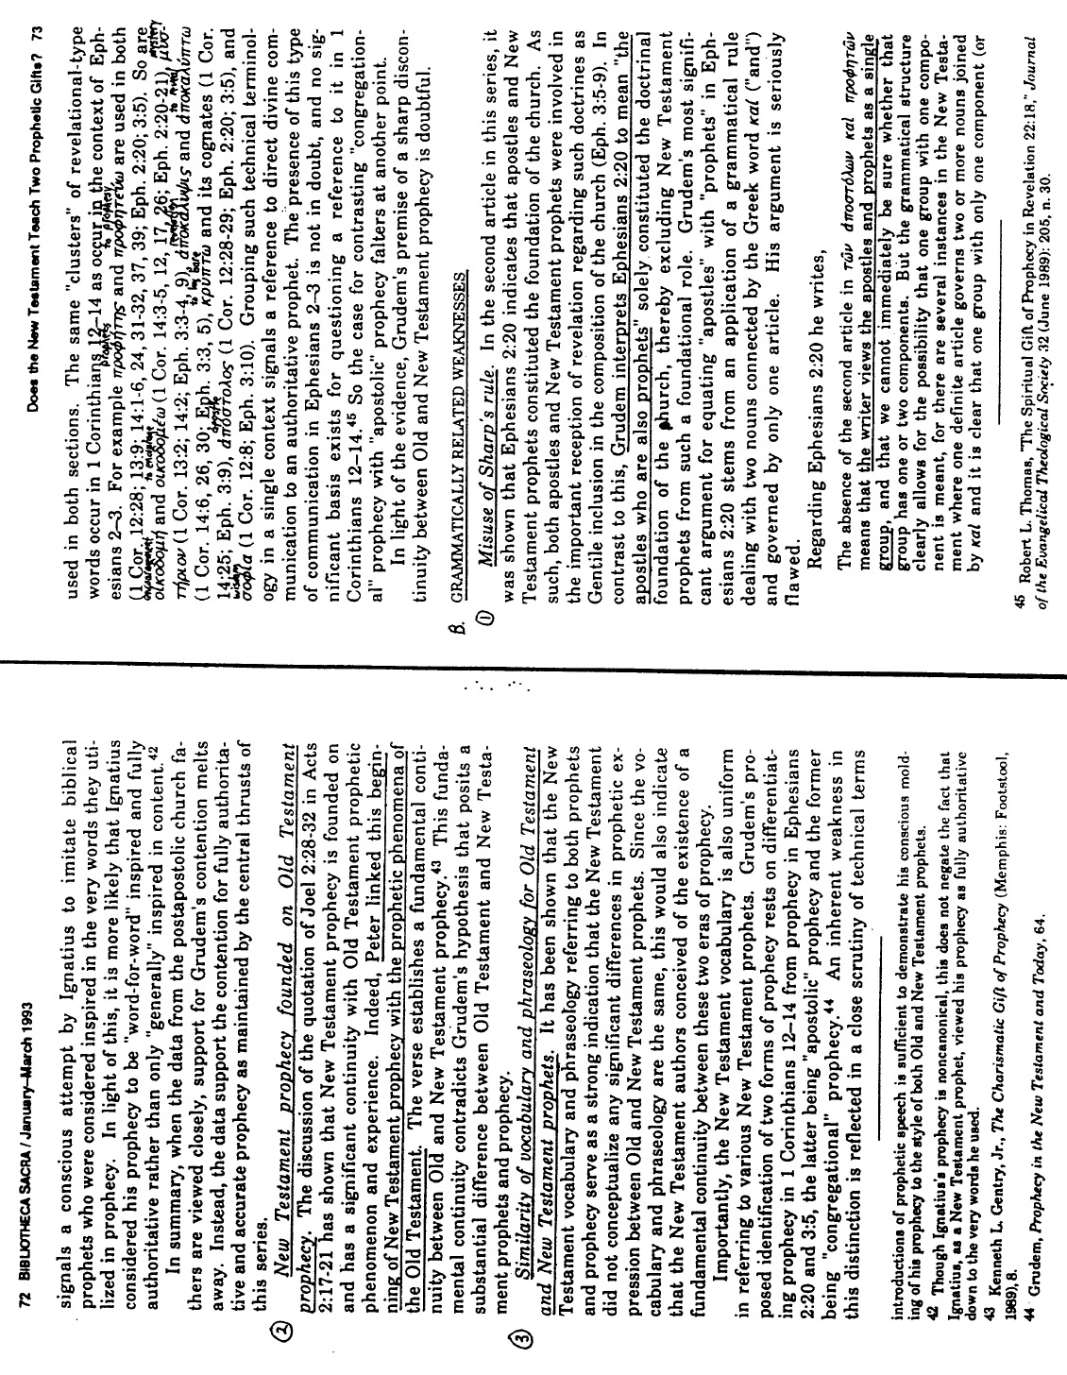
F. David Farnell, “Does the New Testament Teach Two Prophetic Gifts?” (7 of 14)

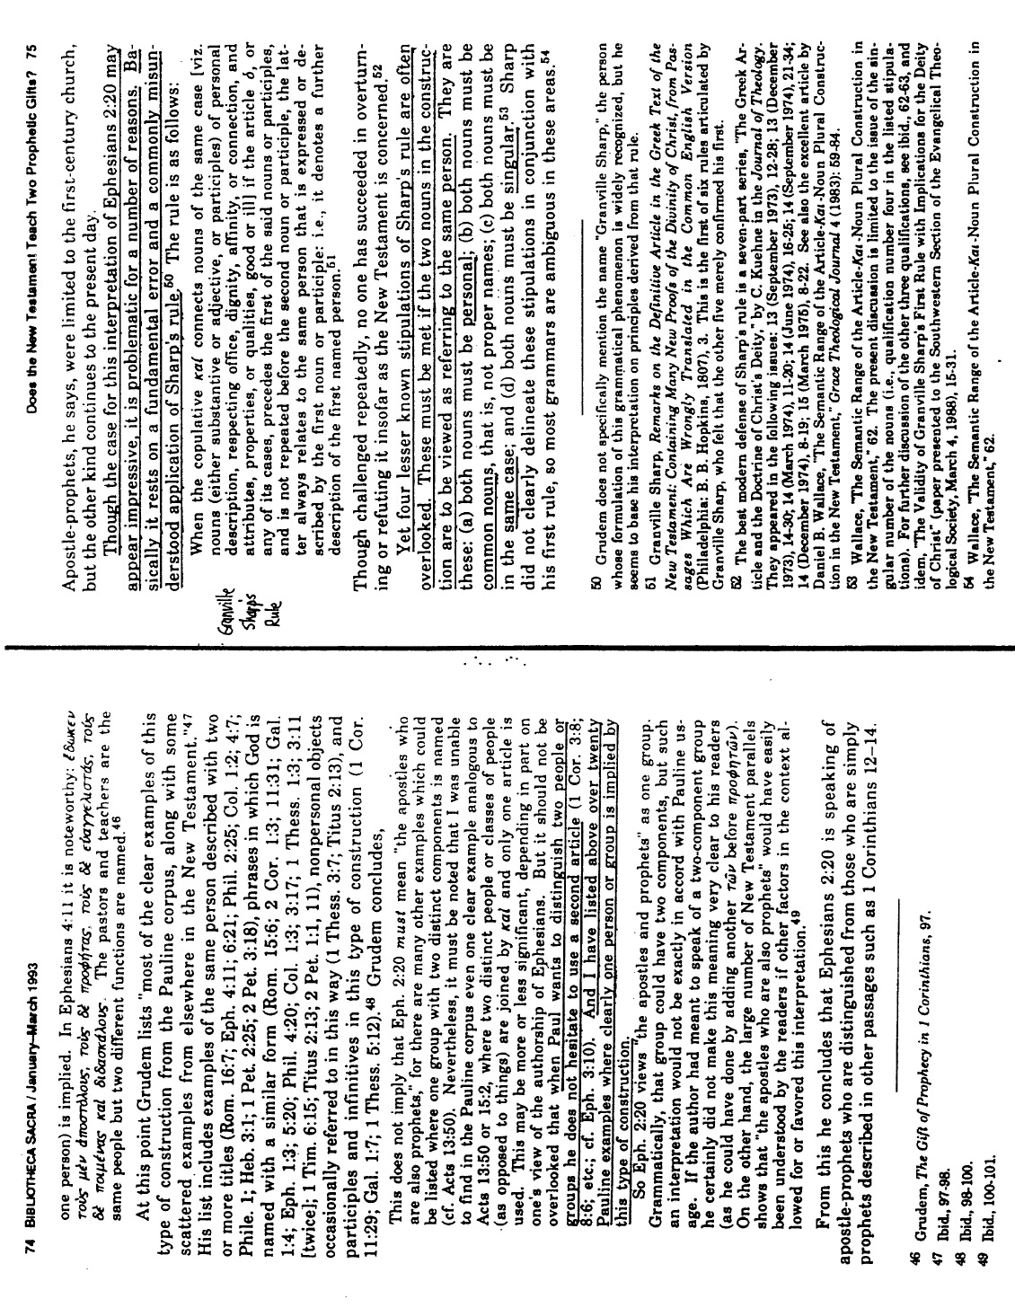
F. David Farnell, “Does the New Testament Teach Two Prophetic Gifts?” (8 of 14)

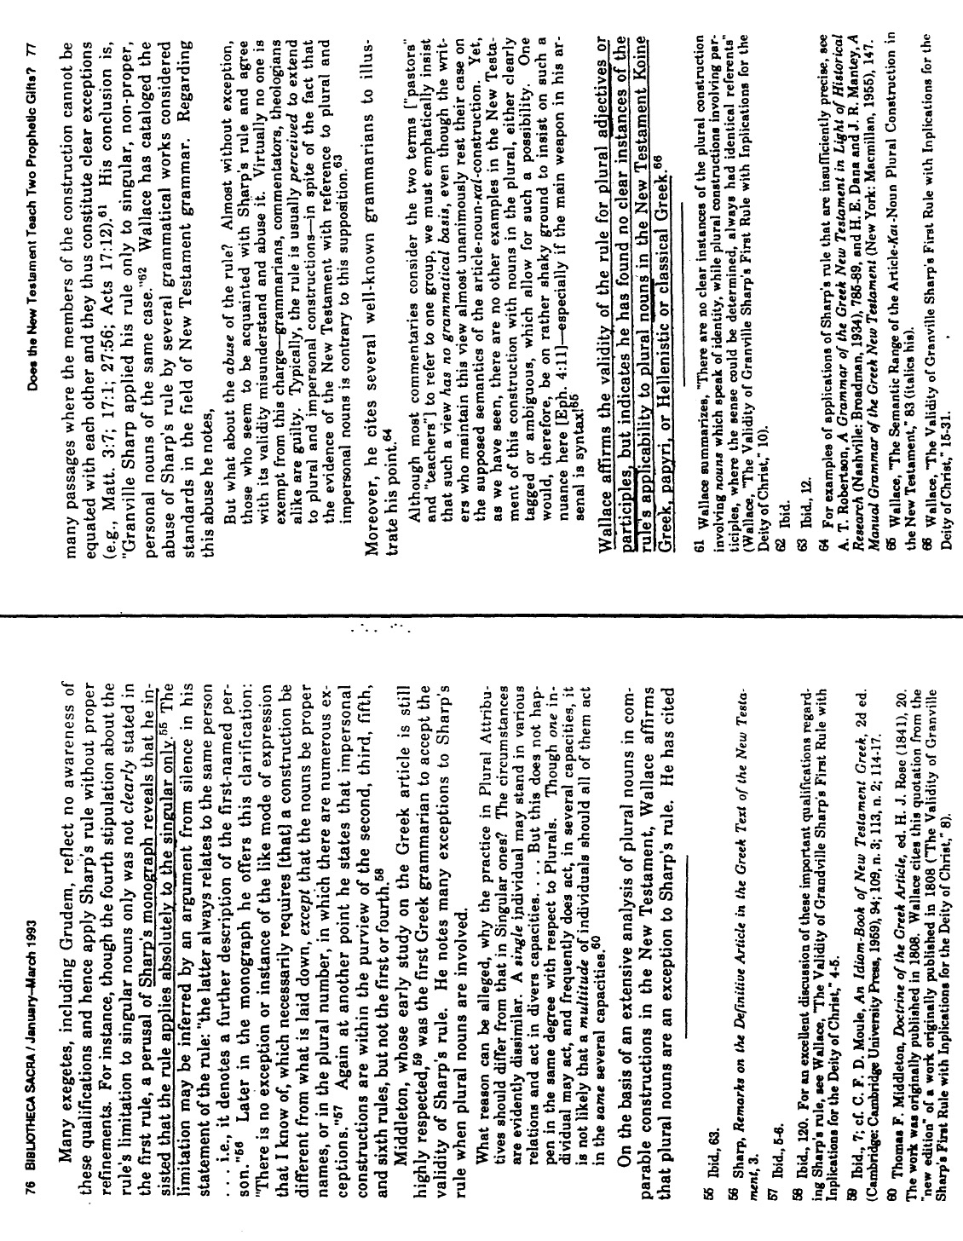
F. David Farnell, “Does the New Testament Teach Two Prophetic Gifts?” (9 of 14)

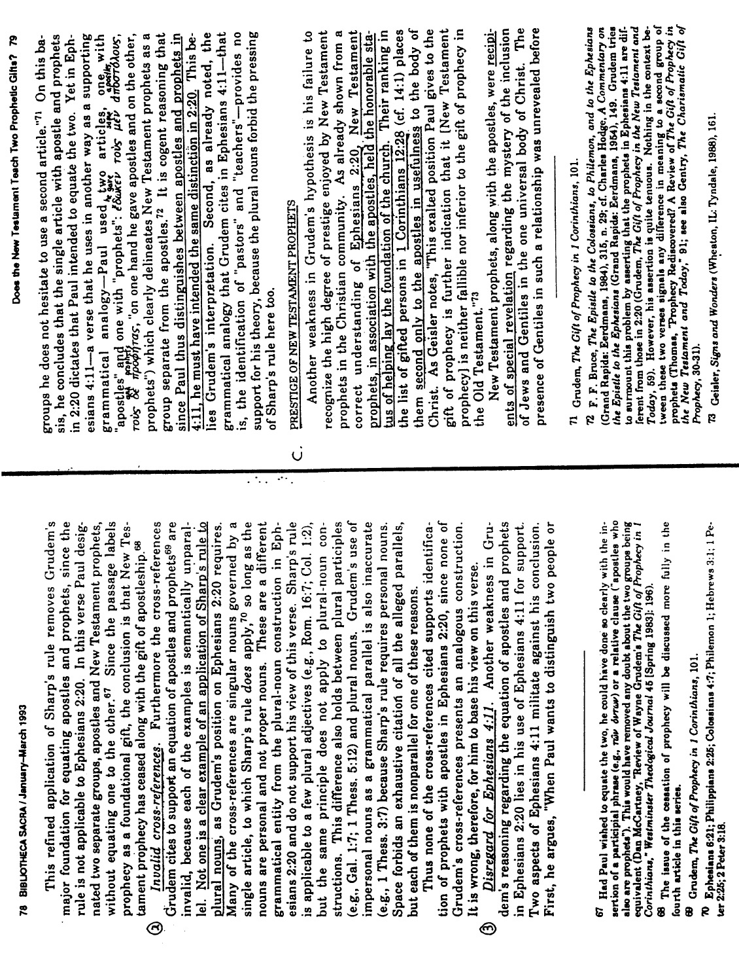
F. David Farnell, “Does the New Testament Teach Two Prophetic Gifts?” (10 of 14)

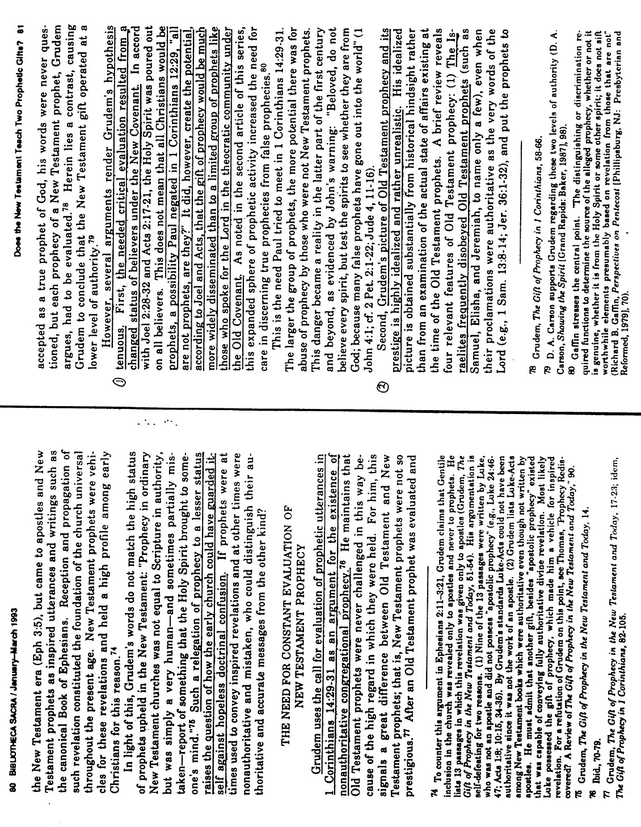
F. David Farnell, “Does the New Testament Teach Two Prophetic Gifts?” (11 of 14)

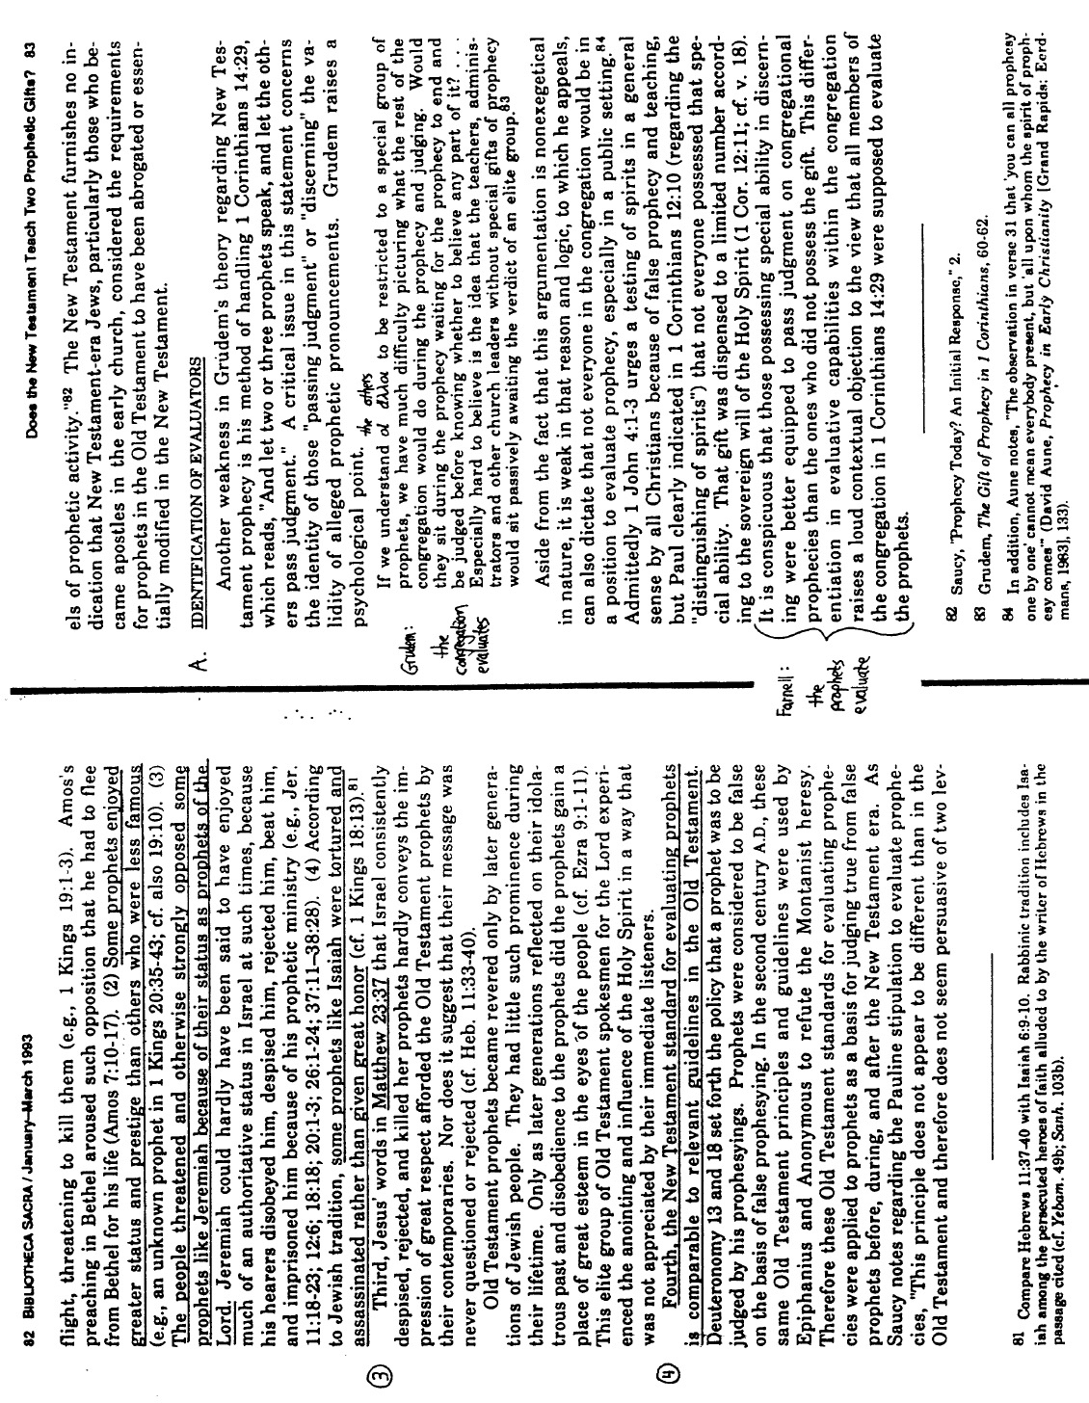
F. David Farnell, “Does the New Testament Teach Two Prophetic Gifts?” (12 of 14)

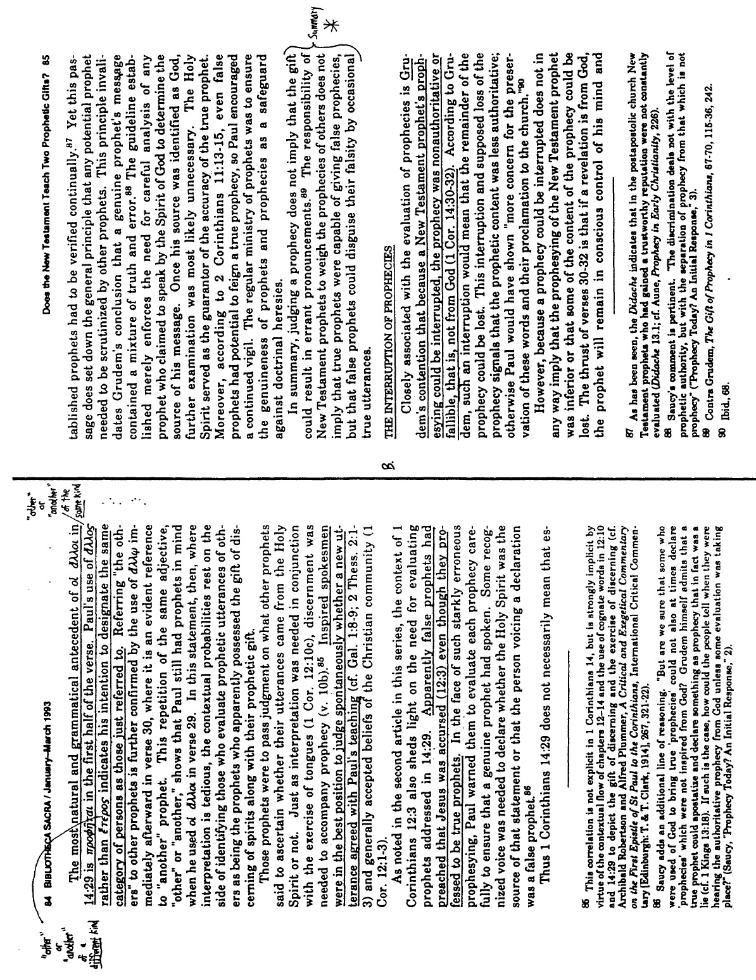
F. David Farnell, “Does the New Testament Teach Two Prophetic Gifts?” (13 of 14)

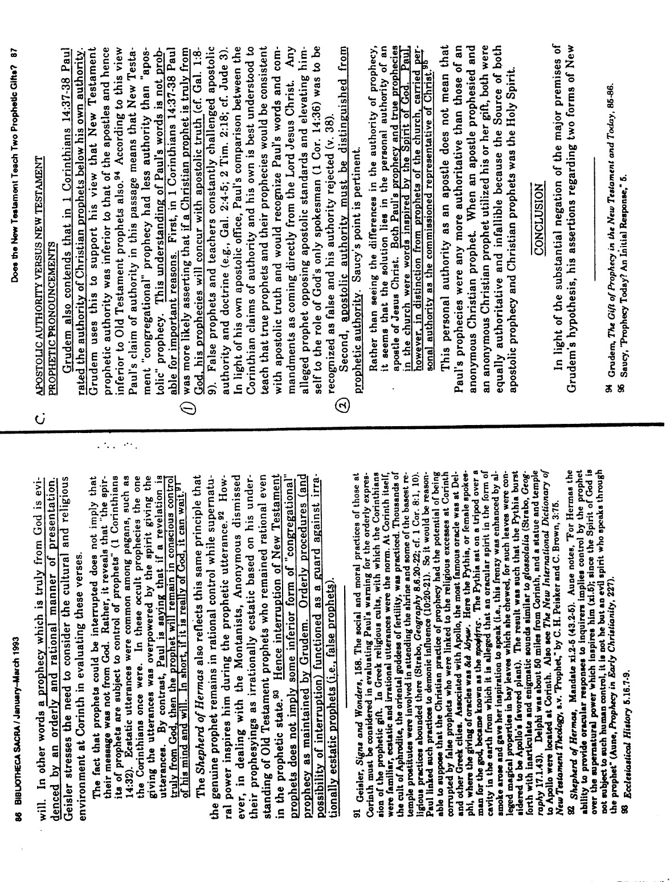
F. David Farnell, “Does the New Testament Teach Two Prophetic Gifts?” (14 of 14)

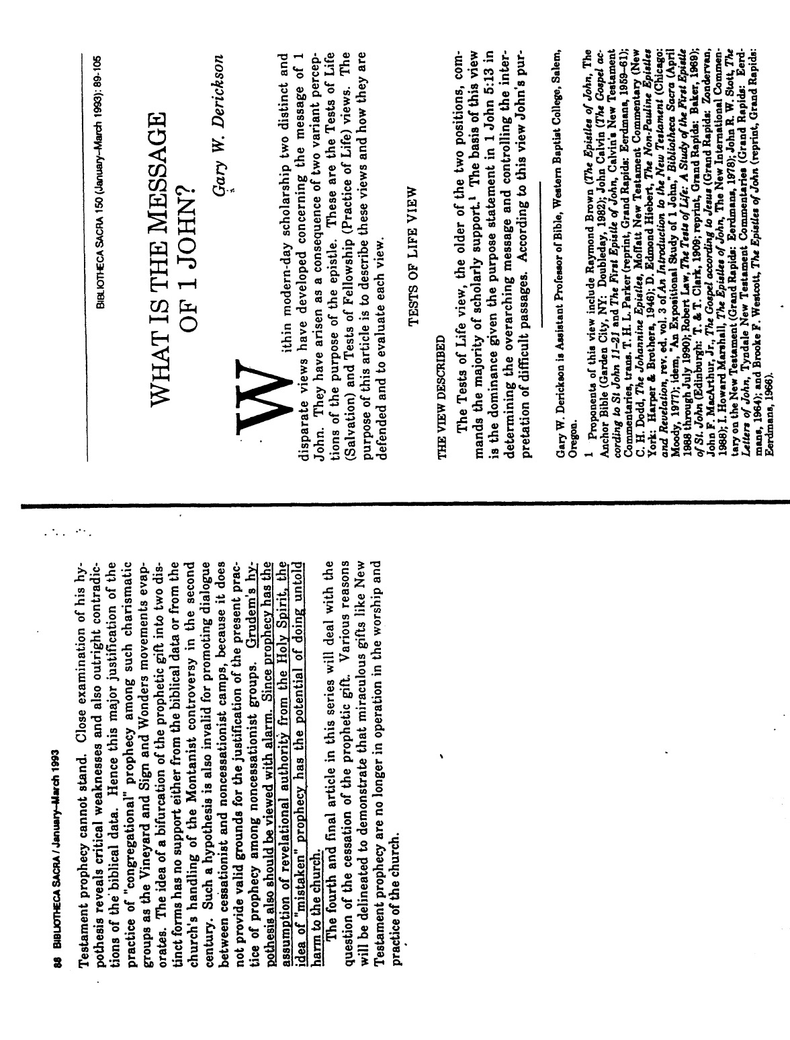
Jack Deere, “Did Miraculous Gifts Cease With the Apostles?”
Surprised by the Power of the Spirit
(1 of 13)

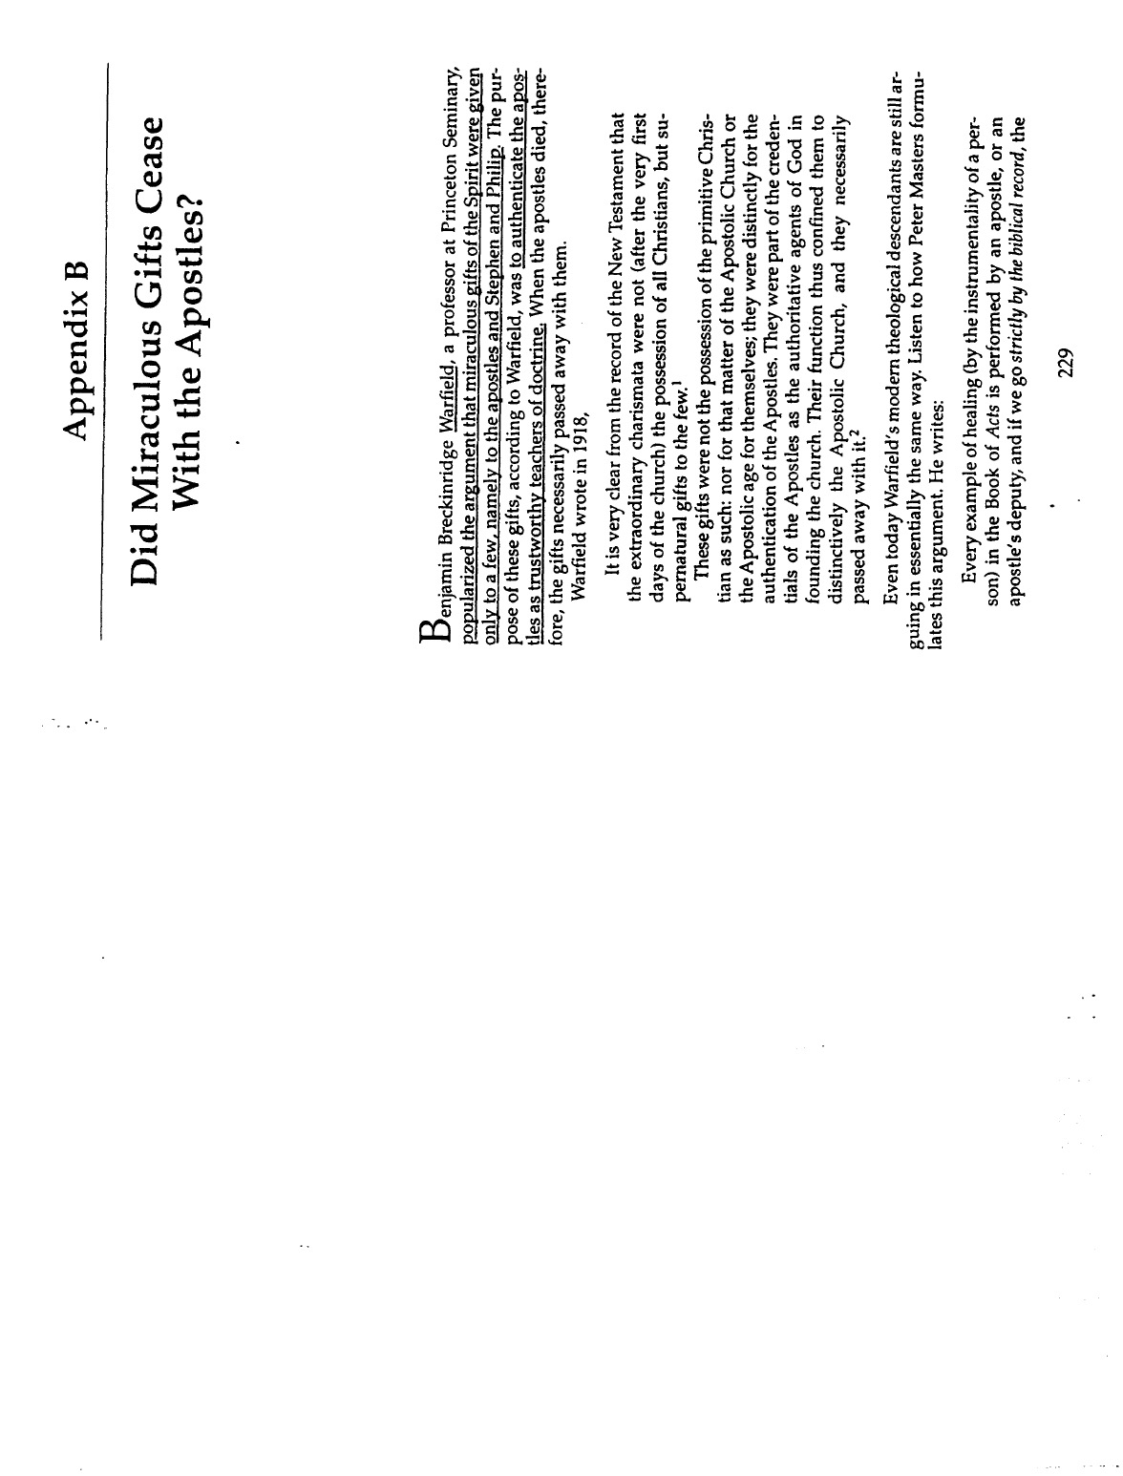
Jack Deere, “Did Miraculous Gifts Cease With the Apostles?” (2 of 13)

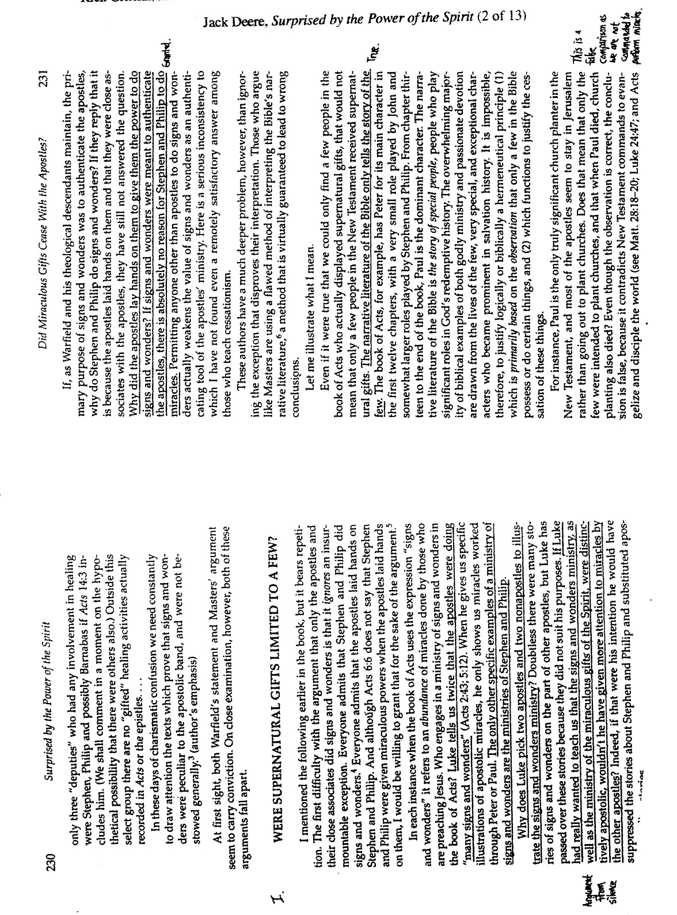
Jack Deere, “Did Miraculous Gifts Cease With the Apostles?” (3 of 13)

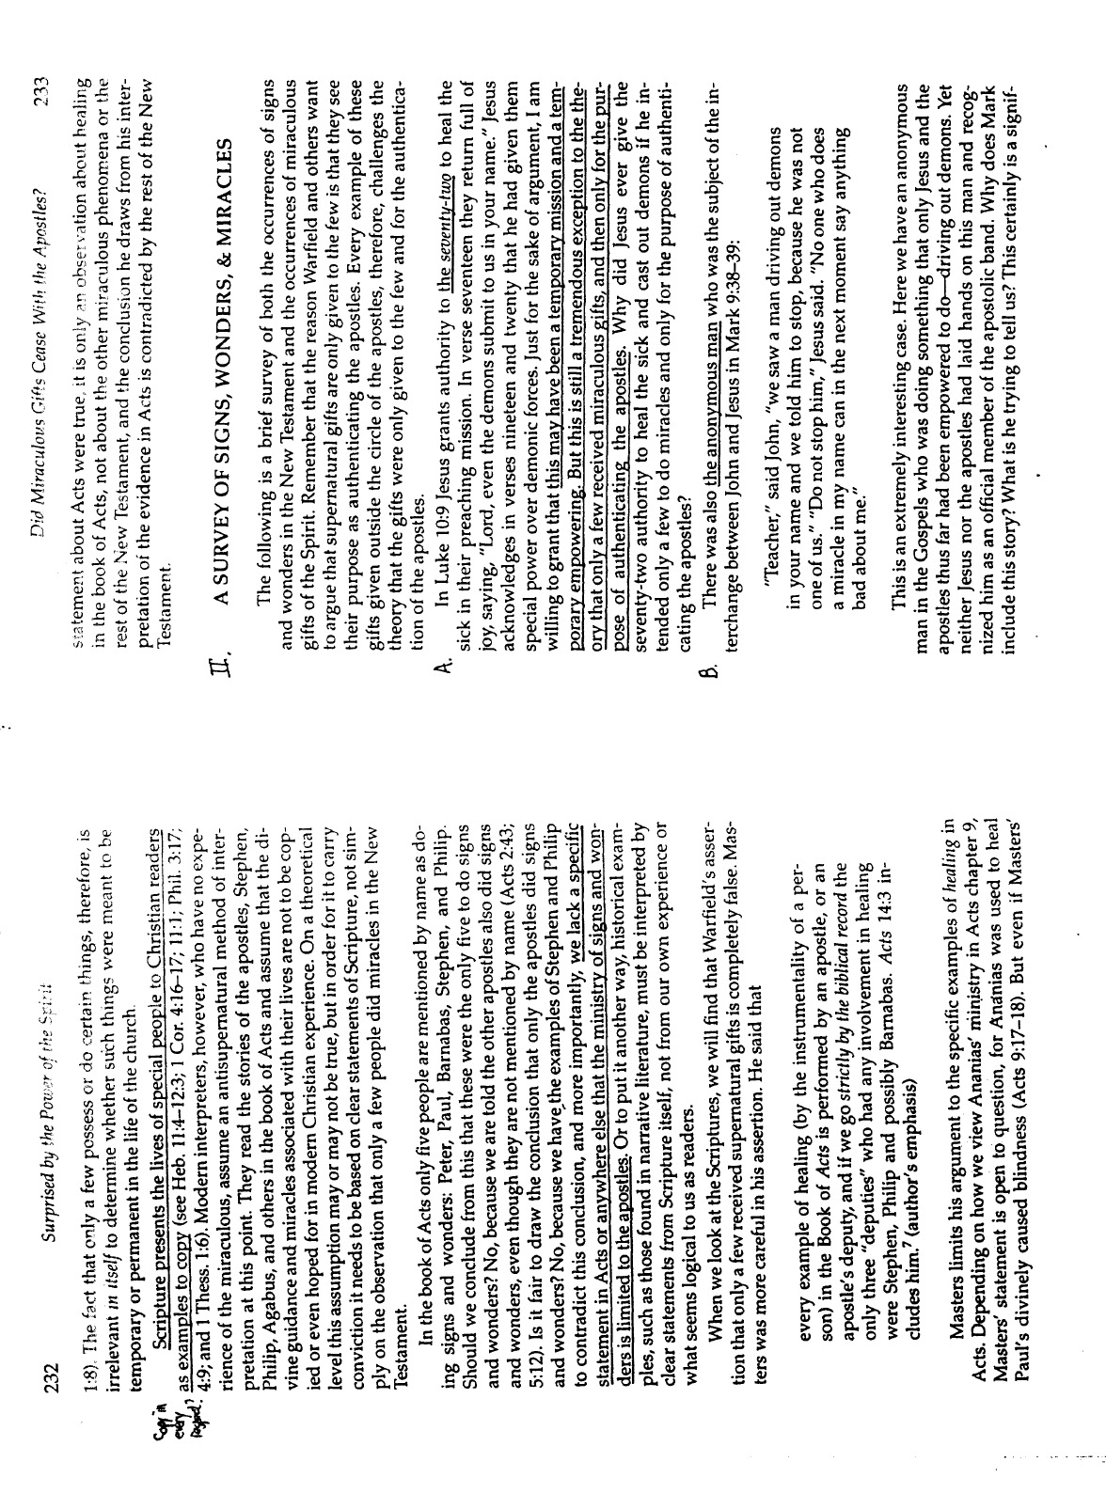
Jack Deere, “Did Miraculous Gifts Cease With the Apostles?” (4 of 13)

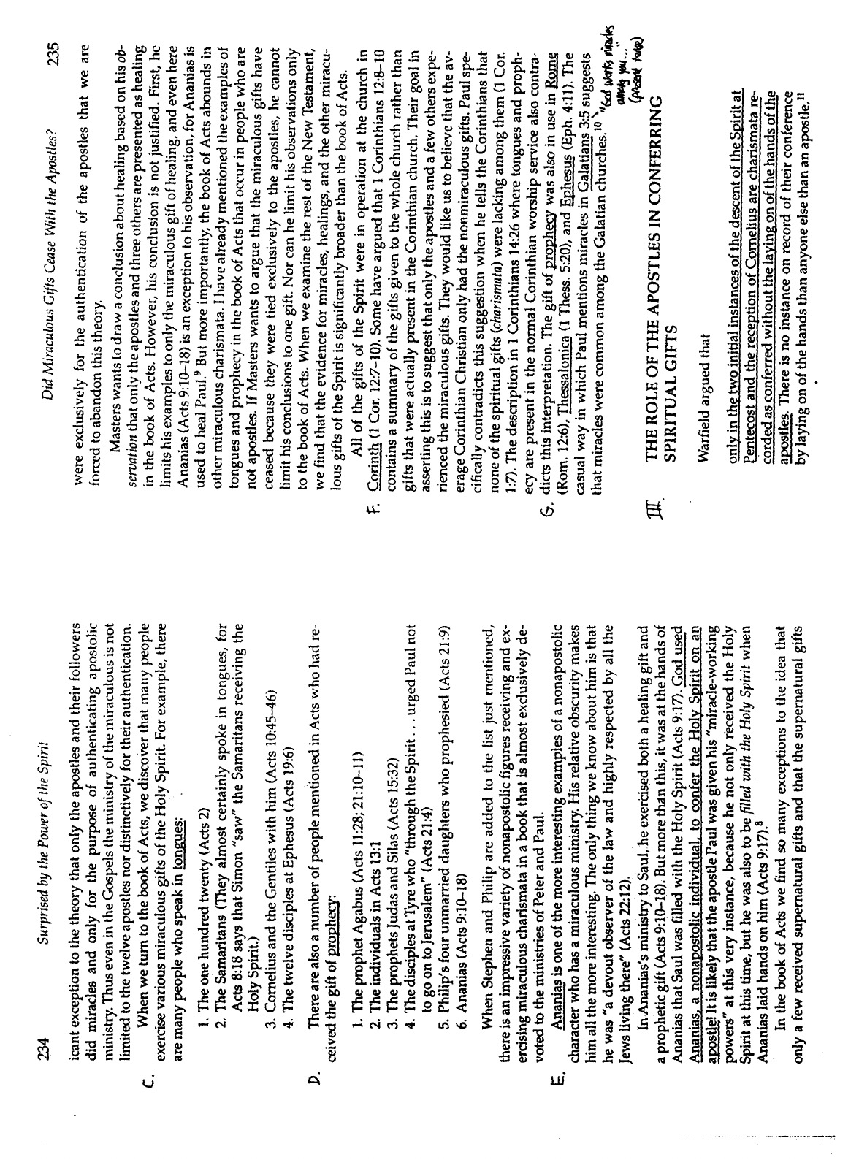
Jack Deere, “Did Miraculous Gifts Cease With the Apostles?” (5 of 13)

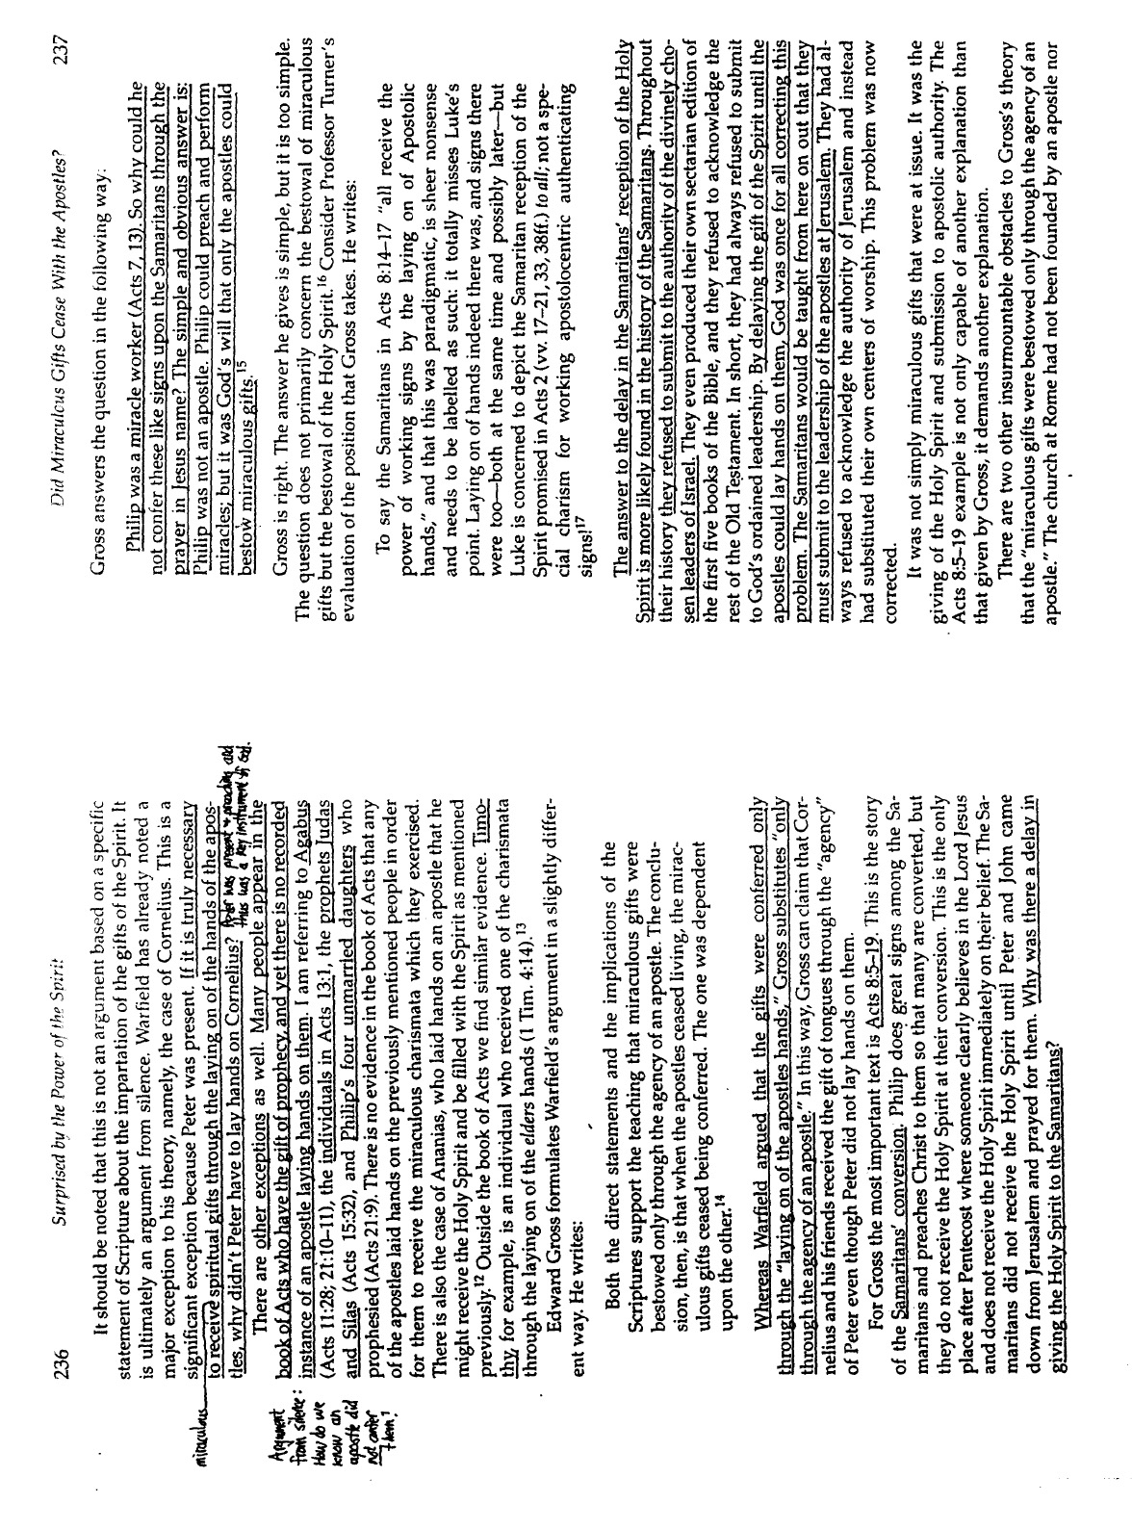
Jack Deere, “Did Miraculous Gifts Cease With the Apostles?” (6 of 13)

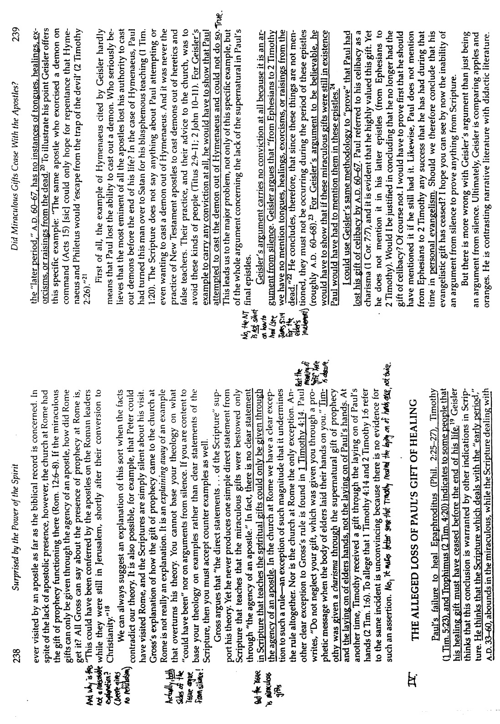
Jack Deere, “Did Miraculous Gifts Cease With the Apostles?” (7 of 13)

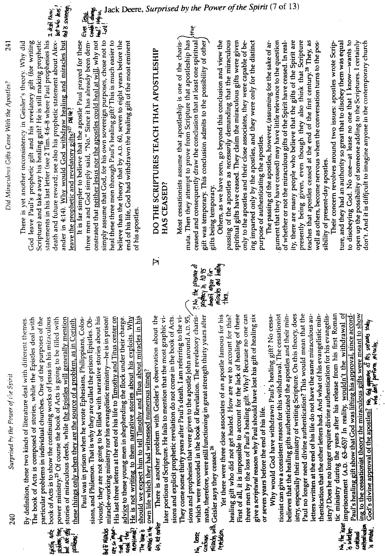
Jack Deere, “Did Miraculous Gifts Cease With the Apostles?” (8 of 13)

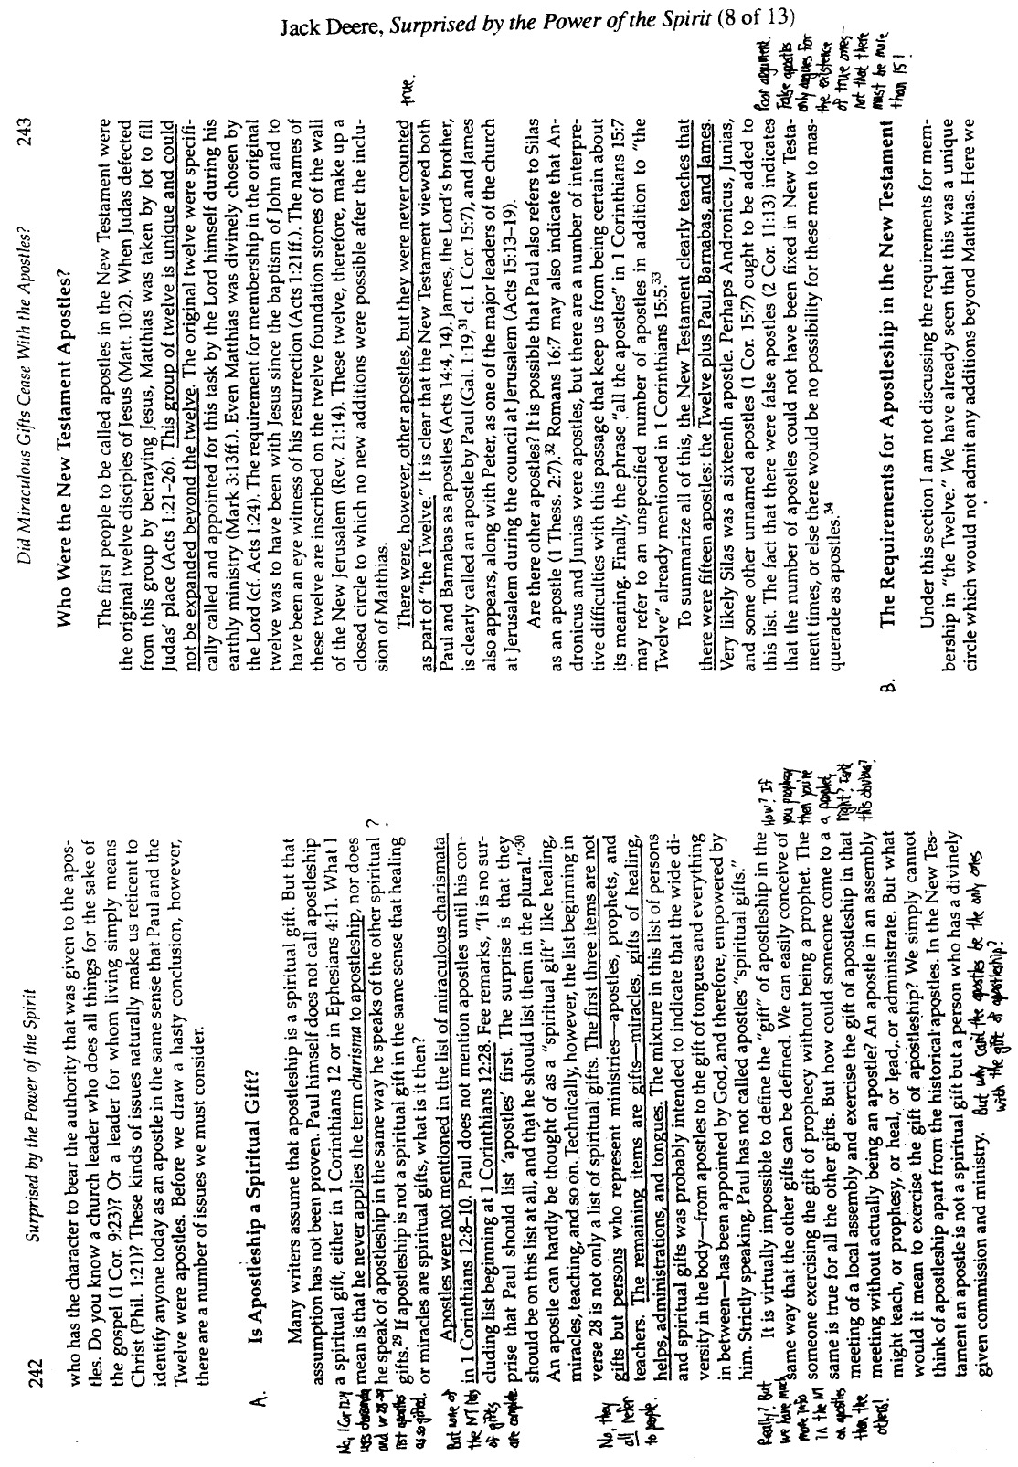
Jack Deere, “Did Miraculous Gifts Cease With the Apostles?” (9 of 13)

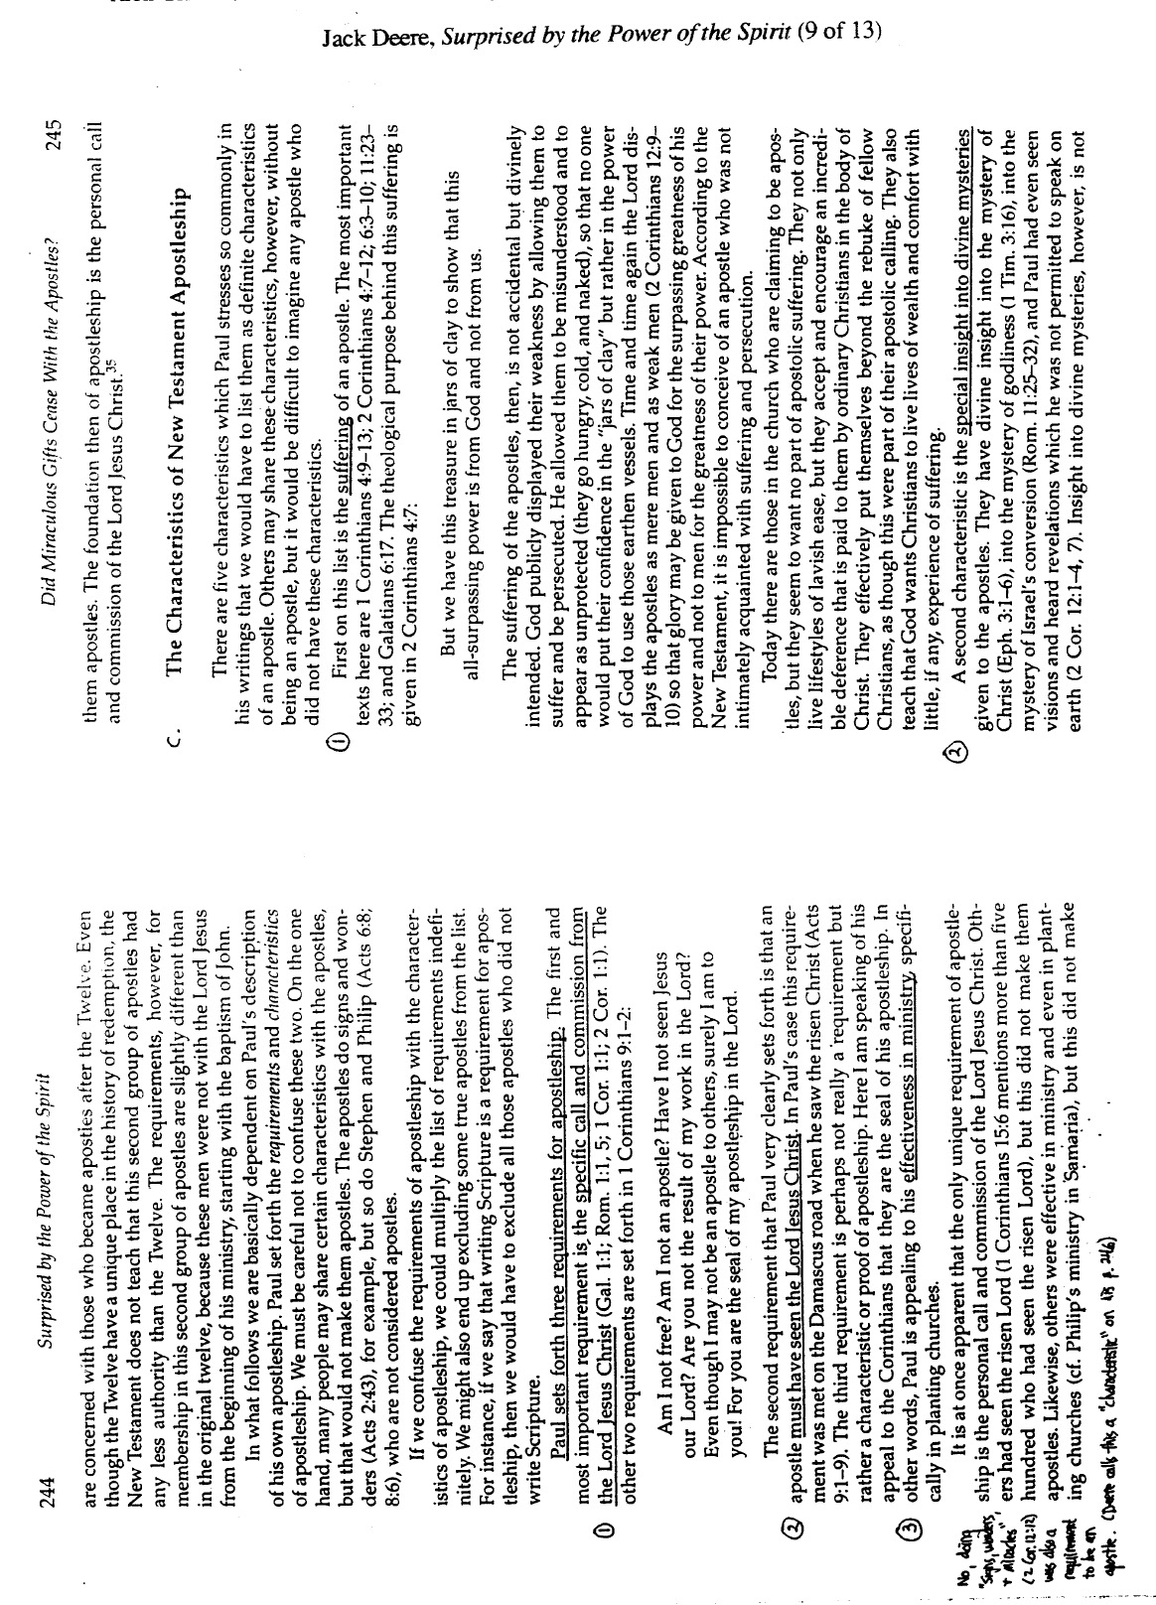
Jack Deere, “Did Miraculous Gifts Cease With the Apostles?” (10 of 13)

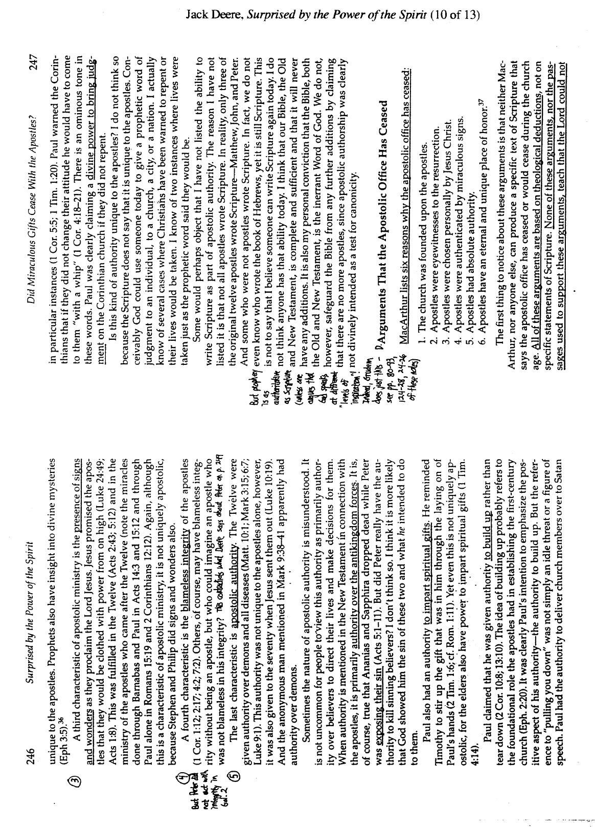
Jack Deere, “Did Miraculous Gifts Cease With the Apostles?” (11 of 13)

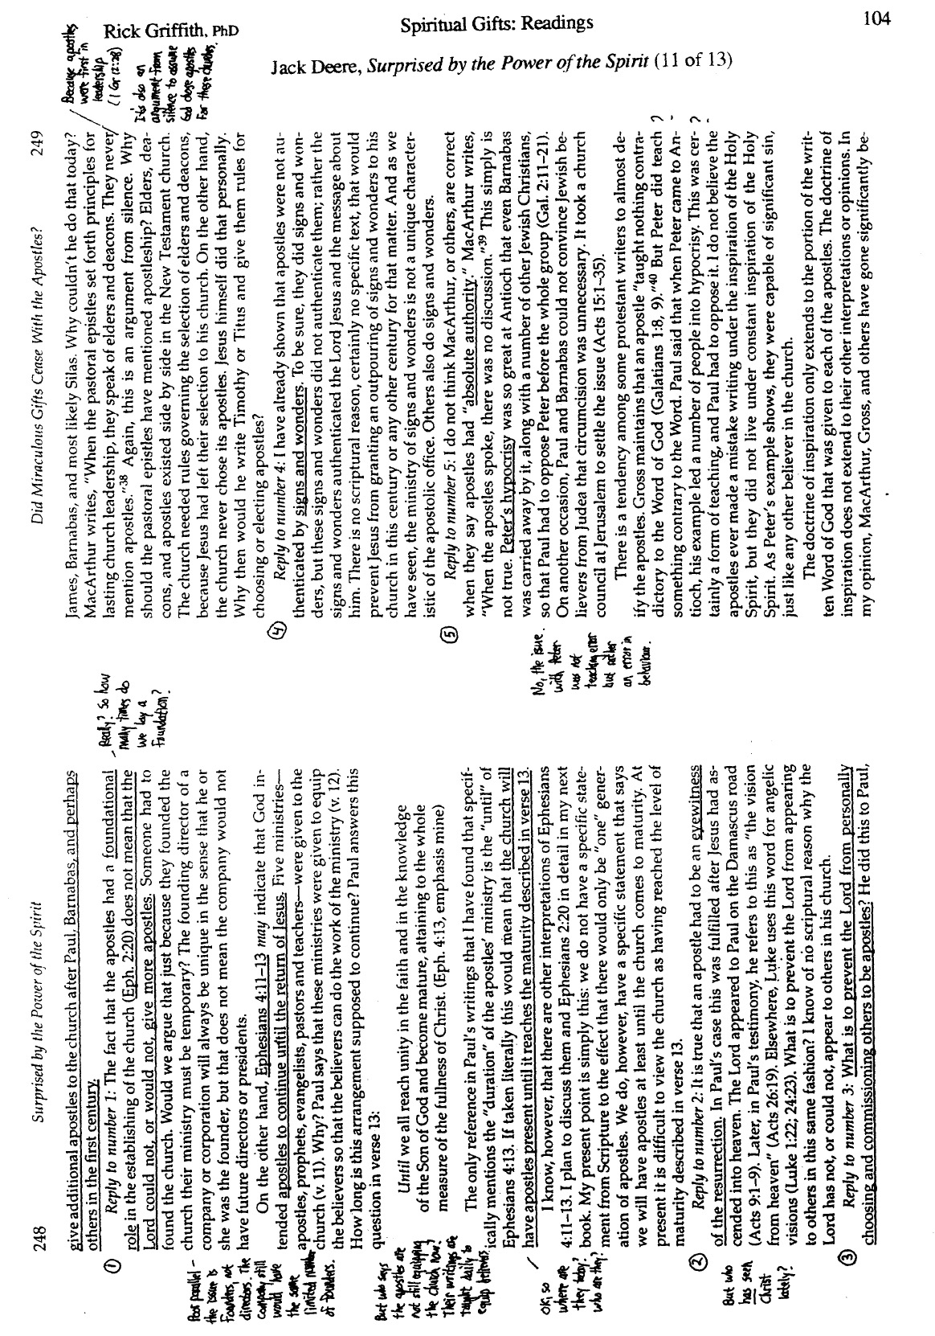
Jack Deere, “Did Miraculous Gifts Cease With the Apostles?” (12 of 13)

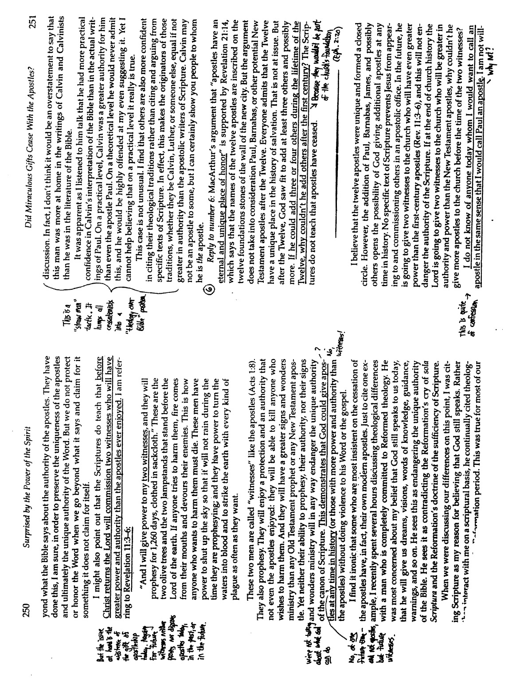
Jack Deere, “Did Miraculous Gifts Cease With the Apostles?” (13 of 13)

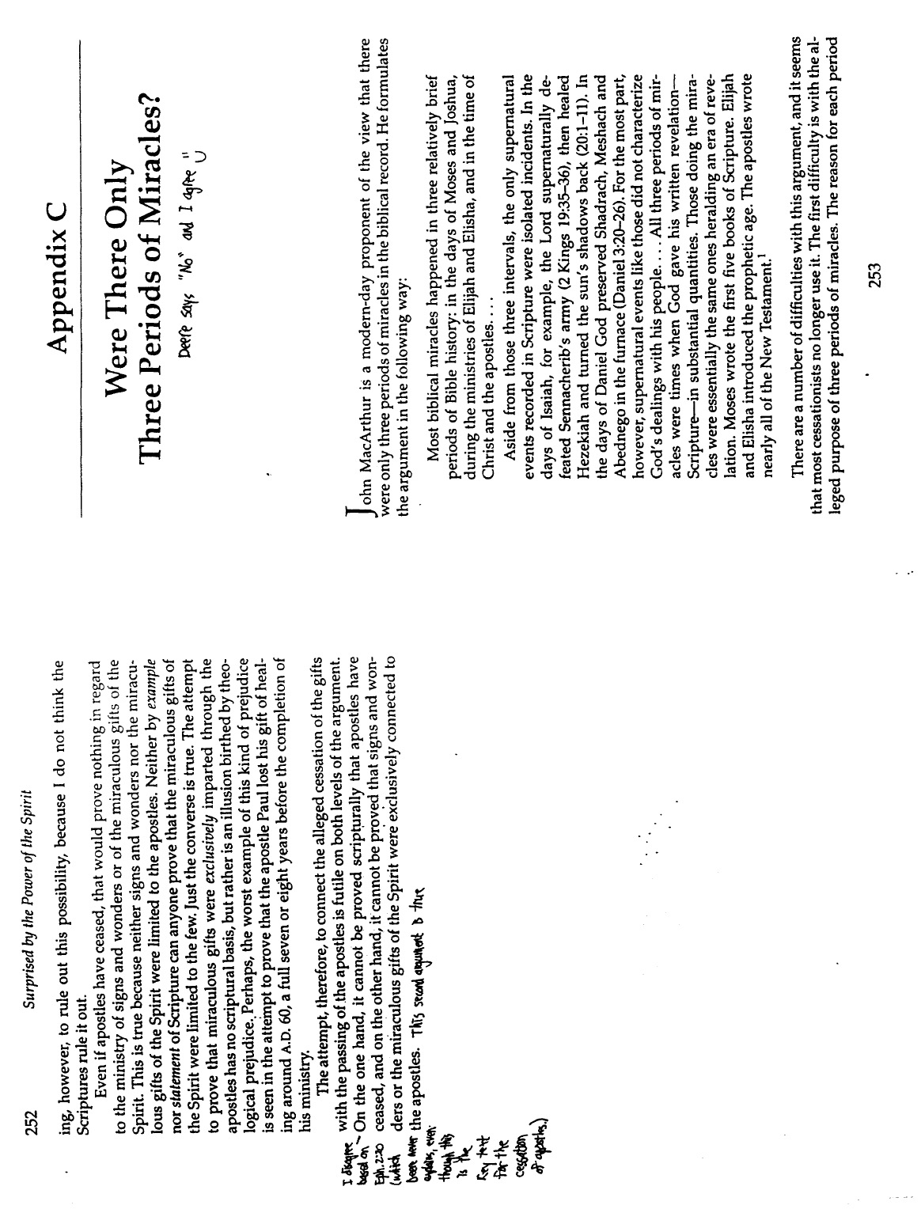
Jack Deere, “Did Miraculous Gifts Cease With the Apostles?” (Endnotes 1 of 3)

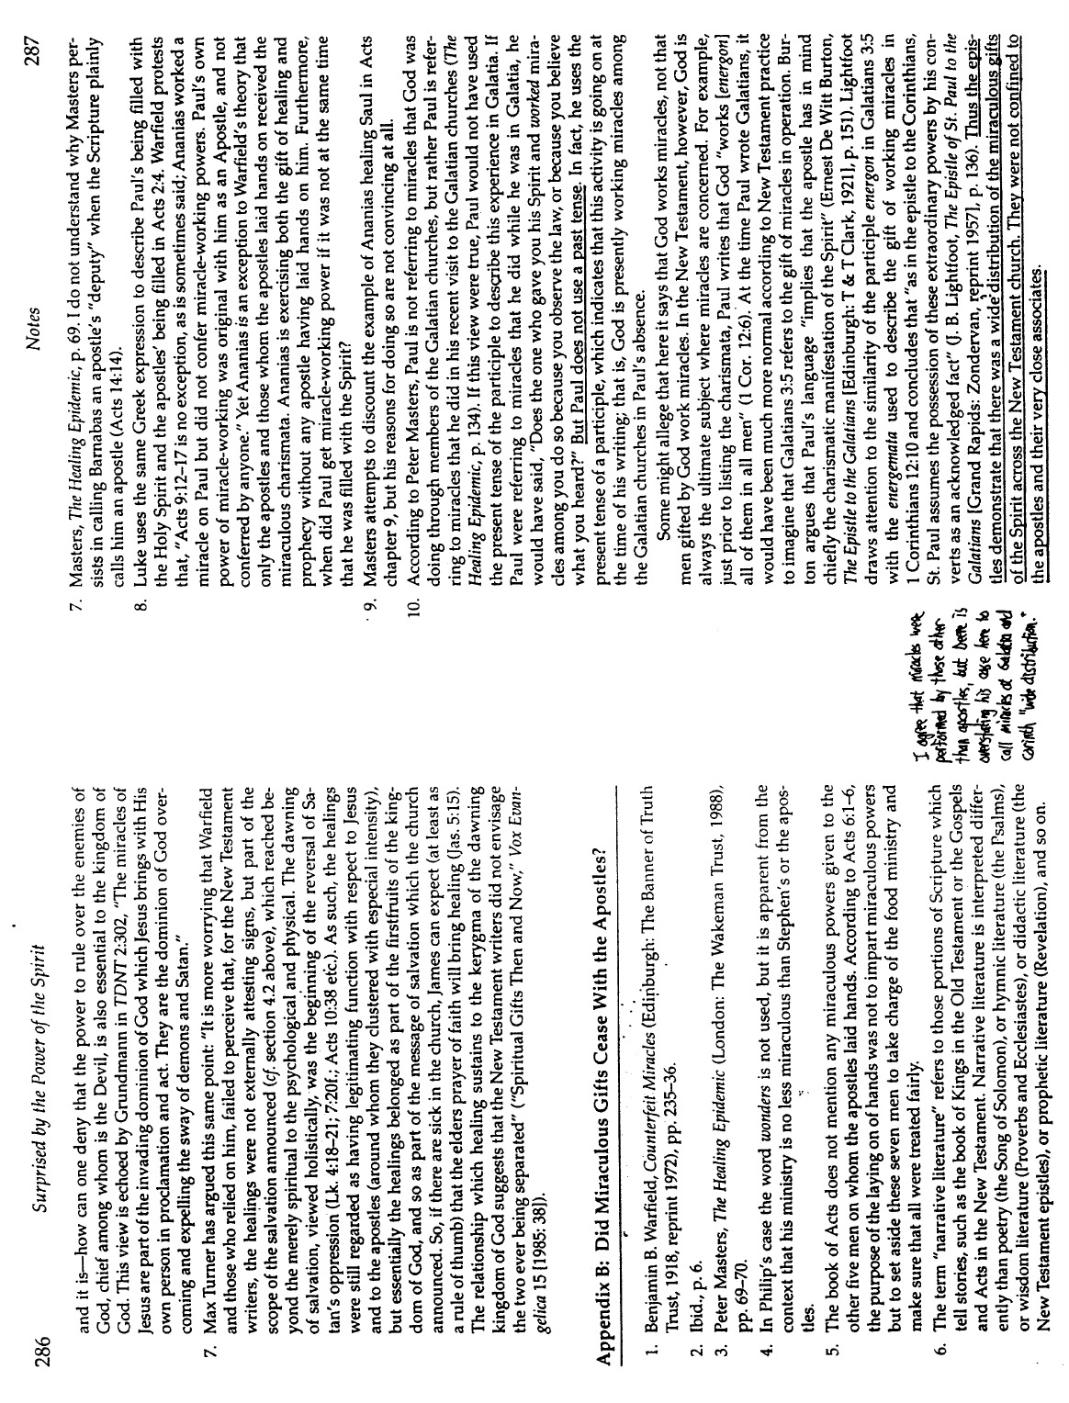
Jack Deere, “Did Miraculous Gifts Cease With the Apostles?” (Endnotes 2 of 3)

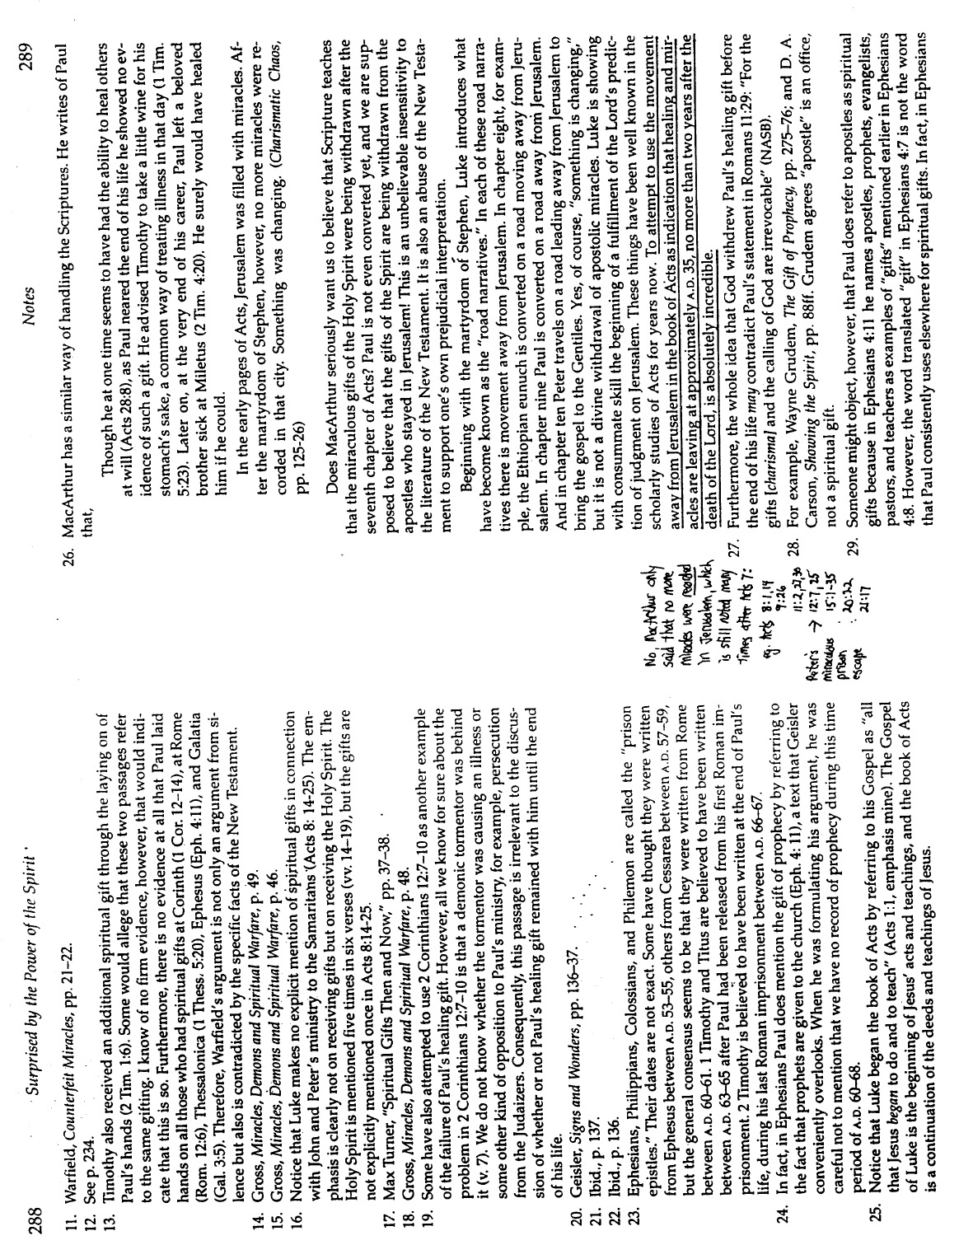
Jack Deere, “Did Miraculous Gifts Cease With the Apostles?” (Endnotes 3 of 3)

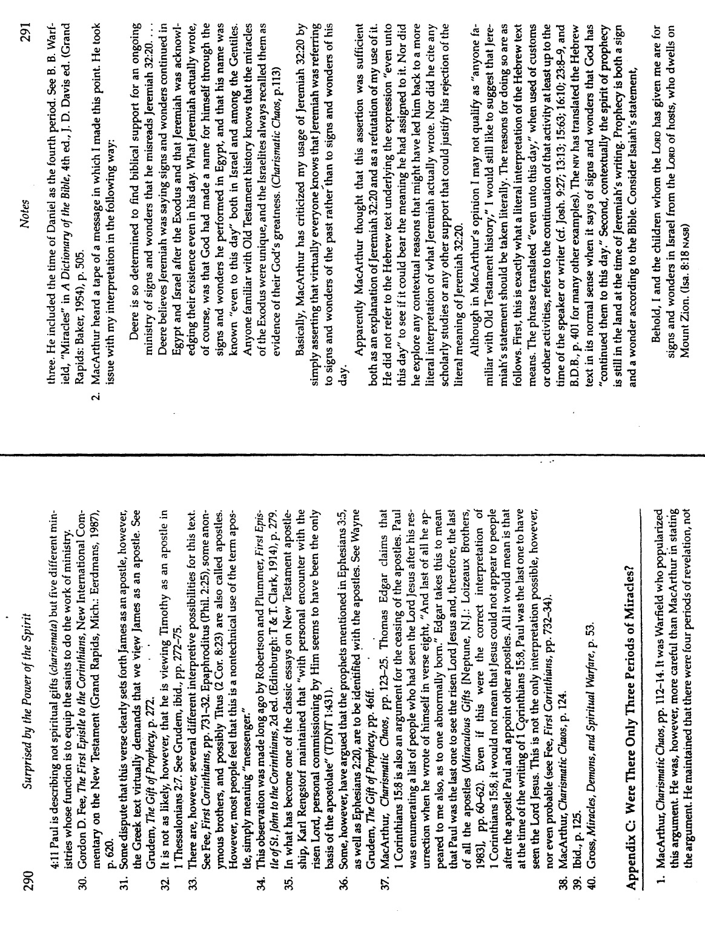
Robert A. Pyne’s Response to Deere’s Book
This is not an official response of Dallas Seminary but Pyne does teach at DTS and Bib Sac is the DTS journal

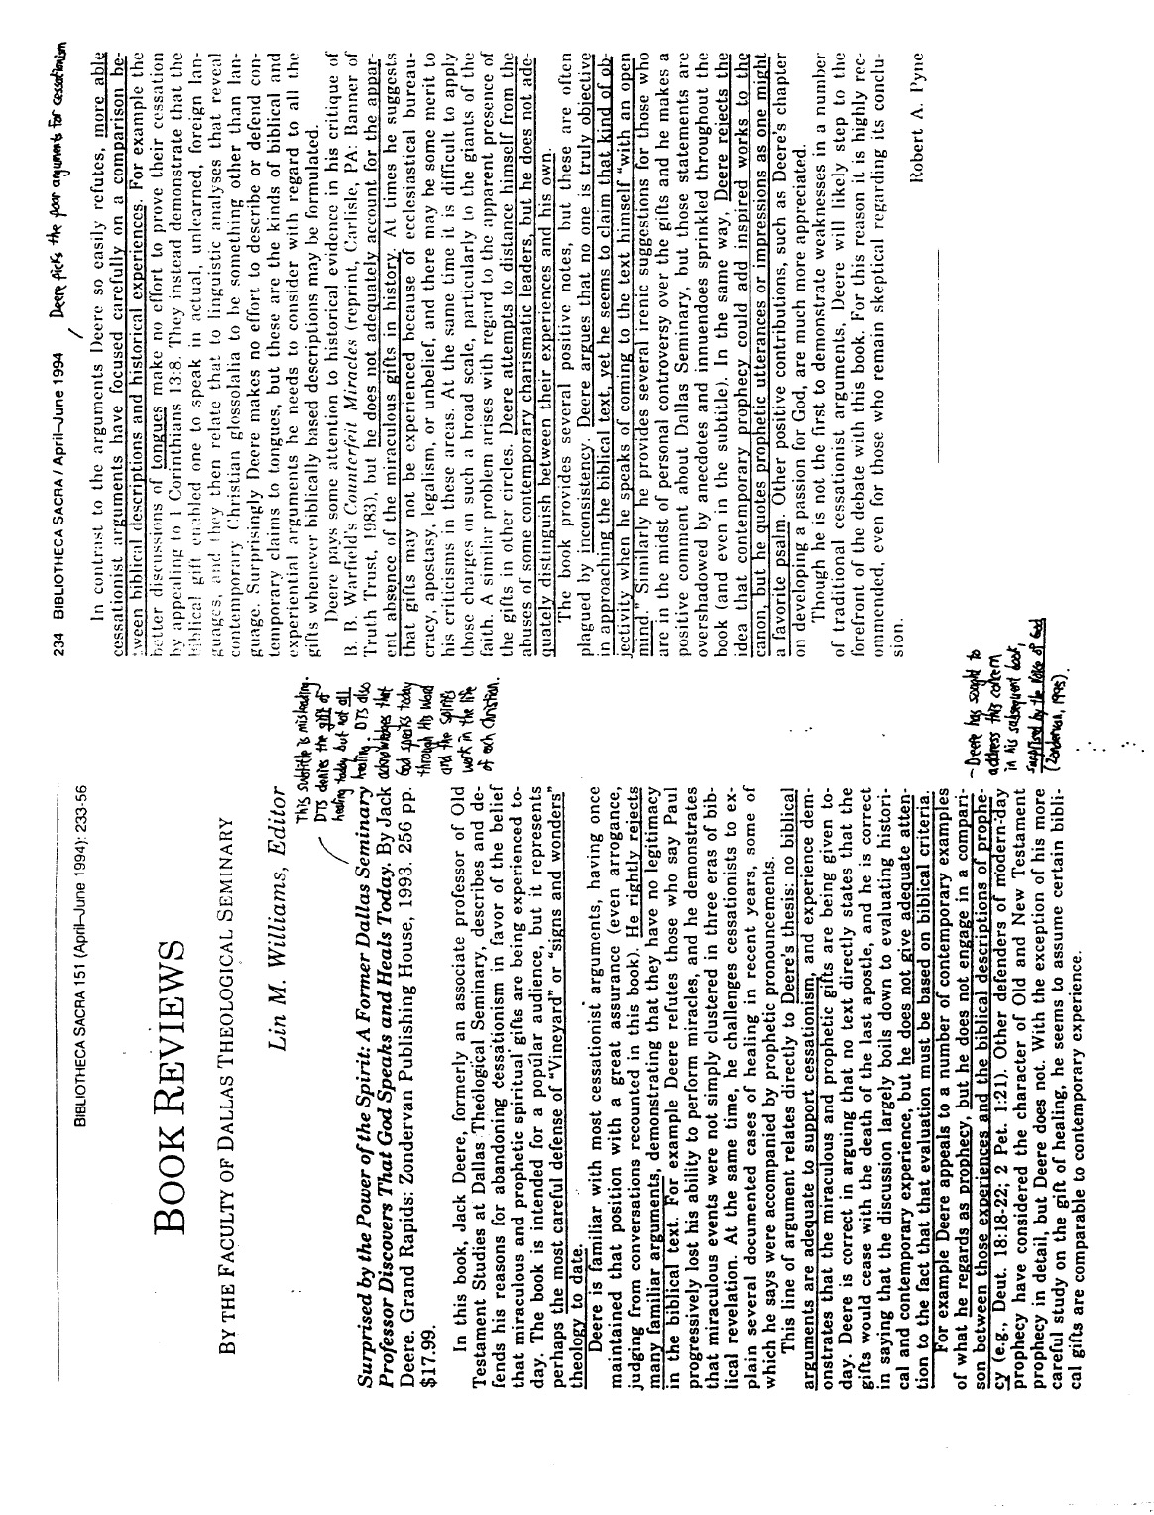
John F. MacArthur, Jr., “The Issue of Tongues”
The Charismatics
(1 of 13)

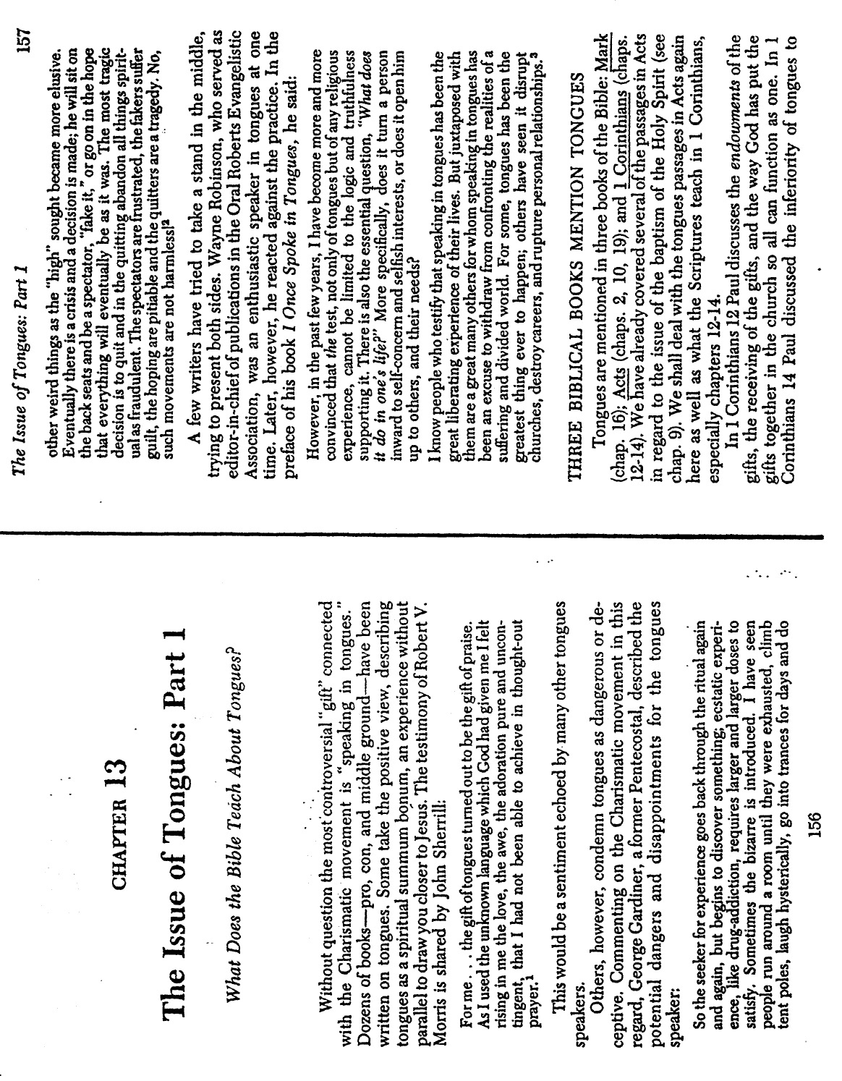
John F. MacArthur, Jr. “The Issue of Tongues” (2 of 13)

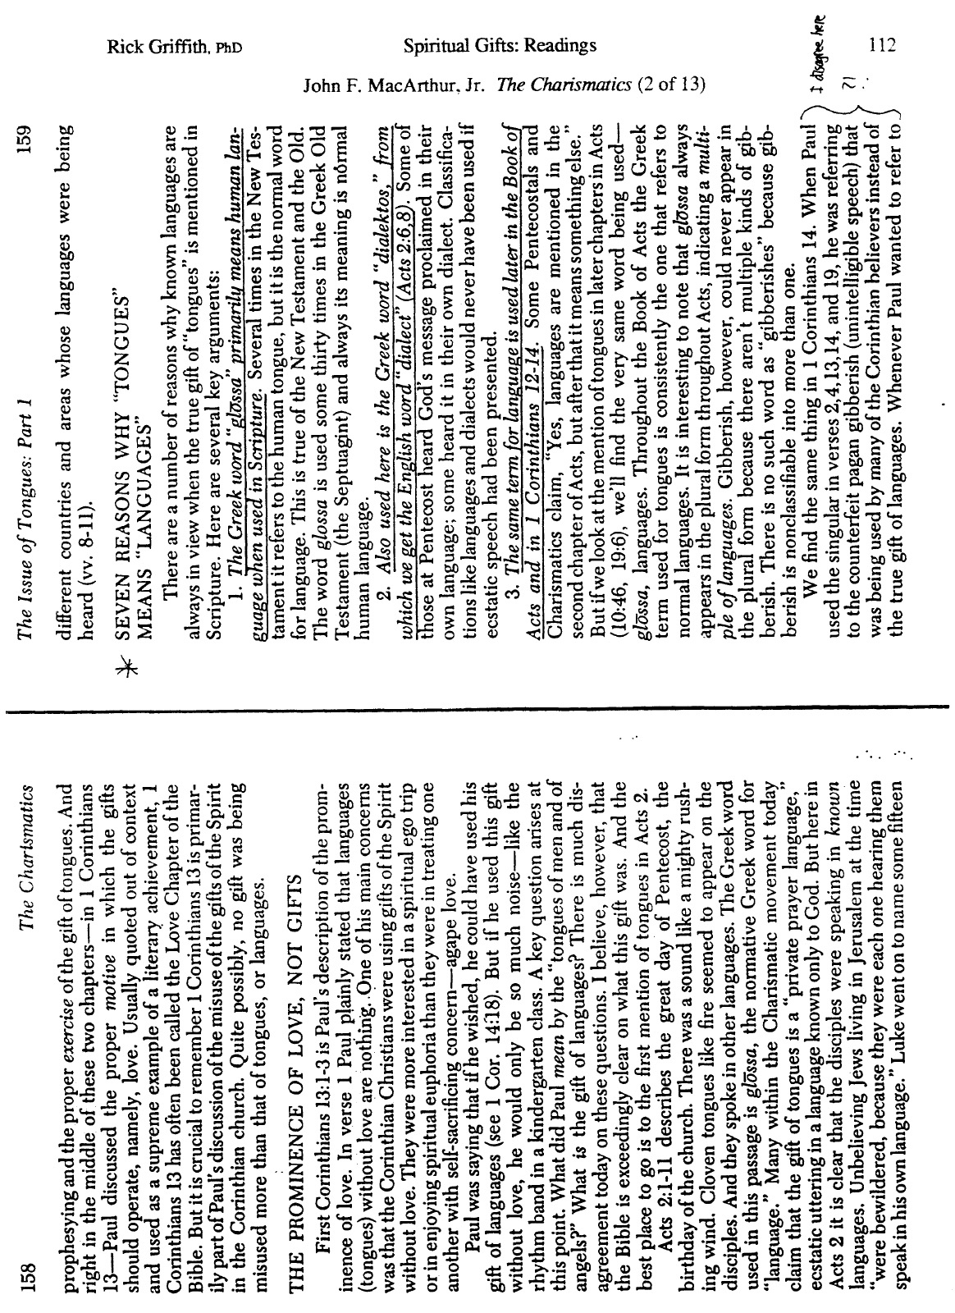
John F. MacArthur, Jr. “The Issue of Tongues” (3 of 13)

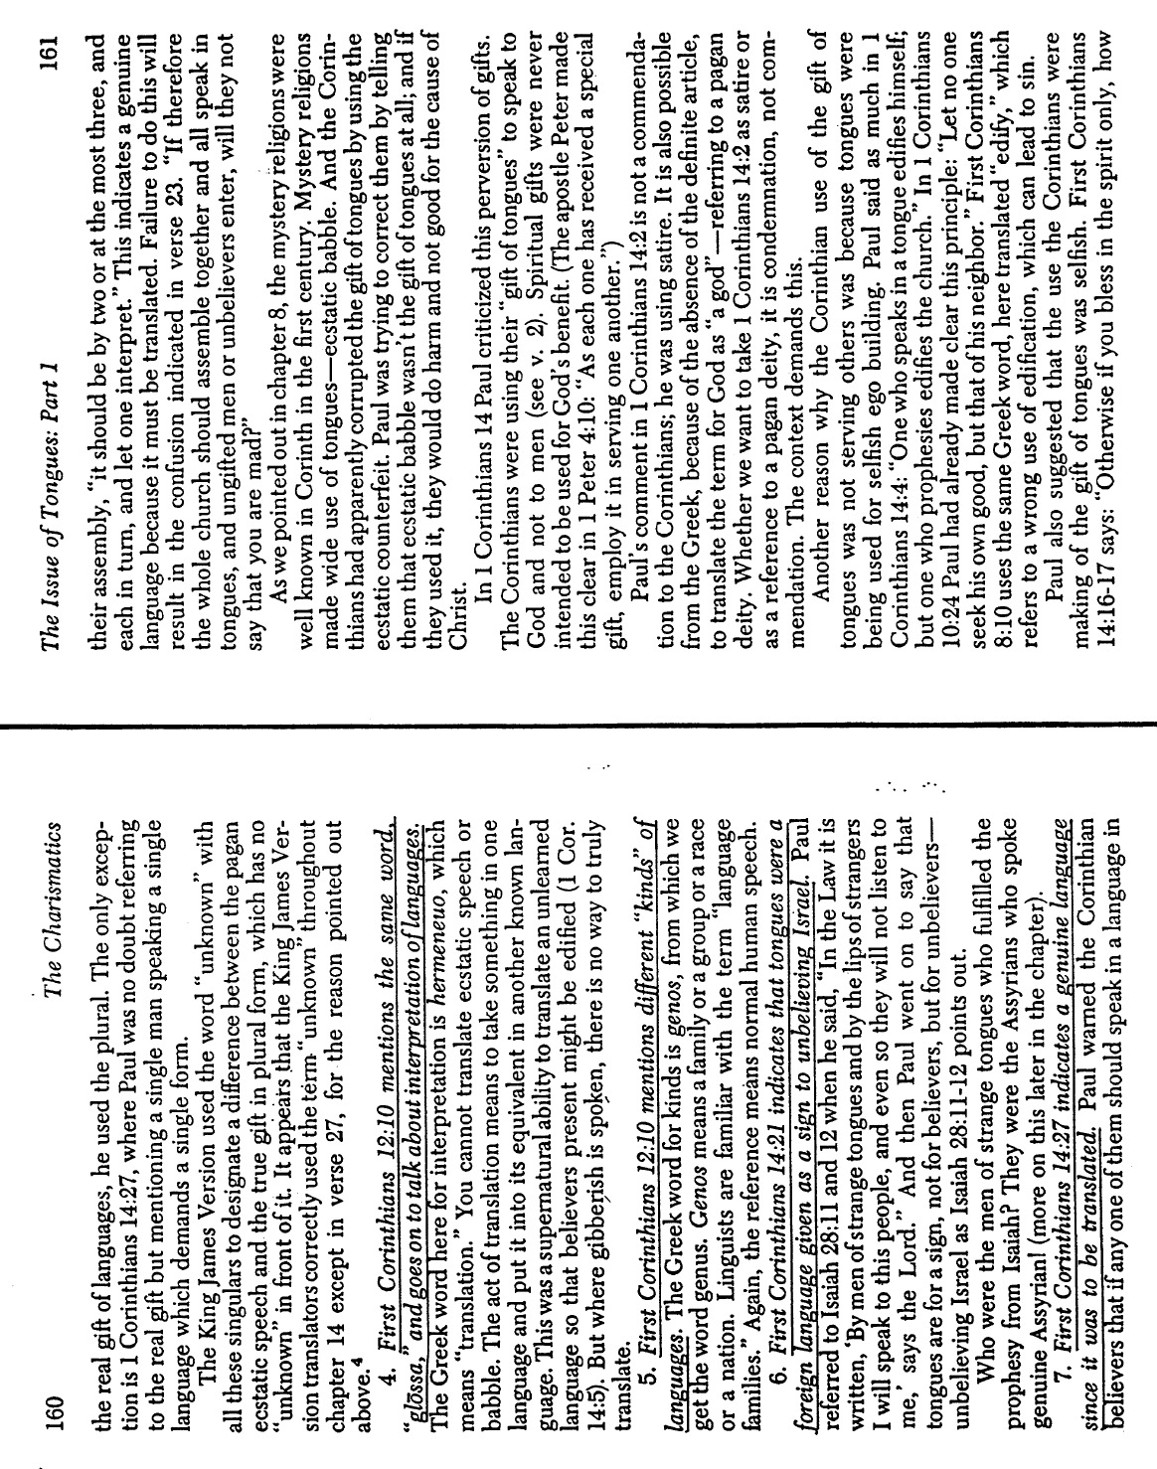
John F. MacArthur, Jr. “The Issue of Tongues” (4 of 13)

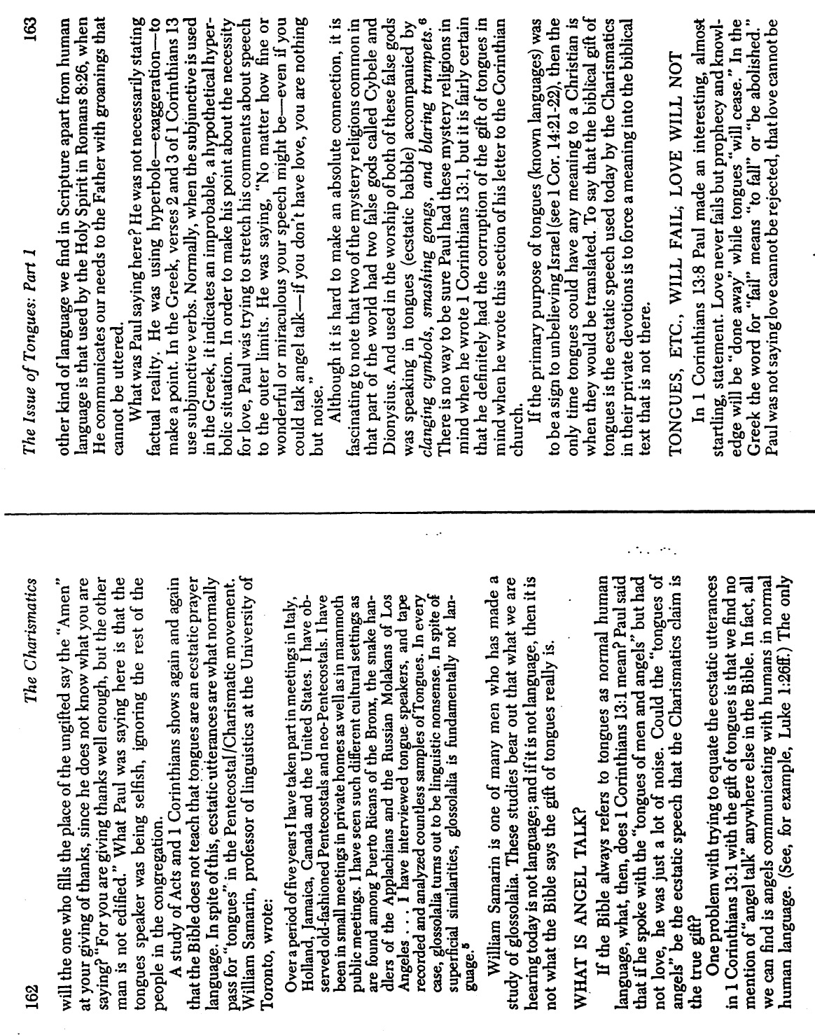
John F. MacArthur, Jr. “The Issue of Tongues” (5 of 13)

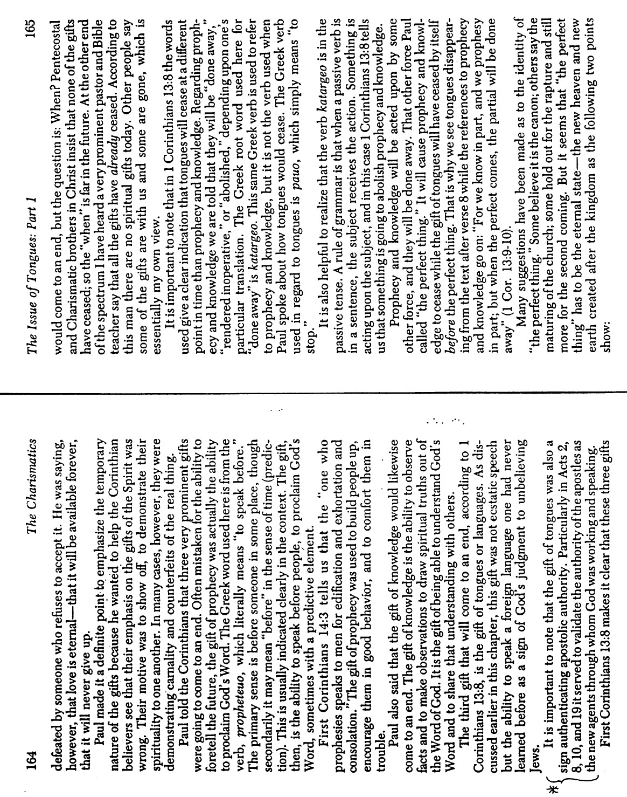
John F. MacArthur, Jr. “The Issue of Tongues” (6 of 13)

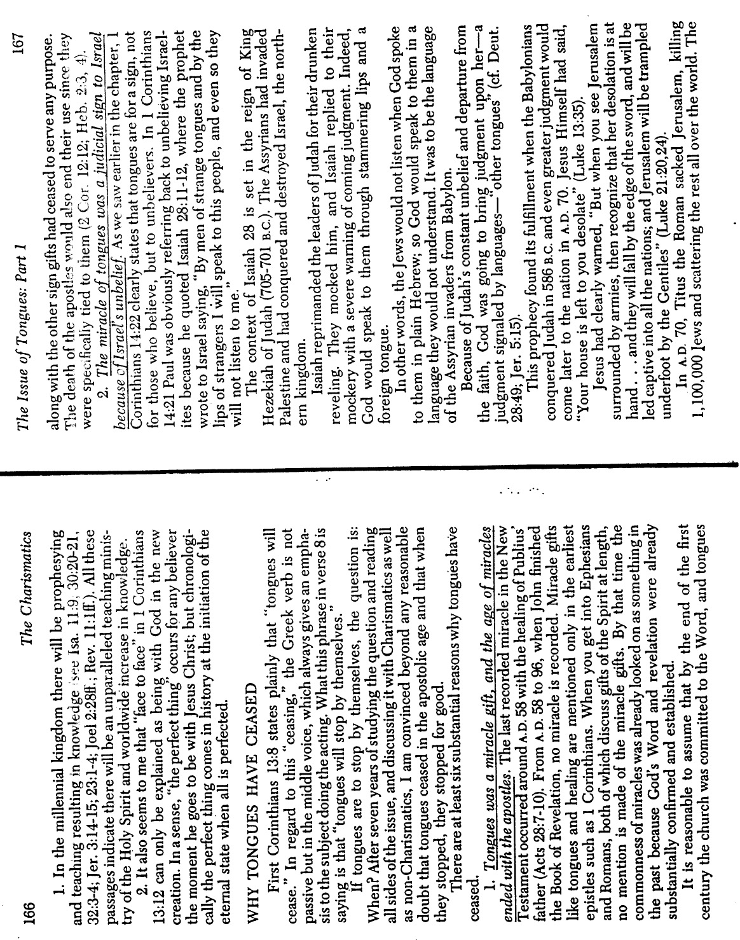
John F. MacArthur, Jr. “The Issue of Tongues” (7 of 13)

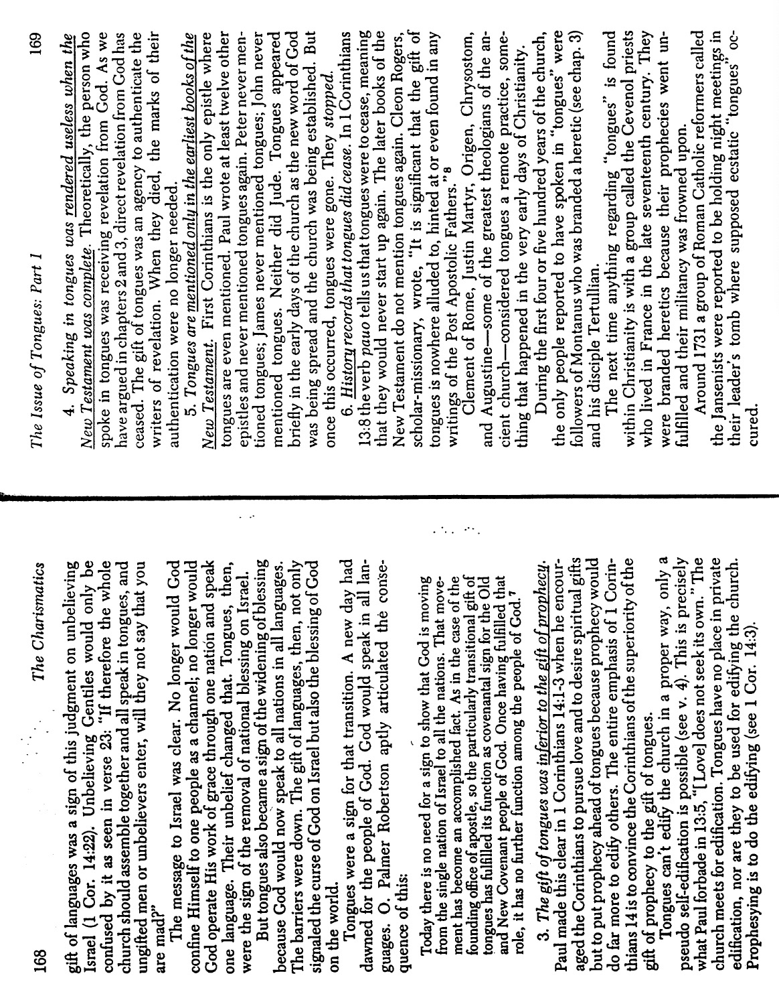
John F. MacArthur, Jr. “The Issue of Tongues” (8 of 13)

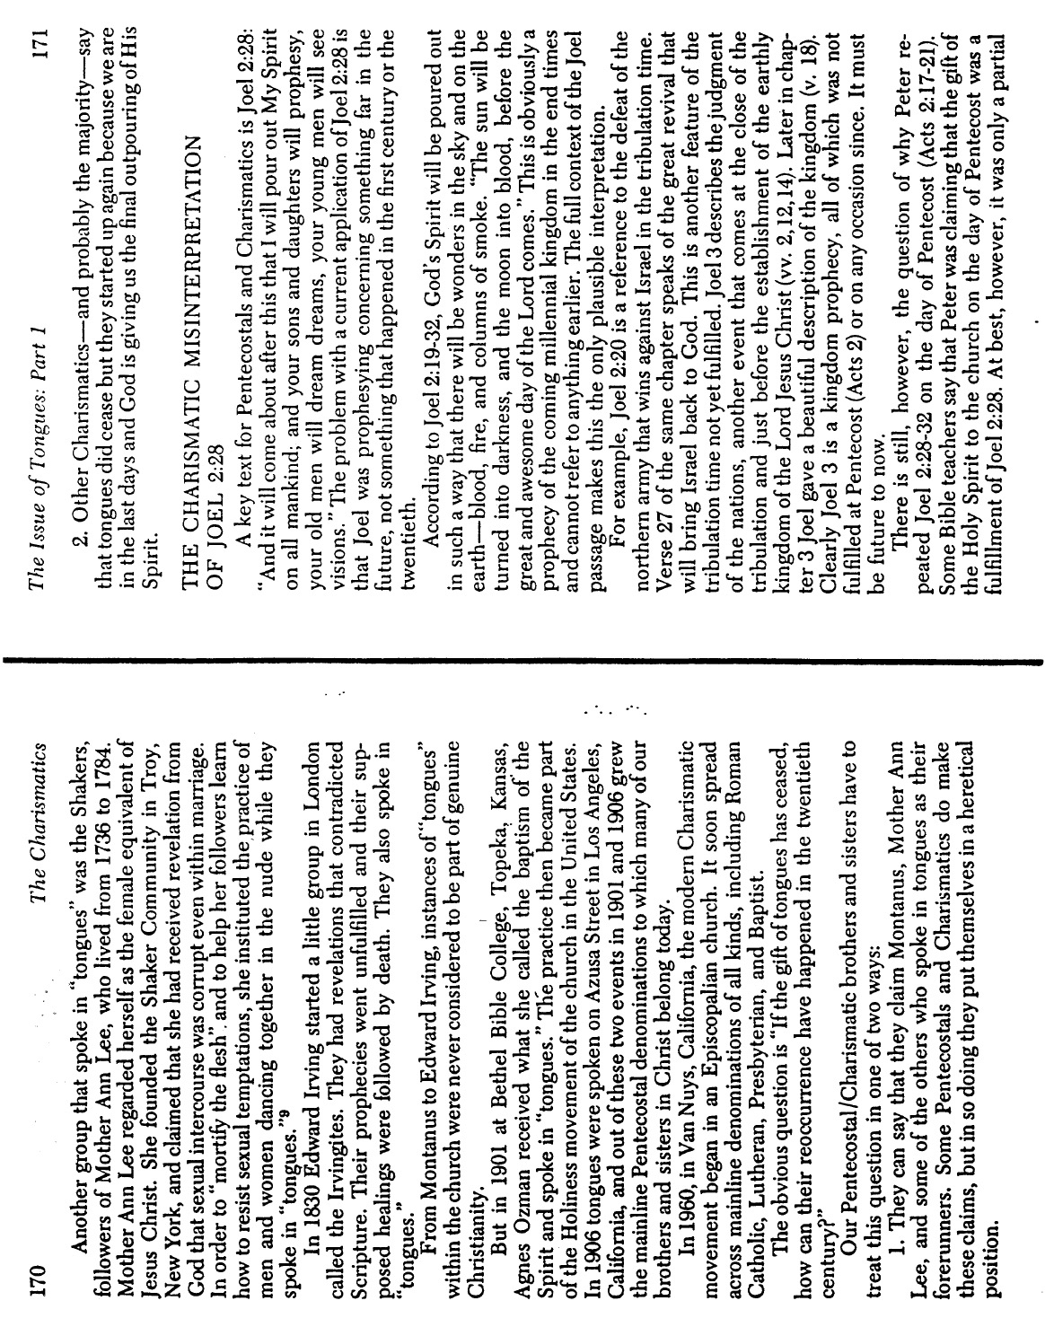
John F. MacArthur, Jr. “The Issue of Tongues” (9 of 13)

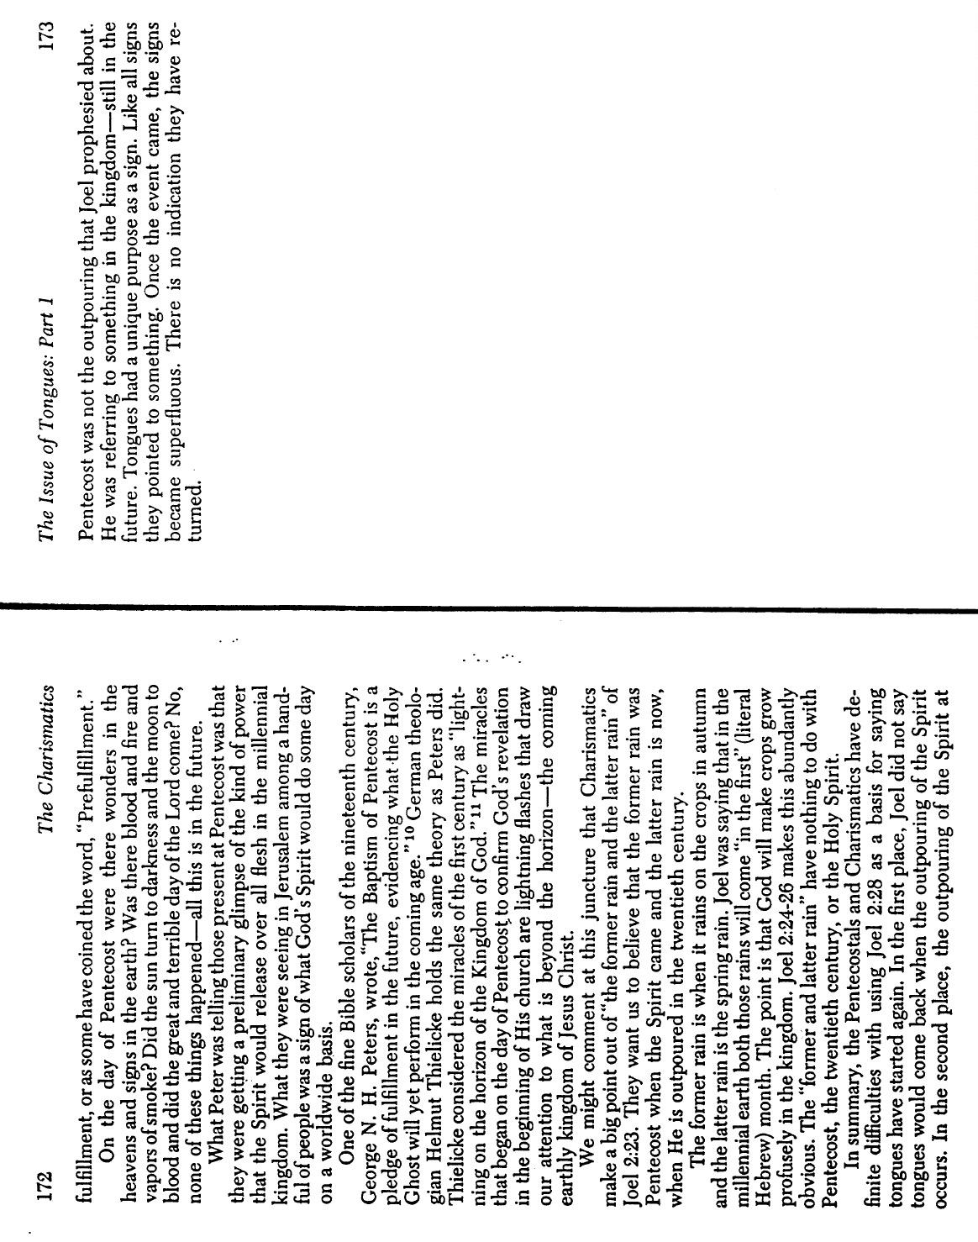
John F. MacArthur, Jr. “The Issue of Tongues” (10 of 13)

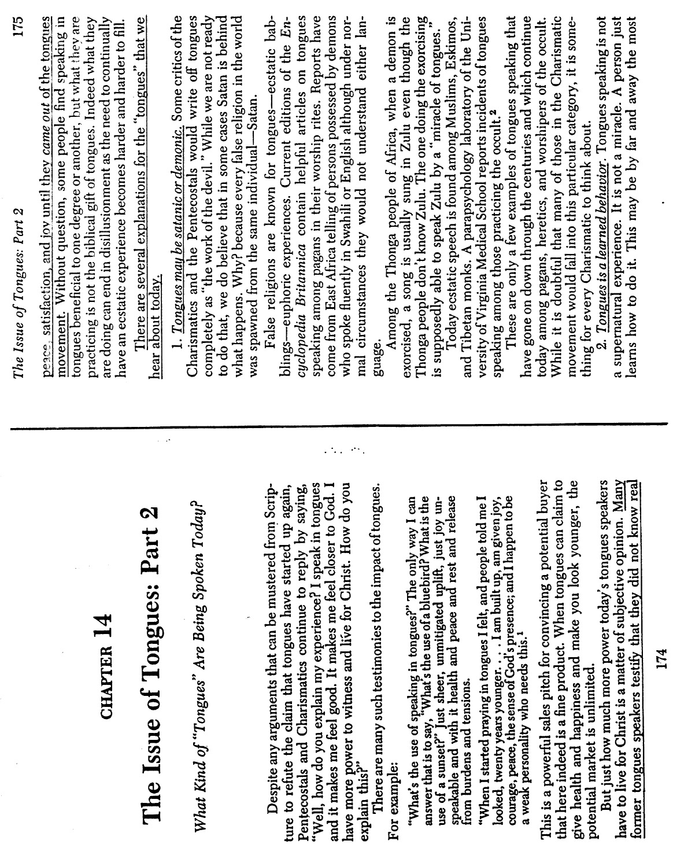
John F. MacArthur, Jr. “The Issue of Tongues” (11 of 13)

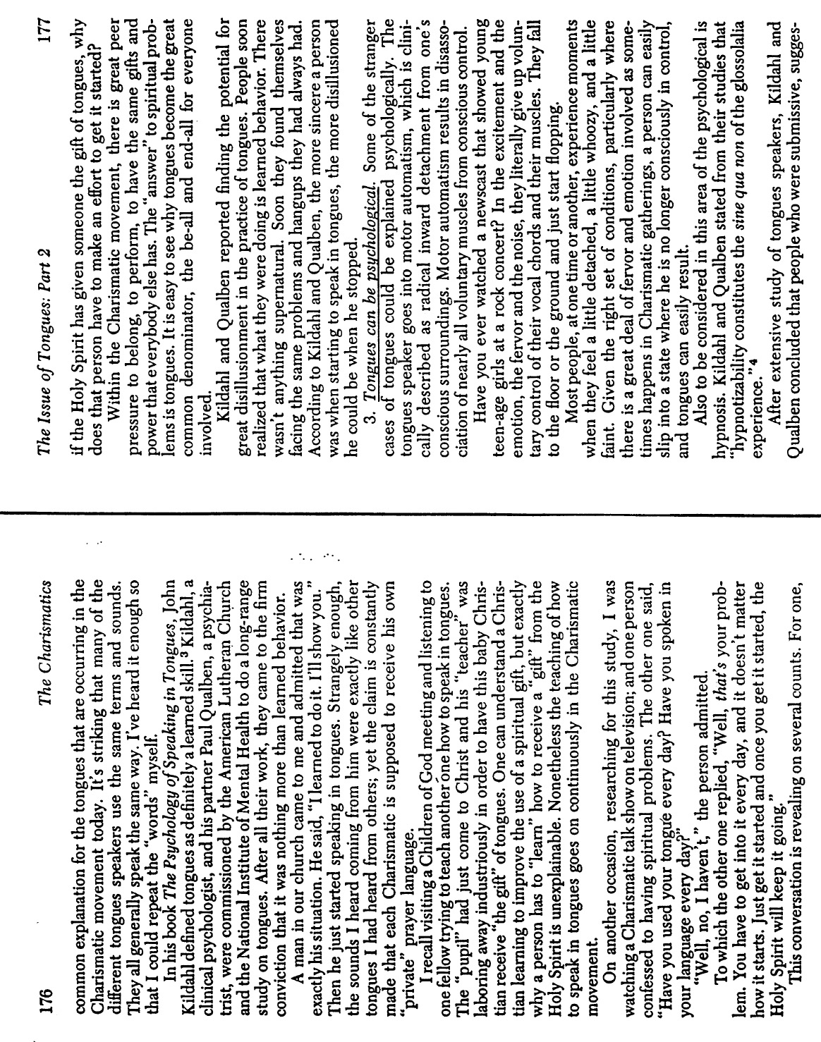
John F. MacArthur, Jr. “The Issue of Tongues” (12 of 13)

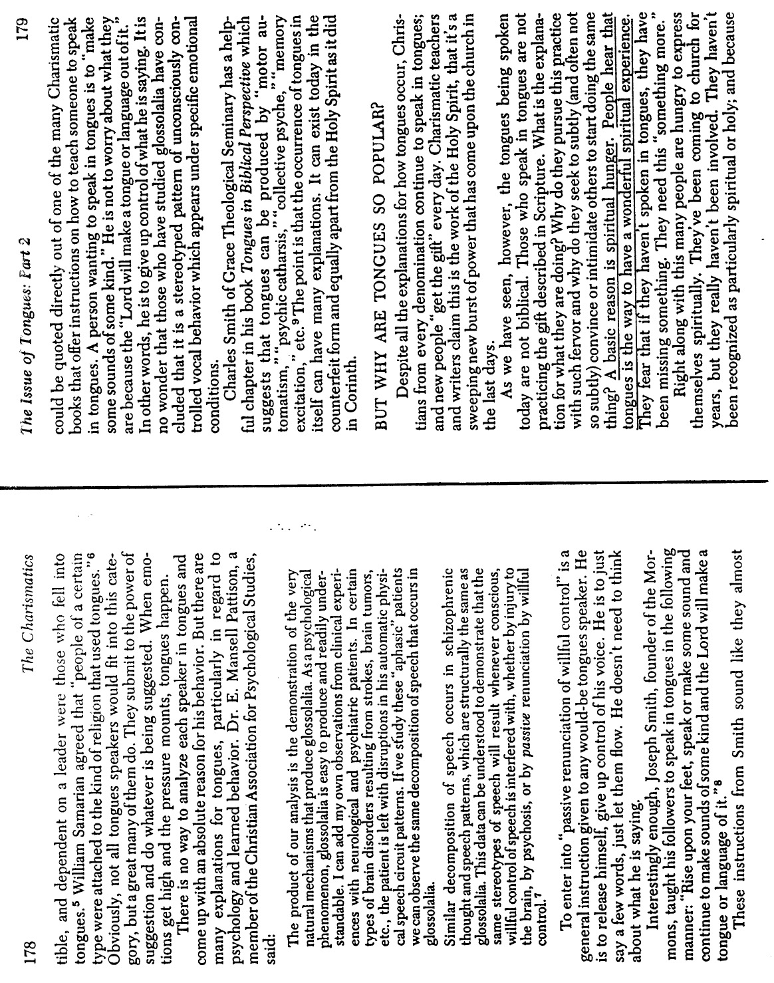
John F. MacArthur, Jr. “The Issue of Tongues” (13 of 13)

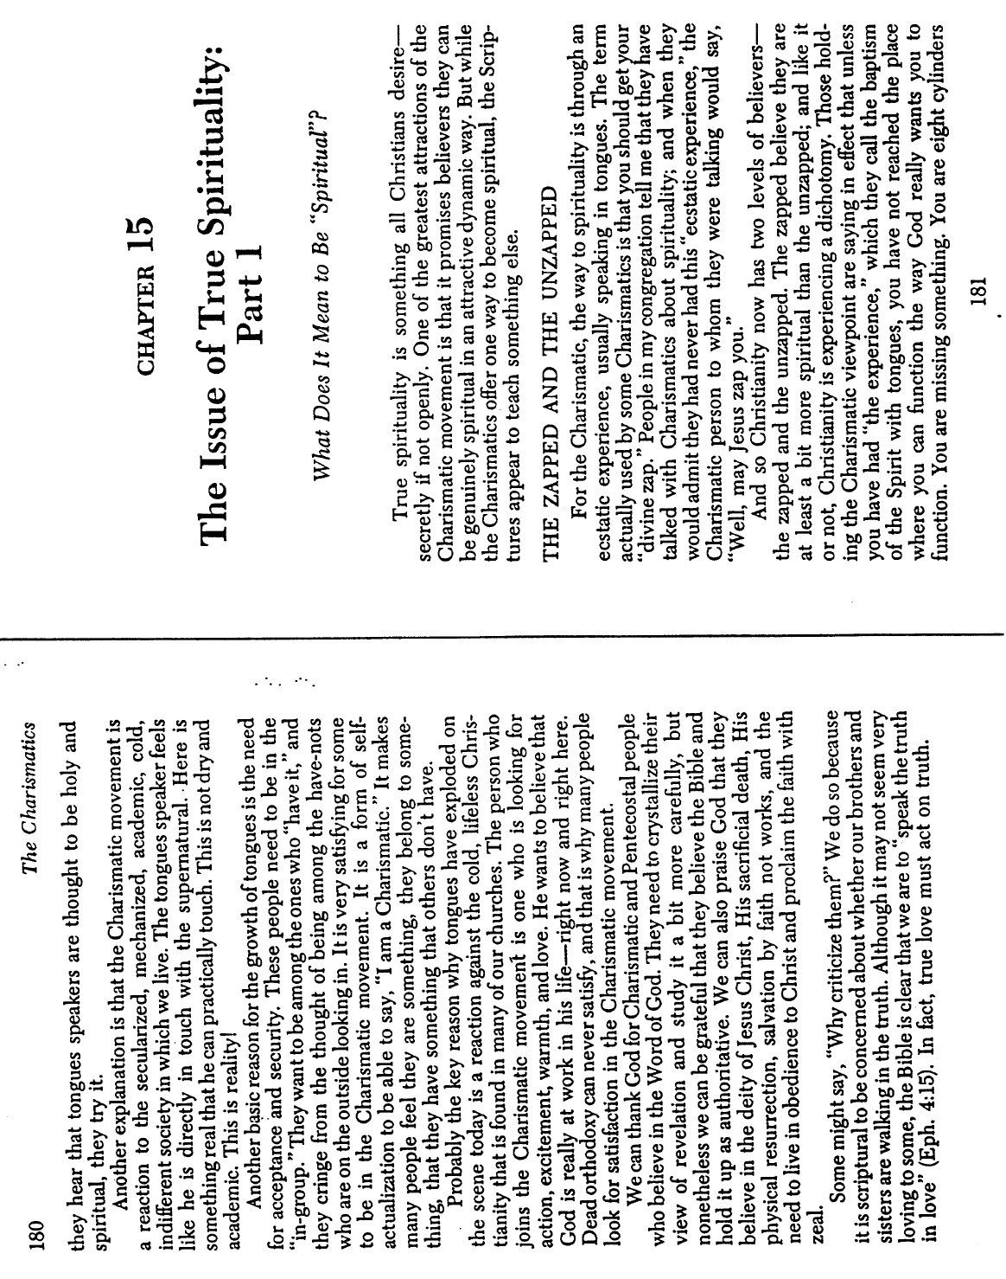
Wayne A. Grudem, “Why Christians Can Still Prophesy”
(1 of 5)

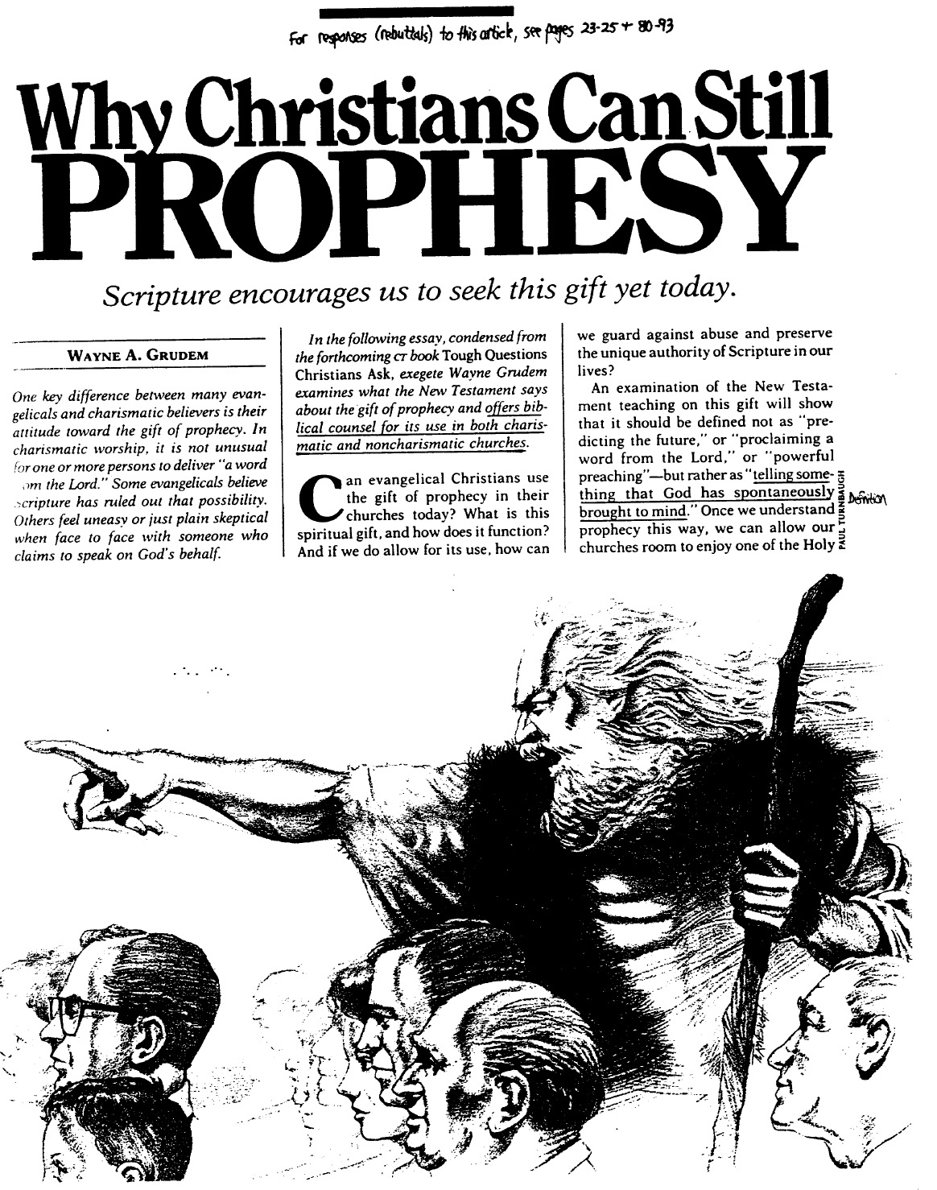
Wayne A. Grudem, “Why Christians Can Still Prophesy” (2 of 5)

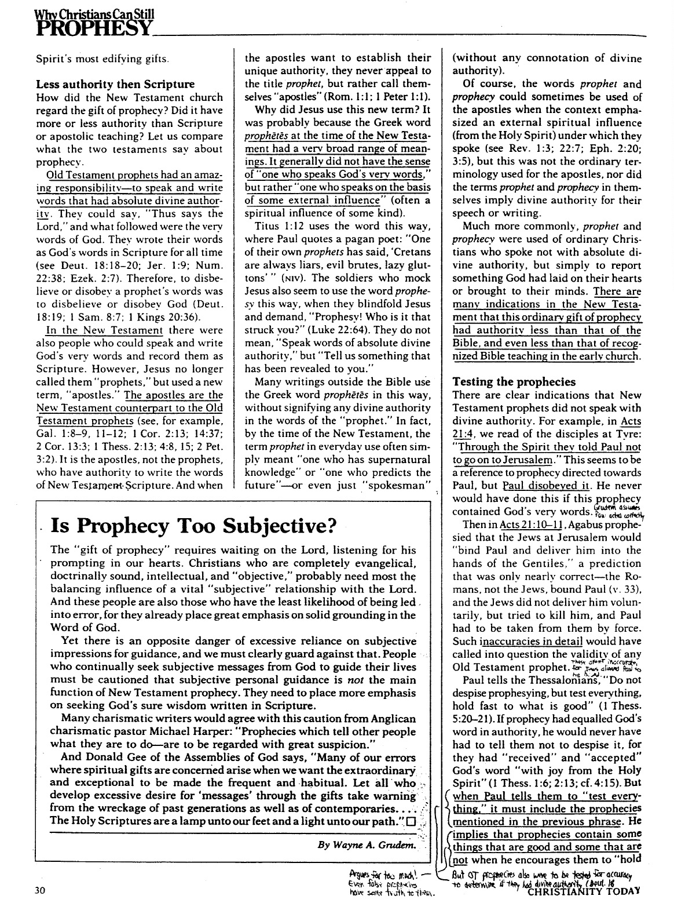
Wayne A. Grudem, “Why Christians Can Still Prophesy” (3 of 5)

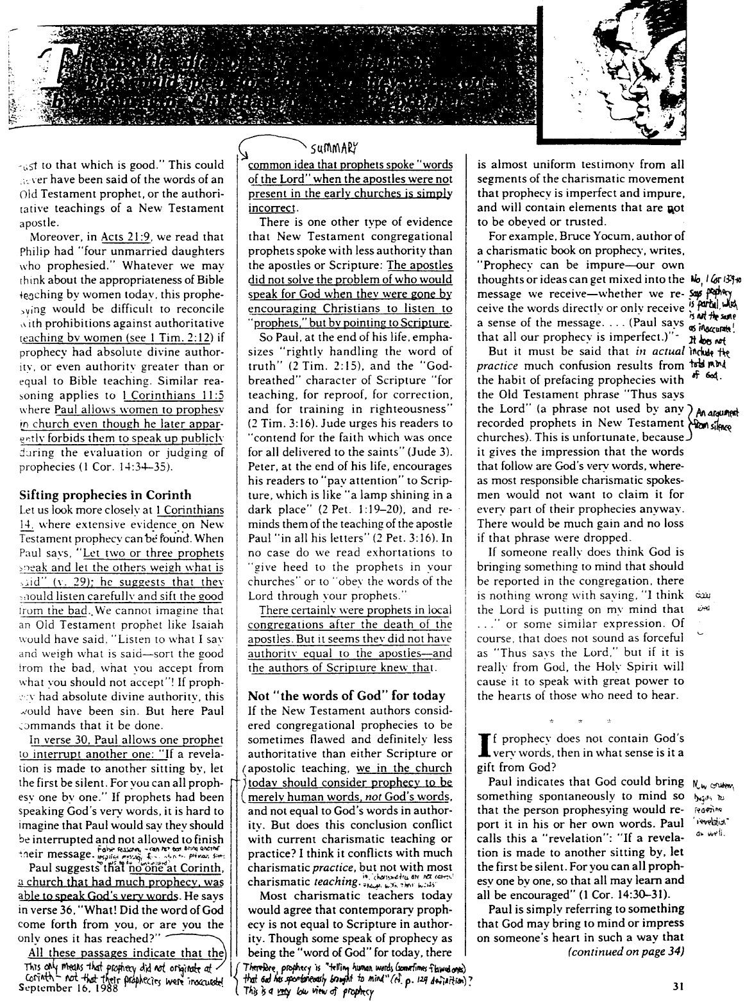
Wayne A. Grudem, “Why Christians Can Still Prophesy” (4 of 5)

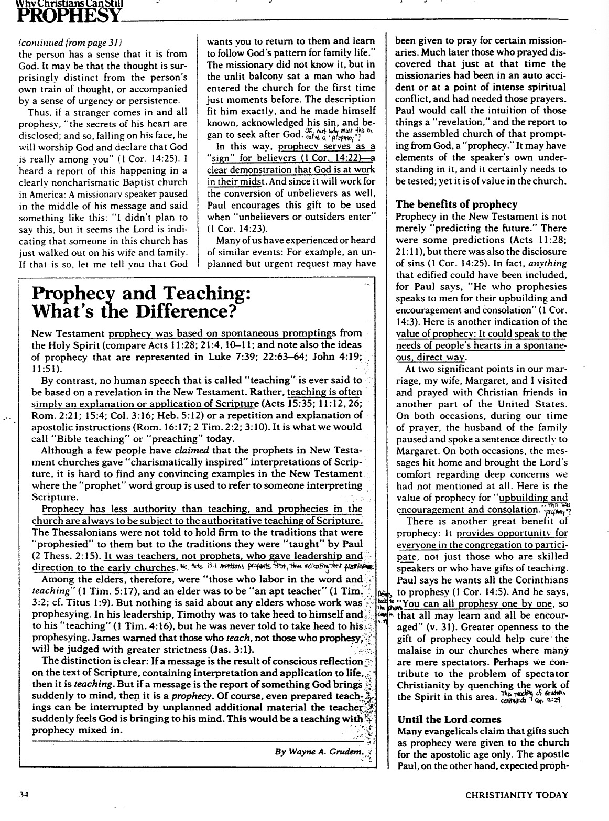
Wayne A. Grudem, “Why Christians Can Still Prophesy” (5 of 5)

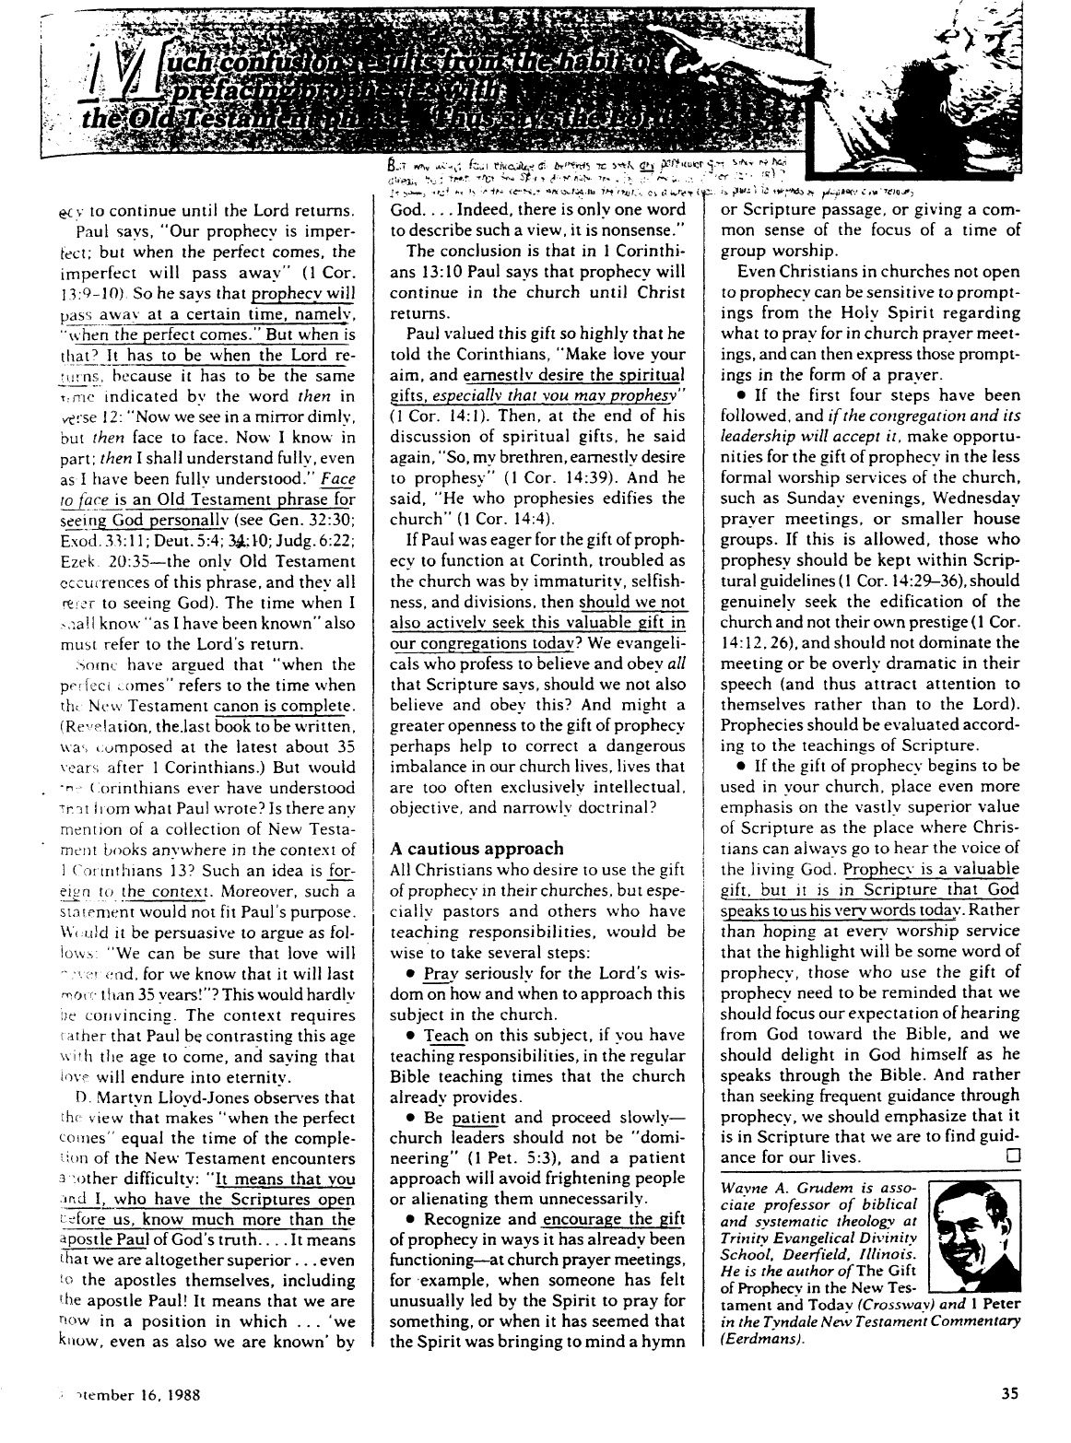

Basic Issues in 1 Corinthians 12
A Completed Handout of Page 2

1) What are spiritual gifts?

a) "Divinely given capacities to perform useful functions for God, especially in the area of spiritual service… to contribute to the welfare of the church as a whole, as well as to bear an effective witness to the world" (Walvoord, The Holy Spirit at Work Today, 38).

b) "A God-given ability for service" (Ryrie, The Holy Spirit, 83).

c) "A spiritual capacity for development" (Radmacher, "Spiritual Gifts" tape series, Campus Crusade for Christ).

d) "The manifestation of the Spirit for the common good (of the church)" (1 Cor. 12:7).

Note: Spiritual Gifts are Not :

a) Place of Service: The gift is the ability not where that ability is exercised.

b) Age Group Ministry: Spiritual gifts are not abilities working with certain age groups. It's the ability, not who benefits from it!

c) Natural Talents: Writing, Christian Education, and music are manifestations of spiritual gifts such as exhortation, teaching and service.

2) Who has spiritual gifts? Who gives spiritual gifts? Who decides the gift for each person?

a) Every Christian (and only Christians) has a spiritual gift (vv. 7, 11, 18).

b) The Holy Spirit gives the gifts (vv. 4, 7-9, 11, 18).

c) The Holy Spirit decides which gift each believer receives (vv. 7, 8, 10, 11).

The Involvement of the Whole Trinity (vv. 4-6):

God the Spirit gives (distributes) the spiritual gifts (v. 4)

God the Son assigns the place of the ministry of the gifts (v. 5)

God the Father gives the energy operative through the gifts in the place of ministry (v. 6)
(Radmacher, "Spiritual Gifts" tape, Campus Crusade for Christ)

3) Where are the spiritual gifts to be used?

They are to be used in the church ("for the common good," v. 7) which ultimately equips the church for effective witness to the world (cf. Eph. 4:11).

4) When do Christians receive their spiritual gifts? (Must be deduced from vv. 7, 11, and 18)

Since every Christian has a gift (vv. 7, 11, 18) they must be received at salvation.

5) Why are spiritual gifts given?

Gifts are given for ministry to the other members of the body (v. 7; cf. 1 Cor. 14:26b).

Distinguishing Natural Talents from Spiritual Gifts
A Completed Handout of Page 2

 | Natural Talents | Spiritual Gifts
Who has them? | Christians and Non-Christians | Christians only
How are they obtained? | Self-discipline, hard work | Given by the Holy Spirit by grace
When are they obtained? | Innate or acquired since birth | Acquired at salvation
Who benefits from them? | All people: Christians and Non-Christians | The church, which in turn benefits all men

The Real Issue: Does it really make any difference whether a believer thinks his ability is a natural talent or a spiritual gift? (Yes and No)

Yes : We shouldn't add to God's Word by calling an ability a "spiritual gift" if the Bible doesn't call it a gift, but . . .

No: Both natural talents and spiritual gifts are:
1) given from God, and
2) to be used for God!!
The Basis and Nature of Spiritual Gifts
Greek Words Relating to Spiritual Gifts
A Completed Handout of Page 3

1) Charisma (χάρισμα) is the most popular word for spiritual gifts (Rom. 12:6; 1 Cor. 1:7; 12:4, 9, 28, 30, 31; 1 Tim 4:14; 2 Tim 1:6; 1 Pet. 4:10)
Translations: "gift" or "spiritual gift" (1 Tim 4:14 only), but literally means "gifts of grace."

Roots: charis means “grace” (The basis of receiving our spiritual gifts is grace)
char means “joy” (The result of exercising our spiritual gift is joy)

Other uses of the word charisma in the New Testament (Vine):
a) gift of salvation (Rom. 5:15, 16; 6:23; 11:29)
b) truth which is imparted through human instruction (Rom. 1:11)
c) celibacy and marriage (1 Cor. 7:7)
d) gracious deliverances in answer to the prayers of fellow believers (2 Cor. 1:11)

2) Diakonia (διακονία) refers to a place of service (1 Cor. 12:5 ) & category of gifts (1 Pet. 4:11).
Translations: "service" (NIV), "ministries" (NASB)

3) Energema (ἐνἐργημα) concerns the energy operating through the gifts (1 Cor. 12:6; Rom. 12:3)
Translations: "working" (NIV), "effects" (NASB)

4) Phanerosis (φανέρωσις) denotes the evidence of the Spirit in believers (1 Cor. 12:7).
Translations: “manifestation" (NASB, NIV)
Infinitive: phaneroein (φανερόειν) "to make visible or known"
Secular Usage: "disclosure, announcement" (BAGD; cf. 2 Cor. 4:2)

5) Pneumatikoi (πμευμάτικοι) refers to the Spirit as the Source of gifts (1 Cor. 12:1; 14:1)
Translations: "spiritual gifts " (NASB), but a more literal translation would be "spiritual things," "things of the Spirit," or simply "spirituals"
Root: pneuma (πμεῦμα) "Spirit"

6) Doma (δώμα) is a gift given by Christ only to the church after His Ascension (Eph. 4:7-8, 11), not during the Old Testament (i.e., only Christians have gifts, not Old Testament saints).

Why Study and Know Our Gifts?

1) MINISTRY TO THE CHURCH BODY - Ministering in the area of our gifts results in:
a) edification of the body—Unity and interdependency (1 Cor. 14:12).
b) mobilizing the church for mission to a lost world.
c) encouraging other believers to discern and develop their gifts.

2) PERSONAL FULFILLMENT - Exercising our gifts results in:
a) ministering in areas of strength, reducing frustration and wasted time.
b) assisting us in establishing priorities for study, growth, and ministry (Eph. 4:13).
c) a sense of usefulness and belonging in the body of Christ (1 Cor. 12:14-17).

3) OBEDIENCE TO GOD'S WORD - Scripture gives several commands relating to gifts:
a) "Do not neglect the spiritual gift within you..." (1 Tim 4:14a).
b) "Now concerning spiritual gifts, brethren, I do not want you to be unaware" (1 Cor. 12:1).
c) "And since we have gifts that differ according to the grace given us, let us exercise them accordingly..." (Rom. 12:6a).
d) "As each one has received a special gift, employ it in serving one another, as good stewards of the manifold grace of God" (1 Pet. 4:10).

Dangers Associated with Spiritual Gifts
Attitudes and Actions to Avoid
A Completed Handout of Page 13

1) Division resulting from comparison and competition.

a) Viewing your gift as unimportant (problem = inferiority).

i.e., "My gift is not like yours!" (1 Cor. 12:15-16)

b) Viewing your gift as superior (problem = pride).

i.e., "Your gift is not like mine!" (1 Cor. 12:21)

2) Confusion with natural talents.

3) Seeking sign (controversial) gifts and neglecting ministering gifts.

4) Seeking "up-front" ministering gifts while neglecting "behind the scenes" ministering gifts.

5) Willing to be ignorant of gifts because of the subject's complexity and the varying views of respected scholars (1 Cor. 12:1).

6) Focusing upon gifts as a more significant evidence of the Holy Spirit than the fruit of the Holy Spirit (Gal. 5:22-23).

"Doing" overemphasized to the neglect of "being."

"Service" overemphasized to the neglect of "character."

7) Rejecting opportunities for service in "non-gifted" areas because you don't have that particular gift which would make the service easier on you (2 Tim 4:5).

8) Supposing that spiritual gifts are rewards for service, for holiness, for sincerity, for maturity, or for anything else!

9) Believing that there is any correspondence between spiritual gifts and spirituality.

10) Supposing that God has withdrawn your spiritual gift because He has not chosen to use it at the present time.

"For the gifts and the calling of God are irrevocable" (Rom 11:29)

11) Seeking gifts and overlooking the importance of love (Rom. 12:9ff.; 1 Cor. 13:1ff.).

"By this shall all men know that you are my disciples, if you love one another" (John 13:35 NASB).
Class ________________________ Date ________________________

Spiritual Gifts Inventory Group Record

Directions: After completing the Spiritual Gifts Inventory and the Spiritual Gifts Inventory Worksheet, please print your name and record your personal gift ratings for each gift below. Then circle those ratings of the gifts which you think may be your own spiritual gifts.

 | Teaching | Evang. | Pastor-Teacher | Exhort. | Admin. | Faith | Giving | Service | Mercy
Example: Rick Griffith | 1 | 6 | 2 | 3 | 2 | 8 | 4 | 5 | 7
1
2
3
4
5
6
7
8
9
10
11
12
13
14
15
16
17
18
19
20
21
22
23
24
25
26
27
28
29
30
31
32
33
34
35
36
37
38
39
40
Total “1”s per column
Ministry Opportunities
at First Baptist Church of Yucaipa

Scripture teaches that God has gifted each member of this church body with a spiritual gift "for the common good" (1 Cor. 12:7). This, of course, implies that each of us would benefit the church most when we function primarily in a ministry which employs these strong traits. Isn’t this true for you? Why not consider some of the current needs in these areas right now?

Related to this gift ... our church has these openings ... so talk to ... at ...

Teaching Sunday School Teachers Wendell Duke 797-6986

Evangelism Evangelism Explosion Ministry Walt Plumb 793-5252

Pastor-Teacher Sunday School Teachers Wendell Duke 797-6986
Boy's Brigade Leader Greg Franklin 795-5085
Pioneer Girls Leader Connie Geshay 795-1209

Exhortation Phoning ministry for College/Career Donna Strange 795-4662

Administration Planning for College/Career Activities Doug Strange 795-4662
Children's Church Ministry Coordinator Martha Amistadi 795-5578
Sunday School Department Head Wendell Duke 797-6986
Bus Ministry Coordinator Steve Woodard 790-1971

Faith Start a College/Career Ensemble John Withem 790-1971

Giving General Fund/Missions Kurt Ahlstrom 790-1971

Service College/Career Class refreshments Iva Gier 881-4010
Choir Director for children's choirs John Withem 790-1971
Handbell Choir Director John Withem 790-1971
Sing in College/Career Ensemble John Withem 790-1971

Showing Mercy Visitation ministry to hospitalized youth Ivah Zapp 790-1971

Spiritual Gifts Inventory Group Record

Directions: After completing the Spiritual Gifts Inventory and the Spiritual Gifts Inventory Worksheet, please print your name and record your personal gift ratings for each gift below. Then circle those ratings of the gifts which you think may be your own spiritual gifts.

 | Teaching | Evang. | Pastor-Teacher | Exhort. | Admin. | Faith | Giving | Service | Mercy
Example: Rick Griffith 1 6 2 3 2 8 4 5 7
1 Susan Griffith 4 6 7 3 8 5 4 1 2
2 Doug Strange 1 8 4 3 1 2 7 5 6
3 Donna Strange 2 8 3 1 1 5 7 6 4
4 Steve Gier 1 6 5 3 4 7 4 4 2
5 Iva Gier 3 4 2 3 1 6 7 6 5
6 Jim Raube 3 8 5 4 1 7 2 5 6
7 Margy Raube 1 6 2 3 7 8 2 5 4
8 Lonnie Looysen 7 9 5 3 2 6 8 1 4
9 Doug Sandburg 6 8 5 5 2 7 4 1 3
10 Brad Flater 8 9 4 6 3 2 1 5 7
11 Tom Caylor 2 5 2 3 8 4 6 7 1
12 James Jensen 4 2 1 3 5 6 4 7 1
13 Ted Evans 1 3 1 5 6 6 7 4 2
14 Rick Welles 1 9 8 6 3 5 2 4 7
15 Tim. Poole 7 8 3 6 1 5 2 5 4
16 Bob Gibbs 3 7 4 4 2 6 2 1 5
17 Matt Anderson 7 7 4 6 2 3 4 1 5
18 Kylene Franklin 7 6 3 4 2 7 5 1 4
19 Chris Morgret 4 7 3 4 6 2 5 4 1
20 Debbie Anderson 4 5 3 2 3 6 7 2 1
21 Brie Mosquetta 4 6 5 4 3 5 4 2 1
22 Debbie Gibbs 1 8 6 4 2 4 5 2 1

Class Totals 7 0 3 2 6 0 1 6 7
 | Teaching | Evang. | Pastor-Teacher | Exhort. | Admin. | Faith | Giving | Service | Mercy

