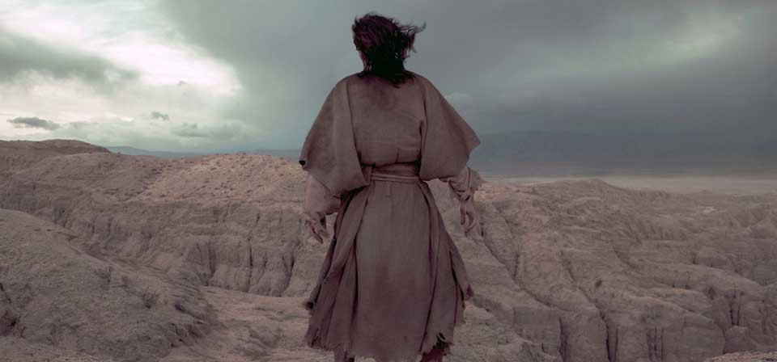

The Life of Christ

Dr. Rick Griffith, ThM, PhD
Jordan Evangelical Theological Seminary
Version 23 (8 May 2024)

Contents

The Names of Jesus: The Context-Relevant Saviour 5
One Solitary Life 7
Why I Follow Jesus 8

Outline of the Life of Christ 9

Introduction §§ 1-2 10

I. Introduction of the King §§ 3-27 10
A. The Arrival of the King 10
B. The Ambassador of the King 12
C. The Approval of the King 13

II. Authentication of the King §§ 28-59 14
A. The Acceptance of His Person 14
B. The Authority of the King 15

III. Controversy Over The King §§ 60-73 21
A. The Rejection of the Herald 21
B. The Curse of the Cities of Galilee 21
C. Reception by a Sinner 21
D. Witness to the King 21
E. Rejection of Christ and His Offer by the Leaders 21
F. Request for a Sign by the Leaders 22
G. Rejection of the Nation by Christ 22
H. Revelation in View of Rejection 22
I. Rejection in Nazareth 22
J. Death of the Herald 23

IV. Instruction of the Twelve By the King §§ 74-97 24
A. Feeding the Five Thousand 24
B. Rejection of an Offer to Make Christ King 24
C. Instruction Through the Storm 24
D. Reception in Gennesaret 24
E. Instruction Concerning the Bread of Life 24
F. Instruction Concerning Defilement 24
G. Reception in Tyre and Sidon 24
H. Reception in Decapolis 24
I. Rejection in Magadan 25
J. Warning Against Rejection 25
K. Confession of Peter 25
L. Instruction Concerning His Death 25
M. Instruction Concerning Discipleship 25
N. Revelation of the Kingdom 25
O. Instruction Concerning Elijah 25
P. Instruction Concerning Dependence 25
Q. Additional Instruction Concerning His Death 25
R. Instruction Concerning Sonship 26
S. Instruction Concerning Humility 26
T. Instruction Concerning Pride 26
U. Instruction Concerning Forgiveness 26
V. Instruction Concerning Discipleship 26
W. Challenge by His Brothers 26
X. Journey to Jerusalem 26

V. Opposition to the King §§ 98-119 27
A. Conflict At the Feast of Tabernacles 27
B. Conflict Over the Law 27
C. Conflict Over the Light 27
D. Conflict Over His Person 28
E. Conflict Over the Healing of the Blind Man 28
F. Conflict Over the Shepherd 28
G. Witness of the Seventy-two 28
H. Conflict Over the Question of Eternal Life 28
I. An Example of Fellowship 28
J. Instruction in Prayer 28
K. Conflict Over the Healing of the Dumb Man 28
L. Conflict Over Pharisaic Ritualism 28
M. Instruction of the Disciples 29
N. Conflict at the Feast of Dedication 30

VI. Preparation of the Disciples by the King §§ 120-137 31
A. Withdrawal from Judea 31
B. Instruction Concerning Entrance Into the Kingdom 31
C. Instruction in a Pharisee's House 31
D. Instruction Concerning Discipleship 31
E. Instruction Concerning God's Attitude Toward Sinners 31
F. Instruction Concerning Wealth 31
G. Instruction Concerning Forgiveness 31
H. Instruction Concerning Service 31
I. The Raising of Lazarus 32
J. Instruction Concerning Thankfulness 32
K. Instruction Concerning His Coming 32
L. Instruction Concerning Prayer 32
M. Instruction Concerning Divorce 32
N. Instruction Concerning Entrance Into the Kingdom 32
O. Instruction Concerning Eternal Life 32
P. Instruction Concerning His Death 33
Q. Instruction Concerning Israel's Need 33
R. Instruction Concerning the Kingdom Program 33
VII. Official Presentation of the King §§ 138-149 34
A. The Arrival in Bethany 34
B. The Triumphal Entry 34
C. The Authority of the King 34
D. Invitations by the King 34
E. Proof of the Authority of the King 34
F. The King's Authority Challenged 34
G. Challenge by the King 35
H. Judgment by the King 35
I. Instruction at the Treasury 35

VIII. Preparation for the Death of the King §§ 150-167 36
A. Predictions by Christ 36
B. Preparation for Christ's Death 37
C. Precepts By Christ 38
D. Prayer by Christ for Believers 40
E. Prayer in the Garden 40

IX. Rejection of the King §§ 168-183 41
A. The Arrest 41
B. The Religious Trial 41
C. The Civil Trial 41
D. Procession to Calvary 42
E. The Crucifixion 42
F. The Burial of Christ 43
G. The Sealing of the Tomb 43

X. Resurrection of the King §§ 184-198 44
A. The Preparation by the Women 44
B. The Opening of the Tomb 44
C. The Visit of the Women 44
D. The Report to the Disciples 44
E. The Appearance to Mary 44
F. The Appearance to the Women 44
G. The Report of the Guard 44
H. The Appearance to the Two on the Emmaus Road 44
I. The Report of the Two to the Disciples 45
J. The Appearance to Several Disciples 45
K. The Appearance to the Eleven 45
L. The Appearance to Seven Disciples 45
M. The Commission to the Disciples 45
N. The Final Commission 45
O. The Ascension of Christ 45

The Names of Jesus: The Context-Relevant Saviour
Rev. Dr. Rick Griffith
Former DMin Director & Assoc. Professor of Biblical Studies
“Pray for Us” Newsletter, Singapore Bible College, Nov-Dec 2016, p. 2, edited

We all want to be current. No one desires to be out of date. Who seeks to use the oldest software possible? Doesn’t everyone like to be informed and in touch with the news and with other people?

Sadly, the popular myth is that God is “dated” and “irrelevant.” Unbelieving humanity sees the Creator of the Universe as out of touch, needing to be “brought into the 21st century.” Nothing could be further from the truth. The most up-to-date one on our planet is God himself. Good thing. If he wasn’t involved and relevant, Earth would spin out of orbit (Col 1:17).

This is the purpose of the Incarnation, God becoming a man in the person of the Lord Jesus Christ. Do you see this in this very designation: “Lord Jesus Christ”? Before reading on, can you explain the significance of these three terms: Lord, Jesus, and Christ? This designation appears 60 times in the New Testament, yet most Christians cannot put in their own words what the very name of their Savior means. Can you? Do it now before you read further.

Many of us have three names, so we answer this way. “This is easy! Lord was his first name, Jesus was his middle name, and Christ was his last name!” If that was your answer, you better read on.

LORD

What do we mean when we say, “Jesus is Lord”? The Greek word for “lord” is kurios, which refers to “1. one who is in charge by virtue of possession, owner” or “2. one who is in a position of authority, lord, master” (BDAG 577). Jesus as “Lord” means that he is in charge as the ultimate authority. His authority comes as the owner of this world and no position is higher than his as God.

This got the early Christians into trouble. Rome recognized the emperor as the highest authority, and in the reigns of Caligula, Nero, and Domitian, loyal citizens worshipped the emperor as a god. However, believers in the lordship of Christ could worship no other god. As they recognized no higher authority, let us not forget that this same Jesus is indeed the highest authority of all. Don’t be fooled by his quiet entrance into our world with the weaknesses of a baby. He alone is Lord.

JESUS

What about the name “Jesus”? When announcing his soon birth to Joseph, the angel declared, “…you are to name him Jesus, for he will save his people from their sins” (Matt 1:21b). This verse confuses most of us. We know his name is Jesus, but we don’t see the connection to the next phrase, “for he will save…”

Actually, the link is very direct. “Jesus” simply means “Saviour,” so the verse actually means, “…you are to name him Saviour, for he will save his people from their sins.” Now that makes sense. The name comes from Jeshua, which was a later form for Joshua (BDAG 472). As Joshua delivered Israel from the enemies in Canaan, so Jesus delivers us from sin itself. Calling him “Jesus” points to his later atoning work on the cross where our sins were forgiven.

CHRIST

The designation “Christ” is probably the most misunderstood term about our Saviour. The Greek Christos means “1. fulfiller of Israelite expectation of a deliverer, the Anointed One, the Messiah, the Christ” and “2. the personal name ascribed to Jesus” (BDAG 1091). First-century Gentiles often confused Christos with the similar-sounding name Chrestos, which was simply a surname, but it means far more!

So what does it mean that Jesus is the “Messiah,” or “Anointed One”? At their appointments in the OT, both priests and kings were anointed, yet here it means that Jesus is the Anointed King. The magi saw this clearly since they sought the “king of the Jews” (Matt 2:2), and Herod confirmed that “Messiah” means “king” when he asked where the Messiah would be born (Matt 2:4).

CONTEXT-RELEVANT

One core value of SBC is to be context relevant. We present the unchanging Lord Jesus Christ to our ever-changing world because no one is more relevant than him. How do we do this? We proclaim that he is the ultimate authority as God (Lord), yet took on humanity to save us from our sins (Jesus) and will rule over all (Christ). Worship him fully as Lord Jesus Christ.
One Solitary Life
James Allen Francis*

He was a man born of a peasant woman. For the first thirty years of His life, He lived in obscurity, working as a carpenter's son.

He never wrote a book. He never ran for political office. He never even went more than 200 miles from His hometown. He never did any of the things which are normally associated with greatness.

During the last three years of His life, He became an itinerant preacher, roaming the land of His birth, healing the sick, and comforting the poor. At the end of these three years, the tide of public opinion turned against Him, and He was betrayed by a friend and arrested for disturbing the status quo. He went through six trials, each of which was a mockery of jurisprudence. The charge was blasphemy. He had claimed to be the Son of God.

The Roman procurator was nervous. Never had he seen such quiet dignity, such intrepid courage, such noble majesty. He brought this now mutilated carpenter's son before the mob and hurled a challenge to them which has resounded across twenty centuries: he said: "Ecce homo!"-"Behold the man!" The crowd shouted, "Crucify him," and, cowardly washing his hands of the whole affair, Pilate turned Him over to be crucified. They beat Him, crushed a crown of thorns down upon His head, and then led Him outside the city walls and nailed Him to a cross.

But the story does not end there. Three days later something happened that changed the entire course of human history-He emerged from the tomb in resurrection power.

His greatness has never been paralleled. Though twenty centuries have come and gone, He is the cornerstone of history still today, the center of human progress. He still stands as the highest example of moral purity—the pinnacle of Divine Glory.

We would be well within the mark if we said that all the armies which have ever marched, all the navies which have ever sailed, all the kings who have ever reigned, and all the parliaments which have ever sat, put together, have not influenced man's life on this earth as powerfully as that...

...One Solitary Life.

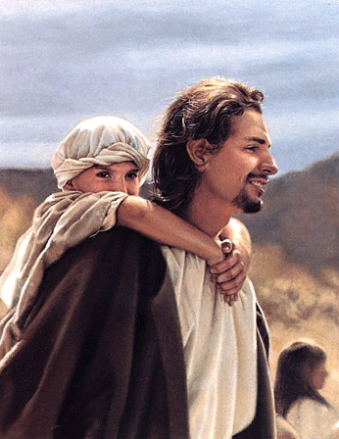

* A briefer version is at https://www.tullylish.com/education-4-life/85-reflections

Why I Follow Jesus
Michael Sprague (Capitol Commission)

A lawyer asked me this basic question. If Jesus was ordinary, plain, and unimpressive in his physical appearance...why did big burly fisherman leave their nets and follow him and business sharks in the marketplace leave their cash registers to follow him? Great Question.

My answer... Who is the real Jesus?

Dorothy Sayers has said, “We have very efficiently pared the claws of the Lion of Judah, certified Him ‘meek and mild,’ and recommended Him as a fitting household pet for pale curates and pious old ladies.” But what if Jesus can’t be put in a box…tamed…or domesticated? When it comes to the real Jesus … no one is more surprising, baffling, rattling, frustrating, astonishing, and compelling.

He was born some 20 centuries ago to an impoverished couple in an obscure part of the planet. He never traveled outside his region. He didn’t write a book. He didn’t have a home. The Romans didn’t consider him significant enough to record his execution in their records. Jesus stepped into a world with a rigid religious establishment, a pagan empire, and political parties of all stripes. Normally at odds with each other, these powers conspired to literally take Jesus out.

Jesus had no political base. No army. No resources. No voting bloc. No motorcade or secret service. No spin. No swords. His only weapons were a serving towel, a blood-stained cross, an empty tomb, a bunch of scars, and a handful of insignificant ragamuffins who didn’t start out too hot but ended up out-praying, out-thinking, out-serving, and out-living everyone and turned the world upside down.

Jesus befuddled everyone in not fighting but giving up his life. He didn’t get all bent out of shape every election cycle. He read God’s book more than the newspaper. He prayed more than he talked about praying. He built bridges rather than throw rocks. He blessed more than cursed. Love him or hate him… the truth is you can never be the same after an encounter with Jesus.

Jesus had the nerve to hang out with the wrong crowd and sketchy people…the lost, the lame, the irreligious and misfits flocked to him. He blew people away by saying that tax collectors and prostitutes are entering the Kingdom of Heaven ahead of the religious leaders. Oh, how he could tick off powerful people and the respectable folks always seemed threatened by him. Jesus didn’t play by the rules… that is religious rules. In fact, he was the enemy of dead religion.

His scandalous message is that the Shalom of God is available to every human being through him. Amazing Grace is available to all. He didn’t come to start a religion but to build a relationship. He offers the Grace Plan, not the Human Performance Plan. Jesus did for us what we could never do for ourselves. He is none other than the sin-substitute, the Savior, and the hope of mankind. His invitation is, “Follow me.” Wise men still seek him.

I hope to inspire people of all backgrounds to consider, wonder, dialogue about, and know the person, life, and teaching of Jesus.

Outline of the Life of Christ

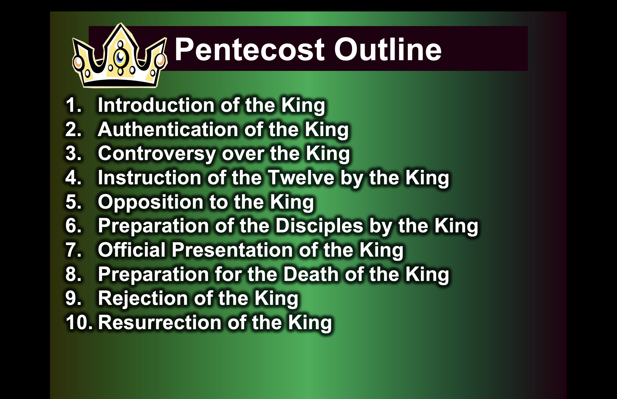

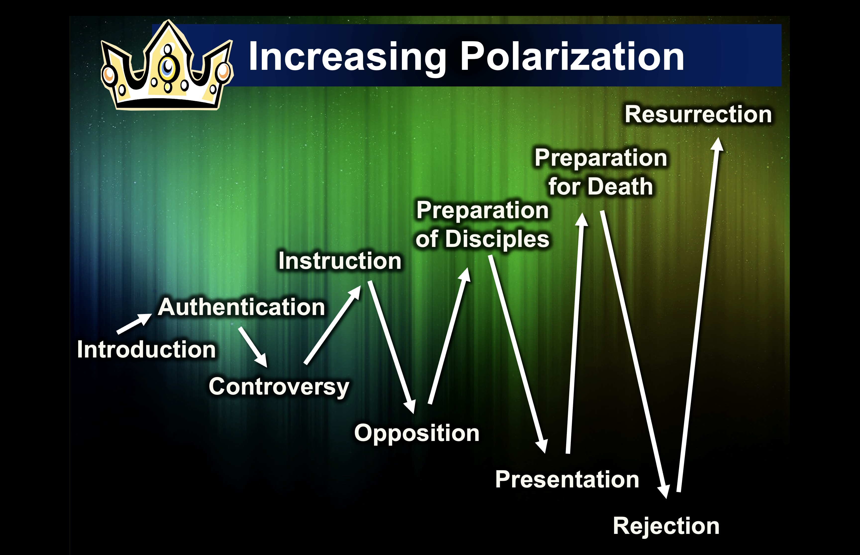

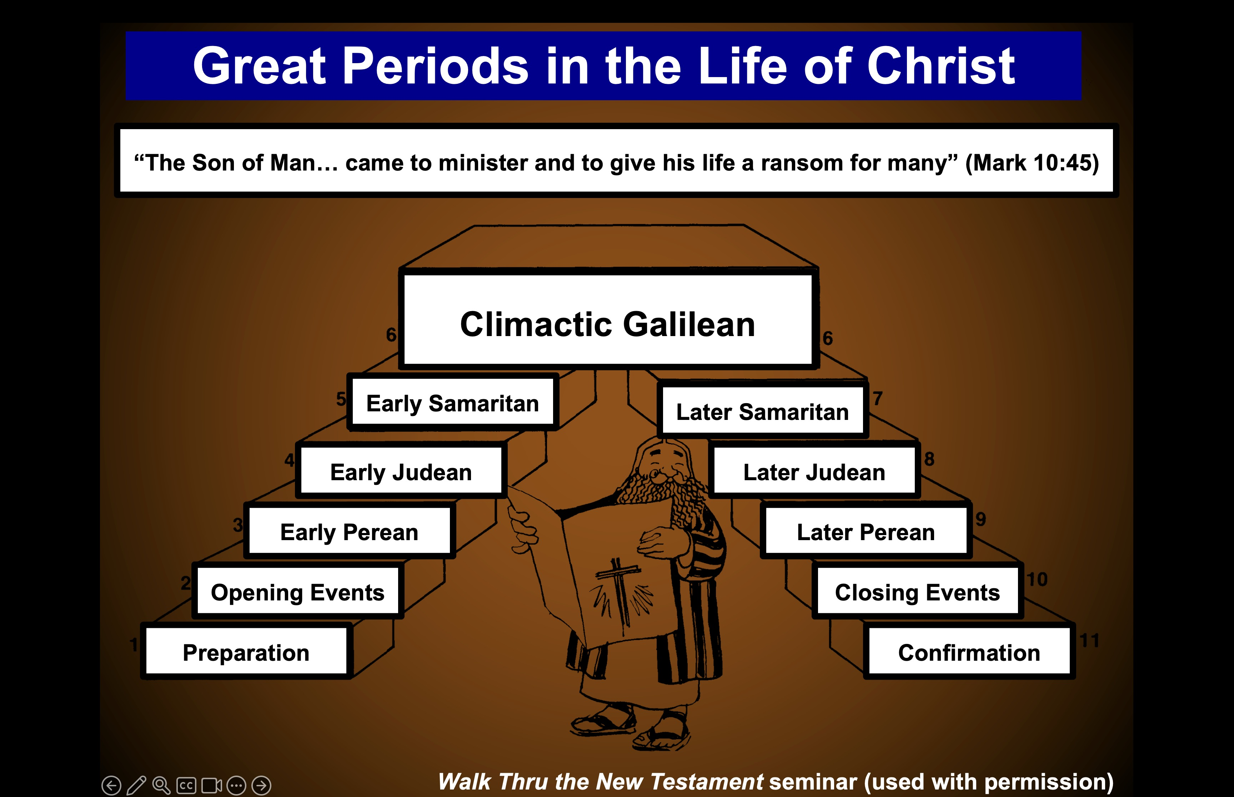
Outline of the Life of Christ
Based on J. Dwight Pentecost, A Harmony of the Words and Works of Jesus Christ (Grand Rapids: Zondervan, 1981)

Introduction §§ 1-2
The Gospel writers introduce the Person of Christ by emphasizing their sources and his deity to establish the validity of their claims

A. The Source of Knowledge
§ 1
Luke 1:1-4
Luke's account is carefully researched and authoritative so his readers can rely on what they have been taught

B. The Preexistence of Christ
§ 2
John 1:1-18
Christ's relation to the Father, creation, men, and John shows Him God in the flesh and redeemer of believers despite Israel's rejection

I. Introduction of the King §§ 3-27
The Messianic identity of Jesus Christ is proved in his arrival, John's testimony, and approvals at his baptism and temptation

A. The Arrival of the King
§§ 3-19
His lineage, birth, infancy, and childhood show that Jesus is the Messiah of Israel

1. His Ancestry
§ 3
Matthew 1:1-17; Luke 3:23b-38
The genealogy of Jesus establishes his legal and physical right to the throne of David in fulfillment of the Davidic Covenant

2. His Advent
§§ 4-11
The arrival of both John and Christ is announced and fulfilled to show through their births that Jesus is the promised Messiah

a. The Annunciation of the Birth of John to Zechariah § 4
Luke 1:5-25
Gabriel tells Zechariah that his wife Elizabeth would miraculously give birth to John to set him apart as the forerunner of Messiah

b. The Annunciation of the Birth of Jesus to Mary § 5
Luke 1:26-38
Gabriel tells the Virgin Mary that her conception by the Spirit would bear Jesus as Messiah and Godman without a fallen nature

c. The Arrival of Mary in Judea § 6
Luke 1:39-45
Mary visits her cousin Elizabeth to confirm to them that God would fulfill the prophecies about the babies John and Jesus

d. The Anthem of Mary § 7
Luke 1:46-56
Mary praises God for His grace in using a humble woman like her to bear the Messiah to fulfill the Abrahamic Covenant

e. The Advent of John § 8
Luke 1:57-80
Zechariah prophesies after John's birth that God will use John in the desert (not the temple) to fulfill His covenants by the Messiah

f. The Announcement of the Birth of Jesus to Joseph § 9
Matthew 1:18-25
An angel convinces Joseph to marry Mary to bear the Messiah as a virgin so that Joseph serve as the faithful foster father of Jesus

g. The Advent of Jesus § 10
Luke 2:1-7
Jesus is born humbly in Bethlehem to prove His lineage from David, fulfill Micah 5:2, and die as the Messianic deity, pictured in His swaddling clothes

h. The Announcement to the Shepherds § 11
Luke 2:8-20
God's angels recruit shepherds as His unlikely yet unprejudiced witnesses of the birth of Israel's Savior and Messianic Ruler in the coming kingdom

3. His Infancy and Childhood
§ 12-19
Selected events from the infancy and childhood of Jesus affirm Jesus as the promised Messiah

a. His Circumcision § 12
Luke 2:21
Jesus is circumcised as a sign of the Abrahamic Covenant to make Him eligible to fulfill the promises that God gave to Abraham

b. His Presentation § 13
Luke 2:22-38
Jesus is presented in the temple for Mary to obey the Law as ceremonially clean and to redeem Jesus from the Aaronic priesthood

c. His Infancy §14-16
The worship by the Magi, escape to Egypt, and escape to Nazareth all fulfill prophecies to confirm Jesus as Israel's Messiah

(1) In Bethlehem § 14
Matthew 2:1-12
Gentiles worship Jesus as King of the Jews in Bethlehem to fulfill Micah 5:2 and show Him as eventual Sovereign Ruler over all nations
(2) In Egypt § 15
Matthew 2:13-18
Joseph, Mary, and Jesus flee to Egypt to escape death by Herod to fulfill Hosea 11:1 and preserve Christ to redeem the world

(3) In Nazareth § 16
Matthew 2:19-23; Luke 2:39
The family returns to Israel and chooses Nazareth (not Bethlehem) to fulfill prophecies of the Messiah's humble origins

d. His Boyhood § 17-19
The early life of Christ shows that while He grew physically, intellectually, spiritually, and socially, He knew of His deity

(1) His growth § 17
Luke 2:40
Jesus grows physically, intellectually, and spiritually, showing His training in the Scriptures from his youth in a godly home

(2) His visit to Jerusalem § 18
Luke 2:41-50
Jesus teaches Israel's leaders at age 12 not merely as a "son of the law" but as the Son of God who knew His deity and mission

(3) His development § 19
Luke 2:51-52
During the 18 years of unrecorded events, Jesus grows mentally, physically, spiritually, and socially as a perfect and obedient man

B. The Ambassador of the King
§ 20-23
John the Baptist precedes Jesus Christ to prepare Israel to receive Him as the long-awaited Messiah

1. The Message to John
§20
Mark 1:1; Luke 3:1-2
John receives a prophetic message from God in the desert to separate Israel for the Lord in preparation for the Messiah

2. The Message from John
§ 21
Matthew 3:1-6; Mark 1:2-6; Luke 3:3-6
John preaches repentance for the forgiveness of sins and baptizes to prepare for the Messianic kingdom on earth ruled by Jesus

3. The Explanation by John
§ 22
Matthew 3:7-10; Luke 3:7-14
John warns of Israel’s judgment by Messiah to convince the Jewish leaders of their need for changed lives resulting from repentance
4. The Promise by John
§ 23
Matthew 3:11-12; Mark 1:7-8; Luke 3:15-18
John warns that the Messiah will give the Spirit to fulfill Joel 2:28 and Ezekiel 36:25-27 and judge Israel of all unfit for the kingdom

C. The Approval of the King
§§ 24-27
The Father, Spirit, and John all testify through Christ's baptism, temptation, and herald, respectively, that Jesus is the Messiah

1. At His Baptism
§ 24
Matthew 3:13-17; Mark 1:9-11; Luke 3:21-23a
At his baptism, the Father approves of Christ's person and messianic work through the designated forerunner, John the Baptist

2. Through His Temptation
§ 25
Matthew 4:1-11; Mark 1:9-11; Luke 4:1-13
At the temptation of Christ, the Spirit approves of Jesus as Messiah in that He could not be made to sin

3. By His Herald
§§ 26-27
John testifies that he is the forerunner fulfilling Isaiah 40:3 to prepare Israel before Jesus begins His public ministry

a. Testimony of John Before the Leaders §26
John 1:19-28
John answers Israel's leaders that he is the forerunner of Messiah to fulfill Malachi 4:5 so they will accept Christ and His message

b. Testimony of John to Christ § 27
John 1:29-34
John testifies that Jesus is Israel's Passover Lamb and the Son of God to prepare Israel before Jesus begins His public ministry

II. Authentication of the King §§ 28-59
Jesus proves to be the Messiah in the initial acceptance of His person and His authority shown in His works and teaching

A. The Acceptance of His Person
§§ 28-36
Christ is initially accepted in Judea, Samaria, and Galilee by His new disciples and by the multitudes

1. The Belief of the First Disciples
§ 28
John 1:35-51
Peter, Andrew, John, and Nathaniel confess faith in Christ's person, work, and office as Messiah of Israel

2. The Belief Through the First Miracle
§ 29
John 2:1-11
Jesus confirms John’s disciples and others by turning water into wine to reveal his glory as God's Son and the joy he gives to believers

3. The Sojourn in Capernaum
§ 30
John 2:12
Jesus further verifies the faith of His disciples in His Messianic identity in Capernaum before starting His first public ministry in Judea

4. The Possession of the Temple
§ 31
John 2:13-22
Jesus shows His Messianic authority in His zeal for the Temple, which He promises to authenticate in His death and resurrection

5. Acceptance in Judea
§ 32
John 2:23–3:21
Judeans accept Jesus, as does Nicodemus, who sees that Jesus reveals God and gives spiritual birth to enter the kingdom

6. The Witness of John
§ 33
John 3:22-36
John declares Christ’s superiority as a heavenly Revealer of the Father for people to have eternal life instead of God’s wrath

7. The Withdrawal from Judea
§ 34
Matthew 4:12; Mark 1:14; Luke 3:19-20; John 4:1-4
Christ transfers from Judea to Galilee to avoid potential conflict with John and premature death by the Pharisees

8. The Acceptance in Samaria
§ 35
John 4:5-42
Samaritans believe in Jesus as Messiah through a woman at the well who accepts His person and the eternal life He came to give

9. The Acceptance in Galilee
§ 36
John 4:43-45
Galileans welcome and honor Jesus as a Galilean after His Jerusalem Passover miracles, but He predicts their future rejection

B. The Authority of the King
§§ 37-59
Jesus substantiates His authority as Messiah through His miracles and teachings that authenticate Himself and His message

1. Christ's Authority to Preach
§ 37
Matthew 4:17; Mark 1:15; Luke 4:14-15
Christ preaches as a Spirit-appointed teacher and prophet the same repentance to enter the Messianic kingdom that John declared

2. Christ's Authority Over Disease
§ 38
John 4:46-54
Jesus shows His messianic authority by healing a royal official's son based on the official's faith in Christ's word alone

3. Rejection in Nazareth
§ 39
Luke 4:16-30
Jesus cites Isaiah 61:1-2 for His messianic authority to heal, including his hometown among Israel’s first apostates to reject Him

4. Residence in Capernaum
§ 40
Matthew 4:13-16
After rejection in Nazareth, Jesus moves to Capernaum to foreshadow His ministry to Gentiles after Israel rejects him as Messiah

5. Christ's Authority Over Nature
§ 41
Matthew 4:18-22; Mark 1:16-20; Luke 5:1-11
Christ confirms His authority over nature in a miraculous catch of fish, so four fishermen follow His authority instead of their father's

6. Christ's Authority Over Demons
§ 42
Mark 1:21-28; Luke 4:31-37
Christ shows his authority to expel a demon that knew Him as the Messiah, but He would not allow the testimony of demons

7. Christ's Authority Over Sickness
§ 43
Matthew 8:14-17; Mark 1:29-34; Luke 4:38-41
Christ heals Peter's mother-in-law and others to show his messianic authority over sickness but again rejects the witness of demons

8. Christ's Authority to Preach
§ 44
Matthew 4:23-25; Mark 1:35-39; Luke 4:42-44
Jesus heals many and preaches that God honored His covenant promises by sending Him, showing His ever-widening ministry

9. Christ's Authority Over Defilement
§ 45
Matthew 8:2-4; Mark 1:40-45; Luke 5:12-16
Jesus' healing of a leper shows His authority as Messiah for the Sanhedrin to consider Him when the leper presents himself in Jerusalem

10. Christ's Authority to Forgive Sin
§ 46
Matthew 9:1-8; Mark 1:41-45; Luke 5:17-26
Through healing the paralytic, Jesus maintains that as Messiah and God, He has the authority to forgive sin

11. Christ's Authority Over Men
§ 47
Matthew 9:9-13; Mark 2:13-17; Luke 5:27-32
Jesus calls Matthew from his tax-collector booth due to His Messianic authority over and His acceptance of all repentant sinners

12. Christ's Authority Over Tradition
§ 48
Matthew 9:14-17; Mark 2:18-22; Luke 5:33-39
Jesus declares that His disciples do not fast due to His authority as Messiah over tradition in a new system, contrary to the Pharisees

13. Christ's Authority Over the Sabbath
§§ 49-51
Jesus shows that He is over the Sabbath by two healings and by defending his disciples with God's view of the Sabbath

a. Through the Healing of the Paralytic § 49
John 5:1-47
Jesus heals a paralytic to verify His authority over the Sabbath as Messiah (Son of Man) and deity (Son of God)

b. Through the Controversy Over Grain § 50
Matthew 21:1-8; Mark 2:23-28; Luke 6:1-5
Christ says His disciples may pick Sabbath grain by exceptions of necessity to show authority over it as God to be trusted

c. Through Healing the Man With the Withered Hand § 51
Matthew 12:9-14; Mark 3:1-6; Luke 6:6-11
Jesus shows his authority over the Sabbath by healing a withered hand to model doing good on it and reveal Pharisaical hypocrisy

14. Christ's Authority to Heal
§ 52
Matthew 12:15-21; Mark 3:7-12
Christ shows his authority to heal both Jews and Gentiles as Messiah with compassion, gentleness, and mercy to fulfill Isaiah 42:1-4

15. Commissioning of the Twelve
§ 53
Mark 3:13-19; Luke 6:12-16
After a night in prayer, Christ chooses from among the disciples twelve apostles to be His authoritative representatives in His work

16. Christ's Authority to Interpret the Law
§§ 54-56
Matthew 5:1–7:29; Luke 6:17-42
Jesus' Sermon on the Mount shows God’s holiness in His subjects, His fulfilling the Law, and kingdom entrance in Jesus, not Pharisees

a. The Subjects of the Kingdom § 54
Matthew 5:1-16; Luke 6:17-26
Those entering Messiah's kingdom should show godly character beyond Pharisaical rites befitting the righteous kingdom Christ offered

(1) Introduction
Matthew 5:1-2; Luke 6:17-19
Christ instructs his disciples on the righteousness expected of those in his kingdom while the crowd begins to gather

(2) The subjects
Matthew 5:3-16; Luke 6:20-26
Christ describes the characteristics and influence of a righteous man to show the type of person blessed in the kingdom

(a) Their character
Matthew 5:3-12; Luke 6:20-26
The Beatitudes describe the holy traits of the righteous person based on Jesus to experience a blessed life

(b) Their influence
Matthew 5:13-16
A righteous person creates a thirst for God in others by revealing God's righteousness, exposing sin, and attracting them to the Lord

b. The Relation of the King to the Law § 55
Matthew 5:17–7:6; Luke 6:27-42
Jesus fulfills the Law by replacing Pharisaic views and practices with kingdom entrance in Christ's righteousness rather than in the Law
(1) The Fulfiller
Matthew 5:17-20
Christ fulfills all that the Law and prophets required, so Pharisaic righteousness cannot save as it misconstrues the Law's true intent

(2) Rejection of traditional interpretation of the law
Matthew 5:21-48
Pharisees misinterpreted the Law, so it saved no one and neglected the second table of the law about proper conduct toward others

(a) Murder
Matthew 5:21-26
Exceeding Pharisaic righteousness preserves life and avoids the anger, hatred, and unreconciled relationships that lead to murder

(b) Adultery
Matthew 5:27-30
Exceeding Pharisaic righteousness will be faithful to one's spouse but also remove lust and its causes that lead to adultery

(c) Divorce
Matthew 5:31-32
Exceeding Pharisaic righteousness avoids not only legal divorce but all divorce lest the divorcee commit adultery when she remarries

(d) Oaths
Matthew 5:33-37
Exceeding Pharisaic righteousness avoids not only taking ambiguous oaths but also speaks so oath-taking is unnecessary

(e) Retaliation
Matthew 5:38-42
Exceeding Pharisaic righteousness not only avoids retaliation but also gives up rights in godliness

(f) Love
Matthew 5:43-48; Luke 6:27-30, 32-36
Exceeding Pharisaic righteousness not only loves a neighbor who repays favors but loves his enemy who will never repay favors

(3) Rejection of the Pharisaic practices of the law
Matthew 6:1–7:6; Luke 6:37-42
Pharisees misinterpreted the Law, so they no one into the kingdom but only had hypocritical practices for show rather than true Godward righteousness

(a) Almsgiving
Matthew 6:1-4
The Pharisaical practice of public almsgiving only showed piety rather than the love of God by meeting a need

(b) Prayer
Matthew 6:5-15
The Pharisaical practice of public prayer should be private prayer of worship, requests, confession, protection, and forgiveness

(c) Fasting
Matthew 6:16-18
The Pharisaical practice of public fasting should be done privately before God to receive a reward only from Him

(d) Attitude toward wealth
Matthew 6:19-24
The Pharisaical practice of gaining riches as a sign of God's approval should be replaced with eternal investments that cannot be lost

(e) Lack of faith
Matthew 6:25-34
The Pharisaical practice of despising faith by greed should become trust in God to provide food and clothing as one seeks the kingdom

(f) Judging
Matthew 7:1-6; Luke 6:37-42
The Pharisaical practice of judging others by one’s morals that assumed motives should not judge others until his own life is pure

c. Instruction to Those Who Would Enter the Kingdom § 56
Matthew 7:7-29
Despite the Pharisees' rejection, Jesus teaches God's ethics to those who want to experience a full life in His kingdom

(1) Prayer
Matthew 7:7-11
God answers persistent prayer as a Father who meets His children's needs, not due to endless repetitions like the Pharisees did

(2) True righteousness
Matthew 7:12; Luke 6:31, 43-45
Treating others as one desires to be treated demonstrates true righteousness

(3) The way of access
Matthew 7:13-14
Christ invites kingdom entrance through Him as the only way instead of the false, broad way of the Pharisees that brings destruction

(4) Warning to false teachers
Matthew 7:15-23
Pharisees are false prophets with godless lives whom God will judge for external piety without knowing Jesus for kingdom entrance

(5) The two foundations
Matthew 7:24–8:1; Luke 6:46-49
Jesus contrasts trust in Pharisaism with faith in the King to show that one’s destiny is determined by their response to His message

17. Recognition of Christ's Authority in Capernaum
§ 57
Matthew 8:5-13; Luke 7:1-10
Jesus heals a centurion's servant at a distance to picture salvation extended to Gentiles in response to Israel's rejection

18. Recognition of Christ's Authority in Nain
§ 58
Luke 7:11-17
Christ proves His authority over death by restoring life to the widow of Nain's son, once again proving that He is the Messiah

19. Witness of the Twelve
§ 59
Matthew 9:35–11:1; Mark 6:6b-13; Luke 9:1-6
Jesus delegates to 12 apostles His Messianic authority over demons, sickness, and disease so they can preach that the kingdom is near

III. Controversy Over The King §§ 60-73
The Messianic identity of Jesus Christ is challenged and publicly opposed in preparation for His sacrifice for the nation

A. The Rejection of the Herald
§ 60
Matthew 11:2-19; Luke 7:18-35
The rejection of John by Israel's leaders is paralleled by the rising opposition to Christ and His offer of the kingdom

B. The Curse of the Cities of Galilee
§ 61
Matthew 11:20-30
Christ curses Galilean cities that saw his miracles but would not believe to show how Gentiles received him more than the Jews.

1. Condemnation for Unbelief
Matthew 11:20-24
Christ condemns the unbelieving Jewish area of Galilee with greater judgment than Gentiles who saw no signs

2. Explanation of Unbelief
Matthew 11:25-27
Galilean cities persist in unbelief because of Israel's spiritual blindness stemming from a history of willful rejection of God's revelation

3. Invitation to Belief
Matthew 11:28-30
Despite condemning them, Christ offers rest from the taxing submission to Pharisaical regulations by trusting in His person

C. Reception by a Sinner
§ 62
Luke 7:36-50
Christ reveals the self-righteous Pharisees when they hear Him forgive a repentant woman at Simon the Pharisee's home

D. Witness to the King
§ 63
Luke 8:1-3
Several believing women of financial means show in Christ through their witness and material support for His ministry

E. Rejection of Christ and His Offer by the Leaders
§ 64
Matthew 12:22-37; Mark 3:20-30
Jesus defends himself to Pharisees who attribute his exorcisms to Satan since Israel's destiny depended on their response

F. Request for a Sign by the Leaders
§ 65
Matthew 12:38-45
Israel's leaders demand a miracle, so Christ reveals their rejection by promising to conquer death which Satan could never do

G. Rejection of the Nation by Christ
§ 66
Matthew 12:46-50; Mark 3:31-35; Luke 8:19-21
In response to rejection by Israel's leaders, Jesus sets aside Israel for a new form of the kingdom in the Interadvent age

H. Revelation in View of Rejection
§§ 67-71
Due to Israel's rejection, Christ reveals the nature of the kingdom in the present age in conjunction with displays of His power

1. The Course of the Kingdom in the Present Age
§ 67
Matthew 13:1-53; Mark 4:1-34; Luke 8:4-18
Good and evil coexist in the Interadvent age as God’s Word starts small but reaches the world before judgment and the Millennium

2. Power Over Nature
§ 68
Matthew 8:18, 23-27; Mark 4:35-41; Luke 8:22-25
Jesus calms the Sea of Galilee as Lord over nature so His disciples would trust Him for everything until all creation submits to Him

3. Power Over Demons
§ 69
Matthew 8:28-34; Mark 5:1-20; Luke 8:26-39
As Israel's leaders oppose Him, Jesus proves His authority over Satan by showing authority over demons that controlled pigs

4. Power Over Disease and Death
§ 70
Matthew 9:18-26; Mark 5:21-43; Luke 8:40-56
Christ shows his messianic authority by healing an unclean woman and raising Jairus' daughter by touching and being touched
\
5. Power Over Blindness
§ 71
Matthew 9:27-34
Two blind men healed by Jesus prove him as Messiah who can remove Israel's spiritual blindness if the nation believes

I. Rejection in Nazareth
§ 72
Matthew 13:54-58; Mark 6:1-6a
Christ's rejection in His hometown for not being taught by an accredited teacher shows spiritual blindness in these unbelievers

J. Death of the Herald
§ 73
Matthew 14:1-12; Mark 6:14-29; Luke 9:7-9
The ultimate rejection of Christ and His kingdom is foreshadowed in Herod's execution of John for righteousness' sake

IV. Instruction of the Twelve By the King §§ 74-97
Jesus switches from public ministry to teaching the apostles to continue His ministry since His rejection would soon end in death

A. Feeding the Five Thousand
§ 74
Matthew 14:13-21; Mark 6:30-44; Luke 9:10-17; John 6:1-13
Christ feeds 5000 as the New Moses of Deut 18:15, teaching the believers sufficiency in Him and unbelievers their spiritual blindness

B. Rejection of an Offer to Make Christ King
§ 75
Matthew 14: 22-23; Mark 6:45-46; John 6:14-15
Jesus refuses to rule over the 5000 in Galilee as the New Moses of Deuteronomy 18:15 must rule over all Israel, but the leaders disbelieve

C. Instruction Through the Storm
§ 76
Matthew 14:24-33; Mark 6:47-52; John 6:16-21
Jesus rescues His disciples by walking on stormy water to teach them that they can trust Him to overcome obstacles by faith

D. Reception in Gennesaret
§ 77
Matthew 14:34-36; Mark 6:53-56
Christ teaches through physical healings that He can do the same in the spiritual realm if they trust Him in faith

E. Instruction Concerning the Bread of Life
§ 78
John 6:22-71
As the true bread from heaven, Jesus teaches that He came not to give physical bread but the new heavenly bread of eternal life

F. Instruction Concerning Defilement
§ 79
Matthew 15:1-20; Mark 7:1-23; John 7:1
Christ teaches that defilement is internal to show that Pharisees violate the law with their traditions in the uncleanness of their heart

G. Reception in Tyre and Sidon
§ 80
Matthew 15:21-28; Mark 7:24-30
Jesus heals a Canaanite woman's demon-possessed daughter to teach individual Gentile salvation now before Israel repents

H. Reception in Decapolis
§ 81
Matthew 15:29-38; Mark 7:31–8:9a
Jesus heals deaf and dumb man and feeds 4000 Gentiles to teach His men to minister by His power to both Jews and Gentiles

I. Rejection in Magadan
§ 82
Matthew 15:39–16:4; Mark 8:9b-12
Jesus refuses to give a sign to unbelieving religious leaders except His resurrection due to their unbelief, not due to a lack of signs

J. Warning Against Rejection
§ 83
Matthew 16:5-12; Mark 8:13-26
Christ warns His disciples of the hypocrisy of the Pharisees and Herod that led to unbelief so they would not be hypocrites themselves

K. Confession of Peter
§ 84
Matthew 16:13-20; Mark 8:27-30; Luke 9:18-21
Peter affirms Christ's deity, so Jesus reveals for the first time that the Twelve will declare what God said in a new organism, the Church

L. Instruction Concerning His Death
§ 85
Matthew 16:21-23; Mark 8:31-33; Luke 9:22
Peter opposes Christ's declaration that He would soon die and rise again because he did not see the need for His sacrifice for sin

M. Instruction Concerning Discipleship
§ 86
Matthew 6:24-28; Mark 8:34–9:1; Luke 9:23-27
A true disciple must submit not to the Pharisees but to Jesus since He would judge Israel and rule as Messiah

N. Revelation of the Kingdom
§ 87
Matthew 17:1-8; Mark 9:2-8; Luke 9:28-36
Three disciples see Christ’s glory to foretaste His reign at the Second Advent and prove Him as worthy of obedience

O. Instruction Concerning Elijah
§ 88
Matthew 17:9-13; Mark 9:9-13
Elijah must precede the kingdom, but John the Baptist fulfilled Malachi's prophecy of his coming since sacrifice precedes glory

P. Instruction Concerning Dependence
§ 89
Matthew 17:14-21; Mark 9:14-29; Luke 9:37-43a
The inability of the disciples to exorcise a demon teaches them to depend on Jesus as He could deliver Israel if the nation believed

Q. Additional Instruction Concerning His Death
§ 90
Matthew 17:22-23; Mark 9:30-32; Luke 9:43b-45
Jesus predicts His death and resurrection again to teach that suffering must precede glory in the same Messiah, not two Messiahs
R. Instruction Concerning Sonship
§ 91
Matthew 17:24-27
Jesus has Peter pay their temple tax to avoid accusation despite His disciples being exempt since they are sons of the King

S. Instruction Concerning Humility
§ 92
Matthew 18:1-5; Mark 9:33-37; Luke 9:49-50
After the disciples argue which of them is greatest in the kingdom, Jesus teaches them humility and dependence for true greatness

T. Instruction Concerning Pride
§ 93
Matthew 18:6-14; Mark 9:38-50; Luke 9:49-50
Jesus rebukes his disciples’ pride over the inability of others to exorcise a demon to help them prize the humility that God values

U. Instruction Concerning Forgiveness
§ 94
Matthew 18:15-35
Christ teaches the disciples that they are to forgive both unconditionally and entirely in the same way God has forgiven them

V. Instruction Concerning Discipleship
§ 95
Matthew 8:19-22; Luke 9:57-62
Jesus teaches that discipleship costs dearly through three men who value comfort, a father's money, or family more than Christ

W. Challenge by His Brothers
§ 96
John 7:2-9
Jesus rejects His brothers' tainted counsel to reveal Himself in Jerusalem to keep God's timing for Him to be King and Passover Lamb

X. Journey to Jerusalem
§ 97
Luke 9:51-56; John 7:10
Jesus passes through unrepentant Samaria toward the opposition of Jerusalem's leaders that would end in His death and resurrection

V. Opposition to the King §§ 98-119
The Jewish leaders resist Jesus in many conflicts over his person and miracles as they question his authority as God.

A. Conflict At the Feast of Tabernacles
§ 98
John 7:11-52
Jesus defends His authority and person at the Feast of Tabernacles, giving the unbelieving Jews further motivation to kill Him

1. Christ's Authority Questioned
John 7:11-15
Jerusalem crowds wonder how Christ could teach with authority without rabbinic training to prepare for Him to reveal His true nature

2. Christ's Explanation
John 7:16-24
Christ tells the Pharisees to submit to his teaching as authoritative as was Moses since the Father (not rabbis) taught Jesus

3. Christ's Person Questioned
John 7:25-27
The crowds disbelieve Jesus is Messiah since the Pharisees do not arrest Him and since they assume he was born in Nazareth

4. Christ's Explanation
John 7:28-30
Christ claims that his origin is heaven (not Nazareth) and God is His Father (not Joseph) so that His identity is the Son of God

5. Response
John 7:31-36
The response to Christ is that while some believe, the leaders commit even more to kill Him for blasphemy, even if He tries to escape

6. Christ's Invitation
John 7:37-52
Jesus' use of the Feast's golden pitcher ceremony (= God giving water to Israel) shows that he can satisfy their spiritual thirst

B. Conflict Over the Law
§ 99
John 7:53–8:11
Jesus avoids a Pharisee trap by not judging an adulterous woman to judge the Law too stringent or accept their disdain for the Law

C. Conflict Over the Light
§ 100
John 8:12-20
The Pharisees reject Jesus as the Light of the World as witnessing of himself, so He says that Tabernacles and the Father testify of him

D. Conflict Over His Person
§ 101
John 8:21-59
Jesus claims to be Messiah and deity, and the Jewish leaders unsuccessful try to kill Him by stoning for blasphemy

E. Conflict Over the Healing of the Blind Man
§ 102
John 9:1-41
By healing a man born blind on the Sabbath, Christ authenticates His claim as Light to those in darkness and is worshipped as God

F. Conflict Over the Shepherd
§ 103
John 10:1-21
Israel's remnant follows Jesus as the true, good, and obedient Shepherd, so He calls Pharisee followers from their false shepherds

G. Witness of the Seventy-two
§ 104
Luke 10: 1-24
Christ sends 72 men to tell the crowds that He is Messiah who offers the kingdom to show debate about Him from the leaders and people

H. Conflict Over the Question of Eternal Life
§ 105
Luke 10:25-37
Christ tells the Good Samaritan parable to a self-justifying lawyer that he must help all in need to be rewarded kingdom blessings

I. An Example of Fellowship
§ 106
Luke 10:38-42
Christ favors Mary's fellowship over Martha's service to show that occupation with Christ is more important than occupation for Christ

J. Instruction in Prayer
§ 107
Luke 11:1-13
Jesus teaches persistence in praying to God who alone can meet our needs to exhort prayer for the Spirit after His departure

K. Conflict Over the Healing of the Dumb Man
§ 108
Luke 11:14-36
After claims of exorcism by Satan, Jesus says that God will judge Israel's unbelief, so it is worse than before John's ministry

L. Conflict Over Pharisaic Ritualism
§ 109
Luke 11:37-54
Christ claims that Pharisee traditions mislead from the Law's true intent so that He and the Pharisees cannot be reconciled

M. Instruction of the Disciples
§§ 110-118
Christ teaches believers among the multitude about Pharisaic practices and the program of God given Israel's rejection

1. Hypocrisy
§110
Luke 12:1-12
The crowd should break with the hypocritical Pharisees to secure their eternal destiny by putting their faith in Him

2. Covetousness
§ 111
Luke 12:13-34
The Pharisees who trust in riches as proof of their acceptance before God stemmed from greed, so disciples should trust Jesus alone

3. Watchfulness
§ 112
Luke 12:35-41
The delay of the kingdom should motivate the disciples to prepare for His return to establish the kingdom

4. Faithfulness
§ 113
Luke 12:42-48
Those who are watchful must also be faithful since it will determine the degrees of both rewards and punishments

5. The Effect of His Coming
§ 114
Luke 12:49-53
At the return of Jesus, a judgment will bring division over the person of Christ, so the people should reject Pharisaism for Jesus

6. The Signs of the Times
§ 115
Luke 12: 54-59
People can interpret the weather but not the signs authenticating Jesus, so they must seek reconciliation with the Judge

7. Concerning Repentance
§ 116
Luke 13:1-9
The belief that tragedy only befalls sinners is false, so God will judge that entire generation unless they repent

8. Concerning Israel's Need
§ 117
Luke 13:10-17
Christ heals a crippled woman on the Sabbath to show Israel needs Him as Messiah and to show His blessings if the nation trusts Him

9. Concerning the Kingdom Program
§ 118
Luke 13:18-21
Despite unbelief, Jesus taught the kingdom's small start would grow quietly, pervasively, and irreversibly into a large, new form

N. Conflict at the Feast of Dedication
§ 119
John 10:22-39
Jesus shows that the Jews reject Him as the Messiah of God despite His words and works, not for lack of evidence

VI. Preparation of the Disciples by the King §§ 120-137
Christ ministers privately to the twelve disciples to prepare them for the ministries they will have after His departure

A. Withdrawal from Judea
§ 120
John 10:40-42
Christ withdraws from Judea to prevent premature death so he can instruct His disciples how to minister on His behalf

B. Instruction Concerning Entrance Into the Kingdom
§ 121
Luke 13:22-35
After Israel rejects Christ, He encourages the fearful to still enjoy the kingdom and prepares the apostles for future ministry

C. Instruction in a Pharisee's House
§ 122
Luke 14:1-24
Pharisees will miss the kingdom by trusting their descent from Abraham while "unworthy Jews" and Gentiles enter by faith

D. Instruction Concerning Discipleship
§ 123
Luke 14:25-35
Christ seeks disciples with Him as their highest priority, given Israel's rejection—not professing discipleship and later defecting

E. Instruction Concerning God's Attitude Toward Sinners
§ 124
Luke 15:1-32
Instead of hating sinners like the Pharisees, Jesus tells three parables of God's love to seek them out and rejoice in their repentance

F. Instruction Concerning Wealth
§ 125
Luke 16:1-31
Invest in eternity as servants of God instead of temporal ventures like Pharisees who trust money as a basis for eternal security

G. Instruction Concerning Forgiveness
§ 126
Luke 17:1-6
Disciples can hate the teachings of Pharisees without hating them, so they can come to Christ and forgive other believers

H. Instruction Concerning Service
§ 127
Luke 17:7-10
Christ reminded His disciples that service for Him is never fulfilled so they would see that obedience is their minimal duty

I. The Raising of Lazarus
§ 128
John 11:1-54
Christ raises Lazarus from the dead to teach that resurrection and life are found only in Him, not in some program of God

1. The Miracle of Restoration
John 11:1-44
Christ restores life to Lazarus to confirm the faith of those who had already believed in Him

2. Conflict Over the Miracle
John 11:45-54
The miracle of Lazarus' restoration confirms the disciples' faith, adds new believers, and moves the religious leaders to plan His death

J. Instruction Concerning Thankfulness
§ 129
Luke 17:11-19
Thankfulness of a cleansed leper against nine others exhorts gratitude in the disciples against Israel’s rejection despite blessings

K. Instruction Concerning His Coming
§ 130
Luke 17:20-37
Israel rejecting the kingdom and King would lead to His sudden return to judge Israel at the Second Advent to take away the unsaved

L. Instruction Concerning Prayer
§ 131
Luke 18:1-14
Pray for the millennial kingdom despite its political aspects being delayed and because God forgave sin in Jesus as the Lamb of God

M. Instruction Concerning Divorce
§ 132
Matthew 19:1-12; Mark 10:1-12
Jesus prohibits divorce except for adultery, avoiding the Jewish divorce debate and slander of Herod's marrying his brother's wife

N. Instruction Concerning Entrance Into the Kingdom
§ 133
Matthew 19:13-15; Mark 10:13-16; Luke 18:15-17
Jesus blesses little children to illustrate to the disciples that people need confidence and trust in Christ to enter the kingdom

O. Instruction Concerning Eternal Life
§ 134
Matthew 19:16-20; 16; Mark 10:17-31; Luke 18:18-30
One cannot enter a kingdom life through riches, so the Pharisee belief of material wealth showing God's approval is wrong
P. Instruction Concerning His Death
§ 135
Matthew 20:17-28; Mark 10:32-45; Luke 18:31-34
Christ tells of His coming death and resurrection to instruct His disciples on the importance of being servants instead of lords

Q. Instruction Concerning Israel's Need
§ 136
Matthew 20:29-34; Mark 10:46-52; Luke 18:35-43
Jesus heals two blind men to show Israel's spiritual blindness and His ability to help the nation see if it would turn to Him in faith

R. Instruction Concerning the Kingdom Program
§ 137
Luke 9:1-28
The millennial kingdom is delayed, but eternal life is guaranteed for any individual trusting in His person

1. A Lesson in Personal Faith
Luke 19:1-10
Christ accepts the corrupt but repentant Zacchaeus to show that He forgives anyone who places simple faith in Him

2. Instruction Concerning the Delayed Kingdom
Luke 19:11-28
The parable of the man of noble birth teaches the delay of the millennium until Christ returns at the Second Advent to judge Israel

VII. Official Presentation of the King §§ 138-149
Jesus presents Himself to Israel as Messiah, but Jews reject His authority, and He declares judgment upon Israel for rejecting Him

A. The Arrival in Bethany
§ 138
John 11:55–12:1, 9-11
As Christ arrives in Bethany before Passover, Jewish leaders plan to kill Him and Lazarus to try to protect Israel from a Roman invasion

B. The Triumphal Entry
§ 139
Matthew 21:1-11, 14-17; Mark 11:1-11; Luke 19:29-44; John 12:12-19
Christ enters Jerusalem to officially present Himself to the nation as Messiah to fulfill the OT prophecies

C. The Authority of the King
§ 140
Matthew 21:12-13, 18-19; Mark 11:12-18; Luke 19:45-48
Jesus curses a fig tree to signify Israel's hypocritical profession of fruit for God and clears the temple to judge as the Messiah

D. Invitations by the King
§ 141
John 12:20-50
After Christ's death, all can believe in His death and resurrection as Gentiles will approach Him apart from Israel

E. Proof of the Authority of the King
§ 142
Matthew 21:20-22; Mark 11:19-25; Luke 21:37-38
The fig tree that Christ cursed withers to show that His judgment on the nation would fall quickly and to call for faith in His person

F. The King's Authority Challenged
§§ 143-146
Religious and political leaders challenge the messianic authority of Jesus to show their rejection of Him and His message

1. By the Priests and Elders
§ 143
Matthew 21:23–22:14; Mark 11:27–12:12; Luke 20:1-19
Jesus shows His authority through parables of Israel's rejection, bringing Gentile entrance despite centuries of divinely sent prophets

2. By the Pharisees and Herodians
§ 144
Matthew 22:15-22; Mark 12:13-17; Luke 20:20-26
Jesus teaches allegiance first to God but also to the Romans, thus not alienating him from Israel nor inciting rebellion against Rome

3. By the Sadducees
§ 145
Matthew 22:23-33; Mark 12:18-27; Luke 20:27-40
Jesus affirms the resurrection of patriarchs to take part in the Abrahamic promises to defeat the disbelieving and cunning Sadducees

4. By the Pharisees
§ 146
Matthew 22:34-40; Mark 12:28-34
Jesus requires perfect love for both God and man to convince the Pharisees that one must instead receive His salvation by faith

G. Challenge by the King
§ 147
Matthew 22:41-46; Mark 12:35-37; Luke 20:41-44
Jesus shows from Psalm 110 that the Messiah is human as David's Son and God as David's Lord so the Pharisees would see that He was no son of hell

H. Judgment by the King
§ 148
Matthew 21:1-39; Mark 12:38-40; Luke 20:45-47
Christ denounces the Pharisees to show why God's judgment will fall on them and their hypocritical system

I. Instruction at the Treasury
§ 149
Mark 12:41-44; Luke 21:1-4
Christ shames the hypocrisy of the Pharisees by the sacrificial giving of a poor widow to show her as the true disciple of the kingdom

VIII. Preparation for the Death of the King §§ 150-167
Christ prepares for his death by predicting both Israel's future and his final days and giving precepts and prayers

A. Predictions by Christ
§ 150
Matthew 24:1–25:46; Mark 13:1-37; Luke 21:5-36
Christ foretells the events that will accompany his Second Advent so that Israel might know that he will appear as Judge

1. The Question
Matthew 24:1-3; Mark 13:1-4; Luke 21:5-7
Jesus predicts the temple’s destruction after the disciples ask when it will be destroyed, and when Jesus will return to end the age

2. The Tribulation
Matthew 24:4-26; Mark 13:5-23; Luke 21:8-26
The 70th week of Daniel 9:27 will be a seven-year tribulation before Jesus returns so Israel should prepare for His coming and judgments

a. The First Half
Matthew 24:4-8; Mark 13:5-8; Luke 21:8-11
The signs of the first 3.5 years of the Tribulation forewarn Israel of the coming judgment at Christ's Second Advent

b. The Second Half
Matthew 24:9-14; Mark 13:9-13; Luke 21:12-19
The signs of the second 3.5 years of the Tribulation forewarn Israel of the coming judgment at Christ's Second Advent

c. Repetition and Explanation
Matthew 24:15-26; Mark 13:14-23; Luke 21:20-26
The Tribulation terror focuses on the Antichrist as the sign to forewarn Israel of the approaching Second Advent

3. The Second Advent
Matthew 24:27-30; Mark 13:24-27; Luke 21:27-28
Jesus predicts that He will return to the earth in power and glory to rule the earth with believers as their destiny

4. The Regathering of Israel
Matthew 24:31
Jesus predicts Israel's supernatural restoration to its land after having been scattered by military invasions

5. Parenthetical Exhortations
Matthew 24:32-51; Mark 13:28-37; Luke 21:29-36
Jesus gives practical exhortations given His coming as Judge to stress further our need to be watchful, prepared, and faithful

a. The Fig Tree
Matthew 24:32-44; Mark 13:28-37; Luke 21:29-36
A fig tree’s budding shows that Israel will see signs that Christ's judgment is imminent to be watchful and prepared

b. The Faithful Servant
Matthew 24:45-51
The illustration of the faithful servant warns Israel to be faithful since the nation will not know when Christ will return

6. Judgment on Israel
Matthew 25:1-30
Two parables of judgment on living Israel prepare Jews for the Millennium by faith and predict Israel failing as a light to Gentiles

a. The Ten Virgins
Matthew 25:1-13
The parable of the ten virgins teaches that only those prepared through faith in Jesus will enter the millennial feast

b. Talents
Matthew 25:14-30
The parable of the talents teaches that Jesus will judge living Israel for not being a light to the Gentiles

7. Judgment on Gentiles
Matthew 25:31-46
Jesus predicts judgment on living Gentiles based on their treatment of Israel to determine their entrance into the Millennial kingdom

B. Preparation for Christ's Death
§§ 151-160
Various events follow their divinely prescribed order to prepare for the death of the Messiah as a sacrifice for the world's sin

1. The Prediction of His Death
§ 151
Matthew 26:1-2; Mark 14:1a; Luke 22:1
Christ predicts His death on Passover to show that He would fulfill prophecy as God's sacrificial Lamb on that very day

2. The Plan of the Rulers
§ 152
Matthew 26:3-5; Mark 14:1b-2; Luke 22:2
The Sanhedrin takes Caiaphas' advice to kill Jesus at some time other than during the feast to prevent a riot

3. The Pouring of the Ointment
§ 153
Matthew 26:6-13; Mark 14:3-9; John 12:2-8
Mary anoints Christ as King, but Jesus states that her anointing anticipated His upcoming death

4. The Promise to Betray
§ 154
Matthew 26:14-16; Mark 14:10-11; Luke 22:3-6
Judas agrees to betray Jesus to the Sanhedrin in His trial, showing his bitterness and disappointment with the Lord

5. The Preparation of the Passover
§ 155
Matthew 26:17-19; Mark 14:12-16; Luke 22:7-13
Jesus sends Peter and John to prepare the Passover supper so that they may fully obey the law's demands to observe the feast

6. The Passover Observance
§ 156
Matthew 26:20; Mark 14:17; Luke 22:14-16, 24-30
Jesus notes that the Passover will be fulfilled in the Millennium, so his disciples argue for their greatness based on their table positions

7. The Provision of an Example
§ 157
John 13:1-20
Christ loves the disciples as their servant by washing their feet to show that the one who rules must become one who serves

8. The Prediction of Judas' Betrayal
§ 158
Matthew 26:21-25; Mark 14:18-21; Luke 22:21-23
Christ predicts Judas' betrayal by passing the sop to offer forgiveness to Judas if he believes in Jesus

9. The Prediction of Peter's Denial
§ 159
Matthew 26:31-35; Mark 14:27-31; Luke 22:31-38
Jesus predicts Peter's denial and prays that the Twelve would all be restored after denying Him as Lord

10. The Provision of a Memorial
§ 160
Matthew 26:26-30; Mark 14:22-26; Luke 22:17-20
Jesus establishes memorials of His person in the cup and bread so that they would help His followers remember His sacrificial death

C. Precepts By Christ
§§ 161-165
John 13:31–16:33
Christ's final teaching at the Last Supper prepares them for His departure and for their ministry apart from His bodily presence

1. Prologue
§ 161
John 13:31-35
Jesus commands His men to love each other with His same love to identify themselves to the world as His followers

2. Problems
§ 162
John 13:36, 14:1-24
Jesus promises His troubled disciples a new intimacy with the Trinity as He was the only way to God, who would soon be replaced by the Spirit

3. Promises
§ 163
John 14:25-31
Jesus would send the Spirit to teach what still did not make sense so the disciples could proclaim His words with His peace, not fear

4. Instruction Concerning Their Present Experience
§ 164
John 15:1-16:4
Jesus promises the Spirit to connect his followers to Him for ministry success and to prepare them for spiritual conflict

a. Fruit bearing
John 15:1-17
Christ likens Himself a vine with disciples as connected branches as Christ-like character and ministry success are sourced in Him

b. The Foe of the Disciples
John 15:18-16:4
Christ warns of opposition from the world, even to death, for his followers to depend on the Spirit and prepare for spiritual conflict

5. Instruction Concerning the Future
§ 165
John 16:5-33
Jesus instructs on the future ministry of the Spirit, the resurrection, and His presence to empower for ministry, prayer, and peace

a. The Ministry of the Holy Spirit
John 16:5-15
The coming of the Spirit depends upon His departure so that the Holy Spirit might indwell them for an effective ministry

b. The Result of the Resurrection
John 16:16-28
Jesus will be resurrected with great joy after his men grieve, but they will have unlimited access to the Father in prayer through Christ

c. Conclusion
John 16:29-33
Christ will not abandon the disciples, but they will know His peace as they wait for Him to fulfill His promise to overcome the world

D. Prayer by Christ for Believers
§ 166
John 17:1-26
Christ prays for Himself, His disciples, and future believers so they can minister successfully on His behalf after He leaves

1. His Prayer for Himself
John 17:1-5
Jesus prays for His resurrection and glorification, showing His subjection to God and confidence in God for His resurrection

2. His Prayer for His Disciples
John 17:6-19
Jesus prays for the protection and joy of his men and then ordains them for ministry to make the Father known to the world

3. His Prayer for the Family of Believers
John 17:20-26
Jesus prays for future believers to have unity, glorification, and love for one another to match the love of the Father for the Son

E. Prayer in the Garden
§ 167
Matthew 26:36-46; Mark 14:32-42; Luke 22:39-46; John 18:1
Christ prays for the Father to accept His death as payment for the world's sins and to raise Him to fellowship with the Father for eternity

IX. Rejection of the King §§ 168-183
Israel rejects the Messiah in His arrest, trials, procession to Calvary, crucifixion, burial, and sealing of the tomb to bear the world’s sins

A. The Arrest
§ 168
Matthew 26:47-56; Mark 14:43-52; Luke 22:47-53; John 18:2-12a
Christ willingly allows His betrayal and arrest in Gethsemane, while remaining in complete control with authority over His adversaries

B. The Religious Trial
§§ 169-173
The Jewish leaders illegally try Jesus on religious blasphemy that this unjust treatment would end at the cross as the sacrifice for sin

1. The Examination before Annas
§ 169
John 18:12b-14, 19:23
The deposed high priest Annas sends Jesus to Caiaphas to continue the religious trial after illegally evaluating His teaching

2. Examination before Caiaphas
§ 170
Matthew 26:57, 59-68; Mark 14:53, 55-65; Luke 22:54a, 63-65; John 18:24
The Sanhedrin illegally decrees Jesus must die for blasphemy before dawn to ratify their illegal partial court trial at Caiaphas’s home

3. Denial by Peter
§ 171
Matthew 26:58, 69-75; Mark 14: 54, 66-72; Luke 22:54b-62;
John 18:15-18, 25-27
Peter thrice denies Jesus, thus proving Christ's prediction and his inadequacy apart from Jesus amidst His adversaries

4. Condemnation by the Sanhedrin
§ 172
Matthew 27:1; Mark 15:1a; Luke 22:66-71
The whole Sanhedrin illegally sentences Jesus to death for blasphemy before dawn to ratify their illegal partial court trial at Caiaphas’s home

5. Death of Judas
§ 173
Matthew 27:3-10
Judas's returned thirty coins and suicide give a burial plot for foreigners to fulfill Zechariah (11:12-13) and Jeremiah (18:1-4; 19:1-3)

C. The Civil Trial
§§ 174-177
Jews could not execute Jesus, so they get the Romans to try, mock, and sentence Jesus to crucifixion for the political charge of treason

1. Trial Before Pilate
§ 174
Matthew 27:2, 11-14; Mark 15:1b-5; Luke 23:1-5; John 18:28-38
Pilate exonerates Jesus of ambiguous charges and tries to save Him from the cross as he deems his kingdom no threat to Rome

2. Trial Before Herod
§ 175
Luke 23:6-12
Pilate does not judge Jesus but sends Him to Galilee’s ruler Herod, who also declares Him innocent of treason

3. Trial Before Pilate
§ 176
Matthew 27:15-26; Mark 15:6-15; Luke 23:13-25; John 18:39-19:1, 4-16a
Pilate exonerates Jesus of treason but approves his crucifixion instead of Barabbas due to fear of Rome and the crowd

4. Mockery
§ 177
Matthew 27:27-30; Mark 15:16-19; John 19:2-3
Roman soldiers mock Jesus as a king and repeatedly beat and spit on Him before leading Him to crucifixion

D. Procession to Calvary
§ 178
Matthew 27:31-34; Mark 15:20-23; Luke 23:26-33; John 19:16b-17
Christ’s inability to carry His cross to Calvary forces it upon Simon of Cyrene due to the guards severely beating Jesus

E. The Crucifixion
§§ 179-181
Christ is crucified for the sins of the world with signs at His death to show that the people had executed their own Messiah

1. First Three Hours
§ 179
Matthew 27:35-44; Mark 15:24-32; Luke 23:34-43; John 19:18-27
Christ’s crucifixion assertions from 9 AM to noon selflessly forgive his persecutors, save a murderer, and care for his mother

2. Second Three Hours
§ 180
Matthew 27:45-50; Mark 15:33-37; Luke 23:44, 46; John 19:28-30
Christ’s crucifixion from 12-3 PM show substitutionary atonement, thirst to fulfill Ps 22:15, sacrifice for all, and power over death

3. Accompanying Signs
§ 181
Matthew 27:51-56; Mark 15:38-41; Luke 23:45, 47-49
Christ’s death tears the veil for all to come to God, shakes the earth to redeem creation, and raises saints to show believers’ resurrection

F. The Burial of Christ
§ 182
Matthew 27:57-61; Mark 15:42-47; Luke 23:50-56;
John 19:31-42
Due to the Sabbath approaching and to prevent defilement from a corpse, Christ is quickly buried in Joseph of Arimathea's tomb

G. The Sealing of the Tomb
§ 183
Matthew 27:62-66
The Sanhedrin secures Roman guards at the tomb to prevent a fake resurrection, which only increases resurrection witnesses

X. Resurrection of the King §§ 184-198
Jesus rises to life again as Victor over death to prove his deity and the disciples' proclamation of the gospel to all nations

A. The Preparation by the Women
§ 184
Matthew 28:1; Mark 16:1
After the Sabbath, early Sunday morning Mary Magdalene, Mary the mother of James, and Salome go to the tomb to anoint Jesus' body

B. The Opening of the Tomb
§ 185
Matthew 28:2-4
Christ resurrects with an earthquake, an angel rolling back the stone to show the tomb empty, and Roman guards as witnesses

C. The Visit of the Women
§ 186
Matthew 28:5-8; Mark 16:2-8; Luke 24:1-8; John 20:1
The women see an open tomb and angels who herald Christ's resurrection, commanding them for the disciples to meet Jesus in Galilee

D. The Report to the Disciples
§ 187
Luke 24:9-12; John 20:2-10
The women tell the disciples about the empty tomb, so Peter and John run to the tomb to investigate the matter themselves, resulting in John's belief

E. The Appearance to Mary
§ 188
Mark 16:9-11; John 20:11-18
Mary Magdalene sees the resurrected Jesus at the tomb and tells the disciples, but they do not believe even this eyewitness account

F. The Appearance to the Women
§ 189
Matthew 28:9-10
The other women see Jesus at the tomb, and He tells them to tell the disciples to meet Him in Galilee for teaching and a final commission

G. The Report of the Guard
§ 190
Matthew 28:11-15
The guards report the resurrection to the Jewish leaders, who pay them to lie that the disciples stole Christ's body while they slept

H. The Appearance to the Two on the Emmaus Road
§ 191
Mark 16:12-13; Luke 24:13-32
Jesus appears to two men on the Emmaus Road to reveal that His suffering precedes His glory, but this makes sense only when He disappears at dinner

I. The Report of the Two to the Disciples
§ 192
Luke 24:33-35
These two disciples report to the Eleven that they have seen the Lord, thus verifying the earlier report of the women

J. The Appearance to Several Disciples
§ 193
Mark 16:14; Luke 24:36-43; John 20:19-25
Jesus appears to ten disciples who later tell the disbelieving Thomas, showing that faith alone is insufficient for some to believe

K. The Appearance to the Eleven
§ 194
John 20:26-31
Jesus appears to all 11 disciples a week later, and Thomas submits to Him as Lord and deity so these men can preach what they witnessed to the nations

L. The Appearance to Seven Disciples
§ 195
John 21:1-25
Christ appears to seven disciples at the Sea of Galilee to confirm His resurrection and reinstate Peter thrice in his love and devotion

M. The Commission to the Disciples
§ 196
Matthew 28:16-20; Mark 16:15-18
Christ commissions the apostles to make disciples everywhere with the Spirit's authority and power to be His witnesses

N. The Final Commission
§ 197
Luke 24:44-49
After time with the apostles in Galilee, Jesus leads them to Jerusalem where He encourages them to stay until the Spirit empowers them for ministry

O. The Ascension of Christ
§ 198
Mark 16:19-20; Luke 24:50-53
Jesus blesses His disciples on the Mount of Olives and rises to heaven to sit at God's right hand for His present ministry for the saints

