Crossroads International Church Singapore Dr. Rick Griffith
11 Aug 2019 Message 56 of 66
NLT 50 Minutes
Title
Be Knowledgeable
Letter of 2 Peter

Topic: Knowledge
Subject: What must you know to grow in grace rather than to fall for false teaching?
Complement: Know that Christ chose you and will judge apostates at his return (MI).
Purpose: The listeners will commit to knowing Christ better each year of their lives.
Attribute: We worship the God Who Reveals Himself
Reading: 2 Peter 1:1-11
Song: Knowing You, More Precious Than Silver, A Mighty Fortress, Breathe, Is He Worthy?
Benediction: 2 Peter 3:17-18

Introduction
Knowledge
(12 slides)

Interest: The key word of 2 Peter for us today is “knowledge.” Believers are falling away to false teaching due to lack of knowledge. They know a lot about many things, but they lack an understanding of grace and a knowledge of Jesus (2 Pet 3:18).

Need: How are you growing in knowledge so you can grow in grace to protect yourself from false teaching?
Key Verse
(2 slides)

We all need to have the necessary tools to fight heresy.

Peter’s message was that the basis of combating heretics is to know the Lord Jesus Christ and continually build upon that knowledge.

Subject: What must you know to grow in grace rather than to fall for false teaching?
Subject
Backgrd
(8 slides)

Background: In AD 64, believers were falling away not due to persecution but due to lack of knowledge.

Peter had likely sent his first letter to the readers only months before.

In fact, more NT letters were written in the 60s than in any other decade. Why? Two reasons:

In 1 Peter, Peter advised believers to stand firm in God’s grace during unjust suffering—as this was the first big wave of suffering to hit the church.

More than that, though, was the proliferation of false teachers in the 60s.
Josh Harris
(6 slides)

Preview: In the past month, Josh Harris says that he has “fallen away.” Today we will see three things that we need to know to grow in grace rather than fall like him.
3 Truths
(2 slides)

Text: I will survey all three chapters of 2 Peter.

(What do you need to know first to grow in grace rather than to fall for false teaching?)
MP
(2 slides)

Know that Christ chose and fully equipped you (2 Pet 1).
[Know that Jesus elected you and gives you all you need for godliness.]

We have knowledge by faith in Christ to combat false teaching (1:1-2).
2 Pet 1
(5 slides)

Peter introduces himself as a slave and messenger (apostle) of Jesus Christ so that the readers may know his authority in writing (1:1a).

Peter’s readers must know that their faith comes only through the righteousness of the Savior Jesus Christ, who is God (1:1b).

Peter introduces his theme of knowledge in his blessing that notes that grace and peace come by knowing God the Father and Jesus our Lord (1:2).

Knowing God chose us for salvation gives us all we need for godliness (1:3-11).
1:3-4
(3 slides)

God’s election of us gives us all we need to be like Christ (1:3-4).

Every spiritual provision we need comes by knowing that God chose us for salvation (1:3).

God shows his glory and goodness in promises that lead us to Christ-likeness (1:4).

The purpose spiritual qualities should grow sequentially by our efforts is so that we can become pure and Christ-like (1:5-7).
1:5-7
(5 slides)
⇑
Love—agape, Christian concern and interest (1:7b; cf. 1 Pet. 4:8)
⇑
Brotherly Kindness—love that seeks the best for family members (1:7a; cf. 1 Pet. 1:22)
⇑
Godliness—good deeds like God (1:6c; cf. 2 Pet. 1:3)
⇑
Perseverance—lit. “bearing under,” patient endurance (1:6b; cf. Jas. 1:3)
⇑
Self-Control—opposite to the world’s lust and gluttony (1:6a; cf. Acts 24:25; Gal. 5:23)
⇑
Knowledge—insight and understanding from Scripture (1:5c; cf. 1 Pet. 3:7; 2 Pet. 3:18)
⇑
Goodness—morality, the opposite of evil (1:5b; cf. 2 Pet. 1:3; Phil. 4:8)
⇑
Faith—our basis and means to salvation (1:5a; parentheses above = same word, different vv.)

We can affect our future by whether we grow in these qualities or not (1:8-9).
1:8-9
(3 slides)

One continually growing in these traits will be effective based on his knowledge (1:8).

A believer who doesn't show these spiritual qualities will be useless due to ignorance of his forgiven state (1:9).

We should live out our election in a continually growing spiritual life (1:10-11).
1:10-11
(4 slides)

Show the virtues of verses 5-7 to show that your calling and election are sure (1:10a).

Assurance of salvation has at least two wonderful benefits (1:10b-11).

Assurance leads to a stable spiritual life now that prevents apostasy (1:10b).

Assurance leads to a more richly rewarded heavenly welcome later at death or the Lord’s return (1:11).
Attacks Today
Which teachings do you hear today that seek to undermine the truthfulness of our faith?

- The Da Vinci Code says the NT is inaccurate and even included the wrong gospels
Da Vinci
(2 slides)

- Various types of criticisms (source, form, etc.) shed doubt on the Gospel accounts
Rob Bell
(4 slides)

- Rob Bell denies eternal punishment and now advocates homosexuality as legit

- Magazines question biblical accuracy (e.g., BAR, Time, US News & World Report)

- Health and wealth false teachers deny suffering and poverty for the godly
Grudem
(3 slides)

- Even evangelical scholars like Wayne Grudem say prophecies need not be true

We can overcome heresy by knowing what the OT prophets and NT apostles said (1:12-21).

Peter knew that Nero was about to execute him, so he reminded his readers of God’s election and provisions (1:12-15).

Two reliable sources (not false teachers) helped Peter remind his readers of these truths vital to their spiritual lives (1:16-21).

He knew about Christ’s power not from cleaver second-hand tales but because he witnessed it at the Transfiguration (1:16-18).

He knew about Christ’s power from OT prophets accurately predicting Christ in uninterpreted messages from God (1:19-21).

The apostles knew the OT prophets spoke truth, so readers should heed their messages until Jesus returned (1:19).

No true OT prophet ever misinterpreted a prophecy (1:20).

Every true prophet spoke truth since it came not from his own will but only as a willing instrument of the Spirit’s message (1:21).
Subject

(What else do you need to know to grow in grace rather than to fall for false teaching?)

Know a fake teacher before you see one (2 Pet 2).
MP
(2 slides)
[Know how to spot future apostates to defeat them.]
2 Pet 2
(4 slides)

Heretics exploit believers with false stories (2:1-3a).

Israel had both true prophets in OT times (1:19-20) and false prophets, so false prophecy was not new among God’s people (2:1a).

Peter briefly describes the false teachers so his readers can identify them soon (2:1b-3a).
What traits do these false teachers have in verses 1b-3a?
2:3b-10a

Apostates will be condemned just like we will be protected (2:3b-10a).

Even though these teachers had yet to deceive, God had already condemned them (2:3b).

God has a long history of judging the ungodly while protecting the righteous (2:4-8).

Demons who sinned [probably by enticing rulers in Genesis 6 into immorality] have long been in Tartarus (hell) awaiting final judgment (2:4).

Ungodly people died in the Flood while God spared the godly Noah’s family (2:5).

Sodom and Gomorrah were burned alive while righteous Lot was delivered (2:6-8).

These three past examples of judgment and salvation show that God will do the same in the future (2:9-10a).

God will rescue the godly but judge the ungodly in the future and the present (2:9).

God especially judges heretics guilty of sexual sin and despising authority (2:10a).

(The preceding, scathing denunciation of these teachers even boldly declares that they will go to hell. But although Peter gave their general characteristics in verse 1-3, we still we need a more thorough description of who these men are so we can recognize them and avoid their snares. The rest of the chapter does just that…)

A lengthy depiction of the heretics shows how to identify them when they come (2:10b-22).

The false teachers are rebellious (2:10b-12).

They boldly slander demons but powerful angels do not even dare try this (2:10b-11).

* Health and wealth teachers curse “demons” of poverty, lust, gluttony, etc.!

They blaspheme like brute beasts without thinking, so they likewise will be ruined (2:12).

The false teachers are immoral (2:13-16).

The harm they have done others will befall them (2:13a).

Their sexual sin is public (2:13b).

* The popularity of many health and wealth “evangelists” has led to illicit sex.

They eat with the saints but boast about their immorality (2:13c).

They continually commit adultery (2:14a).

* All women in The People’s Temple had to sleep with Jim Jones at least once.

They seduce those without firm footing in the faith (2:14b).

* Dan Brown’s The da Vinci Code seduces the naive to thinking that “Yah” was the feminine consort of the “male deity” resulting in “Jehovah” and illicit temple sex!

They greedily get their way to their own curse (2:14c).

* A US$1-2 million salary satiated Rev. Jim Bakker’s greed until his imprisonment.

They entice others into immorality like Balaam did to Israel (Num. 25:1-9) though a donkey rebuked him (2:15-16; Num. 22:28).
2:15-16
(3 slides)

The false teachers are depraved unbelievers who ensnare others, even though they may have tasted the blessings of a righteous life (2:17-22).

Hell is reserved for them just like a dry spring or waterless storm (2:17).

They entice others into “free” sex while they are slaves to sex (2:18-19).

They reject the knowledge of righteousness they once held so that their final state is even worse—like animals that once again soil themselves in filth (2:20-22).
Agony of Deceit
* The Agony of Deceit exposes many TV preachers headed for destruction.

For brief evaluations of hundreds of current teachers, see http://faith.propadeutic.com/

For Life Change: Which teachers must you warn yourself and your family about? How?

(What do you need to know third to grow in grace rather than to fall for false teaching?)
MP
(3 slides)

Know to live for the eternal—not the temporal (2 Pet 3).
[Know how to prioritize what you cannot see over what you can see.]
[Know how to live godly before Christ destroys everything in the Day of the Lord.]
2 Pet 3

Know that apostates will be godless and scoff at Christ’s coming until he returns (3:1-7).

Both of Peters’ letters remind his readers that both the OT prophets and NT apostles stimulated wholesome thinking (3:1-2).

Scoffers ridicule belief in creation and the Flood to create doubt that God will climatically judge in the future as well (3:3-7).
Skeptics

Scoffers show that the Church Age comprises the “last days” before Christ returns (3:3; cf. 2:1; predicted by Jesus in Matt. 24:3-5, 11, 23-26).

Scoffers doubt God by assuming that nothing catastrophic ever happens (3:4-6).
• Return

Scoffers ridicule Christ’s return (3:4a).

Scoffers teach uniformitarianism—the belief that the earth has continued in the same state since creation (3:4b).
Creation

Scoffers deny two catastrophic events both from water—Creation and the Great Flood (3:5-6).
Flood

The same word of God that judged the world by Flood also will judge the world and unbelievers by fire (3:7).
End
(4 slides)

Know that the world you see is temporary to motivate you to godliness (3:8-16).
How to Live

God can patiently wait 1000 years (cf. Ps. 90:4) for more to trust in Christ, but he will still destroy the “heavens” (atmosphere and stars), elements, and earth (3:8-10).

  - Do not confuse the patience of God with the omnipotence of God.

Knowing the temporary nature of the present heavens and earth should motivate three actions (3:11-16).

Knowing that this creation is temporary motivates holy living separated from the world and used for God (3:11-12).

Knowing that this creation is temporary helps us long for our eternal home (3:13).

Knowing that this creation is temporary brings peace with God (3:14).

Knowing that this creation is temporary helps us understand God’s patience despite Paul being misinterpreted (3:15-16).

Paul’s letters show the same wisdom as Peter that God waits to bring more into his family (3:15).

However, some unbelievers distorted Paul's difficult teachings as they also did to the other Scriptures (3:16).

  - Note that Peter considered Paul’s letters Scripture along with the OT!
Key Verse

Know the ruin of heretics and the grace of Jesus to protect you and help you grow (3:17-18).

What does it mean that believing heresy can cause a Christian to “fall from his secure position”?

Some say this means a Christian could lose his salvation. However, many passages in the NT affirm that the believer’s position in Christ is permanent (e.g., John 3:16; 10:28-29; see also 1 John supplements on pages 296a-d in this NT Survey volume).

It is better to see this as referring to believers being led astray (1:10; Gal. 5:4).
Subject

(What do you need to know to grow in grace rather than to fall for false teaching?)

Conclusion
Main Idea

Know that Christ chose you and will judge apostates at his return (MI).

How can you grow in grace rather than fall for false teaching?
Chose

Know that Christ chose and fully equipped you (2 Pet 1).
Fake

Know a fake teacher before you see one (2 Pet 2).
Eternal

Know to live for the eternal—not the temporal (2 Pet 3).
Apply
(2 slides)

Exhortation: How can you do these three things—or one of them?
Bible
(2 slides)

Commit to know Jesus better each year of your life (3:18)!
Gospel

Know Jesus, Know Peace. No Jesus, No Peace.

Prayer
Prayer

Preliminary Questions

Verses Questions

Context: What did the author record just prior to this passage?

Peter had likely sent his first letter to the readers only months before.

In fact, more NT letters were written in the 60s than in any other decade. Why? Two reasons:

In 1 Peter, Peter advised believers to stand firm in God’s grace during unjust suffering—as this was the first big wave of suffering to hit the church.

More than that, though, was the proliferation of false teachers in the 60s.

Purpose: Why is this passage in the Bible?

We all need to have the necessary tools to fight heresy.

Peter’s message was that the basis of combating heretics is to know the Lord Jesus Christ and continually build upon that knowledge. The key word of 2 Peter is “knowledge.”

Background: What historical context helps us understand this passage?

The most horrific day ever to hit Rome was 19 July AD 64. That day began the Great Fire that burned much of Rome—a devastation that lasted nine days—mostly because the water supply had been turned off!

Nero was outside Rome in the city of Antium during the fire, but the fingers on the street began to point to him. It was common knowledge that the emperor wanted to replace the poor, wood houses with stone. Burning all the “kindling houses” down quickly was an easy way to pave the way for his massive rebuilding project.

But when the man-on-the-street suspected Nero, he found a convenient scapegoat—the Christians. They were peace-loving and would not mount a fierce attack. They were poor and thus unable to afford the legal team to defend themselves.

So, the persecution of believers began in Rome and a body of literature followed so that we have more NT books from the AD 60s than any other decade. Peter addressed how Christians should respond to unjust suffering in his first letter to believers in Turkey, likely not knowing how relevant his teaching would be in Rome where he wrote! He advised believers to stand firm in God’s grace during unjust suffering.

Now, in 2 Peter, the suffering resulted in Peter’s own life. Imprisoned as one of the “arsonists of the Great Fire,” Peter had but a short time to live. What would be the message he could send to those undoing persecution like he was?

Questions

How can the unsaved false teachers be said to be “bought” by Jesus (2:1)? “How can these false teachers, who were said to be among the people, and whom the Lord had bought (avgora,santa, “redeem”), end up in everlasting destruction? Several suggestions have been offered:” (BKC).

(1) They were saved but lost their salvation. But this contradicts many other Scriptures (e.g., John 3:16; 5:24; 10:28-29).

(2) “Bought” means the Lord created them, not that He saved them. But this stretches the meaning of avgora,zw (“redeem”).

(3) The false prophets merely said they were “bought” by Christ. This, however, seems to read into the verse.

(4) They were “redeemed” in the sense that Christ paid the redemptive price for their salvation, but they did not apply it to themselves and so were not saved. Christ’s death is “sufficient” for all (1 Tim. 2:6; Heb. 2:9; 1 John 2:2), but is “efficient” only for those who believe. This is a strong argument for unlimited atonement (the view that Christ died for everyone) and against limited atonement (the view that Christ died only for those whom He would later save).

Tentative Main Ideas

Know Christ better each year of your life!

Illustrations That Apply

A few years back, one person at this church told me, “I heard the sermon last week but the next time I heard or read the Bible was the next week’s sermon—I never opened the Bible the entire week.”

Imagine that type of attitude towards spiritual nourishment applied to your need for physical food. Imagine eating only one day a week—how do you think your life would go?

Knowledge isn’t everything—but anything without knowledge is incomplete. Knowing something is the foundation of doing something. No one ever applies more than what they know!

Screwtape gave advice to Wormwood on things you cannot see

Avoid influences that promote the occult:

Games like Magic teach people to be sorcerers to kill their opponents:

The game is described by one Christian this way:

A card game created in 1993 has spread from coast to coast, selling a billion cards within 18 months. "Magic C The Gathering," sold by its Oregon makers, Wizards of the Coast, is described by them as a fantasy trading card game. The creator is mathematician and veteran Dungeons and Dragons player, Richard Garfield (The Washington Post Weekend, 5-27-95, p. 13).

The cards are linked to one of five kinds of magic (magic here refers to sorcery, not tricks): red, blue, green, white or black. The players, representing sorcerers, use the cards to "kill the other guy before he kills you, with spells, enchantments and creatures like Chaos, Orb....Bad Moon and Animate Dead... (Washington Post Weekend).

Like Dungeons & Dragons, the famed role-playing game, Magic is a challenging game that calls for intricate strategy and shrewd plays. However, that strategy is worked out within the dark context of the occult. Many cards portray frightening and repellent creatures. Skeletons, blood and images of death are common. There's the Bone Shaman, the Necrite (shown licking blood off a dagger), Prodigal Sorcerer, Dark Ritual, Sadistic Glee, Torture, Endless Scream and others. One card showing several skeletons and called The Kjeldoran Dead has this quote: "'They shall kill those whom once they loved.' C Lim-Dul, the Necromancer." Necromancy is communication with the dead through supernatural and/or occult techniques.”

https://www1.cbn.com/onlinediscipleship/introduction-to-the-occult

It is said to be the world’s most complex game: https://www.technologyreview.com/s/613489/magic-the-gathering-is-officially-the-worlds-most-complex-game/

http://www.christiananswersforthenewage.org/Articles_Magic.html notes 5 possible results of exposure to these images and terms:

Desensitization to what is ugly, evil or repulsive

Desensitization to sorcery and the occult

An interest in or fascination with death

Familiarity with occult terms & concepts

Developing a taste for the bizarre

New Testament Survey Notes
2 Peter

Knowledge to Combat False Teaching

God’s Election |  |  | Future Apostasy |  |  | Lord’s Return
Chapter 1 |  |  | Chapter 2 |  |  | Chapter 3
Salutation  1:1-2 | Provides Every Need  1:3-11 | Foundation of Knowledge  1:12-21 | False Teachers Coming  2:1-3a | End in Hell  2:3b-10a | Character Described  2:10b-22 | Scoffers Before Rapture  3:1-7 | Temporary World Motivates Holiness  3:8-16 | Protection &  Growth Encouraged  3:17-18
Adequacy of  Believers |  |  | Inadequacy of  Unbelievers |  |  | Expectancy of  Believers
Holiness |  |  | Heresy |  |  | Hope
Disciples of the Lord |  |  | Diabolical Leaders |  |  | Day of the Lord
Rome to North Asia Minor

AD 64

Key Word: Knowledge

Key Verse: “Therefore, dear friends, since you already know this, be on your guard so that you may not be carried away by the error of lawless men and fall from your secure position. But grow in the grace and knowledge of our Lord and Savior Jesus Christ. To him be glory both now and forever! Amen” (2 Peter 3:17-18).

Summary Statement: To grow in grace instead of succumbing to false teaching, we need to know that Jesus chose us and that he will judge apostates at his return.

Application: Never stop being a student of the Scripture. If you do, you will stop growing in grace and you will eventually tolerate and/or promote heresy. What new things in His Word has God been teaching you lately?
2 Peter

Introduction

I. Title: The Greek title (Pe,trou b, Second of Peter) follows the standard practice of naming the General Epistles after their authors.

II. Authorship

A. External Evidence: The early tradition divides whether Peter wrote this epistle, but most regarded it authentic. The views of the Church Fathers and early canons are summarized below by century (Hiebert, 3:134-37; cf. p. 36 of these notes).

Support 2 Peter as Authentic Lack Mention of 2 Peter

1st Shows parallels with Jude (1:5 and Jude 3; 1:12 and Jude 5; etc.; cf. Hiebert 3:138)
—This point could be argued either way, depending upon one's dating of Jude
Possible allusions are in 1 Clement (AD 95) and Barnabas (AD 70-130)
2nd | Vague Allusions:  —Ignatius (AD 110)  —Polycarp (ca. AD 110-150)  —Justin Martyr (AD 150-155)  —Irenaeus (ca. AD 185)  Probable Allusions (Quotes)  —Gospel of Truth (Gnostic)  —Apocryphon of John (Gnostic)  —Apocalypse of Peter (Spurious) | Muratorian Canon (ca. AD 170)  Old Latin Version (ca. AD 170)  Old Syriac Version (ca. AD 200)
3rd | Bodmer Papyrus (p 72)  Firmilian, Bishop of Caesarea (AD 256)  Methodius, Bishop of Lycis (quotes 3:8) | Origen (AD 185-253)—disputed  Tertullian  Cyprian  Dionysius of Alexandria
4th | Athanasius of Alexandria (AD 367)  Basil the Great  Epiphanes, Bishop of Cyprus  Ambrose, Bishop of Milan  Cyril of Jerusalem  Hillary of Piotiers in Gaul  Gregory of Nazianzus  Augustine  Council of Laodicea (AD 363)  Third Council of Carthage (AD 397)  Jerome's Vulgate (with doubt due to style) | Eusebius placed it among books widely accepted but disputed by some since:  1) Writers whose opinion he respected  regarded it as noncanonical  2) Few earlier sources quoted it  (However, he did not call it spurious)  Chrysostom  Theodore of Mopsuestia (rejected it)
6th | Syrian Church

Note 2 Peter's acceptance by the fourth century councils despite the objections raised.

B. Internal Evidence: The liberal scholar Kümmel rejects Petrine authorship but candidly admits, “the letter clearly and unambiguously makes the claim that it was written by the apostle Peter” (Kümmel, 430). Then he cites the following evidence:

1. It says Peter was the author: “Simon Peter, servant and apostle of Jesus Christ” (1:1).

2. The author speaks as an eyewitness of the transfiguration of Jesus (1:16f.).

3. He makes reference to the saying of Jesus concerning the martyrdom of Peter (1:14).

4. Reference to the “beloved brother Paul” places the author on the same level of apostolic authority as Paul (3:15f.).

5. It clearly refers to 1 Peter: “This is already the second letter I am writing to you” (3:1).

6. “Since Peter regards his death as near (1:13ff), 2 Peter is written in the form of a testament of Peter.”

After presenting irrefutable internal evidence for Peter as author, Kümmel's very next statement denies the evidence by stating, “But this letter cannot have been written by Peter.” The following cites his six objections (Kümmel, 430-33) and rebuttals to each:

1. Objection: The literary dependence on Jude rules this out.

Response: The unconfirmed assumptions are that Jude is post-apostolic and that 2 Peter quotes Jude, but the opposite is true since Peter wrote first (AD 64 for 2 Peter and ca. AD 70-80 for Jude). Jude 17-18 quotes 2 Peter 3:3 as written by an apostle.

2. Objection: The language and style show a Hellenistic flavor that not only rules out Peter, but his disciples as well.

Response: Stylistic differences between 1 and 2 Peter can be explained in that Silas helped write 1 Peter (5:12), whereas Peter wrote 2 Peter by himself. Also, the letters deal with different subjects so the vocabulary should differ.

3. Objection: It argues against Gnostics who deny Christ's soon coming (1:12f; 3:3).

Response: The unproven assumption is that the writing refers to second century Gnostics. There exists no reason that Peter couldn’t have faced doubters in AD 64.

4. Objection: The author calls Paul's collected letters Scripture (3:16), whose interpretation is reserved for the ecclesiastical teaching office (1:20f.). This dates the letter “without doubt far beyond the time of Peter and into the epoch of 'early Catholicism'” (Kümmel, 432).

Response: The “interpretation” of 1:20 refers not to a teaching office in the church. It says that prophecy did not come by any prophet's interpretation. Further, reference to Paul's letters as Scripture only shows that they were regarded as authoritative very early.

5. Objection: “The pseudonymity in 2 Peter is carried through consistently by means of heavy stress on the Petrine authorship” (Kümmel, 433).

Response: Kümmel denies the evidence that he has listed. If the letter did not emphasize Petrine authorship it would be spurious, and even if does, it is suspect! This “logic” exalts preconceived speculations over textual fact.

6. Objection: Second Peter is nowhere mentioned in the second century in spite of its heavy stress on Petrine authorship.

Response: The lack of mention by early individuals, councils, and canons proves only that while most accepted it, some disputed it. The epistle was never rejected, so internal evidence must take priority over arguments from silence.

Conclusion: While some disputed the authenticity of 2 Peter, the evidence (especially internal) shows that Peter did in fact write this letter bearing his name. The book is markedly superior to the spurious books attributed to Peter—Gospel of Peter, Preaching of Peter, Acts of Peter, and Apocalypse of Peter (Guthrie, 845). The authenticity of the epistle is also confirmed in its language that is similar to Peter's speeches in Acts (Guthrie, 844).
III. Circumstances

A. Date: Peter was martyred in the spring AD 64 (Hoehner, 381-84). Second Peter was likely written in this same year as it was shortly before his death (2 Pet. 1:13-15).

B. Origin: Both conservatives and critics agree that the evidence for the origin of 1 Peter in Rome undoubtedly applies to 2 Peter as well (1 Pet. 5:13; cf. 1 Peter notes).

C. Recipients: In 1 Peter the apostle addresses “God's elect, strangers in the world, scattered throughout Pontus, Galatia, Cappadocia, Asia and Bithynia” (1 Pet. 1:1b). The readers were likely both Jews (the minority) and Gentiles (the majority) which Peter himself had nurtured (cf. 1 Peter notes). In 2 Peter he addresses the same group (2 Pet. 3:1).

D. Occasion: Peter referred to his readers as “strangers in the world” (1 Pet 1:1b), reminding himself and them that this earth is not their home. Such a truth was especially needed since Nero ruled Rome! In his letter Peter does not specifically refer to his imprisonment, unlike Paul, who calls himself as a “prisoner of Christ Jesus” in his Prison Epistles. However, it is clear that Peter expected the persecutions to take his life (1:14-15a), which in fact did take place, according to tradition. Within a few months after recording this letter, Rome burned (19 July 64) and Nero used the Christians as his scapegoat. Believers suffered the most horrible kinds of deaths in the ensuing four years. Peter wrote this epistle before his soon death as a reminder of truths his readers already knew (1:12, 15b; 3:17a) to stimulate them to wholesome thinking (3:1b)—both knowledge of error (3:17) as well as truth (3:18). Interestingly, he cared about orthodoxy in the midst of this suffering.

IV. Characteristics

A. Contrasts Between Peter’s Two Letters

 | First Peter | Second Peter
Nature of Problem | Persecution (Hostility) | False Teaching (Heresy)
Source of Problem | External | Internal
Theme | Hope | Knowledge
Key Word (all forms) | “suffering” (16 times) | “knowledge” (16 times)
Date | early AD 64 | early spring AD 64

B. “Peter's scenario from the creation of the present heavens and earth to the dissolution of the universe and creation of the new heavens and earth is one of the most astonishing passages in all of Scripture (3:5-13)” (TTTB, 480).

C. This second letter of Peter has the most explicit teaching in Scripture on false teachers.

Argument

Second Peter emphasizes knowledge, shown in the 16 occurrences of words for “knowledge” (evpi,gnwsij 1:2, 3, 8; 2:20; evpiginw,skw 2:21a, 21b; proginw,skw 3:17; gnwri,zw 1:16; gnw/sij 1:5, 6; 3:18; gigw,skw 1:20; 3:3; oi=da 1:12, 14; 2:9). Peter wanted his readers to know three areas: a knowledge of God and his choice of them (2 Pet 1), a knowledge of the characteristics and destruction of future false teachers (2 Pet 2), and a knowledge of Christ's return and the coming Day of the Lord (2 Pet. 3). However, the apostle was not content with knowledge alone, stored in a reader’s head. This knowledge must work itself out in godly behavior (1:3-9; 3:11, 14, 18) and a cautiousness that protects them from being ensnared by heresies surrounding them (3:17). The last two verses of the epistle especially emphasize this dual purpose for knowledge: protection and maturity (3:17-18).
Synthesis

Knowledge to combat false teaching

1 God’s election
1:1-2 Salutation
1:3-11 Provides all that believers need
1:12-21 Foundation of knowledge

2 Future apostasy
2:1-3a False teachers coming
2:3b-10a End in hell
2:10b-22 Character described

3 Lord's return
3:1-7 Scoffers ridicule Creation and Flood
3:8-16 Temporary world motivates holiness
3:17-18 Protection/growth encouraged

What’s Your View?

Please circle A (Agree), U (Unsure), or D (Disagree) before each of these statements:

1. A U D God chooses those who will go to heaven

2. A U D People on earth can know for sure whether they are going to heaven

3. A U D False teachers sometime teach in evangelical churches

4. A U D No one who has truly trusted Christ will stop trusting him until death

5. A U D Christians already have all they need for successful spiritual living

Outline

Summary Statement for the Book
To grow in grace instead of succumbing to false teaching, we need to know that Jesus chose us and that he will judge apostates at his return.

To grow in grace instead of succumbing to false teaching, know that Jesus chose you and gives you all you need for godliness (2 Pet 1).

We have knowledge by faith in Christ to combat false teaching (1:1-2).

Peter introduces himself as a slave and messenger (apostle) of Jesus Christ so that the readers may know his authority in writing (1:1a).

Peter’s readers must know that their faith comes only through the righteousness of the Savior Jesus Christ, who is God (1:1b).

Peter introduces his theme of knowledge in his blessing that notes that grace and peace come by knowing God the Father and Jesus our Lord (1:2).

Knowing God chose us for salvation gives us all we need for godliness (1:3-11).

God’s election of us gives us all we need to be like Christ (1:3-4).

Every spiritual provision we need comes by knowing that God chose us for salvation (1:3).

God shows his glory and goodness in promises that lead us to Christ-likeness (1:4).

The purpose spiritual qualities should grow sequentially by our efforts is so that we can become pure and Christ-like (1:5-7).
⇑
Love—agape, Christian concern and interest (1:7b; cf. 1 Pet. 4:8)
⇑
Brotherly Kindness—love that seeks the best for family members (1:7a; cf. 1 Pet. 1:22)
⇑
Godliness—good deeds like God (1:6c; cf. 2 Pet. 1:3)
⇑
Perseverance—lit. “bearing under,” patient endurance (1:6b; cf. Jas. 1:3)
⇑
Self-Control—opposite to the world’s lust and gluttony (1:6a; cf. Acts 24:25; Gal. 5:23)
⇑
Knowledge—insight and understanding from Scripture (1:5c; cf. 1 Pet. 3:7; 2 Pet. 3:18)
⇑
Goodness—morality, the opposite of evil (1:5b; cf. 2 Pet. 1:3; Phil. 4:8)
⇑
Faith—our basis and means to salvation (1:5a; parentheses above = same word, different vv.)

We can affect our future by whether we grow in these qualities or not (1:8-9).

One continually growing in these traits will be effective based on his knowledge (1:8).

A believer who doesn't show these spiritual qualities will be useless due to ignorance of his forgiven state (1:9).

We should live out our election in a continually growing spiritual life (1:10-11).

Show the virtues of verses 5-7 to show that your calling and election are sure (1:10a).

Assurance of salvation has at least two wonderful benefits (1:10b-11).

Assurance leads to a stable spiritual life now that prevents apostasy (1:10b).

Assurance leads to a more richly rewarded heavenly welcome later at death or the Lord’s return (1:11).

But how do you need to grow more like Christ? Luke 2:52 says Jesus grew four ways:
in wisdom (intellectual), stature (physical), favor with God (spiritual), and favor with man (social).

See the worksheet on the next page to set goals for growth in these four dimensions.

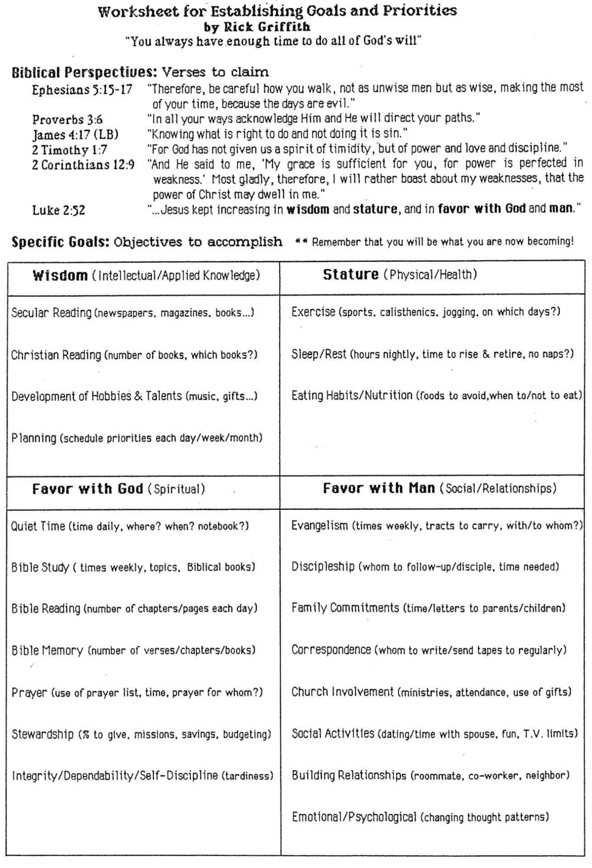

Attacks Against Scripture Today

Which teachings do you hear today that seek to undermine the truthfulness of our faith?

- The Da Vinci Code says the NT is inaccurate and even included the wrong gospels

- Various types of criticisms (source, form, etc.) shed doubt on the Gospel accounts

- The “Jesus Seminar” prioritizes Gospel texts into four levels of reliability

- Magazines question biblical accuracy (e.g., BAR, Time, US News & World Report)

- Health and wealth false teachers deny suffering and poverty for the godly

- Even evangelical scholars like Wayne Grudem say prophecies need not be true

Even as early as AD 64 when many apostles were still living, false teachers questioned what the believers had been taught. Peter cared that his readers had an accurate knowledge of the truth they had heard, so he responded in 2 Peter to these attacks.

We can overcome heresy by knowing what the OT prophets and NT apostles said (1:12-21).

Peter knew that Nero was about to execute him, so he reminded his readers of God’s election and provisions (1:12-15).

Two reliable sources (not false teachers) helped Peter remind his readers of these truths vital to their spiritual lives (1:16-21).

He knew about Christ’s power not from cleaver second-hand tales but because he witnessed it at the Transfiguration (1:16-18).

He knew about Christ’s power from OT prophets accurately predicting Christ in uninterpreted messages from God (1:19-21).

The apostles knew the OT prophets spoke truth, so readers should heed their messages until Jesus returned (1:19).

No true OT prophet ever misinterpreted a prophecy (1:20).

Every true prophet spoke truth since it came not from his own will but only as a willing instrument of the Spirit’s message (1:21).
Summary of Prophetic Views

Grudem’s View | Biblical View
Prophecy is declaring anything (true or false)  that the Spirit brings to one’s mind | Prophecy is declaring God’s inspired and inerrant revelation to others
The above definition was invented in 1988  by Wayne Grudem | The above definition has been the teaching of the church for 20 centuries
OT prophets are parallel to NT apostles | OT prophets are parallel to NT prophets
God changed the definition of prophecy  from the OT to the NT | God kept the meaning of prophecy consistent between the two testaments
God gives some prophecies with errors | God gives all prophecies without errors (2 Pet. 1:20-21)
Any believer can prophesy | Only those with the gift of prophecy can prophesy  (1 Cor. 12:29)
There are two kinds of NT prophecy  (fallible and infallible) | There’s one kind of NT prophecy  (infallible)
Fallible prophecy can be inspired | Fallible prophecy is false prophecy (Deut. 13:1-5; 18:14-20)
God sometimes lies | God always tells the truth since He cannot lie (Heb. 6:18)
Wayne A. Grudem, “Why Christians Can Still Prophesy: Scripture Encourages Us to Seek this Gift yet Today,” Christianity Today (September 16, 1988): 29; cf. Grudem’s book, The Gift of Prophecy (Eastbourne: Kingsway, 1988).

Discussion Questions:

1. What should the church do today with a person who claims to be a true prophet of God but fails to fulfill any of these tests? For example, if one makes a prediction that proves false or the “prophet” falls into moral sin, should a local church stone him, rebuke him, remove him, or admit, “We all make mistakes”?

2. In light of this study, what do you think of this now popular definition of prophecy by Wayne Grudem: Prophecy is “telling something that God has spontaneously brought to mind”? Is this true prophecy even if it is erroneous? Why or why not?

3. Do you think Grudem’s teaching that all believers can prophesy has biblical support (cf. 1 Cor. 12:29 vs. 14:1)? Support your answer.

4. What would you say to someone who claimed that his prophecy is inspired but not equal in authority to Scripture? (In other words, he argues for different levels of inspiration and/or inerrancy.) Support your answer.

Time for Self-Evaluation:
Do you have secret doubts about whether the Bible has errors? What should you do about it?

To grow in grace instead of succumbing to false teaching, know how to spot future apostates to defeat them (2 Pet 2).

Heretics exploit believers with false stories (2:1-3a).

Israel had both true prophets in OT times (1:19-20) and false prophets, so false prophecy was not new among God’s people (2:1a).

Peter briefly describes the false teachers so his readers can identify them soon (2:1b-3a).
What traits do these false teachers have in verses 1b-3a?

Apostates will be condemned just like we will be protected (2:3b-10a).

Even though these teachers had yet to deceive, God had already condemned them (2:3b).

God has a long history of judging the ungodly while protecting the righteous (2:4-8).

Demons who sinned [probably by enticing rulers in Genesis 6 into immorality] have long been in Tartarus (hell) awaiting final judgment (2:4).

Ungodly people died in the Flood while God spared the godly Noah’s family (2:5).

Sodom and Gomorrah were burned alive while righteous Lot was delivered (2:6-8).

These three past examples of judgment and salvation show that God will do the same in the future (2:9-10a).

God will rescue the godly but judge the ungodly in the future and the present (2:9).

God especially judges heretics guilty of sexual sin and despising authority (2:10a).

The preceding, scathing denunciation of these teachers even boldly declares that they will go to hell. But although Peter gave their general characteristics in verse 1-3, we still we need a more thorough description of who these men are so we can recognize them and avoid their snares. The rest of the chapter does just that…

A lengthy depiction of the heretics shows how to identify them when they come (2:10b-22).

The false teachers are rebellious (2:10b-12).

They boldly slander demons but powerful angels do not even dare try this (2:10b-11).

* Health and wealth teachers often curse “demons” of poverty, lust, gluttony, etc.!

They blaspheme like brute beasts without thinking, so they likewise will be ruined (2:12).

The false teachers are immoral (2:13-16).

The harm they have done others will befall them (2:13a).

Their sexual sin is public (2:13b).

* The popularity of many health and wealth “evangelists” has led to illicit sex.

They eat with the saints but boast about their immorality (2:13c).

They continually commit adultery (2:14a).

* All women in The People’s Temple had to sleep with Jim Jones at least once.

They seduce those without firm footing in the faith (2:14b).

* Dan Brown’s The da Vinci Code seduces the naive to thinking that “Yah” was the feminine consort of the “male deity” resulting in “Jehovah” and illicit temple sex!

They greedily get their way to their own curse (2:14c).

* A US$1-2 million salary satiated Rev. Jim Bakker’s greed until his imprisonment.

They entice others into immorality like Balaam did to Israel (Num. 25:1-9) though a donkey rebuked him (2:15-16; Num. 22:28).

The false teachers are depraved unbelievers who ensnare others, even though they may have tasted the blessings of a righteous life (2:17-22).

Hell is reserved for them just like a dry spring or waterless storm (2:17).

They entice others into “free” sex while they are slaves to sex (2:18-19).

They reject the knowledge of righteousness they once held so that their final state is even worse—like animals that once again soil themselves in filth (2:20-22).

* The end for Jim Jones was the death (suicide?) of nearly 1000 followers with him.

For brief evaluations of hundreds of current teachers, see http://faith.propadeutic.com/

For Life Change: Which teachers must you warn yourself and your family about? How?
Something to Think About…
What decision have you made differently due to knowing Christ could return at any moment?

To grow in grace instead of succumbing to false teaching, know how to live godly before Christ destroys everything in the Day of the Lord (2 Pet 3).

Know that apostates will be godless and scoff at Christ’s coming until he returns (3:1-7).

Both of Peters’ letters remind his readers that both the OT prophets and NT apostles stimulated wholesome thinking (3:1-2).

Scoffers ridicule belief in creation and the Flood to create doubt that God will climatically judge in the future as well (3:3-7).

Scoffers show that the Church Age comprises the “last days” before Christ returns (3:3; cf. 2:1; predicted by Jesus in Matt. 24:3-5, 11, 23-26).

Scoffers doubt God by assuming that nothing catastrophic ever happens (3:4-6).

Scoffers ridicule Christ’s return (3:4a).

Scoffers teach uniformitarianism—the belief that the earth has continued in the same state since creation (3:4b).

Scoffers deny two catastrophic events both from water—Creation and the Great Flood (3:5-6).

The same word of God that judged the world by Flood also will judge the world and unbelievers by fire (3:7).

Know that the world you see is temporary to motivate you to godliness (3:8-16).

Although God can patiently wait 1000 years (cf. Ps. 90:4) for more to trust in Christ, he will still destroy the “heavens” (atmosphere and stars), elements, and earth (3:8-10).

  - Do not confuse the patience of God with the omnipotence of God.

Knowing the temporary nature of the present heavens and earth should motivate three actions (3:11-16).

Knowing that this creation is temporary motivates holy living separated from the world and used for God (3:11-12).

  - How does our knowing that the earth is temporary lead to holy living?

Knowing that this creation is temporary helps us long for our eternal home (3:13).

Knowing that this creation is temporary brings peace with God (3:14).

Knowing that this creation is temporary helps us understand God’s patience despite Paul being misinterpreted (3:15-16).

Paul’s letters show the same wisdom as Peter that God waits to bring more into his family (3:15).

However, some unbelievers distorted Paul's difficult teachings as they also did to the other Scriptures (3:16).

  - Note that Peter considered Paul’s letters Scripture along with the Old Testament!

Know the ruin of heretics and the grace of Jesus to protect you and help you grow (3:17-18).

What does it mean that believing heresy could cause a Christian to “fall from his secure position”?

Some say this means a Christian could lose his salvation. However, many passages in the NT affirm that the believer’s position in Christ is permanent (e.g., John 3:16; 10:28-29; see also 1 John supplements on pages 296a-d in this NT Survey volume).

It is better to see this as referring to believers being led astray (1:10; Gal. 5:4).

Applying 2 Peter as a Whole

Do you feel that you are progressively growing “in the grace and knowledge of our Lord and Savior Jesus Christ” (3:18) like you should? What new habit can you start to better assure your growth continues?

52 Week Bible Reading Plan

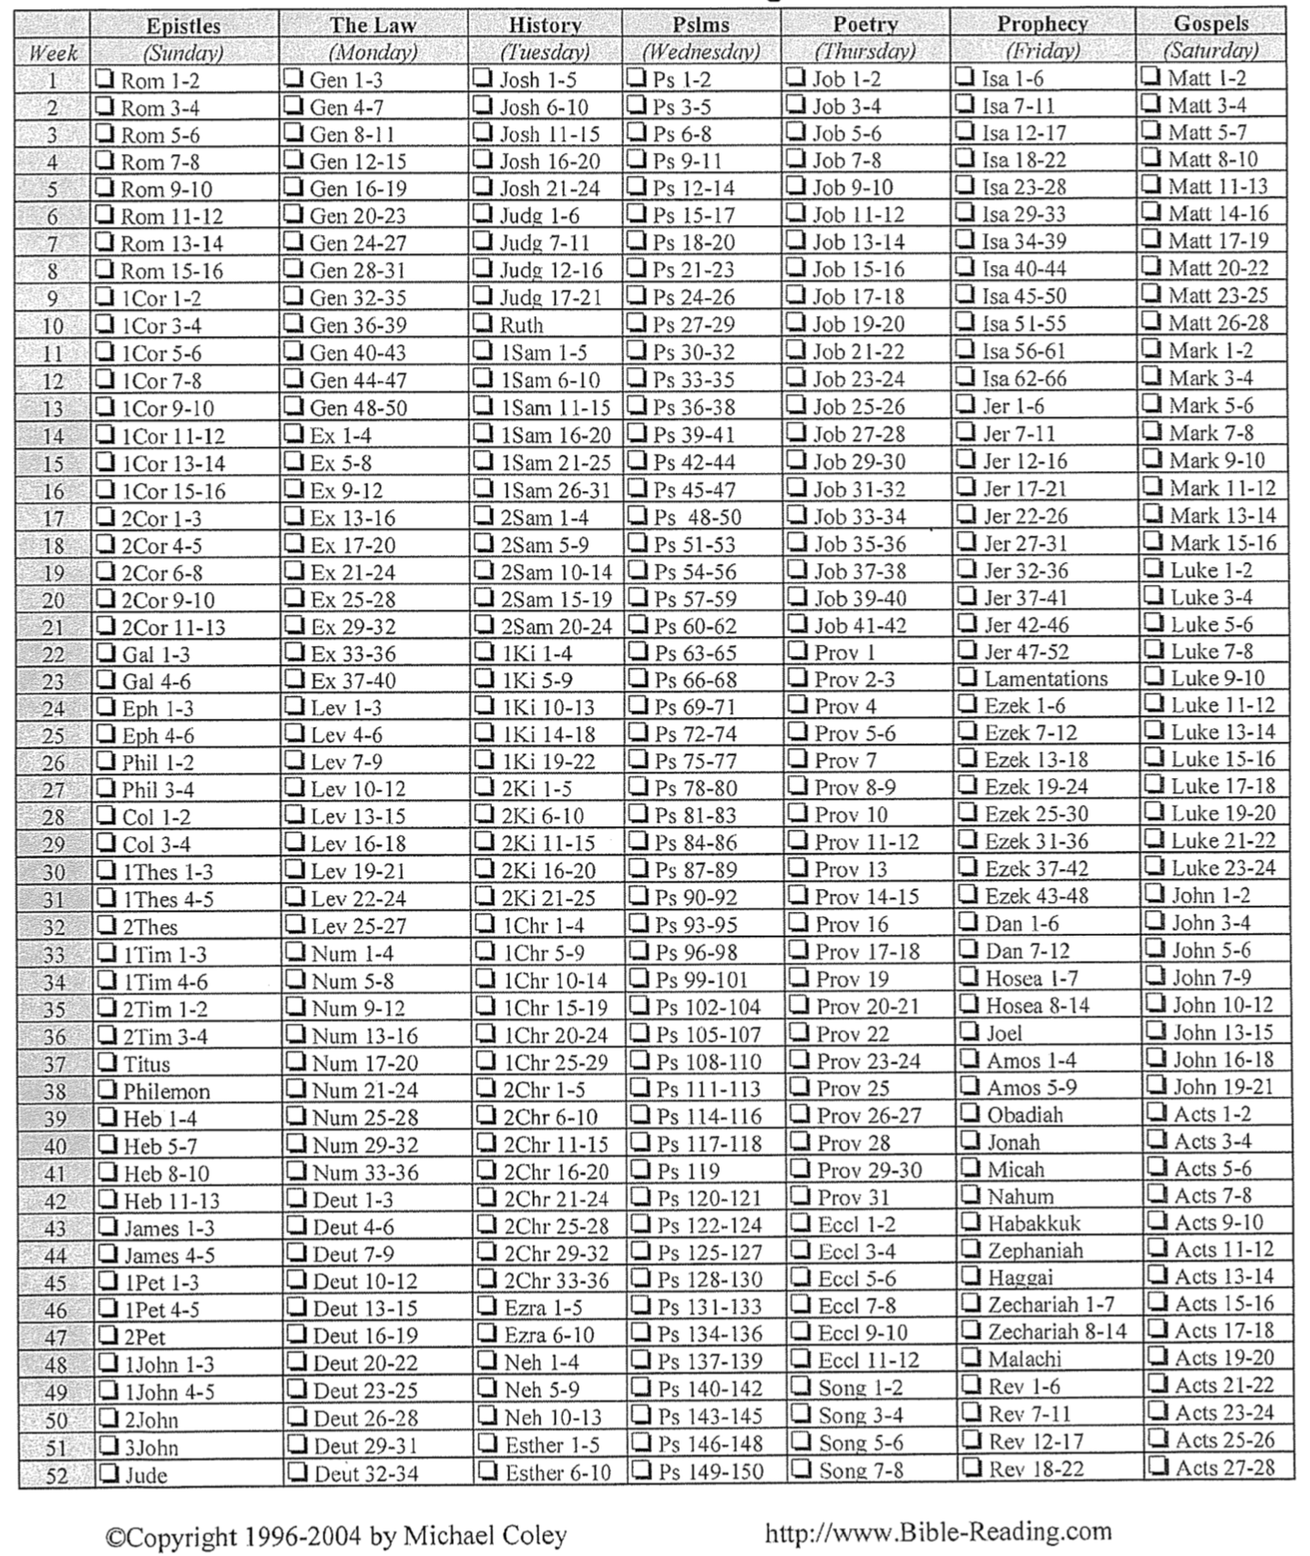

Do you want to be more regular in your Bible reading? The above plan has such variety in weekly reading that it brings you through seven sections of Scripture each week.

Be Knowledgeable
2 Peter

Exegetical Outline (Steps 2-3)

Exegetical Idea: The content of what we need to know to grow in grace instead of succumbing to false teaching is we need to know that Jesus chose us and that he will judge apostates at his return.

To grow in grace instead of succumbing to false teaching, know that Jesus chose you and gives you all you need for godliness (2 Pet 1).

God has blessed Peter’s readers with knowledge by faith in Christ as a foretaste of the letter's emphasis of knowing God amidst false teaching (1:1-2).

Knowing God’s choice of us for salvation gives us everything we need for godliness (1:3-11).

Our knowledge of God has a firm foundation in apostolic witness and fulfillment of OT prophecy so we can confidently fight heresy (1:12-21).

To grow in grace instead of succumbing to false teaching, know how to spot future apostates to defeat them (2 Pet 2).

Heretics would exploit believers about ten years later in AD 75 with false stories so his readers should prepare to defend themselves (2:1-3a).

The destiny of all apostates in hell shows that believers will be protected as much as apostates will be condemned (2:3b-10a).

A lengthy depiction of the heretics shows how to identify them when they come (2:10b-22).

To grow in grace instead of succumbing to false teaching, know how to live godly before Christ destroys everything in the Day of the Lord (2 Pet 3).

Apostates live godlessly and will scoff until Christ returns but this should stimulate us to live for Christ until his return (3:1-7).

Knowing that the Day of the Lord [Tribulation + Millennium] will replace the heavens and earth should motivate us to godliness (3:8-16).

Knowing the ultimate destruction of false teachers and the grace of Jesus Christ will protect us and stimulate growth in godliness (3:17-18).

Purpose or Desired Listener Response (Step 4)
The listeners will commit to knowing Christ better each year of their lives.

Homiletical Outline (Cyclical inductive form)

Introduction

Interest: Believers are falling away to false teaching due to lack of knowledge. In particular, they lack an understanding of grace and a knowledge of Jesus (2 Pet 3:18).

Need: How are you growing in knowledge so you can grow in grace to protect yourself from false teaching?

Subject: What must you know to grow in grace rather than to fall for false teaching?

Background: In AD 64, believers were falling away not due to persecution but due to lack of knowledge.

Preview: Today we will see three things that we need to know to grow in grace rather than fall for false teaching.

Text: I will survey all three chapters of 2 Peter.

(What do you need to know first to grow in grace rather than to fall for false teaching?)

Know that Christ chose and fully equipped you (2 Pet 1).

We have knowledge by faith in Christ to combat false teaching (1:1-2).

Knowing God chose us for salvation gives us all we need for godliness (1:3-11).

We can overcome heresy by knowing what the OT prophets and NT apostles said (1:12-21).
(What else do you need to know to grow in grace rather than to fall for false teaching?)

Know a fake teacher before you see one (2 Pet 2).

Heretics exploit believers with false stories (2:1-3a).

Apostates will be condemned just like we will be protected (2:3b-10a).

A lengthy depiction of the heretics shows how to identify them when they come (2:10b-22).
(What do you need to know third to grow in grace rather than to fall for false teaching?)

Know to live for the eternal—not the temporal (2 Pet 3).

Know that apostates will be godless and scoff at Christ’s coming until he returns (3:1-7).

Know that the world you see is temporary to motivate you to godliness (3:8-16).

Know the ruin of heretics and the grace of Jesus to protect you and help you grow (3:17-18).
(What do you need to know to grow in grace rather than to fall for false teaching?)

Conclusion

Know that Christ chose you and will judge apostates at his return (MI).

How can you grow in grace rather than fall for false teaching?

Know that Christ chose and fully equipped you (2 Pet 1).

Know a fake teacher before you see one (2 Pet 2).

Know to live for the eternal—not the temporal (2 Pet 3).

Exhortation: Commit to know Jesus better each year of your life (3:18)!

Prayer

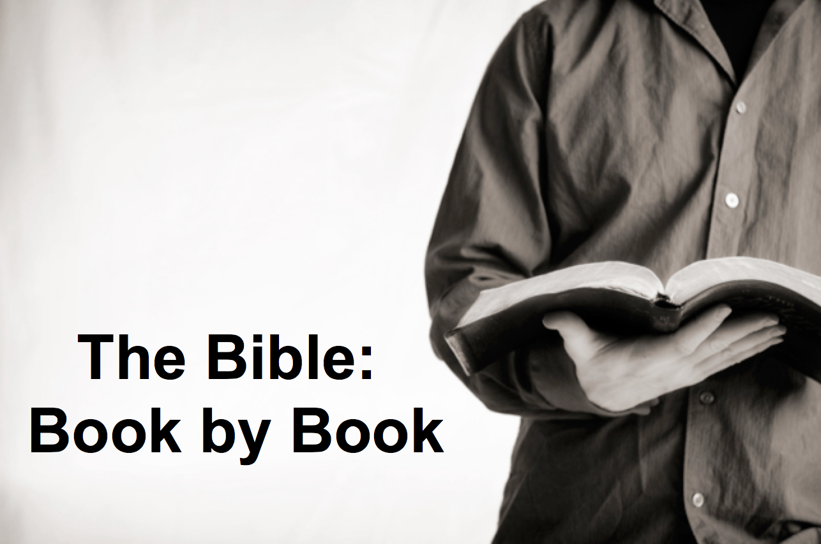

Rick Griffith
11 August 2019
Message 56 of 66

Be Knowledgeable
Letter of 2 Peter

Introduction

What must you ________ to grow in grace rather than fall for false teaching (2 Pet 3:18)?

In AD 64, believers were falling away not due to persecution but to lack of knowledge.

Know that Christ ________________ and fully equipped you (2 Pet 1).

We have knowledge by faith in Christ to combat false teaching (1:1-2).

Knowing God chose us for salvation gives us all we need for godliness (1:3-11).

We can overcome heresy by knowing what the OT prophets and NT apostles said (1:12-21).

Know a __________________ teacher before you see one (2 Pet 2).

Heretics exploit believers with false stories (2:1-3a).

Apostates will be condemned just like we will be protected (2:3b-10a).

A lengthy depiction of the heretics shows how to identify them when they come (2:10b-22).

Know to live for the _____________________—not the temporal (2 Pet 3).

Know that apostates will be godless and scoff at Christ’s coming until he returns (3:1-7).

Know that the world you see is temporary to motivate you to godliness (3:8-16).

Know the ruin of heretics and the grace of Jesus to protect you and help you grow (3:17-18).

Conclusion

Know that Christ chose you and will judge apostates at his return (Main Idea).

How can you grow in grace rather than fall for false teaching?

Commit to know Jesus better each year of your life (3:18)!

Download this sermon PPT and notes for free at BibleStudyDownloads.org/resource/new-testament-preaching/
Listen to this message online at cicfamily.com/sermon-listing/
2 Peter

Knowledge to Combat False Teaching

God’s Election |  |  | Future Apostasy |  |  | Lord’s Return
Chapter 1 |  |  | Chapter 2 |  |  | Chapter 3
Salutation  1:1-2 | Provides Every Need  1:3-11 | Foundation of Knowledge  1:12-21 | False Teachers Coming  2:1-3a | End in Hell  2:3b-10a | Character Described  2:10b-22 | Scoffers Before Rapture  3:1-7 | Temporary World Motivates Holiness  3:8-16 | Protection &  Growth Encouraged  3:17-18
Adequacy of  Believers |  |  | Inadequacy of  Unbelievers |  |  | Expectancy of  Believers
Holiness |  |  | Heresy |  |  | Hope
Disciples of the Lord |  |  | Diabolical Leaders |  |  | Day of the Lord
Rome to North Asia Minor

AD 64

Key Word: Knowledge

Key Verse: “Therefore, dear friends, since you already know this, be on your guard so that you may not be carried away by the error of lawless men and fall from your secure position. But grow in the grace and knowledge of our Lord and Savior Jesus Christ. To him be glory both now and forever! Amen” (2 Peter 3:17-18).

Summary Statement: To grow in grace instead of succumbing to false teaching, we need to know that Jesus chose us and that he will judge apostates at his return.

Application: Never stop being a student of the Scripture. If you do, you will stop growing in grace and you will eventually tolerate and/or promote heresy. What new things in His Word has God been teaching you lately?

Dick Lucas and Christopher Green, The Message of 2 Peter and Jude, The Bible Speaks Today (Leicester, England: IVP, 1995), 156; Kenneth O. Gangel, “2 Peter,” in The Bible Knowledge Commentary (Wheaton: Victor, 1983), 878.
Marcia Montenegro, “Magic: The Gathering - To Play or Not to Play,” Christian Answers for the New Age (http://www.christiananswersforthenewage.org/Articles_Magic.html accessed 8 Aug 2019).
Dick Lucas and Christopher Green, The Message of 2 Peter and Jude, The Bible Speaks Today (Leicester, England: IVP, 1995), 156; Kenneth O. Gangel, “2 Peter,” in The Bible Knowledge Commentary (Wheaton: Victor, 1983), 878.

