Crossroads International Church Singapore Dr. Rick Griffith
20 Jan 2019 Message 44 of 66
NLT 60 Minutes
Title
Be Affirmed
2 Thessalonians

Topic: Affirmation
Subject: How does God affirm us when we face tough times?
Complement: God affirms us holistically.
Purpose: The listeners will affirm others like God affirms them.
Attribute: We worship the God of Comfort
Reading: 2 Thess 1:11-12
Benediction: 2 Thess 3:16
Song: He Will Hold Me Fast (Getty)

Introduction

Interest: Lately I have been thinking a lot about how we all need to be affirmed.
Affirmation

The past two weeks both Susan and I have had the most health issues ever in our 35-year marriage. Last Sunday was the first time we both ever missed church. My voice just wasn’t in shape to preach, I didn’t have the energy, etc. I won’t give you all the details lest it become “an organ recital.”

That’s not what is important. What is more significant is that some of you reached out to us and genuinely affirmed us! Thank you! Susan’s eye operation to correct her double vision did happen and was a success, despite our doubts about it going through with her rapid heartbeat days before the operation. Now, instead of seeing two husbands with her double vision, she is back to having only one husband.
Math
Our…
(3 slides)
Don’t Deserve
Enough
Self
(5 slides)

We need to be increasingly committed to fulfilling our mission, our vision and our priorities [explain slides].

Curious about this concept of affirmation, I began looking up the word “affirmation” on Google to see what I could find. To my surprise, nearly all of the affirmations were about self-affirmation!

Need: That raises a question: Do you think it will be sufficient for you simply to recite a mantra of 1000 self-affirmations?

What if you don’t feel that you deserve self-esteem?

What do you do if you say, “I am not sure how many problems I have because math is one of them”?

Isn’t it far better for others to praise you than for you to praise yourself?
Spiral
(2 slides)

More than that, isn’t even better for God to praise you and tell you how valuable you are to him? Do you see him affirming you?
Subject

Subject: How does God affirm us when we face tough times?
Backgrnd

Background: Today we will look at a church caught in the “winepress of persecution” that had yielded to God, resulting in a fragrant display of God’s grace. The Thessalonians still had “persecutions and trials” about a year after Paul had established the church but they were bearing under it, though crushed.

The church was located in northern Greece on a peninsula as both a key port city and also on the main east-west land route in the Roman Empire called the Via Egnatia.
Down With Paul
Overview
(3 slides)
3 Ways
Focus
(3 slides)
1:1-2
(9 slides)
1:3-12
(15 slides)
Persevere
Marbles or Grapes
Port & Land
(2 slides)

Paul established the Thessalonian church amidst great difficulty. The background is in Acts 17. Paul only stayed there about three months, but the Jews who kicked him out over to Berea even followed him to Berea and kicked him out of there too!
Map

Paul had told them to be prepared for Jesus to return and deliver them from their trials. In his first letter to the church, we find the most amazing passage in the Bible about Jesus coming back to rescue his own (1 Thess 4:13-18).
1 Thess
(10 slides)

But now, months later, Jesus had not come and the church was wondering if they had already entered the tribulation. So Paul wrote them to show how God continued to affirm them.

Preview: Today, as we see how God used Paul to affirm this suffering church, we will see three ways that God affirms us when we face tough times.

Text: We will survey the entire letter of 2 Thessalonians.

(So what’s the first way that God affirms us when we face tough times?)
2 Thess 1
(3 slides)

I. Emotionally: God develops perseverance to bring maturity (2 Thess 1).
[The Lord helps us not to lose heart so we will grow.]

Emotional: Persecuted believers should persevere since God will judge their persecutors but make them mature (2 Thess 1).

Paul mentions his fellow-workers Silas and Timothy but not his position as an apostle to begin his letter relationally (1:1-2).

God will reward the church’s perseverance during affliction but punish their persecutors by helping the church become mature (1:3-12).

Persevering through affliction develops maturity (Swindoll).

We decide how difficulties will change us. Do you agree? In his book No Greater Power, Richard C. Halverson, past chaplain of the US Senate, wrote:

“Crush marbles and you get fragmentation, disintegration—hard, sharp pieces. You can get hurt if you’re not careful.

Crush grapes and you get fragrant, refreshing wine.

Some people relate like marbles. The fear of vulnerability hardens them. They protect themselves, allow no one to penetrate. Being vulnerable is high-risk, and they want low-risk. They bump against others and ricochet around, never enjoying a vital relationship. In brittle lovelessness, they shatter when crushed, and hurt others.

Some people relate like grapes. They yield to pressure. They accept their weakness as essential to intimacy. They give love, knowing love is always vulnerable, knowing love is the heart and soul of our faith. When crushed, they bring blessing: fragrant, redemptive blessing.”

Difficulties certainly come our way for every one of us.

But how do you respond to these trials? Are you like a marble or like a grape? In either case, we get crushed, but marbles resist it while grapes welcome the benefits.

Are you angry at God for allowing difficulty into your life? Or do you see him affirming you?
My Defensive
Transition
(2 slides)
3-4
2:3a

I have needed affirmation to overcome my own weakness of defensiveness.

As I have recently reflected on my early years as a Christian teenager, I recall one particular weakness. When someone expressed a concern about me, I reacted with defensiveness. This was a problem I had in my early years of marriage too. Susan would observe a weakness in me and I would defend myself as if she was attacking me.

After further consideration and prayer about this, I realized that it went back to my teenage years. My mother married a third time when I was age 13, and my step-father would point out a deficiency in me rather roughly. He had a horrible relationship with his own father—so much that he called him by his first name rather than “Dad” or “Father”—and he lacked an ability to gently tell me how to better sweep the floor or wash the dishes or whatever. I constantly felt attacked, even though that wasn’t his intention.

So I developed this defensive attitude in my other relationships too. I suspect I felt that way about God as well.

God really changed me, though. At least I think he did! I guess you can be the judge whether I defend myself right now. I think he has given me an ability to respond rather than react, to persevere in a way that helps me grow in maturity.

Do you also need help in an area of your life where you need affirmation? Simply ask God to help you—and ask a trusted friend or spouse to help you grow here.

(So we see in the first chapter that God affirms us when he develops perseverance to bring maturity. What other way does God affirm us when we face tough times? The next area is…)

II. Theologically: God gives us truth to bring stability (2 Thess 2).
MP
(3 slides)
[Theology matters! The Lord corrects our misconceptions to give us firm footing.]

Theological: Paul taught that the day of the Lord required the Antichrist so the church could be stable (2 Thess 2).
2:1-2
(6 slides)

Paul had not changed his views on the time of the day of the Lord meaning that they had missed the rapture (2:1-2).
Sets Up Image

Specific events will precede the day of the Lord so that the Thessalonians could see that they had not missed this event (2:3-12).

The Church will depart from the earth (or from the God’s Word) before the day of the Lord comes, leaving only an apostate church (2:3a).

The Antichrist will reveal himself to the discerning before the day of the Lord begins (2:3b-4; by signing a covenant with Israel; cf. Dan. 9:27).

The restraining ministry of the Holy Spirit in the Church will be removed from earth, allowing the Antichrist to rule (2:5-7).
5-8
(3 slides)

Then the Antichrist will prove himself in counterfeit miracles and a powerful delusion sent by God but will be destroyed at Christ’s return (2:8-12).
9-12
(12 slides)

Paul prays that they will stand firm in good works since they will be spared from the day of the Lord by sharing in Christ's glory (2:13-17).
13-17
(2 slides)

Trusting amidst confusion produces stability (Swindoll).
Trusting

There is an immense amount of theological confusion spouted all over today. The rise of the Internet has allowed YouTube and other avenues to spread heresies. It seems that the more hits or likes, the more bizarre and damaging the teaching. My own YouTube video has just a few hundred views, but the insane stuff has millions of views!

How can we keep trusting the Lord amidst such craziness?

Keep going back to the source—the Word of God.

How are you doing at your goal of reading the Bible each day this year?
Trans
(3 slides)
(What’s the last way that God affirms us when we face tough times?)

III. Practically: God cultivates discipline in us to build responsibility (2 Thess 3).
MP
(3 slides)
[The Lord helps us hold one another accountable so we will be reliable.]

Practical: The church must discipline lazy believers living off others so they will work like Paul and his companions (2 Thess 3).

Paul requests prayer for the progress of the gospel and prays the same for them to model sensible behavior in light of the day of the Lord (3:1-5).
3:6-15
(6 slides)
3:1-5
(2 slides)

They must discipline idle believers who live off others as they wait for the rapture to shame them into responsible work (3:6-15).

Paul signs the concluding blessing and benediction to show the genuineness of the epistle (cf. 2:2b) so that the church would act on its authority (3:16-18).
Discipline
3:16-18
(2 slides)

Waiting with discipline cultivates responsibility (Swindoll).

Hard-working Singapore weeds out lazy people. There is no unemployment insurance here that people can take advantage of, and there is no welfare program that can make people dependent.

However, occasionally we still have people go from church to church to try to get money out of each congregation. Like other churches, we try to have a balanced view where we help people in need—but we also expect our people to work for a living.

Would you say you are a disciplined person?

Do you discipline your time? Or do you waste time?

Do you serve others or spend most of your time on yourself?

The general rule in this passage is Paul’s maxim: “Those unwilling to work will not get to eat” (3:10 NLT).
Subject
(How does God affirm us when we face tough times?)

Conclusion

God affirms us holistically (Main Idea). He is not incomplete or piecemeal in his ministry to us. He touches the heart (emotionally), the mind (theologically), and the hands (practically).
Main Idea

Main Points: How does God affirm us when we face tough times?
MPI

Emotionally: God develops perseverance to bring maturity (2 Thess 1).
MPII
MPIII

Theologically: God gives us truth to bring stability (2 Thess 2).

Practically: God cultivates discipline in us to build responsibility (2 Thess 3).

So what can we take home from 2 Thessalonians today?
Words of Affirmation

How are you responding to God’s gentle affirmation during your difficulty?

Are you becoming more mature through perseverance?

Are you growing more stable by growing in truth?

Are you increasing in discipline and responsibility?

How do you affirm others in their tough times so that their trials will make them better instead of bitter?

A Catholic nun named Sister Helen P. Mrosla relates this story about affirmation…
Class Picture

He was in the first third grade class I taught at Saint Mary's School in Morris, Minn. All 34 of my students were dear to me, but Mark Eklund was one in a million. Very neat in appearance, but had that happy-to-be-alive attitude that made even his occasional mischievousness delightful.

Mark talked incessantly. I had to remind him again and again that talking without permission was not acceptable. What impressed me so much, though, was his sincere response every time I had to correct him for misbehaving - "Thank you for correcting me, Sister!" I didn't know what to make of it at first, but before long I became accustomed to hearing it many times a day.
Sister Mrosla

One morning my patience was growing thin when Mark talked once too often, and then I made a novice-teacher's mistake. I looked at Mark and said, "If you say one more word, I am going to tape your mouth shut!"

It wasn't ten seconds later when Chuck blurted out, "Mark is talking again." I hadn't asked any of the students to help me watch Mark, but since I had stated the punishment in front of the class, I had to act on it.

I remember the scene as if it had occurred this morning. I walked to my desk, very deliberately opened my drawer and took out a roll of masking tape. Without saying a word, I proceeded to Mark's desk, tore off two pieces of tape and made a big X with them over his mouth. I then returned to the front of the room. As I glanced at Mark to see how he was doing, he winked at me. That did it!! I started laughing. The class cheered as I walked back to Mark's desk, removed the tape, and shrugged my shoulders. His first words were, "Thank you for correcting me, Sister."
• Taped

At the end of the year I was asked to teach junior-high math. The years flew by, and before I knew it Mark was in my classroom again. He was more handsome than ever and just as polite. Since he had to listen carefully to my instructions in the "new math," he did not talk as much in ninth grade as he had in third.

One Friday, things just didn't feel right. We had worked hard on a new concept all week, and I sensed that the students were frowning, frustrated with themselves - and edgy with one another. I had to stop this crankiness before it got out of hand. So I asked them to list the names of the other students in the room on two sheets of paper, leaving a space between each name. Then I told them to think of the nicest thing they could say about each of their classmates and write it down.

It took the remainder of the class period to finish the assignment, and as the students left the room, each one handed me the papers. Charlie smiled. Mark said, "Thank you for teaching me, Sister. Have a good weekend."

That Saturday, I wrote down the name of each student on a separate sheet of paper, and I listed what everyone else had said about that individual. On Monday I gave each student his or her list. Before long, the entire class was smiling. "Really?" I heard whispered. "I never knew that meant anything to anyone!" "I didn't know others liked me so much!"

No one ever mentioned those papers in class again. I never knew if they discussed them after class or with their parents, but it didn't matter. The exercise had accomplished its purpose. The students were happy with themselves and one another again.

That group of students moved on. Several years later, after I returned from vacation, my parents met me at the airport. As we were driving home, Mother asked me the usual questions about the trip - the weather, my experiences in general. There was a slight lull in the conversation. Mother gave Dad a side-ways glance and simply says, "Dad?" My father cleared his throat as he usually did before something important. "The Eklunds called last night," he began. "Really?" I said. "I haven't heard from them in years. I wonder how Mark is."
Uniformed
Dad responded quietly. "Mark was killed in Vietnam," he said. "The funeral is tomorrow, and his parents would like if it you could attend." To this day I can still point to the exact spot on I-494 where Dad told me about Mark.

I had never seen a serviceman in a military coffin before. Mark looked so handsome, so mature. All I could think at that moment was, Mark, I would give all the masking tape in the world if only you would talk to me.

The church was packed with Mark's friends. Chuck's sister sang "The Battle Hymn of the Republic." Why did it have to rain on the day of the funeral? It was difficult enough at the graveside. The pastor said the usual prayers, and the bugler played taps. One by one those who loved Mark took a last walk by the coffin and sprinkled it with holy water. I was the last one to bless the coffin. As I stood there, one of the soldiers who had acted as pallbearer came up to me. "Were you Mark's math teacher?" he asked. I nodded as I continued to stare at the coffin. "Mark talked about you a lot," he said.

After the funeral, most of Mark's former classmates headed to Chuck's farmhouse for lunch. Mark's mother and father were there, obviously waiting for me. "We want to show you something," his father said, taking a wallet out of his pocket. "They found this on Mark when he was killed. We thought you might recognize it." Opening the billfold, he carefully removed two worn pieces of notebook paper that had obviously been taped, folded and refolded many times. I knew without looking that the papers were the ones on which I had listed all the good things each of Mark's classmates had said about him.

"Thank you so much for doing that," Mark's mother said. "As you can see, Mark treasured it."

Mark's classmates started to gather around us. Charlie smiled rather sheepishly and said, "I still have my list. It's in the top drawer of my desk at home." Chuck's wife said, "Chuck asked me to put his in our wedding album." "I have mine too," Marilyn said. "It's in my diary." Then Vicki, another classmate, reached into her pocketbook, took out her wallet and showed her worn and frazzled list to the group. "I carry this with me at all times," Vicki said without batting an eyelash. "I think we all saved our lists." That's when I finally sat down and cried. I cried for Mark and for all his friends who would never see him again (http://assumptionofmorris.org/site/about/ourviralnun/).
‘Bout You?

The affirmation you give this week just might meet a specific need and inspire hope too.

Let’s bow in prayer. Who needs your affirmation this week, today? Someone with family struggles? Work issues? School trials? Raise your hand if someone comes to mind. Take some moments now to tell the Lord who you are going to encourage and how you’re going to do it—

Take that person out for a meal?

Offer a helping hand?

Send a card or note?

Phone him or her to show that you care?

Make it simple—but most of all, make it genuine affirmation.

Maybe you need to receive affirmation today more than to give it.

Even if people fail to affirm you, God doesn’t.

He sent his own son for you to affirm you—so tell him thanks!

If you need human affirmation, we are up here to talk afterwards.
Black

Prayer

Preliminary Questions

Verses Questions

Context: What did the author record just prior to this passage?

This letter followed 1 Thessalonians by probably less than a year.

One support for this is that both letters are written by Paul, Silas and Timothy. As far as we know, these three were together only in Corinth, so both letters to the Thessalonians were written during this stay.

Purpose: Why is this passage in the Bible?

It has a few things that no other book of Scripture gives us.

Nowhere else do we find certain teachings about the day of the Lord—such as it not starting until after a great apostasy and the removal of the “restrainer” before the “man of lawlessness” is revealed (2 Thess 2:3-6).

Only this book tells us about people who lived idle lives rather than working for a living (3:6-12).

Background: What historical context helps us understand this passage?

Paul established the Thessalonian church amidst great difficulty. The background is in Acts 17. Paul only stayed there about three months, but the Jews who kicked him out over to Berea even followed him to Berea and kicked him out of there too!

Many months later—up to a year later—we see in this letter that the church is still going through tough times.

Questions

What is the “rebellion” that precedes the day of the Lord (2:3)?

Who or what is the “restrainer” that precedes the day of the Lord (2:6-7)?

Tentative Main Ideas

Affirm others like God affirms you.
Affirm holistically: emotionally, theologically, and practically.

Illustrations That Apply

Mark Eklund story

Marbles versus grapes (Richard C. Halverson, No Greater Power [Portland, OR: Multnomah, 1986), 67; cited in Charles R. Swindoll, Steadfast Christianity: A Study of Second Thessalonians [Fullerton, CA: Insight for Living, 1986], 1).

New Testament Survey Notes

2 Thessalonians

Tribulation Corrections

Persevere in Persecution |  | Day Still Future |  |  | Discipline the Idle
Chapter 1 |  | Chapter 2 |  |  | Chapter 3
Emotional |  | Theological |  |  | Practical
Encouragement  in Persecution |  | Explanation  of the Day |  |  | Exhortation  in Body Life
Discouraged  Believers |  | Disturbed  Believers |  |  | Disobedient  Believers
Correct  Perspective |  | Correct  Doctrine |  |  | Correct  Behaviour
Salutation  1:1-2 | Reward vs. Judgment  1:3-12 | Pretrib  Teaching  2:1-2 | Antichrist  Prerequisite  2:3-12 | Stand  Firm  2:13-17 | Prayer  Requests  3:1-5 | Discipline  Idle  3:6-15 | Blessing  Given  3:16-18
Corinth

Late Summer AD 51

Key Word: Tribulation

Key Verse: Do not “become easily unsettled or alarmed by some prophecy, report or letter supposed to have come from us, saying that the day of the Lord has already come. Don’t let anyone deceive you in any way, for that day will not come until the rebellion occurs and the man of lawlessness is revealed, the man doomed to destruction” (2 Thessalonians 2:2-3).

Summary Statement: The way Paul affirmed others during the heresy that the day of the Lord (Tribulation) had already begun was holistic: emotional, theological and practical.

Application: How does your view of the future spur your commitment to serve Christ?

2 Thessalonians

Introduction

I. Title The Greek title (Pro.j Qessalonikei/j b , Second to the Thessalonians) distinguishes this letter from Paul's first letter to the church just a few months before.

II. Authorship

A. External Evidence: Support for Pauline authorship has been upheld “very probably” since Polycarp (ca. AD 135; cf. Best, 37-38) and possibly earlier with Ignatius (ca. AD 110). One can add to this the Marcion Canon (ca. AD 140) and Muratorian Canon (ca. AD 170), plus the testimony of the early Church Fathers and ancient versions.

B. Internal Evidence: The letter itself strongly supports Pauline authorship:

1. The epistle claims that Paul wrote it (1:1; 3:17).

2. The premature ending (3:1-5) suits Paul more than a conscious imitator (Kümmel, 189).

3. The similarities to 1 Thessalonians, cited by some critics as evidence against Pauline authorship, actually support it (Best, 50-56).

4. Critics infer discrepancies between 2 Thessalonians 2:1-12 and 1 Thessalonians 4:13–5:11, but these differences refer to two different phases of Christ’s coming (Hiebert, 57).

C. Conclusion: The attacks upon Paul’s authorship have been soundly defeated so that nearly all scholars, despite their critical assumptions, believe that Paul penned this epistle.

III. Circumstances

A. Date: Hoehner suggests that Paul wrote 2 Thessalonians in the summer AD 51 (just a few months after his first letter). The following supports this claim:

1. Paul, Silas, and Timothy (1:1) are not known to have been together again after their stay in Corinth, which was the place Paul wrote the letter (Hiebert, 59).

2. The same general conditions exist in the church as discussed in 1 Thessalonians (e.g., idleness; cf. 1 Thess. 4:11-12; 2 Thess. 3:6-15).

3. These men apparently stayed in Corinth another year. This doesn’t necessarily argue for a date only a few months after 1 Thessalonians, but certainly the second letter precedes Paul's visit to them five years later (May 56). It is fairly certain that 2 Thessalonians did not follow the first letter by more than 12 months (Constable, BKC, 2:713).

B. Origin/Recipients: Paul wrote from Corinth to the Thessalonian believers north of him in the province of Macedonia (see “Date” above for support). Although this was his second letter to them, the congregation was still young—probably less than year old.

C. Occasion: The historical and chronological scenario for Paul’s ministry at Thessalonica during his second missionary journey probably looks like this:

1. Paul plants the Thessalonian church November 50-January 51
2. Paul’s ministry in Berea, Athens, and Corinth February-March 51
3. Silas and Timothy report to Paul in Corinth April/May 51
4. Paul writes 1 Thessalonians and sends it from Corinth Early Summer 51
5. The carrier of 1 Thessalonians reports back to Paul Mid-Summer 51
6. Paul writes 2 Thessalonians from Corinth Late Summer 51
7. Paul departs Corinth First of September 52

Within only a few months after writing 1 Thessalonians, Paul got news (probably from the letter carrier) of problems unresolved by his first letter. The persecution of the believers had increased (1:3-10), false teachers had taught that the day of the Lord had already come (2:1-12), and some of the Thessalonian Christians had become idle as they simply “waited for the rapture” (3:6-15). Therefore, Paul decided to write the church again to help the believers handle these difficulties.

IV. Characteristics

A. Although 2 Thessalonians is Paul's shortest letter to a New Testament church, it contains significant information regarding the second coming of Christ and the day of the Lord.

1. The return of Christ, occupying the major theme of chapters 1–2, is the most mentioned doctrine in the New Testament, referred to 318 times (TTTB, 423). This averages out to every 25 verses in the New Testament, or 1.2 times per chapter! (The NT has 7959 verses and 260 chapters.) In 2 Thessalonians, 18 of 47 verses (38%) stress eschatology.

2. The day of the Lord is also taught many places in Scripture (cf. Isa. 13:6, 9; Joel 1–2; Zeph. 1:14-16; 1 Thess. 5:1-11; Rev. 6–20) and refers to a time of judgment upon God's enemies and blessing upon His children that is unsurpassed. Chronologically, it begins after the rapture (perhaps half way through the seven-year tribulation) and continues to the end of the millennium (Constable, BKC, 2:717).

3. The rapture is the “catching up” of the saints by Christ at his return (1 Thess. 4:17). The word itself comes from around AD “1600, ‘act of carrying off,’ from Middle French rapture, from Medieval Latin raptura ‘seizure, rape, kidnapping,’ from Latin raptus ‘a carrying off, abduction, snatching away; rape’ (see rapt). Earliest attested use in English is of women and in 17c. it sometimes meant rape (v.), which word is a cognate of this” (https://www.etymonline.com/word/rapture). This negative connotation is not found in the theology of the rapture but the act of being suddenly carried off is the common element of both rape and the rapture.

4. A problem exists concerning the day of the Lord: if the rapture can happen at any time (i.e., without preceding signs), and the day of the Lord begins after that, how then can this latter “day” be preceded by three signs (2:3-12)?

a. These verses are clear that three signs (the apostasy, the revelation of the Antichrist, and the removal of the restrainer) all precede the day of the Lord. At first this may look like support for the posttribulational position (i.e., that the church will be removed from the earth after the tribulation).

b. However, the tribulation does not begin with the rapture. It begins when the Antichrist signs a covenant with Israel (Dan. 9:27). What 2 Thessalonians 2:3-7 notes is only that the three signs will take place prior to the beginning of the tribulation, which could happen days, weeks, or months after the rapture.

c. Therefore, while no signs precede the rapture, at least three signs precede the day of the Lord during the time period between the rapture and day of the Lord.

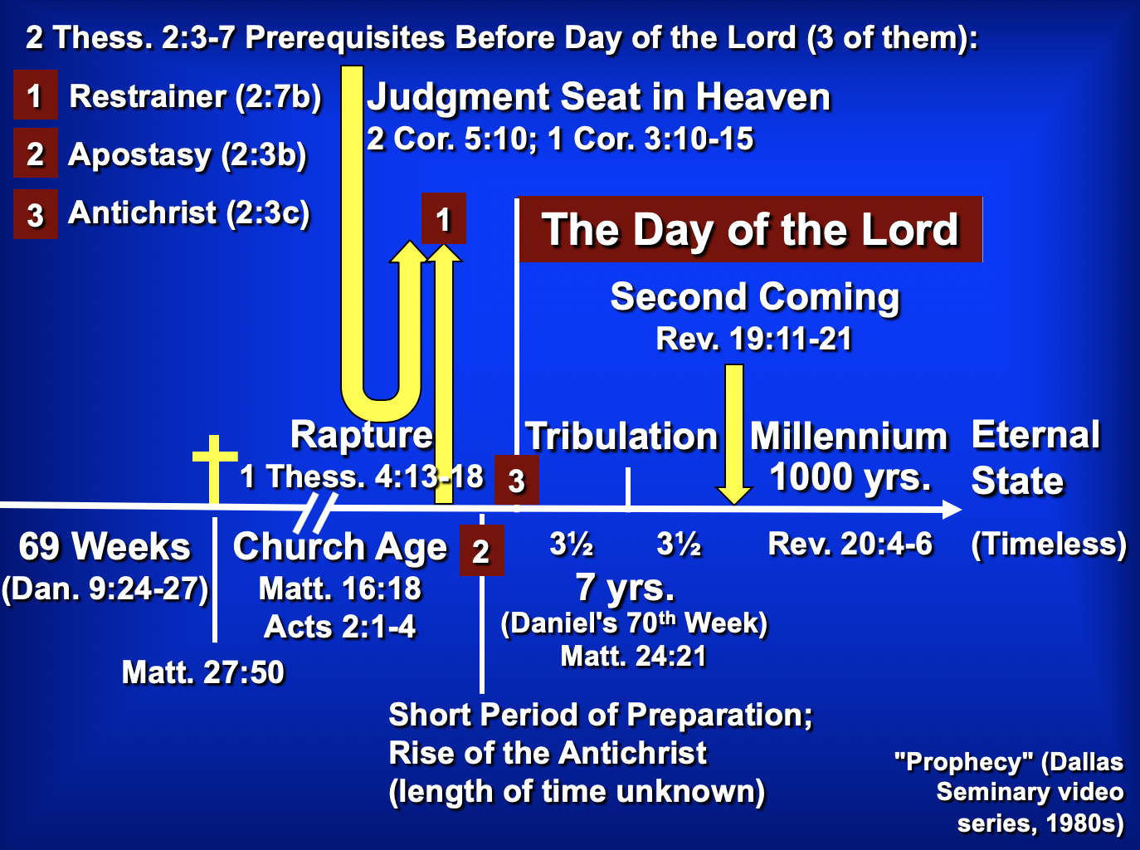

B. Whereas Paul wrote 1 Thessalonians to comfort, he wrote 2 Thessalonians to correct.

C. Paul deviates from his usual epistolary pattern through his two thanksgivings (1:3f.; 2:13f.) and two prayers (1:11-12; 2:16-17). Some believe that this indicates a merging of two separate letters, but there is no evidence that Paul ever felt constrained by a particular literary pattern and no manuscript evidence exists to doubt the unity of the epistle.

Argument

As mentioned above, Paul wrote 2 Thessalonians to help the believers handle three difficulties facing the church: increased persecution (1:3-10), false teaching that the day of the Lord had already come (2:1-12), and idleness among some of the Thessalonian Christians who were “waiting for the rapture” (3:6-15). Paul's design in writing was to encourage perseverance based upon their future reward at the day of the Lord (2 Thess 1) and to correct their false notion of the day of the Lord (2 Thess 2) which had resulted in idleness (2 Thess 3). The overriding theme is the day of the Lord and its implications on behavior.

Synthesis

Day of the Lord corrections

1 Emotional: Persevere in persecution
1:1-2 Salutation
1:3-12 Church's reward vs. persecutors' judgment at day of the Lord

2 Theological: Day still future
2:1-2 Teaching hasn't changed
2:3-7 Antichrist events preceding Day
2:3a Apostasy
2:3b-4 Worship as God
2:5-7 Restrainer removed
2:8-12 Antichrist activity and end
2:13-17 Stand firm

3 Practical: Discipline the idle
3:1-5 Pray for spread of the gospel
3:6-15 Discipline lazy unemployed members
3:16-18 Blessing/benediction

Outline

Summary Statement for the Book
The way Paul affirmed others during the heresy that the day of the Lord (Tribulation) had already begun was holistic: emotional, theological and practical.

Emotional: Persecuted believers should persevere since God will judge their persecutors but make them mature (2 Thess 1). Swindoll: Persevering through affliction develops maturity.

Paul mentions his fellow-workers Silas and Timothy but not his position as an apostle to begin his letter relationally (1:1-2).

God will reward the church’s perseverance during affliction but punish their persecutors by helping the church become mature (1:3-12).

Theological: Paul teaches that the day of the Lord required the Antichrist so the church could be stable (2 Thess 2). Swindoll: Trusting amidst confusion produces stability.

Paul had not changed his views on the time of the day of the Lord meaning that they had missed the rapture (2:1-2).

Specific events will precede the day of the Lord so that the Thessalonians could see that they had not missed this event (2:3-12).

The Church will depart from the earth (or from the God’s Word) before the day of the Lord comes, leaving only an apostate church (2:3a).

The Antichrist will reveal himself to the discerning before the day of the Lord begins (2:3b-4; by signing a covenant with Israel; cf. Dan. 9:27).

The restraining ministry of the Holy Spirit in the Church will be removed from earth, allowing the Antichrist to rule (2:5-7).

Then the Antichrist will prove himself in counterfeit miracles and a powerful delusion sent by God but will be destroyed at Christ’s return (2:8-12).

Paul prays that they will stand firm in good works since they will be spared from the day of the Lord by sharing in Christ's glory (2:13-17).

Practical: The church must discipline lazy believers living off others so they will work like Paul and his companions (2 Thess 3). Swindoll: Waiting with discipline cultivates responsibility.

Paul requests prayer for the progress of the gospel and prays the same for them to model sensible behavior in light of the day of the Lord (3:1-5).

They must discipline idle believers who live off others as they wait for the rapture to shame them into responsible work (3:6-15).

Paul signs the concluding blessing and benediction to show the genuineness of the epistle (cf. 2:2b) so that the church would act on its authority (3:16-18).
In our day when most talk of self-esteem, it is refreshing to find the Godhead noted more than once each verse on the average in these books…

Focus on God in the Thessalonian Epistles
Total Verses | “God” | “Lord” | “Jesus” | “Christ” | Total
1 Thess. (89) | 36 | 24 | 16 | 10 | 86
2 Thess. (47) | 18 | 22 | 13 | 10 | 63
Total (136) | 54 | 46 | 29 | 20 | 149
Numbers of Greek occurrences from Elwell & Yarbrough, Encountering the New Testament, 332
The Day of the LORD

I. Usage

A. The “day of the LORD” concept appears in every prophetical writing in the Old Testament, although not always by that same term.

B. The judgment aspect receives detailed treatment in Zephaniah, Joel, and Revelation 6–19. Some believe that the “Lord’s day” of Revelation 1:10 also refers to this period (cf. 2 Thess. 2:2-3).

II. Definition

A. The day of the LORD is “the time of Yahweh’s final intervention in history when He will judge the wicked, deliver the righteous, and establish His kingdom” (Hobart Freeman, An Introduction to the OT Prophets, 146).

1. Judgment

a. Primarily it refers to a destruction of Israel’s enemies (Zeph. 2–3; Amos 1:3–2:3; Joel 3; Zech. 12–14; Isa. 13:6, 9; 14:28-32; 17:1ff.; 20:1-6; 31:1-5; Jer. 46:10; Ezek. 30:3ff.).

b. However, it also includes punishment of the rebellious and disobedient in the nation of Israel (Amos 5:18-20).

c. The Great Tribulation of Revelation 6–19 finds so many parallels with descriptions by the OT prophets that the two judgments must certainly be the same period.

d. Ultimately the day of the LORD will end in a destruction of the world (2 Pet. 3:10).

2. Deliverance

a. Israel’s salvation from Gentile oppressors will occur through God who preserves and delivers a remnant of Israel (Joel 2:32; Zech. 14; Zeph. 3:8-20; Isa. 2, 11; 65-66; Amos 9:11-15; Ezek. 20:33-44, etc.).

b. This salvation is to enable Israel to enter into the kingdom in which God will fulfill all His promises to Abraham (cf. class notes, 336-37).

c. The deliverance has many blessings (Deut. 30:3-9) also for Gentiles (Zeph. 3:9).

d. Final salvation after judgment will be in the new heaven and earth (2 Pet. 3:11-13).

3. Diagram

Judgment + Salvation = Day of the LORD

Great Tribulation + Christ’s Return/ = Day of the LORD
Millennium

B. The day of the LORD also had a nearer aspect to the prophets, depicting an imminent, impending disaster–generally through the Assyrians or Babylonians. Sometimes even both the near and far aspects appear together in a dual sense. God did not clearly reveal whether a near or far perspective was to be understood so as to encourage repentance.

C. For further study see Greg A. King, “The Day of the LORD in Zephaniah,” Bibliotheca Sacra 152 (January-March 1995): 16-32.

The Antichrist

I. The Post-Rapture Crisis for Leadership

A. The need for a world leader after the rapture cannot be overstated.
1. Someone will need to explain the disappearance of millions of Christians.
2. Communications, transportation, economic, and all other systems will be disrupted.
3. The middle-east problem especially will need to be resolved.

B. Difficult times have always set the stage for a strong man to take control. The world scene after the rapture will be a perfect environment for the Antichrist to gain power.

II. Names for the Future Fuhrer

A. The names are many, describing his multifaceted character and the great emphasis placed upon this man in the Bible.

B. List of the names in scriptural order:

Bloody and Deceitful Man Ps. 5:6
Wicked One Ps. 10:2-4
Man of the Earth Ps. 10:18
Mighty Man Ps. 140:1
Assyrian Isa. 10:5-12
King of Babylon Isa. 14:2
Sun of the Morning Isa. 14:12
Spoiler Isa. 16:4-5; Jer. 6:26
Branch of the Terrible Ones Isa. 25:5
Profane Wicked Prince of Israel Ezek. 21:25-27
Little Horn Dan. 7:8
King of Fierce Countenance Dan. 8:23
Prince that shall Come Dan. 9:26
One who causes Desolation Dan. 9:27
Vile Person Dan. 11:21
Willful King Dan. 11:36
Idol Shepherd Zech. 11:16-17
Abomination of Desolation Matt. 24:15
One Coming in His Own Name John 5:43
Man of Sin 2 Thess. 2:3
Man Doomed to Destruction 2 Thess. 2:3
Lawless One 2 Thess. 2:8
Antichrist 1 John 2:18, 22
Angel of the Bottomless Pit Rev. 9:11
Beast from the Abyss/Sea Rev. 11:7; 13:1
[Scarlet] Beast Rev. 17:3, 8, 12

III. Summary of the Activity of the Future Fuhrer

A. Makes 7-year treaty with Jews Dan. 9:27a; 2 Thess. 2:3 (treaty reveals him?)
B. Peaceful beginning Rev. 6:1-2
C. Heads 10 nation confederacy Dan. 7:20
D. Dominated by world church Rev. 17:3-11
E. Dominates world church Rev. 17:12-16
F. Breaks covenant with Israel Dan. 9:27 (midpoint of the Tribulation)
G. Counterfeits death/resurrection Rev. 13:3a
H. Worshiped worldwide Rev. 13:3b-8, 11-15
I. Sets up image for worship 2 Thess. 2:3-4
J. False prophet promotes mark Rev. 13:16-18
K. Two witnesses slain Rev. 11:7
L. Persecutes Jews & Victorious in Israel Dan. 11:40-43
M. Defeated by Christ Rev. 19:11-19
N. Doom in Lake of Fire Rev. 19:20

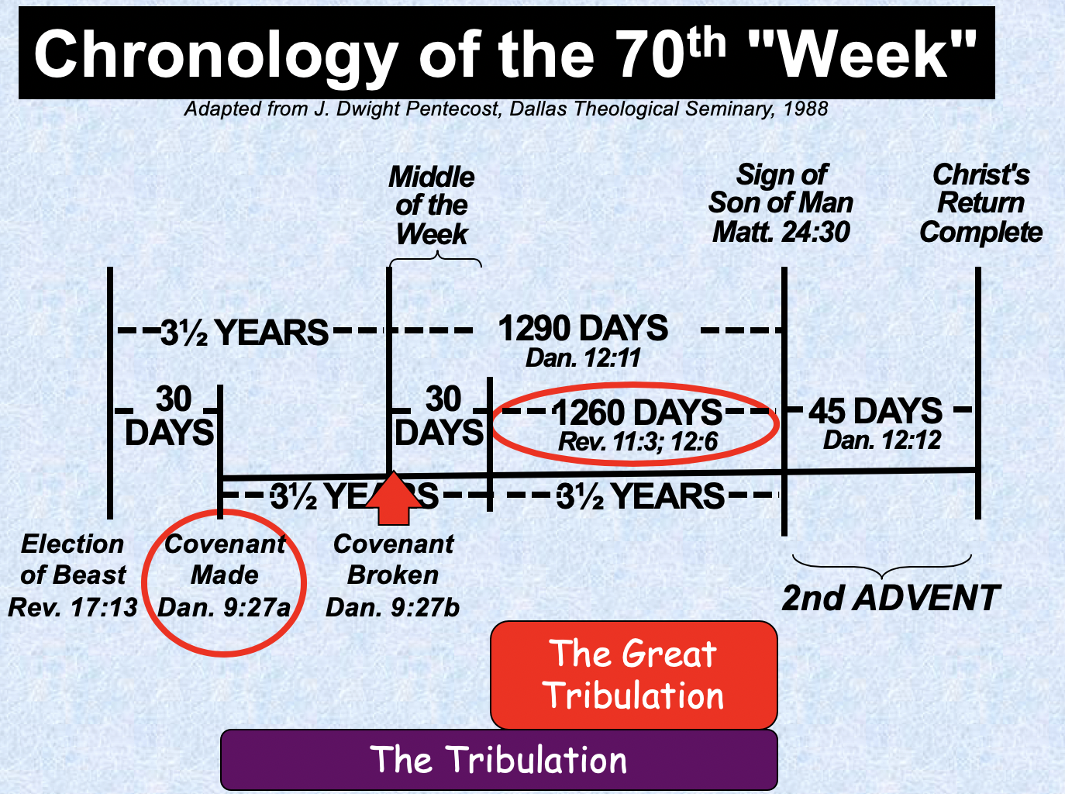

Be Affirmed
2 Thessalonians

Exegetical Outline (Steps 2-3)

Exegetical Idea: The way God through Paul affirmed others during the heresy that the day of the Lord (Tribulation) had already begun was holistic: emotional, theological and practical.

Emotional: Persecuted believers should persevere since God will judge their persecutors but make them mature (2 Thess 1). Swindoll: Persevering through affliction develops maturity.

Paul mentions his fellow-workers Silas and Timothy but not his position as an apostle to begin his letter relationally (1:1-2).

God will reward the church’s perseverance during affliction but punish their persecutors by helping the church become mature (1:3-12).

Theological: Paul teaches that the day of the Lord required the Antichrist so the church could be stable (2 Thess 2). Swindoll: Trusting amidst confusion produces stability.

Paul had not changed his views on the time of the day of the Lord meaning that they had missed the rapture (2:1-2).

Specific events will precede the day of the Lord so that the Thessalonians could see that they had not missed this event (2:3-12).

The Church will depart from the earth (or from the God’s Word) before the day of the Lord comes, leaving only an apostate church (2:3a).

The Antichrist will reveal himself to the discerning before the day of the Lord begins (2:3b-4; by signing a covenant with Israel; cf. Dan. 9:27).

The restraining ministry of the Holy Spirit in the Church will be removed from earth, allowing the Antichrist to rule (2:5-7).

Then the Antichrist will prove himself in counterfeit miracles and a powerful delusion sent by God but will be destroyed at Christ’s return (2:8-12).

Paul prays that they will stand firm in good works since they will be spared from the day of the Lord by sharing in Christ's glory (2:13-17).

Practical: The church must discipline lazy believers living off others so they will work like Paul and his companions (2 Thess 3). Swindoll: Waiting with discipline cultivates responsibility.

Paul requests prayer for the progress of the gospel and prays the same for them to model sensible behavior in light of the day of the Lord (3:1-5).

They must discipline idle believers who live off others as they wait for the rapture to shame them into responsible work (3:6-15).

Paul signs the concluding blessing and benediction to show the genuineness of the epistle (cf. 2:2b) so that the church would act on its authority (3:16-18).

Purpose or Desired Listener Response (Step 4)
The listeners will affirm others like God affirms them.

Homiletical Outline (Cyclical inductive form)

Introduction

Interest: Lately I have been thinking a lot about how we all need to be affirmed.

Need: That raises a question: Do you think it will be sufficient for you simply to recite a mantra of 1000 self-affirmations?

Subject: How does God affirm us when we face tough times?

Background: The Thessalonians were still experiencing “persecutions and trials” about a year after Paul had established the church. He had told them to be prepared for Jesus to return and deliver them from their trials, but now, months later, Jesus had not come and the church was wondering if they had already entered the tribulation.

Preview: Today, as we see how God used Paul to affirm this suffering church, we will see three ways that God affirms us when we face tough times.

Text: We will survey the entire letter of 2 Thessalonians.

(So what’s the first way that God affirms us when we face tough times?)

I. Emotionally: God develops perseverance to bring maturity (2 Thess 1).

Emotional: Persecuted believers should persevere since God will judge their persecutors but make them mature (2 Thess 1).

Paul mentions his fellow-workers Silas and Timothy but not his position as an apostle to begin his letter relationally (1:1-2).

God will reward the church’s perseverance during affliction but punish their persecutors by helping the church become mature (1:3-12).

Persevering through affliction develops maturity (Swindoll).
(What other way does God affirm us when we face tough times?)

II. Theologically: God gives us truth to bring stability (2 Thess 2).

Theological: Paul teaches that the day of the Lord required the Antichrist so the church could be stable (2 Thess 2).

Paul had not changed his views on the time of the day of the Lord meaning that they had missed the rapture (2:1-2).

Specific events will precede the day of the Lord so that the Thessalonians could see that they had not missed this event (2:3-12).

The Church will depart from the earth (or from the God’s Word) before the day of the Lord comes, leaving only an apostate church (2:3a).

The Antichrist will reveal himself to the discerning before the day of the Lord begins (2:3b-4; by signing a covenant with Israel; cf. Dan. 9:27).

The restraining ministry of the Holy Spirit in the Church will be removed from earth, allowing the Antichrist to rule (2:5-7).

Then the Antichrist will prove himself in counterfeit miracles and a powerful delusion sent by God but will be destroyed at Christ’s return (2:8-12).

Paul prays that they will stand firm in good works since they will be spared from the day of the Lord by sharing in Christ's glory (2:13-17).

Trusting amidst confusion produces stability (Swindoll).
(What’s the last way that God affirms us when we face tough times?)

III. Practically: God cultivates discipline in us to build responsibility (2 Thess 3).

Practical: The church must discipline lazy believers living off others so they will work like Paul and his companions (2 Thess 3).

Paul requests prayer for the progress of the gospel and prays the same for them to model sensible behavior in light of the day of the Lord (3:1-5).

They must discipline idle believers who live off others as they wait for the rapture to shame them into responsible work (3:6-15).

Paul signs the concluding blessing and benediction to show the genuineness of the epistle (cf. 2:2b) so that the church would act on its authority (3:16-18).

Waiting with discipline cultivates responsibility (Swindoll).
(How does God affirm us when we face tough times?)

Conclusion

God affirms us holistically (Main Idea).

Main Points: How does God affirm us when we face tough times?

Emotionally: God develops perseverance to bring maturity (2 Thess 1).

Theologically: God gives us truth to bring stability (2 Thess 2).

Practically: God cultivates discipline in us to build responsibility (2 Thess 3).

So what can we take home from 2 Thessalonians today?

How are you responding to God’s gentle affirmation during your difficulty?

Are you becoming more mature through perseverance?

Are you growing more stable by growing in truth?

Are you increasing in discipline and responsibility?

How do you affirm others in their tough times so that their trials will make them better instead of bitter?

Exhortation: Mark Eklund Story

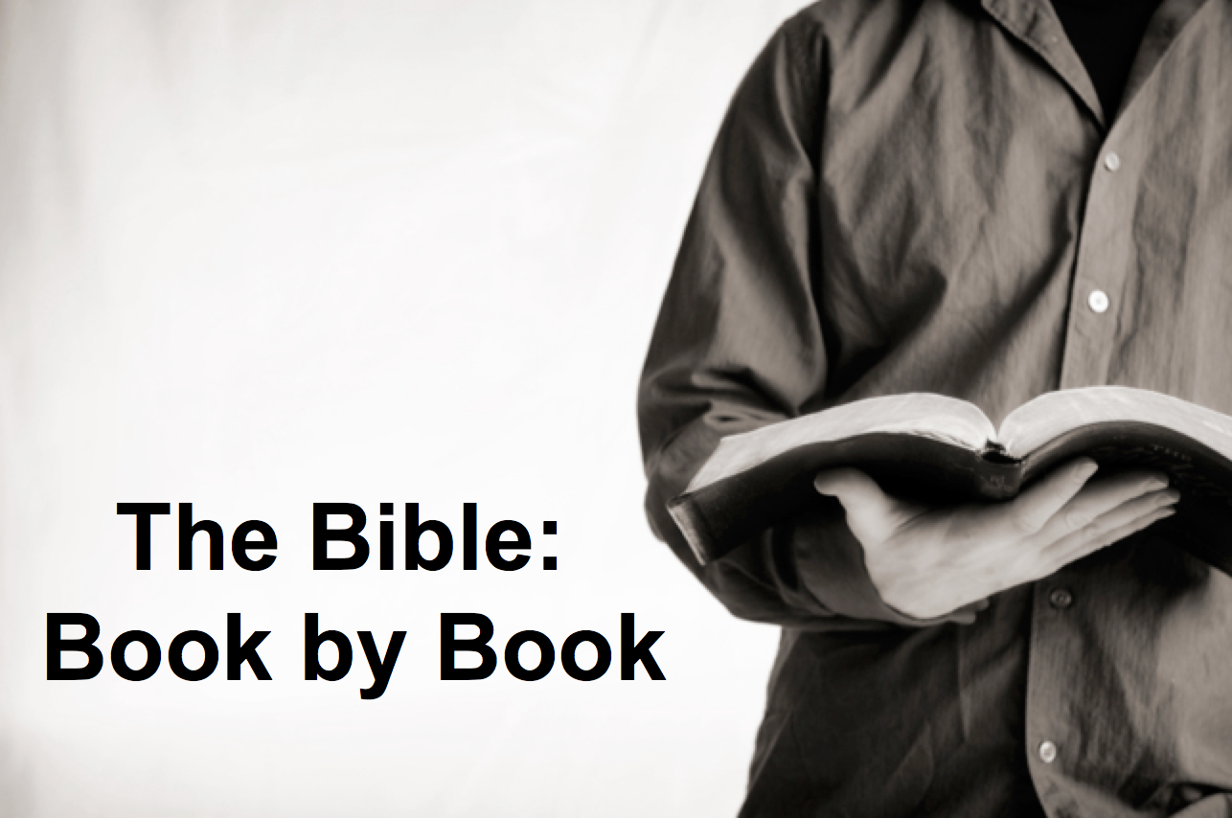

Rick Griffith
20 January 2019
Message 44 of 66

Be Affirmed
2 Thessalonians

Introduction

How does God _________________ us when we face tough times?

I. Emotionally: God develops _________________ to bring maturity (2 Thess 1).

Emotional: Persecuted believers should persevere since God will judge their persecutors but make them mature (2 Thess 1).

Persevering through affliction develops maturity (Swindoll).

II. Theologically: God gives us _________________ to bring stability (2 Thess 2).

Theological: Paul teaches that the day of the Lord required the Antichrist so the church could be stable (2 Thess 2).

Paul had not changed his views on the time of the day of the Lord meaning that they had missed the rapture (2:1-2).

Specific events will precede the day of the Lord so that the Thessalonians could see that they had not missed this event (2:3-12).

Paul prays that they will stand firm in good works since they will be spared from the day of the Lord by sharing in Christ's glory (2:13-17).

Trusting amidst confusion produces stability (Swindoll).

III. Practically: God cultivates _________________ in us to build responsibility (2 Thess 3).

Practical: The church must discipline lazy believers living off others so they will work like Paul and his companions (2 Thess 3).

Waiting with discipline cultivates responsibility (Swindoll).

Conclusion

God affirms us ______________________ (Main Idea).

How are you responding to God’s gentle affirmation during your difficulty?

How should you affirm others so that their trials will make them better instead of bitter?

Download this sermon PPT and notes for free at BibleStudyDownloads.org/resource/new-testament-preaching/
Listen to this message online at cicfamily.com/sermon-listing/
2 Thessalonians

Tribulation Corrections

Persevere in Persecution |  | Day Still Future |  |  | Discipline the Idle
Chapter 1 |  | Chapter 2 |  |  | Chapter 3
Emotional |  | Theological |  |  | Practical
Encouragement  in Persecution |  | Explanation  of the Day |  |  | Exhortation  in Body Life
Discouraged  Believers |  | Disturbed  Believers |  |  | Disobedient  Believers
Correct  Perspective |  | Correct  Doctrine |  |  | Correct  Behaviour
Salutation  1:1-2 | Reward vs. Judgment  1:3-12 | Pretrib  Teaching  2:1-2 | Antichrist  Prerequisite  2:3-12 | Stand  Firm  2:13-17 | Prayer  Requests  3:1-5 | Discipline  Idle  3:6-15 | Blessing  Given  3:16-18
Corinth

Late Summer AD 51

Key Word: Tribulation

Key Verse: “Do not become easily unsettled or alarmed by some prophecy, report or letter supposed to have come from us, saying that the day of the Lord has already come. Don’t let anyone deceive you in any way, for that day will not come until the rebellion occurs and the man of lawlessness is revealed, the man doomed to destruction”
(2 Thessalonians 2:2-3).

Summary Statement: The way Paul affirmed others during the heresy that the day of the Lord (Tribulation) had already begun was holistic: emotional, theological and practical.

Application: How does your view of the future spur your commitment to serve Christ?

Richard C. Halverson, No Greater Power (Portland, OR: Multnomah, 1986), 67; cited in Charles R. Swindoll, Steadfast Christianity: A Study of Second Thessalonians (Fullerton, CA: Insight for Living, 1986), 1.

