Crossroads International Church Singapore Dr. Rick Griffith
Title
21 April 2019 (Easter) Message 52 of 66
NLT 50 Minutes
Be Christlike
Book of Philippians

Topic: Christlikeness
Subject: What happens when we imitate Christ’s resurrection attitude?
Complement: Imitating Christ's resurrection attitude brings joy, humility, protection and peace.
Purpose: The listeners will mimic Jesus in one new way.
Attribute: We worship God Our Example
Reading: Philippians 2:5-11
Closing Song: Yet Not I but Through Christ in Me
Benediction: Philippians 3:12-14

Introduction
Video

Interest: Years ago a Czech father killed his own dear son to save others on a passing train. The boy did not accidentally die, but he willingly risked his life for the apathetic passengers. The agony of the father can hardly be fathomed. What an example of sacrifice! Don’t you admire him?
Most
(2 slides)

Need: Who is your ultimate example in life? Who do you admire most? Who do you want to be like more than anyone else?
Admire?

A century ago the most admired people were scientists.

Today those most admired are actors who make a pretty good living by pretending to be someone else.
2018 Admired

Actually, in 2018 the most admired man was Barak Obama and woman was Angelina Jolie.

Theme: But what I find amazing is that Jesus does not top every list. He—more than anyone—should be our example in life!
Where is Jesus?
God Raised Son
Cross

I know that the followers of Jesus never reach up to his ideal, but Jesus himself is the most amazing person ever to live.

Who else left heaven to take on humanity?

Who else was completely innocent any sin but willingly gave his life for all?

Who else came back from the dead and appeared to over 500 people?

The boy did not accidentally die, but he willingly risked his life for the apathetic passengers.

The agony of the Czech father to sacrifice his son aptly depicts God's grief to put Jesus to death even for apathetic people like us. What an example of sacrifice!

Yet God also brought Jesus back to life. We worship a risen Savior!

Now none of us could ever imitate the actions of Jesus. He lived in a different time and place. He was single whereas God’s will for most of us is marriage. We are told WWJD? (What Would Jesus Do?).
How Be Like Jesus

But this can become ridiculous like the t-shirt that says “Jesus took naps. Be like Jesus—Mark 4:38.
Naps
1:1-2
Phil
(4 slides)
• 70x

The reality is that we are told to mimic the attitude of Christ in the book of Philippians.
Attitude

This is the key verse of Philippians in 2:5.
Phil 2:5

It clues us in that the theme of this letter relates to the results of imitating Christ’s attitude.
Results Theme

Subject: So the letter of Philippians answers this question: What happens when we imitate Christ’s resurrection attitude? What are some results when we commit ourselves to respond to life with the same perspective that Jesus had—that kind of view or thinking that the risen Savior has?
Subject

Background: Paul grasped the reality of the resurrected Christ and it revolutionized this life in many practical ways.
Paul

By the time Paul wrote the Philippian letter we will see today, he had spent the last four years in two prisons with a shipwreck between them!

If we need easy circumstances to show the attitude of Jesus, then Paul certainly would be no example!
Prominent

But his letter is FILLED with references to Jesus.

I have gone through it verse by verse and see Christ noted over 70 times in 4 chapters!

While other themes are prominent, the key theme is imitating the attitude of Christ.
Imitating Attitude

Preview: We have many wonderful benefits of imitating Jesus, but today we will narrow it down to four simple effects in our lives when we live out Christ’s attitude.

Text: Today we will survey the whole book of Philippians to see the results of mimicking the attitude of Jesus.

(What’s the first thing that happens when we imitate Christ’s resurrection attitude?)

Imitating Christ’s attitude brings joy (Phil 1).
[Mimicking Jesus gives us the same joyfulness that Christ had.]

Paul's introduces himself and Timothy warmly to begin on an affectionate note (1:1-2).

Authors: Paul calls himself and Timothy servants to set a tone of affection (1:1a).

Recipients: The Philippian congregation and leaders received its holiness in Christ (1:1b).

Salutation: The Father and Son are identified as the Source of favor and harmony (1:2).
Thanks
1:3-6
Title
Title
Title
Title
Title
Title
Title
Title
Title
Title

Paul gives thanks and prays for them to have Christ's attitude of righteousness (1:3-11).

Paul thanks them for partnering in their giving with the promise of God’s blessing (1:3-8).

Paul prays for their love to grow in both knowledge and virtue until the rapture (1:9-11).
Happy
(4 slides)

Paul rejoices that his captivity spread the gospel so they will show joy in their trials (1:12-30).
Joy Attitude

Paul rejoices that guards trust Jesus so the church will rejoice in its suffering (1:12-18a).
1:12-18a
(4 slides)
Phil
(3 slides)

Prison helped Paul preach the gospel even farther rather than hindering it (1:12-14).

Paul even rejoiced that some selfishly preached the gospel (1:15-18a).
Chained
(4 slides)

Paul rejoices whether executed or freed since both have their advantages (1:18b-26)!
Jesus Joy
(3 slides)

They must contend against their persecutors by obeying Jesus in unity and joy (1:27-30).

(What else happens when we imitate Christ’s resurrection attitude?)

Imitating Christ’s attitude brings humility (Phil 2).
[Mimicking Jesus leads us to be meek.]

We must have unity through a humble concern for one another (2:1-4; see p. 186d).
2:1-4
(5 slides)

Four humble individuals exemplify selfless concern to lead to the unity of the body (2:5-30).
Christ
(10 slides)

Christ modeled humility as our best example since he refused his rights as God (2:5-11).
3 Others
(2 slides)
Legalism
(7 slides)

Paul modeled humility in selfless service so they should stop their complaining (2:12-18).

Timothy modeled humility so Paul planned to send him to the church (2:19-24).

Epaphroditus modeled humility in his concern for the church (2:25-30).

(What else happens when we imitate Christ’s resurrection attitude?)
Phil
(3 slides)

Imitating Christ’s attitude brings protection (Phil 3).
[Mimicking Jesus guards us from either starving or indulging our flesh.]

Christlikeness guards us from legalism by denying our flesh (3:1-16).

Paul warns the church against legalists (3:1-3).

Paul used to have confidence in his works and pedigree (3:4-6; cf. p. 186h).

Paul renounces his self-righteousness by seeking Christlikeness above all else (3:7-16).

All his gains are garbage compared to knowing Christ (3:7-11; see p. 186h).

The church should seek Christlikeness like Paul (3:12-16).

*Have you renounced personal accomplishments to pursue Christlikeness (see p. 186i)?

Christlikeness protects us from libertines who indulge their flesh (3:17-21).
License
(4 slides)

Libertines live for today by indulging their flesh, so avoid them (3:17-19; see p. 186j).
Title
Title
Title
Title
Title
Title
Title
Title

Believers live for tomorrow by anticipating their glorified bodies (3:20-21).

(What else happens when we imitate Christ’s resurrection attitude?)

Imitating Christ’s attitude brings peace (Phil 4).
Phil
(3 slides)
[Mimicking Jesus leads to harmony with people and God.]
Women
(5 slides)

Paul pleads for peace between two arguing women (4:1-3).

Paul promises peace with God by following some simple commands (4:4-9).
God
(4 slides)

Rejoice (4:4).

Be gentle with others (4:5).

Pray in all circumstances (4:6-7).

Think about praiseworthy things (4:8-9).
4 Ways to Peace

Paul rejoices with peace in all circumstances (4:10-20).

Paul closes his letter with affectionate greetings to show his deep care for them (4:21-23).
Subject

(So what happens when we imitate Christ’s resurrection attitude? This book givers four results…)

Conclusion
Main Idea
Prayer

Imitating Christ's resurrection attitude brings joy, humility, protection and peace (MI).

Better than imitating the naps of Jesus, realize that you can really be like him!
T-Shirts
(2 slides)

Application: Which of these four traits of Jesus do you need most today? How?
Summary & Application

His joy? Do you have happiness through happenings or a joy transcending your circumstances?
Results

His humility? Are you taking credit for the work of Jesus in you?

His protection? Are you out of balance: towards legalism or license?

His peace? Do you lack a “settledness” in your walk?
Phil 4:13

Exhortation: You can mimic Jesus in any of these areas with his help (Phil 4:13).

Prayer

Sing “Yet Not I but Through Christ in Me”

Preliminary Questions

Verses Questions

Context: What did the author record just prior to this passage?

Purpose: Why is this passage in the Bible?

Background: What historical context helps us understand this passage?

By the time Paul wrote the Philippian letter we will see today, he had spent the last four years in two prisons with a shipwreck between them!

If we need easy circumstances to show the attitude of Jesus, then Paul certainly would be no example!

Questions

Tentative Main Ideas

Text

Illustrations That Apply

And Singapore rated the gap between President Obama and President Trump wider than any other country!

Or another crazy example is a 30-year old man who had 21 plastic surgeries to look like Jesus. These cost US$215,000!

New Testament Survey Notes
Philippians

Results of Imitating Christ’s Attitude

Joy |  |  | Humility |  | Protection |  | Peace
Chapter 1 |  |  | Chapter 2 |  | Chapter 3 |  | Chapter 4
Joy (5x) |  |  | Joy (7x) |  | Joy (1x) |  | Joy (4x)
Attitude (1x) |  |  | Attitude (7x) |  | Attitude (8x) |  | Attitude (4x)
Suffering |  |  | Submission |  | Salvation |  | Sanctification
Salutation  1:1-2 | Thanks & Prayer  1:3-11 | In Prison Ministry  1:12-30 | Exhorted  2:1-4 | Exemplified  2:5-30 | From Legalism  3:1-16 | From Indulgence  3:17-21 | With People  4:1-3 | With God  4:4-9 | Always  4:10-20  –  Greetings  4:21-23
Rome

Early Spring AD 62 (first Roman imprisonment)

Key Word: Attitude

Key Verse: “Your attitude should be the same as that of Christ Jesus”
(Philippians 2:5).

Summary Statement: The results of imitating Christ’s resurrection attitude are joy, humility, peace, and protection from false teachers and disunity in the church.

Application: How do you need to show a more Christ-like attitude during difficulty?

Note: Words for “joy” total 17 times in the letter but words for “attitude” total 20 times.
Philippians

Introduction

I. Title: The Greek for Philippians (Pro.j Filipphsi,ouj To the Philippians) follows the standard practice of naming the Pauline Epistles after their recipients.

II. Authorship

A. External Evidence: Scholars of nearly all persuasions believe Paul wrote Philippians. The only exception is perhaps F. Baur of the radical 19th century German critics.

B. Internal Evidence: Philippians claims to be written by Paul (1:1). This is confirmed in the references to his companion Timothy (1:1; cf. Acts 16) and the description the author gives of himself (3:4-6).

III. Circumstances

A. Date: Paul notes his chains (1:14) in Rome (palace guard 1:13), which places the letter in his first Roman imprisonment (AD 60-62). Philippians probably was the last of the four prison epistles since Ephesians lacks mention of any expected release, and Colossians and Philemon were written at about the same time as Ephesians or shortly afterwards (AD 60-61). Therefore, the best date for Philippians is early spring AD 62. Paul wrote just before his release in answer to the church's prayers (1:19).

B. Origin/Recipients: The palace guard (1:13) and Caesar's household (4:22) show that Paul wrote during his Roman imprisonment (not his captivity in Ephesus or Caesarea). Therefore, he wrote from Rome and sent the letter to the colony of Philippi (1:1b) by Epaphroditus (2:25-30).

C. Occasion: Paul’s “Macedonian Call” on his second missionary journey led him to plant the church at Philippi (Aug-Oct AD 50). Lydia, others, and the Philippian jailer responded to the gospel, but then government officials asked Paul and Silas to leave (Acts 16). Paul returned to the city six years later, but probably only for a few days (between June-Nov AD 56; Acts 20:1, 6). He wrote this thank you letter to the church six years later (AD 62) after the church had sent Epaphroditus with a gift (4:18). Epaphroditus almost died of an illness, but when he recovered Paul sent him back to the Philippians with the letter (2:25-30). Paul’s immediate motive for writing was to express his affection and thanks for the church's generosity (other purposes are listed in the “Argument” section below). Yet another key purpose was to encourage perseverance (1:27-28; 2:12; 3:13-15; 4:1) against Judaizers who sought to require obedience to the Mosaic law (1:27-28; 3:2-4, 17-19; cf. Acts 15:1-6; Gal. 1:6-9; 2:1-16; 3:1-5; 5:7-10; 6:12-13). The way the Philippians could persevere was to imitate Christ’s attitude, so Paul emphasized the results of this type of resurrection spirit.

IV. Characteristics

A. Philippians is not a systematic treatise of formal doctrine, but it contains the most significant christological passage in the Pauline epistles (2:5-11), cited as an example of humility. This passage is often called the kenosis passage since it refers to Christ's emptying (Gr. keno,w “to empty”) his rights (not deity) as God. These seven verses provide profound insights into his preexistence, incarnation, humiliation, and exaltation (TTTB, 408).

B. The authorship has rarely been debated for Philippians, but the unity has been strongly challenged. Some suggest several interpolations by Paul at different times. Particularly at issue are: (1) a sudden change in tone from affection to warning and from the posture of fellow worker to an assertion of authority (3:1a contrasts 3:1b) and (2) the so-called poetic hymn in the midst of prose (2:6-11). The first issue is not significant since Paul certainly could change disposition as he writes and secondly, the insertion of a well-known or even Pauline “hymn” does not affect the inspiration of the letter.
C. Central Theme: Philippians is one of the most studied biblical books, resulting in differing ideas on the theme. Here are some examples of the central idea (from least likely to most likely):

1. Living the Christian life (Robert P. Lightner, “Philippians,” BKC, 2:647) is offered as a theme but is too general since all NT books exhort Christian living.

2. Pastoral: Paul's warmth here is unmatched by any other epistle. “He pours out his heart [to these] whom he prizes highly and loves profoundly” (Hendriksen, NTC, 39; cf. Lightfoot, 66; Martin, NCBC, vii). After all, this was the first church ever in Europe. But this theme does not account for the exhortations and doctrinal content.

3. Joy: The most popular theme for Philippians is that believers can rejoice despite their circumstances due to Christ (Benware, 222; Wiersbe, Be Joyful; Briscoe, Bound for Joy; William D. Lawrence, “Overcoming Under the Circumstances,” DTS Video Series, 1984, 4). Joy during trials is certainly an emphasis since the words “joy” or “rejoice” or “glad” appear 17 times in this four-chapter book (1:4, 18 [2x], 25, 26; 2:2, 17 [2x], 18 [2x], 28, 29; 3:1; 4:1, 4a, 4b, 10). Yet this theme downplays its doctrinal elements too much.

4. The Person of Christ (Alec Motyer, The Message of Philippians, BST, 22-23) is prominent as his name is noted 70 times or more. The following lists every occurrence of “Christ,” “Jesus,” “Lord,” or pronouns referring to Him in the book:

Characteristics | Chapter 1 | Chapter 2 | Chapter 3 | Chapter 4
Deity (God) |  | 2:6
Pre-eminent (Lord) | 1:2, 20 | 2:9-11 | 3:20-21
Returning in Power | 1:6, 10 | 2:10, 16 | 3:20-21 | 4:5
Sacrificial (Cross) | 1:29 | 2:8 | 3:18
Savior |  |  | 3:20
Glorified Body (Resurrected) |  |  | 3:10, 21
Incarnation (man) |  | 2:6-8
Humble |  | 2:6-8
Obedient |  | 2:8
Selfless Interests (Servant) |  | 2:6, 21
Has a Ministry Plan |  | 2:21, 30
Provider of Needs |  |  |  | 4:19
Helper via the Spirit | 1:19
Answers Prayer | 1:19
Gives Faith to Believe | 1:29
Gives Privilege of Service | 1:1, 14-18, 22
Gives Ability to Glorify Him |  |  | 3:3
Gives Affection for Others | 1:8 | 2:29
Gives Righteousness (Saints) | 1:1, 10-11 |  | 3:9 | 4:21
Gives Encouragement |  | 2:19
Gives Knowledge of Himself |  |  | 3:8, 10
Gives Glory to God | 1:11
Gives Grace | 1:2 |  |  | 4:23
Gives Comfort to Us |  | 2:1
Gives Comfort for Others |  | 2:1
Gives Purpose for Ministry |  | 2:16
Gives Life | 1:21
Gives Ability to Do Everything |  |  |  | 4:13
Gives Joy (Contentment) | 1:18, 26 | 2:29 | 3:1 | 4:4, 10-13
Gives Confidence (Ability to Stand) | 1:13-14 | 2:19, 24 |  | 4:1, 19
Gives Peace | 1:2 |  |  | 4:2, 7
Gives Suffering | 1:13, 29 |  | 3:10
Gives Rewards | 1:21, 23 |  | 3:7-8, 14
Gives Humility |  | 2:5
Gives Unity | 1:15-17 | 2:1-2 |  | 4:21-22
Gives New Bodies (Resurrection) |  |  | 3:11, 21
Gives Christlikeness (Exalts Himself in Us) | 1:20, 27 | 2:5 | 3:10-14

5. Multipurpose (TTTB, 408): Paul had many purposes in composing this epistle to the Philippians. He expresses affection for them (1:7), thanks them for their gift (1:5, 7; 4:10-19), updates them on his missionary work in prison (1:12f.), encourages them in their growth (1:27f.), corrects a problem of disunity in the church (2:1-4, 14; 4:2), encourages them of Epaphroditus' recovery (2:25f.), warns of false teaching (1:28)—especially legalism (3:2-4) and libertinism/ antinomianism (3:17-19)—and exhorts them to express joy in their trials as he had in his own sufferings (3:1; 4:4).

6. Imitating the Attitude of Christ: While Philippians emphasizes the person of Christ, the application of this truth is the focus of the book. Having Christ’s attitude (or mind) appears to be the most all-encompassing purpose, with 2:5-11 forming the heart of the book (Moisés Silva, WEC, 19-20; cf. see “Argument” below). This theme goes deeper than joy (or any other positive characteristic in the book) since it explains how one can experience these qualities during difficulty (cf. p. 186k).

Argument

As good as the above purposes are, none sums up the book as a whole except the last one—to have the mind or attitude of Christ. Clearly Christ is the main subject as his name appears 70 times, but some key verbs convey the idea of imitating his thinking, attitude, or mind appear twenty or more times (frone,w “think, form opinion, set one's mind on, be minded, or disposed” [BAGD] 1:7; 2:2a, 2b, 5; 3:15a, 15b, 16 [Byz.], 19; 4:2, 10a, 10b; h`ge,omai “think, consider, regard, lead, guide” [BAGD] 2:3, 6, 25; 3:7, 8a, 8b; skope,w “notice, consider” 2:4; 3:17; logi,zomai “reckon, consider” 3:13; 4:8). This is supported with many “knowledge” terms (esp. 1:9-11; 3:8-10) “which include, but are not restricted to, purely intellectual concerns” (Silva, 20).

Therefore, the concept of imitating Christ's attitude in difficulty appears more times (over 20) than the theme of rejoicing (17 times) and should be given at least as much weight (3:10). Each chapter bears out this emphasis since having Christ's attitude produces: joy in adversity (Phil 1), humility leading to unity (Phil 2), protection from legalistic or libertine teaching (Phil 3), and peace with God and man in all circumstances (Phil 4). Paul wrote the Philippians to let them know that “as a man thinks, so is he” (Prov 23:7) and the best thinkers do so with Christ's attitude. Paul states the key verse in this respect in Philippians 2:5, “Your attitude should be the same as that of Christ Jesus” (NIV), which begins the heart of the book (2:5-11). A related concept is that of mimicking Paul (3:17; 4:9).

Synthesis

Results of imitating Christ’s attitude

1 Joy
1:1-2 Salutation
1:3-11 Thanksgiving/prayer
1:12-30 Joy in prison ministry

2 Humility
2:1-4 Exhorted
2:5-30 Exemplified in…
2:5-11 Christ
2:12-18 Paul
2:19-24 Timothy
2:25-30 Epaphroditus

3 Protection
3:1-16 From Legalists
3:1-3 Warning against legalists
3:4-6 Paul's former confidence in the flesh
3:7-16 Paul's present pursuit of Christlikeness
3:17-21 From Libertines
3:17-19 Warning against libertines
3:20-21 Christ's power
4 Peace
4:1-3 Peace between two women
4:4-9 Peace with God
4:10-20 Peace in all circumstances
4:21-23 Affectionate greetings

Outline

Summary Statement for the Book
The results of imitating Christ’s resurrection attitude are joy, humility, peace, and protection from false teachers and disunity in the church.

Imitating Christ’s attitude brings joy like Paul had in prison by seeing the gospel advance, so the Philippians should have while fighting their enemies (Phil 1).

Paul's introduces himself and Timothy as God's servants and greets the church with God's grace and peace as a foretaste of his warmth and affection in the letter (1:1-2).

Authors: Paul calls himself and Timothy servants to set a tone of affection (1:1a; cf. he does not refer to his apostolic authority as in Gal. 1:1).

Recipients: The Philippian congregation and leaders received its holiness in Christ (1:1b).

Salutation: The Father and Son are identified as the Source of favor and harmony (1:2).

Paul thanks them for their gifts and prays for their love to multiply so that Christ's attitude would produce greater righteousness in them (1:3-11).

Paul affectionately thanks them for partnering in their giving with the promise of God’s blessing on it (1:3-8).

Paul prays that the church’s love would grow in both knowledge and righteousness until the rapture (1:9-11).

Paul rejoices that his captivity spread the gospel to exhort them to rejoice with the same joyful attitude in their own trials (1:12-30; see p. 186c).

Paul rejoices for Roman guards trusting Jesus due to his imprisonment so the church will rejoice in its own persecutors (1:12-18a; cf. p. 186c).

The church thought that prison hindered Paul from proclaiming the gospel, but he says that it advanced it even farther (1:12-14).

Paul was so selfless that he even rejoiced that some preached the gospel from selfish motives (1:15-18a).

Paul rejoices that whether he is executed or released from prison doesn’t matter since both have their advantages (1:18b-26)!

Persecutors | Paul
“Aha! You like to share about Jesus? I’ll imprison you!” | “Good! This will give me more time to pray, write letters to the churches, and share Christ with soldiers guarding me.”
“Well, then, I’ll torture you!” | “Thank you, for in this way I can participate in the sufferings of my Master, Jesus.”
“Oh yeah? Then I’ll kill you!” | “This is the best option yet, for then you will usher me into his presence!”

The church should faithfully contend against their own persecutors by living worthy of Christ in unity and rejoicing (1:27-30).

Imitating Christ’s attitude brings humility modeled in Christ, Paul, Timothy, and Epaphroditus to exhort the church to unity (Phil 2).

Each believer should work towards unity through a humble concern for one another to prevent church divisions (2:1-4; see p. 186d).

Four humble individuals exemplify selfless concern to lead to the unity of the body (2:5-30).

They should imitate Christ’s humility as believer’s ultimate example since he renounced his equal rights with the Father (2:5-11).
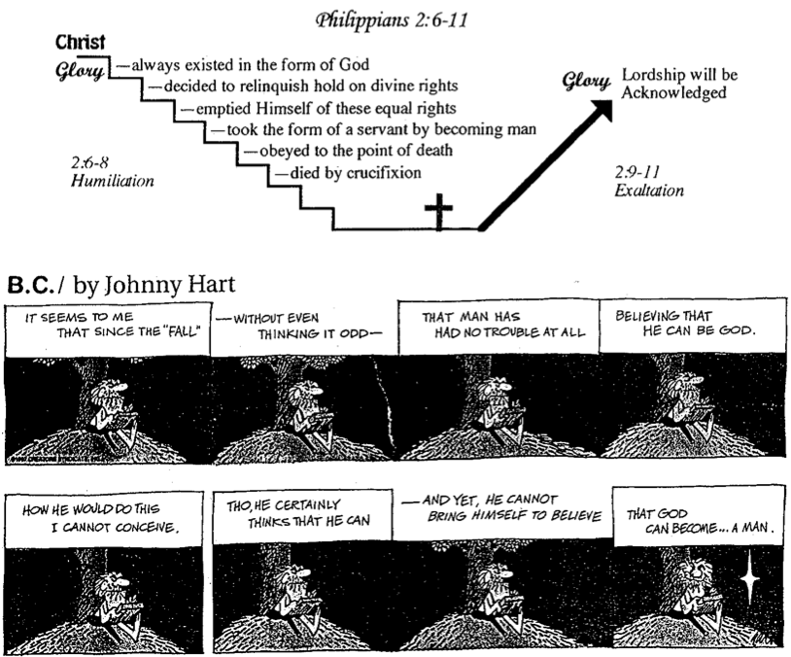

They should imitate Paul’s humility in selfless service to put away divisive complaining (2:12-18; see pp. 186e-f).

They should imitate Timothy’s humility as an example of Christ's selfless attitude so Paul planned to send him to the church (2:19-24).

They should imitate Epaphroditus as a model of humility since he was concerned that the church was distressed over his illness (2:25-30).

Imitating Christ’s attitude brings protection from the extremes of law and liberty to give them balance instead of self-righteousness or excess (Phil 3).

Christlikeness should be our goal instead of self-righteousness to guard from legalists (Judaizers) whose confidence was in denying their flesh (3:1-16; see p. 186g).

Paul warns the church against legalists (3:1-3).

Paul used to be like the Judaizers when he placed confidence in his own seemingly righteous deeds and pedigree (3:4-6; cf. p. 186h).

Paul renounces his self-righteousness by modeling one who seeks Christlikeness above all else (3:7-16).

a. All his advantages are garbage compared to knowing Christ (3:7-11; see p. 186h).

b. The church should seek Christlikeness like Paul (3:12-16).

*Have you renounced personal accomplishments to pursue Christlikeness (see p. 186i)?

They should seek Christlikeness since Jesus will give them new bodies to protect them from libertines indulging their flesh (3:17-21).

Libertines live for today by indulging their flesh, so avoid them (3:17-19; see p. 186j).

Believers live for tomorrow by anticipating their glorified bodies (3:20-21).

Imitating Christ’s attitude brings peace with God and man at all times through Christ's strength for unity and contentment (Phil 4).

Paul pleads for peace between two women by having Christ's attitude of standing firm for unity to prevail in the assembly (4:1-3).

Paul promises peace with God by following some simple principles (4:4-9).

Rejoice (4:4).

Be gentle with others (4:5).

Pray in all circumstances (4:6-7).

Think about praiseworthy things (4:8-9).

Paul rejoices with peace in all circumstances to let them know that he appreciates their gift but his and their strength and contentment lie in Christ (4:10-20).

Paul closes his letter with affectionate greetings to show his deep care for them (4:21-23).

Philippi in the Time of Paul
Bible Visual Resource Book, 247

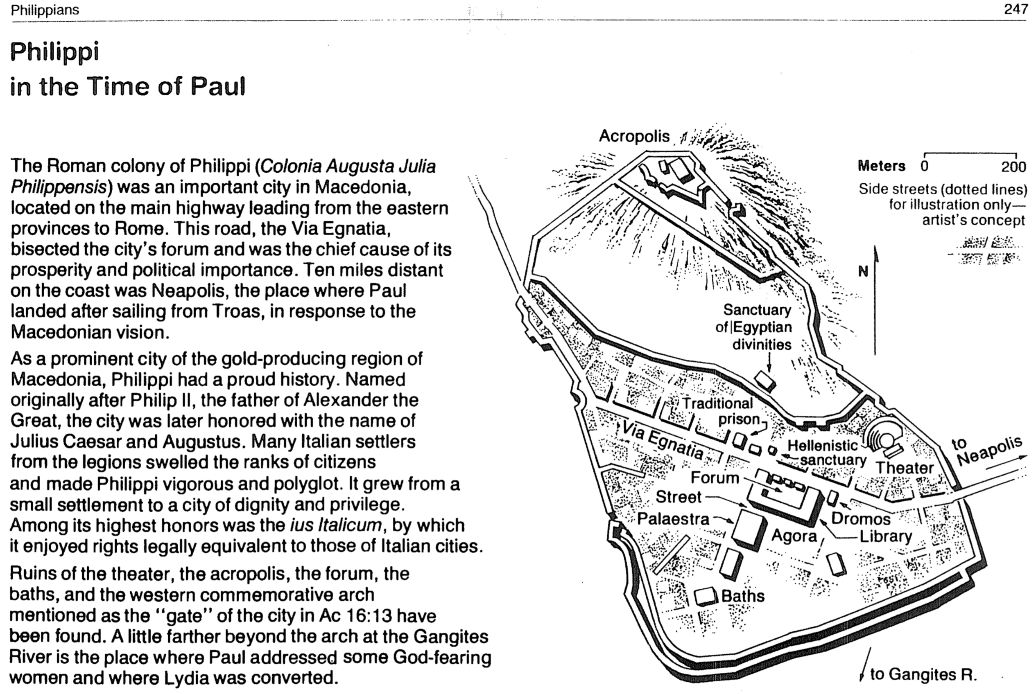

Happiness verses Joy

Happiness | Joy
External | Internal
Dependent on circumstances | Independent of circumstances
Emotional response | Act of the will
Having what  you want | Wanting what  you have
Euphoria | Contentment
Effect | Cause
Result | Foundation
Inconsistent | Consistent
Temporary | Eternal

Two Ways to Relate to Others
Philippians 2:1-4

Selfish | Selfless
Produces grumbling  (2:14) | Produces joy  (2:2a)
Leads to division  (4:2) | Leads to unity  (2:2b)
Proud  (2:3a) | Humble  (2:3b)
Considers self better than others  (2:3a) | Considers others better than self  (2:3b)
Looks out for self  (2:4a) | Looks out for others  (2:4b)
Imitates Satan | Imitates Christ  (2:5)

Results of a Bad Attitude
Philippians 2:14-16

Those who invested in us will wish they had invested in others
We won’t be blameless and innocent
We won’t stand out with a positive impact
If we complain and argue
Results of a Good Attitude
Philippians 2:14-16

Those who invested in us will rejoice that their efforts had been worth it
If we do everything without complaining and arguing
We will be blameless and innocent, children of God above reproach
We will shine like stars in the universe
Balance in the Christian Life

Legalism | A Godly Balance | Libertinism
Phil. 3:1-3 | Phil. 3:4-16 | Phil. 3:17-20
Legal = Law Only | Standards and Liberty | Liberty = No Law
Excessive Rules | Only Biblical Rules | License for Everything
Actions are Everything | Actions are Something | Actions are Unimportant
Highly Structured | Some Structure | No Structure
Pharisee-like | Christlike | Glutton-like
“god” is their Traditions | God is Christ | “god” is their Stomach
Starves the Flesh | Controls the Flesh | Indulges the Flesh
Claim of Perfectionism | In Process (3:12-13) | Practice of Fatalism
Think they’ve Arrived | Know they Haven’t | Don’t Care if they Do
Confidence  in Flesh (3:3) | Confidence  in Christ (3:7) | Confidence  in Shame (3:19c)
Righteousness  from the Law (3:9a) | Righteousness  by Faith (3:9b) | Righteousness  Not Pursued (3:19d)
No Movies | Wholesome Movies | All Movies
No TV | Wholesome TV | All TV
No Music | Wholesome Music | All Music
No Wine for Merit | No Wine/Moderation | Drunkenness
Unclean Foods | Moderation | Gluttony
“Christian Sabbath” | Rest | Frivolity
Celibacy Required | Celibacy for Ministry | Sexual Immorality
Salvation can be Lost | Eternal Security | Salvation can’t be Gained

Paul’s Pedigree (Phil. 3:4-6)
Circumcised the eighth day | This sign of participation in the Abrahamic Covenant separated Paul from pagans and was performed on him the exact day the OT prescribed (Gen. 17:11-12)
Of the people of Israel | Paul was a pure-blooded member of this race chosen by God himself (not even a proselyte, who was often viewed as “second class”)
Of the tribe of Benjamin | This tribe was one of the smallest, yet it boasted Israel’s first king (Saul)–so Paul was not from a disreputable tribe like Dan, Reuben, etc.
A Hebrew of Hebrews | Paul did not adopt Greek ways even though he grew up in a Greek city (Tarsus)
In regard to the law, a Pharisee | This sect adhered more strictly to the Mosaic law than any sect in mainstream society
As for zeal, persecuting the church | Even most Pharisees did not actively seek to do away with Messianic believers
As for legalistic righteousness, faultless | Paul followed all 613 Pharisaical laws without exception

Excrement for Christ
Philippians 3:7-8

Paul considered his life’s best accomplishments mere “dung” (KJV) compared to knowing Christ. Which of the following items are potential sources of pride in your own life?

Personal
Occupational position/title
Income level
Power
Education/Degree(s)
Other

Social
Social position
Friends
Spouse
House
Car
Neighborhood
Country club
Golf/sports
Children
Other

Spiritual
Church position/title
Tithes, offerings, gifts
Church membership
Ministry experience or giftedness
Bible knowledge
Humility
Other

Physical
Personal Appearance
Strength
Health
Abilities
Other

Is your attitude toward these things like Paul’s? Are they “rubbish” to you?

Modern License
Philippians 3:18-19

Text | Interpretation | Mormons | Holy Laughter
Live as enemies of the cross of Christ | They oppose salvation by faith | Salvation by works | Do not preach the cross
Their destiny is destruction | They are unsaved | Claim that all are saved but are not even saved themselves | Claim to be Christians but if so, why don’t they preach Christ?
Their god is their stomach | Their real goal is pleasure | Goal is to be a god to have sex with as many celestial wives as possible | Goal is to feel good
Their glory is in their shame | They’re proud about things that they should be ashamed of | Temple polygamy is the highest goal | The spiritual heights is to laugh uncontrollably and cluck like a chicken
Their mind is on earthly things | They have  “here-and-now” priorities | “Become a god for ego and sex” | “Don’t use your mind and you will feel great!”

Imitating Christ

Mimicking Christ is one of the most practical suggestions of how to live the Christian life. If each of us could simply ask, “What would Jesus do?” in a given situation, and then actually do it, then our behaviour would radically change for the better.

This challenge is presented in Charles M. Sheldon’s book, In His Steps, written in 1896—over 100 years ago but still in print (Copyright: Chosen Books, 1984; Grand Rapids: Kregel, 1989; Grand Rapids: Spire [Baker], 1994; Uhrichsville, OH: Barbour, 2002. 251 pp.). Due to a copyright error, sixteen publishers began publishing it in the US alone and soon it was printed in 45 countries so that a conservative estimate is 22 million copies in circulation—the world’s record next to the Scriptures! This fiction depicts what happens when a small group of Christians commit themselves to live as Jesus would for an entire year.

Imitating Jesus is not only the theme of the book of Philippians (2:5). Throughout the New Testament we are exhorted to imitate Christ…

In His Character
“For those God foreknew he also predestined to be conformed to the likeness of his Son” (Rom. 8:29)

In His Joyful Suffering
“You became imitators of us and the Lord; in spite of severe suffering, you welcomed the message with the joy of the Holy Spirit” (1 Thess. 1:6)

In His Maturity
“until we all reach unity in the faith and in the knowledge of the Son of God and become mature, attaining to the whole measure of the stature of Christ” (Eph. 4:13)

In His Patience
“But for that very reason I was shown mercy so that in me, the worst of sinners, Christ Jesus might display his unlimited patience as an example for those who would believe and receive eternal life” (1 Tim. 1:16)

In His Perfection
“We proclaim Him, admonishing and teaching everyone with all wisdom, so that we may present everyone perfect in Christ” (Col. 1:28; Matt. 6:33)

In His Submission to Unjust Suffering
“To this you were called, because Christ suffered for you, leaving you an example, that you should follow in His steps” (1 Pet. 2:21)

In Everything
“He must become greater. I must become less important” (John 3:30)

“…I am in the pains of childbirth until Christ is formed in you” (Gal. 4:19)

“Whoever claims to live in him must walk as Jesus did” (1 John 2:6)

Be Christlike
Philippians

Exegetical Outline (Steps 2-3)

Exegetical Idea:
The results of imitating Christ’s resurrection attitude are joy, humility, peace, and protection from false teachers and disunity in the church.

Imitating Christ’s attitude brings joy like Paul had in prison by seeing the gospel advance, so the Philippians should have while fighting their enemies (Phil 1).

Paul's introduces himself and Timothy as God's servants and greets the church with God's grace and peace as a foretaste of his warmth and affection in the letter (1:1-2).

Authors: Paul calls himself and Timothy servants to set a tone of affection (1:1a; cf. he does not refer to his apostolic authority as in Gal. 1:1).

Recipients: The Philippian congregation and leaders received its holiness in Christ (1:1b).

Salutation: The Father and Son are identified as the Source of favor and harmony (1:2).

Paul thanks them for their gifts and prays for their love to multiply so that Christ's attitude would produce greater righteousness in them (1:3-11).

Paul affectionately thanks them for partnering in their giving with the promise of God’s blessing on it (1:3-8).

Paul prays that the church’s love would grow in both knowledge and righteousness until the rapture (1:9-11).

Paul rejoices that his captivity spread the gospel to exhort them to rejoice with the same joyful attitude in their own trials (1:12-30; see p. 186c).

Paul rejoices for Roman guards trusting Jesus due to his imprisonment so the church will rejoice in its own persecutors (1:12-18a; cf. p. 186c).

The church thought that prison hindered Paul from proclaiming the gospel, but he says that it advanced it even farther (1:12-14).

Paul was so selfless that he even rejoiced that some preached the gospel from selfish motives (1:15-18a).

Paul rejoices that whether he is executed or released from prison doesn’t matter since both have their advantages (1:18b-26)!

The church should faithfully contend against their own persecutors by living worthy of Christ in unity and rejoicing (1:27-30).

Imitating Christ’s attitude brings humility modeled in Christ, Paul, Timothy, and Epaphroditus to exhort the church to unity (Phil 2).

Each believer should work towards unity through a humble concern for one another to prevent church divisions (2:1-4; see p. 186d).

Four humble individuals exemplify selfless concern to lead to the unity of the body (2:5-30).

They should imitate Christ’s humility as believer’s ultimate example since he renounced his equal rights with the Father (2:5-11).

They should imitate Paul’s humility in selfless service to put away divisive complaining (2:12-18; see pp. 186e-f).

They should imitate Timothy’s humility as an example of Christ's selfless attitude so Paul planned to send him to the church (2:19-24).

They should imitate Epaphroditus as a model of humility since he was concerned that the church was distressed over his illness (2:25-30).

Imitating Christ’s attitude brings protection from the extremes of law and liberty to give them balance instead of self-righteousness or excess (Phil 3).

Christlikeness should be our goal instead of self-righteousness to guard from legalists (Judaizers) whose confidence was in denying their flesh (3:1-16; see p. 186g).

Paul warns the church against legalists (3:1-3).

Paul used to be like the Judaizers when he placed confidence in his own seemingly righteous deeds and pedigree (3:4-6; cf. p. 186h).

Paul renounces his self-righteousness by modeling one who seeks Christlikeness above all else (3:7-16).

All his advantages are garbage compared to knowing Christ (3:7-11; see p. 186h).

The church should seek Christlikeness like Paul (3:12-16).

*Have you renounced personal accomplishments to pursue Christlikeness (see p. 186i)?

They should seek Christlikeness since Jesus will give them new bodies to protect them from libertines indulging their flesh (3:17-21).

Libertines live for today by indulging their flesh, so avoid them (3:17-19; see p. 186j).

Believers live for tomorrow by anticipating their glorified bodies (3:20-21).

Imitating Christ’s attitude brings peace with God and man at all times through Christ's strength for unity and contentment (Phil 4).

Paul pleads for peace between two women by having Christ's attitude of standing firm for unity to prevail in the assembly (4:1-3).

Paul promises peace with God by following some simple principles (4:4-9).

Rejoice (4:4).

Be gentle with others (4:5).

Pray in all circumstances (4:6-7).

Think about praiseworthy things (4:8-9).

Paul rejoices with peace in all circumstances to let them know that he appreciates their gift but his and their strength and contentment lie in Christ (4:10-20).

Paul closes his letter with affectionate greetings to show his deep care for them (4:21-23).

Purpose or Desired Listener Response (Step 4)
The listeners will mimic Jesus in one new way.

Homiletical Outline (Cyclical inductive form)

Introduction

Interest: Years ago a Czech father killed his own dear son to save others (“Most” movie).

Need: Who is your ultimate example in life? Who do you admire most? Who do you want to be like more than anyone else?

Theme: But what I find amazing is that Jesus does not top every list. He—more than anyone—should be our example in life!

Subject: What happens when we imitate Christ’s resurrection attitude?

Background: Paul grasped the reality of the resurrected Christ and it revolutionized this life in many practical ways.

Preview: We have many wonderful benefits of imitating Jesus, but today we will narrow it down to four simple effects in our lives when we live out Christ’s attitude.

Text: Today we will survey the whole book of Philippians to see the results of mimicking the attitude of Jesus.

(What’s the first thing that happens when we imitate Christ’s resurrection attitude?)

Imitating Christ’s attitude brings joy (Phil 1).

Paul's introduces himself and Timothy warmly to begin on an affectionate note (1:1-2).

Paul gives thanks and prays for them to have Christ's attitude of righteousness (1:3-11).

Paul rejoices that his captivity spread the gospel so they will show joy in their trials (1:12-30).

(What else happens when we imitate Christ’s resurrection attitude?)

Imitating Christ’s attitude brings humility (Phil 2).

We must have unity through a humble concern for one another (2:1-4).

Four humble individuals exemplify selfless concern to lead to the unity of the body (2:5-30).

Christ modeled humility as our best example since he refused his rights as God (2:5-11).

Paul modeled humility in selfless service so they should stop their complaining (2:12-18).

Timothy modeled humility so Paul planned to send him to the church (2:19-24).

Epaphroditus modeled humility in his concern for the church (2:25-30).

(What else happens when we imitate Christ’s resurrection attitude?)

Imitating Christ’s attitude brings protection (Phil 3).

Christlikeness guards us from legalism by denying our flesh (3:1-16).

*Have you renounced personal accomplishments to pursue Christlikeness?

Christlikeness protects us from libertines who indulge their flesh (3:17-21).

(What else happens when we imitate Christ’s resurrection attitude?)

Imitating Christ’s attitude brings peace (Phil 4).

Paul pleads for peace between two women in unity (4:1-3).

Paul promises peace with God by following some simple commands (4:4-9).

Rejoice (4:4).

Be gentle with others (4:5).

Pray in all circumstances (4:6-7).

Think about praiseworthy things (4:8-9).

Paul rejoices with peace in all circumstances (4:10-20).

Paul closes his letter with affectionate greetings to show his deep care for them (4:21-23).

(So what happens when we imitate Christ’s resurrection attitude? This book givers four results…)

Conclusion

Imitating Christ's resurrection attitude gives joy, humility, protection & peace (Main Idea).

Application: Which of these four traits of Jesus do you need most today? How?

Exhortation: You can mimic Jesus in any of these areas with his help (Phil 4:13).

Prayer

Sing “Yet Not I but Through Christ in Me”

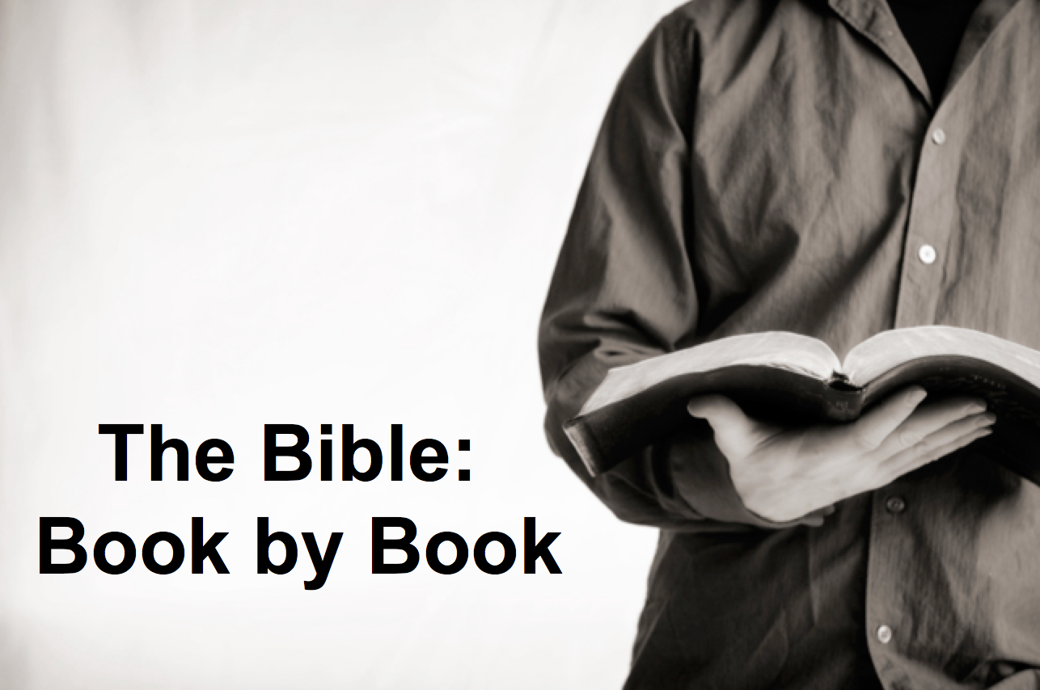

Rick Griffith
21 April 2019
Message 52 of 66

Be Christlike
Philippians

Introduction

Who is your ultimate example in life?

What happens when we imitate Christ’s resurrection __________________?

Imitating Christ’s attitude brings __________________ (Phil 1).

Paul's introduces himself and Timothy warmly to begin on an affectionate note (1:1-2).

Paul gives thanks and prays for them to have Christ's attitude of righteousness (1:3-11).

Paul rejoices that his captivity spread the gospel so they will show joy in their trials (1:12-30).

Imitating Christ’s attitude brings __________________ (Phil 2).

We must have unity through a humble concern for one another (2:1-4).

Four humble individuals exemplify selfless concern to lead to the unity of the body (2:5-30).

Christ modeled humility as our best example since he refused his rights as God (2:5-11).

Paul modeled humility in selfless service so they should stop their complaining (2:12-18).

Timothy and Epaphroditus modeled humility in their concern for the church (2:19-30).

Imitating Christ’s attitude brings __________________ (Phil 3).

Christlikeness guards us from legalism by denying our flesh (3:1-16).

Christlikeness protects us from libertines who indulge their flesh (3:17-21).

Imitating Christ’s attitude brings __________________ (Phil 4).

Paul pleads for peace between two women in unity (4:1-3).

Paul promises peace with God by following some simple commands (4:4-9).

Paul rejoices with peace in all circumstances (4:10-23).

Conclusion

Imitating Christ's resurrection_______gives joy, humility, protection & peace (Main Idea).

Which of these four traits of Jesus do you need most today? How?

Download this sermon PPT and notes for free at BibleStudyDownloads.org/resource/new-testament-preaching/
Listen to this message online at cicfamily.com/sermon-listing/
Philippians

Results of Imitating Christ’s Attitude

Joy |  |  | Humility |  | Protection |  | Peace
Chapter 1 |  |  | Chapter 2 |  | Chapter 3 |  | Chapter 4
Joy (5x) |  |  | Joy (7x) |  | Joy (1x) |  | Joy (4x)
Attitude (1x) |  |  | Attitude (7x) |  | Attitude (8x) |  | Attitude (4x)
Suffering |  |  | Submission |  | Salvation |  | Sanctification
Salutation  1:1-2 | Thanks & Prayer  1:3-11 | In Prison Ministry  1:12-30 | Exhorted  2:1-4 | Exemplified  2:5-30 | From Legalism  3:1-16 | From Indulgence  3:17-21 | With People  4:1-3 | With God  4:4-9 | Always  4:10-20  –  Greetings  4:21-23
Rome

Early Spring AD 62 (first Roman imprisonment)

Key Word: Attitude

Key Verse: “Your attitude should be the same as that of Christ Jesus”
(Philippians 2:5).

Summary Statement: The results of imitating Christ’s resurrection attitude are joy, humility, peace, and protection from false teachers and disunity in the church.

Application: How do you need to show a more Christ-like attitude during difficulty?

Note: Words for “joy” total 17 times in the letter but words for “attitude” total 20 times.

“Most” (Czech for “The Bridge”) movie at https://www.wingclips.com/movie-clips/most/the-bridge.
Olivia Petter @oliviapetter1Wednesday 11 April 2018 12:49 (https://www.independent.co.uk/life-style/worlds-most-admired-people-2018-angelina-jolie-bill-gates-yougov-a8299426.html)

