Crossroads International Church Singapore Dr. Rick Griffith
Title
4 Nov 2019 Message 41 of 66
NLT 50 Minutes
Be Free
Book of Galatians

Topic: Freedom
Subject: Why must salvation be by faith alone?
Complement: Salvation by faith frees us from the Law to give freedom in Christ.
Purpose: The listeners will show they embrace salvation by faith by being free from legalism.
Attribute: We worship God as Liberator
Video: Carrying the Weight of the World
Reading: Galatians 1:1-9
Benediction: Galatians 6:8
Song: For All You’ve Done, Your Grace is Enough, Amazing Grace (My Chains Are Gone), Only by Grace

Introduction

Interest: [The most horrible slavery is salvation by works.]
Slavery

Aristotle said, “The slave is a living tool and the tool is a lifeless slave.” This horrible view of people 2000 years ago actually is still with us today. Slavery hasn’t ended. Perhaps even you are a slave. Are you? Tim Keller writes, “Sin isn’t only doing bad things, it is more fundamentally making good things into ultimate things. Sin is building your life and meaning on anything, even a very good thing, more than on God. Whatever we build our life on will drive us and enslave us. Sin is primarily idolatry.” https://www.monergism.com/topics/sin-temptation/idolatry

But slavery to false teaching is the worst slavery because we all have experienced it and its affects are much more far-reaching, so how can you be free?
False Teaching

Most say freedom comes by works.

The Bible says freedom (salvation) is by faith.
Are You a Slave?

Need: Are you a slave or are you free?

The Gentile Christians in Galatia were a ceremonial religion before their conversion. Their worship was a constant effort to please the gods in order to escape their punishment. They worshipped tangible objects––idols. They had many sacred rites and forms to be observed. They trusted in horoscopes and other signs to guide them. They had their sacred days and seasons and years.
Circles

Our family backgrounds are different, but in school as we grow up and in society at large we have law drilled into us throughout our lives. The early bird gets the worm. The hardworking student gets the As and lands the good job. The law-abiding citizen stays out of prison. Most of all, the good go to heaven.

It is tough to grasp grace! It goes against everything around us. Religions tell us to be good and we will be OK in the afterlife.

Yet grace is how God brings us to heaven. Specifically, we are saved from sin by grace through faith in our Lord Jesus Christ.

But the Galatians inherited the traditional view and the view taught at Qumran and by the rabbis that only good people go to heaven. This is clear in the letter called MMT at Qumran—as seven copies of it were dug up and it is the only letter along with 870 scrolls!
MMT
(4 slides)

Subject: Why must salvation be by faith alone? What reasons can we give that simple trust in Christ alone puts us in a right relationship with God? We will answer this question as part of our series through the Bible one book at a time.
Subject
(2 slides)

Background: Justification by faith was attacked in Galatia.
Backgrnd

Paul taught the church salvation by faith but false teachers soon confused them by teaching salvation by works.
Freedom
Title
Clip Tattoo
(2 slides)
AD 49
AD 48-49

The differences between Jews and Gentiles in Paul’s time could hardly be overstated. They believed in different Gods (one v. many), they ate different foods (kosher v. whatever), and their thinking was entirely contrary (revelation v. philosophy).

These differences did not come into focus for the first 16 years of the church when the church was composed of nearly all Jews.

But Paul spent 1.5 years planting churches in Galatia and the makeup of the church really changed. These Gentiles accepted the gospel eagerly at first (3:1-5; 4:13-14) but some false teachers went to Galatia and confused the new believers.

By the time we come to the letter to the Galatians, the church is 16 years old and had been thoroughly Jewish. However, Paul has just finished his first church planting thrust into modern-day Turkey and many Gentiles had come to Christ.

This letter is the first one Paul wrote that we have in the NT and addresses a church composed of both Jews (minority) and Gentiles (majority).

The word justification means to be made right with God.

Are we made right with God by cutting our hair or bodies?

What do you think about the Law?
Law?

Galatians teaches justification or salvation by faith to make us right with God.
Galatians
(5 slides)

Catholics disagree with this view.
Catholics
(2 slides)

Preview: In response, Paul gives three reasons to believe in salvation by faith. These reasons helped them—and will help us too—be free in Christ instead of being bound by the slavery of works.
3 Reasons
(2 slides)

Text: The whole letter to the Galatians answers why salvation has to be by faith alone.

(Why must salvation be by faith alone?)

Jesus called Paul to teach salvation by faith (Gal 1–2).
MP
[Jesus himself appointed Paul to proclaim justification by faith as his defining doctrinal truth.]
[Personal: Paul defends his apostolic call to counter Judaizer teaching that Paul invented justification by faith.]

Paul rebukes their legalism instead of thanking them (1:1-9).
Gal 1
(6 slides)

Paul didn’t invent justification by faith by his own authority (1:10–2:21).
1:10-24
(4 slides)

He was independent of other apostles by being called by Jesus alone (1:10-24).
Gal 2:1-10
(2 slides)

He was interdependent with other apostles but approved by them (2:1-10).
Gal 2:11-21
(3 slides)

He indicted Peter when Peter publicly acted against justification by faith (2:11-21).
Transition
(4 slides)
Transition
(5 slides)

(Why must salvation be by faith alone?)
MP

Salvation has always been by faith (Gal 3–4).
[Whether Old Testament or new, we have always been put in a right relationship with God by simple trust.]
[Doctrinal: Here Paul affirms and illustrates salvation by faith and not by the Law to counter the Judaizer accusation that justification by faith was a new teaching.]

Justification by faith instead of Law is seen in the superior Holy Spirit and Promise (Gal 3).
Why Law?
(4 slides)

Both salvation and sanctification must be by the same means—faith (3:1-5).
Abraham
(3 slides)

Abraham was saved by faith, not by Law, so this doctrine is not a new teaching (3:6-14).
Counters
(4 slides)

Salvation was by faith 430 years before the Law led to faith by revealing sin (3:15-29).
Gal 4
(3 slides)

Illustrations of justification by faith should convince the Galatians to abandon legalism (Gal 4).

A son’s privileges over a slave’s shows a believer's faith over the Law (4:1-11).

They need to regain their precious commitment to Paul and the truth (4:12-20).

Isaac (=Abrahamic Covenant)—not Ishmael (=Mosaic Covenant)—shows faith (4:21-31).

(Why must salvation be by faith alone?)
MP

Salvation by faith alone changes us inside (Gal 5–6).
[Whether Old Testament or new, we have always been put in a right relationship with God by simple trust.]
[Practical: Paul applies salvation by faith in Spirit-led living by exhorting balance and others-orientation.]

Balance between legalism and license comes the Spirit—not the sinful nature (Gal 5).
Gal 5
(5 slides)

Avoid the extremes of legalism and license in light of freedom from the Law (5:1-15).

Don’t be entrapped in legalism (5:1-12).

Love others instead of being selfish (5:13-15).

Live under direction from the Spirit rather than from the sinful nature (5:16-26).
Spirit
(3 slides)
Gal 6
(6 slides)

Serve others since freedom from the Law leads to caring for others (6:1-10).

Contrast the impure Judaizer motives with Paul’s pure motives (6:11-18).
Subject

(Why must salvation be by faith alone?)

Conclusion

Paul defends justification by faith in three ways in this letter (Main Points):
MPI

Jesus called Paul to teach salvation by faith (Gal 1–2).
MPII

Salvation has always been by faith (Gal 3–4).
MPIII

Salvation by faith alone changes us inside (Gal 5–6).

Salvation by faith frees us from the Law to give freedom in Christ (Main Idea).
MI

Application: Be free from the slavery of legalism so you can live for Christ.
Legalism
(9 slides)

Prayer
Prayer

Preliminary Questions

Verses Questions

Context: What did the author record just prior to this passage?

By the time we come to the letter to the Galatians, the church is 16 years old and had been thoroughly Jewish. However, Paul has just finished his first church planting thrust into modern-day Turkey and many Gentiles had come to Christ.

This letter is the first one Paul wrote that we have in the NT and addresses a church composed of both Jews (minority) and Gentiles (majority).

Purpose: Why is this passage in the Bible?

Our family backgrounds are different, but in school as we grow up and in society at large we have law drilled into us throughout our lives. The early bird gets the worm. The hardworking student gets the As and lands the good job. The law-abiding citizen stays out of prison. Most of all, the good go to heaven.

It is tough to grasp grace! It goes against everything around us. Religions tell us to be good and we will be OK in the afterlife.

Yet grace is how God brings us to heaven. Specifically, we are saved from sin by grace through faith in our Lord Jesus Christ.

But the Galatians inherited the traditional view and the view taught at Qumran and by the rabbis that only good people go to heaven.

Background: What historical context helps us understand this passage?

The differences between Jews and Gentiles in Paul’s time could hardly be overstated. They believed in different Gods (one v. many), they ate different foods (kosher v. whatever), their thinking was entirely contrary (revelation v. philosophy).

These differences did not come into focus for the first 16 years of the church when the church was composed of nearly all Jews.

However, Paul spent 1.5 years planting churches in Galatia and the makeup of the church really changed. The Galatians accepted the gospel eagerly at first (3:1-5; 4:13-14) but some false teachers went to Galatia and confused the new believers.

The enthusiasm and joy of the new Christians ended (4:15) due to this opposition from Jewish false teachers (Judaizers) who had spread their teaching in the churches after Paul established them (1:7b; 4:13-14; 5:7). They proclaimed “another gospel” (1:6-9) associated with the Jewish Torah and circumcision (2:15-21; 3:2-5; 4:21; 5:2-12; 6:12-17). The result? Galatian confusion1

Paul had to act fast before the situation got worse—especially since this was no minor issue. It concerned the nature of the gospel itself. Were the Galatians really saved? Or did these Gentiles still need to follow the Jewish laws?

Questions

Were the Judaizers non-believers or simply confused believers? The heretical non-Christian view is supported on page 173c.

Where was Galatia? See support for the southern view below.

When did Paul write the letter to the Galatians? The date of AD 49 just after the first missionary journey is supported below.

What does justification mean? Is it the same as salvation?

“In Christian theology, justification is God's act of removing the guilt and penalty of sin while at the same time making a sinner righteous through Christ's atoning sacrifice”—Wikipedia at https://en.wikipedia.org/wiki/Justification_(theology)

It is similar to salvation which means to deliver or save us from sin’s penalty.

Tentative Main Ideas

Don’t be a legalist.
Protect the true gospel of grace.

Subject: Why can’t we be saved by obeying the Law?

Subject: Why should we believe in salvation by faith?

Subject: Why is salvation by faith true?

Illustrations That Apply

Works-based religions tell us do. Christianity tells us done.

My first year as a Christian where I only adopted new rules rather than understanding grace. Then I read the book Grace by Lewis Sperry Chafer that changed my life.

New Testament Survey Notes

Galatians

Justification by Faith

Judaizer Attack #1  “Paul teaches this doctrine by his own authority!” |  | Judaizer Attack #2  “This is a new teaching contrary to the OT!” |  | Judaizer Attack #3  “Teaching faith alone will encourage a sinful lifestyle!”
Paul’s Defense:  “God called me and the 12 apostles affirmed this” |  | Paul’s Defense:  “Salvation has always been by faith–even in the OT” |  | Paul’s Defense:  “No, justification by faith naturally leads to godly living”
Biographical |  | Theological |  | Practical
Chapters 1–2 |  | Chapters 3–4 |  | Chapters 5–6
Upholds  Apostleship |  | Upholds  Justification by Faith |  | Upholds  Responsibilities
Rebuke | Relationships | Affirmed | Illustrated | Balance | Service | Warnings
1:1-9 | 1:10–2:21 | 3 | 4 | 5 | 6:1-10 | 6:11-18
Antioch of Syria

Fall AD 49 (after first missionary journey)

Key Word: Justification

Key Verse: “[We Jews] know that a man is not justified by observing the law, but by faith in Jesus Christ. So we, too, have put our faith in Christ Jesus that we may be justified by faith in Christ and not by observing the law, because by observing the law no one will be justified” (Galatians 2:16).

Summary: The reason we must uphold justification by faith is because Paul affirmed it in his call, theology and practice.

Application:
Do you add any other requirements for salvation except faith in Christ—baptism, tongues, good works or any other good deed?
The logical result of justification by faith is godliness.
Galatians

Introduction

I. Title The Greek title for the letter (Pro.j Gala,taj To the Galatians) follows the standard form of naming Paul's writings after their recipients.

II. Authorship

A. External Evidence: The traditional view is that the Apostle Paul wrote Galatians.

1. This finds early support by Polycarp (3:3; 5:1; cf. Kümmel, 198). Marcion also placed the epistle at the top of his list of genuine Pauline epistles (Harrison, 255).

2. Paul as author of Galatians has been mostly uncontested even among the 19th century German critics in the Tübingen school. The few that do oppose Pauline authorship include Bauer, R. Streck (the Swiss scholar), and the nineteenth century radical Dutch critics (Kümmel, 198).

B. Internal Evidence: The Book of Galatians explicitly mentions Paul as its author (1:1; 5:2). In fact, Paul probably departed from his usual practice of dictating his letters to a secretary by actually penning the epistle himself (6:11; cf. “Characteristics” section below). Most of chapters 1 and 2 are autobiographical (e.g., 1:11f.) and several Pauline themes are evident (e.g., grace, law).

C. Conclusion: Both external and internal evidence point to Paul's authorship (Harrison, 255; Guthrie, 468; Kümmel, 198). Galatians has always been the least challenged of Paul's epistles (Guthrie, 468). There exists not even scant evidence to disprove the genuineness of the Epistle. The Epistle to the Galatians is generally the standard by which other Pauline writings are tested (Bruce, 2).

III. Circumstances

A. Date: The issue of date closely relates to the destination of the letter (Bruce, 43-56). The two theories of destination are the North Galatian Theory (adopting the later date) and the South Galatian Theory (generally suggesting an earlier date):

1. External evidence from Marcion suggests that Paul wrote from Ephesus shortly before writing 1 Corinthians (approx. AD 55), thus supporting the later date. However, Marcion's reliability and sources are questionable as he believed only in Luke’s gospel and Paul’s letters (Kümmel, 197).

2. Internal evidence shows that the Galatians deserted Paul's teaching just after his first visit (1:6f.), lending more credence to the South Galatian Theory. If the second visit of 4:13 is the one in Acts 16:6, then the epistle is post-Jerusalem Council (AD 53-56; Harrison, 260; Kümmel, 197-198; Betz, 9-12). However, if this later date is true, one would think that Paul would have mentioned the decree of the Jerusalem Council in the letter since both the Council and the epistle address the same theme (requirements of the law for Gentile believers). On the other hand, if the second visit (4:13) refers to revisiting Acts 14:21 churches then the letter could be pre-Jerusalem Council (AD 48-49), though it would not need to demand the early date (Guthrie, 458).

3. Conclusion: Arguments for both dates are inconclusive, but the best evidence supports the South Galatian Theory (see below) and the earlier date of about fall AD 49.

B. Origin: The origin of the book of Galatians is not specifically stated and depends upon the identity of the recipients as to whether they lived in North or South Galatia:

- The Northern Theory says Paul wrote to North Galatia from Ephesus, Corinth, Macedonia, or Rome (Betz, 12).

2. The Southern Theory says that Paul wrote to South Galatia from Antioch or somewhere en route from Antioch to Jerusalem for the Jerusalem Council (Harrison, 260).

C. Recipients: The epistle addressed “the churches of Galatia” (1:2). This is the only Pauline letter to a group of churches. Evidently Paul did not have enough time to write each church individually, so a circular letter was sent (Hiebert, 2:71). The greatly debated question is, “Where were these churches?” The two theories of destination hinge largely upon the interpretations of two verses in Acts (16:6; 18:23) that refer to this Galatian region (Bruce, 3-18; Guthrie, 450-457; Harrison, 257-259; Kümmel, 191-193). Both theories agree that the recipients were Gentiles (4:8; 5:2f.; 6:12f.), but the question is, “Which Gentiles?” See notes, 174a (chart) and 138-40, 280a (maps).

1. The Traditional View (North Galatian Theory): Galatians was written to Gallic believers in the territory of Galatia (ethnic Galatia, including the cities of Ancyra, Pessinus, and Tavium) of whom Paul had won to Christ on his second missionary journey (Acts 16:6; p. 139). Advocates include Lightfoot, Betz, Kümmel, and Harrison.

a. External evidence (from Acts and history)

1) The Gauls overtook North Galatia from the Phrygians in the 3rd century BC then named the region after themselves (Bruce, 3-8; Guthrie, 450; Kümmel, 191).

2) The characteristics of fickleness, strife, anger, and impulsiveness that Paul denounced in his readers closely parallel Gallic lifestyles (Bruce, 4).

3) Luke describes the South Galatian towns in the province of Galatia in geographical, not provincial terms (Betz, 11).

4) The northern view was the unanimous view of the church fathers (Hiebert, 2:77).

b. Internal evidence

1) Interpreting the visit of Galatians 2:1-10 as the Jerusalem Council visit allows for only the northern view (explained in the Characteristics section).

2) The chronology of Paul's life in the southern view places his conversion at AD 23-30 (Harrison, 262; Hiebert, 2:84), which is too early.

2. Alternative to the Traditional View (South Galatian Theory): Paul wrote to the Greek believers in the Roman province of Galatia (political Galatia, including the cities of Pisidian Antioch, Iconium, Lystra, and Derbe), whom Paul had won to Christ on his first missionary journey (Acts 13–14; p. 138). Advocates include Ramsay, Bruce, Hiebert, and Guthrie (Griffith too).

a. External evidence (from Acts; Guthrie, 452-57)

1) Phrygia and Galatia in Acts 16:6; 18:23 are designated a “region” (singular), not “regions” (plural), so this region can refer to both the districts in the province of Asia (southern part) and the part of Phrygia in the adjoining province of Asia.

2) Assuming the Northern Theory, it would be strange for Luke to say so little about this area in which such a major controversy arose.

3) Paul generally referred to groups of churches by their Roman province (e.g., Macedonia, Achaia, Asia, and Judea). Luke’s usage of the term should not be imposed upon Paul.

4) “Galatia” was the best term to describe the various ethnic groups in the south.

b. Internal evidence

1) Since Paul visited the Galatian churches during his recovery from a bodily illness (4:13) it is unlikely that he traversed the difficult journey off the road to the central plateau on which Northern Galatia was located.

2) The mention of Barnabas (2:1, 9, 13) is more natural if the readers knew him. Barnabas accompanied Paul only in South Galatia.

3) No mention is made to the verdict of the Jerusalem Council (cf. Acts 15) which would have already occurred, assuming the Northern Theory.

4) The letter was written in Greek, a language understood by only the northern people of Ancyra and Pessinus at best (Bruce, 9).

5) Peter hardly would have acted as he did (2:11f.) right after the Jerusalem Council.

Conclusion: External evidence is divided. The Northern Theory was virtually unchallenged until the last two centuries, but the evidence from Acts seems to best support the Southern Theory. The Patristic bias for the Northern Theory may be explained by second century evidence that the term “Galatia” had ceased to be used in reference to the southern area; therefore, the Fathers interpreted the term in light of their own day (Hiebert, 2:77).

However, the internal evidence favors the southern view. While the southern view has chronological difficulties, the northern view has the problem of attributing the “again” of Galatians 2:1 to a third (not second) visit. Therefore, the weight of the evidence supports the Southern Galatian Theory.

D. Occasion: The Galatians accepted the gospel eagerly at first (3:1-5; 4:13-14) but this ended (4:15) due to opposition from Jewish false teachers (Judaizers) who had spread their teaching in the churches after Paul established them (1:7b; 4:13-14; 5:7). They proclaimed “another gospel” (1:6-9) associated with the Jewish Torah and circumcision (2:15-21; 3:2-5; 4:21; 5:2-12; 6:12-17). Paul had confronted these Judaizers already in Jerusalem (2:4-5) but this letter was written before the Jerusalem leaders officially disapproved of them at the Jerusalem Council (Acts 15:19-21, 24). Since no official word had yet come from Jerusalem, Paul wrote the churches immediately to combat this false teaching by defending his apostleship (Gal 1–2) and the true gospel of justification by faith alone (Gal 3–4), which produces a unique lifestyle based upon freedom in Christ (Gal 5–6).

IV. Characteristics

A. Literary Characteristics:

1. Structure: Its threefold structure is explained in the occasion section above. This is different from the twofold structure characteristic of other Pauline writings: Romans (1–11, 12–16), Ephesians (1–3, 4–6), Colossians (1–2, 3–4), etc.

2. Mood: Even the first verse shows a severe tone as it lacks the customary salutation. The letter lacks a thanksgiving for the readers or words of praise for them (e.g., they are never referred to as “saints”). However, some touch of affection does appear (4:12-15, 19-20).

3. Unity: Paul vindicates his authority repeatedly (1:1, 11-16; 6:11-16) and defends justification by faith (1:6-10; 2:4, 14; 3:1–5:12), so the unity of the letter has gone virtually unchallenged. It is the most accepted epistle of Pauline authorship.

B. The Jerusalem visit (2:1-10) has been seen as either Paul's famine trip to aid the depressed church (cf. Acts 11:27-30) or Paul's attendance at the Jerusalem Council (cf. Acts 15:1-29).

1. Advocates of the Jerusalem Council view (Lightfoot, Hendriksen, Hiebert) argue:

a. The apostles (2:9) and Titus (2:1-3) are not mentioned in the famine visit.

b. Although the apostles acknowledged Paul and Barnabas' Gentile ministry, this is unlikely before their first missionary journey (i.e., before Acts 13).

c. It is difficult to see why the Jerusalem Council would need to be called (Acts 15) if the issue of Gentile salvation had already been settled (Acts 11).

d. Perhaps the best Council view evidence is the problematic chronology of the southern view that places Paul's conversion between AD 23-30 (1:18; 2:1; Harrison, 262; Hiebert, 2:84).

2. Advocates of the Famine view (Bruce, Tenney, Duncan) affirm this evidence:

a. The visit to Jerusalem “again” (2:1), taken in its most natural sense, refers to Paul's actual second visit following his conversion (Acts 11).

b. Galatians 2:1-10 is a private discussion, not the Jerusalem Council assembly of Acts 15.

c. The decrees of the Council are totally missing in Galatians 2.

d. Peter and Paul's dispute over eating with Gentiles (2:11-21) makes better sense pre-Jerusalem Council.

3. Conclusion: The southern view has chronological difficulties and the northern view forces the second visit to Jerusalem (“again” in 2:1) to mean a third visit. Both views have problems, but better evidence for the Southern Galatian Theory favors the famine view.

C. Paul declares at the end of the epistle, “See with what large letters I am writing (e[graya, aorist) to you with my own hand” (6:11). Two views of the aorist prevail:

1. The traditional view sees Paul using an epistolary aorist (“I am writing”) where he signs after his normal custom of dictating the bulk of his letter to a scribe (cf. Rom. 16:22; 1 Cor. 16:21).

2. However, Paul never uses the aorist when writing only a few concluding words, so it seems more logical that he uses the normal use of the aorist (“I wrote”). This means Paul painstakingly wrote the entire letter himself, possibly with large letters due to an eye malady (4:25; Hiebert, 2:89-90).

D. Galatians is the only Pauline letter written to a group of churches.

E. This is the first letter of Paul that has been included in the New Testament.

Argument

Galatians is often called “the Magna Carta of Christian Liberty” since it emphasizes the believer's freedom in Christ. However, it is evident that Paul's purpose was threefold: to defend his apostleship against the Judaizers (Gal 1–2), to defend the essence of the gospel based in justification by faith alone (Gal 3–4), and to give practical exhortations in light of the believer's freedom in Christ (Gal 5–6).

Therefore, Paul's purpose in writing is to convince the Galatians that since they were saved by grace they are free from the Law. As a result, Judaizers who sought to impose upon them a legalistic system based upon the Law should not lead them away from their moorings in Christ.

Synthesis

Justification by faith

1–2 Biographical: Defends apostleship
1:1-9 Rebuke
1:10–2:21 Relationship to other apostles
1:10-24 Independence
2:1-10 Interdependence
2:11-21 Indictment

3–4 Theological: Defends justification by faith
3 Affirmed
3:1-5 Galatian's experience
3:6-14 Abraham's experience
3:15-29 Law/Promise vs. faith
4 Illustrated
4:1-11 Domestic: son vs. servant
4:12-20 Historical: personal plea
4:21-31 Biblical: Isaac (Abrahamic) vs. Ishmael (Mosaic)

5–6 Practical: Defends responsibilities
5 Balance
5:1-15 No to legalism/license
5:16-26 Yes to Spirit
6:1-10 Service
6:11-18 Warnings
6:11-13 Against legalists
6:14-17 Against despising him
6:18 Benediction

Outline

Summary Statement for the Book
The reason we must uphold justification by faith is because Paul affirmed it in his call, theology and practice.

Biographical: Paul defends his apostolic call to counter Judaizer teaching that Paul invented justification by faith (Gal 1–2).

Paul omits the usual thanksgiving and rebukes the Galatians for replacing the gospel with Judaizer legalism to show his displeasure (1:1-9).

Paul defends his apostleship against the Judaizers to show that he did not make up justification by faith by his own authority (1:10–2:21).

His independence of other apostles is evident by receiving revelation directly from Christ and by not meeting them for three years (1:10-24).

His interdependence with other apostles was seen at the famine visit when apostles at Jerusalem approved his justification by faith teaching (2:1-10).

He indicted Peter, the chief apostle who contradicted justification by faith when he publicly acted against justification by faith (2:11-21).

Theological: Paul illustrates salvation by faith and not by the Law to counter the Judaizer accusation that justification by faith was a new teaching (Gal 3–4).

Paul affirms justification by faith by comparing the inferior Law with the superior Holy Spirit and Promise (Gal 3).

The Galatians received salvation by receiving the Holy Spirit by faith, not the Law, so their sanctification must also be by faith (3:1-5).

Abraham was justified by faith, not by Law, so this doctrine has solid scriptural foundation and is not a new teaching (3:6-14).

Salvation was by faith for 430 years between Jacob and the Law, so the Law led man to faith by revealing sin (3:15-29).

Paul illustrates justification by faith in domestic, historical, and biblical life to convince the Galatians to abandon legalism (Gal 4).

A son’s privileges over a slave’s pictures a believer's spiritual religion over the Law to help the readers abandon legalism (4:1-11).

Their former commitment to Paul when he was with them should encourage them to show the same zeal for the truth now (4:12-20).

God blessing Isaac (=Abrahamic Covenant) instead of Ishmael (=Mosaic Covenant) shows the folly of Galatians following the Law (4:21-31; cf. p. 174a).

Practical: Paul applies salvation by faith in Spirit-led living by exhorting balance and others-orientation (Gal 5–6).

Balance between legalism and license comes the Spirit—not the sinful nature (Gal 5).

Believers should not live in the extremes of legalism and license in light of their freedom from the Law (5:1-15).

A Christian is free from the Law so should never again be entrapped in legalism (5:1-12).

A Christian is free from the Law so should use this freedom to love instead of selfish pursuits (5:13-15).

Believers should live under direction from the Spirit rather than from the sinful nature (5:16-26).

Serve sinning Christians, burdened believers, teachers, and everyone since freedom from the Law leads to caring for others (6:1-10).

A final warning contrasts the impure Judaizer motives with his own pure motives to convince them to apply what he has written (6:11-18).

Contrasting Galatians and Romans

Galatians and Romans have common themes such as justification by faith (Gal. 2:16; 3:14; Rom. 1:17; 3:21-22), freedom from the Law (Gal. 3:10-13, 23-25; 5:1; Rom. 7:1, 6; 8:2-4), and how the Law reveals sin (Gal. 3:22; Rom. 3:20; 5:20; 7:7). Yet these books remain unique in several ways:

 | Galatians | Romans
Influence of Cities | Minor | Major
Number of Churches | Several Cities  (Lystra, Derbe, etc.) | Single City  (Rome)
Church Founded | AD 48-49  (on first missionary journey) | AD 33-56  (no one knows exactly when)
Founder | Paul | Pentecost converts? or  Paul’s disciples?
Written | AD 49  from Antioch | AD 56-57  from Corinth
View of Paul | Doubted  (but most knew him!) | Credible  (but most didn’t know him!)
Paul’s Opponents | Judaizers | None
Jew-Gentile Relations | Serious rift | Mild criticism of each other
Readers | Mostly Gentiles | Jew-Gentile mix
Theological Errors | Serious: Salvation | Minor: Christian liberty
Theme (Key Word) | Justification (2:16) | Righteousness (1:17)
Vocabulary & Tone | Simple yet Severe | Technical and Structured
Form | Modified Defense  (e.g., no thanksgiving) | Traditional Presentation  (e.g., names, greetings…)
OT Quotes | Few  (only 12, or 2 per chapter) | Nearly as many as the rest of Paul’s epistles (63 total!)
Doctrinal Focus | Narrow: Justification | Broad: Many topics*

* Natural revelation (1:19-20), universality of sin (3:9-20), justification (3:21-24), propitiation (3:25), faith (4:1-25), Israel (chaps. 9–11), gifts (12:3-8), government (13:1-7), Christian liberty (14:1–15:13)
Who Are the Judaizers Today?

Scholars generally agree that the teachers who came to Galatia after Paul left taught that faith alone does not save. These teachers insisted on a “faith plus works” formula by adding works of the law as a requisite for genuine conversion—especially the rite of circumcision (5:6). Paul actually never gives them a name. However, since these teachers sought to get the believers to return to the Jewish law, the term “Judaizers” has been coined for them.

But were these Judaizers at Galatia Jewish believers or unbelievers? The consensus among commentators is that they were genuine believers who were simply confused in this area of doctrine (cf. Ronald Y. K. Fung, The Epistle to the Galatians, NICNT, 7-9; Kümmel, 298-301; Lightfoot, 27, 52-53; Ridderbos, 15-16). Some factors may support them being believers:

- The apostles and elders allowed representation of the “circumcision party” at the Jerusalem Council (Acts 15:1, 24). This may argue that these teachers are the same as the Judaizers since they also argued that Gentiles should be required to keep the Law (Gal. 2:12). If so, then the mother church considered them to be Christians and we should probably do the same.
- These Jewish teachers had no doubt about Jesus being the Messiah, in contrast to the majority of Jews who would not accept Christ as Israel’s king.

However, some factors may indicate that the Judaizers were indeed unsaved:
- Paul says that the Judaizer’s was “a different gospel” (NIV) which was really not the gospel at all (1:6-7). Since there is only one true gospel, the Judaizer “gospel” would then be a false teaching that was not Christian after all.
- Paul described these men in the strongest words possible, pronouncing upon them eternal condemnation (1:8-9). Ascribing hellfire to anyone but unbelievers would seem inappropriate.
- Paul also refers to them as “false brothers” (2:4).
- The Jerusalem Council occurred shortly after Paul’s letter to the Galatians and it verified Paul’s teaching on faith alone (as opposed to the Judaizer view being considered another “evangelical option” or gray area). While Judaizers (i.e., the “circumcision party”) were allowed to attend the meeting, they were soundly defeated.
- Although the Judaizers did not reject Christ outright as Messiah as did their Jewish brethren, by adding other requisites to salvation they taught a second type of heresy that undermined the nature of the true gospel.

Given the above reasons, this study takes the view that the Judaizers were not actually Christians. Any group that adds to the simple gospel of justification by faith alone cannot be deemed “Christian.” This includes the Catholic Church (which adds works), Church of Christ (which adds baptism), and the True Jesus Church (which adds works, baptism, tongues, foot washing, etc.). This diagram depicts how Judaizers were Jews on the fringes of the church but still outside the body:
All Humanity
(the entire large rectangle)

Gentiles
(this square with unbelievers outside the circle)
Jews
(this square with unbelievers outside the circle)

Church
(Jews & Gentiles in the circle)

Judaizers
Ceremonial vs. True Religion

One basic difference between Paul’s gospel and the religion of the Judaizers is that Paul taught faith by experience whereas his opponents taught that man is made right by ceremonial religion. These are contrasted in Galatians 4 with the infant-gr own son contrast. Note the distinctions between these modes of living in these diagrams from Paul A. Pomerville, Galatians and Romans (Brussels, Belgium: International Correspondence Institute, 1976), 95, 96, 98.

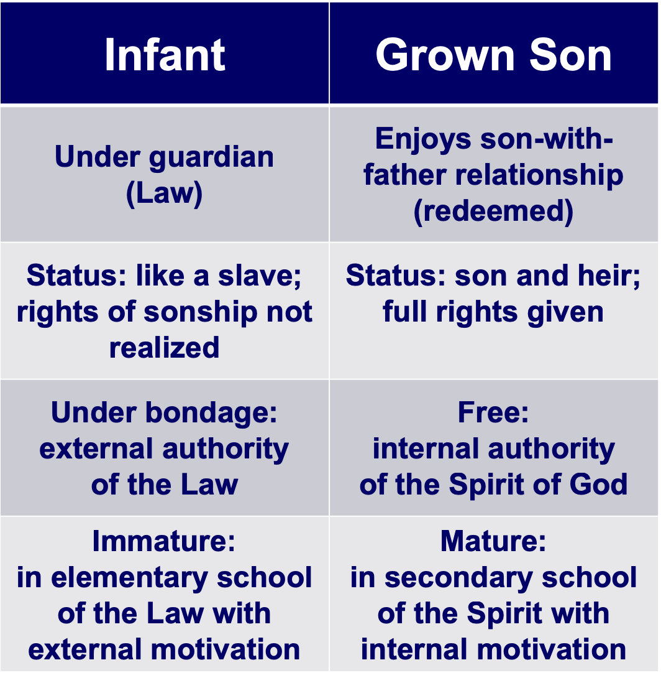
Faith & Works in the Bible
Personal knowledge of God
Worship in the Spirit
God's revelation and work
Symbolic Objects
Rites
Man's Efforts
Religion of Personal Experience
Remember that ceremonial religion emphasizes physical things in worship while the gospel emphasizes worship in the Spirit. You can see the conflict between these two types of religion in Jesus' conversation with the Samaritan woman at Jacob's well (John 4).
Ceremonial Religion
The Gentile Christians in Galatia were in this kind of religion before their conversion. Their worship was a constant effort to please the gods in order to escape their punishment. They worshipped tangible objects––idols. They had many sacred rites and forms to be observed. They trusted in horoscopes and other signs to guide them. They had their sacred days and seasons and years.

Here’s an Issue for your small group…

Which is the most accurate depiction of salvation in the OT and NT?

Salvation by…

Faith Alone

Faith Alone

Faith + Works

Faith Alone
Works

Faith
Faith + Works

Faith + Works

OT

NT

Which verses in the Bible support your answer?

Distinguishing Salvation and Sanctification

 | Man’s  Role | God’s Response | Life of  Faith | Restored Fellowship
OT | Faith in God’s Passover Lamb | Exodus | Wilderness Wanderings | Sacrifices (Sin, Guilt)
NT | Faith in Christ as Lamb of God | Salvation  Positional Sanctification | Growth  Progressive Sanctification | Confession (1 John 1:9)

Salvation in the Old Testament

How were people saved during Old Testament times? Were only Jews saved? How? Was it through the tabernacle and temple sacrifices? Did killing these animals actually forgive sin? These questions will naturally arise in a thinking person’s mind when encountering the OT.

First, salvation has always been by faith and not by works of the Law. This is Paul’s key point in Galatians and Romans and it applies to all times. Paul gives Genesis 15:6 as support: “Abraham believed God, and it was credited to him as righteousness” (Rom. 4:3; cf. vv. 11, 16-24; Heb. 11). Salvation in all ages is based in God’s grace, not our works (Eph. 2:8-9). The ways He has shown His grace has changed over the ages, but His method of salvation by grace through faith is constant.

OT believers expressed their faith in many ways: worshipping God, offering sacrifices, or doing good deeds, but it was their faith that saved–not their sacrifices or worship or deeds. Their faith was placed in God’s provision of a coming Saviour (1 Pet. 1:10-12), though they did not realise that this Redeemer specifically was Jesus Christ. Further, there is no hint that their salvation could be lost.

One may ask, “But doesn’t the OT say sacrifices forgave people?” Leviticus promises Israelites that they “will be forgiven” by sin offerings and guilt offerings (4:20, 26, 31, 35; 5:10, 13, 16, 18; 6:7; 19:22; cf. Heb. 9:13). However, these refer to any specific sin rather than forgiveness from all sin for salvation; also, ritual without repentant faith was useless (Ps. 40:6-8; Isa. 1:11-20; Jer. 7:21-26).

This parallels our experience some. We are saved from the penalty of sin by faith, just like Jews (and Gentiles identifying with Israel) in the OT–but we show faith by trusting Christ as our past sacrifice rather look forward to a future sacrifice. We still sin, but 1 John 1:9 promises, “If we confess our sins, he is faithful and just and will forgive us our sins and purify us from all unrighteousness.” We have positional forgiveness for all sins (past, present, and future) and a secure relationship with God. However, confession helps us experience practical forgiveness and restoration of our fellowship with Him. In like manner, Job sacrificed for cleansing and restored fellowship while saved (Job 42:7-9).

But why can’t the “blood of bulls and goats…take away sins” (Heb. 10:4)? Sacrifices forgave and cleansed only from external ceremonial impurity (Heb. 9:13), but Christ removed all sin and cleansed internally. A clear treatment of OT sacrifices is John S. Feinberg, “Salvation in the Old Testament,” Tradition and Testament, eds. John S. and Paul D. Feinberg (Chicago: Moody, 1981), 39-77 (adapted below into chart form). Issues 1-3 are the same for OT and NT but 4-5 are different:

 | OT Times  (Moses to Christ’s Death) | NT Times  (Christ’s Death to Today)
Basis  of Salvation | God’s gracious provision of the death of Christ since “it is the blood that makes atonement for one’s life” (Lev. 17:11b) | God’s gracious provision of the death of Christ (“without the shedding of blood there is no forgiveness” Heb. 9:22)
Requirement  of Salvation | Faith in the provision that God has revealed–as a gift (Ps. 51:16-17) | Faith in the provision that God has revealed–as a gift (Gal. 2:16)
Ultimate Content  of Salvation | Object of faith is God Himself–prophets exhorted repentance, not sacrifices (Jer. 3:12; Joel 2:12) | Object of faith is God Himself–heroes of faith are cited to exhort faith in God (Heb. 11)
Specific  Revealed Content  of Salvation | Cumulative content of faith involved sacrifices & promises: animals (Gen. 3:21); Abel’s sacrifice (Gen. 4:4); Abrahamic covenant (Gen. 15), etc. | New content of faith is the shed blood of Jesus Christ (1 Pet. 1:18-21) which removes sin removes sin while OT sacrifices merely covered sin
Believer’s Expression  of Salvation | Obey moral law, offer animal sacrifices, obey Mosaic law (civil and ceremonial aspects) | Obey moral law, observe Lord’s Supper and baptism, etc. through the Spirit’s enabling (Rom. 8:9)

The Readers of Galatians
A Summary on the Location of “Galatia”

 | Northern Theory | Southern Theory
Advocates | Lightfoot, Betz, Kümmel, Harrison,  John A.T. Robinson | Ramsey, Bruce, Hiebert, Guthrie, Grassmick, Hoehner, Tenney, Benware, Griffith
Age | Traditional View | Newer View (1800s)
Location | North Galatia (small area) | South Galatia (large area)
Nature | Territory | Roman Province
Describes | Ethnic Galatia | Political Galatia
Cities | Ancyra, Pessinus, Tavium | Pisidian Antioch, Iconium, Lystra, Derbe
Established | Second Missionary Journey  (Acts 16:6-8; AD 51-52) | First Missionary Journey  (Acts 13–14; AD 49)
Barnabas | Absent (with John Mark) | Present
Gal 2 Ref. | Jerusalem Council (Acts 15) | Famine Visit (Acts 11:27-30)
Date | AD 53-57 | AD 48-49
Writing | Paul’s third NT letter | Paul’s first NT letter
Origin | Ephesus, Corinth, Macedonia | Antioch, en route to Jerusalem
Support | Luke Used Geographical Names  Gallic Lifestyles  Unanimous Patristic Support | Paul Used Roman Names  Paul did Plant Churches Here  Mention of Barnabas  Paul's Sickness  Absence of Jerusalem  Council Decree
Problems | Second Visit (2:1)  No Support Paul ever Visited North  No Mention of Jerusalem Council  (Acts 15) | Paul's Dates (1:18; 2:1)

Why does it make any difference whether the book was written to the north or south? If it was to the south, this makes the readers the same people as in Acts 13–14 so that we have the scriptural background for the letter.

Covenant Contrasts in Galatians 4:21-31

In the book of Galatians Paul is arguing for justification by faith against Judaizers who followed up his ministry in these churches with a heretical doctrine of justification by the law (specifically, circumcision). In chapter 3 he argues that believers are spiritual sons of Abraham because they, like him, trust God by faith (3:1-15. Also, since the Abrahamic promise preceded the law by 430 years, salvation cannot be in the law—otherwise Abraham couldn’t have been saved hundreds of years earlier.

In the next chapter, Paul continues his argument for salvation by faith by contrasting the Sinai covenant (law) with the covenant of Abraham within which Christians participate. Paul contrasts these diametrically opposing ways of salvation by contrasting Sarah and Hagar through using a figurative teaching technique (4:21, Gr. avllhgorou,mena, from which we get our word “allegory”). This Sarah-Hagar passage is not a true allegory in that true allegories do not point back to historical persons, places and events. For this reason, the NIV translates the word as “figuratively.”

Covenant | Law (24-25) | Abrahamic (28b; cf.3:16-18)
Son | Ishmael (not specifically named | Isaac (28)
Mother | Hagar（24-25) | Sarah (not specifically named)
Freedom | Slave (22a, 24b, 31a) | Free (22b, 26a, 31a)
Birth | Ordinary (23a) | Of Promise (23b)
Mount | Sinai in Arabia (24) | Calvary (implied?)
Jerusalem | Present Earthly (25b) | Future (?), Heavenly, Mother (26)
Followers | Children Not of Promise (implied) | Children of Promise (28b)
Persecution | Persecutor (29a) | Persecuted (29b)
Teachers | Judaizers | Paul & True Evangelists
Salvation by | Works | Faith in Christ
Result | Unsaved | Saved

The Catholic View of Justification

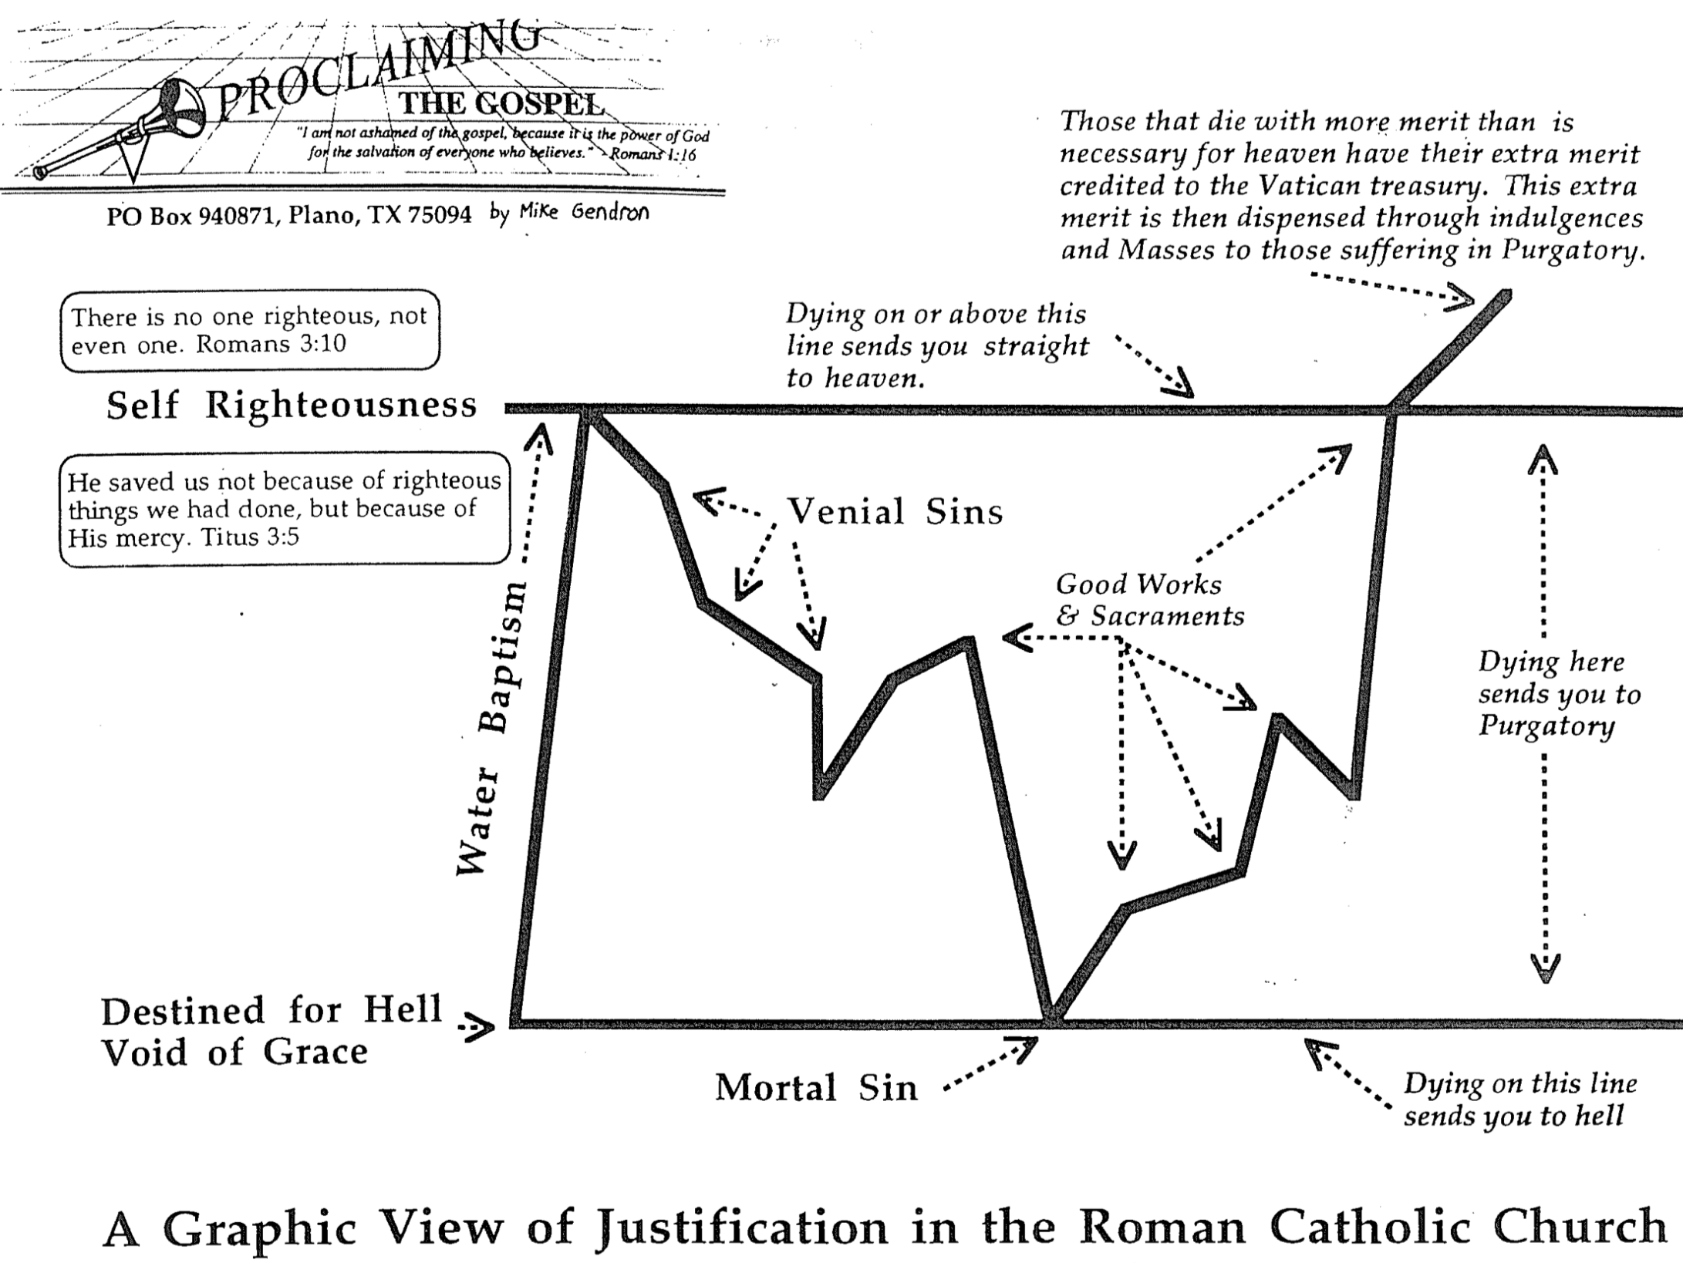
The Scriptural View of Justification

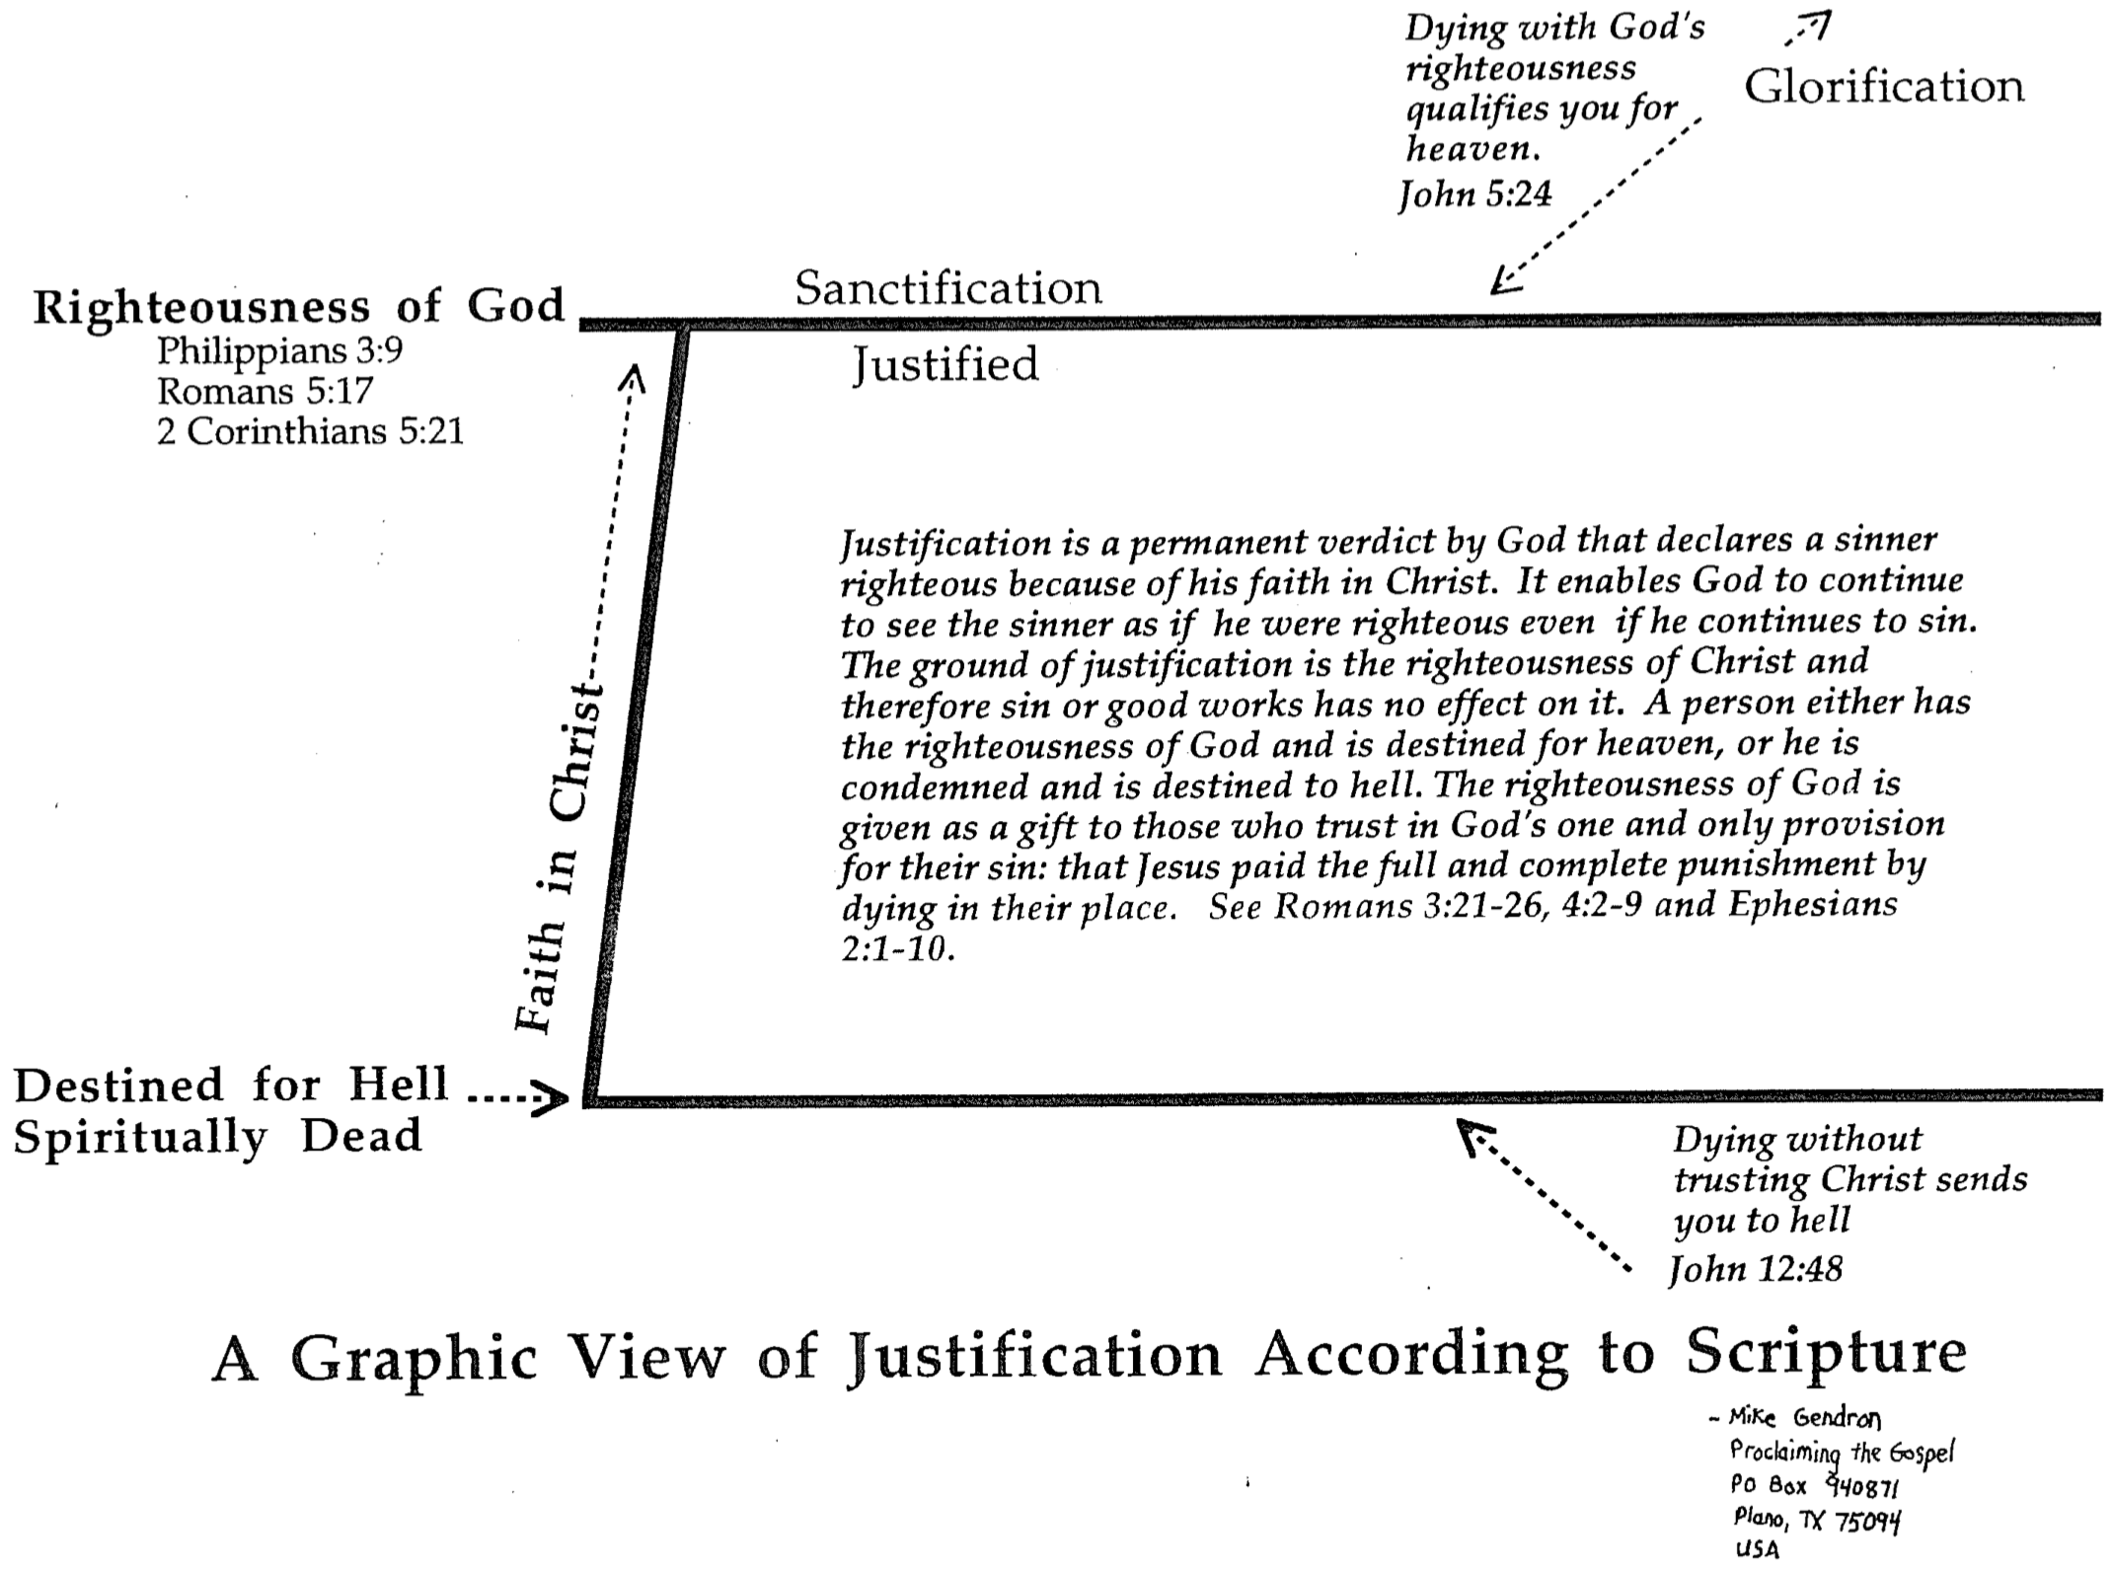
Evangelicals and Catholics Together
1 of 2

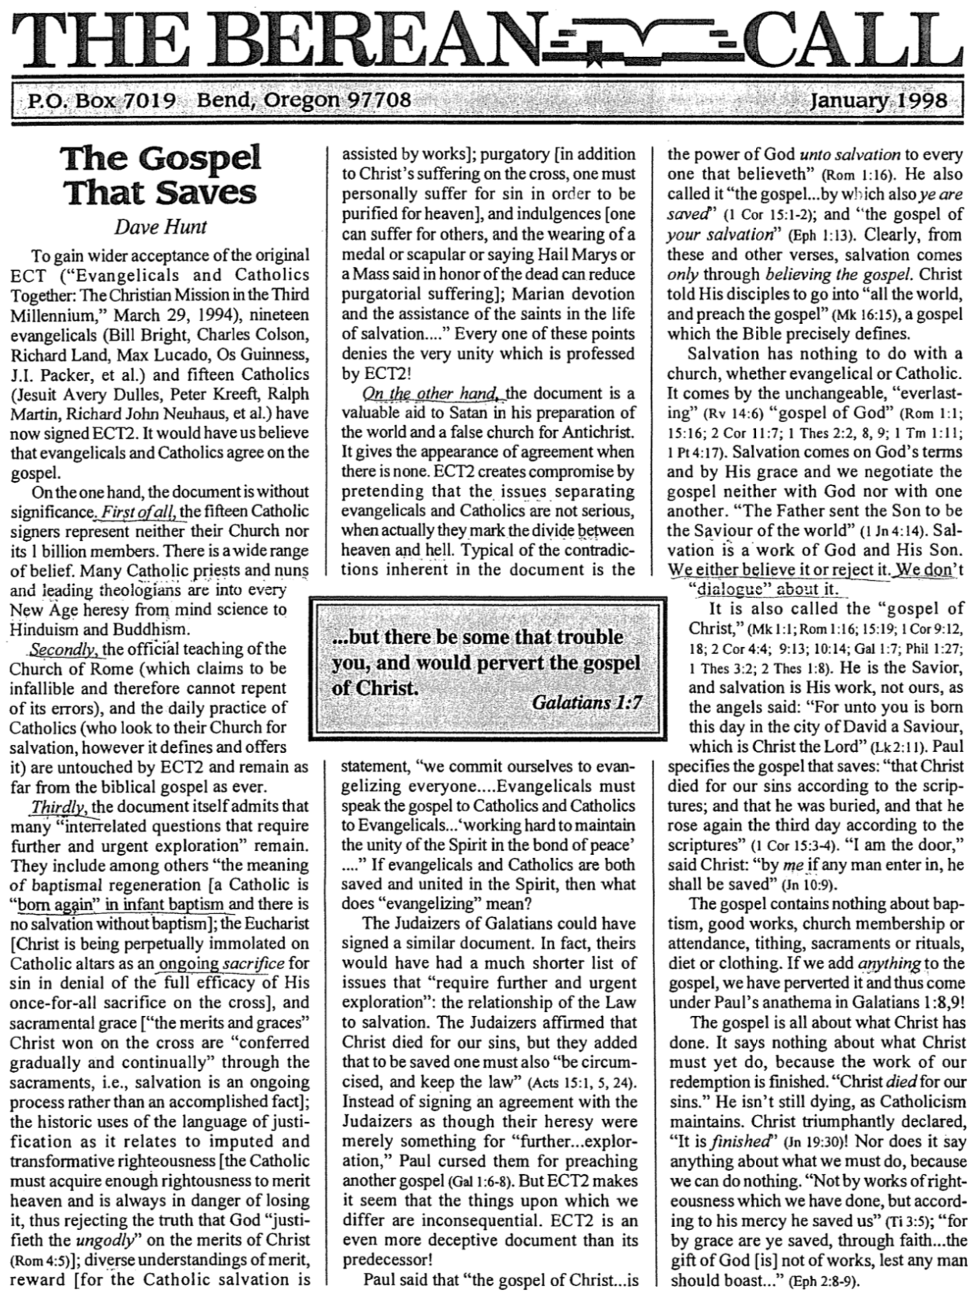
Evangelicals and Catholics Together (2 of 2)

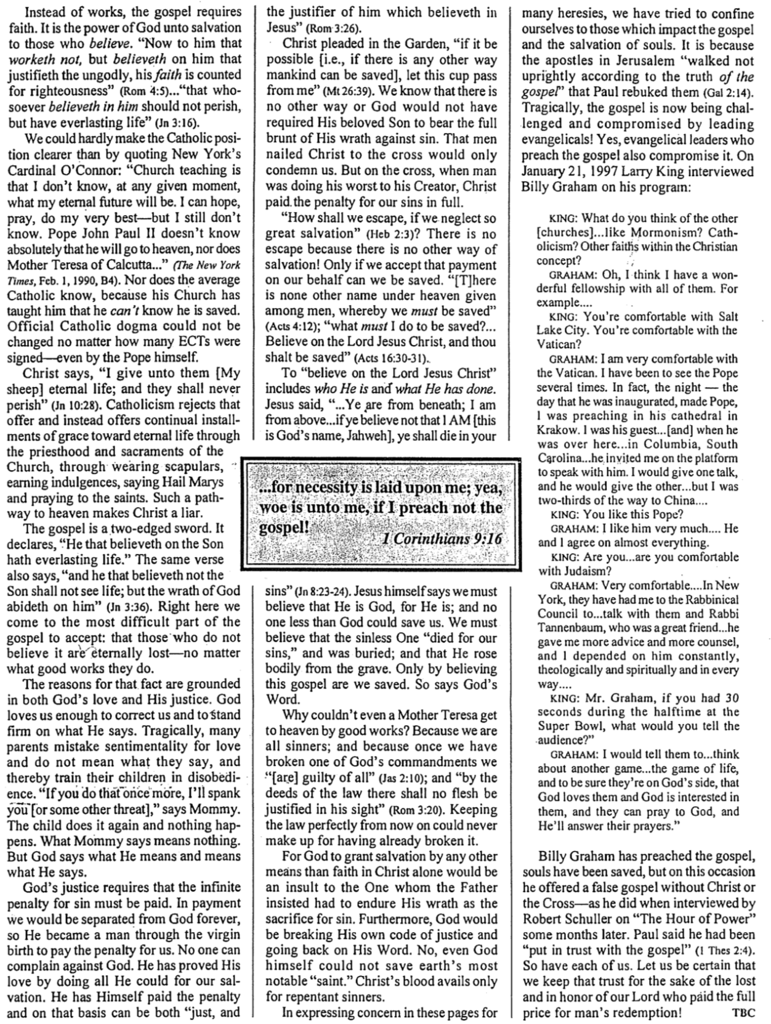
Fruit of the Spirit Defined

Most of us cannot recognize what kind a tree we are looking at by seeing only its leaves and branches. But when we see fruit on it, identifying it is simple.

The same is true of Christians. The unmistakable fruit of God’s Spirit in our lives is powerful evidence that one has truly trusted Christ. Galatians 5:22-23 notes that this fruit (singular) is love, but love includes the other eight traits as well…

Inner Life | Love | Unconditional and unselfish commitment to others; active service to them
 | Joy | Deep happiness stemming from a personal relationship with God, including a sense of fulfilling His will
 | Peace | Wholeness, tranquility of mind, sense of well-being, based on forgiveness

Social Relationships | Patience | Longsuffering, steadfastness, forbearance, willingness to wait for others like God waits for us
 | Kindness | Excellence of character towards those of fragile nature in personality and need
 | Goodness | Sense of ideal character, righteousness softened by love

Principles  of  Conduct | Faithfulness | Fidelity towards others, reliable since God is reliable towards us
 | Gentleness | Meekness, tamed and trained, submissive to God’s will and considerate to others
 | Self-Control | Self-mastery, priority of others’ concerns over selfish desires
Fruit of the Spirit Compared

Does the Law of Moses Apply to Me?

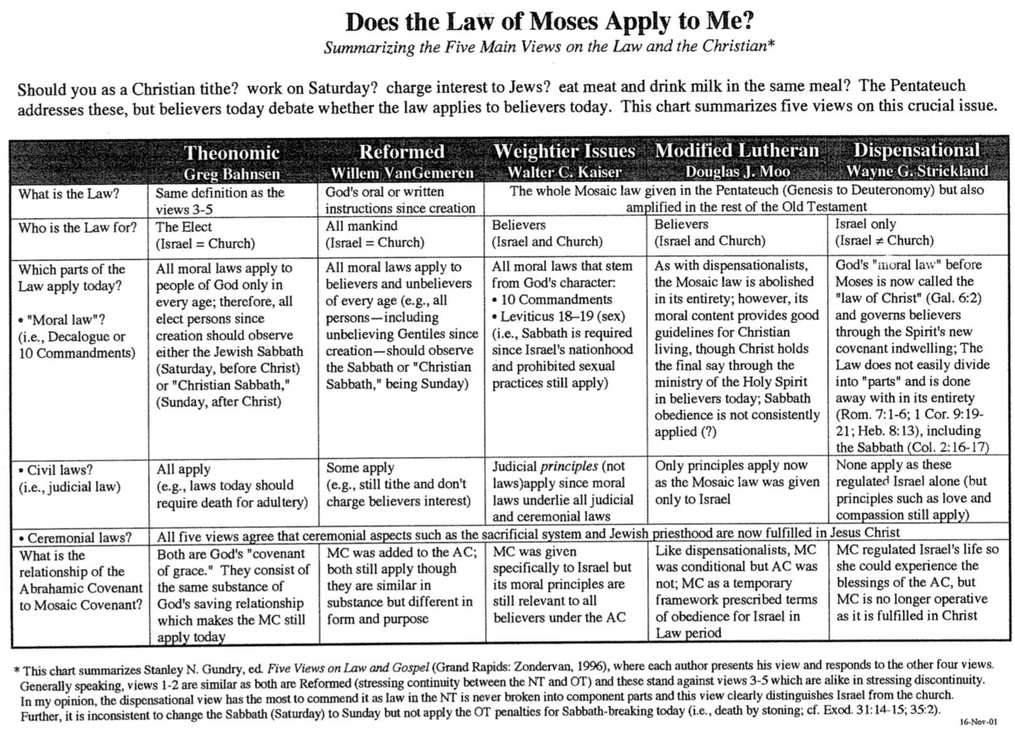
Does the Law of Moses Apply to Me? (2 of 2)

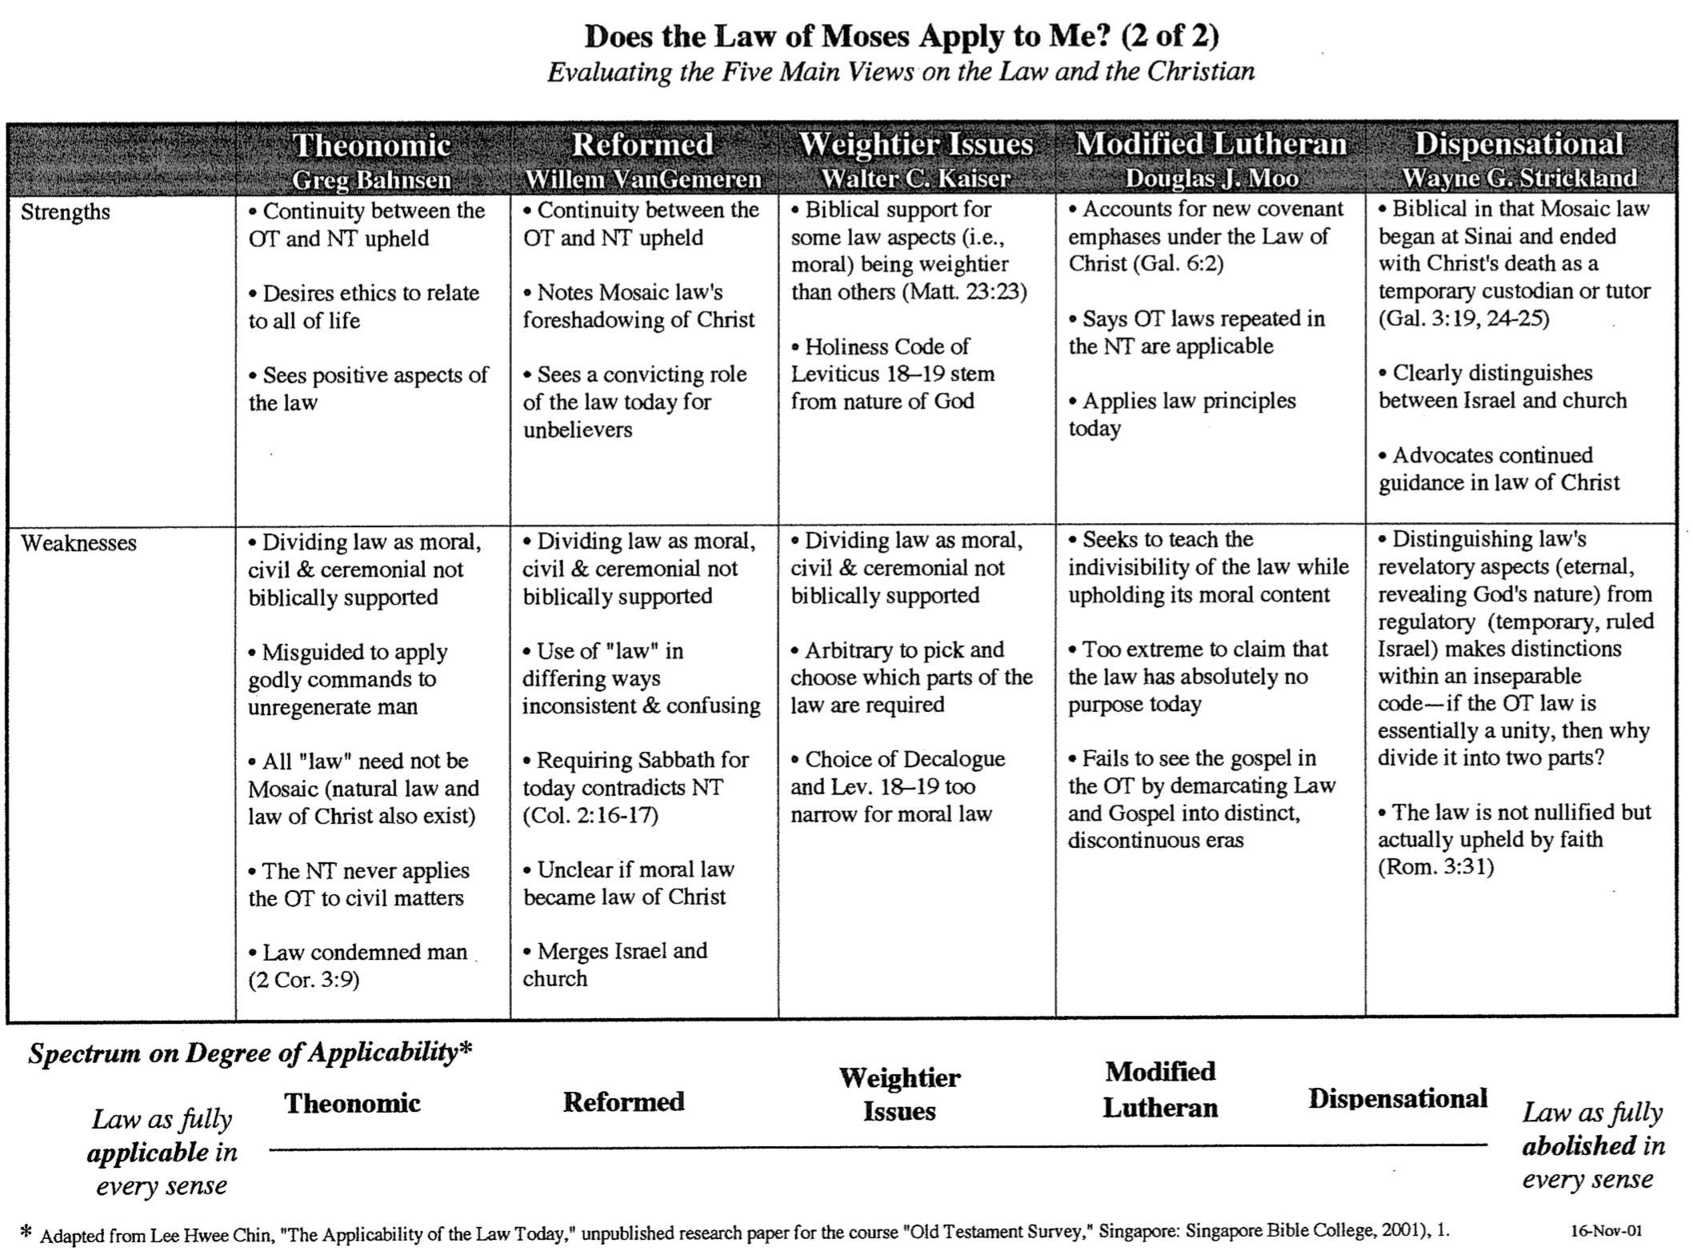

Be Free
Galatians

Exegetical Outline (Steps 2-3)

Exegetical Idea: The reason we must uphold justification by faith is because Paul affirmed it in his call, theology and practice.

Biographical: Paul defends his apostolic call to counter Judaizer teaching that Paul invented justification by faith (Gal 1–2).

Paul omits the usual thanksgiving and rebukes the Galatians for replacing the gospel with Judaizer legalism to show his displeasure (1:1-9).

Paul defends his apostleship against the Judaizers to show that he did not make up justification by faith by his own authority (1:10–2:21).

His independence of other apostles is evident by receiving revelation directly from Christ and by not meeting them for three years (1:10-24).

His interdependence with other apostles was seen at the famine visit when apostles at Jerusalem approved his justification by faith teaching (2:1-10).

He indicted Peter, the chief apostle who contradicted justification by faith when he publicly acted against justification by faith (2:11-21).

Theological: Paul illustrates salvation by faith and not by the Law to counter the Judaizer accusation that justification by faith was a new teaching (Gal 3–4).

Paul affirms justification by faith by comparing the inferior Law with the superior Holy Spirit and Promise (Gal 3).

The Galatians received salvation by receiving the Holy Spirit by faith, not the Law, so their sanctification must also be by faith (3:1-5).

Abraham was justified by faith, not by Law, so this doctrine has solid scriptural foundation and is not a new teaching (3:6-14).

Salvation was by faith for 430 years between Jacob and the Law, so the Law led man to faith by revealing sin (3:15-29).

Paul illustrates justification by faith in domestic, historical, and biblical life to convince the Galatians to abandon legalism (Gal 4).

A son’s privileges over a slave’s pictures a believer's spiritual religion over the Law to help the readers abandon legalism (4:1-11).

Their former commitment to Paul when he was with them should encourage them to show the same zeal for the truth now (4:12-20).

God blessing Isaac (=Abrahamic Covenant) instead of Ishmael (=Mosaic Covenant) shows the folly of Galatians following the Law (4:21-31; cf. p. 174a).

Practical: Paul applies salvation by faith in Spirit-led living by exhorting balance and others-orientation (Gal 5–6).

Balance between legalism and license comes the Spirit—not the sinful nature (Gal 5).

Believers should not live in the extremes of legalism and license in light of their freedom from the Law (5:1-15).

A Christian is free from the Law so should never again be entrapped in legalism (5:1-12).

A Christian is free from the Law so should use this freedom to love instead of selfish pursuits (5:13-15).

Believers should live under direction from the Spirit rather than from the sinful nature (5:16-26).

Serve sinning Christians, burdened believers, teachers, and everyone since freedom from the Law leads to caring for others (6:1-10).

A final warning contrasts the impure Judaizer motives with his own pure motives to convince them to apply what he has written (6:11-18).

Purpose or Desired Listener Response (Step 4)
The listeners will show they embrace salvation by faith by being free from legalism.

Homiletical Outline (Cyclical inductive form)

Introduction

Interest: The most horrible slavery is salvation by works.

Need: Are you a slave or are you free?

Subject: Why must salvation be by faith alone?

Background: Justification by faith was attacked in Galatia.

Preview: In response, Paul gives three reasons to believe in salvation by faith.

Text: The whole letter to the Galatians answers why salvation has to be by faith alone.

(Why must salvation be by faith alone?)

Jesus called Paul to teach salvation by faith (Gal 1–2).

Paul rebukes their legalism instead of thanking them (1:1-9).

Paul didn’t invent justification by faith by his own authority (1:10–2:21).

He was independent of other apostles by being called by Jesus alone (1:10-24).

He was interdependent with other apostles but approved by them (2:1-10).

He indicted Peter when Peter publicly acted against justification by faith (2:11-21).

(Why must salvation be by faith alone?)

Salvation has always been by faith (Gal 3–4).

Justification by faith instead of Law is seen in the superior Holy Spirit and Promise (Gal 3).

Both salvation and sanctification must be by the same means—faith (3:1-5).

Abraham was saved by faith, not by Law, so this doctrine is not a new teaching (3:6-14).

Salvation was by faith 430 years before the Law led to faith by revealing sin (3:15-29).

Illustrations of justification by faith should convince the Galatians to abandon legalism (Gal 4).

A son’s privileges over a slave’s shows a believer's faith over the Law (4:1-11).

They need to regain their precious commitment to Paul and the truth (4:12-20).

Isaac (=Abrahamic Covenant)—not Ishmael (=Mosaic Covenant)—shows faith (4:21-31).

(Why must salvation be by faith alone?)

Salvation by faith alone changes us inside (Gal 5–6).

Balance between legalism and license comes the Spirit—not the sinful nature (Gal 5).

Avoid the extremes of legalism and license in light of freedom from the Law (5:1-15).

We are free from the Law so should never again be entrapped in legalism (5:1-12).

We are free from the Law so we must love instead of being selfish (5:13-15).

Live under direction from the Spirit rather than from the sinful nature (5:16-26).

Serve others since freedom from the Law leads to caring for others (6:1-10).

Contrast the impure Judaizer motives with Paul’s pure motives (6:11-18).

(Why must salvation be by faith alone?)

Conclusion

Salvation by faith frees us from the Law to give freedom in Christ (Main Idea).

Main Points

Application: Be free from the slavery of legalism so you can live for Christ.

Prayer

Rick Griffith
4 Nov 2019
Message 41 of 66

Be Free
Book of Galatians

Introduction

The most horrible slavery is salvation by works.

Why must salvation be by faith __________________?

Jesus called __________________ to teach salvation by faith (Gal 1–2).

Paul rebukes their legalism instead of thanking them (1:1-9).

Paul didn’t invent justification by faith by his own authority (1:10–2:21).

He was independent of other apostles by being called by Jesus alone (1:10-24).

He was interdependent with other apostles but approved by them (2:1-10).

He indicted Peter when Peter publicly acted against justification by faith (2:11-21).

Salvation has __________________ been by faith (Gal 3–4).

Justification by faith instead of Law is seen in the superior Holy Spirit and Promise (Gal 3).

Both salvation and sanctification must be by the same means—faith (3:1-5).

Abraham was saved by faith, not by Law, so this doctrine is not a new teaching (3:6-14).

Salvation was by faith 430 years before the Law led to faith by revealing sin (3:15-29).

Illustrations of justification by faith should convince the Galatians to abandon legalism (Gal 4).

Salvation by faith alone changes us __________________ (Gal 5–6).

Balance between legalism and license comes the Spirit—not the sinful nature (Gal 5).

Serve others since freedom from the Law leads to caring for others (6:1-10).

Contrast the impure Judaizer motives with Paul’s pure motives (6:11-18).

Conclusion

Salvation by faith ________ us from the Law to give freedom in Christ (Main Idea).

Application: Be free from the slavery of legalism so you can live for Christ.

Download this sermon PPT and notes for free at BibleStudyDownloads.org/resource/new-testament-preaching/
Listen to this message online at cicfamily.com/sermon-listing/

Galatians

Justification by Faith

Judaizer Attack #1  “Paul teaches this doctrine by his own authority!” |  | Judaizer Attack #2  “This is a new teaching contrary to the OT!” |  | Judaizer Attack #3  “Teaching faith alone will encourage a sinful lifestyle!”
Paul’s Defense:  “God called me and the 12 apostles affirmed this” |  | Paul’s Defense:  “Salvation has always been by faith–even in the OT” |  | Paul’s Defense:  “No, justification by faith naturally leads to godly living”
Biographical |  | Theological |  | Practical
Chapters 1–2 |  | Chapters 3–4 |  | Chapters 5–6
Upholds  Apostleship |  | Upholds  Justification by Faith |  | Upholds  Responsibilities
Rebuke | Relationships | Affirmed | Illustrated | Balance | Service | Warnings
1:1-9 | 1:10–2:21 | 3 | 4 | 5 | 6:1-10 | 6:11-18
Antioch of Syria

Fall AD 49 (after first missionary journey)

Key Word: Justification

Key Verse: “[We Jews] know that a man is not justified by observing the law, but by faith in Jesus Christ. So we, too, have put our faith in Christ Jesus that we may be justified by faith in Christ and not by observing the law, because by observing the law no one will be justified” (Galatians 2:16).

Summary: The reason we must uphold justification by faith is because Paul affirmed it in his call, theology and practice

Application:
Do you add any other requirements for salvation except faith in Christ—baptism, tongues, good works or any other good deed?
The logical result of justification by faith is godliness.

