Galatians

Justification by Faith

Judaizer Attack #1  “Paul teaches this doctrine by his own authority!” |  | Judaizer Attack #2  “This is a new teaching contrary to the OT!” |  | Judaizer Attack #3  “Teaching faith alone will encourage a sinful lifestyle!”
Paul’s Defense:  “God called me and the 12 apostles affirmed this” |  | Paul’s Defense:  “Salvation has always been by faith–even in the OT” |  | Paul’s Defense:  “No, justification by faith naturally leads to godly living”
Biographical |  | Theological |  | Practical
Chapters 1–2 |  | Chapters 3–4 |  | Chapters 5–6
Upholds  Apostleship |  | Upholds  Justification by Faith |  | Upholds  Responsibilities
Rebuke | Relationships | Affirmed | Illustrated | Balance | Service | Warnings
1:1-9 | 1:10–2:21 | 3 | 4 | 5 | 6:1-10 | 6:11-18
Antioch of Syria

Fall AD 49 (after first missionary journey)

Key Word: Justification

Key Verse: “[We Jews] know that a man is not justified by observing the law, but by faith in Jesus Christ. So we, too, have put our faith in Christ Jesus that we may be justified by faith in Christ and not by observing the law, because by observing the law no one will be justified” (Galatians 2:16).

Summary: The reason we cannot be saved by obeying the Law is because Paul’s call, theology and practice all uphold justification by faith.

Application:
Do you add any other requirements for salvation except faith in Christ—baptism, tongues, good works or any other good deed?
The logical result of justification by faith is godliness.
Galatians

Introduction

I. Title The Greek title for the letter (Πρὸς Γαλάτας To the Galatians) follows the standard form of naming Paul's writings after their recipients.

II. Authorship

A. External Evidence: The traditional view is that the Apostle Paul wrote Galatians.

1. This finds early support by Polycarp (3:3; 5:1; cf. Kümmel, 198). Marcion also placed the epistle at the top of his list of genuine Pauline epistles (Harrison, 255).

2. Paul's authorship of Galatians has been mostly uncontested, even among the 19th-century German critics in the Tübingen school. The few who oppose Pauline’s authorship include Bauer, R. Streck (the Swiss scholar), and the nineteenth-century radical Dutch critics (Kümmel, 198).

B. Internal Evidence: The Book of Galatians explicitly mentions Paul as its author (1:1; 5:2). In fact, Paul probably departed from his usual practice of dictating his letters to a secretary by actually penning the epistle himself (6:11; cf. “Characteristics” section below). Most of chapters 1 and 2 are autobiographical (e.g., 1:11f.), and several Pauline themes are evident (e.g., grace, law).

C. Conclusion: Both external and internal evidence point to Paul's authorship (Harrison, 255; Guthrie, 468; Kümmel, 198). Galatians has always been the least challenged of Paul's epistles (Guthrie, 468). There exists not even scant evidence to disprove the genuineness of the Epistle. The Epistle to the Galatians is generally the standard by which other Pauline writings are tested (Bruce, 2).

III. Circumstances

A. Date: The date issue closely relates to the letter's destination (Bruce, 43-56). The two theories of destination are the North Galatian Theory (adopting the later date) and the South Galatian Theory (generally suggesting an earlier date):

1. External evidence from Marcion suggests that Paul wrote from Ephesus shortly before writing 1 Corinthians (approx. AD 55), thus supporting the later date. However, Marcion's reliability and sources are questionable as he believed only in Luke’s gospel and Paul’s letters (Kümmel, 197).

2. Internal evidence shows that the Galatians deserted Paul's teaching just after his first visit (1:6f.), lending more credence to the South Galatian Theory. If the second visit of 4:13 is the one in Acts 16:6, then the epistle is post-Jerusalem Council (AD 53-56; Harrison, 260; Kümmel, 197-198; Betz, 9-12). However, if this later date is true, one would think that Paul would have mentioned the decree of the Jerusalem Council in the letter since both the Council and the epistle address the same theme (requirements of the law for Gentile believers). On the other hand, if the second visit (4:13) refers to revisiting Acts 14:21 churches, then the letter could be pre-Jerusalem Council (AD 48-49), though it would not need to demand the early date (Guthrie, 458).

3. Conclusion: Arguments for both dates are inconclusive, but the best evidence supports the South Galatian Theory (see below) and the earlier date of about fall AD 49.

B. Origin: The origin of the book of Galatians is not explicitly stated and depends upon the identity of the recipients as to whether they lived in North or South Galatia:

- The Northern Theory says Paul wrote to North Galatia from Ephesus, Corinth, Macedonia, or Rome (Betz, 12).

2. The Southern Theory says that Paul wrote to South Galatia from Antioch or somewhere en route from Antioch to Jerusalem for the Jerusalem Council (Harrison, 260).

C. Recipients: The epistle addressed “the churches of Galatia” (1:2). This is the only Pauline letter to a group of churches. Paul may not have had enough time to write each church individually, so a circular letter was sent (Hiebert, 2:71). The intensely debated question is, “Where were these churches?” The two theories of destination hinge mainly upon the interpretations of two verses in Acts (16:6; 18:23) that refer to this Galatian region (Bruce, 3-18; Guthrie, 450-457; Harrison, 257-259; Kümmel, 191-193). Both theories agree that the recipients were Gentiles (4:8; 5:2f.; 6:12f.), but the question is, “Which Gentiles?” See notes, 174a (chart) and 138-40, 280a (maps).

1. The Traditional View (North Galatian Theory): Galatians was written to Gallic believers in the territory of Galatia (ethnic Galatia, including the cities of Ancyra, Pessinus, and Tavium) of whom Paul had won to Christ on his second missionary journey (Acts 16:6; p. 139). Advocates include Lightfoot, Betz, Kümmel, and Harrison.

a. External evidence (from Acts and history)

1) The Gauls overtook North Galatia from the Phrygians in the 3rd century BC and then named the region after themselves (Bruce, 3-8; Guthrie, 450; Kümmel, 191).

2) The characteristics of fickleness, strife, anger, and impulsiveness that Paul denounced in his readers closely parallel Gallic lifestyles (Bruce, 4).

3) Luke describes the South Galatian towns in the province of Galatia geographically, not in provincial terms (Betz, 11).

4) The northern view was the unanimous view of the church fathers (Hiebert, 2:77).

b. Internal evidence

1) Interpreting the visit of Galatians 2:1-10 as the Jerusalem Council visit allows for only the northern view (explained in the Characteristics section).

2) The chronology of Paul's life in the southern view places his conversion at AD 23-30 (Harrison, 262; Hiebert, 2:84), which is too early.

2. Alternative to the Traditional View (South Galatian Theory): Paul wrote to the Greek believers in the Roman province of Galatia (political Galatia, including the cities of Pisidian Antioch, Iconium, Lystra, and Derbe), whom Paul had won to Christ on his first missionary journey (Acts 13–14; p. 138). Advocates include Ramsay, Bruce, Hiebert, and Guthrie (Griffith too).

a. External evidence (from Acts; Guthrie, 452-57)

1) Phrygia and Galatia in Acts 16:6; 18:23 are designated a “region” (singular), not “regions” (plural), so this region can refer to both the districts in the province of Asia (southern part) and the part of Phrygia in the adjoining province of Asia.

2) Assuming the Northern Theory, it would be strange for Luke to say so little about this area in which such a major controversy arose.

3) Paul generally referred to groups of churches by their Roman province (e.g., Macedonia, Achaia, Asia, and Judea). Luke’s usage of the term should not be imposed upon Paul.

4) “Galatia” was the best term to describe the various ethnic groups in the south.

b. Internal evidence

1) Since Paul visited the Galatian churches during his recovery from a bodily illness (4:13), he is unlikely to have traversed the arduous journey off the road to the central plateau of Northern Galatia.

2) The mention of Barnabas (2:1, 9, 13) is more natural if the readers knew him. Barnabas accompanied Paul only in South Galatia.

3) No mention is made of the verdict of the Jerusalem Council (cf. Acts 15), which would have already occurred, assuming the Northern Theory.

4) The letter was written in Greek, a language understood by only the northern people of Ancyra and Pessinus at best (Bruce, 9).

5) Peter hardly would have acted as he did (2:11f.) right after the Jerusalem Council.

Conclusion: External evidence is divided. The Northern Theory was virtually unchallenged until the last two centuries, but the evidence from Acts seems to best support the Southern Theory. The Patristic bias for the Northern Theory may be explained by second century evidence that the term “Galatia” had ceased to be used in reference to the southern area; therefore, the Fathers interpreted the term in light of their own day (Hiebert, 2:77).

However, the internal evidence favors the southern view. While the southern view has chronological difficulties, the northern view has the problem of attributing the “again” of Galatians 2:1 to a third (not second) visit. Therefore, the weight of the evidence supports the Southern Galatian Theory.

D. Occasion: The Galatians accepted the gospel eagerly at first (3:1-5; 4:13-14) but this ended (4:15) due to opposition from Jewish false teachers (Judaizers) who had spread their teaching in the churches after Paul established them (1:7b; 4:13-14; 5:7). They proclaimed “another gospel” (1:6-9) associated with the Jewish Torah and circumcision (2:15-21; 3:2-5; 4:21; 5:2-12; 6:12-17). Paul had confronted these Judaizers already in Jerusalem (2:4-5) but this letter was written before the Jerusalem leaders officially disapproved of them at the Jerusalem Council (Acts 15:19-21, 24). Since no official word had yet come from Jerusalem, Paul wrote the churches immediately to combat this false teaching by defending his apostleship (Gal 1–2) and the true gospel of justification by faith alone (Gal 3–4), which produces a unique lifestyle based upon freedom in Christ (Gal 5–6).

IV. Characteristics

A. Literary Characteristics:

1. Structure: Its threefold structure is explained in the occasion section above. This is different from the twofold structure characteristic of other Pauline writings: Romans (1–11, 12–16), Ephesians (1–3, 4–6), Colossians (1–2, 3–4), etc.

2. Mood: Even the first verse shows a severe tone as it lacks the customary salutation. The letter lacks a thanksgiving for the readers or words of praise for them (e.g., they are never referred to as “saints”). However, some touch of affection does appear (4:12-15, 19-20).

3. Unity: Paul vindicates his authority repeatedly (1:1, 11-16; 6:11-16) and defends justification by faith (1:6-10; 2:4, 14; 3:1–5:12), so the unity of the letter has gone virtually unchallenged. It is the most accepted epistle of Pauline authorship.

B. The Jerusalem visit (2:1-10) has been seen as either Paul's famine trip to aid the depressed church (cf. Acts 11:27-30) or Paul's attendance at the Jerusalem Council (cf. Acts 15:1-29).

1. Advocates of the Jerusalem Council view (Lightfoot, Hendriksen, Hiebert) argue:

a. The apostles (2:9) and Titus (2:1-3) are not mentioned in the famine visit.

b. Although the apostles acknowledged Paul and Barnabas' Gentile ministry, this is unlikely before their first missionary journey (i.e., before Acts 13).

c. It is difficult to see why the Jerusalem Council would need to be called (Acts 15) if the issue of Gentile salvation had already been settled (Acts 11).

d. Perhaps the best Council view evidence is the problematic chronology of the southern view that places Paul's conversion between AD 23-30 (1:18; 2:1; Harrison, 262; Hiebert, 2:84).

2. Advocates of the Famine view (Bruce, Tenney, Duncan) affirm this evidence:

a. The visit to Jerusalem “again” (2:1), taken in its most natural sense, refers to Paul's actual second visit following his conversion (Acts 11).

b. Galatians 2:1-10 is a private discussion, not the Jerusalem Council assembly of Acts 15.

c. The decrees of the Council are totally missing in Galatians 2.

d. Peter and Paul's dispute over eating with Gentiles (2:11-21) makes better sense pre-Jerusalem Council.

3. Conclusion: The southern view has chronological difficulties, and the northern view forces the second visit to Jerusalem (“again” in 2:1) to mean a third visit. Both views have problems, but better evidence for the Southern Galatian Theory favors the famine view.

C. Paul declares at the end of the epistle, “See with what large letters I am writing (ἕγραψα, aorist) to you with my own hand” (6:11). Two views of the aorist prevail:

1. The traditional view sees Paul using an epistolary aorist (“I am writing”), where he signs after his custom of dictating the bulk of his letter to a scribe (cf. Rom. 16:22; 1 Cor. 16:21).

2. However, Paul never uses the aorist when writing only a few concluding words, so it seems more logical that he uses the everyday use of the aorist (“I wrote”). This means Paul painstakingly wrote the entire letter himself, possibly with large letters, due to an eye disorder (4:25; Hiebert, 2:89-90).

D. Galatians is the only Pauline letter written to a group of churches.

E. This is the first letter of Paul that has been included in the New Testament.

Argument

Galatians is often called “the Magna Carta of Christian Liberty” since it emphasizes the believer's freedom in Christ. However, it is evident that Paul's purpose was threefold: to defend his apostleship against the Judaizers (Gal 1–2), to defend the essence of the gospel based in justification by faith alone (Gal 3–4), and to give practical exhortations in light of the believer's freedom in Christ (Gal 5–6).

Therefore, Paul's purpose in writing is to convince the Galatians that since they were saved by grace they are free from the Law. As a result, Judaizers who sought to impose upon them a legalistic system based upon the Law should not lead them away from their moorings in Christ.

Synthesis

Justification by faith

1–2 Biographical: Defends apostleship
1:1-9 Rebuke
1:10–2:21 Relationship to other apostles
1:10-24 Independence
2:1-10 Interdependence
2:11-21 Indictment

3–4 Theological: Defends justification by faith
3 Affirmed
3:1-5 Galatian's experience
3:6-14 Abraham's experience
3:15-29 Law/Promise vs. faith
4 Illustrated
4:1-11 Domestic: son vs. servant
4:12-20 Historical: personal plea
4:21-31 Biblical: Isaac (Abrahamic) vs. Ishmael (Mosaic)

5–6 Practical: Defends responsibilities
5 Balance
5:1-15 No to legalism/license
5:16-26 Yes to Spirit
6:1-10 Service
6:11-18 Warnings
6:11-13 Against legalists
6:14-17 Against despising him
6:18 Benediction

Outline

Summary Statement for the Book
The reason we cannot be saved by obeying the Law is because Paul’s call, theology and practice all uphold justification by faith.

Biographical: Paul defends his apostolic call to counter Judaizer teaching that Paul invented justification by faith (Gal 1–2).

Paul omits the usual thanksgiving and rebukes the Galatians for replacing the gospel with Judaizer legalism to show his displeasure (1:1-9).

Paul defends his apostleship against the Judaizers to show that he did not invent justification by faith by his authority (1:10–2:21).

His independence from other apostles is evident by receiving revelation directly from Christ and by not meeting them for three years (1:10-24).

His interdependence with other apostles was seen at the famine visit when apostles at Jerusalem approved his justification by faith teaching (2:1-10).

He indicted Peter, the chief apostle who contradicted justification by faith when he publicly acted against justification by faith (2:11-21).

Theological: Paul illustrates salvation by faith and not by the Law to counter the Judaizer’s accusation that justification by faith was a new teaching (Gal 3–4).

Paul affirms justification by faith by comparing the inferior Law with the superior Holy Spirit and Promise (Gal 3).

The Galatians received salvation by receiving the Holy Spirit by faith, not the Law, so their sanctification must also be by faith (3:1-5).

Abraham was justified by faith, not by Law, so this doctrine has solid scriptural foundation and is not a new teaching (3:6-14).

Salvation was by faith for 430 years between Jacob and the Law, so the Law led man to faith by revealing sin (3:15-29).

Paul illustrates justification by faith in domestic, historical, and biblical life to convince the Galatians to abandon legalism (Gal 4).

A son’s privileges over a slave’s pictures a believer's spiritual religion over the Law to help the readers abandon legalism (4:1-11).

Their former commitment to Paul when he was with them should encourage them to show the same zeal for the truth now (4:12-20).

God blessing Isaac (=Abrahamic Covenant) instead of Ishmael (=Mosaic Covenant) shows the folly of Galatians following the Law (4:21-31; cf. p. 174a).

Practical: Paul applies salvation by faith in Spirit-led living by exhorting balance and others-orientation (Gal 5–6).
  - Balance between legalism and license comes the Spirit—not the sinful nature (Gal 5).

Believers should not live in the extremes of legalism and license in light of their freedom from the Law (5:1-15).

A Christian is free from the Law so should never again be entrapped in legalism (5:1-12).

A Christian is free from the Law so should use this freedom to love instead of selfish pursuits (5:13-15).

Believers should live under direction from the Spirit rather than from the sinful nature (5:16-26).

Serve sinning Christians, burdened believers, teachers, and everyone since freedom from the Law leads to caring for others (6:1-10).

A final warning contrasts the impure Judaizer motives with his own pure motives to convince them to apply what he has written (6:11-18).

Contrasting Galatians and Romans

Galatians and Romans have common themes such as justification by faith (Gal. 2:16; 3:14; Rom. 1:17; 3:21-22), freedom from the Law (Gal. 3:10-13, 23-25; 5:1; Rom. 7:1, 6; 8:2-4), and how the Law reveals sin (Gal. 3:22; Rom. 3:20; 5:20; 7:7). Yet these books remain unique in several ways:

 | Galatians | Romans
Influence of Cities | Minor | Major
Number of Churches | Several Cities  (Lystra, Derbe, etc.) | Single City  (Rome)
Church Founded | AD 48-49  (on first missionary journey) | AD 33-56  (no one knows exactly when)
Founder | Paul | Pentecost converts? or  Paul’s disciples?
Written | AD 49  from Antioch | AD 56-57  from Corinth
View of Paul | Doubted  (but most knew him!) | Credible  (but most didn’t know him!)
Paul’s Opponents | Judaizers | None
Jew-Gentile Relations | Serious rift | Mild criticism of each other
Readers | Mostly Gentiles | Jew-Gentile mix
Theological Errors | Serious: Salvation | Minor: Christian liberty
Theme (Key Word) | Justification (2:16) | Righteousness (1:17)
Vocabulary & Tone | Simple yet Severe | Technical and Structured
Form | Modified Defense  (e.g., no thanksgiving) | Traditional Presentation  (e.g., names, greetings…)
OT Quotes | Few  (only 12, or 2 per chapter) | Nearly as many as the rest of Paul’s epistles (63 total!)
Doctrinal Focus | Narrow: Justification | Broad: Many topics*

* Natural revelation (1:19-20), universality of sin (3:9-20), justification (3:21-24), propitiation (3:25), faith (4:1-25), Israel (chaps. 9–11), gifts (12:3-8), government (13:1-7), Christian liberty (14:1–15:13)
Who Are the Judaizers Today?

Scholars generally agree that the teachers who came to Galatia after Paul left taught that faith alone does not save. These teachers insisted on a “faith plus works” formula by adding works of the law as a requisite for genuine conversion—especially the rite of circumcision (5:6). Paul actually never gives them a name. However, since these teachers sought to get the believers to return to the Jewish law, the term “Judaizers” has been coined for them.

But were these Judaizers at Galatia Jewish believers or unbelievers? The consensus among commentators is that they were genuine believers who were simply confused in this area of doctrine (cf. Ronald Y. K. Fung, The Epistle to the Galatians, NICNT, 7-9; Kümmel, 298-301; Lightfoot, 27, 52-53; Ridderbos, 15-16). Some factors may support them being believers:

- The apostles and elders allowed representation of the “circumcision party” at the Jerusalem Council (Acts 15:1, 24). This may argue that these teachers are the same as the Judaizers since they also argued that Gentiles should be required to keep the Law (Gal. 2:12). If so, then the mother church considered them to be Christians and we should probably do the same.
- These Jewish teachers had no doubt about Jesus being the Messiah, in contrast to the majority of Jews who would not accept Christ as Israel’s king.

However, some factors may indicate that the Judaizers were indeed unsaved:
- Paul says that the Judaizer’s was “a different gospel” (NIV) which was really not the gospel at all (1:6-7). Since there is only one true gospel, the Judaizer “gospel” would then be a false teaching that was not Christian after all.
- Paul described these men in the strongest words possible, pronouncing upon them eternal condemnation (1:8-9). Ascribing hellfire to anyone but unbelievers would seem inappropriate.
- Paul also refers to them as “false brothers” (2:4).
- The Jerusalem Council occurred shortly after Paul’s letter to the Galatians and it verified Paul’s teaching on faith alone (as opposed to the Judaizer view being considered another “evangelical option” or gray area). While Judaizers (i.e., the “circumcision party”) were allowed to attend the meeting, they were soundly defeated.
- Although the Judaizers did not reject Christ outright as Messiah as did their Jewish brethren, by adding other requisites to salvation, they taught a second type of heresy that undermined the nature of the true gospel.

Given the above reasons, this study takes the view that the Judaizers were not actually Christians. Any group that adds to the simple gospel of justification by faith alone cannot be deemed “Christian.” This includes the Catholic Church (which adds works), the Church of Christ (which adds baptism), and the True Jesus Church (which adds works, baptism, tongues, foot washing, etc.). This diagram depicts how Judaizers were Jews on the fringes of the church but still outside the body:
All Humanity
(the entire large rectangle)

Jews
(this square with unbelievers outside the circle)
Gentiles
(this square with unbelievers outside the circle)

Church
(Jews & Gentiles in the circle)

Judaizers
Ceremonial vs. True Religion

One basic difference between Paul’s gospel and the religion of the Judaizers is that Paul taught faith by experience whereas his opponents taught that man is made right by ceremonial religion. These are contrasted in Galatians 4 with the infant-gr own son contrast. Note the distinctions between these modes of living in these diagrams from Paul A. Pomerville, Galatians and Romans (Brussels, Belgium: International Correspondence Institute, 1976), 95, 96, 98.

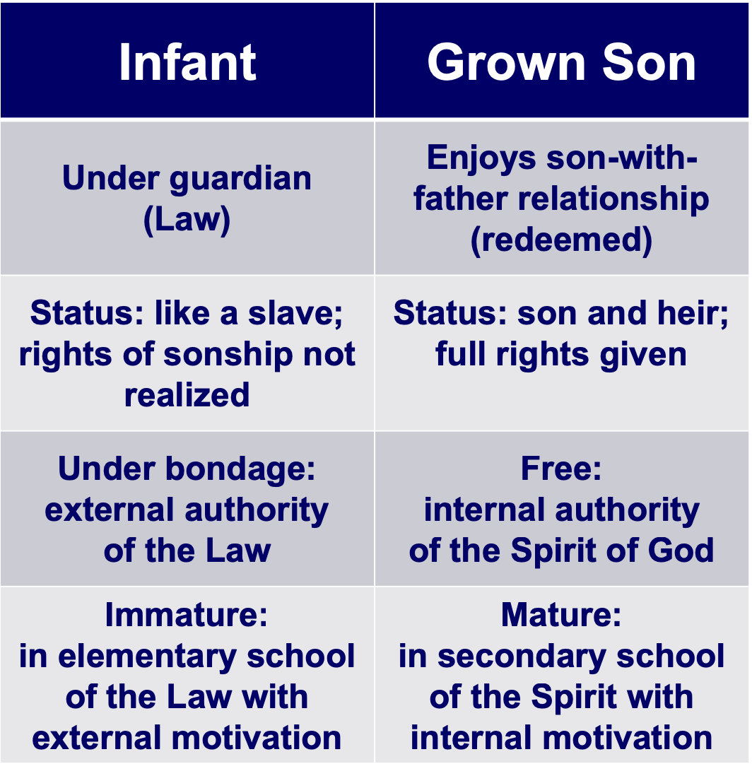
Faith & Works in the Bible
Symbolic Objects
Rites
Man's Efforts
Personal knowledge of God
Worship in the Spirit
God's revelation and work
Ceremonial Religion
The Gentile Christians in Galatia were in this kind of religion before their conversion. Their worship was a constant effort to please the gods to escape their punishment. They worshipped tangible objects––idols. They had many sacred rites and forms to be observed. They trusted in horoscopes and other signs to guide them. They had their sacred days, seasons and years.
Religion of Personal Experience
Remember that ceremonial religion emphasizes physical things in worship, while the gospel emphasizes worship in the Spirit. You can see the conflict between these two types of religion in Jesus' conversation with the Samaritan woman at Jacob's well (John 4).

Here’s an Issue for your small group…

Which is the most accurate depiction of salvation in the OT and NT?

Salvation by…

Faith Alone

Faith Alone

Faith + Works

Faith Alone
Works

Faith
Faith + Works

Faith + Works

OT

NT

Which verses in the Bible support your answer?

Distinguishing Salvation and Sanctification

 | Man’s  Role | God’s Response | Life of  Faith | Restored Fellowship
OT | Faith in God’s Passover Lamb | Exodus | Wilderness Wanderings | Sacrifices (Sin, Guilt)
NT | Faith in Christ as Lamb of God | Salvation  Positional Sanctification | Growth  Progressive Sanctification | Confession (1 John 1:9)

Salvation in the Old Testament
(From Exodus notes, 119e)

How were people saved during Old Testament times? Were only Jews saved? How? Was it through the Tabernacle and temple sacrifices? Did killing these animals forgive sin? When encountering the OT, these questions will naturally arise in a thinking person’s mind.

First, salvation has always been by faith, not the works of the Law. This is Paul’s key point in Galatians and Romans, and it applies to all times. Paul gives Genesis 15:6 as support: “Abraham believed God, and it was credited to him as righteousness” (Rom. 4:3; cf. vv. 11, 16-24; Heb. 11). Salvation in all ages is based on God’s grace, not our works (Eph. 2:8-9). The ways He has shown His grace have changed over the ages, but His method of salvation by grace through faith is constant.

OT believers expressed their faith in many ways: worshipping God, offering sacrifices, or doing good deeds, but it was their faith that saved them—not their sacrifices or worship or deeds. Their faith was placed in God’s provision of a coming Saviour (1 Pet. 1:10-12), though they did not realize that this Redeemer specifically was Jesus Christ. Further, there is no hint that their salvation could be lost.

One may ask, “But doesn’t the OT say sacrifices forgave people?” Leviticus promises Israelites that they “will be forgiven” by sin offerings and guilt offerings (4:20, 26, 31, 35; 5:10, 13, 16, 18; 6:7; 19:22; cf. Heb. 9:13). However, these refer to any specific sin rather than forgiveness from all sin for salvation; also, rituals without repentant faith were useless (Ps. 40:6-8; Isa. 1:11-20; Jer. 7:21-26).

This parallels our experience. We are saved from the penalty of sin by faith, just like Jews (and Gentiles identifying with Israel) in the OT—but we show faith by trusting Christ as our past sacrifice instead of looking forward to a future sacrifice. We still sin, but 1 John 1:9 promises, “If we confess our sins, he is faithful and just and will forgive us our sins and purify us from all unrighteousness.” We have positional forgiveness for all sins (past, present, and future) and a secure relationship with God. However, confession helps us experience practical forgiveness and restoration of our fellowship with Him. In like manner, Job sacrificed for cleansing and restored fellowship while saved (Job 42:7-9).

But why can’t the “blood of bulls and goats…take away sins” (Heb. 10:4)? Sacrifices forgave and cleansed only from external ceremonial impurity (Heb. 9:13), but Christ removed all sin and cleansed internally. See John S. Feinberg, “Salvation in the Old Testament,” Tradition and Testament, eds. John S. and Paul D. Feinberg (Chicago: Moody, 1981), 39-77, for an excellent treatment of this issue, adapted into chart form below. Issues 1-3 are the same for OT and NT, but 4-5 are different:

 | OT Times  (Moses to Christ’s Death) | NT Times  (Christ’s Death to Today)
Basis  of Salvation | God’s gracious provision of the death of Christ since “it is the blood that makes atonement for one’s life” (Lev. 17:11b) | God’s gracious provision of the death of Christ (“without the shedding of blood there is no forgiveness” Heb. 9:22)
Requirement  of Salvation | Faith in the provision that God has revealed–as a gift (Ps. 51:16-17) | Faith in the provision that God has revealed–as a gift (Gal. 2:16)
Ultimate Content  of Salvation | Object of faith is God Himself–prophets exhorted repentance, not sacrifices (Jer. 3:12; Joel 2:12) | Object of faith is God Himself–heroes of faith are cited to exhort faith in God (Heb. 11)
Specific  Revealed Content  of Salvation | Cumulative content of faith involved sacrifices & promises: animals (Gen. 3:21); Abel’s sacrifice (Gen. 4:4); Abrahamic covenant (Gen. 15), etc. | New content of faith is the shed blood of Jesus Christ (1 Pet. 1:18-21) which removes sin removes sin while OT sacrifices merely covered sin
Believer’s Expression  of Salvation | Obey moral law, offer animal sacrifices, obey Mosaic law (civil and ceremonial aspects) | Obey moral law, observe Lord’s Supper and baptism, etc. through the Spirit’s enabling (Rom. 8:9)

The Readers of Galatians
A Summary on the Location of “Galatia”

 | Northern Theory | Southern Theory
Advocates | Lightfoot, Betz, Kümmel, Harrison,  John A.T. Robinson | Ramsey, Bruce, Hiebert, Guthrie, Grassmick, Hoehner, Tenney, Benware, Griffith
Age | Traditional View | Newer View (1800s)
Location | North Galatia (small area) | South Galatia (large area)
Nature | Territory | Roman Province
Describes | Ethnic Galatia | Political Galatia
Cities | Ancyra, Pessinus, Tavium | Pisidian Antioch, Iconium, Lystra, Derbe
Established | Second Missionary Journey  (Acts 16:6-8; AD 51-52) | First Missionary Journey  (Acts 13–14; AD 49)
Barnabas | Absent (with John Mark) | Present
Gal 2 Ref. | Jerusalem Council (Acts 15) | Famine Visit (Acts 11:27-30)
Date | AD 53-57 | AD 48-49
Writing | Paul’s third NT letter | Paul’s first NT letter
Origin | Ephesus, Corinth, Macedonia | Antioch, en route to Jerusalem
Support | Luke Used Geographical Names  Gallic Lifestyles  Unanimous Patristic Support | Paul Used Roman Names  Paul did Plant Churches Here  Mention of Barnabas  Paul's Sickness  Absence of Jerusalem  Council Decree
Problems | Second Visit (2:1)  No Support Paul ever Visited North  No Mention of Jerusalem Council  (Acts 15) | Paul's Dates (1:18; 2:1)

Why does it make any difference whether the book was written to the north or south? If it was to the south, this makes the readers the same people as in Acts 13–14 so that we have the scriptural background for the letter.

Covenant Contrasts in Galatians 4:21-31

In the book of Galatians, Paul argues for justification by faith against Judaizers who followed up his ministry in these churches with a heretical doctrine of justification by the law (specifically, circumcision). In chapter 3, he argues that believers are spiritual sons of Abraham because they, like him, trust God by faith (3:1-15. Also, since the Abrahamic promise preceded the law by 430 years, salvation cannot be in the law—otherwise, Abraham couldn’t have been saved hundreds of years earlier.

In the next chapter, Paul continues his argument for salvation by faith by contrasting the Sinai covenant (law) with the Abrahamic covenant in which Christians participate. Paul contrasts these diametrically opposing ways of salvation by contrasting Sarah and Hagar through using a figurative teaching technique (4:21, Gr. άλληγορούμενα, from which we get our word “allegory”). This Sarah-Hagar passage is not a true allegory in that true allegories do not point back to historical persons, places, and events. For this reason, the NIV translates the word as “figuratively.”

Covenant | Law (24-25) | Abrahamic (28b; cf.3:16-18)
Son | Ishmael (not specifically named | Isaac (28)
Mother | Hagar（24-25) | Sarah (not specifically named)
Freedom | Slave (22a, 24b, 31a) | Free (22b, 26a, 31a)
Birth | Ordinary (23a) | Of Promise (23b)
Mount | Sinai in Arabia (24) | Calvary (implied?)
Jerusalem | Present Earthly (25b) | Future (?), Heavenly, Mother (26)
Followers | Children Not of Promise (implied) | Children of Promise (28b)
Persecution | Persecutor (29a) | Persecuted (29b)
Teachers | Judaizers | Paul & True Evangelists
Salvation by | Works | Faith in Christ
Result | Unsaved | Saved

The Catholic View of Justification

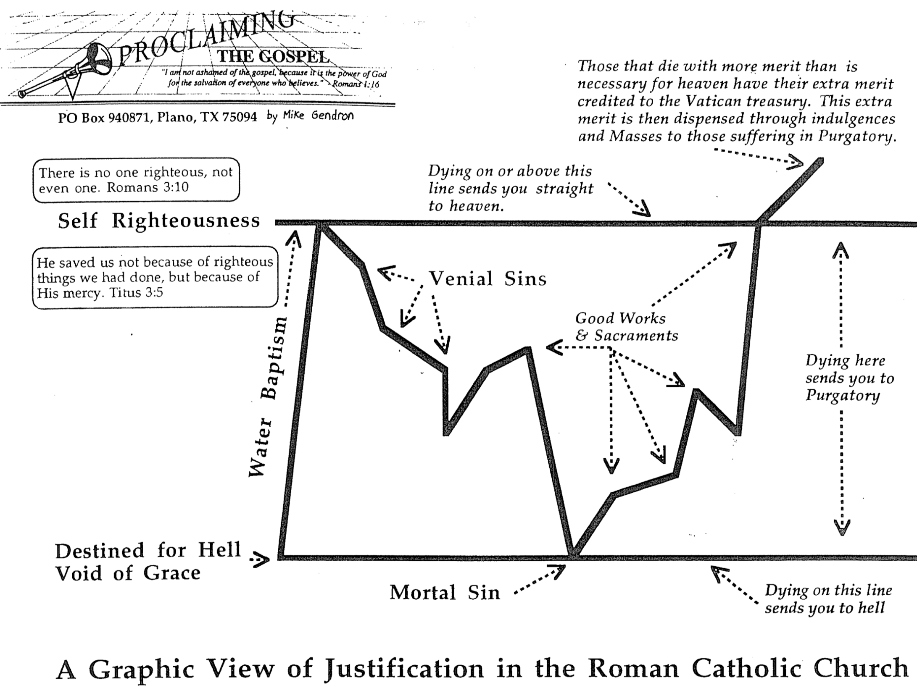
The Scriptural View of Justification

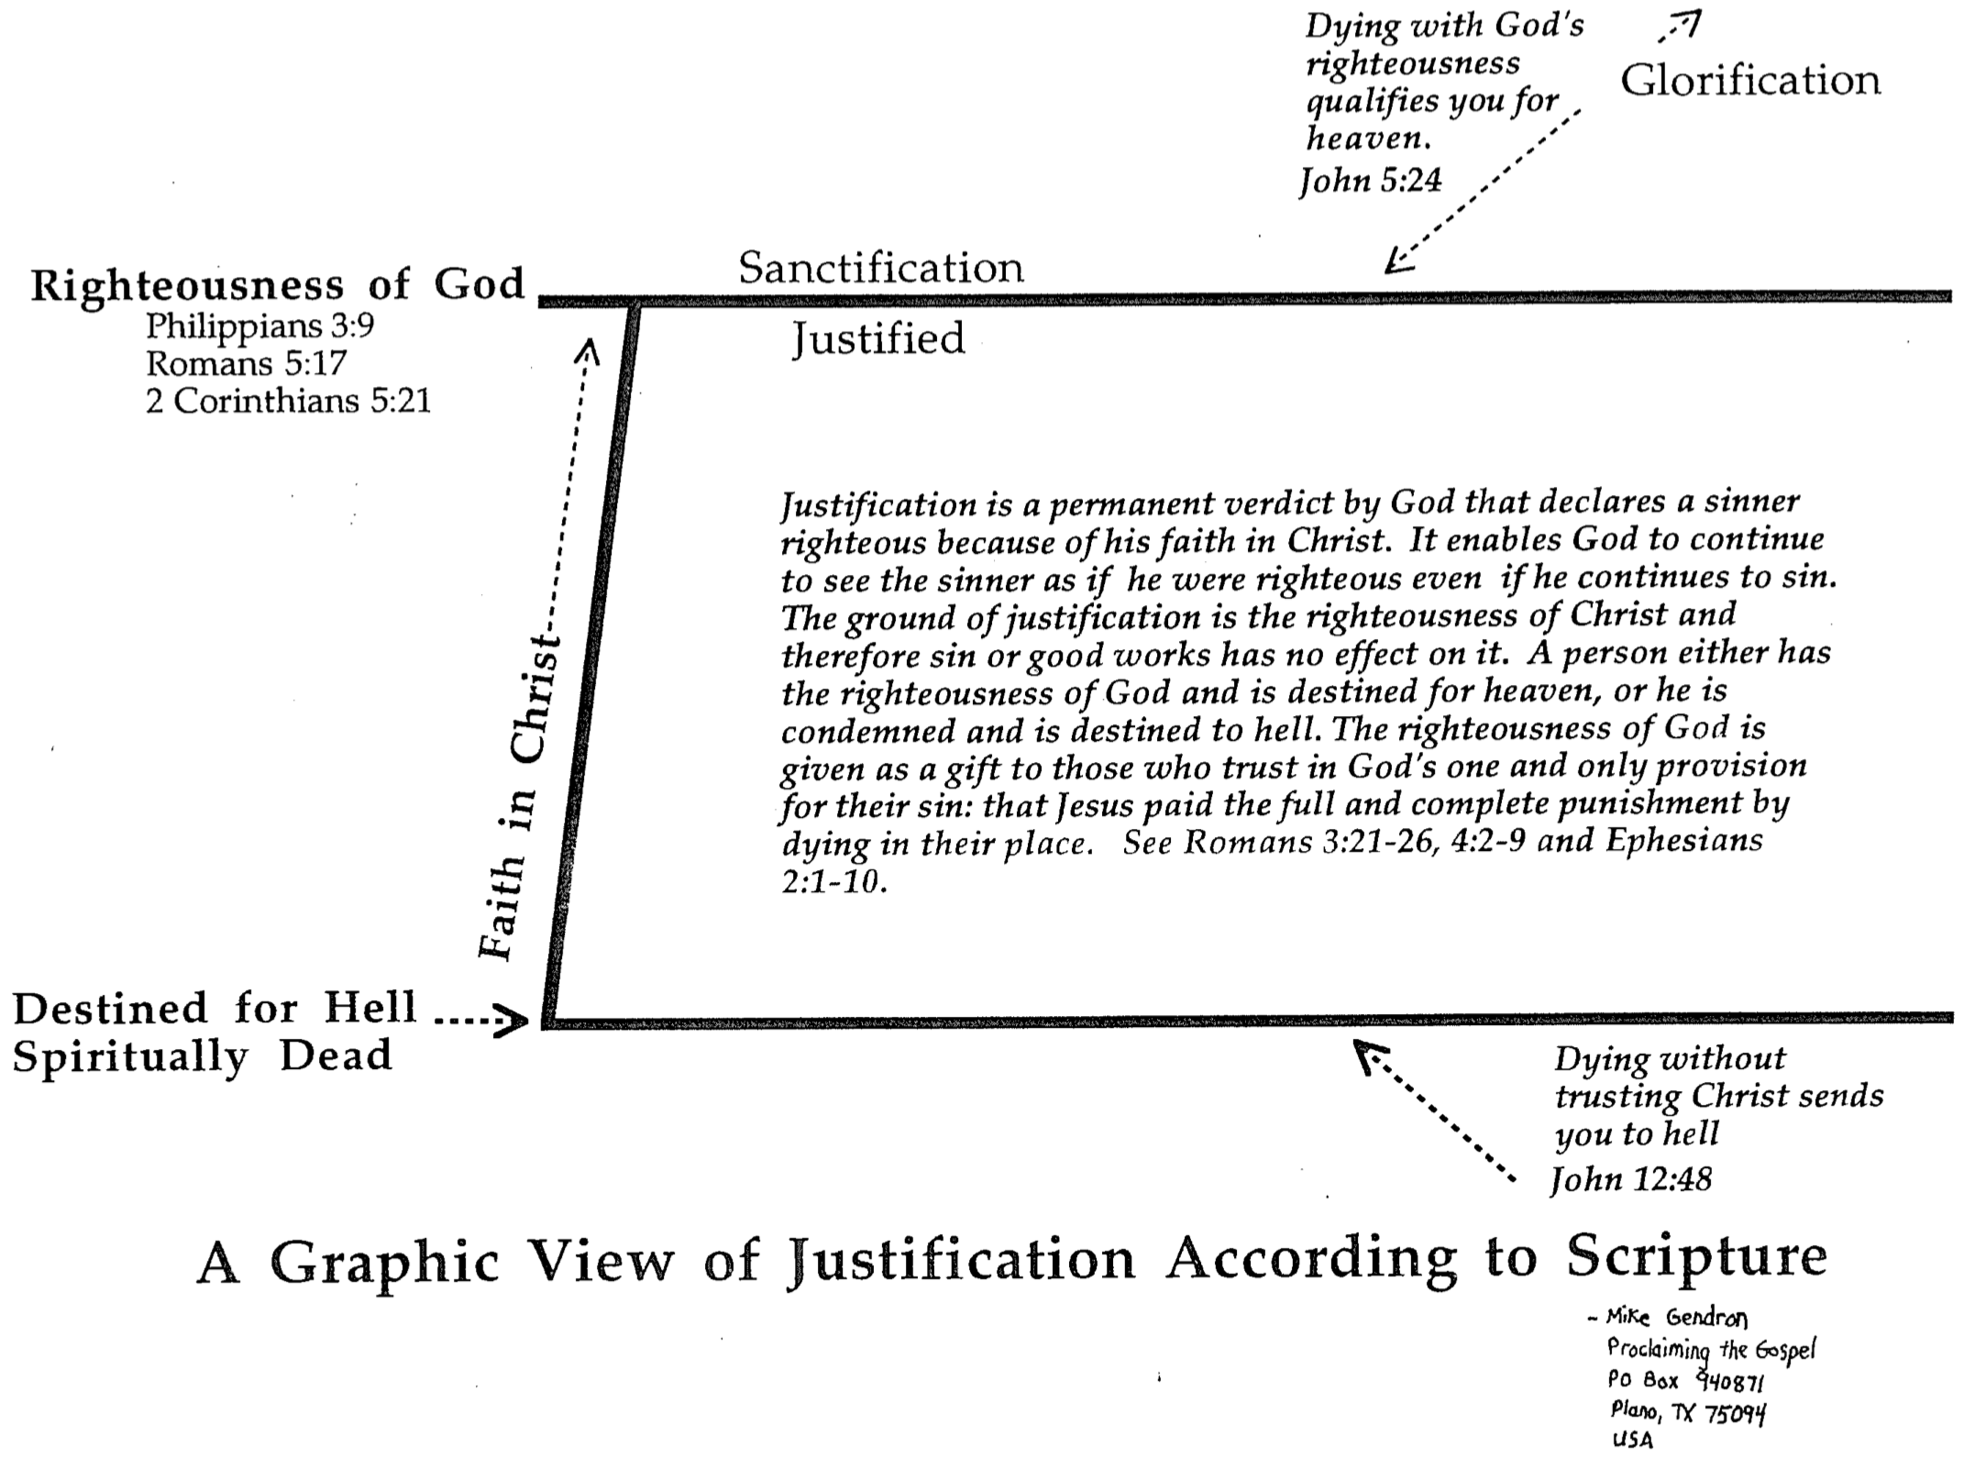
Evangelicals and Catholics Together
1 of 2

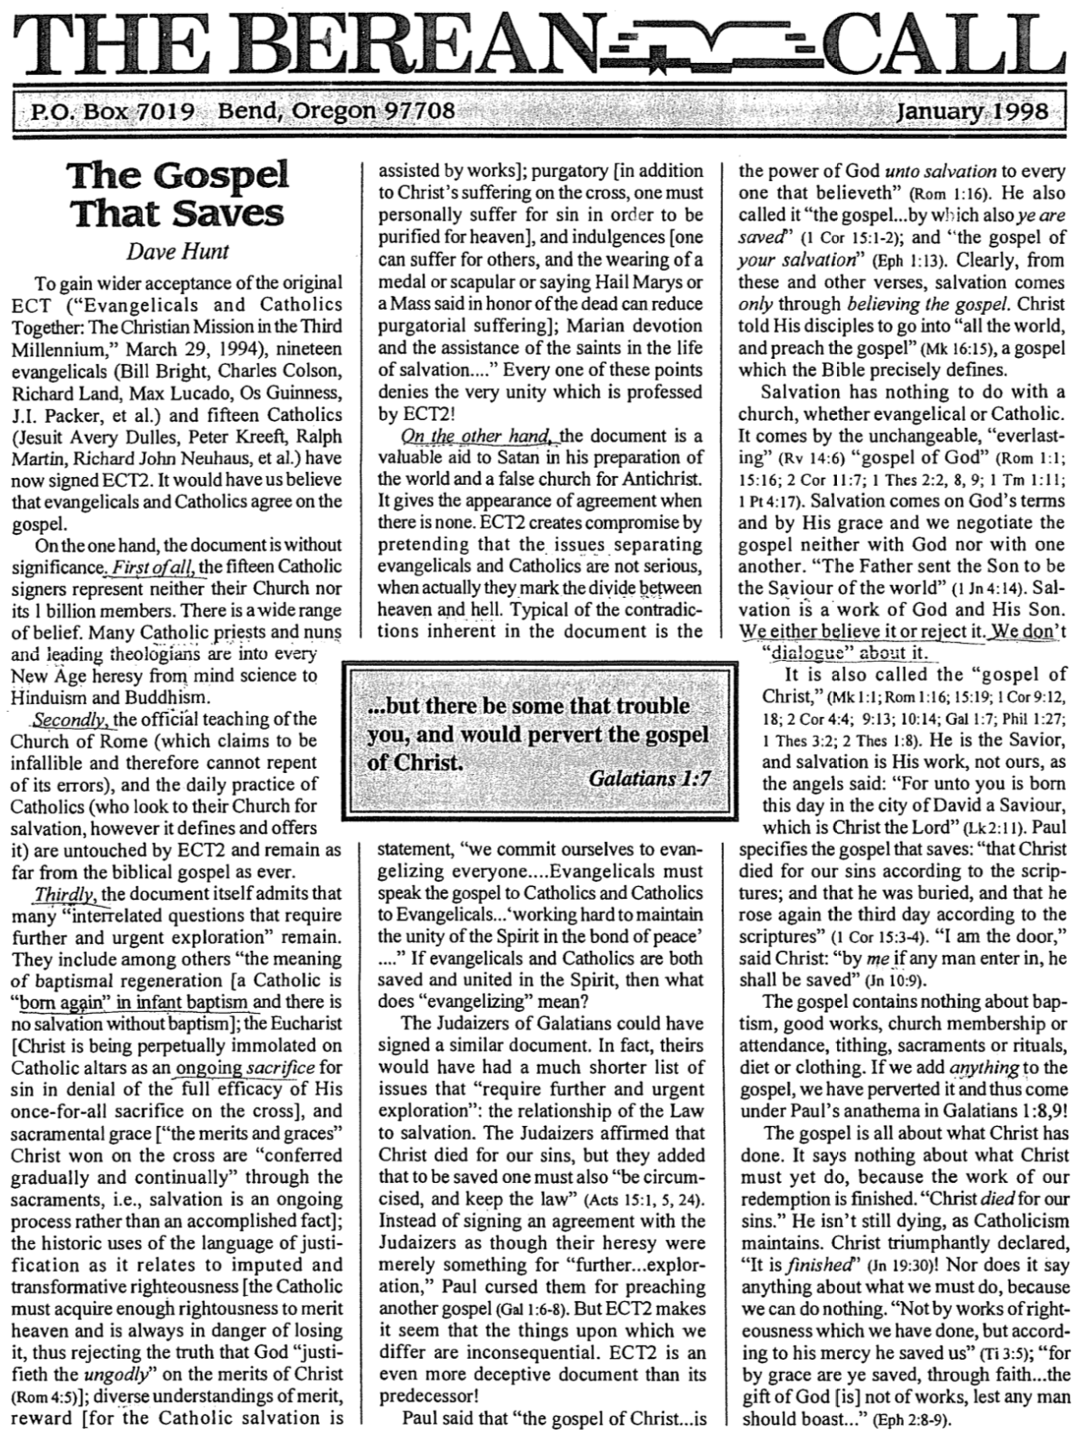
Evangelicals and Catholics Together (2 of 2)

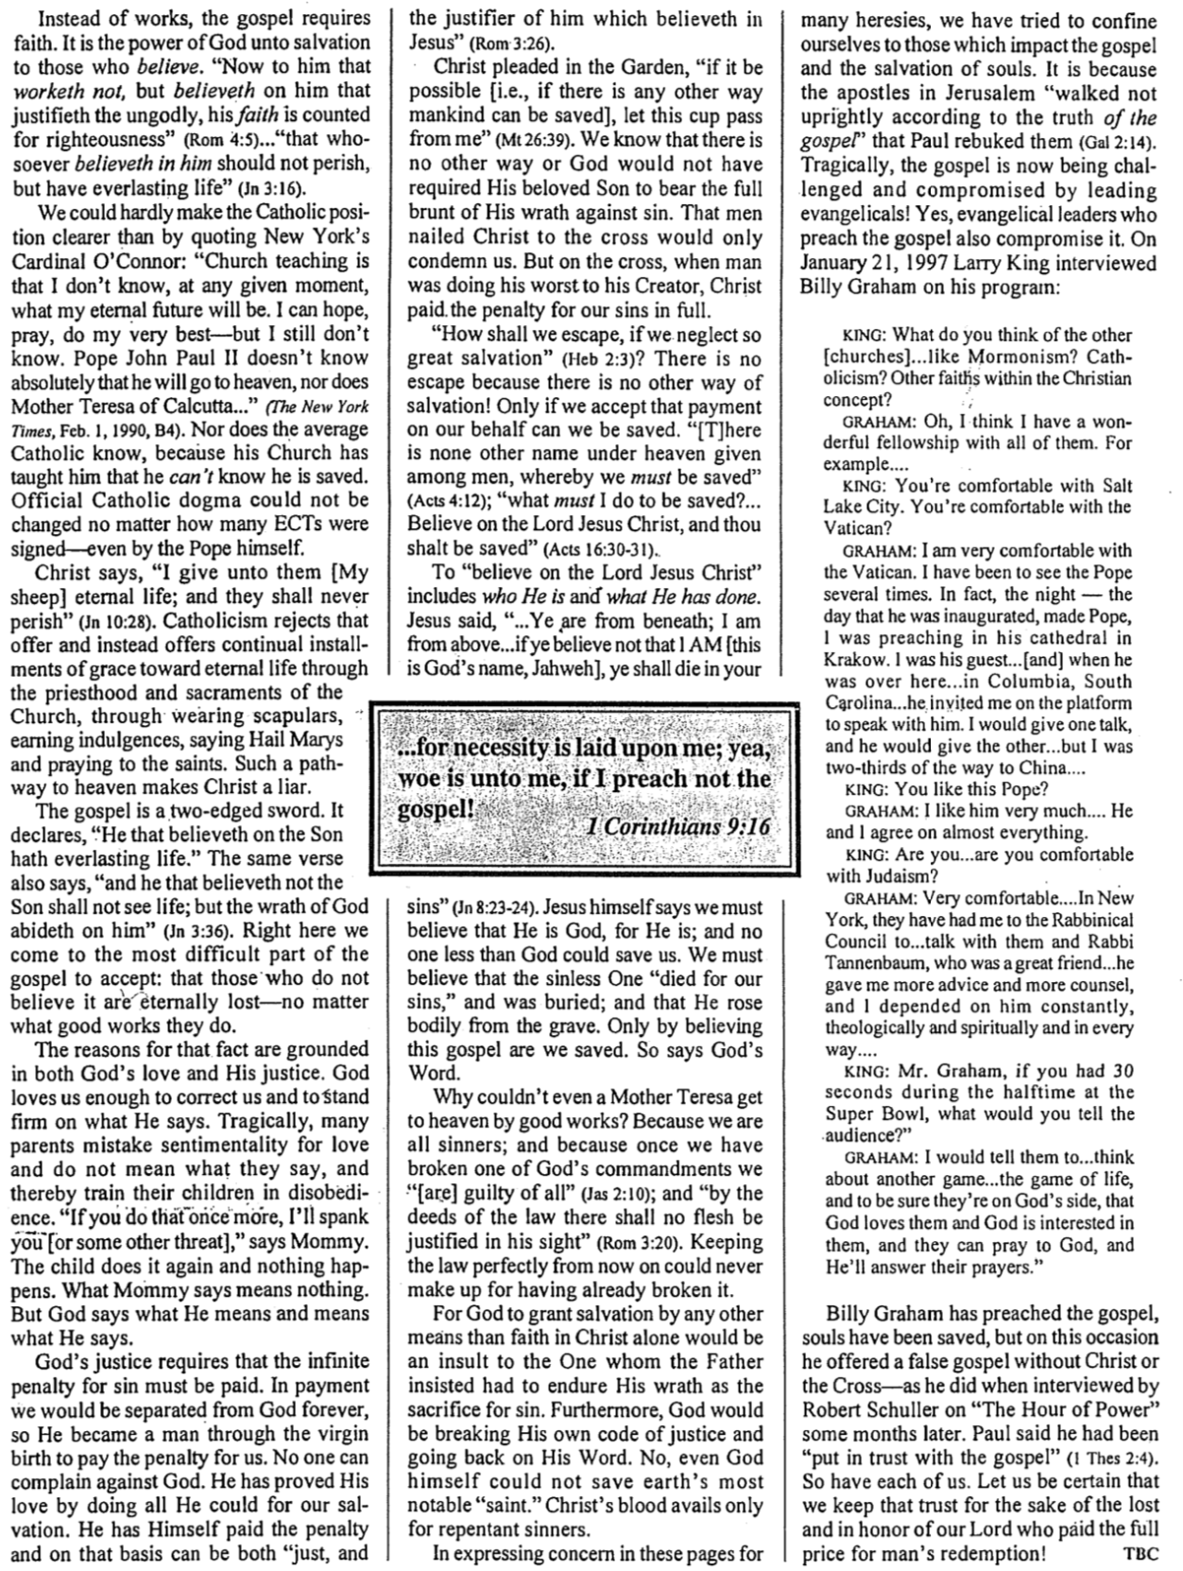
Fruit of the Spirit Defined

Most of us cannot recognize what kind a tree we are looking at by seeing only its leaves and branches. But when we see fruit on it, identifying it is simple.

The same is true of Christians. The unmistakable fruit of God’s Spirit in our lives is powerful evidence that one has truly trusted Christ. Galatians 5:22-23 notes that this fruit (singular) is love, but love includes the other eight traits as well…

Inner Life | Love | Unconditional and unselfish commitment to others; active service to them
 | Joy | Deep happiness stemming from a personal relationship with God, including a sense of fulfilling His will
 | Peace | Wholeness, tranquility of mind, sense of well-being, based on forgiveness

Social Relationships | Patience | Longsuffering, steadfastness, forbearance, willingness to wait for others like God waits for us
 | Kindness | Excellence of character towards those of fragile nature in personality and need
 | Goodness | Sense of ideal character, righteousness softened by love

Principles  of  Conduct | Faithfulness | Fidelity towards others, reliable since God is reliable towards us
 | Gentleness | Meekness, tamed and trained, submissive to God’s will and considerate to others
 | Self-Control | Self-mastery, priority of others’ concerns over selfish desires
Fruit of the Spirit Compared


Does the Law of Moses Apply to Me? (1 of 2)
(From Exodus notes, 113b-c)

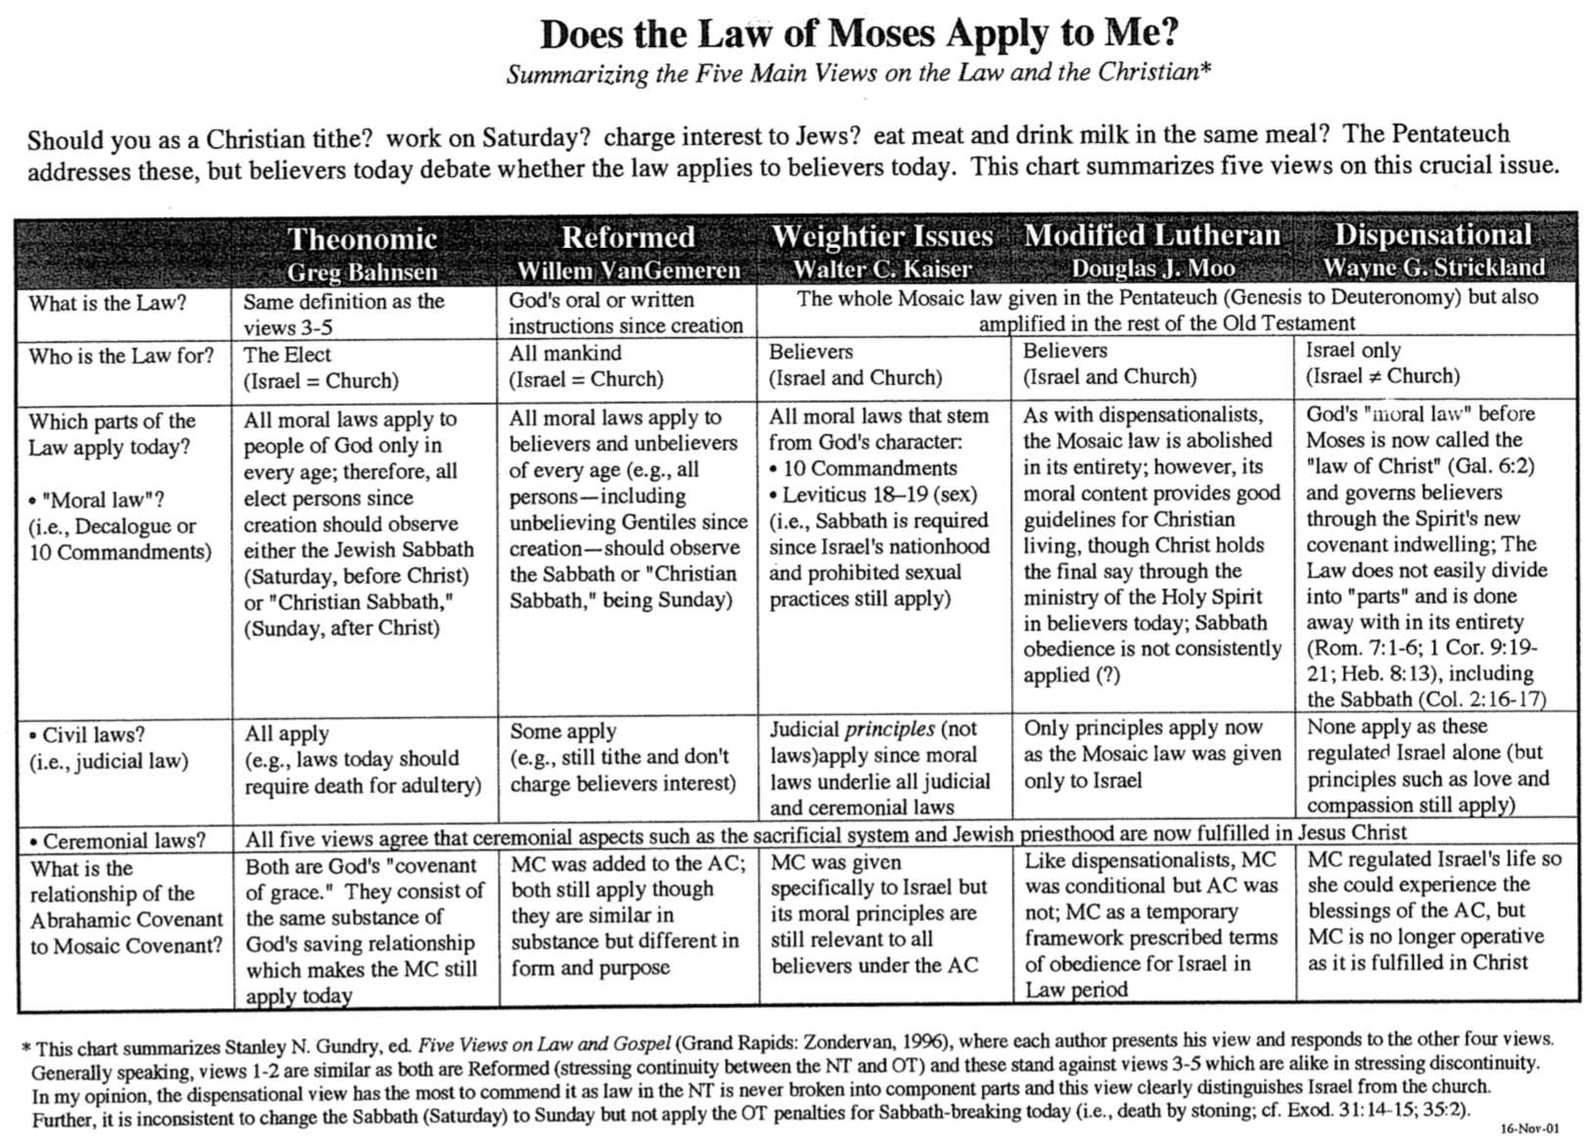
Does the Law of Moses Apply to Me? (2 of 2)

