Romans

God's Righteousness by Faith in Christ Helps Us Accept Others

Righteousness Explained |  |  |  |  | Righteousness Applied
Theological |  |  |  |  | Practical
Chapters 1–11 |  |  |  |  | Chapters 12–16
Relationship to God |  |  |  |  | Relationship to Others
Righteousness  Theme | Righteousness Needed | Righteousness  Provided | Righteousness Imparted | Righteousness Vindicated | Righteousness Applied | Righteousness Disseminated
Introduction  1:1-17 | Condemnation  1:18–3:20 | Justification  3:21–5:21 | Sanctification  6–8 | Election  9–11 | Transformation  12:1–15:13 | Propagation  15:14–16:27
Sin |  | Salvation | Set Apart | Sovereignty | Service
Corinth

Winter AD 56/57

Key Word: Righteousness

Key Verses: “For in the gospel a righteousness from God is revealed, a righteousness that is by faith from the first to last, just as it is written, ‘The righteous will live by faith’” (Romans 1:17).

“Accept one another, then, just as Christ accepted you, in order to bring praise to God” (Romans 15:7)

Summary Statement: The reason Jews and Gentiles in Rome should accept each other is because they all have God’s righteousness only by faith in Christ and not by works of the Law.

Application: Do you experience peace with other believers as fellow recipients of God’s righteousness by faith? Or do you have conflicts with them stemming from pride?

Romans

Introduction

Title: The Greek title (Πρός ΡωμαίουςTo the Romans) has been used since its writing.

Authorship

External Evidence: Paul's authorship of Romans has been denied by almost no one.

All extant New Testament book lists before AD 200 include Romans among Paul’s letters—even that of the early heretic Marcion (AD 140).

Pauline authorship was upheld by Clement of Rome (ca. AD 95; 1 Clement 32.2; 35.5; 50.6f.), Ignatius (ca. AD 115; Ephesians 19.3; etc.), and Polycarp (ca. AD 115; Letter to the Philippians 3.3; 4.1; 6.2; cf. Grassmick, DTS Class Notes, 2).

Nearly all modern radical critics even agree that Paul wrote Romans. The only notable exceptions are the radical 18th-century critics such as Baur.

Internal Evidence: The vocabulary, style, logic, and theological development of Romans is consistent with all other Pauline writings and therefore has not been challenged (TTTB, 372). In fact, the Books of Romans, First and Second Corinthians, and Galatians have been considered the standard by which other books are judged as Pauline. The unity of the book, however, has been attacked as many critics have questioned Romans 15–16:

Some doubt the authenticity of chapter 15 since a few Latin manuscripts omit 15:1–16:24 and some place the closing doxology (16:25-27) after chapter 14. However, Romans 15 fits logically into the argument of the book and is in all Greek manuscripts.

Romans 16 has been doubted even more as Paul greets by name 26 people in a church that he had never visited. However, Paul wrote Colossians, the only other epistle concluding with a similar greeting, also to a church he had never seen! He had ministered with many people from Rome in his journeys (e.g., Aquila and Priscilla; v. 3; cf. Acts 18:19, 26). Perhaps some manuscripts omit chapter 16 because it seemed irrelevant (TTTB, 372).

Circumstances

Date: Paul wrote from Corinth on his third missionary journey (see below) where he stayed from November 56 to February 57 (Acts 20:2-3; cf. Hoehner’s dissertation). Therefore, the date for Romans can be pinpointed to winter AD 56/57.

Origin/Recipients: The text clearly identifies the readers as Roman believers (1:7), which included some Jews (2:17; cf. Acts 28:17-28) but mostly Gentiles (11:13, 17-31; 15:14-16; 16:3-16 Greek names). This is understandable as Rome was a Gentile city and Paul was an apostle to the Gentiles (11:13; 15:16). The uniform internal evidence indicates that Paul wrote from Corinth (Grassmick, DTS Class Notes, 7):

Paul had just completed the collection for the poor saints at Jerusalem (15:22f.) and was about to return to Jerusalem with the money (15:25; Acts 24:17).

Paul's host was Gaius (16:23), who was a Corinthian (1 Cor. 1:14).

The deliverer of the letter was likely Phoebe since Paul commends her to the church (16:1-2). Her ministry location was nearby Cenchrea, the eastern port of Corinth.

Romans 1:18-32 describes the immoral city of Corinth better than any city in the Roman Empire. Paul may have looked outside his window as he wrote!

Occasion: Paul had never visited Rome (1:10, 12) but wanted to as he had finished sharing Christ in the eastern Roman Empire (15:23). He hoped the church would help him in his future plans to share the gospel in Spain (15:24), so he wrote this letter beforehand to advise them of his plan to deliver the offering from the churches in Macedonia and Achaia to the Jerusalem church, then stop by Rome en route to Spain (15:25-29). Paul made it to Rome, but only as a prisoner after three years and two imprisonments (Acts 21:17–28:29). Tradition records that he later served in Spain (spring 64-spring 66) between his two Roman imprisonments (Feb. 60-Mar. 62 and autumn 67-spring 68). Paul's purposes in writing were fourfold (Witmer, BKC, 2:437):

The immediate purpose was to announce his soon visit to solicit prayer and financial support for his preaching in Spain (explained above).

He wanted to build up the Roman believers with his theological foundation in the gospel even as he had done with other Gentile churches (1:15).

He sought to reconcile conflicts between the Jewish and Gentile segments in the church. “The Jew-versus-Gentile issue looms large in this letter. Paul did not take sides, but he carefully set forth both sides of the question. On the one hand, he emphasized the historical and chronological priority of the Jews—'first for the Jew, then for the Gentile' (Rom. 1:16; cf. 2:9-10). He also stressed the 'advantage . . . in being a Jew' (3:1-2; 9:4-5). On the other hand, he pointed out that 'since there is only one God' (3:30), He is the God of the Gentiles as well as the God of the Jews (3:29). As a result, 'Jews and Gentiles alike are all under sin' (3:9) and alike are saved by faith in the Lord Jesus Christ…” (Witmer, BKC, 2:437; cf. Walter B. Russell III, “An Alternative Suggestion for the Purpose of Romans,” Bibliotheca Sacra 145 [April-June 1988]: 174-84).

Most importantly, Paul expounded upon the righteousness of God revealed in the gospel and received by faith (1:17). He affirmed God's goodness (3:4), wisdom (11:33), and justice (3:26), evident in his defense of God's plan of salvation, which must have as its basis justification by faith since no one can reach the righteousness of God through his own works.

Characteristics

Romans has been called “the most profound book in existence” (poet Samuel Coleridge). It has played a key role in every spiritual awakening in church history—from Augustine (AD 354-430) to the Reformation (16th century) to the present day. This is because it stands as the greatest exposition of the Christian gospel ever written (Grassmick, 1).

Romans quotes the OT (esp. Isa., Ps.) 63 times—almost as much as in all the other Pauline epistles combined (75 quotes in 1 Corinthians to Titus)!

Romans is the most systematic of Paul's epistles. Therefore, it is fitting that it is placed first among his thirteen epistles in the New Testament. The outline of Romans almost exactly conforms to the well-known secular and biblical epistolary format of the first century:
1. Salutation 1:1-7
a. Sender 1:1-6
b. Recipient 1:7a
c. Greeting 1:7b
2. Thanksgiving 1:8-17
3. Body 1:18–15:13
4. Conclusion 15:14–16:27
a. Plans 15:14-32
b. Peace Wish 15:33
c. Greetings 16:1-24
d. Close 16:25-27

The Christian doctrine emphasis shows in its many theological terms: sin, salvation, grace, faith, righteousness, justification, sanctification, redemption, death and resurrection.

Paul’s concern for Israel is seen in her present status, her relationship to the Gentiles and her final salvation. He even notes that he would rather go to hell himself instead of his fellow Jews for rejecting the Messiah (9:1-2).

Argument

Paul wrote Rome for a variety of reasons (see “Occasion” above), but his chief aim declared at the beginning of the letter is to explain the righteousness of God revealed in the gospel and received by faith (1:17). Like in many of his letters, his theological foundation (Romans 1–11) preceded the practical outworking of that doctrinal basis (Romans 12–16). These two major halves break down into seven important movements in the letter.

Because of the mixed Jew-Gentile readership at Rome and the problems this posed, Paul first argues in chapters 1–11 for justification by faith and not by the works of the Law:

This is evident beginning in his introduction, which establishes his authority as God's minister to the Gentiles and previews the content of the letter with the theme of the righteousness of God that requires justification by faith alone (1:1-17).

The righteousness of God is shown as needed because of God’s condemnation of all mankind as sinners (1:18–3:20).

This condemnation proves that justification has to be through faith because of sin (3:21–5:21), the basis of this faith being the death of Christ that God has provided for us.

Paul then moves to sanctification, the natural result of justification. He states that God's righteousness imparted in sanctification identifies believers with Christ, frees them from the Law, and conforms them to Christ since the Law was powerless against sin in contrast to the empowering of the Spirit, which eventually will lead to glorification (Rom 6–8).

His last doctrinal section relates to the election of Israel, a sovereign choice that vindicates God’s righteousness in that he has and will fulfill his promises to the nation even though at present Israel does not believe (Rom 9–11). Israel's rejection allows the full measure of the Gentiles to come into God’s family until the nation will believe in the future.

At Romans 12, Paul begins the letter’s main practical portion, though several applications in the letter precede chapter 12. The remainder of the book (Rom 12–16) shows how the believer should live out the righteousness of God:

Here the theology of justification by faith resulting from God's righteousness is applied in a life of transformation (12:1–15:13). This includes transformed relationships with other believers, unbelievers, governing authorities, and weaker conscience Christians, all of whom should see selfless love since believers have received this love themselves totally by grace.

Paul's conclusion includes his need for finances to disseminate God’s righteousness through propagation to reach more Gentiles in Spain, personal greetings, and praise for God's plan of salvation for both Jews and Gentiles (15:14–16:27).

Throughout the book Paul addresses Jews and Gentiles in the church as if he knew of potential conflicts between the two groups. They should treat one another with humility (11:17-24) and respect over differing issues of conscience (14:1–15:13) since they are equally condemned by sin (1:18–3:20) but now equal in Christ (10:12).

Synthesis

God's righteousness by faith in Christ helps us accept others

1:1-17 Theme—Righteousness
1:1-7 Salutation
1:8-15 Intent
1:16-17 Righteousness by faith

1:18–3:20 Needed—Condemnation
1:18-32 for Gentiles
2:1–3:8 for Jews
3:9-20 for all

3:21–5:21 Provided—Justification
3:21-31 How? Faith
4 Who? Abraham/David
5:1-11 Result? Assurance
5:12-21 Basis? Imputation

6–8 Imparted—Sanctification
6 New Basis—identification with Christ
7 New Relationship—freedom from the law
8 New Power—Spirit

9–11 Vindicated—Election (of Israel)
9:1-29 Election in grace
9:1-5 Privileges
9:6-18 Choice illustrated
9:6-9 Isaac over Ishmael
9:10-13 Jacob over Esau
9:14-18 Pharaoh
9:19-29 God’s mercy
9:30–10:21 Rejection in works
9:30–10:4 Stumbled over Christ via works
10:5-15 God's offer
10:16-21 Israel's rejection
11 Restoration—rejected temporarily & partially
11:1-10 Remnant
11:11-24 Gentiles engrafting (for salvation & to make Israel jealous)
11:25-32 Future salvation
11:33-36 God's glory and praise

12:1–15:13 Applied—Transformation
12:1-2 Ourselves
12:3-21 Church
12:3-8 Humility in ministry
12:9-21 Love in social dimensions
13:1-7 Government submission
13:8-14 Love in light of future accounting
14:1–15:13 Doubtful things
14:1-13a “Weak, don't judge the strong”
14:13b-23 “Strong, don't offend the weak”
15:1-13 Imitate Christ

15:14–16:27 Disseminated—Propagation
15:14-33 Propagation Example = Paul
16:1-24 Propagation Tips
16:1-16 Commend Others
16:17-20 Work for Unity
16:21-24 Encourage Fellowship Between Churches
16:25-27 Doxology

Outline

Summary Statement for the Book
The reason Jews and Gentiles in Rome should accept each other is because they all have God’s righteousness only by faith in Christ and not by works of the Law.

The reason Jews and Gentiles in Rome should accept each other is because God’s righteousness comes to them equally by faith in Christ (1:1-17).

As God’s servant to preach the gospel to the Gentiles, Paul greets the believers at Rome and blesses them in the standard epistolary style of his day (1:1-7).

God set apart Paul to share with Rome the trinitarian gospel—the Father sent the Son to die and resurrect through the power of the Spirit (1:1-6).

Paul greets Christians in Rome and reminds them up front that God’s love for them should result in set apart lifestyle (1:7a).

Paul wishes his readers both grace and peace as key themes he will address later in the letter (1:7b).

Paul establishes rapport by thanking God for them and expressing his desire to hopefully see them after having tried so many times (1:8-15).

Paul thanks God that the Roman’s faith is widespread (1:8).

Paul prays that he might finally visit Rome to strengthen believers and lead some Romans to Christ since his ministry is to the Gentiles (1:9-14).

The letter’s theme is that God's righteousness requires justification to be only by faith in Christ and not by the Law (1:16-17).

The reason Paul is not ashamed of the gospel is because it alone works as the solution to Jew or Gentile salvation (1:16).

The gospel reveals God’s righteousness since righteousness comes only by trusting God for it—not by obeying the law (1:17; cf. Hab 2:4).

The reason Jews and Gentiles at Rome should accept each other is because God's righteousness is needed by both groups due to God’s condemnation of sin (1:18–3:20).

Gentiles must be justified by faith since their suppressing a knowledge of God from nature and their conscience leads to a sinful lifestyle (1:18-32).

Gentiles experience God’s anger against their sin for suppressing the knowledge of God they see in creation (1:18-20).

The reality of God’s wrath is that Gentiles are now being judged for their godlessness and wickedness (1:18a).

The reason God judges Gentiles is for denying God’s omnipotence and monotheism that they know from creation and conscience (1:18b-20a).

The result of this rejection is that Gentiles stand before God guilty without a valid reason for rejecting him (1:20b).

Gentile rejection of their innate knowledge of God leads them into a downward spiral of sin and judgment (1:21-32).

Acting against their conscience leads Gentiles to ignore God by worshipping idols (1:21-23).

Idolatry moves God to give them over to degrading sexual sin and further idolatry (1:24-25).

Idolatry and immorality move God to give them over to homosexuality and its penalties (1:26-27).

* Before AIDS research, the average life expectancy for a homosexual male in America was 42 years old—half the lifespan of heterosexual men who typically live to about 82 years old!

Homosexuality moves God to give them over to depravity leading to death but they even encourage others to be bound by their sin (1:28-32).

The self-righteous must be justified by faith since they condemn themselves by their lack of truth and work against God’s righteousness in their consciences (2:1-16).

One who self-righteously judges others condemns himself for doing the same sins instead of escaping God’s judgment by repenting (2:1-4).

Such hypocrites don’t do good to others and the degree of their punishment depends upon their works before an impartial God (2:5-11).

The self-righteous will be judged by their consciences since they sin and do good works without knowledge of the Mosaic Law (2:12-16).

Jews must be justified by faith for condemning themselves by their bigotry and defiance of the Law in contrast to God’s righteousness (2:17–3:8).

A Jew who steals, commits adultery or idolatry, or dishonors God must not hypocritically look down on Gentiles who break God’s Law (2:17-24).

Circumcision is valuable only if it is backed up with obedience to the Law (2:25-29).

An uncircumcised Gentile who otherwise keeps the Law is better than a circumcised Jew who otherwise neglects it (2:25-27).

God approves of heart circumcision by the Spirit more than outward circumcision by the hands (2:28-29).

Jews are blessed with God’s Word, but their disobeying it never nullifies God’s faithfulness as it is their fault—not God’s (3:1-8).

All people must be justified by faith since their sin condemns them—bad news before Paul later shares the good news of justification (3:9-20).

All people—Jew and Gentile alike—show they are under sin in their actions (3:9-18).

Paul and the readers are also included among those under God’s judgment since all Jews and Gentiles sin (3:9).

Many texts in Psalms and Isaiah teach that all people sin (3:10-18).

Not one person is righteous, understands or seeks God, or does good (3:10-12; cf. Ps 14:1-3; 53:1-3; Eccles 7:20).

Every part of our bodies sins—from our tongues (3:13-17; cf. Pss. 5:9; 140:3; 10:7) to our feet (Isa. 59:7-8).

No one truly fears God (3:18; cf. Ps. 36:1).

The Mosaic Law reveals that we all sin and must account to God so it will not give the righteousness we need before God (3:19-20).

Condemned Group | Benefits  Received | Reason Condemned | Degree of Judgment
Gentiles  (1:18-32) | Creation  (1:18-20) | Rejection of the light they have (1:21-22) | Great  (1:20b)
Self-Righteous  (2:1-16) | Conscience  (2:14-15) | Refusal to obey conscience (2:1) | Greater  (2:4)
Jews  (2:17–3:8) | Law  (2:17-20; 3:2) | Hypocrisy  (2:21-24) | Greatest  (2:24)
All Humanity  (3:9-20) | Creation and/or Conscience and/or Law | Lack of understanding and turning away (3:11-18) | —

The implied question then is, “If we all have sinned and can’t become righteous even by obeying the very Mosaic Law that God gave the Jews, how then can we become righteous before this holy God?” Paul says, “I’m glad you asked!” as he intends to answer this question in the next section of his letter…

The reason Jews and Gentiles at Rome should accept each other is because God provided righteousness equally in the justification of all who trust Christ (3:21–5:21).

God provided righteousness through justification by faith and not by works of the Law, so Jews and Gentiles have equal opportunity for salvation (3:21-31).

Righteousness can’t be earned, so it must be received by faith in Christ, resulting in God’s justice in justification, redemption, and propitiation (3:21-26).

No saved person can boast since faith rather than law adherence saves all (3:27-31).

God’s righteousness by faith is shown in Abraham’s faith in God's promise—not by works, rites, or the Law—so justification by faith is not a new way of salvation (Rom 4).

Abraham wasn’t declared righteous (justified) by works but by simple belief (4:1-3).

David also spoke of faith that brings righteousness apart from works in Psalm 32 when he praised God’s forgiveness by faith (4:4-8).

Abraham was declared righteous while uncircumcised as the “father” of both the uncircumcised and circumcised since he was circumcised later (4:9-12).

Abraham received by faith God’s promise that he would bless the nations (Gen 12:1-3)—not by the law since the law brings wrath, not righteousness (4:13-15).

As Abraham exemplifies salvation by faith in trusting God for a son, so both Jews and Gentiles are saved by grace through faith that God resurrected Jesus (4:16-25).

God's righteousness gives us the benefits of a relationship with God dependent on Christ’s work—not our own works—and also peace, joy, and salvation (5:1-11).

Justification by faith brings peace with God (5:1-2).

Justification by faith brings joy in all circumstances (5:3-5).

Justification by faith reconciles us with God despite formerly being enemies (5:6-8).

Justification by Christ’s blood brings salvation from God’s wrath (5:9-11).

God's righteousness is imputed to believers by Christ's atoning work as the basis for justification by faith for Jews and Gentiles (5:12-21).

Adam’s sin brought death to the whole world since all after him also sinned before the Law was given (5:12-14).

As Adam’s trespass imputed sin and death to all, so Christ’s righteousness imputed grace to all who believe (5:15-17).

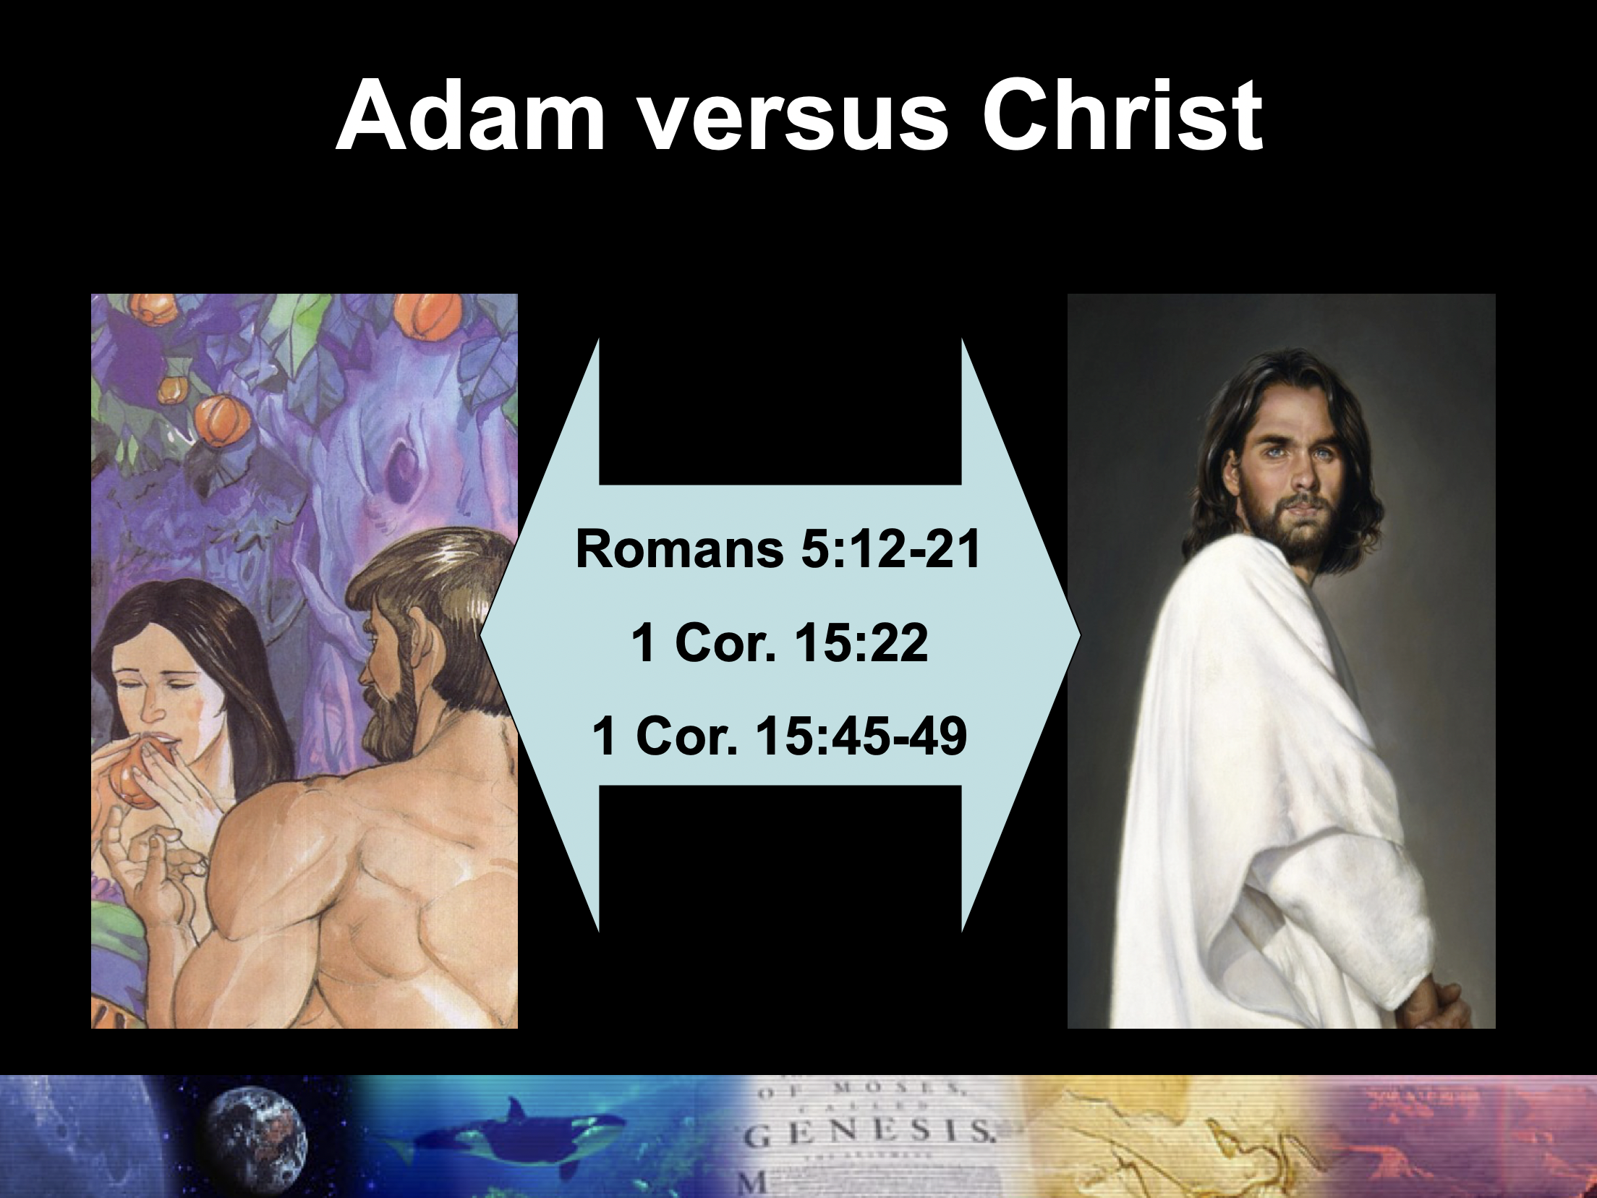

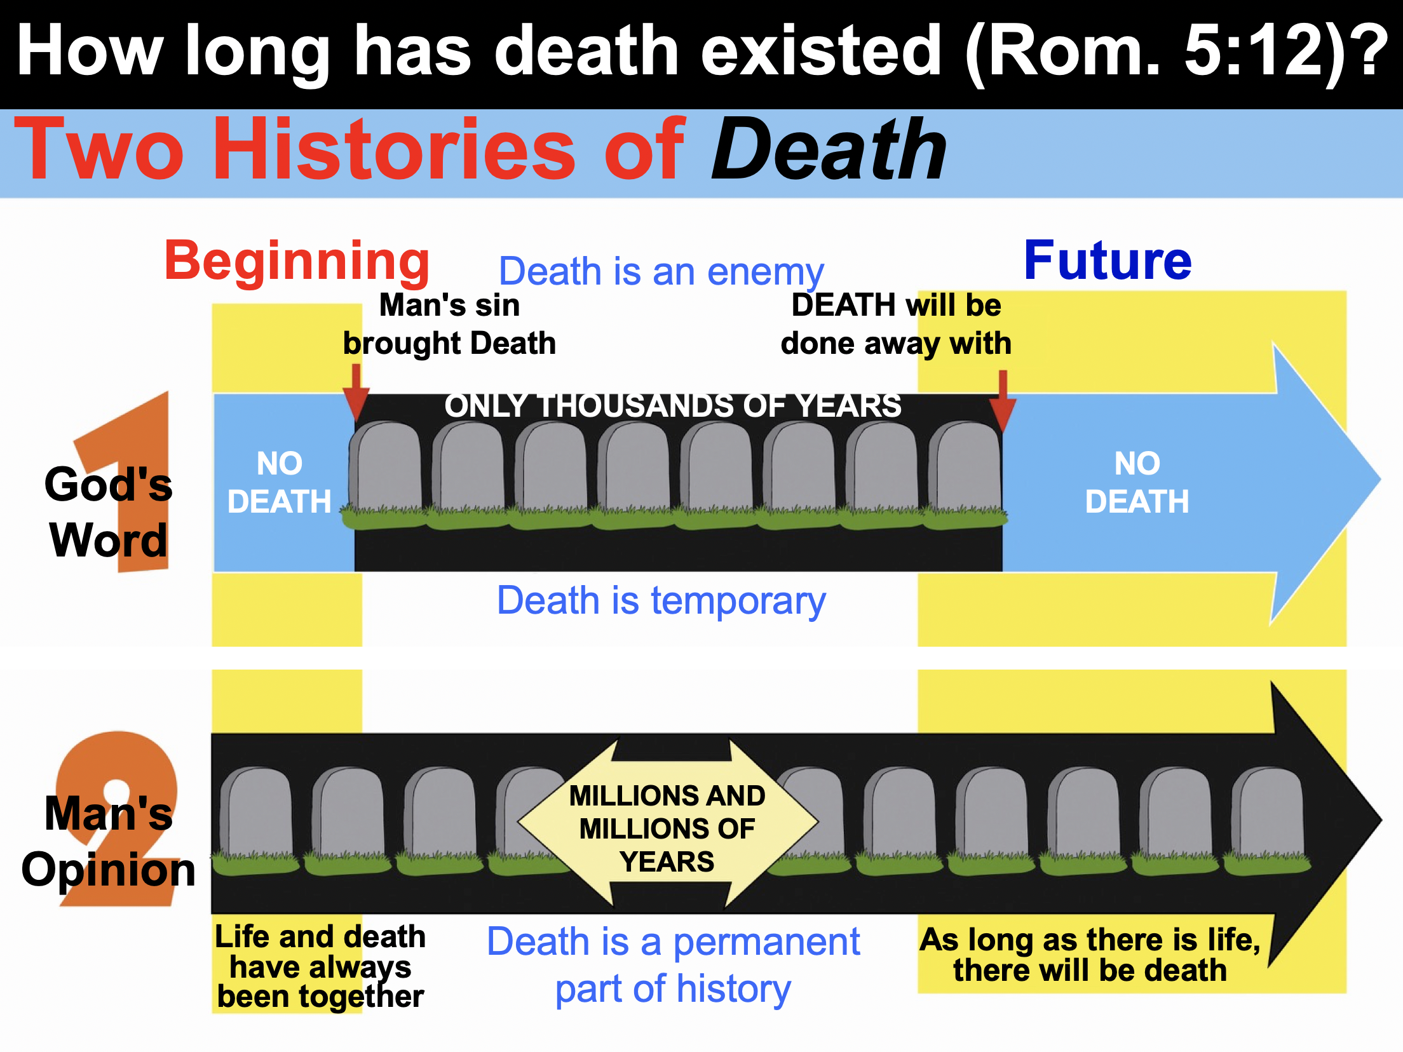

Adam’s sin condemned all who became sinners, but Christ’s righteousness justifed all believers who become righteous (5:18-19).

The law revealed sin so sin ruled over people in death, but God’s grace forgave sin and reigns through righteousness to bring eternal life through Christ (5:20-21).

The reason Jews and Gentiles at Rome should accept each other is because God's righteousness imparted sanctification equally to both groups (Rom 6–8).

Our positional identification with Christ is our new basis for sanctification so Jews should avoid legalism and Gentiles should avoid indulgence (Rom 6).

Our positional freedom from sin’s power comes from a once-for-all identification with Christ’s death and resurrection symbolized in water baptism (6:1-10).

Our practical freedom from sin’s power occurs by continually yielding by faith to Christ as our new master (6:11-14).

We must each choose righteousness by realizing that our old master of sin now has no claim on us (6:15-23).

How do Christians replace their vital experience with Christ with rituals and duties?

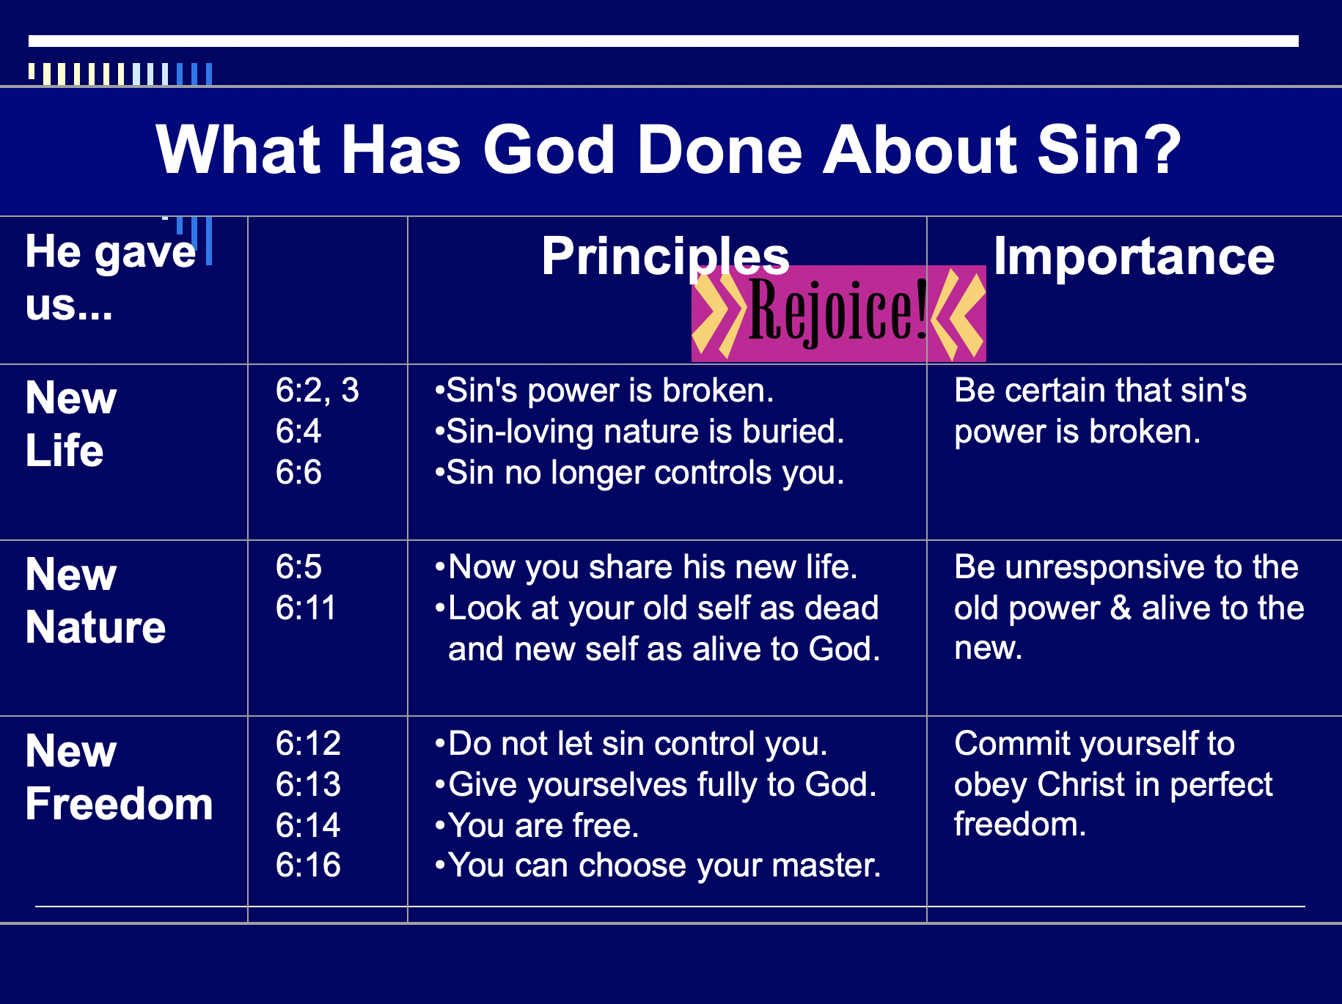

Our freedom from the Law results from Christ’s death but we still sin and need sanctification since the Law cannot deliver us from our sinful heart (Rom 7).

Believers are released from obeying the Mosaic Covenant (Law) just as a widow is not bound to her first husband when she is in new a marriage (7:1-6).

The law is not evil since it shows the presence of sin, but we are evil instead (7:7-12).

Sin causes death so our only way to be free from sin is not by self-effort but by trusting Christ’s victory over death on the cross (7:13-25).

In what ways do believers today still try to live by the Mosaic Law?

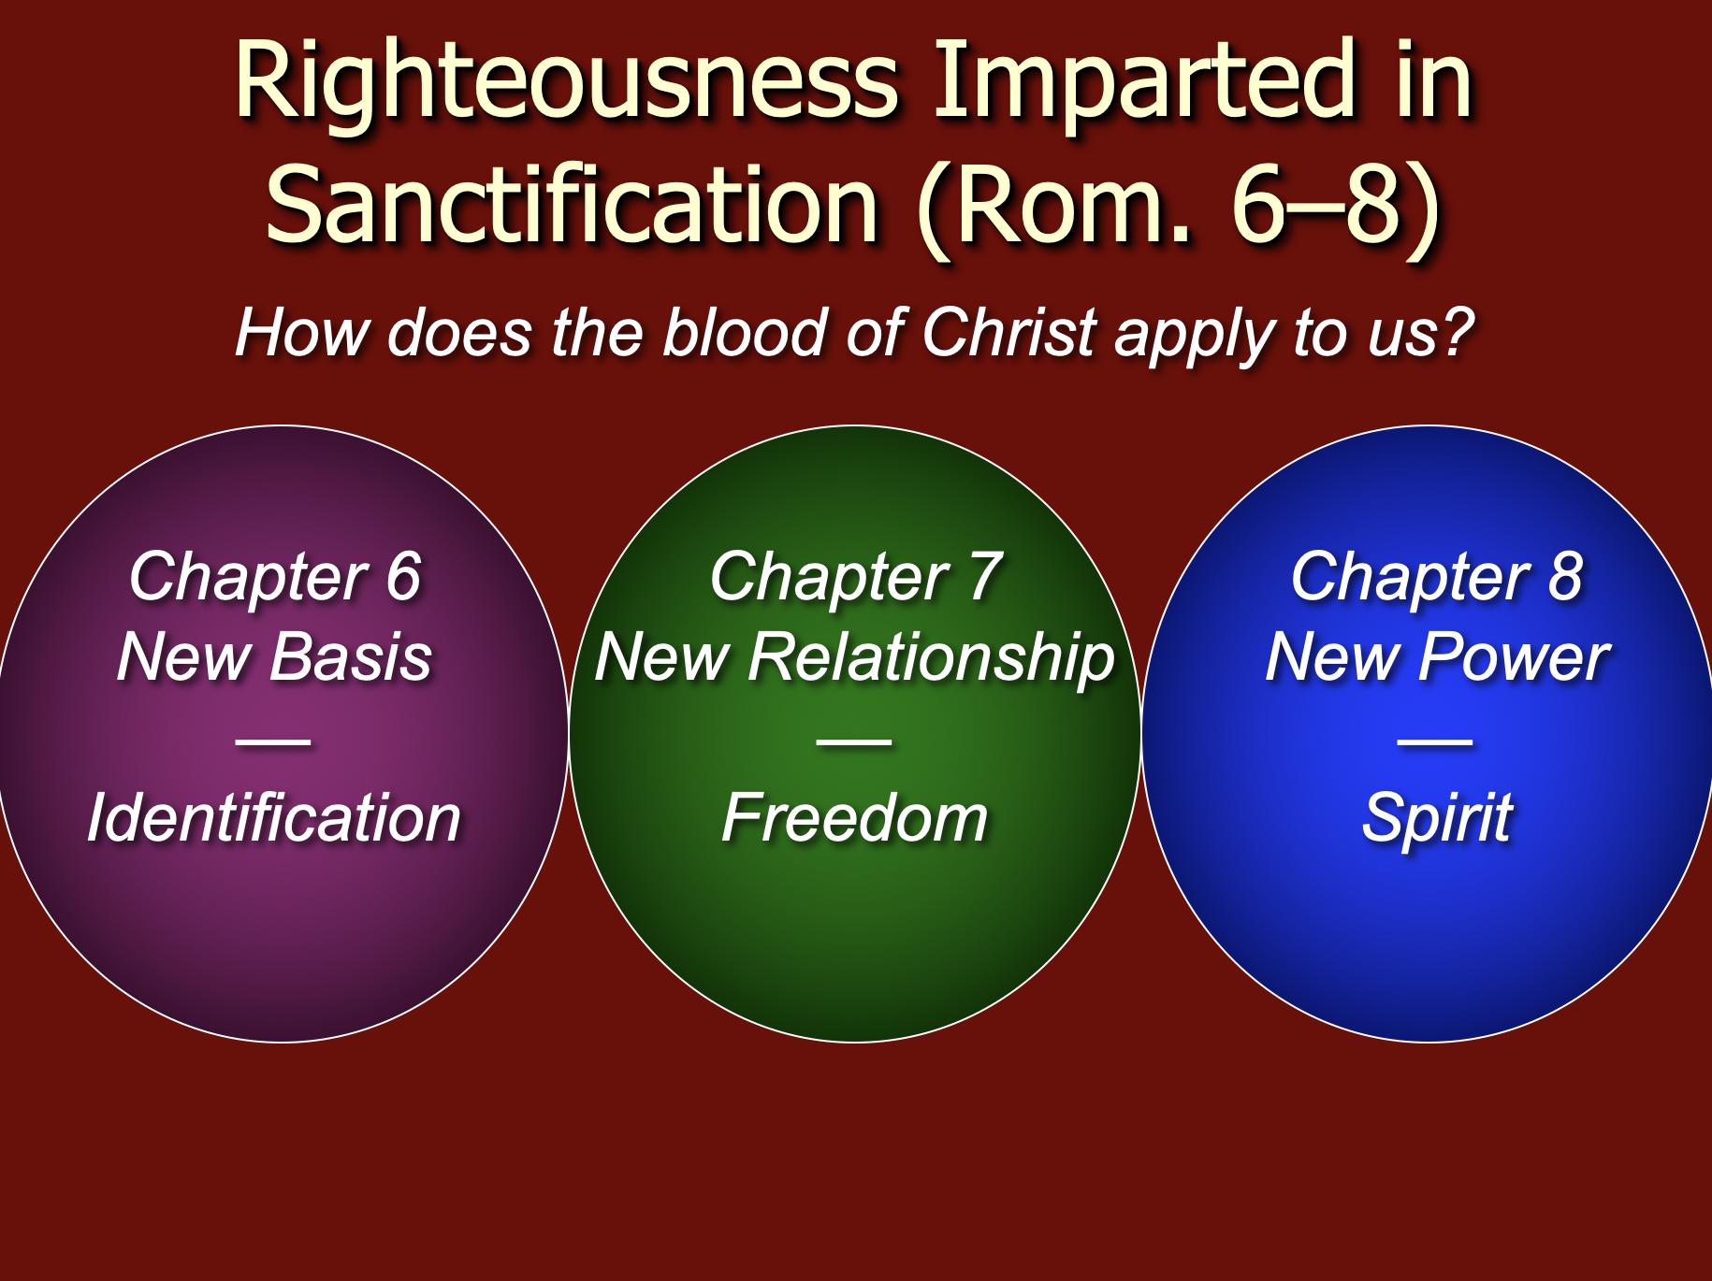
Whether Paul describes his past or present in 7:7-25 is debated…

Pre-Conversion Support | Post-Conversion Support
How can a believer say, “I am a slave to sin” (7:14)? This is contrary to believers dying to sin (6:2) and “should no longer be slaves to sin” (6:6).  “Being in the flesh/being in sinful nature” does not mean physical passion, but a way of life (7:5ff.)  The structure of 7:7-25 interprets 7:5 (pre-conversion) while 8:1-17 interprets 7:6 (post-conversion) | Believers also sin since Paul says: “Do not let sin reign in your mortal body so that you obey its evil desire” (6:12)  Paul describes his pre-conversion life as free from struggle (Gal. 1:14; Phil. 3:5-6)  The present tense (7:14-25)  Rom. 6–8 describe sanctification (post-conversion context)  Christians still struggle with sin  The non-Christian cannot be described as simultaneously having a sinful nature and a slave to God’s law (7:25)

Our power in sanctification through the Spirit gives victory over sin that the Law could never do for us to eventually be like Jesus in glorification despite our sufferings (Rom 8).

Victory over sin comes from the Spirit of life as our new power source for living (8:1-13).

Adoption into God’s family as sons comes from the Spirit as our new power source for living (8:14-27).

Assurance of salvation results from the Spirit as our new power source for living (8:28-39).

Romans 8 supports our assurance of salvation in many ways:
- We are not condemned (8:1)
- Our position is set free from the law of sin and death (8:2)
- We possess the Spirit of Christ (8:9)
- The Spirit will give us glorified bodies (8:11)
- The Spirit testifies to our human spirit that we are God’s children (8:16)
- We are adopted into God’s family (8:14, 16, 17, 21, 23)
- Our bodies will receive final redemption (8:23)
- We have hope that will be fulfilled (8:24-25)
- We will be conformed to Christ’s likeness (8:29)
- All who are predestined will eventually be glorified (8:30)
- Nothing can separate us from God’s love (8:35-39)
- We are already more than conquerors over sin (8:37)

The reason Jews and Gentiles at Rome should accept each other is because God vindicated his righteousness in Israel’s election and Gentile salvation (Rom 9–11).

God's righteousness is revealed in His sovereign past choice of Israel so that Israel’s failure is not due to God’s unfaithfulness (9:1-29).

Paul grieves that Israel rejected Christ despite their election for many privileges to show that Israel’s unbelief is not God’s fault (9:1-5).

OT examples of election illustrate that God’s election by grace is not new and that Israel’s failure is not due to God’s unfaithfulness (9:6-18).

Isaac’s election over Ishmael disproved physical descent from Abraham as enough for salvation since one needed faith for Israel’s blessings (9:6-9).

Jacob’s election over Esau proved God can bless the younger son instead of the older to serve his purpose apart from human tradition or merit (9:10-13).

Pharaoh’s hardening by God’s choice proved that God can elect to show mercy on whoever he wishes and harden whom he wishes (9:14-18).

God proves that he is just to elect some for salvation by showing mercy even in judgment by saving Gentiles and preserving a believing Jewish remnant (9:19-29).

*In addition to Israel being called God’s people in Hosea 1:10; 2:23, here in Romans 9:25-26 the Hosea texts are applied to the Church also as God’s people; yet this still does not annul God’s promise to the nation. See W. Edward Glenny, “The ‘People of God’ in Romans 9:25-26,” Bibliotheca Sacra 152 (January-March 1995): 42-59.

God shows his righteousness in Israel’s present rejection of his offer of righteousness in Christ despite the gospel being preached throughout the world to Gentiles (9:30–10:21).

Israel misses out on God’s righteousness by unsuccessfully seeking salvation by works while Gentiles successfully find salvation by faith in Christ (9:30–10:4).

God's offer of salvation by faith in Christ (rather than 100% obedience to the law) is still offered to Israel and all men (10:5-15).

Israel rejected righteousness by faith by disobedience in fulfillment of OT prophecies, not by lack of hearing or understanding the gospel of Christ (10:16-21).

God will show his righteousness in Israel’s future since he rejected her only in part and temporarily so Gentiles can be saved, so they should not be proud (Rom 11).

God has not rejected his people whom he foreknew (11:2a) because a remnant is now being saved (11:1-10).

Israel’s present rejection will stop but now brings salvation of the Abrahamic covenant to Gentiles to provoke Israel to faith and restoration of blessing (11:11-24).

*See the study on the wild and cultivated trees on page 155d.

God has not rejected Israel forever since the nation will be saved after all elect Gentiles have repented at the return of Christ to Jerusalem (11:25-32).

God deserves all glory and praise for unrivaled wisdom and knowledge (11:33-36).

Summary of Romans 9–11

9:1-29 | 9:30–10:21 | 11:1-36
Israel’s past | Israel’s present | Israel’s future
God elected Israel | Israel rejects God | God will reject Israel only partially and temporarily
Israel’s failure is not due to God’s unfaithfulness | Israel’s failure is due to rejecting her Messiah | Israel’s failure will be neither total in scope nor final
A Jewish remnant has been preserved by God | But this Jewish remnant  resists Him now | Yet this remnant will grow into an entire believing nation
Gentiles have also become elect of God in Christ | Gentiles are now becoming saved by faith in Christ | Gentiles should not be proud over blessings that Jews reject
Divine side | Human side | Divine results
God’s election | Man’s responsibility | God’s mercy
Human unbelief cannot eradicate God’s promises because they are based on the principle of sovereign election | However, God’s election in sovereign grace to fulfill His Word does not eradicate human responsibility for unbelief | Ultimately, God’s election will be justified in the salvation of the Jewish nation alive when Christ returns

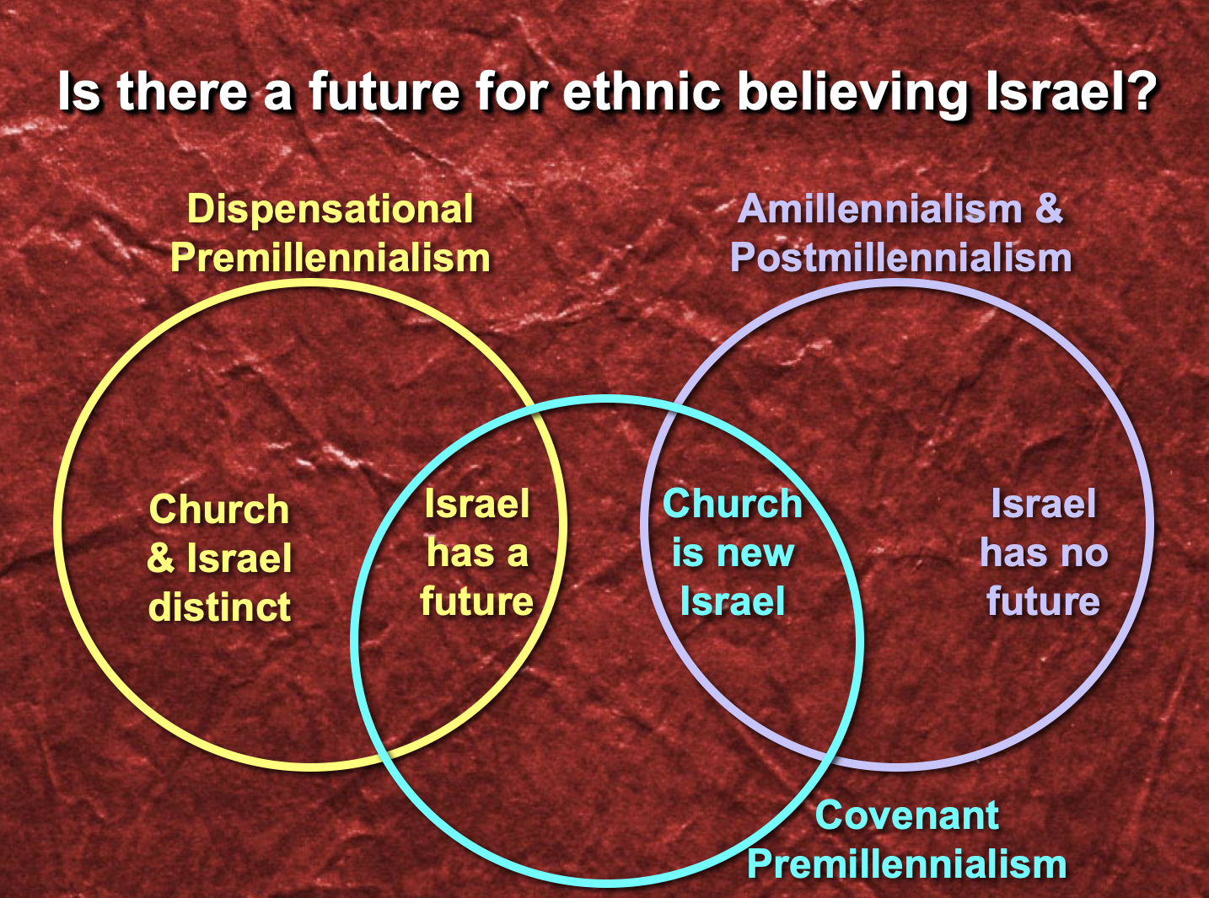

The reason Jews and Gentiles at Rome should accept each other is so righteousness is applied in transformation with all people, government, and weak believers (12:1–15:13).

God’s abundant mercy should move us to total dedication to his will rather than conform to the world as the key to the transformed lifestyle explained in 12:3–15:13 (12:1-2).

God's righteousness in a transformed life produces humility in using spiritual gifts and love in difficult social dealings to win watching unbelievers to Christ (12:3-21).

Categories of Gifts (1 Peter 4:11; cf. Romans 12:6-8)

Speaking | Serving
Teaching* | Administration*
Evangelism | Faith
Pastor-Teacher | Giving*
Encouraging* | Service*
 | Mercy*
* Six of these nine gifts are listed in Romans 12:6-8.

God's righteousness in a transformed life produces submission to government to escape punishment and win watching persecutors to Christ (13:1-7).

Are You Submissive?
Please rate yourself on the following scale:

0 1 2 3 4 5
Never Very Rarely Seldom Sometimes Usually Always
(or only once) (hardly ever) (infrequently) (occasionally) (often) (or almost always)

1. ____ I have a problem with complaining (especially about the government)
2. ____ I feel the need to be the one in control
3. ____ I struggle with admitting my faults
4. ____ People call me stubborn
5. ____ I rationalize: (a) driving over the speed limit (if you drive), or (b) disobeying
pedestrian laws (e.g. jaywalking—if you do not drive). If you do both then pick where you are worst!
____ Total

Scale: 0 (Jesus, why are you taking this?), 1-5 (you must be my wife Susan ), 6-10 (could you please teach today’s class?), 11-19 (you need this class session), 20-25 (please see me after class for counseling referrals)

God's righteousness in a transformed life produces love for other believers since all will soon account before God (13:8-14).

God's righteousness in a transformed life creates sensitivity to conscience so Gentiles will forgo habits offensive to Jews and Jews will follow their conscience (14:1–15:13).

Two Conflicting Groups at Rome

Weak | Strong
Jewish minority | Gentile majority
Conscience easily offended | Not easily offended
Narrow, more closed perspective | Broad, more open perspective
Vegetarian (14:2b) | Eats all meats freely (14:2a)
Sabbath worship (14:5a) | Worships any day (14:5b)
Less mature (most of the time) | More mature
Strong convictions in above areas | Ambivalent convictions in above areas
Commanded not to violate own conscience (14:5b, 23) | Commanded not to hurt weaker brother’s conscience (14:1, 15, 20, 21; 15:1)

Principles for Both:
1. Be convinced of your own convictions (14:5b)
2. Accept one another’s beliefs instead of being critical or judgmental (14:13; 15:7)
3. Work towards peace, mutual edification, and unity (14:19; 15:5)
4. Remember that each of us is individually accountable to God (14:12).
5. Keep your personal convictions in gray areas private (14:22a)
6. Since Christianity has no food laws (14:6), work for righteousness, peace and joy (14:17)
7. Do everything for God’s glory (15:6)
8. Teach one another (15:14)

The reason Jews and Gentiles at Rome should accept each other is for righteousness to be disseminated in propagating the gospel to Spain to praise God's plan (15:14–16:27).

Paul sets the example how to propagate God’s righteousness by requesting the church's support to reach Gentiles in Spain after visiting the church (15:14-33).

Paul sets the example how to propagate God’s righteousness by showing how to relate to others in the body of Christ (16:1-24).

Commending co-laborers in the dissemination of the righteousness of God should be a priority for Christian leaders (16:1-16).

Paul commends Phoebe (the probable carrier of the epistle) so that the believers in Rome might assist her in return for her service to others and Paul (16:1-2).

Paul commends twenty-six church members in Rome whom he had met in his travels but now lived in the capital to show his deep concern for them (16:3-16).

Working for unity by watching out for and avoiding divisive persons will also enable the righteousness of God to spread (16:17-20).

Fellowship between churches is shown as an important priority to propagate God’s righteousness by Paul’s sending greetings from those with him in Corinth (16:21-24).

A doxology praises God for revealing his eternal plan to save both Jews and Gentiles to encourage both groups at Rome that their salvation brings glory to God (16:25-27).

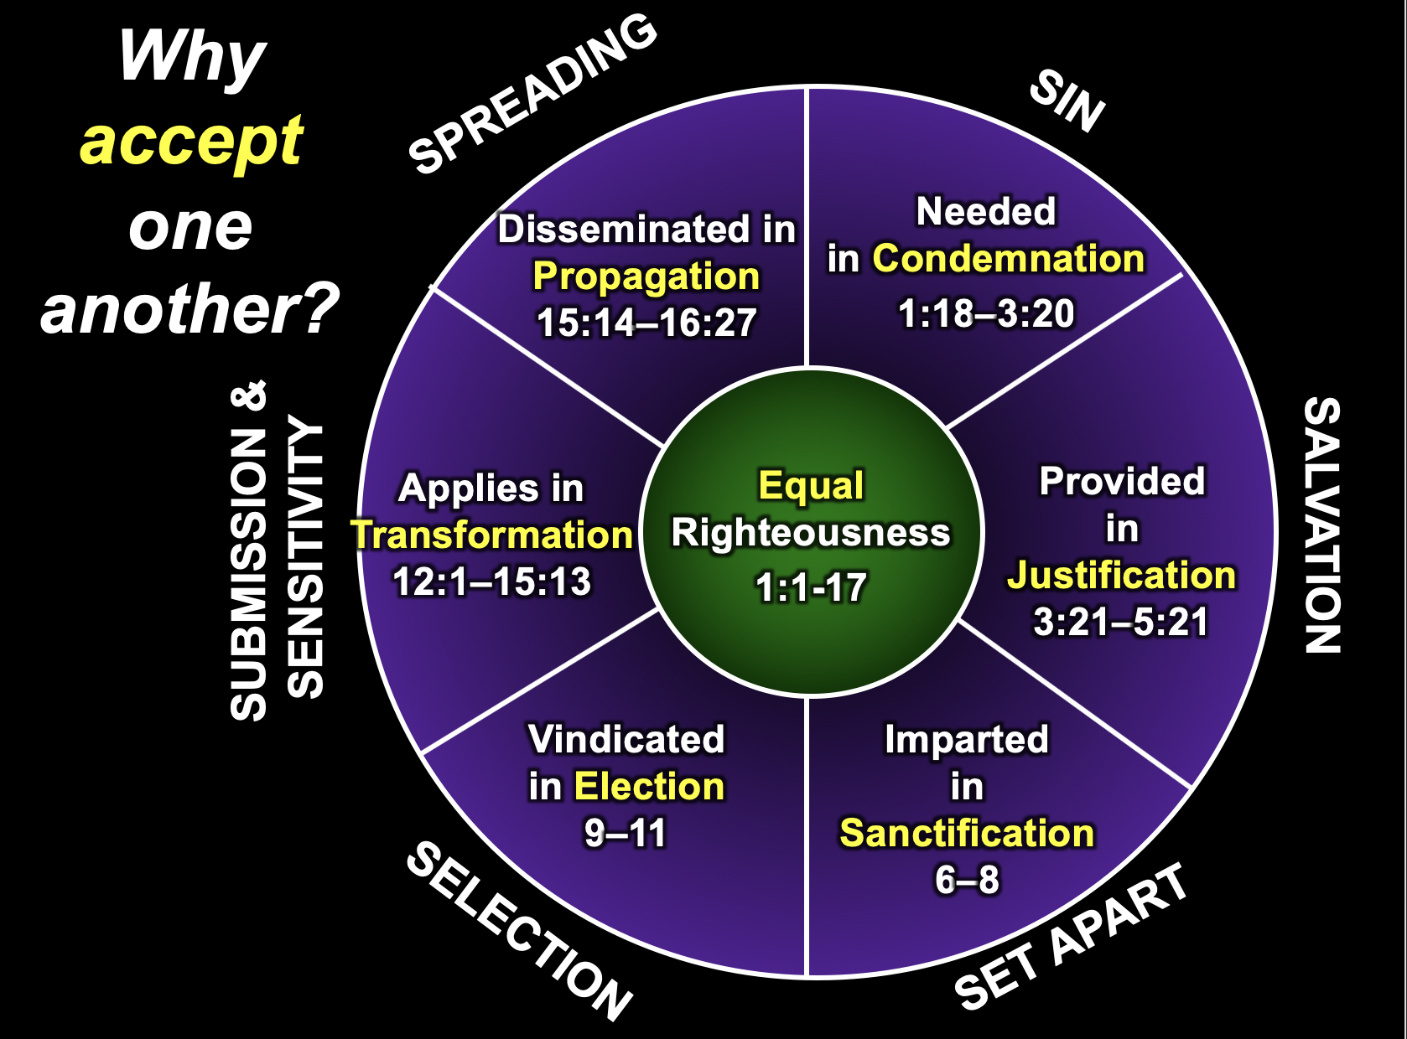

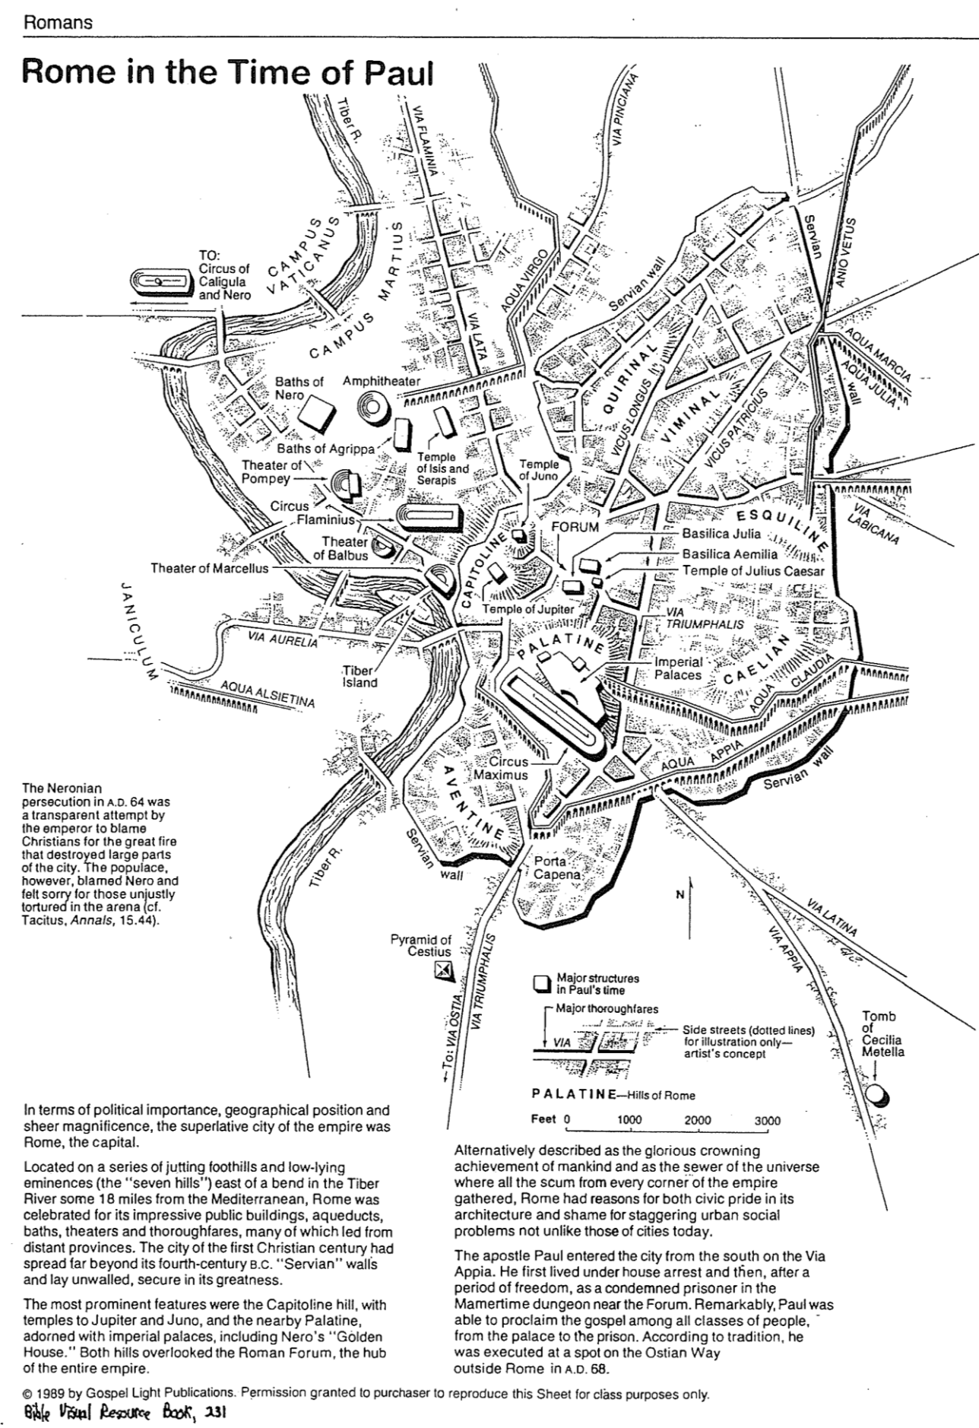
Rome in the Time of Paul
Bible Visual Resource Book, 231

Circular View of Romans
Terry Hall, Bible Panorama, 162

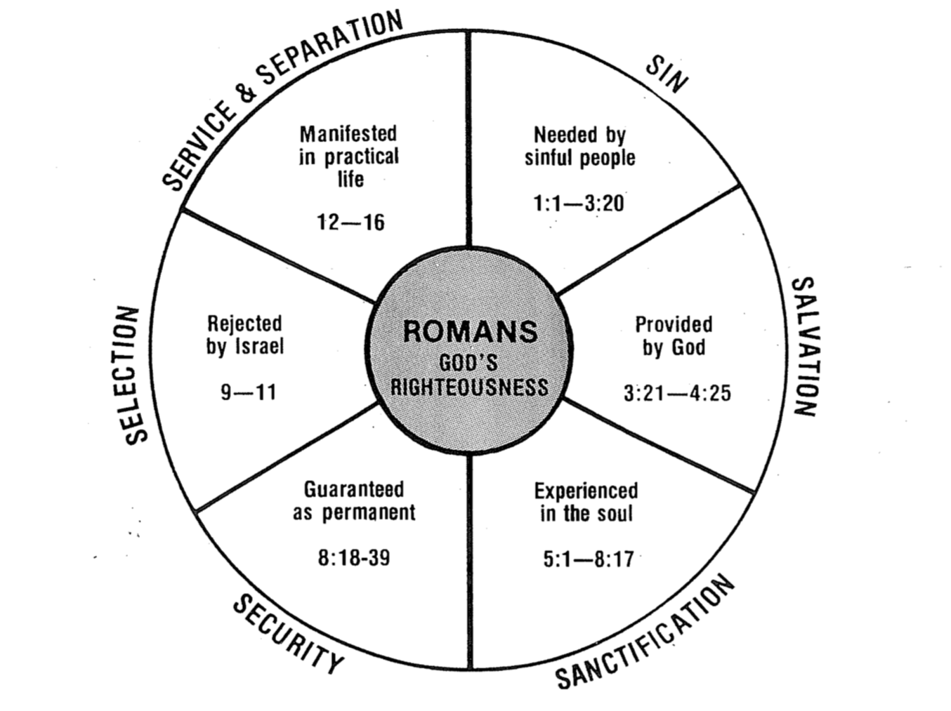

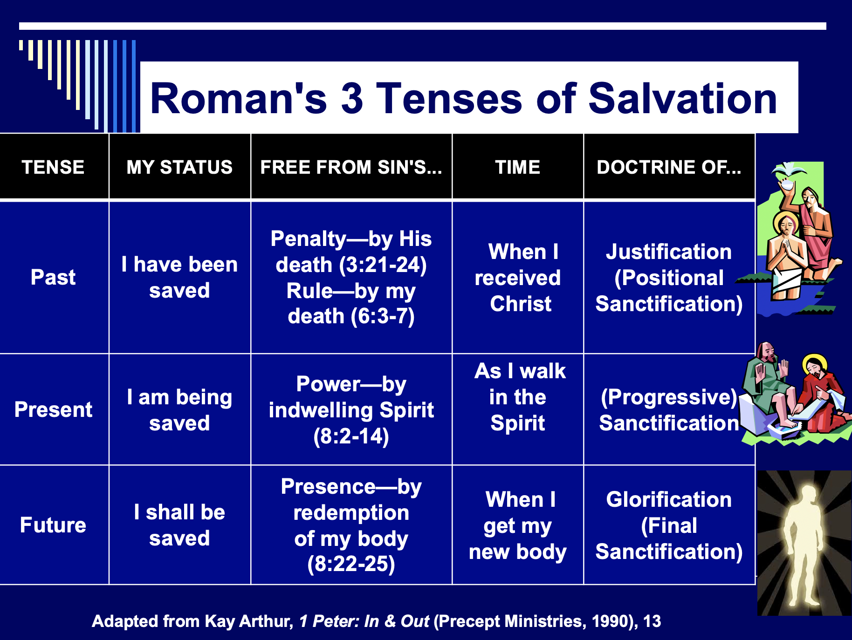

The Three Tenses of Salvation

The Flow of the Book of Romans
Seeing the Book Through the Lens of the Sovereignty Theme
John D. Grassmick, Dallas Seminary, 1985

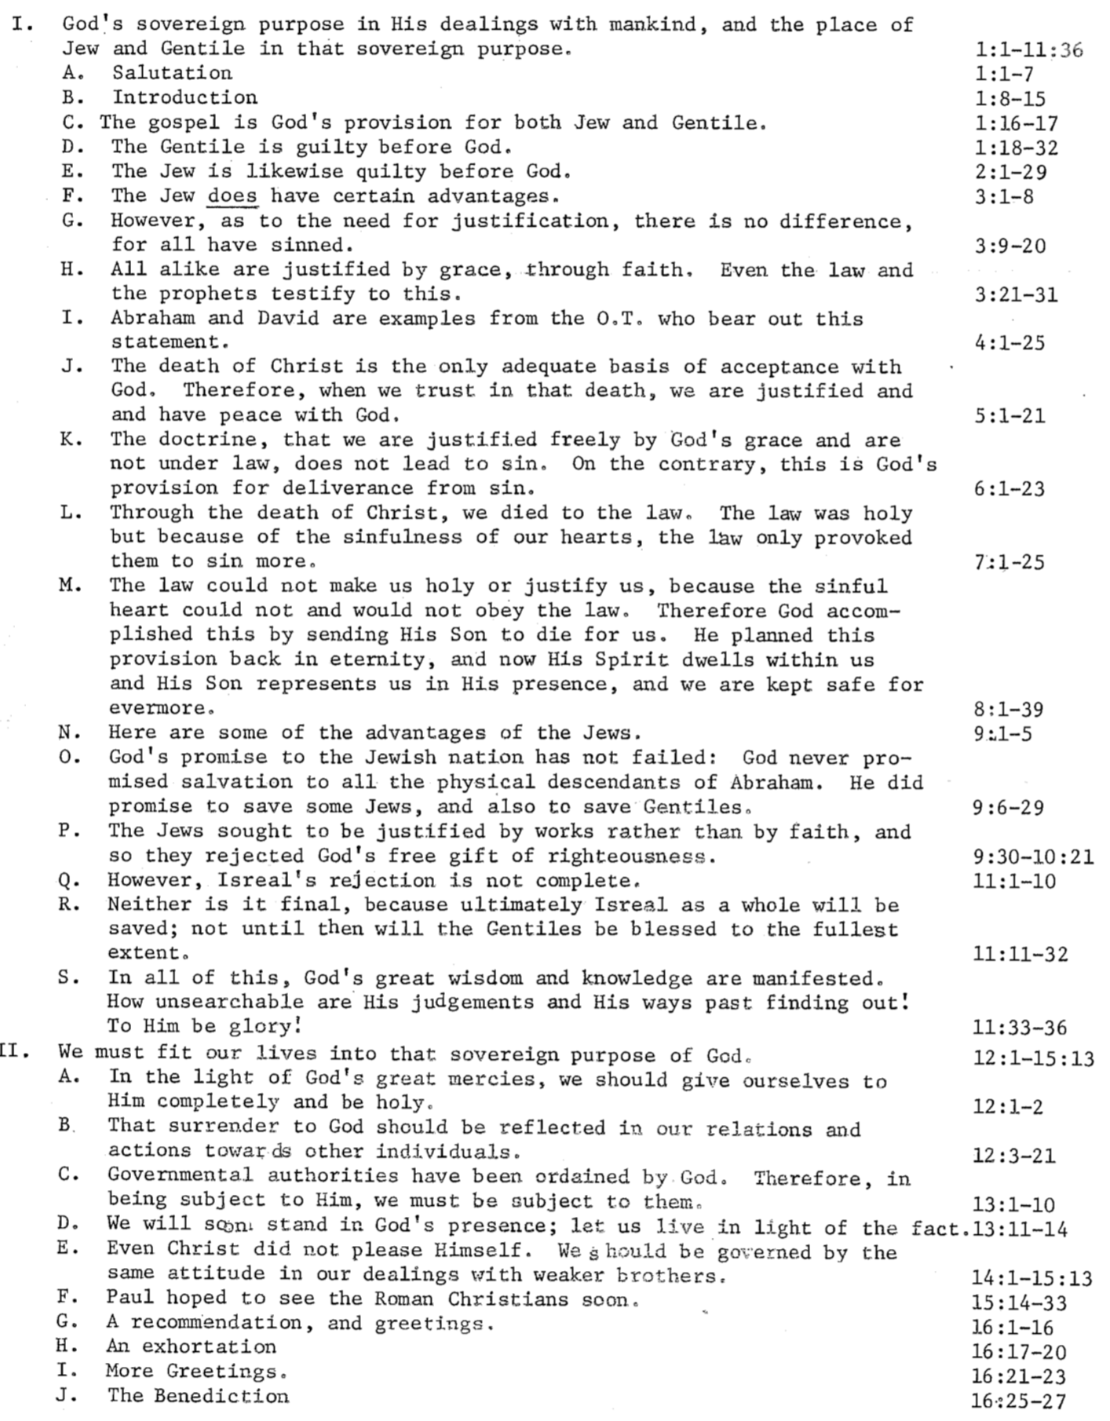
Outlines of Romans

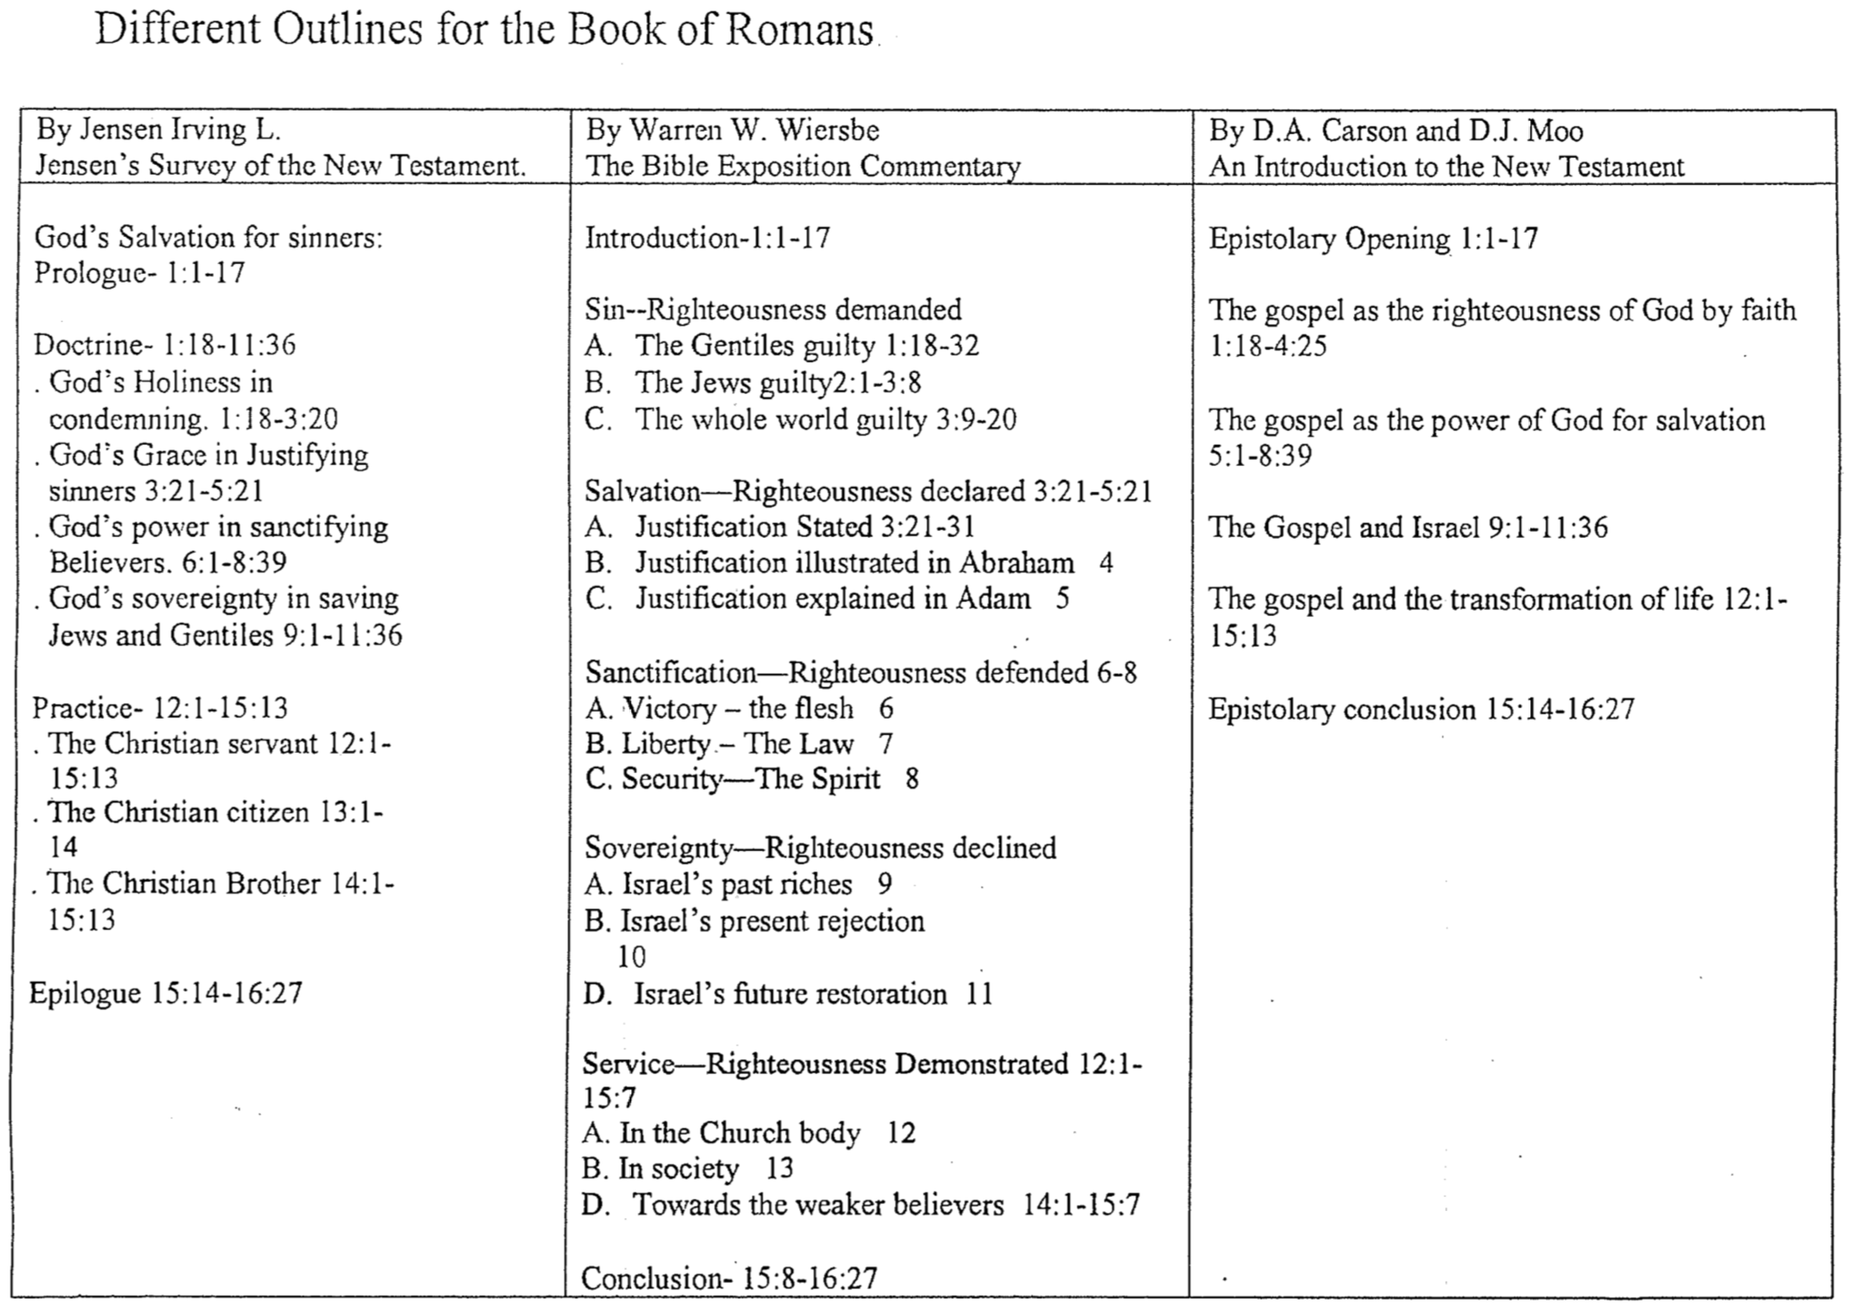
Romans Crossword Puzzle

Across: Down:
1. Set apart 2. The righteous will live by ______
3. Choice 4. The city where Romans was written
5. Key word 6. The place the author wanted to bring the gospel
7. Written in ___ 56-57 8. The host of the author (16:23)
9. Written to Christians in the city of ___ 10. A type of unclean food
11. The season when the book was written 12. Author
13. The reason we deserve God’s wrath 14. Symbol for one accepting Gentiles in covenant
15. Paul’s secretary (16:22) 15. Never ________ in your own works!
17. Right attitude towards others 16. Genre of the book
19. Point of conflict 20. Opposite of Gentiles

Adapted from a 1999 NT Survey class project
What About the Unreached (Rom. 1:18-20)?

One friend I know leads several people to Christ each week. Once I asked him how he did it. “Rick,” David noted, “you gotta get ‘em lost before you can get ‘em saved.” Seeing my puzzled look, he commented insightfully, “Most presentations of the gospel tell people that Christ is the answer before they even know what the question is. We try to give the solution before they even know they have a sin problem, so I spend most of my presentation showing them how helpless they are without Christ.”

This strategy is not unique to my friend David. Paul begins his great epistle in Romans 1:1–3:20 by expressing in clear terms how lost all people are without Christ. Most evangelicals believe that those who hear the message about Christ and reject it will go to hell (John 3:36; cf. Luke 16:27-31), but many also ask, “Are all people really lost? What about those who have never even heard of Christ?” Let’s address some common questions on this subject:

1. What about those who never hear the message about Christ in the first place?

a. Some (e.g., universalists) say all religions are basically the same and each provides a route to God; however, this denies the uniqueness of Christianity.

b. Some (e.g., Catholics) say there’s a second chance after death, but Hebrews 9:27 excludes any kind of purgatory.

c. Others point to the sincerity of the unevangelised, claiming that they will be judged only if they fail to live up to the light that they already have. However, this claims a form of salvation by works and Romans 1:20 says that all people are without excuse—not they may be without excuse.

d. One view attracting some evangelicals says if the unevangelised respond in faith to the light received, God saves them on the basis of Christ’s saving work—even though they do not know about this Giver of salvation (John Sanders, No Other Name: An Investigation into the Destiny of the Unevangelized [Grand Rapids: Eerdmans, 1992], 215, 282-83 and Clark H. Pinnock, A Wideness in God’s Mercy: The Finality of Jesus Christ in a World of Religions [Grand Rapids: Zondervan, 1992], 149-50; idem, “Toward an Evangelical Theology of Religions,” Journal of the Evangelical Theological Society 33 (1990): 359-68). For a rebuttal, see Robert A. Peterson, Hell on Trial (Presbyterian & Reformed, 1995), 228-34.

e. The only proper response to the state of the unevangelised is that they indeed are lost without Christ. This is supported in several ways:

1) Scriptural Arguments:

a) God’s wrath is on people rejecting the clear light of conscience and creation evidence so that all are “without excuse” (Rom. 1:18-20; 2:12-16). Thus, God’s judgment “is based not on their response to unrevealed truth but to revelation they have received” (J. Ronald Blue, “Untold Billions: Are They Really Lost?” Bibliotheca Sacra 138 [Oct.-Dec. 1981]: 344; cf. Millard J. Erickson, “The Destiny of the Unevangelized,” Bibliotheca Sacra 152 [January-December 1995 in 4 parts]; The Evangelical Mind and Heart [Grand Rapids: Baker, 1993], 130-31; Ronald H. Nash, Is Jesus the Only Savior? [Grand Rapids: Zondervan, 1994]).

b] God does not send people to hell—He only lets those who reject what is plain to them go on the self-designated course to hell (ibid, 347). These are “given over” to heterosexual lusts (Rom. 1:24-25), homosexuality (vv. 26-27), and a depraved mind (vv. 28-32).

c] No one is righteous (Rom. 3:10-11) and all are condemned (5:18). This is why all people must call upon the name of the Lord to be saved (Rom. 10:13; cf. John 14:6; Acts 4:12), which cannot happen unless someone is sent to tell them about Christ (vv. 14-15). This means that there exists no one who genuinely obeys even conscience and the so-called “moral law” which many claim is taught by the Ten Commandments.

2) Great Commission: Christ’s mandate to bring the gospel to every person assumes a lost world (Matt. 28:19; Mark 16:15; Luke 24:47; John 20:21; Acts 1:8). The fact that he gave this commission presumes that he knew the first century believers could do it. In fact, they largely did it in the Roman Empire even to India, though it took much longer to reach China.

3) Apostolic Example: Paul’s passion was to reach people for Christ in new areas which never heard the gospel (Rom. 15:17-24). How could this have been his passion if persons in these unreached areas were not lost? Each apostle was persecuted while seeking to reach the lost, and all but John died a martyr’s death doing so.

4) Logical Argument: If the unreached are not headed for hell, then the worst thing a Christian could do is to tell them about Christ! Why? Because if they hear the message, there’s a possibility of rejecting it and going to hell; however, if they don’t hear the message in the first place, hell isn’t even a possibility. Therefore, the best decision is to call back all our missionaries.

2. What happens to babies who die? I believe that they go to heaven based on two texts:

a. David showed confidence in seeing his infant son who died (2 Sam. 12:23). While someone may question whether David’s opinion is correct (or whether we can read a NT understanding of the afterlife into his words), neither of these counterarguments is convincing to me. See Robert P. Lightner, Heaven for Those who Can’t Believe (Schaumburg, IL: Regular Baptist Press, 1977) for support for these babies. I believe the same applies to insane people whole cannot even discern general revelation noted in Romans 1:18-20.

b. Jesus noted that the kingdom of God belonged to little children (Mark 10:14-15). Some believe this means we need childlike faith to enter heaven (Sanders, No Other Name, 290), but the passage appears to teach both doctrines.

3. How can I communicate hell to non-Christians? A few suggestions:

a. Don’t be afraid to talk about hell. Jesus wasn’t! Christ talked about hell even more than He did about heaven.

b. Talk about sin in your evangelistic presentations. Talk about how God is holy and just and therefore must judge sin.

c. Remind unbelievers that hell was “prepared for the devil and his angels” (Matt. 25:41). Man through his disobedience has entered into this arrangement.

d. Avoid speaking of hell and sin as “spiritual separation from God.” Unbelievers are used to being separated from God and because of their sin many have convinced themselves that separation is good—so this hardly seems like a punishment!

e. Teach about hell in balance with even more fundamental doctrines, such as the deity of Christ, Trinity, substitutionary death of Christ, virgin birth, etc. While one need not be well-versed in these to become a Christian, he certainly cannot oppose them and be considered a true believer. Of course, all of us believe in some false beliefs, but those who oppose these basic ones must be taught clearly before they can be deemed truly evangelized.

Salvation by Works

Can a person really be saved without any works at all? Wouldn’t it seem odd for someone to live his entire life for evil but then trust Christ just before he died, and then live in heaven eternally? However, would one who did good works throughout his life yet never trusted Christ be eternally lost in hell? Two passages below seem to teach salvation by works, so how do we explain them?

Works Verses | Explanation
Rom. 2:6 God “will give to each person according to what he has done.”  Rom. 2:7 To those who by persistence in doing good seek glory, honor and immortality, he will give eternal life.  Rom. 2:8 But for those who are self-seeking and who reject the truth and follow evil, there will be wrath and anger. | These verses seem to teach salvation by works while others teach salvation by faith (e.g., Rom. 3:20). Paul appears to teach salvation by works elsewhere (cf. 1 Cor. 6:9-11; 2 Cor. 5:10; Gal. 5:21) but he did not see these as contradictory. It is better to see Romans 2:7 as hypothetical. Paul simply says that eternal life would be possible if one could keep the law entirely, but since no one can do this then all alike are under sin. This fits his argument that all persons are under judgment in Romans 1–3 and it also harmonizes well with 3:19-20.
Matt. 19:16 Now a man came up to Jesus and asked, “Teacher, what good thing must I do to get eternal life?”  Matt. 19:17 “Why do you ask me about what is good?” Jesus replied. “There is only One who is good. If you want to enter life, obey the commandments.”  Matt. 19:18 “Which ones?” the man inquired. Jesus replied, “ ‘Do not murder, do not commit adultery, do not steal, do not give false testimony,  Matt. 19:19 honor your father and mother,’ and ‘love your neighbor as yourself.’ ”  Matt. 19:20 “All these I have kept,” the young man said. “What do I still lack?”  Matt. 19:21 Jesus answered, “If you want to be perfect, go, sell your possessions and give to the poor, and you will have treasure in heaven. Then come, follow me.”  Matt. 19:22 When the young man heard this, he went away sad, because he had great wealth. | Was Jesus really telling this man that salvation was by works? If so, Jesus would contradict the numerous times he taught that salvation came through simple faith in Him (John 3:15, 16, 18, 36; 5:24; 6:35; 7:38; 11:25; 20:31; cf. 1 John 5:11-13).  Rather, it seems more reasonable that Jesus was calling this rich man’s bluff. The man had claimed to perfectly keep the law and thus be worthy of salvation (v. 16), so Jesus was asking him to prove it.  But if the man had truly sold everything, he still wouldn’t be saved. Notice that Jesus said he must also follow him. This means that he must be one who believed in Jesus.  The preceding context emphasizes having the humble faith of a child to enter heaven. The rich man provides the contrast, for his trust in his works was far from humble. He thought of eternal life as something he could earn (vv. 16, 20). When he had to choose between money and Jesus, money won.
Theological Words in Romans

Predestination (8:29, 30a)  Election (9:10-13) | The gracious act of God before creation when he chose some people for salvation and conformity to the likeness of Christ because of his sovereign good pleasure
Foreknowledge (8:29, 30) | God’s personal, relational look into the future to save certain individuals not based upon their faith but upon His desire to bring them into relationship with Him
Calling (8:28, 30b) | God’s effective “summons” through the preaching of the gospel of persons from the kingdom of darkness that guarantees their response and entrance into His kingdom
Righteousness (3:21) | Holiness or perfection which is inherent for God yet imputed (applied) to persons who trust in the perfection of Christ on their behalf
Faith (3:22, 25) | Trust or reliance of a person upon the atoning work of Christ on the cross as the sinless substitute to pay the sinner’s penalty due to God
Grace (3:24) | God’s giving undeserved blessings through His own good pleasure and no merit of their own—giving us what we do not deserve
Mercy (11:30, 31, 32; 12:1) | God’s withholding punishment through His compassion and no merit of their own—not giving us what we do deserve
Justice (3:25-26) | The fairness of God whereby He must punish sin in an individual or in a Sinless Substitute for that person, who for the believer is Jesus Christ
Justification  (3:24; 4:25; 5:18; 8:30c) | The instantaneous legal act of God when he declares a sinner “not guilty” due to Christ’s righteousness being applied to this person, which makes him/her righteous in God’s sight
Redemption (3:24; 8:23) | The return of a sinner to God (“buying back” from the slave market) by Jesus Christ’s payment of the price of death with his own blood to make an unbeliever a believer
Propitiation (3:25) | The removal of God’s punishment for sin through the perfect sacrifice of Jesus Christ so that God’s righteous anger is satisfied
Imputation (5:13) | Taking into account or reckoning (an accounting term for counting or charging to one’s account) either the sin of Adam to an unbeliever or the perfection of Christ to a believer
Salvation (1:16; 5:9-10; 8:24; 9:27; 10:1, 9-10, 13; 11:11, 26) | The act of God which delivers fallen man from the penalty of sin (eternal death) through his faith in Jesus Christ
Sanctification (5:2; 15:16) | God’s progressive work though the Holy Spirit to make a Christian increasingly free from sin’s power and increasingly like Jesus Christ
Glorification (8:18, 19, 30d) | The believer’s final state of being in complete conformance to the character of Jesus Christ in a resurrected body that will last forever

The Roman Road

Many years ago someone discovered a way to share the gospel simply by using verses only within the book of Romans. Since this became a “road” to salvation for many, it became known as the “Roman Road.” Try it with a pre-believer!

1. | Romans 3:23 | All have sinned
2. | Romans 6:23 | The penalty for our sin is death
3. | Romans 5:8 | Jesus Christ died for sin
4. | Romans 10:9-10 | To be forgiven for our sin, we must believe and confess Jesus as Lord
Whose Children (Rom. 5)?

Adam’s Children | God’s Children
Ruin 5:9b | Rescue 5:8-9a
Sin 5:12, 15, 21 | Righteousness 5:18
Separation from God 5:18 | Relationship with God 5:11, 19
Disobedience 5:12, 19 | Obedience 5:10
Judgment 5:18 | Deliverance 5:10, 11
Law 5:20a | Grace 5:20b

Justification, Sanctification, and Death to Sin (Rom. 6)

Contrasts Between Justification and Sanctification

Justification | Sanctification
“Not guilty” | “Set apart”
Legal standing | Internal condition
Once for all time | Continuous throughout life
Entirely God’s work | We cooperate
Perfect in this life | Not perfect in this life
The same in all Christians | Greater in some than in others

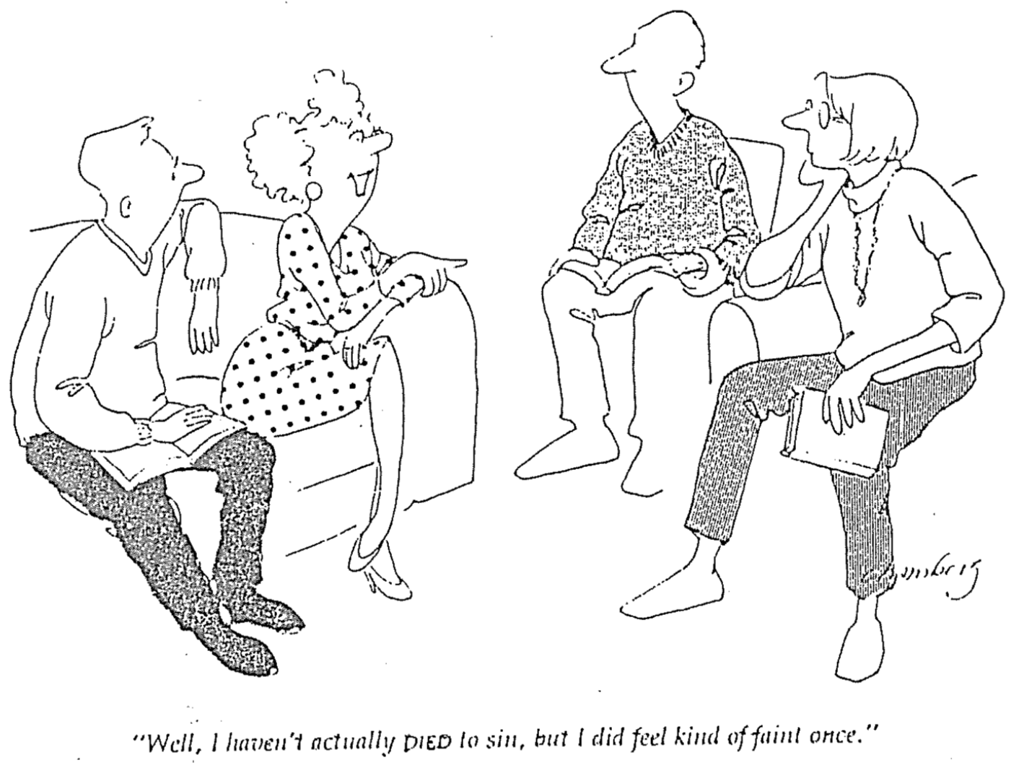

“Well, I haven’t actually DIED to sin, but I did feel kind of faint once.”
Should Christians Follow the Ten Commandments (Rom. 7)?
Adapted from my 1990 dissertation, “The Eschatological Significance of the Sabbath,” Dallas Seminary, 148-53

Despite the popularity of the belief that the Law is presently valid for believers, the New Testament treats the entire law as abrogated. This is a major tenant of the Book of Galatians, written in response to the error of supposing that some of the law was still in effect. Paul's readers were falsely led into believing that most of the law was abrogated (e.g., the sacrificial system, dietary laws, etc.) but certain laws remained, circumcision in particular. Paul forcefully took issue with such teaching:
Mark my words! I, Paul, tell you that if you let yourselves be circumcised, Christ will be of no value to you at all. Again I declare to every man who lets himself be circumcised that he is obligated to obey the whole law (Gal. 5:2-3).

The issue to be emphasized here is Paul's view of the law as a whole. His point is that if one is required to keep any part of it, he is obligated to keep all of it. Conversely stated, if the believer is free from the law, he is free from all of it. This applies whether the part referred to is circumcision, the Sabbath, or any other part.

The Pauline epistles uphold the abolishment of the entire law, not only part of it. Paul affirmed emphatically that believers are dead to the law (Rom. 7:1-6) and not under its rule (Rom. 6:14; Gal. 3:19, 23-29; 4:25, 31; 5:18). This is because Christ is the fulfillment (cf. Matt. 5:17-18) and termination or end of the law (Rom. 10:4) since His death abolished the law (Eph. 2:15). Further, Paul taught that the Mosaic Covenant has passed away (2 Cor. 3:6-11) and that the Abrahamic Covenant both preceded and followed the period of the law since the law served only temporarily (Gal. 3:14-25). The result is that "now that faith has come, we are no longer under the supervision of the law" (Gal. 3:25). Also, "the fact that God has (manifestly) accepted Gentiles as sons demonstrates that the period of the law is at an end; the custodian has finished his task and the son has become an heir (4:1-6)." Finally, in 1 Corinthians 9:20 Paul very clearly declares himself free from the law:
To the Jews I became like a Jew, to win the Jews. To those under the law I became like one under the law (though I myself am not under the law), so as to win those under the law.

Paul could not have stated more clearly that he was not under the law. He makes the same claim for his Roman readers as well: "you are not under law, but under grace" (Rom. 6:14). The preceding verses represent only a select group of passages that indicate that the law has been abolished and thus has no jurisdiction over the believer. Indeed, when comparing the Mosaic dispensation with "the dispensation in Christ, Paul found the former, glorious as it had been, to be worthless."
Paul and the Decalogue
While many passages have been cited above to show the end of the law, those most pertinent to the present study are two texts specifically pointing to the end of the Ten Commandments in the present age. The first text is Romans 7. Here Paul emphatically states that the believer has died to the law by being joined to Christ (v. 4) with the result that he is released from the law (v. 6). His following illustration specifies this "law" as the Decalogue by referring to the tenth commandment which prohibits coveting (vv. 7f.). The purpose of this prohibition was to reveal Israel's inability to obey the law of God. Specifically, Paul claims freedom from the law because it has already fulfilled its purpose in revealing sin. Further, since the Decalogue is an essential unity, the abolition of one of its commandments (coveting) shows the abolition of them all. In other words, since his illustration denotes that believers are free from one of the Ten Commandments, and the Decalogue is a unity, it follows that believers are also free from all of the commandments, which includes the Sabbath.

Second Corinthians 3 is a second passage that even more clearly shows the believer's freedom from the Ten Commandments. In this chapter Paul contrasts his apostolic authority as a minister of the New Covenant with that of his opponents at Corinth who, by implication, were ministers of the Old Covenant (cf. 2:17; 3:14). One reason the New Covenant is more glorious than the Old is because this New Covenant is internal, written on men's hearts through the Person or activity of the Spirit (3:3b). Conversely, the Old Covenant was engraved upon tablets of stone (3:3, 7). The crucial issue here is what was written on stone in the Old Testament. Was it the entire law? No, only the Ten Commandments were engraved upon the tablets at Sinai (Deut. 4:13; 5:22). In other words, Paul equates the Old Covenant with the Decalogue. This law had a fading glory (i.e., lacked permanent validity) "because only in Christ is it taken away" (v. 14b). Therefore, since Paul contrasts his continuing ministry of blessing with the ministry of cursing in the Ten Commandments, he in effect teaches the abolishment of the Decalogue as a system by which one should live, including the Sabbath. That the Sabbath is included within this abolished Decalogue also finds support in that the death penalty for disobeying the Ten Commandments is never enforced in the New Testament. It is inconsistent to argue for the continuance of the Sabbath requirement in the present age without a continued penalty for neglecting it.

The Ten Commandments

# | Old Testament Commands | New Testament Repetitions
1 | And God spoke all these words: “I am the LORD your God, who brought you out of Egypt, out of the land of slavery. You shall have no other gods before me” (Exod. 20:1-3). | “Men, why are you doing this? We too are only men, human like you. We are bringing you good news, telling you to turn from these worthless things to the living God…” (Acts 14:15; mentioned at least 50 times).
2 | “You shall not make for yourself an idol in the form of anything in heaven above or on the earth beneath or in the waters below… for I… am a jealous God, punishing the children for the sin of the fathers to the third and fourth generation … but showing love to a thousand generations of those who love me…” (Exod. 20:4-6). | “Dear children, keep yourselves from idols” (1 John 5:21; cf. 1 Thess. 1:9; Rev. 2:14, 20; 9:20; mentioned in the NT 12 times = 12x).  * This chart is adapted and expanded from one by Lewis Sperry Chafer, Systematic Theology, 4:209-10
3 | “You shall not misuse the name of the LORD your God, for the LORD will not hold anyone guiltless who misuses his name” (Exod. 20:7). | “Above all…do not swear–not by heaven or by earth or by anything else. Let your ‘Yes’ be yes, and your ‘No,’ no, or you will be condemned” (James 5:12; 4x).
4 | “Remember the Sabbath day by keeping it holy. Six days you shall labor and do all your work, but the seventh day is a Sabbath to the LORD your God. On it you shall not do any work, neither you, nor your son or daughter, nor your manservant or maidservant, nor your animals, nor the alien within your gates. For in six days the LORD made the heavens and the earth… but he rested on the seventh day. Therefore the LORD blessed the Sabbath day and made it holy” (Exod. 20:8-11). | No NT text requires this of Christians.  However, one passage clearly prohibits the practice as required for believers: “Therefore do not let anyone judge you by what you eat or drink, or with regard to a religious festival, a New Moon celebration or a Sabbath day. These are a shadow of the things that were to come; the reality, however, is found in Christ” (Col. 2:16-17; 0x).
5 | “Honor your father and your mother, so that you may live long in the land the LORD your God is giving you” (Exod. 20:12). | “Children, obey your parents in the Lord, for this is right. ‘Honor your father and mother’–which is the first commandment with a promise–that it may go well with you and that you may enjoy long life on the earth” (Eph. 6:1-3; cf. Matt. 15:4-6; 19:19; Mark 7:10; 10:19; 6x).
6 | “You shall not murder” (Exod. 20:13). | “Anyone who hates his brother is a murderer, and you know that no murderer has eternal life in him” (1 John 3:15; cf. Matt. 19:18; Mark 10:19; Luke 18:20; Rom. 13:9; James 2:11; 6x).
7 | “You shall not commit adultery” (Exod. 20:14). | “Marriage should be honored by all, and the marriage bed kept pure, for God will judge the adulterer and all the sexually immoral” (Heb. 13:4; cf. Mark 10:19; 12x).
8 | “You shall not steal” (Exod. 20:15). | “He who has been stealing must steal no longer, but must work, doing something useful with his own hands…” (Eph. 4:28; cf. Matt. 27:64; Mark 10:19; Luke 18:20; Rom. 13:9; Titus 2:10; 6x).
9 | “You shall not give false testimony against your neighbor” (Exod. 20:16). | “Do not lie to each other, since you have taken off your old self with its practices” (Col. 3:9; cf. Eph. 4:25; 4x).
10 | “You shall not covet your neighbor’s house… wife, or his manservant or maidservant, his ox or donkey, or anything that belongs to your neighbor” (Exod. 20:17). | “Then he said to them, ‘Watch out! Be on your guard against all kinds of greed; a man’s life does not consist in the abundance of his possessions’” (Luke 12:15; Rom. 7:7; 13:9; Eph. 5:3; James 4:2; 2 Pet. 2:3, 14; 9x).

Interpreting and Preaching Legal Literature

A. A quick quiz to get you thinking…

1. T or F Christians should keep parts of the OT law that are not repeated in the NT.
2. T or F There are two laws: the moral (Ten Commandments) and ceremonial/civil.
3. T or F The Sabbath should still be obeyed by Christians.
4. T or F Believers today are obligated to keep all of the Ten Commandments.
5. T or F Tithing should be practiced by all followers of Christ.
6. T or F Christians today are prohibited from eating blood (e.g., yong tau foo, blood pudding, pig or duck blood at Chinese New Year).
7. T or F Believers must not charge other Christians interest based upon the Law (Deut. 23:19; Exod. 22:25; Lev. 25:36-37; Ezek. 18:8, 13, 17; 22:12; Prov. 15:5; 28:8).

B. Defining the Meaning of Law (adapted from Fee/Stuart, 135-36)

1. Sometimes “Law” refers to the Pentateuch as a single book (e.g., Josh. 1:8).

2. Sometimes Christians refer to the “Law” as the five books of the Pentateuch, even though Genesis has no legal codes.

3. NT usage of the term “Law” sometimes refers to the Pentateuch and sometimes the entire OT (e.g., Luke 16:17).

4. Oftentimes “Law” refers to only the legal formation from Exodus 20–Deuteronomy 33. (It always refers to at least this portion of Scripture.)

C. The Christian’s Relationship to the Law (adapted from Fee/Stuart, 136-39; these issues are addressed in detail in my ThD dissertation in the SBC library under Richard James Griffith, “The Eschatological Significance of the Sabbath,” Dallas Seminary, 1990, esp. pp. 144-56).

1. The OT law is a covenant between Israel and God–not between the church and God. The church and Israel must be kept distinct.

2. Our loyalty to God is shown in different ways than was Israel’s. In other words, God expected Israel to be loyal and He expects the same of us, but Israel’s loyalty was shown through observing the sacrificial system whereas our loyalty is shown by our obeying NT commands. (However, faith is what pleased God then and now–Heb. 11:6.)

3. Most OT stipulations are not repeated in the NT–especially the civil (penalties for crimes) and ritual (worship, especially sacrificial regulations) laws. Therefore, most of the OT does not directly apply to believers.

4. Some OT stipulations are repeated in the NT–including nine of the Ten Commandments, the exception being the Sabbath.

5. All of the OT law is still the Word of God for us even though it is not still the command of God for us. As such it is still useful for teaching and preaching, though applications must be made based upon the principles under girding the laws.

6. Only that which the NT explicitly renews from the OT law can be considered part of the NT “law of Christ” (Gal. 6:2). [Note: Fee/Stuart put all of the Ten Commandments in this category, which makes modern believers guilty of Sabbath breaking. I disagree that the Sabbath is binding in the present age. I worship corporately on Sunday, not Saturday!]
D. The Purposes of the Law (adapted from J. Dwight Pentecost, BibSac 128 [July 1971]: 227-33)

Paul’s letter to the Galatians teaches sanctification not by the Law but by faith in Christ alone. This finds support in that Abraham was justified by faith centuries before the Law even came (Gal. 3:17). After that, the Law and the Promise (Gen. 12:1-3) co-existed for years, so there is no basic conflict between the Law and the Promise. This led Paul to ask, “What, then, was the purpose of the law?” (Gal. 3:19). Actually, there were at least ten purposes for the Law:

1. It revealed or exposed the sinfulness of man (Gal. 3:19).

2. It revealed the holiness of God (1 Pet. 1:15).

3. It revealed the standard of holiness for people in fellowship with God (Ps. 24:3-5).

4. It supervised the physical, mental, and spiritual development of the redeemed Israelite until he could come to maturity in Christ (Gal. 3:24).

5. It unified the people to establish the nation in voluntary submission to God’s decrees (Exod. 19:5-8; Deut. 5:27-28).

6. It separated Israel among the nations as a kingdom of priests to mediate God’s truth to these nations (Exod. 31:13).

7. It provided forgiveness of sins for individual Israelites to restore their fellowship with God, even though they already functioned as a redeemed people (Lev. 1–7).

8. It made provision for Israel to worship God as a redeemed people (Lev. 23).

9. It tested if one was in the kingdom or the theocracy over which God ruled (Deut. 28). Faith led to obedience and blessing; lack of faith led to disobedience and judgment.

10. It revealed Jesus Christ (typology in the sacrificial system; Luke 24:27).

Pentecost suggests that the revelatory aspect of the Law is permanent as it still reveals the holiness of God today (1 Tim. 1:8), but the regulatory aspect is temporary as it regulated the life and worship of the Israelite (Gal. 4:8-10; Col. 2:16-17). However, this view does not seem correct, as the entire Law has been abolished (see the next two pages, i.e., pp. 114-115). I feel that a better approach is the one below…

E. A Suggested Strategy for Expounding Old Testament Law

1. Interpretation: Study the intent behind the legal command, asking the question, “Why was this command given in Israel?” It is especially helpful to answer this question by showing how the law reveals the character of God. For example:

“God told Israel in Leviticus 19:9-10 not to harvest the corners of the fields because He had compassion on the poor who could glean there for their food.”

2. Principlizing: State the intent of the law in the form of a general principle.

“God wants his people to give the underprivileged the chance to earn a living.”

3. Application: Show how this principle relates to a contemporary parallel situation.

“As an employer you should provide opportunities for the poor to support themselves.”

You probably can tell now that I think the answer to each question on the previous page’s quiz is false.

The Indwelling & Sealing of the Spirit (Rom. 8)

I. Confusion: All or Part at Salvation?

A. Sometimes Christians pray that they will receive the Spirit at some point after salvation.

1. The reception of the Spirit came after salvation in some passages in Scripture:

Acts 2 (cf. 1:4-5)

Acts 8:14-17

(Acts 19:1-7 refers to OT believers in Messiah)

2. Christians sometimes point to these verses for support that the Spirit does not indwell all believers. They contend that every Christian must seek His indwelling.

B. The Issue: Do we receive all or part of God when we become a Christian? (In other words, can God be divided up into parts, each of whom comes at different times?)

II. The Indwelling of the Spirit (adapted from Charles Ryrie, The Holy Spirit, 67-73)

A. The Spirit indwells even carnal believers (1 Cor. 3:16; 6:19).

B. Since the Spirit is a gift given indiscriminately (Acts 11:17; cf. 10:44), believers cannot earn Him (John 7:37-39; Rom. 5:5; 1 Cor. 2:12; 2 Cor. 5:5).

C. Absence of the Spirit indicates an unregenerate state (Rom. 8:9b; Jude 19; cf. 1 Cor. 2:14).

D. The Spirit abides forever (John 14:16), though Christians can grieve Him (Eph. 4:30).

E. The obedience requirement for the indwelling (Acts 5:32) is the obedience of faith in Christ.

F. The times when the Spirit was withdrawn due to sin (1 Sam. 16:14; Ps. 51:11; Luke 11:13) all occurred prior to Pentecost when He was given permanently (Acts 2; cf. John 14:16).

G. The delay of giving the Spirit to the Samaritans (Acts 8:14-17) is not the norm for today:

1. The Spirit came at the same time as salvation for Gentiles (Acts 10:44), so if a pattern is to be followed for Gentiles today then this would be it.

2. The reason the Spirit indwelt the Samaritans after salvation: This was the first time any Samaritans were saved, so God delayed the Spirit’s coming until Jews could verify it. This tied them into the church as a whole to prevent two types of Christians.

H. The anointing of the Spirit is given to all believers (2 Cor. 1:21; 1 John 2:20, 27). No passage teaches that certain Christians are anointed and others are not.

“The difference between the anointing and indwelling seems to lie in their distinct purposes. The indwelling brings the presence of God into the life of the believer. The anointing, as far as the believer is concerned, is that he might be taught (1 John 2:20, 27). Actually, this seems to be the only purpose specified in the believer’s case. However, if one may use the example of the anointing of Christ [Luke 4:18; Acts 4:27; 10:38; Heb. 1:9] and of Old Testament priests [Exod. 30:32-33; cf. anointing of kings 1 Sam. 10:1; Zech 4:14], then another purpose emerges—that of service. But…the full experience of the anointing depends on being filled with the Spirit” (Ryrie, 73).
III. The Sealing of the Spirit (cf. Eldon Woodcock, “The Seal of the Holy Spirit” Bibliotheca Sacra 155 [April-June 1998]: 139-63)

A. Agent: God is the agent of the sealing (i.e., He is the one who seals the believer), according to 2 Corinthians 1:22 (cf. John 6:27).

B. Sphere: “The Holy Spirit is the seal. The believer is sealed with or in the Spirit. In Ephesians 1:13 there is no preposition expressed” (Ryrie, 80). In other words, technically we are not sealed “by” the Spirit but “with” the Spirit.

C. Extent: All believers are sealed:

1. All the Corinthian believers (carnal and spiritual alike) were sealed (2 Cor. 1:22).

2. Christians are nowhere exhorted to seek a sealing.

3. The believer’s sealing is the basis for the exhortation not to grieve the Spirit (Eph. 4:30).

D. Time: Since all Christians are sealed, this must happen at salvation.

E. Intent: There exist two purposes for the sealing of Christians:

1. Security: It assures that since God gave us His Spirit, He will give us our entire inheritance in heaven as well (2 Cor. 1:22b; Eph. 4:30), including redeeming our bodies (Eph. 1:13-14).

2. Ownership: It shows that God owns us (2 Cor. 1:22b, “seal of ownership”)

IV. Security and Assurance

 | Eternal Security | Assurance of Salvation
Basic Meaning | Being saved from the penalty of sin forever (once saved, always saved) | Knowing that we are saved from the penalty of sin forever
Definition | “The work of God which guarantees that the gift of salvation, once received, is forever and cannot be lost” (Ryrie, Basic Theology, 328) | “The realization of the truth of eternal security or perseverance” (Ryrie, Basic Theology, 328)
Spirit’s Ministry | Sealing (Eph. 1:13-14) | Assuring (Rom. 8:15-17)
Believer’s… | Position as child of God (Rom. 8:16b) | Practice of confidence (Rom. 8:16a)
Recipients | All Christians possess | Some Christians doubt
Permanence | Can’t be lost (John 6:39-40; 10:27-29; Rom. 8:30, 38-39; Heb. 7:25) | Can be lost (for this reason John wrote 1 John 5:11-13)
Songs | “I Know Whom I Have Believed” | “Blessed Assurance”

Clarification: Preservation is largely the same as eternal security, but perseverance focuses more on the believer who perseveres (by through the decree and power of God). In contrast, security focuses on God—it is God who secures our salvation (Ryrie, Basic Theology, 328).

V. Conclusion

A. We are secure in Christ with the Spirit’s presence—and He will never leave us (Heb. 13:5)!

B. The Holy Spirit guarantees us that once we have Him, it is only a matter of time before we will have our entire heavenly inheritance.

C. A believer has security whether or not he has assurance.
Romans 8:28-30
John D. Grassmick, Romans 206, Dallas Seminary, 1985

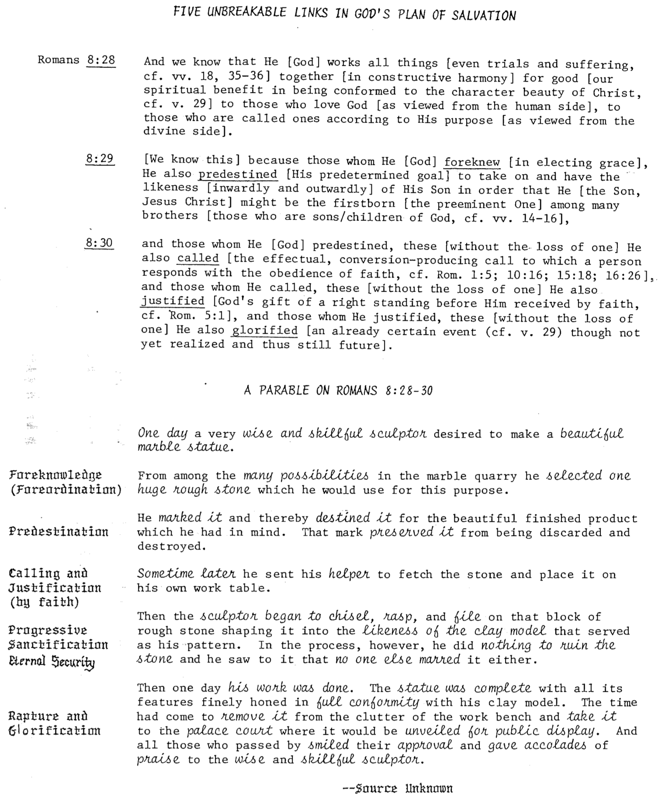
Gentile Engrafting (Rom. 11)
Adapted from Romans 11 notes of John D. Grassmick, Romans 206, Dallas Seminary, 1985, p. 48

In Romans 11:17-27 Paul clarifies the present relationship of both Jews and Gentiles to the Abrahamic Covenant by using an illustration of two olive trees.

This covenant is a place of both opportunity and privilege: first given to Israel (cultivated olive tree) but after the unbelief of individual Jews (branches cut off) also extended to Gentiles (wild olive tree) in the church (branches grafted into the cultivated olive tree).

Paul’s purpose here is twofold:
1. To warn Gentiles against pride in light of God’s discipline of Israel for unbelief (11:17, 21-22)
2. To give an argument for the restoration of Israel (11:22-27)

Graphically, the Gentile engrafting looks like this:
Parts of the Tree

4 Branches (11:17-21):

a Natural: Ethnic Israel, descendants of Abraham (9:4-5)

1) Those remaining in or grafted in = believing Jews who exercise the faith of Abraham (11:23-24)

2) Those cut off (11:19-21)= unbelieving Jews who do not exercise the faith of Abraham (hardened, 11:7b)

b Wild: Gentile humanity as a whole

1) Those grafted in = believing Gentiles (11:17b, 22)

2) Those cut off = unbelieving Gentiles (11:21b)

3 Trunk (11:24): the place of spiritual blessing and responsibility in relationship to the Abrahamic Covenant (Gen. 12:3b; Acts 3:25; Gal. 3:8)

2 Nourishing Sap of the Root (11:17b): opportunity due to God’s grace of a relationship to Abraham as his spiritual descendants (place of privilege)

1 Root (11:16-18): Abraham & the patriarchs
Cultivated Olive Tree
(Abrahamic Covenant)

Wild Olive Tree
(All Gentiles)
Israel & the Church (Rom. 9–11)

How does Israel relate to the Church? Amillennialists, postmillennialists, and covenant premillennialists argue that the Church is the “new Israel” with full or near complete continuity between these entities. Thus, the Church is seen to have simply replaced Israel and assumed her promises and covenants.

The other side of the spectrum is classical and revised dispensationalism which sees more discontinuity. In this scheme, there are two separate peoples of God: Israel and the Church. The only overlap is that the believers today participate in some of the aspects of the Abrahamic and New Covenants (see pp. 20-25).

I have held both views in the past, but recently have adopted a third model with some elements of progressive dispensationalism. This newer system (since 1987) emphasizes both continuity and discontinuity yet still holds the dispensational distinctive that the Church is not the “new Israel.” Rather, it is a continuation of God’s covenant plan begun with Israel and continuing with a believing remnant of Israel today, along with Gentile believers grafted into the Abrahamic Covenant (see Romans 9–11; Galatians 3). Here are some points of difference and contact between these two entities:

Discontinuity

 | Israel | Church
Identity | Physical seed of Abraham (Gal. 6:12-16) | Spiritual seed of Abraham (Gal. 3:7, 29)
Palestinian Covenant | Still outstanding (Deut. 30:1-10) but partly fulfilled since 1948 (Ezek. 37:1-7) | No land promise (Palestinian Covenant) can be claimed by present believers
Law | Required to obey the law (Exod. 19–20) | Freedom from the law (Rom. 7; Gal. 3)
Duration | Abraham (Gen. 12:1-3) to eternity (Jer. 31:35-37) | Pentecost (Acts 2) to Rapture (1 Thess. 4:13-18) or even later (?)
Wrath | Experienced in Tribulation (Jer. 30:7) | Free from wrath (1 Thess. 5:9; Rev. 3:10)
Faith | Shown in offering sacrifices | Shown in trusting Christ’s sacrifice
Priesthood | Has one: a special class by heredity | Is one: all are priests (1 Pet. 2:5)
Activity | Set aside between 69th & 70th “Weeks” (Dan. 9:24-27)—a part of the “times of the Gentiles” (Luke 21:24) | Between 69th & 70th “Weeks” the church is a mystery unforeseen in the OT (Eph. 3:1-9; Col. 1:26)
Qualification | Ethnic—descendants of Abraham or Gentile proselytes who became Jews through circumcision as blessing is through Israel (1 Kings 8:41-43; Isa. 2:2-3; 19:19-25; 49:6; 51:4; 56:6-8; Zech. 14:16-19) | Nonethnic—”Neither Jew nor Gentile” (Gal. 3:28) means a combination of Jews and Gentiles without need to become Jewish proselytes (Acts 15; Eph. 3:3, 6)
Continuity

 | Israel | Church
Abrahamic Covenant | Origin in Abraham as the father of the nation (Gen. 12:1-3) | Believers today are grafted into this same covenant (Rom. 11:17-21; cf. Gal. 3:29)
Davidic Covenant | Promise of a literal temple (2 Sam. 7:13) fulfilled by Solomon (1 Kings) | Functions now as a spiritual temple  (Eph. 2:19-22; 1 Pet. 2:4-10)
New Covenant | Promised forgiveness of sins, indwelling Spirit, new heart, reunification of Israel and Judah, and knowledge of God throughout the earth (Jer. 31:31-34) | The first three aspects (forgiveness of sins, indwelling Spirit, new heart) true today in a progressive fulfillment of the covenant (Luke 22:20)
Law | Required to obey the Mosaic law (Exod. 19–20) | Required to obey the “law of Christ” (Gal. 6:2) or “law that gives freedom” (James 1:25; 2:12)
Salvation by | God’s grace through faith (Gen. 15:6) | God’s grace through faith (Rom. 4:3)
Basis of Salvation | Sacrificial lamb | Sacrificial Lamb
Spirit | Filling on leaders | Indwelling of all believers (Rom. 8:9)
Prophets | Provided revelation of God’s word | Foundation of the church (Eph. 2:20)
Election | Based on grace (Mal. 1:2) | Based on grace (Eph. 1:4-6, 11)
Disobedience | Lead to God’s discipline | Leads to God’s discipline (1 Cor. 11:30)
Leadership | Elders (Exod. 3:16, 18; 4:29, 31;12:21; Num. 11:16-17; Josh. 24:31; 1 Sam. 15:30; 2 Sam. 17:4, 15; 1 Kings 21:8, 11 and many other texts) | Elders (Acts 11:30; 14:23-24; 15:1-6; 16:4; 20:17-38; 21:17-26; 1 Thess. 5:12-13; Phil. 1:1; 1 Tim. 3:1-7; 4:14; 5:17-25; Tit. 1:5-9; Jas. 5:14; 1 Pet. 5:1-5; Heb. 13:17)
Witness | “light for the Gentiles” (Isa. 49:3-6)  “kingdom of priests” (Exod. 19:6)  “holy nation” (Exod. 19:6) | “light of the world” (Matt. 5:14-16)  “holy…royal priesthood” (1 Pet. 2:5, 9)  “holy nation” (1 Pet. 2:9)

More Contrasts Between Israel and the Church
See Paul Enns, Moody Handbook of Theology, 389-90, 522; Charles Ryrie, Basic Theology, 399

The early church fathers almost unanimously taught that Christ will return to rule over Israel in a literal 1000-year millennium (Rev. 20:1-6; cf. Eschatology notes, 121-121b). However, since the 4th century AD many have taught that there is no future for national Israel due to its rejection of Christ so that Israel’s promises have been transferred to the church as “the new Israel.” Can such a teaching be found in Scripture? I believe it cannot for many reasons:

1. Israel and the Church have many differences in Scripture (see charts on preceding two pages).

2. Throughout Scripture the term “Israel” always refers to physical descendants of Jacob—it never refers to the church. To claim that it does is to argue from silence.

3. Luke contrasts natural Israel and Gentiles after the church is established (Acts 3:12; 4:8, 10; 5:21, 31, 35; 21:19).

4. Paul distinguishes Israel from the church, showing that the church is not Israel. If they were the same, his distinctions would be meaningless.

God has not rejected Israel to replace the nation with the church
Rom. 11:1-2a I ask then: Did God reject his people? By no means! I am an Israelite myself, a descendant of Abraham, from the tribe of Benjamin. God did not reject his people, whom he foreknew.

Some Jews are in the church, a separate group from Israel
Rom. 9:6 … For not all who descended from Israel [the nation] are Israel.

At present, Israel is mostly unsaved (and thus distinct from the saved Church)
Rom. 9:30-31 What then shall we say? That the Gentiles [believers in the Church], who did not pursue righteousness, have obtained it, a righteousness that is by faith; but Israel, who pursued a law of righteousness, has not attained it.

God is not finished with Israel
Rom. 11:11 Again I ask: Did they [Israel] stumble so as to fall beyond recovery? Not at all! Rather, because of their transgression, salvation has come to the Gentiles to make Israel envious.

Israel’s hardening is both partial and temporary as the future nation will be saved
Rom. 11:25-27 I do not want you to be ignorant of this mystery, brothers, so that you may not be conceited: Israel has experienced a hardening in part until the full number of the Gentiles has come in. And so all Israel will be saved, as it is written:
‘The deliverer will come from Zion; he will turn godlessness away from Jacob.
And this is my covenant with them when I take away their sins.’

Israel is spoken of as separate from the Church
1 Cor. 10:32 Do not cause anyone to stumble, whether Jews, Greeks or the church of God.

Israel and the Church are separate but fellow heirs of God’s promises
Eph. 3:4, 6 This mystery… is that through the gospel the Gentiles are heirs together with Israel, members together of one body, and sharers together in the promise in Christ Jesus.

5. John notes that Jews from all twelve tribes (Rev. 7:1-8) will witness for Christ in the future (Rev. 14:1-5). This group is distinct from believing Gentiles (Rev. 7:9).

6. Matthew also acknowledged a future for Israel in Christ’s promise that the nation will again see Him (Matt. 19:28; 23:39).

7. Early Church Fathers before AD 325 believed in the 6000 Year Theory (cf. Eschatology, 112-15), dispensations, a premillennial return of Christ, and imminency (cf. Eschatology, p. 121 Crutchfield note). Therefore, dispensational features were very early in the church.
Responses to Dispensational Problem Passages

Texts Used to Equate Israel & Church | Dispensational Responses
The church is the “seed of Abraham” (Gal. 3:7; 4:31), which in the OT refers only to Israel. So isn’t the church the “new Israel”? | The church is the spiritual seed of Abraham, but this doesn’t mean it replaces the physical seed so that Israel is done away with permanently (cf. Rom. 11:1-2, 11, 15, 25; see preceding page).
“Neither circumcision nor uncircumcision means anything; what counts is a new creation. Peace and mercy to all who follow this rule, even to the Israel of God” (Gal. 6:15-16). | Paul doesn’t say that all who follow the rule (i.e., Christians) are the “true Israel.” He had just attacked the Jewish legalists, so it makes better sense that he announced blessing on Jews who had forsaken legalism to truly follow Christ.
The church is called the “true circumcision” (Phil. 3:3). | The comparison is not between the church and Israel but between the church and legalistic Jews.
Jesus told Pilate His kingdom “is not of this world” but “from another place” (John 18:36). | Christ did not comment on the place of His kingdom. He said the source of His kingdom was heaven. He did not say that this kingdom could not eventually be established on earth.
“Once, having been asked by the Pharisees when the kingdom of God would come, Jesus replied, ‘The kingdom of God does not come with your careful observation, nor will people say, “Here it is,” or “There it is,” because the kingdom of God is within you’” (Luke 17:20-21). Isn’t this amillennialism? | The “within you” (NIV) cannot refer to a spiritual rather than literal kingdom. Christ spoke this to unbelieving Pharisees who rejected Him as Messiah, so the kingdom was not within them! A better translation is “the kingdom of God is in your midst” (the King stood right before them). “All they needed to do was acknowledge that He is indeed the Messiah who could bring in the kingdom—and then the kingdom would come” (Martin, “Luke,” Bible Knowledge Com., 2:249).
Amos 9:11-12 says that the Davidic Covenant will be fulfilled, and James quoted this prophecy to say that the rebuilt house of David is the church which was used to preach the gospel to the Gentiles (Acts 15:15-18). | James did not say that Amos was fulfilled in the church, but only that Gentile inclusion (“the remnant of men”) agreed with the OT prophets. Also, the “return” (Acts 15:16) is used of a literal return (cf. Acts 5:22) that precedes the fulfillment of Amos’ prophecy. This means Christ’s return will precede the re-establishment of David’s throne. Christ’s present ministry at the Father’s right hand (Rom. 8:34) is not elsewhere in the NT associated with the Davidic throne— only when He returns will He occupy this throne (Matt. 19:28; Toussaint, “Acts,” BKC, 2:394).
Jer. 31:31-34 refers to Israel’s new covenant, which the NT applies to the church (Heb. 8), thus equating Israel with the church. | Not all of Jeremiah’s descriptions apply (e.g., all do not know the Lord), so the church only begins to fulfill this prophecy.

Responses to the Romans 9–11 “New Israel” View

Passages Some Use to Say that the Church is the “new Israel” | Dispensational Responses
“For not all who are descended from Israel are Israel” (9:6). Since many Gentiles believe who have not descended from Israel, then they must be the “true, new Israel.” | The verse simply means that not all Jews believe. It does not speak of anyone who has not descended from Israel. The only ones that have descended from Israel are Jews. In fact, the first part of the verse reads, “It is not as though God’s word had failed…” in respect to him fulfilling the promises to Israel in verses 4-5. Verse 6 shows that there are two types of Israelites: the natural only (unbelievers) and the spiritual (believers). It never notes Gentiles. It means that “within Israel there is a separation, that of unbelieving Israel and believing Israel” (NIV Study Bible note).
“In other words, it is not the natural children who are God’s children, but it is the children of promise who are regarded as Abraham’s offspring” (9:8). | Yes, unbelieving Jews are not God’s children. However, like 9:6 above, this verse also says nothing about Gentiles being the “new Israel.” It only ties believers into Abraham as spiritual children of Abraham along with all Jews who believe.
“As he says in Hosea, ‘I will call them ‘my people’ who are not my people’…” (9:25). Since Gentiles are spoken of here as this new people (v. 24), then the church must have replaced Israel. | It is true that the verse speaks of Gentiles being called God’s people. But the verse does not say that Gentiles have replaced ethnic Israel as the “new Israel” so that God has no future for ethnic Israel. As “new covenant” demonstrates that the “old covenant” has been replaced, so use of “new Israel” implies a replacement of the “old Israel,” or ethnic Israel. Since no text explicitly calls the church “the new Israel” or “a new Israel” it is a confusing term to use.
Certain branches of the cultivated olive tree (11:24b) were cut off so that Gentiles could be grafted in. Thus the church has replaced Israel. | Only certain branches will be replaced—not the entire tree. God still has plans for the tree (Abrahamic Covenant) to be fulfilled, including both its Jewish and Gentile branches.
“Israel has experienced a hardening in part until the full number of Gentiles has come in. And so all Israel will be saved, as it is written: ‘The deliverer will come from Zion; he will turn godlessness away from Jacob. And this is my covenant with them when I take away their sins” (11:25b-27). This means that at Jesus’ first coming the church (spiritual Israel) believed. | This is not Christ’s first coming but his second:  (1) Christ did not turn away godlessness from ethnic Israel at his first coming. Most rejected him.  (2) The covenant removing Jacob’s sins is the new covenant given to Israel and Judah (Jer. 31:34).  (3) There is no reason to redefine “Israel” here to mean anything other than ethnic descendants of Jacob as the passage makes complete sense. It means that his descendants (Jews) will continue hardened until the Gentiles have plenty of chance to believe, but then, at that point, the Jewish nation as a whole will trust Christ and be saved in fulfillment of the hundreds of OT prophecies that speak of a believing Israel under Messiah (e.g., Isa. 2:5; 10:20-22; 25:8-9; 26:2; 29:23; 40:9; 45:17, 25; 52:3, 6-7, 9-11; 54:7-10; 62:12). Israel will be redeemed and righteous (Isa. 1:25-27; 2:3; 4:3-4; 33:24; 44:22-24; 45:25; 48:17; 63:16).
Views on “All Israel Will Be Saved” (Rom. 11:26)

Near the end of Paul’s three chapters on God’s election of Israel (Rom. 9–11), his argument includes this perplexing statement (11:25-27):

²⁵I do not want you to be ignorant of this mystery, brothers, so that you may not be conceited: Israel has experienced a hardening in part until the full number of the Gentiles has come in. ²⁶And so all Israel will be saved, as it is written:
‘The deliverer will come from Zion;
he will turn godlessness away from Jacob.
²⁷And this is my covenant with them when I take away their sin.’”

What does Paul mean? His declaration has been viewed in four major ways:

I. All Jews will be saved.
A. Support: Israel is the people of God—His elect nation (9:4, 11; 11:1, 28).
B. Response: The election of the nation does not mean the salvation of each individual in it, especially since most Jews through the centuries have rejected Christ. God does not have a different method of salvation for Jews since they must trust Christ too (1:16-17).

II. All Christians will be saved.
A. Support: Paul upheld the security of the believer elsewhere (see Romans 8 studies).
B. Response: This is a theologically true statement but doubtful that Paul had it in mind here. The believer’s security is not in the context. But the main problem with this view is that nowhere does Paul ever call Christians or the church “Israel.”

III. All elect Jews will be saved.
A. Support: The total number of elect Jews in every generation, or the “fullness” of Israel (11:12), parallels the “fullness of the Gentiles” (11:25) in the context that refers to the total number of elect Gentiles.
B. Response: Paul’s use of the words “all Israel” ruins these parallels on “fullness.” Certainly, he meant more than simply all the elect (Jew or Gentile) would be saved.

IV. The great majority of Jews of the final generation will be saved.
A. Support: The nation of Israel will, in large part, trust in Christ at the second coming and be saved on the same basis as everyone else. This view has the best arguments for it:
1. The OT prophesies repeatedly that Israel will trust in Messiah (e.g., Isa. 2:5; 10:20-22; 25:8-9; 26:2; 29:23; 40:9; 45:17, 25; 52:3, 6-7, 9-11; 54:7-10; 62:12). Israel will be redeemed and righteous (Isa. 1:25-27; 2:3; 4:3-4; 33:24; 44:22-24; 45:25; 48:17; 63:16). Paul then is only repeating a truth known for generations.
2. This view best addresses the time element: the salvation of Israel will occur only after the “full number of Gentiles has come in.”
3. The deliverer in the quote from Isaiah 59:20 was clearly God coming from Zion. The Jewish Talmud saw Isaiah depicting the Messiah, so Paul used it in like manner to refer to Christ’s return “to those in Jacob who repent of their sins” (Isa. 59:20b).
4. The covenant “when I take away their sins” (11:27) is the new covenant initiated with Israel in the messianic kingdom when her sins are forgiven (Jer. 31:34) and the Spirit given to the nation (Isa. 59:21; Ezek. 36:27).
B. Response: How can Paul say “all” Jews will be saved if he really means “the great majority”? This use of “all” with some exceptions is common in Scripture. Besides, we cannot say for sure that literally all Jews will not repent at Christ’s return.

How to Discern a Gray Area

Although some Christians think so, not every practice is right or wrong, black or white. These have been often called doubtful issues or gray areas. I define gray areas as practices not forbidden in the Bible over which Christians disagree. Some believers consider them sinful while others think them legitimate. But how can we discern if a certain practice is gray or not? Perhaps the following flow chart will help.

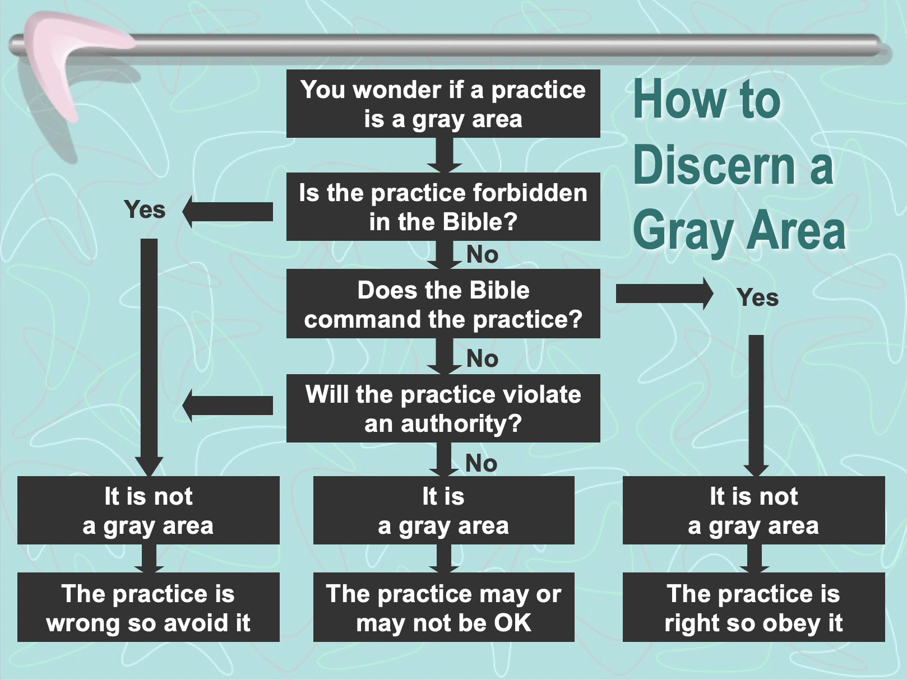
How to Handle Gray Areas in Yourself

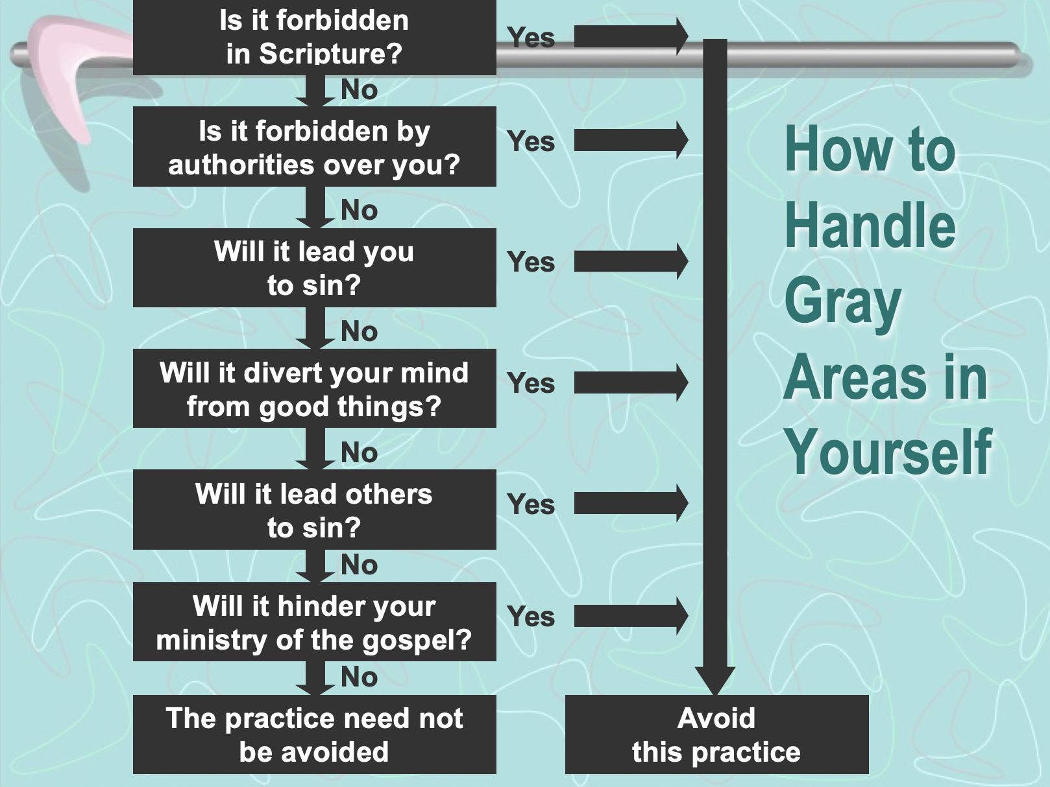
How to Handle Gray Areas in the Church

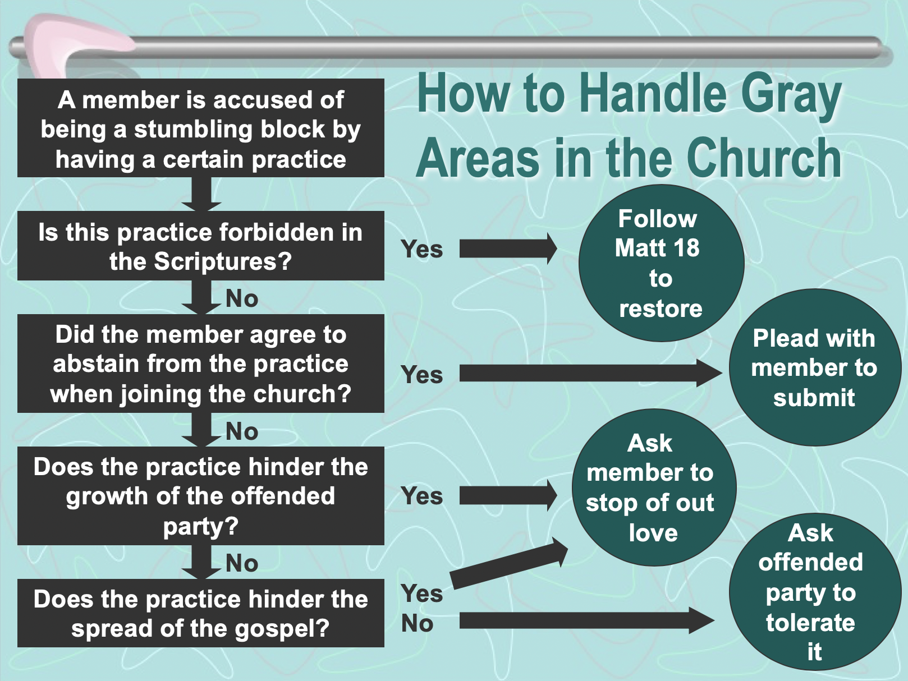
Examples of Potential Gray Areas (Rom. 14–15)

The gray areas noted in Romans 14–15 include sacred worship days (probably the Sabbath) and eating meat (see esp. 14:5-6). But these are only some of the issues that divide believers. Gray areas are defined as practices not forbidden in the Bible over which Christians disagree. Some believers therefore consider them sinful while others think them legitimate. The following is only a partial list, which varies from church to church and culture to culture:

Accepting gifts with the left hand
Celebrating Christmas
Celebrating Easter
Celebrating Good Friday
Celebrating Lent
Celebrating Palm Sunday
Changing one’s name to a “Christian” name
Chinese New Year giving of hong baos
Christmas trees in church sanctuary
Clapping in church services
Dancing (western, tribal, ballroom, frenzy)
Drinking beer
Drinking hard liquor
Drinking wine
Driving a motorcycle
Eating bloody foods
Eating food sacrificed to idols
Eating junk food
Eating meat
Eating only “Christian food” (whatever that is!)
Giving only “Christian” greetings (New Year)
Giving to non-religious causes
Having a gynecologist who performs abortions
Killing in war
Laughing with men and women together
Listening to rock music
Masturbation
Men wearing a beard or sideburns
Men with earrings
Men with long hair
Mothers working outside the home
Obesity & gluttony
Owning a Mercedes or BMW
Owning an executive flat
Playing cards
Playing golf on Sunday
Playing the drums in church
Playing the organ in church
Posting pictures of Jesus
Preaching past 12 noon
Preaching while sitting (not using a pulpit)
Preaching without a tie
Premarital kissing
Raising one hand in church
Raising two hands in church
Saturday night church services
Shaking hands women (Nepal, Cambodia)
Singing karaoke
Sitting with your spouse in church
Skipping church while on holiday
Skipping Sunday School at church
Smoking
Swimming with the opposite sex
Talking between men and women (Burmese)
Tithing
Using birth control
Using non-KJV translations
Voting for opposition political party candidates
Watching cable TV
Watching movies at church (esp. in worship)
Watching PG-rated movies
Watching violent movies
Wear native dress rather than western clothes
Wearing contact lens rather than glasses
Wearing sandals to church
Wearing shorts in church
Women C.E. director
Women pastors to women
Women song leaders in services
Women Sunday School superintendents
Women Sunday School teachers (adult level)
Women Sunday School teachers (primary)
Women going bra-less?
Women with epidural to reduce childbirth pain
Women wearing an Indian forehead dot
Women wearing a sari
Women not wearing a sari
Women wearing jewelry
Women wearing makeup and/or lipstick
Women wearing pants in church
Women with short hair
Working at an abortion facility
Working at a night club
Working at a tobacco company
Working on Sunday
Worship in a different language

Living Like Jesus, A Torah-Observant Jew
1 of 2
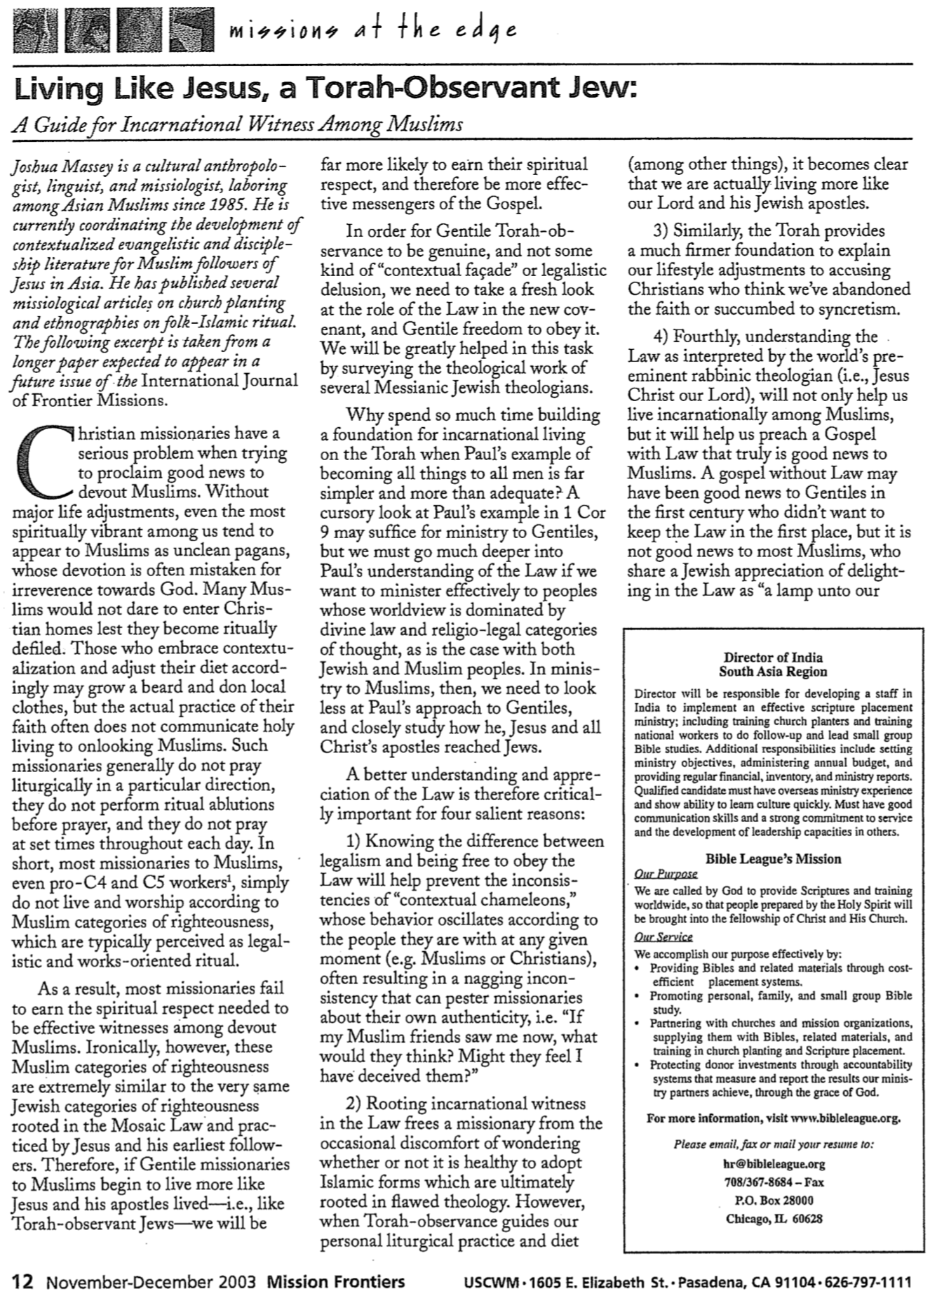

Living Like Jesus, A Torah-Observant Jew
2 of 2
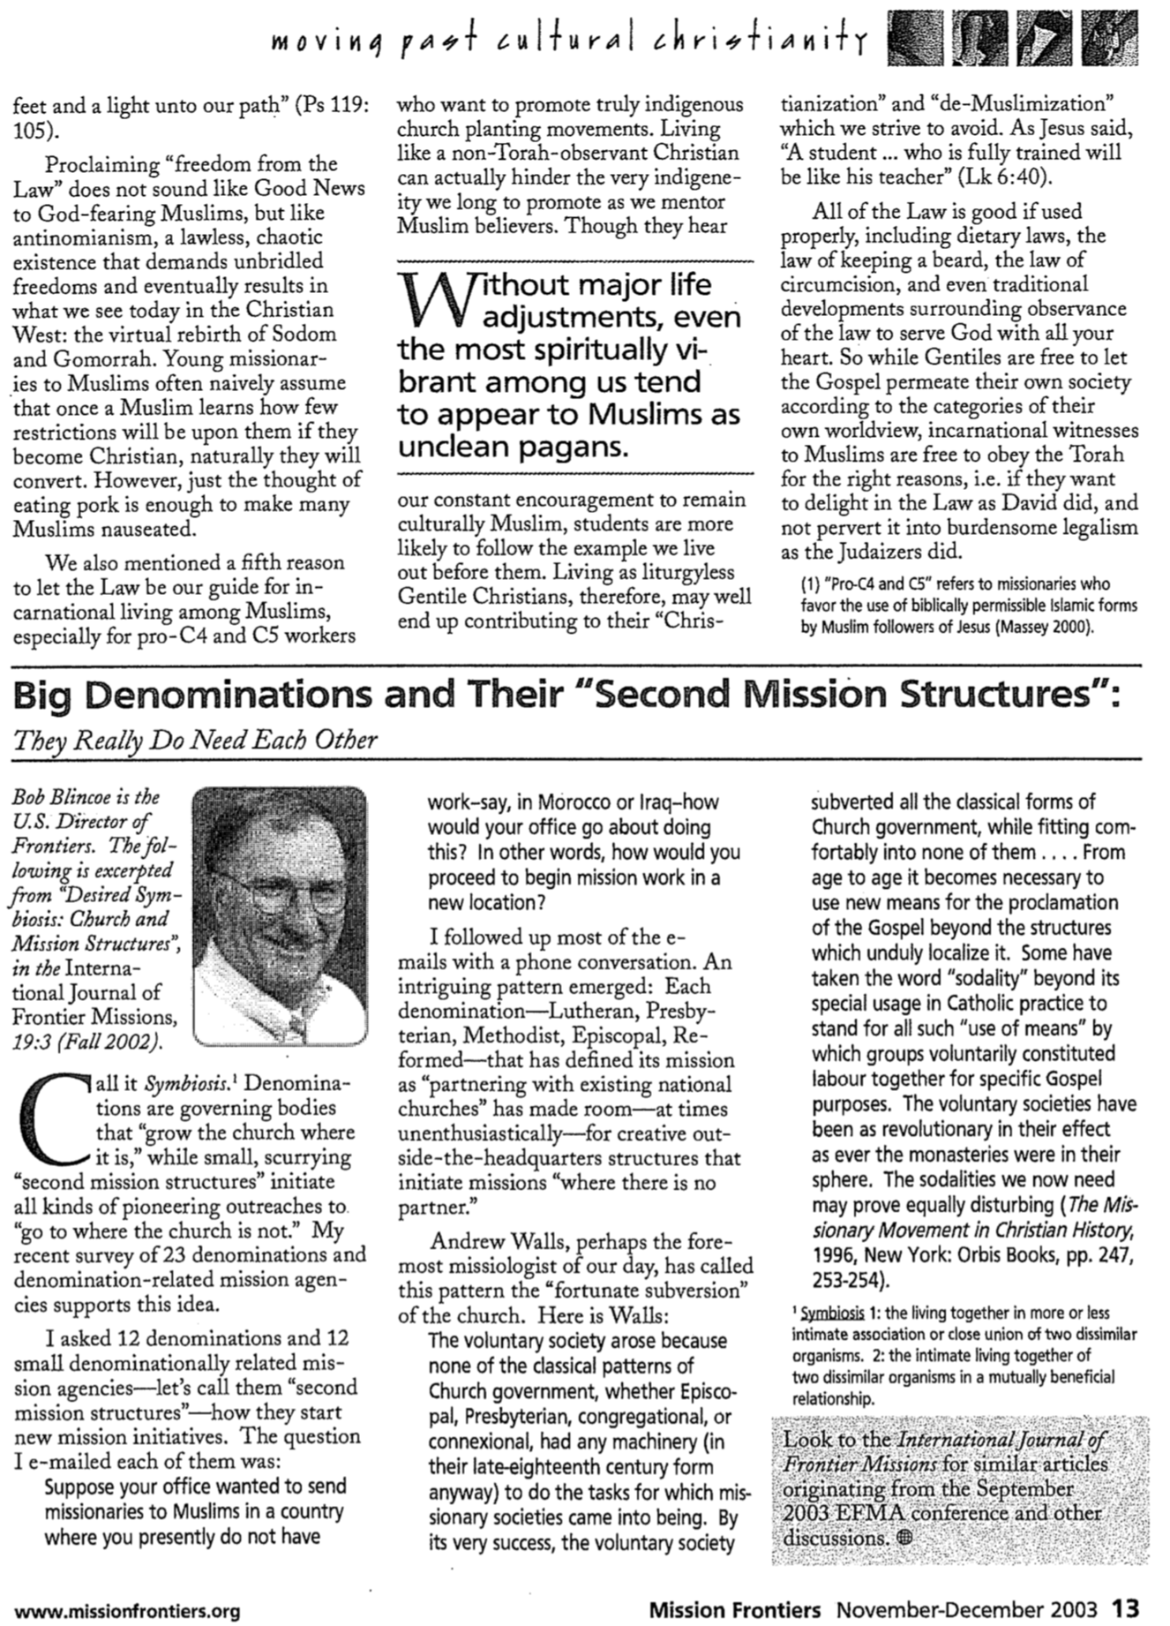
Name ________________________ Date ________________________

Spiritual Gifts Inventory

This inventory has been designed not to test your knowledge of spiritual gifts, but rather, your interest and experience in using your gift(s). Answer each of the following 90 questions according to the scale below. (Record your responses on scratch paper if you want to use this inventory again.) Do not answer what you would like to be true for yourself, but what is actually true for you. (Be honest!) Should a question ask if you enjoy doing something that you have never experienced, answer according to how much you think you would enjoy it. After you have finished, transfer your responses onto the Spiritual Gifts Inventory Worksheet to tabulate your scores. Do not record your responses directly onto the worksheet so that you will be able to take the inventory objectively.

0 1 2 3 4 5
Never Very Rarely Seldom Sometimes Usually Always
(or only once) (hardly ever) (infrequently) (occasionally) (often) (or almost always)

1. I feel motivated to study the Bible in order to give an orderly presentation of Scripture.
2. I enjoy giving a public testimony of how Christ changed my life.
3. I like to give of myself even when it causes me inconvenience if it will help other believers grow in their relationship with Christ.
4. I have a warm heart towards people and enjoy "coming alongside them" to encourage growth.
5. I desire to complete tasks and projects as quickly as possible.
6. I have joy in thanking God in advance while praying as if my request was already answered.
7. I delight in donating things to others in the body of Christ.
8. I enjoy helping with practical tasks that need to be done at church.
9. I enjoy going out of my way to help individuals in distress.
10. I am concerned about the accuracy of words in scriptural matters.
11. I feel I need to give people opportunity to become Christians after I share the gospel.
12. I like taking on the responsibility of nurturing new Christians in their spiritual growth.
13. I desire to visualize specific achievement and to design steps of action for others to develop a deeper commitment to Christ.
14. I find fulfillment in organizing people with various abilities in order to achieve a common goal.
15. I enjoy trusting God for goals even when external circumstances cause the accomplishment of these goals to appear humanly impossible.
16. I am very concerned that my financial investments in God's work be of high quality.
17. I like to volunteer for "behind the scenes" manual tasks such as cleaning, typing, ushering, etc.
18. I feel compelled to console a person who is embarrassed or who needs comfort.
19. I am interested in researching what the Bible says in order to discern the truth concerning what has been presented to me (I carefully evaluate what I'm taught).
20. I like to go where non-Christians often pass or congregate so that I may win them to Christ.
21. I enjoy going out of my way for new people at church in order to make them feel welcome.
22. I enjoy spending time with people who are eager to follow strategies to enable them to change a personal behavior pattern or to pursue a particular goal.
23. I delight in organizing people to accomplish projects (i.e., being used to "see all the pieces come together" and to see others enjoying the finished product).
24. I love to dream great dreams and tackle great tasks for God.
25. I enjoy contributing money or possessions in order to encourage others also to contribute.
0 1 2 3 4 5
Never Very Rarely Seldom Sometimes Usually Always
(or only once) (hardly ever) (infrequently) (occasionally) (often) (or almost always)

26. I can easily sense whether others really appreciate my help with projects.
27. Not only do I feel sympathetic with people experiencing physical discomfort, I have sympathy with those undergoing mental stress.
28. I find that I am willing to be criticized as stubborn or narrow-minded for sticking to God's Word when others' opinions differ from what I see the Bible saying.
29. I am concerned to use the proper approach when giving the gospel to different kinds of people.
30. When a fellow Christian strays from the Lord, I feel compassionate to help him return to Christ.
31. I love conversations which give me insights into how I can better meet people's spiritual needs.
32. I can endure criticism from people under my leadership in order to accomplish the ultimate task.
33. I love to persist in prayer until God miraculously changes circumstances (or until something is obviously not His will).
34. I am not greatly concerned that my donations will prevent me from having enough money, so I trust God by contributing sacrificially.
35. I like to avoid delegating those responsibilities that I think I may be able to do myself.
36. I prefer not to be a firm disciplinarian.
37. I find joy in harmonizing and arranging biblical content.
38. I enjoy encouraging and teaching other Christians how to be more effective in witnessing.
39. I want to know others well so I can most effectively guide them and meet their spiritual needs.
40. When encouraging others, I’m very concerned how that person responds to my efforts to help.
41. I desire to move on to a new challenge after fully completing the previous project.
42. Seeing my vision accomplished is more important to me than seeing details needed to achieve it.
43. I feel that Christians' offerings should be at least a tithe, but probably more.
44. I delight to assist others with everyday tasks to help them be more effective in their ministries.
45. I sympathize with others so much that I fail to confront them with truth when they need it.
46. I show ability at effectively communicating a spiritual truth that someone else shared with me.
47. I experience a great joy when leading someone to Christ.
48. My experience has shown that others look to me for guidance in their spiritual growth.
49. Believers come to me for Christian counsel because I can apply the Scriptures to their situations.
50. I have an ability to see the overall picture and clarify long-range goals.
51. Others say I have an unusual ability to rely on God's promises despite “impossible” situations.
52. I am "unusually generous" when donating to the Lord's work (i.e., compared to my income).
53. I get asked to assist in practical projects because I like to help and will "go the extra mile."
54. I am very understanding and sympathetic with those experiencing grief and affliction.
55. I have had others comment on how clearly I expound the Scriptures.
56. I find it natural and easy to invite others to commit themselves to Christ as Savior.
57. I can abhor a person's sin while at the same time lovingly accept that person as an individual.
58. I experience grief when teaching lacks practical application (e.g., specific steps of action).
59. I will delegate a responsibility if I can find someone else who can do it better.
60. I can discern projected plans for the future as to whether or not they may be God's will.
61. I have been one of the first to contribute to people who need food, clothing, or money.
62. I recall the likes and dislikes of others that enable me to effectively meet their practical needs.
63. I am able to remove hurts, renew hope and bring healing to others.
64. I continually test others’ preaching or teaching with what the Bible says about that subject.
65. I explain the gospel clearly (because I know it well) and confidently (I am bold).
0 1 2 3 4 5
Never Very Rarely Seldom Sometimes Usually Always
(or only once) (hardly ever) (infrequently) (occasionally) (often) (or almost always)

66. I am patient with believers who are making slow progress in their Christian growth.
67. I can easily apply God's truth to a person's circumstances so that he/she is encouraged.
68. I assume leadership in managing if no structured leadership exists, but I'm not domineering.
69. I find it easy to trust God even when others lack confidence in His workings.
70. I need to feel a part of the work to which I contribute financial support.
71. I am very alert to detect and meet small, unnoticed details that require attention.
72. I show much sensitivity to words and actions that may dishearten and hurt others.
73. I have a resistance to scriptural quotations used out of context.
74. Compared to most Christians, I experience unusual success in bringing others to know Christ.
75. I take responsibility to protect weak Christians from influences that may undermine their faith.
76. I can gently rebuke others without condemning or discouraging them.
77. I work well under pressure and get to the heart of the matter quickly to take decisive action.
78. Raising another's expectations that God will do the improbable is an ability that I exercise.
79. I experience great joy when my gift (money or possessions) was an answer to specific prayer.
80. I am easily overextended in helping with a variety of projects because it is difficult to say "no."
81. I naturally sense when others are hurting inside.
82. I tend to see how scriptural truths relate to one another as a whole.
83. I witness to strangers even though I know that I won't be able to follow them up.
84. I can easily express warmth to individuals even though I may not know them very well.
85. I find it easy to call forth the best in others (their potential).
86. I easily discern and employ the abilities and gifts of others to meet practical needs.
87. I have a unusual prayer capacity to tap into God's resources on behalf of others.
88. I can sense when certain appeals for money are not worthy appeals.
89. I get frustrated when time limitations are placed on what I have to do (like this inventory!).
90. I can cheerfully spend time consoling those who need a listening ear.
Name ________________________ Date ________________________

Spiritual Gifts Inventory Worksheet
Directions

1. Transfer your answers from the Spiritual Gifts Inventory onto the corresponding blanks below. Do not record your responses directly onto this sheet while answering the inventory questions because this will tend to make you more biased in your self-evaluation. The inventory had ten questions for each gift: five related to interest or preference (questions 1-45) and five related to experience or ability (questions 46-90).

2. Add up your scores in the vertical columns to determine a total score for each gift and put each sum on the blank in the Total Score line. The highest possible score for each gift is 50.

3. Rate each gift on the Gift Rating line by assigning the highest Total Score a rating of 1, the second highest a 2, etc. Give tied scores the same rating and go to the next highest score.

1 ____ 2 ____ 3 ____ 4 ____ 5 ____ 6 ____ 7 ____ 8 ____ 9 ____
10____ 11 ____ 12 ____ 13 ____ 14 ____ 15 ____ 16 ____ 17 ____ 18 ____
19 ____ 20 ____ 21 ____ 22 ____ 23 ____ 24 ____ 25 ____ 26 ____ 27 ____
28 ____ 29 ____ 30 ____ 31 ____ 32 ____ 33 ____ 34 ____ 35 ____ 36 ____
37 ____ 38 ____ 39 ____ 40 ____ 41 ____ 42 ____ 43 ____ 44 ____ 45 ____
46 ____ 47 ____ 48 ____ 49 ____ 50 ____ 51 ____ 52 ____ 53 ____ 54 ____
55 ____ 56 ____ 57 ____ 58 ____ 59 ____ 60 ____ 61 ____ 62 ____ 63 ____
64 ____ 65 ____ 66 ____ 67 ____ 68 ____ 69 ____ 70 ____ 71 ____ 72 ____
73 ____ 74 ____ 75 ____ 76 ____ 77 ____ 78 ____ 79 ____ 80 ____ 81 ____
82 ____ 83 ____ 84 ____ 85 ____ 86 ____ 87 ____ 88 ____ 89 ____ 90 ____
____ ____ ____ ____ ____ ____ ____ ____ ____ Total Score
____ ____ ____ ____ ____ ____ ____ ____ ____ Gift Rating

Teaching | Evang. | Pastor-Teacher | Exhort. | Admin. | Faith | Giving | Service | Mercy
–––––––––––– Speaking Gifts –––––––––– |  |  |  | –––––––––––––––––Serving Gifts–––––––––––––––––

Small Group Discussion Questions

1. What did the inventory show as your gift(s)? Did you score higher in speaking or serving gifts?

2. Do you agree with the inventory results? Do the others in your group agree?

3. What commitment will you make to the Lord to develop your gift(s)? Be specific concerning where and how you think it can be used. Be sure to share this with your small group.
Class ________________________ Date ________________________

Spiritual Gifts Inventory Group Record

Directions: After completing the Spiritual Gifts Inventory and the Spiritual Gifts Inventory Worksheet, please print your name and record your gift ratings for each gift below. Then circle those ratings of the gifts that you think may be your spiritual gifts.

 | Teaching | Evang. | Pastor-Teacher | Exhort. | Admin. | Faith | Giving | Service | Mercy
Example: Rick Griffith | 1 | 6 | 2 | 3 | 2 | 8 | 4 | 5 | 7
1
2
3
4
5
6
7
8
9
10
11
12
13
14
15
16
17
18
19
20
21
22
23
24
25
Total “1s” per column

Discussion Questions:

1. What does these inventory results indicate as our church’s strengths? weaknesses? Do you agree? Why or why not?

2. How is our church doing at seeing people’s gifts and plugging them into ministries they enjoy? (Or are we just desperate for any unqualified volunteer?) How can we improve here?

3. Do you feel cared for and useful in our church body? How? If not, what can we do?
Spiritual Gifts Inventory Explanatory Supplement

The Purpose of the Spiritual Gifts Inventory

The Spiritual Gifts Inventory is a self-diagnostic test that, if taken honestly, will fairly accurately measure strengths and weaknesses in relation to the spiritual gifts. It helps evaluate interests and preferences (questions 1-45) as well as experience and ability (questions 46-90). Each of the nine gifts receives a final score which has helped hundreds of believers to discern areas of strengths, either: (1) confirming what they already knew about themselves, or (2) pointing out "hidden" areas of interest and potential that should be developed. However, there are some limitations and cautions about the use of this inventory that are explained below.

The Limitations of the Spiritual Gifts Inventory

1) Single Indicator: This inventory really serves as only one possible indicator of what may be your spiritual gifts. Obviously, considering the opinions of others who know you well also has great value. You might want to have your spouse or close friend take the inventory evaluating you by simply replacing occurrences of the word "I" with your name, then compare your evaluation of yourself with the other person's evaluation of you. It might surprise you!

2) Easily Misinterpreted: Scripture clearly teaches that the Holy Spirit distributes the spiritual gifts (1 Cor. 12:7, 11, 18), so this inventory does not decide which gifts apply to you. Be careful not to automatically assume that the column with the highest total score indicates your gift. However, on the other hand, it does indicate that in comparison to the other gifts your strongest areas of ability and interest seem to be associated with that particular gift.

3) Pastor-Teacher Scoring: In that this gift is the only "dual gift" (half of which is tested under the questions for the teaching gift) only the "pastor" aspect of this gift is covered in the questions associated with this gift. One should look at scores for both teaching and pastor-teacher to obtain an accurate self-appraisal of the gift of pastor-teacher.

4) Subjective: One characteristic of all self-diagnostic tests is subjectivity, so this Inventory is influenced by certain variables that may distort the "actual picture." Some people are more critical of themselves than others (holding higher standards, especially in the area of their gift!). Others tend to read too much into each question. Also, if you recently experienced success in a particular area you will tend to rate yourself higher in that area. (The opposite applies to areas of recent failure where you may score lower than the "real you.") Taking the inventory at "non-emotional" or "non-transitional" periods will produce the most accurate results. Also, taking the inventory again after a time lapse may provide further confirmation of your score.

5) Trait Orientation: The Inventory measures only traits that are true of all of us to varying degrees. This has led some to erroneously think that they must have a "portion" of all of these gifts! However, mature Christians generally score higher on most gifts than new believers because they have had more experience in spiritual matters with a longer time to develop godly characteristics in several areas. This is why, for comparison purposes, only the "Gift Rating Row" (not the "Total Score Row") should be used when comparing scores with others. The Spiritual Gift Inventory certainly is not the perfect diagnostic tool; however, the application of good common sense and a prayerful heart will enable the inventory to help you be most effective for our Lord.
Questions to Help Discern Your Gifts

The following questions contrast various gifts to enable you to determine more accurately what may be your own gift(s). This should be especially helpful if you have already narrowed them down to a few. However, contrasting two gifts doesn't necessarily imply that you can't have both, or neither! For example, if you have no strong leaning towards one answer on a question below it may be that you possess both gifts! Hopefully, by seeing the various gifts contrasted you'll develop a better understanding of the nature of each gift.

Teaching or Evangelism
Which brings you a greater joy: instructing Christians in the Word of God (teaching) or imparting spiritual truth to non-believers to lead them to salvation in Christ (evangelism)?

Teaching or Exhortation*
Do you enjoy teaching in order to participate in research (teaching) or as an opportunity to counsel others (exhortation)?

On finding solutions to human problems, do you usually begin with Scripture and relate it to human experiences (teaching) or do you usually begin with human experiences and relate them to Scripture (exhortation)?

Evangelism or Exhortation
Which is a greater concern of yours as it relates to counseling: to counsel the lost in order to bring them to Christ (evangelism) or to counsel believers in order to stimulate them to obedience (exhortation)?

Pastor-Teacher or Teaching
Which is a stronger motivation for you in teaching the Scriptures: the privilege of being involved in accurately presenting truth (teaching) or the privilege of being used in "nourishing other's needs" through God's Word (pastor-teacher)?

Pastor-Teacher or Exhortation
Do you find it fairly easy to encourage those who seem to be making slow progress in their spiritual growth (pastor-teacher) or do you find this difficult and discouraging (exhortation)?

Exhortation or Administration*
When conflicts arise between two Christians for whom you are responsible, are you more inclined to change one's responsibilities to solve the problem (administration) or would you focus on changing the believer's attitude (exhortation)?

Administration or Showing Mercy*
Do you desire harmony in a group in order that it may run smoothly (administration) or because of the joy and fellowship that results in unity (showing mercy)?

Do you receive greater joy in being able to openly and freely discuss a problem (showing mercy) or in designing steps to solve the problem (administration)?

Administration or Service
When facing tasks are you more inclined to do the whole job yourself (service) or to enlist others to help you (administration)? Is delegation difficult (service) or easy (administration) for you?

Faith or Administration
In being involved in a great project for God, which would you enjoy more: providing the initial and sustained vision to see it completed (faith) or providing the leadership to coordinate the resources necessary to complete the task (administration)?

Giving or Service
What type of involvement appeals to you more in being used to see a project completed for the Lord: contributing of your material means for the project (giving) or contributing of your time and abilities to see the project accomplished (service)?

Service or Exhortation*
Do you enjoy counseling individuals in order to give them steps of action (exhortation) or in order to discern what their practical needs are so that you can meet their needs (service)?

Service or Showing Mercy*
Are you more comfortable in helping to meet the practical needs of others (service) or in meeting their mental and emotional needs (showing mercy)?

Showing Mercy or Teaching*
Are you motivated to do research in order to establish correct doctrine (teaching) or in order to understand doctrinal differences among Christians and how to bring harmony and oneness (showing mercy)?

Are you more concerned with the Scriptural pattern of a worship service (teaching) or with the atmosphere of a worship service (showing mercy)?

Showing Mercy or Exhortation*
Which emphasis is more important to you: spiritual healing or spiritual growth?

If the answer is spiritual healing: Are you interested in healing for the sake of preventing unnecessary suffering (showing mercy) or to challenge one on to spiritual maturity through healing (exhortation).

If the answer is spiritual growth: Are you interested in spiritual growth primarily that by growing spiritually one may eliminate suffering and disharmony caused by wrong responses (showing mercy) or primarily for the sake of that person's spiritual maturity (exhortation)?

Which is more important: that you can sense a genuine concern and interest in a person helping you (showing mercy) or that the person can give you steps of action in solving a problem (exhortation)?

When ministering to another's needs, do you generally encourage him/her regarding hurts from something that already occurred in the past (showing mercy) or do you encourage him/her in areas of growth looking primarily to the future (exhortation)?

* Adapted from the Institute in Basic Youth Conflicts by Bill Gothard, "Understanding Your Spiritual Gifts," 6-8.

Illustrations to Use in Sharing the Gospel

Love

Paternal (God loves us because we are made in His image): Do you have a son or daughter? Do you love him/her? Why? It’s because he’s part of your family, made in your image. Would you still love that child even if he/she did something wrong against your wishes? We, too, are originally part of God’s creation, made in his image. But even though we’ve turned away from him, He continues to reach out in love to us.

Sin

Rock (All fall short of God’s standards): Let’s suppose you and I were both to pick up a rock and try to throw it to China (or some other location mentioned in the conversation). Neither of us would reach the target because it is too far. Well, God is completely holy and perfect, so His target for us is perfection. None of us can claim to be without sin, so we all fall way short of His standard.

Three a day (All fall short of God’s standards): How bad are we in comparison to God’s standard of perfection? Let’s suppose you were a relatively good person who sinned only three times a day. This includes every bad thought, word, and action. This would amount to over 1000 sins a year. Multiply this by your age and you’ll see that you have fallen much short of God’s perfect standard!

Central Business District (We have no excuse for our sin): I once drove down to a hotel on Orchard Road at 6:15 PM. As I approached the road, I noticed that the big sign over the road said “Restricted Zone: In Progress.” However, it was too late to turn back and get a day pass. The police wrote down my car’s license number and three weeks later I received a ticket for $70. Even though I was sincere, even though I was ignorant of the sign until it was too late, even though I could offer other excuses, in the final analysis, I had no excuse.

Archery (All fall short of God’s standards): One definition of sin is an archery term that means to “miss the mark.” There’s a bullseye that is rarely hit. Morally speaking, God is perfect and always hits the “bullseye.” But we always fall short of His standards.

Non-swimmers (Man cannot save himself): Suppose a ship sank but none of the passengers in the water could swim. When each turned to his friend for help, what would happen? Of course, all would die, for they would all be in the same predicament. What if each one tried to save himself by pulling himself out of the water? Death would also result. In like manner, man cannot save himself spiritually. In fact, spiritually speaking, we’re all in the water together and drowning.

Death

Capital Punishment (Certain sins result in death)
In Singapore, the government has established various laws to punish those who sin. If one is caught with drugs in his possession at the airport, the law says that person must die. Why? To uphold standards for society. God’s standards are even higher than the government’s and He says that sin must result in death.

Wages (We have all earned death): Suppose you were to work for me for a day and I pay you $50. This would be your wages since it represents what you have earned. The Bible says that because of our sin, we have all earned death as our wage (Rom. 6:23).

Substitution

Book (Christ bore the weight of our sin upon Himself): Your sin weighs upon you just like this book weighs down my hand. But my other hand represents Jesus, and God desires to take this weight off of you to place it on Jesus (turn book over and place on other hand).

Cancer (Christ exchanges His goodness for our sin): Suppose you had cancer and through some medical means I was able to take your cancer cells into my own body in exchange for my good cells into your body. What would happen to me? Right, I would die. What would happen to you? Yes, you would live.

Kai (Christ gave His blood for us)
During the Vietnam War there was an orphanage located near an American Marine Base. One day the Viet Cong fired mortar shells into the orphanage, killing dozens of children and wounding many more. A boy name Kai had a seriously wounded friend who needed a blood transfusion. Kai’s friend had a rare blood type and only Kai’s blood matched it. Little Kai had never heard of a blood transfusion before but when the American doctors explained it would save his friend’s life, little Kai volunteered. As Kai’s blood began to flow to his friend, Kai began to whimper. When the doctors asked if it hurt, he said no. A little later he whimpered again. Again, he told the doctors it did not hurt. Finally, the doctors asked, “What’s wrong, Kai?” With tears coursing down his light brown, dusty cheeks, Kai asked, “When am I to die, sir, when am I to die?” You see, little Kai did not know that he was to give only a portion of his blood. He thought he would give it all, and he was willing to die for his little friend.

Snake (Christ took the cause of our death upon Himself): A poisonous snake once bit a little girl in her backyard. Seeing that the girl would be dead in just a few minutes, the girl’s mother cut her daughter’s leg and sucked out the venom. The girl lived, but the poison killed the mother, who in effect had died as her daughter’s substitute.

Drawbridge (People take for granted Christ’s death for them): A man once had a job to lower a drawbridge twice a day at 8:00 AM and 4:00 PM for people to take a train over a river to and from work. He had a young boy whom he loved very much that was too young for school so he often accompanied his father up to the switching station. They would often wave to the train passengers as the train passed by. One day at about 3:45 while the bridge was up the man lost track of the whereabouts of his son, who had wandered off. He looked for him panicking for several minutes but had to give up the search as the train was coming at full steam towards the raised drawbridge. He made it back to the switching house in time enough to lower the bridge, but just as he reached for the lever, he spotted his son, far down below him—in the midst of the gears! The father had to make a split-second decision—either to leave the bridge up and cause the train to hit the raised drawbridge and crash into the river, or to allow the gears to crush his only son to save the train passengers. With pools of tears in his eyes and great anguish in his heart he lowered the drawbridge, crushing his small boy in the powerful gears. The people on the train safely passed by as usual, unaware of the great cost to save their lives. Those of us on earth are aware of an even greater cost to save us—the precious Son of the Father—who was crushed for our sins. Yet we often act like the passengers and glibly cast aside the tremendous sacrifice on our behalf.

Judge (God balances his fairness with mercy): A judge once had a boy come before him for sentencing only to discover that the lad was his own son. In order to be fair to the law, he set the fine at the appropriate amount, but then did something quite unusual. Laying down his legal robes, he came down from the bench and paid the fine himself to the officer, thus satisfying the legal requirement while at the same time being gracious to the boy he loved. In like manner, Christ also saw our awful predicament in our disobedience, except in our case the penalty was much more severe—death itself. But Jesus laid aside his royal robes as God and came and paid that death penalty himself, thus satisfying the penalty and showing us his grace.

Siblings (Satisfaction for sin has been paid by Christ): Suppose you killed someone and ran away, then the dead person’s family members came looking for you for revenge. However, your brother/sister loves you very much and delivers himself/herself over to these people, who vent their anger by killing him/her. This would satisfy the anger of the relatives and save your life.

Soldier (Christ died for ungrateful, ungodly people): A promising, young, American lieutenant graduated from West Point Military Academy and soon found himself leading a group of recruits to fight the North Vietnamese in Vietnam. One night they confronted the enemy who wounded one of their men. The rest ran for cover in a trench where they stayed all night, listening to the groans of the dying, wounded soldier a few feet away. Finally, the lieutenant could not bear to hear the groans of his friend any longer and risked his life to save the man. He successfully pulled him back to the trench, but as he was about to hop in himself, he was shot in the back and killed instantly. Sometime later, back in the US, the brave lieutenant’s parents heard that the young soldier whom their own son had saved was in town. The surviving soldier came to their home late, drunk, using profanity and insensitive to the great cost given for his own life. After shutting the door behind the young soldier, the bereaved mother could only say, “I gave my own precious son to save that wretch of a man?” Likewise, the Father gave his precious Son, Jesus Christ, to save an ungrateful, profane, race like ours.

Gift

Birthday (Seeking to earn our salvation insults God): On your birthday people give you gifts, don’t they? Have you ever insisted upon paying for a gift? How do you think your friend or relative would feel if you did this? How do you think God feels when He offers us eternal life for free but we insist that we must pay for it (by our good works, baptism, church attendance, money, religious rituals, etc.)?

Pencil (The gift of salvation must be received to apply to us): I would like to give you this pencil for free (extend it to the person). If you pay me 10¢ or any price for it, it’s not a gift. If you work for me in any way it’s not a gift. It’s simply yours—you just need to receive it.

Faith

Jet (Christ is trustworthy): Let’s suppose I was employed by the ticket counter at an airport in a poor country to lead you to your jet to get you back to Singapore. I lead you to a jet that hadn’t been painted for years, had oil leaking out of the back, had part of a wing broken off, and had a hole in three of the windows? How would you feel? When you hesitate, I simply reply, “Oh, don’t worry. Just have faith and this jet will get you to Singapore!” The important thing isn’t the amount of your faith, it’s the condition of the jet!

Ice (Christ is trustworthy): If you walked out on a lake frozen over with ice 1 millimeter thick, what do you think would happen? Of course, you’d fall in! What if you really sincerely believed that the ice would hold you up? Yes, you’d still fall in! How about if the ice was 1 meter thick, would it hold you up? Even if you had very little faith that it would? You see, the issue is not how much faith you have, it’s what or whom you place your faith in! Many people are sincerely trusting “thin ice” to sustain them in this life and the next, but it won’t work. On the other hand, even if you place the little faith that you have in Christ, you place this trust in the right source. He’ll sustain you.

Chair (We all exercise faith every day): Have you ever personally met the designer of this chair? (Pause for an answer.) When you sat down on this chair you exercised faith.

Doctor (Faith can be placed in Christ because of His credentials): Once my wife got very sick and I took her to the hospital. When the doctor gave her some pills to take, she simply took them without asking any questions at all! Can you imagine that? She had never seen the man before, we had never been to this hospital before, and we didn’t know who made the pills or even their chemical composition! Why would she do such an outrageous thing as take a pill which, for all she knew, could have been poison? (Pause for an answer.) This was a simple act of faith in the credentials of one whom the hospital had deemed competent. As my wife found the doctor competent to meet her physical needs, I have found Jesus Christ competent to meet all of my spiritual needs.

Pilot (Faith can be placed in Christ because of His credentials): Have you ever taken a plane ride? Did you personally know the pilot of the jet? No, you exercised faith in this person to get you to your destination without ever knowing him.

Niagara (Biblical faith is a commitment—not simply intellectual assent): A famous tightrope walker once performed the greatest feat of his career by walking across Niagara Falls with only the aid of a balancing bar. The crowd was very enthusiastic! “Do you think I can do it without the balancing bar?” he asked in response. The crowd cheered him on, so he did it. “How many feel I can take a wheelbarrow across and back?” The crowd went wild again, “Yes! You can do it!” they yelled. So he went back and forth with a wheelbarrow. “Who believes I can do it again with a dog inside?” the tightrope walker shouted. “We do!” responded the crowd, so a dog was brought over, placed in the wheelbarrow, and the two made another successful trip. “Now who believes that I can do it with an even heavier load within the wheelbarrow—with the weight of a person inside?” he asked. By this time the crowd was ecstatic and going wild. “Any volunteers?” came the request. (Pause.) No one volunteered! They believed intellectually that he was able to take them across, but they were not committed to this belief. In like manner, many people intellectually believe Christ can take them to God but they are unwilling to commit themselves to that belief. Such belief without personal commitment is not genuine belief.

Circles (Biblical faith is a commitment—not simply intellectual assent): Two circles can be used to represent two kinds of life. Trusting Christ means being willing to turn your life over to Him to let Him direct your life. (See Four Spiritual Laws)

Douglas J. Moo, "Jesus and the Authority of the Mosaic Law," JSNT 20 (February 1984): 3-49; Roy L. Aldrich, "Causes for Confusion of Law and Grace," BS 116 (July-September 1959): 221-29; id., "Has the Mosaic Law Been Abolished?" 322-35; id., "The Mosaic Ten Commandments Compared to Their Restatements in the New Testament," BS 118 (July-September 1961): 251-58.
One may object to this reasoning based upon that fact that Paul used circumcision (in the so-called ceremonial law) rather than the Sabbath (in the so-called moral law), but Paul's teaching on the present applicability of the Ten Commandments is noted later in this discussion.
Douglas R. de Lacey, "The Sabbath/Sunday Question and the Law in the Pauline Corpus," in From Sabbath to Lord's Day: A Biblical, Historical, and Theological Investigation, ed. D. A. Carson, 159-95 (Grand Rapids: Zondervan, 1982), 166.
E. P. Sanders, Paul, the Law, and the Jewish People (Philadelphia: Fortress Press, 1983), 144.
This is certainly not to say that believers are now free to covet, for this is prohibited elsewhere in the New Testament (e.g., James 4:2). What Paul means is that the prohibition of coveting in the Decalogue revealed man's inability to follow God's commands.
Bernardin Schneider, "The Meaning of St. Paul's Antithesis 'The Letter and the Spirit,'" CBQ 15 (1953): 193-207.
Charles Hodge, A Commentary on 1 & 2 Corinthians, GCS, 428. See also Exodus 24:12; 31:18; 32:15-16 for other verses mentioning the tablets. Many argue that Paul's reference to "tablets of stone" serves as a figurative designation for the entire law or Old Covenant (e.g., Victor Paul Furnish, II Corinthians, AB, 200; Bultmann, 73-75; Frederick W. Danker, II Corinthians, ACNT, 54; Colin Kruse, The Second Epistle of the Paul to the Corinthians, TNTC, 91-93; Knofel Staton, Second Corinthians, SBS, 56-57). However, the passage compares in graphic terms the actual writing (content) on the cold, external tablets with that "written" on the warm, internal heart; thus, the comparison drawn is between the Decalogue and that which replaces it–the work of the Spirit in the inner man. However, even if the tablets represent the entire law (the Old Covenant is the implied contrast in verse 6 and specifically mentioned in verse 14), this still argues for the abolition of the Sabbath as part of that law.
De Lacey, "The Sabbath/Sunday Question and the Law in the Pauline Corpus," 167.
Ernest Best, Second Corinthians, Interp., 31.
Even Paul's statement that circumcision is nothing but rather what matters is "keeping the commandments of God" (1 Cor. 7:19) is inadequate proof that believers are to keep the Ten Commandments. There is no evidence that "commandments of God" refers exclusively or even primarily to the Decalogue (C. K. Barrett, 1 Corinthians, 169; de Lacey, "The Sabbath/Sunday Question and the Law in the Pauline Corpus," 176). Objection to the preceding presentation of Paul's view of the Decalogue may also be based upon his appeal to the fifth commandment in Ephesians 6:1-3. However, here the primary motive for children obeying their parents is not the Decalogue, but because this is part of one's calling in Christ (4:1) and is right (v. 1b). The appeal to the Ten Commandments is at best a third motivation (ibid., 176).
For an evaluation of the penalties for each of the Ten Commandments, see Aldrich, "The Mosaic Ten Commandments Compared to Their Restatements in the New Testament," 251-58. He shows how the believer is not under the Decalogue, but instead "he is under the eternal moral law of God which demands far more than the Ten Commandments. It calls for nothing less than conformity to the character of God" (p. 257).

