Jeremiah

Deserved Captivity & Undeserved Restoration

Jeremiah’s  Call | Judah’s  Judgment Deserved |  |  |  | Nations’  Judgment Deserved |  |  |  | Jerusalem’s  Fall
Chapter 1 | Chapters 2–45 |  |  |  | Chapters 46–51 |  |  |  | Chapter 52
Commission | Condemnation & Comfort |  |  |  | Condemnation |  |  |  | Captivity
Judgment Message but God’s Presence | Pre-Fall  2–38 | Fall  39 | Post-Fall  40–44 | Baruch  45 | South-west  46–47 | East  48:1–  49:22 | North  49:23-33 | North-east  49:34–  51:64 | Fall  52:1-30 | Rise  52:31-34
Prologue | Ministry |  |  |  |  |  |  |  | Epilogue
Judah |  |  |  |  | Nations |  |  |  | Babylon
c. 627-580 BC

Key Word: Inevitable

Key Verses: (Jeremiah to Judah) “…For the LORD our God has doomed us to perish and given us poisoned water to drink, because we have sinned against him” (Jeremiah 8:14b).

(God to Jeremiah) “See, today I appoint you over nations and kingdoms to uproot and tear down, to destroy and overthrow, to build and to plant” (Jeremiah 1:10).

Summary Statement:
The ways God comforted his people were by limiting Jerusalem’s deserved and inevitable fall to 70 years and promising restoration under a new covenant.

Application:
If we choose to continue in sin we’ll eventually come to the point where God’s discipline is inevitable (i.e., resisting repentance requires breaking before remaking).

Jeremiah

Introduction

I. Title The name Jeremiah (WhymryI yirmeyahu; BDB 941c 1) is difficult to determine in meaning as it may come from either of two roots meaning "cast, shoot" or possibly "loosen." Some say it has the connotation "Yahweh throws," perhaps in the sense of laying a foundation, or even "Yahweh establishes, appoints or sends" (TTTB, 198), but no one really knows.

II. Authorship

A. External Evidence: Daniel 9:2 calls Jeremiah 25:11-14; 29:10 a prophetic writing from Jeremiah's hand, as does the NT explicitly in Matthew 2:17-18 (31:15) and implicitly in Matthew 21:13; Mark 11:17; Luke 19:46 (7:11), Romans 11:27 (31:33) and Hebrews 8:8-13 (31:31-34), this last quote being the longest OT quote in the NT. The Talmud, Josephus, and Ecclesiasticus also affirm Jeremiah as author (TTTB, 198).

B. Internal Evidence: Despite the above external support, critical scholars continue to doubt Jeremiah's authorship on several internal grounds. However, the author is clearly designated as Jeremiah (1:1, 11) who was appointed to be a prophet by God before his birth (1:5) and officially called to the prophetic office as a youth (1:6f.). He was the son of Hilkiah, one of the priests at Anathoth in the territory of Benjamin (1:1; 11:21, 23; 29:27; 32:7-9), a village just over two miles (three kilometers) north of Jerusalem.

However, chapter 52 is nearly identical to 2 Kings 24:18–25:30 and the postscript (52:31-34) says Jehoiachin was released 37 years into his exile (ca. 560 BC) and lived at the king's table until his death. Assuming 645 BC for Jeremiah's birth would make him at least eighty-five when Jehoiachin was elevated (but no one knows how long Jehoiachin lived after this). It is likely that chapter 52 was recorded by the same author as the 2 Kings postscript under the direction of the Holy Spirit, especially since “the words of Jeremiah end here” (51:64).

III. Circumstances

A. Date: Jeremiah prophesied in the darkest days of Judah's history, starting in the thirteenth year of Josiah (627 BC; cf. 1:2) and extending past the fall of Judah (586 BC) to about 580 BC. Thus, his ministry spanned over four decades during the reigns of Josiah's four successors, the last kings of Judah (Jehoahaz, Jehoiakim, Jehoiachin, and Zedekiah). Most of his material, however, concerns events after Josiah's tragic death in 609 BC (LaSor, 404).

B. Recipients: The majority of the prophecy addresses Judah before the fall of Jerusalem, but some directs itself to the exiles following the fall (Jer 38–44, 52). One chapter (Jer 29) was sent to the exiles in Babylon before the fall of Jerusalem.

C. Occasion: Rule over Judah during Jeremiah’s time shifted hands from several powers:

1. Assyria: Since before 722 BC (nearly 100 years before Jeremiah’s birth) Assyria had been the foreign power dominating Jerusalem.

2. Babylon: In 612 BC Nineveh, Assyria’s capital, fell to Babylon, the rising power to the south. This meant Judah would be subject to Babylon.

3. Egypt: But Assyria-Babylon conflicts in the east gave Egypt control of Israel in the west. Pharaoh Neco killed Josiah of Judah in 609 BC, then his son Jehoahaz ruled three months. Neco then deposed him and replaced him with Jehoahaz's brother Jehoiakim.

4. Babylon: When Nebuchadnezzar of Babylon defeated Pharaoh Neco of Egypt at the Battle of Carchemish (605 BC), Jehoiakim switched allegiance from Egypt to Babylon.

5. Egypt: Then again only four years later (601 BC) Neco defeated Nebuchadnezzar and Jehoiakim switched his allegiance back to Egypt.

6. Babylon: Jehoiakim’s trust again in Egypt as the main power force was a fatal mistake. Within 3 years (597 BC) Nebuchadnezzar regrouped, successfully attacked Jerusalem and killed Jehoiakim. Nebuchadnezzar replaced him with his son Jehoiachin and 3 months later deported him to Babylon with 10,000 others, replacing him with his uncle Zedekiah as Judah's vassal king. Zedekiah's control was instable and defiant towards Babylon, which soon sieged Jerusalem, leading to the city's final fall in 586 BC.

Although Jeremiah preached over forty years, most of his prophecy (all except Jer 1–6, 11–12, 52) was delivered in this 22-year period (points #3-6 above; cf. p. Error! Bookmark not defined. chart) before Jerusalem’s fall (ca. 607-586 BC). At times he encouraged the people of Judah to repent, but after chapter 19 he indicated to Judah that God's warnings against the nation's sin would soon stop since the captivity was inevitable. Many of his sermons noted the people’s sins, showing that God was just in punishing the nation.

IV. Characteristics

A. Jeremiah communicated his messages through many symbolic acts, including a rotten waistband (Jer 13), his never marrying (Jer 16), a potter's clay (Jer 18), a broken jar (Jer 19), wearing a yoke (Jer 27), purchasing a field (Jer 32), hiding stones in the palace of Egypt (Jer 43), and throwing scrolls into a river (Jer 51).

B. Several literary types compose the prophecy: poetic discourse (e.g., Jer 30–31), prose discourse (e.g., Jer 32–33), and prose narrative (e.g., Jer 46–51).

C. The LXX (Greek) version of this book has a different arrangement and omits about one eighth (about 2700 words) of the original. The LXX omits 10:6-8; 27:19-22; 29:16-20; 33:14-26; 39:4-13; 52:2-3, 15, 28-30, etc. in comparison to the MT (Hebrew) that underlies the English translations. The LXX is therefore not recommended.

D. Jeremiah includes the key passage in the entire Bible on the New Covenant (31:31-34). The significance of this covenant can be seen in the following:

1. Definition: God’s unconditional amplification of the blessing promise in the Abrahamic Covenant in which Israel and Judah will experience national and spiritual redemption.
Four Unconditional Biblical Covenants

ABRAHAMIC
Genesis 12:1-3

LAND SEED BLESSING

LAND DAVIDIC NEW
Deuteronomy 30:1-10 2 Samuel 7:12-16 Jeremiah 31:31-34

Adapted from Robert P. Lightner, Last Days Handbook, 77
2. Provisions

a. Indwelling of the Holy Spirit (Jer. 31:33 with Ezek. 36:27)
b. New nature, heart, and mind (Jer. 31:33; Isa. 59:21) Fulfilled now
c. Forgiveness of sins (Jer. 31:34b)
d. Everyone will know the LORD (Jer. 31:34a) Fulfilled at
e. Israel and Judah will be reunited (Jer. 31:31) Second Coming

3. Unconditional Nature

a. Eternal (Jer. 31:36, 40; 32:40; 50:5; Isa. 61:2, 8-9; 24:5; Ezek. 37:26)

b. Amplification of the Abrahamic Covenant, which is unconditional

c. Unqualified “I will” statements of God (Jer. 31:31-34; Ezek. 16:60-62)

4. Time of Fulfillment

a. Partial fulfillment in the present church age: Three premillennial views have been given on how to correlate Jeremiah 31:31f. with various NT passages (Luke 22:20; 1 Cor. 11:25; 2 Cor. 3:6; Heb. 8:8; 9:15; cf. p. 489 for other views.)

1) Only one New Covenant for Israel (Darby)

2) Two New Covenants: one for Israel and one for the church (Chafer)

3) One New Covenant with a two-fold application: to the church now and to Israel in the future (Scofield)

b. Complete fulfillment in the future after return of Christ (amillennialists believe all of the provisions of the New Covenant are being realized now in the Church which they consider the “new Israel”)

E. Jeremiah edited his own material in a logical rather than chronological form (like Ezekiel). Therefore, dates of the prophecies repeatedly move from the reigns of earlier kings to later ones and back. Note this chart by Charles H. Dyer (“Jeremiah,” in The Bible Knowledge Commentary, 1:1126):

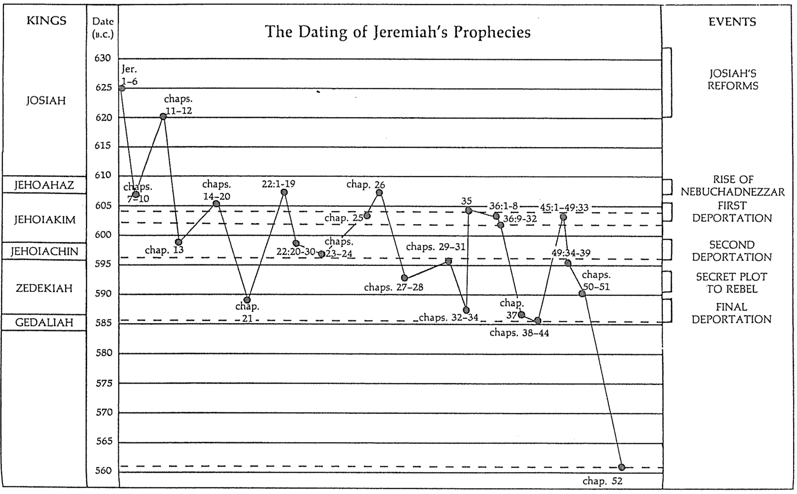

F. Jeremiah is the only prophet to specify the length of the exile as 70 years (25:11-12; 29:10).

G. Jeremiah alone chronicled the fall of Jerusalem twice in the same book (chapters 39, 52). He also wrote a poetic description in Lamentations on the same theme.

H. Jeremiah was the sole prophet in Judah who ministered through the fall of the southern kingdom. Thus he alone provides personal perspectives before, during, and after Jerusalem’s downfall.

- Jeremiah is the longest prophetic book in terms of the number of words.

Book | Chapters | Verses | Words
Psalms | 150 | 2461 | 43,743
Jeremiah | 52 | 1364 | 42,659
Ezekiel | 48 | 1273 | 39,407
Genesis | 50 | 1533 | 38,267
Isaiah | 66 | 1292 | 37,044

J. Jeremiah 31:31-34 is the longest OT quote in the NT (Heb. 8:8-13).

K. This prophet alone records how judgment for Judah was inevitable. In other words, the nation had gone so far in its sin that even if it repented, judgment would still come. This is seen in the book in several ways:

1. The people are encouraged to repent only up until chapter 19 (e.g., 15:19; 17:24; 18:8; cf. 5:3; 8:6). Yet after this point no exhortations to repent appear.

2. God told Jeremiah not even to pray for the people of Judah (11:14; 14:11).

3. Jeremiah told the people that each could individually have life instead of death if he/she would surrender to the Babylonians, but the destruction still would come on the nation as a whole (21:8-9; 24:1-10; 27:5-12, 16-17; 32:5; 38:17-23; 42:9-22; 52:24-27).

4. God specifying the length of the captivity at 70 years indicates that judgment was unavoidable (25:11-12; 29:10).

5. Jeremiah smashed a pot to illustrate that God’s decision to destroy the city was not retractable (19:1-2, 10-11).

6. Jeremiah instructed those already in exile to settle down (29:4-14) in contrast to the false prophet Hananiah, who said the exile would only last two years (28:1-3, 10-12). This shows that the “die was already cast” and even repentance of the people could not forestall God’s judging hand.

Argument

As already noted, Jeremiah's prophecies follow a thematic arrangement. This explains why the fall of Jerusalem appears twice in the book (Jer 39, 52). Following the introductory chapter that reveals Jeremiah's mission to proclaim God's judgment upon the nation (Jer 1), the material is arranged to prove the deserved judgment of Judah (Jer 2–45) and the nations (Jer 46–51). The final chapter (Jer 52) describes how God fulfilled His promise of judgment in the fall of Jerusalem but would soon return the people to their land. Throughout the prophecy Jeremiah lists the moral and spiritual causes for God's judgment balanced with His gracious promise of hope through restoration to the land under a new covenant. The goal is for Judah to receive God’s comfort despite receiving his disciplining hand.

Synthesis

Deserved captivity and undeserved restoration

1 Jeremiah’s call
1:1-3 Ministry at fall
1:4-10 Judgment and restoration
1:11-16 Branch and pot
1:17-19 God's presence

2–45 Judah’s deserved captivity
2–38 Pre-fall ministry
2–20 Reasons for judgment
2 Treatment of God
3–6 Spiritual adultery
7–10 Temple address (temple trust misguided)
11–12 Covenant sermon (Mosaic covenant replaced by idolatry)
13–20 Illustrations
13 Rotten waistband
14–15 Drought
16:1-9 Restrictions: singleness, no parties or funerals
16:10–17:18 *Restoration (excursus)
17:19-27 Sabbath disobedience
18–20 Pots
18 Potter
19 Broken pot
20 Pashhur #1 (evil)
21–29 Captivity unavoidable
21:1–23:8 Messiah replaces civil leaders—Pashhur #2 (righteous)
23:9-40 False prophets
24 Figs
25 70-year captivity
26–29 Opposition
26 Priests
27 Yoke
28 Hananiah (“Exile’s only 2 years!”)
29 Shemaiah (“Don’t believe Jeremiah”)
30–33 Book of Comfort (Undeserved restoration)
30–31 New Covenant (Israel/Judah reunited)
32 Field redemption
33 Restoration under Messiah
34–38 Siege messages
34–36 Contrasts
34 Zedekiah (evil)
35 Recabites (good)
36 Jehoiakim (evil)
37–38 Jeremiah's imprisonment
39 Fall ministry
40–44 Post-fall ministry
40–42 in Judah
43–44 in Egypt
45 Baruch's depression

46–51 Nations’ deserved judgment
46 Egypt
47 Philistia
48 Moab
49:1-6 Ammon
49:7-22 Edom
49:23-27 Damascus
49:28-33 Kedar/Hazor
49:34-39 Elam
50–51 Babylon

52 Fall of Jerusalem
52:1-30 Fall
52:31-34 Elevation (of Jehoiachin by Evil-Merodach)

Outline

Summary Statement for the Book
The ways God comforted his people were by limiting Jerusalem’s deserved and inevitable fall to 70 years and promising restoration under a new covenant.

The way God comforted his people was through Jeremiah’s prophetic call to proclaim judgment and restoration to the nation (Jer 1).

Jeremiah reveals himself as author and reveals that his ministry lasted over four decades from Josiah's thirteenth year (627 BC) to the exile (586 BC) (1:1-3).

God calls Jeremiah as a prophet to proclaim judgment and restoration to the nation (1:4-10).

God confirms Jeremiah's call to proclaim judgment through the signs of the blossoming almond branch and the boiling pot (1:11-16).

God assures Jeremiah of his presence to encourage him to speak God's entire message without fear (1:17-19).

The way God comforted his people was by speaking to them before, during, and after Jerusalem's fall that the exile would last only 70 years and result in a new covenant (Jer 2–45).

Prophecies before Jerusalem’s fall on God’s just judgment and the need to yield to Babylon’s 70-year exile before restoration under a new covenant are violently opposed (Jer 2–38).

God has just reasons to judge the nation so Judah cannot think its punishment is undeserved (Jer 2–20).

God indicts the nation for its sinful treatment of God seen in its ingratitude, idolatry, immorality, and irrationality (Jer 2; see esp. 2:10-11).

God calls the nation to repent from spiritual adultery to motivate the people to escape the impending judgment of the Babylonians (Jer 3–6).

God calls Israel to repentance from its spiritual adultery shown in its turning to other gods (3:1–4:4).

God foretells of the impending destruction from Babylon as a motivation for the people to repent (4:5–6:30).

Jeremiah's temple address aims to convince the people to turn from their false reliance on the temple and idolatry to avoid impending judgment (Jer 7–10).

Jeremiah preaches his temple sermon to convince the people that the temple’s presence cannot prevent God's judgment on their false worship (7:1–8:3).

God details the coming judgment for the nation's idolatry to cause the people to repent from their false worship (8:4–10:25).

God describes the coming judgment as imminent and terrible so that the people would lament like Jeremiah does (8:4–9:26).

God’s description of the coming judgment as imminent and terrible enables the people to see his perspective (8:4-17).

Jeremiah’s lament models the kind of repentant response God desires of the entire nation (8:18–9:2).

God again describes the horrible nature of and justified reasons for the coming catastrophe (9:3-26).

God proclaims that the judgment will come upon the nation for its idolatry and Jeremiah requests judgment on the other nations also (Jer 10).

Jeremiah delivers his covenant sermon detailing how Judah violated God's statutes and the consequences of violating the covenant (Jer 11–12).

Jeremiah delivers his covenant sermon that proclaims that Judah violated God's statutes through its idolatry (11:1-17).

The men of Anathoth, Jeremiah's home town, plot against his life because they do not want to listen to the violations of the covenant (11:18-23).

Jeremiah complains about the prosperity of the wicked and God says that worse events are coming, but the destruction will bring Judah to repent (Jer 12).

God uses various illustrations of Judah’s judgment to graphically portray the severity of Judah’s sin and his response (Jer 13–20).

A rotten waistband and a proverb about drunkenness depict how useless the nation has become to God (Jer 13).

Jeremiah identifies with Judah during God's judgment of drought (Jer 14–15).

God restricts Jeremiah to singleness and prohibits attendance at funerals or parties to illustrate his judgment coming upon the land (16:1-9).

Excursus (16:10–17:18): God promises restoration after Judah experiences the consequences of its sin and Jeremiah expresses his trust in Yahweh.

Jeremiah rebukes the Sabbath disobedience shown in carrying loads on this day that signifies the covenant (17:19-27).

Jeremiah announces God's sovereign decision to destroy Judah using the imagery of pots and Pashhur persecutes him as a result (Jer 18–20).

God is sovereign like a potter with clay (Jer 18).

God will destroy Judah like a broken pot (Jer 19).

The priest Pashhur persecutes Jeremiah because he compares the judgment of Judah to the broken pot, then Jeremiah laments to God (Jer 20).

An unavoidable 70-year captivity should encourage the people to submit to Babylon but receives stiff opposition (Jer 21–29).

Jeremiah prophesies judgments against Judah's kings and leaders but promises that the Messiah will come to lead the nation justly (21:1–23:8).

Jeremiah tells the priests to tell Zedekiah that he will be judged and God will reject his request to save them from the Babylonian siege (21:1–22:9).

Shallum (Jehoahaz) will be judged through his death in exile (22:10-12).

Jehoiakim will be judged through a terrible death without burial (22:13-23).

Coniah (Jehoiachin) will be judged by not having any of his immediate descendants sit upon the throne (22:24-30).

Godless leaders will be replaced with ones who genuinely care for the people, the Messiah (Righteous Branch) being the preeminent leader (23:1-8).

Jeremiah prophesies destruction on Judah's false prophets who claim that God sent them to prophesy safety on the unrepentant land (23:9-40).

Baskets of good and bad figs denote Jews exiled or who die in the land to exhort Judah to submit to Babylon despite Jeconiah’s deportation (Jer 24; 597 BC).

Jeremiah predicts seventy years of captivity (605-536 BC) to let the people know that while God will punish Judah it will not be permanent (Jer 25).

Jerusalem’s leaders reject Jeremiah and lead to captivity as unavoidable (Jer 26–29).

Priests and false prophets oppose Jeremiah in his second temple sermon but others save him, in contrast to Uriah prophesying and dying for his false prophecies (Jer 26).

The genealogy of Shaphan (26:24) below depicts how his sons righteously stood for the truth in various ways (except the youngest, who rebelled against his father’s values).

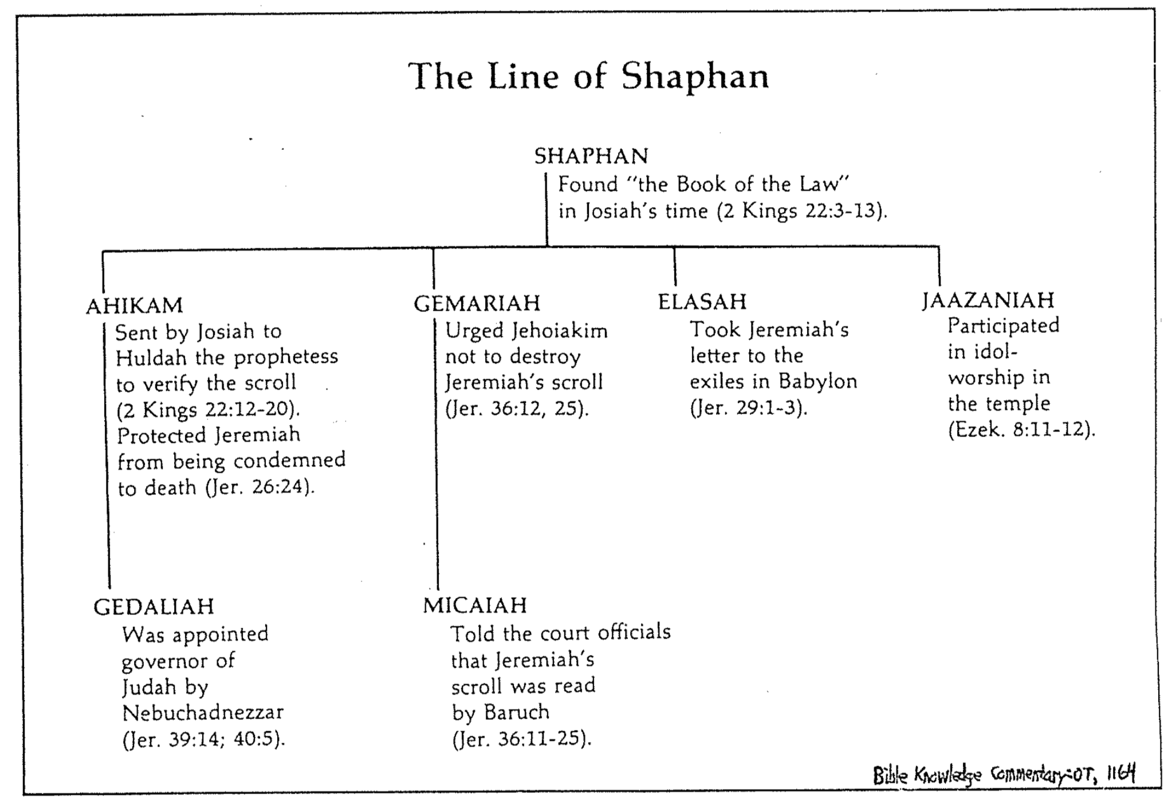

Jeremiah uses a yoke to convince the people of Judah and the nations to submit to Babylon (Jer 27).

The false prophet Hananiah opposes Jeremiah by claiming that the captivity will last only two years but he dies only two months later (Jer 28).

The false prophet Shemaiah opposes Jeremiah's open letter to the exiles that tells them to unpack their bags for a long stay but God promises to judge him (Jer 29).

Israel’s future restoration with a new covenant (The Book of Comfort) should encourage the remnant that God has not forgotten his promises (Jer 30–33).

Israel and Judah will be reunited in the land with a new heart under a new covenant [after Messiah’s second coming] (Jer 30–31).

Jeremiah buys a field to comfort the people that they will return to the land (Jer 32).

Jeremiah prophesies restoration of the people, land, and Davidic line under Messiah who will sit on the throne (Jer 33).

Final messages warn against disobedience while Jerusalem is under siege lead to Jeremiah being imprisoned instead (Jer 34–38).

The disobedience of Zedekiah and Jehoiakim is contrasted with Recabite obedience to convince the people to obey God in surrender to Babylon (Jer 34–36).

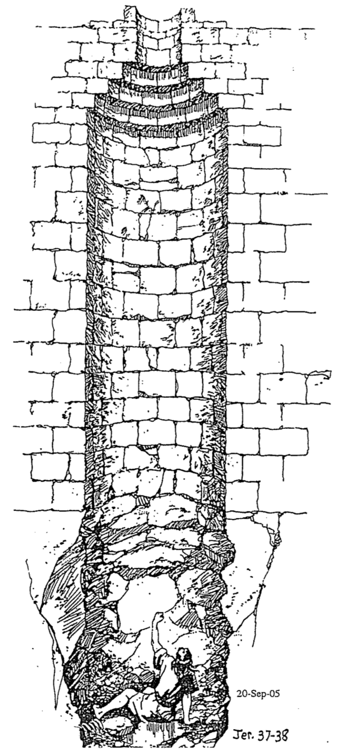
Zedekiah frees Jewish slaves in supposed repentance but takes them back (Jer 34).

The Recabite abstinence exemplifies for the people that obeying leads to blessing (Jer 35).

Jehoiakim burns Jeremiah's scroll in disdain for God's word, but Jeremiah rewrites an expanded prophecy to show how God's word cannot be thwarted (Jer 36).

Jeremiah suffers in a dungeon and cistern for faithfully proclaiming God's message of judgment (Jer 37–38).

God fulfills his threat to destroy Jerusalem, but Ebed-Melech, God's foreign servant, is spared for protecting Jeremiah (cf. 38:7-13), showing the profits of obedience (Jer 39).

Jeremiah need not go to Babylon so he ministers to the remnants in Judah and Egypt, showing God’s blessing on his faithfulness (Jer 40–44).

Jeremiah exhorts the remnant in Judah after the slaughter of Gedaliah to remain in the land under Babylon's rule, and not go to Egypt (Jer 40–42).

Jeremiah rebukes the remnant in Egypt who disobeyed God's command by fleeing Israel, warning against falsely claiming to want God’s will (Jer 43–44).

An incident 20 years before, when Jeremiah encouraged Baruch in his depression over Jehoiakim's burning of the scroll shows that God sovereignly kept his promise to save his life (Jer 45).

The way God comforted his people was by judging nations that persecuted Judah (Jer 46–51).

The title introduces chapters 46–51 as oracles against nations that persecuted Judah (46:1).

God prophesies judgment against Egypt at Carchemish and within its own borders as a testimony to Judah that God will regather her from exile (46:2-28).

God prophesies judgment against Egypt at Carchemish [fulfilled in 605 BC] (46:2-12).

God prophesies judgment against Egypt to occur within its own borders in an invasion and exile (46:13-26).

God encourages Judah that he will regather the nation from exile even if all nations are destroyed (46:27-28).

God prophesies judgment against Philistia to encourage Judah that its enemies will be punished also (Jer 47).

God prophesies Moab's judgment to encourage Judah that its enemies will be punished also (Jer 48).

God prophesies Ammon's judgment to encourage Judah that its enemies will be punished also (49:1-6).

God prophesies Edom's judgment to encourage Judah that its enemies will be punished also (49:7-22).

God prophesies Damascus' judgment to encourage Judah that its enemies will be punished also (49:23-27).

God prophesies Kedar and Hazor's judgment to encourage Judah that its enemies will be punished also (49:28-33).

God prophesies Elam's judgment to encourage Judah that its enemies will be punished also (49:34-39).

God prophesies Babylon's judgment to encourage Judah that its enemies will be punished also [key verse is 51:49] (Jer 50–51).

The way God comforted his people was by balancing Jerusalem’s fall with Jehoiachin’s elevation to reassure the exiles that they too would soon be elevated in a return to the land (Jer 52).

The fall of Jerusalem is detailed as a declaration of God's faithfulness to fulfill his promise of judgment upon his unrepentant people (52:1-30).

Evil-Merodach's elevation of Jehoiachin encourages the exiles that they too would soon be elevated in a return to the land, to show God's mercy and faithfulness to his promise (52:31-34).
The Man Jeremiah
Wilmington’s Guide to the Bible, 204

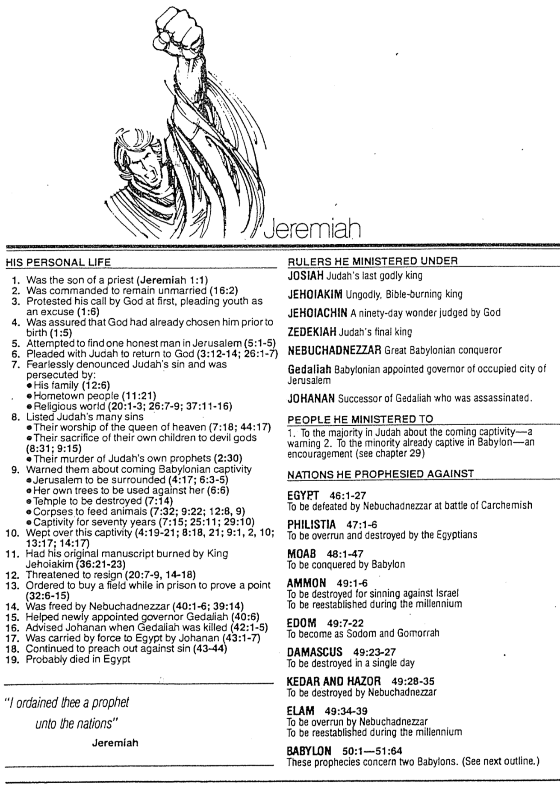
Structure of Jeremiah
Homer Heater, Jr.

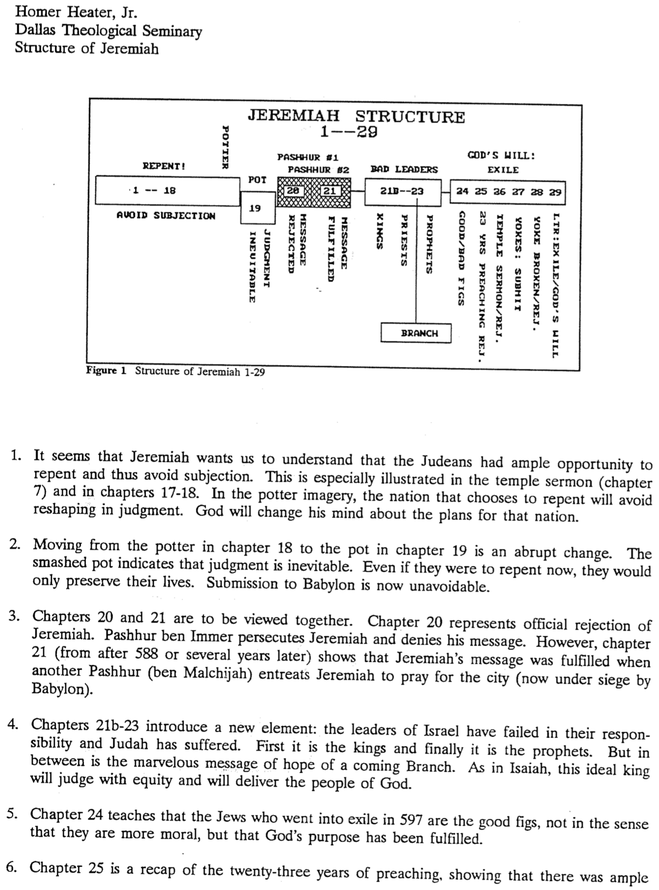
Structure of Jeremiah 2 of 4

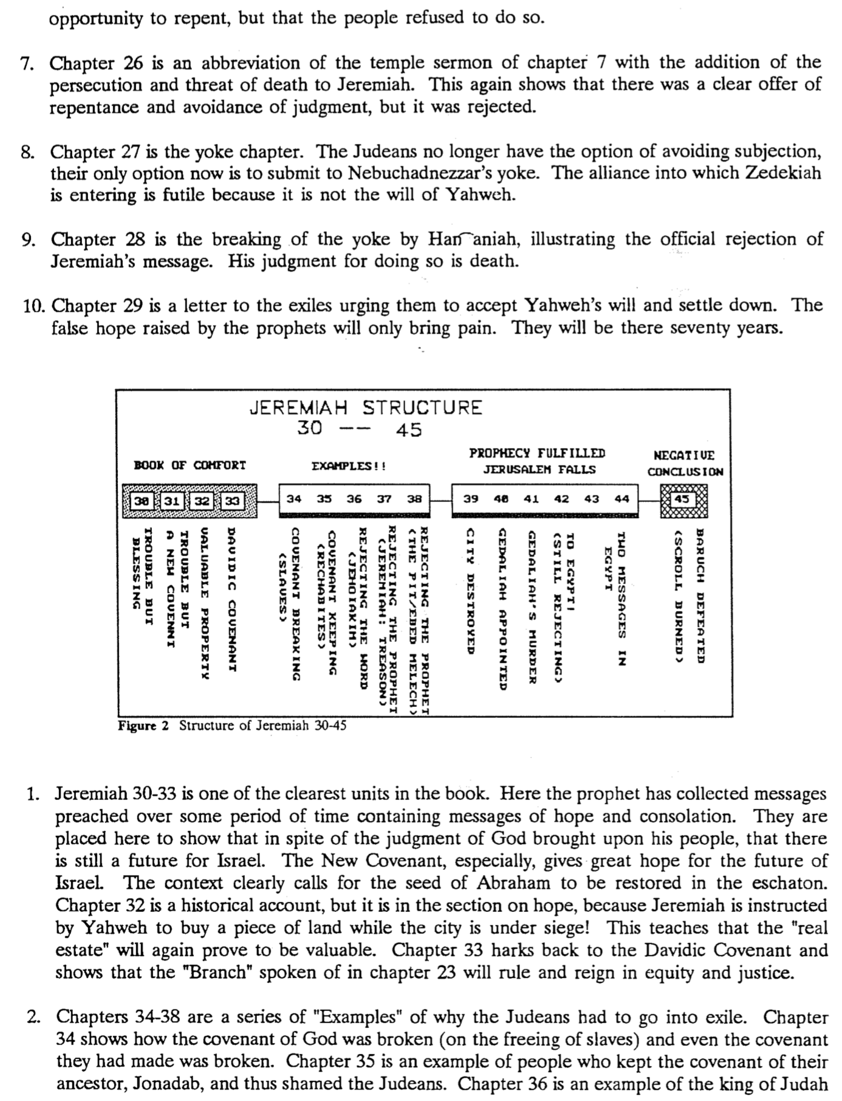
Structure of Jeremiah 3 of 4

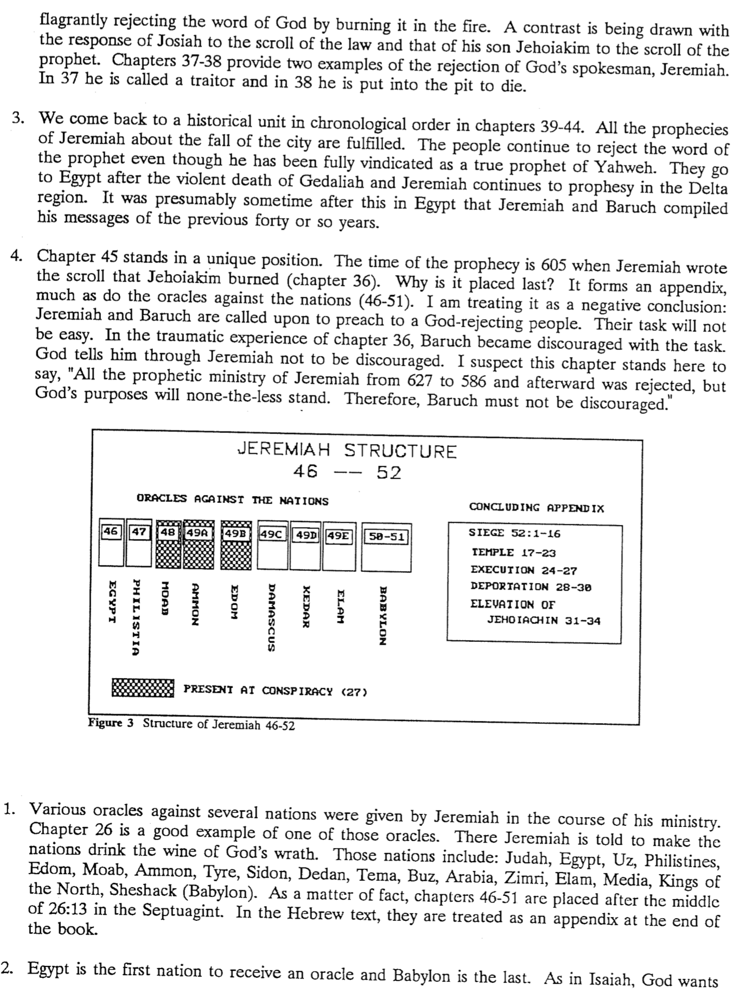
Structure of Jeremiah 4 of 4

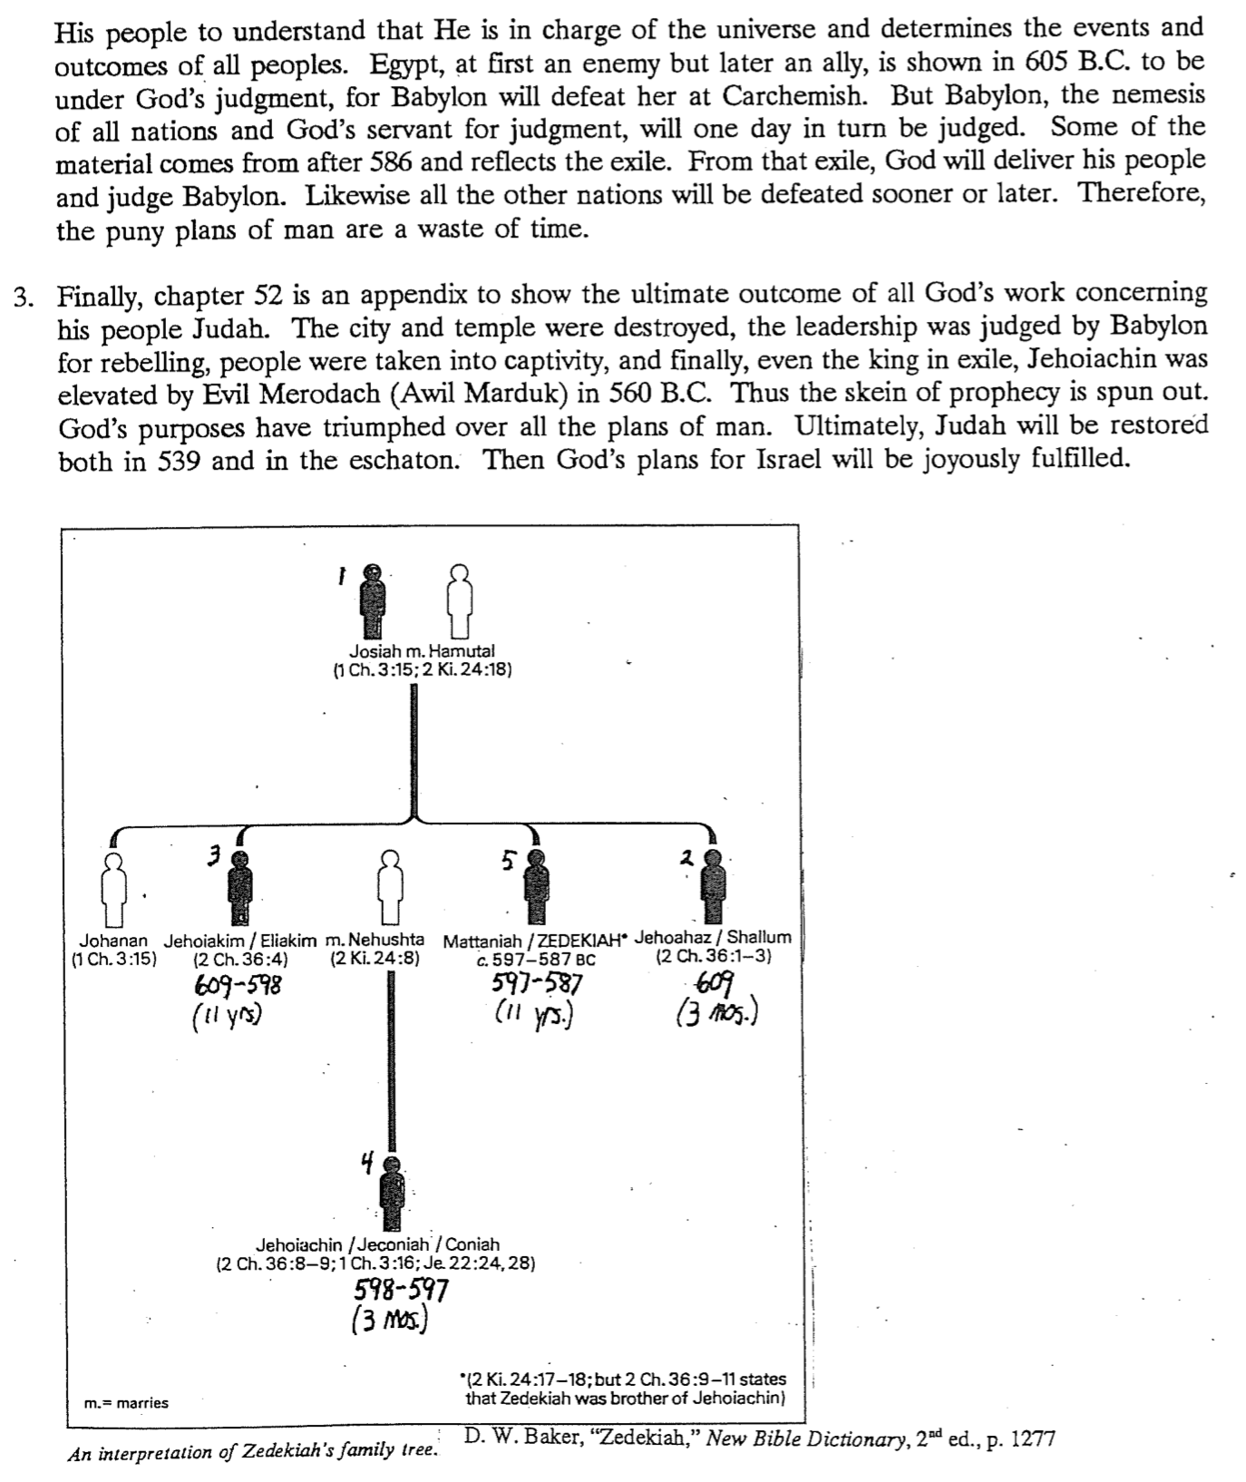

Covenant Conditions
Adapted from John F. Walvoord, “The New Covenant,” in Integrity of Heart, Skillfulness of Hands, eds. Dyer & Zuck (Baker, 1994), 186-200

Covenant |  | God’s Part |  | Man’s Part
Edenic  Gen. 1:26-31; 2:16-17 | - Gave man rule over all creatures  - Commanded man to be fruitful  - Permitted man to eat green plants |  | - Adam and Eve could not eat from the tree of the knowledge of good and evil
Adamic  Gen. 3:14-19 | - Judged Satan (3:14-15)  - Judged Adam & Eve (3:16-19)  - Cursed ground (3:17-19)  - Promised Redeemer (3:15) |  | - RESULTS (not conditions)  - Difficult to find food (3:17-19)  - Sorrow & death (3:19)
Noahic  Gen. 6:18;  9:9-16 | - Instructions on ark  - Promised no more worldwide floods  - Invented rainbow (9:13) |  | - RESULTS (not conditions)  - Noah got drunk but covenant still unconditional (9:20-23)  - Assumed that Noah would build ark
Abrahamic  Gen. 12:1-3 | - Made Abram great (12:2b)  - Made Israel great from Abram (12:2a)  - Blesses all [believing] peoples through him (12:3b)  - Will give land eternally (Gen. 12:7; 17:8; Jer. 23:5-8; 31:4-11; 35-37; Ezek. 20:33-38; 47–48) |  | - Abram left Ur (a condition?)  - Man must bless Israel as persecutors are always judged (12:3a)  - Circumcision is the sign (Gen. 17)  - Land possession conditioned on obedience (Deut. 28; 30:1-10) but the covenant is unconditional as its ultimate fulfillment is certain
Mosaic  Exod. 20;  Lev. 26;  Deut. 28 | - Imposed this works covenant on Israel (not on any other nation)  - Warned of blessings & cursings  - Set standards for temporal blessing (not eternal salvation) |  | - “Be holy, because I, the LORD your God, am holy” (Lev. 19:2)  - Obey covenant stipulations such as Ten Commandments (Exod. 20)
Davidic  2 Sam. 7:12-17;  1 Chron. 17:10b-14; Ps. 89 | - Promised far beyond what David deserved (thus unconditional)  - Descendent will rule Israel forever (7:13, 16)  - Never will rescind the covenant (7:15-16)  - Will fulfill at Israel’s regathering (Ps. 72; Jer. 23:5-8; Ezek. 39:25-29; Jer. 30:5-9) |  | - Accept divine discipline for sin (7:14), which would interrupt the line of kings by disobeying the Mosaic covenant (Ps. 132:11-12)  - The covenant applies only to David’s descendants and thus is limited in scope (not for all people not even for all Israel directly, though indirectly all will be blessed in Christ’s reign)
New  Jer. 31:31-37;  Isa. 61:8-9;  Jer. 32:27-41;  Ezek. 37:1-22 | - Will make it with Israel and Judah (31:31)  - Will make it unlike Mosaic law  - Write His laws on hearts (31:33)  - Promises that all on earth will know Him (31:34a)  - Will forgive and forget Israel’s sins (31:34b)  - Unconditional promise for Israel to be a nation forever (31:35-37) |  | - The new covenant is by grace through faith in Christ (Rom. 3:21-24) and not works (Eph. 2:8-10) to bring redemption (Eph. 2:4-7) so no conditions are given beyond faith  - The sign of this covenant is the cup of the Lord’s Supper (Luke 22:20), which believers are commanded to take (1 Cor. 11:24-25)

Signs of the Covenants

God made many covenants with man over the ages. He has also attached a sign or memorial with each one to function as a reminder of his and/or our responsibilities to keep these covenants.

Covenant | Definition | Promise | Fulfillment | Sign
Noahic | Unconditional promise not to flood the earth again | Gen. 9:12-17 | No more sea  (Rev. 21:1) | Rainbow  (Gen. 9:12-17)
Abrahamic | Promise to provide Israel a land, rule, and spiritual blessing | Gen. 12:1-3; 15:13-18 | Continues at present (Gal. 3:17) but Israel still has a future (see Rom. 11:25-27) | Circumcision  (Gen. 17:11)
Mosaic | Conditional stipulations for blessing on Israel | Exod. 19–31; Deut. 28 | Death of Christ (Rom. 7:4-6) | Sabbath  (Exod. 31:13)
Land | Promise of physical land from the Wadi of Egypt to the River Euphrates | Deut. 30:1-10 | Land blessed (Amos 9:13-15) | Israel’s partial restoration to the land in unbelief (Ezek. 37:8, 21)
Davidic | Promise of eternal,  political rule of a descendant of David | 2 Sam. 7:12-17 | Rule renewed (Amos 9:11-12) | Christ seated at the right hand of the Father (Acts 2:34-36)
New | Promise of spiritual indwelling of the Spirit (“law written on hearts”), forgiveness, and total evangelization of Israel | Jer. 31:31-34 | Paul & the Apostles (2 Cor. 3–4)  All Israel saved (Rom. 11:26-27) | Cup of the Lord’s Supper (Luke 21:20; 1 Cor. 11:25)

Views on the New Covenant

Issue: How can the OT and NT data on the New Covenant be reconciled? Jeremiah 31 declares it is for Israel and Judah but the NT (Luke 22:20; 1 Cor. 11:25; 2 Cor. 3:6; Heb. 8:8; 9:15) apply it to the church. Is there actually no New Covenant, is it only for Israel or only for the church, or are there two New Covenants, or does the church participate in some of its aspects while awaiting the final fulfillment of the covenant? This study takes the last view, as do most modern premillennialists.

View Explanation School/Scholars Problems

Restated No New Critical 1. OC/NC distinctions in text ignored
Mosaic Covenant -Couturier 2. OC=conditional, NC=unconditional
-Duhm 3. OC=temporal, NC=eternal
-Schmidt 4. OC=external, NC=internal
-Potter 5. OC=no enablement, NC=enablement
6. NC=peace, prosperity, sanctuary, Spirit (parallel passages)

Church No Israel Amillennial/ 1. Ignores OT data by equating
Alone Participation Postmillennial Israel and the Church
-Allis 2. NC introduced≠fulfilled to Israel
-Cox 3. Present need to know YHWH
-Smick (need for Great Commission)
-Boettner 4. AD 70 Jerusalem vs. Jer. 31:40

Israel No Church Misc/Classical 1. Ignores NT data
Alone Participation Dispensational -Christ's Last Supper words
-Darby -Paul's statements
-Thompson -Hebrews application to Church
-von Rad 2. Ignores present work of Spirit

Two NC for Israel Early 1900s 1. Same terminology for OT & NT NCs
New NC for Church Dispensational 2. Israel/Church distinction too sharp
Covenants -Chafer 3. Basis of forgiveness the same
-Walvoord (old) 4. If 2 NCs then no OC for Church
-Ryrie (old) 5. Church doesn’t possess Israel's
promises

Church Primarily Misc/Present Support:
Partici- for Israel Dispensational 1. Primary fulfillment future–Rom 11
pation Secondarily -Keil 2. Deals with both OT & NT data
for Church -Lemke 3. Forgiveness/Spirit=blessings now
-Bright 4. NC has new law
-Scofield 5. Rebuttals to above views
-Walvoord (DTS)
-Ryrie (DTS)
-Archer (TEDS)
-Kaiser (TEDS)
-Feinberg (Talbot)
-Thiessen (Talbot)

Journal Articles on the Covenants

The New Testament builds upon the Old Testament teaching on the OT covenants but also presents some difficulties, especially concerning the role these covenants play in the church. The following articles from evangelical theological journals attempt to reconcile these difficulties.

NEW COVENANT

Decker, Rodney J. "The Church's Relationship to the New Covenant" (2 pts.) Bibliotheca Sacra 152 (July-Sept 1995): 290-305; 152 (Oct-Dec 1995): 431-56.

Kaiser, Walter C. "The Old Promise and the New Covenant," JETS 15 (Winter 1972): 11-23.

Kent, Homer A., Jr. "The New Covenant and the Church," Grace Theological Journal 6 (Fall 1985): 289-98.

Wallis, Wilber B. "Irony in Jeremiah's Prophecy of a New Covenant," JETS 12 (Spring 1969): 107-110.

DAVIDIC COVENANT

Rogers, Cleon L., Jr. "The Covenant of David in the New Testament" (2 pts.), "The Davidic Covenant in the Gospels," Bibliotheca Sacra 150 (Oct-Dec 1993): 458-78.

_____________ . "The Davidic Covenant in Acts-Revelation," Bibliotheca Sacra 151 (Jan-March 1994): 71-84.

The Church’s Relationship to the New Covenant

Rodney J. Decker, “The Church’s Relationship to the New Covenant” (Part 1), Bibliotheca Sacra 152 (July-September 1991)

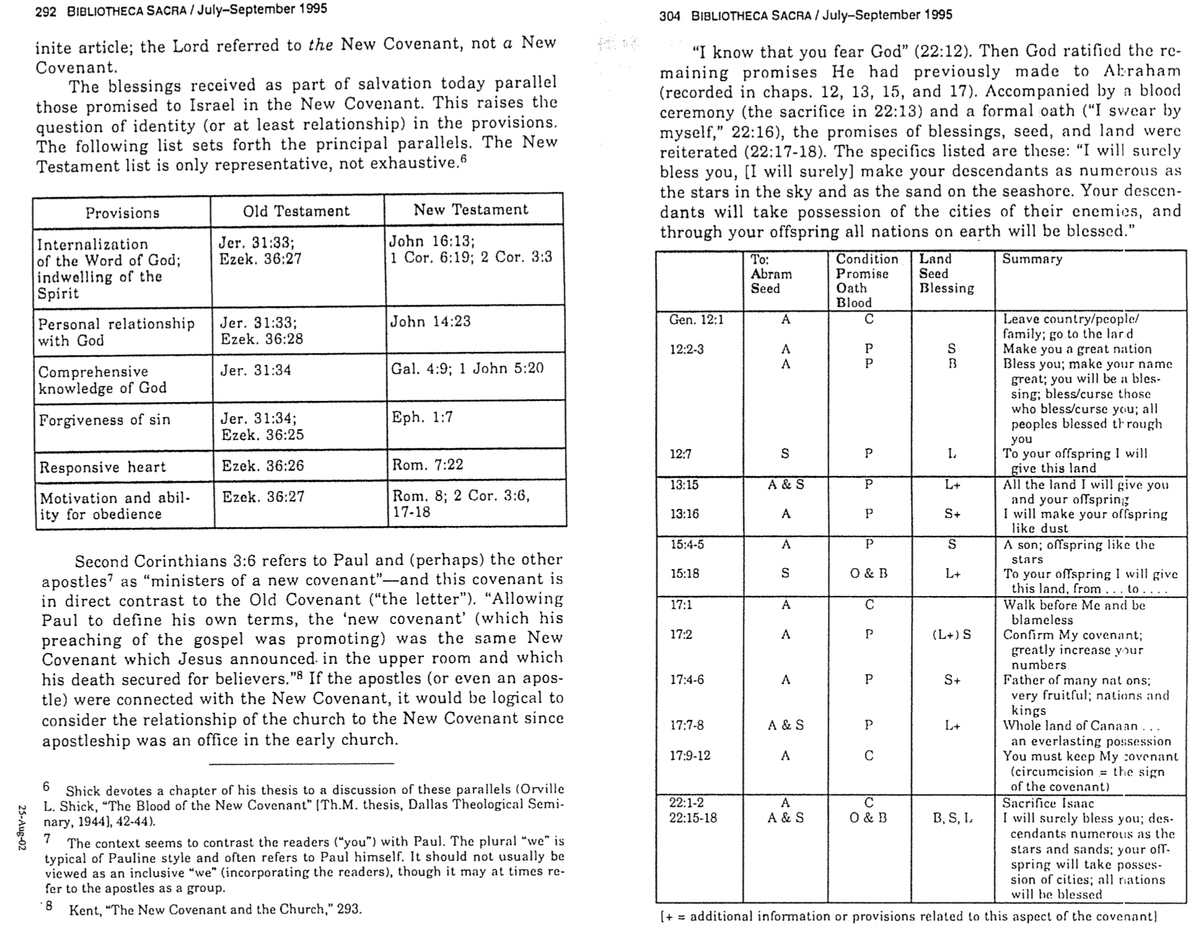

Jeremiah's Two Accounts of Jerusalem's Fall

The destruction of Jerusalem in 586 BC occupies an important place in the prophetic literature. Some pre-exilic prophets had warned of the city's fall, yet Jeremiah is unique in that he narrates the story twice (Jer. 39 and Jer. 52). But why does he tell the story twice?

Jeremiah is the only prophet that gives us a firsthand account since he was there behind Jerusalem’s walls, so it makes sense that he would emphasize the fall of the city more than any other prophet.

The fall of the city provides the climax of both the chronological account of the destruction of Jerusalem (Jer 2–45) and the final city/country to receive God’s judgment (Jer 46–52). In the first case, Jeremiah’s prophecies are chronologically grouped around this destruction (Jer 39). In the second, the reader should ask, “If God would destroy the pagan nations for their idolatry (Jer 46-51), how much more would he judge his own nation for the same sin of idolatry (Jer 52) even though it had been given much more spiritual truth?” The reader is thus left with the sobering reality that God is a just God to both the nations and his own nation.

Reasons for the Exile

Israel lived in its land for nearly 850 years (1405-586 BC) until God banished them to Babylon for a 70-year exile (586-516 BC). Why did He do it? Why would God graciously and miraculously give the land to them and then take it away—especially since He had promised it as an everlasting inheritance (Gen. 17:8)? Why would God command Israel to make a temple where he could dwell as king only to eventually leave that very temple? Why grant them the holy city only to see it soon destroyed and the people kicked out of the land?

The answer to the above questions is simply one word: idols.

Israel forsook the God who brought them into the land by following idols. In fact, all of the other nations continued to worship their false gods, but the only nation with the true God was not true to that God. The Moabites faithfully worshipped Chemosh, the Ammonites did not waver from their commitment to Molech, the Philistines stayed true to give Dagon his due, the Phoenicians could not be deterred from their Baal worship, and each of the other nations remained steadfast towards their false deities. Though Baal worship spread among the nations, it did not replace the local deity but instead was added to the mix.

God’s people expressed idolatry even in following the religious demands of their own faith. In other words, they put faith in their faith instead of faith in the God of their faith. This is particularly seen in reliance on sacrifices at the temple while still practicing immortality. In response, Jeremiah's temple address aimed to convince the people to turn from their false reliance on the temple and idolatry to avoid impending judgment (Jer 7–10). They refused to believe that God would destroy his own temple—a fatal mistake. They convinced themselves that the symbol of God’s presence (the temple) was more important than God’s actual presence and blessing.

The question should not be, “How could God abandon his people?” Instead, we should ask, “How could his people abandon their God?” What had he done to deserve such ill treatment? Hundreds of years earlier in the message of Moses, he had warned them of exile in the blessings and curses before even entering the land (Lev 26; Deut 28). Like any good parent, God had to remain faithful to his own word to carry out the punishment that he promised.

The World of Jeremiah and Ezekiel

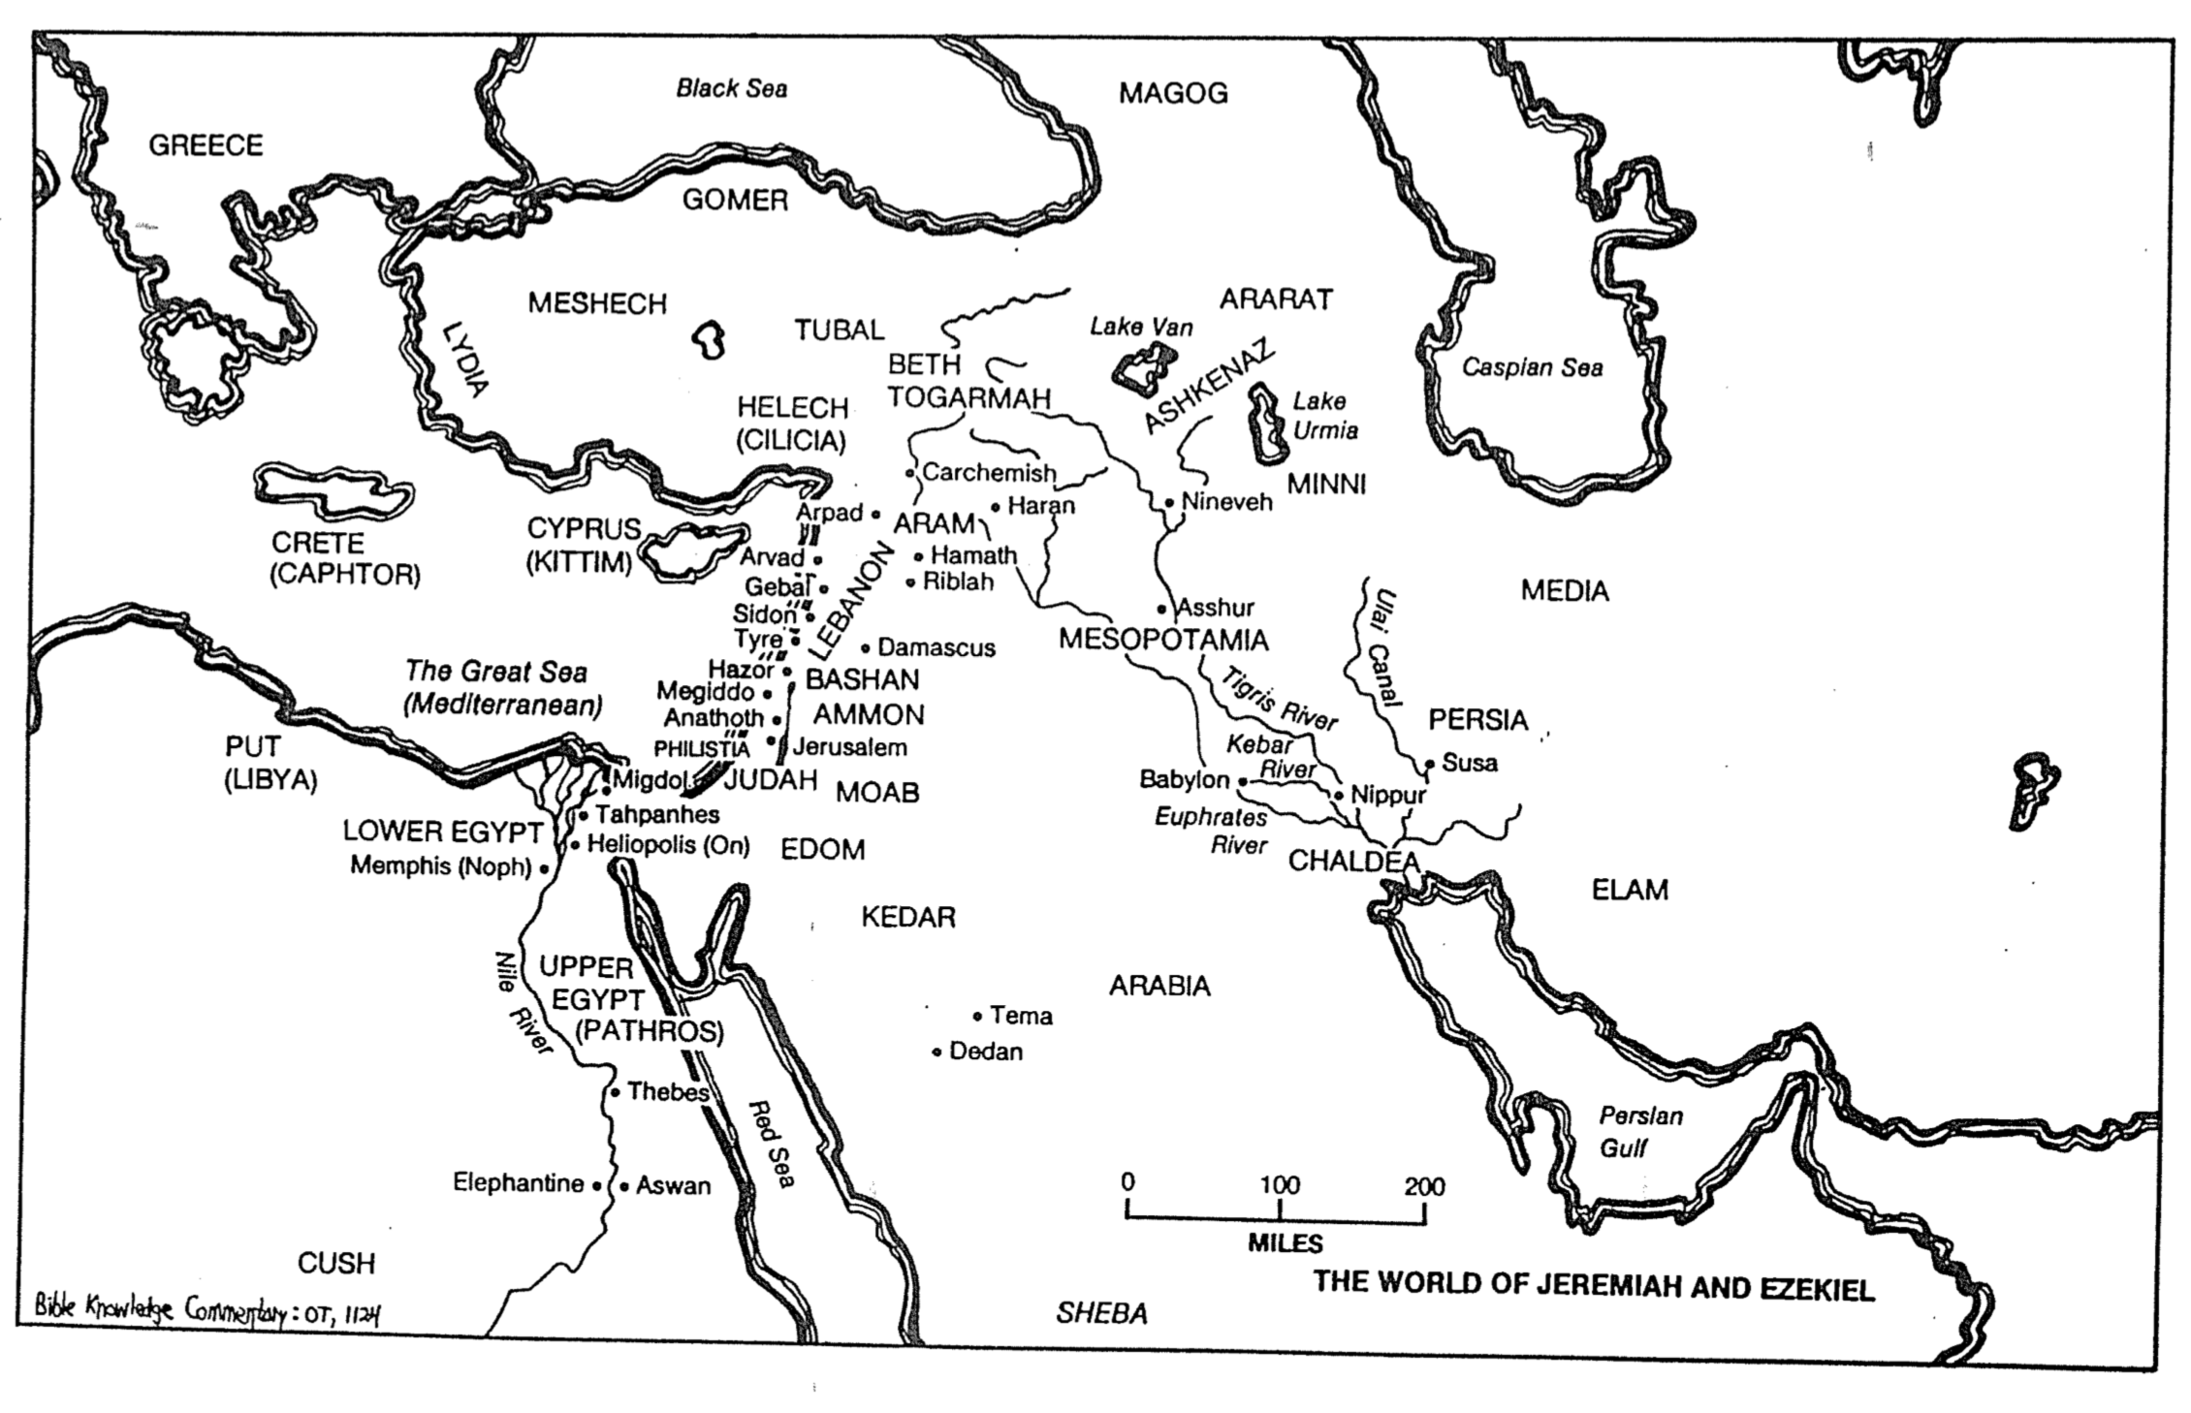
Nebuchadnezzar’s Six Deportations to Babylon

Sequence & Size | Date | King of Judah | Number Taken | Key Captives | Results/  Comments
1  Minor | 605 BC | Jehoiakim | Few  (Dan. 1:3) | Daniel, his 3 friends, & other nobility & royalty | Tribute imposed.  Egypt powerful.
2  Moderate | 598 BC | Jehoiakim | 3,023  (Jer. 52:28) | – | Minor deportation before the 597 BC deportation
3  Major | 597 BC | Jehoiachin | 10,000  (2 Kings 24:14) | Jehoiachin (2 Kings 24:12b), Ezekiel (Ezek. 1:2), Mordecai (Esther 2:6) | Large deportation.  Jehoiachin replaced with his uncle Zedekiah.
4  Minor | 587 BC | Zedekiah | 832  (Jer. 52:29) | – | Minor deportation before the 586 BC destruction
5  Major | 586 BC | Zedekiah | 10,400*  (2 Kings 25:11) | Zedekiah | Jerusalem & temple destroyed after  30-month siege
6  Minor | 582 BC | – | 745  (Jer. 52:30) | – | Four years after Jerusalem’s destruction

- Jeremiah 52:30b says that 4600 people were brought into captivity during the minor deportations (598, 587, and 582 BC). However, assuming the total captives reached about 25,000 (Eugene H. Merrill, Kingdom of Priests, 471), since the 597 BC deportation took 10,000 captives (2 Kings 24:14) then the fall in 586 must have included approximately 10,400 exiles (25,000 - 10,000 - 4600 = 10,400).

