Esther

Extermination Plot Foiled

Plot Planned |  | Plot Foiled
Chapters 1–4 |  | Chapters 5–10
Threat |  | Triumph
Providence Prepared |  | Providence Enacted
Persecution |  | Preservation
Grave Danger |  | Great Deliverance
Feasts of Ahasuerus |  | Feasts of Esther and Purim
Esther Exalted  1:1–2:18 | Haman Plots  2:19–4:17 | Mordecai over  Haman  5:1–8:2 | Jews over Enemies  8:3–9:32 | Mordecai over Persia  10
Persia

10 Years
(483-473 BC)

Key Word: Providence

Key Verse: (Mordecai to Esther) “For if you remain silent at this time, relief and deliverance for the Jews will arise from another place, but you and your father’s family will perish. And who knows but that you have come to royal position for such a time as this?” (Esther 4:14).

Summary Statement:
The reason postexilic Israel should be committed to God is because he reverted Haman's massacre plot on his own head via Mordecai and Esther to fulfill the Abrahamic Covenant.

Application:

Use your providentially placed position to help God’s people.

Esther

Introduction

I. Title Esther (rTes]a, ‘ester) is a Persian name derived from the Persian word for "star" (stara; BDB 64d). The meaning is fitting since Esther is the star of this book that bears her name. Her Hebrew name, Hadassah, means "myrtle(-tree)" (hS;dæh} BDB 213c; cf. 2:7).

II. Authorship

A. External Evidence: The Jewish discussions regarding Esther have concerned several other issues more than authorship, which remains anonymous (see "Characteristics" section). Therefore, parallel passages and opinions of the Church and Synagogue concerning authorship have not been significant.

B. Internal Evidence: Since the book gives no hint who wrote it one can only guess his identity. The account shows such detail of Persian and Jewish life that it is difficult to suppose an author who was not Jewish and well acquainted with Persian ways. Some suggest Ezra or Nehemiah as author, but the vocabulary and style of Esther does not match either of these two books. Others maintain that Mordecai penned the work, but chapter 10 implies that his career had already ended (TTTB, 131), unless, of course, this chapter was added later. Therefore, no one really knows who wrote the book.

III. Circumstances

A. Date: While critical scholars have claimed that Esther was written much later than the time of its contents (because of its language and style), their arguments are unconvincing. Since the events of the book close at 473 BC it is reasonable to presume a date shortly after this–perhaps after Xerxes' reign (ending in 464 BC) but no later than 435 BC when the palace at Susa was destroyed by fire, a significant event not mentioned in Esther.

B. Recipients: Esther's first readers constituted the postexilic communities during the time of Nehemiah and Malachi and the intertestamental period–probably initially in Persia but soon in Israel as the book was copied and distributed. These providential dealings of God on their behalf would have been a tremendous source of encouragement to both Jews in Persia as well as Jews living in Israel.

C. Occasion: The events of Esther chronicle 10 years of the 58 year gap between Ezra 6 (516 BC) and Ezra 7 (458 BC). The story takes place from 483 to 473 BC between the time of the first return under Zerubbabel (538 BC) and the second under Ezra (458 BC). Without Esther the Scripture would remain silent as to the state of the majority of post-exilic Jews who chose to remain in Babylon when a small remnant of their brothers returned to the land. Why did they remain? They were prospering materially and therefore saw nothing but hard work by returning to Jerusalem, a city that lacked even walls (cf. Book of Nehemiah). The Books of Ezra and Nehemiah assert God's providential care over the small remnant that returned, while Esther reveals that God even graciously cared for these spiritually indifferent Jews whose priorities needed rearranging.

IV. Characteristics

A. Historicity: Esther contains much in the way of eyewitness accounts about the Persian Empire, of which little has been verified from outside sources. Ahasuerus has recently been identified with Xerxes who reigned over Persia from 485-465 BC. Nothing in the book hints other than being a historical account.

B. Canonicity: The usefulness of Esther has long been debated. Maimonides taught that when the Messiah comes, every book of the Jewish Scriptures would pass away but the Law and Esther, which would remain forever. However, Martin Luther wished the book had never been written because of its many problems (Donald K. Campbell, “Esther,” DTS Class Notes, 1984, 1).

The reasons for differing opinions on the book stem from many unique characteristics:

1. The name of God is never mentioned in the book (although his hand is very evident).
2. Esther is never quoted in the New Testament nor found among the Dead Sea Scrolls.
3. It never mentions the Law or Jewish sacrifices or offerings.
4. It never refers to prayer (although fasting is mentioned).
5. The book contains no mention at all of anything spiritual.
6. Its unique literary type (i.e., almost a drama) has caused it to be placed within several different sections in various collections of Old Testament books.

C. Placement: Esther is the only biblical book with a history of the Jews outside of the land during the times of the Gentiles (586 BC until the return of Christ). This may explain why it appears as the last historical book in English Bibles, for while it precedes Nehemiah chronologically, the same conditions in the book continue during the time of the Gentiles until the deliverance of the Jews at the return of Christ (Campbell, 2).

D. Lessons: The Book of Esther teaches several principles such as (Campbell, 2):

1. Satan's purpose is to destroy the Jews by use of the nations.
2. God's purpose is to preserve the Jews by use of the nations.
3. God works in the affairs of nations to accomplish his will to preserve his people.
4. God works in the affairs of individuals to accomplish his will to preserve his people.

E. Interpretation: At least four different hermeneutical methods have been employed in seeking to understand the message of Esther:

1. Prophetical—Esther predicts that the Jews will be preserved while outside of the land during the times of the Gentiles.

Response: Nothing is mentioned of the “times of the Gentiles” and the account is presented in a straightforward manner as history.

2. Allegorical—Esther is the story of mankind.

Response: This is ambiguous and the account is presented in a straightforward manner as historical.

3. Typical—Esther is God’s illustration of the Christian experience in the Church Age or a type of the Millennium. "Some suggest a typical application as follows. The replacing of Vashti (a Gentile) by Esther (a Jew) typifies the setting aside of Christendom and the taking up of Israel. Haman, the enemy of the Jews, typifies the anti-Christ to be destroyed at the second coming. The numerical value of the Hebrew letters of Haman the wicked is 666. Mordecai is a type of Jesus Christ in his glorious exaltation. The triumph of the Jews is typical of the millennium" (Campbell, 2).

Response: While this is an ingenious view, it fails in that it reads the NT back into the OT (which means that its original readers would not have understood the meaning). Also, the spelling of “Haman” must be altered to fit this numerical scenario!

4. Historical—Esther records God's providential care of his chosen people as evidence of his commitment to the Abrahamic Covenant. The following "Argument" section will demonstrate this to be the best option.

F. Seven: The number seven holds a prominent place (days, 1:5; eunuchs, 1:10; nobles, 1:14; maids, 2:9).

G. Banquet: Ten banquets are noted—more than the rest of the OT combined (see page 315). The idea of eating food in the midst of tragedy recalls Joseph’s brothers who ate after selling him (Gen 37:25).

H. Reversals: The story continually shows how God reverses the plots of evil men. Haman’s plot to kill Mordecai reverses on his own head and Haman’s first decree is reversed.

- Typology: Esther depicts Jesus as she foreshadows our deliverance in Christ. In a very patriarchal society, God chose a woman to deliver the nation. She even married a Gentile, as did Joseph and Moses.

Argument

Esther records a historical story of how a plot to exterminate the entire Jewish population is averted by God's providential workings through the godly Jewess, Queen Esther. The account cites the threat to the Jews (Esther 1–4) and the triumph of the Jews over those who threatened their existence (Esther 5–10). Chapter 9 celebrates the preservation of the nation in the Feast of Purim—an annual reminder of God's faithfulness on their behalf.

Synthesis

Extermination plot foiled

1–4 Plot planned—threat
1:1–2:18 Esther exalted
1 Vashti divorced
2:1-18 Esther married
2:19–4:17 Haman plots
2:19-23 Mordecai: plot to murder the king
3 Haman: plot to murder the Jews
4 Esther challenged

5–10 Plot foiled—triumph
5:1–8:2 Mordecai over Haman
5:1-8 Invitation offered
5:9-14 Gallows built
6 Mordecai honored
7 Haman hanged
8:1-2 Mordecai promoted
8:3–9:32 Israel over enemies
8:3–9:16 Counter-decree slaughter
9:17-32 Purim
10 Mordecai over Persia

Outline

Summary Statement for the Book
The reason postexilic Israel should be committed to God is because he reverted Haman's massacre plot on his own head via Mordecai and Esther to fulfill the Abrahamic Covenant.

Threat: God strategically placed Mordecai and Esther to thwart Haman's plot to exterminate the Jews to fulfill the Abrahamic Covenant (Esther 1–4).

Esther replaced the deposed Queen Vashti as God's intervention to save his people from annihilation as a nation (1:1–2:18).

Xerxes (Heb. Ahasuerus in the book) divorced his disobedient Queen Vashti, unaware of God’s plan for Esther to replace Vashti to preserve the Jews (Esther 1; 483 BC; 1:3).

Xerxes married Esther to replace Vashti after a divinely designed beauty contest where God controlled Xerxes' taste in women to avert a disaster for the Jews (2:1-18; 479 BC).

Haman’s plot to kill the Jews came just after Mordecai foiled a plot to murder the king to show God protecting the Jews through Esther to uphold the Abrahamic Covenant (2:19–4:17).

God informed Mordecai of a secret assassination plot that saved Xerxes' life as God’s design to later exalt Mordecai to benefit his people (2:19-23).

Haman’s anger at Mordecai refusing to honor him convinced Xerxes to try to kill all Jews from Egypt to India eleven months later for God protect them instead (Esther 3).

Mordecai convinced Esther to risk her life for the Jews by showing that God crowned her for this role even if she failed since he would still uphold the Abrahamic Covenant (Esther 4).

Triumph: God reverted Haman's massacre plot on his own head via Mordecai and Esther to fulfill the Abrahamic Covenant (Esther 5–10).

Mordecai triumphed over Haman as evidence of God's faithfulness to those who fear him (5:1–8:2).

The king enthusiastically and curiously accepted Esther's boldness, yet Esther only invited him to a banquet to put him in the proper mood to grant her request (5:1-8).

Haman arrogantly plotted to murder Mordecai on a 75-foot gallows as God's provision for his own death to protect the Jews (5:9-14).

Haman honored Mordecai and returned home humiliated (Esther 6).

Haman died on the gallows prepared for Mordecai as evidence that God protects those who fear him and punishes those who oppose him and his people (Esther 7).

Mordecai was elevated to Haman's position and appointed over Haman's estate to show that those who plot evil will only prosper the righteous (8:1-2).

Israel triumphed over its enemies and began to annually celebrate the Feast of Purim as evidence of God's faithfulness to the Abrahamic Covenant (8:3–9:32).

God delivered the Jews in a massive slaughter of their enemies authorized by a counter-decree for their self-defense to show God upholding the Abrahamic Covenant (8:3–9:16).

Xerxes commanded Esther and Mordecai to write a counter-decree allowing the Jews to defend themselves and God caused many Gentiles to become proselytes (8:3-17).

The Jews slaughtered at least 75,810 enemies in two days with help from royal officials to show God's faithfulness to the Abrahamic Covenant (9:1-16; Feb-Mar 473 BC).

Mordecai and Esther authorized the Feast of Purim (plural for pur, the lot thrown by Haman) to annually celebrate God’s victory over the enemies of the Jews (9:17-32).

The LORD exalted Mordecai to second only to Xerxes due to his selfless concern for the Jews, which shows God's blessing on those who seek the welfare of others (Esther 10).

Chronology of the Persian Period

John H. Walton, Chronological and Background Charts of the OT, 2d ed., 70

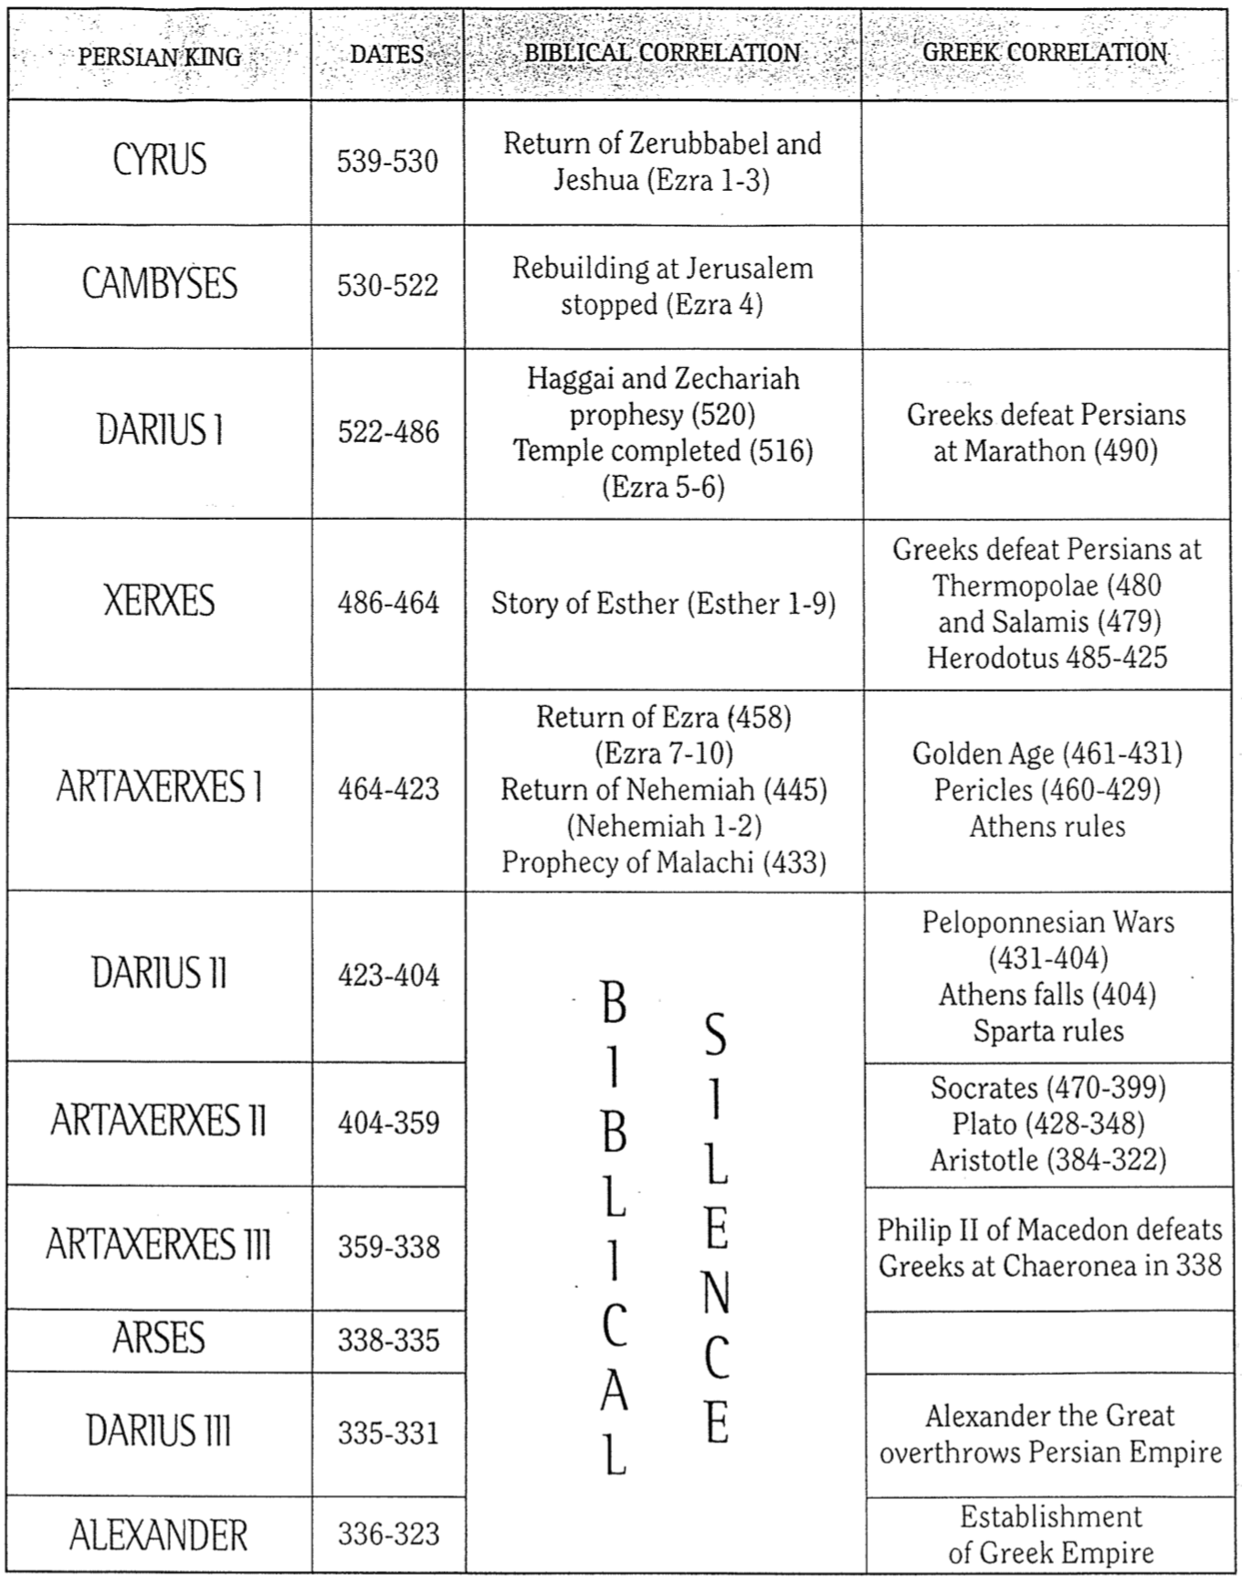
Key Dates Related to the Book of Esther

Reference | Date | Event
– | 486 | Xerxes’ reign began
1:3 | 483  (3rd year of Xerxes) | Xerxes threw a 7-day banquet for his nobles and officials in which Queen Vashti was deposed
– | 482-479 | Xerxes led disastrous campaigns against Greece as recorded by the Greek historian Herodotus (7.8)
2:16 | December 479 or January 478 | Esther became queen after a four-year beauty contest
3:7 | Early April 474 | During the fifth year of Esther’s reign, Haman and the astrologers (5:10, 14; 6:12-13) cast the pur (lot) to determine the day of the planned extermination of the Jews eleven months later (7 March 473)
3:12 | April 17, 474  (13th of Nisan) | Xerxes’ first edict (to destroy the Jews) informed everyone of the fateful day, royal secretaries wrote it out in the various languages of the empire
8:9 | June 25, 474  (23rd of Sivan) | Xerxes’ second edict (to protect the Jews) was sent out two months and ten days after the first one on April 17
3:13  8:12  9:1, 17a | March 7, 473  (13th of Adar) | Rather than being destroyed on this day, Jews protected themselves by killing at least 75,810 enemies eight months and twenty days after the counter-edict was signed
9:17b-18a | March 8, 473  (14th of Adar) | Jews feasted in celebration of their victory throughout the empire except in Susa where they killed their enemies an additional day (today Jews everywhere except Jerusalem celebrate Purim on this day, the 14th of Adar)
9:18b | March 9, 473  (15th of Adar) | Jews feasted in celebration of their victory in Susa (today Jews in Jerusalem celebrate Purim on this day, the 15th of Adar)
– | 464 | Palace at Susa destroyed by fire and Xerxes reign ended

Banquets in the Book of Esther

One key theme in Esther is feasting. There are ten banquets in the book, spread fairly evenly so that nearly every chapter has a banquet:

 | References | Hosts | Guests | Events
1 | 1:3-4 | Xerxes | Nobles and Officials | Wealth of the kingdom displayed over 180 days
2 | 1:5-8 | Xerxes | All the people | Wine flowed for everyone for 7 days
3 | 1:9 | Vashti | Palace women | Vashti deposed for declining to attend Xerxes’ banquet
4 | 2:18 | Xerxes | Nobles and Officials | Esther introduced as the new queen
5 | 3:15 | Xerxes | Haman | Annihilation of the Jews decreed by the king
6 | 5:1-8 | Esther | Xerxes and Haman | Xerxes kept in suspense as to Esther’s request
7 | 7:1-10 | Esther | Xerxes and Haman | Esther exposes Haman as seeking her life
8 | 8:17 | Jews | Jews | Rejoicing over the king’s edict on the Jews behalf and many Gentiles became Jews
9 | 9:17 | Jews | Jews | Rejoicing over slaughter of 75,810 or more enemies of the Jews
10 | 9:18-32 | Jews | Jews | Feast of Purim established to be an annual event through Mordecai’s decree
Map of Esther’s Canonical Status

Carey A. Moore, Esther, Anchor Bible, xxvi-xxvii

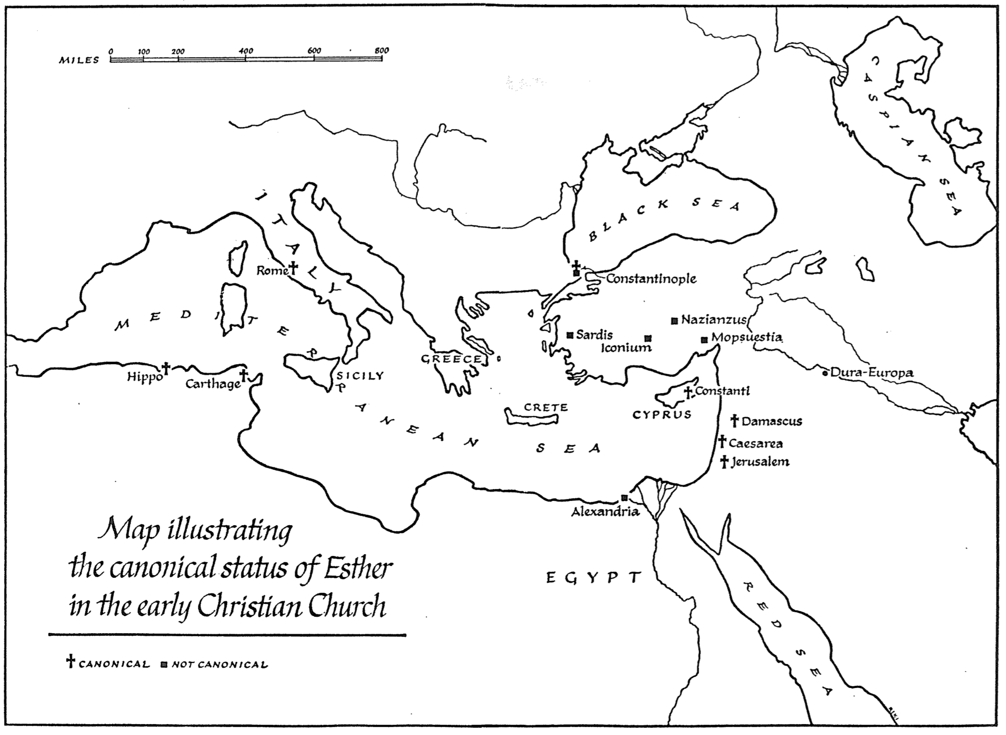
Map of the Persian Empire
Barry J. Beitzel, Moody Atlas of Bible Lands, 1st ed., 150-51
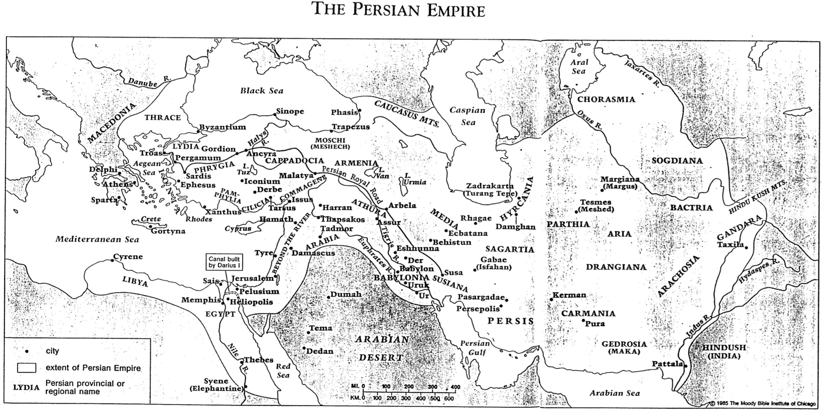

Shadow and Fulfillment in the Book of Esther

The Conclusion to an Article of the Same Title by Michael J. Wechsler, Bibliotheca Sacra 154 (July-September 1997): 275-84

