2 Kings

Downfalls of the Kingdoms

Late Divided Kingdom |  |  | Surviving Kingdom
Israel and Judah |  |  | Judah
Chapters 1–17 |  |  | Chapters 18–25
Israel Exiled to Assyria |  |  | Judah Exiled to Babylon
Ahaziah to Hoshea |  |  | Hezekiah to Zedekiah
130 Years  (852-722 BC) |  |  | 163 Years  (722-560 BC)
2 Bad Israel Kings & Elisha’s Ministry  1:1–8:15 | 10 Bad Israel Kings &  4 Bad/4 Good Judah Kings  8:16–16:20 | Bad Hoshea culminating in Fall of Israel  17 | Good Hezekiah & 2 Bad Judah Kings  18–21 | Good Josiah  &  4 Bad Judah Kings  22:1–24:16 | Bad Zedekiah culminating in Fall of Judah & Jerusalem  24:17–25:30

Key Word: Downfalls

Key Verse: “So the LORD said, “I will remove Judah also from my presence as I removed Israel, and I will reject Jerusalem, the city I chose, and this temple, about which I said, ‘There shall my Name be’” (2 Kings 23:27)

Summary Statement:
The covenant disobedience and resultant downfalls of the kingdoms of Israel and Judah are contrasted with God's loyalty to the Davidic Covenant to remind Israel of the need to obey the Law–not repeat past mistakes.

Application:

“Don’t rearrange your idols! Remove them!” (Huang Sabin, OT Made Simple)

2 Kings

Introduction

Note: This introduction repeats that of 1 Kings except for the Characteristics section.

I. Title First and Second Kings originally comprised only one book in the Hebrew canon called "Kings" (~ykil,m,) after the first word in 1:1 ("Now King"; &l,M,h;w>). However, this single scroll was arbitrarily divided in the Septuagint (250 BC) since the Greek required a greater amount of scroll space. The Septuagint titles were Third and Fourth Kingdoms (since 1 and 2 Samuel were designated 1 and 2 Kingdoms). Jerome called 1 and 2 Kings "The Book of the Kings" about six centuries later. These titles are appropriate as these books record and interpret the reign of every king of Israel and Judah except Saul (David has brief mention in 1 Kings 1:1–2:12).

II. Authorship

A. External Evidence: Jewish tradition ascribes authorship of the Books of Kings to Jeremiah. There exist literary parallels between this record and the prophecy of Jeremiah.

B. Internal Evidence: The prophetic-like descriptions of Israel's apostasy indicate that the author was a prophet/historian. Also, this compiler had several historical documents at his fingertips: “the book of the acts of Solomon” (1 Kings 11:41), “the book of the chronicles of the kings of Israel” (1 Kings 14:19), and “the book of the chronicles of the kings of Judah” (1 Kings 14:29; 15:7). These books may be attributed to the official secretary Shebna and/or the official recorder Joah, son of Asaph (2 Kings 18:18; cf. Isa. 36:11). Parallels between 2 Kings 18–20 and Isaiah 36–39 also reveal that Isaiah's scroll also was a source. No firm evidence exists to refute the tradition that Jeremiah authored the Book of Kings.

III. Circumstances

A. Date: Three lines of evidence indicate that First Kings and even most of Second Kings were written before the Babylonian Captivity (586 BC). The ark still resided in Solomon's temple (1 Kings 8:8), Israel was still in rebellion against Judah (1 Kings 12:19), and Samaria's idolatry persisted even after its resettlement (2 Kings 17:34, 41). However, the final two chapters of Second Kings record up to 26 years after this captivity and may have been recorded by a Jewish captive in Babylon or by Jeremiah himself, who would have been at least 84 years old.

First Kings covers a period of history totaling 120 years, beginning in 971 BC with the inauguration of Solomon and ending in 852 BC near the end of Ahaziah's reign. The year 931 BC marks the most significant date when Solomon's kingdom split into the northern nation of Israel and the southern kingdom of Judah after his death.

Second Kings picks up at 852 BC and goes to the falls of Samaria (722 BC) and Jerusalem (586 BC) until the release of Jehoiachin in Babylon in 560 BC—a period of over 293 years.

B. Recipients: The Book of Kings was written to the remaining kingdom of Judah before (1 Kings 1–2 Kings 23) and after (2 Kings 24–25) its own exile in Babylon.

C. Occasion: Jeremiah's prophecy and Lamentations record his eyewitness account of Babylon's siege and destruction of Jerusalem for the nation's sins. In addition to his own prophetic word, the Holy Spirit moved him to record an historical compilation to give the context and justification for God's judgments on these two nations. The leaders and the people sinned through ungodliness and idolatry, and, true to the curses of Deuteronomy 28, God gave them the consequences of their disobedience. Therefore, the purpose 1-2 Kings is to show how the welfare of Israel and Judah depended on the king and people’s faithfulness to the Law of Moses to teach the exiles to learn from the mistakes of their ancestors. This purpose was fulfilled in history as Israel has not since the Captivity had a problem with idolatry.

IV. Characteristics

A. Some contrasts between the two books of Kings may prove helpful:

1 Kings 2 Kings

Dates 971-852 BC 852-560 BC

Length 120 years Over 293 years

Kings David-Ahaziah Ahaziah-Zedekiah

# of Chapters 22 25

General Content Division of the Kingdom Downfall of the Kingdoms

Major Judgments Divided Kingdom (931 BC) Israel (722 BC), Judah (586 BC)

Temple Built and consecrated Violated and destroyed (380 yrs. later)

Beginning/end Begins with blessings Ends with judgment
for obedience for disobedience

B. Second Kings depicts the reigns of more kings than any book in Scripture.

Argument

Second Kings continues the account from First Kings since they originally composed a single work. Therefore, the book presents the same ethical argument—to convince the readers from the lessons of the past that God blesses obedience to his covenant but judges disobedience. This is observable in the account of the kings of both Israel and Judah before the fall of Assyria (2 Kings 1–17) and the kings of Judah before its own fall (2 Kings 18–25). The book also shows God's merciful commitment to the Davidic Covenant through the kings of Judah who constitute only a single dynasty in contrast to the five dynasties of the northern kingdom that does not possess the promise of the Davidic Covenant. Therefore, while God punishes rebellion he nevertheless is faithful to the covenant he made with David.

Synthesis

Later divided kingdom covenant disobedience Downfalls of the Kingdoms

1–17 Later divided kingdom (good kings in bold print)
1 Ahaziah (I)
2:1–8:15 Joram (I) vs. Elisha
2 Succession of Elijah
3 Water for [Joram, Jehoshaphat, king of Edom] vs. Moab
4:1-7 Oil for widow
Key:

Good kings are in bold print
I = Israel’s kings
J = Judah’s kings
5 = Numbers show new dynasties
in Israel (Judah is one dynasty)
4:8-17 Son for Shunammite
4:18-37 Restoration for Son
4:38-41 Stew for prophets
4:42-44 Bread for men
5 Healing for Naaman
6:1-7 Ax head for seminarians
6:8-23 Blinding of Syrians
6:24–7:20 Food of Syrians
8:1-6 Guidance for Shunammite
8:7-15 Prophecy of Hazael's succeeding Ben-Hadad
8:16-24 Jehoram (J)
8:25–9:29 Ahaziah (J)
9:30–10:36 Jehu (5; I)

11 Athaliah (J)

12 Joash (J)
13:1-9 Jehoahaz (I)
13:10-25 Jehoash (I)
14:1-22 Amaziah (J)
14:23-29 Jeroboam II (I)
15:1-7 Azariah (Uzziah; J)
15:8-12 Zechariah (I)
15:13-16 Shallum (6; I)
15:17-22 Menahem (7; I)
15:23-26 Pekahiah (8; I)
15:27-31 Pekah (I)
15:32-38 Jotham (J)
16 Ahaz (J)
17:1-6 Hoshea (9; I)
17:7-23 Captivity reasons
17:24-41 Resettlement

18–25 Surviving kingdom (all Judah)
18–20 Hezekiah
18:1-8 Destroys paganism
18:9-12 Rabshakeh ridicules
19 185,000 killed
20:1-11 Sickness and sun
20:12-21 Babylonian messengers
21:1-18 Manasseh
21:19-26 Amon
22:1–23:30 Josiah
23:31-34 Jehoahaz
23:35–24:7 Jehoiakim 605 BC Deportation #1
24:8-16 Jehoiachin 597 BC Deportation #2
24:17–25:21 Zedekiah 586 BC Deportation #3
25:22-26 Governor Gedaliah
25:27-30 Jehoiachin released

Outline

Summary Statement for the Book
The covenant disobedience and resultant downfalls of the kingdoms of Israel and Judah are contrasted with God's loyalty to the Davidic Covenant to motivate Israel to obey the Law—not repeat past mistakes.

God judged covenant disobedience of the divided later kingdoms of Israel and Judah in the Assyrian Captivity for them to obey the Law—not repeat the past (2 Kings 1–17; 852-722 BC).

Ahaziah's evil reign in Israel (4th Dynasty) chronicles Elijah's fulfilled prophecy of his death after the fire-deaths of 102 men to show God over Baal-Zebub, god of Ekron (2 Kings 1).

Elisha revealed Joram's evil and idolatrous reign in Israel by miraculously showing God's sovereignty over Baal to convince Israel to trust in the LORD alone (2:1–8:15).

Elisha miraculously healed water in Jericho after succeeding Elijah as prophet after his master ascended into heaven as evidence that the same LORD was with both (2:1-22).

Elisha miraculously killed 42 mocking teenagers as a further sign of his prophetic authority (2:23-25).

Elisha miraculously provided water for Israel’s wicked Joram and good Jehoshaphat of Judah to defeat Moab to show God's sovereignty over Baal, god of rain (2 Kings 3).

Elisha miraculously provided oil for a prophet's widow to pay her debts to show God's care for those who trust him despite the apostasy around them (4:1-7).

Elisha miraculously enabled a Shunammite woman to bear a son to embarrass the powerless Baal, so-called god of fertility (4:8-17).

Elisha miraculously restored the Shunammite's boy to life years later to show God's sovereignty over Baal, to whom child sacrifice was offered in Israel (4:18-37).

Elisha miraculously cured a deadly stew to show God stronger than Baal, god of vegetation, and warn of the deadly effects of Baalism despite its apparent harmlessness (4:38-41).

Elisha miraculously multiplied 20 bread loaves to feed 100 men during a famine to show God's sovereignty over the powerless Baal, god of fertility and "lord of the earth" (4:42-44).

Elisha miraculously transferred faithful, thankful, foreign Naaman’s leprosy to the unfaithful, greedy, Israelite Gehazi to show God cares for foreigners and Baal can’t heal (2 Kings 5).

Elisha miraculously floated an iron ax head to reassure students building a new dorm that they serve the LORD who provides all their needs while Baal meets no needs at all (6:1-7).

Elisha miraculously helped his servant see God's protective chariots and led the blinded raiding Syrians to Joram to show God protects through a prophet—not warriors (6:8-23).

Elisha miraculously prophesied Samaria’s rescue from a Syrian famine siege and God gave the enemy’s food to show that God provides food and protection, not Baal (6:24–7:20).

Elisha miraculously told a Shunammite how long to sojourn from her land during a famine so that she regained her house, land, and income to show God delivers the righteous (8:1-6).

Elisha miraculously prophesied of God's discipline of Israel through the cruelty of Hazael as king of Aram, and then Hazael impatiently seized the crown (8:7-15; cf. 1 Kings 19:15).

Jehoram's evil reign in Judah due to marrying a daughter of Ahab saw victory over Edom and the sparing of Jehoram's life because of God's commitment to the Davidic Covenant (8:16-24).

Ahaziah's evil reign in Judah as a grandson of Ahab ended with God anointing Jehu of Israel to slay Ahaziah and Joram to end the fourth dynasty as God's sentence for wickedness (8:25–9:29).

Jehu's evil reign in Israel (5th Dynasty) continued golden calf worship but deceitfully purged Israel of Jezebel, Ahab’s whole family, and all Baal worship to show God over Baal (9:30–10:36).

Athaliah's evil reign in Judah destroyed the entire royal family except her one-year-old grandson Joash, but he still became king and Athaliah died to show God guarding David’s line (2 Kings 11).

Joash's good reign in Judah until his servants murdered him still retained the high places but did repair the temple and began a righteous rule by four Judean kings lasting 105 years (2 Kings 12).

Jehoahaz's evil reign in Israel was judged by the complete dominance of Hazael and his son Ben-Hadad II of Aram to show God's judgment of idolatry (13:1-9).

Jehoash's evil reign in Israel had only three victories over Aram (as Elisha predicted before his death) rather than a complete victory to warn of the dangers of disbelieving God (13:10-25).

Amaziah's good reign in Judah retained the high places, executed his father's murderers, defeated Edom, but was defeated after picking a fight with Jehoash of Israel (14:1-22).

Jeroboam II's evil reign in Israel restored Israel's borders in fulfillment of Jonah's prophecy and saw Israel spared from intense suffering due to God's promise not to blot out Israel (14:23-29).

Azariah's (Uzziah) good reign in Judah lasted 52 years but did not remove the high places so that he lived in a separate house due to his leprosy (15:1-7; cf. 2 Chron. 26).

Zechariah's evil and idolatrous reign in Israel ended when Shallum publicly assassinated and succeeded him to fulfill God's word for Jehu's house to last to the fourth generation (15:8-12).

Shallum's evil reign in Israel (6th Dynasty) lasted only one month until his assassination by Menahem son of Gadi as God's punishment on his wickedness (15:13-16).

Menahem's evil reign in Israel (7th Dynasty) paid tribute to Pul (Tiglath-Pileser) of Assyria as God's judgment for his idolatry (15:17-22).

Pekahiah's evil reign in Israel ended his dynasty by assassination from Pekah, son of Remaliah, as God's judgment upon his sin of idolatry (15:23-26).

Pekah's evil reign in Israel (8th Dynasty) ended with Tiglath-Pileser's second invasion that took cities, deported Israelites, and saw Pekah’s murder by Hoshea for his idolatry (15:27-31).

Jotham's good reign in Judah rebuilt the temple’s Upper Gate but allowed high places and saw Pekah of Israel and Rezin of Aram start to attack in anticipation of Ahaz's evil reign (15:32-38).

Ahaz's evil reign in Judah broke 105 years of good reigns by sacrificing his own son, building and worshipping at high places, and trusting Tiglath-Pileser instead of God for protection (2 Kings 16).

Hoshea's evil reign in Israel (9th Dynasty) sought So of Egypt to shun tribute to Shalmaneser of Assyria and led to a third and final Assyrian invasion that deported Israel (17:1-6; 722 BC).

Israel went into Assyrian exile as God's judgment for despising God for idols, sacred stones, high places, Asherah poles, astrology, divination, sorcery and other pagan practices (17:7-23).

Other conquered pagan peoples resettled Samaria and, despite the teaching of a priest of Yahweh, mixed pagan practices of their national deities with Yahweh worship (17:24-41).

God judged covenant disobedience of the surviving kingdom of Judah in the Babylonian Captivity for them to obey the Law—not repeat past mistakes (2 Kings 18–25; 722-560 BC).

Hezekiah's good reign surpassed any king in devotion to God but his foolish trust in Babylonian messengers eventually led Judah into exile to teach Judah to trust God alone (2 Kings 18–20).
(Note: Isaiah 36–39 records this account nearly verbatim).

Hezekiah's good reign excelled that of any king of Judah before or after him in that he destroyed all forms of pagan worship and served the LORD wholeheartedly (18:1-8).

In Hezekiah's 14th year Sennacherib's Assyrian army commander Rabshakeh ridiculed Judah’s God and threatened to conquer Jerusalem (18:9-12; cf. Isa. 36).

Hezekiah trusted God to kill Rabshekah and 185,000 Assyrian soldiers as evidence of God's sovereignty over the Assyrian and local gods (2 Kings 19; cf. Isa. 37).

Hezekiah's sickness and miraculous 15-year lease on life displayed God's sovereignty even over death and the sun’s movements as well as over Assyria (20:1-11; cf. Isa. 38).

Hezekiah's foolish trust in the Babylonian messengers eventually led to Judah being taken into exile after Hezekiah's death to encourage trust in God alone (20:12-21; cf. Isa. 39).

Manasseh's evil 55-year reign (the longest of any king) reinstitutes all of the pagan practices ended by his father Hezekiah to vindicate God's soon Babylonian exile for the nation (21:1-18).

Amon's evil reign repeated Manasseh's mistakes until his officials assassinated him and the people assassinated the officials before they placed Amon's son Josiah on the throne (21:19-26).
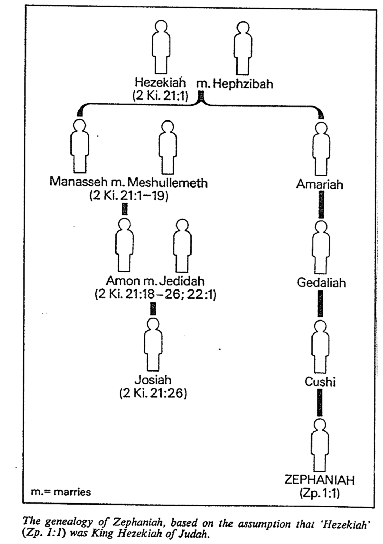
C. F. Pfeiffer, “Zephaniah,” New Bible Dictionary, 2nd ed., 1279

Josiah's good reign recovered the Book of the Law (Deut?) during temple repairs that spurred him to renew the Law and destroy his grandfather Manasseh’s pagan altars (22:1–23:30).

Jehoahaz's evil reign ended subject to Pharaoh Neco after only three months followed by exile and death in Egypt while his brother Jehoiakim replaced him (23:31-34).

Jehoiakim's evil reign became subject to Pharaoh Neco of Egypt, Nebuchadnezzar of Babylon, and raiders from Aram, Moab, and Ammon to teach the cost of rejecting God (23:35–24:7).

Jehoiachin's evil reign yielded in Nebuchadnezzar's second invasion (597 BC) with Jerusalem sieged and Jehoiachin [and Ezekiel], temple treasures and 10,000 rich people taken (24:8-16).

Zedekiah's evil reign led to Nebuchadnezzar's third and last siege (586 BC) that ruined the temple, palace, key buildings, and most of the citizens as he judged their idolatry (24:17–25:21).

Ishmael of Nethaniah (of royal blood) killed the Babylonian appointee Gedaliah, but then fled to Egypt and never ruled to show the folly of trying to seize rule only for Davidic kings (25:22-26).

Jehoiachin’s release from his Babylonian prison in 560 BC to eat at the king's table until his death foreshadows God's mercy by protecting David’s dynasty to restore Israel to their land (25:27-30).

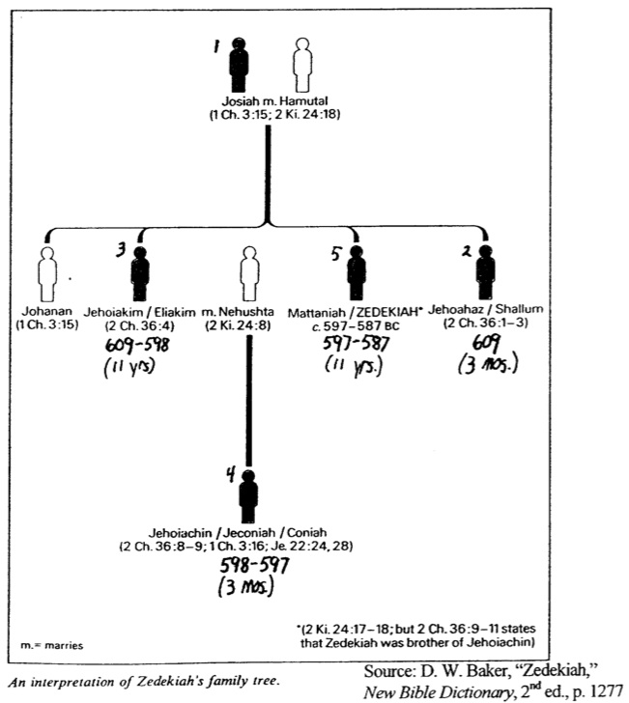

Assyrian Foreign Policy

John H. Walton, Chronological and Background Charts of the OT, 2d ed., 66

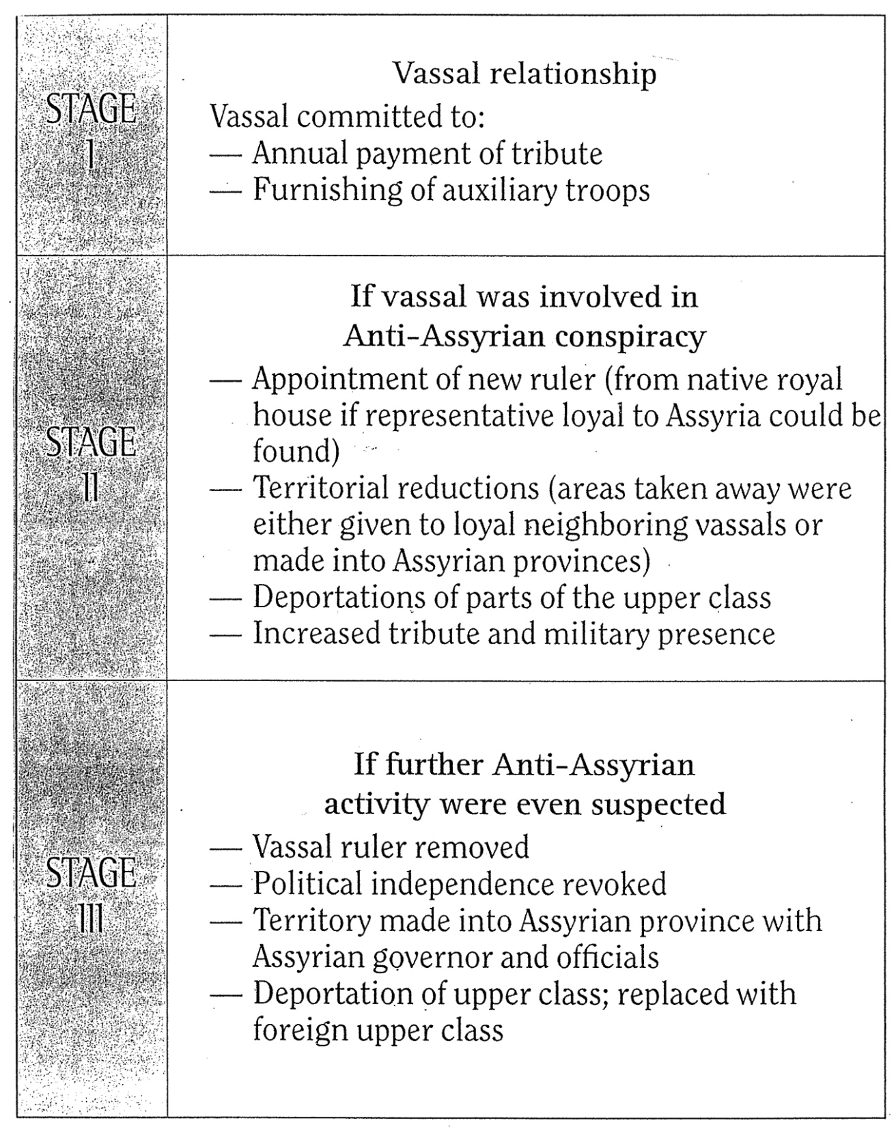
Assyrian Campaigns Against Israel and Judah

The Bible Visual Resource Book, 79

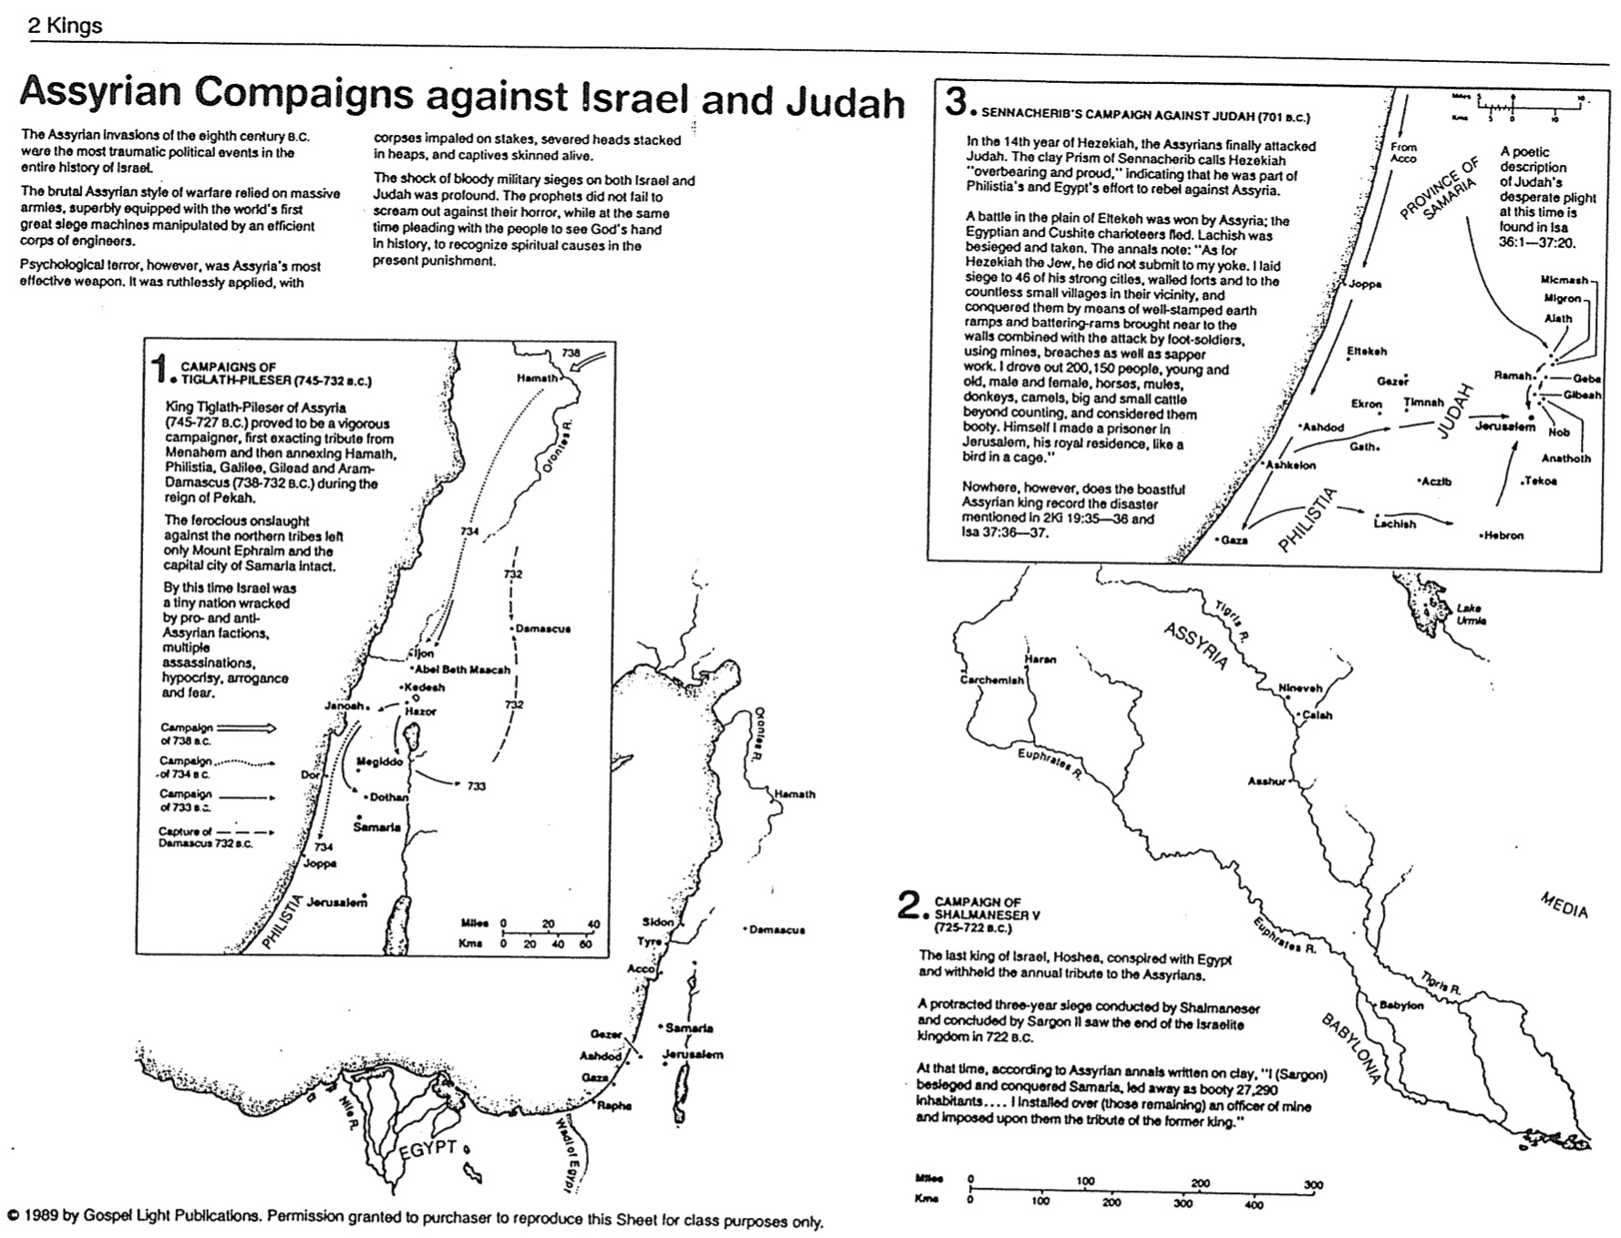
Exile of the Northern Kingdom
The Bible Visual Resource Book, 81

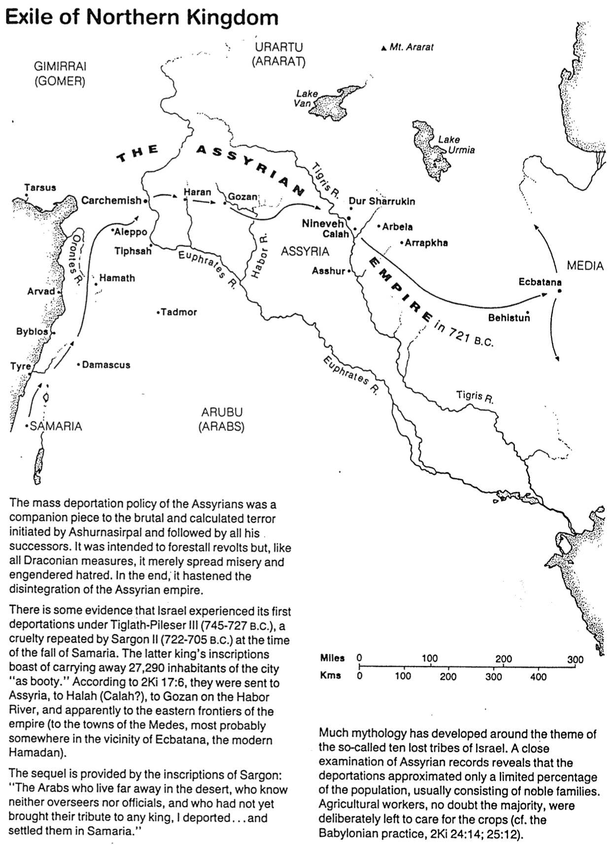

Nebuchadnezzar’s Campaign Against Judah

The Bible Visual Resource Book, 83

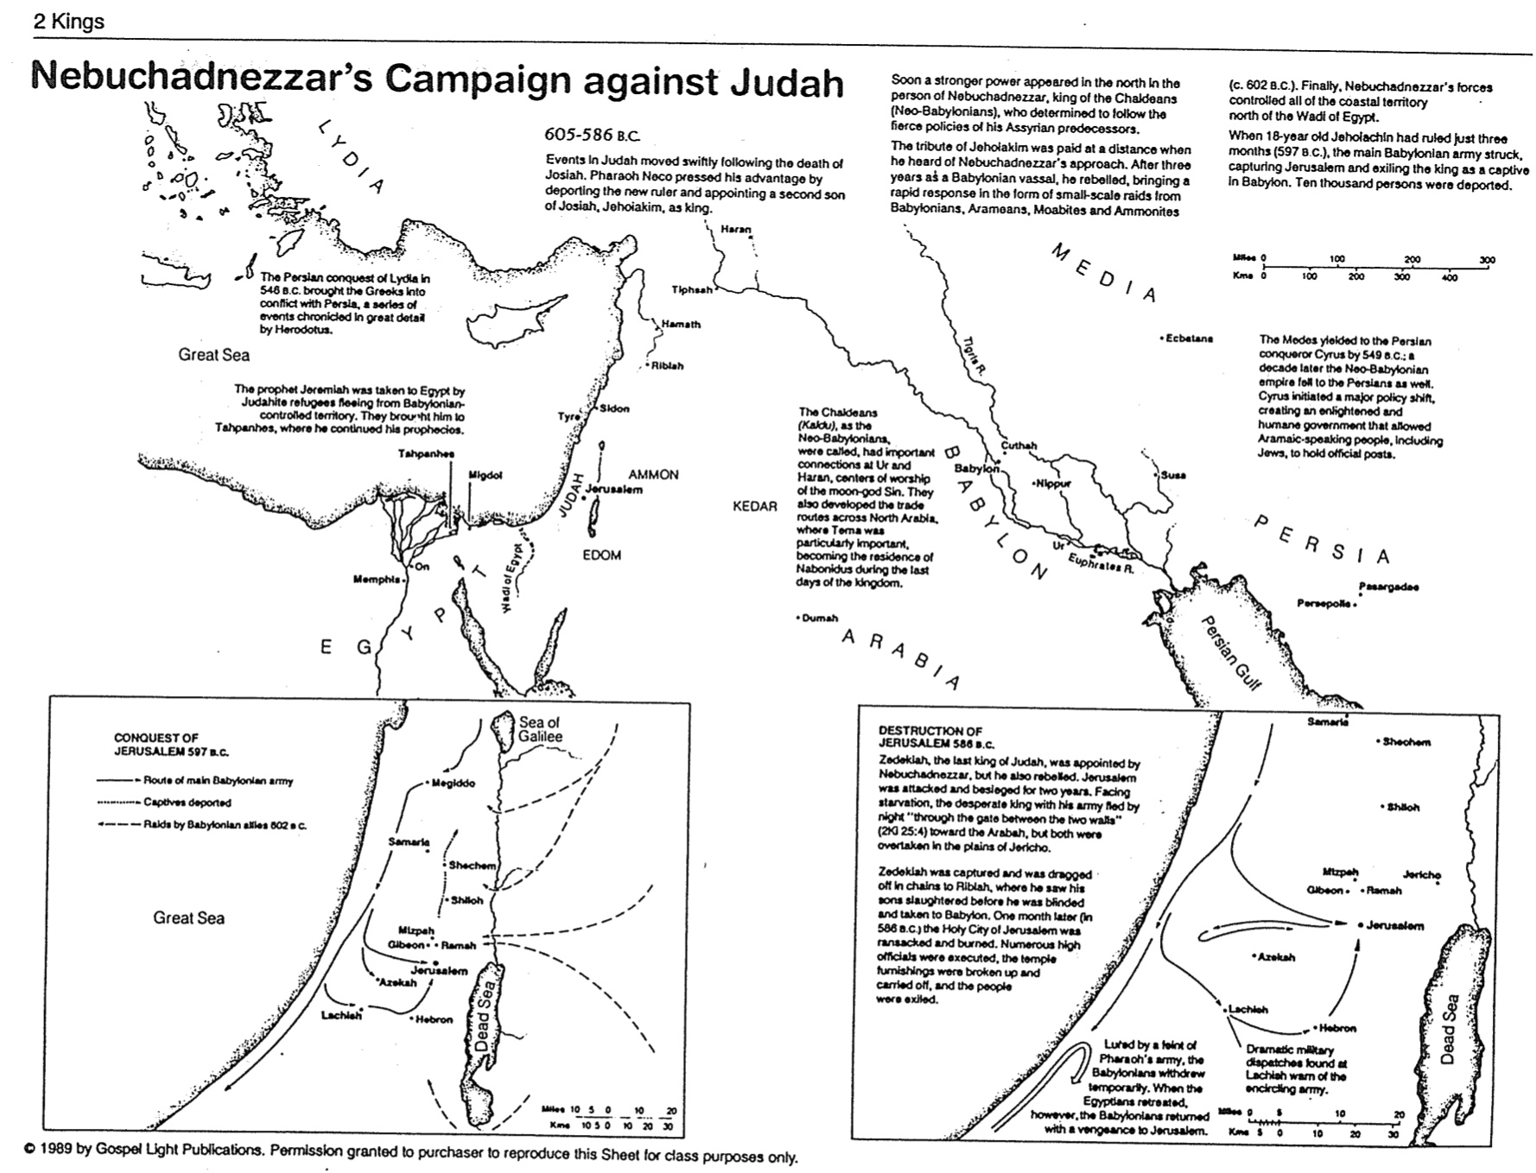
Exile of the Southern Kingdom
The Bible Visual Resource Book, 84

