**Deuteronomy**

|  |  |  |  |  |  |
| --- | --- | --- | --- | --- | --- |
| **Renewal of the Mosaic Covenant** | | | | | |
| **Past** | | **Present** | **Future** | | |
| **Examples** | | **Laws** | **Challenges** | | |
| **What God has Done** | | **What God Expects** | **What God will Do** | | |
| **Historical** | | **Legal** | **Prophetic** | | |
| **Preamble** | **Historical Prologue** | **Stipulations** | **Blessings and Curses** | **Covenant Renewal** | **Leadership Transition** |
| **1:1-4** | **1:5–4:43** | **4:44–26:19** | **27–28** | **29–30** | **31–34** |
| **Introduction** | **Sermon #1** | **Sermon #2** | **Sermon #3** | **Sermon #4** | **Sermons** |
| **Plains of Moab** | | | | | |
| **About 1 Month** | | | | | |

**Key Word: Renewal**

**Key Verse: “Hear, O Israel: The LORD our God, the LORD is one. Love the LORD your God with all your heart and with all your soul and with all your strength” (Deuteronomy 6:4-5)**

**Summary Statement:**

**Moses preaches and records sermons which expound the Law in order to encourage Israel's new generation in renewal of the covenant at Sinai, resulting in blessing in Canaan for obedience, not cursing for disobedience.**

**Applications:**

**True obedience is based on love—not legalism.**

**God’s general rule is that blessing results from obedience, but problems result from disobedience.**

**Renewal spiritually stems from recalling God’s past deliverance, committing to love Him in the present, and living with future hope in Him fulfilling His promises.**

**Deuteronomy**

**Introduction**

**I. Title** Deuteronomy means "second law" (Greek: δεύτερος, *second*, and νόμος, *law*). This title needs clarification, as the book adapts and expands upon the original law given on Mount Sinai. This English title stems from the Septuagint mistranslation of Deuteronomy 17:18 as "this repetition of the Law" (correctly rendered "this copy of the Law" in English translations). The Hebrew title is "These Are The Words" (הַדְּבָרִים אֵלֶּה *'elleh haddebarim*) from the first two words according to ancient methods of titling a work. This is a better title since the book records Moses' sermons that expound the Law (1:5).

**II. Authorship**

A. External Evidence: The ancient Jewish, Samaritan, and Christian testimonies uniformly attribute the authorship of Deuteronomy to Moses. Other Old Testament passages refer to the whole Pentateuch as Mosaic (cf. Josh. 1:7; Judg. 3:4; 1 Kings 2:3; etc.). Christ Himself considered the book authoritative (though he did not specifically mention Mosaic authorship) in His quotations of Deuteronomy during His temptation (cf. Matt. 4:4, 7, 10 with Deut. 8:3; 6:16, 13, respectively).

B. Internal Evidence: The Mosaic authorship of Deuteronomy has been held almost universally by Jews and Christians until the rise of 19th-century liberal critics. They don't know who wrote it, but they still assume this cannot be Moses for four reasons (Deere, *BKC*, 1:259-260):

1. These liberals believe the "book of the Law" found 800 years after Moses in Josiah's reign was a “pious forgery” of Deuteronomy written in Josiah's era (2 Chron. 34:14ff.).

Response: No one knows the identity of the "book of the Law" (whether it was Deuteronomy, the entire Pentateuch, or a portion of either), and the production of "pious frauds" is virtually unknown in the Near East as well as unethical (and an oxymoron). The book's structure also fits the time of Moses, not Josiah (see under “Characteristics” below).

2. They claim the book commands a central sanctuary (12:1-14) at Jerusalem to combat the worship at the "high places" in Israel's later history.

Response: The book does not claim that Jerusalem is this central sanctuary but cites Mount Ebal (27:1-8). This would be a significant oversight for a forger seeking to motivate Israel to replace the high places for true worship in Jerusalem.

3. Some material is post-Mosaic (2:10-12, 20-23; 3:13b-14; chap. 34).

Response: These are indeed later additions, but this does not provide convincing evidence that Moses did not record the bulk of the book. Neither is inspired editorial activity incompatible with the doctrine of inspiration.

4. It contains accurate predictions concerning Israel's exile and regathering (4:25-31; 28:20-68; 29:22-28; 30:1-10; 32:23-43).

Response: This reveals an anti-supernatural bias by saying even God cannot know the future!

How else do we know Moses wrote it? The book claims Moses wrote it over forty times (31:24-26; cf. 1:1-5; 4:44-46; 29:1; 31:9). It also views Canaan from the outside, assumes hearers recall the wilderness, shows Israel living in tents, has firsthand knowledge of geography and historical details, and follows the suzerain treaty form of the fifteenth and fourteenth centuries (*TTTB*, 37-38).

**III. Circumstances**

A. Date: Moses died before Israel entered the Promised Land (Deut. 34) in 1405 BC. The Book of Deuteronomy records his last words to the nation in this strategic year.

B. Recipients: The original readers comprised the new generation of Jews in Moab with Moses who heard him preach the sermons recorded in Deuteronomy.

C. Occasion: The nation had been elected by God (Genesis), redeemed from Egypt with a completed Tabernacle (Exodus), instructed for a month in holy living (Leviticus), and prepared for possession of the land through forty years in the wilderness (Numbers). At this point, the new generation was poised to subdue the land, having arrived at the plains of Moab just across from the Jordan River. Seeing his imminent death and the strategic time in the nation's history, Moses preached several significant sermons, then wrote them down to encourage Israel to love, believe, and obey God to receive His blessings. This generation’s need for this covenant renewal is evident in their major failure in immorality at Beth Peor just a short time earlier (cf. Num. 25).

**IV. Characteristics**

A. Deuteronomy is one of the most influential books in the Old Testament, with many quotations by the prophets and a notable number of manuscripts at Qumran. It is one of the Old Testament books most quoted in the New Testament (e.g., Matt. 4) with 49 quotations. This is exceeded only by more references to Psalms (119 times) and Isaiah (100 times). Of the 27 New Testament writings, 11 of them quote the book of Deuteronomy.

B. Deuteronomy possesses the famous *Shema* ("Hear") which states, "Hear, O Israel: The LORD our God, the LORD is one" (6:4). This simple declaration is the most significant doctrinal statement in the Old Testament, Judaism's basic confession of faith, the potent affirmation of monotheism and the declaration of God's uniqueness among the pantheon of Near Eastern "gods." It is probably the most explicit statement of the Trinity in the Pentateuch since "God" (*'elohim)* is plural but "one" (*'ehad*) may suggest a unity of Persons in the Godhead (cf. Gen. 2:24, where *'ehad* is used of Adam and Eve being "one flesh").

C. This final book of Moses also includes the greatest commandment—that Israel should love the LORD with totality of heart, soul, and strength (6:5). Love for God and obedience to God find their greatest marriage here of all the books of the Pentateuch. Still, the emphasis is on the former: the word "obey" occurs ten times, whereas "love" appears twenty-two times. The love of God towards Israel and His people's response of love back towards Him pervade the entire book.

D. This writing is also the first to mention the Great Tribulation (4:29-31).

E. The test for determining true and false prophets is found only in Deuteronomy (18:20-22).

F. Deuteronomy delineates the Land Covenant more than any book of Scripture (chs. 29–30). This covenant promises complete occupation of Canaan only after exile and repentance.

G. The structure of Deuteronomy is unique in Scripture as it follows a similar, though not identical, pattern of the fifteenth-century international vassal treaty. When a king (the suzerain) made a treaty with a subject country (vassal), the treaty generally included the following six elements, many of which find parallels in Deuteronomy (Deere, *BKC*, 1:260; LaSor, 144-146, 176):

**Element Explanation**  **Parallel in Deuteronomy**

1. Preamble Introduction to the Introduction: Historical Setting/Moses as

treaty Covenant Mediator (1:1-4)

2. Historical History of the king's Sermon #1: Historical Prologue

Prologue dealings with the vassal (1:5–4:43)

3. General Call for wholehearted Sermon #2: Covenant Obligations

Stipulation allegiance to the king (4:44–11:32)

4. Specific Detailed laws required of Sermon #2 cont'd: Specific Laws

Stipulations vassal to show allegiance (Chs. 12–26)

5. Divine Deities called to Heaven and earth witness since no deities

Witnesses witness the treaty exist (4:26; 30:19; 31:28; 32:1)

6. Blessings Results for obeying or Sermon #3: Blessings and Curses

and Curses disobeying the treaty (Chs. 27–28)

Sermon #4: Covenant Summary

(Chs. 29–30)

Narrative/Sermons: Transition of the Covenant Mediator from Moses to Joshua

(Chs. 31–34)

Chapters 29–34 do not follow the suzerain-vassal format. Still, this section has parallels too (Deere, *BKC*, 1:316): depositing the treaty in a sacred place (31:24-26), providing for dynastic succession (31:7-8), and providing for future reading of the covenant and covenant ceremonies (31:9-13).

**Argument**

As noted above, Deuteronomy follows the suzerain-vassal treaty format of its time. The LORD (suzerain) uses Moses as His covenant mediator to guide the new generation of Israel (vassal) to renew the Mosaic Covenant made with their parents who died in the desert. After a preamble (1:1-4), Moses reminds Israel of what the LORD had already done for the nation (1:5–4:43). Moses then expounds upon the stipulations to which Israel as the vassal must agree for renewal (4:44–26:19), and the results of either obeying or defaulting upon the covenant (chaps. 27–28). The final appeal for obedience (chaps. 29–30) is followed by the transition from Moses to Joshua as the covenant mediator (chs. 31–34), since the final chapter records Moses' death. In each section, Moses appeals to the nation to obey the covenant.

**Synthesis**

**Renewal of the covenant**

**1:1-4 Preamble: Setting/Mediator**

**1:5–4:43 #1: Historical Prologue**

1:5–3:29 God's faithfulness: Sinai to Beth Peor

4:1-43 Obedience exhorted

**4:44–26:19 #2: Stipulations**

4:44–5:33 Decalogue—General obligation

6–11 Loving the LORD—General principle

6:1-9 Shema declared

6:10–11:32 Shema expounded

12:1–26:15 Specific Laws–Allegiance

12:1–16:17 Ceremonial

16:18–20:20 Civil

21:1–26:15 Social

26:16-19 Covenant ratified

**27–28 #3: Blessings and Curses**

27 Palestinian renewal ceremony commanded

28 Blessings/Curses of Mosaic Covenant

**29–30 #4: Covenant Summary**

29 Obedience exhorted

30:1-10 Palestinian Covenant–ultimate blessings

30:11-20 Choose life/death

**31–34 Leadership Transition**

31:1-29 Appointment 31

31:30–32:43 Song 32

32:44–34:12 Death/replacement

32:44-52 Address

33 Blessing 33

34 Death 34

**Outline**

**Summary Statement for the Book**

**The last sermons of Moses expound the Law so Israel's new generation would renew the Sinai covenant to experience blessing in Canaan for obedience, not cursing for disobedience.**

# Preamble: The historical setting of Moses' sermons in the desert east of Canaan after Israel’s new generation conquered the Transjordan but before it possessed Canaan provides the context for the Land Covenant (1:1-4).

## The Book of Deuteronomy contains what Moses, the covenant mediator, speaks to Israel's new generation, who is opposite the Jordan River, to provide the context for the Land Covenant (1:1).

## The time of Deuteronomy is after the Transjordan conquests in the final month (cf. 34:8) of the 40 years of wandering that should have taken eleven days, showing the cost of disobeying God (1:2-4).

# Historical Prologue: Moses' first sermon reviews God's blessings when the people obeyed and judgment when they rebelled to exhort them to obey the Law and resist idolatry (1:5–4:43).

## Reviewing God's acts for Israel from Sinai to Beth Peor reminds the people of His deliverance and provision when they obeyed and judgment when they rebelled (1:5–3:29).

## Israel should obey the Law and resist idolatry based on God's benevolent acts for them (4:1-43).

# Stipulations: Moses' second sermon gives the general covenant obligations and specific laws that God expects to encourage Israel to total allegiance to the LORD as King (4:44–26:19).

## The Ten Commandments are repeated for the new generation as their general covenant obligation since their defection at Beth Peor showed that they needed to review God's stipulations (4:44–5:33).

### An introduction to the Ten Commandments reminds the new generation to hear them afresh due to their idolatry and immorality at Beth Peor five months before (4:44-49; cf. Num. 25:1-3).

### The Ten Commandments that God spoke to their parents at Mount Sinai are repeated as the general covenant obligation for the new generation of Israel (Chap. 5).

## The basic obligation to love the LORD is shown in obedience, encouraging Israel to have total allegiance to the LORD as King (Chs. 6–11).

### The basic principle in the *Shema*—to love the LORD—by thanking Him for an undeserved land and teaching the Law to their children will give Israel land, long life, and material wealth (6:1-9).

#### Israel is promised blessings of land, long life, and material prosperity as an incentive to obey the covenant (6:1-3).

#### The importance of loving the LORD (the *Shema*) is the basis for obeying all stipulations in the covenant (6:4-9).

### Loving the LORD through obeying basic commands and warnings encourages Israel to total allegiance to the LORD as King (6:10–11:32).

#### Thanking God for a land not deserved so as not to acquire a sense of independence shows love for the LORD (6:10-19).

#### Teaching the Law to one's children so that this love might continue in future generations shows love for the LORD (6:20-25).

#### Conquering Canaan completely so that no rival may exist to God's Lordship shows love for the LORD (Chap. 7).

#### Remembering God's provision in the wilderness so that the land's abundance will not promote a spirit of self-sufficiency shows love for the LORD (Chap. 8).

#### Avoiding self-righteousness by remembering God's mercy at the golden calf failure shows love for the LORD (9:1–10:11).

#### Israel should love the LORD due to their election, His mighty deeds, the resulting success, and obedience from love leading to longevity in the land instead of a curse (10:12–11:32).

## Israel agrees to obey specific ceremonial, civil, and social laws in total allegiance to the LORD as King (12:1–26:15).

### Ceremonial laws encourage Israel to total allegiance to the LORD as King (12:1–16:17).

#### *A single, central sanctuary* must be the sole place of worship to prevent Israel from sacrificing on the Canaanite worship centers, which the nation must destroy (12:1-28).

#### *Idolatry* must be repressed by the destruction of false prophets, family members, friends, and towns to prevent all pagan practices (12:29–13:18).

#### *Unclean food* must not be eaten since it symbolizes evil in the human realm to teach Israel its unique relationship to God among the nations (14:1-21).

#### *Tithes* must be given for the Levites and the poor to show total allegiance to the LORD, who can make up for money dedicated to Him (14:22-29).

#### *Debts* must be canceled, and slaves must be set free every seventh year to show a generous heart towards God and man (15:1-18).

#### *Firstborn animals* must be given to God to show total allegiance to the LORD, who can make up for animals dedicated to Him (15:19-23).

#### *The three annual pilgrimage Feasts* of Passover/Unleavened Bread, Weeks, and Tabernacles will corporately remind Israel of the LORD as Deliverer and Provider (16:1-17).

### Civil laws exhort Israel to allegiance to the LORD as King (16:18–20:20).

#### Administrators appointed to maintain justice must themselves be just (16:18–18:22).

##### Judges and officials must be impartial and not accept bribes, and the verdict of the law courts must stand (16:18–17:13).

##### Kings must avoid materialism and write their copy of this law so they will humbly follow God (17:14-20).

##### Priests and Levites must live on the support of the people so that Israel will express allegiance to the LORD through sacrificial giving (18:1-8).

##### Prophets must avoid detestable practices and be 100% accurate to avoid the death penalty (18:9-22).

#### Criminal laws must provide cities of refuge, punish thieves who steal property by moving boundaries, and fit judgments to the crime based on at least two witnesses (Chap. 19).

#### Holy war laws dictate courage in battle, exemption for certain men from military service, offering peace before a siege, and a prohibition from destroying fruit trees (Chap. 20).

### Social laws encourage Israel to total allegiance to the LORD as King (21:1–26:15).

#### Atonement for an unsolved murder shows how to purge the land of the guilt of shedding innocent blood (21:1-9).

#### Family laws prescribe the right way to marry a captive woman, the rights of the firstborn son, and killing a rebellious son, to keep family rights intact in Israel (21:10-21).

#### Various social laws encourage total allegiance to the LORD as King (21:22–22:12).

#### Marriage violations in sexual matters such as dissatisfaction, rape, and adultery are condemned to uphold the marital vow and premarital purity (22:13-30).

#### Exclusion from the assembly of emasculated and specific foreign individuals will enable Israel to worship in purity (23:1-8).

#### Laws of nocturnal emission and proper means of disposing of excrement help prevent uncleanness in the camp to retain God's abiding presence (23:9-14).

#### Social laws, mainly on finances, divorce, and remarriage, show total allegiance to the LORD (23:15–25:19).

#### Ceremonial rituals for presenting first fruits and tithes show thankfulness and allegiance to the LORD (26:1-15).

## Israel and God both ratify the covenant by vowing to fulfill their respective commitments as a binding conditional suzerain-vassal treaty (26:16-19).

# Moses' third sermon commands renewal of the covenant in Canaan to motivate obedience through declaring blessings for obedience and curses for disobedience (Chs. 27–28).

## Israel must renew the covenant in Canaan to reinforce the official responsibilities the nation promised to obey (Chap. 27).

### Israel must have the proper ceremony to renew the covenant after they arrive in Canaan to reinforce the seriousness of their covenant duties (27:1-8).

### After explaining all the covenant stipulations, Moses finally declares, "You have now become the people of the LORD your God…" to initiate the covenant for the people (27:9-10).

### The covenant renewal must have "blessing" tribes on Mount Gerizim and "cursing" tribes on Mount Ebal with Levites in between to show which tribes get God's special blessing (27:11-14).

### The Levites must then recite twelve curses, primarily upon those who break the Decalogue and/or sin in secret, to inform Israel of the severity of disobeying the covenant (27:15-26).

## Blessings for obedience and curses for disobedience should motivate Israel to obey the covenant (Chap. 28).

### Blessings for obedience include military victories over the nations, material and agrarian wealth, and a worldwide reputation of intimacy with God to encourage covenant obedience (28:1-14).

### Curses for disobedience include destruction, disease, drought, military defeat, oppression, crop failure, economic ruin, besieged cities, and exile to exhort obedience (28:15-68).

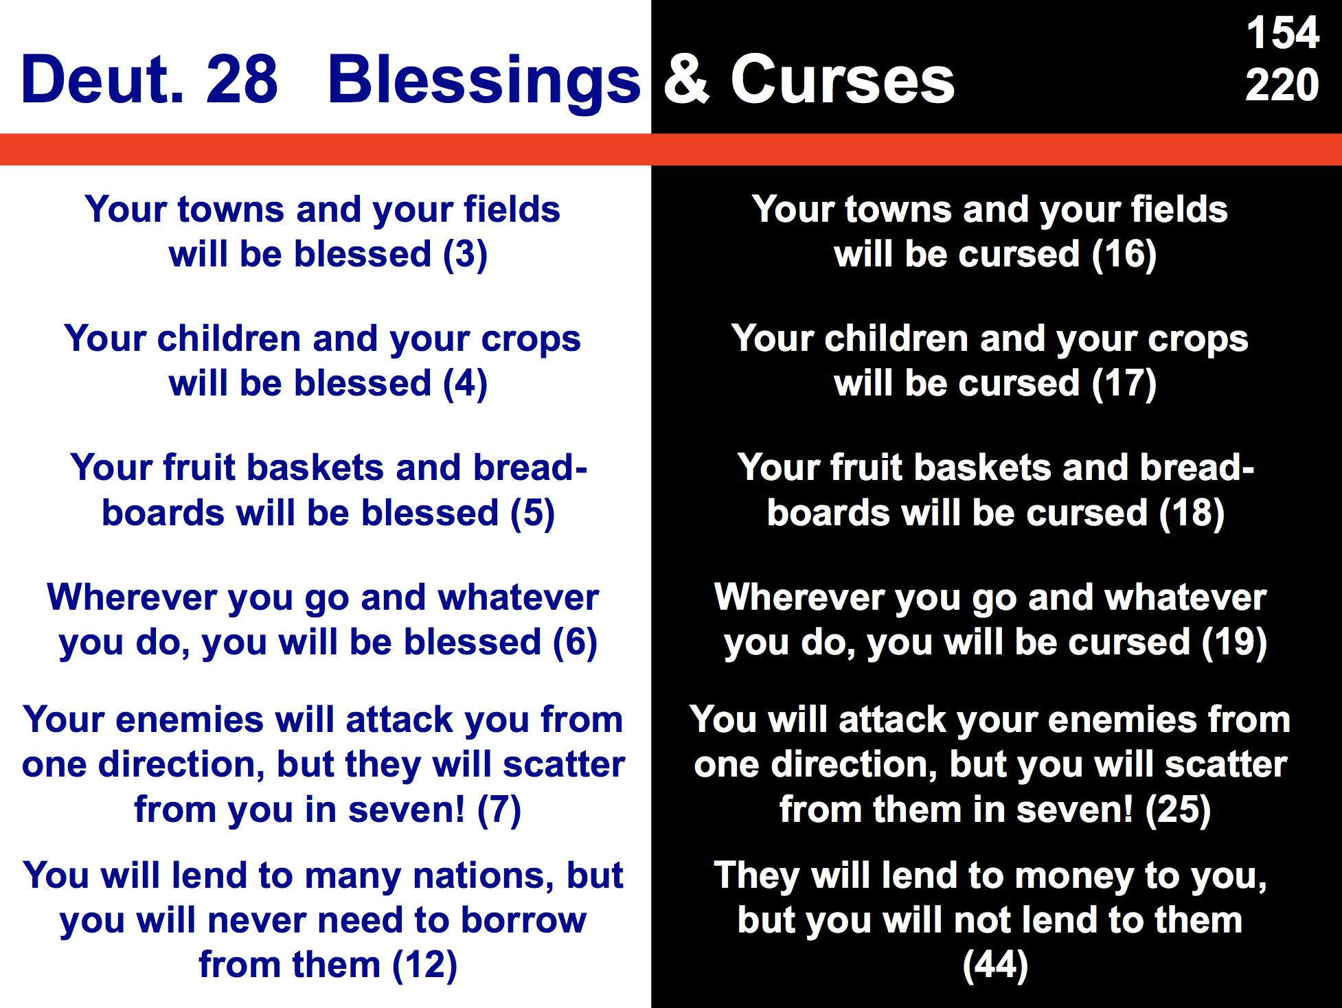

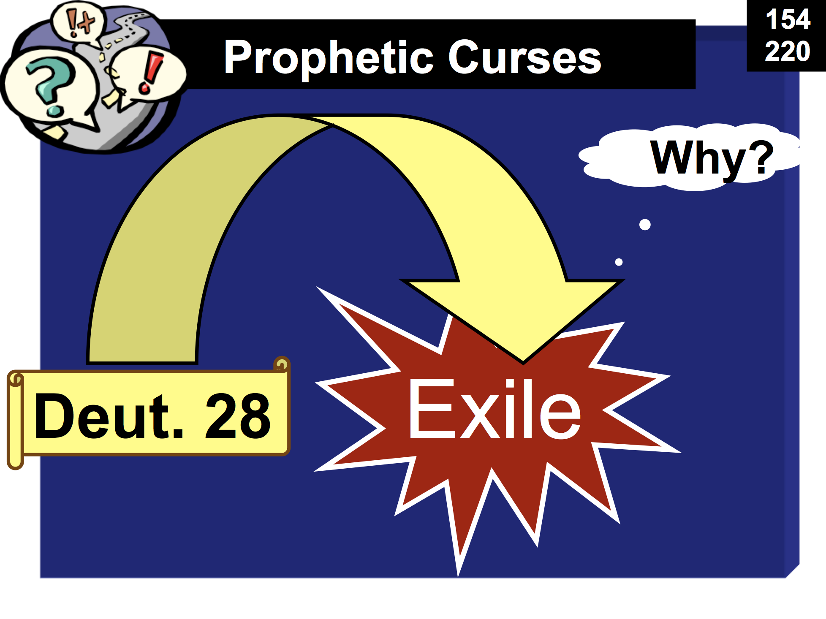

# Moses' fourth sermon appeals to covenant obedience and assures the ultimate blessing of motivating Israel to obey the covenant (Chaps. 29–30).

## Israel should commit itself afresh to the Mosaic Covenant in light of the LORD's past faithfulness and future curses for disobedience (Chap. 29).

## The Land Covenant assures prosperity after exile and repentance [at Christ's Second Coming before the Millennium] to warn that blessing depends on repentance and to encourage Israel with the promise of ultimate blessing (30:1-10).

## Israel should choose the prosperity of obedience (life) rather than the destruction of disobedience (death) since they know precisely what the Law requires and can obey it, to maintain that both the choices and consequences are clear (30:11-20).

# The transition from Moses to Joshua as the covenant mediator instructs Israel in God's faithful provision for covenant continuity and warns of apostasy for covenant obedience (Chs. 31–34).

## Moses appoints Joshua and deposits the Law while the LORD warns of Israel's future rebellion to help Israel see the need for covenant faithfulness (31:1-29).

## The Song of Moses on Israel's gloomy future for apostasy commands covenant-renewal ceremonies to remind them to obey the LORD and His righteous judgment if they fall away (31:30–32:43).

## Moses’s death and replacement by Joshua instruct Israel in God's faithful provision for covenant continuity (32:44–34:12).

### Moses prepares for death before his last sermon, and God commands him to ascend Mount Nebo for his death (32:44-52).

### In his last message, Moses blesses the tribes so that the nation will thrive and experience the blessings of the covenant (Chap. 33).

### Joshua records Moses' death and burial by the LORD on Mt. Nebo after seeing the land from afar, and Joshua replaces him to show God's faithfulness for covenant continuity (Chap. 34).

**Major Social Concerns in the Mosaic Covenant**

*The Bible Visual Resource Book*, 39

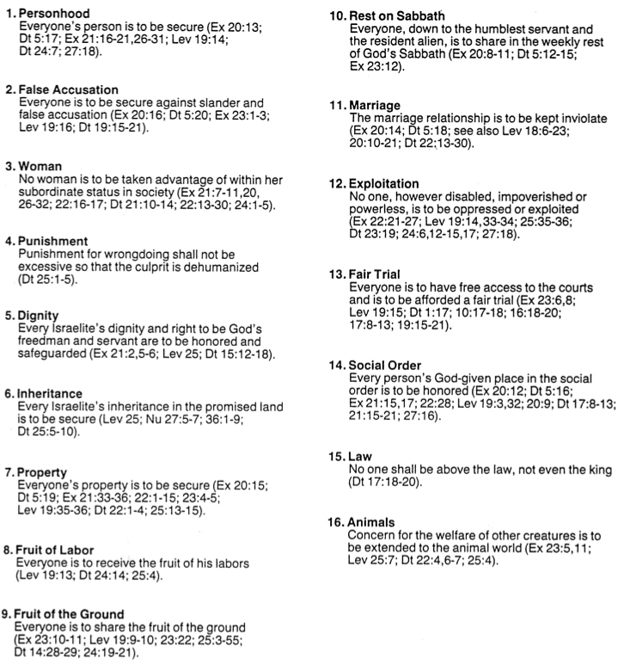**Sacrifices at the High Places**

One of the perplexing issues in the OT historical books concerns the high places. Were these spots alternate places to sacrifice to the LORD, or did they always relate to pagan deities?

In patriarchal times, men like Job, Abraham, and Jacob built altars in many places and offered sacrifices. However, the first prohibition of sacrifices in various locations is probably in Leviticus, which was revealed to the people at Mount Sinai before they entered Canaan.

Any Israelite who sacrifices an ox, a lamb or a goat in the camp or outside of it instead of bringing it to the entrance to the Tent of Meeting to present it as an offering to the LORD in front of the Tabernacle of the LORD—that man shall be considered guilty of bloodshed; he has shed blood and must be cut off from his people. This is so the Israelites will bring to the LORD the sacrifices they are now making in the open fields. They must bring them to the priest, that is, to the LORD, at the entrance to the Tent of Meeting and sacrifice them as fellowship offerings (Lev. 17:3-5).

A similar text commands sacrifice at only one spot (later revealed to be Jerusalem):

But you will cross the Jordan and settle in the land the LORD your God is giving you as an inheritance, and he will give you rest from all your enemies around you so that you will live in safety. Then to the place the LORD your God will choose as a dwelling for his Name—there you are to bring everything I command you: your burnt offerings and sacrifices, your tithes and special gifts, and all the choice possessions you have vowed to the LORD. And there rejoice before the LORD your God, you, your sons and daughters, your menservants and maidservants, and the Levites from your towns, who have no allotment or inheritance of their own. Be careful not to sacrifice your burnt offerings anywhere you please. Offer them only at the place the LORD will choose in one of your tribes, and there observe everything I command you (Deut. 12:10-14; cf. 14:23-25; 16:6, 11, 15-16).

The judgments for disobeying the Mosaic Law included God’s destruction of these places. God said if Israel persisted in sin, “I will destroy your high places, cut down your incense altars and pile your dead bodies on the lifeless forms of your idols, and I will abhor you” (Lev. 26:30). For this reason God commanded the people, “Drive out all the inhabitants of the land before you. Destroy all their carved images and their cast idols, and demolish all their high places” (Num. 33:52; Deut. 33:29).

But Israel did not destroy them. In fact, after entering the land we find Samuel offering sacrifices at a high place (1 Sam. 9:12-25; cf. 10:5, 13) where they were certainly legitimate (Homer Heater, “A Theology of Samuel and Kings,” *Biblical Theology of the OT*, ed. Roy B. Zuck, 117, 126).

God even granted Solomon’s request for wisdom at “the most important high place” (1 Kings 3:4)! How are we to deal with these texts, especially the last one which is preceded by the clear statement, “Solomon showed his love for the LORD by walking according to the statutes of his father David, except that he offered sacrifices and burned incense on the high places” (1 Kings 3:3)? It appears that God is both blessing and condemning high place sacrifice in the same text.

Perhaps the solution is found one verse earlier still: “The people, however, were still sacrificing at the high places, because a temple had not yet been built for the Name of the LORD” (1 Kings 3:2). Maybe God conceded His command in Leviticus until the temple was built.

Yet after the temple was built, sacrifices were prohibited outright in the high places. Solomon built pagan high places (1 Kings 11:7)—the very king who built the temple! And Jeroboam built them at Bethel and Dan to prevent the people in the north from going to Jerusalem to sacrifice at the temple (1 Kings 12:31-32; 13:2, 32-33). Many kings made the mistake of allowing these places to continue (1 Kings 14:23; 15:14; 22:43; 2 Kings 12:3-4; 14:4; 15:4, 35; etc.). Brief revivals occurred when Hezekiah (2 Kings 18:4) and Josiah (2 Kings 23:5-20) tore these places down, but the general practice was to rebuild them.

Disagreeing with this analysis is Heater, who states, “When David brought the ark to Jerusalem, the centralization of worship began. The high places, *legitimate places of worship*, continued throughout the history of the monarchy, but Jerusalem, the home of the Ark, increasingly became the center of worship” (ibid, 126-27, *italics* mine).

**Grumbling in the Wilderness**

Chart adapted from Paul N. Benware, *Survey of the Old Testament,* 68

God hates complaining, so He commands believers to do all things without complaining and arguing (Phil. 2:14).

Unfortunately, Israel did not learn this lesson very well. The following summary shows how God initially tolerated the people’s complaining in the wilderness by supplying their needs in the Exodus account. However, in Numbers, most of the time, He judged grumbling in severe ways. By the time the people were poised to enter the land in Deuteronomy, they had lost thousands of fellow Israelites to complaining.

Notice also Moses’ response to the people’s complaints. He never joined in with them in this sin, but instead brought it to the LORD and rebuked the people for their ungratefulness. Are there any lessons in spiritual leadership for you here?

|  |  |  |  |  |  |
| --- | --- | --- | --- | --- | --- |
| Scripture | | Israel’s Complaints | Moses’s Response | | God’s Response |
| Ex 14:11 | Grumbled at the sight of Pharaoh’s army | | Encouraged Israel to trust God | Delivered Israel | |
| Ex 15:24 | Grumbled about the bitter water | | Cried out to God | “Healed” the water | |
| Ex 16:2 | Grumbled about the lack of food | | Rebuked Israel | Supplied manna | |
| Ex 17:2 | Grumbled about the lack of water | | Prayed to the Lord | Water from the rock | |
| Num 11:1 | Grumbled about God’s provision of food | | Anger and prayer | Judgment | |
| Num 14:2 | Grumbled about Moses’s leadership so can’t possess Canaan | | Pled with Israel, prayed to the Lord | Judgment | |
| Num 16:2 | Grumbled about Moses’s leadership | | Rebuked and prayed | Judgment | |
| Num 16:41 | Grumbled about Moses | | Prayed | Judgment | |
| Num 20:2 | Grumbled about Moses and a lack of water | | Rebuked Israel  Struck rock | Supplied water | |
| Num 21:4 | Grumbled about Moses and the manna | | No response | Judgment | |

**Covenant Contrasts**

There are only four key eschatological covenants in Scripture. They share these traits in common:

1. Unconditional

2. Eternal

3. Partially & spiritually fulfilled at present

4. Fully & literally fulfilled in the future

5. Universal in scope

Yet they can be contrasted in many ways as well (see also Eschatology notes, pages 21-22, 55a, 59-61, 116):

|  |  |  |  |  |
| --- | --- | --- | --- | --- |
|  | **Abrahamic** | **Land** | **Davidic** | **New** |
| ***Definition:***  ***God’s promise to give Israel…*** | land, rule, and blessing to benefit the world | *physical* land from the Wadi of Egypt to the Euphrates River (Gen. 15:18) | *political* rule  of a descendant of David forever from Zion | *spiritual* blessings of national cleansing and restoration |
| ***Relationship*** | Umbrella | Land | Seed | Blessing |
| ***Key Text*** | Gen. 12:1-3 | Deut. 30:1-10 | 2 Sam. 7:12-16 | Jer. 31:31-34 |
| ***Recipient***  ***Date***  ***Place*** | Abraham  2060 BC  Ur of Chaldees | Moses  1445 BC  Mt. Sinai | David  1004 BC  Jerusalem | Jeremiah  595 BC  Jerusalem |
| ***Personal Blessings***  ***to First***  ***Recipient*** | Possessions & name blessed, son, opposers disciplined | Privilege of seeing Canaan from afar | Sons (“house”) never wiped out (Matt. 1:1-17) | – |
| ***National***  ***Blessings*** | A great nation would come from Abraham | Reproof (exile)  Regathering  Reunited (Isa.  11:11-16)  Repentance  Restored land  prosperity | Temple (via son)  Righteous king to rule (a Davidic descendant) over a kingdom where Israel prominent (Isa. 11:1-5) | Reuniting of Israel  and Judah  Forgiveness  Indwelling Spirit  New heart  100% Christian  (Ezek. 36:25-38) |
| ***Universal***  ***Blessings*** | All nations blessed through Christ | World blessed via visiting Jerusalem (Zech. 14:16-19) | Kingdom (political rule over entire world) | All the world evangelized |
| ***Present (Partial) Fulfillment*** | Church as spiritual seed of Abraham (Gal. 3:5) | Regathering & rebirth of modern Israel (Ezek. 37:7-8) | Church as spiritual temple (Eph. 2:19-22) & Christ as the King awaiting rule | Law abolished, forgiveness, new nature and Spirit indwelling |
| ***Future***  ***(Full)***  ***Fulfillment*** | All four covenants fulfilled in the millennial kingdom | Israel given full borders (Ezek. 37:8-28; 47–48) | Christ rules world (Isa. 2, 11) with saints (Rev. 5:10) | World 100%  Christian and Israel/Judah reunited |

**Key OT Passages about the Land**

David Larsen, *Israel, Gentiles and the Church*, 26 (adapted in Jeremiah texts)

Perhaps more than with any religious group (including Christians), the heart of Judaism lies in the land of its forefathers. The land and the people are inseparable to Jews, for they experienced God’s presence indwelling the temple in Jerusalem for centuries (966-586 BC). This emphasis on the land of Canaan is repeated numerous times in the Old Testament:

|  |  |  |  |
| --- | --- | --- | --- |
| Genesis | 12:7; 13:14-17; 15:7-21; 17:1-8; 24:7; 28:13-15 | Jeremiah | 12:14-17; 16:14-15, 18; 18:16; 23:5-8; 30:18-21; 31:10-14, 21-40; 32:37-41; 33:10-13 |
| Exodus | 12:25; 13:5, 11; 32:13; 33:1 | Ezekiel | 11:17-21; 17:22-24; 34:11-31; 37:1-14 |
| Numbers | 11:12; 14:15-16, 23; 32:8 | Hosea | 13:9–14:9 |
| Deuteronomy | 1:8; 6:10; 9:28; 12:20; 19:8; 27:3 | Micah | 2:12 |
| Joshua | 23:5 | Zephaniah | 2:19-20 |
| Isaiah | 5:25-26; 11:11-12; 66:19-20 | Zechariah | 12:10-11 |

Which books have the most significant emphasis on the land?

Why do you think this is so?

**Israel’s Future in Deuteronomy 28–32**

Adapted from Wilbur M. Smith, “Prophecies Regarding Israel,” *Moody Monthly* (December 1958), 39   
(Quoted by David Larsen, *Israel, Gentiles and the Church,* 23-24)

Deuteronomy 28–32 summarizes Israel’s future from Moses’ time to a time yet future. These prophecies are repeated throughout the Old Testament.

|  |  |
| --- | --- |
| **31:16-21** | **Israel will turn away from the Lord (began after Joshua’s death)** |
| **28:15-60** | **God will judge Israel in the land for her apostasy (period of judges and divided kingdom)** |
| **28:32-39, 48-57** | **Israel will be taken captive (by Assyria and Babylon)** |
| **28:33** | **Israel’s enemies will possess her land for a time (Babylon, Persia, Greece, Romans, Catholic Crusades, Muslims, Britain, etc.)** |
| **28:38-42; 29:23** | **The land will remain desolate (AD 70 to AD 1948)** |
| **28:63-67; 32:26** | **Israel will be scattered among the nations “from one end of the earth to the other” (28:64; AD 70 to AD 1948)** |
| **28:62** | **Israel will be “few in number” (today Jews comprise of 1% of the world’s population)** |
| **28:44-45** | **Though punished, Israel will not be destroyed if she repents** |
| **28:40-41; 30:1-2** | **Israel will indeed repent in her tribulation (trials have continued throughout the ages but will increase in the 72 month Great Tribulation)** |
| **30:3-10** | **God will regather Israel from the nations and bring her back to her divinely given land (it began in the late 1800s in unbelief as predicted in Ezekiel 37:7-8 and continues even today)** |
| **30:3-13; 28:1-14** | **Israel’s obedience will be blessed in numerous ways (worldwide acclaim and prosperity in the millennial kingdom)** |