Numbers

Preparation to Occupy the Land

Preparing the  Old Generation |  | Postponement  for Unbelief |  |  |  |  | Preparing the  New Generation
1:1–10:10 |  | 10:11–25:18 |  |  |  |  | 26–36
God’s Faithfulness |  | Israel’s Faithlessness |  |  |  |  | God’s Faithfulness
God’s Blessings |  | God’s Discipline |  |  |  |  | God’s Blessings
Israel’s Commitment |  | Israel’s Complaining |  |  |  |  | Israel’s Commitment
Order |  | Disorder |  |  |  |  | Reorder
Mount Sinai |  | Wilderness |  |  |  |  | Moab
20 Days |  | 38 Years, 3 Months, 10 Days |  |  |  |  | ca. 5 Months
Organization  (1–4) | Sanctification (5:1–10:10) | To Kadesh (10:11–12:16) | Kadesh Sin (13–14) | Wilder-ness (15–19) | To Moab (20–21) | Moab Sin (22–25) | Provision for Land (26–27) | Offerings & Vows (28–30) | Final Preparations (31–36)

Key Word: Preparation

Key Verses: Discipline–“Not one of the men who saw my glory and the miraculous signs I performed in Egypt and in the desert but who disobeyed me these ten times–not one of them will ever see the land I promised on oath to their forefathers…” (Numbers 14:22-23)

Blessing–“God is not a man, that he should lie, nor a son of man, that he should change his mind. Does he speak and then not act? Does he promise and not fulfill? I have received a command to bless; he has blessed, and I cannot change it” (Numbers 23:19-20)

Summary Statement:
God prepared Israel to enter Canaan by showing that he would fulfill the Abrahamic Covenant only through believing Israelites.

Applications:
We as believers need to realize that God has given us everything we need to do his will, but disobedience deserves discipline.

God will get his will done either through us or in spite of us.

Are we characterized by commitment or complaining?

Numbers

Introduction

I. Title The name for the book of Numbers comes from two censuses of Israel about 38 years apart. The first census was of the Exodus generation at Mount Sinai (Num 1) and the second recorded those on the plains of Moab born in the wilderness who later conquered Canaan (Num 26). The Hebrew title is "And He Said," taken from the first word of the book (rBed:y>w: Wayyedabber). However, Jewish writings usually refer to the writing as "In the Wilderness" from the fifth word of 1:1 (rB;d>miB. Bemidbar).

II. Authorship

A. External Evidence: Ancient Jewish, Samaritan, and Christian testimony uniformly claims that Moses authored the book of Numbers.

B. Internal Evidence: Numbers states "the LORD spoke to Moses" more than 80 times, starting in 1:1. However, 33:2 gives the clearest reference to his authorship: "Now Moses wrote down the starting points of their journeys at the command of the LORD" (cf. 36:13). The book also evidences a consistency of style characteristic of a single author. Nevertheless, most critical scholars deny Mosaic authorship based upon the varying linguistic forms within the work (e.g., LaSor, 165).

III. Circumstances

A. Date: Mosaic authorship places the writing in his lifetime (1525-1405 BC). The tabernacle was set up exactly one year after the Exodus (Exod 40:17) and Numbers picks up the story one month later (Num 1:1). Therefore, the time covered by Numbers begins one year after the Exodus (in 1444 BC) and covers the 38 year and nine month (Num. 10:11; Deut. 1:3; cf. LaSor, 163) wilderness wandering until just before the conquest of Canaan (beginning ca. 1405 BC). Moses probably kept a journal of the wanderings and compiled them shortly before his death in ca. 1405 BC.

B. Recipients: Moses did not enter Canaan so the first readers were the Jews in the wilderness.

C. Occasion: The nation had been redeemed from Egypt and constructed the tabernacle (Exodus), had learned about holy living (Leviticus), and thought it ready to possess the land. However, God knew that Israel was not ready (cf. Exod. 13:17) without more preparation, so he organized the people for conquest (1:1–10:10), though their unbelief prevented them from entering Canaan (10:11–25:18).

IV. Characteristics

A. Numbers is the book of the wilderness wanderings. Exodus records the short journey from Egypt to Sinai, but Numbers chronicles the nearly 40-year wilderness journey.

B. Numbers provides more census data about pre-exilic Israel than any book (Num 1, 26).

C. Numbers illustrates truths twice in the New Testament (1 Cor. 10:1-12; Heb. 3:7–4:6).

Argument

While Leviticus relates to the nation's worship, Numbers records the nation's walk. Numbers records how God prepared Israel to walk with him in a covenant relationship (1:1–10:10) but the nation postponed the fulfillment of the promise of the land through unbelief, so God purged it of its rebellion (10:11–25:18). Nevertheless, due to God's faithfulness to his covenant, he prepared the next generation of Jews to enter the land (chs. 26–36). The narrative continually contrasts God's faithfulness with Israel's faithlessness. We are fickle, frazzled, fleeting and floundering but God is fair, fantastic, far-sighted and a faithful foundation.

Synthesis

Preparation to occupy the land (God's faithfulness vs. Israel's faithlessness)

1:1–10:10 Preparing the old generation
1–4 Travel organization
1–2 Census/camp/march
3–4 Levite responsibilities
5:1–10:10 Sanctifying Israel
5–6 Separation
7:1–9:14 Worship
9:15–10:10 Divine guidance

10:11–25:18 Postponement for unbelief
10:11–12:16 To Kadesh
10:11-36 Leave Sinai
11 Quail
12:1-15 Miriam/Aaron oppose
12:16 Paran
13–14 Kadesh: Climactic unbelief
15–19 Wilderness
15 Offering/death penalty review
16 Korah
17–19 Priests-rod, roles, heifer
20–21 To Moab
20 Rock water
21 Sihon, Og, bronze snake
22–25 Moab
22–24 Balaam/Barak
25 Beth Peor

26–36 Preparing the new generation
26–27 Provision for land
26 New census
27:1-11 New inheritance law
27:12-23 New leader–Joshua
28–30 Offerings/vows
31–36 Final preparations
31–32 Transjordan conquered
33:1-49 Wanderings summarized
33:50–36:13 Canaan defined (boundaries, Lev./refuge cities, new inherit. law)

Outline

Summary Statement for the Book
The way God prepared Israel to enter Canaan was by showing that he would fulfill the Abrahamic Covenant only through believing Israelites.

I. The way God prepared Israel’s old generation to enter Canaan was by fulfilling the covenant to Abraham through an orderly and holy nation (1:1–10:10; 20 days at Mount Sinai).

A. God organizes Israel's old generation and Levites for efficient travel through the wilderness and conquest of Canaan (Num 1–4).

1. God organizes the people through an army census, camp arrangement, and marching order as his preparation to defeat the Canaanites (Num 1–2).

a. The first census in Israel numbers 603,550 soldiers to show God faithful to provide Israel an army to defeat the Canaanites (Num 1).

b. The camp planning and marching order affirms God's desire for an orderly people (Num 2).

2. God organizes the Levites to care for and transport the tabernacle and redeems them for lifelong service that Israel would treat his holy things respectfully (Num 3–4).

a. God appoints the three Levite clans to care for the tabernacle so that Israel would treat the holy things respectfully (3:1-39).

b. God substitutes Levites for the firstborn sons as compensation for sparing the firstborn Israelites at the Exodus to provide lifelong servants for the tabernacle (3:40-51).

c. God assigns the tabernacle transport to the three Levite clans to orderly move his holy things (Num 4).

B. God sanctifies Israelites through separation, worship, and his guiding presence so they could enter Canaan as a holy nation (5:1–10:10).

1. Laws of holiness by separation preserve the camp’s physical, social, spiritual, and marital purity (Num 5–6).

a. Make ritually unclean people live outside the camp to protect its physical purity (5:1-4).

b. Recompense for financial wrongdoing to protect Israel’s social purity (5:5-10).

c. Test women suspected of adultery to protect Israel’s marital purity (5:11-31).

d. Separate Nazirites to protect Israel’s spiritual purity (6:1-21).

e. Bless the Israelites that God might separate them as his own unique people (6:22-27).

2. Israel's sanctification through worship will give God his due honor (7:1–9:14).

a. Each tribe offers identical gifts at the tabernacle dedication as sanctified worship to honor God (Num 7).

b. The arrangement of the lighted lamps gives Israel more formerly unrevealed teaching about its worship (8:1-4).

c. The Levites' consecration provides divine approval for the worship of Israel (8:5-26).

d. God allows Passover for the ceremonially unclean one month later but only in the prescribed manner to encourage Israel to worship God in holiness (9:1-14).

3. Israel's sanctification through God’s guidance in the tabernacle cloud and assembly trumpets assures his presence so Israel might enter Canaan as a holy nation (9:15–10:10).

a. God guides Israel through the tabernacle cloud to sanctify the people with his presence and help them depend on him for direction (9:15-23).

b. Trumpets must be blown for meetings, battle, and feasts to recall his guiding presence (10:1-10).

II. The way God prepared believing Israelites for Canaan was by judging the old generation’s unbelief and blocking their entry (10:11–25:18; 38-year wilderness wandering).

A. God judges Israel's unbelief en route to Kadesh shown in complaining over manna and opposing leadership by Moses to affirm his just yet faithful guiding to Canaan (10:11–12:16).

1. Israel leaves Sinai at the LORD’s command in original trust in God's guidance (10:11-36).

2. God provides quail for the people when they complain about the manna but judges them with plagues for their rebellion to teach his grace balanced with justice (Num 11).

3. God judges Miriam and Aaron for envy of Moses by briefly making Miriam leprous to show he approves of Moses (12:1-15).

4. Israel leaves Hazeroth north of Sinai and camps in the Desert of Paran to move closer to the Promised Land (12:16).

B. God judges Israel's unbelief to enter Canaan from Kadesh by forbidding future entrance into the land to teach that his rest can be claimed only by faith (Num 13–14).

C. God judges Israel's unbelief in the wilderness by resisting his leaders and teaches about priests for Israel to respect leaders and obey the covenant for God's nonstop presence (Num 15–19).

1. A review of offerings for thanksgiving and unintentional sins and a story of the death penalty for intentional sin show God’s covenant requirements (Num 15).

2. God kills Korah and his followers, 250 men, and 14,700 Israelites for opposing Moses and Aaron to warn Israel to obey his appointed leaders (Num 16).

3. Priestly instructions remind Israel to obey and pay God's workers to maintain their purity for God's continued presence (Num 17–19).

a. God vindicates Aaron by making his rod bud before rebels who challenged his authority to provide a lasting memorial to obey his appointed leaders (Num 17).

b. The roles and salary of priests and Levites remind jealous Levites that only Aaron's offspring can be priests and remind the nation to care for God's workers (Num 18).

c. Priests must sacrifice a red heifer for ceremonial purification from corpses to maintain ritual cleanness in the nation for God's presence to abide with the people (Num 19).

D. God judges Israel's unbelief by complaining en route to Moab yet still defeats the Transjordan nations (Num 20–21).

1. In the Desert of Zin, God judges Moses and Aaron for hitting a rock, Miriam and Aaron die, and Edom refuses passage to Israel all due to Israel’s unbelief (Num 20).

2. En route to Moab, Israel defeats Canaanites, Sihon of Heshbon, and Og of Bashan but defeat themselves by grumbling, yet God heals them with a bronze snake (Num 21).

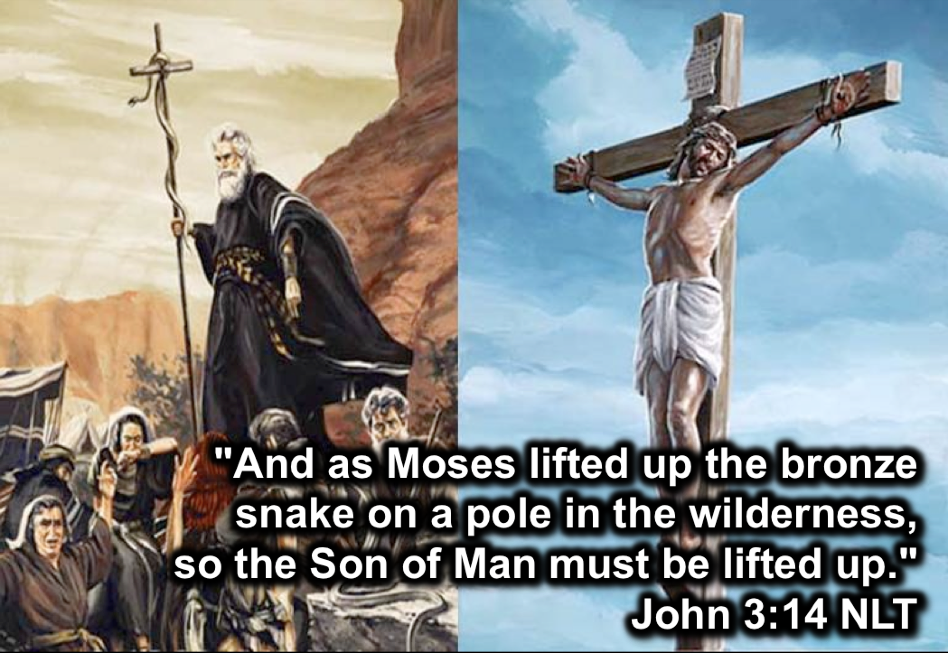

E. God judges Israel’s sexual idolatry at Moab but still gives undeserved blessing through Balaam (Num 22–25).

1. Balak (king of Moab) doesn’t turn God against Israel when he hires the pagan Balaam to curse Israel, but he blesses them to show God's commitment to Israel (Num 22–24).

2. At Baal of Peor, Balak turns Israel against God by Moabite prostitutes and by idolatry that kills 24,000 before Phinehas atones for the sin due to God's hatred of defiant sin (Num 25).

III. The way God prepared the believing new generation for Canaan was by organizing them, reviewing offerings and vows, and outlining Canaan (Num 26–36; 5 months near Moab).

A. God provides for the new generation to inherit the land by reorganizing them in a new census, new law of inheritance, and new leader (Num 26–27).

1. Israel's second census shows the new generation of 601,730 is barely smaller than the old generation 38 years earlier as God's provision of soldiers to defeat Canaan (Num 26).

Population Changes in the Wilderness

Tribe | Numbers 1 (1444 BC)  Start of Wanderings | Numbers 26 (1406 BC)  End of Wanderings | Increase (Decrease)
Reuben | 46,500 | 43,730 | (2,770)
Simeon | 59,300 | 22,200 | (37,100)
Gad | 45,650 | 40,500 | (5,150)
Judah | 74,600 | 76,500 | 1,900
Isaachar | 54,400 | 64,300 | 9,900
Zebulun | 57,400 | 60,500 | 3,100
Ephraim | 40,500 | 32,500 | (8,000)
Manasseh | 32,200 | 52,700 | 20,500
Benjamin | 35,400 | 45,600 | 10,200
Dan | 62,700 | 64,400 | 1,700
Asher | 41,500 | 53,400 | 11,900
Naphtali | 53,400 | 45,400 | (8,000)
Total | 603,550 | 601,730 | (1,820)

These numbers only include men at least 20 years old who served in the army (26:2, 4). Women, children, Levites and the handicapped were not counted. Assuming each soldier had a wife and an average of only one child puts the total population nearly 2 million. The tribe of Reuben decreased partly due to rebelling with Korah (26:8-9; cf. 16:1-35). The tribe of Simeon shrank the most. Perhaps this was due to the plague that killed 14,700 (16:49) and/or the tribe’s immorality at Beth Peor, which killed 24,000 (25:9), as its leader Zimri was a Simeonite (25:14).

2. Inheritance goes to five daughters of Zelophehad, a man who died without sons, showing God's grace for those who would otherwise have no inheritance (27:1-11).

3. God gives a leader to the new generation in Joshua’s appointment to succeed Moses (27:12-23).

B. The rules on offerings and vows sanctify the new generation to worship God (Num 28–30).

1. Offering regulations for daily, weekly, monthly, and yearly sacrifices help the new generation to worship God appropriately (Num 28–29).

2. Regulations on women's vows highlight keeping promises made to God to help the new generation to worship God appropriately (Num 30).

C. God defeats the Transjordan, summarizes his wilderness guidance, and defines land boundaries to prepare Israel to enter Canaan (Num 31–36).

1. The defeat of the Transjordan ends by destroying the Midianites but defining inheritances according to man's will reveals that God's inheritance is always best (Num 31–32).

a. Israel defeats the Midianites and divides the spoil for turning Israel away from the LORD at Peor to show God's jealous love for his people (Num 31).

b. The eastern two-and-a-half tribes receive their lands provided they fight in Canaan and forfeit their Canaan inheritance to show God's inheritance is always best (Num 32).

2. A summary of God’s faithful provision on Israel's journey from Egypt to Moab helps the people further trust in God for entrance into the land (33:1-49).

3. The land west of the Jordan (Canaan) is defined in boundaries, Levite towns, cities of refuge, and separate tribal areas to prepare Israel to enter the land (33:50–36:13).

a. The Western tribes are promised their inheritance in Canaan if they drive out the inhabitants to teach Israel that God's gifts involve human responsibility (33:50–34:29).

b. Forty-eight cities in Canaan are granted to the Levites, including six cities of refuge for fugitives of unintentional murders, to protect God's name from slander (Num 35).

c. Daughters inheriting land must marry within their tribal clan so every Israelite will retain his father’s property and thus prevent mixing lands in a tribal area (Num 36).

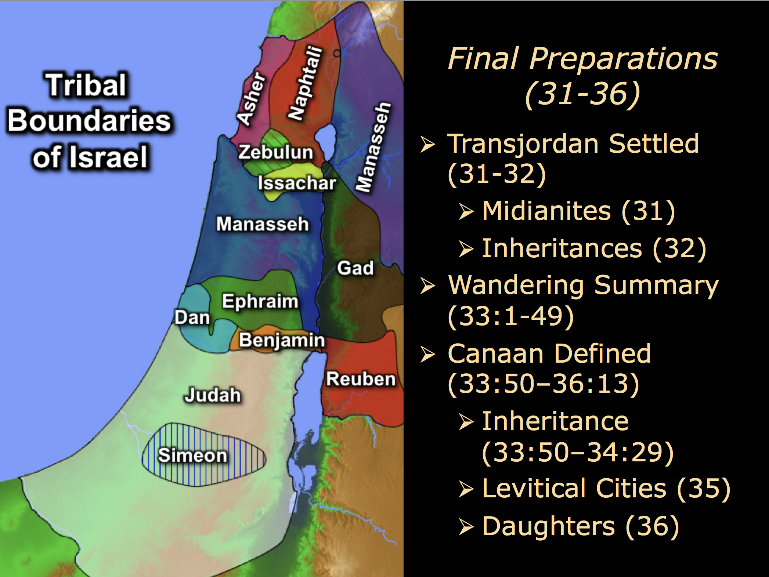
Encampment of the Tribes of Israel and Cities of Refuge
The Bible Visual Resource Book, 35

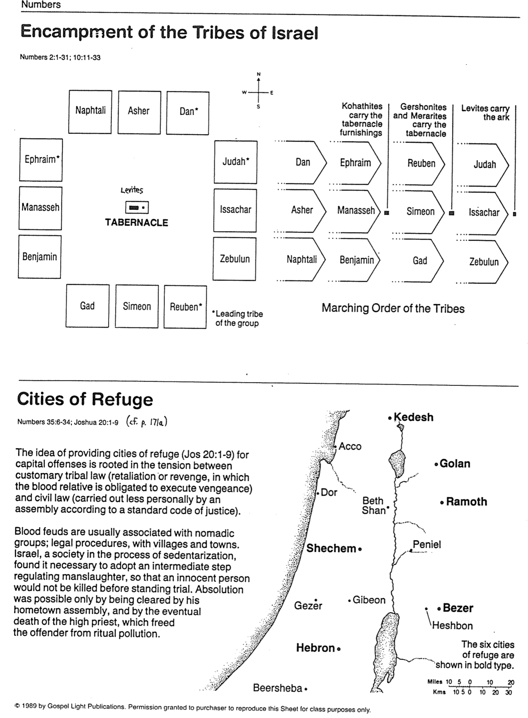

Journey of the Spies
Barry Beitzel, The Moody Atlas of Bible Lands, 93

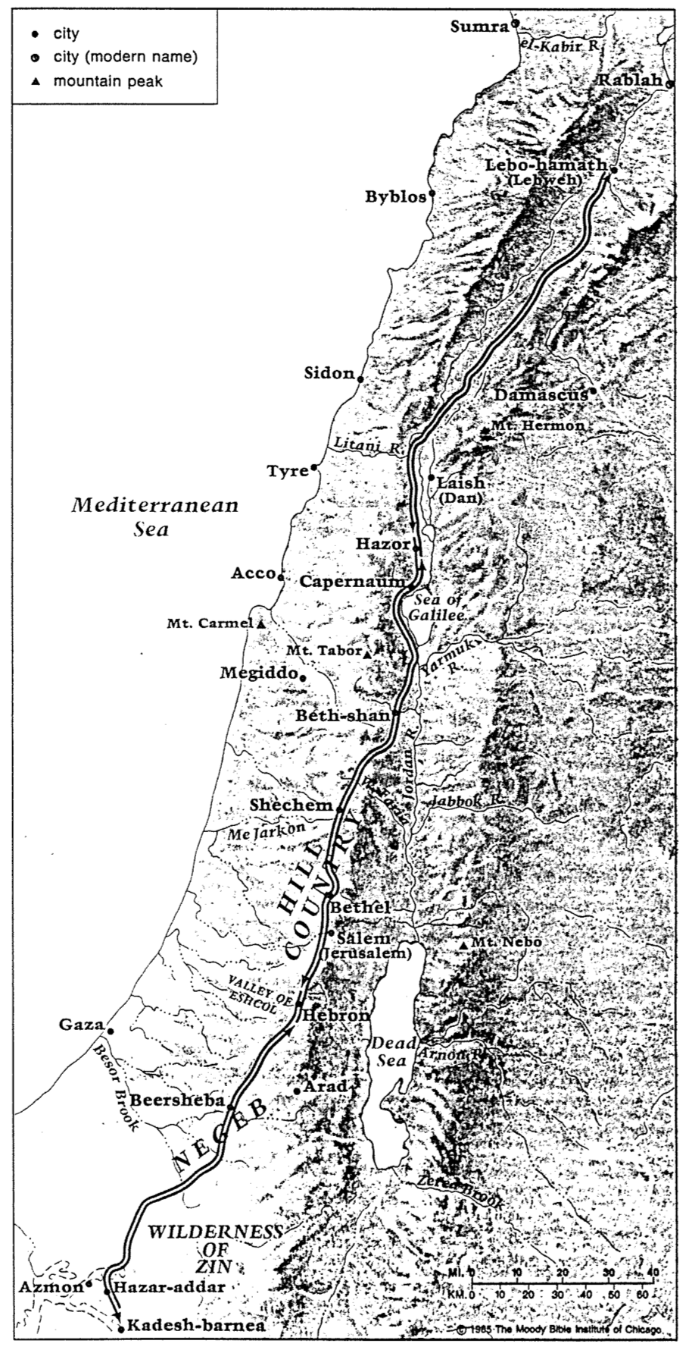

Israel’s Early Eastern Neighbors
John H. Walton, Chronological and Background Charts of the OT, 2d ed., 71

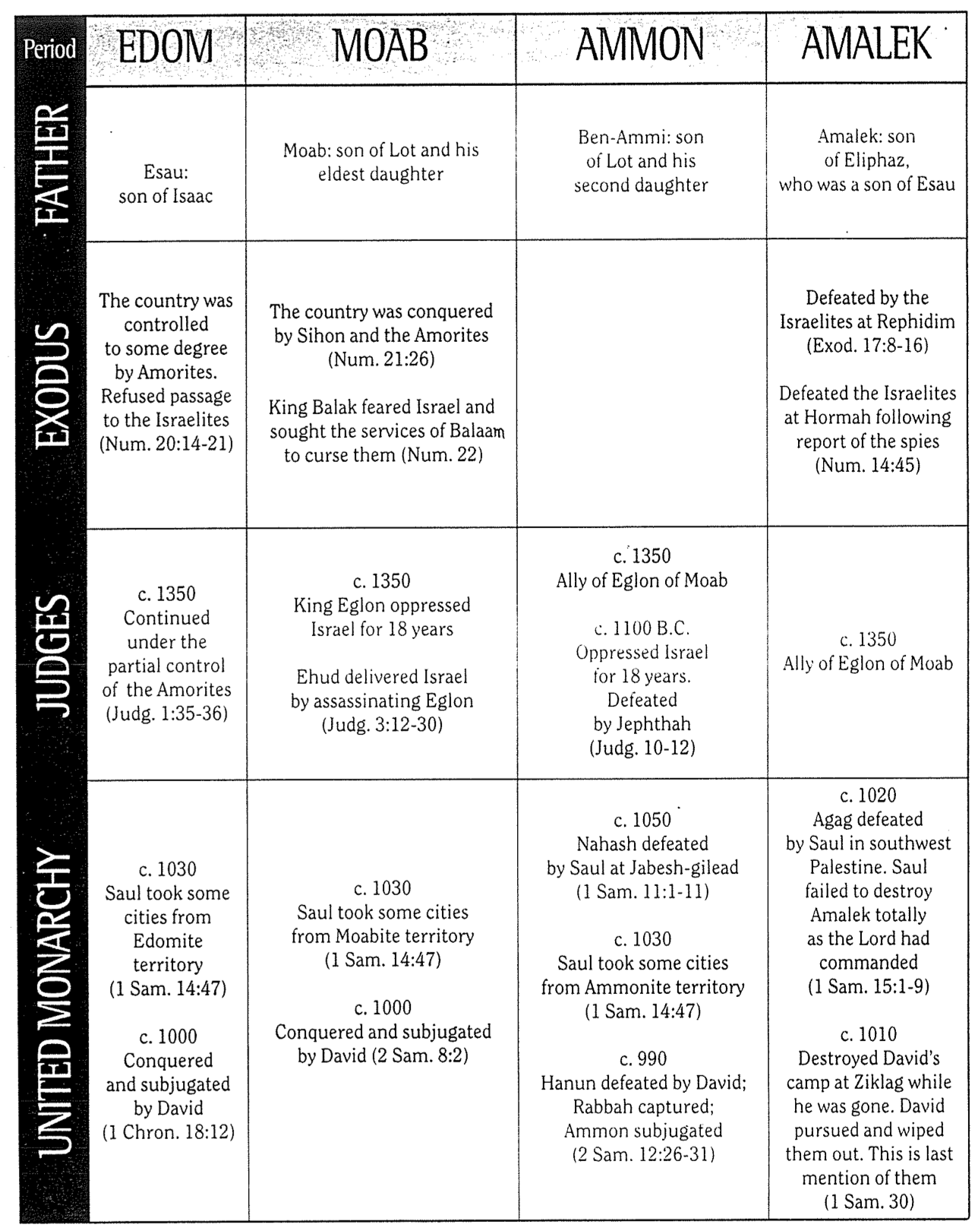

Israel’s Early Western Neighbors

John H. Walton, Chronological and Background Charts of the OT, 2d ed., 73

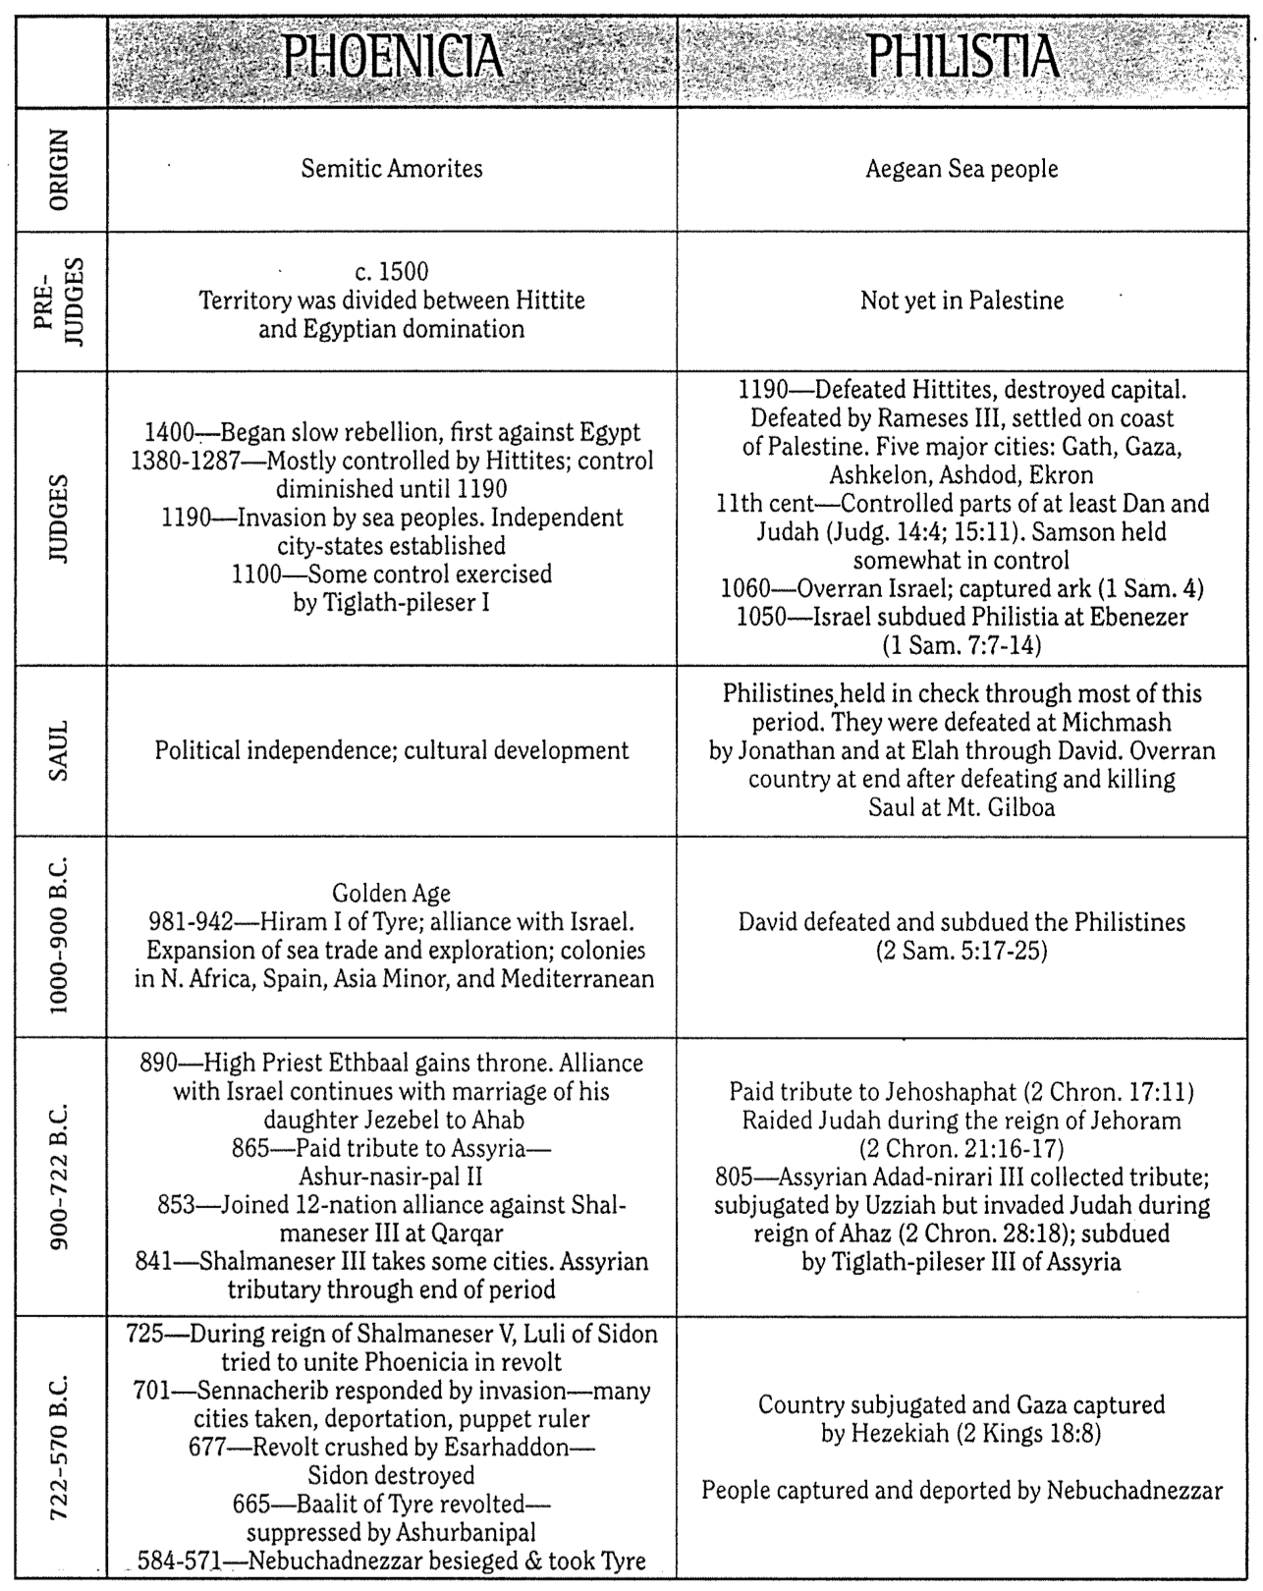

Broken People
Henry Blackaby (1 of 2)

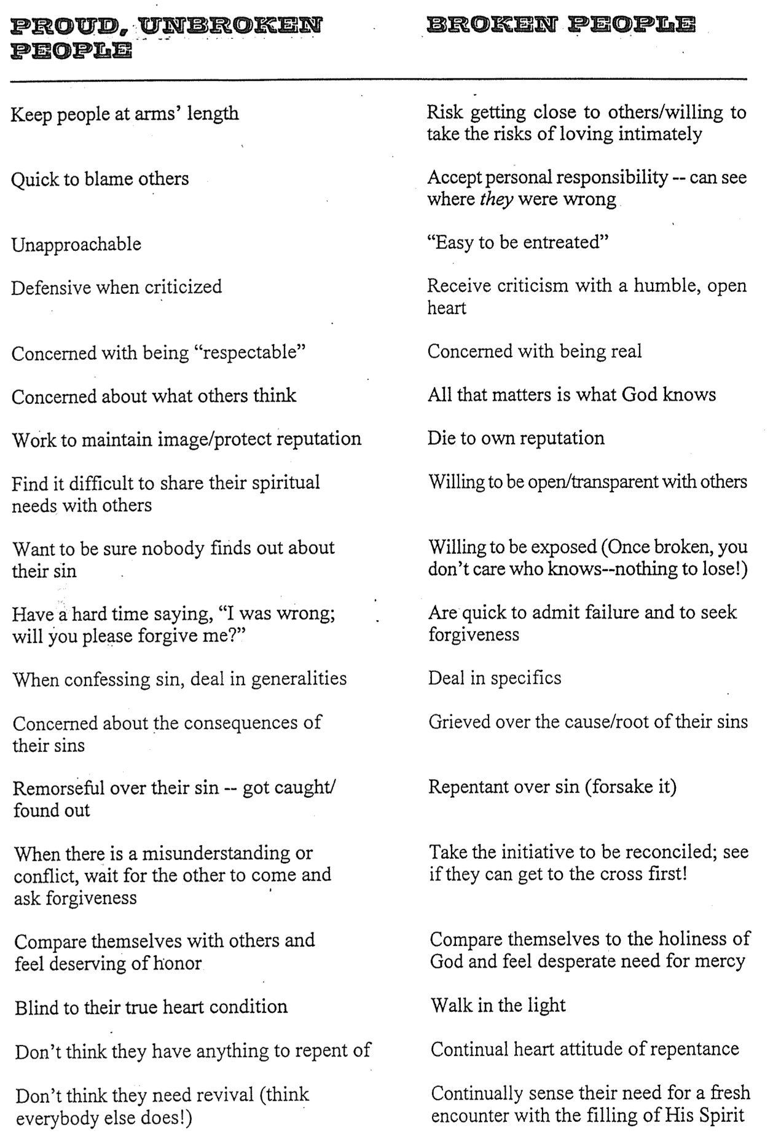

Broken People
Henry Blackaby (2 of 2)

