
Crossroads School of the Bible

Course Description

The Bible… Basically seeks to increase biblical literacy by teaching the structure and geography of Scripture from an overall perspective. This includes showing how the OT and NT books fit together chronologically. The theme of each book is briefly explained, as well as how God glorifies Himself through fulfilling His covenant with Abraham in the person of Christ.

Course Objectives

By the end of the course the student should be able to …

Place any Bible event into one of ten chronological “mental folders” of the Bible.

Identify ten major cities and six key bodies of water in the Ancient Near East.

Articulate how the four sections of the OT are parallel to four NT sections.

Explain from Scripture how the Abrahamic Covenant is foundational to understanding the nature of Christ.

Put the OT prophets in chronological order.

Show familiarity with the themes of each biblical book.

Note major developments of the Greeks and Romans between 400 BC and Christ.

Teach the basic outline of biblical events to someone else.

Course Requirements for Certificate Credit for SBC CCTE

Attend at least ten of the twelve sessions.

Read the course notes and fill in the study guides in the appendix.

Teach at least twelve (12) of the fifteen (15) PowerPoint presentations to another individual or group of persons who has not attended the class.

You should be able to fulfill these requirements with only one hour of effort weekly. Your grade will be based on the following scale:

Grade | Sessions Attended | Pages Read from Student Handbook | Presentations Taught to Others Outside the Class
A | 12 | 100% | 10+
B | 11 | 80% | 9
C | 10 | 60% | 8
D | 10 | 40% | 7
F | 0-9 | 0-39% | 0-6

Course Bibliography

Fee, Gordon D., and Stuart, Douglas. How to Read the Bible for All Its Worth. Grand Rapids: Zondervan, 1982; London: Scripture Union, 1983.
Excellent insights on the types of scriptural literature. Not a detailed work on each book.

Huddleston, Barry. The Acrostic Summarized Bible. Atlanta: Walk Thru The Bible Press, and Nashville, TN: Nelson, 1978; reprint, Grand Rapids: Baker, 1992.
Creative cartoons and acrostic memory aids for each book of the Bible.

Walvoord, John F., and Zuck, Roy B., eds. The Bible Knowledge Commentary. Vol. 2: New Testament Edition. Wheaton: SP Pub., Victor, 1983. Abbreviated “BKC.” 991 pp. hb.
The best single volume commentary on the NT (my opinion). Volume 1 is an excellent OT commentary. Authored by present or former faculty at Dallas Theological Seminary. Provides the most help on difficulty passages (in contrast to many other commentaries which avoid controversial texts). Is theologically consistent (dispensational) throughout. This set is also available in Chinese, French, German, Hungarian, Italian, Korean, Russian, and Spanish with portions in Hindi, Thai, and Sinhalese.

Wilkinson, Bruce, and Boa, Kenneth. Talk Thru the Bible. Nashville: Nelson, 1983. 522 pp. Abbreviated TTTB.
Very helpful charts and maps. A very practical guide to the whole Bible by book and from a dispensational perspective. Highly recommended!

Other Matters

Contacting Me: You can contact me at Singapore Bible College, 9-15 Adam Road, Singapore 289886 at mailbox L19 or by phone (6559-1555 ext. 7130). My home address is on campus at Block 2-302 and home telephone is 6762-2011. Also, my email address at griffith@sbc.edu.sg automatically forwards to drrickgriffith@gmail.com.

Copying Class Notes: Permission granted until you make a lot of money publishing them. The same applies to taping lectures.

Schedule (Reading Report)

Name Box Reading Grade Course Grade

Please tick the last column if completed in full on time. Note if completed late and/or partially.

Session | Day | Presentation (# of Slides) | Assignment | 
1 | Aug 10 | Syllabus  01-Intro to C7SJ (74) | None
2 | Aug 17 | 02-Map (85) | Teach 01
3 | Aug 24 | 03A-Creation (27)  03B-Abraham to Joseph (64) | Teach 02
4 | Aug 31 | 03C-Moses to Joshua (50) | Teach 03A & 3B
5 Sat | Sep 6 (9 AM) | 05A-Bedrock 1 (62) | Teach 03C
6 Sat | Sep 6 (10 AM) | 05B-Bedrock 2 (81)
7 Sat | Sep 6 (11 AM) | 07-Old Testament (86)
8 Sat | Sep 6 (12 PM) | 08-New Testament (86)
9 | Sep 7 | 03D-3 Societies (69) | Teach 07
10 | Sep 14 | 03E-Silence (34)  03F-Jesus (1-42: Part 1) | Teach 03D & 08
11 | Sep 21 | 03F-Jesus (43-84: Part 2)  04-Quick Time (17) | Teach 03E & 03F 1-42
12 | Sep 28 | 06-Open Bible (42)  09-End (40) | Teach 03F 43-84 & 04  Turn in this report page

Questions

1. How many of the 15 presentations did you teach to someone else? _________

2. Did you read all 54 pages of the first part of the Student Workbook? _________

3. Did you fill in all of the Study Guide pages in the Appendix? _____________

4. What comments do you have about this course?
Teacher’s Biographical Data

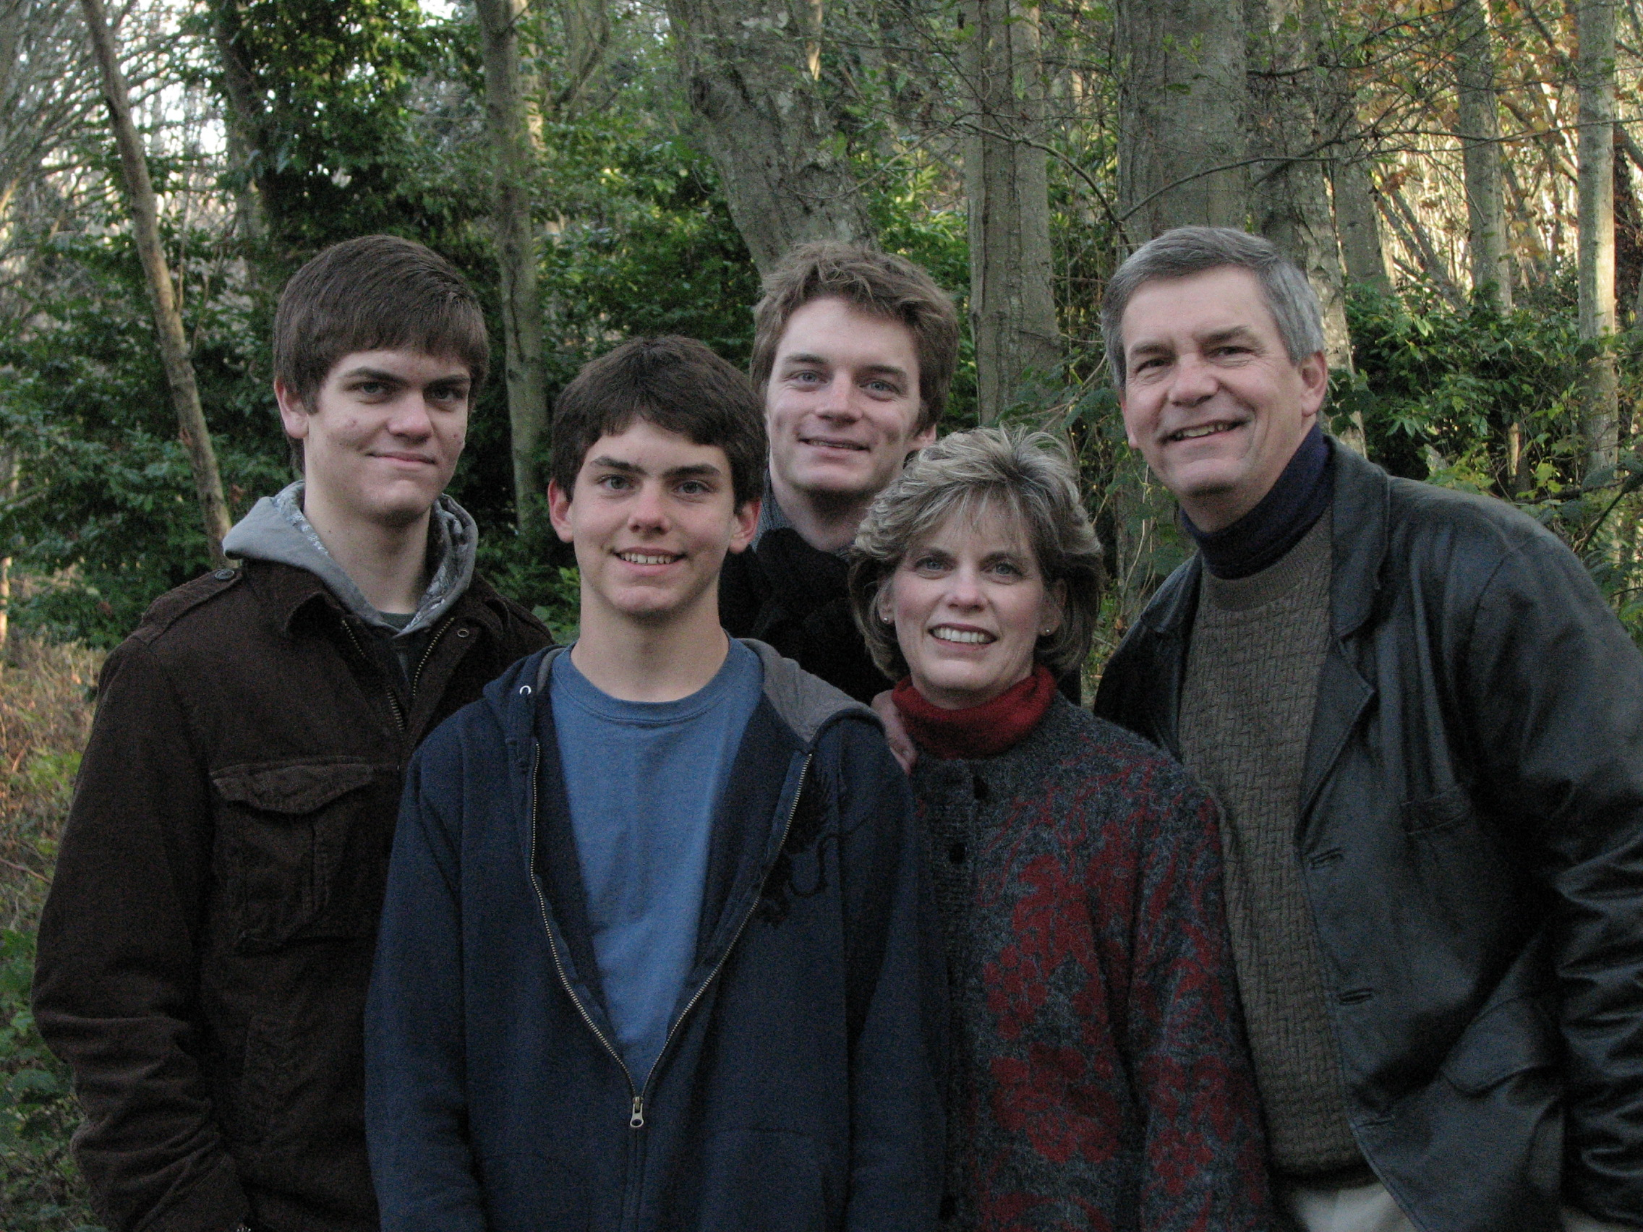
Rick and Susan Griffith
Kurt, Stephen, and John
Background

“Never say never.” Rick and Susan Griffith both learned this age-old tip the hard way.

Rick recalls sitting in his elementary school classes thinking, “If there’s one thing I’ll never become it’s a teacher. Imagine saying the same stuff over and over, year after year!”

Yet after trusting Christ in junior high and acquiring a taste for teaching the Word of God, Rick’s attitude began to change. After his business degree at California State University, Hayward, and Master of Theology degree (Pastoral Ministries) and the Doctor of Philosophy degree (Bible Exposition) from Dallas Theological Seminary in Texas, Dr. Griffith soon found himself on the other end of the classroom—and loving it!

Susan, from Yucaipa, California, also learned not to say “never.” As she earned her Bachelor of Arts degree in piano at Biola University, several friends married and worked to put their husbands through three more years of seminary training. “I’ll never do that!” she exclaimed. Soon afterwards she invested three years (1981-1983) singing together with her future husband in the Crossroads, Campus Crusade's traveling music team in Asia. This nine member Philippines-based group shared Christ in the Philippines, China, Hong Kong, Korea, Japan, Macau, Thailand, Malaysia, Indonesia, and Singapore.

In December 1983 Susan’s “never” became a reality. She and Rick married and like Jacob and Rachel of old, Susan also worked for her mate. During these seven seminary years Rick served as a pastor, corporate chaplain, and International Students church consultant. Susan taught women's Bible studies and often ministered through her singing. Their primary church in Texas is Christ Chapel Bible Church in Fort Worth.

The Griffith family now includes three sons: Kurt (21 yrs.), Stephen (19 yrs.), and John (15 yrs.). Their home church is First Baptist Church of Yucaipa, California—a two-hour drive east from Los Angeles.
Ministry

However, since 1991 the Griffiths’ home has been Singapore where Rick serves with 30 other full-time faculty at Singapore Bible College. SBC has 555 full-time students from 25 countries and 20 denominations, as well as over 300 professionals in the non-degree Certificate of Christian Studies program. Currently he teaches preaching, OT and NT Backgrounds & Survey, Eschatology (Future), Ecclesiology (Church), and Pneumatology (Holy Spirit).

Dr. Griffith loves the variety and strategic nature of his teaching. He invests his life into Anglicans from Sri Lanka, Lutherans from Singapore, Presbyterians from Korea, Conservative Baptists from the Philippines, and missionaries from Campus Crusade, OMF, and Operation Mobilization—sometimes all in one class! A survey of one of his courses revealed that 17 of the 20 students were training for ministry outside of Singapore. Nearly all SBC graduates enter pastoral or missionary ministries due to Asia’s shortage of trained leaders.

Ministry opportunities abound. Rick and Susan have conducted premarital counseling for students and their home has an open door to students and guests traveling through Singapore. They have sung in evangelistic thrusts and also participated in founding International Community School, an expatriate Christian primary and secondary school in Singapore begun in 1993 where the Griffith sons have attended over the years. This missionary family is attached to WorldVenture based in Littleton, Colorado, USA. In Singapore Rick serves as pastor-teacher at Crossroads International Church (www.cicfamily.com), which he helped plant in November 2006. Susan serves as the church Administrative Assistant, Woman’s Ministry Director, and one of the pianists.

Rick also teaches (and recruits other teachers to teach) poor pastors in Mongolia, Sri Lanka, Nepal, Jordan and some restricted access countries. He is also preparing his Old and New Testament Survey courses for the Internet Biblical Seminary (www.internetseminary.org).

Field

Singapore Bible College is strategically located at the “ministry hub” of Southeast Asia, the Republic of Singapore. A small island of only 14 by 26 miles, Singapore is a city-nation located on the tip of the Malayan Peninsula in Southeast Asia. The 4.6 million population of this multi-cultural society is 76 percent Chinese, 15 percent Malay and 7 percent Indian. Other groups include Filipinos, Thais, Japanese, Americans, and Europeans. This beautiful island nation, with dynamic growth in churches and missionary force, has been called the “Antioch of Asia.”

Passion

Rick’s passion is for God’s leaders to preach and live the Word of God. The servant of God’s role is clearly given in the following verses:

- Teaching/preaching all that Christ taught is a key part of our commission (Matt. 28:20)
- The apostles priority was teaching and prayer (Acts 6:1-16)
- Paul’s legacy to Timothy focused on exposition: “Preach the Word” (2 Tim. 4:2-3)

However, recent trends include the following:

- Church people are biblically illiterate—Amos lamented in his day of prosperity that there existed a “famine for hearing the words of the Lord” (Amos 8:11)
- Pastors are doing too many things
- Preachers give empty sermons
- Attempting to be “relevant,” pastors preach what people want to hear—not what they need

