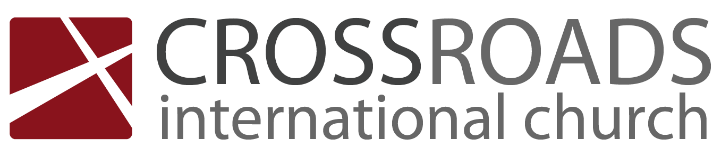
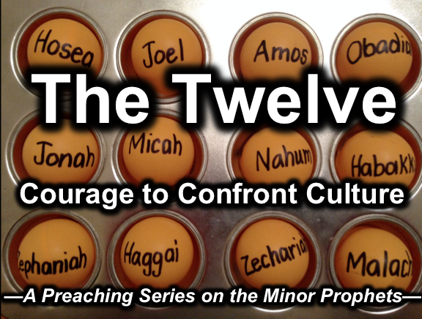
Rick Griffith
9 April 2017
Message 8 of 12

要有纪律
约珥书

Introduction

你要有纪律，要不然你会受到上帝的纪律。这是真实的因为任何好的领导者纪律他关心的人。最终,神是最好的纪律师。

Be disciplined or you will be disciplined. This is true because any good leader disciplines those he cares about, and ultimately, God is the best disciplinarian.

哪一个更好地描述你的生活？纪律自己，还是受到上帝的纪律？

Which better describes your life now? Disciplining yourself or being disciplined by God?

当我们受到上帝的纪律时，我们应该做什么？

What should we do when we are disciplined?

(当我们受到上帝的纪律时，我们应该做什么？)
(What should we do when we are disciplined?)

I. 纪律带来我们的悔改。

Discipline should bring repentance.

犹太人应该忏悔最近蝗虫的判断和耶和华与巴比伦人和苦难军队的未来日子.

Judah should repent over a recent judgment of locusts and the future day of the LORD with Babylonian and Tribulation armies (1:1–2:17).

乔尔肯定了他预言的神圣权威以及他所描述的事件的独特性，所以人们将他的话传给后代(1:1-3).

Joel affirms the divine authority of his prophecy and the uniqueness of the events he will describe so the people will pass his words on to future generations (1:1-3).

读者应该哀悼和忏悔，寻求上帝从可怕的蝗虫入侵和干旱中解脱出来(1:4-20).

Readers should mourn and repent to seek God's deliverance from a terrible locust invasion and drought (1:4-20).

人民应该悔改，因为可怕的判断（耶和华的日子）将在远方将来由巴比伦军队和末日帝国来临(2:1-17)

The people should repent since a more dreadful judgment (day of the LORD) will come soon by the Babylonian army and Armageddon in the distant future (2:1-17).

上帝纪律我们应该激励我们寻求主。

God’s disciplining us should motivate us to seek the Lord.

约珥书 2：12-17中的悔改造成什么结果？）
(What results from repentance like that in Joel 2:12-17?)

II. 悔悟会带来恢复。

Repentance will bring restoration.

以色列的悔悟将带来宽恕，救赎和恢复(2:18–3:21).

Israel’s repentance will bring forgiveness, deliverance and restoration (2:18–3:21).

以色列的悔改将会带来赦免和祝福(2:18-27).

Israel’s repentance will bring forgiveness and blessing (2:18-27).

上帝将通过审判各国来传递他所修复的人，并将发出伟大的精神觉醒时刻，激励他的子民现在悔改(2:28–3:21).

God will deliver His restored people by judging the nations and will send a great time of spiritual awakening to motivate His people to repent now (2:28–3:21).

在耶和华的日子，神必将发送圣灵住在所有的犹太人和发送天上的迹象（犹太国民在基督归来时悔改）(2:28-32).

In the day of the LORD, God will send the indwelling of the Spirit upon all Jews and celestial signs [when the Jewish nation repents at the return of Christ] (2:28-32).

当上帝恢复以色列作为一个国家时，他会判断许多国家因为他们滥用犹大(3:1-16).

When God restores Israel as a nation He will judge the nations for abusing Judah (3:1-16).

约尔描述犹大的富有成果，与以东和埃及的荒凉相反，犹太人将永远居住(3:17-21).

Joel describes the fruitfulness of Judah in contrast to the desolation of Edom and Egypt as an indication that Judah will be inhabited forever (3:17-21).

只有你对耶和华的信靠才会带来祝福。

Your trust in the Lord alone will bring his blessing.

(当我们受到上帝的纪律时，我们应该做什么？)
(What should we do when we are disciplined?)

结论(Conclusion)

让纪律带来悔改和悔改带来恢复（大意）。

Let discipline bring repentance and repentance bring restoration (Main Idea).

你要有纪律，要不然你会受到上帝的纪律。

Be disciplined or you will be disciplined.

要问的问题：

Questions to ask:

你需要上帝剥夺你的一切, 你才肯悔改吗？（黄萨宾）

Do you need God to strip you of everything before you repent? (Huang Sabin)

你看过你生活中的困难，认为可能是上帝的纪律，让你再次注意他吗？

Have you looked at the difficulties in your life as potentially God’s discipline to get your attention on him once again?

你有没有考虑过斋戒吗（1:14; 2:12）还是你觉得斋戒不适合我们现代时代？为什么会这样？

Have you considered fasting (1:14; 2:12) or do you think fasting isn’t for our modern age? Why wouldn’t it be?

思想问题(Thought Questions)

1. 阅读 的约珥书 三个章节，并列出以下内容：
Read the three chapters of Joel and list the following:

章节/上帝纪律犹大的方法

Verse | Ways God Disciplined Judah

上帝何时在你自己的生活中纪律你?

When has God disciplined you in your own life?

Download this sermon PPT and notes for free at BibleStudyDownloads.org/resource/old-testament-preaching/
Listen to this message online at cicfamily.com/sermon-listing/

