Crossroads International Church Retreat Ron Man
November 3-5, 2017 Worship Resources Intl. (www.worr.org)

LET US DRAW NEAR
Perspectives on Biblical Worship
5. Worship in the Church

A. THE IMPORTANCE OF WORSHIP IN THE CHURCH
1. It honors the Father

2. It celebrates Christ and His work

3. It draws up into fellowship with God and one another

4. It foreshadows the Kingdom

5. It is used by the Holy Spirit

6. It reminds the Church of its identity

7. It testifies to the world

8. It prepares us for preaching

B. THE CONTENT OF WORSHIP IN THE CHURCH

- The Centrality of the Word of God in Worship

- Music

- Prayer

- The Lord’s Supper

  - Uniquely corporate
  - All 5 senses
  - Not a funeral!
  - “Remembering”

C. DRESSING FOR WORSHIP (Colossians 3:12-17)

D. WORSHIP AND CULTURE: The Bridge
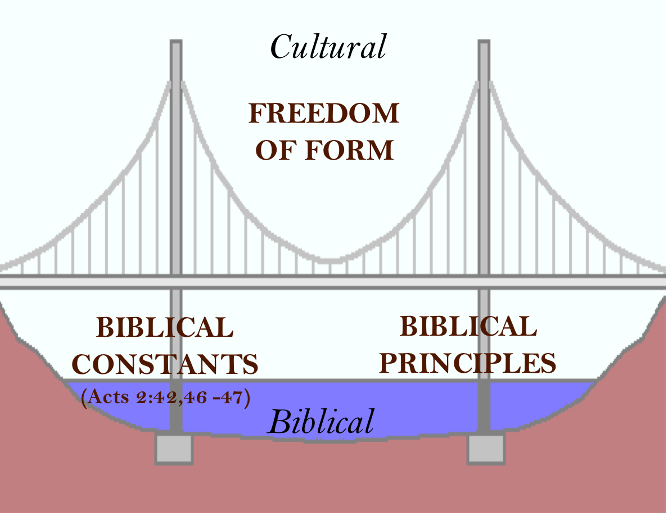

1. Biblical Constants (Acts 2:42,46-47)
a. Word of God
b. Fellowship
c. Lord’s Supper
d. Prayer
e. Praise
(f. Christ- and gospel-centered)
2. Cultural Freedom/Flexibility of Form
- Diversity & unity
- History & tradition
- Cultural context

- The Nairobi Statement on Worship and Culture

1) Transcultural
- Contextual
- Counter-cultural
- Cross-cultural
simultaneously!

3. Biblical Principles

