Crossroads International Church Singapore Dr. Rick Griffith
No PPT
8 April 2020 Single Message
NLT 9 Minutes
Quarantine Blessings
Topical

Topic: Quarantines
Subject: What would God possibly want to do with us in quarantines?
Complement: God has often used quarantines to expand his work.
Purpose: The listeners will set quarantine goals so God can expand his work through them during the present lockdown.
Attribute: Our unlimited God
Meditation: “The secret things belong to the Lord, but the things revealed belong to us and to our children forever, that we may obey them” (Deut 29:29)

Introduction

Interest: Today is the BIG day! What big day? It is 8 April 2020—and so…”

Today begins the Great Singapore Circuit Breaker.

Today is also the 48th anniversary of my Mom and Step-Dad.

Today is also Passover.

Need: You know what all of these events have in common? Each is a God-ordained quarantine!

Circuit Breaker refers to a period of at least a month when all but essential services must be conducted from home—thus my guest room in the background.

My parents are both on quarantine for their anniversary—Mom at my brother’s house and my Step-Dad at his assisted care facility—so they cannot see each other.

And Passover? Well, that was God’s first quarantine in the Bible.

Subject: So what would God possibly want to do with us in quarantines?

Preview: Today I would like to take a quick look at quarantines in both the Bible and church history—and then see what we might take away from this.

(Do we see any lockdowns in the OT? Indeed, we do!)

I. God often used quarantines for his purposes in the OT.

Joseph in prison for two years in Egypt produced a humbling that he would need once he became second only to Pharaoh later.

Passover constituted the first quarantine that God required of the nation at the end of an essentially 400-year quarantine in Egypt—but it led to a new nation.

The Sabbath is really a weekly quarantine—a sign of the covenant God made with Israel (Exod 31:13).

David was in confinement for a time in the stronghold to escape Saul—and here he learned not to be a Saul once he had power.

Elijah at Sinai saw God as no man ever has and he also gained the vision for his successor to be Elisha.

Jeremiah limited in the palace prison of Jerusalem protected him from the death to the city on the outside.

(Do we see any lockdowns in the NT? Indeed, we do!)

II. The Lord also used confinements in the NT era to advance his purposes.

Paul in Arabia for three years—this led to grace and clarity for Paul what it means to be “in Christ.”

Paul’s imprisonments for 5 of the last 10 years of his life in Caesarea and twice in Rome—this gave us the precious letters Ephesians, Colossians, Philemon, Philippians and 2 Timothy.

John at Patmos—Revelation

(Do we see any lockdowns in the history? There were many!)

III. History records many advances that God led through times of isolation and seclusion.

At Qumran, godly Jewish scholars who had left Jerusalem’s materialism and paganism copied over 870 OT scrolls.

Martin Luther Kidnapped—(Knowing that he would likely be tortured or burned at the stake for upholding God’s Word at the Diet of Worms, friends helped Luther escape these fates by kidnapping him. “Frederick III of Saxony staged Luther’s kidnapping and placed him at Wartburg Castle. Luther disguised himself as a knight named [‘Knight George’] and spent his time translating the NT from Greek into German so common people could read it.” (source) This translation standardized the German language of his time as well!

John Bunyan —"Bunyan was arrested and spent the next twelve years in jail as he refused to give up preaching. During this time he wrote a spiritual autobiography, Grace Abounding to the Chief of Sinners, and began work on his most famous book, The Pilgrim's Progress, which was not published until some years after his release” (source)

My PhD dissertation was primarily written in a self-caused quarantine—I wrote it in a solitary room without telephone at my Texas church for 12 hours a day over a seven month period, ironically on the Sabbath rest!

(So how should we respond to these many restrictions and limitations imposed on us?)

IV. God wants to develop us in new ways during this pandemic break.

What Not to Do?

Drunkenness is one escape that many are trying in order to address their loneliness and depression.

Porn & horrible movies are documented as on the rise right now.

Family Conflict—

Wife beating—It will not turn bad marriages into good ones.

One US city normally receives 1000 calls a day on their suicide line. This past week the 1000 has risen to 26,000 calls daily.

What to Do?

Take inventory of your life.

Read the Bible and good books.

Write articles, books, journal your thoughts.

Exercise—lose weight.

Learn new skills—teach online, cook, whatever.

Declutter paper.

Family time—games, walks—can improve at this time.

Watch good films at Christiancinema.com

Reach out via video calls

(So what would God possibly want to do with us in quarantines? What can the Circuit Breaker time do for us, for the church, and for the world?)

Conclusion

God has often used quarantines to expand his work (MI).

At many times in the Bible and history, confining us and subtracting from us has led to enlarging and multiplying his ministry through us (restated).

Jabez prayed that God would expand his ministry from his “pain” (the meaning of his name) and God answered.

Our church has grown by 50% by going online!

Southern California pastor Greg Laurie had 386k views last Sunday and has seen 5k people trust Christ online the past two Sundays.

At the end of Holy Week, the disciples were on lockdown—but resurrection changed all that!

Exhortation: Let’s identify with these first century believers and see God expand his work through us.

Preliminary Questions

Verses Questions

Context: What did the author record just prior to this passage?

Purpose: Why is this passage in the Bible?

Background: What historical context helps us understand this passage?

Questions

Tentative Subject/Complement Statements

Text

Possible Illustrations

Text

Possible Applications

Text
Quarantine Blessings
Topical

Exegetical Outline (Steps 2-3)

Exegetical Idea:

I.

II.

III.

Purpose or Desired Listener Response (Step 4)
The listeners will

Homiletical Outline (Cyclical inductive form)

Introduction

Interest: Today is the BIG day! What big day?

Today begins the Great Singapore Circuit Breaker.

Today is also the 48th anniversary of my Mom and Step-Dad.

Today is also Passover.

Need: You know what all of these events have in common? Each is a God-ordained quarantine!

Circuit Breaker refers to a period of at least a month when all but essential services must be conducted from home—thus my guest room in the background.

My parents are both on quarantine for their anniversary—Mom at my brother’s house and my Step-Dad at his assisted care facility—so they cannot see each other.

And Passover? Well, that was God’s first quarantine in the Bible.

Subject: So what would God possibly want to do with us in quarantines?

Preview: Today I would like to take a quick look at quarantines in both the Bible and church history—and then see what we might take away from this.

(Do we see any lockdowns in the OT? Indeed, we do!)

I. God often used quarantines for his purposes in the OT.

Joseph in Prison—humbling

Passover—new nation

Sabbath—sign of covenant

David in Stronghold—not 2nd Saul

Elijah at Cherith—famine protection

Elijah at Sinai—saw God/successor

Jeremiah in Palace Prison—hope

(Do we see any lockdowns in the NT? Indeed, we do!)

II. The Lord also used confinements in the NT era to advance his purposes.

Paul in Arabia—grace, in Christ

Paul imprisonments—letters

John at Patmos—Revelation

(Do we see any lockdowns in the history? There were many!)

III. History records many advances that God led through times of isolation and seclusion.

Qumran—OT scrolls

Luther Kidnapped—Bible, language

Bunyan — Pilgrims Progress

PhD dissertation room—rest

(So how should we respond to these many restrictions and limitations imposed on us?)

IV. God wants to develop us in new ways during this pandemic break.

What Not to Do?

Drunkenness

Porn & movies

Family Conflict—

Wife beating—It will not turn bad marriages into good ones.

One US city normally receives 1000 calls a day on their suicide line. This past week the 1000 has risen to 26,000 calls daily.

What to Do?

Take inventory of your life

Read Bible and good books

Write articles, books, journal

Exercise—lose weight

Learn skills—teach online, cook

Declutter paper

Family time—games, walks

Christiancinema.com

Reach out via video calls

(So what would God possibly want to do with us in quarantines? What can the Circuit Breaker time do for us, for the church, and for the world?)

Conclusion

God has often used quarantines to expand his work (MI).

At many times in the Bible and history, confining us and subtracting from us has led to enlarging and multiplying his ministry through us (restated).

Jabez expansion

CIC growth

Greg Laurie—386k views, 5k PRC

Disciples lockdown—resurrection

Exhortation: Let’s identify with these first century believers and see God expand his work through us.

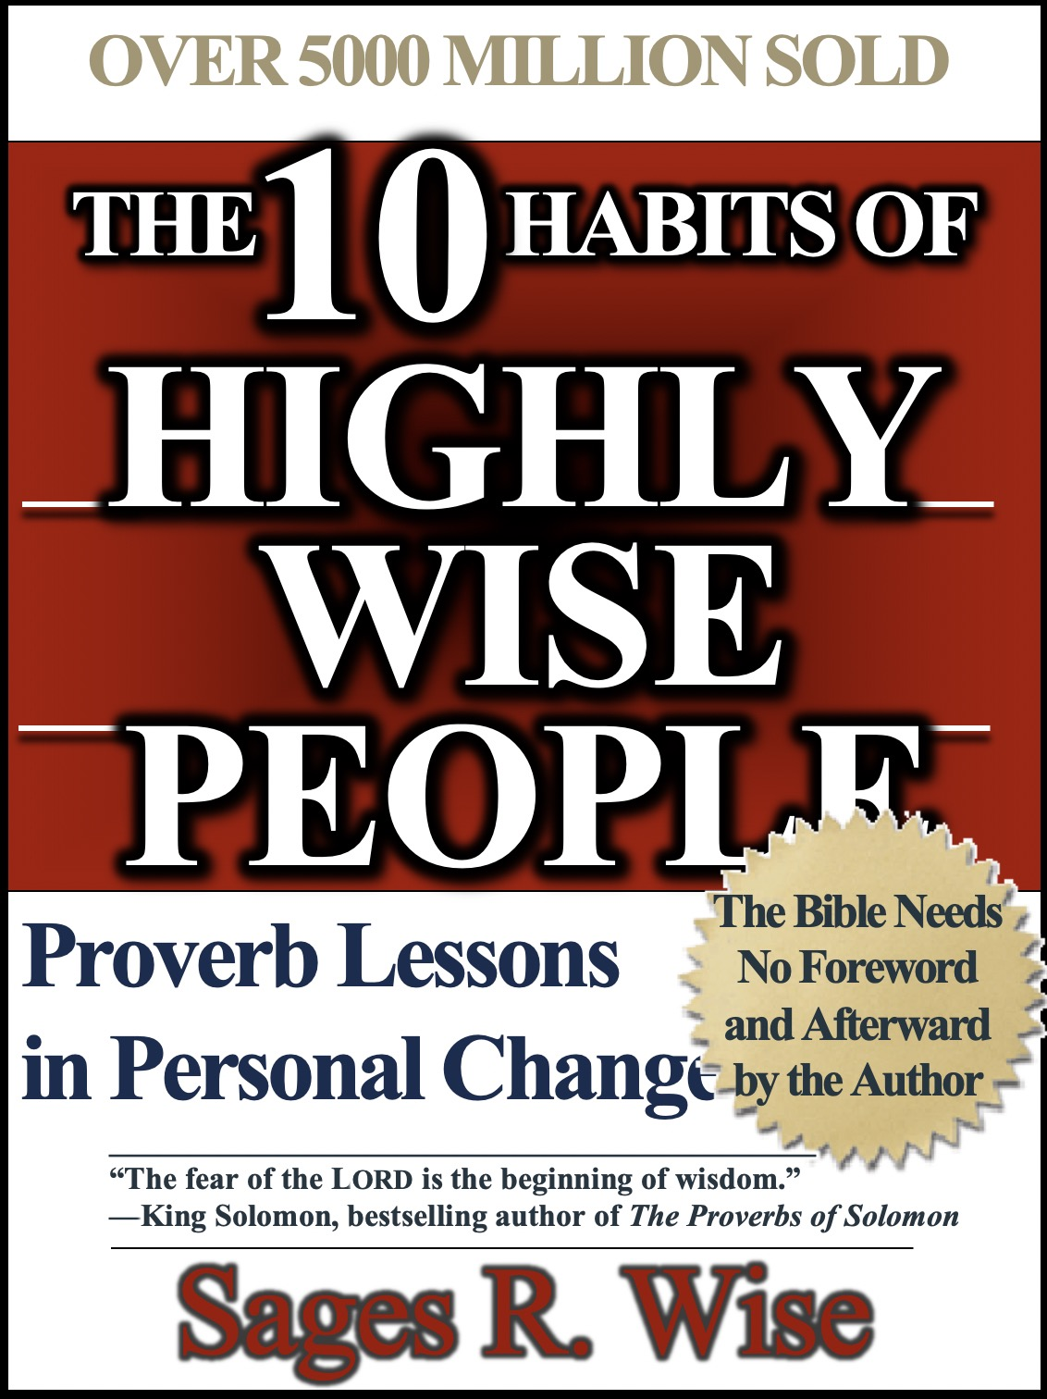
Rick Griffith
2020
Message of 10

Title
Passage

Introduction

Subject with a blank for the key word _______________

I. MP has a blank for the key word ________________ (verses).

SP has a blank for the key word ________________ (verses).

SP has a blank for the key word ________________ (verses).

SP has a blank for the key word ________________ (verses).

II. MP has a blank for the key word ________________ (verses).

SP has a blank for the key word ________________ (verses).

SP has a blank for the key word ________________ (verses).

SP has a blank for the key word ________________ (verses).

Conclusion

Main Idea has a blank for the key word ________________ (verses).

Application question

Thought Questions

- Read the passage aloud. Contrast:

Issue | Contrast

- Text-based question

- Application to your own Christian experience

Download this sermon PPT and notes for free at BibleStudyDownloads.org/resource/new-testament-preaching/

