Sermon Format for Students

INSTRUCTIONS: First, make sure you are viewing this page in Outline View. Then fill in the basic info below by changing the speaker, date, title, passage, etc., skip to page 2 and study your passage in the sequence of seven steps on Homiletics, 27-28. Once your homiletical (sermon) outline is finished, paste it over the “Paste Homiletical Outline here to Develop Manuscript (Step 6b)” statement below. Then flesh this outline out with supporting material to explain, prove, or apply the main points and sub-points. If you think of illustrations or applications earlier than this while working on your outlines, add them at the end of the file and then paste them at the correct spots once your sermon outline has been pasted over the sentence below in step 6b. Of course, delete this paragraph as well. You may be tweaking your topic, theme (subject), thrust (complement) and purpose as you work along, so you may need to up this below as you go—or better yet, fill it in after you finish your manuscript by pasting these statements in from your manuscript. Also go to the header on page 2 to fill in your name, title, and text.

Place where sermon is preached Preacher’s Name
Day-Month-2016 Message 1 of 2
NIV (or whatever text you are preaching from) 15 Minutes
Title
Passage

Topic: Give one word that sums up your message idea
Subject: Generally a question or incomplete statement
Complement: Answers the question addressed by the subject
Purpose: The listeners will… (complete it with the desired listener response)
Meditation: Put a short passage here that can go in the church bulletin for pre-service prayer
Reading: State the exact verses to be read aloud during the service (often a portion of your text)
Song: What is the best closing song you know that will reinforce your main idea?

Paste Sermon Outline here to Develop Manuscript (Step 6b)

Study Questions (Step 1)

Context: What did the author record just prior to this passage?

Purpose: Why is this passage in the Bible?

Background: What historical context helps us understand this passage?

Questions

Tentative Subject/Complement Statements

Text

Possible Illustrations

Text

Possible Applications

Text

Older Outlines Before Working on This Sermon

Text
Title
Passage
Exegetical Outline (Steps 2-3)

Exegetical Idea (CPT):

I.

II.

III.

Purpose or Desired Listener Response (Step 4)
The listeners will

Sermon Outline (Cyclical inductive form)—Steps 5-6

Introduction

Interest:

Need:

Subject:

Background:

Preview:

Text:

(Transition into MPI here.)

I.
[Restate MP here.]

(Transition into MPII here.)

II.
[Restate MP here.]

(Transition into MPIII here.)

III.
[Restate MP here.]

(Transition into the MI here.)

Conclusion

(MI/CPS).

Main Points

Exhortation/Application

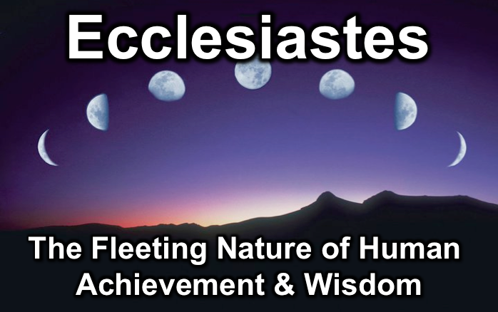
Rick Griffith
2016
Message of 17

Title
Passage

Introduction

Subject with a blank for the key word _______________

I. MP has a blank for the key word ________________ (verses).

SP has a blank for the key word ________________ (verses).

SP has a blank for the key word ________________ (verses).

SP has a blank for the key word ________________ (verses).

II. MP has a blank for the key word ________________ (verses).

SP has a blank for the key word ________________ (verses).

SP has a blank for the key word ________________ (verses).

SP has a blank for the key word ________________ (verses).

Conclusion

Main Idea has a blank for the key word ________________ (verses).

Application question

Home Group Questions:

- Read the passage aloud. Contrast:

Issue | Contrast

- Text-based question

- Application to your own Christian experience

Download this sermon PPT and notes for free at BibleStudyDownloads.org/resource/new-testament-preaching/

