Crossroads International Church Dr. Rick Griffith
Title
2016 Message __ of 10
NLT 40 Minutes
Title
Passage

Topic:
Subject:
Complement:
Purpose: The listeners will
Meditation:
Reading:
Song:

Introduction

Preliminary Questions

Verses Questions

Context: What did the author record just prior to this passage?

Purpose: Why is this passage in the Bible?

Background: What historical context helps us understand this passage?

Questions

Tentative Subject/Complement Statements

Text

Possible Illustrations

Text

Possible Applications

Text
Title
Passage

Exegetical Outline (Steps 2-3)

Exegetical Idea:

I.

II.

III.

Purpose or Desired Listener Response (Step 4)
The listeners will

Homiletical Outline (Cyclical inductive form)

Introduction

Interest:

Need:

Subject:

Background:

Preview:

Text:

(Transition into MPI here.)

I.
[Restate MP here.]

(Transition into MPII here.)

II.
[Restate MP here.]

(Transition into MPIII here.)

III.
[Restate MP here.]

(Transition into the MI here.)

Conclusion

(MI).

Main Points

Exhortation/Application

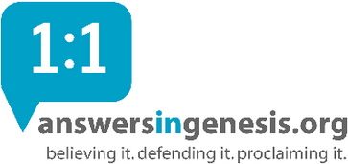
Rick Griffith
2016
Message of 10

Title
Passage

Introduction

Subject with a blank for the key word _______________

I. MP has a blank for the key word ________________ (verses).

SP has a blank for the key word ________________ (verses).

SP has a blank for the key word ________________ (verses).

SP has a blank for the key word ________________ (verses).

II. MP has a blank for the key word ________________ (verses).

SP has a blank for the key word ________________ (verses).

SP has a blank for the key word ________________ (verses).

SP has a blank for the key word ________________ (verses).

Conclusion

Main Idea has a blank for the key word ________________ (verses).

Application question

Thought Questions

- Read the passage aloud. Contrast:

Issue | Contrast

- Text-based question

- Application to your own Christian experience

Download this sermon PPT and notes for free at BibleStudyDownloads.org/resource/new-testament-preaching/

