Planning for Oral Clarity (Step 6b)
Illustrations

I. The Importance of Good Illustrations
Why it is important to illustrate the text well in preaching? (Robinson, 149-50)

• Illustrations explain, validate, or apply ideas by relating them to tangible experiences.
• Illustrations render a truth believable
• Illustrations aid memory
• Illustrations stir emotion
• Illustrations create need
Listener’s World
Preacher’s World
• Illustrations hold attention
• Illustrations establish rapport with the audience (entertaining is good!)

II. How to Give Good Illustrations

A. Draw illustrations from the listener’s world—not yours!

B. Get your sermon outline done early enough in the week to give time to find good and fitting illustrations (Mawhinney, 38, 40, 252-53).

C. Vary the type of sermon illustration used. Variety is key!

Hardly ever used Sometimes used Often used
• Humor • Historical incident • Statistic
• Nursery rhyme • Definition • Scientific data
• Bible story • Quotation • Poem
• Visualization (use of objects) • Hymn • Overused story
• Emotional story • Newspaper story • Anecdote
• Personal story (which is true, modest, and does not violate a confidence)

Try to emphasize this first column and you’ll be a hero to your listeners as very few Chinese preachers share illustrations in these areas!

(For a good example of variety, see Duane Litfin’s sermon in Haddon Robinson’s book, Biblical Sermons, 89-103, 107. He illustrates from Greek classics, pop music, science, poetry, hot air balloons, and his own experiences—all in one message!)
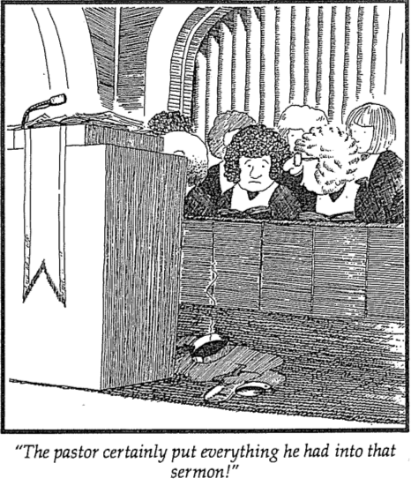
D. Don’t tell stories—relive them! Be dramatic!

E. Illustrate for every 3 minutes of preaching
(p. 51 has 18 ILLs in 15 minutes!)

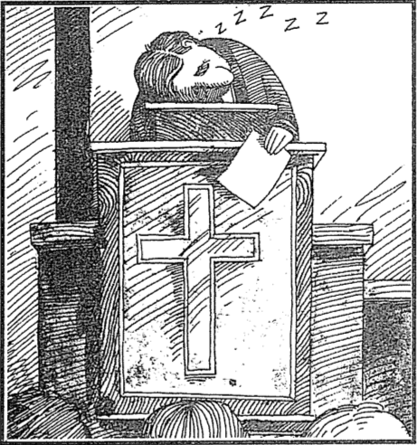

F. Avoid these dangers when illustrating your points
(from 100-Fold, the EDAA [English Department Alumni Association]-SBC News, February 1992)

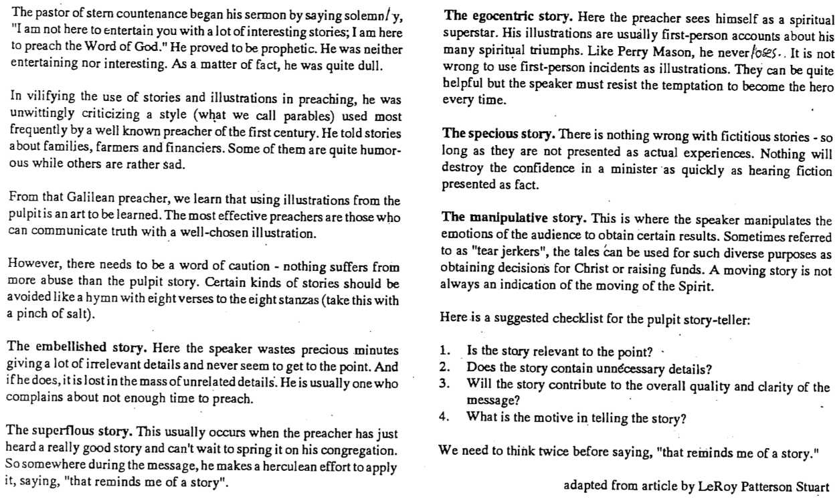

II. How to Catalog Illustrations

A. Find your illustrations. Beg, borrow, or steal illustrations wherever you can—from…

1. Sermons you hear (in church, chapel, on tape, etc.): Never be caught without your mobile phone to write down what you hear as soon as you hear it.

2. Things you read

a. Newspaper articles and comics—especially on the morning you preach!

b. Christian Books—especially by Charles R. Swindoll (read Living on the Ragged Edge, For Those Who Hurt, Improving Your Serve, Strengthening Your Grip, Dropping Your Guard, Growing Strong in the Seasons of Life)

c. Secular Books—see Tan Huay Peng, Fun With Characters: The Straits Times Collection. 3 vols. Singapore: Federal Publications, 1982.

d. Magazines—especially Reader’s Digest, Insight, and U.S. News and World Report

e. Devotional guides—especially Our Daily Bread

f. Written sermons—especially Haddon Robinson, Biblical Sermons

3. Your own personal experiences in life (but be transparent)

4. Other people’s life experiences or quotes (good for clarity and authority)

5. Your imagination (make up a scenario or conversation as if the listener is in it)
6. Websites of Illustration Collections

- IllustrationExchange.com allows weekly subscriptions of one free illustration per week
- PreachingToday.com
- SermonCentral.com might be the best one with the most illustrations
- SermonIdeas.com
- MoreIllustrations.com

7. Films and Television—including advertisements (printed ones too)—hundreds of clips are available at wingclips.com

8. Other preachers (exchange your best ones with one another)

B. Categorize your illustrations by pasting them into a separate Word file for each illustration where the file name has the TITLE in CAPS and the subtitle in small letters. For practice, give each of these four illustrations a TITLE and subtitle:

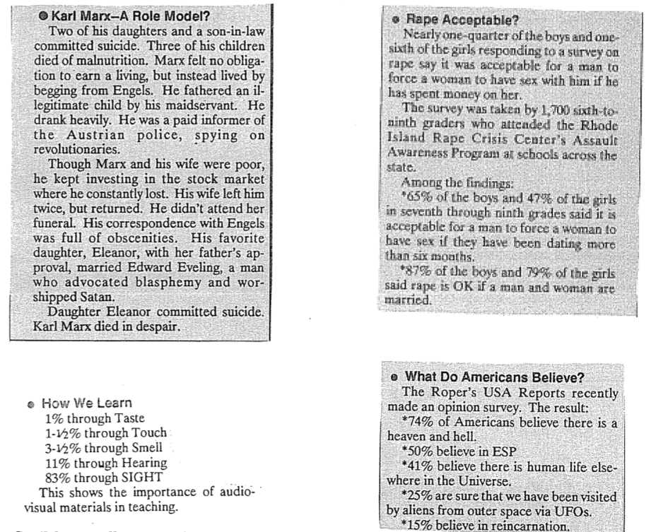

C. File these illustrations in a folder on your computer. If your titles and subtitles make sense, then this will be valuable in the future when looking for illustrations.

