Psalms

Praising and Petitioning God

 | Book 1  (1–41) | Book 2  (42–72) | Book 3  (73–89) | Book 4  (90–106) | Book 5  (107–150)
Number of Psalms | 41 | 31 | 17 | 17 | 44
Authors  and Number of Psalms Authored | David-37  Anon-4 | David-18  Korah-7  Anon-4  Solomon-1  Asaph-1 | Asaph-11  Korah-3  Ethan-1  Heman-1  David-1 | Anon-14  David-2  Moses-1 | Anon-28  David-15  Solomon-1
Prominent Type | Lament-22 | Lament-21 | Lament-9 | Praise-12 | Praise-22
Closing Doxology | 41:13 | 72:18-19 | 89:52 | 106:48 | 150:1-6
Possible Compiler | David | Hezekiah or Josiah |  | Ezra or Nehemiah
Possible Compilation Dates | c. 1020-  970 BC | c. 970-610 BC |  | Until c. 430 BC
Span of Authorship | About 1000 Years (c. 1410-430 BC)

Key Word: Praise

Key Verse: “Praise the LORD. I will extol the LORD with all my heart in the council of the upright and in the assembly” (Psalm 111:1).

Summary Statement:
Praise and petition God for who He is and what He has done in providing wisdom, protection, Messianic fulfillment, and His Word to be humble before Him in trust and thanksgiving.

Application:

Praise God for who He is as well as for what He’s done.

Honestly state your complaint to God since He knows you fully anyway.

Psalms

Introduction

I. Titles

A. Hebrew: The Hebrew Bible calls this the Book of Praises (~yLihiT] rp,se), abbreviated to Praises (~yLihiT] or ~yLiT,] or !yLiT]). Although the word “praise” occurs often in the Psalter, Psalm 145 is the only psalm with the title “praise” (hLhiT]). However, Westermann notes that even every lament psalm includes praise (except maybe Psalm 88) since all lament psalms progress beyond petition and lament to praise God (The Praise of God in the Psalms, 74).

B. Greek: The Septuagint (LXX) translated the Hebrew word mizmor (rAmz>mi) as “psalm” (yalmo,ς)—the technical word for a song sung to the accompaniment of a plucked (i.e., stringed) instrument.

C. English: Three English titles (The Psalms, The Psalter, and The Book of Psalms) are derived from the Greek and Latin titles (Psalmoi, Psalterian and Liber Psalmorum, respectively).

II. Authorship

A. External Evidence: Many scholars have challenged the superscriptions of many psalms, especially recently. Much of the debate centers on the use of the Hebrew preposition l, lamed, which can be translated "to," "for," "of," and several other ways (e.g., "A Psalm to David," "A Psalm for David," "A Psalm of David," etc.). However, its "use to designate authorship has been well attested in the Northwest Semitic inscriptions, other Semitic dialects such as Arabic, and other biblical passages such as Habakkuk 3:1 ('of Habakkuk')" (Ross, BKC, 1:782). Therefore, the traditional meaning that attributes authorship to these men is well substantiated.

B. Internal Evidence: Fifty psalms are anonymous, but the Psalter names seven different authors in 100 of the psalms (in descending order regarding the number of psalms each contributed):

1. David (second king of Israel), whose name means "Beloved of Yahweh" (73 pss. mostly in Books I and II) wrote the most psalms
2. Asaph (a famous musician and Levite from Gershom), "Collector" (12 pss.: Pss. 50, 73–83)
3. The sons of Korah (a guild of singers and composers who descended from Levi in the line of Kohath), "Bald" (10 pss.: Pss. 42, 44–49, 84, 85, 87)
4. Solomon, (third king of Israel and son of David and Bathsheba), "Peaceful" (2 pss.: Pss. 72, 127)
5. Moses (Israel’s leader out of Egyptian bondage and author of the oldest psalm), "Son of the Water" (Ps. 90)
6. Heman the Ezrahite (like the sons of Korah he was a Levite from the family of Kohath), "Faithful" (Ps. 88)
7. Ethan the Ezrahite (a Levite from the family of Merari), "Enduring" (Ps. 89)

III. Circumstances

A. Date: The various psalms were written over nearly a 1000-year period from the time of Moses (Ps. 90; ca. 1410 BC) to the postexilic period under Ezra and Nehemiah (Ps. 126; ca. 430 BC).

B. Recipients: The Book of Psalms served as a hymnal for the nation of Israel in its worship at the temple and as a devotional guide for the Jewish people.

C. Occasion: David and Asaph organized Israel's worship around 1000 BC. Some of King David's hymns were probably collected at this time and used in the first temple under Solomon. Since Book of Praises was the original name of the entire Book, the collection was probably named such as the hymnbook of the second temple built by Zerubbabel with its worship re-established by Nehemiah (Neh. 12:46). The reason people need this collection is very simple: We must praise and petition God for who He is and what He has done in providing wisdom, protection, Messianic fulfillment, and His Word to be humble before Him in trust and thanksgiving.

IV. Characteristics

A. Psalms is the most diverse book of the Old Testament.

1. The content of the psalms covers a tremendous breadth of material (jubilation, war, peace, worship, judgment, messianic prophecy, praise, complaint).

2. The events stretch back to Creation and to the patriarchal, theocratic, monarchical, exilic, and postexilic periods.

B. Psalms is the longest book in the Bible in terms of chapters and in words:

Book | Chapters | Verses | Words
Psalms | 150 | 2461 | 43,743
Jeremiah | 52 | 1364 | 42,659
Ezekiel | 48 | 1273 | 39,407
Genesis | 50 | 1533 | 38,267
Isaiah | 66 | 1292 | 37,044
http://www.kneeholedesk.com/Pages/Did_You_Know/Books_of_the_Bible.html

C. Psalms is the most quoted book of the Old Testament in the NT (119 or more times).

D. Psalm 23 is the most quoted and memorized poem in history.

E. Psalms is likely the most loved book in the Bible that has ministered to more people in more situations in more ages than any other biblical book.

Argument

Classification by Book: Psalms is a songbook to facilitate the worship of Israel, especially corporately. However, the reason for the particular arrangement of the psalms into five books (listed below) has long perplexed scholars. Each book concludes with a doxology, but why the certain psalms are classified into each book is unknown, partly due to the difficulty in classifying each individual psalm. The fivefold division has been explained at least three ways:

1. The Jews believed that the five sections mirror the Pentateuch (cf. Jensen’s chart, next page), but these appear to have no correspondence.

2. Herbert C. Leupold and A. A. Anderson both postulate that the divisions have resulted one book at a time from chronological development (cf. Jensen on the next page and Ralph Smith on p. 389). This is probably the better explanation.

Summary Statement for the Book
Praise and petition God for who He is and what He has done in providing wisdom, protection, Messianic fulfillment, and His Word to be humble before Him in trust and thanksgiving.

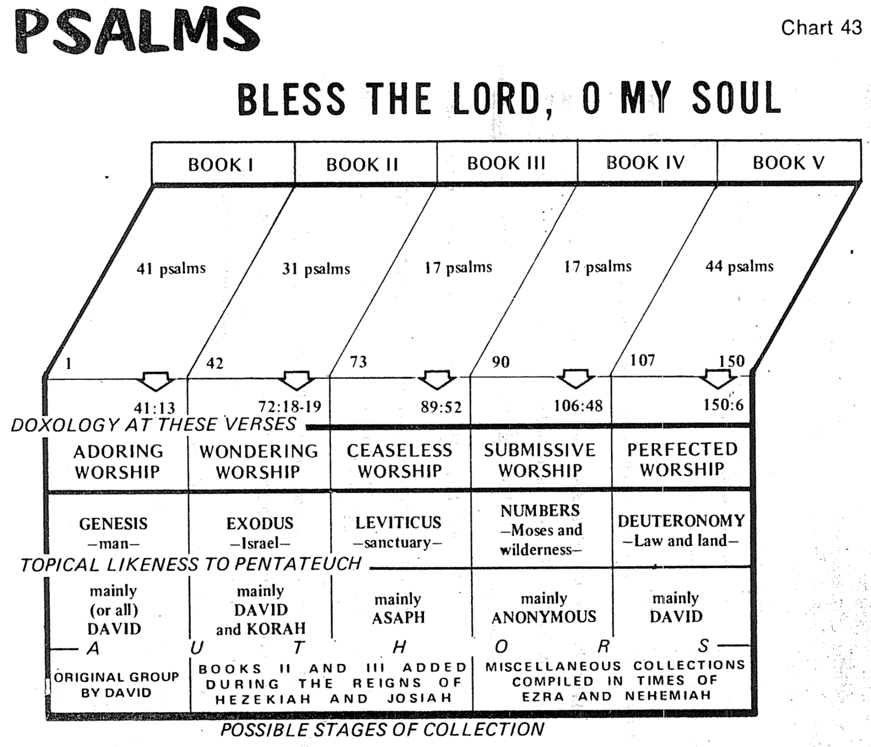
Irving L. Jensen, Jensen’s Bible Charts

Individual Psalms Classified Generally

Classification by Individual Psalm: Several attempts at classifying the individual psalms have been made, but probably Westermann, The Praise of God in the Psalms (Richmond: John Knox Press, 1965), 25-35, has the best broad divisions. He suggests that two broad categories—either "praise" or "lament" (petition)—describe every individual psalm. These two broad categories break down further into the following outline (abbreviations supplied by me):

Praise |  |  | Lament (Petition)
Declarative |  | Descriptive | Individual |  | People
Individual | People |  | Open | Heard
DPI | DPP | DSP | LIO | LIH | LOP
1 | 2 | 3 | 4 | 5 | 6

In outline form the above chart can be described in the following manner:

I. Praise (P): Worship of God for what He has done or who He is

A. Declarative Praise (DP): Worship of God for what He has done–Actions of God

1 1. Declarative Praise of the Individual (DPI): Worship of God for what He has done for an individual

2 2. Declarative Praise of the People (DPP): Worship of God for what He has done for the congregation

3 B. Descriptive Praise (DSP): Worship of God for who He is–Attributes of God.

These are not divided into the individual and people/congregation subcategories since the distinction of the subject cannot be made except in a few of these psalms)

II. Lament/Petition (L): Request from God based on what He has done or who He is

A. Lament (Petition) of the Individual (LI): Request of God by one person

4 1. Lament (Petition) Not Answered (Open) (LIO): Request of God before the answer

5 2. Lament (Petition) Heard (LIH): Testimony of an answered request of God

6 B. Lament (Petition) of the People (LP): Request of God by the entire congregation

This classification results in six types of psalms as listed by number in the left hand column above. Each of these six types has specific components that normally occur, but not always. These are listed on the next page in their respective categories.
Components of Six Types of Psalms
Claus Westermann

Type (see previous page):
6 2 4 5 1 3
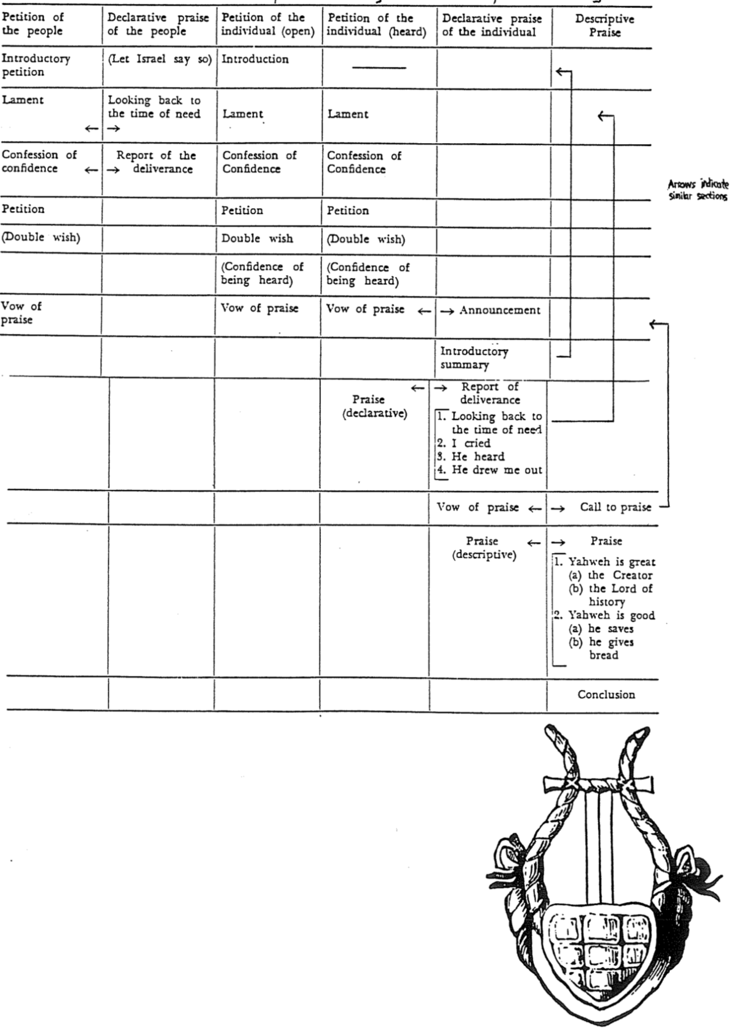
Classification of Each Psalm
F. Duane Lindsey, DTS Class Handout

Dr. F. Duane Lindsey feels that the previous six Westermann categories are not complete enough since several psalms have a didactic, or teaching theme (rather than being either praise or lament). Therefore, he adds a third major type of psalms called Didactic Psalms. He also breaks down the lament psalms and descriptive praise psalms into further categories:

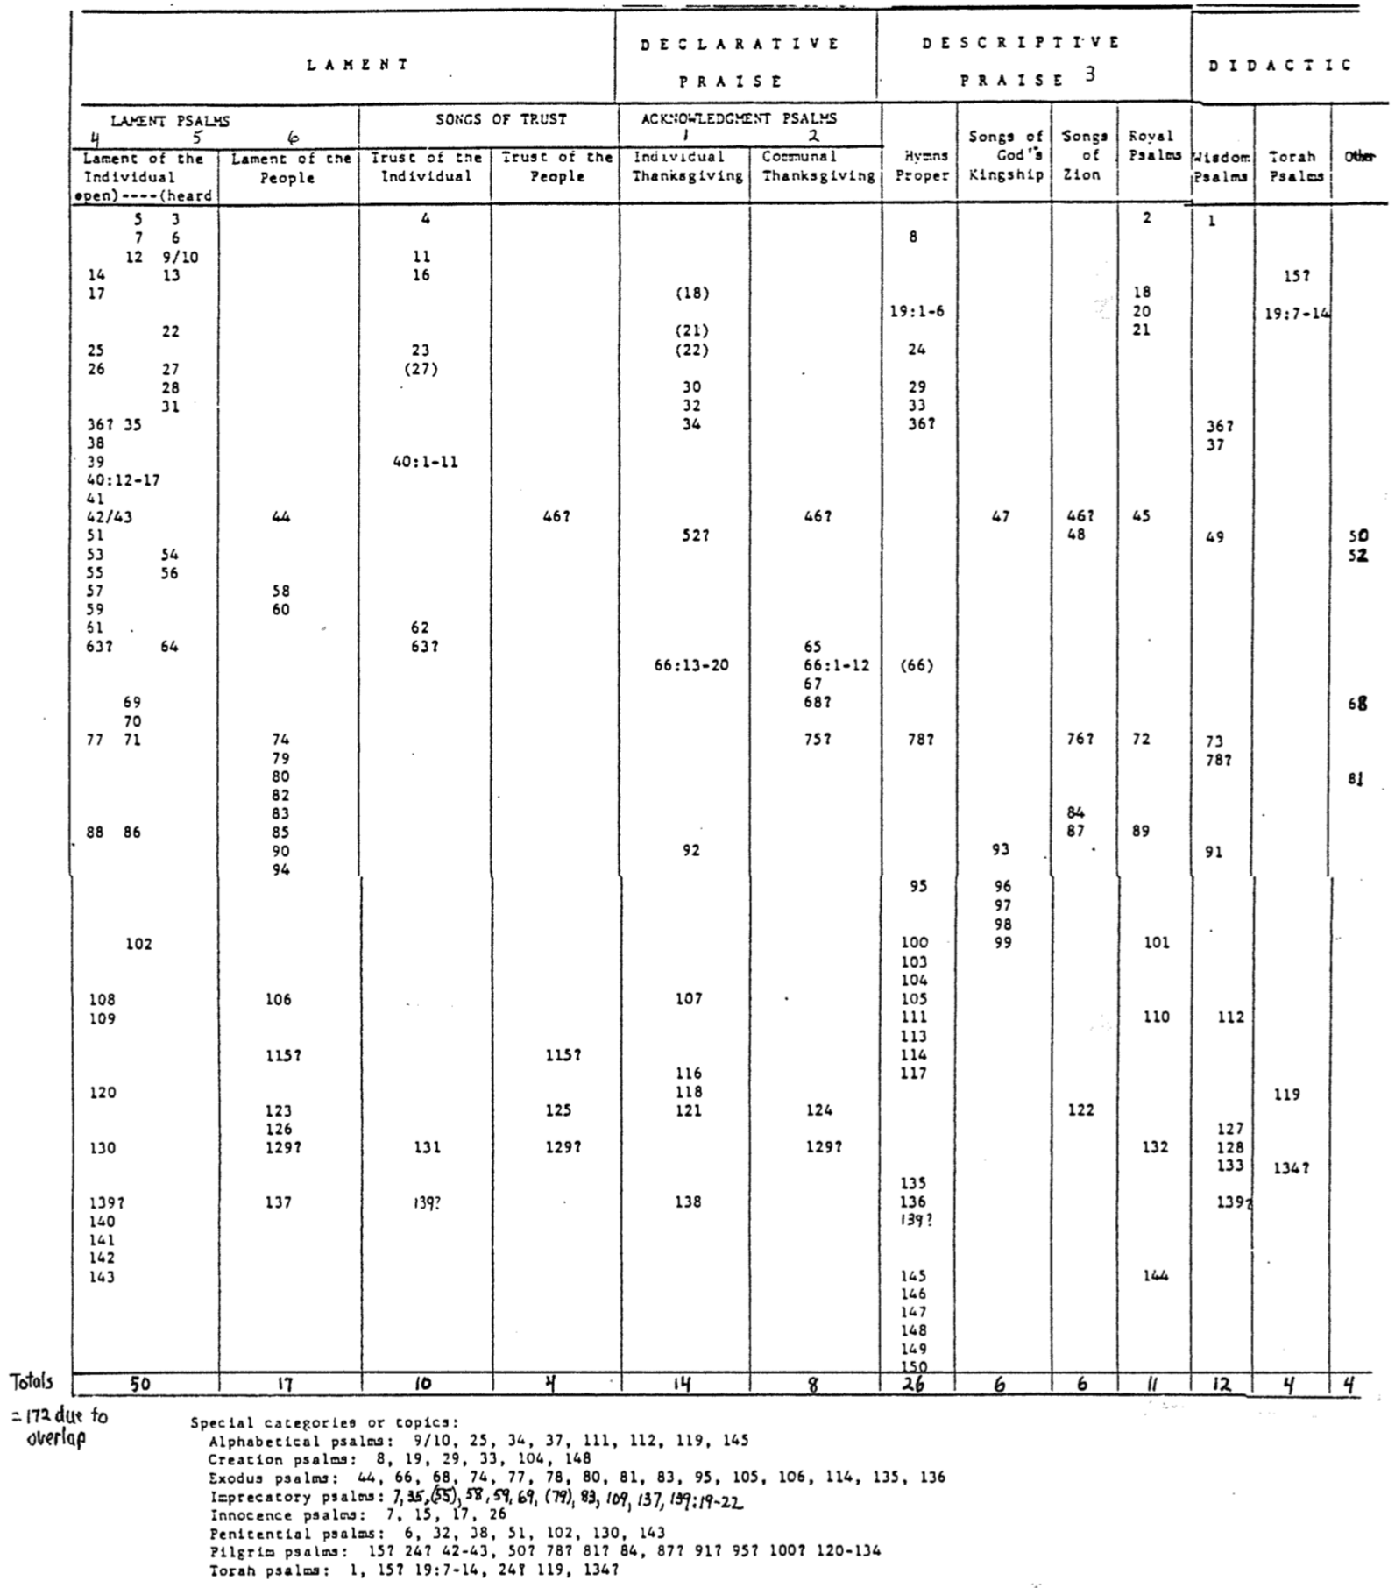

Themes of Each Psalm

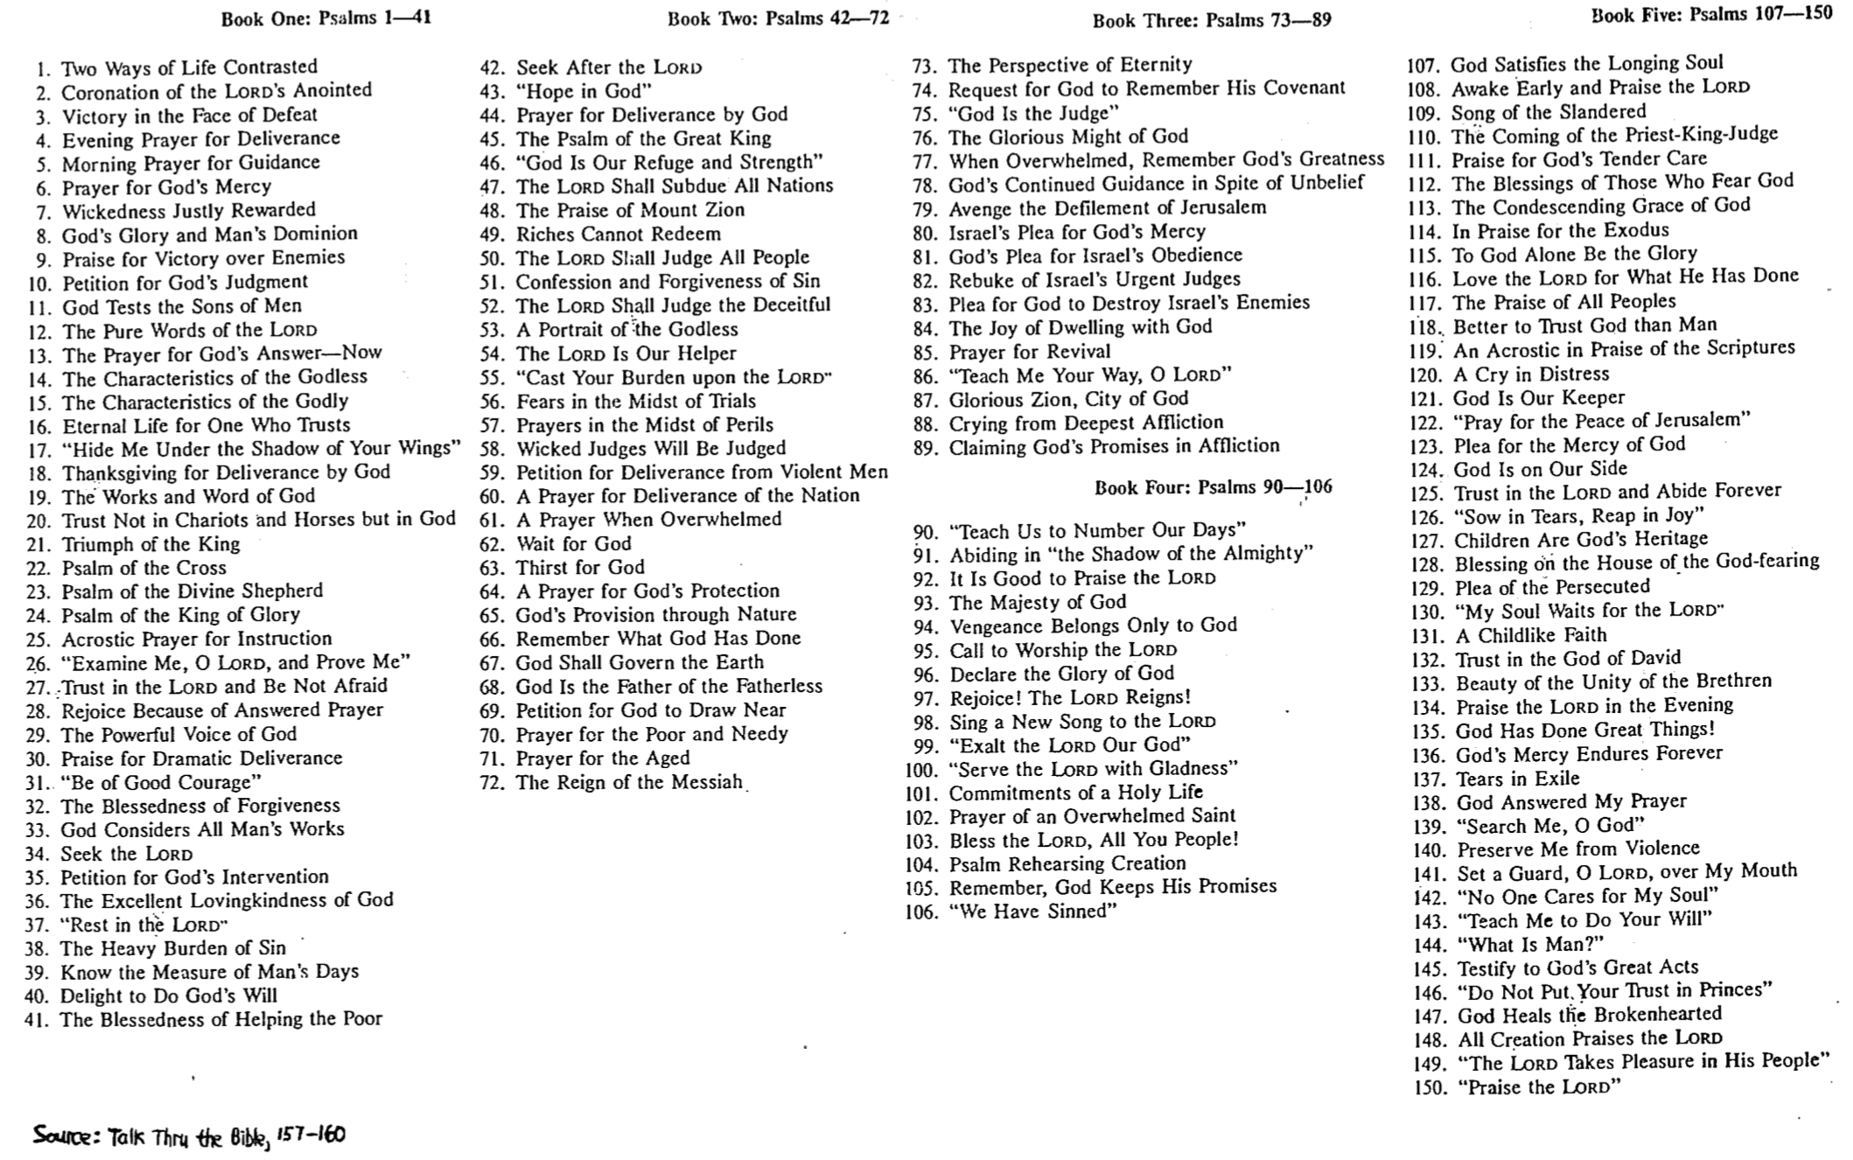
Fulfilled Messianic Prophecies in the Psalms

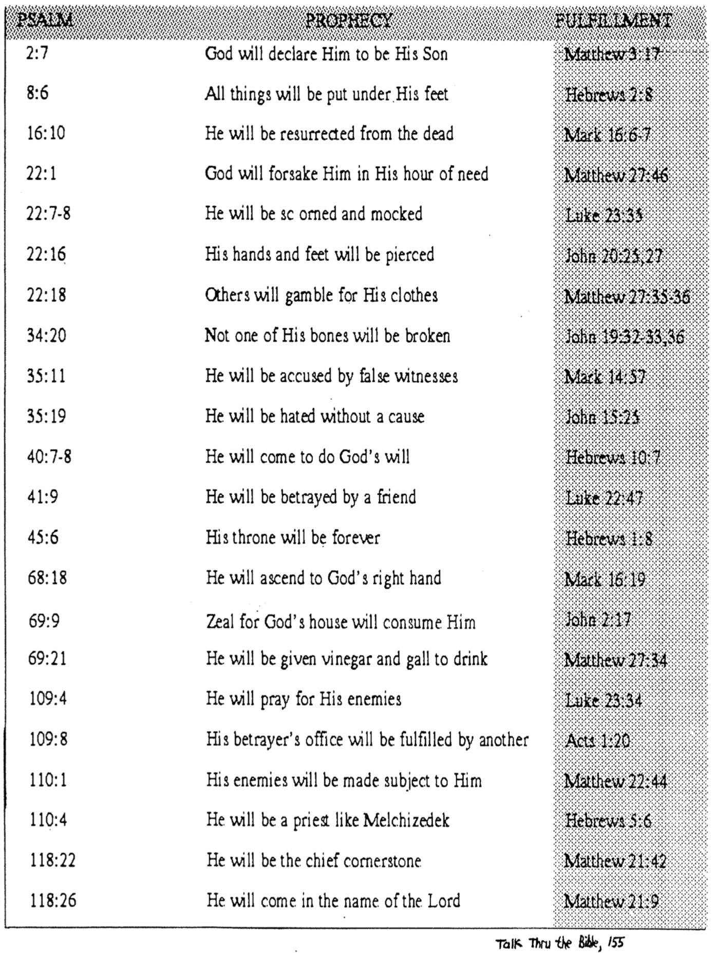

The Psalms in History

Ralph Smith, “The Use and Influence of the Psalms,” Southwestern Journal of Theology 27 (Fall 1984): 5-16

I. The Origin of the Psalms (Smith, 10-11)

A. The Singing Community
1. Praise (Moses in Exod. 15:1-18)
2. Lament (Deborah in Jud. 5:19)

B. David
1. Praise (1 Chron. 23:1–27:1)
2. Lament (2 Sam. 1:17-27)

C. Others

II. Compilation Hypothesis of A. A. Anderson (Smith, 11)

A. Davidic (Pss. 3–41): emphasizes the name of Yahweh (272 times) over Elohim (15 times)

B. Davidic (51–72): all have titles except 66–67, 71–72 (72:20 but 18 Davidic psalms follow!)

C. Korahite (42, 44–49) and Elohistic Asaphite (50, 73–83)

D. Yahwistic Asaphite (84–85, 87–88), David (86), Ethan (89)

E. Final Divisions (90–150)
1. Enthronement (95–99): also called messianic or kingdom psalms
2. Davidic (108–110, 138–145)
3. Ascent (120–134)
4. Hallelujah (111–118, 146–150)

F. Arrangement into Five Books (1–41; 42–72; 73–89; 90–106; 107–150)
1. Psalms extolling the Law added (1, 119)
2. Psalm 2 extolling the Messiah added

III. Usage by Christians (Smith, 7-9)

A. First to Fourth Centuries (Clement of Alexandria, Origen, Dionysius of Alexandria, Jerome)

B. Fourth to Fifth Centuries
1. Ambrose, Augustine
2. Pope Gregory I
3. St. Patrick, “Apostle of Ireland”

C. Sixth to Sixteenth Centuries (Eastern Church)

D. Sixteenth Century Reformation
1. Luther
2. Edward VI and Church of England

E. Vatican II (1963-65)

F. Modern Disuse (3 reasons)
1. Time: No one has the time to read or recite the psalms each week or month
2. Relevance: The gap between biblical times and our age must be bridged
3. Theology: Some texts are deemed “sub-Christian” (e.g., Ps. 51:11; 109:6, 19; 137:9)

Hebrew Poetry & Parallelism

I. Hebrew Poetry

A. Uniqueness of Psalms compared to Job, Proverbs, Ecclesiastes, and Song of Solomon

B. Characteristics of Hebrew Poetry

1. Stress Patterns or Rhythm (Kidner) or Meter (Ross): accented words per line. Actually, no one really knows if Hebrew poetry contains a metrical pattern since pronunciation of ancient Hebrew has not been preserved.

2. Evocative Language: concentrated form of discourse with use of earthy and militaristic images, symbols, figures, emotive vocabulary, and multiple meanings which allow the psalmist to convey several things simultaneously (Ross, BKC, 1:780).

3. Acrostic Arrangement: sometimes it has alphabetical sequence with each verse beginning with a different consecutive letter of the Hebrew alphabet (Pss. 9–10 [one poem], 25, 34, 37, 111–112; 145). Psalm 119 is divided into 22 strophes of eight verses each.

4. Thought Rhyme (Parallelism): sense is repeated rather than sound (see below).

II. Parallelism

A. Definition: “the repetition of meaning in parallel expressions” (Ross, BKC, 1:780).

B. Advantages: Repetition of thought…

1. Makes understanding easier since truths or expressions are repeated in other words. This keeps us from the error of thinking that a different point is being made in the second line.

2. Allows translations “to reproduce its chief effects with very little loss of either force or beauty” (Kidner, 1:4).

C. Types of Parallelism

1. Synonymous: the second line “reinforces the first, so that its content is enriched and the total effect becomes spacious and impressive” (Kidner, 1:3).

“Then Israel entered Egypt;
Jacob sojourned in the land of Ham” (105:23 Ross translation)

“He does not treat us as our sins deserve
or repay us according to our iniquities” (103:10)

2. Antithetic: the second line provides a contrasting truth to the first line.

“The wicked borrow and do not repay,
but the righteous give generously” (37:21)

3. Emblematic: one of the lines explains the other by metaphorical comparison

“As a father has compassion on his children,
so the LORD has compassion on those who fear him” (103:13)

4. Synthetic: the second line develops the idea of the first (a general category developed by Lowth but broke down here using Ross’ categories).

a. Incomplete with Compensation: lines are equal length with only some terms parallel.

“You will destroy their offspring from the earth
and their children from among the sons of men” (21:10 Ross translation)

b. Climactic: each line builds upon the previous one with increasing intensity (stair-step parallelism). This is actually a type of incomplete parallelism with compensation.

“Ascribe to the LORD O holy ones (heavenly beings)
Ascribe to the LORD glory and strength
Ascribe to the LORD the glory due His name
Worship the LORD in the beauty of His holiness” (29:1-2 Maranatha Song!)

c. Incomplete without Compensation: lines are different length with only some terms parallel.

“O LORD, do not rebuke me in Your anger
or discipline me in Your wrath” (6:1)

d. Formal: the second line is all compensation so that it simply continues the thought of the first (so actually there’s not really parallelism at all!

“I have installed My King
on Zion, my holy hill” (2:6)

Hermeneutics & Figures in Psalms

I. Tips for Interpreting the Psalms

A. Give attention to repeating refrains, phrases, or ideas to identify the structure so as to outline the psalm correctly.

B. Summarize the message of the psalm in a sentence.

C. Consider the historical notations in the text and/or title to discover the historical setting.

D. Classify the psalm using one of F. Duane Lindsey’s categories (class notes, p. 386).

E. Take into account the progress of revelation to correctly interpret incomplete theology (e.g., 51:11, “…do not…take your Holy Spirit from me”).

F. Reword figures of speech to give their meanings (see next page).

G. Use New Testament allusions and/or quotations of the psalm for understanding, but do not read back into the text what the original author and audience would not have understood.

II. Common Figures of Speech in Psalms

A. Figures of Comparison

1. Simile: denotes resemblance between two things unlike but yet have something in common (“x is like y”).

“He shall be like a tree planted by streams of water” (1:3)

2. Metaphor: denotes representation between two things unlike but yet have something in common (“x is y”)

“The LORD God is a sun and shield” (84:11)

3. Hypocatastasis: denotes implication between two things unlike but yet have something in common (“x” alone is stated but the context implies that “x” is like y)

“Dogs have surrounded me” (22:16)

4. Anthropomorphism: God compared to man’s bodily part(s)

“Hide your face from my sins” (51:9)

5. Zoomorphism: God compared to animals

“In the shadow of your wings I used to rejoice” (63:7)

6. Personification: Inanimate objects are given properties or characteristics of living things

“Their mouths lay claim to heaven, and their tongues take possession of the earth” (73:9)

B. Figures of Substitution

1. Metonymy: substituting one word for another (the most common figure in Psalms)

“They flatter with their tongue” (5:9)

2. Synecdoche: substituting a part for the whole or vice versa

“But you are… my Glorious One, who lifts up my head” (3:3)

C. Figures of Addition

1. Parallelism: saying the same concept in different words in parallel lines (explained and illustrated in detail on previous pages)

2. Repetition: the exact same word or words are used twice or more

“My God, My God, why have you forsaken me?” (22:1)

D. Figures of Omission

1. Ellipsis: omission of a word or words in a sentence

“When you make ready [your arrows] upon your strings” (21:12)

2. Aposiopesis: sudden silence or breaking off what is being said

“My soul is greatly troubled; but You, O LORD, how long–?” (6:3)

Worship in Israel

Adapted from Allen P. Ross, “The Psalms and Israel’s Worship” (Dallas Seminary class handout, 1985)

I. The Nature of Worship (Fourfold)

A. Aesthetic Sense: Drama, symbolism, and ritual ceremony all appeal to our aesthetic instincts. Jews lived in booths, ate communal offerings, put blood on doorposts, and did other symbolic acts that taught well (a similar methodology is developed in the excellent book, Let’s Make a Memory, by Shirley Dobson & Gloria Gaither).

B. Intellectual Sense: Worship must emphasize understanding or knowledge to (1) keep it free from superstition, and (2) enable people to see that ours is a rationally ordered universe.

C. Moral Sense: Ethical and moral content must be present in ritual through reading/meditation of Scripture and fellowship to inspire truth in living.

D. Corporate Sense: “Worship is a communal activity. There is a place for personal piety and devotion, but the purpose of such must be the participation in the congregation of the righteous. The results of private meditations will be the sharing in the corporate assembly.”

II. The Five Component Features of Worship

A. Sacrifice and Offering: the way something became holy (things were clean, unclean, or holy) where the external rite expressed an inward disposition (faith) necessary to please God since without sacrifice there was no worship!

1. Consecration/Voluntary/Dedicatory
a. Burnt: the entire animal was burnt to signify God’s total acceptance of the sacrifice
b. Grain (Meal): recognition that everything the worshipper had belonged to God
c. Fellowship (Communal, Peace): shared meal signifying one’s blessings were to share
d. Drink: wine poured on the ground signifying total dedication (cf. Phil. 2:17)

2. Cleansing/Obligatory/Expiatory
a. Sin: forgiveness for unintentional sin (Num. 15:22) vs. deliberate sin (15:30-36; cf. willful violations of any of the 10 commandments had the death penalty)
b. Guilt (Reparation): covered violations that needed restitution to God or man

B. Reading of the Word: priests were required to read the Torah every service
C. Prophetic Exhortation: priests also gave expositions of the passage
D. Prayer: both spontaneous and private and also planned and public
E. Praise: given to God for who He is (descriptive) or what He has done (declarative)

III. Occasions for Worship

A. Individual Cultic Activities

1. Fulfillment of Religious Obligations (e.g., Firstfruits, tithes): Deut. 26
2. Times of Illness and Disease (e.g., leprosy): Lev. 13–15
3. Legal Procedures (e.g., temple refuge for manslaughter but involved forfeit of liberty)
4. Atonement for Sin (e.g., deception, rash oaths, touching unclean things, etc.)
5. Fulfilling Special Vows/Presenting Special Offerings: 1 Sam. 1:24-28; 2 Sam. 15:7-9
—in rudimentary form this special vow is seen in Gen. 28:18-22

B. Communal Cultic Activities

1. Regular Celebrations (e.g., daily offering, new moon, and feasts)
2. Special Services (e.g., during military conflict, drought, famine, fasts, prayers)

