Judges

Failure Under the Theocracy

Incomplete Occupation |  | Deliverance by Judges |  |  |  |  |  |  | Need for Monarchy
1:1–2:5 |  | 2:6–16:31 |  |  |  |  |  |  | 17–21
Deterioration |  | Discipline |  |  |  |  |  |  | Depravity
Causes  of the Cycles |  | Curse  of the Cycles |  |  |  |  |  |  | Conditions  in the Cycles
Living with  the Canaanites |  | War with  the Canaanites |  |  |  |  |  |  | Living Like  the Canaanites
Military Disobedience  1 | Spiritual Disobedience  2:1-5 | Intro  2:6-3:6 | South  3:5-  3:31 | North  4:1–  5:31 | Central  6:1–  10:2 | East  10:3–  12:7 | North  12:8-  12:15 | West  13:1–  16:31 | Religious  Depravity  17–18 | Moral  Depravity  19–21
Canaan

c. 341 Years (1390-1049 BC)

Key Word: Failure

Key Verse: “In those days Israel had no king; everyone did as he saw fit [what was right in his own eyes]” (Judges 21:25)

Summary Statement:
Israel’s failure under the theocracy due to faithless disobedience is contrasted with God's merciful care in disciplining and delivering Israel through judges to exhort submission to its new, divinely appointed kings in a righteous monarchy.

Applications:

Rejecting God’s lordship (incomplete obedience) plants the seeds for failure (1–2).

Following relative standards instead of God’s absolute standards leads to cycles of sin (3–16).

Replacing God’s wisdom with personal whims ultimately leads to idolatry (17–21).

Judges

Introduction

I. Title The name Judges (~yjip.vo sopetim) refers to those who "act as law-giver, judge, governor" (BDB 1047b 1b). However, the book itself shows that the term applies not only to those who maintain justice and settle disputes, but also liberate or deliver the people first before ruling and administering justice (2:16, 18).

II. Authorship

A. External Evidence: The Talmud (Tractate Baba Bathra 14b) ascribes to Samuel the books of Judges, Ruth, and Samuel.

B. Internal Evidence: The author is anonymous, but the Jewish tradition regarding Samuel's authorship makes good sense for several reasons:

1. The repeated phrase "in those days Israel had no king" (17:6; 18:1; 19:1; 21:25) places the writing between the beginning of Saul's reign and the divided monarchy, which makes the earliest possible date at 1043 BC when Saul became king.

2. The fact that the Jebusites still inhabited Jerusalem when the book was penned (1:21) places the latest possible date of writing before 1004 BC when David conquered the city (2 Sam. 5:5-9).

While other evidence can be cited, these two factors alone place the writing during the time of Samuel when Israel had a king (#1 above) and that king was either Saul or David (#2 above). Although a contemporary of Samuel could have reported this history, the Jewish tradition and fact that Samuel was a writer (1 Sam. 10:25) provide strong evidence that he wrote the book.

III. Circumstances

A. Date: The information above proves that Judges was written between the coronation of Saul (1043 BC) and David's conquest of Jerusalem (1004 BC). Some critics feel this date is too early since a summation of the rules of each judge yields 410 years (too many years to fit between Joshua and Saul's times). However, due to overlapping judgeships, the events in the book span about 341 years (from about 1390 BC-1049 BC; cf. p. 96) and therefore end just before the time of the book's composition.

B. Recipients: The early monarchy date reveals that the original readers of Judges constitute the Jews who recently experienced the change from a theocracy to a monarchy.

C. Occasion: Judges records life in Israel during the final days of the theocracy when the nation officially operated under the rule of God. However, in reality Israel did not submit to his authority since "everyone did as he saw fit," or more literally, "every man did what was right in his own eyes" (17:6; 21:25; NASB). The oft-mentioned motto "Israel had no king" coupled with this anarchy statement shows that the book aimed to defend the monarchy for Israel to be united under the rule of a righteous king.

IV. Characteristics

A. In contrast to the national leadership of Moses and/or Joshua in the Pentateuch and Book of Joshua, Judges is the OT first book to record leadership by judges who ruled Israelites on a local level.

B. Judges is similar to Numbers in that it also contrasts the faithful, patient love of God with the faithless, impatient ingratitude of Israel in cycles.

1. Pattern: Israel’s faithlessness in a cyclical five-stage pattern from sin to servitude to supplication to salvation to silence repeats seven times:

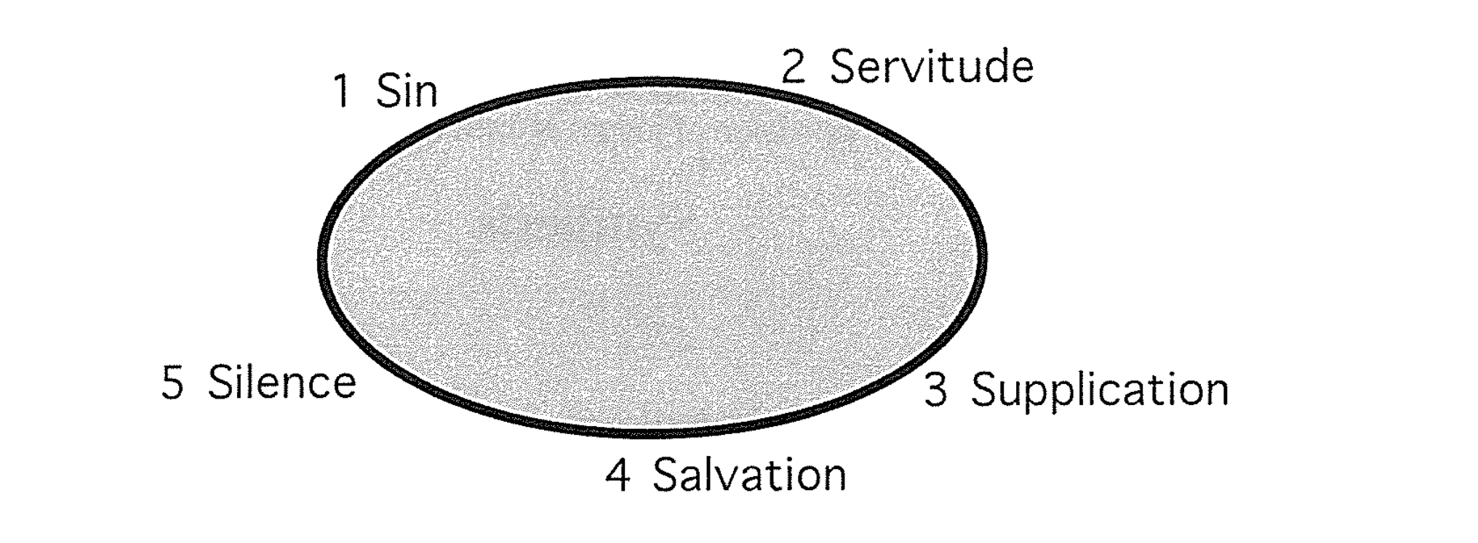

2. The Seven Cycles of the Book of Judges (see chronology on p. 96):

Cycle | Oppressor | Location  in Israel | Years of Oppression |  | Deliverer |  | Years of Peace
1  (3:7-11) | Mesopotamians | South | 8 | Othniel |  | 40
2  (3:12-30) | Moabites | Southeast | 18 | Ehud |  | 80
Parenthesis (3:31) | Philistines | Southwest | – | Shamgar |  | –
3  (chs. 4–5) | Canaanites | North | 20 | Deborah & Barak |  | 40
4  (6:1–8:32) | Midianites | Northcentral  (Ophrah) | 7 | Gideon |  | 40
5  (8:33–9:57) | Abimelech | Central | 3 | Unnamed Woman |  | –
Parenthesis (10:1-2) | – | Central  (Shamir) | – | Tola |  | 23
Parenthesis (10:3-5) | – | East  (Komon,Gilead) | – | Jair |  | 22
6  (10:6–12:7) | Ammonites | East  (Zaphon, Gilead) | 18 | Jephthah |  | 6
Parenthesis (12:8-10) | – | Southeast  (Bethlehem) | – | Ibzan |  | 7
Parenthesis (12:11-12) | – | Northwest | – | Elon |  | 10
Parenthesis (12:13-15) | – | Central  (Pirathon) | – | Abdon |  | 8
7  (chs. 13–16) | Philistines | Southwest  (Zorah) | 40 | Samson |  | 20
Totals |  |  | 114 |  |  | 296

Argument

The repeated phrase "in those days Israel had no king" (17:6; 18:1; 19:1; 21:25) provides the key to unlock the argument of Judges. The book chronicles the failure of the theocracy in the political and religious failure of the nation (1:1–2:5), the successive attempts of twelve judges to provide stability to the theocracy (2:6–16:31), and the complete spiritual and moral collapse of the nation (Judges 17–21). The four occurrences of the lack of a king (above) appear only in this third section of the book to show the need for a righteous monarchy to replace the failed theocracy explained in the first sixteen chapters. Throughout the account God's merciful care contrasts sharply with the disobedience of his wayward people. The provision of judges served as an act of God's compassion (2:16, 18).

Synthesis

Failure of the theocracy

1:1–2:5 Incomplete occupation/obedience
1 Military
2:1-5 Spiritual

2:6–16:31 Deliverance by Judges
2:6–3:6 Introduction
3:7–16:31 12 Judges, 7 cycles
3:7-11 Othniel
3:12-31 Ehud
3:31 Shamgar
4–5 Deborah/Barak
6:1–8:28 Gideon
8:29–9:57 Unnamed woman
10:1-2 Tola
10:3-5 Jair
10:6–12:7 Jephthah
12:8-10 Izban
12:11-12 Elon
12:13-15 Abdon
13–16 Samson

17–21 Need for Monarchy
17–18 Religious failure
17 Micah's priest
18 Danite migration
19–21 Moral failure
19 Levite concubine disaster
20 Benjamites almost destroyed
21 Wives provided
21:25 Monarchy needed

Outline

Summary Statement for the Book
The reason Israelites failed under the theocracy and had to submit to their new kings was because they rejected God’s lordship, followed God’s deliverers instead of God’s word, and replaced God’s wisdom with the idolatry of personal whims.

Israel's incomplete occupation of Canaan led to the need for judges (1:1–2:5).

Israel's political-military failure to finish the conquest shows that they did not trust God to claim his promise of the entire land (Judges 1).

Israel's religious-spiritual failure from the incomplete conquest shows that they would need human deliverers (2:1-5).

Judges tried to stop Israel’s cycles of sin to show that God’s absolute standards were better than Israel’s relative standards (2:6–16:31).

The introduction to the twelve judges previews God's repeated provision of judges to deliver Israel from the remaining nations even though Israel broke the covenant after Joshua’s death (2:6–3:6).

Israel's deliverance through twelve judges in a downward moral spiral in seven cycles shows God's mercy when they repent from idols so God cannot be blamed for the theocracy’s failure (3:7–16:31).

Cycle 1: Othniel (Caleb's nephew) delivered southern Israel from the Mesopotamians as God's merciful provision after the nation turned from idols to the LORD (3:7-11).

Sin: Israel forgot the LORD and served the Baals and Asherahs (3:7).

Servitude: God punished the nation's idolatry for eight years through Cushan-Rishathaim, King of Mesopotamia (3:8).

Supplication: The nation cried out to the LORD for deliverance from its enemies (3:9a).

Salvation: Othniel (Caleb's nephew) delivered southern Israel from the Mesopotamians as God's merciful provision for the nation (3:9b-10).

Silence: The nation had peace for 40 years until Othniel died (3:11).

Cycle 2: Ehud delivered southeastern Israel from the Moabites by killing the fat King Eglon as God's merciful provision after the nation turned from idols to the LORD (3:12-30).

Sin: Israel again did evil before the LORD (3:12a).

Servitude: God punished the nation's disobedience for 18 years through King Eglon of Moab (3:12b-14).

Supplication: The nation cried out to the LORD for deliverance from its enemy (3:15a).

Salvation: Ehud delivered southeastern Israel from the Moabites by killing the fat King Eglon as God's merciful provision for the nation (3:15b-29).

Silence: The nation had peace for 80 years (3:30).

Shamgar delivered southwestern Israel from the Philistines by killing six hundred men as God's merciful provision for the nation during the lifetime of Ehud (3:31).

Cycle 3: Deborah and Barak delivered northern Israel from the Canaanites and sang a song of victory as God's merciful provision after the nation turned from idols to the LORD (Judges 4–5).

Sin: Israel again does evil before the LORD (4:1).

Servitude: God punished the nation's disobedience for 20 years through Jabin, a king of Canaan (4:2-3a).

Supplication: The nation cried out to the LORD for deliverance from its enemies (4:3b).

Salvation: Deborah and Barak delivered northern Israel from the Canaanites and sang a song of victory as God's merciful provision for the nation (4:4–5:31a).

Silence: The nation had peace for 40 years (5:31b).

Cycle 4: Gideon delivered north-central Israel from the Midianites as God's merciful provision after the nation turned from idols to the LORD (6:1–8:32).

Sin: Israel again did evil before the LORD (6:1a).

Servitude: God punished the nation's disobedience through the Midianites, Amalekites, and other eastern peoples who ravage the land for seven years (6:1b-6).

Supplication: The nation cried out to the LORD for deliverance from its enemies (6:7-10).

Salvation: Gideon delivered north-central Israel from the Midianites as God's merciful provision for the nation (6:11–8:27).

The pre-incarnate Christ calls, tests, empowers, and encourages Gideon to lead Israel against the Midianites, Amalekites, and other eastern peoples (6:11-40).

God called Gideon to lead Israel (6:11-24).

God tested Gideon whether he would obey by destroying Baal's altar (6:25-32).

God empowered Gideon for service as the Midianites, Amalekites, and other eastern peoples camped opposite Israel for war (6:33-35).

God encouraged Gideon by confirming his call through a wet and dry fleece (6:36-40).

Gideon delivered north-central Israel from the Midianites as God's merciful provision for Israelites by keeping his promise to protect them when they obey (7:1–8:21).

Gideon judged the people when they made a golden ephod and worshipped it (8:22-27).

Silence: The nation experienced peace for 40 years (8:28-32).

Cycle 5: An unnamed woman delivered central Israel from Abimelech's vicious rule of fellow Israelites as God's merciful provision after the nation turned from idols to the LORD (8:33–9:57).

Sin: Israel sinned against the LORD by prostituting itself before the Baals (8:33-35).

Servitude: The nation broke the covenant by oppression though one of its own—Gideon's son Abimelech—who murdered 69 of his half-brothers (9:1-49).

Supplication (Absent): Israel never asked God for deliverance from Abimelech.

Salvation: Though not specifically designated a judge, an unnamed woman of Thebez delivered Israel from Abimelech by killing him with a millstone in Shechem (9:50-57).

Silence (Absent): Since no judge delivered Israel from Abimelech, no time period of peace is recorded and the account continues with Tola.

Tola delivered central Israel from unknown oppressors as God's merciful provision (10:1-2).

Jair led eastern Israel as God's merciful provision for the nation (10:3-5).

Cycle 6: Jephthah delivered eastern Israel from the Ammonites as God's merciful provision after the nation turned from idols to the LORD (10:6–12:7).

Sin: Israel sinned against the LORD by serving the gods of many nations (10:6).

Servitude: The nation's breaking of the covenant in Gilead led to oppression by the Philistines and Ammonites for 18 years (10:7-9).

Supplication: The people cried out to God in repentance and rid themselves of idols (10:10-16).

Salvation: Jephthah delivered eastern Israel from Ammonites in God's mercy but fulfilled a foolish vow by executing his daughter and 42,000 Ephraimites for their jealousy (10:17–12:6).

* For views on the fate of Jephthah’s daughter, see page 183.

Silence: Jephthah ruled the land for six years (12:7).

Izban led southeastern Israel as God's merciful provision for the nation (12:8-10).

Elon led northwest Israel as God's merciful provision for the nation (12:11-12).

Abdon led central Israel as God's merciful provision for the nation (12:13-15).

Cycle 7: Samson delivered southwestern Israel from the Philistines as God's merciful provision for the nation even though it never turned from evil to God (Judges 13–16).

Sin: Israel again did evil before the LORD (13:1a).

Servitude: God punished the nation's disobedience through the Philistines for 40 years (13:1b).

Supplication (Absent): Israel never cried out to the LORD for deliverance from its enemy.

Salvation: Samson delivered southwestern Israel from the Philistines as God's merciful provision for the nation (13:2–16:31).

Samson's miraculous birth identifies him as God's merciful provision for Israel (13:2-25).

Samson killed 30 Philistines after being deceived at his sinful wedding feast with a Philistine woman as God's agent for vengeance against the Philistines (Judges 14).

Samson burned Philistine fields for giving his wife to his wedding attendant and killed 1000 Philistines after the murder of her and her father as God's vengeance (Judges 15).

Samson's downfall by succumbing to Delilah's nagging leads to death with 3000 Philistines as his final act of vengeance on Israel's enemy (Judges 16).

Silence (Absent): Israel lacked a time of peace after Samson's 20-year rule.

Israel's religious and moral failures showed they needed a righteous king instead of their relativism (Judges 17–21).

Israel's religious failure in a Levite priest who blessed Dan's ungodly migration shows they needed a godly king (Judges 17–18).

Micah's idolatry and hiring of a Levite as pagan priest exemplifies the personal religious apostasy in Israel to show that a righteous monarchy must replace the failed theocracy (Judges 17).

The Levite's pagan blessing upon the godless Danite migration plan reveals the tribal religious apostasy in Israel to show that a righteous monarchy must replace the failed theocracy (Judges 18).

Israel's moral failure in the Benjamite murder of a concubine and national retaliation shows they needed a godly king (Judges 19–21).

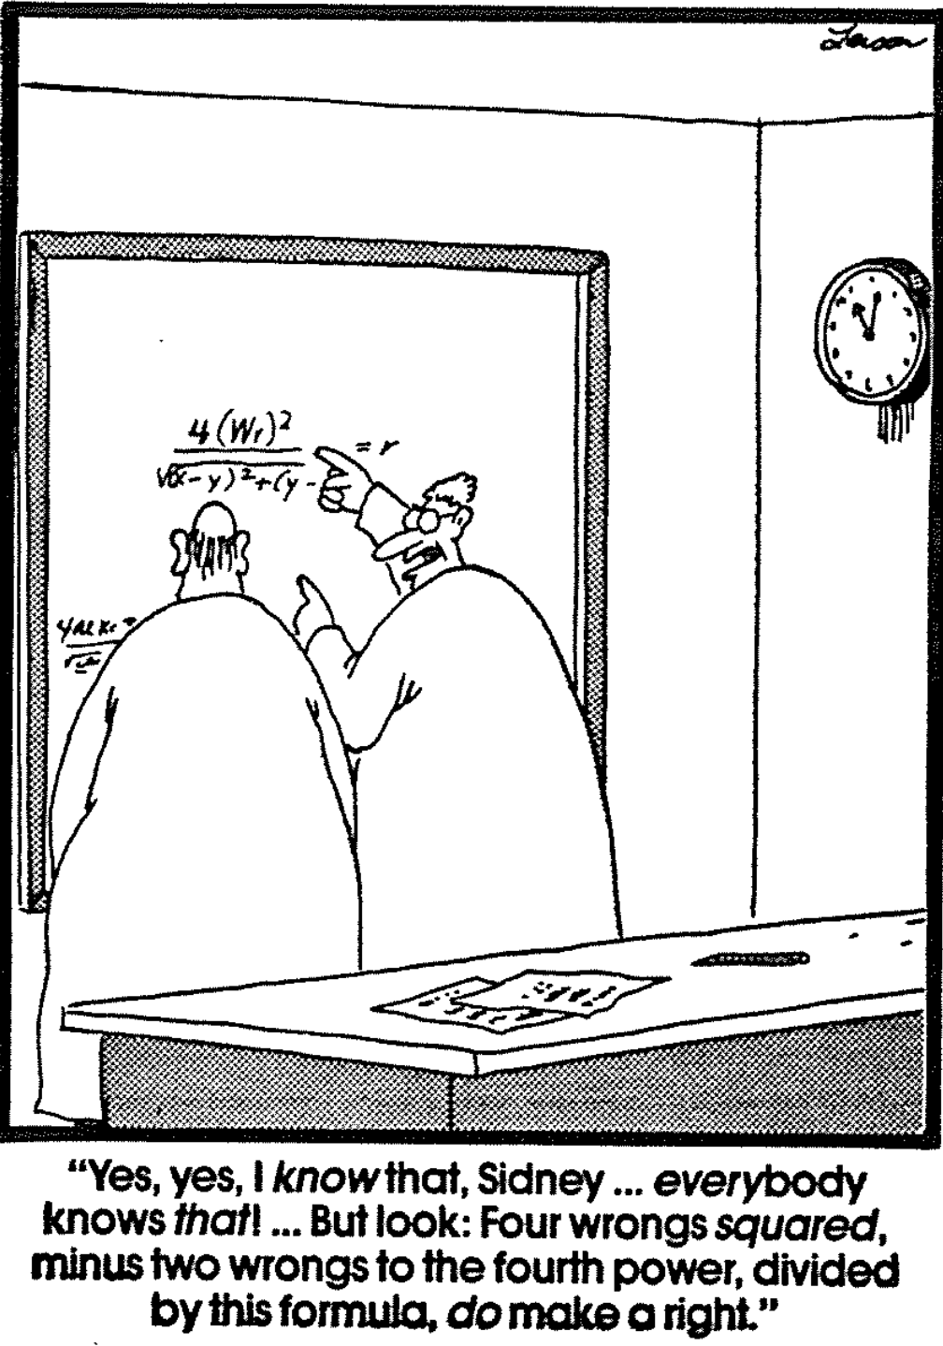
Benjamites in Gibeah rape and kill a traveling Levite’s concubine, whose body pieces are sent to each tribe in Israel to show the rampant immorality in the failed theocracy (Judges 19).

The 400,000 warriors of the other eleven tribes destroy 26,100* of the 26,700 Benjamites as well as all the women and children, and thus nearly destroy the entire tribe except 600 men who fled into the desert (Judges 20).

* The 25,100 killed (20:35) exclude 1000 Benjamites killed on days 1 & 2 of the battle.

Israelites preserve the Benjamite tribe by providing wives for the 600 living Benjamites by killing everyone in Jabesh Gilead except 400 virgins and stealing 200 virgins at a festival at Shiloh—both godless attempts to undo their wrong (21:1-24).

The closing statement of relativism as the people’s ethical standard reiterates the moral failure of the people to show the need for a righteous monarchy to replace the failed theocracy (21:25).

Joshua and Judges Contrasted

Based on Thomas L. Constable, “A Theology of Joshua, Judges, and Ruth,” in
A Biblical Theology of the Old Testament (ed. Roy B. Zuck), 107, and TTTB, 61

 | Joshua | Judges
Leadership Transition | Moses discipled Joshua | Joshua discipled No-one
Tone | Positive | Negative
People’s Faith to God | Faithfulness | Faithlessness
People’s Obedience | Obedience | Disobedience
Battle Results | Victory | Defeat
Overall Results | Success | Failure
Growth | Progress | Retrogression
God’s Attributes | Hatred of Sin | Grace towards Sinners
Idolatry | Destroyed Idols | Worshipped Idols
Community | Unity | Tribal Hostility
Response to the Law | Regard | Abandonment (18:24-25)
Values | Transmitted | Didn’t know the LORD (2:10)
Authority for Living | Absolute | Relative (17:6; 21:25)
Morality | Objective | Subjective
Slavery | Freedom | Bondage
Servitude | Served God (24:31) | Served Self (21:25)
Attitude towards Sin | Judged | Tolerated
Theocracy | Strengthened | Declined
Pattern of Life | Linear & Upward | Cycles leading Downward

The Judges According to Their Tribes
Yohanan Aharoni and Michael Avi-Yonah, The MacMillan Bible Atlas, 57

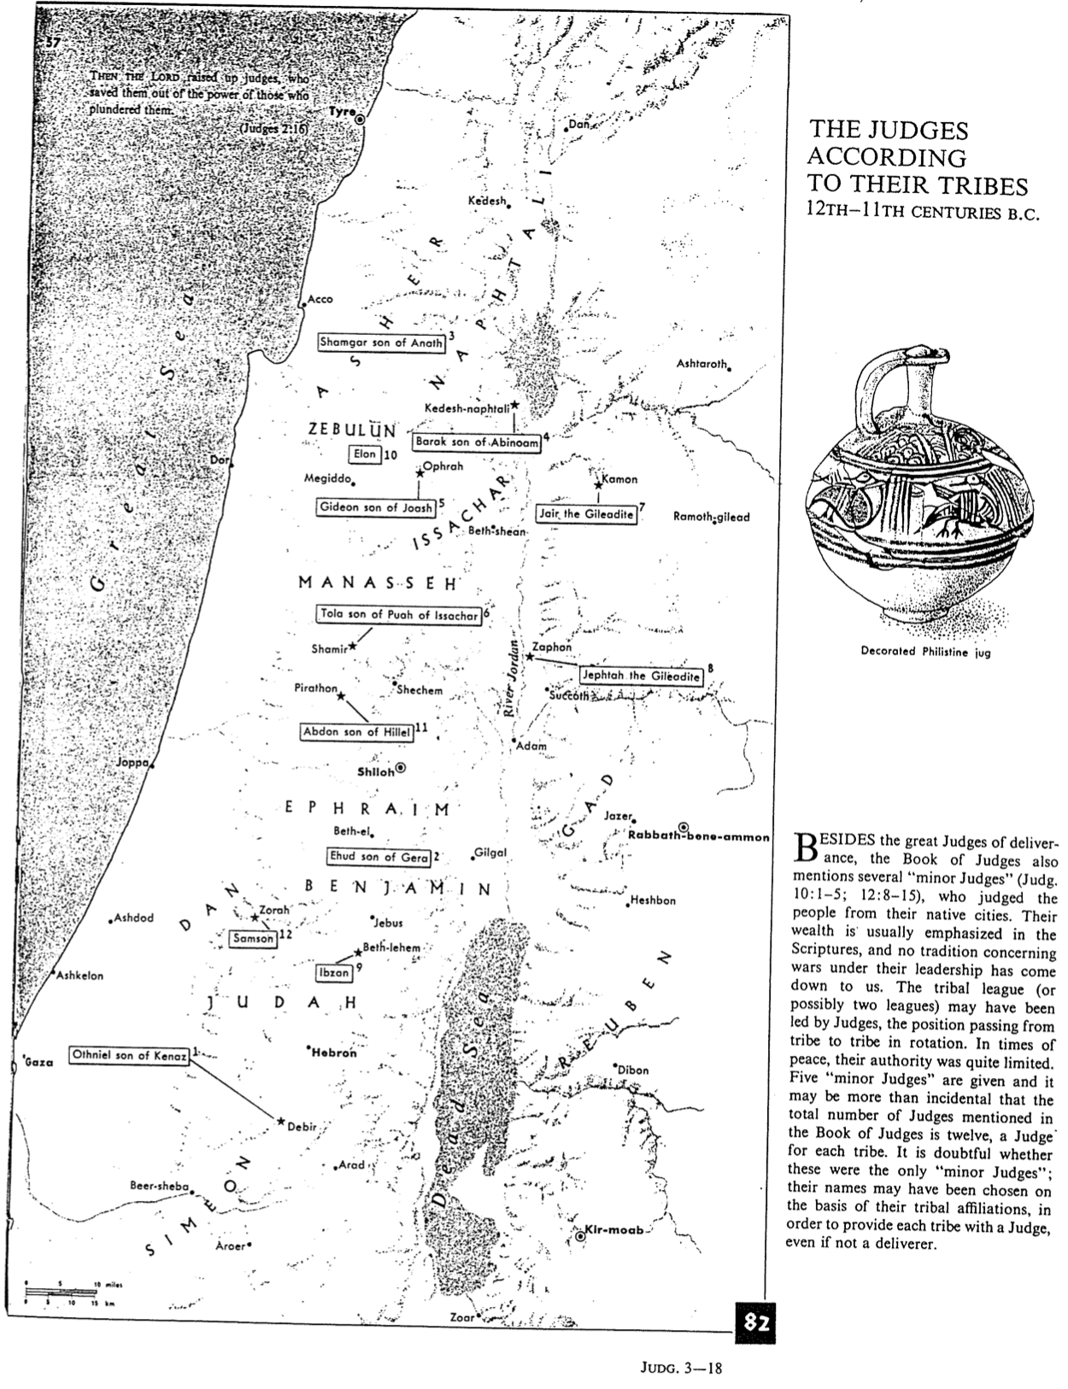

The Gideon Narrative as the Focal Point of Judges
J. Paul Tanner, Bibliotheca Sacra 149 (April-June 1992): 146-61 (1 of 2)

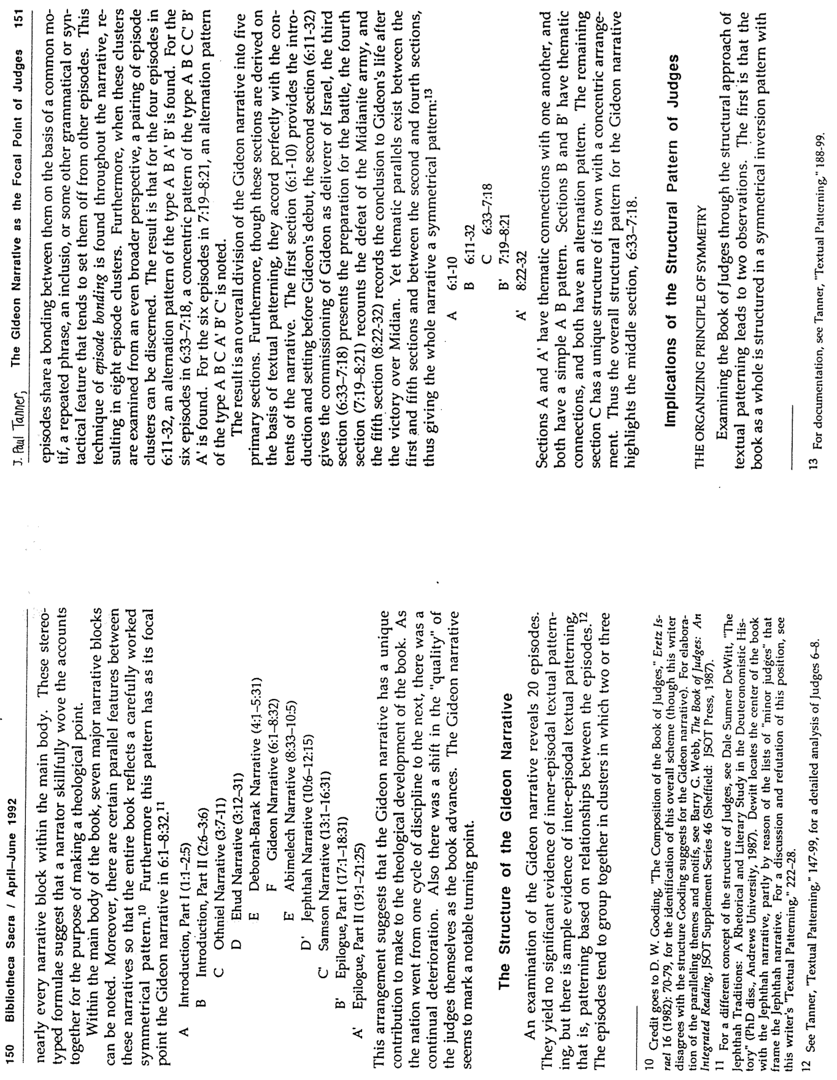

The Gideon Narrative as the Focal Point of Judges
J. Paul Tanner, Bibliotheca Sacra 149 (April-June 1992): 146-61 (2 of 2)

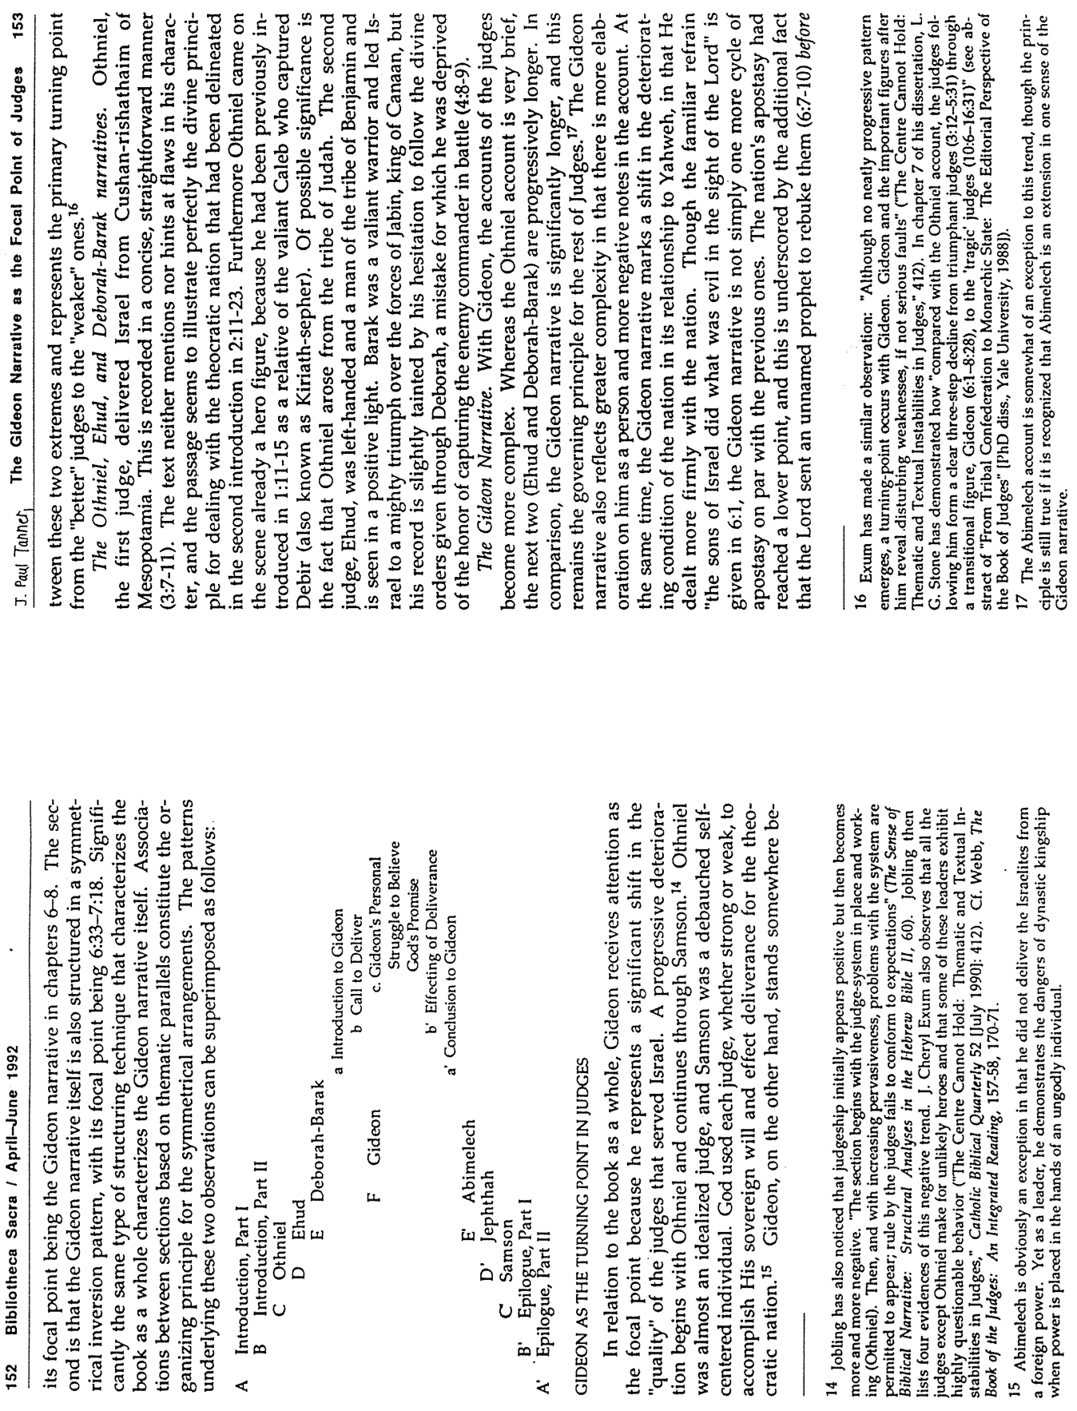

Enemies in Canaan During the Judges
Irving L. Jensen, Jensen’s Survey of the Old Testament, 155

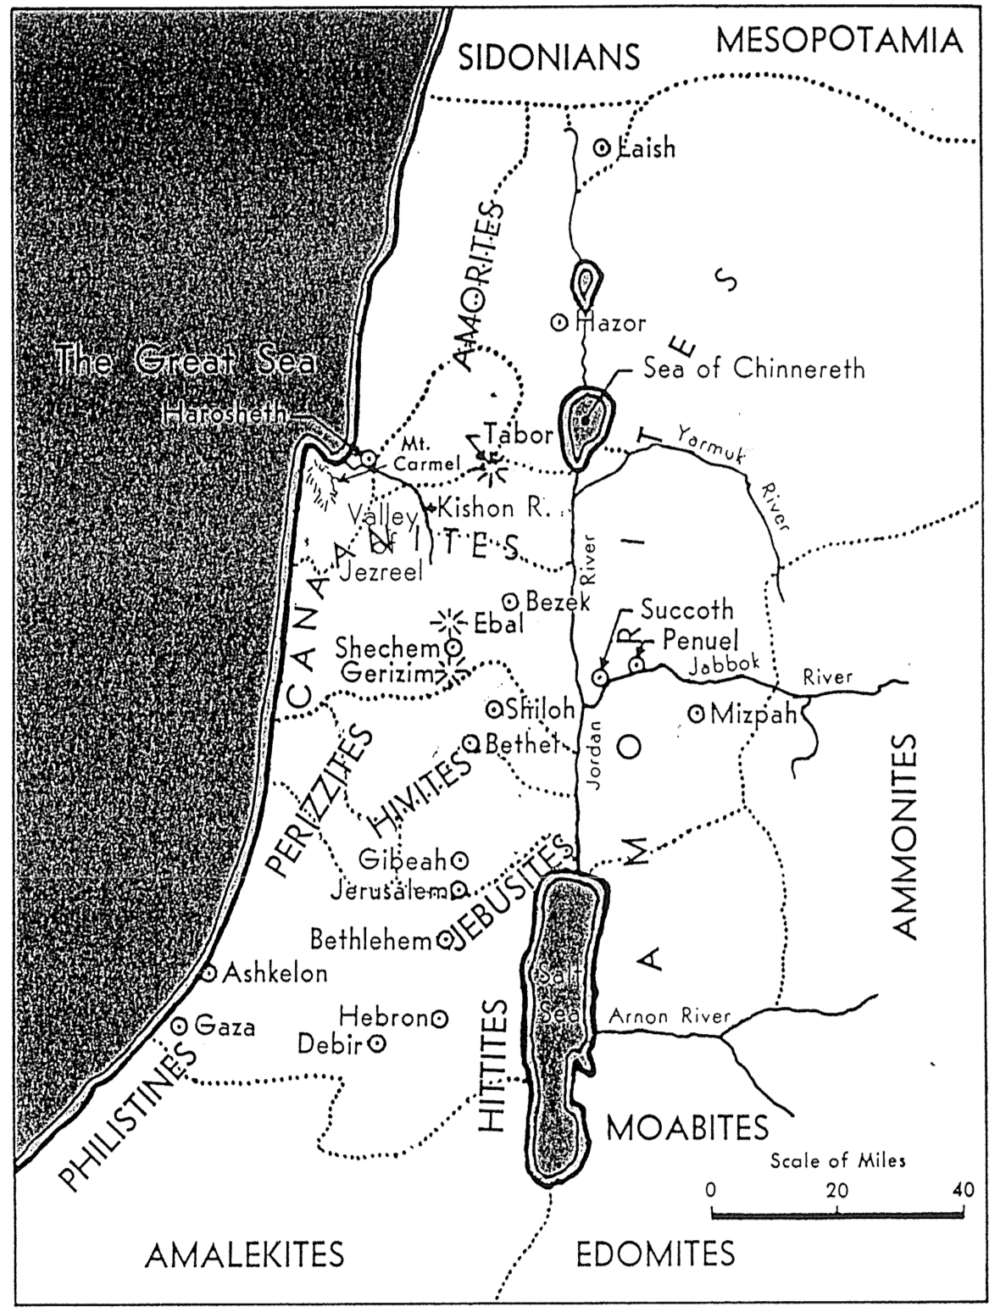
Five Cities of the Philistines and Gideon’s Battles
The Bible Visual Resource Book, 49

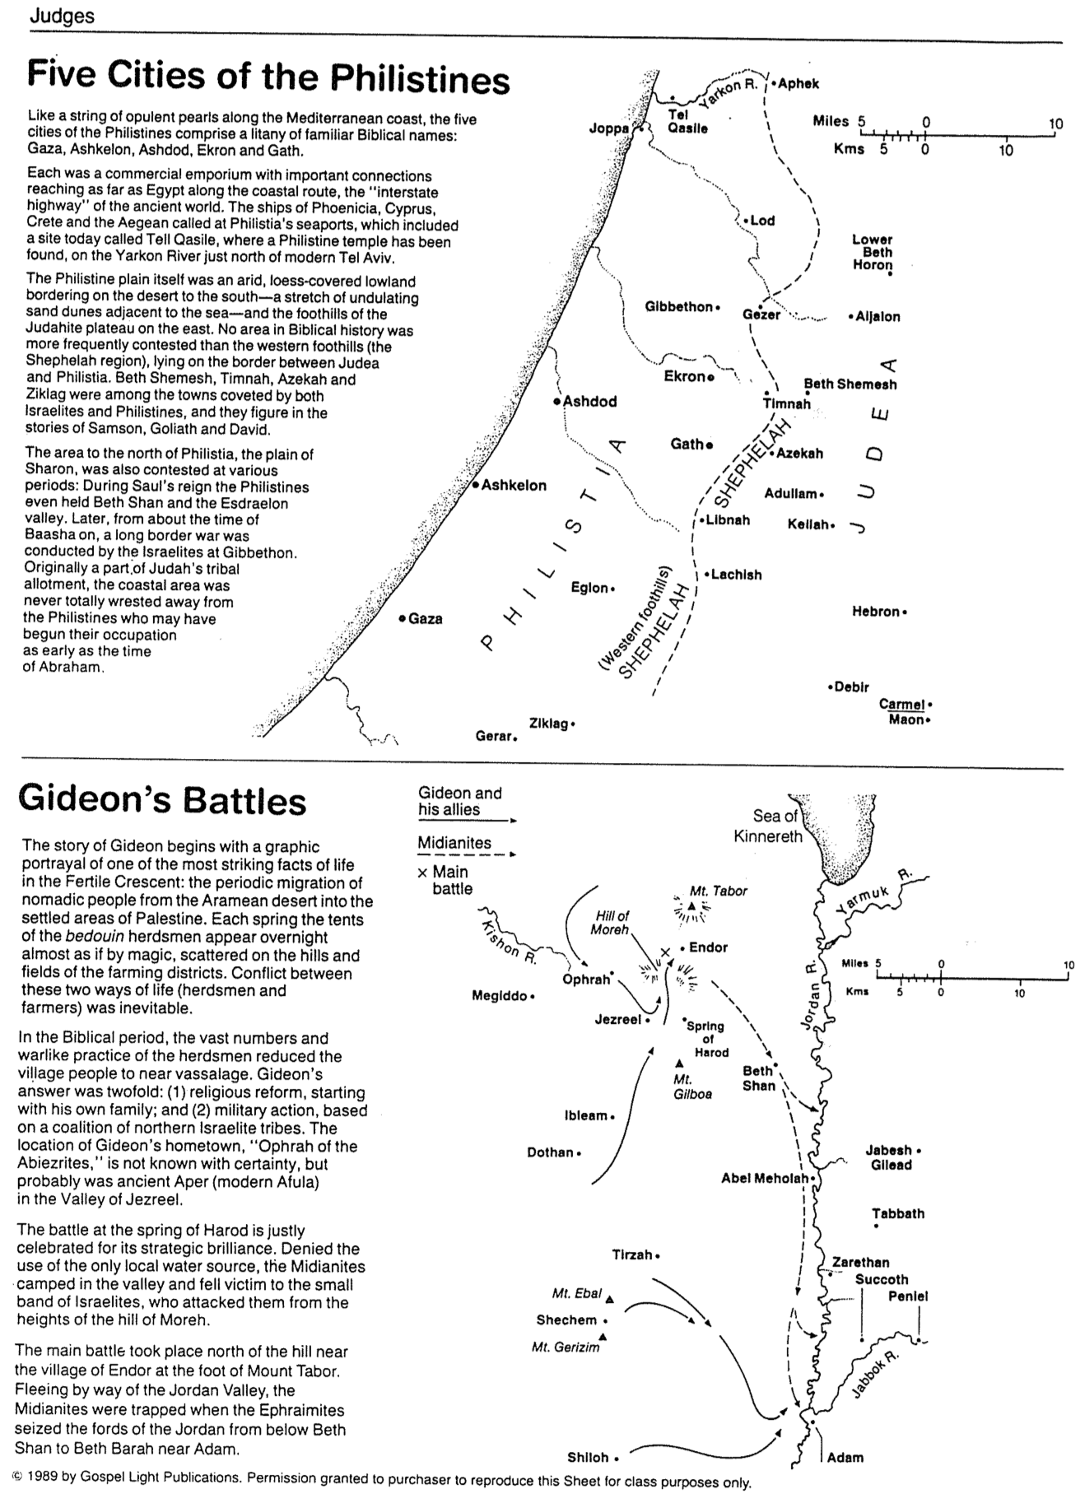

Views on Jephthah’s Daughter (Judg. 12)

John H. Walton, Chronological and Background Charts of the OT, 2d ed., 104

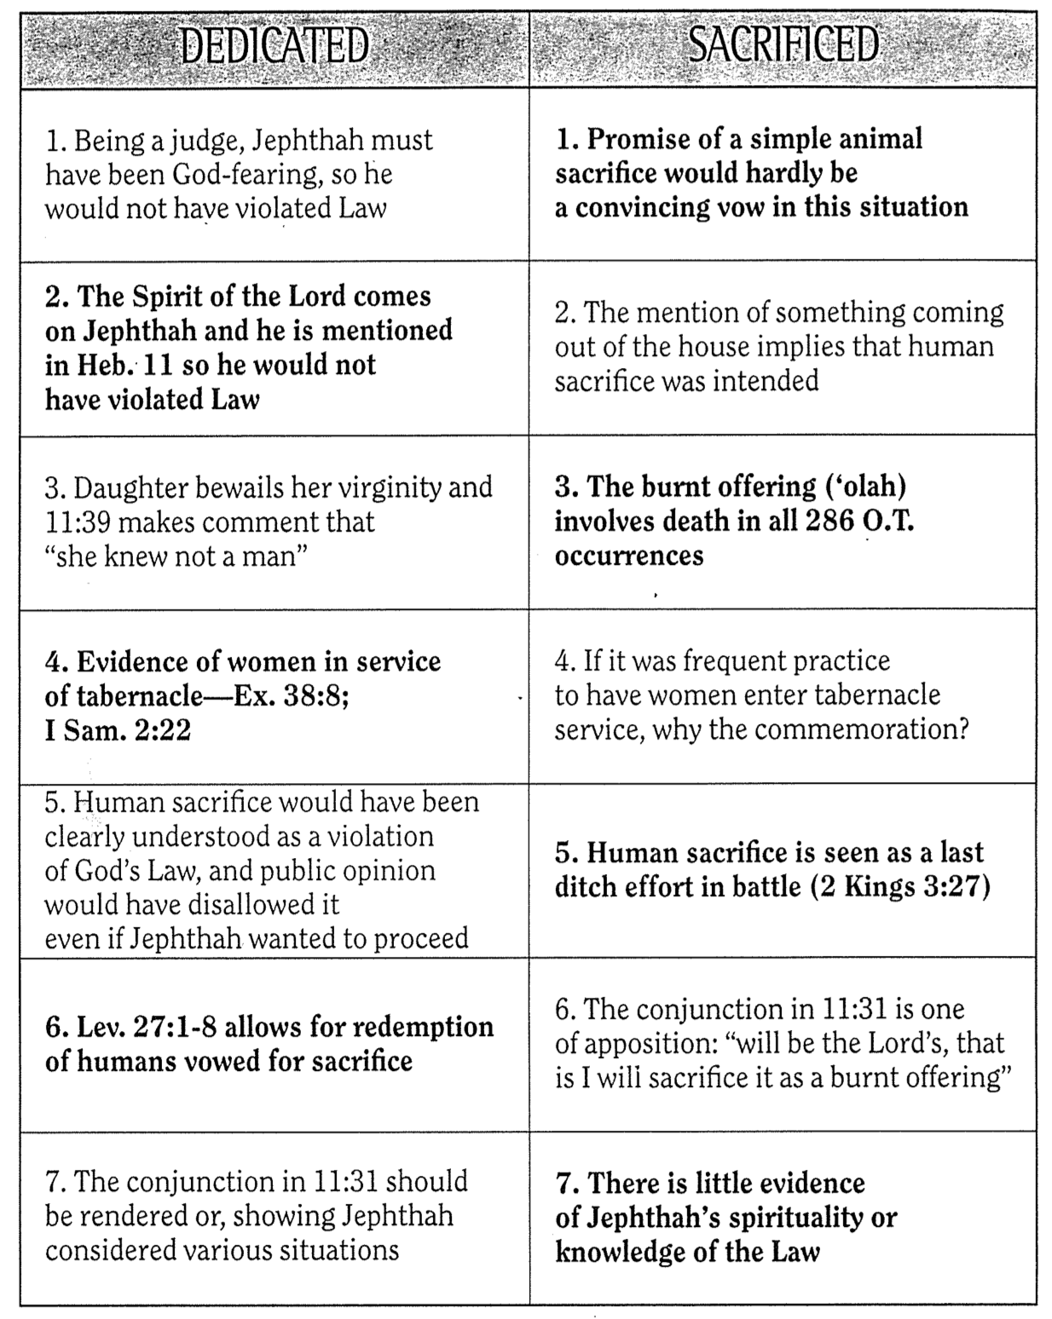

What is Sin?
Huang Sabin, Singapore Bible College (based on Moody Monthly)

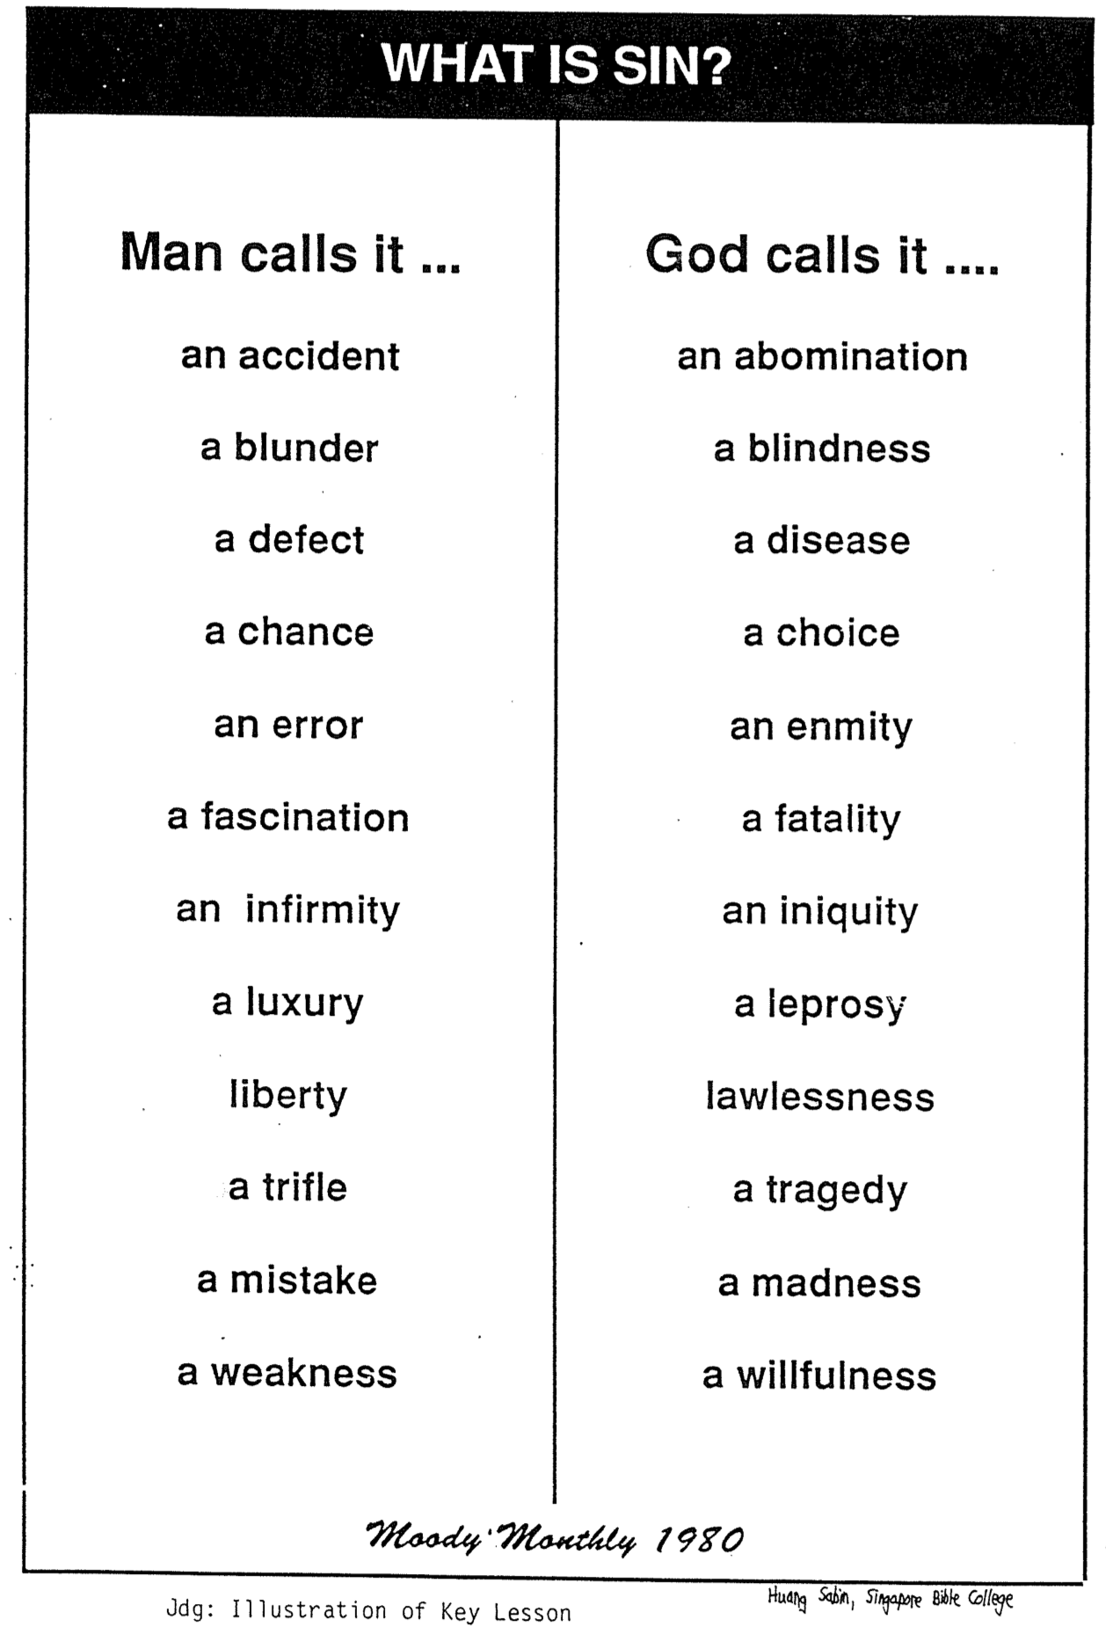

Judges vs. Kings
Adapted and Expanded much from Paul Benware, A Survey of the Old Testament, 88

While God used both judges and kings to lead Israel in their respective time periods, several differences distinguish these two groups of leaders.

 | Judges | Kings
Period | Theocracy | Monarchy
Dates | 1373-1020 BC | 1043-586 BC
Length | 353 years | 457 years
Persons | Othniel to Samuel  (13 men, 2 women) | Saul to Zedekiah  (39 kings, 1 queen)
Power | Limited  (could not tax people or keep a standing army) | Extensive  (taxed subjects and kept standing armies)
Jurisdiction | Geographically small  (typically over a few tribes of Israel) | Ruled over all the land (united kingdom) or half of it (divided kingdom)
Heredity | Came from various tribes (p. 180a) | Came from various tribes in Israel, but Judah had descendants of David only
Succession | No lineage from father to son, gaps between judges during periods of oppression when no judge ruled | Continuous succession, generally from father to son (Judah, p. 237) though Israel had nine dynasties (p. 236)
Reason Needed | Because Israel refused to live in obedience under the theocracy | Because Israel needed a model of godliness due to rejecting God as king
Basic Responsibility | To deliver Israel from their oppressors | To exemplify God’s rule to the Israelites

OT Book Word Search
Adapted from Heng Siang Hoon (SBC student)

Be a judge yourself! Now that you are half way through this volume, it’s time to look back and look ahead at the whole OT. Among the mass of letters below is the name of each of the Old Testament books. Can find all 39 books? They are hidden in every direction.

D U G J H V E S W K M Y V E J K B F D K

E L D R L A M E N T A T I O N S Z I T Q

C G E N E S I S 2 E J O E L E D 2 S E U

C Z U V R H Y O T S O E J O H E Z A Z T

L H T G I K T 2 J O B J O E E N E I R H

E A E I X T A S W N A H U M M I C A H P

S I R H E X I S E G D U J R I M H H P R

I M O C Q W R C Z O I W U M A L A A S O

A E N A U C H R U F A T A A H 2 R L A V

S R O L J O N A H S H A G G A Z I E L E

T E M A M 1 C H R O N I C L E S A I M R

E J Y M I C A Z S L S G N I K 2 H K S B

S W S U D O X E R O J O M N U M B E R S

H A G G A I A S A M O S O M 1 C L Z E E

K U K K A B A H J O S H U A K S E E M G

F O A V Z E P H A N I A H 2 I Z U E N D

Q W N H C O G H G G A V A B N A M N O U

Z E 1 S A M U E L 2 I N G S G C A E R J

Y B N M H 2 M D A N I E L K S H S G H E

A C G S I S S E L C I N O R H C 2 I C D

