Ballard Mortuary, Honolulu, HI Dr. Rick Griffith
1 February 2018 Funeral Message
KJV 15 Minutes
Responding to Our Shepherd
Ps 23
Psalm 23

Topic: Shepherding
Subject: How should you respond to God’s goodness to you?
Complement: When you taste God’s goodness, you love to commune with Him at church.
Purpose: The listeners will trust Jesus as their Good Shepherd.
Attribute: We worship our Shepherding God
Reading: Psalm 23
Songs:

Introduction

Interest: Two days before Dad went to heaven, I offered to read Scripture to him. So I asked him, “Dad, what passage do you want me to read?” He could barely get the words out by then, but Carolynn and I could understand him when he said, Psalm 23.” So I began to read. Well, actually, the three of us began to recite together.
A Psalm of David.

Psa. 23:1 The Lord is my shepherd; I shall not want. 2 He maketh me to lie down in green pastures: he leadeth me beside the still waters. 3 He restoreth my soul: he leadeth me in the paths of righteousness for his name’s sake. 4 Yea, though I walk through the valley of the shadow of death, I will fear no evil: for thou art with me; thy rod and thy staff they comfort me. 5 Thou preparest a table before me in the presence of mine enemies: thou anointest my head with oil; my cup runneth over. 6 Surely goodness and mercy shall follow me all the days of my life: and I will dwell in the house of the Lord forever.

Need: Dad’s most loved passage was Psalm 23, so it is fitting to remind us of this most famous poem in history. But why would a psalm like this impact him so much?

Dad felt like he needed a Shepherd—for his start in life was something few of us could imagine. I saw his birth certificate for the first time this week. It is hand-written in cursive, and under “name,” all it reads is, “Griffith.” No first name. No middle name. Just “Griffith.” But next to it is written in ALL CAPS the words “Harold Francis.” For his first 17 years he was known as “Harry Frank.” Harry was his grandpa and Frank was his father. Yet both of his parents—famous dancers in the mid 20s, believe it or not—dropped him off at his maternal grandparents home as a baby and they went on tour to the Caribbean. So, at age 17, upon entering the Navy, he had to look up his birth certificate. There he found no first or middle name! So he had the unusual privilege—if you call it that—to name himself. He decided to keep the same H.F. initials, choosing Harold Francis.
Early Years
Cert
Frank
Gaylords
Black

Do you “have the world by the tail”? No. You are fooling yourself if you think you do.

Each of us needs the Shepherd of Psalm 23.

Are you convinced? I say that God has shown his goodness to you—yes, to you!

Intro MP: Dad saw in Psalm 23 that God had time and again shown his goodness to him. How does God show his goodness to you?
Intro MPI

Background: The author was no armchair poet. David knew his sheep and loved his sheep, even rescuing them from a lion and a bear!

Preview: The psalm has two ways God shows his goodness to us, and then a response.

Text: Let’s see from Psalm 23 the answer to this question.

(How does God show his goodness to you?)

I. God’s goodness provides everything you need.
Provides
[The LORD wisely does not meet every want, but he faithfully meets every need.]

David saw that God provided for him like a shepherd provides for his sheep (1-4).
Black

The LORD satisfied David by providing all of his needs (1-3).

God gave quality physical provisions (food, rest & water) that satisfied David (1-2): The Lord is my shepherd; I shall not want. 2 He maketh me to lie down in green pastures: he leadeth me beside the still waters.

God gave spiritual refreshment that restored David’s soul (3a): He restoreth my soul.

God gave guidance in holiness to protect His own name (3b): he leadeth me in the paths of righteousness for his name’s sake.

David’s response to the LORD’s protection during danger was comfort instead of fear (4): Yea, though I walk through the valley of the shadow of death, I will fear no evil: for thou art with me; thy rod and thy staff they comfort me.

None of us can rightfully accuse God of not providing for all our needs.

Even though Dad’s parents rejected him at birth, he saw God provide through his grandparents. They had a home on Market Street in Port Jefferson Station on Long Island and his cousins even lived down the street.
House

Dad saw God provide for him throughout his life. Oh, how he loved his boat, Nalu. He even had the Corvette for some years. Despite many difficulties, God provided for him.
T
Nalu

(Besides providing for you, how else does God show his goodness to you?)

II. God’s goodness protects you from harm.
Protects
[The LORD defends us with his strong arm.]

The LORD protected—and even honored—David during attack (5).
Black

God protected David like a sheep happily eating before enemies (5a): Thou preparest a table before me in the presence of mine enemies.

God honored David (5b): thou anointest my head with oil

God gave more blessings than David could possibly enjoy (5c): my cup runneth over.

Each of us has witnessed God’s protecting hand—but especially Dad.

Dad flew the A-1 Skyraider that had the most powerful engine ever on a propeller fighter—so strong that when taking off from a carrier that the pilot had to immediately jerk the plane to the right or else the power of the propeller would flip the plane upside down into the sea. He had an amazing 660 carrier landings!
3 planes
A-1 on Flight Deck

He also flew and incredible 186 combat missions destroying supply bridges and boats in a barrage of anti-aircraft fire. Once the left wing of his plane was so shot up that he could only steer right and not make it back to the carrier to land so he flew to a friendly airbase instead. He looped and looped to eventually land safely.
Wing

I asked him how he could see over 50 of his fellow pilots die but he was spared. He didn’t attribute this to his astonishing flying ability—though he was one of the best pilots. He clearly noted that God himself watched over him “in the presence of mine enemies.”
Squadron

(Subject: Where should all this realization lead? How did Dad—and how should we—respond to God’s goodness to us? When you have tasted God’s goodness, what’s the natural response? When you know he has provided for you and protected you, what do you do? Well, the last verse says that…)

III. You love to publicly commune with Him.
Worship
[You commit to declare that the LORD is good and do it visibly with others.]

David sought to regularly and publicly commune with God at the tabernacle (6).
Black

David expressed confidence that he would see the LORD’s goodness and love the rest of his life (6a): Surely goodness and mercy shall follow me all the days of my life.

David’s response was to commit to commune with God at the tabernacle the rest of his life (6b): and I will dwell in the house of the Lord forever.

Feeling in our gut God’s goodness leads us to worship him with others.

Here is where Dad kept his faith very private rather than public. I wish he had been committed to a church where he told others of God’s goodness in his life, but he didn’t. He and Mom were married in a Lutheran Church in Washington DC, but their worship there didn't stick.

I wonder how many of us have forgotten to express our thanks to God before others as well as in our own hearts.

(So how should you respond to God’s goodness to you?)

Conclusion

When you really taste God’s goodness, you love to publicly commune with Him (MI).

This psalm has three wonderful movements:

God’s goodness provides everything you need (1-4).

God’s goodness protects you from harm (5).

So love to publicly commune with Him (6).

Application: Dad knew that the “LORD” of this passage was none other than Jesus himself. Jesus claimed, “I am the Good Shepherd.”

Good is an understatement! Jesus is a wonderful Shepherd because he even gave up his life for sheep like us—but is he your Shepherd?

Dad credited his long life to Jesus—but do you credit Jesus?

Dad no doubt wishes now that he more openly communed with the God he credited for saving him, but do you?

Jesus can be your Shepherd simply by you asking him.

Prayer

Preliminary Questions

Verses Questions

Context: What did the author record just prior to this passage?

Purpose: Why is this passage in the Bible?

Background: What historical context helps us understand this passage?

Questions

Tentative Main Ideas

Text

Illustrations That Apply

Text

Homiletics Notes, page 46
Exegetical Idea: The response of David to God’s goodness shown in providing for and protecting him was to fearlessly commune with God at the tabernacle the rest of his life.

I. (1-4) The response of David to God’s provision and protection [like a shepherd does for his sheep] was comfort instead of fear.

A. (1-3) The way the LORD satisfied David was by providing all of his needs.
1. (1-2) The LORD provided quality physical provisions (food, rest & water) that satisfied David.
2. (3a) The LORD provided spiritual refreshment that restored David’s soul.
3. (3b) The LORD provided guidance in holiness to protect His own name.

B. (4) The response of David to the LORD’s protection during danger was comfort instead of fear.

II. (5) The way God showed His goodness was by protecting David so that he was honored like a banqueting victor before his enemies.

A. (5a) The LORD protected and exalted David like a banqueting victor before humbled enemies.

B. (5b) The LORD honored David.

C. (5c) The LORD provided more blessings than David could possibly enjoy.

III. (6) The response of David to God’s continued goodness was to commit to commune with the LORD at the tabernacle the rest of his life.

A. (6a) David expressed confidence that he would see the LORD’s goodness and love the rest of his life.

B. (6b) David’s response was to commit to commune with God at the tabernacle the rest of his life.

Homiletical Exposition (cyclical inductive form)

Introduce Subject: How should we respond to God’s goodness towards us?

I. God shows His goodness by providing everything His people need. Principle

A. David saw that God provided for him as a shepherd provides for his sheep (1-4). Text

B. None of us can say that God has not properly provided for all our needs (examples). Appl.

II. God shows His goodness by protecting His people from harm. Principle

A. The LORD protected David from his foes and even honored him before them (5). Text

B. Each of us has witnessed God’s protecting hand (examples). Appl.

III. The right response to God’s provision & protection is to publicly commune with Him. Principle

A. David sought to regularly and publicly commune with God at the tabernacle (6). Text

B. Regularly fellowship with God at church in response to His provision and protection. Appl.

Main Idea: God’s goodness to us should result in a desire to commune with Him at church.

Responding to Our Shepherd
Psalm 23

Exegetical Outline (Steps 2-3)

Exegetical Idea: The response of David to God’s goodness shown in providing for and protecting him was to fearlessly commune with God at the tabernacle the rest of his life.

I. The response of David to God’s provision and protection [like a shepherd does for his sheep] was comfort instead of fear (1-4).

The way the LORD satisfied David was by providing all of his needs (1-3).

The LORD gave quality physical provisions (food, rest & water) that satisfied David (1-2).

The LORD gave spiritual refreshment that restored David’s soul (3a).

The LORD gave guidance in holiness to protect His own name (3b).

The response of David to the LORD’s protection during danger was comfort instead of fear (4).

II. The way God showed His goodness was by protecting David so that he was honored like a banqueting victor before his enemies (5).

The LORD protected and exalted David like a banqueting victor before humbled enemies (5a).

The LORD honored David (5b).

The LORD provided more blessings than David could possibly enjoy (5c).

III. The response of David to God’s continued goodness was to commit to commune with the LORD at the tabernacle the rest of his life (6).

David expressed confidence that he would see the LORD’s goodness and love the rest of his life (6a).

David’s response was to commit to commune with God at the tabernacle the rest of his life (6b).

Homiletical Exposition (cyclical inductive form)

Introduce Subject: How should we respond to God’s goodness towards us?

I. God shows His goodness by providing everything His people need. Principle

A. David saw that God provided for him as a shepherd provides for his sheep (1-4). Text

B. None of us can say that God has not properly provided for all our needs (examples). Appl.

II. God shows His goodness by protecting His people from harm. Principle

A. The LORD protected David from his foes and even honored him before them (5). Text

B. Each of us has witnessed God’s protecting hand (examples). Appl.

III. The right response to God’s provision & protection is to publicly commune with Him. Principle

A. David sought to regularly and publicly commune with God at the tabernacle (6). Text

B. Regularly fellowship with God at church in response to His provision and protection. Appl.

Main Idea: God’s goodness to us should result in a desire to commune with Him at church.

Purpose or Desired Listener Response (Step 4)
The listeners will trust Jesus as their Good Shepherd

Homiletical Outline (Cyclical inductive form)

Introduction

Interest: Dad’s most loved passage was Psalm 23, so it is fitting to remind us of this most famous poem in history. We recited with him the day before he left this earth. [Read it.]

Need: Why would a psalm like this have such an enormous impact?

Do you “have the world by the tail”? No. You are fooling yourself if you think you do.

Each of us needs the Shepherd of Psalm 23.

Are you convinced? I say that God has shown his goodness to you—yes, to you!

Intro MP: How does God show his goodness to you?

Background: The author was no armchair poet. David knew his sheep and loved his sheep, even rescuing them from a lion and a bear!

Preview: We will see two ways God shows his goodness to us, and then our response.

Text: Let’s see from Psalm 23 the answer to…

(How does God show his goodness to you?)

I. God’s goodness provides everything you need.
[The LORD wisely does not meet every want, but he faithfully meets every need.]

David saw that God provided for him like a shepherd provides for his sheep (1-4).

None of us can rightfully accuse God of not providing for all our needs.
(Besides providing for you, how else does God show his goodness to you?)

II. God’s goodness protects you from harm.
[The LORD defends us with his strong arm.]

The LORD protected—and even honored—David during attack (5).

Each of us has witnessed God’s protecting hand.

(Subject: But how should you respond to God’s goodness to you? When you have tasted God’s goodness, what’s the natural response? When you know he has provided for you and protected you, what do you do? Well…)

III. You love to publicly commune with Him.
[You commit to declare that the LORD is good and do it visibly with others.]

David sought to regularly and publicly commune with God at the tabernacle (6).

Feeling in our gut God’s goodness leads us to worship him with others.
(So how should you respond to God’s goodness to you?)

Conclusion

When you taste God’s goodness, you love to commune with Him at church (MI).

This psalm has three wonderful movements:

God’s goodness provides everything you need (1-4).

God’s goodness protects you from harm (5).

So love to publicly commune with Him (6).

Application: Jesus is a wonderful Shepherd—but is he your Shepherd?

Dad credited his long life to Jesus—but do you credit Jesus?

Dad no doubt wishes now that he more openly communed with the God he credited for saving him, but do you?

Jesus can be your Shepherd simply by your asking him.

Prayer

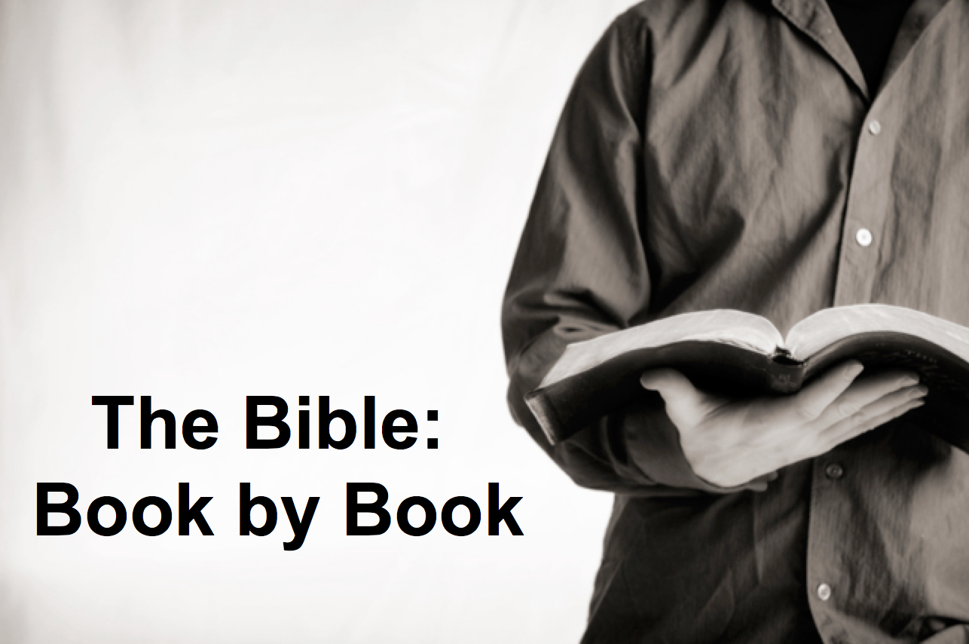

Rick Griffith
2018
Message of 66

Title
Passage

Introduction

Subject with a blank for the key word _______________

I. MP has a blank for the key word ________________ (verses).

SP has a blank for the key word ________________ (verses).

SP has a blank for the key word ________________ (verses).

SP has a blank for the key word ________________ (verses).

II. MP has a blank for the key word ________________ (verses).

SP has a blank for the key word ________________ (verses).

SP has a blank for the key word ________________ (verses).

Conclusion

Main Idea has a blank for the key word ________________ (verses).

Application question

Download this sermon PPT and notes for free at BibleStudyDownloads.org/resource/old-testament-preaching/
Listen to this message online at cicfamily.com/sermon-listing/

BOOK CHART

