Crossroads International Church/ CIC again Rick Griffith
8 February 2009/ 4 Aug 2013 Message 4 of 15
NLT 35 Minutes
Title
Wall-to-Wall People
Nehemiah 3

Topic: Unity
Theme: God fights opposition
Thrust: through a sensible plan that includes us all.
Purpose: The listeners will each faithfully play their part towards unity within our church.

Introduction

Interest: Our present series in Nehemiah is called “Rebuilding Broken Dreams.” That’s not always easy, so where did we ever get the idea that the Christian life was supposed to be easy? God’s work always gets opposed!
Theme
Solitude

Motivational posters can help—like those on solitude, leadership, and persistence. My favorite one I posted in my office [read].
Lead/Det
Persist 2

However, the web has even more de-motivational posters—take, for example, websites like despair.com on vision, success, and retards [read]. It is demotivating to have people oppose you when you are trying to follow the Lord.
Subj
Demot 3

Need: Do YOU experience opposition right now? Where are you being challenged?
Ez-Neh

Background: In Ezra-Nehemiah, the people of Jerusalem saw God do a great thing to people in exile.

Zerubbabel brought the people back and helped them rebuild the temple. It was celebrated with huge fanfare.

Then Ezra brought more of them back to their land from Babylon.
Altar
Zerub
Ezra

So the temple was established, but it stood by itself in the ruins of the former city for almost 100 years!
Temple

However, far away in Persia a vision was birthed in Nehemiah.

Securing the kings help, Nehemiah traveled to Jerusalem.
Prayer
King

He wisely investigated the situation during the cover of night. He also discovered that the rebuilding would be no easy task.
Wise

Enemies of the Jews made fun of the disgrace of the walls of Jerusalem in ruins. In particular, 2:19-20 mentions three opponents: Sanballat the Samaritan, Gershom the Arab, and Tobiah the Ammonite.
Enemy Map

Subject: How does God help us serve Him when we’re opposed? How can He help you hang in there when the going gets tough?
Subject

Text: Nehemiah 3 is not your normal bedtime reading passage. Well, it might be if you want to go to sleep! Here we see 38 strange names and 42 different groups in 32 verses, plus places listed that we can’t even find today. Can it really be helpful? Most of the time we don’t really see it visually though, so we don’t understand it or even think about it. Let’s read it and see where these locations are [read whole chapter 3].
Neh 3 slides

Subject: Now remember our question again: How does God help us stay at the task of serving Him even when we’re opposed? How can He help you hang in there when the going gets tough?
Subj

Preview: This passage shows two of God’s ways for us to overcome opposition when serving him.

(What’s God’s first way to succeed against attacks?)
MP

I. God helps us to be sensible to overcome opposition.

The Nehemiah 3 project made sense. How?

Geographic: God motivated the Jews to work at the right spots on the wall:
Map 1
• Geog

The priests repaired the Sheep Gate that led from where sheep were washed to the temple (1).
Sheep Gate

Other priests helped build right next to the high priest’s home (22).
Map 20-22

Others strengthened the wall adjacent to their own homes (23, 26, 28, 29, 30).
Map 23-24

British humorist Jerome K. Jerome said, “I like work, it fascinates me. I can sit and look at it for hours.” Wiersbe notes, “When it comes to the work of the Lord, there is no place for spectators or self-appointed advisors and critics; but there is always room for workers.”
Jerome
• Wiersbe
• Communal

Communal: God called them to all work together—Nehemiah couldn’t do it all himself.
Relation

Inconvenient: Yet this certainly was inconvenient as they left their regular jobs. When service is inconvenient (which it always is!), God causes us to really consider the inconvenience of the cross!
• Inconv

Complete: One breach in the wall was one too much as it was only as strong as the weakest point.
chain
• Compl

Reasonable:
• Reason

They rebuilt a much smaller city than in Hezekiah’s time when the city was at its height.
Map

They didn’t “bite off more than they could chew.”

God calls us to serve him in sensible ways to protect His church.
SP

Have you gone on our website? There you will see that it is sensible for us to have a common goal in our mission and vision statements.
Website

The mission of Crossroads is to reach the nations by reaching internationals residing in Singapore.
Mission

The vision of Crossroads is to lead internationals into a vital relationship with Jesus Christ as disciples who can transform their unique spheres of influence (2 Tim. 2:2). In particular, Crossroads focuses primarily, but not exclusively, on reaching the English-speaking community.
Vision

It is also sensible for God to grant us each at least one spiritual gift to strengthen the body against opposition.
Gifts

I already taught on nine gifts in our 1 Corinthians series. If you missed this, check out the website.
Categories

This is a God given ability that has two basic characteristics:

You like to do it.

You do it better than most people.

If you don’t know your gift, please do two things:

Serve in different areas to discern it and,

Take the Spiritual Gifts Inventory too.

Here are two reasons to study and know your gift:

Ministry to the church body [explain]
Why 1

Personal fulfillment [explain]
Why 2

When we don’t use our gifts, we become vulnerable to enemy attack: things are done poorly, people who do have to serve struggle with resentment, etc.

We also have talents to use for him.
Instrument

Doesn’t it make sense for pianists to play piano? I wonder if we really have pianists among us that could play well enough so that when Susan is gone, we need not scramble to find pianists from other churches.

Drummers to drum? Enriko is great, but he is divided between the drama and drumming ministries at 3 PM.

If you could draw out what God’s sensible, protective wall for Crossroads, it might look something like this…
CIC Feb

Of our 32 adults, 19 are actively serving. That’s fantastic!

One of weakest areas though, is evangelism—like this pastor says [read slide].
Evangelism

(So God helps us to be sensible to overcome opposition. What else do we see in this chapter?)

II. God helps us to be united to overcome opposition.

(Of course, the world makes fun of needing to depend upon others!)
Mtgs
MP

God united all kinds of Jews to work as common laborers.
SP A

Priests (1, 22, 28)
• Priests

It starts with the leaders. If the high priest wouldn’t get dirty, no one would. He, of all people, should have helped since God’s glory was at stake.

Sad to say, Eliashib did not remain true to his calling; for later he allied with the enemy and created serious problems for Nehemiah (Neh. 13:4–9). Some people who enthusiastically begin their work may drop out or turn against it for one reason or another. Eliashib’s grandson married a daughter of Sanballat (v. 28), and this alliance no doubt influenced the high priest.

Goldsmiths (8a, 31, 32)
• etc

Perfumer (8b)

Political leaders (9, 15, 16, 17, 18, 19)

Women (12)

Levites (17)

Merchants (32)

Even people from outside the city (2, 5, 7)

[God unites all types of people as they serve him today.]

A young boy wanted to show his strength in front of the class by breaking a bunch of 20 small, thin sticks tied together. He tried hard to break these sticks tied together, but even after several attempts he failed. He gave up. Then the teacher called him and told him to untie the bunch of sticks and break them one by one. The boy found it very easy to break them. It wasn’t that difficult after all. Once the bunch of sticks was untied the sticks lost their strength. “United we stand, divided we fall.”
Sticks

Our church has 10 nationalities and many professions represented. That was the original vision that kick-started this church into being.
SP B

How are you performing your role in unity in your given area?

The people of Jerusalem each built and repaired their portion. They did it seeing the bigger picture of the whole wall––how their portion helped the entire nation in unity.

How about us? Are we seeing the bigger picture of God’s church growing? Are we playing our part in unity?

But please note: God often calls us to do something for which we do not feel qualified.
He qualifies

That’s how we have priests, goldsmiths, perfumers, women and merchants as construction workers!

Several of you feel inadequate to take on leading our missions or nursery ministry. I can understand that, as I also feel inadequate. But I wonder if God is working in you even today to tell you that you don’t have to be a professional to lead effectively.
• He qualifies

(How can we sum up this entire chapter? Perhaps this way…)

Conclusion

God fights opposition through a sensible plan that includes us all (MI).
MI

This passage helps to show how God gives a sensible and united plan to accomplish His will through us. God worked his will through many people and he still does today. He is a God of order. He works in the same way today to see our church grow for His glory.

What sensible part of his overall plan is His will for you?

Some people just will not work (Neh. 3:5). Wiersbe notes, “Tekoa was a town about eleven miles from Jerusalem, and some of their people traveled to Jerusalem to assist in the work. What a contrast between these people and their nobles! The Tekoites built in two places on the wall (vv. 5 and 27), while their nobles refused to bend the neck and work in even one place. Were these ‘aristocrats’ so important in their own eyes that they could not perform manual labor? Yet Paul was a tentmaker (Acts 18:3), and Jesus was a carpenter (Mark 6:3).”
Wiersbe

I dare say that some of the worst pew-sitters are missionaries. When I served in the Philippines in 1981, I’d talk to Filipinos at church and mention some missionaries who attended but they’d say, “Who’s that?!”

“A great many people have got a false idea about the church,” said evangelist D.L. Moody. “They have got an idea that the church is a place to rest in... to get into a nicely cushioned pew, and contribute to the charities, listen to the minister, and do their share to keep the church out of bankruptcy, is all they want. The idea of work for them—actual work in the church—never enters their minds.”
Moody

Friends, but in Feb 2009 this is where we stood in just four months when the church lost 1/3 of its people moving out of Singapore. God raised up a new team though!
June 09

So what we do? Please send me an email at griffith@sbc.edu.sg to show where you can help breach a spot.
YOU!

One little known fact is that when the founding fathers of the USA got together to form the union, they were anything but united. We see the flag with 13 stars and 13 stripes, but this didn’t come around for some time. Each state only had its own flag.
The 13

Many were Christians, but of differing denominational stripes. Some hated slavery, while others owned slaves. When declaring independence, what held them together was a common hatred of England. But hatred is not a strong glue! The first dozen years after independence, they couldn’t even agree on a common currency!
Continent Congress

Yet at a deciding moment, when all seemed lost, the great statesman Benjamin Franklin stood up and addressed the group. He declared, “We must all hang together, gentlemen... or assuredly we shall all hang separately.”
Franklin

Prayer
Black
Study Questions (Step 1)

Context: What did the author record just prior to this passage?

Prior to this passage the author records that it is a disgrace for the people if the walls of Jerusalem lie in ruin (2:17-18). They had to realize it’s a misery for them. He also says that it’s the gracious Hand of God that has helped them realize this and it is God who is driving them towards the rebuild of the wall through the approval of King for the rebuilding.

Purpose: Why is this passage in the Bible?

This passage helps to show how God gives the willingness and unity to accomplish His will through us. This passage is a very good reminder of how God worked his will through so many people in this section. This shows that he is a God of order. He can work in the same fashion today to see the our church grow for his glory.

Background: What historical context helps us understand this passage?

This book is a kind of continuation from the Book of Ezra. The key aspect in the book of Ezra is on the rebuilding of the Temple whereas the key aspect in the book of Nehemiah is the rebuilding of the Walls of Jerusalem. Many scholars believe that this book must have been written after 400B.C. Nehemiah is the key person carrying out a lot of things in this book, but the bigger picture is not of his character or leadership although he is a very prominent person but it is God who is behind all this. He is good servant of God. Certainly it is Nehemiah’s work in establishing the Jerusalem community, defending against its neighbors. It is God great plan that is being accomplished.

Questions
- Why are there so many names being mentioned is chapter 3?

Chapter 3 has 38 names in all of the 32 verses. There are two most important things we can look at from so many people being involved. First and for most is the size of the wall itself, the number of people involved in rebuilding throws light on the size of the wall like the length and breadth. Secondly it shows the unity they had in rebuilding the wall. Even though all of them were of different personalities they united to play their part and rebuild their portion. It is God who gives them the willingness and unity and these are some of the major lessons we can learn from this chapter.

- What significance do the gates hold?

There are about 10 gates mentioned in this chapter. This kind of gives the vastness of the wall as such and it is interesting to note there were some key people involved in the building of the gate, like for example it was Eliashib the high priest who headed the first gate. Gate plays a significance because it the entrance and exit. The better the gate the better the wall.

- What are some of the interesting that can be noted from this chapter?

Some of the interesting that can be noted from this chapter are, the name of God or Temple is not being mentioned at all. No sacrifices or singing are being mentioned in fact there is no prayer being said. Nevertheless we see how God works with groups of people from different segments of the society to realize the divine promise and plans of God.

Tentative Theme/Thrust Statements (Step 5)

Hang in there

Possible Illustrations (Step 6)

“Brothers, either we shall all hang together or we shall hang separately” –Benjamin Franklin

Feb 2009:

Susan is finding it tough to help her Mom deal with the pain of generative spinal arthritis. She is scheduled to move into assisted living March 1, so Susan is now in week 3 of 8 weeks gone. She now has three weeks to get her Mom to brush her teeth again, and clear out many memories in her house before they sell it next month. Missionaries often leave the field in times like this!

We also have talents to use for him.
Instrument

Doesn’t it make sense for pianists to play piano? I wonder if we really have pianists among us that could play well enough so that when Susan is gone, we need not scramble to find pianists from other churches.

Drummers to drum? Enriko is great, but he is divided between the drama and drumming ministries at 3 PM.

If you could draw out what God’s sensible, protective wall for Crossroads, it might look something like this…
CIC Feb

Of our 46 adults, 27 are actively serving. That’s fantastic!
CIC June

However, June is coming when our wall will look like this!

Possible Applications (Step 6)

List real life examples of people who live out the Main Idea that you might want to use in the message, then paste the best ones in the manuscript later

Discussion Questions:

- Write up questions that relate to the sermon here if this is needed for small group ministry in the church

Outlines (Steps 2-5)

Wall-to-Wall People
Nehemiah 3

Exegetical Outline (Steps 2-3)

Exegetical Idea: The way God helped the Jews succeed over their opposition was to sensibly rebuild Jerusalem’s wall in unity.

I. The way the northern wall was built was sensible and in unity.

II. The way the western wall was built was sensible and in unity.

III. The way the southern wall was built was sensible and in unity.

IV. The way the eastern wall was built was sensible and in unity.

A Topical Outline…

I. People worked in geographical areas that made sense:

The priests repaired the Sheep Gate that led from where sheep were washed to the temple (1).

Other priests helped build right next to the high priest’s home (22).

Other people strengthened the wall adjacent to their own homes (23, 28, 29, 30).

II. People of all types of professions became common laborers

Priests (1, 22, 28)

Goldsmiths (8a, 31, 32)

Perfumer (8b)

Political leaders (9, 15, 16, 17, 18, 19)

Women (12)

Levites (17)

Merchants (32)

Sources Used by David Paul:

The Message of Nehemiah, Brown Raymond, Inter-Varsity press, Leicester England, 1998.

Nehemiah: Man in Charge, Campbell K. Donald, Victor Books, Wheaton Illinois, 1987.

The New Interpreter’s Bible commentary, Vol 3, Keck, E. Leander, Abingdon Press, Nashville.
1999.

The New American Commentary, Vol 10 Breneman Mervin, Broadman & Holman Publishers. 1993.

Word Biblical Commentary, Vol 16, Williamson. H.G.M, Word book publishers, Waco,
Texas. 1985.

Purpose or Desired Listener Response (Step 4)
The listeners apply the principle of willingness and unity according God’s guidance for the benefit of Church.
Wall-to-Wall People
(Cyclical inductive method)

Introduction

Interest: God’s work always gets opposed (motivational and de-motivational posters)

Need: Where are you experiencing opposition right now?

Background: The people of Jerusalem saw the disgrace of the walls of Jerusalem in ruins but were also made fun of by their enemies (2:18b-20).

Subject: How does God help us serve Him when we’re opposed? How can He help you hang in there when the going gets tough?

Text: Nehemiah 3 is not your normal bedtime reading passage. Well, it might be if you want to go to sleep! Read it.

Preview: This passage shows two of God’s ways for us to overcome opposition when serving him.
(So what’s God’s first way to succeed against attacks? It is to…)

I. God helps us to be sensible to overcome opposition.

God motivated the Jews to work in ways that made sense:

The priests repaired the Sheep Gate that led from where sheep were washed to the temple (1).

Other priests helped build right next to the high priest’s home (22).

Others strengthened the wall adjacent to their own homes (23, 28, 29, 30).

God calls us to serve him in sensible ways to protect His church.

II. God helps us to be united to overcome opposition.

God united all types of Jews to work as common laborers.

Priests (1, 22, 28)

Goldsmiths (8a, 31, 32)

Perfumer (8b)

Political leaders (9, 15, 16, 17, 18, 19)

Women (12)

Levites (17)

Merchants (32)

God unites all types of people as they serve him today.

Conclusion

God fights opposition through a sensible plan that includes us all (MI).

What sensible part of his overall plan is His will for you?

“Brothers, either we shall all hang together or we shall hang separately” –Benjamin Franklin

Prayer.
Wall-to-Wall People (filled-in)

Introduction

God’s work always gets opposed.

How does God help us serve Him when we’re opposed?

I. God helps us to be sensible to overcome opposition.

God motivated the Jews to work in ways that made sense:

The priests repaired the Sheep Gate that led from where sheep were washed to the temple (1).

Other priests helped build right next to the high priest’s home (22).

Others strengthened the wall adjacent to their own homes (23, 28, 29, 30).

God calls us to serve him in sensible ways to protect His church.

II. God helps us to be united to overcome opposition.

God united all types of Jews to work as common laborers.

Priests (1, 22, 28)

Goldsmiths (8a, 31, 32)

Perfumer (8b)

Political leaders (9, 15, 16, 17, 18, 19)

Women (12)

Levites (17)

Merchants (32)

God unites all types of people as they serve him today.

Conclusion

God fights opposition through a sensible plan that includes us all (MI).

What sensible part of his overall plan is His will for you?

Wall-to-Wall People (blanks)

Introduction

God’s work always gets opposed.

How does God help us serve Him when we’re _______________?

I. God helps us to be _______________ to overcome opposition.

God motivated the Jews to work in ways that made sense:

The priests repaired the Sheep Gate that led from where sheep were washed to the temple (1).

Other priests helped build right next to the high priest’s home (22).

Others strengthened the wall adjacent to their own homes (23, 28, 29, 30).

God calls us to serve him in sensible ways to protect His church.

II. God helps us to be ____________ to overcome opposition.

God united all types of Jews to work as common laborers.

Priests (1, 22, 28)

Goldsmiths (8a, 31, 32)

Perfumer (8b)

Political leaders (9, 15, 16, 17, 18, 19)

Women (12)

Levites (17)

Merchants (32)

God unites all types of people as they serve him today.

Conclusion

God fights _______________ through a _______________ plan that includes us all (MI).

What sensible part of his overall plan is His will for you?

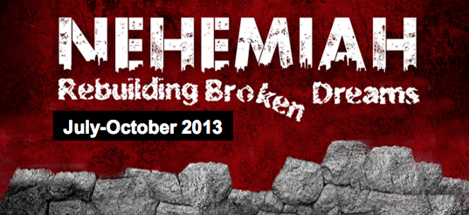
Rick Griffith
4 August 2013
Message 4 of 15

Wall-to-Wall People
Nehemiah 3

Introduction

God’s work always gets opposed.

How does God help us serve Him when we’re _______________?

I. God helps us to be _______________ to overcome opposition.

God motivated the Jews to work in ways that made sense:

The priests repaired the Sheep Gate that led from where sheep were washed to the temple (1).

Other priests helped build right next to the high priest’s home (22).

Others strengthened the wall adjacent to their own homes (23, 28, 29, 30).

God calls us to serve him in sensible ways to protect His church.

We have common goals:

The mission of Crossroads is to reach the nations by reaching internationals residing in Singapore.

The vision of Crossroads is to lead internationals into a vital relationship with Jesus Christ as disciples who can transform their unique spheres of influence (2 Tim. 2:2). In particular, Crossroads focuses primarily, but not exclusively, on reaching the English-speaking community.

We have gifts to serve in our areas of strength.

We have talents to use for God too.

God has a sensible, protective wall for CIC.

II. God helps us to be ____________ to overcome opposition.

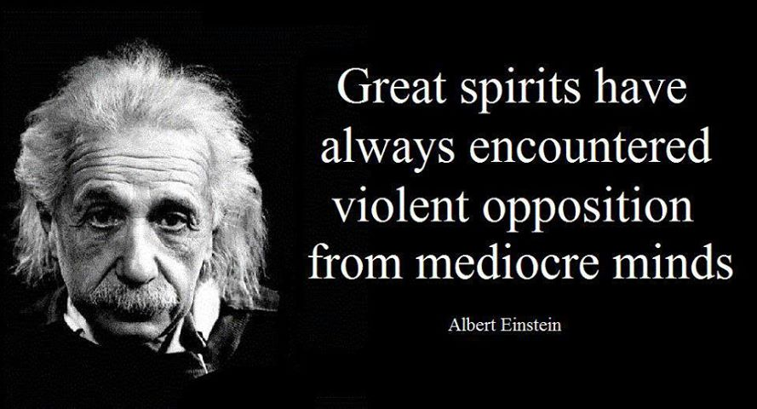
God united all types of Jews to work as common laborers.

Priests (1, 22, 28)

Goldsmiths (8a, 31, 32)

Perfumer (8b)

Political leaders (9, 15, 16, 17, 18, 19)

Women (12)

Levites (17)

Merchants (32)

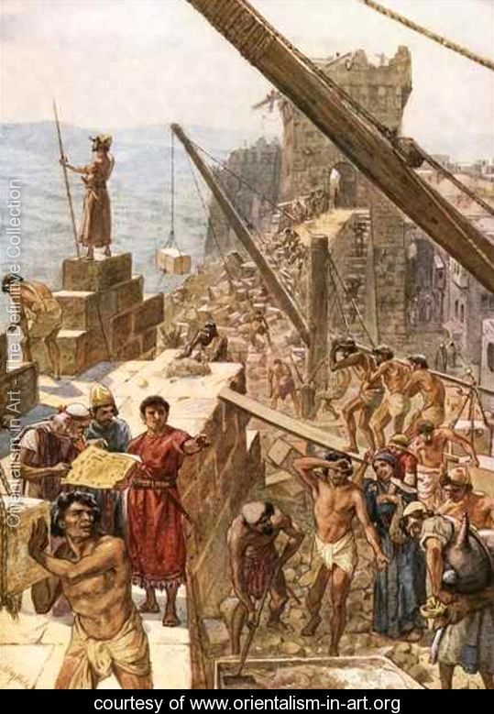
God unites all types of people as they serve him today.

Conclusion

God fights _______________ through a _______________
plan that includes us all (Main Idea).

What sensible part of his overall plan is His will for you?

Home Group Questions:

- Read Nehemiah 3 aloud. What repeated patterns do you see here as the people worked together to rebuild the wall?

- What options did the Jews have other than to build the wall themselves? Any lessons here?

- Which principle on building the wall applies most to your own Christian experience?

Warren W. Wiersbe, Be Determined (Wheaton, Ill.: Victor Books, 1996, c1992), Ne 4:1.
Warren W. Wiersbe, Be Determined (Wheaton, Ill.: Victor Books, 1996, c1992), Ne 4:1.
Warren W. Wiersbe, Be Determined (Wheaton, Ill.: Victor Books, 1996, c1992), Ne 4:1.
Ibid.

